IOE K3 2023 - 2024 SỐ 01
1. Which word has the underlined part pronounced like the letter ‘e’ in ’’red’’?
A. table B. bed C. quiet D. listen
2. What/ this?/ is/ colour/
3. See you la_ er.
4. Ảnh: 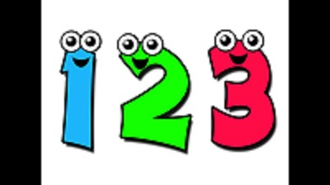ON_ , TWO, THREE
5. I want to st_ y at home.
6. Nghe: Nhấn giữ Ctrl và bấm chuột để nghe: _ _ _ _
7. Thank you very much. - You ... welcome.
A. is B. am C. are D. isn’t
8. Nghe: Nhấn giữ Ctrl và bấm chuột để nghe: _ _ _ _
9. Is your ruler short? - No, it isn't. It's ____ .
A. large B. big C. long D. small
10. Thank you very m_ _ h.
11. you/ song?/ Can/ sing/ a
12. ... to meet you!
A. How B. Go C. Nice D. Get
13. This is m_ cat.
14. Ảnh: Do you like ... TV? – Yes, I do.
A. seeing B. looking C. watching D. reading
15. _ _ this a ruler? – Yes, it is.
16. Nghe: Nhấn giữ Ctrl và bấm chuột để nghe: This is the _ _ _ _ _ _ _ _ room.
17. A: _________. - B: Yes, you can
A. Open your book! B. Stand up! C. May I go out? D. Be quiet!
18. Ảnh: _ _ _ _ the words aloud.
19. Wh_ is that? – It’s Mary.
20. Nghe: Nhấn giữ Ctrl và bấm chuột để nghe: _______ table tennis.
A. Peter plays B. I play C. Mai plays D. My friends play
21. G_ _ e me the book, please.
22. Ảnh: It's a ____ computer.
A. black B. blue C. red D. green
23. This is _ green doll.
24. I am fine. ... you?
A. End B. And C. An D. At
25. Choose the odd one out:
A. are B. you C. am D. is
26. C_ _ e over here.
27. It is _ _ ice-cream.
28. yellow/ This/ hat./ is/ a/
29. There are t_ _ ee crayons in my bags.
30. L_ _ k at the board, please.
31. Nghe: Nhấn giữ Ctrl và bấm chuột để nghe: There are _ _ _ _ books in the bookcase.
32. Ảnh: ____ brown books.
A. There are B. They are C. It is D. It's is
33. Choose the odd one out:
A. frog B. desk C. tiger D. lion
34. Jack ___ in the playground.
A. are B. am C. is D. be
35. ask you/ a question?/ I/ May/
36. is/ new/ my/ backpack./ That/
37. Ảnh: 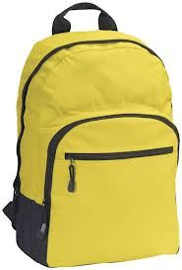Is your school bag y_ _ _ _ _ ? - Yes, it is.
38. That/ ruler/ is/ pink.
39. What’s ... name?
A. she B. he C. you D. her
40. I have _ _ apple.
41. Nghe: Nhấn giữ Ctrl và bấm chuột để nghe: He’s _ _ _ _ _ years old.
42. seven/ Quan/ is/ years old.
43. make/ a/ Let’s/ circle.
44. I_ is a crayon.
45. Ảnh: 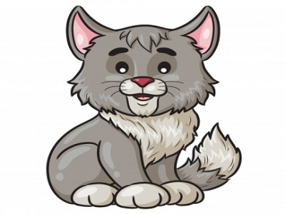CA_
46. Se_ you again.
47. To_ _ h your desk, please.
48. Choose the incorrect word(s) in the following sentence: These are my notebook.
A. These B. are C. my D. notebook
49. This is my classr_ _ m.
50. …, students. See you tomorrow.
A. Good morning B. Good night C. Goodbye D. Nice to meet you
51. ... ? – It’s yellow.
A. What colour is it B. What is this C. Is this yellow D. This is yellow pen
52. Ảnh: 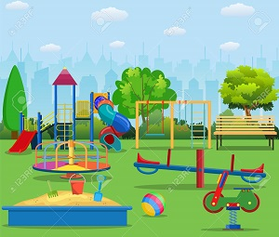We are ______ at break time.
A. in the classroom B. in the computer room C. in the playground D. on the roof
53. Close your ..., please.
A. name B. book C. ball D. took
54. Ảnh: Unscramble this word: ’’AERSRE’’ -> ’’ERAS_ _ ’’.
55. Is that your pencil? – No, it is _ _ _ .
56. My school isn't new. It's _ ld.
57. I … a blue pencil and a white ruler.
A. has B. have C. don’t have D. doesn’t have
58. Do you like _______ TV?
A. playing B. watching C. reading D. talking
59. Look … your book, please.
A. of B. in C. on D. at
60. He has a ... .
A. sunny B. cloudy C. windy D. doll
61. Nghe: Nhấn giữ Ctrl và bấm chuột để nghe: Who’s that?
A. Mary B. Jane C. Linda D. Ellie
62. Ảnh: These are th_ _ _ dogs.
63. That is my fr_ _ nd.
64. Ảnh: 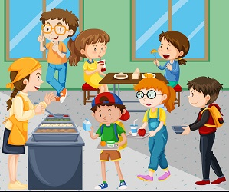It's my school ____ room.
A. music B. art C. lunch D. computer
65. What is her name? - ... .
A. He name is Peter B. His name Peter C. Her name Sammy D. Her name is Sammy
66. Nghe: Nhấn giữ Ctrl và bấm chuột để nghe: What AREN’T the students doing?
A. Running B. Jumping C. Laughing D. Studying
67. class 3A./ in/ Tony and I/ are/
68. Is your classroom big? - …, it isn't. It’s small.
A. Yes B. Yes, it isn’t C. No, it is D. No
69. You ... Richard. You are a new student in my class.
A. is B. be C. are D. am
70. Please, be q_ _ et.
71. Nghe: Nhấn giữ Ctrl và bấm chuột để nghe: Th_ _ _ are my pencils.
72. TEACH_ R
73. your/ close/ books./ Please/
74. What’s _______ name?
A. you B. I C. his D. he
75. She is my tea_ _ er.
76. Ảnh: 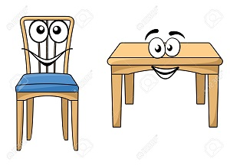TABLE AND CHAI_
77. What do you do ... English lessons?
A. on B. to C. near D. during
78. There _ _ a pen in my school bag.
79. My pen is o_ the desk.
80. This is the way we go _ _ school.
81. Put your book a_ _ y please.
82. Gi_ e me the book, please.
83. Ảnh: That's my computer _ oom.
84. student./ am/ I/ a/
85. Ảnh: 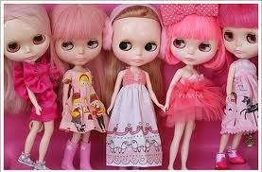What are these? – These are pink _ _ _ _ _ .
86. are/ Mary./ Hi,/ you?/ How/
87. I'm/ thank/ you./ fine,/
88. That is a big tr...e.
A. a B. u C. e D. i
89. Who is she? – S_ e is Mary.
90. Ảnh: Our _ _ _ _ _ _ _ _ is not big.
91. A: Is that _ _ y your friend? - B: No, he isn’t.
92. John./ How/ are/ Hi, I’m/ you?/
93. you./ meet/ Nice/ to/
94. May I go out? - Yes, ….
A. you can B. you can’t C. you aren’t D. it is
95. Tom is my friend, t_ _ .
96. My name is Jane. This is … family.
A. I B. my C. mine D. me
97. have/ I/ in/ two books/ my bag./
98. a/ pen./ is/ This/
99. Nghe: Nhấn giữ Ctrl và bấm chuột để nghe: gi_ _
100. There are ... books on the desk.
A. a B. one C. much D. many
101. Is/ that/ Viet?/
102. very/ teacher/ My/ tall./ is/
103. Nghe: Nhấn giữ Ctrl và bấm chuột để nghe: Listen and tick:
A. This is my school bag. B. This is my school bus. C. This is my school car. D. This is my school book.
104. May I come _ n? – Yes, please.
105. This is my sister. _ _ _ name is Alice.
106. These are ....
A. cat B. cats C. cat’s D. a cat
107. the/ at/ picture./ Look/
108. This rose ... for you. - Thank you very much.
A. are B. and C. is D. this
109. is/ my/ This/ classroom.
110. Nghe: Nhấn giữ Ctrl và bấm chuột để nghe: F_ ur brothers and 4 sisters.
111. morning./ every/ I/ school/ go to/
112. A parrot can f_ _ .
113. food./ some/ wants/ Peter/
114. Ảnh: A LARG_ ROOM
115. ___ is my sister, Hoa.
A. Her B. He C. She D. His
116. What/ have?/ does/ subjects/ he
117. ... you like a candy? – No, thanks.
A. Who B. When C. Would D. How
118. Sit down/ and/ please!/ open/ your book,
119. Nghe: Nhấn giữ Ctrl và bấm chuột để nghe: Is the school gym _______?
A. large B. big C. lag D. larg
120. Nghe: Nhấn giữ Ctrl và bấm chuột để nghe: That is my _ _ _ _ _ _ _ .
121. Ảnh: 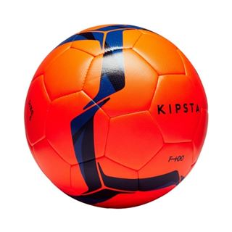This is a ______.
A. ball B. hat C. book D. table
122. and Linda/ years old./ are/ eight/ Peter/
123. The bag is p...nk.
A. u B. i C. e D. o
124. at/ that/ blue/ picture./ Look/
125. No, it is n_ _ .
126. How are y_ _ ?
127. two/ There/ are/ pencil boxes.
128. This isn’t ... ruler. It’s my ruler.
A. he’s B. his C. me’s D. you’s
129. I/ am/ thirsty/ now.
130. Let’s make a ci_ cle.
131. What are _ _ _ se? – These are pink dolls.
132. is/ your teacher?/ old/ How/
133. Is this a book? - _ _ , it isn’t.
134. Be qu_ et, please.
135. is/ new/ and/ nice./ The school library/
136. Choose the odd one out:
A. cat B. dog C. pencil D. parrot
137. How _ _ _ you?
138. Nghe: Nhấn giữ Ctrl và bấm chuột để nghe: _ _
139. in/ There/ that box./ are/ many toys/
140. Good morning, te...cher.
A. u B. a C. e D. o
141. a/ It/ box./ big/ is/
142. Stand in line, pl_ _ _ _ .
143. What is ... name? – My name is Simon.
A. I B. he C. my D. your
144. She is _ _ new friend.
145. Put your book a_ _ y.
146. The pencil sharpener/ is in/ my pencil case./
147. Bob: What is this? - Peter: ...
A. His name is Hien. B. It is a ruler. C. It’s an ruler. D. It is my friend.
148. colour/ My favourite/ is blue./
149. A fish can s_ _ m but it can’t run.
150. Is this a bag? - ... .
A. Yes, it is B. Yes, isn’t C. No, it is D. Nice to meet you.
151. Ảnh: SCHOOL TH_ NGS
152. These/ kites/ beautiful./ are/
153. Look _ _ that map on the wall, please.
154. May I/ pencil/ close/ box?/ your/
155. Nghe: Nhấn giữ Ctrl và bấm chuột để nghe: _ _ _ _
156. These/ are/ my sister's/ dolls./ pink
157. are/ relatives./ my/ These/
158. GR_EN
A. I B. O C. E D. A
159. Nghe: Nhấn giữ Ctrl và bấm chuột để nghe: They are _ _ own.
160. name, Nam?/ your/ How do/ you spell/
161. He can play football … can’t play chess.
A. and B. but C. so D. or
162. … brother is very tall.
A. My B. I C. Me D. Mine
163. My favourite colour is ____.
A. oranges B. red C. apple D. back
164. What is your f_ _ _ _ _ _ _ e food?
165. Close/ your book,/ please!/
166. small./ school/ Her/ new/ is
167. Be q_ _ et, please.
168. I ... Simon. Nice to meet you.
A. am B. you C. she D. he
169. L_ _ k, listen and repeat.
170. that/ his/ Is/ teacher?
171. Nghe: Nhấn giữ Ctrl và bấm chuột để nghe: This is my _ _ _ _ _ .
172. books/ Are there/ your bedroom?/ any/ in
173. you/ later./ See/ Goodbye./
174. ... is that? - It’s a chair.
A. Who B. Where C. What D. When
175. Nghe: Nhấn giữ Ctrl và bấm chuột để nghe: Listen and tick:
A. This toy is Nam. B. This friend is Nam. C. This girl is Nam. D. This boy is Nam.
176. I ... Andy.
A. are B. am C. is D. you
177. Co_ plete the sentences.
178. How are y_ _ ?
179. _ _ es she like table tennis?
180. gym/ the/ Is/ large?
181. Ảnh: 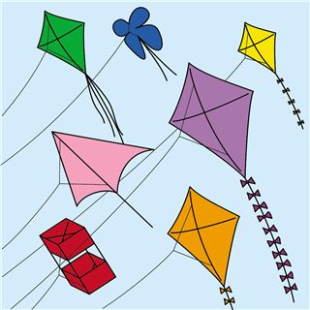There are many k_ _ _ _ in the sky.
182. mess./ a/ Don’t/ make/
183. … is your name? – My name is Jenny.
A. How B. Where C. Who D. What
184. This is ... cat.
A. he B. she C. my D. you
185. _______ the tables old?
A. Am B. Is C. Are D. It
186. Good mo_ _ ing, children!
187. today./ very/ It/ hot/ is/
188. Ảnh: 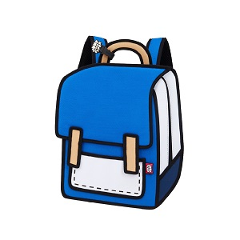BACK_ ACK
189. This gift is for you. - Thank you very _ _ _ _ .
190. Listen/ please./ teacher,/ the/ to/
191. I'm _____ so I don’t go to school today.
A. fine B. good C. well D. sick
192. What color is this? - It’s ... .
A. book B. pen C. green D. pencil
193. Is this a book? - ... .
A. Yes, it is B. Yes, isn’t C. No, It is D. Nice to meet you.
194. Green./ Miss/ Goodbye,/
195. He is ... .
A. Peter B. It C. Mai D. She
196. Nice to me_ t you.
197. What is this? – It is … ice cream.
A. a B. an C. these D. that
198. _______. See you again.
A. Good morning B. Good afternoon C. Good evening D. Goodbye
199. Nghe: Nhấn giữ Ctrl và bấm chuột để nghe: They are in the _ _ _ _ _ _ _ .
200. That’_ his brother.

IOE K3 2023 - 2024 SỐ 02
1. What’s y_ ur name?
2. Nghe: Nhấn giữ Ctrl và bấm chuột để nghe: Let’s go to the school _ _ _ _ _ _ _ .
3. I draw a pictu_ _ in the room.
4. _ _ at is your name? - My name is Hung.
5. your book,/ Open/ please!/
6. May I ___ the book?
A. open B. stand C. play D. sit
7. That is a big tr...e.
A. a B. u C. e D. i
8. _______ fine, thanks.
A. I am B. I C. I’m am D. I I’m
9. Odd one out:
A. fish B. cat C. dog D. book
10. school./ we/ This is/ go to/ the way/
11. Ảnh: Sit _ _ wn , please!
12. Choose the odd one out:
A. she B. my C. he D. you
13. How _ _ _ are you? – I’m seven years old.
14. am fine/ , thanks./ I/ you?/ And
15. ... are you? – I’m fine, thanks.
A. Hi B. Hello C. How D. How’s
16. Ảnh: 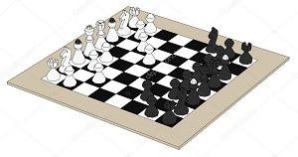CH_ SS
17. and/ My brother/ two dogs./ has/ a cat/
18. A/ in the classroom./ is/ black board/
19. Ảnh: 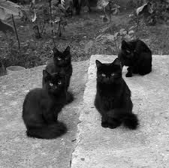These cats are _ _ _ _ _ .
20. new/ my/ teacher./ is/ Miss Lien/
21. A: _ _ _ _ ’s it? - B: It’s my notebook.
22. Point _ _ the teacher.
23. Is your school new? - No. It's _____.
A. new B. old C. not D. is
24. … that woman your new teacher?
A. Is B. Has C. Who’s D. Does
25. Stand u_ , please.
26. Is your classroom big? - …, it isn't. It’s small.
A. Yes B. Yes, it isn’t C. No, it is D. No
27. your/ to/ friend./ Listen/
28. I’m ... , thank you. And you?
A. nice B. bye C. fine D. hi
29. … ? – It’s black.
A. What colour is it B. What is this C. How are you D. How many
30. Simon./ Come/ over/ here,/
31. Is this your ruler? - No, ____ isn't
A. it B. that C. its D. it's
32. the pink/ pen,/ please./ Give/ me/
33. Ảnh: 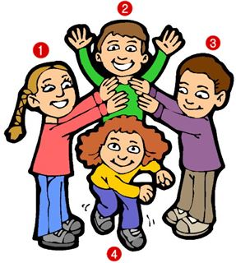A: Who’s Tracy? - B: The girl is in the yellow shirt.
A. 1 B. 2 C. 3 D. 4
34. Don't/ girls!/ in class,/ talk/
35. Is it _ ruler? – No, it isn’t.
36. Jack ___ in the playground.
A. are B. am C. is D. be
37. I go to school ___ my classmates.
A. in B. and C. but D. with
38. W_ _ t is this? – This is a marker.
39. May I go out? - ... .
A. Hello B. Nice to meet you C. Fine, thanks D. Sure
40. That’s my fathe_ .
41. that,/ Who's/ Peter?/
42. I go to school library to ... books.
A. read’s B. reads C. read D. read to
43. Are/ sick/ you/ today?
44. books/ How/ there?/ many/ are
45. Hi, I’m Collin. Nice to meet ....
A. me B. they C. he D. you
46. ... this a pencil?
A. Are B. You C. Is D. My
47. Nghe: Nhấn giữ Ctrl và bấm chuột để nghe: I’m standing in a ... .
A. living room B. classroom C. room D. bedroom
48. Nghe: Nhấn giữ Ctrl và bấm chuột để nghe: I like basketba_ _ .
49. Nghe: Nhấn giữ Ctrl và bấm chuột để nghe: The school _______ is large.
A. gym B. school C. room D. library
50. the teacher/ Write/ what/ says.
51. Unscramble this word: ’’YBEDOGO’’ -> ’’GOOD_ _ _ ’’.
52. A: … that boy your friend? - B: Yes, ….
A. Are – they are B. Are – they aren’t C. Is – he isn’t D. Is – he is
53. My school _ _ new.
54. Odd one out:
A. fish B. cat C. dog D. book
55. Nghe: Nhấn giữ Ctrl và bấm chuột để nghe: It’s a _ _ _ blue green ball.
56. Lan and Hoa ___ in class 3C.
A. is B. am C. are D. on
57. Ảnh: That is a blue s_ _ _ .
58. Let’s make a ci_ cle.
59. Ảnh: Put your books on the tabl_ .
60. Ảnh: 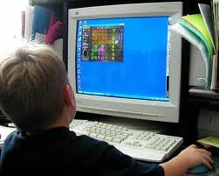My brother likes playing _ _ _ _ _ _ _ _ games.
61. Goodbye. ...
A. Nice to meet you B. See you later C. Good morning D. Good evening
62. Ảnh: Our _ _ _ _ _ _ _ _ is not big.
63. Ảnh: 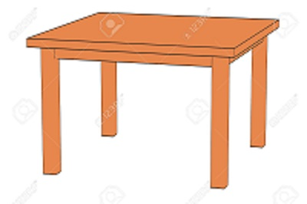TA_LE
A. P B. B C. C D. G
64. Gale ______ books in the school library.
A. listens B. speaks C. says D. reads
65. ____ are his pets.
A. These B. This C. That D. It
66. is/ name?/ your/ What/ mother's
67. Is this _ _ eraser?
68. my/ friends./ are/ These/
69. Nghe: Nhấn giữ Ctrl và bấm chuột để nghe: Put the books … the table.
A. under B. on C. next to D. behind
70. This is ... school bag.
A. he’s B. my’s C. me D. my
71. Ảnh: The ball is ___ the box.
A. in B. on C. at D. of
72. Nghe: Nhấn giữ Ctrl và bấm chuột để nghe: Listen and tick:
A. This is my T-shirt. B. This is my shirt. C. This is my skirt. D. This is my jeans.
73. There is a picture … the wall.
A. in B. at C. on D. of
74. Is this a pencil box? – ..., it is.
A. No B. Not C. Yes D. No’s
75. Choose the odd one out
A. Green B. Yellow C. Apple D. Blue
76. like/ My/ doesn’t/ brother/ cats./
77. school/ large?/ Is/ your/
78. Choose the letter(s) to make a correct word: blac__
A. c B. t C. k D. h
79. _ _ _ do you spell your name, Sam? - It’s S-A-M.
80. Listen and ti_ _ .
81. Let’s ma_ _ a line, students.
82. eight/ I/ am/ years old.
83. me./ after/ repeat/ Please/
84. Bye. S_ _ you later.
85. My classroom is … .
A. name B. news C. new D. names
86. Nice _ _ see you.
87. Put/ your/ down./ hand/
88. Nghe: Nhấn giữ Ctrl và bấm chuột để nghe: There are ... boats on the sea.
A. twenty B. three C. two D. twelve
89. That/ green/ a/ is/ chair./
90. Nghe: Nhấn giữ Ctrl và bấm chuột để nghe: These are your new … and ….
A. bookcases – boards B. tables – computers C. beds – chairs D. tables – chairs
91. I’m fine, th_ _ k you.
92. There are two books o_ the table.
93. on/ are there/ erasers/ How many/ the table?/
94. Nghe: Nhấn giữ Ctrl và bấm chuột để nghe: Listen and tick:
A. My father is a teacher. B. My mother is a teacher C. My father is a doctor. D. My brother is a teacher.
95. Nghe: Nhấn giữ Ctrl và bấm chuột để nghe: She wears a big ___ hat.
A. black B. blue C. green D. yellow
96. This isn’t ... bag.
A. he B. his C. this D. he’s
97. I’m fine, thank you. ... ?
A. You B. And you C. Are you D. Bye
98. Ảnh: Look! That flower is ....
A. pink B. blue C. green D. black
99. How _ _ you spell your name?
100. Raise/ your/ hands,/ please
101. Nghe: Nhấn giữ Ctrl và bấm chuột để nghe: There are … sweets.
A. three B. two C. four D. no
102. Nghe: Nhấn giữ Ctrl và bấm chuột để nghe: Point and s_ y.
103. ... your name?
A. What B. What’s C. How’s D. Why’s
104. Nice to/ Mary./ meet you./ Hi,/
105. Choose the odd one out:
A. you B. I C. she D. my
106. I’m fine, _ _ _ _ k you.
107. I ... Maths and Arts on Monday.
A. play B. say C. study D. look
108. is short./ is small/ My rubber/ and my ruler/
109. I’m fine, thank ... .
A. yous B. you’s C. you’re D. you
110. Sit do_ n, please.
111. my/ is/ friend./ Jenny/
112. May/ I/ borrow/ your notebook?
113. your/ Where/ are/ books?
114. bag./ a purple/ This is/
115. Where are ... from?
A. and B. my C. you D. she
116. Mai and Phong?/ How/ you today,/ are/
117. Bye. _ _ _ you later.
118. after/ repeat/ me./ Please/
119. A: What colour is this? - B: It’s ... .
A. book B. a green C. green D. pencil
120. Open ... book, please.
A. you B. your C. you’s D. your’s
121. _ _ this a ruler? – Yes, it is.
122. Listen _ _ me, please.
123. Ảnh: 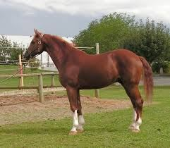That is my ho_ _ e.
124. Nghe: Nhấn giữ Ctrl và bấm chuột để nghe: Nam's pencils are_____ .
A. black B. blue C. green D. red
125. Nghe: Nhấn giữ Ctrl và bấm chuột để nghe: Where is the ...?
A. bus B. class C. lab D. tab
126. Ảnh: E_ GHT
127. How do you … your name? – That’s A-N-N-E.
A. spell B. read C. call D. say
128. your/ Raise/ hand./
129. Choose the odd one out
A. Ruler B. Pen C. Book D. Library
130. LIS_ EN
131. Nam’s pencil is _ _ _ _ but mine is short.
132. Gi_ e me the book, please.
133. My n_ me is Hieu.
134. Ảnh: 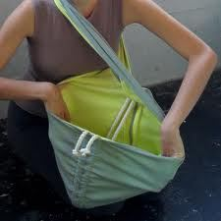_ _ _ _ the bag, please.
135. go to/ school/ don't/ I/ today./
136. teacher./ Listen to/ the/
137. This isn’t ... ruler. It’s my ruler.
A. he’s B. his C. me’s D. you’s
138. Mary is at sch_ _ l.
139. David and Tony p_ _ _ football after school.
140. are/ My/ pink./ shoes/ new/
141. Gi_ e me a pen, please.
142. St_ _ d up, please.
143. Is th_ _ _ any water in the fridge, mom?
144. _ _ _ many students are there in your classroom?
145. …, students. See you tomorrow.
A. Good morning B. Good night C. Goodbye D. Nice to meet you
146. your/ Don't/ bike/ too fast./ ride/
147. She is my tea_ _ er.
148. M_ THER
149. books/ in/ your school bag?/ are there/ How many/
150. down./ Put/ your pencil/
151. Ảnh: 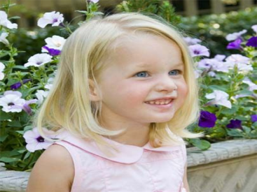Does she have bl_ _ _ _ hair?
152. Pl_ _ _ ed to meet you, Linda.
153. Ảnh: 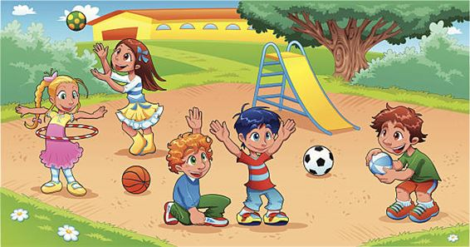My school .... is small.
A. playground B. library C. classroom D. gym
154. Nghe: Nhấn giữ Ctrl và bấm chuột để nghe: _ _ _ _ _ are my crayons.
155. Does/ basketball?/ she like/ volleyball/ or
156. This is ... cat.
A. he B. she C. my D. you
157. Choose the odd one out:
A. eraser B. ruler C. name D. pen
158. an/ like/ ice cream?/ you/ Would/
159. _ _ _ , he is.
160. My brother likes to play computer g_ _ _ _ .
161. Ảnh: 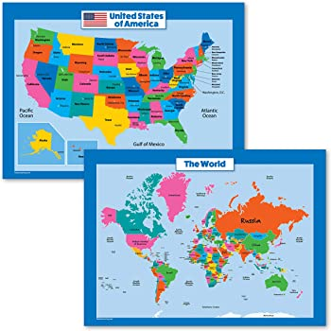Two maps __ on the wall.
A. are B. is C. re D. am
162. Choose the odd one out:
A. how B. hello C. hi D. good morning
163. Choose the odd one out:
A. book B. pencil C. rubber D. library
164. Choose the odd one out:
A. you B. hi C. I D. She
165. W_ _ _ are these? – These are pencil cases.
166. Choose the odd one out:
A. young B. white C. pink D. gray
167. Come here and _ _ _ _ an English song now.
168. Don't talk _ _ class!
169. Fine, th_ nks.
170. Choose the letter(s) to make a correct word: pencil c__se
A. a B. e C. i D. o
171. Look/ at/ the/ board.
172. A: Who’s that boy? - B: _ _ ’s Peter.
173. too./ The window/ is/ new,/
174. Choose the incorrect word(s) in the following sentence: Do you like hide seek?
A. Do B. you C. like D. hide seek
175. Unscramble this word: ’’HOLOCS’’ -> ’’SCHO_ _ ’’.
176. Nghe: Nhấn giữ Ctrl và bấm chuột để nghe: Is this ___ bike? - No, it isn't.
A. his B. your C. my D. her
177. Ảnh: 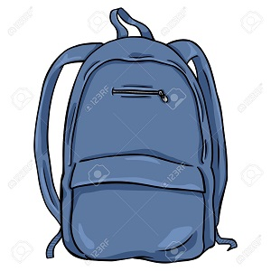My bag is ______.
A. blue B. gray C. black D. yellow
178. Nghe: Nhấn giữ Ctrl và bấm chuột để nghe: Choose the sentence that you hear:
A. I’m fine. B. I’m fine, thanks. C. Fine, thank you. D. I am fine, thank you.
179. How are y_ _ ?
180. pet./ is/ my/ This/
181. Ảnh: Sally has bl_ _ eyes and blonde hair.
182. Odd one out:
A. meet B. I C. you D. he
183. It's a brow_ teddy bear.
184. Horses and sheep live on the _ _ _ _ .
185. read/ Let’s/ the/ book.
186. Tha_ is my doll.
187. open/ your/ Stand up/ book./ and/
188. very/ tidy./ isn’t big/ My school/ but/
189. want/ I/ the world./ around/ to travel/
190. It _ _ a pencil.
191. List_ _ carefully.
192. SCHOOL-B_ G
193. Nghe: Nhấn giữ Ctrl và bấm chuột để nghe: This is my ... .
A. class B. school C. room D. desk
194. a pupil/ Primary School./ I am/ at Quang Trung/
195. What does he do during ... lessons? - He learns about numbers.
A. Maths B. English C. Arts D. Music
196. We write \"06:20\" and we say \"It’s twenty _ _ _ _ six\".
197. Nghe: Nhấn giữ Ctrl và bấm chuột để nghe: What colour is ______?
A. they B. that C. it D. these
198. Ảnh: 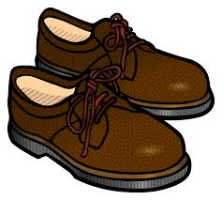_ _ OWN SHOES
199. That is my fa_ _ er.
200. nice/ a/ puppy./ It's/

IOE K3 SỐ 03
1. Mary/ English songs./ dance and/ sing/ likes to/
2. I _ _ Mai.
3. name's/ My/ Elizabeth./
4. Ảnh: 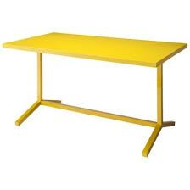This is a ... desk.
A. pink B. yellow C. blue D. green
5. Ảnh: Jimmy wants a hel_ _ _ _ _ _ _ for his birthday.
6. A: Is that your classmate? - B: ...
A. Yes, he isn't. B. No, she isn’t. C. Yes, it is. D. No, I’m not.
7. ... your name?
A. What B. What’s C. How’s D. Why’s
8. Nice to ... you!
A. meet B. go C. for D. come
9. after school./ Peter/ and I/ don't/ play baseball
10. new/ This is/ my/ school bag.
11. … many desks are there in your classroom?
A. How B. What C. Who D. Which
12. What/ he/ doing?/ is/
13. … many books are there on the bookshelf?
A. Who B. How C. Where D. What
14. That is Lan. _ _ _ is my friend.
15. Where is Simon f_ _ m? – He’s from England.
16. How/ spell/ do you/ his name?
17. Ảnh: _ pen your book, please!
18. Hi, _ _ _ are you? – Fine, thanks.
19. Stand _ _ , please.
20. Th_ t is my school. It’s very big.
21. your/ room?/ it/ Is/ computer
22. Choose the correct sentence.
A. I like play basketball. B. My brother is twelve year old. C. Tony plays football at break time. D. What are your name?
23. What colour ... this?
A. it B. is C. that D. hi
24. Let’s ma_ e a circle.
25. Is th_ _ _ any water in the fridge, mom?
26. Happy birthday, Alice. This doll is for ... .
A. I B. you C. he D. she
27. My friends are in the pla_ ground.
28. This _ _ a pen.
29. is/ room?/ your/ What colour/
30. my/ not/ It/ is/ school bag./
31. Ma_ I go out, please?
32. Whe_ _ is your book? - It's on the shelf.
33. What’s _______ name?
A. you B. I C. his D. he
34. Ảnh: 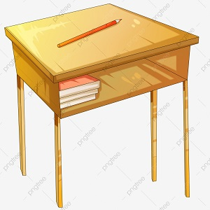D_SK
A. E B. A C. O D. U
35. Nghe: Nhấn giữ Ctrl và bấm chuột để nghe: … is my father.
A. This B. That C. It D. He
36. They/ in the/ classroom./ aren't/
37. Look _ _ the board.
38. Ảnh: TABLE AND CHAI_
39. Listen ... the teacher.
A. to B. me C. you D. he
40. Nghe: Nhấn giữ Ctrl và bấm chuột để nghe: Choose the sentence that you hear:
A. I’m fine. B. I’m fine, thanks. C. Fine, thank you. D. I am fine, thank you.
41. Ảnh: YE_ _ OW
42. Take/ pens,/ out/ your/ Henry./
43. My cla_ _ room is small.
44. Good m_ rning, teacher!
45. He's 8 years _ _ _ .
46. Ảnh: 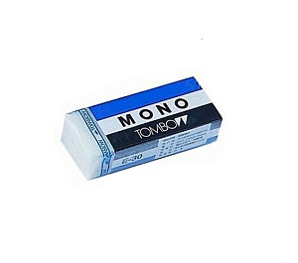RU_ BER
47. Ảnh: 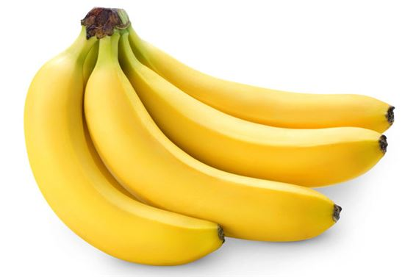Monkeys’ favourite fruits are ba_ _ nas.
48. please./ some/ me/ Give/ chalks,
49. erasers/ on/ How many/ are there/ the table?/
50. that/ Miss/ Is/ Lan?
51. How _ _ _ _ crayons are there?
52. He is ... farmer.
A. an B. a C. this D. am
53. Good ..., Jame. - Hi, Tom. How are you?
A. nice B. morning C. see D. my
54. Does/ volleyball/ or/ she like/ basketball?/
55. large?/ school/ your/ Is/
56. My sister … books in the school library.
A. read B. reads C. to read D. reading
57. don't/ go to/ today./ I/ school
58. his friends/ don’t like/ basketball./ Peter/ and/
59. You are wel_ _ me.
60. the/ at/ please!/ Look/ board,
61. He/ likes/ swimming./
62. a/ That/ brown/ cat./ is/
63. Nghe: Nhấn giữ Ctrl và bấm chuột để nghe: LI_ _ _ _ _
64. Who’s that? - That’s ... .
A. my’s teacher B. me’s teacher C. my teacher D. me teacher
65. Write/ the teacher/ says./ what/
66. Let’s mak_ a line.
67. bag./ is/ That/ school/ a green/
68. Choose the correct order.
A. L, M, N, O, P, Q B. M, L, N, O, Q, P C. N, M, L, P, Q, O D. O, L, M, N, P, Q
69. He __ a newcomer.
A. are B. am C. is D. do
70. Ảnh: 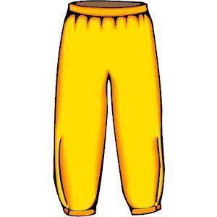What colour are the trousers? - They are _ _ _ _ _ _ .
71. Collins: Hello. My name is Collins.Barry: ... .
A. Nice to meet you B. Hi. See you later C. Goodbye D. Bye
72. Unscramble this word: ’’OOBETKNO’’ -> ’’NOTEBO_ _ ’’.
73. repeat/ me./ after/ Please/
74. _ _ _ , he is.
75. go to/ This is/ school./ we/ the way/
76. Ảnh: Put your books on the tabl_ .
77. Odd one out:
A. footballer B. singer C. teacher D. cooker
78. is/ old./ three/ years/ My brother/
79. your/ hands/ the table./ Put/ on
80. What’s this? - ... .
A. That a picture B. These are pictures C. There are picture D. This is a picture
81. I’d like some strawberries. – Here … are.
A. they B. them C. those D. these
82. What is this? - ... .
A. It a apple B. Is a apple C. It’s a apple D. It’s an apple
83. We play _______ in the playground.
A. badminton B. football C. hide-and-seek D. baseball
84. ruler?/ your/ Is/ it/
85. I have ... robot.
A. a B. an C. two D. and
86. Nghe: Nhấn giữ Ctrl và bấm chuột để nghe: Lucy and her ... draw picture in classroom.
A. boys B. teachers C. friends D. girls
87. Nghe: Nhấn giữ Ctrl và bấm chuột để nghe: She is in _ _ _ music room.
88. Be/ quiet,/ boys!/
89. in/ the sky./ many/ There are/ clouds/
90. Please dr_ _ a picture, children.
91. Can you he_ p me?
92. Is ... a chair? - Yes, it is.
A. are B. it C. it’s D. his
93. What colou... is this? – It’s pink.
A. t B. q C. r D. p
94. That’s Peter. ... is my friend.
A. I B. You C. She D. He
95. is/ friend./ my/ Jenny/
96. Ảnh: The elephant ___ big and the mouse ___ small.
A. are - is B. are - are C. is - are D. is - is
97. Mary often gets up early so she _ _ never late for shool.
98. This _ _ my new school. I love my new school.
99. Is ... a flower? – Yes. That is a flower.
A. that’s B. that C. this D. this is
100. My brother is ______ years old.
A. two B. to C. too D. do
101. Simon can sing ... he cannot swim.
A. and B. end C. but D. or
102. my/ book?/ I/ May/ close/
103. Can you swim? - _ _ , I can’t.
104. Hello, ... name is Scott.
A. he B. she C. it D. my
105. Is this a book? – Yes, ... .
A. I am B. is it C. it is D. it isn’t
106. The teddy is betw_ _ _ the car and the robot.
107. They _ _ _ my good friends.
108. Nghe: Nhấn giữ Ctrl và bấm chuột để nghe: That's my ______.
A. schoolbag B. school gym C. school playground D. school
109. Nghe: Nhấn giữ Ctrl và bấm chuột để nghe: Her old car is a ___ Honda.
A. red B. black C. white D. pink
110. Nghe: Nhấn giữ Ctrl và bấm chuột để nghe: Loo_ at the school.
111. May I come ...?
A. in B. at C. on D. to
112. W_ _ is she? – She is my new teacher.
113. teacher?/ Is/ your/ he/
114. Here/ my/ is/ notebook.
115. Lan’s school _ _ _ _ ground is large.
116. Nghe: Nhấn giữ Ctrl và bấm chuột để nghe: Listen and choose the correct response
A. Yes, I am. B. This is my teddy. C. No, it isn’t. D. The teddy is Peter’s.
117. Nghe: Nhấn giữ Ctrl và bấm chuột để nghe: Listen and tick:
A. My father is a teacher. B. My mother is a teacher C. My father is a doctor. D. My brother is a teacher.
118. I like to s_ ng.
119. Sit d_ _ _ , Tommy.
120. from/ My new/ is/ friend/ France./
121. Let's/ play./ outside/ go/ and
122. Ảnh: That is a blue s_ _ _ .
123. Nghe: Nhấn giữ Ctrl và bấm chuột để nghe: _ _ _ _ _ are my crayons.
124. That is my school gym. ___ new.
A. Its B. It's is C. It's D. Its's
125. My friends/ in/ the playground./ are/
126. Ảnh: 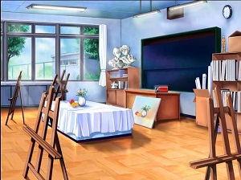It's the _ rt room.
127. Nghe: Nhấn giữ Ctrl và bấm chuột để nghe: These are your new … and ….
A. bookcases – boards B. tables – computers C. beds – chairs D. tables – chairs
128. Hello my fr...end.
A. u B. i C. w D. o
129. May I co_ _ in?
130. ______ colour is your bag?
A. What B. Where C. When D. How
131. Gi_ e me the book, please.
132. down./ your pencil/ Put/
133. my pencils./ those are/ her crayons/ These are/ and/
134. What’s your nam_ ? - My name is Alan.
135. cats/ many/ How/ there?/ are
136. learn/ the gym./ in/ PE lessons/ We/
137. Nghe: Nhấn giữ Ctrl và bấm chuột để nghe: The ... is short.
A. ruler B. pencil C. pen D. rubber
138. _ _ at is my ruler.
139. I’m fine, thanks. How a_ _ _ t you?
140. Nghe: Nhấn giữ Ctrl và bấm chuột để nghe: Listen and tick:
A. Is that girl Mary? - Yes, she is. B. Is that boy Mary? - Yes, he is. C. Is that pen Mary? - Yes, it is. D. Is that room Mary? - Yes, it is.
141. Nghe: Nhấn giữ Ctrl và bấm chuột để nghe: _ ite
142. Nghe: Nhấn giữ Ctrl và bấm chuột để nghe: b_ g
143. bag/ My/ small./ is/ school/
144. three crayons/ are/ There/ the table./ on
145. … do you like? – I like riding a horse.
A. When B. How C. What D. Who
146. Nghe: Nhấn giữ Ctrl và bấm chuột để nghe: What is her favorite colour?
A. red B. orange C. yellow D. green
147. Ảnh: 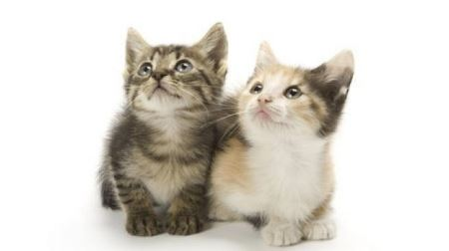_ _ _ CATS
148. sch_ _ l
149. play/ together./ Let’s/ chess/
150. _ _ that your new friend? - No, he isn’t.
151. Do you like goldfish?
A. Yes, I am. B. Yes, I can. C. Yes, it is. D. Yes, I do.
152. Good mo...ning, Peter.
A. w B. t C. r D. q
153. Ảnh: We are on the _ _ _ _ _ because it’s very hot today.
154. clap your hands./ and/ Sing/
155. Gi_ e me the book, please.
156. Circle the ans_ er.
157. Ảnh: 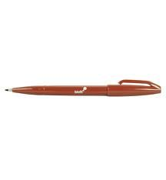That pen is ... .
A. yellow B. pink C. black D. brown
158. _____ are my shoes.
A. This B. That C. It D. These
159. This gift is ... you.
A. on B. in C. for D. at
160. Goodbye! - Bye, see you ... .
A. hi B. later C. hello D. good
161. I/ play chess/ in the classroom./
162. Cl_ _ n your teeth, please.
163. Nghe: Nhấn giữ Ctrl và bấm chuột để nghe: That is a small ... .
A. board B. bus C. box D. boat
164. Sit/ , please./ down/
165. Ảnh: 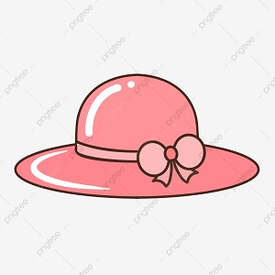It's a pink ha_ .
166. … is she? – She is my sister.
A. What B. When C. Who D. How
167. my/ classroom./ is/ This/
168. Hello, how a..e you?
A. u B. r C. e D. i
169. What is your name? - ... .
A. Her name is Mary. B. His name is Alan. C. My name is Lan. D. Your name is Peter.
170. This ... my school.
A. are B. is C. you D. bye
171. H...llo, how are you?
A. u B. e C. i D. a
172. It is _ _ ice-cream.
173. What ... is this? – It’s blue.
A. colour B. colours C. colour’s D. coulor
174. These are t_ o cats.
175. Nice to m_ _ t you!
176. This is Tom and that … Mary.
A. am B. is C. are D. have
177. She ... my friend.
A. are B. is C. me D. I
178. I draw a pictu_ _ in the room.
179. Nice ... meet you, too.
A. for B. to C. from D. me
180. Look/ at/ picture./ that/ blue
181. Bob: What is this? - Peter: ...
A. His name is Hien. B. It is a ruler. C. It’s an ruler. D. It is my friend.
182. Does/ have/ hair?/ she/ long
183. Those are f_ ve boxes.
184. Is t_ is your eraser?
185. What is this? – It is ... ice cream.
A. a B. an C. these D. that
186. Nghe: Nhấn giữ Ctrl và bấm chuột để nghe: Listen and tick:
A. I’ve got two rulers. B. I’ve got two erasers. C. I’ve got two scissors. D. I’ve got two eggs.
187. Ảnh: 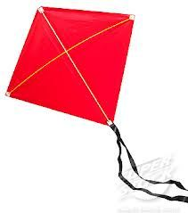Look! That is a ... kite!
A. green B. red C. blue D. brown
188. Nice to meet you, t_ _ .
189. Be … Don’t make noise.
A. lazy B. quiet C. funny D. angry
190. Listen _ _ the teacher carefully.
191. Giv_ me the crayon, please.
192. ... do you like? – I like milk.
A. How B. What C. When D. Who
193. Nghe: Nhấn giữ Ctrl và bấm chuột để nghe: _ _ ain
194. H_ _ many students in your class?
195. Ảnh: I'm five years _ ld.
196. I have _ _ apple.
197. What do you do at b_ _ _ k time?
198. Is your school new? - Yes, ______ .
A. is it B. its is C. it is D. is its
199. SCHOOL-B_ G
200. Point to your frie_ _ , please.

IOE K3 SỐ 04
1. Ảnh: My teacher goes to work by _ _ _ _ _ .
2. new/ Is/ your/ school/ big?/
3. a/ there/ dog?/ Is/
4. Give ... that pink crayon.
A. he B. she C. me D. the
5. Ảnh: They are ni_ _ years old.
6. How/ mother/ today?/ is/ your/
7. Nghe: Nhấn giữ Ctrl và bấm chuột để nghe: Which is NOT mentioned in the recording?
A. bike B. train C. kite D. truck
8. Is ______ house old? – Yes, it is.
A. it B. Nga C. her D. she
9. What c_ _ _ ur is this? – It’s green.
10. Nghe: Nhấn giữ Ctrl và bấm chuột để nghe: _ _ _ da
11. Ảnh: This is a ... desk.
A. pink B. yellow C. blue D. green
12. Stand up now and open ... book, Tom.
A. you B. your C. you’s D. you’re
13. and new./ large/ My bedroom/ is/
14. What does he do during ... lessons? - He learns about numbers.
A. Maths B. English C. Arts D. Music
15. Come ..., please.
A. out B. in C. to D. under
16. two dogs./ a cat/ and/ My brother/ has/
17. Who/ that?/ is/
18. Goodbye Sally. See ... later.
A. hi B. my C. your D. you
19. This is Alice. _ _ _ is my friend.
20. Nghe: Nhấn giữ Ctrl và bấm chuột để nghe: a_ _ le
21. go out?/ me!/ Excuse/ I/ May/
22. ... are you from, Jean? – I’m from Canada.
A. Where B. What C. How D. When
23. Happy birthday _ _ you, Alan. – Thank you.
24. Nghe: Nhấn giữ Ctrl và bấm chuột để nghe: Fine, ________.
A. thank B. thank you C. thanks D. thanks you
25. Ảnh: _ _ ITE
26. Nghe: Nhấn giữ Ctrl và bấm chuột để nghe: _ _ _ are you?
27. Goodbye, chi_ _ ren. See you later.
28. Nghe: Nhấn giữ Ctrl và bấm chuột để nghe: Choose the sentence that you hear:
A. How do you spell her name? B. How do you spell his name? C. How do you spell its name? D. How do you spell your name?
29. She doesn’t like ma_ _ ng paper boat.
30. Choose the odd one out:
A. Hello B. Hi C. Goodbye D. Green
31. Nghe: Nhấn giữ Ctrl và bấm chuột để nghe: Good ______, class.
A. afternoon B. evening C. morning D. bye
32. How are you? - ... .
A. I’m Binh B. She’s my sister C. I’m fine, thank you D. Goodbye
33. That is her n_ w school.
34. dancing./ I/ Yes,/ like/
35. What/ are/ those?/
36. Put/ please./ hands/ down,/ your/
37. Ảnh: 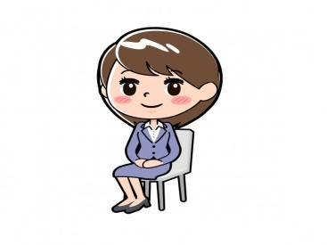______ down, please!
A. Stand B. Get C. Close D. Sit
38. Ảnh: _ EVEN
39. Wr_ _ _ the names in the blanks.
40. ____ teacher is fine.
A. Me B. Her C. Him D. You
41. May I _ _ me in?
42. Nice to meet ..., too .
A. me B. he C. your D. you
43. Is this a school bag? - ... .
A. Yes, she is B. No, it isn’t C. Yes, I am D. No, he isn’t
44. make/ mess./ a/ Don’t/
45. Choose the letter(s) to make a correct word: win__ow
A. t B. d C. c D. h
46. English/ some/ songs./ sing/ Let's/
47. A: Is that your classmate? - B: ...
A. Yes, he isn't. B. No, she isn’t. C. Yes, it is. D. No, I’m not.
48. my/ Simon/ is/ friend./ new
49. I_ is a crayon.
50. Choose the incorrect word(s) in the following sentence: Those are my pencil.
A. Those B. are C. my D. pencil
51. Hello, ... Kate.
A. my name B. I C. I’m D. me
52. How are you, Sandy? - ... .
A. I’m fine, thank B. Fine, thank C. Fine, thanks D. I fine, thank
53. Ảnh: 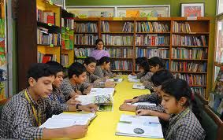This is my school _ _ _ _ _ _ _ .
54. Ảnh: 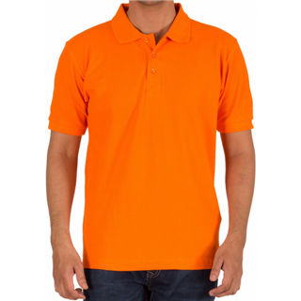He is wearing an o_ _ _ _ _ T-shirt.
55. Ảnh: 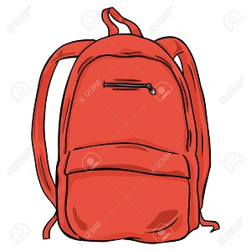BA_ KPACK
56. What colour ... this?
A. it B. is C. that D. hi
57. This ... a house.
A. are B. is C. you D. here
58. Nghe: Nhấn giữ Ctrl và bấm chuột để nghe: I’m standing in a ... .
A. living room B. classroom C. room D. bedroom
59. Ảnh: 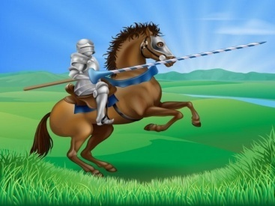Who is this?
A. A prince B. A princess C. A knight D. A monster
60. I go to school library to ... books.
A. read’s B. reads C. read D. to read
61. _ _ _ Mai and Hoa your friend?
62. ... , I’m Lan.
A. Hi B. Goodbye! C. See you D. Goodnight!
63. That is a br_ _ n book.
64. my/ friend/ This/ , Peter./ is/
65. The pencils are ____ my pencil case.
A. in B. on C. at D. of
66. I ... watching television.
A. is B. are C. am D. aren’t
67. May/ I/ you/ your name?/ ask/
68. A: Do you like skating or skipping? - B: …
A. Yes, I do. B. No, I don’t. C. I like skipping. D. I skip at break time.
69. Let’s co_ nt the boys.
70. Peter is my friend, t_ _ .
71. Where _ _ your cat?
72. What’s ... name?
A. she B. he C. you D. her
73. Sit d_ _ _ , Tommy.
74. Hi, I’m Richard. Nice ... meet you.
A. to B. at C. on D. in
75. she/ Is/ your sister?/
76. Is this a d_ sk? - Yes, it is.
77. Nghe: Nhấn giữ Ctrl và bấm chuột để nghe: This is my new ….
A. pencil B. pencil case C. rubber D. pencil sharpener
78. That is my fr_ _ nd.
79. Ảnh: TEA_ _ ER
80. is/ friend/ very nice./ new/ My/
81. _ _ _ t’s your name? – My name’s Tom.
82. answer,/ the/ Circle/ children.
83. Circle the an_ _ er.
84. A: This is my school. - B: ….
A. Wow! It’s very nice. B. I’m fine, thanks. C. Let’s go. D. I don’t like it.
85. What do you do in … free time?
A. you B. yours C. you’re D. your
86. any/ Are there/ your bedroom?/ in/ books/
87. _ _ _ are you? - Fine, thanks.
88. See/ tomorrow./ Goodbye./ you/
89. Ảnh: _ _ _ _
90. I have Art ... Friday.
A. in B. at C. to D. on
91. Ảnh: 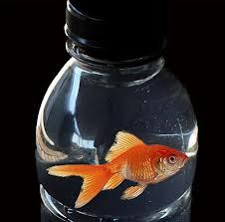The f_ _ _ is in the bottle.
92. is/ your/ What/ name?
93. This/ a/ pen./ is/
94. Ảnh: 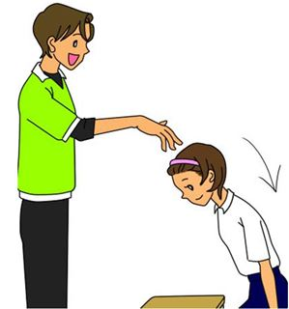Please, _ _ _ down.
95. a book/ I have/ my bag./ in/
96. Anna doesn’t play skipping at br_ _ _ time.
97. Ảnh: 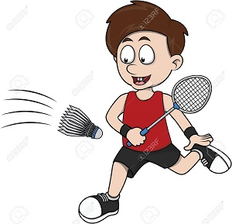BAD_INTON
A. M B. N C. T D. D
98. Ảnh: 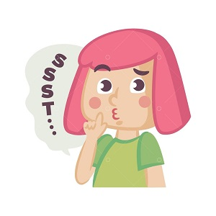Be q_ iet , boys!
99. There is ... dog in my house.
A. a B. are C. two D. is
100. sentences/ Reorder/ the/ , please.
101. Put/ hand/ your/ down.
102. Is that you_ friend?
103. My school is near _ bakery.
104. Nghe: Nhấn giữ Ctrl và bấm chuột để nghe: _ play basketball.
105. Nghe: Nhấn giữ Ctrl và bấm chuột để nghe: There are … people in her family.
A. seven B. six C. five D. eight
106. Nice … meet you, Susan.
A. too B. to C. two D. toe
107. are/ Peter’s/ pencil/ Those/ cases./
108. W_ _ is he? – He is my best friend.
109. Peter./ you,/ Thank/
110. please!/ and/ Sit down/ your book,/ open/
111. Pick … your pencil.
A. at B. up C. on D. for
112. It is ... desk.
A. an B. a C. two D. you
113. This is a b_ cycle.
114. This/ is/ school/ my/ bus./
115. Come ov_ r here.
116. This isn’t ... bag.
A. he B. his C. me D. you
117. Listen _ _ your friends, please.
118. my school bag./ There are/ pencils/ ten/ in
119. Choose the incorrect word(s) in the following sentence: These are my notebook.
A. These B. are C. my D. notebook
120. Ảnh: 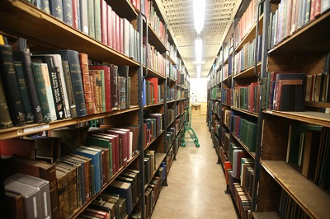LIBRAR_
121. What is her j_ _ ? – She is a teacher.
122. Nghe: Nhấn giữ Ctrl và bấm chuột để nghe: Emma doesn’t like playing _ _ _ _ _ _ .
123. Hello, ... name is Scott.
A. he B. she C. it D. my
124. A: May I ask a question, Miss Nga? - B: Yes, you ...
A. may B. can C. are D. do
125. Miss Lan is my new t_ _ _ her.
126. Choose the odd one out:
A. fine B. read C. meet D. play
127. Si_ down!
128. _ _ n't be late!
129. Ảnh: The rain_ _ _ is beautiful.
130. Clean/ your/ teeth/ , please.
131. Don’t/ make/ a/ mess.
132. Nghe: Nhấn giữ Ctrl và bấm chuột để nghe: Listen and tick:
A. There are two bathrooms. B. There are three bedrooms. C. There are two bedrooms. D. There are two living rooms.
133. This is Tom and that … Mary.
A. am B. is C. are D. have
134. apple./ This/ is/ a/ red
135. _ _ _ you happy today? - Yes, I am.
136. is/ old/ brother?/ your/ How/
137. Is it _ ruler? – No, it isn’t.
138. What/ time/ the/ now?/ is/
139. Ảnh: 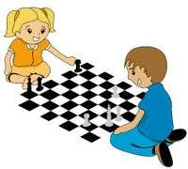What do you do at break time? – I ... .
A. play tennis B. play football C. play chess D. swim
140. SCHO_ L
141. Goodbye. See you tomorr_ w.
142. name/ Write/ please./ your/ here,
143. my/ These/ notebooks/ are/ and pencils./
144. I have/ a glass of juice?/ May/
145. Nghe: Nhấn giữ Ctrl và bấm chuột để nghe: What’s his name?
A. Pitir B. Peter C. Beter D. Bitia
146. This is my new bicycle. – O_ , it’s very nice.
147. Ảnh: Sally has bl_ _ eyes and blonde hair.
148. This is ... desk.
A. an B. he C. he’s D. a
149. What’s h_ _ name? – She is Hoa.
150. stand/ please./ Let's/ up,/
151. How ... is she? – She’s nine years old.
A. years B. and C. but D. old
152. My school _ _ new.
153. What is your ...? – I’m Peter.
A. name B. name’s C. meet D. friend
154. Is this a pen? - _ _ _ , it is.
155. - Hello, Lan. - _______
A. Bye, Phuong. B. Good night, Phuong. C. Hi, Phuong. D. Yes, you.
156. How m_ _ y pens do you have?
157. Nghe: Nhấn giữ Ctrl và bấm chuột để nghe: I like skipp_ _ _ .
158. Nghe: Nhấn giữ Ctrl và bấm chuột để nghe: Choose the sentence that you hear:
A. This is Peter. And that’s Tony. B. That’s Peter. And that’s Tony. C. That’s Peter. And that’s Mary. D. That’s Tony. And that’s Mary.
159. Po_ _ t to the teacher.
160. playing/ football./ They/ are/
161. This is Tom. _ _ is my friend.
162. Choose the letter(s) to make a correct word: sk__te
A. a B. e C. o D. u
163. Sing a ..., please.
A. you B. me C. song D. he
164. Ảnh: That is a blue s_ _ _ .
165. Good ev_ _ ing, Tom.
166. How ... robots are there?
A. many B. much C. any D. very
167. Nghe: Nhấn giữ Ctrl và bấm chuột để nghe: b_ g
168. I want to st_ y at home.
169. _ _ y I go out? – Yes, please.
170. my bag./ The books/ in/ are/
171. in/ is/ the blue T-shirt/ my brother./ The boy/
172. This is ... chair.
A. he B. she C. it D. my
173. Nghe: Nhấn giữ Ctrl và bấm chuột để nghe: I'm _ _ ven.
174. It’s ______ ball.
A. a B. an C. two D. Ø
175. This is m_ blue book.
176. H_ _ are you? – I’m fine, thanks.
177. That/ box./ my/ is/
178. They ___ in the living room.
A. are B. is C. am D. on
179. Ảnh: 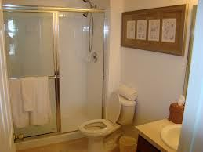Her _ _ _ _ _ _ _ _ is small.
180. Ảnh: 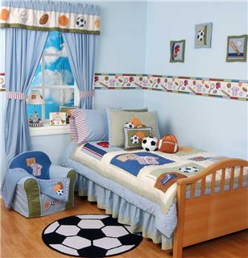Her _ _ _ _ _ _ _ is small.
181. Nghe: Nhấn giữ Ctrl và bấm chuột để nghe: _____ and write.
A. Read B. Look C. Listen D. Point
182. Hi, how _ _ _ you?
183. is/ pretty./ Mary/ very/
184. Nghe: Nhấn giữ Ctrl và bấm chuột để nghe: Listen and tick:
A. My father is a teacher. B. My mother is a teacher C. My father is a doctor. D. My brother is a teacher.
185. She/ old./ ten/ years/ is/
186. _ _ _ t colour is this? – It’s pink.
187. This is ... orange pen.
A. an B. a C. the D. this
188. old./ years/ seven/ I’m/
189. Would you like some milk? – Yes, ... .
A. his B. please C. this D. is
190. the school gate./ Peter and Mary/ are/ at/
191. Choose the odd one out:
A. classroom B. bedroom C. bathroom D. living room
192. _ _ o is that? – That’s Mary.
193. _ _ ese are my pencil boxes.
194. We go to school to ... .
A. stay B. study C. sit D. go
195. is/ That/ apple./ red/ a/
196. What is this? – It is … eraser.
A. a B. an C. this D. that
197. down/ Copy/ the/ words.
198. Henry./ pens,/ out/ your/ Take/
199. I’m fine, thank you. ... ?
A. You B. And you C. Are D. Bye
200. Thank you very m_ _ h.

IOE K3 SỐ 05
1. Nghe: Nhấn giữ Ctrl và bấm chuột để nghe: There are _ _ _ _ books in the bookcase.
2. Is/ this/ pencil,/ your/ Tom?/
3. you/ See/ Bye./ later.
4. songs./ English/ some/ sing/ Let's/
5. Ảnh: I have a ____ and a ______ .
A. cat - dog B. cat - bird C. cat - chicken D. dog - pig
6. Open the b_ _ k.
7. There is a fence … of my house.
A. before B. in front C. between D. next to
8. Ảnh: These are th_ _ _ dogs.
9. Nghe: Nhấn giữ Ctrl và bấm chuột để nghe: This is my school _ _ _ .
10. This is _ _ eraser.
11. Ảnh: 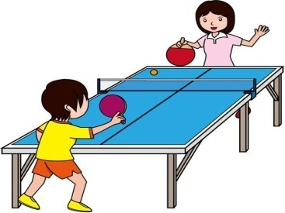Let’s play _ _ _ _ _ tennis.
12. Peter/ and I/ after school./ don't/ play baseball
13. Let’s sing a s_ ng.
14. , too./ Trang/ England/ is/ from/
15. Bye. See you aga_ n.
16. A: How are you? - B: I’m ..., thank you.
A. Adam B. at home C. OK D. nine
17. ____ do you spell your name?
A. How B. What C. Who D. Which
18. His n_ _ e is Tommy.
19. Nghe: Nhấn giữ Ctrl và bấm chuột để nghe: Listen and tick:
A. There are two bathrooms. B. There are three bedrooms. C. There are two bedrooms. D. There are two living rooms.
20. Ảnh: 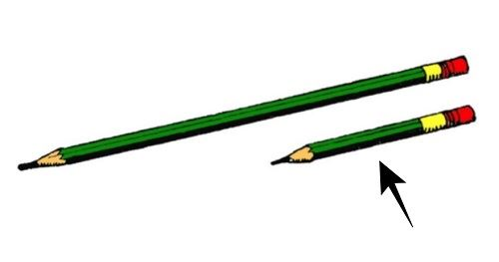It’s a _ _ _ _ _ pencil.
21. Ảnh: Unscramble this word: ’’AERSRE’’ -> ’’ERAS_ _ ’’.
22. ___ old are you?
A. Who B. What C. When D. How
23. Please, be q_ _ et.
24. This is Tony and this is Hoa. _ _ _ _ are my friends.
25. Ảnh: _ LUE
26. Nghe: Nhấn giữ Ctrl và bấm chuột để nghe: ___ name is Simon.
A. His B. Her C. My D. Your
27. Happy birthday _ _ you, Alan. – Thank you.
28. Jane is not ... name.
A. he B. her C. I D. you
29. There _ _ _ twenty chairs.
30. and/ those are/ my pencils./ her crayons/ These are/
31. Do you like milk? – No, I ... .
A. do B. does C. doesn’t D. don’t
32. This is my r_ ler.
33. _ _ _ t colour is this? – It’s pink.
34. Nghe: Nhấn giữ Ctrl và bấm chuột để nghe: She asks you to put the _ _ _ _ _ _ under the chair.
35. Count the ..., please.
A. she B. they C. boy D. boys
36. Ảnh: I have got a skipping r_ _ e.
37. These are green hat_ .
38. I like football, ... I don’t like baseball.
A. and B. or C. but D. so
39. SCHO_ L
40. Ảnh: 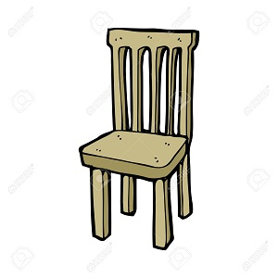_ _ AIR
41. ... Nam. How are you?
A. See B. Fine C. Hello D. Bye
42. Is your school white? - ... .
A. Yes, it isn’t B. No, it is C. No, is it not D. Yes, it is
43. and Quang/ brothers./ are/ Quan/
44. What is this? - ... .
A. His name is Tom B. It is a ruler C. It’s an ruler D. It’s Tom
45. Nice to _ _ _ t you, Hans.
46. today./ Henry/ goes swimming/
47. I/ now./ am/ thirsty/
48. is/ new/ friend./ Tony/ my/
49. Goo...bye. See you later.
A. t B. h C. d D. s
50. Ảnh: 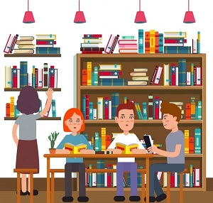LIBRA_ _
51. May I go out? - Yes, ….
A. you can B. you can’t C. you are D. it is
52. Let’s/ together./ chess/ play/
53. Ảnh: 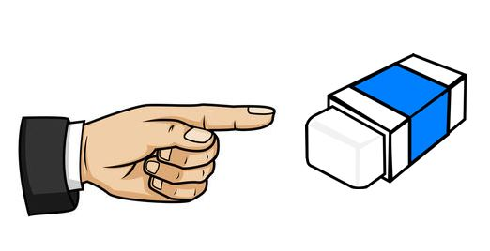Th_ _ is my rubber.
54. Nghe: Nhấn giữ Ctrl và bấm chuột để nghe: _ _ _ _
55. Ảnh: 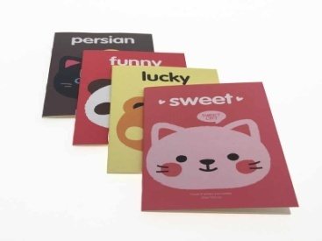Thomas has _ _ _ _ notebooks.
56. This _ _ a pencil case.
57. songs./ some/ sing/ Let's/ English
58. Nghe: Nhấn giữ Ctrl và bấm chuột để nghe: F_ ur brothers and 4 sisters.
59. Nghe: Nhấn giữ Ctrl và bấm chuột để nghe: R_ _ _ _
60. I like Maths the mo_ t.
61. baby/ This/ is/ my/ brother./
62. the/ on/ There is/ a lamp/ table./
63. classmates./ not/ are/ They/ my
64. her/ bag./ This/ is/
65. What colour is this? - ... .
A. It’s a pink B. It’s pink C. It pink D. Is pink
66. Remember … wash your hands before meals. – Yes, Mum.
A. to B. in C. for D. on
67. That is my school bag. _______ brown.
A. Its B. It’s C. It’s is D. Its is
68. like/ doesn’t/ tennis./ Mike/
69. Peter/ new friend./ is/ my/
70. Pick _ _ your pen, San.
71. The flower vase is ... the table.
A. at B. for C. on D. to
72. colour/ is/ this?/ What/
73. Ảnh: 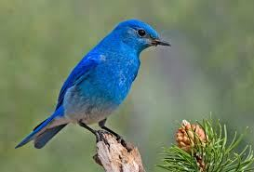That is my bird. It’s _ _ _ _ .
74. Ảnh: This is my school _ _ _ _ _ _ _ .
75. rubbers/ small?/ Are/ your/
76. … do you like? – I like riding a horse.
A. When B. How C. What D. Who
77. We like to _ _ _ _ books at the school library.
78. Nghe: Nhấn giữ Ctrl và bấm chuột để nghe: _ octor
79. Say hell... to Alice.
A. e B. o C. u D. t
80. Look ... the map on the wall.
A. at B. to C. on D. in
81. chant/ aloud./ Read/ the/
82. Henry./ Take/ pens,/ your/ out/
83. Please be q_ _ te.
84. These _ _ _ two pencil cases.
85. Peter is my friend, t_ _ .
86. What/ colour/ it?/ is/
87. How are y_ _ ?
88. Listen t_ the teacher.
89. It is ... desk.
A. bye B. me C. a D. hi
90. Who/ is/ Linda?/ that,/
91. How old ... she? - She’s 9 years old.
A. is B. are C. am D. be
92. Ảnh: I have a bl_ _ ball.
93. How ... is she? – She’s nine years old.
A. years B. and C. but D. old
94. _ ootball
95. ... is she? – She is my little sister.
A. What B. When C. Who D. How
96. Ảnh: F__TBALL
A. OO B. EE C. II D. UU
97. This is m_ ruler.
98. notebooks,/ please./ Take/ out/ your/
99. What is the name … your school?
A. at B. to C. for D. of
100. Is that Nam? - Yes, _ _ is.
101. the paper./ on/ Write/ your name/
102. my brother./ I/ play football/ often/ with
103. T_ is is a pencil.
104. _____ are my shoes.
A. This B. That C. It D. These
105. Ảnh: We are ______ at break time.
A. in the classroom B. in the computer room C. in the playground D. on the roof
106. is/ That/ a/ red/ apple./
107. notebook./ Write/ your/ answer/ into the
108. What is _ _ _ _ name? - My name is Tom.
109. Nghe: Nhấn giữ Ctrl và bấm chuột để nghe: Choose the sentence that you hear:
A. What is your name? B. What’s your name? C. What’s your school name? D. What is your school name?
110. that,/ Who's/ Peter?/
111. Ảnh: There is a cl_ _ _ on the wall.
112. Choose the correct sentence
A. They is my toys. B. They are my toys. C. They are my toy. D. Them is my toy.
113. to/ number/ count/ ten./ Let’s/
114. Ảnh: 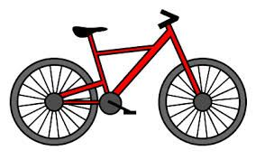Show me your new ... .
A. ruler B. bike C. pen D. school
115. How are you? - ... .
A. I’m Binh B. She’s my sister C. I’m fine, thank you D. Goodbye
116. Good ni_ _ t, Owen.
117. Let’s ... a song.
A. look B. sing C. stand D. sit
118. Wa_ _ your hands, please.
119. Ảnh: 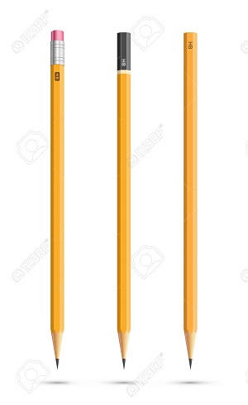THREE PENCIL_
120. Ảnh: BR__N
A. WO B. WW C. OO D. OW
121. The art room is small b_ _ new.
122. There are many toys he_ e.
123. Ảnh: 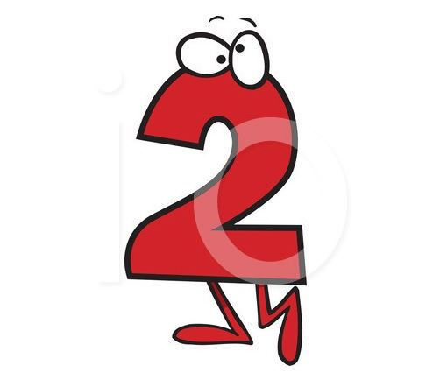_ _ _
124. Nghe: Nhấn giữ Ctrl và bấm chuột để nghe: Put the books … the table.
A. under B. on C. next to D. behind
125. Nghe: Nhấn giữ Ctrl và bấm chuột để nghe: She likes to eat ______ apples.
A. big red B. small red C. big green D. small green
126. PEN_ IL
127. Nghe: Nhấn giữ Ctrl và bấm chuột để nghe: It’s not a white _ _ _ _ _ _ _ _ .
128. They ___ in the living room.
A. are B. is C. am D. on
129. Ảnh: She is in the _ ym .
130. ... your hand, please.
A. Goodbye B. Hi C. Wash D. Study
131. This … a cassette.
A. are B. is C. am D. an
132. Choose the letter(s) to make a correct word: NI_E
A. V B. C C. M D. Z
133. My school ______ Ngo Gia Tu School.
A. am B. is C. are D. that
134. Nice to meet ... .
A. I B. me C. he D. you
135. Jenny./ Her/ is/ name/
136. T...is is a desk.
A. e B. w C. h D. n
137. What’s this? – It’s an … .
A. table B. orange C. ruler D. crayon
138. Ảnh: SIX ______
A. PUPILS B. PUPIL C. STUDENT D. TEACHER
139. A: I’m Linda. And your n_ _ _ ? - B: Peter.
140. May I co_ _ in?
141. She's ten y__rs old.
A. ae B. eo C. oe D. ea
142. Ảnh: 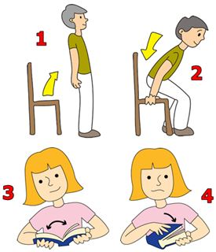’’Open your book, please.’’
A. Picture 1 B. Picture 2 C. Picture 3 D. Picture 4
143. Ảnh: _ _ OWN SHOES
144. is/ brown/ a/ That/ cat./
145. Ảnh: 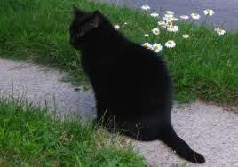That cat is ... .
A. brown B. yellow C. green D. black
146. Nghe: Nhấn giữ Ctrl và bấm chuột để nghe: … is she?
A. How B. Where C. Who D. What
147. is/ What/ your/ name?
148. Write the an_ _ _ rs.
149. Is/ this/ your/ pen?
150. She can ________ a picture.
A. draw B. listen C. read D. cycle
151. there?/ are/ How/ crayons/ many/
152. Nghe: Nhấn giữ Ctrl và bấm chuột để nghe: Listen and tick:
A. I can’t find my pen. - It’s here B. I can’t find my ball. - It’s here. C. I can’t find my phone. - It’s here. D. I can’t find my school. - It’s here.
153. Ảnh: LIBRAR_
154. What’s h_ _ name? – She is Hoa.
155. Nghe: Nhấn giữ Ctrl và bấm chuột để nghe: _ _ _ gry
156. Ảnh: This is a _______ house.
A. pink B. yellow C. white D. blue
157. What's/ your/ name?/
158. Look _ _ that kite. It’s so beautiful.
159. These bags ____ small.
A. is B. its C. are D. re
160. How are you today? - ... .
A. Very good B. Fine, thanks C. Good, thanks D. No, thanks
161. How ... you? – Fine, thanks.
A. are B. am C. is D. this
162. A: … - B: I like badminton.
A. What sport do you like? B. Do you like badminton? C. Why do you like badminton? D. What do you do at break time?
163. Nghe: Nhấn giữ Ctrl và bấm chuột để nghe: Listen and tick:
A. Is that girl Mary? - Yes, she is. B. Is that boy Mary? - Yes, he is. C. Is that pen Mary? - Yes, it is. D. Is that room Mary? - Yes, it is.
164. volleyball/ fun./ is/ Playing/
165. Let’s co_ nt the boys.
166. name/ Long./ is/ His/
167. my/ uncle/ his son./ This is/ and
168. The blackboard is _ _ the wall.
169. my/ father./ That/ is/
170. evening,/ students!/ Good/
171. _ _ , Mai. I’m Nhung.
172. Nghe: Nhấn giữ Ctrl và bấm chuột để nghe: The _ _ _ _ _ _ _ _ are in the classroom.
173. Nghe: Nhấn giữ Ctrl và bấm chuột để nghe: Where is your _ _ _ _ _ _ ?
174. two pens/ school bag./ in/ There are/ my
175. Don’t s_ _ on that chair.
176. ___ he a newcomer?
A. Is B. Are C. Am D. Be
177. Ảnh: How old are you? - I'm eigh_ .
178. Sing with ... .
A. he B. she C. I D. me
179. like/ dogs./ My/ father/ doesn’t/
180. Ảnh: 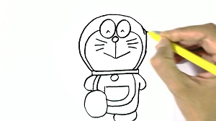I dra_ a picture in the art room.
181. Choose the letter(s) to make a correct word: pencil c__se
A. a B. e C. i D. o
182. Those/ books./ my/ aren’t/
183. present./ birthday/ This doll/ your/ is/
184. My mother’s b_ _ _ _ day is in October.
185. Nghe: Nhấn giữ Ctrl và bấm chuột để nghe: This is a … .
A. dot B. dog C. door D. down
186. These/ short./ pencils/ are/
187. book./ It/ a/ is/ small
188. Bye, see you … .
A. later B. late C. laters D. later’s
189. A: What is y_ _ r name? B: My name is Trang.
190. My school is very _ _ _ _ tiful.
191. This gift is ... you.
A. on B. in C. for D. at
192. Would you like some m_ _ k? – Yes, please.
193. I'm/ five,/ too./
194. M_ y I go out? Yes, please.
195. Nga: How do you spell … name, Robert? - Robert: R-O-B-E-R-T.
A. him B. his C. your D. yours
196. aren't/ in the/ They/ classroom.
197. Ảnh: ru_ _ er
198. Choose the incorrect word(s) in the following sentence: He are at school today.
A. are B. at C. school D. today
199. B_ OK
200. It ... a ball.
A. are B. an C. be D. is

IOE K3 SỐ 06
1. M_ y I go out, please?
2. Nghe: Nhấn giữ Ctrl và bấm chuột để nghe: We are a … family.
A. big B. happy C. large D. wonderful
3. teacher./ my/ English/ Mr. John/ is/
4. I'm eight. Tony is eight, ___ .
A. to B. two C. tow D. too
5. There is ... dog in my house.
A. a B. are C. two D. is
6. What is your name?
A. Her name is Mary. B. His name is Alan. C. My name is Lan. D. Your name is Peter.
7. Open ... book, please.
A. you B. your C. you’s D. your’s
8. What’s _______ name?
A. you B. I C. his D. he
9. Choose the correct sentence.
A. These are my pens. B. This is my pens. C. That is my pencils. D. These are my pencil.
10. She/ nice./ is/
11. Can you ... a picture?
A. draw B. look C. on D. when
12. That hat is ye_ _ ow.
13. She ... Lan. She is a new student in my class.
A. am B. is C. are D. be
14. A: Do you like skating or skipping? - B: …
A. Yes, I do. B. No, I don’t. C. I like skipping. D. I skip at break time.
15. Good_ ye. See you tomorrow.
16. ... many pens are there in your school bag? – There are 3 pens.
A. How B. What C. Who D. When
17. She doesn’t like ma_ _ ng paper boat.
18. Nghe: Nhấn giữ Ctrl và bấm chuột để nghe: Peter is ______ years old
A. 5 B. 6 C. 7 D. 8
19. My father likes to _ _ _ _ _ a car.
20. He_ _ o, my name’s Richard. - Nice to meet you.
21. Nghe: Nhấn giữ Ctrl và bấm chuột để nghe: … your books.
A. Open B. Close C. Read D. Keep
22. How old is Nam? – ... is 10 years old.
A. He B. She C. I D. They
23. Nghe: Nhấn giữ Ctrl và bấm chuột để nghe: That is a small ... .
A. board B. bus C. box D. boat
24. school gym/ your/ new?/ Is/
25. a/ is/ father/ My/ worker./
26. Ảnh: 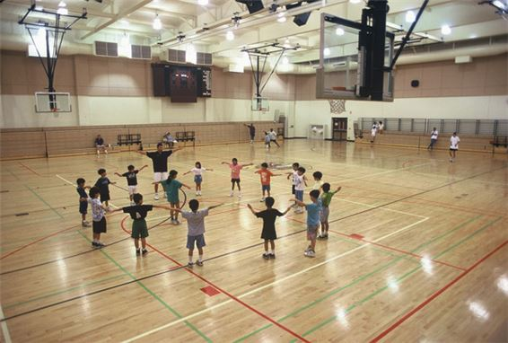We learn P.E in the _ _ _ . It is very large.
27. This is ... teddy bear.
A. she B. me C. my D. hi
28. son./ watch/ TV,/ Don't/
29. Hello. My name’s Thompson. - Hi, ….
A. What’s that? B. Goodbye C. I’m Collin. Nice to meet you D. See you later
30. Nghe: Nhấn giữ Ctrl và bấm chuột để nghe: ... is a pupil.
A. She B. He C. Me D. I’m
31. beautiful./ school/ is/ Her/
32. Nghe: Nhấn giữ Ctrl và bấm chuột để nghe: How old are you? - I’m ________ years old.
A. 4 B. 5 C. 6 D. 7
33. Unscramble this word: ’’ISUCM’’ -> ’’_ _ SIC’’.
34. Wa_ _ your hands, please.
35. Ảnh: Can I borrow your pencil _ _ _ _ _ _ _ _ _ ?
36. Bye, see you tomo_ _ ow.
37. Nghe: Nhấn giữ Ctrl và bấm chuột để nghe: _ _ _ gry
38. some/ food./ Peter/ wants/
39. He ___ seven years old.
A. are B. am C. be D. is
40. Ảnh: 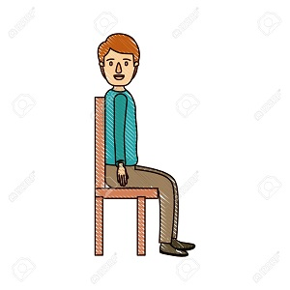S_ T DOWN
41. My name _ s Adam.
42. Ảnh: That’s a(n) _______.
A. cat B. bird C. elephant D. lion
43. Ảnh: There is a _ _ _ ck on the wall.
44. Is your school new? - Yes, ______ .
A. is it B. its is C. it is D. is its
45. ... is my school.
A. How B. Too C. When D. This
46. Ảnh: 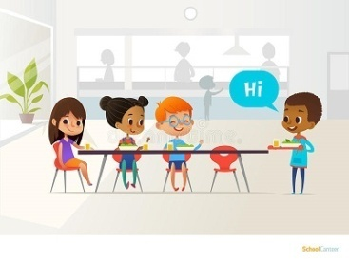NEWCOM_ R
47. mess./ Don't/ a/ make/
48. What colour ... this?
A. it B. is C. that D. hi
49. This is my fa_ _ _ r.
50. Choose the letter(s) to make a correct word: rea__
A. t B. h C. d D. c
51. I’m fine, th_ _ k you.
52. Thank you very much. - You ... welcome.
A. is B. am C. are D. isn’t
53. Bru_ h your teeth, Tom.
54. My/ teacher/ is/ very/ tall./
55. I'm/ Hello./ Peter./
56. What _ _ it? - It’s a pink ruler.
57. Choose the letter(s) to make a correct word: FIV_
A. O B. I C. W D. E
58. What are those? – _ _ _ _ ’re my books.
59. I have ... pink doll.
A. a B. an C. two D. and
60. ... you like some bread? – No, I don't.
A. Does B. Do C. Are D. Is
61. Thank you very _ _ _ _ for your lovely birthday gift.
62. Nghe: Nhấn giữ Ctrl và bấm chuột để nghe: The boy loves ba_ _ _ _ _ on.
63. Ope_ your books, children.
64. Ảnh: 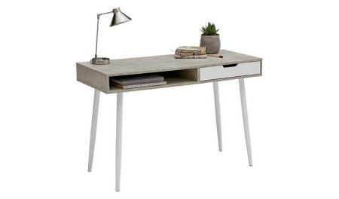D_ SK
65. Choose the letter(s) to make a correct word: r__ler
A. a B. o C. p D. u
66. Nghe: Nhấn giữ Ctrl và bấm chuột để nghe: Choose the sentence that you hear:
A. What is your name? B. What’s your name? C. What’s your school name? D. What is your school name?
67. CLASSR_ OM
68. Wh_ t’s your name? - My name’s John.
69. a yo-yo./ He/ play/ with/ can/
70. beautiful./ song/ The/ is/
71. - Hello, _ am Peter. - Nice to meet you, Peter.
72. Ảnh: 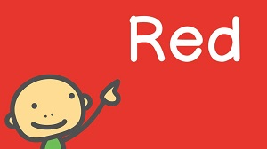My favourite _ _ lour is red.
73. Nice to _______ you.
A. mit B. meat C. meet D. miit
74. ... you Lan?
A. Is B. Are C. He D. She
75. eraser./ an/ is/ This/
76. Ảnh: A SMAL_ MOUSE
77. Are those your rubbers? - No, they ___ .
A. are B. aren't C. is D. isn't
78. box?/ Is/ pencil/ your/ that/
79. Choose the odd one out:
A. repeat B. listen C. read D. am
80. The rabbit _________ white.
A. are B. am C. not D. is
81. Where are your father and mother? - ... are in the living room.
A. He B. She C. We D. They
82. This ... a blue pencil.
A. are B. is C. am D. the
83. Good ev_ _ ing, Tom.
84. My n_ me is Lan.
85. May I go _____?
A. out B. of C. in D. at
86. The … is John.
A. me B. boy C. I D. girl
87. I am fi_ e, thanks.
88. in/ the school bag./ Put/ your/ school things/
89. has/ cat./ sister/ one/ My/
90. to school./ we go/ the way/ This is/
91. Nghe: Nhấn giữ Ctrl và bấm chuột để nghe: Listen and tick:
A. This toy is Nam. B. This friend is Nam. C. This girl is Nam. D. This boy is Nam.
92. Choose the letter(s) to make a correct word: RU__ER
A. PP B. BB C. LL D. MM
93. is/ school./ my/ That/
94. That is my classroom. It’s not small. It’s _ _ g.
95. N_ ce to meet you.
96. listen/ often/ music./ I/ to
97. Nghe: Nhấn giữ Ctrl và bấm chuột để nghe: _ _ ain
98. How/ his name?/ do you/ spell/
99. have?/ your sister/ How many/ apples/ does/
100. Nghe: Nhấn giữ Ctrl và bấm chuột để nghe: What are they? - They’re _ _ _ _ .
101. See/ you/ tomorrow./
102. Who is ...? – He’s my father.
A. she B. it C. he D. they
103. a blue/ is/ It/ ball.
104. Is your classroom big? – No, it’s s_ _ ll.
105. are/ in/ the schoolyard./ Linh and Nhi/
106. What is _ _ _ s? – This is a bag.
107. Is your school new? - No. It's _____.
A. new B. old C. not D. is
108. Choose the incorrect word(s) in the following sentence: He is six year old.
A. He B. is C. year D. old
109. Nghe: Nhấn giữ Ctrl và bấm chuột để nghe: Listen and tick
A. How are you? B. What are they? C. How old are you? D. Who are you?
110. My music room _ _ old.
111. Go ... the door, children.
A. to B. too C. two D. at
112. pencil./ Pick/ up/ your/
113. Clo_ e your book, please.
114. M_ classroom is big.
115. your/ Clap/ hands./
116. She is tw_ years old.
117. S_ _ you again.
118. There/ are/ ten/ books.
119. old/ your/ is/ baby sister?/ How/
120. Choose the letter(s) to make a correct word: CLO__
A. SS B. SA C. SE D. EE
121. Would/ like/ you/ milk?/ some
122. Bye, _ _ _ you later.
123. This ruler is b_ _ wn. That ruler is pink.
124. Hi, Molly. _ _ w are you?
125. is/ My/ blue./ colour/ favourite/
126. … go to school together.
A. Can B. We C. Let’s D. Hi
127. open/ please!/ Sit down/ your book,/ and/
128. Nghe: Nhấn giữ Ctrl và bấm chuột để nghe: I’m fine, _ _ _ _ _ _ .
129. This gift is for you. - Thank you very _ _ _ _ .
130. Miss/ that/ Is/ Lan?
131. some/ has/ chalks./ He/
132. How m_ _ y crayons are there?
133. Count the ... in the class, please.
A. she B. boys C. girl D. he
134. Ảnh: ____ quiet, please!
A. Do B. Don't C. Be D. Being
135. Ảnh: 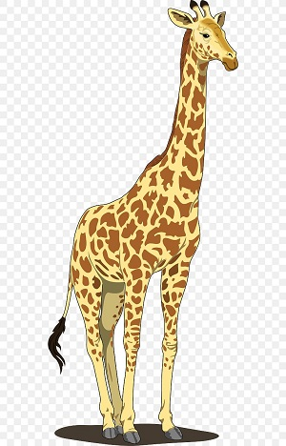L_ NG
136. Are your pencils long? – No, they ___________. They’re short.
A. is B. are C. isn’t D. aren’t
137. H_ _ ’s the weather in Hanoi?
138. I don’t like playing b_ _ _ _ man’s bluff. It’s boring.
139. Nghe: Nhấn giữ Ctrl và bấm chuột để nghe: _ _ _ da
140. W_ _ _ are these? – These are pencil cases.
141. name?/ What’s/ your/
142. Nghe: Nhấn giữ Ctrl và bấm chuột để nghe: Do you _ _ _ _ at break time?
143. How m_ _ _ books are there on the bookshelf? – There are four books.
144. doesn’t/ My/ father/ like/ dogs./
145. Point to your frie_ _ , please.
146. C_ me here, Peter. Let’s play with us.
147. This dress is ve_ _ beautiful.
148. Ảnh: N_ _ EBOOK
149. … is your notebook? – It’s on the desk.
A. Where B. What C. Who D. When
150. Ảnh: YE_ _ OW
151. Look at that girl. ... name’s Jasmine.
A. Her B. Your C. His D. My
152. I ... fine. How are you?
A. is B. are C. am D. a
153. This cak_ is for you. - Thank you very much.
154. is/ new/ That/ backpack./ my/
155. Thes_ are my dolls.
156. to school/ my friends./ to go/ with/ I like/
157. What su_ _ ect do you like the most?
158. my/ new/ These/ pencil box./ are/
159. need/ pencil/ sharpener./ a new/ I/
160. This/ family./ is/ my/
161. I like to s_ ng a song with Peter.
162. Nghe: Nhấn giữ Ctrl và bấm chuột để nghe: He’s _ _ _ _ _ years old.
163. Ảnh: Her _ _ _ _ _ _ _ _ is small.
164. How/ today?/ is/ your/ mother
165. May I come in? - Yes, you ______ .
A. can't B. can C. may D. may not
166. large?/ playground/ Is/ your/
167. May I sit here? - ______
A. Yes, I can. B. Yes, you are. C. Yes, you can. D. Yes, you here.
168. an/ orange cat./ is/ This/
169. I _ _ in the computer room.
170. Ảnh: My school is ne_ .
171. Goodbye, chi_ _ ren. See you later.
172. This _ _ my school.
173. W_ sh your hand, please.
174. What colour ... this?
A. it B. is C. that D. hi
175. late!/ be/ Don't/
176. black./ My/ shoes/ are/
177. at/ David/ school/ now./ is/
178. Jane is not ... name.
A. he B. her C. she D. you
179. Look … your book, please.
A. of B. in C. on D. at
180. Ảnh: 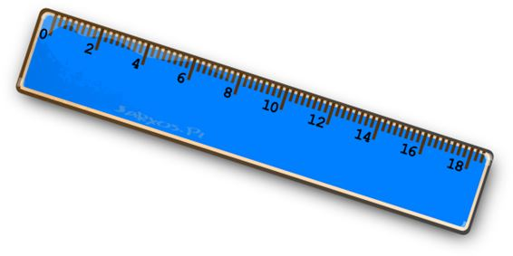A: What colour is the ruler? - B: It’s ....
A. green B. red C. blue D. brown
181. the playground/ play football/ at break time./ We/ in/
182. Ma_ I go out?
183. Choose the odd one out:
A. white B. new C. yellow D. green
184. My books are on the ta_ _ e.
185. Hi, I’_ Nam. Nice to meet you.
186. Nghe: Nhấn giữ Ctrl và bấm chuột để nghe: My ... is a teacher.
A. mother B. father C. brother D. sister
187. Fine, thanks. A...d you?
A. n B. d C. a D. o
188. plays chess/ Tony/ at break time./
189. ... is this? – It is a pen.
A. When B. Who C. How D. What
190. I _______ Mary.
A. am B. is C. are D. m
191. are on/ The pictures/ the wall./ my family/ of/
192. Ra_ _ e your hand, please.
193. Nghe: Nhấn giữ Ctrl và bấm chuột để nghe: Which DON’T they have for the picnic?
A. Grapes. B. Orange juice. C. Sandwiches D. Bananas.
194. How many ... are there in your class?
A. students B. student C. teacher D. chair
195. Nghe: Nhấn giữ Ctrl và bấm chuột để nghe: She likes to eat ______ apples.
A. big red B. small red C. big green D. small green
196. Hi, I _ _ Tom.
197. Is it _______rubber?
A. your B. you C. Lan D. I
198. Who is …? – He’s Phillip. He is my friend.
A. she B. she’s C. he D. he’s
199. Choose the letter(s) to make a correct word: P_NCIL CASE
A. E B. A C. I D. O
200. is/ The/ bookcase/ brown.

IOE K3 SỐ 07
1. Good/ morning,/ teacher!/
2. What colour is this? - ... .
A. It’s big B. It’s small C. It’s blue D. It’s nice
3. Lisa./ Her/ is/ name/
4. Nice _ _ meet you, Alan.
5. Nice ... meet you.
A. for B. to C. from D. on
6. This is _ _ eraser.
7. The book/ table./ is/ on the/
8. kites/ are/ beautiful./ These/
9. Ảnh: TWO B_ LLS
10. Her room is small _______ tidy.
A. but B. and C. are D. on
11. I’m fine, thank you. How ... you?
A. out B. about C. and D. end
12. ... your name?
A. Who B. How C. What’s D. Why
13. Nghe: Nhấn giữ Ctrl và bấm chuột để nghe: That is my _ _ _ _ _ _ _ .
14. Nghe: Nhấn giữ Ctrl và bấm chuột để nghe: Listen and tick:
A. My mother sits on her chair. B. Mai’s brother sits on his chair. C. May’s mother sits on her chair. D. May’s mother sit on the chair.
15. Hello, ... name is Scott.
A. he B. she C. it D. my
16. Nghe: Nhấn giữ Ctrl và bấm chuột để nghe: We are a … family.
A. big B. happy C. large D. wonderful
17. Who’s that? - That’s ... .
A. my’s teacher B. me’s teacher C. my teacher D. me teacher
18. This's my friend. ___ name is Jack.
A. Her B. My C. Their D. His
19. is/ teacher./ my/ Mr. Loc/
20. Ảnh: That is a red cu_ _ ain.
21. It i... a book.
A. i B. s C. r D. t
22. The picture is o_ the wall.
23. Nghe: Nhấn giữ Ctrl và bấm chuột để nghe: _ _ o is that?
24. Come ..., please.
A. out B. in C. to D. under
25. are/ and pencils./ my notebooks/ These/
26. Pick ... your pencil, Tommy.
A. on B. to C. up D. down
27. This is ______ apple and that is ______ orange.
A. a – a B. a – an C. an – an D. an - Ø
28. Ảnh: TW_
29. stand up./ close the book/ We/ and/
30. Nghe: Nhấn giữ Ctrl và bấm chuột để nghe: gi_ _
31. Ảnh: 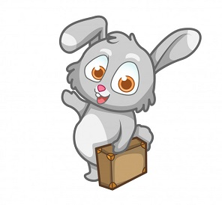Bye. See you _____ .
A. later B. to C. late D. too
32. Would you like … coffee? – No, thanks.
A. some B. any C. an D. the
33. This is _ desk.
34. May I go out? - Yes, ….
A. you can B. you can’t C. you are D. it is
35. Is this a book? - ... .
A. Yes, it is B. Yes, isn’t C. No, it is D. Yes, that is
36. you/ How/ do/ your name?/ spell
37. It’s ______ ball.
A. a B. an C. two D. Ø
38. I/ come/ May/ in?
39. This gift is for you. - ... .
A. How are you B. Fine, thanks C. Thank you D. Thank
40. are on/ The pictures/ of/ the wall./ my family/
41. B_ OK
42. Bye. See you aga_ _ .
43. Is this a bag? - ...
A. Yes, it is B. Yes, isn’t C. No, it is D. Nice to meet you
44. How are y_ _ ? – Fine, thanks.
45. Jenny is a … at London Primary School.
A. boy B. toy C. student D. she
46. words./ down/ the/ Copy/
47. Ma_ I go out?
48. This is my school. It_ name is London Primary School.
49. gym. It's/ a/ This/ is/ new./
50. List_ _ carefully.
51. your/ Is/ teacher?/ he/
52. Ảnh: bas_ _ _ _ _ _ _
53. May _ go out? - Yes, you can.
54. It’s an e_ _ _ _ r.
55. Anne has long … hair.
A. nice B. slim C. curly D. sunny
56. the/ Who/ new/ pupil?/ is/
57. _ _ she a newcomer?
58. What ... is this? – It’s blue.
A. colour B. colours C. colour’s D. coulor
59. My classroom is … .
A. name B. news C. new D. names
60. His/ is/ name/ Tommy.
61. Nghe: Nhấn giữ Ctrl và bấm chuột để nghe: The boy likes ….
A. badminton B. tennis C. baseball D. table tennis
62. , please./ the/ answer/ Circle/
63. She/ my/ is/ teacher/ too./
64. Let’s ma_ e a circle.
65. Listen ... the teacher.
A. to B. me C. you D. he
66. Nghe: Nhấn giữ Ctrl và bấm chuột để nghe: He is _ _ _ _ _ years old.
67. My sister _ _ kes eating candies.
68. I like to s_ _ g English song.
69. Ảnh: TABLE AND CHAI_
70. learn/ Let’s/ English./
71. Ảnh: Does she have bl_ _ _ _ hair?
72. His/ is/ in/ birthday/ May./
73. How are y_ _ ?
74. Write w_ _ t the teacher says.
75. fish/ The/ in/ is/ the bottle./
76. Nghe: Nhấn giữ Ctrl và bấm chuột để nghe: The _ _ _ room is over there.
77. I have/ May/ a glass of juice?/
78. Point/ say./ and/
79. yellow/ Their bags/ are/ and green.
80. H_ , I’m Simon. Nice to meet you.
81. This is ... red apple.
A. are B. a C. am D. an
82. What co_ _ _ _ is that bag? - It’s green.
83. This is an appl...
A. t B. u C. e D. a
84. It’s a _ _ _ puter room.
85. Nghe: Nhấn giữ Ctrl và bấm chuột để nghe: Listen and tick
A. Monday B. Thursday C. Friday D. Sunday
86. This is _ _ orange.
87. ... a tree, please.
A. Stand B. Sit C. Write D. Draw
88. _ re those your rubbers?
89. purple/ a/ scarf./ is/ This/
90. Ảnh: 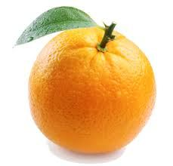Is this an _ _ _ _ _ _ ?
91. What colour is your skirt?
A. It’s new. B. It’s white. C. It’s fine. D. It’s two years old.
92. to work./ his/ drives/ car/ My father/
93. This is Alice. _ _ _ is my friend.
94. My pencil is lo_ _ , but his pencil is short.
95. What/ your/ is/ name?
96. Ảnh: We are ______ at break time.
A. in the classroom B. in the computer room C. in the playground D. on the roof
97. Ảnh: 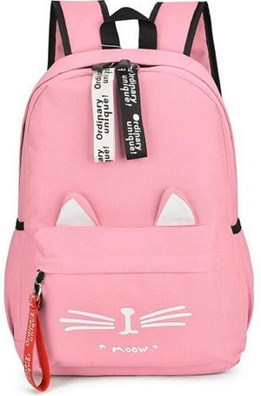A _ INK SCHOOL BAG
98. This is my b_ ok.
99. Ảnh: What do you do at break time? – I ... .
A. play tennis B. play football C. play chess D. swim
100. Point _ _ the teacher.
101. _ _ _ is she? – She is my teacher.
102. … this word after me: ’’compass’’.
A. Do B. Write C. Copy D. Read
103. often/ It is/ rainy/ July./ in
104. My hat is gr_ en.
105. How m_ _ y pens do you have?
106. Choose the odd one out
A. Cat B. Dog C. Chicken D. Table
107. There are t_ _ ee crayons in my bags.
108. H_ _ ’s the weather in Hanoi?
109. Nghe: Nhấn giữ Ctrl và bấm chuột để nghe: The gym is sm_ ll.
110. What _ _ it? - It’s a pen.
111. Close your ..., please.
A. name B. book C. ball D. took
112. John likes to play games v_ _ _ much.
113. My sister’s n_ _ _ is Lily.
114. These shoes … green and yellow.
A. am B. are C. is D. do
115. Nghe: Nhấn giữ Ctrl và bấm chuột để nghe: Who’s that?
A. It’s Mr Loc. B. It’s Tony. C. It’s Peter. D. It’s Quan.
116. Nice _ _ see you.
117. Nghe: Nhấn giữ Ctrl và bấm chuột để nghe: Listen and tick:
A. There are two bathrooms. B. There are three bedrooms. C. There are two bedrooms. D. There are two living rooms.
118. Nghe: Nhấn giữ Ctrl và bấm chuột để nghe: The teacher is ... .
A. hall B. tall C. small D. cold
119. to school/ go/ We/ early./ so
120. These are my cats. _______ white and yellow.
A. They are B. It is C. Cats D. Are
121. Nghe: Nhấn giữ Ctrl và bấm chuột để nghe: Dan and Lily are having a … in the garden.
A. barbecue B. party C. lesson D. picnic
122. my/ These/ new/ pencil box./ are/
123. She _ _ from Hanoi.
124. Re_ d after me, children.
125. It is a de_ k.
126. is/ green/ a/ table./ That/
127. During Ma_ _ s lessons, I learn about numbers.
128. Good morning, Peter. - ... .
A. Good morning, Jean B. Good night, Jean C. My name’s Jean D. Jean, this is my pen
129. chalks./ He/ has/ some/
130. Unscramble this word: ’’ERBBRU’’ -> ’’RUBB_ _ ’’.
131. Let’s go t_ _ _ ther, Mary.
132. This isn’t ... bag.
A. he’s B. his C. me’s D. you’s
133. Odd one out:
A. you B. hi C. I D. She
134. and pencils./ These/ my/ are/ notebooks
135. Nghe: Nhấn giữ Ctrl và bấm chuột để nghe: _______ table tennis.
A. Peter plays B. I play C. Mai plays D. My friends play
136. thank you./ I'm/ fine,/
137. This is my fam_ _ y.
138. They are Jane ... Lily.
A. are B. is C. and D. bye
139. is/ not/ my/ name./ Jane/
140. school?/ What’s/ the/ your/ name of/
141. How are ... ?
A. he B. Lan C. you D. bye
142. Ảnh: Good _____!
A. afternoon B. evening C. night D. morning
143. Nghe: Nhấn giữ Ctrl và bấm chuột để nghe: Choose the correct response.
A. I’m fine, thank you. B. Goodbye, Sally. C. I don’t know you. D. Hi, Sally. Nice to meet you.
144. G_ _ _ bye, see you later.
145. hot/ in/ Is/ summer?/ it/
146. Ảnh: It’s my _ _ _ book.
147. Nghe: Nhấn giữ Ctrl và bấm chuột để nghe: The teddy is … and ….
A. small – brown B. big – brown C. small – purple D. big – purple
148. It’s big./ The house/ isn’t/ small./
149. Goodbye, John. - ... .
A. Hello B. How are you C. Good morning D. Bye Tom. See you later
150. wants/ food./ some/ Peter/
151. Tom _ _ d Minh can play football.
152. What colour ______ your eyes?
A. are B. is C. to D. two
153. Look _ _ the board, please.
154. Ảnh: We are on the _ _ _ _ _ because it’s very hot today.
155. Nice to m__t you.
A. ee B. ii C. oo D. aa
156. in?/ come/ I/ May/
157. favourite/ is/ blue./ colour/ My/
158. Gi_ e me that yellow pen, please.
159. picture./ this/ Let’s/ and colour/ draw/
160. pink/ cake./ a/ It is/
161. Can you he_ p me?
162. My teacher is v_ _ y beautiful.
163. pen. It’s not/ This is/ my/ your pen.
164. Nghe: Nhấn giữ Ctrl và bấm chuột để nghe: They are in the _ _ _ _ _ _ .
165. on/ run/ the/ Don't/ street./
166. Bob: What is this? - Peter: ...
A. His name is Hien. B. It is a ruler. C. It’s an ruler. D. It is my friend.
167. Is this a d_ sk? - Yes, it is.
168. Linh is in the computer ____.
A. school B. gym C. library D. room
169. These flowers are be_ _ _ iful.
170. G_ _ dbye. See you later.
171. Ảnh: The flower ... is beautiful.
A. case B. say C. vase D. play
172. Bye./ See/ tomorrow./ you/
173. it/ ?/ is/ What/
174. Raise you h_ _ d, please.
175. What is this? –This is ... .
A. a pen B. pen C. pens D. an pen
176. They are Jane ... Tim.
A. is B. and C. or D. too
177. We must stay here ... 8.30 to 9.
A. between B. before C. from D. on
178. please./ Let’s/ circles,/ make/ two/
179. https://res.ioe.vn/edu/EOlympic/ExamData/Thi_cac_cap/2020-2021/Lop3/Captruong/Images/3-tn-31.jpeg They are _____ hats.
A. green and yellow B. green and black C. black and yellow D. yellow and red
180. ... morning, Simon!
A. But B. Good C. Shut D. Hi
181. Is it _ ruler? – No, it isn’t.
182. Nghe: Nhấn giữ Ctrl và bấm chuột để nghe: Listen and tick:
A. My father is a teacher. B. My mother is a teacher C. My father is a doctor. D. My brother is a teacher.
183. Ảnh: 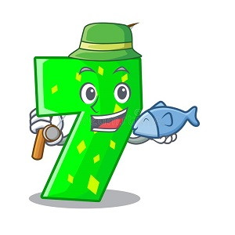Minh is ____ years old.
A. five B. six C. seven D. eight
184. The computer/ room/ big./ is not/
185. Thank you. – You’re ... .
A. welcome’s B. welcomes C. welcome D. welcome’re
186. Choose the odd one out
A. Pencil B. Black C. Book D. Ruler
187. Nghe: Nhấn giữ Ctrl và bấm chuột để nghe: _ _ _ _ ball
188. His classroom is s_ all.
189. Ảnh: It _ _ a black cat.
190. It is my chai...
A. t B. w C. r D. s
191. What’s __________ name?
A. you B. its C. she D. dog
192. Ảnh: Th_ _ is my rubber.
193. Is this a penc_ l?
194. There/ my family./ four people/ in/ are/
195. That is my school gym. ___ new.
A. Its B. It's is C. It's D. Its's
196. See you l_ _ er, Jack.
197. I can play ... a ball.
A. to B. on C. in D. with
198. Ảnh: 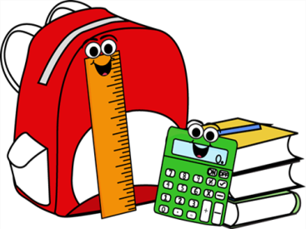My _ _ _ _ _ lator is next to the book. It’s green.
199. you/ Do/ badminton?/ like/
200. How are ... ? - I’m fine, thanks.
A. he B. Lan C. you D. bye

IOE K3 SỐ 08
1. What’s her name ? – ....
A. I’m fine, thanks B. Her name is Daisy C. See you later D. My name is Daisy
2. Let’s co_ nt the boys.
3. books./ close/ your/ Please/
4. Who _ re they?
5. … that your friend? – No, he isn’t.
A. Are B. Am C. Is D. It
6. in/ the bottle./ is/ The/ fish/
7. are/ My friends/ in/ the playground.
8. May I go out? - ... .
A. Hello B. Nice to meet you C. Fine, thanks D. Sure
9. I/ have/ two/ robots.
10. That’s Peter. ... is my friend.
A. I B. You C. She D. He
11. Listen ... the teacher.
A. to B. me C. you D. he
12. Let’s play with … .
A. she B. he C. me D. see
13. _ s this a desk? – No, it isn’t.
14. What c_ _ _ _ _ is this? - It’s green.
15. W_ o is she? – She’s my teacher.
16. Clo_ e the door, Mary.
17. please./ hands,/ Wash/ your/
18. _ _ _ t’s your name? – My name’s Tom.
19. How _ _ _ _ crayons are there?
20. Give ... that pink crayon.
A. he B. she C. me D. the
21. classroom/ is/ My/ small.
22. Choose the letter(s) to make a correct word: swi__ing
A. m B. mm C. k D. kk
23. white./ The/ rabbit/ is/
24. a/ puppy./ It's/ nice/
25. Goodbye, Alice. – Bye. See you ... .
A. later B. later’s C. laters D. a later
26. Hello. My n____ is Nam.
A. ema B. ane C. ame D. eam
27. This is Harry. ... is my friend.
A. They B. He C. She D. It
28. Nghe: Nhấn giữ Ctrl và bấm chuột để nghe: This is my ... .
A. class B. school C. room D. desk
29. Please,/ aloud./ this/ word/ read/
30. Ảnh: These are th_ _ _ dogs.
31. W_ _ t is this? – This is a marker.
32. Hello, ... Kate.
A. my name B. I C. I’m D. me
33. Nghe: Nhấn giữ Ctrl và bấm chuột để nghe: Is this your _ _ _ _ _ ? - Yes, it is.
34. This is the way we go _ _ school.
35. May/ I/ my/ book?/ open/
36. Nga _ _ _ _ s hide-and-seek with her friends.
37. N_W
A. A B. E C. I D. U
38. What’s your n_ _ e? - My name is Hoa.
39. May I ___ the book?
A. open B. stand C. play D. sit
40. Listen _ _ the teacher carefully.
41. Nghe: Nhấn giữ Ctrl và bấm chuột để nghe: Listen and tick:
A. Is that girl Mary? - Yes, she is. B. Is that boy Mary? - Yes, he is. C. Is that pen Mary? - Yes, it is. D. Is that room Mary? - Yes, it is.
42. Ảnh: My sister is _ _ _ _ years old.
43. Good ..., Alice. How are you today?
A. mornings B. bye C. morning D. hi
44. Ảnh: 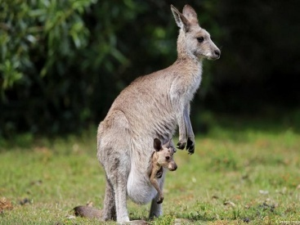We can see a kang_ _ _ _ in Australia.
45. I am ... now. I want some water.
A. hungry B. thirsty C. happy D. pink
46. My father is a taxi _ _ _ _ _ _ .
47. ... is a bird.
A. You B. He C. It D. She
48. ___ is his name?
A. What B. Where C. How D. Why
49. Give ... a pen.
A. he B. me C. she D. they
50. sister/ friend./ my/ is/ Her/
51. Let’s stand ... !
A. down B. up C. in D. on
52. Nice to ... you!
A. meet B. go C. for D. come
53. Ảnh: 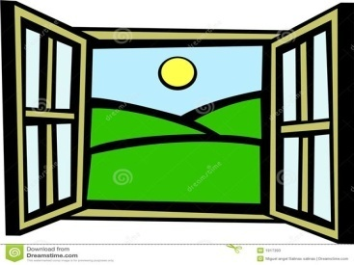We need a new _ _ _ dow.
54. classroom/ My/ is/ big.
55. ... your name?
A. What B. What’s C. How’s D. Why’s
56. Our classr_ _ m is big.
57. Nghe: Nhấn giữ Ctrl và bấm chuột để nghe: Loo_ at the school.
58. Hi, how are you? – I’m very ..., thanks.
A. when B. well C. and D. how
59. very/ tall./ is/ teacher/ My/
60. Nghe: Nhấn giữ Ctrl và bấm chuột để nghe: It’s beau_ _ _ _ _ .
61. My rubber/ and my ruler/ is short./ is small/
62. Nghe: Nhấn giữ Ctrl và bấm chuột để nghe: Listen and tick:
A. How are you? B. How old are you? C. How school are you? D. How room are you?
63. _ ESK
64. you./ meet/ Nice/ to/
65. the/ Let’s/ to/ go/ library./
66. My/ is/ name/ Billy.
67. I go … school in the morning.
A. from B. to C. at D. in
68. I/ volleyball/ to play/ like/ in the evening./
69. Alice can ri_ _ a bicycle.
70. bookcase/ is/ The/ brown.
71. now/ Stand up/ books, please./ and open/ your
72. Choose the odd one out:
A. blue B. pink C. green D. book
73. flowers?/ those/ are/ What colour/
74. Who’s that? - That’s ... .
A. my’s new teacher B. me’s new teacher C. my new teacher D. me new teacher
75. That’s Miss White. She is my _ ew teacher.
76. school gym./ in the/ are/ The students/
77. Nghe: Nhấn giữ Ctrl và bấm chuột để nghe: Look at the _____.
A. gym B. school C. room D. library
78. my/ not/ It/ is/ chair./
79. Nghe: Nhấn giữ Ctrl và bấm chuột để nghe: _ _ _ gry
80. Be … Don’t make noise.
A. lazy B. quiet C. funny D. angry
81. green kites./ two/ They/ are/
82. TH_T
A. I B. A C. E D. O
83. ... your hand, please.
A. Goodbye B. Hi C. Wash D. Study
84. Happy birthday. This robot is for you, Richard. – Thank you very m_ _ _ .
85. Nghe: Nhấn giữ Ctrl và bấm chuột để nghe: His brother’s name is _ _ _ _ .
86. Is that Nam? - Yes, _ _ is.
87. These _ _ _ my toy planes.
88. a red/ That/ is/ pencil.
89. children./ Circle/ answer,/ the/
90. _ _ she a newcomer?
91. Nghe: Nhấn giữ Ctrl và bấm chuột để nghe: There are _ _ _ _ books in the bookcase.
92. This is Mary. ... is my friend.
A. They B. He C. She D. It
93. circles,/ make/ Let’s/ please./ two/
94. W_ _ t is this? - This is a pen.
95. The books are o_ the table.
96. Che_ _ the words you hear.
97. Odd one out:
A. small B. short C. tall D. yellow
98. That is my s_ _ ter. Her name is Mandy.
99. She/ friend./ is/ new/ my/
100. Odd one out:
A. you B. hi C. I D. She
101. Nice to meet you, Hai. – Nice to meet you, ... .
A. to B. two C. too D. those
102. _ _ _ are they? - They are our new teachers.
103. How are you? - ... .
A. My name is Mary B. She’s my friend C. I’m fine, thank you D. Bye. See you later
104. Ảnh: N_ _ EBOOK
105. My books are o_ the table.
106. My bedroom/ large/ is/ and new.
107. Lis_ en to me, please.
108. Choose the odd one out:
A. May B. July C. April D. Jimmy
109. I’m/ thank/ you?/ you. And/ fine,/
110. What are those? – _ _ _ _ ’re my books.
111. How m_ _ y rulers are there?
112. Is this Phong? - No, it ___.
A. is B. are C. aren't D. isn't
113. _ _ _ they fine?
114. Ảnh: _ ELLOW
115. are/ These/ relatives./ my/
116. Nghe: Nhấn giữ Ctrl và bấm chuột để nghe: a_ _ le
117. Ảnh: What is that? - It is a/an … .
A. ruler B. eraser C. pencil D. crayon
118. Nice to meet ..., too .
A. you’s B. you’re C. your D. you
119. May I read the book aloud? – Yes, you ca_ .
120. like/ Do/ playing/ you/ robots?/
121. This is ... cat.
A. he B. she C. my D. you
122. Can you he_ p me?
123. ... is that? – That’s Mary. She is my friend.
A. How B. When C. Who D. Where
124. Ảnh: ru_ _ er
125. This is _ pen.
126. class./ please./ Good morning,/ down,/ Sit/
127. This is m_ blue book.
128. Ảnh: This is my new h_ _ _ e.
129. How ____ are you? - I'm eight years old.
A. old B. long C. much D. many
130. is/ Peter./ My/ brother’s/ name/
131. Nghe: Nhấn giữ Ctrl và bấm chuột để nghe: LI_ _ _ _ _
132. my/ in/ two pens/ There are/ school bag./
133. am/ I/ Hello,/ Andy.
134. May I come ...?
A. in B. at C. on D. to
135. Wh_ t is your favourite food? - I like noodles the most.
136. Nghe: Nhấn giữ Ctrl và bấm chuột để nghe: a b_ g
137. Choose the odd one out:
A. house B. gym C. library D. music room
138. I sin_ a song.
139. Nghe: Nhấn giữ Ctrl và bấm chuột để nghe: I’ve got two ... .
A. hats B. apples C. oranges D. balls
140. you/ fine/ Are/ today?
141. your/ Raise/ hands,/ please
142. Nice to ... you too.
A. bye B. meet C. later D. hello
143. How are you to_ _ y, Tom? – I’m fine, thanks.
144. Nghe: Nhấn giữ Ctrl và bấm chuột để nghe: There are _ _ _ _ books in the bookcase.
145. Septem_ _ _ is the ninth month in a year.
146. _____ colour are your pens?
A. Who B. What C. How D. Why
147. the teacher./ Point/ to/
148. Choose the odd one out:
A. Maths B. Science C. Vietnam D. Arts
149. ... you David? - Yes, I am.
A. Is B. Are C. He D. She
150. T_ ank you very much.
151. EI_ HT
152. playground/ Is/ large?/ your/
153. Nghe: Nhấn giữ Ctrl và bấm chuột để nghe: Lisa loves to go _____ .
A. to school B. home C. fishing D. shopping
154. are/ There/ books./ ten/
155. ... is she? – She’s Mary. She’s my friend.
A. How B. Who C. What D. Hi
156. Nghe: Nhấn giữ Ctrl và bấm chuột để nghe: Listen and tick:
A. I’ve got two rulers. B. I’ve got two erasers. C. I’ve got two scissors. D. I’ve got two eggs.
157. Where is Simon f_ _ m? – He’s from England.
158. There’s a garden in fr_ nt of my house.
159. Flowers in the park _ _ _ very beautiful.
160. Those/ my/ aren't/ rulers.
161. During Ma_ _ s lessons, I learn about numbers.
162. red/ are there?/ many/ How/ apples
163. Ảnh: S_ T DOWN
164. What … is it? – It’s green.
A. a colour B. colour C. colours D. two colours
165. We learn about _ _ _ _ _ _ _ in Maths.
166. big./ classroom/ not/ Your/ is/
167. ... that a dog? – No, it isn’t.
A. Are B. Is C. Who D. When
168. ... your hand, please.
A. Read B. Listen C. Raise D. Write
169. Be q_ _ et, please.
170. Look at the boa_ d.
171. name/ here,/ please/ Write/ your/
172. Read and an_ _ _ _ my question.
173. Hi, Molly. _ _ w are you?
174. Today's children, _______'s future.
A. today B. tomorrow C. yesterday D. next day
175. It is my chai...
A. t B. w C. r D. s
176. He_ _ o, my name’s Richard. - Nice to meet you.
177. Linda and Mary _____ my friends.
A. is B. am C. are D. do
178. Ảnh: We learn P.E in the _ _ _ . It is very large.
179. Read/ aloud/ sit down./ then/ and/
180. a pupil/ primary school./ at a/ He's/
181. Nghe: Nhấn giữ Ctrl và bấm chuột để nghe: They’re my _ _ _ _ _ _ things.
182. Nghe: Nhấn giữ Ctrl và bấm chuột để nghe: It's _______.
A. orange B. oranges C. black D. brown
183. Mary likes skat_ _ _ but Sarah doesn’t.
184. Would you like some m_ _ k? – Yes, please.
185. Do you want ... milk?
A. an B. a C. some D. it
186. my sisters,/ Mai and Lan./ These/ are/
187. Is Tom from Cananda? - ….
A. Yes, he is B. Yes, he does C. No, he is D. Yes,he isn’t
188. Let’s make a ci_ _ le.
189. ...at colour is this? – It’s blue.
A. Wt B. Ho C. Wh D. We
190. May I come ...?
A. in B. at C. on D. to
191. name/ Green./ Louis/ is/ My/
192. My bedroom is new ______ nice.
A. but B. and C. not D. no
193. Sparks./ dog,/ my/ is/ This/
194. It's a brow_ teddy bear.
195. This _ _ a pencil case.
196. Ảnh: 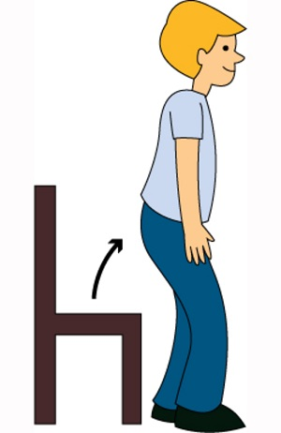_ _ and up!
197. Nghe: Nhấn giữ Ctrl và bấm chuột để nghe: What’s this?
A. It’s a pink doll. B. It’s a pink boat. C. It’s a pink boot. D. It’s a pink nose.
198. ... this a pencil? – No, it isn’t.
A. Are B. Is C. It D. The
199. W_ _ _ _ on the board, please.
200. Let’s ma_ _ a circle.

IOE K3 SỐ 09
1. are/ school gym./ The students/ in the/
2. Who is he? - ... .
A. She is my friend B. He my friend C. She my friend D. He’s my friend
3. My br_ _ her’s name is John.
4. Come ov_ r here.
5. Nghe: Nhấn giữ Ctrl và bấm chuột để nghe: My school is _ _ _ _ _ .
6. Is/ in the room?/ Tony/
7. Choose the odd one out
A. ruler B. rubber C. notebook D. long
8. a question?/ ask/ May/ I/
9. Choose the odd one out.
A. Don’t talk! B. Be quiet! C. Keep silent! D. Stand up!
10. Jenny/ is/ my/ new/ friend./
11. That’s/ Peter./ He/ my friend./ is
12. What _ s this?
13. Is that a pen? - ..., it isn’t.
A. Yes B. Yes, it is C. Not D. No
14. Nghe: Nhấn giữ Ctrl và bấm chuột để nghe: She likes to eat ______ apples.
A. big red B. small red C. big green D. small green
15. Ảnh: 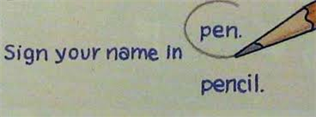Ci_ _ le the answer, John.
16. Is ... a chair? - Yes, it is.
A. are B. it C. it’s D. his
17. Lis_ _ _ to the teacher, please.
18. my/ This/ is/ classroom.
19. Thank/ you,/ Peter./
20. Peter/ and Linda/ years old./ are/ eight
21. A: How _ _ _ are you? - B: I’m eight.
22. My brother’s name is ... .
A. Alice B. Mary C. Daisy D. Tom
23. Hi,/ How/ you?/ are/ Mary./
24. It is ... desk.
A. bye B. me C. a D. hi
25. What _ _ your name?
26. I have f...ve dogs.
A. u B. i C. e D. a
27. Play with ...
A. to B. hi C. me D. hello
28. Some b_ _ _ s can fly but they can’t swim.
29. Put on your coat … you’ll get cold.
A. but B. or C. and D. so
30. It ... a ball.
A. are B. hi C. goodbye D. is
31. How/ many/ cats/ there?/ are
32. A: What _ _ _ our is your pen? - B: It’s brown.
33. This gift is ... you.
A. on B. in C. for D. at
34. To_ ch your desk.
35. Ảnh: CLASSROO_
36. Ảnh: 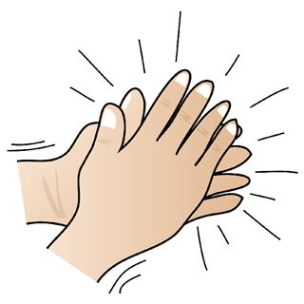Clap your h_ _ _ _ , please.
37. This is m_ blue book.
38. Is that your pencil box? - _ _ , it isn’t.
39. black board/ is/ in the classroom./ A/
40. Ảnh: Put your books on the tabl_ .
41. Choose the odd one out
A. Green B. Yellow C. Apple D. Blue
42. Ảnh: Can I borrow your pencil _ _ _ _ _ _ _ _ _ ?
43. Ảnh: 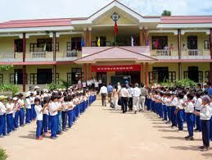That is her new _ _ _ _ _ _ .
44. That is a br_ _ n book.
45. Ảnh: 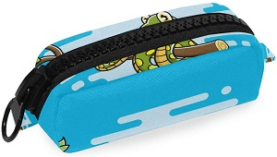Is that a blue pencil case? - ______
A. Yes, its is. B. Yes, it's is. C. Yes, it is D. Yes, it isn't
46. Hi, Alice. I _ _ Tommy.
47. Nice to meet you to_ .
48. is/ nine/ Nam/ years/ old./
49. Do you like milk? – No, I ... .
A. do B. does C. doesn’t D. don’t
50. Hello, ... Sean.
A. you B. am C. I’m D. I
51. Nghe: Nhấn giữ Ctrl và bấm chuột để nghe: Look at the _____.
A. gym B. school C. room D. library
52. I chat ______ my friends in our classroom.
A. and B. are C. with D. Ø
53. How are you? - ... .
A. I’m Binh B. She’s my sister C. I’m fine, thank you D. Goodbye
54. _ _ that your new friend? - No, he isn’t.
55. Thank you very m_ _ h.
56. book/ Put/ your/ away.
57. boys./ Don’t/ talk,/
58. Ảnh: T_O BOOKS
A. O B. E C. U D. W
59. Good mor_ ing everyone.
60. Nghe: Nhấn giữ Ctrl và bấm chuột để nghe: This is my ….
A. bookcase B. pencil case C. notebook D. pencil
61. A: _________. - B: Yes, you can
A. Open your book! B. Stand up! C. May I go out? D. Be quiet!
62. Thes_ are my cats.
63. my/ That/ grandmother./ is/
64. books/ three/ on the/ table./ There are/
65. This ruler is b_ _ wn. That ruler is pink.
66. but/ small/ nice./ house is/ My/
67. I like skating _ _ _ I don’t like skipping.
68. Close the ..., Philip.
A. name B. book C. ball D. look
69. Ảnh: 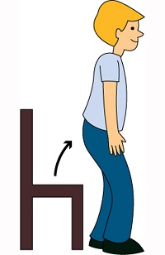Stan_ up, please!
70. B_ _ , Lan. See you soon.
71. teacher/ to/ Listen/ the/ carefully./
72. Look _ _ that kite. It’s so beautiful.
73. My/ beautiful./ is/ mother/
74. Sing a ..., please.
A. you B. me C. song D. he
75. My _ ame is Peter.
76. today./ It/ is cold/
77. Bye./ later./ See/ you/
78. Ảnh: 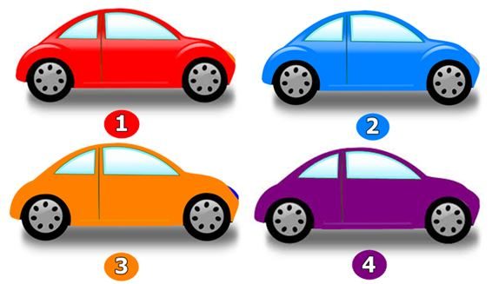A: Which car is Peter’s? - B: The orange one.
A. 1 B. 2 C. 3 D. 4
79. My pen is o_ the desk.
80. ... is that? – That’s Mary. She is my friend.
A. How B. When C. Who D. Where
81. Nghe: Nhấn giữ Ctrl và bấm chuột để nghe: Listen and choose the best response.
A. Goodbye! See you later. B. I’m fine, thanks. C. This is my friend, Lan. D. Hi! My name’s Lan.
82. May I go out? - _______
A. Yes, you can. B. No, you can. C. Thank you. D. Sorry.
83. are/ There/ in/ my family./ four people/
84. dog./ My/ brother/ doesn’t/ like
85. Is your classroom big? - …, it isn't. It’s small.
A. Yes B. Yes, it isn’t C. No, it is D. No
86. We play football in the play_ _ _ _ _ _ after school.
87. you/ Bye./ tomorrow./ See/
88. is mine/ the blue one/ is Phong’s./ and/ The red ruler/
89. is/ That/ Jack./ boy/
90. What is your f_ _ _ _ _ _ _ e food?
91. How are you? - ____, thank you.
A. Yes B. No C. Good D. Fine
92. Nice to me_ t you.
93. This is my sch...ol.
A. o B. u C. i D. e
94. Hi, n_ _ _ to meet you.
95. Mary is ... friend.
A. I B. my C. he’s D. she
96. Tom _ _ d Minh can play football.
97. in/ class 3B./ She/ is/
98. Ảnh: Her _ _ _ _ _ _ _ _ is small.
99. Ảnh: He is a newcom_ _ .
100. are/ lunch boxes?/ What colour/ your/
101. in/ my bag./ are/ The books/
102. Nghe: Nhấn giữ Ctrl và bấm chuột để nghe: What's ____ name?
A. his B. her C. your D. their
103. I want ... ice-cream, please.
A. a B. is C. it D. an
104. Ảnh: BACK_ ACK
105. Choose the odd one out:
A. book B. pen C. ruler D. Mary
106. I’m fine, _ _ _ nk you. And you?
107. Nghe: Nhấn giữ Ctrl và bấm chuột để nghe: ... are my books.
A. They B. These C. Those D. They’re
108. Nghe: Nhấn giữ Ctrl và bấm chuột để nghe: He plays c_ _ _ _ at break time.
109. but it's/ new./ isn't big/ My room/
110. your pet?/ Is/ this/
111. Ảnh: What is that? - It is a/an … .
A. ruler B. eraser C. pencil D. crayon
112. the room./ He/ in/ is not/
113. How are ..., Tom? – I’m fine, thank you.
A. he B. she C. you D. his
114. This is ... purple bag.
A. a B. an C. two D. this
115. I like to s...ng.
A. o B. i C. y D. e
116. Listen ... the teacher.
A. to B. me C. you D. he
117. Unscramble this word: ’’RYRALIB’’ -> ’’_ _ BRARY’’.
118. like/ you/ some/ butter?/ Do/
119. Who is she, Peter? - ... .
A. She Mary B. He’s Tom C. She’s Mary D. My name is Mary
120. These shoes … green and yellow.
A. am B. are C. is D. do
121. Nghe: Nhấn giữ Ctrl và bấm chuột để nghe: What colour is ______?
A. they B. that C. it D. these
122. That’s is Mary. _ _ _ is my friend.
123. What colour is this? – It’s ... .
A. book B. crayon C. ruler D. pink
124. Choose the letter(s) to make a correct word: cla__
A. rr B. ss C. hs D. s
125. name/ Hello,/ Peter Smith./ is/ my/
126. My classroom is ... .
A. bigs B. a big C. the big D. big
127. Listen ... your friend, Tom.
A. on B. of C. to D. for
128. Nghe: Nhấn giữ Ctrl và bấm chuột để nghe: fi_ _
129. I can sing but I _ _ _ _ _ _ dance.
130. new/ my/ is/ Tony/ friend./
131. Ảnh: TA_LE
A. P B. B C. C D. G
132. Nice to meet you, Miss Lan. – Nice to meet you, t_ _ .
133. It's _ blue rubber.
134. Nghe: Nhấn giữ Ctrl và bấm chuột để nghe: _ _ _ _
135. a purple/ bag./ This is/
136. Nghe: Nhấn giữ Ctrl và bấm chuột để nghe: Listen and tick:
A. Tom, have you got any pens? B. Tom, have you got any pencils? C. Tom, have you got any pen cases? D. Tom, have you got any pencil cases?
137. What ... these? – They are my pens.
A. is B. are C. and D. am
138. her rubbers/ and rulers./ aren't/ These/
139. be/ late!/ Don't/
140. play chess/ I/ in the classroom./
141. Those are f_ ve boxes.
142. Hello. My name’s Thompson. - Hi, ….
A. What’s that? B. I’m Simon. Nice to meet you C. Goodbye. D. See you later
143. My _ ame is Tony.
144. I/ to play/ volleyball/ in the evening./ like/
145. Nghe: Nhấn giữ Ctrl và bấm chuột để nghe: It’s … .
A. cloudy B. rainy C. windy D. stormy
146. Henry doesn’t work _ _ Saturday and Sunday.
147. Choose the letter(s) to make a correct word: PL_Y
A. E B. U C. A D. I
148. Do you like … a bicycle?
A. playing B. riding C. making D. doing
149. Do Peter and Tony go to the park? - No, they _ _ _ ’t.
150. There is a picture … the wall.
A. in B. at C. on D. of
151. My sister likes to go sw_ _ _ _ ng in summer.
152. Happy birthday, Alice. This doll is for ... .
A. I B. you C. he D. she
153. _______ you like dolls?
A. Do B. Are C. Is D. Don’t
154. My school is near _ bakery.
155. W_ _ _ _ on the board, please.
156. _ _ ce to meet you, Lan Anh.
157. Nghe: Nhấn giữ Ctrl và bấm chuột để nghe: Let’s go to the _ _ _ _ _ _ library.
158. Nghe: Nhấn giữ Ctrl và bấm chuột để nghe: How do you ... your name?
A. spend B. ten C. spell D. tell
159. old/ beautiful./ but/ is/ The classroom/
160. Ảnh: That's my computer _ oom.
161. Nghe: Nhấn giữ Ctrl và bấm chuột để nghe: My school _ _ _ is very long.
162. What _ _ you do at break time?
163. Good_ ye. See you tomorrow.
164. _ _ _ ’t play football in the classroom.
165. _ _ your school big? – No, it isn’t.
166. I/ Laura./ am/
167. Ảnh: This is a ... desk.
A. pink B. yellow C. blue D. green
168. _______ are our flowers.
A. This B. That C. It D. Those
169. Is it _______rubber?
A. your B. you C. Lan D. I
170. Listen to the teacher carefull_ .
171. Simon can sing ... he cannot swim.
A. and B. end C. but D. or
172. Ảnh: There are many k_ _ _ _ in the sky.
173. today?/ do you/ subjects/ What/ have
174. your/ Write/ school./ about/
175. is/ My/ school/ new and big.
176. Where’s she today? - ... .
A. She’s at school B. Yes. She’s from America C. She’s nine years old today D. She can swim
177. Look _ t the board.
178. Let’s ma...e a circle.
A. g B. r C. t D. k
179. Here we _ _ _ together.
180. Take ... your books, children.
A. on B. at C. out D. for
181. Nghe: Nhấn giữ Ctrl và bấm chuột để nghe: _ octor
182. Choose the odd one out
A. Nine B. Bird C. Five D. Three
183. Nghe: Nhấn giữ Ctrl và bấm chuột để nghe: Listen and tick
A. What're they? B. What's that? C. What's it? D. What's this?
184. Mary/ to school/ goes/ every/ morning./
185. There is _ pen in my school bag.
186. I’m fine, thanks. How a_ _ _ t you?
187. girls!/ talk/ Don't/ in class,/
188. the library./ place/ favourite/ is/ My/
189. Is this a book? - ... .
A. Yes, it is B. Yes, isn’t C. No, it is D. Yes, that is
190. meet/ Pleased/ you, Miu./ to/
191. Th_ _ _ are three pens on the desk.
192. Ảnh: We are on the _ _ _ _ _ because it’s very hot today.
193. Look _ _ the picture, please.
194. the/ classroom/ in/ She is/ now./
195. Nghe: Nhấn giữ Ctrl và bấm chuột để nghe: Mon_ _ _
196. Nghe: Nhấn giữ Ctrl và bấm chuột để nghe: Let’s play _ _ _ _ _ .
197. Is t_ _ s a desk?
198. Ảnh: Who is she? – She is Lan. She is my t_ _ _ _ _ _ .
199. A: What colour … these flowers? - B: … purple.
A. are – They’re B. is – It’s C. are – It’s D. is – They’re
200. Let’s say hel_ _ to Peter, students.

IOE K3 SỐ 10
1. Ảnh: This is number _ _ _ .
2. This is my class_ _ _ _ . It’s small.
3. Nghe: Nhấn giữ Ctrl và bấm chuột để nghe: Listen and tick:
A. Tom, have you got any pens? B. Tom, have you got any pencils? C. Tom, have you got any pen cases? D. Tom, have you got any pencil cases?
4. Choose the odd one out:
A. on B. to C. in D. read
5. Which is a kind of fruit?
A. blue B. green C. orange D. pink
6. Nice ... meet you.
A. for B. to C. from D. on
7. Close the ..., Philip.
A. name B. book C. ball D. look
8. Nam’s pencil is _ _ _ _ but mine is short.
9. my/ is/ teacher./ Miss Lien/ new
10. Don’t make ... mess.
A. an B. the C. a D. this
11. … that woman your new teacher?
A. Is B. Has C. Who’s D. Does
12. These are t_ o cats.
13. Gi...e me the book, please.
A. t B. v C. n D. b
14. It’s ... ruler.
A. are B. a C. an D. is
15. Let’s s_ y ’’Hello’’ to Tom.
16. What is your name?
A. Her name is Mary. B. His name is Alan. C. My name is Lan. D. Your name is Peter.
17. Choose the odd one out:
A. read B. sing C. draw D. book
18. Linda and her sister like jumping rope in _ _ _ _ _ free time.
19. What _ _ it? - It’s a pen.
20. is/ My/ classroom/ small.
21. Ảnh: 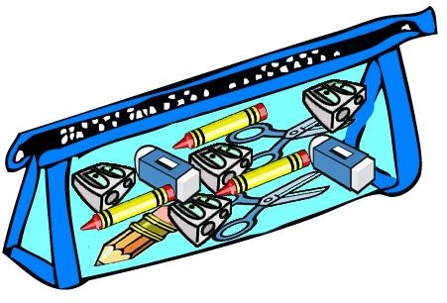This is my _ _ _ cil case.
22. _ _ your school big? – No, it isn’t.
23. Nghe: Nhấn giữ Ctrl và bấm chuột để nghe: Listen and tick:
A. There are two bathrooms. B. There are three bedrooms. C. There are two bedrooms. D. There are two living rooms.
24. Ảnh: 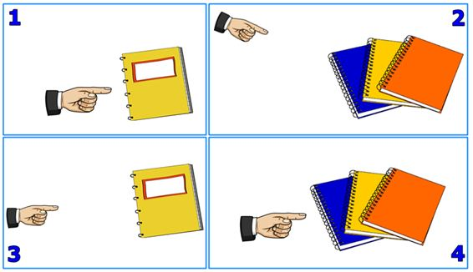Those notebooks are Sarah’s.
A. Picture 1 B. Picture 2 C. Picture 3 D. Picture 4
25. your pet?/ Is/ this/
26. Have a n_ _ e day.
27. Ảnh: 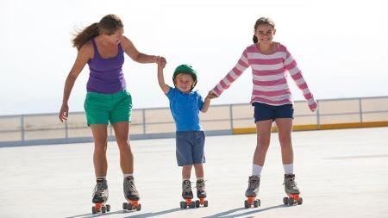Do you like ska_ _ ng?
28. a/ draw/ , please./ Let’s/ picture
29. go/ fishing/ I don't/ weekends./ at
30. Sing wit_ me.
31. Nghe: Nhấn giữ Ctrl và bấm chuột để nghe: Is it _ _ _ ? – Yes, it is.
32. This/ red./ pen. It's/ is my/
33. Ảnh: BACK_ ACK
34. Can/ your pen?/ I borrow/
35. ... is Mary.
A. You B. He C. She D. My
36. Who is ...? – She’s Mary.
A. he B. she C. his D. her
37. Goodbye./ tomorrow./ See/ you/
38. pens./ blue/ are/ my/ These/
39. ... to meet you!
A. How B. Go C. Nice D. Get
40. There a_ _ five flowers in the vase.
41. Nghe: Nhấn giữ Ctrl và bấm chuột để nghe: Emma doesn’t like playing _ _ _ _ _ _ .
42. her/ notebooks./ are/ These/
43. Li_ ten to the teacher, please.
44. Put/ your/ down./ hand/
45. Look ... the cat, Tom.
A. in B. on C. to D. at
46. Nghe: Nhấn giữ Ctrl và bấm chuột để nghe: Let’s go to the school _ _ _ _ _ _ _ .
47. Gr...et your friend, please.
A. a B. e C. u D. i
48. He/ is not/ in/ the room.
49. What’s/ name?/ your/
50. W...o is she? - She is Mary.
A. t B. h C. w D. q
51. Hi. I am Peter. – Hello. I ... Alice.
A. is B. are C. am D. be
52. Sit d_ _ _ , Tommy.
53. Ảnh: 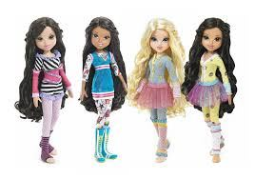Those do_ _ _ are small.
54. Odd one out:
A. chair B. table C. black board D. football
55. How _ _ _ you today? - Fine, thanks. And you?
56. Is/ your/ this/ pen?
57. Thank you very m_ _ h.
58. This is yo_ r book.
59. Have ... nice day!
A. a B. an C. the D. this
60. Nghe: Nhấn giữ Ctrl và bấm chuột để nghe: Listen and tick:
A. Is that girl Mary? - Yes, she is. B. Is that boy Mary? - Yes, he is. C. Is that pen Mary? - Yes, it is. D. Is that room Mary? - Yes, it is.
61. Is this a notebook? – No, ... .
A. it isn’t B. it is C. it does D. it doesn’t
62. a/ dog?/ there/ Is/
63. These are three pencil box_ _ .
64. are/ Five/ on the desk./ pens/
65. How ... students are there in your class? - There are twenty five students.
A. much B. very C. old D. many
66. large./ is/ lunch room/ My/
67. Nghe: Nhấn giữ Ctrl và bấm chuột để nghe: _ _ _ _
68. This __ his book.
A. it B. its C. is D. it's
69. Ảnh: THREE PENCIL_
70. Sta_ _ up now and open your book.
71. now/ books, please./ and open/ your/ Stand up/
72. Let's/ book./ read/ a/ comic
73. Ảnh: I'm five years _ ld.
74. Read/ and/ sit down./ aloud/ then
75. Can/ open/ the door?/ I/
76. Ảnh: _ _ _ _ _ _
77. Where is Peter? – ... at school.
A. He B. She C. He’s D. She’s
78. Nghe: Nhấn giữ Ctrl và bấm chuột để nghe: The_ _ are my rulers.
79. ___________ to meet you.
A. Nie B. Nine C. Nice D. Like
80. the/ Point/ to/ teacher.
81. in/ are/ They/ the park.
82. Here is their s_ _ ool.
83. My friends are in the pla_ ground.
84. … I open my book? – Yes, you can.
A. Do B. What C. Could D. May
85. I ... Mai.
A. am B. am’s C. are D. is
86. Clo_ e your book, please.
87. Anna doesn’t play skipping at br_ _ _ time.
88. Wh_ is that? – It’s Mary.
89. Is/ large?/ classroom/ his/
90. His classroom is s_ all.
91. Nghe: Nhấn giữ Ctrl và bấm chuột để nghe: BOO_
92. Ảnh: The rain_ _ _ is beautiful.
93. Don't/ knife./ the/ with/ play/
94. How/ Hien?/ Miss/ old/ is/
95. Take/ pens,/ out/ Henry./ your/
96. Where __________ your brothers?
A. am B. is C. are D. its
97. Goodbye Sally. See ... later.
A. hi B. my C. your D. you
98. Is … a library at your school?
A. these B. this C. there D. that
99. M_ y I go out? Yes, please.
100. That/ a/ chair./ green/ is/
101. _______ up, please.
A. Sit B. Open C. Close D. Stand
102. very/ much./ you/ Thank/
103. There are t_ _ ee crayons in my bags.
104. Nghe: Nhấn giữ Ctrl và bấm chuột để nghe: B_ E
105. subjects/ does/ What/ he/ have?/
106. Is this your ruler? - No, ____ isn't
A. it B. that C. its D. it's
107. My/ not/ bedroom/ is/ big./
108. the board./ on/ Write/ name/ your/
109. Where/ your/ school?/ is/ primary
110. are/ What colour/ these dogs?/
111. Nghe: Nhấn giữ Ctrl và bấm chuột để nghe: A: What’s that? - B: It’s a … .
A. cat B. bag C. rat D. bat
112. ... pictures are there on the wall?
A. Who B. How C. How many D. How much
113. B_ OK
114. I’m David. This is … family.
A. I B. my C. mine D. me
115. What ... is this? – It’s black.
A. colour B. age C. old D. school
116. bedroom/ My/ big./ is/ not
117. Choose the correct sentence.
A. I like play basketball. B. My brother is twelve year old. C. Tony plays football at break time. D. What are your name?
118. Nghe: Nhấn giữ Ctrl và bấm chuột để nghe: His book is ________.
A. pink B. blue C. green D. white
119. _ _ r baby sister is young.
120. ... name is Linda.
A. You B. He C. Her D. She
121. Do you like cats?
A. Yes, I am. B. No, I’m not. C. Yes, I do. D. No, I like.
122. fine./ and John/ are/ Linda/
123. not/ red./ His/ is/ pen/
124. This is _ _ apple.
125. Nghe: Nhấn giữ Ctrl và bấm chuột để nghe: ___ name is Simon.
A. His B. Her C. My D. Your
126. Let’s dr_ _ a picture.
127. The room is _ _ _ _ _ . It isn’t big.
128. Let’s … a picture.
A. draw B. sit C. stand D. go
129. Is this a pen? – No, ... isn’t.
A. this B. it’s C. its D. it
130. there./ over/ The/ is/ bookshelf/
131. What’s this? – It’s an ... .
A. crayon B. table C. ruler D. eraser
132. ... , I’m Alice. – Nice to meet you.
A. Hi B. Goodbye C. See you D. Bye
133. Nice to meet ... .
A. I B. me C. he D. you
134. ______ to meet you.
A. Nice B. Nine C. Night D. Naive
135. Nghe: Nhấn giữ Ctrl và bấm chuột để nghe: I’m standing in a ... .
A. living room B. classroom C. room D. bedroom
136. How m_ _ y rulers are there?
137. a/ gym. It's/ new./ This/ is/
138. This is _ desk.
139. Is this your _ _ ayon?
140. are on/ The pictures/ the wall./ of/ my family/
141. Look _ _ my house.
142. I’m fine, th_ _ k you.
143. football./ I do/ like/ playing/ not/
144. That is a white _ _ d pink pen.
145. Sit do_ n, please.
146. T_ _ e out your books, students.
147. is/ my brother/ I’m ten/ and/ fifteen./
148. I’m fin_ , thanks.
149. I’m fine, th_ _ k you.
150. It ... Oxford Primary school.
A. is B. a C. are D. an
151. Goodn_ _ _ _ , mommy.
152. I _ _ Mai.
153. Nghe: Nhấn giữ Ctrl và bấm chuột để nghe: _ _ _ are you?
154. Ảnh: 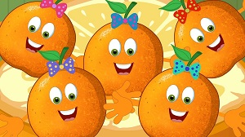FI_ _ ORANGES
155. Come/ class,/ please./ to/
156. Nghe: Nhấn giữ Ctrl và bấm chuột để nghe: _ en
157. Ảnh: 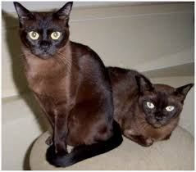These cats are _ _ _ _ _ .
158. Good morning. … are you? - I’m fine.
A. Who B. Where C. What D. How
159. Nghe: Nhấn giữ Ctrl và bấm chuột để nghe: Lucy and her ... draw picture in classroom.
A. boys B. teachers C. friends D. girls
160. How m_ _ _ books are there on the bookshelf? – There are four books.
161. _ _ _ do you spell your name, Sam? - It’s S-A-M.
162. … do you play badminton with?
A. Whom B. When C. Which D. What
163. Hello. I a... Mai.
A. n B. m C. p D. q
164. The teddy is betw_ _ _ the car and the robot.
165. A: … is that? - B: It’s Tony.
A. Which B. Where C. Whom D. Who
166. Hi, how are you? – I’m very ..., thanks.
A. when B. well C. and D. how
167. ... this a chair? – No, it isn’t.
A. What B. How C. Is D. Are
168. What _ _ lour is it?
169. Can I have … cookies, Mom? – Of course, dear.
A. any B. some C. a D. an
170. My n_ me is Hieu.
171. Let’s .... outside, children.
A. bye B. play C. hi D. hello
172. is/ beautiful./ very/ Betty/
173. Her name is Alice. _ _ _ is my friend.
174. the desk./ lamp/ The/ is/ on
175. How do you … your name? – That’s A-N-N-E.
A. spell B. read C. call D. say
176. How many/ are/ the desk?/ there on/ erasers/
177. This is my friend. ... name is Lisa.
A. She B. He C. Her D. His
178. Nghe: Nhấn giữ Ctrl và bấm chuột để nghe: _ _ _ _
179. What is your f_ _ _ _ _ _ _ e food?
180. your/ Take/ book./ out/
181. my notebooks/ are/ and pencils./ These/
182. My ... is Bruce. Nice to meet you.
A. names B. name C. game D. name’s
183. Ảnh: I am _ _ the playground.
184. apples/ There are/ some/ the cupboard./ in
185. This ... a house.
A. are B. is C. you D. here
186. My n_ me is Peter.
187. Nice to _______ you.
A. mit B. meat C. meet D. miit
188. M_ _ I close my book? - Yes, please.
189. What’s y_ _ r name? – My name’s Tom.
190. My ... is Jean.
A. name’s B. names C. name D. namese
191. Ảnh: _ _ _ CIL SHARPENER
192. are/ two/ These/ little puppies.
193. My school isn't new. It's _ ld.
194. This cak_ is for you. - Thank you very much.
195. ___ this your pen? - No, _____ .
A. Is - it isn't B. Is - it is C. Are - its D. Are - it are
196. Nghe: Nhấn giữ Ctrl và bấm chuột để nghe: The box is re_ .
197. I _ _ _ ’t like skipping.
198. Nghe: Nhấn giữ Ctrl và bấm chuột để nghe: e_ _
199. What _ _ his name? - He is Jean.
200. Ảnh: N_ _ _ BOOK

IOE K3 SỐ 11
1. Nghe: Nhấn giữ Ctrl và bấm chuột để nghe: What colour is ______?
A. they B. that C. it D. these
2. My/ is/ blue./ colour/ favourite/
3. Ảnh: _ _ _ _
4. fish/ the bottle./ is/ The/ in
5. Nghe: Nhấn giữ Ctrl và bấm chuột để nghe: ... your books, please.
A. open B. listen C. close D. go
6. W_ _ t is that? – It’s a robot.
7. from/ Where/ you/ are/ , Tommy?/
8. th_ nks
9. How are y_ _ ?
10. Nghe: Nhấn giữ Ctrl và bấm chuột để nghe: It’s beau_ _ _ _ _ .
11. ... your name?
A. Who B. How C. What’s D. Why
12. Choose the odd one out:
A. May B. July C. April D. Jimmy
13. this./ a rubber./ Look/ It’s/ at/
14. Be q_ _ et, please.
15. Cl_ _ n your teeth, please.
16. Who is he? - ... .
A. She is Mary B. He my friend C. She my friend D. He’s Tom
17. are/ on the table?/ the books/ What colour/
18. Choose the odd one out:
A. white B. new C. yellow D. green
19. Nghe: Nhấn giữ Ctrl và bấm chuột để nghe: Do you _ _ _ _ at break time?
20. I’m fine. How ab_ _ t you?
21. They/ yellow./ are/
22. Choose the odd one out:
A. mother B. father C. brother D. teacher
23. I’d like some strawberries. – Here … are.
A. they B. them C. those D. these
24. new/ The school library/ nice./ is/ and
25. ... you like some bread? – No, I don't.
A. Does B. Do C. Are D. Is
26. Good/ morning,/ teacher!/
27. Nice _ _ meet you, Alan.
28. Wa_ _ your hands, please.
29. Nghe: Nhấn giữ Ctrl và bấm chuột để nghe: I’ve got two ... .
A. hats B. apples C. oranges D. balls
30. my/ This/ school/ is/ library./
31. She/ every/ afternoon./ does/ puzzles/
32. Listen to the teac_ er.
33. L_ _ k at the board.
34. go/ to school./ This is/ we/ the way/
35. is/ That/ bicycle./ a/
36. Ảnh: We learn P.E in the _ _ _ . It is very large.
37. … make a mess in class.
A. Are B. Is C. Do D. Don't
38. This is Richard. _ _ is my new friend.
39. Good morning teacher! - ... .
A. Goodbye B. See you later C. Good morning D. Fine, thanks
40. What’s _ _ _ _ name? - My name is Peter.
41. Henry doesn’t work _ _ Saturday and Sunday.
42. This is _ book.
43. Hello./ Mary./ I/ am/
44. Ten, eleven, twelve, ..., fourteen, fifteenThe missing number is:
A. 12 B. 13 C. 14 D. 15
45. like/ doesn’t/ tennis./ Mike/
46. you/ tomorrow,/ See/ Peter.
47. Her ruler is short, but my ruler is l_ _ _ .
48. Nghe: Nhấn giữ Ctrl và bấm chuột để nghe: ______ are my notebooks.
A. They B. These C. Those D. That
49. N_ _ e to meet you, Sam.
50. Miss Lan is my new t_ _ _ her.
51. Peter _ _ from America.
52. BOA_ D
53. My ... is Tim. Nice to meet you.
A. name’s B. names C. name D. namese
54. Nghe: Nhấn giữ Ctrl và bấm chuột để nghe: The girl’s favourite toy is ….
A. kite B. teddy C. doll D. robot
55. Nghe: Nhấn giữ Ctrl và bấm chuột để nghe: What are these? - They are my _ _ _ _ _ _ _ .
56. backpack/ My/ is/ green./ new/
57. are/ Huong?/ How/ you,/ old/
58. is long./ Her/ pencil/
59. Ảnh: BAD_ INTON
60. are/ in/ the gym./ My friends/
61. Is this a pencil box? – ..., it is.
A. No B. Not C. Yes D. No’s
62. Write w_ _ t the teacher says.
63. the school garden./ are/ in/ They/
64. Nghe: Nhấn giữ Ctrl và bấm chuột để nghe: This is a … .
A. dot B. dog C. door D. down
65. Good ni_ _ _ , children.
66. ... this a chair? – No, it isn’t.
A. What B. How C. Is D. Are
67. Lo...k at the board, please.
A. u B. o C. e D. i
68. new/ my/ book./ is/ This/
69. Choose the odd one out:
A. young B. out C. big D. short
70. I’m fine, thanks. How a_ _ _ t you?
71. How do you sp_ll your name?
A. e B. o C. u D. a
72. What is _ _ _ _ name? - My name is Tom.
73. What's your name? - ______ name is Nam.
A. My B. His C. Her D. Your
74. Ảnh: _ _ _ CATS
75. Nghe: Nhấn giữ Ctrl và bấm chuột để nghe: Good ______, class.
A. afternoon B. evening C. morning D. bye
76. Choose the letter(s) to make a correct word: pencil c__se
A. a B. e C. i D. o
77. How are ...u? - Fine, thanks.
A. yu B. ye C. yo D. yi
78. I’m fine, thank ... .
A. you B. you’re C. you are D. your
79. This gift is for you. - ... .
A. How are you B. Fine, thanks C. Thank you D. Thank
80. Ảnh: 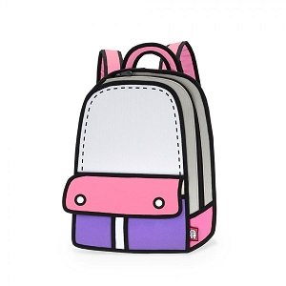BACKPA_ _
81. Nghe: Nhấn giữ Ctrl và bấm chuột để nghe: He plays c_ _ _ _ at break time.
82. are/ Their/ brown./ backpacks/
83. Happy birthday _ _ you, Tommy.
84. Can/ I/ the door?/ open/
85. This is _ banana.
86. in the playground./ My friends/ and I/ are/
87. This is ... ruler.
A. a B. an C. and D. end
88. Ảnh: 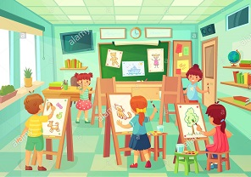AR_ ROOM
89. is/ new and big./ My/ school/
90. Ảnh: _ UBBER
91. Nghe: Nhấn giữ Ctrl và bấm chuột để nghe: There are _ _ _ _ books in the bookcase.
92. It ... Oxford Primary school.
A. is B. a C. are D. an
93. is/ Minh./ my friend./ This/ He’s
94. song./ that/ like/ don't/ I/
95. Nghe: Nhấn giữ Ctrl và bấm chuột để nghe: Listen and tick:
A. Both Mary and Tom love cats very much. B. Both Mary and Tom love cars very much. C. Both Mary and Tom love buses very much. D. Both Mary and Tom love pets very much.
96. Nghe: Nhấn giữ Ctrl và bấm chuột để nghe: My _ _ _ _ _ _ _ _ _ is large.
97. … do you spell your name?
A. How B. What C. Who D. Why
98. Is this a notebook? …, it is.
A. No B. Not C. Yes D. No, it is
99. Don't talk _ _ class!
100. … many books are there on the bookshelf?
A. Who B. How C. Where D. What
101. Choose the odd one out
A. Pig B. Dog C. Cat D. Book
102. is/ The/ bookshelf/ over/ there./
103. Nghe: Nhấn giữ Ctrl và bấm chuột để nghe: Listen and tick:
A. This is my pencil. B. This is my pen case. C. This is my pen. D. This is my ball.
104. A: _ _ _ _ ’s it? - B: It’s my notebook.
105. That's Susan. ___ is eight.
A. Her B. She C. Him D. His
106. … out your book, children.
A. Take B. To take C. Takes D. Taking
107. books,/ please./ Show/ me/ your/
108. That is a br_ _ n book.
109. How many/ your school bag?/ books/ in/ are there/
110. Good morning, Peter. - ... .
A. Good morning, Jean B. Good night, Jean C. My name’s Jean D. Jean, this is my pen
111. How ...re you?
A. e B. s C. a D. o
112. Linda and her sister like jumping rope in _ _ _ _ _ free time.
113. H_ _ ’s the weather in Hanoi?
114. Let’s play with … .
A. she B. he C. me D. see
115. It’s su_ ny in Hue.
116. Bye. ___ you soon.
A. See B. Get C. Meet D. Have
117. answer,/ children./ Circle/ the/
118. Jenny has t...o dolls.
A. u B. w C. y D. o
119. you./ fine,/ I’m/ thank/
120. Please/ books./ close/ your/
121. Ảnh: Look! That flower is ....
A. pink B. blue C. green D. black
122. APP_ E
123. a book. It/ is a/ It isn’t/ notebook.
124. Odd one out:
A. footballer B. singer C. teacher D. cooker
125. These are three pencil box_ _ .
126. I … a blue pencil and a white ruler.
A. has B. have C. don’t have D. doesn’t have
127. How are you, Sandy? - ... .
A. I’m fine, thank B. Fine, thank C. Fine, thanks D. I fine, thank
128. Choose the odd one out:
A. black B. stand C. read D. listen
129. your/ Open/ , Peter./ schoolbag/
130. They/ are/ dogs./ small/ cats and
131. Pick … your pencil.
A. at B. up C. on D. for
132. Choose the correct sentence.
A. I'm eight years old. B. I'm eight year old. C. He are a student. D. They is my friends.
133. What is _ _ _ name? – He is Tony.
134. This is my ... house.
A. a new B. new C. news D. new’s
135. these/ his pens and/ Are/ pencils?
136. Nghe: Nhấn giữ Ctrl và bấm chuột để nghe: I’m fine, ________.
A. thank B. thank you C. thanks D. thanks you
137. Bye. See you l_ _ _ r.
138. Let’s make a ci_ _ le.
139. Yes./ are my/ new/ They/ books./
140. Nghe: Nhấn giữ Ctrl và bấm chuột để nghe: The boy loves ba_ _ _ _ _ on.
141. ... up, students.
A. Sit B. Open C. Stand D. Read
142. We sing many songs ... Music lessons.
A. to B. during C. so D. and
143. See/ you/ tomorrow,/ Peter.
144. These are green hat_ .
145. Hello, Mary. How _ _ _ you?
146. are/ pencil boxes./ There/ two/
147. This is ... brother. His name is Richard.
A. I B. my C. me D. am
148. Clo_ _ your book, please.
149. Ảnh: Does she have bl_ _ _ _ hair?
150. ... morning, Simon!
A. But B. Good C. Shut D. Hi
151. W_ _ is he? – He is my best friend.
152. What colour ... this? - It’s yellow.
A. it B. is C. that D. hi
153. Is that Linda? - _ _ , it isn't.
154. Ảnh: _ _ _ _ _
155. Hello. I … Mary.
A. is B. are C. am D. do
156. your friend./ say/ to/ ’Hello!’/ Let’s/
157. Odd one out:
A. You B. I C. Hi D. She
158. kittens?/ What colour/ are your/
159. Thank you very _ _ _ _ for your lovely birthday gift.
160. Nghe: Nhấn giữ Ctrl và bấm chuột để nghe: Listen and tick:
A. My father is a teacher. B. My mother is a teacher C. My father is a doctor. D. My brother is a teacher.
161. _ _ quiet, please.
162. Nghe: Nhấn giữ Ctrl và bấm chuột để nghe: She’s ... a kite.
A. making B. flying C. playing D. drawing
163. ___________ do you do after school?
A. What B. Who C. How D. How old
164. Choose the letter(s) to make a correct word: CLO__
A. SS B. SA C. SE D. EE
165. This is a blue ... white book.
A. and B. an C. a D. am
166. It ... a green pencil.
A. am B. are C. is D. an
167. Circle the ans_ er.
168. Ảnh: Good _____!
A. afternoon B. evening C. night D. morning
169. A: _ _ _ ’s it going? - B: Great. Thank you.
170. ... are you? – I’m fine, thanks.
A. Hi B. Hello C. How D. How’s
171. the/ words./ down/ Copy/
172. Open the b_ _ k.
173. volleyball/ or/ basketball?/ she like/ Does/
174. That is my school gym. ___ new.
A. Its B. It's is C. It's D. Its's
175. Nghe: Nhấn giữ Ctrl và bấm chuột để nghe: My school _ _ _ is very long.
176. W_ _ _ _ on the board, please.
177. Look _ _ the blackboard, please.
178. big?/ your/ Is/ new/ school
179. Ảnh: 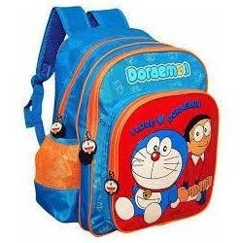_ AG
180. _ _ _ _ is the date today, Sam?
181. _ _ _ ’t play football in the classroom.
182. name/ Her/ Lisa./ is/
183. They ____ a song in the classroom.
A. point B. read C. look D. sing
184. Ảnh: 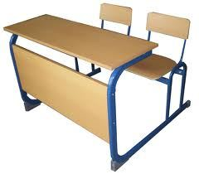This is a _ _ _ _ .
185. Ảnh: Is that a black _ _ _ _ ?
186. I’m fine, thanks. _ _ d you?
187. with/ play/ me./ Let’s/
188. Choose the odd one out
A. dog B. cat C. friend D. chicken
189. Stand _ _ , please.
190. Don't ma_ _ noise in class.
191. Ảnh: 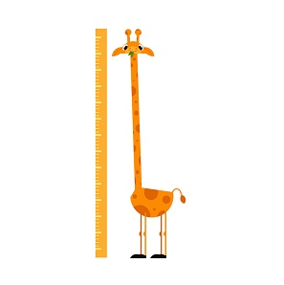A _ ONG NECK
192. Is this yo_ _ book? - Yes, it is.
193. are/ kites/ beautiful./ These/
194. Can you he_ p me?
195. We _ _ _ pupils.
196. Ảnh: 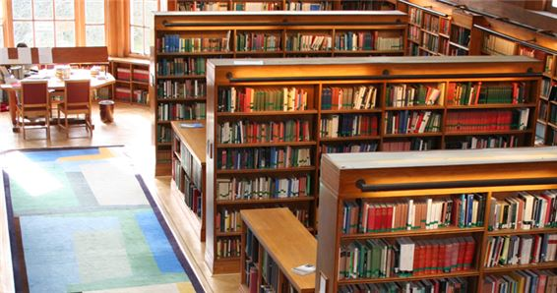My school l_ _ _ ary is big.
197. Open ... books, please.
A. am B. I C. you D. your
198. Jane/ and Tim./ are/ These/
199. name?/ What's/ its/
200. Can you ride a bicycle? - ... .
A. No, I can B. No, thanks C. Yes, I can D. Yes, I can’t

IOE K3 SỐ 12
1. Don't talk _ _ class!
2. The...e are four books on the table.
A. t B. w C. y D. r
3. SCHOOL-B_ G
4. Nghe: Nhấn giữ Ctrl và bấm chuột để nghe: _ _ ain
5. Keep silent = Don't ___.
A. look B. see C. talk D. go
6. _ _ _ name is Lisa.
7. How old ... Peter? – He’s twelve years old.
A. is B. are C. isn’t D. am
8. like/ Would/ you/ ice-cream?/ an
9. Can you he_ p me?
10. the books/ on the table?/ are/ What colour/
11. _ _ _ are they? - They are our new teachers.
12. later,/ Goodbye./ you/ Simon./ See/
13. Nghe: Nhấn giữ Ctrl và bấm chuột để nghe: What colour is ______?
A. they B. that C. it D. these
14. Nice to _ _ _ t you, too.
15. Ảnh: What do you do at break time? – I ... .
A. play tennis B. play football C. play chess D. swim
16. like/ dog./ brother/ My/ doesn’t/
17. Three pen_
18. M... name is Collin.
A. o B. i C. y D. e
19. ... your school bag, Alice.
A. Point B. Stand C. Sit D. Open
20. _ _ ve me the pencil, please.
21. I/ hungry/ now./ am/
22. ... this a desk? - Yes, it is.
A. Is B. Are C. Am D. What
23. Be qu_ _ t. Listen to the teacher, please.
24. Listen _ _ the teacher carefully.
25. this/ and colour/ picture./ draw/ Let’s/
26. name?/ What/ is/ your/
27. Nghe: Nhấn giữ Ctrl và bấm chuột để nghe: The girl is … years old.
A. 7 B. 8 C. 9 D. 10
28. Her family n_ _ _ is Green.
29. Is this a de_ k?
30. Peter/ food./ wants/ some/
31. My father likes to _ _ _ _ _ a car.
32. we/ go/ This is/ the way/ to school./
33. notebooks,/ your/ out/ Take/ please./
34. How are you?
A. I’m Philip. B. I’m fine, thanks. C. I’m seven. D. I’m a pupil.
35. My schoolbag is n_ _ orange. It’s red.
36. new/ books./ are my/ Yes./ They/
37. your/ is/ school?/ primary/ Where/
38. … make a mess in class.
A. Are B. Is C. Do D. Don't
39. This is my fam_ _ y.
40. Choose the odd one out
A. Pencil case B. Ruler C. Rubber D. School
41. _____ are my rulers.
A. This B. That C. Those D. It
42. name/ on/ the paper./ Write/ your/
43. the bookcase./ on/ The books/ are/
44. Ảnh: This is a ... desk.
A. pink B. yellow C. blue D. green
45. Tommy is happy bec_ _ se today is her birthday.
46. is/ He/ my/ father.
47. Nghe: Nhấn giữ Ctrl và bấm chuột để nghe: The school is______.
A. new B. big C. large D. old
48. please./ your/ name/ Write/ here,
49. Wr_ _ _ the names in the blanks.
50. the/ sentences./ Reorder/
51. Good ev_ _ ing, Tom.
52. Copy/ down/ words./ the/
53. Thank you very m_ _ h.
54. Ảnh: NEWCOM_ R
55. Hello, I’m John. ... J-O-H-N.
A. This B. That C. It D. That’s
56. Who is he? - ... .
A. He’s my father B. She’s my mother C. This is my mother D. He is tall
57. I’m fine, thank ... .
A. he B. she C. it D. you
58. _______ name’s Elsa.
A. I B. My C. He D. Friend
59. Who is he? - ... .
A. She is Mary B. He my friend C. She my friend D. He’s Tom
60. My school is ... .
A. name B. new C. news D. names
61. Nghe: Nhấn giữ Ctrl và bấm chuột để nghe: My ... is a teacher.
A. mother B. father C. brother D. sister
62. Wh_ t is this?
63. Ảnh: 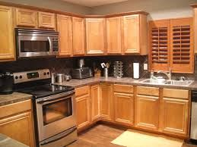Is that your …? - Yes, it is.
A. bathroom B. bedroom C. kitchen D. library
64. _ _ _ do you spell your name, Sam? - It’s S-A-M.
65. is/ large./ My/ school garden/
66. Ảnh: That is a b_ _ _ curtain.
67. A: How _ _ _ are you? - B: I’m eight.
68. Nghe: Nhấn giữ Ctrl và bấm chuột để nghe: What's ____ name?
A. his B. her C. your D. their
69. Let’s sing a s_ ng.
70. Nghe: Nhấn giữ Ctrl và bấm chuột để nghe: There are sweets, _ _ _ _ _ and lollipops.
71. Choose the incorrect word(s) in the following sentence: This is my friends Linda.
A. This B. my C. friends D. Linda
72. I’d like _ _ apple.
73. Odd one out:
A. fish B. cat C. dog D. book
74. Ảnh: FI_ _ ORANGES
75. H_ _ name is Nam.
76. Where are ... from?
A. and B. my C. you D. she
77. It ... a ball.
A. am B. is C. are D. but
78. box?/ pencil/ your/ Is/ that/
79. Nghe: Nhấn giữ Ctrl và bấm chuột để nghe: This is your … and this is your ….
A. teddy – doll B. doll– ball C. ball – book D. teddy – book
80. Sing a s...ng.
A. o B. w C. u D. q
81. Here we _ _ _ together.
82. My school isn't new. It's _ ld.
83. What is _ _ _ name? – He is Tony.
84. Flowers in the park _ _ _ very beautiful.
85. small./ isn’t/ It’s big./ The house/
86. ... morning, Simon!
A. But B. Good C. Shut D. Hi
87. ... this a pencil? – No, it isn’t.
A. Are B. Is C. It D. The
88. teacher./ Mr. Loc/ is/ my/
89. These cats a_ _ black.
90. Nghe: Nhấn giữ Ctrl và bấm chuột để nghe: f_ _ e
91. My friends/ and I/ go home/ together.
92. Nghe: Nhấn giữ Ctrl và bấm chuột để nghe: _ _ , Mr. Robot.
93. Choose the odd one out:
A. dog B. pen C. ruler D. desk
94. Give ... that pink crayon.
A. he B. she C. me D. the
95. Choose the odd one out:
A. small B. talk C. large D. old
96. Ảnh: NI_ E BOOKS
97. Nice _______ you.
A. meet B. meeting C. to meet D. is meet
98. Odd one out:
A. meet B. I C. you D. he
99. H_ _ many cats are there? – There are 2 cats.
100. a/ want/ carrot./ I/ big
101. Ảnh: He is a newcom_ _ .
102. ... to ... you, Nam.
A. Nice - meet B. Fine - hi C. You - me D. He - she
103. small./ is/ school/ Her/ new/
104. She is _ _ new friend.
105. Look,/ and repeat./ listen/
106. like/ apple,/ please./ an/ I’d/
107. Linda/ today./ goes/ to school/
108. Happy birthday. This robot is for you, Richard. – Thank you very m_ _ _ .
109. L_ _ _ ! It’s our new teacher, Miss Hien.
110. new/ That/ my/ school./ is/
111. Ảnh: This is a mar_ _ r.
112. H_ _ is your mother? – She’s fine.
113. ... name is Linda.
A. You B. He C. Her D. She
114. Which is your book? - … one.
A. The B. A C. An D. This
115. large/ Is/ and new?/ your room/
116. My new school is n_ _ big. It’s small.
117. This is Tony and this is Hoa. _ _ _ _ are my friends.
118. my/ bicycle./ That/ is/
119. See/ Goodbye./ you/ later.
120. I’m fine, thank you. ... ?
A. Hi you B. How C. And you D. Bye
121. I like to s_ _ g English song.
122. Choose the correct order.
A. L, M, N, O, P, Q B. M, L, N, O, Q, P C. N, M, L, P, Q, O D. O, L, M, N, P, Q
123. My _______’s Kevin.
A. old B. name C. class D. school
124. The pictures/ on/ are/ the wall./ not/
125. My brother/ is/ old./ seven/ years
126. My teacher is v_ _ y beautiful.
127. Ảnh: These cats are _ _ _ _ _ .
128. shoes/ My/ are/ pink./ new/
129. Nghe: Nhấn giữ Ctrl và bấm chuột để nghe: … your books.
A. Open B. Close C. Read D. Keep
130. Nghe: Nhấn giữ Ctrl và bấm chuột để nghe: That is a small ... .
A. board B. bus C. box D. boat
131. See you tomo_ _ ow.
132. is/ wall./ The picture/ on/ the
133. Lan?/ that/ Miss/ Is/
134. you/ later./ Bye./ See/
135. It’s an e_ _ _ _ r.
136. Hello, _ am Peter.
137. Ảnh: 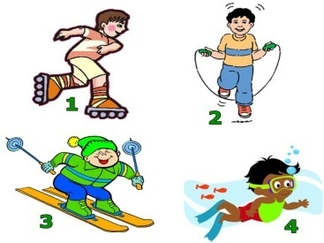Nam: Do you like swimming or skipping? - Adam: Oh, I like skipping.
A. Picture 1 B. Picture 2 C. Picture 3 D. Picture 4
138. May I go out? - Yes, ….
A. you can B. you can’t C. you aren’t D. it is
139. the table./ on/ There/ three crayons/ are/
140. This ... a pen.
A. is B. are C. he D. she
141. Goodbye. See you la_ _ r!
142. This _ _ Tom. He is my new friend.
143. cats/ that box?/ are there/ in/ How many/
144. Nghe: Nhấn giữ Ctrl và bấm chuột để nghe: bad_ _ _ _ _ _
145. kite?/ What/ colour/ that/ is/
146. Peter: Lan is my friend. - John: She’s my friend, ....
A. two B. to C. too D. who
147. I can ri_ _ a bicycle.
148. May I co_ _ in?
149. I’m fine, thank you. ... ?
A. You B. And you C. Are D. Bye
150. Can you dance, Kate? - ..., I can’t.
A. No B. Not C. Yes D. Hi
151. My/ is/ teacher/ nice.
152. I’m fine, thanks. A_ _ you?
153. What does he do ... Maths lessons?
A. from B. and C. during D. end
154. Nghe: Nhấn giữ Ctrl và bấm chuột để nghe: _ _ _ da
155. are/ What/ they?/ colour/
156. Is your classroom big? – No, it’s s_ _ ll.
157. students!/ Good/ evening,/
158. Goodbye, Alice. – Bye. See you ... .
A. later B. later’s C. laters D. a later
159. What _ _ you do at break time?
160. I’m fine, ... you.
A. thank B. thanks C. good D. bye
161. Ảnh: That ___ my pen.
A. is B. are C. am D. do
162. Nghe: Nhấn giữ Ctrl và bấm chuột để nghe: Choose the sentence that you hear:
A. I’m fine. B. I’m fine, thanks. C. Fine, thank you. D. I am fine, thank you.
163. Ảnh: 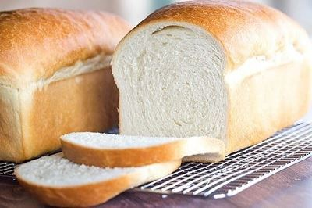I like having br_ _ _ for breakfast.
164. What c...lour is this? - It’s blue.
A. u B. o C. e D. i
165. Ảnh: _ _ _ _ _ _
166. Ảnh: There are many k_ _ _ _ in the sky.
167. the/ large?/ Is/ playground/
168. It is ... mine.
A. and B. not C. see D. nice
169. Ảnh: We often play chess in our c_ _ _ _ room.
170. Odd one out:
A. stand B. sit C. come D. book
171. Nghe: Nhấn giữ Ctrl và bấm chuột để nghe: Her old car is a ___ Honda.
A. red B. black C. white D. pink
172. Odd one out:
A. what B. orange C. blue D. yellow
173. Nghe: Nhấn giữ Ctrl và bấm chuột để nghe: Choose the sentence that you hear:
A. What is your name? B. What’s your name? C. What’s your school name? D. What is your school name?
174. What colour ... this?
A. it B. is C. that D. hi
175. Let’s draw ... picture.
A. a B. an C. the D. her
176. ___ you later.
A. Meet B. See C. Know D. Saw
177. Is this an eraser? - ... .
A. Yes, it is not B. No, it isn’t C. Yes, they are D. No, it is
178. your/ Write/ here./ name/
179. W_ _ te your name, please.
180. C_ me here!
181. there?/ How/ many/ are/ cats/
182. Nghe: Nhấn giữ Ctrl và bấm chuột để nghe: What are they? - They’re _ _ _ _ .
183. Nghe: Nhấn giữ Ctrl và bấm chuột để nghe: How many people are having lunch?
A. Five B. Six C. Four D. Seven
184. Can you play chess? - No, I _______.
A. may B. can C. can’t D. don’t
185. Nghe: Nhấn giữ Ctrl và bấm chuột để nghe: Listen and choose.
A. Go out! B. Come in! C. Stand up! D. Sit down!
186. Ảnh: Keep silen_ , please!
187. Gi_ e me the book, please.
188. - Hello, _ am Peter. - Nice to meet you, Peter.
189. is/ My/ name/ Simon.
190. _ i, I’m Peter.
191. in/ are/ the school garden./ They/
192. I’m f_ _ e, thank you.
193. Those are f_ ve boxes.
194. What ... do you have today? – Today I have Music and Maths.
A. names B. times C. subjects D. school
195. I _ _ Mai.
196. There are two book... on the desk.
A. t B. s C. r D. k
197. Take ... your books, children.
A. on B. out C. for D. at
198. Happy birthday. This robot is for you, Richard. – Thank you very m_ _ _ .
199. fishing/ go/ with him./ I/
200. ... is Mary.
A. You B. He C. She D. My

IOE K3 SỐ 13
1. cats/ in/ are there/ that box?/ How many/
2. I’m fin_ , thanks.
3. a/ Can/ she/ book?/ read/
4. Nghe: Nhấn giữ Ctrl và bấm chuột để nghe: That is a small ... .
A. board B. bus C. box D. boat
5. I’m fine, thank you. _ _ _ you?
6. come/ I/ May/ in?
7. I can ... English.
A. speaks B. speak C. to speak D. speaking
8. What colour is this? - ... .
A. It’s big B. It’s small C. It’s blue D. It’s nice
9. May I go out? - _______
A. Yes, you can. B. No, you can. C. Thank you. D. Sorry.
10. Ảnh: 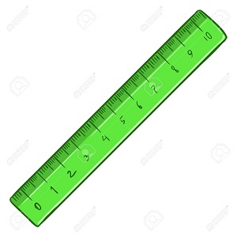That's a rul_ _ .
11. That _ _ my new book. I like it very much.
12. you?/ I’m/ fine,/ you. And/ thank/
13. Choose the odd one out:
A. classroom B. bedroom C. bathroom D. living room
14. ... I come in? - Yes, please.
A. My B. May C. Me D. Mai
15. Nghe: Nhấn giữ Ctrl và bấm chuột để nghe: _ _ _ _
16. My backpack ___ red and my rubber is yellow.
A. is B. am C. are D. not
17. This is _ green doll.
18. a/ This/ is/ doll.
19. _ _ at is your name?
20. What is her j_ _ ? – She is a teacher.
21. Nghe: Nhấn giữ Ctrl và bấm chuột để nghe: How old are you? - I’m ________ years old.
A. 10 B. 9 C. 8 D. 7
22. ... is that? – That’s Mary. She is my friend.
A. How B. When C. Who D. Where
23. Choose the odd one out:
A. is B. it C. am D. are
24. W_ sh your hand, please.
25. is/ That boy/ Peter./
26. _______, Nam. I’m Phong.
A. Bye B. Hello C. I D. Goodbye
27. Open ... book, please.
A. my B. your C. its D. is
28. Is that a pink pen? - ..., it is.
A. Yes, it is B. No, it is C. No, it isn’t D. Yes
29. ... that a round box? – No, it isn’t.
A. What B. How C. Is D. Are
30. Co_ plete the sentences.
31. Nghe: Nhấn giữ Ctrl và bấm chuột để nghe: The girl’s school has got a big _ _ _ _ _ ter room.
32. I ... Maths and Arts on Monday.
A. play B. say C. study D. look
33. Good morning, teacher! - ... .
A. Goodbye B. See you later C. Good morning D. Fine, thanks
34. Ảnh: 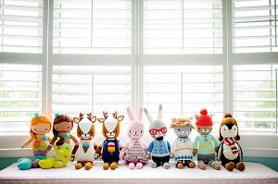NI_E DOLLS
A. D B. V C. M D. N
35. shirt./ It/ a/ is/ red
36. ... night, children.
A. Bye B. Hi C. Good D. Fine
37. Ảnh: BA_ KPACK
38. Ảnh: This is my _ _ _ cil case.
39. _______ do you spell your name?
A. How B. What C. Who D. Are
40. M_ _ I close my book? - Yes, please.
41. Circle the an_ _ er, Sam.
42. Close your ..., please.
A. name B. book C. ball D. took
43. … is the weather like today? – It’s sunny.
A. What B. How C. When D. Where
44. Nghe: Nhấn giữ Ctrl và bấm chuột để nghe: My school is _ _ _ _ _ .
45. Gi_ e me that yellow pen, please.
46. Choose the odd one out
A. Computer room B. Library C. Classroom D. Chair
47. Ảnh: 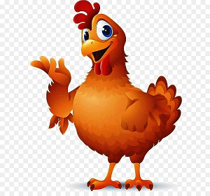That is a _____ .
A. pig B. chicken C. cat D. dog
48. Where is Simon f_ _ m? – He’s from England.
49. that/ bag?/ your/ Is/
50. She is _ _ new friend.
51. What does he do during ... lessons? - He learns about numbers.
A. Maths B. English C. Arts D. Music
52. A: Do you like skating or skipping? - B: …
A. Yes, I do. B. No, I don’t. C. I like skipping. D. I skip at break time.
53. Listen _ _ the teacher, please.
54. How many pens _ _ you have?
55. These are three pencil box_ _ .
56. ... fine, thank you
A. Hi B. I C. I’m D. Am
57. Nghe: Nhấn giữ Ctrl và bấm chuột để nghe: Which toy is orange?
A. The ball. B. The doll. C. The car. D. The teddy.
58. Anne is f_ _ r years old.
59. _ _ _ _ your grandpa like fishing?
60. ..., students. See you tomorrow.
A. Good morning B. Good night C. Goodbye D. Nice to meet you
61. Ảnh: What is that? - It’s a ….
A. chair B. desk C. door D. television
62. A: What colour is the dress? - B: ....
A. It’s too long. B. It’s very cheap. C. It’s bright yellow. D. It’s very nice.
63. _ _ n't be late!
64. How are ..., Tom? – Fine, thanks. And you?
A. you B. you’re C. your D. yous
65. these?/ are/ What/
66. Ảnh: 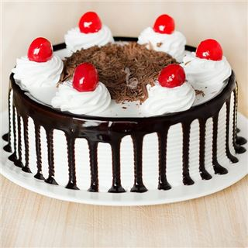It’s a _ _ _ _ .
67. your/ sister?/ How/ old/ is/
68. Ảnh: A: Are those bookcases? - B: ....
A. Yes, they are. B. No, they aren’t. C. Yes, it is. D. No, it isn’t.
69. and/ Sit down/ please!/ open/ your book,
70. Ảnh: It's my school ____ room.
A. music B. art C. lunch D. computer
71. your/ big?/ Is/ school/
72. ... are you? – I’m fine, thanks.
A. When B. How C. What D. Who
73. Nghe: Nhấn giữ Ctrl và bấm chuột để nghe: … your books.
A. Open B. Close C. Read D. Keep
74. is a/ This/ red apple./
75. That is her n_ w school.
76. Op_ _ your books, children.
77. Her eyes/ aren't/ brown. They/ are/ blue./
78. Nghe: Nhấn giữ Ctrl và bấm chuột để nghe: That is my _ _ _ _ _ _ _ .
79. Clo_ _ your pencil boxes, children.
80. Ảnh: It’s _ _ _ ny today.
81. Nghe: Nhấn giữ Ctrl và bấm chuột để nghe: _ _ _
82. Ảnh: 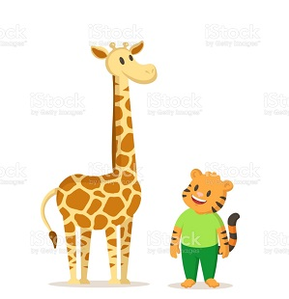SHOR_
83. Nghe: Nhấn giữ Ctrl và bấm chuột để nghe: _ ake
84. Choose the odd one out
A. Jack B. Lisa C. Linda D. Mary
85. swim./ can/ dance/ I can’t/ but I/
86. Ảnh: Peter’s pencil is … and Mary’s is ….
A. long – short B. short – long C. big – small D. small – big
87. They’re on the left and we’re on the _ _ _ _ _ .
88. M_ THER
89. My classma_ _ s are in the music room.
90. colour/ it?/ What/ is/
91. What colour is this? - ... .
A. It blue B. It’s blue C. Is blue D. It is a blue
92. to buy/ I want/ a blue scarf/ for me./ my mother/
93. Nghe: Nhấn giữ Ctrl và bấm chuột để nghe: Listen and tick:
A. This is my school bag. B. This is my school bus. C. This is my school car. D. This is my school book.
94. Nghe: Nhấn giữ Ctrl và bấm chuột để nghe: The boy’s favourite colour is ….
A. green B. pink C. red D. blue
95. Do you like to _ _ ng an English song?
96. When is your birthday? - ….
A. It’s on September B. It’s in October C. It’s second of June D. It’s in third of June
97. I like to s_ ng.
98. This is my pe_ _ _ l. It’s short.
99. She/ is/ my teacher./
100. like/ you/ ice-cream?/ an/ Would/
101. David/ school/ now./ is/ at/
102. How _ _ _ you?
103. his/ large?/ Is/ classroom/
104. How are you? - I’m _ _ _ _ , thank you.
105. What _______ these?
A. is B. are C. ant D. aunt
106. Don’t s_ _ on that chair.
107. meet/ pleased/ to/ you./ I’m/
108. Bye. S_ _ you later.
109. When the teacher wants my class not to talk, she says: ’’…’’
A. Be quiet! B. Come here! C. Sit down! D. Stand up!
110. Nghe: Nhấn giữ Ctrl và bấm chuột để nghe: DO_ N
111. My new classroom is very _ _ _ tty.
112. school/ big./ is/ My/
113. Ảnh: This is my fa_ _ _ y.
114. My cats/ yellow./ are/
115. Which is NOT outdoor activity for kids?
A. Playing soccer B. Doing yoga C. Fishing D. Climbing mountains
116. Nghe: Nhấn giữ Ctrl và bấm chuột để nghe: shar_ _ _ _ _
117. A: Is that your classmate? - B: ...
A. Yes, he isn't. B. No, she isn’t. C. Yes, it is. D. No, I’m not.
118. Let’s ma_ e a circle.
119. Nghe: Nhấn giữ Ctrl và bấm chuột để nghe: Who’s that?
A. Mary B. Jane C. Linda D. Ellie
120. Nice to m_ _ _ you, too.
121. This is a b_ cycle.
122. is/ friend/ my/ , Peter./ This/
123. birthday?/ your/ is/ When/
124. are/ skirts?/ your/ What colour/
125. Ảnh: I like having br_ _ _ for breakfast.
126. isn't big/ My room/ new./ but it's/
127. ... is that kite? - It’s green.
A. How many B. How C. What D. What colour
128. grandmother./ That/ my/ is/
129. the schoolyard./ in/ are/ Linh and Nhi/
130. Listen/ teacher carefully./ the/ to/
131. _ _ _ _ _ birthday to you, Alice.
132. It’s _ _ ice cream.
133. am/ I/ Hello,/ Andy.
134. Nghe: Nhấn giữ Ctrl và bấm chuột để nghe: This is the _ _ _ _ _ _ _ _ room.
135. father./ is/ my/ That/
136. Odd one out:
A. stand B. sit C. come D. book
137. Tram is my fr_ _ nd.
138. What’s her name ? – ....
A. I’m fine, thanks B. Her name is Daisy C. See you later D. My name is Daisy
139. I have t_ o cats.
140. I’m ... , thank you. And you?
A. nice B. bye C. fine D. hi
141. Peter can speak Vietname_ _ .
142. Ảnh: COL_ _ R
143. Nghe: Nhấn giữ Ctrl và bấm chuột để nghe: The boy likes ….
A. badminton B. tennis C. baseball D. table tennis
144. Nghe: Nhấn giữ Ctrl và bấm chuột để nghe: SCHOOL BA_ S
145. What's/ name?/ his/
146. The living room ______ big _____ old.
A. and – and B. but – but C. and - are D. is - but
147. The w_ _ ther is really cold.
148. Let’s/ room./ go to/ computer/ the/
149. children./ your/ Close/ books,/
150. Is this a bag? - ...
A. Yes, it is B. Yes, isn’t C. No, it is D. Nice to meet you
151. Sing wit_ me.
152. Ảnh: What colour is your pencil? - It’s ye_ _ _ _ .
153. Ảnh: My book i_ green.
154. Choose the odd one out:
A. white B. new C. yellow D. green
155. here./ name/ Write/ your/
156. Whose rulers _ _ _ these? – They’re mine.
157. The girl/ years/ three/ is/ old./
158. Nghe: Nhấn giữ Ctrl và bấm chuột để nghe: Listen and tick:
A. This is my pencil. B. This is my pen case. C. This is my pen. D. This is my ball.
159. Ảnh: THA_ _ YOU
160. There are/ two pens/ my/ in/ school bag./
161. ____ those your parents? - Yes, _______
A. Is - he is B. Is - she is C. Are - they are D. Are - they aren't
162. I … a blue pencil and a white ruler.
A. has B. have C. don’t have D. doesn’t have
163. Please/ come/ Mr Smith./ in,/
164. Choose the odd one out
A. Father B. Ten C. Teacher D. Friend
165. There are ten books _ _ my bag.
166. Your ... Peter.
A. name B. names C. name is D. is name
167. Hi, _ y name is Alan.
168. Wh_ t’s your name?
169. Please, s_ _ _ l your name again.
170. Your classr_ _ _ is big.
171. years/ old./ ten/ is/ She/
172. Let’s s_ y ’’Hello’’ to Tom.
173. Look … your book, please.
A. of B. in C. on D. at
174. These are ....
A. cat B. cats C. cat’s D. a cat
175. case is/ is old./ This pencil/ new. That/ pencil case
176. name/ Write/ here./ your/
177. Lis_ _ _ to the teacher, please.
178. This ... a blue pencil.
A. are B. is C. am D. the
179. drives/ car/ his/ My father/ to work./
180. I’m ... , thank you. And you?
A. nice B. bye C. fine D. hi
181. is/ What/ your primary school?/ of/ the name/
182. These/ and rulers./ aren't/ her rubbers/
183. Choose the odd one out
A. Pencils B. Pencil sharpeners C. Classroom D. Rulers
184. Please ______ the window.
A. opening B. open C. to open D. opens
185. Nghe: Nhấn giữ Ctrl và bấm chuột để nghe: Listen and tick:
A. Both Mary and Tom love cats very much. B. Both Mary and Tom love cars very much. C. Both Mary and Tom love buses very much. D. Both Mary and Tom love pets very much.
186. _ _ that a ruler? - No, it isn’t.
187. Is this a bag? - … .
A. Yes B. Yes, it is C. No, it is D. Nice to meet you.
188. you./ to/ meet/ Nice/
189. Be qu_ _ t, please.
190. Ảnh: The elephant is b_ _ .
191. How do you ... your name? - It’s J-O-H-N.
A. spend B. spell C. send D. she
192. H_ s name is Tom.
193. ______ are they? - They are black.
A. What B. What's colour C. How colour D. What colour
194. some/ has/ chalks./ He/
195. P_ _ your books down, please.
196. pencil./ a/ That/ is/ green
197. Draw _ mouse in your notebook.
198. Are/ those/ your/ friends?
199. Is your classroom big? – No, it’s s_ _ ll.
200. What colour ... this?
A. it B. is C. that D. hi

IOE K3 SỐ 14
1. Let’s cou_ _ the boys.
2. Nghe: Nhấn giữ Ctrl và bấm chuột để nghe: Listen and tick
A. How are you? B. What are they? C. How old are you? D. Who are you?
3. My _ _ _ e is John.
4. Have a n_ _ _ day!
5. Unscramble this word: ’’RYRALIB’’ -> ’’_ _ BRARY’’.
6. Let’s ... a song.
A. look B. open C. sing D. sit
7. She is/ classroom/ the/ now./ in/
8. I’m fine. How ab_ _ t you?
9. This is a ca...ot.
A. rt B. rs C. rr D. rq
10. Ảnh: 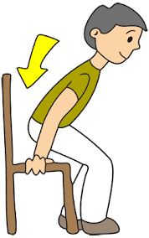Choose the best answer:
A. Come in B. Go out C. Sit down D. Stand up
11. _ _ _ you OK, John?
12. Those/ my/ pencils./ aren't/
13. Good mo_ _ ing, children!
14. May/ open/ the book,/ I/ Miss Brown?/
15. Hello. What is ____ name?
A. your B. you C. me D. him
16. It is so mu_ _ fun.
17. my/ are/ Tony and Peter/ best friends.
18. Nice _ _ meet you!
19. school/ Is your/ bag/ brown/ or black?/
20. How are you?
A. I’m Philip. B. I’m fine, thanks. C. I’m seven. D. I’m a pupil.
21. Where _ _ _ you from? - I’m from England.
22. has/ dolls./ two/ Mary/
23. Cl_ _ e your books, please.
24. What are those? – ... .
A. They’re blue pen B. They’re blue pens C. It’s blue pens D. It is a blue pen
25. _ _ _ old are you? - I’m eleven years old.
26. Nghe: Nhấn giữ Ctrl và bấm chuột để nghe: Listen and tick:
A. Nice to know you, Li Li. B. Nice to meet you, Li Li. C. Nice to see you, Li Li. D. Nice to have you, Li Li.
27. Nghe: Nhấn giữ Ctrl và bấm chuột để nghe: LI_ _ _ _ _
28. Nghe: Nhấn giữ Ctrl và bấm chuột để nghe: He’s _ _ _ _ _ years old.
29. your/ and open/ Stand up/ now/ books, please./
30. Is it _ ruler? – No, it isn’t.
31. ...at colour is this? – It’s blue.
A. Wt B. Ho C. Wh D. We
32. your/ is/ name?/ mother's/ What/
33. Ảnh: 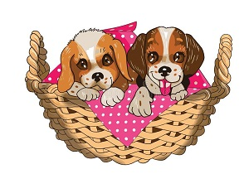T_ O PUPPIES
34. My/ backpack/ black and/ is/ white./
35. Count the ... in the class, please.
A. she B. boys C. girl D. he
36. fishing/ Let's/ this/ go/ afternoon./
37. ______ old are you?
A. How B. What C. Which D. When
38. Nghe: Nhấn giữ Ctrl và bấm chuột để nghe: _ _
39. It is my chai...
A. t B. w C. r D. s
40. Nghe: Nhấn giữ Ctrl và bấm chuột để nghe: Listen and tick:
A. What’s that? -That’s my pet. B. What’s that? -That’s my desk. C. What’s that? - That’s my bag. D. What’s that? - That’s my bus.
41. Nghe: Nhấn giữ Ctrl và bấm chuột để nghe: F_VE
A. I B. O C. E D. A
42. Ảnh: 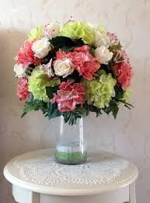There is a vase of flowers on the t_ _ _ _ .
43. Have ... nice day!
A. a B. an C. the D. this
44. What colour is this ruler? - It is ... .
A. big B. small C. green D. short
45. Nghe: Nhấn giữ Ctrl và bấm chuột để nghe: Listen and tick:
A. My brother is very tall. B. My father is very tall. C. My brother isn’t very tall. D. My mother is very tall.
46. My sister likes to go sw_ _ _ _ ng in summer.
47. Let’s make a li_ e.
48. Bru_ h your teeth, Tom.
49. I/ Rosie./ Hi./ am/
50. This _ _ my new school.
51. very/ well,/ you./ thank/ I am/
52. W_ o is she? – She’s my teacher.
53. Is/ a desk?/ this/
54. Ảnh: 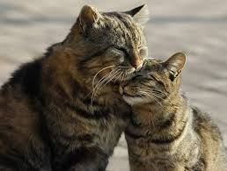These are t_ _ cats.
55. I have _ _ apple.
56. Nice to m__t you.
A. ee B. ii C. oo D. aa
57. can/ I can’t/ swim./ but I/ dance/
58. There are ten books _ _ my bag.
59. to/ meet/ Sam./ Nice/ you today,
60. I go to school with my _ riends.
61. Nghe: Nhấn giữ Ctrl và bấm chuột để nghe: Choose the correct response.
A. I’m fine, thank you. B. Goodbye, Sally. C. I don’t know you. D. Hi, Sally. Nice to meet you.
62. My classmates like to _ _ ay hide-and-seek.
63. What are _ _ _ se? – These are pink dolls.
64. Nghe: Nhấn giữ Ctrl và bấm chuột để nghe: The _ _ _ room is over there.
65. These/ pencils/ are/ short.
66. Ảnh: SILE_ T
67. Odd one out:
A. Daisy B. Michael C. Jenny D. Mary
68. I'm in ___ 3C.
A. grade B. class C. classroom D. school
69. for you,/ John./ pink pen/ This/ is/
70. It’s _ _ ice cream.
71. I ... Andy.
A. are B. am C. is D. you
72. Ảnh: A: Who’s Tracy? - B: The girl is in the yellow shirt.
A. 1 B. 2 C. 3 D. 4
73. What is your name? - ... .
A. Her name is Mary B. His name is Peter C. My name is Harry D. Your name is Simon
74. _______ quiet, please.
A. Be B. Don’t C. No D. Do
75. brown. They/ are/ blue./ aren't/ Her eyes/
76. Ảnh: Her _ _ _ _ _ _ _ _ is small.
77. new friends./ They/ are/ my/
78. is/ apple./ a/ red/ That/
79. Ảnh: Those notebooks are Sarah’s.
A. Picture 1 B. Picture 2 C. Picture 3 D. Picture 4
80. ... to ... you, Simon. How are you?
A. Nice – meet B. Fine – hi C. You – me D. He – She
81. Do you have toys? – Yes, I h_ _ _ a doll.
82. That is a cha...r.
A. e B. a C. i D. u
83. This isn’t ... bag.
A. her B. he C. she D. this
84. And/ fine,/ thank you./ you?/ I’m/
85. Ảnh: Molly’s favourite sport is bask_ _ _ _ _ _ .
86. ... is his name? – His name is John.
A. Where B. What C. When D. Who
87. Nghe: Nhấn giữ Ctrl và bấm chuột để nghe: H_ LLO
88. , Peter./ your/ Open/ schoolbag/
89. Nghe: Nhấn giữ Ctrl và bấm chuột để nghe: _ _ _ gry
90. A: Who’s in the _ _ _ puter room? - B: My teacher, Mr. Tuan.
91. How _______ Hai?
A. am B. is C. are D. and
92. It ... a ball.
A. are B. an C. be D. is
93. It is _ _ ice cream.
94. Ảnh: SC_ OOL
95. This is m_ cat.
96. Be qu_ _ t, please.
97. These are three pencil box_ _ .
98. See you tomo_ _ ow.
99. are/ those?/ Who/
100. Let’s look ... read.
A. and B. end C. an D. hello
101. so/ My/ big./ is/ classroom/
102. is/ old./ three/ The girl/ years
103. A: Who’s that _ _ _ _ ? - B: She’s Linda.
104. are/ in/ My/ notebooks/ my school bag./
105. and I/ are/ in the playground./ My friends/
106. Nghe: Nhấn giữ Ctrl và bấm chuột để nghe: policema_
107. ... morning, Adam!
A. Hello B. Hi C. Good D. You
108. These shoes are yours, not _ _ _ _ .
109. Sit down/ your book,/ open/ and/ please!/
110. ... your name?
A. Who B. How C. What’s D. Why
111. ... are you? – I’m fine, thanks.
A. Who B. What C. How D. When
112. His/ Peter./ is/ name/
113. my/ pens./ are/ These/
114. I’m fine, ... you. And you?
A. thanks B. thank C. thank you D. thanks you
115. brown./ is/ bookcase/ The/
116. ... is her name? – Her name is Joane.
A. How B. What C. When D. Who
117. Is this a notebook? – No, ... .
A. it isn’t B. it is C. it does D. it doesn’t
118. How m...ny pets do you have? – I have one cat.
A. u B. i C. a D. e
119. Is this a bag? - ... .
A. Yes, it is B. Yes, isn’t C. No, it is D. Nice to meet you.
120. Nghe: Nhấn giữ Ctrl và bấm chuột để nghe: Who’s that?
A. Mary B. Jane C. Linda D. Ellie
121. Come ..., please.
A. out B. in C. to D. under
122. Jenny is a … at London Primary School.
A. boy B. toy C. student D. she
123. Ảnh: TWO B_ LLS
124. ... many pens are there in your school bag? – There are 3 pens.
A. How B. What C. Who D. When
125. What/ is/ doing?/ he/
126. _ ice to meet you.
127. Minh has a blue shirt, a red shirt and a black shirt. He has ____ shirts.
A. three B. four C. five D. six
128. What school is _ _ ?
129. Make two …, please.
A. bye B. lines C. fine D. five
130. There/ my family./ four people/ in/ are/
131. Look ... the board, please.
A. on B. in C. at D. to
132. your rulers/ and/ they/ your book?/ Are/
133. His na_ _ is Peter.
134. house/ is/ big./ not/ Her/
135. Ảnh: I have a bl_ _ ball.
136. I _ _ Simon. I am in class 3A.
137. How many notebooks are there? - ... .
A. Three bags B. Three books C. Three notebooks D. Three pens
138. Stand _ _ , please.
139. What colour is your teddy bear?
A. It brown. B. It is brown. C. Its brown. D. Is brown.
140. your/ book./ new/ is/ Here/
141. your/ hands,/ Wash/ Tom.
142. What c_ _ _ ur is this? – It is pink.
143. How are you? - ... .
A. I’m Binh B. She’s my sister C. I’m fine, thank you D. Goodbye
144. W_ _ _ are these? – These are pencil cases.
145. Nghe: Nhấn giữ Ctrl và bấm chuột để nghe: It’s a _ _ _ blue green ball.
146. How are ... ?
A. he B. Lan C. you D. bye
147. Ảnh: 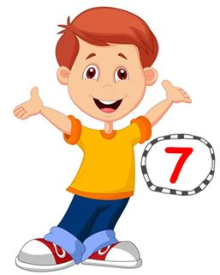He’s se_ _ _ years old.
148. That is a big tr...e.
A. a B. u C. e D. i
149. My n_ me is Hieu.
150. sing/ English songs./ likes to/ dance and/ Mary/
151. Ảnh: CA_
152. Please ______ the window.
A. opening B. open C. to open D. opens
153. years/ seven/ is/ old./ Peter/
154. _ _ _ , he is.
155. in the room?/ Is/ Tony/
156. mum/ My/ cook./ can/
157. Ảnh: 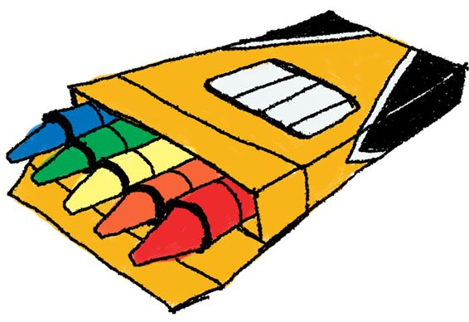You use cr_ _ _ _ s to colour the pictures.
158. go/ May/ out?/ I/
159. Peter is ___ the classroom.
A. in B. for C. on D. at
160. Ảnh: Keep silen_ , please!
161. Ảnh: 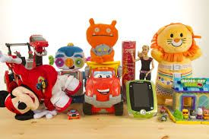I have many t_ _ s.
162. Stand ____!
A. down B. up C. on D. in
163. Ảnh: It's the _ rt room.
164. you hear/ words/ , please./ the/ Check/
165. A: What colour are those T-shirts? - B: ... are brown.
A. Those B. These C. We D. They
166. OR_ NGE
167. Go to t_ e door, please.
168. B_ OK
169. My/ doctor./ a/ father/ is/
170. W_ _ is that? – That’s Jenny. She is my friend.
171. Nghe: Nhấn giữ Ctrl và bấm chuột để nghe: Let’s go to _ _ _ _ _ _ together.
172. I ... Monday and Wednesday because I have Maths lessons then.
A. fun B. bye C. like D. buy
173. Nghe: Nhấn giữ Ctrl và bấm chuột để nghe: Listen and tick:
A. The ball is green. B. The doll is green. C. The boy is brown. D. The ball is brown.
174. Open ... book, please.
A. your B. I C. you D. your’s
175. My father likes to _ _ _ _ _ a car.
176. Is your school new? - No. It's _____.
A. new B. old C. not D. is
177. Jane is not ... name.
A. he B. her C. I D. you
178. Ảnh: 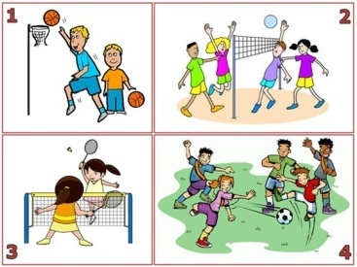They like playing volleyball.
A. Picture 1 B. Picture 2 C. Picture 3 D. Picture 4
179. is/ What/ your/ name?/ friend’s
180. My/ new and big./ school/ is/
181. _ i, I’m Peter.
182. Ảnh: This is my book_ _ _ _ .
183. ... is a bird.
A. You B. He C. It D. She
184. Wash/ your/ hands,/ Tom.
185. Nghe: Nhấn giữ Ctrl và bấm chuột để nghe: _ _ _ _
186. What is this? – It is … ice cream.
A. a B. an C. these D. that
187. Ảnh: My brother likes to play _ _ _ _ _ .
188. Write ... the teacher says.
A. what’s B. you C. where’s D. what
189. What's your name? - My _____ Hoa.
A. name B. name's C. name're D. name are
190. Nghe: Nhấn giữ Ctrl và bấm chuột để nghe: Listen and tick:
A. Both Mary and Tom love cats very much. B. Both Mary and Tom love cars very much. C. Both Mary and Tom love buses very much. D. Both Mary and Tom love pets very much.
191. Nghe: Nhấn giữ Ctrl và bấm chuột để nghe: ... your books, please.
A. Open B. Close C. Listen D. Go
192. please./ I’d/ like/ apple,/ an/
193. Who’s that? That’s ... .
A. my’s teacher B. me’s teacher C. my teacher D. me teacher
194. H_ _ many students in your class?
195. song./ sing/ English/ an/ Let’s/
196. She is _ student.
197. Ảnh: 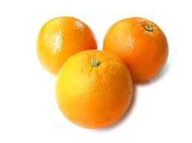There are _ _ _ _ _ oranges on the table.
198. his/ old shoes./ are/ They/
199. Be qu_ _ t. Listen to the teacher, please.
200. Cl_ _ n your teeth, please.

IOE K3 SỐ 15
1. This is my brother and this is … bike.
A. her B. his C. their D. its
2. This _ _ my new school.
3. Circle the an_ _ er.
4. is/ eraser./ That/ an/
5. Ảnh: That's my computer _ oom.
6. Let’s/ learn/ English./
7. What does he do ... Maths lessons?
A. from B. and C. during D. end
8. Do you like cakes? – Yes, I ... .
A. am B. is C. are D. do
9. This is _ _ apple.
10. Let’s dr_ _ a picture.
11. Hi, Alice. I _ _ Tommy.
12. I go … school in the morning.
A. in B. at C. on D. to
13. ___ is his name?
A. What B. Where C. How D. Why
14. do/ you/ What/ subjects/ like?/
15. the/ is/ table./ The computer/ on/
16. at/ Look/ teacher./ the/
17. Nghe: Nhấn giữ Ctrl và bấm chuột để nghe: These are my ____.
A. rubbers B. rulers C. pens D. pencils
18. St_ _ d up, please.
19. to play/ I/ like/ volleyball/ in the evening./
20. Nghe: Nhấn giữ Ctrl và bấm chuột để nghe: May I s_ t down?
21. you./ thank/ am/ I/ fine,/
22. Thomas plays hide-and-_ _ _ _ with his friends at weekend.
23. am/ I/ Mary./ Hello./
24. from/ friend/ My new/ France./ is/
25. Those are f_ ve boxes.
26. G_ _ dbye.
27. So_ _ y. I am late.
28. _ _ _ t is your name?
29. ... morning, Simon!
A. But B. Good C. Shut D. Hi
30. Give/ your/ me/ notebooks.
31. Stand _ _ , please!
32. Nghe: Nhấn giữ Ctrl và bấm chuột để nghe: This _ _ _ is pink and yellow.
33. Is your school big? - _ _ _ , it is.
34. Nghe: Nhấn giữ Ctrl và bấm chuột để nghe: _ _ _ are you?
35. Bella'_ in her bedroom.
36. She is _ _ new friend.
37. Nghe: Nhấn giữ Ctrl và bấm chuột để nghe: Peter likes _ _ _ _ _ _ _ _ but Lulu doesn’t.
38. G_ _ _ bye, see you later.
39. Nghe: Nhấn giữ Ctrl và bấm chuột để nghe: _ at
40. morning,/ Hien./ Miss/ Good/
41. This/ is a/ book./ green/
42. What do you play ... break time?
A. on B. at C. in D. by
43. on/ the paper./ your name/ Write/
44. Ảnh: She is my new tea_ _ er.
45. My n_ me is Lan.
46. Is your school ...? - No, it is small.
A. big B. this C. bye D. these
47. some/ He/ chalks./ has/
48. A: Is that your classmate? - B: ...
A. Yes, he isn't. B. No, she isn’t. C. Yes, it is. D. No, I’m not.
49. Nghe: Nhấn giữ Ctrl và bấm chuột để nghe: How old are you? - I’m ________ years old.
A. 4 B. 5 C. 6 D. 7
50. is/ my/ Mr. Loc/ teacher.
51. Do you like milk? – No, I ... .
A. do B. does C. doesn’t D. don’t
52. How … people are there in your family?
A. much B. are C. many D. old
53. my school bag./ There are/ in/ ten/ pencils/
54. Take/ notebooks,/ out/ please./ your/
55. the/ on/ is/ The picture/ wall./
56. Choose the correct sentence
A. They are two pens. B. They are two pen. C. It is two pen. D. It is two pens.
57. _ _ _ _ your grandpa like fishing?
58. How old is your sister? - … is fifteen years old.
A. He B. She C. They D. It
59. Ảnh: 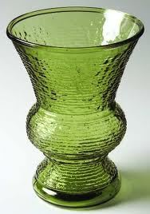That is a green flower v_ _ _ .
60. How are you? - ... .
A. I’m Binh B. She’s my sister C. I’m fine, thank you D. Goodbye
61. We learn about _ _ _ _ _ _ _ in Maths.
62. Is this a book? – Yes, … .
A. I am B. it is C. is it D. it isn’t
63. aren't/ Those/ pencils./ my/
64. Bye, Tommy. - Bye. ... you later.
A. See’s B. Sees C. See D. To see
65. the blue/ book,/ me/ please./ Give/
66. What/ is/ name?/ your/
67. Nghe: Nhấn giữ Ctrl và bấm chuột để nghe: My school _ _ _ is very long.
68. Ảnh: The rainbow has many colo_ _ s.
69. How ol_ are you?
70. Nice to meet you _ _ o.
71. Put your book a_ _ y please.
72. She is tw_ years old.
73. Co_ plete the sentences.
74. Ảnh: 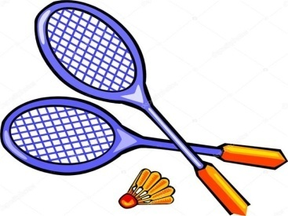A: Does Peter like badm_ _ _ _ _ ? - B: Yes, he does.
75. I like/ my friends./ to go/ with/ to school/
76. Who is he? - ... .
A. She is Mary B. He my friend C. She my friend D. He’s Tom
77. Don’t/ a/ make/ mess.
78. That’s Miss White. She is my _ ew teacher.
79. The doctor _ _ nice.
80. Nghe: Nhấn giữ Ctrl và bấm chuột để nghe: _ _ _ _ _
81. My school _ _ new.
82. _ _ _ you OK, Henry?
83. You are wel_ _ me.
84. are/ my school bag./ notebooks/ in/ My/
85. Have ... nice day!
A. a B. an C. the D. this
86. that/ girl?/ is/ Who/
87. Ảnh: ’’Open your book, please.’’
A. Picture 1 B. Picture 2 C. Picture 3 D. Picture 4
88. Odd one out:
A. fish B. cat C. dog D. book
89. Nghe: Nhấn giữ Ctrl và bấm chuột để nghe: shar_ _ _ _ _
90. Is that a pink pen? - ..., it is.
A. Yes, it is B. No, it is C. No, it isn’t D. Yes
91. Is this a bag? - … .
A. Yes B. Yes, it is C. No, it is D. Nice to meet you.
92. isn’t/ ten. He’s/ My/ nine./ brother/
93. What colour ... this? - It’s yellow.
A. it B. is C. that D. hi
94. His n_ _ e is Tommy.
95. Good m_ _ ning, everyone.
96. Nghe: Nhấn giữ Ctrl và bấm chuột để nghe: The _ _ _ room is over there.
97. Ảnh: _ _ _ _ _
98. Ảnh: You use cr_ _ _ _ s to colour the pictures.
99. Nghe: Nhấn giữ Ctrl và bấm chuột để nghe: policema_
100. Nghe: Nhấn giữ Ctrl và bấm chuột để nghe: My ... is a teacher.
A. mother B. brother C. father D. sister
101. How m...ny pets do you have? – I have one cat.
A. u B. i C. a D. e
102. Peter: Lan is my friend. John: She’s my friend, ... .
A. too B. to C. two D. who
103. Look at t_ e blue kite.
104. It’s ... ruler.
A. are B. a C. an D. is
105. My _ ame is Tony.
106. Nghe: Nhấn giữ Ctrl và bấm chuột để nghe: _ _ _ _ _
107. Choose the odd one out
A. school B. teacher C. student D. bedroom
108. I go to school library to ... books.
A. read’s B. reads C. read D. read to
109. T_ _ e out your notebooks, children.
110. this?/ colour/ is/ What/
111. spell/ his name?/ How/ do you/
112. Hello, my name _ _ Tom.
113. W_ AT
114. _ _ _ is Tim happy today? - Because today is his birthday.
115. I’m fine, ... you.
A. thanks B. thank C. thank you D. thanks you
116. My ... is Jean.
A. name’s B. names C. name D. namese
117. I like to s_ _ g English song.
118. Let’s sing with ... .
A. he B. I C. me D. she
119. It’s/ to/ you./ see/ nice/
120. T_ ank you very much.
121. Give/ me/ chalks,/ please./ some/
122. Ảnh:
W_ _ t is this? – This is a red marker.123. That woman _ _ my teacher, Alice.
124. P_ _ your books down, please.
125. Good_ ye. See you tomorrow.
126. his/ is/ robot./ This/
127. Kevin and Mark ___________ my friends.
A. am B. is C. are D. it
128. Ms. Hoa?/ come in,/ May I/
129. teacher/ She/ is/ my/ , too./
130. Her family n_ _ _ is Green.
131. It’s nice to s_ _ you.
132. Put your pencils a_ ay, please.
133. _ _ n't be late!
134. _ _ o is that? – That’s Mary.
135. I ... Mai.
A. am B. am’s C. are D. is
136. hungry/ am/ very/ now./ I/
137. Nghe: Nhấn giữ Ctrl và bấm chuột để nghe: Choose the sentence that you hear:
A. I’m fine. B. I’m fine, thanks. C. Fine, thank you. D. I am fine, thank you.
138. What is this? - ... .
A. My name is Andy B. It is a doll C. It’s an doll D. This is Mary
139. Ảnh: I have got a skipping r_ _ e.
140. you./ to/ Nice/ meet/
141. Please dr_ _ a picture, children.
142. What’s the ... with Carol? – She is sick.
A. matters B. matter C. a matter D. matter’s
143. Look _ _ my house.
144. three/ books/ table./ There are/ on the
145. Nghe: Nhấn giữ Ctrl và bấm chuột để nghe: I’ve got two ... .
A. hats B. apples C. oranges D. balls
146. our/ is/ teacher./ new/ Mrs. Samantha/
147. How are ...? - Fine, thanks.
A. you B. you’s C. your D. you’re
148. are/ the table./ on/ The school things/
149. Give ... a pen.
A. he B. me C. she D. they
150. Choose the odd one out
A. Pencil case B. Ruler C. Rubber D. School
151. ... is that? – It is a bird.
A. When B. Who C. How D. What
152. N...ce to meet you!
A. u B. w C. e D. i
153. Those/ aren't/ my/ rulers.
154. He ...Tom. He’s my new friend.
A. is B. are C. be D. am
155. How _ _ you spell your name?
156. Choose the odd one out:
A. are B. am C. is D. I
157. SO_ G
158. Let's/ English/ songs./ sing/ some/
159. Odd one out:
A. what B. orange C. blue D. yellow
160. ..., I’m Tom.
A. Hi B. Goodbye C. See you D. Bye
161. Is this a bag? - ...
A. Yes, it is B. Yes, isn’t C. No, it is D. Nice to meet you
162. school playground/ your/ large?/ Is/
163. Her school is not big. It’s ... .
A. a small B. small C. is small D. it’s small
164. Who __ that?
A. are B. is C. do D. doing
165. like/ noodles?/ Do/ you/ eating
166. new/ friend./ She/ is/ my/
167. _ _ ce to meet you, Lan Anh.
168. Ảnh: They are in th_ classroom.
169. pencil./ a/ That/ is/ green
170. Nice/ to/ Tommy./ you,/ meet/
171. Eleven, thirteen, ..., seventeen, nineteenThe missing number is:
A. 10 B. 11 C. 14 D. 15
172. Choose the odd one out:
A. classroom B. bedroom C. bathroom D. living room
173. These/ are/ my blue/ pencil/ cases./
174. This … a cassette.
A. are B. is C. am D. an
175. What ... is this? – It’s blue.
A. colour B. colours C. colour’s D. coulor
176. Three pen_
177. Nghe: Nhấn giữ Ctrl và bấm chuột để nghe: Look at the ….
A. classroom B. bathroom C. bedroom D. music room
178. _______. See you again.
A. Good morning B. Good afternoon C. Good evening D. Goodbye
179. Nghe: Nhấn giữ Ctrl và bấm chuột để nghe: Listen and tick:
A. We’re a happy family. B. We’re a happy class. C. We’re a happy school. D. We’re happy friends.
180. TEACH_ R
181. Choose the odd one out:
A. cake B. pizza C. cheese D. bottle
182. Ảnh: Be q_ iet , boys!
183. but/ house is/ small/ nice./ My/
184. What is ... name? – My name is Simon.
A. I B. he C. my D. your
185. May I go ______?
A. out B. in C. off D. on
186. Ảnh: What are these? - They are ….
A. erasers B. pens C. rulers D. pencils
187. Ảnh: N_ _ EBOOK
188. Nghe: Nhấn giữ Ctrl và bấm chuột để nghe: H_ LLO
189. SCHOOL-B_ G
190. How are you? - ...
A. Five, thanks B. Fine, thanks you C. Five, thanks you D. Fine, thanks.
191. need/ I/ sharpener./ pencil/ a new/
192. My sister … go to the zoo at the weekend.
A. don’t B. doesn’t C. aren’t D. isn’t
193. We play football in the play_ _ _ _ _ _ after school.
194. please!/ Say/ something,/
195. Nghe: Nhấn giữ Ctrl và bấm chuột để nghe: Hello, Mr Ro_ _ _ .
196. H_ _ name is Tom.
197. ... are you from, Nichols? – I’m from Australia.
A. When B. Who C. Where D. How
198. Ảnh: B_ ACK
199. Choose the odd one out
A. Ruler B. Pen C. Book D. Library
200. sharpener/ pink./ is/ The pencil/

IOE K3 SỐ 16
1. Ảnh: FI_ _ ORANGES
2. cats and dogs?/ her/ Are/ those/
3. red and white/ is/ ruler./ This/ a/
4. Nice … meet you, Susan.
A. too B. to C. two D. toe
5. It’s _ _ ice cream.
6. These are my dol_ _ .
7. Choose the letter(s) to make a correct word: RU__ER
A. PP B. BB C. LL D. MM
8. out,/ Sir?/ I/ May/ go/
9. Let’s … to music, Harry.
A. come B. listen C. write D. go
10. Ảnh: 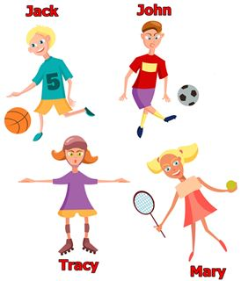Look at the picture and choose the FALSE sentence.
A. Jack likes baseball. B. John likes football. C. Tracy likes skating. D. Mary likes tennis.
11. your/ name./ down/ write/ Please,/
12. I ... watching television.
A. is B. are C. am D. aren’t
13. Nghe: Nhấn giữ Ctrl và bấm chuột để nghe: She is in _ _ _ music room.
14. Good ev_ _ ing, Tom.
15. _________ my cats.
A. That is B. This are C. They are D. Those is
16. fish/ in/ The/ is/ the bottle./
17. Ảnh: 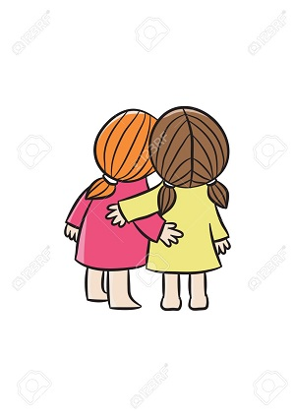FRI_ ND
18. Choose the odd one out:
A. frog B. desk C. tiger D. lion
19. Mary/ the school/ is/ at/ gate./
20. I _ _ _ _ breakfast with my sister.
21. This _ _ my new school.
22. TH_T
A. I B. A C. E D. O
23. your classroom?/ students/ How many/ in/ are there/
24. Mary is at sch_ _ l.
25. Can you sing English songs, Jane? – Yes, I ....
A. can’t B. can’s C. can D. cans
26. Goodbye, _ _ _ you later.
27. A: What _ _ _ our is your pen? - B: It’s brown.
28. Nghe: Nhấn giữ Ctrl và bấm chuột để nghe: _ _ LER
29. Bob: What is this? - Peter: ...
A. His name is Hien. B. It is a ruler. C. It’s an ruler. D. It is my friend.
30. Is this a bag? - ... .
A. Yes, it is B. Yes, isn’t C. No, it is D. See you later
31. My name _ s Adam.
32. Nghe: Nhấn giữ Ctrl và bấm chuột để nghe: Where is Amy now?
A. In her room. B. In the yard. C. Under a tree. D. In the garden.
33. Goodbye. See you tomo_ _ ow.
34. Ảnh: What do you do at break time? – I ... .
A. play tennis B. play football C. play chess D. swim
35. Ảnh: NEWCOM_ R
36. Nghe: Nhấn giữ Ctrl và bấm chuột để nghe: They are in the _ _ _ _ _ _ .
37. _ pen your books, please.
38. How/ there?/ books/ are/ many/
39. Ảnh: Is that a blue pencil case? - ______
A. Yes, its is. B. Yes, it's is. C. Yes, it is D. Yes, it isn't
40. This is ... red apple.
A. are B. a C. am D. an
41. old/ your/ is/ How/ baby sister?/
42. How are you? - ... .
A. My name is Mary B. She’s my friend C. I’m fine, thank you D. Bye. See you later
43. after/ me./ Please/ repeat/
44. Good ni_ _ _ , children.
45. Hello. My name’s Tommy. - ...
A. See you later. B. Good night. C. Hi. I am Peter. D. Goodbye.
46. Nghe: Nhấn giữ Ctrl và bấm chuột để nghe: The _ _ _ _ _ _ _ _ are in the classroom.
47. See/ Goodbye./ you/ later.
48. Ảnh: 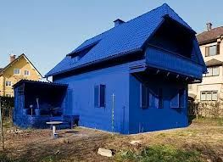My house is _ _ _ _ .
49. L_ ok at the board.
50. Bye. ___ you soon.
A. See B. Get C. Meet D. Have
51. W_ sh your hand, please.
52. your/ a/ mum/ nurse?/ Is/
53. Today's children, _______'s future.
A. today B. tomorrow C. yesterday D. next day
54. Please/ come/ in,/ Mr Smith.
55. Ảnh: They are in the pl_ _ ground .
56. Nguyen Du Primary School./ I am/ at/ a/ student/
57. How are ...? - Fine, thanks.
A. you B. you’s C. your D. you’re
58. Ảnh: That is a green _ _ _ .
59. Would/ like/ ice-cream?/ you/ an
60. The computer room is small ____ new.
A. and B. with C. but D. in
61. television./ is/ She/ watching/
62. How are ..., Tom? – I’m fine, thank you.
A. he B. she C. you D. his
63. Nice to meet you. - Nice to meet you, _ _ _ .
64. Nghe: Nhấn giữ Ctrl và bấm chuột để nghe: She’s ... a kite.
A. making B. flying C. playing D. drawing
65. Nghe: Nhấn giữ Ctrl và bấm chuột để nghe: My pencil is _ _ _ _ _ .
66. A: Goodbye! - B: _________
A. Fine, thanks. B. See you later. C. Good morning! D. Thank you!
67. up/ and come/ here./ Stand/
68. This is ______ apple and that is ______ orange.
A. a – a B. a – an C. an – an D. an - Ø
69. from/ are/ They/ America.
70. a red/ That/ pencil./ is/
71. Nam is/ years old,/ ten/ too.
72. Lan and Hoa skip at br_ _ _ time.
73. _ _ _ Mai and Hoa your friend?
74. Jenny is my friend. _ _ _ is from Hanoi.
75. Are they your new _______?
A. friends B. teacher C. pen D. listen
76. Ảnh: Who is she? – She is Lan. She is my t_ _ _ _ _ _ .
77. This is a b...y.
A. u B. o C. i D. e
78. They are Jane ... Lily.
A. are B. is C. and D. bye
79. This is my sc_ _ _ l.
80. Nghe: Nhấn giữ Ctrl và bấm chuột để nghe: Let’s go to the school _ _ _ _ _ _ _ .
81. is/ This/ my/ best friend.
82. pen./ that/ Look at/ green/
83. Nghe: Nhấn giữ Ctrl và bấm chuột để nghe: Choose the sentence that you hear:
A. This is Peter. And that’s Tony. B. That’s Peter. And that’s Tony. C. That’s Peter. And that’s Mary. D. That’s Tony. And that’s Mary.
84. My/ school/ new and big./ is/
85. Is that a pen? - ..., it isn’t.
A. Yes B. Yes, it is C. Not D. No
86. We go to school to ... .
A. stay B. study C. sit D. go
87. Is this a pen? – No, ... isn’t.
A. this B. it’s C. its D. it
88. Ảnh: There are f_ _ _ coloured pencils in the pencil case.
89. Nice to _______ you.
A. mit B. meat C. meet D. miit
90. Goodbye. See you tomo_ _ ow.
91. H_ , I’m Simon. Nice to meet you.
92. Ảnh: It's the _ rt room.
93. is/ new/ gym/ large./ The/
94. That hat is pi_ k.
95. How do you ... your name? - It’s J-O-H-N.
A. spend B. spell C. send D. she
96. goes/ Sue/ at/ to school/ 7 o'clock./
97. Look _ _ the picture, please.
98. a yo-yo./ play/ can/ He/ with
99. Is that your friend? - _ _ _ , he is.
100. Hi,/ you?/ How/ Mary./ are
101. Nghe: Nhấn giữ Ctrl và bấm chuột để nghe: Her old car is a ___ Honda.
A. red B. black C. white D. pink
102. What is your name? - ... .
A. Her name is Mary B. His name is Peter C. My name is Harry D. Your name is Simon
103. This is a ca...ot.
A. rt B. rs C. rr D. rq
104. Is/ your new/ friend?/ that/
105. How old is Minh? - He’s _______.
A. tent B. for C. four D. too
106. These are my new ...: Adam, Alex and Anna.
A. friends B. friends’s C. friend D. friend’s
107. L_ _ k at the blackboard and read after me.
108. Nghe: Nhấn giữ Ctrl và bấm chuột để nghe: Listen and choose the school thing which is NOT in the recording.
A. rubber B. ruler C. pencil D. crayon
109. Nghe: Nhấn giữ Ctrl và bấm chuột để nghe: Listen and tick:
A. What are these? -They are my pencils B. What are these? - They are my pens. C. What are these? - They are my bags. D. What are these? - They are my balls.
110. Listen _ _ _ repeat.
111. Nghe: Nhấn giữ Ctrl và bấm chuột để nghe: _ octor
112. Open your book, … .
A. for B. please C. no D. how
113. Ha_ _ y birthday to you, Peter.
114. Hello, my name _ _ Tom.
115. How are ... ? - I’m fine, thanks.
A. he B. Lan C. you D. bye
116. … father can’t fly.
A. He B. Hi C. You D. My
117. A: Is your school big? - B: _ _ _ , it is.
118. I ha_ _ an apple.
119. ball./ is/ a blue/ It/
120. Nghe: Nhấn giữ Ctrl và bấm chuột để nghe: How do you ... your name?
A. spend B. ten C. spell D. tell
121. Choose the odd one out:
A. orange juice B. apple C. water D. milk
122. _ _ w do you spell your name?
123. Would you like some m_ _ k? – Yes, please.
124. Let’s mak_ a line.
125. Nghe: Nhấn giữ Ctrl và bấm chuột để nghe: Let’s go to _ _ _ _ _ _ together.
126. The flower vase is ... the table.
A. at B. for C. on D. to
127. She is ... the classroom now.
A. in B. on C. for D. to
128. Stand up/ your/ and open/ now/ books, please./
129. Ảnh: CLA_ _ ROOM
130. That is ... orange pencil sharpener.
A. a B. an C. the D. no article
131. It ... a ball.
A. are B. an C. be D. is
132. _ _ _ those our new comic books?
133. Ảnh: 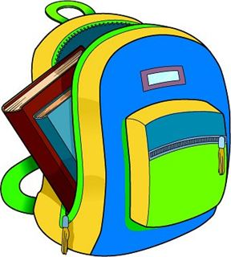There are _ _ _ books in my packback.
134. house/ not/ big./ Her/ is/
135. Keep silent = Don't ___.
A. look B. see C. talk D. go
136. He is n_ _ Linda’s friend.
137. Nice to m_ _ t you, too.
138. Hello! ... Nga. Nice to meet you.
A. He’s B. She’s C. It’s D. I’m
139. She ... Mary.
A. am B. is C. are D. he
140. Po_ _ t to the teacher.
141. How _ _ ny books are there? – There are 2 books.
142. Nghe: Nhấn giữ Ctrl và bấm chuột để nghe: My ... likes playing game.
A. sister B. brother C. mother D. father
143. room./ computer/ is/ my brother's/ This/
144. your/ is/ name?/ What/ friend’s
145. A: Is the library new? - B: No, it isn’t. It’s ....
A. big B. small C. large D. old
146. doll./ a/ This/ is/
147. again./ you/ Sandy./ Goodbye/ See/
148. Ảnh: 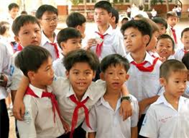Who are they? – They are….
A. boys B. men C. girls D. boy
149. Loo_ at the dog.
150. What’s _ _ _ _ name? - My name is Peter.
151. is/ cat./ a/ That/ black
152. Choose the odd one out:
A. ruler B. rubber C. tennis D. notebook
153. Write ... the teacher says.
A. what’s B. you C. where’s D. what
154. Do you like ______ a bike?
A. ride B. rideing C. riding D. ridding
155. art room./ draws pictures/ in the/ He/
156. Those/ red./ balloons/ are/
157. Nghe: Nhấn giữ Ctrl và bấm chuột để nghe: Nice to _ _ _ _ you.
158. Peter’s./ are/ Those/ orange/ notebooks/
159. How many kit_ _ are there in the sky?
160. is/ This/ my/ bedroom.
161. pencils./ Those/ my/ aren't/
162. Nghe: Nhấn giữ Ctrl và bấm chuột để nghe: _ _ _ _
163. Fine, t_ _ _ _ s.
164. I’m fine, thanks. How a_ _ _ t you?
165. Ảnh: 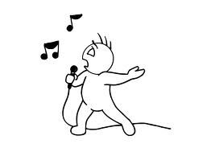Come here and _ _ _ _ a song now.
166. Which word has the underlined part pronounced like the letter ‘o’ in ’’clock’’?
A. open B. one C. go D. boys
167. That is a white _ _ d pink pen.
168. on/ the board./ Write/ name/ your/
169. _ _ that your new friend? - No, he isn’t.
170. He_ _ o, my name’s Richard. - Nice to meet you.
171. Wh_ t’s your name?
172. Ảnh: My teacher goes to work by _ _ _ _ _ .
173. The pen/ table./ is/ on the/
174. H_ _ _ _ ! I’m David.
175. Good mo_ _ ing, children!
176. is/ Their/ school/ a little/ small./
177. down/ , please./ Sit/
178. in the classroom/ Is she/ at break time?/
179. What is this? - ... .
A. His name is Hien B. It is a ruler C. It’s an ruler D. This is Mai
180. Nghe: Nhấn giữ Ctrl và bấm chuột để nghe: Nam's pencils are_____ .
A. black B. blue C. green D. red
181. Harry is my fri_ _ d, too.
182. Ảnh: Those are _ _ _ _ _ flags.
183. There _ _ _ twenty chairs.
184. is/ in the classroom./ A/ black board/
185. This is Jane ... Tim.
A. is B. and C. or D. two
186. That/ blue./ not/ eraser/ is/
187. Flowers in the park _ _ _ very beautiful.
188. Linda./ is/ Your/ name/
189. Choose the letter(s) to make a correct word: __hat
A. w B. h C. o D. a
190. Tuan is 7 _______ old.
A. year B. years C. yeah D. you
191. Look at t..e cat.
A. w B. h C. q D. s
192. Let’s say he_ _ o to Tom.
193. My bedroom is new b_ _ small.
194. Why is Sam happy? - She is ha_ _ y because today is her birthday.
195. ____ are his pets.
A. These B. This C. That D. It
196. Nghe: Nhấn giữ Ctrl và bấm chuột để nghe: Listen and tick:
A. This is my school bag. B. This is my school bus. C. This is my school car. D. This is my school book.
197. Come and … a song now.
A. say B. sing C. stand D. sit
198. Have ... nice day!
A. a B. am C. the D. an
199. Greet/ your/ friend./
200. Ảnh: N_ _ EBOOK

IOE K3 SỐ 17
1. Nghe: Nhấn giữ Ctrl và bấm chuột để nghe: Listen and tick:
A. My grandpa is in the school. B. My grandpa is in the room. C. My father is in the garden. D. My grandpa is in the garden.
2. My school is near _ bakery.
3. Ảnh: Who is he? - He’s a ... .
A. teacher B. doctor C. friend D. man
4. H_ _ many cats are there? – There are 2 cats.
5. ____ talk in class!
A. Do B. Don't C. Doing D. To do
6. your/ Is/ green?/ pencil/
7. Put your book a_ _ y.
8. How/ do/ you have?/ many/ dogs/
9. your/ is/ room?/ What colour/
10. Let’s ... a song.
A. look B. sing C. stand D. sit
11. This is/ to school./ go/ the way/ we/
12. What … is it? – Oxford Primary School.
A. chair B. school C. library D. room
13. Nice to meet you. - Nice to meet you, _______.
A. to B. two C. too D. true
14. Minh has a blue shirt, a red shirt and a black shirt. He has ____ shirts.
A. three B. four C. five D. six
15. I go … school in the morning.
A. in B. at C. on D. to
16. do/ spell/ you/ that name?/ How/
17. Ảnh: Two maps __ on the wall.
A. are B. is C. re D. am
18. Let’s/ ’Hello!’/ to/ your friend./ say/
19. My name _ _ Peter.
20. is/ and pink./ yellow/ This box/
21. I sin_ a song.
22. A: May I come in? - B: …
A. No, you don’t. B. Yes, please. C. Yes, you are. D. No, you aren’t.
23. His classroom is s_ all.
24. Is/ new?/ school gym/ her/
25. Nghe: Nhấn giữ Ctrl và bấm chuột để nghe: shar_ _ _ _ _
26. Wh_ _ e is David from? - He is from England.
27. What colour is this ruler? - It is ... .
A. big B. small C. green D. short
28. My classmates like to _ _ ay hide-and-seek.
29. Look _ t the board.
30. Listen and ti_ _ .
31. What colour is this? - ... .
A. It’s big B. It’s small C. It’s blue D. It’s nice
32. How are you? - ...
A. Five, thanks B. Fine, thanks you C. Five, thanks you D. Fine, thanks.
33. Open the b_ _ k.
34. I can sing but I _ _ _ _ _ _ dance.
35. Nghe: Nhấn giữ Ctrl và bấm chuột để nghe: There are … sweets.
A. three B. two C. four D. no
36. and/ uncle/ my/ This is/ his son./
37. Ảnh: My mother’s birthday is on the f_ _ _ t of January.
38. like/ football./ I do/ playing/ not/
39. bedroom./ This/ is/ my/
40. Ảnh: I dra_ a picture in the art room.
41. can't/ a bike./ The/ ride/ dog/
42. May I write it on your not_ _ _ _ k?
43. Ảnh: We are ______ at break time.
A. in the classroom B. in the computer room C. in the playground D. on the roof
44. close/ door?/ the/ May/ I/
45. Nghe: Nhấn giữ Ctrl và bấm chuột để nghe: The ... is short.
A. ruler B. pencil C. pen D. rubber
46. _ _ you like Music? – Yes, I do.
47. Nghe: Nhấn giữ Ctrl và bấm chuột để nghe: The teddy is … and ….
A. small – brown B. big – brown C. small – purple D. big – purple
48. It/ today./ is/ very/ hot
49. John./ you?/ How/ Hi, I’m/ are
50. How/ do you/ her name?/ spell/
51. Nghe: Nhấn giữ Ctrl và bấm chuột để nghe: I'm _ _ ven.
52. Is it _ ruler? – No, it isn’t.
53. Listen to the teacher ..., children.
A. down B. up C. quiet D. carefully
54. a/ song./ Sing/
55. Nghe: Nhấn giữ Ctrl và bấm chuột để nghe: Yes, they _ _ _ .
56. Nghe: Nhấn giữ Ctrl và bấm chuột để nghe: The_ _ are my rulers.
57. ... fine, thank you
A. Hi B. I C. I’m D. Am
58. Lis_ _ n to the teacher.
59. That is her n_ w school.
60. Let’s ma_ e a circle.
61. friend./ to/ your/ Listen/
62. Let’s play with … .
A. she B. he C. me D. see
63. Hello. I … Mary.
A. is B. are C. am D. do
64. Nghe: Nhấn giữ Ctrl và bấm chuột để nghe: It’s not a white _ _ _ _ _ _ _ _ .
65. Ảnh: BACKPA_ _
66. There _ _ e many things in my room.
67. Nghe: Nhấn giữ Ctrl và bấm chuột để nghe: She asks you to put the _ _ _ _ _ _ under the chair.
68. and pencils./ my/ notebooks/ are/ These/
69. L_ _ k, listen and repeat.
70. me/ Give/ your/ notebooks.
71. Ảnh: 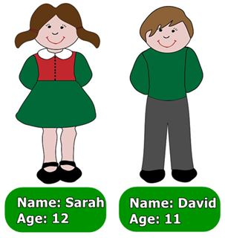Which is not TRUE?
A. The girl is Sarah. B. The boy is David. C. The girl is twenty. D. The boy is eleven.
72. can/ fly?/ animals/ What/
73. She likes _________ tennis.
A. playing the B. play C. plays the D. playing
74. Ảnh: Wash your _ _ _ _ _ before eating, please.
75. Choose the odd one out:
A. cat B. dog C. pencil D. parrot
76. for me./ to buy/ my mother/ I want/ a blue scarf
77. Wh_ t’s your name?
78. Odd one out:
A. it’s B. his C. her D. its
79. Listen ... your friend, Tom.
A. on B. of C. to D. for
80. L_ _ k, listen and repeat.
81. ... pictures are there on the wall?
A. Who B. How C. How many D. How much
82. Nghe: Nhấn giữ Ctrl và bấm chuột để nghe: _ _ at colour are your pencils?
83. on the/ is/ table./ The pen/
84. Choose the odd one out:
A. frog B. desk C. tiger D. lion
85. ..., I’m Tom.
A. Hi B. Goodbye C. See you D. Bye
86. What’s y_ _ r name? - My name’s Frank. Nice to meet you.
87. ... morning, Adam!
A. Hello B. Hi C. Good D. You
88. There are t_ o pens in my bag.
89. books?/ they/ Are/ your/
90. _ _ e they your friends?
91. Nice to meet you, Hai. – Nice to meet you, ... .
A. to B. two C. too D. those
92. Good ni_ _ _ , children.
93. W_ _ is that? – That’s Jenny. She is my friend.
94. C_ me here, John.
95. Nghe: Nhấn giữ Ctrl và bấm chuột để nghe: Who is this? - It’s my … .
A. sister B. brother C. father D. mother
96. Please,/ quiet/ students./ be/
97. quiet,/ boys!/ Be/
98. Let’s mak_ a line.
99. Those pencil sharpeners _ _ _ purple.
100. It is ... mine.
A. and B. not C. see D. nice
101. Ảnh: _ _ OWN SHOES
102. I’m ... Vietnam.
A. down B. up C. from D. under
103. Ảnh: _ _ _ _ _ what the teacher says.
104. is/ It/ lunch room./ my school/
105. lunch room/ is/ large./ My/
106. your/ out/ Take/ book.
107. Wh_ _ colour is this?
108. ... is she? – She’s Margaret.
A. Who’s B. What C. What’s D. Who
109. Wh_ t’s your name?
110. Wr_ _ _ the names in the blanks.
111. A: Who’s that _ _ _ _ ? - B: She’s Linda.
112. Choose the odd one out:
A. who B. how C. what D. ruler
113. What su_ _ ect do you like the most?
114. Don’t make ... mess.
A. an B. the C. a D. this
115. noise. Our/ is/ tired./ Don't make/ grandmother/
116. _ _ quiet, please.
117. Choose the odd one out:
A. I B. my C. he D. they
118. Look/ at/ teacher./ the/
119. What colour is this? - ... .
A. It’s a kite B. It’s a book C. There are two pens D. It’s green
120. Nice ... meet you too.
A. for B. to C. from D. on
121. Ảnh: They are in the pl_ _ ground .
122. Nghe: Nhấn giữ Ctrl và bấm chuột để nghe: _ _ _ _
123. Ảnh: 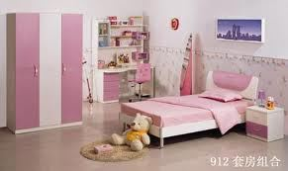Our _ _ _ _ _ _ _ is not big.
124. ... is she? – She is my teacher.
A. Who B. What C. Which D. Where
125. colour/ is/ What/ this?
126. Nghe: Nhấn giữ Ctrl và bấm chuột để nghe: Listen and choose the best response.
A. Goodbye! See you later. B. I’m fine, thanks. C. This is my friend, Lan. D. Hi! My name’s Lan.
127. Ảnh: This is a _ _ _ _ .
128. Ảnh: 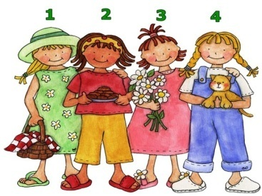A: Who is your friend? - B: The girl in the pink dress.
A. 1 B. 2 C. 3 D. 4
129. small?/ her/ Is/ school library/
130. Ảnh: 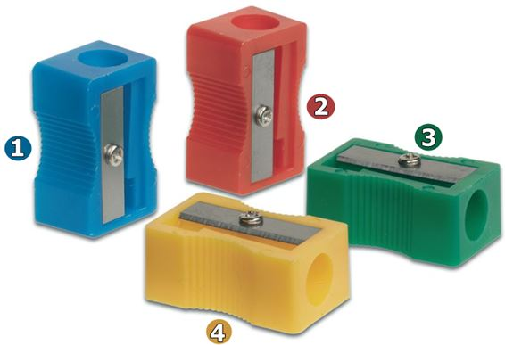My pencil sharpener is yellow.
A. 1 B. 2 C. 3 D. 4
131. ... is her name? – Her name is Joane.
A. How B. What C. When D. Who
132. you/ See/ Peter./ tomorrow,/
133. She ... five dolls.
A. have B. has C. is D. are
134. Ảnh: 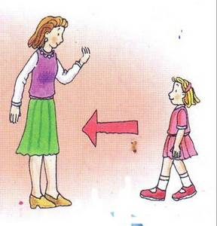____ here, please!
A. Coming B. To come C. Come D. Have
135. teacher./ the/ Look/ at/
136. my/ ruler is/ in/ My new/ pencil case./
137. Ảnh: A LARG_ ROOM
138. bag./ a green/ That/ is/ school
139. Ảnh: What is that? - It’s a ….
A. bus B. school bus C. bike D. car
140. How old are you?
A. My name’s Mai. B. I’m very well, thanks. C. I’m dancing. D. I am nine years old.
141. Henry doesn’t work _ _ Saturday and Sunday.
142. Ảnh: There is a d_ sk in my room.
143. your book/ and read/ aloud./ Open/
144. you have?/ many/ do/ How/ dogs/
145. P_ _ your books down, please.
146. Which is a kind of fruit?
A. blue B. green C. orange D. pink
147. Ảnh: That's a rul_ _ .
148. W_ _ is she, Peter? – She’s is Alice.
149. Ảnh: What colour are the trousers? - They are _ _ _ _ _ _ .
150. ... morning, Peter.
A. Good’s B. Bye C. Hi D. Good
151. Ảnh: Do you like flying a kite? – No, I don’t. I like doing puz_ _ _ s.
152. Nghe: Nhấn giữ Ctrl và bấm chuột để nghe: Peter likes _ _ _ _ _ _ _ _ but Lulu doesn’t.
153. This is Mary. _ _ e is my friend.
154. Hi, my name ... Nam.
A. are B. is C. be D. and
155. our/ is/ Mrs. Samantha/ new/ teacher./
156. My _______ is Tony.
A. school B. friend C. bag D. class
157. Wh_ _ are they? - They are my pens.
158. H_ _ is your mother? – She’s fine.
159. A: _ _ _ I close my book? - B: Yes, please.
160. Is that your pencil? – No, it is _ _ _ .
161. Nghe: Nhấn giữ Ctrl và bấm chuột để nghe: _ _ _ _ ing
162. Choose the letter(s) to make a correct word: na__
A. mi B. me C. em D. im
163. A: May I come here? - B: No, you _ _ _ ’t.
164. ..., teacher? – Yes, please.
A. Stand up B. Open your book C. Who is he D. May I go out
165. Nghe: Nhấn giữ Ctrl và bấm chuột để nghe: C_ ME
166. Nghe: Nhấn giữ Ctrl và bấm chuột để nghe: _ _ _ _
167. Ảnh: 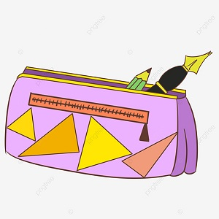What is this? - It's a _____.
A. pen B. pencil C. pencil case D. pencil sharpener
168. When is your birthday? - ….
A. It’s on September B. It’s in October C. It’s second of June D. It’s in third of June
169. My/ a/ doctor./ father/ is/
170. Count the ..., please.
A. she B. they C. boy D. boys
171. Check/ you hear/ words/ , please./ the/
172. Can the cat fly? - ... .
A. No, it can B. No, it does C. No, it can’t D. No, it doesn’t
173. That is my classroom. It’s not small. It’s _ _ g.
174. We play football in the play_ _ _ _ _ _ after school.
175. Choose the odd one out:
A. house B. gym C. library D. music room
176. colour/ What/ sneakers?/ are/ those
177. Is this a round bag? - ... .
A. Yes, it is B. Yes, it isn’t C. No, it is D. Not, it isn’t
178. and I/ are/ My friends/ in the playground.
179. Are they your _________?
A. box B. boxs C. boxes D. boxe
180. Is this a book? – Yes, … .
A. I am B. it is C. is it D. it isn’t
181. He is P_ ter.
182. My pencil is lo_ _ , but his pencil is short.
183. birthday/ present./ This doll/ your/ is/
184. Ảnh: It's the _ rt room.
185. I like to s_ ng.
186. Let’s make a li_ e.
187. What ... it? – It’s a red pencil.
A. is B. hi C. bye D. hello
188. Choose the odd one out:
A. tree B. kite C. yo-yo D. doll
189. Who _ re they?
190. Choose the odd one out:
A. library B. ruler C. rubber D. notebook
191. It is so mu_ _ fun.
192. Miss Lan is my new t_ _ _ her.
193. Nghe: Nhấn giữ Ctrl và bấm chuột để nghe: I play ______ .
A. basketball B. badminton C. skipping D. football
194. my/ at/ Look/ dog.
195. in the classroom./ I/ play chess/
196. Write/ a/ postcard/ a pen friend./ to
197. Nghe: Nhấn giữ Ctrl và bấm chuột để nghe: Listen and tick
A. This B. That C. These D. Those
198. a/ is/ teacher./ father/ My/
199. These trousers are too big _ _ _ me now.
200. weather/ The/ is/ hot/ today./

IOE K3 SỐ 18
1. This is m_ ruler.
2. I often play football _ _ Tuesday afternoons.
3. Nghe: Nhấn giữ Ctrl và bấm chuột để nghe: HOU_ _
4. A: What are …? - B: … are my pencils.
A. those – Here B. these – They C. there – There D. there – Here
5. Choose the odd one out:
A. Good morning. B. Goodbye. C. See you again. D. See you soon.
6. Ảnh: 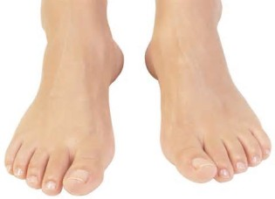There are _ _ _ _ toes on a foot.
7. _ _ _ often do you do morning exercise in the summer?
8. a teacher./ I/ to/ be/ want/
9. some vegetables/ in the garden./ My grandmother/ grows/
10. How m_ _ _ dogs do you have?
11. S_ _ you again, students.
12. Nghe: Nhấn giữ Ctrl và bấm chuột để nghe: Here is his _ _ _ _ er.
13. are on/ the bookcase./ new. They/ are/ Her notebooks/
14. That man is _______.
A. fifty one B. fifteen one C. five ten one D. five one
15. This is _ book.
16. old/ miss/ friend Lizzie./ my/ I/
17. Nghe: Nhấn giữ Ctrl và bấm chuột để nghe: This is my _ _ _ _ _ _ .
18. the wall./ clock on/ There is/ a/ beautiful/
19. How ... pens do you have?
A. are B. many C. much D. so
20. ________ is your grandfather? - He's seventy.
A. How many B. How much C. How old D. How age
21. One plus one makes _ _ _ .
22. beautiful./ kites/ are/ These/
23. a/ desk./ is/ small/ This/
24. you/ What/ play?/ do/ sport/
25. My room is n_ _ big. It’s small.
26. eleven/ Her/ are/ cousins/ years old./
27. Choose the odd one out:
A. blind man’s bluff B. chess C. hide-and-seek D. skating
28. _ _ s name is John.
29. This is _ doll.
30. Science/ favourite/ subject./ his/ is/
31. T_ _ _ are my uncle and aunt.
32. Ảnh: A person has _ _ _ legs.
33. Nghe: Nhấn giữ Ctrl và bấm chuột để nghe: What DOESN’T Polly like?
A. Cats and dogs. B. Cats and spiders. C. Dogs and spiders. D. Cats, dogs and spiders.
34. my/ favourite room./ Living room/ is/
35. It’s m_ umbrella.
36. Nghe: Nhấn giữ Ctrl và bấm chuột để nghe: My pencil is ye_ _ _ _ .
37. My school bag _ _ new.
38. book/ What/ she read?/ does/
39. an egg/ It/ in/ the bowl./ is/
40. you./ It’s/ to/ nice/ meet
41. What is it? - …
A. It’s a rubber. B. I am fine, thanks. C. She is my friend. D. Yes, it is.
42. What's there next _ _ the door?
43. Let’s chan_ .
44. Ảnh: I like _______.
A. skating B. skate C. swimming D. swim
45. Are those your notebooks? - No, ... .
A. it is B. it isn’t C. they are D. they aren’t
46. Goodbye./ later./ See/ you/
47. Is this ... book? - Yes,it’s my book.
A. her B. my C. his D. your
48. where/ the/ Excuse me,/ principal’s room?/ is/
49. Nghe: Nhấn giữ Ctrl và bấm chuột để nghe: Dave is _ _ _ _ _ _ _ _ years old.
50. This is/ we/ school./ the way/ go to
51. My schoo_ is small.
52. Ảnh: 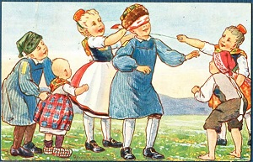The children are playing ______ in the garden.
A. the guitar B. blind man's bluff C. chess D. with some toys
53. John: Are those your pencils? - Sam: Yes, ... .
A. it’s B. it are C. its D. they are
54. Wh_ _ is there next to your book? - A ruler.
55. your names/ in/ blanks./ the/ Write/
56. my/ new/ is/ This/ friend./
57. Wh_ _ _ are the maps? – They are on the wall.
58. This is my friend. ... name is Jane.
A. Her B. Its C. His D. This
59. Nghe: Nhấn giữ Ctrl và bấm chuột để nghe: It’s the _ _ _ _ _ _ _ _ room.
60. Is this your robot? – No, it is _ _ _ .
61. Peter is _ _ the classroom now.
62. Tom?/ friend,/ How/ your/ is/
63. How _ _ _ you? - I’m fine, thank you.
64. Ảnh: 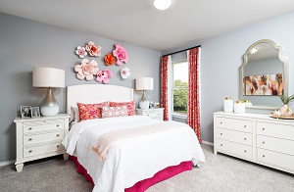This is my b_ droom.
65. My house _ s small.
66. Choose the INCORRECT word or phrase in the following sentence: Three little cat are in the yard.
A. cat B. are C. in D. yard
67. Choose the letter(s) to make a correct word: LIT_LE
A. F B. M C. N D. T
68. Ảnh: 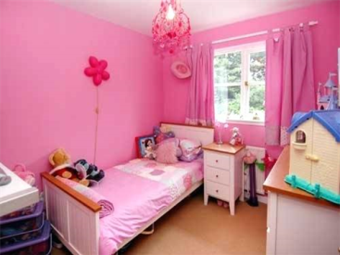What a lovely _ _ _ _ !
69. Nam:... your name? - Peter: My name’s Peter.
A. Who B. Who’s C. What D. What’s
70. Go _ _ the door, please.
71. ______ my uncle next to my father.
A. They are B. There are C. It is D. Is there
72. How/ do you/ spell/ his teacher's/ name?/
73. your teacher's/ Where/ is/ bag?
74. _ _ _ t is that? – That is a red apple.
75. My ... is Tim. Nice to meet you.
A. name’s B. names C. name D. is name
76. Ảnh: 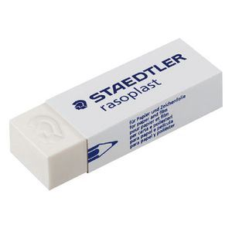What’s that? - It’s an _ _ _ _ _ _ .
77. Choose the INCORRECT word or phrase in the following sentence: They are my ball, Daddy.
A. They B. my C. ball D. Daddy
78. Choose the letter(s) to make a correct word: bla__
A. kk B. cc C. kc D. ck
79. is/ large./ not/ school/ Our/
80. Teacher: What’s this? - Minh: It’s _ pencil sharperner
A. on B. in C. a D. an
81. ... this a desk? – Yes, it is.
A. Is B. Are C. How D. What
82. This is m_ pen. It’s not your pen.
83. are./ Here/ you/
84. Ảnh: _________
A. Happy New Year! B. Merry Christmas! C. Happy birthday! D. Happy day!
85. plays/ basketball/ with his friend/ Tuan/ after school./
86. That yo yo is gre_ n.
87. Which word has the underlined part pronounced LIKE the letter O in MOTHER
A. robot B. school C. forty D. front
88. My uncle doesn’t work … Saturday.
A. at B. in C. on D. of
89. is/ long./ hair/ Her/ not
90. red/ crayons./ are/ These/
91. Peter: Let’s play ch_ _ _ !. - Nam: Yes, let’s.
92. Write your name _ _ the board, please.
93. is/ That/ pink./ ruler/
94. Where is my b_ _ _ pack?
95. garden./ many/ flowers/ in the/ There are/
96. These are their _____.
A. schoolbag B. school bags C. schools bag D. schools bags
97. Nghe: Nhấn giữ Ctrl và bấm chuột để nghe: Look at _ _ _ _ photo.
98. Stand _ _ , please!
99. eleven, twelve, thirteen, _ _ _ _ _ _ _ _
100. Ảnh: The st_ _ is bright at night.
101. At break time, we play many games and sports such as hide-and-seek, football and _____.
A. lunch room B. table tennis C. computer D. eraser
102. Nghe: Nhấn giữ Ctrl và bấm chuột để nghe: There are many _ _ _ _ in the pencil case.
103. _ _ you have pets? - Yes, I do.
104. Reorder the words to make a complete sentence: friend / My / playing / likes / badminton.
A. Friend my likes playing badminton. B. My friend likes playing badminton. C. My friend likes badminton playing. D. Playing badminton my friend likes.
105. Nghe: Nhấn giữ Ctrl và bấm chuột để nghe: _ _ _ _ _
106. Circle/ answer,/ children./ the/
107. Ảnh: The children are happy ________.
A. on Children's Day B. on Teachers' Day C. on Christmas Day D. on school day
108. Ảnh: 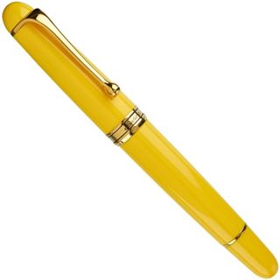My pen is _ _ _ _ _ _ .
109. The trees ___ green.
A. is B. are C. am D. do
110. butterfly./ is playing/ with a/ My cat/
111. … this word after me: ’’Name’’.
A. Do B. Write C. Copy D. Read
112. Nghe: Nhấn giữ Ctrl và bấm chuột để nghe: Today is Emily’s _ _ _ _ _ birthday.
113. now./ is/ the classroom/ Mr. Gerhard/ in/
114. Please, … down on the floor.
A. sit B. stand C. open D. close
115. The/ the shelf./ maps/ on/ are/
116. Are you a student or a teacher?
A. Yes, I am. B. No, I amn’t, C. I’m a teacher. D. I’m fine, thank.
117. Nghe: Nhấn giữ Ctrl và bấm chuột để nghe: Listen and tick:
A. shy B. sit C. six D. soup
118. Her grandmother _____ cooking.
A. like B. are C. likes D. am
119. to play/ piano./ I/ the/ like/
120. Ảnh: I’ve got an _ _ _ _ _ .
121. Is he your uncle? – No, he _ _ _ ’t.
122. Ảnh: 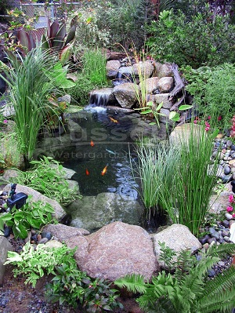There is a small pon_ behind Nam's house.
123. many/ at break time./ The children/ different games/ play/
124. How/ many/ dolls/ there?/ are
125. many/ in/ flowers/ There are/ the garden./
126. Choose the odd one out
A. Pictures B. Pencils C. Markers D. Crayons
127. Those _ _ _ my bags.
128. Ảnh: 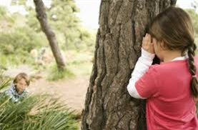The children are playing … now.
A. badminton B. volleyball C. hide-and-seek D. break time
129. Ảnh: The dog is _____ the bed.
A. in B. under C. on D. behind
130. likes chess./ likes/ and Max/ table tennis/ Alex/
131. Nghe: Nhấn giữ Ctrl và bấm chuột để nghe: The _ _ _ _ _ _ _ is very tidy.
132. I ... my teeth in the morning.
A. do B. brush C. have D. does
133. __TCHEN
A. KE B. KA C. KU D. KI
134. Nghe: Nhấn giữ Ctrl và bấm chuột để nghe: Sue is in the … room.
A. living B. dining C. sitting D. bed
135. Choose the odd one out.
A. Teacher B. Pencil C. Rubber D. Ruler
136. Pictures of my family _ _ _ on the wall.
137. I have three toy_ .
138. She _ _ _ _ not love music at all.
139. Wh_ _ _ are your pens? - They're in my pencil case.
140. bird in/ blue/ is a/ the sky./ There/
141. He _ _ my brother.
142. We like Art bec_ _ _ e we like to draw pictures.
143. ..., teacher? – Sure.
A. Stand up B. Open your book C. Who is he D. May I go out
144. Ảnh: 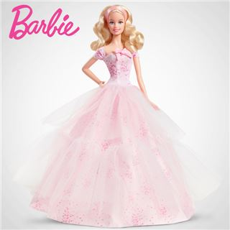She has a beautiful _ _ _ _ .
145. Is this _ _ eraser? – No, it isn’t.
146. It/ Monday/ is/ today.
147. Ảnh: __________
A. Happy New Year! B. Merry Christmas! C. Happy birthday! D. Happy day!
148. Hello, I'm Mai. - ______
A. Thank you! B. Nice to meet you. C. Sorry! D. Goodbye
149. My brother … got two new robots.
A. have B. is C. has D. am
150. Choose the incorrect word(s) in the following sentence: My uncle is thirty year old.
A. My B. is C. year D. old
151. When is your sister’s birthday? – H_ _ birthay is in July.
152. Nghe: Nhấn giữ Ctrl và bấm chuột để nghe: Listen and tick:
A. close B. old C. cold D. rose
153. Lan: Is this your school bag? - Nga: …, it is.
A. Yes B. No C. Yes, it D. Yes, it’s
154. Peter: How …are you? - Hoa: I’m eight years old.
A. all B. old C. tall D. small
155. Let’s ... English.
A. say B. speak C. listen D. show
156. Choose the letter(s) to make a correct word: par__t
A. ao B. ra C. or D. ro
157. and/ number./ Listen/
158. Raise your ..., please.
A. hand B. sit C. stand D. open
159. Nghe: Nhấn giữ Ctrl và bấm chuột để nghe: My mother makes a great cake. She is a good _ _ _ _ .
160. Nghe: Nhấn giữ Ctrl và bấm chuột để nghe: _ _ _ _ _ _
161. her/ relatives./ are/ not/ These/
162. Which is your school? – This _ _ _ .
163. my/ These/ are/ puzzles.
164. Nghe: Nhấn giữ Ctrl và bấm chuột để nghe: There are _ _ _ _ teen students in their class.
165. a/ desk./ is/ It/ new
166. Nghe: Nhấn giữ Ctrl và bấm chuột để nghe: My _ _ _ _ is green.
167. that/ Do/ you/ white blouse?/ like/
168. you/ do/ pets/ What/ have?/
169. You are welc_ me.
170. What … her name? – She is Mai Anh.
A. are B. is C. am D. does
171. How is _________? - ________ is fine, thanks.
A. she - Her B. you - I C. they - We D. Nga - She
172. Ảnh: 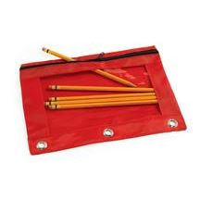That’s my pencil _ _ g!
173. Is that a pen? - ..., it isn’t.
A. Yes B. Yes, it is C. Not D. No
174. Ảnh: 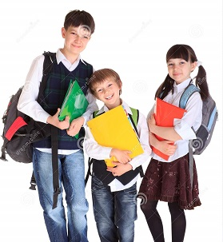We go to school ________.
A. on my classmates B. on my parents C. on my friends D. on school day
175. Ảnh: 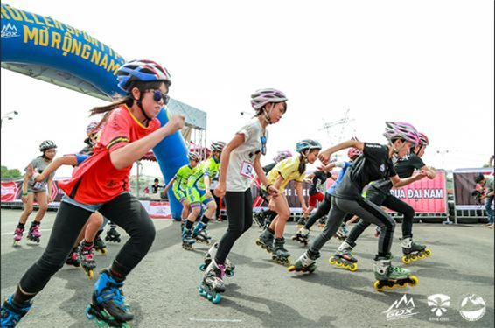Do they like _ _ _ _ _ _ _ ? - Yes, they do
176. Ảnh: 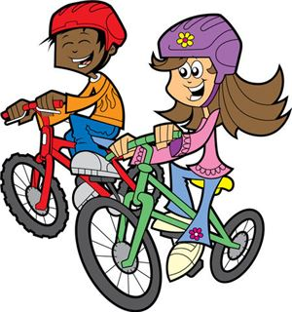They _ _ _ _ _ to school every morning.
177. Ảnh: 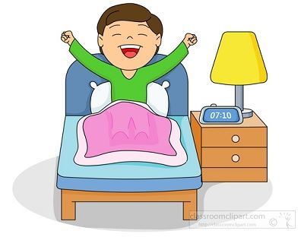I have a y_ _ _ _ _ lamp next to my bed
178. books./ my/ favourite/ some of/ These are/
179. Ảnh: A person has _ _ _ hands.
180. Dogs, cats, rabbits and hamsters are … .
A. birds B. vets C. pets D. turtles
181. How o_ _ are you?
182. Ảnh: 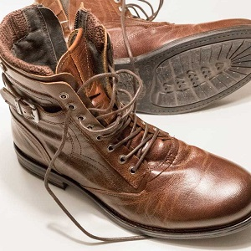His shoes are _ _ _ _ _ .
183. There are some photos _ _ the wall.
184. May I help you? - ….
A. Yes, please. Can you give me a hand? B. I don’t like too. C. No, you are not. D. No, I can’t. Please go away.
185. Choose the odd one out:
A. you B. hi C. I D. She
186. His books are ... the table.
A. at B. in C. down D. on
187. go/ gym./ to/ Let’s/ the
188. Goodbye. See you lat_ _ !
189. Let’s dr_ _ a picture.
190. That kite is bro_ n.
191. May I go _ _ t? - Yes, please.
192. This is Mary. _ _ _ is my friend.
193. It's/ jacket/ in the wardrobe./ his/
194. These are my friends. The_ _ names are Lan and Phuong.
195. Nam, go to ….. blackboard, please.
A. a B. an C. some D. the
196. Ảnh: CIRCL_
197. There _ _ a garden behind my house.
198. Nghe: Nhấn giữ Ctrl và bấm chuột để nghe: My _ _ _ _ _ _ is cooking.
199. Choose the odd one out
A. Sixty B. Book C. Seventeen D. Nineteen
200. your/ hand/ down./ Put/

IOE K3 SỐ 19
1. in/ many cats/ are there/ How/ that box?/
2. What’s this? - ... .
A. It’s a pen B. Yes, it is C. No, it isn’t D. They are pens
3. How … fans are there? – Three.
A. many B. much C. old D. long
4. Nghe: Nhấn giữ Ctrl và bấm chuột để nghe: _ _ _ _ _ _
5. Nghe: Nhấn giữ Ctrl và bấm chuột để nghe: Jamie is celebrating her _ _ _ _ _ birthday party.
6. Nghe: Nhấn giữ Ctrl và bấm chuột để nghe: They go to school by _ _ _ .
7. Nghe: Nhấn giữ Ctrl và bấm chuột để nghe: Phuong is reading a _ _ _ _ .
8. There _ _ _ many flowers in spring.
9. Nghe: Nhấn giữ Ctrl và bấm chuột để nghe: My _ _ _ _ is green.
10. May I come in? - _ _ _ , please.
11. Ảnh: That’s a pencil sharp_ _ _ _ .
12. on/ are/ The/ the wall./ pictures/
13. Nghe: Nhấn giữ Ctrl và bấm chuột để nghe: Tom is in the … .
A. living room B. bedroom C. kitchen D. bathroom
14. What do you do in … free time?
A. you B. yours C. you’re D. your
15. your/ relative?/ he/ Is/
16. Is/ big?/ your/ school/ new/
17. This/ a photo/ of/ is/ my school./
18. ruler/ is/ pink./ This/
19. your cat/ on the roof?/ sleep/ Does/
20. The dog is standing _ _ front of the mirror.
21. Nghe: Nhấn giữ Ctrl và bấm chuột để nghe: _ _ _ _ _ _ _ _ _ _
22. There _ _ a garden behind my house.
23. his free time./ often/ reads books/ in/ My father/
24. to/ Listen/ what/ the teacher/ says./
25. How old is your father?
A. He’s fine. B. He’s three ten. C. He’s forty. D. He’s four five.
26. Choose the letter(s) to make a correct word: DE__
A. KS B. SK C. KA D. AK
27. There are 20 boys and 23 _ _ _ _ _ in my class.
28. David can play ... .
A. desk B. chair C. pencil D. football
29. and pick up/ the wardrobe/ I open/ a shirt.
30. an/ English/ song./ sing/ Let’s/
31. T_ _ _ are my uncle and aunt.
32. These girls are _ _ classmates.
33. friends?/ they/ his/ Are/
34. … My name is Alan. I’m eight … old.
A. Hello - years B. Bye - months C. Hi - weeks D. Good morning - days
35. What time/ up?/ you/ get/ do/
36. How are …, Tom? – Fine, thanks. And you?
A. you B. you’re C. your D. you are
37. Lan: _ ow are you, Hoa? - Hoa: Fine, thanks. And you?
38. When you meet your friend at 9 a.m, you say:
A. Good morning B. Good evening C. Good afternoon D. Good night
39. 'What sports do you _ _ _ _ , Billy?' - 'I like football.'
40. How do … spell … name, Peter?
A. you – your B. he – your C. she – his D. they – our
41. please./ circles,/ Let’s/ two/ make/
42. My/ is/ blue and/ schoolbag/ orange./
43. Ảnh: 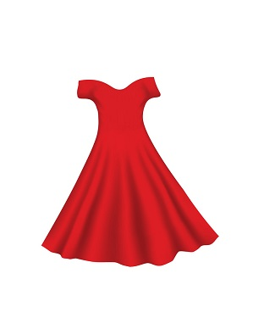She likes _ red dress.
44. How ______ is your sister? – She’s three years old.
A. many B. long C. old D. much
45. very/ My/ new friends/ are/ kind./
46. Mary _ _ s born in America.
47. What/ her/ name?/ is/
48. Where/ is/ your/ house?
49. I l_ _ _ swimming very much.
50. What animal can fly?
A. A frog B. A butterfly C. A tiger D. A goldfish
51. Ảnh: My _ _ _ likes running on grass.
52. Let’s go ... .
A. fishing B. skip C. where D. what
53. is/ over/ robot/ My/ there./
54. We s_ _ _ a song in Music lesson.
55. What colour is this? - ... .
A. It red B. It’s red C. It reds D. It is a red
56. Is it a __________? - No, it isn’t. It’s a long ruler.
A. big poster B. small TV C. short ruler D. long car
57. isn't/ There/ any water/ in the bottle.
58. Ảnh: You use your nos_ to smell.
59. play/ chess/ in the bedroom./ John and Jane/
60. What … those? – They are kites.
A. are B. is C. am D. have
61. Lan: How do you ... your name? - Peter: That’s P_E_T_E_R.
A. write B. read C. spell D. draw
62. Ảnh: What activity do they play?
A. Chess B. Hide-and-seek C. Table tennis D. Blind man's bluff
63. break time/ We/ very much./ love/
64. My father can s_ im.
65. Do you ____ a comic book? - Yes, I do.
A. having B. like C. knows D. are
66. Nghe: Nhấn giữ Ctrl và bấm chuột để nghe: Choose the correct question.
A. Where is the garden? B. Where’s Peter? C. What is Peter doing? D. Is there a garden?
67. Nghe: Nhấn giữ Ctrl và bấm chuột để nghe: Listen and tick the word(s) you hear:
A. sunny B. Sunday C. summer D. seven
68. Can you ... English, Philips? – Yes, I can.
A. sit B. stand C. speak D. say
69. Nghe: Nhấn giữ Ctrl và bấm chuột để nghe: A _______
A. APPLE B. PINEAPPLE C. CANDY D. CAKE
70. Where is Paul? – He’s … puzzles in the living room.
A. making B. doing C. playing D. taking
71. W_ _ _ _ are the children? - They are at school.
72. Nghe: Nhấn giữ Ctrl và bấm chuột để nghe: B: I’m … . Thank you. And you? - A: I’m very … . Thank you.
A. fine – fine B. fine – well C. well – well D. well – fine
73. What …? – They are my crayons.
A. are those B. is this C. is that D. are there
74. your/ When/ is/ birthday?
75. There are ten pencils … the desk.
A. to B. at C. on D. for
76. Ảnh: In autumn, the sky is very _____.
A. black B. white C. green D. blue
77. Nghe: Nhấn giữ Ctrl và bấm chuột để nghe: HOU_ _
78. Is t_ _ s a chair? – Yes, it is.
79. name?/ is/ What/ his/
80. Dogs are bigger than ants. Ants are … .
A. small B. big C. old D. young
81. _ _ at is that? – It’s a compass.
82. Ảnh: The dog is running after the _ _ _ .
83. school bag?/ Are there/ in the/ books/ any/
84. Hello,/ is/ my name/ Giang.
85. This/ classroom./ is/ new/ my/
86. 'Do your friends play games at school?' - 'Yes,they _________.'
A. do B. like C. are D. can
87. Ảnh: _ _ _
88. _ _ o is that? – That’s Tommy. He is my friend.
89. Nghe: Nhấn giữ Ctrl và bấm chuột để nghe: He likes this ___.
A. ball B. apple C. mango D. orange
90. What is his _ _ _ _ ? – He is Eddie Murray.
91. Here are your shoes. – _ _ _ _ _ _ .
92. Is that a bag? – No, it is _ _ _ .
93. There ... three cats in the box.
A. am B. is C. are D. there
94. My sister h_ _ one cat.
95. There is a big tree next _ _ the pond.
96. ... you like some milk? - No, thanks.
A. Can B. Are C. Is D. Would
97. Nghe: Nhấn giữ Ctrl và bấm chuột để nghe: There are _ _ _ _ teen students in their class.
98. My aunt’s daughters _ _ _ my cousins.
99. Here are your shoes. – _ _ _ _ _ _ .
100. Do you want ice cream? Yes, ....
A. you do B. I want C. I do D. I can
101. I have _ cat.
102. Nghe: Nhấn giữ Ctrl và bấm chuột để nghe: Heidi's ____ is Alex.
A. Mom B. sister C. brother D. Dad
103. That is n_ _ my notebook.
104. Nghe: Nhấn giữ Ctrl và bấm chuột để nghe: The _____ trainers are mine.
A. green B. black C. blue D. white
105. My elder brother h_ _ a goldfish.
106. book?/ is/ What/ colour/ your
107. My parents are _ _ the living room.
108. Can you drink ...? - Yes, I can.
A. orange juice B. rice C. chicken D. bread
109. Tha_ is my picture. It’s on the wall.
110. My sister can f_ _ a kite.
111. this/ is/ your/ Alex,/ new classmate?/
112. What animal can fly? - … .
A. A bird B. A fish C. A dog D. A cat
113. Pick _ _ your ruler.
114. What _ _ _ _ your father do?
115. What do you _ _ in your free time?
116. do puzzles/ my brother./ often/ with/ I/
117. What is your f_ _ _ _ _ name?
118. These chairs … small.
A. are B. is C. am D. not
119. How many days are there in a week?
A. 5 B. 6 C. 7 D. 8
120. Choose the odd one out.
A. Teacher B. Pencil C. Rubber D. Ruler
121. _ _ they like apples?
122. This gift is for you. - Thank you very _ _ _ _ .
123. teacher./ Miss Lien/ new/ my/ is/
124. How old ... you? – I’m seven.
A. are B. is C. am D. an
125. like/ pizza?/ Does/ Mary/
126. Where _ _ you study, Trang?
127. Nghe: Nhấn giữ Ctrl và bấm chuột để nghe: Are _ _ _ _ _ your books?
128. Her/ Allie./ name/ is/
129. are/ These/ classmates./ my/
130. is/ very/ beautiful./ flower/ This/
131. Nghe: Nhấn giữ Ctrl và bấm chuột để nghe: They are playing ….
A. volleyball B. football C. basketball D. baseball
132. Ảnh: What colour is the grass?
A. Green B. Brown C. Yellow D. Red
133. … is that? – That’s Jane. She is my friend.
A. How B. When C. Who D. Where
134. This is an ... .
A. pencil B. orange C. pen D. hat
135. What time _ _ you get up?
136. it?/ What/ is/ book/
137. Ảnh: Look. That’s a blue ba_ _ _ _ _ .
138. Susan is a nice ... .
A. boy B. he C. she D. girl
139. Are these dolls? – Yes, th_ y are.
140. When is your sister’s birthday? – H_ _ birthay is in July.
141. The trees/ behind/ are/ the statue.
142. What colour is this? - … .
A. It blue B. It’s blue C. Is blue D. It is a blue
143. brother?/ old/ Lan's/ How/ is/
144. doctor./ My/ is/ father/ a
145. A: What are …? - B: … are my pencils.
A. those – Here B. these – They C. there – There D. there – Here
146. the bed./ is/ coat/ His/ under
147. Don't be late __ school.
A. at B. in C. for D. with
148. Choose the odd one out:
A. you B. I C. fine D. he
149. Andy is my friend. _________ is short.
A. I B. He C. It D. You
150. Nghe: Nhấn giữ Ctrl và bấm chuột để nghe: I have _ _ _ books.
151. Please, _ _ _ down!
152. Ảnh: Uncle Tom is a _ _ _ _ _ driver.
153. Nghe: Nhấn giữ Ctrl và bấm chuột để nghe: _ _ _
154. Choose the odd one out
A. Photo B. Teacher C. Picture D. Poster
155. She ... long hair.
A. have B. has C. is D. with
156. Ảnh: It is snow_ in winter.
157. Which is your school? - … one.
A. The B. A C. An D. This
158. is in/ cage./ parrot/ the/ The/
159. Raise your ..., please.
A. hand B. sit C. stand D. open
160. This is my _ _ _ ssroom.
161. Ảnh: The player throws the ball into the basket. What sport is it?
A. Basketball B. Baseball C. Badminton D. Football
162. songs./ to sing/ English/ like/ We/
163. Ảnh: 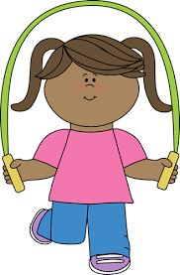The girl is … .
A. doing puzzles B. playing basketball C. playing hide-and-seek D. skipping rope
164. Ảnh: Can you o_ _ _ your book?
165. a/ is/ This/ red/ book./
166. Nice to ... you, Mary.
A. meeting B. meets C. meet D. met
167. Do/ any/ have/ you/ toys?/
168. What sp_ _ _ do you play at break time? - I play badminton.
169. What ________ _________ name?
A. are - their B. is - she C. is - his D. are - your
170. Ảnh: There is a lovely golden _ _ _ _ in a bowl
171. _ _ _ _ do you do at school?
172. Would you _ _ _ _ some water?
173. Good_ _ _ , Tom.
174. new/ my/ She/ friend./ is/
175. R_ _ d after me, please.
176. 'Are you a student?' - 'Yes, I _ _ .'
177. How old is his grandmother? - _______
A. She's fine. B. There are some tables in the room. C. She's sixty now. D. Thank you very much.
178. Choose the odd one out:
A. how B. hello C. hi D. good morning
179. Is your house big … small?
A. and B. or C. but D. of
180. does/ puzzles/ evening./ in the/ Thomas/
181. Ảnh: Let’s count to t_ _ _ ty.
182. My pencil/ table./ is on/ the/ case/
183. Pick … your pencil, Colin.
A. on B. to C. up D. down
184. Is your classroom big? – No, it _ _ n’t.
185. Wr_ _ _ your name here, please.
186. My bedroom is not big. It’s sm_ _ _ .
187. on/ There are/ the table./ five/ books/
188. Are these _ _ _ _ posters? – Yes, they are my posters.
189. Linh: What ... is this bag? - Jame: It’s white.
A. you B. colour C. birthday D. old
190. How o_ _ are you?
191. St_ _ _ up, please.
192. _ _ you like playing football?
193. She is angry because they are too late _ _ _ the class.
194. Ảnh: 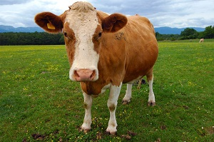C_ W
195. How many ... are there ? - There is one peach.
A. crayons B. peachs C. peach D. peaches
196. Pick ... your notebook, Helen.
A. on B. to C. up D. and
197. two/ on/ pencils/ the table./ There are/
198. My sister/ dolls./ with/ doesn't like/ playing/
199. Ảnh: 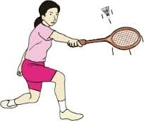Do you play bad_ _ _ _ _ _ at breaktime?
200. A: How do you spell your … name?- B: … Carter.
A. family - It’s B. surname - I’m C. first - He’s D. full - That’s

IOE K3 SỐ 20
1. Nghe: Nhấn giữ Ctrl và bấm chuột để nghe: _ _ _ _ _
2. How are you to_ _ y, David? – I’m fine, thank you.
3. Linda: Is this a book? - Phuong: ….
A. Yes, its B. Yes, it C. Yes, it is D. Yes, it isn’t
4. Does/ stand/ over there?/ his uncle/
5. Clo_ e the door, please.
6. _ _ you have any comic books?
7. Mary: Hello, Sam. … are you? - Sam: Hi, Mary. I’m very … . Thanks.
A. How - well B. Who - fine C. What – so-so D. Where - OK
8. What/ sister's/ your/ name?/ is/
9. T_ _ _ are my uncle and aunt.
10. Which word has the underlined part pronounced LIKE the letter A in FATHER
A. chair B. eraser C. table D. garden
11. Good af_ _ _ _ _ _ _ Mr. Smith.
12. Yes, _ _ is a new notebook.
13. Are you happy?
A. Yes, I am. B. Yes, am. C. Yes, I I’m. D. Yes, it’s me.
14. Listen/ the/ to/ teacher/ please./
15. Ảnh: 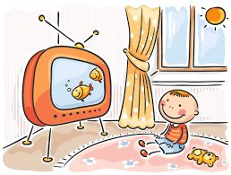The children like watching … .
A. TV B. music C. radio D. books
16. Nghe: Nhấn giữ Ctrl và bấm chuột để nghe: It’s my _ _ _ _ _ _ _ _ room.
17. Billy: Are they your pencils? - Minh: No, they ... .They’re my pens.
A. don’t B. have C. do D. aren’t
18. How … is your grandmother? – She’s 74 years old.
A. young B. old C. much D. many
19. … are my classmates.
A. This B. That C. These D. There
20. your/ really/ Is/ school/ big?/
21. Ảnh: It's __ the box.
A. in B. on C. behind D. under
22. Jacob/ is fifteen./ isn't/ fourteen. He/
23. Nghe: Nhấn giữ Ctrl và bấm chuột để nghe: The monkey has ___ at the front of its head.
A. ears B. eyes C. nose D. mouth
24. Nghe: Nhấn giữ Ctrl và bấm chuột để nghe: Listen and tick:
A. close B. old C. cold D. rose
25. Put/ pencils/ your/ away,/ children./
26. How o_ _ are you?
27. are./ Here/ you/
28. like/ those/ I/ pictures.
29. Choose the letter(s) to make a correct word: par__t
A. ao B. ra C. or D. ro
30. That is _ bicycle.
31. Do you like _______?
A. play football B. playing football C. to playing football D. to play the football
32. That ... a chair.
A. is B. am C. it D. are
33. How _ _ _ _ pens are there in your pencil case?
34. Xuan: How _ _ _ you, Lan? - Lan: Fine, thanks.
35. Ảnh: My Mom puts my clothes in the wardr_ _ _ .
36. Is the_ _ a dog? – No, there is not.
37. Do you like my new ball? - _ _ _ , I do.
38. You are welc_ me.
39. your/ sister's/ What/ name?/ is/
40. Look _ _ the picture, John. This is my sister.
41. I smile when I am hap_ _ .
42. Ảnh: 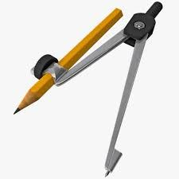Is this your …, Ron?
A. compass B. ruler C. pencil D. paint
43. … does your father do in his free time? – He plays tennis.
A. What B. Who C. When D. Where
44. to school/ goes/ morning./ every/ Daisy/
45. Jim can speak Eng_ _ _ h but cannot speak Vietnamese.
46. Phong ____ a new school bag.
A. have B. do C. has D. does
47. ... is she? – She’s Ms. Mitchell. She’s my new teacher.
A. Who’s B. What C. What’s D. Who
48. At break time, we ___ different games and sports.
A. do B. get C. go D. play
49. How/ the/ weather/ is/ today?/
50. Nice to ... you, Mary.
A. meeting B. meets C. meet D. met
51. many/ at break time./ play/ different games/ The children/
52. Linda ______ swim.
A. cans B. is C. plays D. can
53. it?/ is/ book/ What/
54. Ảnh: 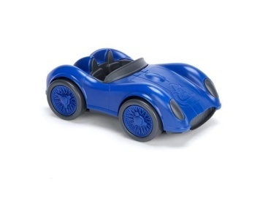This is my new car toy. It’s _ _ _ _ .
55. Nghe: Nhấn giữ Ctrl và bấm chuột để nghe: A ____
A. CANDY B. PEN C. CAKE D. BOOK
56. … school is that? – It’s Khuong Mai primary school.
A. What B. Who C. How D. Where
57. Choose the odd one out
A. Photo B. Teacher C. Picture D. Poster
58. your/ father?/ How/ is/ old/
59. How/ many/ are/ there?/ rulers/
60. I want to be a musician in _ _ _ future.
61. Tom is my best _ _ _ _ _ _ .
62. Ảnh: Max’s favorite colour is _ _ _ _ _ .
63. Who’s that? – My _ _ _ _ ew, Johny.
64. Nghe: Nhấn giữ Ctrl và bấm chuột để nghe: Tom is _ _ _ years old.
65. Choose the odd one out
A. Mother B. Father C. Teacher D. Grandmother
66. want/ to/ I/ be/ a teacher./
67. Ảnh: 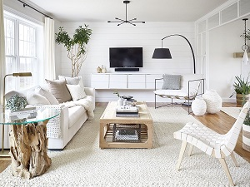Her father is in the livi_ _ room.
68. My brother h_ _ a fish.
69. Ảnh: Tom, my little brother, likes doing _ _ _ _ _ es.
70. Ảnh: 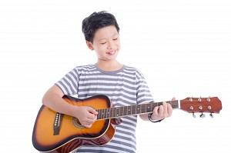The boy plays ____ very well.
A. the piano B. piano C. guitar D. the guitar
71. This is my uncle. _ _ is clever.
72. That yo yo is gre_ n.
73. Ảnh: 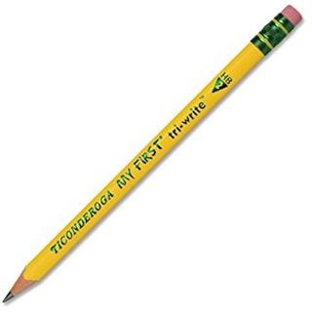What is this? - It’s a _ _ _ _ _ _ .
74. What pet do you have?
A. I have a doll. B. I have blue eyes. C. I have a pencil case. D. I have a cat.
75. Nghe: Nhấn giữ Ctrl và bấm chuột để nghe: This is her grand_ _ _ _ _ _ .
76. Do/ with a robot?/ you/ playing/ like/
77. Ảnh: Juliet has one hun_ _ _ _ stamps.
78. Nghe: Nhấn giữ Ctrl và bấm chuột để nghe: Which number is NOT in the recording?
A. 16 B. 17 C. 18 D. 19
79. Pick … your pencil, Colin.
A. on B. to C. up D. down
80. He has dinner _ _ home.
81. very/ badminton/ much./ like/ I/
82. '_________ are you?' - 'I’m 8 years old.'
A. How B. How old C. What D. How age
83. David can play ... .
A. desk B. chair C. pencil D. football
84. My _ _ _ _ is Linda.
85. Is/ eraser?/ this/ an/
86. Ảnh: 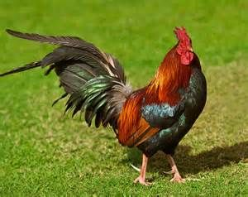CHIC_ _ _
87. Is this a ch_ ir? - Yes, it is.
88. This is my new f_ _ _ _ d, Tony.
89. our/ clean/ room./ Let's/
90. Let’s ... English.
A. say B. speak C. listen D. show
91. Great to s_ _ you.
92. How m_ _ _ dogs do you have?
93. This _ _ my new book.
94. Ảnh: _ _ _ _ is good for your health.
95. Good_ _ _ . See you again.
96. Why do you want _ _ go to the post office?
97. have/ dolls./ I/ two/
98. How/ do you/ have?/ many/ erasers/
99. Let’s _ _ _ _ badminton.
100. Your/ mother/ is/ nice.
101. Nghe: Nhấn giữ Ctrl và bấm chuột để nghe: Do you go to school in the _ _ _ _ _ _ _ _ _ ?
102. Nghe: Nhấn giữ Ctrl và bấm chuột để nghe: Listen and tick the word(s) you hear:
A. draw B. write C. see D. hear
103. Nghe: Nhấn giữ Ctrl và bấm chuột để nghe: Today is Emily’s _ _ _ _ _ birthday.
104. Nghe: Nhấn giữ Ctrl và bấm chuột để nghe: Sue is in the … room.
A. living B. dining C. sitting D. bed
105. Is … a chair? - Yes, it is.
A. are B. it C. it’s D. his
106. It's not my pen. It's y_ _ _ pen.
107. Nghe: Nhấn giữ Ctrl và bấm chuột để nghe: How many ____ are there on your farm?
A. animals B. notebooks C. animal D. pencil
108. Ảnh: 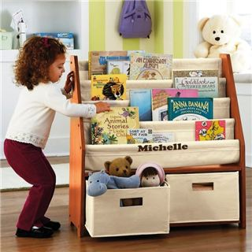Jennifer gets a book from a book_ _ _ _ _ .
109. _ _ _ _ is the date today, Sam?
110. Where ________? - Behind my house.
A. are your bikes B. is your bikes C. are your bike D. your bikes
111. How are you today, Peter? – I’m ..., thanks.
A. nice B. nice’s C. fine D. fine’s
112. singing/ much./ very/ like/ I/
113. Max and his friends/ in the/ badminton/ play/ playground./
114. My brother is th_ _ e years old.
115. Choose the odd one out
A. Games B. Swimming C. Skipping D. Chess
116. ____ many trees are there in the garden?
A. How B. What C. Why D. Which
117. Give me some more honey, please. - H_ _ _ you are.
118. Nghe: Nhấn giữ Ctrl và bấm chuột để nghe: My school _ _ _ is very long.
119. Nghe: Nhấn giữ Ctrl và bấm chuột để nghe: _ _ _ _ _ _ _ _ _ _
120. Do you have any pets?
A. Yes, I am. I have two parrots. B. Yes, I have. I have a yo-yo. C. Yes, I do. I have one cat and one rabbit. D. Yes. I don’t have any pets.
121. Which is your school? – This _ _ _ .
122. Peter has _ _ work all day in the factory.
123. to sing/ We/ like/ song./ English
124. The park is large _ _ _ new.
125. Ảnh: 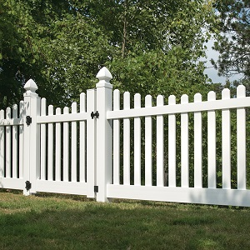What colour is the fence?
A. Blue B. Black C. White D. Yellow
126. room/ Is/ large/ your/ or narrow?/
127. Choose the INCORRECT word or phrase in the following sentence: These are a cup on the table.
A. These are B. cup C. on D. table
128. Choose the odd one out.
A. numbers B. twenty C. thirteen D. seven
129. Which word has the underlined part pronounced LIKE the letter A in TABLE
A. library B. class C. plane D. chair
130. are/ photos/ Those/ the old/ of my family./
131. ______ up, please!
A. Stand B. Sit C. Open D. Close
132. pupil?/ Do/ know/ you/ that
133. Do you like eating …, Chi?
A. fish B. fishes C. fishs D. fishies
134. posters?/ Are/ these/ our/
135. My/ is/ grandmother/ old.
136. Let’s chan_ .
137. Ảnh: 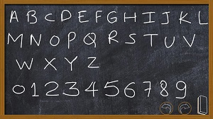Every classroom has a bl_ _ _ board
138. He can play football ________ he can play chess, too.
A. but B. so C. and D. how
139. Does/ playing/ like/ volleyball?/ Lan/
140. Is that Peter’s pen? – Yes, it’s _ _ _ pen.
141. Nghe: Nhấn giữ Ctrl và bấm chuột để nghe: _ _ _ _ _ _ _ _ _
142. My/ are red./ aren't/ yellow. They/ umbrellas/
143. Can you swim? - ... .
A. No, I can B. No, thanks C. Yes, I can’t D. Yes, I can
144. Pick ... your notebook, Harry.
A. on B. to C. up D. down
145. Does your father like p_ _ _ ing sports?
146. pen?/ your/ What/ is/ colour/
147. Ảnh: 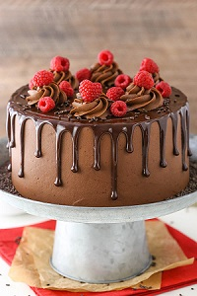CA_ _
148. Every Tuesday, I play soccer ... school.
A. in B. for C. to D. after
149. ... this a desk? – Yes, it is.
A. Is B. Are C. How D. What
150. W_ _ te your name here, please.
151. Listen _ _ me, please.
152. a/ Don’t/ make/ mess.
153. your/ Put/ down./ hand/
154. I have _ _ ice cream.
155. Nghe: Nhấn giữ Ctrl và bấm chuột để nghe: His name is ... .
A. Abramson B. Abraham C. Apranson D. Adramsun
156. How _ _ _ you today?
157. We … football at break time.
A. do B. make C. play D. go
158. My sister likes milk very _ _ _ h.
159. my/ in the/ morning./ house/ I clean/
160. puts/ on the table./ She/ her bag/
161. John./ is/ my/ new friend,/ This/
162. Ảnh: What colour is the grass?
A. Green B. Brown C. Yellow D. Red
163. Nghe: Nhấn giữ Ctrl và bấm chuột để nghe: This is my _ _ _ _ _ _ .
164. My sister can _ _ _ e a bicycle.
165. Come __, please!
A. at B. in C. for D. with
166. Which word has the underlined part pronounced LIKE the letter O in MOTHER
A. robot B. school C. forty D. front
167. say?/ cat/ What/ a/ does/
168. _ _ _ your books pink? – Yes, they are.
169. I/ a/ at me./ monkey looking/ see/
170. My/ are/ the table./ on/ pencils/
171. to/ gym./ Let’s/ the/ go/
172. I like my school _ _ _ _ much.
173. Are those your notebooks? - No, ... .
A. it is B. it isn’t C. they are D. they aren’t
174. What/ is/ school/ it?
175. Nice to ... you.
A. meet B. meet’s C. meets D. to meet
176. Listen ... the teacher, please.
A. on B. in C. to D. for
177. How … students are there in your classroom?
A. much B. many C. more D. some
178. Nghe: Nhấn giữ Ctrl và bấm chuột để nghe: Today is Carla’s _ _ _ _ _ _ birthday.
179. it/ school/ bag?/ your/ Is/
180. Can you drink ...? - Yes, I can.
A. orange juice B. rice C. chicken D. bread
181. She is angry because they are too late _ _ _ the class.
182. W_ _ is that? – That’s my sister.
183. Look … the picture, Mary.
A. to B. on C. for D. at
184. The fish/ are swimming/ pond./ in the/
185. Is this your green ruler? No, it is _ _ _ .
186. Are you a student or a teacher?
A. Yes, I am. B. No, I am not. C. I’m a student. D. Yes, I.
187. Ảnh: She has a beautiful _ _ _ _ .
188. Ảnh: You use your ____ to see.
A. eyes B. head C. arm D. ears
189. Listen/ and/ number./
190. Wh_ _ _ are your pens? - They're in my pencil case.
191. Lan: What are they? Huong: They are my ... .
A. teachers B. friends C. pencil cases D. Lan and Mai
192. I’m fine, thanks. ... you?
A. End B. And C. On D. Ten
193. How are …? - … am fine, thanks.
A. they / He B. we / We C. you / I D. him / He
194. How/ old/ is/ grandfather?/ your
195. They are my _ _ _ _ tives.
196. Nghe: Nhấn giữ Ctrl và bấm chuột để nghe: Listen and tick:
A. sunny B. Sunday C. summer D. seven
197. your/ Open/ please./ books,/
198. Ảnh: 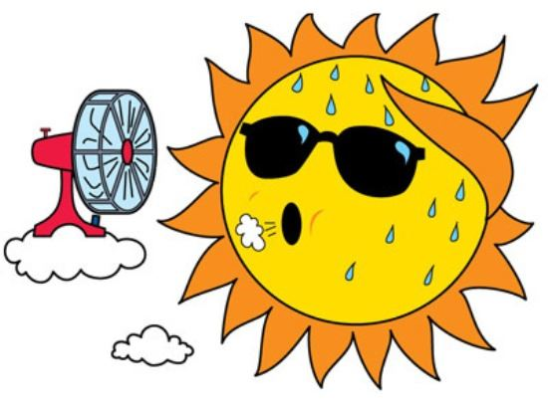It’s _ _ _ outside.
199. This is m_ ruler.
200. his/ blue?/ Is/ pencil case/

IOE K3 SỐ 21
1. sofa./ need/ I/ new/ a/
2. Nghe: Nhấn giữ Ctrl và bấm chuột để nghe: Meg is _ _ _ _ _ years old.
3. My father raises some fish in the _____.
A. garden B. forest C. pond D. yard
4. the sky./ kites/ in/ There are/ six/
5. How many months are there in a year?
A. 10 B. 11 C. 12 D. 13
6. Nghe: Nhấn giữ Ctrl và bấm chuột để nghe: Ben’s _ _ _ _ _ years old today.
7. I … a blue pencil and a white ruler.
A. has B. have C. don’t have D. doesn’t have
8. is/ pink/ a/ book./ This/
9. Ảnh: The children like building a sand_ _ _ _ _ _ on the beach.
10. What time _ _ _ _ the library open?
11. Choose the odd one out.
A. numbers B. twenty C. thirteen D. seven
12. There are/ many/ in/ flowers/ the garden./
13. Choose the letter(s) to make a correct word: G__NDFATHER
A. AR B. OR C. RO D. RA
14. Choose the odd one out:
A. am B. is C. are D. this
15. My class is …: ten girls and eleven boys.
A. nice B. tidy C. big D. new
16. Let’s ... English.
A. say B. speak C. tell D. sing
17. Nghe: Nhấn giữ Ctrl và bấm chuột để nghe: Listen and tick:
A. hat B. hot C. red D. cat
18. Which … their pencil sharpeners?
A. are B. am C. is D. have
19. Choose the odd one out:
A. play B. quiet C. talk D. stand
20. This is ... orange.
A. a B. an C. is D. are
21. B_ _ . See you later.
22. This is m_ pen. It’s not your pen.
23. Nghe: Nhấn giữ Ctrl và bấm chuột để nghe: The ____ watch is mine.
A. blue B. yellow C. black D. white
24. She/ friend./ my/ new/ is/
25. Mary ... to school every morning.
A. go B. go’s C. goes D. goes to
26. Do you/ stamps?/ want/ these/
27. Which is your school? – This _ _ _ .
28. Your father’s brother is your _ _ _ _ _ .
29. Lan's/ How/ is/ brother?/ old/
30. There are four people _ _ my family.
31. Ảnh: 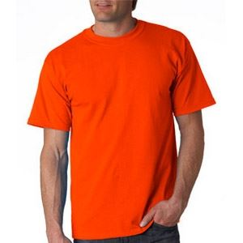He is wearing an o_ _ _ _ _ T-shirt.
32. in/ Is there/ your school?/ one garden/
33. Ảnh: 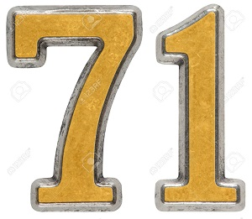My grandfather is ______ years old.
A. seventeen B. seventy C. seventy-one D. seven-one
34. years/ My brother/ eleven/ is/ old./
35. … does your father do in his free time? – He plays tennis.
A. What B. Who C. When D. Where
36. Nghe: Nhấn giữ Ctrl và bấm chuột để nghe: _ _ _ _ _ _ _ _
37. We/ love/ very much./ break time/
38. ______ my uncle next to my father.
A. They are B. There are C. It is D. Is there
39. Is this ... classroom?
A. are B. a C. am D. an
40. Which sentence is correct?
A. Santa Claus flying over the town. B. Santa Claus is riding his sleigh. C. Santa Claus is ride a reindeer. D. Santa Claus is walking in the sky.
41. This is ... eraser. It’s not my eraser.
A. this B. he C. me D. your
42. pencil sharpener?/ is/ What/ colour/ your
43. Ảnh: 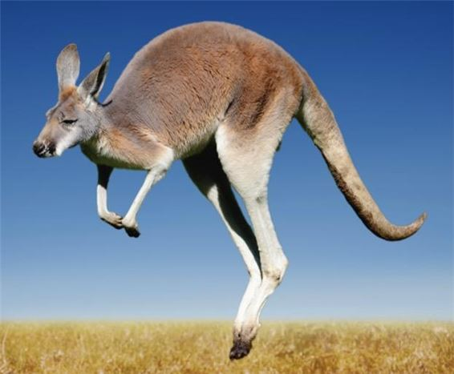We can see a _ _ _ _ _ _ _ _ in Australia.
44. of milk./ a glass/ is/ It/
45. in a/ coffee shop./ cakes and/ We eat/ drink tea/
46. do/ a/ you/ Can/ puzzle?/
47. Ảnh: Shhh! The baby is _ _ _ _ _ _ _ _ .
48. _ _ _ is she? – She’s Ms. Wilson. She’s my English teacher.
49. Goodb_ e, Tommy. See you later.
50. Nghe: Nhấn giữ Ctrl và bấm chuột để nghe: Which number is NOT in the recording?
A. 16 B. 17 C. 18 D. 19
51. My elder brother h_ _ a goldfish.
52. Choose the odd one out:
A. bag B. book C. big D. pencil
53. Ảnh: 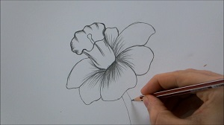D_ _ _ a flower on your sheet.
54. away,/ books/ please./ Put/ your/
55. What can you do … English? – I can count to 100, sing an English song.
A. in B. at C. on D. by
56. Good af_ _ _ _ _ _ _ Mr. Smith.
57. A: Is your school …? – B: Yes, there are four big buildings and a big schoolyard.
A. small B. little C. large D. narrow
58. Is that y_ _ _ nephew?
59. The big tree is beh_ nd my house.
60. Ảnh: 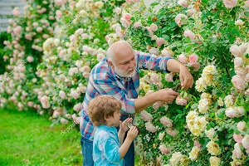My grand_ _ _ _ er is in the garden.
61. the/ sentences./ Reorder/
62. Ảnh: 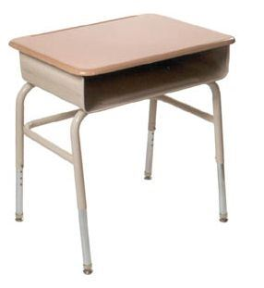This is your …, Tom.
A. bench B. desk C. chair D. board
63. The flowers are colourful in _ _ _ garden.
64. Nghe: Nhấn giữ Ctrl và bấm chuột để nghe: They’ve got two _ _ _ sins, Amy and Leo.
65. Where _ _ you study, Trang?
66. Nghe: Nhấn giữ Ctrl và bấm chuột để nghe: Look at _ _ _ _ photo.
67. Ảnh: Come and see the pho_ _ of my family.
68. How many days are there in _ week?
69. Nghe: Nhấn giữ Ctrl và bấm chuột để nghe: My new _ _ _ _ _ _ is Adam.
70. Nghe: Nhấn giữ Ctrl và bấm chuột để nghe: This is her grand_ _ _ _ _ _ .
71. Nghe: Nhấn giữ Ctrl và bấm chuột để nghe: Sue is in the _ _ _ _ _ _ car
72. How many/ the box?/ pens/ are there/ in
73. I like my school _ _ _ _ much.
74. Ảnh: ELEPH_ _ _
75. friends/ are/ France./ Her/ from
76. Mary often gets _ _ early in the morning.
77. Nghe: Nhấn giữ Ctrl và bấm chuột để nghe: She’s got _ _ _ _ _ eyes.
78. W_ _ _ _ is Mary from? - She’s from England.
79. Choose the odd one out:
A. Vietnam B. England C. America D. Vietnamese
80. Ảnh: 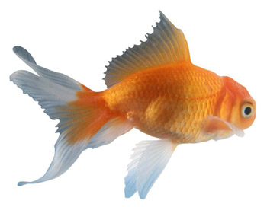F_ SH
81. Pick … your pencil, John.
A. on B. in C. of D. up
82. Is this your bag? - … .
A. No, thanks B. Sure C. No, it is D. Yes, it is
83. Nghe: Nhấn giữ Ctrl và bấm chuột để nghe: His sister’s _ _ _ _ is in the tree.
84. Ảnh: You are in the water to play this sport. What sport is it?
A. Badminton B. Volleyball C. Table tennis D. Swimming
85. We go to school ... .
A. alone B. together C. gether D. by me
86. Write the an_ _ _ rs, please.
87. Goo_ _ _ e. See you tomorrow, students.
88. My mother li_ es jogging.
89. like?/ you/ colour do/ What/
90. Nghe: Nhấn giữ Ctrl và bấm chuột để nghe: The ___ T-shirt is William's.
A. red B. yellow C. black D. white
91. My bedroom is not big. It’s sm_ _ _ .
92. I ... my teeth in the morning.
A. do B. brush C. have D. does
93. Her ruler _ _ n't new. It's old.
94. Is your classroom big? – No, it _ _ n’t.
95. basketball/ Tuan/ after school./ with his friend/ plays/
96. That is my mother. _ _ _ is a teacher.
97. a/ flower./ red/ This/ is/
98. your mother?/ Is/ next to/ your aunt/
99. Ảnh: That _ _ _ _ _ pen is not mine.
100. is/ This/ ruler/ pink.
101. Those/ are/ big/ clouds.
102. not/ The/ schoolyard/ is/ large./
103. _ _ _ are you? - I'm John's brother.
104. Nghe: Nhấn giữ Ctrl và bấm chuột để nghe: Listen and tick the word(s) you hear:
A. a pet B. a bed C. a bird D. a bage
105. How many flowers _ _ _ there in the vase?
106. every/ do you/ evening?/ do/ What/
107. that/ bench./ on/ is/ The cat/
108. _ _ _ _ is your name? - My name is Jerry.
109. two rulers/ in/ school bag./ my/ There are/
110. new/ teacher?/ the/ Is/ she/
111. Nice to meet you. - ... .
A. Goodbye B. See you later C. Nice to meet you, too D. Good morning
112. eraser./ a/ is/ blue/ It/
113. Ảnh: fourteen, _______, sixteen.
A. fiveteen B. fifteen C. fifty D. fourty
114. Ảnh: It is a beautiful purp_ _ flower.
115. How are you? - I _ _ fine.
116. Ảnh: 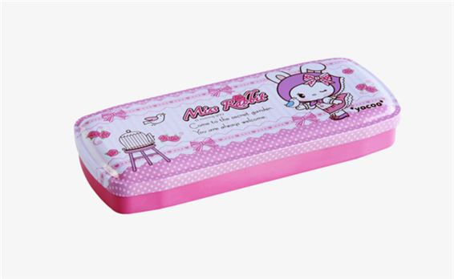Her pencil _ _ _ _ is pink.
117. Choose the incorrect word or phrase in the following sentence: They play badminton in break time.
A. play B. badminton C. in D. time
118. it/ bag?/ your/ school/ Is/
119. is/ my/ friend,/ too./ He/
120. Ảnh: 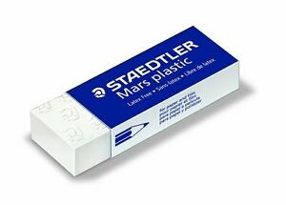It's Alex's ru_ _ _ _ .
121. Wash/ your/ hands,/ Tom.
122. Does she have any _______?
A. banana B. bananas C. bananas’ D. banana’s
123. Raise your ..., please.
A. hand B. sit C. stand D. open
124. rulers/ are/ How/ there?/ many/
125. Linda: How are you? - Jane: I’m _ _ _ _ , thanks.
126. Teacher: Is your school library big? - Tommy: No, it … .
A. don’t B. am not C. doesn’t D. isn’t
127. Do you like _ oing Maths?
128. your/ pencils/ Put/ away,/ children./
129. My school bag is _ _ all. Your school bag is big.
130. Yes, _ _ is a new notebook.
131. David?/ sister,/ this/ your/ Is/
132. spell/ of this animal?/ How/ do you/ the name
133. _ _ _ _ _ are you from? - I'm from Vietnam.
134. I am .... I want a cake.
A. thirsty B. tired C. happy D. hungry
135. Four and five are n_ _ _ .
136. Ảnh: 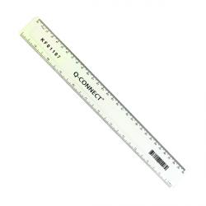R_ _ _ _
137. ____ do you like? - This one.
A. What B. Where C. How D. Which
138. What is your favourite ...? – I like milk very much.
A. food B. drink C. subject D. colour
139. They aren't her books. They are _ _ s books.
140. These are my … .
A. book B. pencil case C. poster D. bags
141. This is m_ cat.
142. My mother buys many school things such as notebooks, pens, pencils and _________.
A. hamburger B. shoes C. balls D. rubbers
143. They like frogs … they don’t like spiders.
A. but B. and C. so D. or
144. Ảnh: 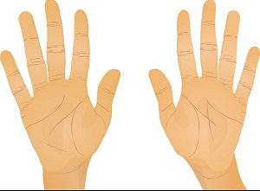Two ha_ _ _ have ten fingers.
145. Nam: May I _ _ out? - Teacher: Yes, please.
146. break time./ hide-and-seek/ Let's/ play/ at
147. Odd one out:
A. fish B. dolphin C. monkey D. shark
148. Nghe: Nhấn giữ Ctrl và bấm chuột để nghe: Listen and tick:
A. pen B. pencil C. pen case D. ruler
149. Nghe: Nhấn giữ Ctrl và bấm chuột để nghe: Polly is my best _ _ _ _ _ _ .
150. Which word is odd one out?
A. pig B. men C. chicken D. fish
151. Ảnh: 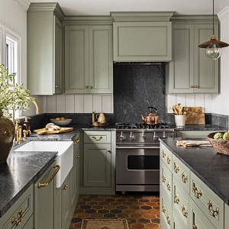His mother is in the kitch_ _ .
152. Ảnh: Let's make paper bo_ ts.
153. 'Do you play badminton at break time?' - '_________.'
A. No, you can’t. B. Yes, you do. C. Yes, I do. D. Yes, I am.
154. like/ English?/ Alice/ does/ Why/
155. My family have dinner in the ____.
A. living room B. bedroom C. basement D. dining room
156. and sister./ brother/ my/ These/ are/
157. play/ Max and his friends/ badminton/ in the/ playground./
158. The _________ is Jane.
A. me B. boy C. girl D. she
159. are/ the wall./ on/ pictures/ The/
160. Are you a student or a teacher?
A. Yes, I am. B. No, I am not. C. I’m a student. D. Yes, I.
161. What time …?
A. are they B. is it C. aren’t they D. isn’t it
162. Can/ one to ten?/ you count/ from/
163. What colour is this? - … .
A. It blue B. It’s blue C. Is blue D. It is a blue
164. Listen _____ repeat.
A. or B. and C. with D. now
165. Jane: What _ _ _ our is your desk? - Linda: It is pink.
166. How old is his grandmother? - _______
A. She's fine. B. There are some tables in the room. C. She's sixty now. D. Thank you very much.
167. A: Goodbye. - B: Bye. _________
A. See you tomorrow. B. Thank you. C. Sorry. D. Nice to meet you.
168. How mu_ _ milk would you like?
169. my/ is/ Living room/ favourite room.
170. Would you _ _ _ _ some water?
171. Hamburger/ favourite/ my/ is/ food./
172. Choose the incorrect word(s) in the following sentence: My uncle is thirty year old.
A. My B. is C. year D. old
173. Let’s listen _ _ some music.
174. Let’s make a cir_ le.
175. W_ _ _ _ is Mary from?
176. Peter: What are their …? - Hoa: Mai and Huong.
A. name B. names C. your name D. your names
177. Nghe: Nhấn giữ Ctrl và bấm chuột để nghe: _ _ _ _ _ _ _ _ _
178. _ _ you like playing football?
179. Ảnh: She has a beautiful _ _ _ _ .
180. At break time, we ___ different games and sports.
A. do B. get C. go D. play
181. A: Do you like bananas? - B: ______
A. I like bananas. B. I don't like bananas. C. Yes, I do. D. Yes, I am.
182. John: Are you a student? - Jane: Yes,... .
A. Yes, I am B. I am C. I’m student D. Yes, I
183. large./ The computer/ is/ room/
184. Nghe: Nhấn giữ Ctrl và bấm chuột để nghe: _ _ _ _ _ _
185. Ảnh: What’s the weather like? - It’s _ _ _ _ _ .
186. Ảnh: 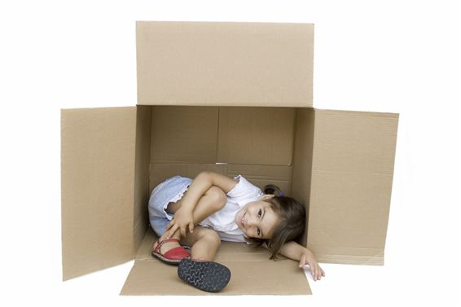The child is _ _ the box.
187. cat/ the/ sofa./ is on/ The/
188. May I _ _ me in?
189. Ảnh: 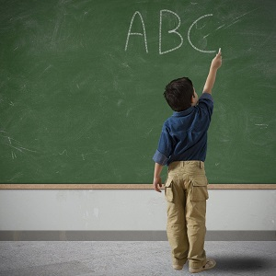He _____ some words on the blackboard.
A. listens B. writes C. goes D. plays
190. my/ pens./ are/ new/ These/
191. David can play ... .
A. desk B. chair C. pencil D. football
192. Choose the odd one out:
A. song B. subjects C. animal D. plant
193. Nghe: Nhấn giữ Ctrl và bấm chuột để nghe: _ _ _ _ _
194. Lien: _ _ you like badminton? - Mary: Yes, I do.
195. The board is big and n_ _ .
196. How _ _ d is she? – She’s nine years old.
197. are/ clouds./ big/ Those/
198. Choose the INCORRECT word or phrase in the following sentence: These are Peter's picture on the shelf.
A. These B. picture C. on D. shelf
199. my/ have/ I/ lunchbox./ don't/
200. Rai_ e your hand, please.

IOE K3 SỐ 22
1. Please, give me some m_ _ e milk.
2. Nghe: Nhấn giữ Ctrl và bấm chuột để nghe: Listen and tick:
A. a plane B. a train C. a fan D. a chair
3. Let's play hide-and-_ _ _ _ at break time.
4. ... old is your sister? – She is nine years old.
A. When B. What C. Where D. How
5. What do you usually do _ _ Saturday evenings, Mary?
6. is/ large./ room/ The/ very
7. Ảnh: 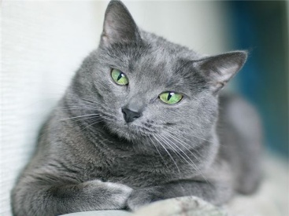My _ _ _ is grey.
8. Jane: What _ _ _ our is your desk? - Linda: It is pink.
9. Every Tuesday, I play soccer ... school.
A. in B. for C. to D. after
10. Nghe: Nhấn giữ Ctrl và bấm chuột để nghe: Listen and tick:
A. close B. old C. cold D. rose
11. Ảnh: 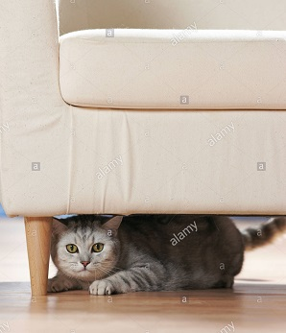It's under the ____.
A. book B. bookcase C. table D. sofa
12. ______ my uncle next to my father.
A. They are B. There are C. It is D. Is there
13. Choose the odd one out
A. Pictures B. Pencils C. Markers D. Crayons
14. favourite/ subject./ my/ Music/ is/
15. Come/ children./ in,/ please,/
16. Choose the letter(s) to make a correct word: LIT_LE
A. F B. M C. N D. T
17. brother's/ name?/ What/ is/ your/
18. Is the_ _ a dog? – No, there is not.
19. Peter _ _ _ a brother. His name is Jack.
20. My schoo_ is small.
21. What sp_ _ _ do you play at break time? - I play badminton.
22. Ảnh: 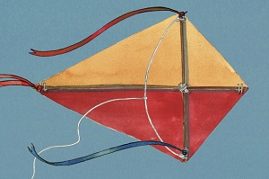Can you make a _ _ _ _ ?
23. Nghe: Nhấn giữ Ctrl và bấm chuột để nghe: Listen and tick:
A. moon B. jump C. sun D. run
24. ____ many trees are there in the garden?
A. How B. What C. Why D. Which
25. Ảnh: 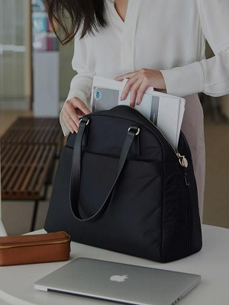The teacher comes in and puts her bag ___ the desk.
A. in B. at C. on D. to
26. June is the ... month of the year.
A. sixth B. fourth C. seventh D. eighth
27. _ _ _ old are you? - I’m seven years old.
28. blind man’s/ Let’s/ play/ bluff.
29. Ảnh: 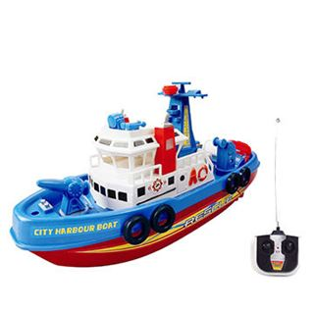The _ _ _ _ is beautiful.
30. The fan/ on/ wall./ the/ is/
31. ... is your birthday? - It’s in July.
A. Where B. How C. When D. How old
32. Let’s speak Eng_ _ _ _ !
33. hungry,/ Are/ you/ Henry?
34. They/ on the wall./ pictures/ three/ are/
35. How _ _ _ your dad and your mom?
36. Anne has long … hair.
A. nice B. curly C. slim D. sunny
37. three/ have/ flowers./ I/
38. T_ _ _ are my uncle and aunt.
39. a/ Is/ she/ student?
40. Ảnh: 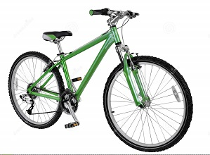I have a new ___. It's green.
A. bike B. car C. ship D. train
41. _ _ my lunchbox, I have a banana and a sandwich.
42. Choose the letter(s) to make a correct word: __mputer
A. ca B. co C. sa D. sko
43. Nghe: Nhấn giữ Ctrl và bấm chuột để nghe: Which is NOT mentioned?
A. A bed B. A window C. A picture D. A bookshelf
44. Is she _______ years old?
A. for B. four C. fuor D.
45. Pictures of my family _ _ _ on the wall.
46. Nghe: Nhấn giữ Ctrl và bấm chuột để nghe: My brother is thir_ _ _ _ years old.
47. __________ elephant has a long nose.
A. A B. An C. It D. All are incorrect.
48. What do you _ _ in your free time?
49. _________ - She's forty.
A. How many books are there? B. How old are you? C. What is her name? D. How old is she?
50. Lien can sing _______ English songs.
A. an B. some C. this D. a
51. Nghe: Nhấn giữ Ctrl và bấm chuột để nghe: Which number is NOT in the recording?
A. 16 B. 17 C. 18 D. 19
52. Ảnh: 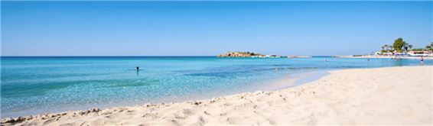We are on the _ _ _ _ _ because it’s very hot today.
53. and/ that is/ her pencil./ This is/ my pen/
54. One and one is _ _ _ .
55. … is your school? – It’s at the corner of the street.
A. Who B. Where C. How D. What
56. Ảnh: 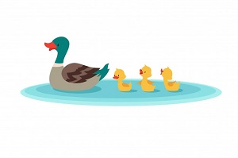The d_ _ _ swims in the pond.
57. eight/ Peter/ old./ is/ years
58. Ảnh: 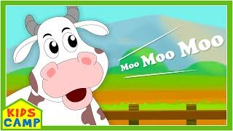The _ _ _ on the farm says 'moo moo moo'.
59. Ảnh: That is the ph_ _ _ of my family.
60. Choose the letter(s) to make a correct word: DE__
A. KS B. SK C. KA D. AK
61. Nghe: Nhấn giữ Ctrl và bấm chuột để nghe: _ _ _ _ _ _
62. This is my/ pencil/ new/ box.
63. Jane: Are … your friends? - David: Yes, they are.
A. Peter B. Mary C. are D. Peter and Mary
64. do you/ How/ spell/ your uncle's/ name?/
65. Nghe: Nhấn giữ Ctrl và bấm chuột để nghe: Do you go to school in the _ _ _ _ _ _ _ _ _ ?
66. My brother has t_ n pets.
67. My bedroom is not big. It’s ... .
A. a small B. small C. is small D. it’s small
68. Ảnh: 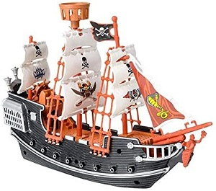I have a _ _ _ _ . It's my birthday present.
69. I don’t/ on/ have/ Friday./ Art/
70. Nice to m_ _ _ you, too.
71. I have a cat _ _ _ a dog.
72. the/ Look/ at/ board.
73. I like/ to/ on the radio./ listening/ fairy tales
74. Ảnh: 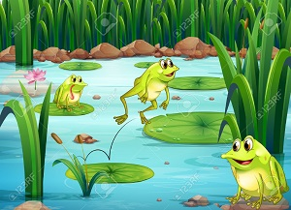The ____ are in the pond.
A. fish B. frogs C. chickens D. birds
75. Nghe: Nhấn giữ Ctrl và bấm chuột để nghe: This is Sue, Andy’s _ _ _ _ _ _ .
76. Ảnh: 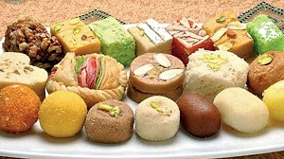SWE_ T
77. lamb./ has/ Marry/ little/ a/
78. you/ Goodbye./ See/ later.
79. Ảnh: 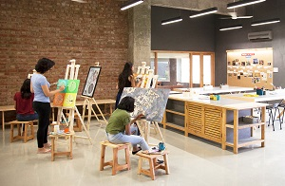That is the _ _ _ room.
80. - Alice: Who is …? - Mark: Who? - Alice: The girl over there.
A. this B. that C. there D. these
81. You are welc_ me.
82. Nghe: Nhấn giữ Ctrl và bấm chuột để nghe: Listen and tick:
A. moon B. man C. meet D. new
83. Happy birthday ... you, Jenny.
A. at B. in C. to D. on
84. There _ _ _ many clouds in the sky.
85. Who is our new tea_ _ er?
86. Tom _ _ _ born on October 24th.
87. Let’s … a song, children.
A. play B. take C. sing D. speak
88. Look ____ this photo of my family. Do you guess how old I am?
A. in B. at C. on D. by
89. Ảnh: 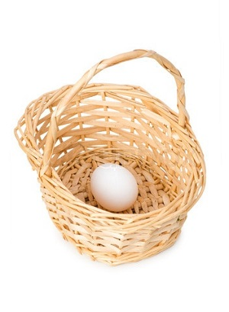There is an _ _ _ on the basket.
90. blue/ eraser./ is/ It/ a/
91. His/ small./ old/ is/ house/
92. kind/ doesn’t/ Tony/ of music./ like this/
93. this/ square/ box?/ a/ Is/
94. your/ Is/ in the wardrobe?/ blanket/
95. How m_ _ y dogs do you have?
96. Choose the letter(s) to make a correct word: G__NDFATHER
A. AR B. OR C. RO D. RA
97. playing chess/ like/ or football?/ you/ Do/
98. Nghe: Nhấn giữ Ctrl và bấm chuột để nghe: Listen and tick:
A. shy B. sit C. six D. soup
99. I like English very ... .
A. many B. much C. any D. how
100. My classroom is ... . It’s not small.
A. big B. a big C. the big D. a small
101. Lan/ Does/ like/ volleyball?/ playing
102. Plea_ _ _ to meet you!
103. I _ _ _ _ books in the school library.
104. Are they/ the bed?/ Peter's balls/ under/
105. … is this? – It’s my brother.
A. Who B. What C. How D. When
106. the children?/ Where/ are/
107. little sister/ is/ years old./ five/ My/
108. They ha_ _ two dogs.
109. How are …? - … am fine, thanks.
A. they / He B. we / We C. you / I D. him / He
110. house/ is/ big./ not/ My/
111. you/ like/ Do/ carrots?
112. Ảnh: Uncle Tom is a _ _ _ _ _ driver.
113. Do you have any pets? – Yes, I have … .
A. any B. some C. much D. no pets
114. Ảnh: My father is ______ years old.
A. thirty-eight B. forty-eight C. fourteen-eight D. fifteen-eight
115. ... your teeth, Tommy.
A. Read B. Listen C. Stand D. Brush
116. Nghe: Nhấn giữ Ctrl và bấm chuột để nghe: Listen and tick the word(s) you hear:
A. a pen B. a pencil C. a bank D. a band
117. Choose the letter(s) to make a correct word: ga__en
A. dd B. td C. rt D. rd
118. Nghe: Nhấn giữ Ctrl và bấm chuột để nghe: _ _ _ _ your book.
119. Your mother’s sister is your … .
A. niece B. aunt C. sister D. relative
120. P_ t the words into the blanks.
121. Nghe: Nhấn giữ Ctrl và bấm chuột để nghe: Where is Mai?
A. She’s in her bedroom. B. She’s in the library. C. She’s in the kitchen. D. She’s in the garden.
122. Say your n_ _ e, please.
123. my/ notebooks./ These/ not/ are/
124. Let’s dr_ _ a picture.
125. Pick ... your books, please.
A. to B. on C. at D. up
126. I want to play sports. Let’s go to the g_ _ .
127. Peter: What _ _ _ _ _ _ is your pen? - Mary: It’s red.
128. my/ bedroom./ is/ This/
129. Nghe: Nhấn giữ Ctrl và bấm chuột để nghe: They are ____.
A. 12 B. 13 C. 14 D. 15
130. me./ after/ read/ Please/
131. May/ mom?/ open/ I/ the window,
132. Lan: What colour are your pencils? - Huong: They ... blue and green
A. do B. don’t C. are D. is
133. Do you have ... on Friday? – No, I have English.
A. Informatics B. cakes C. desks D. books
134. Do you … skateboarding?
A. like B. liking C. likes D. to like
135. John./ my/ This/ new friend,/ is/
136. My pets _ _ _ beautiful.
137. English/ my/ teacher./ is/ Mr. John/
138. What is this? - ….
A. His name is Rod B. It is a ruler C. It’s an ruler D. It’s Rod
139. Choose the INCORRECT word or phrase in the following sentence: Three little cat are in the yard.
A. cat B. are C. in D. yard
140. She plays hide-and-_ _ _ _ in the garden.
141. Are you happy?
A. Yes, I am. B. Yes, am. C. Yes, I I’m. D. Yes, it’s me.
142. When is your ... birthday? - It’s on December 4th .
A. mothers’ B. mother’s C. is mother D. mothers
143. Ảnh: 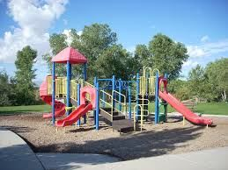This is the play_ _ _ _ _ _ .
144. Lis_ _ _ to the teacher, please.
145. Children shouldn’t drink coffee. It is not good _ _ _ their health.
146. Can you he_ p me, please?
147. What are these? - _______ cakes.
A. These B. There are C. It’s D. They are
148. is/ My father/ forty-five/ old./ years
149. I’m running … Andy. He runs so quickly.
A. behind B. between C. among D. next to
150. It _ _ my birthday today.
151. Ảnh: They _ _ _ _ _ to school every morning.
152. What _ _ _ _ your father do?
153. Nghe: Nhấn giữ Ctrl và bấm chuột để nghe: _ _ _ are you?
154. Betty/ a/ is/ pretty/ girl./
155. … is that? – That’s Jane. She is my friend.
A. How B. When C. Who D. Where
156. small./ school/ My/ bag/ is
157. _ _ _ is that? – It’s Alice.
158. I/ school./ at/ chess/ play/
159. Billy: Are they your friends? - Minh: No, they ... .
A. don’t B. have C. do D. aren’t
160. Nghe: Nhấn giữ Ctrl và bấm chuột để nghe: _ _ _ _ _ _
161. Nghe: Nhấn giữ Ctrl và bấm chuột để nghe: He’s listening to _ _ _ _ _ .
162. It’s m_ umbrella.
163. These/ puzzles./ are/ my/
164. The sky is black __ night.
A. on B. at C. in D. to
165. What time _ _ _ _ the library open?
166. Jim can speak Eng_ _ _ h but cannot speak Vietnamese.
167. Ảnh: Tom, my little brother, likes doing _ _ _ _ _ es.
168. Peter: Is your classroom big? - Mai: … .
A. Yes, it is B. Yes, please C. Yes, I do D. Yes, I don’t
169. Are/ new/ they/ your/ classmates?/
170. Do you like music?
A. Yes, it is. B. Yes, please. C. Yes, I do. D. Yes, I don’t.
171. Listen _ _ me, please.
172. Ảnh: 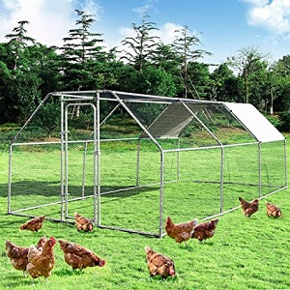The ch_ _ _ _ _ _ are walking in the garden.
173. My aunt’s daughters _ _ _ my cousins.
174. Pick ... your pen, children.
A. at B. on C. to D. up
175. a/ is/ This/ flower./ red
176. Nghe: Nhấn giữ Ctrl và bấm chuột để nghe: The _ _ _ _ _ _ _ is very tidy.
177. _ _ _ are you? - Fine, thanks.
178. Miss White is my new tea_ _ er.
179. These/ circles./ some/ are/
180. Do you like _ oing Maths?
181. Hi, _ _ _ are you? – I’m fine, thanks.
182. H_ _ _ _ , Alex. How are you?
183. I want to be a musician in _ _ _ future.
184. Ảnh: 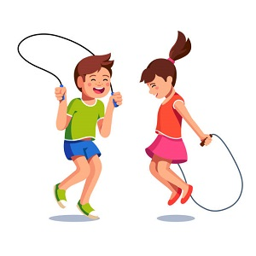It's great to play sk_ _ _ ing with you.
185. ... morning, John.
A. Good’s B. Bye C. Hi D. Good
186. nine/ years old?/ Are/ cousins/ his/
187. Nam is .... He’d like to sit down.
A. tired B. hungry C. thirsty D. cold
188. new?/ classroom/ Is/ your/
189. ... are you? – I’m fine, thanks.
A. Who B. When C. How D. Where
190. Ảnh: A person has o_ _ nose.
191. Choose the INCORRECT word or phrasein the following sentence: How many lamp are there in the room?
A. lamp B. are C. in D. room
192. to/ Happy/ birthday/ you!
193. My sister can play the ... .
A. book B. chess C. piano D. football
194. Choose the odd one out:
A. is B. am C. are D. those
195. Lan: What are they? Huong: They are my ... .
A. teachers B. friends C. pencil cases D. Lan and Mai
196. there/ garden?/ any ponds/ in the/ Are/
197. Where ________? - Behind my house.
A. are your bikes B. is your bikes C. are your bike D. your bikes
198. Tam likes skat_ _ _ very much.
199. Nghe: Nhấn giữ Ctrl và bấm chuột để nghe: There is a _____ next to my bed.
A. table B. desk C. shelf D. book
200. sisters?/ Are/ they/ your/

IOE K3 SỐ 23
1. are/ good/ They/ my/ friends./
2. Linda: _ _ t's go to school together! - Nam: OK.
3. Ảnh: 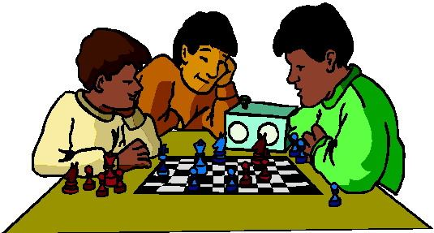We play … at break time.
A. tennis B. football C. chess D. badminton
4. Tom/ new/ are/ my/ and Kevin/ friends./
5. ... you like chicken?
A. Do B. Does C. Are D. Is
6. The cat’s eyes _ _ _ green.
7. He ... my friend.
A. are B. is C. me D. I
8. Choose the odd one out:
A. am B. is C. are D. this
9. I pick ___ my pen and give it to Tony.
A. out B. up C. at D. on
10. Why ... we come and visit Uncle Tom? - That’s a good idea.
A. don’t B. have C. do D. aren’t
11. May I ... in?
A. can B. are C. is D. come
12. How old is your father?
A. He’s fine. B. He’s three ten. C. He’s forty. D. He’s four five.
13. I _ _ a student at Oxford Primary School.
14. Choose the odd one out:
A. bag B. book C. big D. pencil
15. Ảnh: My grand_ _ _ _ er is in the garden.
16. Ảnh: 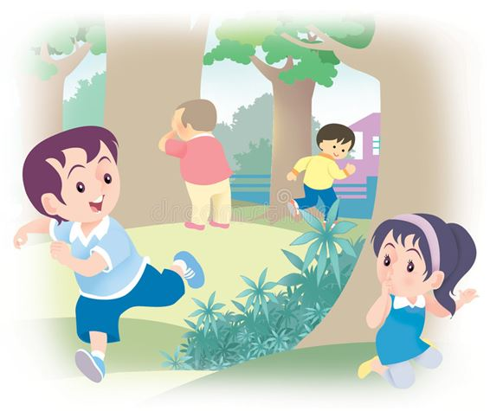We like playing hide-and-_ _ _ _ at weekends
17. are/ three/ They/ on the wall./ pictures
18. Ha can dance _ _ _ she cannot play football.
19. Hi, David. _ _ _ are you? – I’m fine, thanks.
20. are/ They/ in/ the kitchen./ talking/
21. _ _ _ often do you do morning exercise in the summer?
22. Ảnh: My mother is a teac_ _ _ .
23. I/ like/ much./ very/ orange colour/
24. How old is his grandmother? - _______
A. She's fine. B. There are some tables in the room. C. She's sixty now. D. Thank you very much.
25. Ảnh: 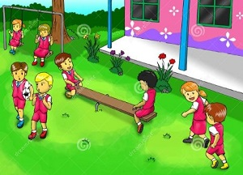What do they do __ break time?
A. in B. on C. for D. at
26. I like _ _ _ _ _ puzzles after school.
27. Nghe: Nhấn giữ Ctrl và bấm chuột để nghe: _ _ _ _ _
28. Nghe: Nhấn giữ Ctrl và bấm chuột để nghe: _ _ _ _ _ _
29. Tick the odd one:
A. picture B. red C. black D. green
30. She is my sister. She is a pretty ________.
A. girl B. boy C. father D. friend
31. Ảnh: The s_ _ is very hot.
32. Peter: What _ _ _ _ _ _ is your pen? - Mary: It’s red.
33. teacher Hoa./ is/ This/ my/
34. Ảnh: It is a beautiful purp_ _ flower.
35. Ảnh: 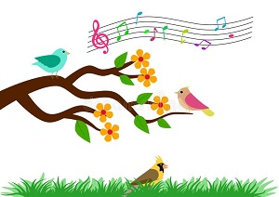On the t_ _ _ , the birds are singing.
36. What's his name? - He _ _ Alan.
37. you/ like/ Do/ or football?/ playing chess
38. I have a cat _ _ d a dog.
39. I like doing karate. - ... .
A. No, thanks B. Me too C. Yes, please D. Sorry
40. Ảnh: This is your …, Tom.
A. bench B. desk C. chair D. board
41. Let’s go t_ the library.
42. My/ blue and/ orange./ is/ schoolbag/
43. evening?/ every/ do/ do you/ What/
44. in winter/ It/ snows/ here./ always/
45. What is your school’s n_ _ _ ? – It’s Oxford Primary School.
46. Nghe: Nhấn giữ Ctrl và bấm chuột để nghe: What do you _ _ _ _ , Billy?
47. Choose the odd one out:
A. am B. are C. is D. thanks
48. Choose the odd one out:
A. you B. I C. fine D. he
49. Pick up/ ruler/ and/ your/ eraser./
50. Nghe: Nhấn giữ Ctrl và bấm chuột để nghe: _ _ _ _ _
51. on/ Are there/ the desk?/ Lan's notebooks/
52. is/ doll/ green./ My/
53. your/ Can/ books?/ close/ you/
54. Ảnh: 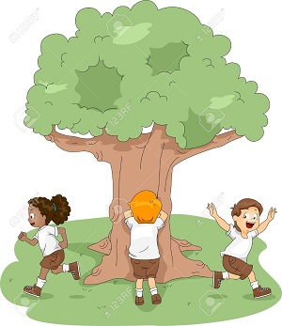Do you like playing hide-and-seek with your friends?
A. Yes, I am B. Yes, I do C. Yes, I don't D. No, I do
55. Nghe: Nhấn giữ Ctrl và bấm chuột để nghe: Which number is NOT in the recording?
A. 16 B. 17 C. 18 D. 19
56. I/ don’t/ sweets./ like/
57. Nghe: Nhấn giữ Ctrl và bấm chuột để nghe: The library is _ _ _ .
58. Phong ____ a new school bag.
A. have B. do C. has D. does
59. Ảnh: The player throws the ball into the basket. What sport is it?
A. Basketball B. Baseball C. Badminton D. Football
60. ... is her classroom.
A. These B. They C. Those D. That
61. is/ coat/ under/ the bed./ His/
62. Dogs, cats, rabbits and hamsters are … .
A. birds B. vets C. pets D. turtles
63. This is my school lib_ _ _ _ . It’s big.
64. Does/ his uncle/ stand/ over there?
65. Lien: _ _ you like badminton? - Mary: Yes, I do.
66. Where are you from, Peter? – I’m _ _ _ _ England.
67. Lan: What colour is your desk? - Huong: It’s o_ _ _ _ _ .
68. Have ... nice day, Robin. – Thank you very much.
A. an B. the C. a D. are
69. Happy birthday to y_ _ !
70. is/ my/ That/ school/ library./
71. That is my mother. _ _ _ is a teacher.
72. Nghe: Nhấn giữ Ctrl và bấm chuột để nghe: He is ____.
A. 12 B. 13 C. 14 D. 15
73. Hello. How _ _ _ you today?
74. your/ away,/ children./ Put/ pencils/
75. Children shouldn’t drink coffee. It is not good _ _ _ their health.
76. Ảnh: 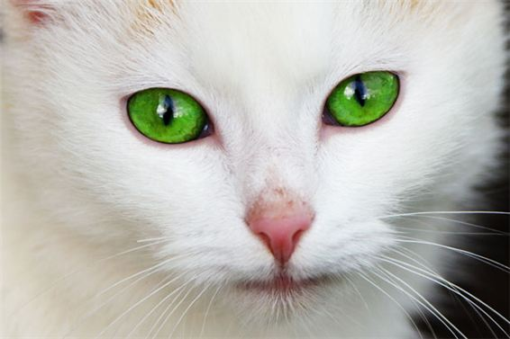What colour is the cat’s eyes? It is _ _ _ _ _ .
77. Sit do_ _ , please.
78. please!/ Be/ quiet,/
79. Ảnh: The woman is very _ _ _ . She's eighty now.
80. Is this a bag? - ... .
A. Nice to meet you B. Yes, it is C. Yes, isn’t D. No, It is
81. Let’s play vo_ _ _ _ ball!
82. Nghe: Nhấn giữ Ctrl và bấm chuột để nghe: Listen and tick the word(s) you hear:
A. happy B. hide-and-seek C. zero D. hero
83. What … those? – They are kites.
A. are B. is C. am D. have
84. Let’s go outside and _ _ _ a kite?
85. Ảnh: 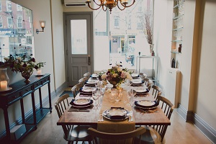We have dinner in the dining _ _ _ _ .
86. Please/ your/ close/ notebook.
87. ... colour are your pencils?
A. What B. How C. Where D. When
88. class./ Be/ quiet,/
89. Ảnh: The woman has got two _ _ _ _ _ _ .
90. This pink box is _ _ _ you, Simon. – Thank you very much.
91. there./ bookshelf/ is/ The/ over
92. This is _ new pen.
93. What is it? - …
A. It’s a rubber. B. I am fine, thanks. C. She is my friend. D. Yes, it is.
94. Ảnh: fourteen, _______, sixteen.
A. fiveteen B. fifteen C. fifty D. fourty
95. Ảnh: The girl is … .
A. doing puzzles B. playing basketball C. playing hide-and-seek D. skipping rope
96. Between two subject lessons, we have a little time for ….
A. break B. take C. make D. check
97. come/ I/ in?/ May/
98. It’s a lo_ _ ruler.
99. and/ your pencil/ Show me/ rulers,/ please./
100. How many people are _ _ _ _ _ in your family?
101. There are twenty stude_ _ _ in my class.
102. Nghe: Nhấn giữ Ctrl và bấm chuột để nghe: They _ _ _ _ and they are happy.
103. say./ and/ ask/ Point,/
104. on the wall./ hangs/ the clock/ My father/
105. Students all ________ when their English teacher comes in.
A. stand up B. sit down C. go out D. come in
106. Ảnh: The children are playing … now.
A. badminton B. volleyball C. hide-and-seek D. break time
107. How m_ _ y dogs do you have?
108. ... are you? – I’m fine, thanks.
A. Who B. What C. How D. When
109. _ _ _ is Tuan happy? - He is happy because today is his birthday.
110. Nghe: Nhấn giữ Ctrl và bấm chuột để nghe: _ _ _ _ _
111. Her coat/ yellow. It's/ new./ is/
112. some/ I/ would/ like/ milk./
113. Nghe: Nhấn giữ Ctrl và bấm chuột để nghe: This is my _ _ _ _ _ _ .
114. Is this _ _ eraser? – No, it isn’t.
115. the pen./ can/ draw/ with/ My sister/
116. Does/ have/ she/ new sandals?
117. Choose the odd one out:
A. you B. your C. his D. her
118. … does your father do in his free time? – He plays tennis.
A. What B. Who C. When D. Where
119. _____ is your grandmother? - She's in the dining room.
A. What B. When C. How D. Where
120. A/ eight/ legs./ has got/ spider/
121. doesn't like it./ badminton/ but/ her sister/ Jane likes/
122. Nghe: Nhấn giữ Ctrl và bấm chuột để nghe: I have _ _ _ books.
123. … does your father get to work? – By taxi.
A. What B. Where C. How D. Which
124. Is/ new?/ classroom/ your/
125. My fish are very _ _ _ _ tiful.
126. Ảnh: 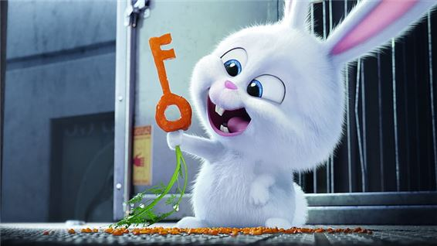This rabbit has an orange _ _ _ .
127. What’s the matter? – I’m ... .
A. doctor B. sick C. teacher D. student
128. W_ _ is he? – He is my best friend.
129. Peter: Are they your friends? - Tom: No, they _ _ _ _ ’t.
130. Lemonade is my favourite … .
A. drink B. food C. apple D. milk
131. How _ _ _ is your brother? - He's eleven.
132. Ảnh: My father is a doct_ _ .
133. This book ... interesting.
A. has B. have C. is D. don’t
134. Do you like my new ball? - _ _ _ , I do.
135. Nghe: Nhấn giữ Ctrl và bấm chuột để nghe: Listen and tick:
A. a pet B. a bed C. a bird D. a bag
136. Ảnh: The board is _ _ the wall.
137. Does your father like p_ _ _ ing sports?
138. Lan: Do you ... swimming? - Huong: Yes, we do.
A. play B. like C. likes D. read
139. ... is your birthday? - It’s in July.
A. Where B. How C. When D. How old
140. Nghe: Nhấn giữ Ctrl và bấm chuột để nghe: _ _ _ _ your book.
141. ... this? – It’s a ball.
A. Is B. What C. What’s D. How
142. This desk is ye_ _ ow.
143. Ảnh: My mother is ______ years old.
A. three-five B. three-fift C. thirteen-five D. thirty-five
144. the song about/ please./ our country,/ Sing/
145. What’s this? - ... .
A. It’s a pen B. Yes, it is C. No, it isn’t D. They are pens
146. How are you today, Peter? – I’m ..., thanks.
A. nice B. nice’s C. fine D. fine’s
147. That is _ bed.
148. Ảnh: 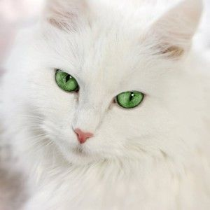His cat has gr_ _ _ eyes.
149. Is/ your/ Peter/ friend?
150. many/ How/ books/ are/ there?/
151. My birthday gift … a doll.
A. is B. are C. am D. the
152. _ _ _ _ _ birthday to you, Jane.
153. Where is his book? - It’s ... the booshelf.
A. on B. in C. at D. to
154. My/ are/ the table./ pencils/ on
155. Ảnh: R_ _ _ _
156. Linda./ name/ is/ Her/
157. in/ now./ the computer/ We are/ room
158. in/ My sister/ 3A./ class/ is/
159. Let’s dr_ _ a picture.
160. old./ is/ Peter/ eight/ years
161. What time _ _ you get up?
162. Reorder the words to make a complete sentence: friend / My / playing / likes / badminton.
A. Friend my likes playing badminton. B. My friend likes playing badminton. C. My friend likes badminton playing. D. Playing badminton my friend likes.
163. My house _ s small.
164. _ _ _ _ _ are you going to stay? - In a hotel.
165. Hi. What's your _ _ _ _ ? - I'm Peter.
166. Ảnh: 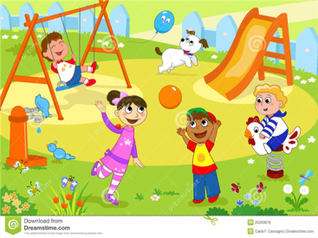Where’s Andy? – He is in the school_ _ _ _ .
167. Choose the odd one out.
A. Teacher B. Pencil C. Rubber D. Ruler
168. Which sentence is correct?
A. Santa Claus flying over the town. B. Santa Claus is riding his sleigh. C. Santa Claus is ride a reindeer. D. Santa Claus is walking in the sky.
169. This is my pen and these ... their pens.
A. is B. are C. am D. be
170. What time does your sister _ _ _ _ lunch?
171. Time always go_ _ fast.
172. Nghe: Nhấn giữ Ctrl và bấm chuột để nghe: What is this? - It’s a _ _ _ _ .
173. This is my …, Eddie. He is very hard-working.
A. uncle B. aunt C. sister D. mother
174. They are her _______.
A. pencil case B. pencils case C. pencils cases D. pencil cases
175. Four and five are n_ _ _ .
176. Nghe: Nhấn giữ Ctrl và bấm chuột để nghe: They are wearing _ _ _ _ _ es.
177. Have ... nice day, Clare. – Thank you.
A. an B. the C. a D. are
178. Are/ garden?/ in the/ there/ any ponds/
179. Let's/ go/ together./ home/
180. desk/ is a/ my room./ There/ in
181. How/ today?/ weather/ is/ the/
182. Nghe: Nhấn giữ Ctrl và bấm chuột để nghe: Listen and tick:
A. a pen B. a pencil C. a bank D. a band
183. These are their _____.
A. schoolbag B. school bags C. schools bag D. schools bags
184. This isn’t ... bag. It’s my bag.
A. he B. his C. me D. you
185. Nghe: Nhấn giữ Ctrl và bấm chuột để nghe: Listen and tick:
A. man B. learn C. plant D. stand
186. today./ her/ It's/ birthday/
187. _________ two teams playing football together.
A. It is B. There is C. There are D. Are there
188. Jane: ... is her name? - Nga: Her name is Joane.
A. How B. What C. When D. Who
189. She never stays _ _ late at night.
190. in/ cooks dinner/ Our grandmother/ the kitchen.
191. Ảnh: They _ _ _ _ _ to school every morning.
192. Listen _ _ me, please.
193. my mother./ with/ often/ go shopping/ I/
194. playground/ Is/ your/ big?
195. She comes home at half _ _ _ _ two and has lunch.
196. Nghe: Nhấn giữ Ctrl và bấm chuột để nghe: Listen and tick the word(s) you hear:
A. snowy B. cloudy C. sunny D. rainy
197. Nghe: Nhấn giữ Ctrl và bấm chuột để nghe: Are your classmates in the _ _ _ _ _ _ _ _ _ _ ?
198. Do you have any toy_ ?
199. _ _ o is that? – That’s Tommy. He is my friend.
200. There … some cheese in the fridge.
A. are B. is C. be D. have

IOE K3 SỐ 24
1. A: How do you spell your … name?- B: … Carter.
A. family - It’s B. surname - I’m C. first - He’s D. full - That’s
2. Nghe: Nhấn giữ Ctrl và bấm chuột để nghe: She can _ _ _ _ .
3. Choose the odd one out:
A. play B. skip C. skate D. boy
4. What ____ is your flower pot? - It's green.
A. old B. many C. name D. colour
5. What is ... name? - My name is Jenny.
A. she B. you C. he D. your
6. Do you _ _ to the zoo with your family?
7. This isn’t ... bag. It’s my bag.
A. he B. his C. me D. you
8. ..., students. See you later.
A. Good morning B. Good night C. Goodbye D. Nice to meet you
9. is/ her/ name?/ What/
10. I have _ cat.
11. under/ The/ is/ that chair./ cat/
12. What’s his name? - … .
A. OK, fine B. Nice to meet you, too C. His name is Rod D. He is my friend
13. My cat/ with a/ ball./ is playing/
14. Ảnh: There is a big poster in ____ of the shop.
A. at B. on C. front D. out
15. Is it … elephant? – No, it’s a hippo.
A. an B. a C. the D. one
16. Ảnh: 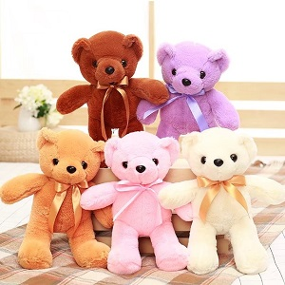My sister has _ _ _ _ teddy bears.
17. I’m fine, th_ _ _ _ .
18. Nghe: Nhấn giữ Ctrl và bấm chuột để nghe: He is ____.
A. 12 B. 13 C. 14 D. 15
19. Penguins live in the South Pole. They … snow.
A. likes B. like C. liking D. to like
20. Would you like to p_ _ _ games with us?
21. ... is the kite? – It’s in the sky.
A. How B. What C. Where D. When
22. Nghe: Nhấn giữ Ctrl và bấm chuột để nghe: The ______ is blue.
A. ski B. skiing C. sky D. fly
23. playing/ No,/ the piano./ like/ I do not/
24. How ...re you today, Lenny? – Oh, I’m fine, thanks.
A. b B. r C. w D. a
25. Ảnh: 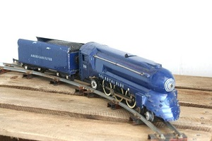It's my new toy. It's a blue ___.
A. bike B. car C. ship D. train
26. My _ _ _ _ is Linda.
27. Ảnh: Do you like playing hide-and-seek with your friends?
A. Yes, I am B. Yes, I do C. Yes, I don't D. No, I do
28. How/ do you/ “playground”?/ spell/ the word
29. Wr_ _ _ the names in the blanks.
30. These are my … .
A. book B. pencil case C. poster D. bags
31. These/ dolls/ beautiful./ are/
32. please./ circles,/ two/ Let’s/ make/
33. What time is it? - … .
A. Nine twenty B. Nine years old C. Nine hundred D. Ninety six
34. your/ What/ family/ is/ name?/
35. are there/ in a month?/ weeks/ How many/
36. … school is that? – It’s Khuong Mai primary school.
A. What B. Who C. How D. Where
37. Linda ____ this yellow dress.
A. like B. is C. likes D. are
38. Tom and Minh are _ _ friends.
39. _ _ _ _ do you do at school?
40. What does your mother do? – She ….
A. She does homework B. She is a cook C. She works hard D. Well, she is nice
41. Ảnh: I like making a _______.
A. paper plane B. paper boat C. paper kite D. paper flower
42. the old/ Those/ photos/ are/ of my family./
43. Ảnh: 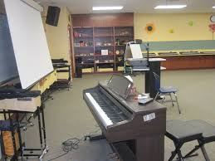Excuse me, where is the mu_ _ _ room?
44. Nghe: Nhấn giữ Ctrl và bấm chuột để nghe: Listen and tick the word(s) you hear:
A. jumping B. climbing C. swimming D. skipping
45. ... is this? – It’s an apple.
A. How B. Who C. What D. Is
46. What are _____? - They are my books.
A. this B. it C. you D. these
47. There _ _ one lamp on the desk.
48. Ảnh: 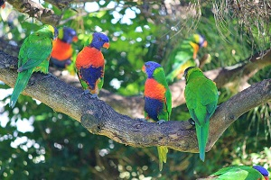How many birds _______ on the tree?
A. there are B. there is C. is there D. are there
49. G_ _ dbye. See you later.
50. Nghe: Nhấn giữ Ctrl và bấm chuột để nghe: Listen and tick:
A. onion B. oil C. orange D. open
51. May I go out? - ... .
A. Sure B. See you later C. Goodbye D. Hello
52. Trang and Chau ... two bikes.
A. has B. have C. is D. don’t
53. Goodb_ e, Tommy. See you later.
54. Ảnh: It’s _ _ _ outside.
55. Does/ reading books?/ her/ like/ brother/
56. Nghe: Nhấn giữ Ctrl và bấm chuột để nghe: B: I’m … . Thank you. And you? - A: I’m very … . Thank you.
A. fine – fine B. fine – well C. well – well D. well – fine
57. Ảnh: Is that your pen_ _ _ ?
58. Ảnh: 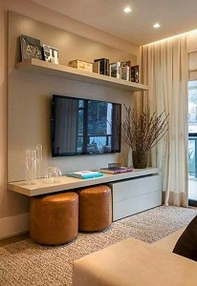The TV is not small. It's _ _ _ .
59. How _ _ d is your sister?
60. Ảnh: I have a _ _ _ _ . It's my birthday present.
61. Ảnh: That’s my pencil _ _ g!
62. my room./ is a/ in/ desk/ There/
63. is/ on/ desk./ The cat/ that
64. Do/ your friends/ skipping?/ like/
65. A: … is your school? - B: … is big and new.
A. Where – He B. How – It C. What – She D. Who - That
66. Pick … your pencil, John.
A. on B. in C. of D. up
67. There/ in the bottle./ any water/ isn't/
68. Where are you from, Peter? – I’m _ _ _ _ England.
69. This is _ photo of my family.
70. Is/ your/ he/ brother,/ Andy?/
71. My _ _ _ _ _ father is old but very sporty.
72. Nghe: Nhấn giữ Ctrl và bấm chuột để nghe: Listen and tick:
A. mirror B. under C. fisher D. soldier
73. like for your birthday?/ you/ do/ toy/ What/
74. Nghe: Nhấn giữ Ctrl và bấm chuột để nghe: _ _ _ _
75. What _______ at break time?
A. do you do B. is he do C. are you do D. are they do
76. A: What is this? - B: …
A. It’s yellow. B. It’s a blue pencil. C. It’s very nice. D. It’s my friend.
77. Nghe: Nhấn giữ Ctrl và bấm chuột để nghe: My room is _ _ _ _ _ .
78. Ảnh: 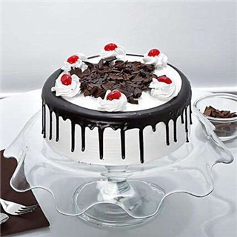_ _ _ _
79. ... your hands, please.
A. Write B. Sing C. Wash D. Study
80. Nghe: Nhấn giữ Ctrl và bấm chuột để nghe: Listen and tick:
A. shy B. sit C. six D. soup
81. days./ I wash/ my hair/ two/ every/
82. Nghe: Nhấn giữ Ctrl và bấm chuột để nghe: The girl is fif_ _ _ _ .
83. What ... it? – It’s a black ruler.
A. is B. it C. that D. this
84. Ảnh: The trees are tall and _____ in the forest.
A. gray B. green C. black D. yellow
85. He likes ____ games.
A. plays B. to playing C. play D. playing
86. Choose the letter(s) to make a correct word: par__t
A. ao B. ra C. or D. ro
87. What/ is/ her/ name?
88. the/ May/ I/ window?/ open/
89. Ảnh: _ _ _ _ _ _
90. your sisters/ dogs?/ Do/ like/
91. much./ I/ swimming/ like/ very
92. Ảnh: 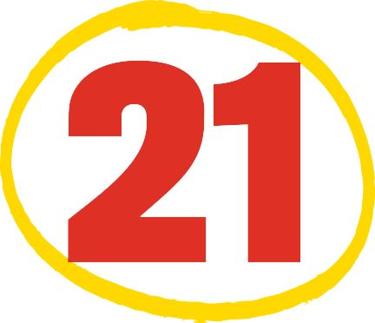How old is Nam’s brother?
A. He’s twenty with one. B. He’s twoty one. C. He’s two one. D. He’s twenty one.
93. I/ would/ some/ like/ milk./
94. The map _ _ on the wall.
95. One plus thr_ _ makes four.
96. Nghe: Nhấn giữ Ctrl và bấm chuột để nghe: _ _ _ _ _
97. Choose the INCORRECT word or phrase in the following sentence: It are a pond in the garden.
A. are B. pond C. in D. garden
98. This is my new f_ _ _ _ d, Tony.
99. She never stays _ _ late at night.
100. Ảnh: My _ _ _ likes running on grass.
101. What is/ book?/ favourite/ of your/ the name/
102. I’m fine, thanks. How a_ _ _ t you?
103. T_ _ _ _ are some birds singing on the tree.
104. One plus one makes _ _ _ .
105. How many colours does a rainbow have?
A. five B. six C. seven D. eight
106. open/ May/ the window,/ I/ mom?/
107. I have _ _ uncle. He's thirty now.
108. Choose the odd one out:
A. library B. bathroom C. bedroom D. dining room
109. Choose the odd one out:
A. large B. small C. old D. class
110. ... your teeth, Tommy.
A. Read B. Listen C. Stand D. Brush
111. He is David. He is my ... .
A. school B. name C. book D. friend
112. large./ The computer/ is/ room/
113. milk./ I/ some/ would/ like/
114. What do _ _ _ do after school, Mary?
115. Nghe: Nhấn giữ Ctrl và bấm chuột để nghe: _ _ _ , Nam.
116. Ảnh: There are five fingers on _ _ _ hand.
117. Ảnh: Shhh! The baby is _ _ _ _ _ _ _ _ .
118. Do you have ... on Friday? – No, I have English.
A. Informatics B. cakes C. desks D. books
119. I’m _ _ _ e, thanks. And you?
120. Ảnh: A person has o_ _ nose.
121. Do you like music?
A. Yes, it is. B. Yes, please. C. Yes, I do. D. Yes, I don’t.
122. It's/ winter./ cold/ in/
123. are there/ your classroom?/ How many/ in/ desks/
124. June is the ... month of the year.
A. sixth B. fourth C. seventh D. eighth
125. _ _ _ _ colour is it? - It’s red.
126. May I go _ _ t? - Yes, please.
127. Nghe: Nhấn giữ Ctrl và bấm chuột để nghe: Here is his grandf_ _ _ _ _ .
128. _____ is Jack from? - He's from England.
A. What B. When C. How D. Where
129. The big tree is beh_ nd my house.
130. Nghe: Nhấn giữ Ctrl và bấm chuột để nghe: _ _ _ _ _ _
131. Wow! A robot. Thank _ _ _ .
132. We go to school ... .
A. alone B. together C. gether D. by me
133. Choose the odd one out:
A. computer room B. park C. zoo D. playground
134. I/ flowers./ three/ have/
135. Nghe: Nhấn giữ Ctrl và bấm chuột để nghe: Max’s favorite color is _ _ _ _ _ .
136. Let’s listen _ _ some music.
137. Nghe: Nhấn giữ Ctrl và bấm chuột để nghe: The teacher tells the students to … .
A. sit down B. stand up C. go out D. come in
138. What do you usually do _ _ Saturday evenings, Mary?
139. _ _ at is my green pencil.
140. Nghe: Nhấn giữ Ctrl và bấm chuột để nghe: Her …’s name’s Frank.
A. brother B. grandpa C. uncle D. dad
141. _ _ you like playing football?
142. spell/ your uncle's/ How/ name?/ do you/
143. Choose the odd one out
A. Pond B. Classroom C. Garden D. Playground
144. _ _ _ is Tuan happy? - He is happy because today is his birthday.
145. Let’s go outside and _ _ _ a kite?
146. after/ me./ read/ Please/
147. My aunt’s daughters _ _ _ my cousins.
148. Nghe: Nhấn giữ Ctrl và bấm chuột để nghe: Choose the correct response.
A. No, I don’t. B. Yes, I am. C. No, it doesn’t. D. Yes, it is.
149. are/ My/ and big./ long/ pencils/
150. like/ Do/ basketball?/ you/
151. sunny/ It's/ in/ summer.
152. This/ is/ my/ cat.
153. Choose the odd one out:
A. nice B. you C. he D. she
154. yellow/ and/ her cats/ Are/ white?/
155. What’s your name? – … Tuan.
A. She’s B. He’s C. I’m D. You’re
156. My family have dinner in the ____.
A. living room B. bedroom C. basement D. dining room
157. Ảnh: Can you make a _ _ _ _ ?
158. _ _ _ t is that? – That is a red apple.
159. the rain./ take any/ photos/ We can’t/ because of
160. Ảnh: 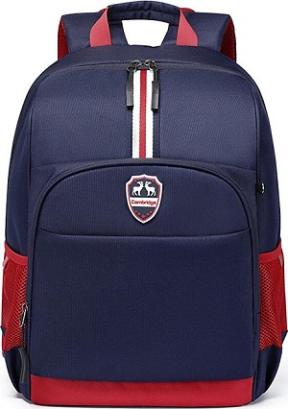SCHOOL _ _ _
161. N_ _ e to meet you, Lan Anh.
162. Be qu_ _ _ . Listen to the teacher, please.
163. ... have you got English? - Four times a week.
A. How B. When C. How often D. Where
164. make/ can/ a paper boat./ Peter/
165. _ _ _ 's that? - It's my teacher.
166. Which is your house? – That … .
A. two B. three C. one D. four
167. like/ some/ pizza./ I'd/
168. W_ _ _ is this? - It’s a ruler.
169. Be q_ _ et, please.
170. case/ the/ My pencil/ is on/ table./
171. please!/ Listen/ to/ your teacher,/
172. Have ... nice day, Robin. – Thank you very much.
A. an B. the C. a D. are
173. you/ See/ later./
174. I _ _ _ _ books in the school library.
175. The dog is ... the sofa.
A. on B. to C. between D. for
176. school things./ not/ are/ her/ These/
177. Which animal has ONLY two legs?
A. Cat B. Tiger C. Bird D. Dog
178. that is/ and/ This is/ her pencil./ my pen/
179. Where are you from, Peter? – I’m _ _ _ _ England.
180. Wh_ _ is this? – This is a pen.
181. A: _______ - B: Sorry.
A. See you later. B. May I come in? C. Nice to see you. D. Don't talk in class!
182. can/ English songs./ many/ I/ sing/
183. Mr. Green is talking _ _ Mrs. Green in a café.
184. Ảnh: 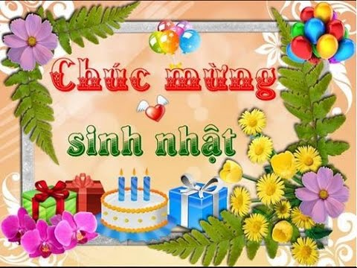Hap_ _ birthday!
185. Ảnh: _ _ _ _ _ _ _
186. I'm __ school now.
A. on B. at C. in D. to
187. Ta_ e out your pencils, children.
188. Come and play with ... .
A. to B. my C. I D. me
189. The piano is nice but … .
A. old B. new C. big D. good
190. Ảnh: What are they doing? - They are sw_ _ _ _ _ _ .
191. _ _ _ those my pens?
192. Nghe: Nhấn giữ Ctrl và bấm chuột để nghe: Some students go by _ _ _ _ _ _ _ .
193. Mr. Parker r_ _ _ _ newspapers everyday.
194. There are/ a week./ days/ seven/ in
195. Ảnh: My pen is _ _ _ _ .
196. Linda: _ _ t's go to school together! - Nam: OK.
197. a shirt./ I open/ and pick up/ the wardrobe/
198. on/ pencils/ the table./ My/ are/
199. father/ a/ is/ My/ doctor./
200. This is _ _ ice cream.

IOE K3 SỐ 25
1. W_ _ is he? – He is my best friend.
2. I often play sports _ _ Tuesday afternoons.
3. Ảnh: 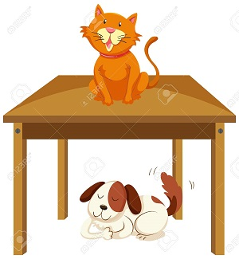The _ _ _ is on the table.
4. ... your teeth, Tommy.
A. Read B. Listen C. Stand D. Brush
5. I have an English friend. _ _ _ name is Kate.
6. How are you? – I’m … .
A. six B. happy C. yellow D. new
7. How _ _ ny bananas are there in the box?
8. This is _ book. It’s green.
9. Let’s go fishing. – That’s a good i_ _ _ .
10. there?/ many/ are/ How/ books/
11. Choose the odd one out.
A. Father B. Mother C. Brother D. Uncle
12. next to/ your mother?/ Is/ your aunt/
13. _____ Lisa like going out with you?
A. Do B. Are C. Is D. Does
14. Can you speak English? - Yes,... can.
A. he B. she C. you D. I
15. John: This is my sister. Peter: What is _ _ r name?
16. pond./ are swimming/ The fish/ in the/
17. These are my s_ _ ters.
18. This is Tom and _ _ _ cute dog, Rex.
19. Those _ _ _ my pens and pencils.
20. Ảnh: What are they doing? - They are sw_ _ _ _ _ _ .
21. with/ Can/ you/ play/ a yo yo?/
22. Hamburger/ my/ favourite/ is/ food./
23. Orange juice is my favourite ... .
A. drink B. food C. apple D. milk
24. playing/ at break time./ We/ like/ games
25. Choose the letter(s) to make a correct word: cent__l
A. ra B. re C. aa D. ar
26. Ảnh: There are _ _ _ _ toes on a foot.
27. Nghe: Nhấn giữ Ctrl và bấm chuột để nghe: The girl is fif_ _ _ _ .
28. white. It's/ small./ Lan's eraser/ is/
29. _ _ _ are you? - I’m fine, thanks.
30. Hello. My name’s Betty. - ....
A. Bye, see you again B. See you soon C. Hi. I am Susan. Nice to meet you D. Goodbye
31. Nghe: Nhấn giữ Ctrl và bấm chuột để nghe: It’s a … book.
A. little B. small C. big D. large
32. Ảnh: 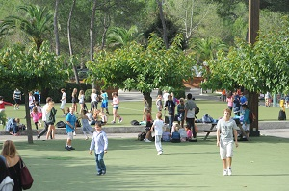The school playground is crowded at _ _ _ _ _ time.
33. Write your name _ _ the board, please.
34. next to/ the living room./ The/ is/ kitchen/
35. My school bag _ _ new.
36. Do you ____ a comic book? - Yes, I do.
A. having B. like C. knows D. are
37. Jane./ new friend/ is/ This/ my/
38. Ảnh: 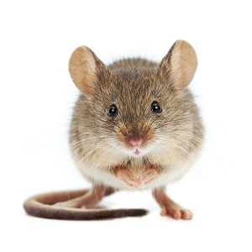MOUS_
39. Where is your school libra_ _ ?
40. Ảnh: 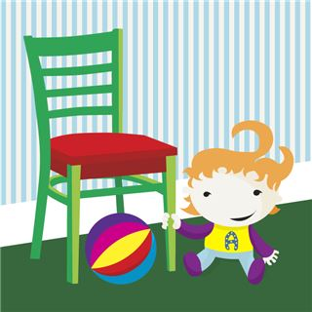There is NOT _______ in the picture.
A. a ball B. a baby C. a desk D. a chair
41. Spe_ _ your name, please.
42. _ _ _ t’s your name? – My name’s Sean.
43. Peter: Let’s dr_ _ a picture. - Nam: Yes, let’s.
44. do/ How/ you/ spell/ her name?/
45. Ảnh: 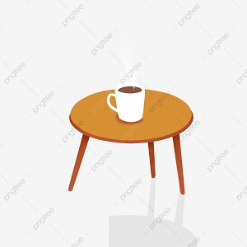The cup is here, __ the table.
A. in B. on C. behind D. under
46. school/ I/ on Sunday./ go to/ don’t/
47. Nghe: Nhấn giữ Ctrl và bấm chuột để nghe: Listen and tick the word(s) you hear:
A. lion B. lamp C. ruler D. cloudy
48. Linda _____ a little cat.
A. have B. do C. has D. am
49. Ảnh: His cat has gr_ _ _ eyes.
50. I like my school _ _ _ _ much.
51. There … some cheese in the fridge.
A. are B. is C. be D. have
52. Ảnh: 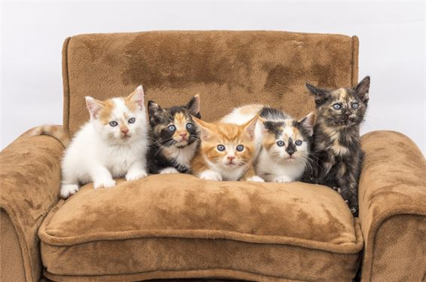There are five _ _ _ _ in the armchair.
53. Is that a crayon? - ... .
A. No, they are B. Yes, they are C. Yes, it is D. No, they aren’t
54. _ _ _ sun is shining.
55. How … fans are there? – Three.
A. many B. much C. old D. long
56. Which word has the underlined part pronounced LIKE the letter E in SISTER
A. nice B. brother C. new D. bedroom
57. Which is your school? - … one.
A. The B. A C. An D. This
58. What is your school’s n_ _ _ ? – It’s Oxford Primary School.
59. song./ sing/ Let’s/ a/
60. are my/ and Tommy/ new/ friends./ Peter/
61. Gi_ e me the book, please.
62. Do you like listening to music?
A. Yes, I am. B. No, I do. C. No, I don't. D. Yes, it is.
63. Choose the INCORRECT word or phrase in the following sentence: Our living room are very big and beautiful.
A. are B. very C. and D. beautiful
64. Nghe: Nhấn giữ Ctrl và bấm chuột để nghe: Sue _ _ _ _ _ up at seven o’clock in the morning.
65. Choose the INCORRECT word or phrase in the following sentence: They are my ball, Daddy.
A. They B. my C. ball D. Daddy
66. is/ What/ your/ sister's/ name?/
67. Is that a purple flower? – ..., it is.
A. No B. Yes C. Not D. No, it isn’t
68. Choose the letter(s) to make a correct word: bla__
A. kk B. cc C. kc D. ck
69. teacher./ Point/ to/ the/
70. My parents are _ _ the living room.
71. Ảnh: What colour is the fence?
A. Blue B. Black C. White D. Yellow
72. Nghe: Nhấn giữ Ctrl và bấm chuột để nghe: How many cakes are there in total?
A. There are twenty-nine. B. There are ninety. C. There are thirty-nine. D. There are ninety-nine.
73. She never stays _ _ late at night.
74. What do you do in … free time?
A. you B. yours C. you’re D. your
75. I’m ha_ _ y.
76. What … her name? – She is Mai Anh.
A. are B. is C. am D. does
77. May/ in?/ come/ I/
78. What/ the evening?/ does/ she do/ in
79. kitchen./ a/ There/ is/
80. their/ is/ name?/ school's/ What/
81. Let’s go t_ the library.
82. Smith?/ How/ are/ Miss/ you,/
83. Reorder/ sentences./ the/
84. These chairs … small.
A. are B. is C. am D. not
85. Nghe: Nhấn giữ Ctrl và bấm chuột để nghe: The library is _ _ _ .
86. Ảnh: Her sister can’t d_ _ _ e.
87. sunny/ It's/ summer./ in/
88. There ... three cats in the box.
A. am B. is C. are D. there
89. Nghe: Nhấn giữ Ctrl và bấm chuột để nghe: That is my _____.
A. notebook B. computer C. pencil case D. rubber
90. Ảnh: 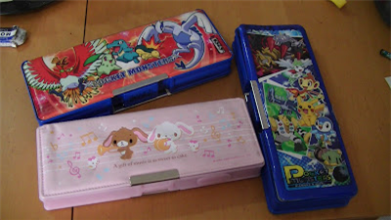These are three pencil _ _ _ _ _ in my school bag.
91. very/ This/ flower/ beautiful./ is/
92. Ảnh: 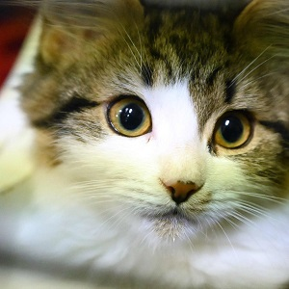_ _ _
93. My favorite colour is g_ _ _ n.
94. Choose the odd one out
A. Mother B. Father C. Teacher D. Grandmother
95. I ... John. Nice to meet you.
A. is B. am C. be D. are
96. Don't make a mess. - _______
A. Thanks. B. Yes, please. C. Yes, you can. D. Sorry.
97. What _______ at break time?
A. do you do B. is he do C. are you do D. are they do
98. Ảnh: That’s my pencil _ _ g!
99. Nghe: Nhấn giữ Ctrl và bấm chuột để nghe: _ _
100. _ _ . Nice to meet you.
101. there?/ over/ Who/ the tall girl/ is/
102. Mandy/ How many/ have?/ dolls/ does/
103. There _ _ one lamp on the desk.
104. Nghe: Nhấn giữ Ctrl và bấm chuột để nghe: Andy is _ _ _ _ _ .
105. What is this? - ….
A. It a orange B. Is a orange C. It’s a orange D. It’s an orange
106. windows./ to the/ is/ next/ The radio/
107. The new music room is _______.
A. new B. ten C. old D. large
108. in/ class/ 3A./ My sister/ is/
109. The pencil is long and the rubber is sh_ _ _ .
110. Nghe: Nhấn giữ Ctrl và bấm chuột để nghe: Listen and tick the word(s) you hear:
A. classroom B. bathroom C. living room D. bedroom
111. Who is your …? – The man over there.
A. father B. mother C. aunt D. sister
112. Peter has _ _ work all day in the factory.
113. Let’s make a ci_ _ le.
114. you/ spell/ your name?/ How/ do/
115. three/ have/ I/ flowers.
116. Your sister is pre_ _ y.
117. Nghe: Nhấn giữ Ctrl và bấm chuột để nghe: Here is his _ _ _ _ _ _ .
118. There … some cheese in the fridge.
A. are B. is C. be D. have
119. I like Maths but my friends ….
A. isn’t B. doesn’t C. don’t D. aren’t
120. Which word has the underlined part pronounced LIKE the letter I in BIG
A. his B. nine C. kite D. nice
121. not/ feel/ today./ I do/ well
122. books/ my/ Those/ are/
123. What …? – They are my crayons.
A. are those B. is this C. is that D. are there
124. Art/ on/ have/ I don’t/ Friday./
125. Thank you very much – You’re ... .
A. welcome’s B. welcomes C. welcome D. welcome’re
126. My uncle doesn’t work … Saturday.
A. at B. in C. on D. of
127. Are there any fruits on the table? - Yes, ______.
A. there is B. are there C. is there D. there are
128. There is ___ pen in the pencil case.
A. one B. two C. three D. four
129. My cla_ _ _ _ _ m is small.
130. Students all ________ when their English teacher comes in.
A. stand up B. sit down C. go out D. come in
131. Which is your house? – That __________.
A. one B. two C. three D. four
132. One plus one makes _ _ _ .
133. How _ _ d is your sister?
134. up,/ please./ Stand/
135. Who _ _ _ those people?
136. The cats are white. _ _ _ _ are very beautiful.
137. This gift is for you. - Thank you very _ _ _ _ .
138. What/ name?/ is/ her/
139. Good morning, children. - ... .
A. Good morning, teacher B. Hello C. Hi D. Bye
140. Ảnh: R_ _ _ _
141. teacher./ my/ Miss Lien/ is/ new
142. ... are you from, Jean? – I’m from Canada.
A. What B. How C. Where D. When
143. Peter: What _ _ _ _ _ _ is your pen? - Mary: It’s red.
144. What/ lunch boxes?/ colour/ are/ your
145. My friend is ten _ _ _ _ _ old.
146. My aunt is a _ _ _ ter of my mother.
147. GRAN___THER
A. TFA B. DMA C. DFO D. DMO
148. Can you remem_ _ r my birthday?
149. Nghe: Nhấn giữ Ctrl và bấm chuột để nghe: Listen and tick the word(s) you hear:
A. sunny B. Sunday C. summer D. seven
150. my bag./ I/ have/ in/ two pens/
151. your/ name,/ Write/ please.
152. _ _ ke out your book.
153. How o_ _ are you?
154. Be … Don’t make noise.
A. lazy B. quiet C. funny D. angry
155. R_ _ se your hands, please.
156. The children like playing in the park because … very large.
A. it is B. they are C. he is D. she is
157. Nghe: Nhấn giữ Ctrl và bấm chuột để nghe: Who likes drawing?
A. Mr. Macaroni. B. Meg. C. Tom. D. Mrs. Green.
158. A: … is your school? - B: … is big and new.
A. Where – He B. How – It C. What – She D. Who - That
159. Don't be late __ school.
A. at B. in C. for D. with
160. ... at the board, please.
A. Put B. Look C. Stand D. Sit
161. Your rulers/ are/ green. They/ are in the bag.
162. you do/ free/ What do/ in your/ time?/
163. I ... my teeth in the morning.
A. do B. brush C. have D. does
164. A: What is this? - B: …
A. It’s yellow. B. It’s a blue pencil. C. It’s very nice. D. It’s my friend.
165. Nghe: Nhấn giữ Ctrl và bấm chuột để nghe: His _ _ _ is in the football net.
166. Nghe: Nhấn giữ Ctrl và bấm chuột để nghe: There are … people in her family.
A. four B. five C. six D. three
167. What are these ? - ….
A. It’s a motorbike B. They’re motorbikes C. They’re motorbike D. It is motorbike
168. that boy/ her/ brother?/ Is/
169. are/ Duong?/ you,/ old/ How/
170. three/ They/ pictures/ on the wall./ are/
171. Nghe: Nhấn giữ Ctrl và bấm chuột để nghe: This is my _ _ _ _ _ _ _ _ _ _ _ .
172. How do you _ _ _ ll your name?
173. _ _ _ _ _ are you going to stay? - In a hotel.
174. my/ books./ Those/ are/
175. your bags/ the car?/ in/ Are/
176. Nice to m_ _ _ you, too.
177. Ảnh: 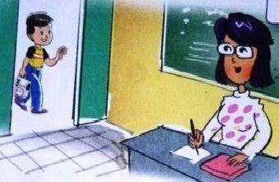May I _ _ _ _ in?
178. Which word has the underlined part pronounced LIKE the letter ’A’ in ’SMALL’?
A. tall B. classroom C. play D. father
179. Ảnh: You use your _____ to write.
A. head B. hand C. eyes D. foot
180. I ... fine, thanks.
A. am B. is C. are D. the
181. _ _ _ _ time do you go to bed?
182. name/ is/ Allie./ Her/
183. Nga: Do you play football? - Huong: No, I … I like basketball.
A. don’t B. am not C. doesn’t D. isn’t
184. quiet,/ Be/ class./
185. Nam: What’s his _ _ _ _ ? - Hoa: Tony.
186. Nghe: Nhấn giữ Ctrl và bấm chuột để nghe: Is she a _ _ _ _ _ _ _ ?
187. Is your house big … small?
A. and B. or C. but D. of
188. please./ Show/ me/ your/ cards,
189. Nghe: Nhấn giữ Ctrl và bấm chuột để nghe: My brother is thir_ _ _ _ years old.
190. Ảnh: 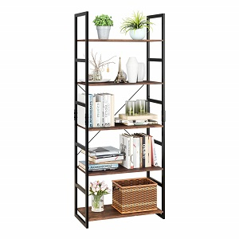BOOK_ _ _ _
191. Ảnh: 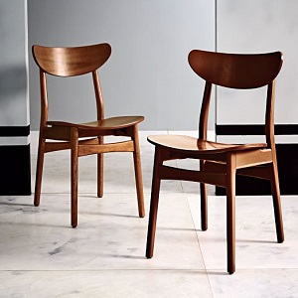Those are our ch_ _ _ _ .
192. Ảnh: The _ _ _ _ is beautiful.
193. Nghe: Nhấn giữ Ctrl và bấm chuột để nghe: Listen and tick:
A. boat B. cook C. book D. look
194. Her father goes to work _ _ 6 o’clock.
195. Ảnh: 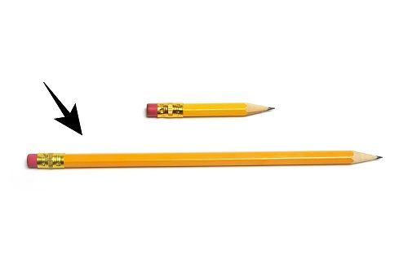My pencil is _ _ _ _ . Her pencil is short.
196. Nghe: Nhấn giữ Ctrl và bấm chuột để nghe: Pat is in the _ _ _ _ _ _ room.
197. I have _ _ ice cream.
198. children/ are/ chess./ The/ playing
199. Can you give me some pens, pl_ _ se?
200. give/ more water./ Please,/ some/ me/

IOE K3 SỐ 26
1. Th_ _ _ s. And you?
2. Does/ stand/ over there?/ his uncle/
3. Peter: Do you play badminton at break time? - Mai: ... .
A. Yes, it is B. Yes, please C. Yes, I do D. Yes, I don’t
4. Let’s make a ci_ _ le.
5. Nghe: Nhấn giữ Ctrl và bấm chuột để nghe: This is his _ _ _ _ _ _ _ .
6. Nghe: Nhấn giữ Ctrl và bấm chuột để nghe: Which is NOT mentioned?
A. There is a bed. B. There is a desk. C. There are two windows. D. There are two chairs.
7. draw/ let’s/ a/ picture./ Peter/
8. Hoa: What do you do ... break time? - Peter: I play badminton.
A. at B. on C. in D. for
9. Ảnh: My father is ______ years old.
A. thirty-eight B. forty-eight C. fourteen-eight D. fifteen-eight
10. Nghe: Nhấn giữ Ctrl và bấm chuột để nghe: This is my _ _ _ _ _ _ .
11. Thank you _ _ _ _ much.
12. she/ teacher?/ Is/ a/
13. free/ in your/ you do/ What do/ time?/
14. Miss Lan./ you/ meet/ Nice/ to/
15. Nghe: Nhấn giữ Ctrl và bấm chuột để nghe: Listen and tick:
A. fingers B. goldfish C. farmer D. fireman
16. ________- Yes, you can.
A. How are you? B. How old are you? C. Let's play football! D. May I borrow your book?
17. Nghe: Nhấn giữ Ctrl và bấm chuột để nghe: D_ _
18. Which is your school? - … one.
A. The B. A C. An D. This
19. That is/ my/ big./ classroom./ It’s
20. time/ for/ It’s/ breakfast,/ John./
21. read/ Look/ and/ aloud.
22. Ảnh: 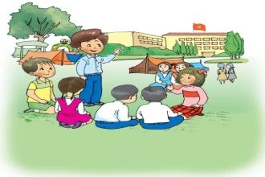What do you do at break time? - I ch_ _ with my friends.
23. ... are you? – Fine, thanks.
A. Who B. Is C. Are D. How
24. Ảnh: 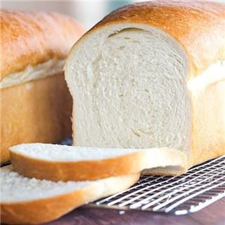I have _ _ _ _ _ and butter for breakfast.
25. of Anna./ have/ picture/ a/ I/
26. Choose the letter(s) to make a correct word: CLE_N
A. I B. O C. E D. A
27. ... are you? – I’m fine, thanks.
A. Who B. When C. How D. Where
28. Ảnh: My father is a doct_ _ .
29. Lo_ _ at the board, children.
30. Ảnh: My brother is a pup_ _ .
31. His backpacks/ black. They/ are/ aren't brown.
32. My pictures are ... the wall.
A. on B. to C. for D. at
33. What ... their …?
A. is name B. are / names C. is / names D. are / name
34. Ảnh: _ _ _ _
35. Are they students in your class? – Yes, ...
A. they are B. they do C. are they D. are their
36. Ảnh: There are five _ _ _ _ _ _ _ on a hand.
37. My little daughter is interested _ _ dancing.
38. It _ _ a pink doll.
39. The box _ _ very big.
40. What is your f_ _ _ _ _ name?
41. My _ _ _ _ is Linda.
42. That’s my new friend. H_ _ name’s Jenny.
43. Nghe: Nhấn giữ Ctrl và bấm chuột để nghe: Listen and tick the word(s) you hear:
A. classroom B. bathroom C. living room D. bedroom
44. The lunch _ _ _ _ is over there.
45. Nghe: Nhấn giữ Ctrl và bấm chuột để nghe: It’s _ _ _ _ _ _ _ _ _ .
46. Nghe: Nhấn giữ Ctrl và bấm chuột để nghe: That is my pen _ _ _ _ .
47. Nghe: Nhấn giữ Ctrl và bấm chuột để nghe: There are four_ _ _ _ eggs in the box.
48. friend,/ How/ your/ is/ Tom?/
49. Ảnh: 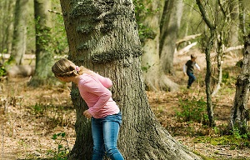We play hide-and-seek, but I can't ____ Nam.
A. meet B. find C. play D. go
50. How are you? - ... .
A. Fine, thanks B. Nice to meet you C. My name’s Sean D. See you later
51. Put the flower vase _ _ the table.
52. ______ this? – It’s a ball.
A. What B. What’s C. What’s is D. What it
53. Ảnh: What a lovely _ _ _ _ !
54. Nghe: Nhấn giữ Ctrl và bấm chuột để nghe: Listen and tick:
A. hide-and-seek B. hometown C. house D. housewife
55. May I go _ _ _ ?
56. do you/ her name,/ How/ spell/ Jane?/
57. Peter: How do you _ _ _ _ _ your name? - Huyen: That’s H-U-Y-E-N.
58. Good morning, children. - ... .
A. Good morning, teacher B. Hello C. Hi D. Bye
59. Let’s make a cir_ le.
60. _ _ my lunchbox, I have a banana and a sandwich.
61. My/ are red./ aren't/ umbrellas/ yellow. They
62. How ... chairs in your classroom?
A. much B. very C. old D. many
63. Is this ... book? - Yes,it’s my book.
A. her B. my C. his D. your
64. Mary _ _ s born in America.
65. Ảnh: 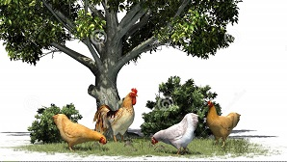The chickens are under the big _ _ _ _ in the garden.
66. Mary is m_ friend.
67. ______ up, please!
A. Stand B. Sit C. Open D. Close
68. Are those your notebooks? - No, ... .
A. it is B. it isn’t C. they are D. they aren’t
69. days./ my hair/ every/ two/ I wash/
70. Choose the correct sentence.
A. I like playing chess at break time. B. I like play chess at break time. C. I like playing chess on break time. D. I like playing a chess at break time.
71. ... your teeth everyday, Tess.
A. Read B. Listen C. Stand D. Brush
72. Ảnh: ELEPH_ _ _
73. How _ _ _ you today?
74. Ảnh: 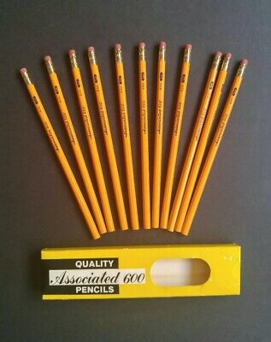There are elev_ _ pencils on the desk.
75. Who is our new tea_ _ er?
76. Ảnh: The children are playing … now.
A. badminton B. volleyball C. hide-and-seek D. break time
77. Linda: Do your friends play games at school? - Hoa: Yes,they ... .
A. do B. does C. are D. is
78. Sit d_ _ n, please!
79. seek/ with my friends./ hide/ I play/ and/
80. often/ do puzzles/ my brother./ I/ with
81. Mary is a student a_ Rose Wood School.
82. What is this? – It is ... ice-cream.
A. a B. an C. this D. that
83. Choose the INCORRECT word or phrase in the following sentence: The woman behind him are my aunt.
A. woman B. behind C. him D. are
84. What is this? – It is ... eraser.
A. a B. an C. this D. that
85. Ảnh: fourteen, _______, sixteen.
A. fiveteen B. fifteen C. fifty D. fourty
86. _ _ _ is Tuan happy? - He is happy because today is his birthday.
87. I have an English friend. _ _ _ name is Kate.
88. Is … a chair? - Yes, it is.
A. are B. it C. it’s D. his
89. Which word has the underlined part pronounced LIKE the letter ’A’ in ’SMALL’?
A. tall B. classroom C. play D. father
90. Write your name _ _ the board, please.
91. to/ Happy/ Jane./ birthday/ you,
92. My pen is red and my pencils ... blue.
A. are B. is C. am D. do
93. Nghe: Nhấn giữ Ctrl và bấm chuột để nghe: It’s a blue _ _ _ _ _ .
94. Do_ _ he go to school today?
95. open/ mom?/ May/ the window,/ I/
96. Choose the INCORRECT word or phrase in the following sentence: They are my ball, Daddy.
A. They B. my C. ball D. Daddy
97. _ _ ite your name here, please.
98. This is my aunt. … is very friendly.
A. She B. He C. Her D. His
99. Nghe: Nhấn giữ Ctrl và bấm chuột để nghe: Look at _ _ _ _ photo.
100. A: _______ - B: Sorry.
A. See you later. B. May I come in? C. Nice to see you. D. Don't talk in class!
101. is/ book./ a/ This/ red
102. Choose the odd one out:
A. Good morning. B. Goodbye. C. See you again. D. See you soon.
103. Good mor_ _ ng, children!
104. Wr_ _ _ your name here, please.
105. Show/ pen,/ your/ please./ me/
106. monkey looking/ see/ I/ a/ at me./
107. has/ Tom/ a new/ case./ pencil
108. It/ the pond./ in/ a fish/ is/
109. Who’s that? - …
A. It’s purple. B. It’s my friend. C. I love food. D. Here you are.
110. pink./ is/ My/ doll/
111. … are my classmates.
A. This B. That C. These D. There
112. O_ _ n your school bags, children.
113. Ảnh: 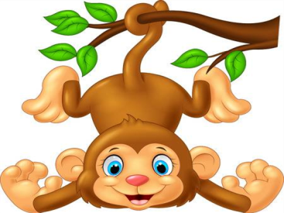The _ _ _ _ _ _ is swinging.
114. name?/ his teacher's/ do you/ spell/ How/
115. Ảnh: That’s a _ _ _ _ _ pencil
116. _ _ _ _ time do you go to bed?
117. Choose the odd one out:
A. is B. am C. are D. those
118. Close/ please./ book,/ your/
119. … your teeth, Tommy.
A. Read B. Listen C. Stand D. Brush
120. Nghe: Nhấn giữ Ctrl và bấm chuột để nghe: My _ _ _ _ is green.
121. lunchbox./ my/ don't/ I/ have/
122. The children are happy at break _ _ _ _ .
123. How … students are there in your classroom?
A. much B. many C. more D. some
124. Ảnh: 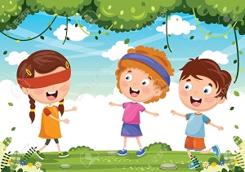_ _ _ nd man's bluff is a game.
125. May I come in? - …
A. No, you don’t. B. Yes, please. C. Yes, you are. D. No, you aren’t.
126. … do you like? – I like riding a horse.
A. When B. How C. What D. Who
127. One and one is t_ _ .
128. I’m h_ _ gry.
129. What's/ name?/ mother's/ her/
130. your/ she/ new/ Is/ classmate?/
131. … is this? – It’s my rubber.
A. Who B. What C. How D. Where
132. Choose the letter(s) to make a correct word: ga__en
A. dd B. td C. rt D. rd
133. Nghe: Nhấn giữ Ctrl và bấm chuột để nghe: HOU_ _
134. Ảnh: What colour is the fence?
A. Blue B. Black C. White D. Yellow
135. Choose the odd one out:
A. repeat B. listen C. read D. am
136. toys./ have/ some/ My sisters/
137. Goodbye. See you a_ _ _ n!
138. That’s a big play_ _ _ _ _ _ .
139. white./ in/ You/ are/ beautiful/
140. Which sentence is correct?
A. Santa Claus flying over the town. B. Santa Claus is riding his sleigh. C. Santa Claus is ride a reindeer. D. Santa Claus is walking in the sky.
141. There … some cheese in the fridge.
A. are B. is C. be D. have
142. Can you give me some pens, pl_ _ se?
143. Does your father like p_ _ _ ing sports?
144. is/ Mr. Gerhard/ now./ the computer room/ in/
145. Have … nice day, Jane. – Thank you.
A. a B. an C. the D. am
146. What is this box? - … a present for mom on Christmas Day.
A. She’s B. He’s C. It’s D. I’m
147. nice/ Have/ day./ a/
148. We play sports _ _ _ games at break time.
149. Nghe: Nhấn giữ Ctrl và bấm chuột để nghe: How do you _ _ _ _ _ your name?
150. a park/ in your/ Is there/ town?
151. Peter: Are they your friends? - Tom: No, they _ _ _ _ ’t.
152. Nga: ... play chess! - Peter: Yes, let’s.
A. Do you B. Don’t you C. Let’s D. Are you
153. Have ... nice day, Robin. – Thank you very much.
A. an B. the C. a D. are
154. This is my school lib_ _ _ _ . It’s big.
155. noodles?/ Can/ more/ I have/ some/
156. Nghe: Nhấn giữ Ctrl và bấm chuột để nghe: _ _ _ _ _ _ _ _ _
157. Do they/ volleyball/ school?/ after/ play/
158. Great to s_ _ you.
159. two/ Let’s/ circles,/ please./ make/
160. toys/ many/ How/ have?/ do you
161. Ảnh: That is my pencil s_ _ _ _ _ _ _ _ .
162. That is my father. … name is Jame.
A. Her B. She C. He D. His
163. with/ my friend./ to play/ I like/ chess/
164. How do/ you/ name?/ spell/ your
165. My fish are very _ _ _ _ tiful.
166. I ... my teeth in the morning.
A. do B. brush C. have D. does
167. There are th_ _ e books on the table.
168. Is the_ _ a dog? – No, there is not.
169. Which animal has four legs?
A. Chicken B. Duck C. Dog D. Hen
170. _ _ _ _ _ are you going to stay? - In a hotel.
171. my bag./ two pens/ I/ have/ in
172. Choose the letter(s) to make a correct word: ki__chen
A. d B. t C. b D. k
173. is/ school/ my/ That/ library./
174. the sky./ There/ a kite/ in/ is/
175. Ảnh: F_ SH
176. Nghe: Nhấn giữ Ctrl và bấm chuột để nghe: The ______ is blue.
A. ski B. skiing C. sky D. fly
177. Nghe: Nhấn giữ Ctrl và bấm chuột để nghe: They go to school by _ _ _ .
178. I want to see the animals. Let’s go to the _ _ _ .
179. Nghe: Nhấn giữ Ctrl và bấm chuột để nghe: My new _ _ _ _ _ _ is Adam.
180. in/ the car?/ your bags/ Are/
181. Tom and Minh are _ _ friends.
182. Which word is odd one out?
A. pig B. men C. chicken D. fish
183. This gift is for you. - Thank you very _ _ _ _ .
184. Let’s _ _ _ _ badminton.
185. Tom can ... a bicycle.
A. bye B. ride C. drive D. rides
186. Let’s speak Eng_ _ _ _ !
187. My classroom is ... . It’s not small.
A. big B. a big C. the big D. a small
188. She plays hide-and-_ _ _ _ in the garden.
189. Ảnh: 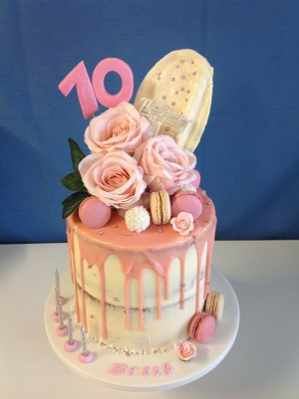_________
A. Happy New Year! B. Happy birthday! C. Merry Christmas! D. Happy day!
190. your/ new/ they/ Are/ classmates?/
191. This is ... orange.
A. a B. an C. is D. are
192. C_ _ se your bag, Tom.
193. Ảnh: That’s a pencil sharp_ _ _ _ .
194. Hello,/ Trang./ is/ my name/
195. of/ is/ a photo/ my school./ This/
196. name?/ What/ family/ is/ your/
197. Ảnh: His brother is _ _ _ teen years old.
198. Nghe: Nhấn giữ Ctrl và bấm chuột để nghe: _ _ _ _
199. your/ Peter/ friend?/ Is/
200. My/ name/ Long./ is/

IOE K3 SỐ 27
1. is/ It/ a box/ under the bed.
2. eraser?/ this/ Is/ an/
3. Ảnh: It is snow_ in winter.
4. your/ brother's/ What/ is/ name?/
5. my/ My pencil/ is in/ backpack./ case/
6. your/ rulers?/ Are/ those/
7. Nghe: Nhấn giữ Ctrl và bấm chuột để nghe: Are there any _ _ _ _ _ _ _ in the room?
8. your/ colour/ What/ pencil sharpener?/ is/
9. Nghe: Nhấn giữ Ctrl và bấm chuột để nghe: The teacher tells the students to … .
A. sit down B. stand up C. go out D. come in
10. pink/ My mother/ a/ wants/ dress./
11. How many … are there? – Two.
A. dinosaur B. dinosaurs C. dinosaur’s D. dinosaurs’
12. What is/ the name/ favourite/ of your/ book?/
13. My brother and I ... to school every morning.
A. go B. go’s C. goes D. goes to
14. What is your favourite ...? – I like milk very much.
A. food B. drink C. subject D. colour
15. in/ room./ computer/ We are/ the/
16. Ảnh: 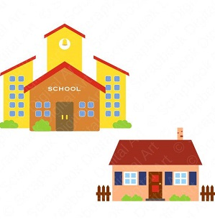My house is _____ my school.
A. on B. at C. in D. near
17. Nghe: Nhấn giữ Ctrl và bấm chuột để nghe: Let’s _ _ _ _ badminton.
18. Is that your father? – No, … .
A. it is B. it isn’t C. that is D. is that
19. Ảnh: _ _ _
20. and/ your/ eraser./ Pick up/ ruler/
21. Nghe: Nhấn giữ Ctrl và bấm chuột để nghe: Sue has ______ tomatoes.
A. two B. three C. some D. any
22. Thanks _ _ _ your invitation.
23. My father is _ _ engineer.
24. Good af_ _ _ _ _ _ _ , Mr. Parker!
25. Nghe: Nhấn giữ Ctrl và bấm chuột để nghe: The ____ watch is mine.
A. blue B. yellow C. black D. white
26. Nam: W_ _ _ is this? - Mai: It’s a ruler.
27. Does/ Lisa/ a cat?/ have/
28. days/ in/ There are/ seven/ a week./
29. Teacher: Do you like break time? - Anh: Yes, ... .
A. thank B. I do C. I don’t D. I am
30. Who’s that girl? - ... .
A. She’s at school B. She’s from Australia C. She’s nine years old D. She’s Mary.
31. Nghe: Nhấn giữ Ctrl và bấm chuột để nghe: Here is his …. .
A. mother B. brother C. sister D. father
32. I’m _ _ _ _ _ , I’m late.
33. Wh_ _ _ are your pens? - They're in my pencil case.
34. What is your fav_ _ _ _ te subject?
35. _ _ _ _ is your name? - My name is Jerry.
36. My brother is th_ _ _ years old.
37. My class is …: ten girls and eleven boys.
A. nice B. tidy C. big D. new
38. Choose the odd one out:
A. you B. hi C. I D. She
39. Nghe: Nhấn giữ Ctrl và bấm chuột để nghe: Choose the correct question.
A. Where is the garden? B. Where’s Peter? C. What is Peter doing? D. Is there a garden?
40. Tony puts some toothpaste on his toothbrush. He is going to _ _ _ _ _ his teeth.
41. My school is ... .
A. new’s B. new C. news D. names
42. Tha_ is my picture. It’s on the wall.
43. Nghe: Nhấn giữ Ctrl và bấm chuột để nghe: Can I have these burgers and that _____?
A. pencil B. chicken C. bread D. toy
44. Ảnh: In autumn, the sky is very _____.
A. black B. white C. green D. blue
45. My new school bag is ... .
A. big B. school C. you D. skate
46. My books are ... the table.
A. at B. to C. under D. on
47. kind/ Tony/ of music./ like this/ doesn’t/
48. your/ pen?/ new/ What/ colour is/
49. Ảnh: That’s a _ _ _ _ _ pencil
50. Ảnh: 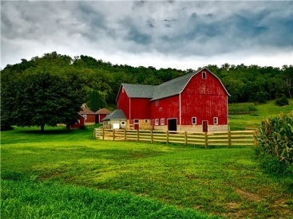Horses and sheep live on the _ _ _ _ .
51. Choose the odd one out:
A. you B. your C. his D. her
52. with/ my mother./ go shopping/ often/ I/
53. Teacher: What’s this? - Minh: It’s _ pencil sharperner
A. on B. in C. a D. an
54. you/ later./ See/
55. My aunt is 51 … old. She is a nurse.
A. months B. years C. weeks D. days
56. sentences./ the/ Reorder/
57. What's his name? - He _ _ Alan.
58. Choose the odd one out
A. Cloud B. Sun C. Moon D. Pencil
59. Peter: How …are you? - Hoa: I’m eight years old.
A. all B. old C. tall D. small
60. Nghe: Nhấn giữ Ctrl và bấm chuột để nghe: My _ _ _ _ is green.
61. G_ _ dbye. See you later.
62. Write the an_ _ _ rs, please.
63. That is my brother. Hi_ name is Tom.
64. I often play football _ _ Tuesday afternoons.
65. Is there/ one garden/ in/ your school?
66. Ảnh: How many cats are there in the picture? - _ _ _ _ _ .
67. playing/ with a robot?/ like/ Do/ you/
68. you/ from?/ are/ Where/
69. H_ _ name is Jenny.
70. My school bag _ _ new.
71. a/ is/ square box./ That/
72. What _______ at break time?
A. do you do B. is he do C. are you do D. are they do
73. Tuan is _ _ the computer room.
74. playground/ Is/ your/ big?
75. Choose the odd one out.
A. school items B. pencil sharpeners C. black boards D. school bags
76. Peter is _ _ the classroom now.
77. _ _ _ _ _ are you going to stay? - In a hotel.
78. I want to play sports. Let’s go to the g_ _ .
79. Nghe: Nhấn giữ Ctrl và bấm chuột để nghe: _ _ _ _ _
80. She ... long hair.
A. have B. has C. is D. with
81. I don’t have ... sandwich.
A. a B. those C. an D. these
82. Listen/ please./ to/ teacher/ the/
83. _ _ _ re is Peter from? – He’s from England.
84. Ảnh: Excuse me, where is the mu_ _ _ room?
85. My name is Peter. I _ _ a student at Oxford Primary School.
86. Billy: Are they your pencils? - Minh: No, they ... .They’re my pens.
A. don’t B. have C. do D. aren’t
87. Let’s introduce … .
A. your B. self C. yourself D. end
88. Ảnh: Let’s count to t_ _ _ ty.
89. My bedroom is b_ _ utiful.
90. subjects/ What/ best?/ like/ do you/
91. Do you _ _ to the zoo with your family?
92. _ _ _ old are you?
93. Ảnh: We go to school ________.
A. on my classmates B. on my parents C. on my friends D. on school day
94. match./ and/ Listen/
95. Where _ _ you study, Trang?
96. Mai: What’s that? - Linda: That’s my … .
A. Peter B. school library C. friend D. teacher
97. Nghe: Nhấn giữ Ctrl và bấm chuột để nghe: This is my s_ _ _ _ _ .
98. Ảnh: My pencil is _ _ _ _ . Her pencil is short.
99. there/ in the room?/ windows/ How many/ are/
100. Stand/ up,/ please./
101. Choose the incorrect word or phrase in the following sentence: There is a garden on front of his house.
A. is B. garden C. on D. his
102. Tom live ... England
A. on B. in C. for D. to
103. Ảnh: The school playground is crowded at _ _ _ _ _ time.
104. Ảnh: How old is your _ _ _ _ _ father?
105. away,/ your/ Put/ books/ please./
106. My family has _ big dinner.
107. This is my/ pencil/ new/ box.
108. Jane: Are … your friends? - David: Yes, they are.
A. Peter B. Mary C. are D. Peter and Mary
109. Ảnh: CA_ _
110. a glass/ It/ of milk./ is/
111. What do you do in … free time?
A. you B. yours C. you’re D. your
112. Why do you like Music? – Because I like _ _ sing.
113. Point … your names, children.
A. at B. on C. in D. to
114. His/ coat/ is/ under/ the bed./
115. Ảnh: The _______ fly around the flowers.
A. frogs B. grasshoppers C. butterflies D. birds
116. Ảnh: What are they doing? - They are sw_ _ _ _ _ _ .
117. What is this? - ….
A. It a orange B. Is a orange C. It’s a orange D. It’s an orange
118. your/ Where/ is/ house?
119. colour/ your old/ ball?/ is/ What/
120. Nghe: Nhấn giữ Ctrl và bấm chuột để nghe: Listen and tick the word(s) you hear:
A. classroom B. bathroom C. living room D. bedroom
121. My ... is Sean.
A. name’s B. names C. name D. namese
122. Why ... we come and visit Uncle Tom? - That’s a good idea.
A. don’t B. have C. do D. aren’t
123. I can sing but I _ _ _ _ _ _ dance.
124. _ _ _ often do you do morning exercise in the summer?
125. Thank you very much – You’re ... .
A. welcome’s B. welcomes C. welcome D. welcome’re
126. Who is your _ _ iend?
127. He_ _ _ , I’m Micheal. Nice to meet you..
128. How _ _ ny bananas are there in the box?
129. Her/ from/ are/ friends/ France./
130. Ảnh: 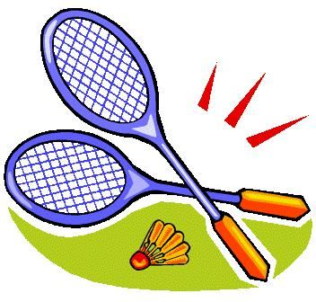My favourite sport is badm_ _ _ _ _ .
131. can/ many/ draw/ pictures./ My brother/
132. Ảnh: This is the _ _ _ _ _ _ _ _ room.
133. Nghe: Nhấn giữ Ctrl và bấm chuột để nghe: Listen and tick the word(s) you hear:
A. a pen B. a pencil C. a bank D. a band
134. ... you like chicken?
A. Do B. Does C. Are D. Is
135. Ảnh: __________
A. Happy New Year! B. Merry Christmas! C. Happy birthday! D. Happy day!
136. Nghe: Nhấn giữ Ctrl và bấm chuột để nghe: Those are my _ _ _ _ _ .
137. … is your school? – It’s at the corner of the street.
A. Who B. Where C. How D. What
138. Is there … sugar in the jar?
A. any B. some C. a D. an
139. These are their _____.
A. schoolbag B. school bags C. schools bag D. schools bags
140. Ảnh: They _ _ _ _ _ to school every morning.
141. white./ You/ beautiful/ in/ are/
142. I like doing karate. - ... .
A. No, thanks B. Me too C. Yes, please D. Sorry
143. The new playground is _ _ g.
144. Ảnh: There are elev_ _ pencils on the desk.
145. Teacher: ... to me, please.
A. Listens B. Listen C. Listening D. Is listening
146. Peter is my fr_ _ _ _ .
147. these,/ What/ Dad?/ are/
148. My pictures are _ _ the wall.
149. Alex/ likes/ table tennis/ likes chess./ and Max
150. ... a round ball.
A. Is it B. It’s C. What is D. They are
151. my/ is/ This/ new/ classroom./
152. Ảnh: 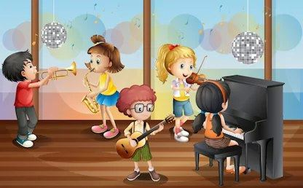_ _ _ _ _ room
153. Nghe: Nhấn giữ Ctrl và bấm chuột để nghe: Sue is in the … room.
A. living B. dining C. sitting D. bed
154. How are you today, Peter? – I’m ..., thanks.
A. nice B. nice’s C. fine D. fine’s
155. Nam is .... He’d like to sit down.
A. tired B. hungry C. thirsty D. cold
156. There is on_ book in my bag.
157. Nghe: Nhấn giữ Ctrl và bấm chuột để nghe: _ _ _ _
158. That is _ bed.
159. Goodbye. See you lat_ _ !
160. Ảnh: What colour is the cat’s eyes? It is _ _ _ _ _ .
161. Phuong: This is my friend Mai. - Linda: Nice to meet ..., Mai.
A. your B. you C. my D. me
162. Linda: Do your friends play games at school? - Hoa: Yes,they ... .
A. do B. does C. are D. is
163. Nghe: Nhấn giữ Ctrl và bấm chuột để nghe: My school has a big _ _ _ _ _ _ _ .
164. Simon is my new fr_ _ _ _ .
165. What colour is ____ classroom? - My classroom is white.
A. her B. your C. its D. his
166. Nghe: Nhấn giữ Ctrl và bấm chuột để nghe: Listen and tick the word(s) you hear:
A. man B. learn C. plant D. stand
167. ... your hands, please.
A. Write B. Sing C. Wash D. Study
168. What are ...? - They are my books
A. it B. this C. that D. these
169. How _ o you spell your name?
170. Ảnh: Let's make paper bo_ ts.
171. What/ book/ it?/ is/
172. My children/ school/ everyday./ walk to/
173. the name/ What is/ favourite/ of your/ book?/
174. Ảnh: The girl is … .
A. doing puzzles B. playing basketball C. playing hide-and-seek D. skipping rope
175. What ... it? – It’s a black ruler.
A. is B. it C. that D. this
176. I l_ _ _ swimming very much.
177. This is _ new pen.
178. more/ some/ please./ Give me/ milk,
179. well./ The/ dance/ can/ little girl/
180. Lan: What colour are your pencils? - Huong: They ... blue and green
A. do B. don’t C. are D. is
181. What’s the matter? – I’m ... .
A. tired B. teacher C. student D. Peter
182. Fine, thanks. … you?
A. But B. So C. And D. Or
183. Spe_ _ your name, please.
184. new pen?/ your/ is/ What/ colour/
185. I’m _ _ ne, thanks.
186. Let’s/ go/ school./ to/
187. I/ May/ notebook?/ close/ the
188. Pick ... your pen, children.
A. at B. on C. to D. up
189. Nghe: Nhấn giữ Ctrl và bấm chuột để nghe: Phuong is reading a _ _ _ _ .
190. One and one is t_ _ .
191. Can you _ _ _ _ _ from one to one hundred?
192. It's/ cream./ ice/ brother's/ my/
193. are/ circles./ These/ some/
194. Where is your school? – It’s … Nguyen Trai Street.
A. on B. at C. to D. from
195. It's not my pen. It's y_ _ _ pen.
196. Nghe: Nhấn giữ Ctrl và bấm chuột để nghe: This is his … and this is his … .
A. hat – shirt B. ball – T-shirt C. cap – shorts D. bag - shoes
197. My brother can ... football.
A. play B. plays C. play’s D. to play
198. The park is large _ _ _ new.
199. Read/ the/ chant/ aloud.
200. Hoa: … that? - Tony: That’s my school bag.
A. Who B. Who’s C. What D. What’s

IOE K3 SỐ 28
1. Thanks _ _ _ your invitation.
2. Lan is a stu_ _ _ _ .
3. ________- Yes, you can.
A. How are you? B. How old are you? C. Let's play football! D. May I borrow your book?
4. your/ new/ What/ colour is/ pen?/
5. much./ I/ swimming/ like/ very
6. Where is your school? – It’s … Nguyen Trai Street.
A. on B. at C. to D. from
7. Students all … when their English teacher comes in.
A. stand up B. go out C. sit down D. come in
8. Her ruler _ _ n't new. It's old.
9. pencil?/ your/ is/ color/ What/
10. Lan: Is Linda your friend? - Huong: Yes, ... is.
A. he B. she’s C. she D. she is
11. Nghe: Nhấn giữ Ctrl và bấm chuột để nghe: _ _ _ _ _
12. Yes, _ _ is a new notebook.
13. Choose the odd one out:
A. Good morning. B. Goodbye. C. See you again. D. See you soon.
14. D_ _ _ she love Science?
15. Ảnh: 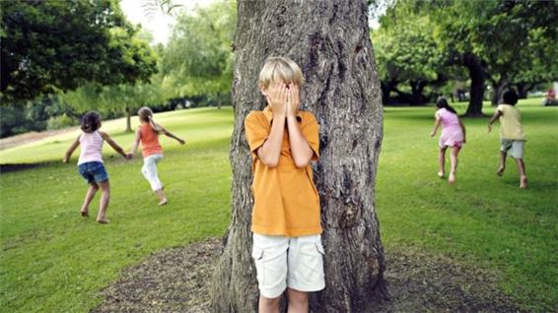Let’s play hide-and-s_ _ k with us.
16. Ảnh: Re_ _ and answer.
17. _ _ you have pets? - No, I don’t.
18. Peter: What are their …? - Hoa: Mai and Huong.
A. name B. names C. your name D. your names
19. Nghe: Nhấn giữ Ctrl và bấm chuột để nghe: My pencil is ye_ _ _ _ .
20. ice/ my/ brother's/ cream./ It's/
21. Your rulers/ green. They/ are/ are in the bag.
22. My little brother … like eating vegetables.
A. doesn’t B. don’t C. isn’t D. aren’t
23. Mr. Parker r_ _ _ _ newspapers everyday.
24. in/ a week./ seven/ There are/ days/
25. Ảnh: That’s my pencil _ _ g!
26. Here are your shoes. – _ _ _ _ _ _ .
27. The new playground is _ _ g.
28. on/ Friday./ I don’t/ Art/ have/
29. is/ book/ it?/ What/
30. Nghe: Nhấn giữ Ctrl và bấm chuột để nghe: He is ____.
A. 12 B. 13 C. 14 D. 15
31. The sofa/ the window./ near/ is/
32. Ảnh: This is your …, Tom.
A. bench B. desk C. chair D. board
33. One and one is t_ _ .
34. Ảnh: What colour is the armchair?
A. yellow B. red C. black D. white
35. Gi_ e me the book, please.
36. Nghe: Nhấn giữ Ctrl và bấm chuột để nghe: This is my _ _ _ _ her.
37. Ảnh: I have a new ___. It's green.
A. bike B. car C. ship D. train
38. My friends go to school _ _ bikes. They live near the school.
39. Teacher: Have a break! - Children: Let’s play … .
A. blind man’s bluff B. books C. board D. dog
40. Tam: What ... is your pencil? - Mai: It’s red.
A. colour B. this C. that D. the
41. Choose the odd one out:
A. bag B. book C. big D. pencil
42. How old is your niece? - … is fifteen years old.
A. He B. She C. They D. It
43. name?/ mother's/ her/ What's/
44. Ảnh: 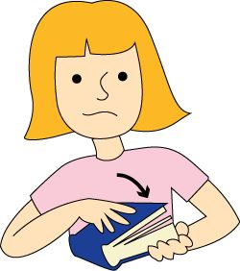… your book, please.
A. Open B. Close C. Read D. Write
45. Ảnh: A person has _ _ _ hands.
46. What are those? - … chalks.
A. They’re B. It’s C. You’re D. We’re
47. Look _ _ the blackboard, please.
48. your/ is/ When/ birthday?
49. What ... it? – It’s a black ruler.
A. is B. it C. that D. this
50. cat/ the table./ is a/ next to/ There/
51. _ _ _ t’s your name? – My name’s Sean.
52. Wh_ is that? – That’s Collin. He is my good friend.
53. park/ my school./ There is/ a small/ near
54. Choose the odd one out
A. Behind B. Front C. Under D. Wall
55. What is his _ _ _ _ ? – He is Eddie Murray.
56. Are these _ _ _ _ posters? – Yes, they are my posters.
57. Nghe: Nhấn giữ Ctrl và bấm chuột để nghe: This is my _ _ _ _ .
58. May I _ _ out?
59. … do you spell his name?
A. How B. What C. Who D. Why
60. Ảnh: It is snow_ in winter.
61. He ... my friend.
A. are B. is C. me D. I
62. Choose the odd one out
A. Picture B. Photo C. Table D. School
63. Teacher: Have a ... . - Children: Let’s play games.
A. break B. take C. make D. check
64. Show/ please!/ me/ your/ tickets,
65. Hello, My name’s Kate. I am ten _ _ _ _ _ old.
66. Nghe: Nhấn giữ Ctrl và bấm chuột để nghe: She’s got curly _ _ _ _ .
67. Ảnh: 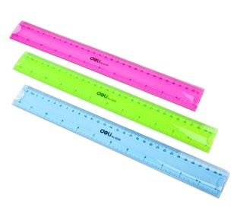These are Mike’s _ _ _ _ _ _ .
68. Does Mary like playing badminton? - …
A. Yes, she does. B. No, she isn’t. C. Yes, she can. D. No, she hasn’t.
69. Ảnh: What colour is the sun? – It’s y_ _ _ _ _ .
70. like/ pizza./ I'd/ some/
71. books/ please./ away,/ your/ Put/
72. Where/ are/ the children?/
73. Let’s sing w_ _ h me, please.
74. Choose the INCORRECT word or phrase in the following sentence: They are my ball, Daddy.
A. They B. my C. ball D. Daddy
75. a new/ ship. It/ is my/ birthday present./ It's/
76. You are welc_ me.
77. Choose the odd one out:
A. repeat B. listen C. read D. am
78. Goodbye. _ _ _ you again.
79. not/ do/ like/ I/ dogs./
80. They are my _ _ _ _ tives.
81. Choose the letter(s) to make a correct word: POS_ER
A. R B. S C. T D. N
82. Where are your pens and pencils?
A. They're the bag. B. They on the bag. C. They're in the bag. D. They are on bag.
83. My bag is … the table.
A. to B. at C. on D. for
84. ten rooms/ Are there/ this building?/ in/
85. Nghe: Nhấn giữ Ctrl và bấm chuột để nghe: His sister’s _ _ _ _ is in the tree.
86. funny./ The/ is/ game/
87. Our/ school library/ is/ not/ large./
88. His classroom is b_ g. It’s not small.
89. Ảnh: 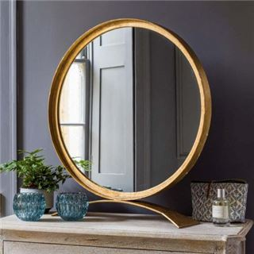There is a magic _ _ _ _ _ _ in the story 'Snow White and Seven Dwarfs'.
90. How old is Rose? - She _ _ ten.
91. Where is my pencil shar_ _ _ er?
92. Nghe: Nhấn giữ Ctrl và bấm chuột để nghe: This is my _ _ _ _ _ _ .
93. Mr. Green is talking _ _ Mrs. Green in the living room.
94. with/ my brother./ do/ I/ puzzles/
95. It’s a b_ ue pencil.
96. Nghe: Nhấn giữ Ctrl và bấm chuột để nghe: There is a p_ _ _ _ .
97. Is this a ch_ ir? - Yes, it is.
98. My mother/ makes/ in the morning./ cakes/
99. Ảnh: _ _ _
100. work/ goes/ to/ at 6 o'clock./ She/
101. How many ... are there ? - There is one peach.
A. crayons B. peachs C. peach D. peaches
102. Choose the odd one out
A. Games B. Swimming C. Skipping D. Chess
103. big?/ Is/ playground/ your/
104. Can you _ _ _ _ _ from one to one hundred?
105. We play sports _ _ _ games at break time.
106. they/ your/ classmates?/ Are/ new
107. ... up, please!
A. Sit B. Open C. Close D. Stand
108. How m_ _ y crayons are there?
109. There is _ _ apple on the table.
110. She ... long hair.
A. have B. has C. is D. with
111. Nghe: Nhấn giữ Ctrl và bấm chuột để nghe: They go to school by _ _ _ .
112. his teacher's/ How/ spell/ name?/ do you/
113. like/ English?/ Alice/ does/ Why/
114. does/ up?/ When/ get/ Hoang/
115. Nghe: Nhấn giữ Ctrl và bấm chuột để nghe: They are playing ….
A. volleyball B. football C. basketball D. baseball
116. orange bag./ an/ is/ This/
117. A: What is this? - B: …
A. It’s yellow. B. It’s a blue pencil. C. It’s very nice. D. It’s my friend.
118. I … a blue pencil and a white ruler.
A. has B. have C. don’t have D. doesn’t have
119. Ảnh: Rosy’s ice cream is _ _ _ _ .
120. Mary is reading books in the … . She comes there every weekend.
A. music room B. computer room C. library D. laboratory
121. Does your mother like do_ _ _ yoga?
122. I am .... I want a cake.
A. thirsty B. tired C. happy D. hungry
123. He_ _ o, my name’s Richard. - Nice to meet you.
124. Ảnh: It’s _ _ _ outside.
125. There is a kite ... the sky.
A. on B. to C. for D. in
126. blue desk?/ Do/ you/ like/ that
127. Ảnh: There are many stars in the s_ _ .
128. sing/ Let’s/ an English/ song.
129. Who is your _ _ iend?
130. Andy is my friend. _________ is short.
A. I B. He C. It D. You
131. David can play ... .
A. desk B. chair C. pencil D. football
132. Do you … skateboarding?
A. like B. liking C. likes D. to like
133. Can you speak English? - ... .
A. Yes, I can’t B. No, I can C. No, I can’t D. Yes, I do
134. G_ _ _ bye, see you later.
135. Nghe: Nhấn giữ Ctrl và bấm chuột để nghe: The _____ trainers are mine.
A. green B. black C. blue D. white
136. football/ plays/ David/ weekend./ at the
137. Ảnh: A person has _ _ _ legs.
138. I like _______ hide-and-seek with my friends.
A. playing B. plays C. play D. to playing
139. How ... chairs in your classroom?
A. much B. very C. old D. many
140. This is my grandf_ _ _ _ _ . He is 83 years old.
141. brown./ green and/ My pencils/ are/ red, blue,/
142. Nghe: Nhấn giữ Ctrl và bấm chuột để nghe: My school _ _ _ is very long.
143. The piano is nice but … .
A. old B. new C. big D. good
144. Nghe: Nhấn giữ Ctrl và bấm chuột để nghe: Sue _ _ _ _ _ up at seven o’clock in the morning.
145. ... you like some milk? - No, thanks.
A. Can B. Are C. Is D. Would
146. Nghe: Nhấn giữ Ctrl và bấm chuột để nghe: There are two _ _ _ _ _ _ _ _ .
147. Ảnh: He is wearing an o_ _ _ _ _ T-shirt.
148. Linh: Does Nam like playing tennis? - Hoa: Yes, … does.
A. he B. he’s C. you D. they
149. I/ book?/ my/ open/ May/
150. This pen _ _ blue.
151. _ _ _ _ _ pencils are these? – They’re mine.
152. isn't/ in the/ classroom. She/ is outside./ My friend/
153. Hello. My ... is Tom.
A. name B. is C. am D. are
154. Choose the odd one out.
A. numbers B. twenty C. thirteen D. seven
155. The map is on the wa_ _ .
156. Nghe: Nhấn giữ Ctrl và bấm chuột để nghe: My room is _ _ _ _ _ .
157. Nghe: Nhấn giữ Ctrl và bấm chuột để nghe: _ _ _ _
158. My/ not/ big./ room/ is/
159. Children shouldn’t drink coffee. It is not good _ _ _ their health.
160. she/ new sandals?/ have/ Does/
161. This is ... bag. It’s yellow.
A. a B. b C. c D. d
162. What/ a/ say?/ does/ cat
163. Choose the correct sentence.
A. I like playing chess at break time. B. I like play chess at break time. C. I like playing chess on break time. D. I like playing a chess at break time.
164. _ _ _ _ time do you go to bed?
165. Nghe: Nhấn giữ Ctrl và bấm chuột để nghe: Listen and tick:
A. fingers B. goldfish C. farmer D. fireman
166. W_ _ _ _ are the children? - They are at school.
167. Underline/ words of place/ the/ text./ in/
168. I have Maths _ _ Monday.
169. I _ _ _ _ books in the school library.
170. Where are you from, Peter? – I’m _ _ _ _ England.
171. What is yo_ _ name? – My name’s Jane.
172. Ảnh: How many rooms are there in your ho_ _ _ ?
173. Ảnh: 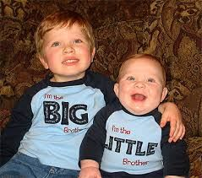Who are in this ph_ _ _ ? - My brother and I.
174. Nghe: Nhấn giữ Ctrl và bấm chuột để nghe: Listen and tick:
A. bike B. kite C. rice D. tie
175. my mother./ go shopping/ I/ often/ with
176. My pictures are ... the wall.
A. on B. to C. for D. at
177. I like playing ... .
A. yoga B. aerobics C. puzzles D. badminton
178. The/ maps/ the shelf./ are/ on
179. My/ sister/ is/ fifteen.
180. Look … the picture, Mary.
A. to B. on C. for D. at
181. Mr. Parker r_ _ _ _ newspapers everyday.
182. One and one is _ _ _ .
183. Nghe: Nhấn giữ Ctrl và bấm chuột để nghe: Her brother, Tom, is _ _ _ years old.
184. play/ Let's/ break time./ at/ hide-and-seek/
185. you/ Do/ pizza?/ like/
186. children./ Raise/ your/ hand,/
187. ______ Mi like chicken?
A. Are B. Do C. Does D. Is
188. … many desks are there in your classroom?
A. How B. What C. Who D. Which
189. Nam: W_ _ _ is this? - Mai: It’s a ruler.
190. My father is _ _ engineer.
191. Choose the odd one out:
A. eraser B. cat C. goldfish D. parrot
192. These books _ re pink.
193. do?/ What/ can/ Ryan/
194. ______ my uncle next to my father.
A. They are B. There are C. It is D. Is there
195. Good...ye! See you later.
A. a B. d C. y D. b
196. Wow! A robot. Thank _ _ _ .
197. notebook/ I/ and a big/ book./ have a small/
198. go/ school./ to/ Let’s/
199. I’m fine, thank you. ... ?
A. You B. And you C. And D. Are
200. Between two subject lessons, we have a little time for ….
A. break B. take C. make D. check

IOE K3 SỐ 29
1. Would you _ _ _ _ some water?
2. now./ is/ in/ Mr. Gerhard/ the computer room
3. Nghe: Nhấn giữ Ctrl và bấm chuột để nghe: I’ve got an _ _ _ _ _ .
4. Which word is the odd one out?
A. table B. doll C. robot D. ball
5. Ảnh: 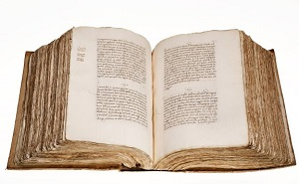_ _ _ _
6. Peter/ make/ can/ a paper boat.
7. Nghe: Nhấn giữ Ctrl và bấm chuột để nghe: Heidi's ____ is Kim.
A. father B. grandfather C. grandmother D. Mom
8. Teacher: Have a break! - Children: Let’s play … .
A. blind man’s bluff B. books C. board D. dog
9. Rooney./ Nice/ to/ you,/ meet/
10. Nam:... do you spell your name? - Linda: L_I_N_D_A.
A. How B. What C. Who D. Who’s
11. new/ she/ Is/ the/ teacher?/
12. are/ you/ from?/ Where/
13. want/ I/ clothes./ new/ some/
14. Ảnh: The boy has a red _ _ _ _ _ .
15. is/ Her/ Allie./ name/
16. It’s eleven o’clock. It’s time ….
A. to have B. for lunch C. for play D. to bed
17. Read/ “Computer”./ after/ me:/
18. This is Mary. _ _ _ is my friend.
19. Ảnh: These are my … .
A. pens B. chalks C. posters D. notebooks
20. Choose the letter(s) to make a correct word: B__THER
A. OR B. RO C. AR D.
21. He … to school every morning.
A. go B. go to C. goes D. goes to
22. ... John from Canada? - No, he isn’t.
A. Are B. This C. Is D. It
23. This is my school lib_ _ _ _ . It’s big.
24. Is that your classmate? – Yes, … .
A. she is B. we are C. they are D. I am
25. What do you … at break time? - I play chess.
A. sing B. go C. hear D. do
26. Ảnh: Her pencil _ _ _ _ is pink.
27. Happy birthday, Hai. This gift is for you. - Thank you _ _ _ _ much.
28. There are twenty stude_ _ _ in my class.
29. Sit … and open your notebooks, please!
A. up B. on C. to D. down
30. These ... my pencils.
A. and B. is C. are D. am
31. My father is _ _ engineer.
32. N_ _ e to meet you, Lan Anh.
33. Choose the odd one out:
A. apple B. bird C. cat D. dog
34. Nghe: Nhấn giữ Ctrl và bấm chuột để nghe: _ _ _ _ _
35. Which word has the underlined part pronounced LIKE the letter I in KITE?
A. ship B. milk C. nine D. fish
36. Ảnh: Those are our ch_ _ _ _ .
37. _ _ _ _ night, mommy.
38. Ảnh: There is a lovely golden _ _ _ _ in a bowl
39. I am …, thanks. And you?
A. five B. fight C. fine D. find
40. It's great ___ you!
A. see B. meet C. seeing D. to see
41. Choose the incorrect word or phrase in the following sentence: The gates of the house is blue.
A. The B. of C. house D. is
42. open/ mom?/ May/ the window,/ I/
43. The apple is a kind of fr_ _ ts.
44. Nghe: Nhấn giữ Ctrl và bấm chuột để nghe: They like _ _ _ _ _ _ _ .
45. That _ _ a green school bag.
46. Ảnh: Tonny is drinking _ _ _ _ .
47. How/ Tom?/ friend,/ is/ your/
48. me/ tickets,/ your/ please!/ Show/
49. Ảnh: I want to buy a _ _ _ _ _ book.
50. Choose the letter(s) to make a correct word: WARD_OBE
A. D B. R C. M D. N
51. shirts?/ are/ their/ What/ colour/
52. I like cakes and biscuits, _ _ _ .
53. at break time?/ do/ do you/ What/
54. Jane./ to/ birthday/ Happy/ you,
55. What colour is that kite? - It is … .
A. big B. small C. green D. short
56. Nghe: Nhấn giữ Ctrl và bấm chuột để nghe: Look at these pictures of my ….
A. house B. family C. class D. school
57. What do you do at b_ _ _ _ time? – We play football.
58. Good_ _ _ . See you again.
59. desks/ your classroom?/ How many/ are there/ in
60. Peter: How do you _ _ _ _ _ your name? - Huyen: That’s H-U-Y-E-N.
61. Ảnh: It's Alex's ru_ _ _ _ .
62. My brother h_ _ a fish.
63. Her _ _ _ ily name is Brown.
64. I/ sharpener./ need/ a new/ pencil
65. John: This is my sister. Peter: What is _ _ r name?
66. Tom’s birthday is in A_ _ _ _ _ .
67. How do ________ spell _________ name, Peter? - R-O-S-Y.
A. she - her B. you - her C. they - she D. you - he
68. _ _ _ . See you later.
69. Nghe: Nhấn giữ Ctrl và bấm chuột để nghe: That is my pen _ _ _ _ .
70. window./ near/ a TV/ There is/ the
71. Do you have any pets? – Yes, I have … .
A. any B. some C. much D. no pets
72. quiet,/ class./ Be/
73. Ảnh: The girl is … .
A. doing puzzles B. playing basketball C. playing hide-and-seek D. skipping rope
74. Ha can dance _ _ _ she cannot play football.
75. R_ _ se your hands, please.
76. Ảnh: _ _ _
77. _________ - He is Tom.
A. Where is Tom? B. How old is he? C. What is he? D. What's his name?
78. Ảnh: 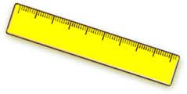That is a _ _ ler.
79. Nghe: Nhấn giữ Ctrl và bấm chuột để nghe: Listen and tick:
A. happy B. hide-and-seek C. zero D. hero
80. It _ _ my birthday today.
81. your/ Is/ playground/ big?
82. What’s your favorite ...? - I like orange juice.
A. colour B. subject C. pet D. drink
83. garden?/ there/ any ponds/ Are/ in the
84. kite?/ a/ Can/ fly/ you/
85. This is my new f_ _ _ _ d, Tony.
86. What …? – They are my crayons.
A. are those B. is this C. is that D. are there
87. every/ two/ I wash/ my hair/ days./
88. butterfly./ is playing/ My cat/ with a/
89. Her ruler _ _ n't new. It's old.
90. How do … spell … name, Peter?
A. you / your B. he / his C. she / her D. they / their
91. What do you _ _ in your free time?
92. _ _ _ your books pink? – Yes, they are.
93. … out your book.
A. Take’s B. Take C. Takes D. To take
94. Thank you very m_ _ h.
95. please!/ Open/ your/ book,/
96. S_ _ _ _ up, please.
97. How do … spell … name, Peter?
A. you – your B. he – your C. she – his D. they – our
98. Ảnh: There are elev_ _ pencils on the desk.
99. I’m fine, _ _ _ _ _ you.
100. Is he your uncle? – No, he _ _ _ ’t.
101. Nghe: Nhấn giữ Ctrl và bấm chuột để nghe: I have _ _ _ books.
102. Pick up/ your/ ruler/ and/ eraser./
103. Nghe: Nhấn giữ Ctrl và bấm chuột để nghe: Is she a _ _ _ _ _ _ _ ?
104. Ảnh: 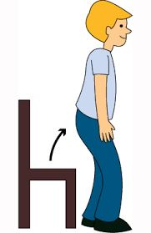..., please.
A. Sit down B. Stand up C. Go out D. Come in
105. I play/ seek/ hide/ and/ with my friends./
106. In summer, it __ hot.
A. is B. are C. am D. do
107. best?/ What/ subjects/ like/ do you/
108. Choose the letter(s) to make a correct word: th...e
A. os B. se C. ar D. he
109. Nghe: Nhấn giữ Ctrl và bấm chuột để nghe: There are many _ _ _ _ in the pencil case.
110. have/ juice./ Let's/ some/
111. Is your classroom big? – No, it isn’t. It’s s_ _ _ _ .
112. Nghe: Nhấn giữ Ctrl và bấm chuột để nghe: Here is his _ _ _ _ _ _ .
113. playing/ with/ My sister/ dolls./ doesn't like/
114. big/ are/ Those/ clouds.
115. My brother can play football … can’t play chess.
A. and B. but C. so D. or
116. Ảnh: 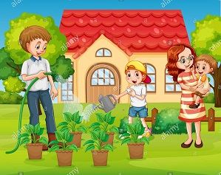The garden is ____ his house.
A. near to B. on front of C. next to D. in front of
117. sleep/ on the roof?/ Does/ your cat/
118. W_ o’s that?
119. What colour is this? - … .
A. It yellow B. It’s yellow C. Is yellow D. It is a yellow
120. Nghe: Nhấn giữ Ctrl và bấm chuột để nghe: _ _ _ _ _ shoes are hers.
121. Would you like ... apple? – Yes, please.
A. an B. a C. the D. some
122. Nghe: Nhấn giữ Ctrl và bấm chuột để nghe: _ _ _ are you?
123. in/ my bag./ There are/ pencils/ two/
124. box?/ Is/ square/ a/ this/
125. Ảnh: How old is your _ _ _ _ _ father?
126. to/ I/ May/ go/ the library?/
127. There _ _ _ many trees in the park.
128. Ảnh: 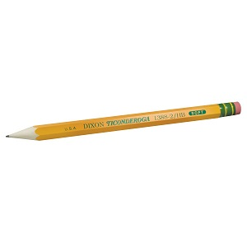PEN_ _ _
129. Billy: Are they your pencils? - Minh: No, they ... .They’re my pens.
A. don’t B. have C. do D. aren’t
130. ruler/ is/ pink./ That/
131. Pick ... your pen, children.
A. at B. on C. to D. up
132. Ảnh: It’s _ _ _ _ _ now.
133. Is your house big … small?
A. and B. or C. but D. of
134. like/ Do/ football?/ you/
135. likes/ She/ Art/ the/ most./
136. Class: Good morning t_ _ _ _ _ _ ! - Miss Hoa: Good morning, children. Please, sit down.
137. W_ _ is he? – He is my best friend.
138. Ảnh: This is the _ _ _ _ _ _ _ _ room.
139. Choose the letter(s) to make a correct word: swi__ing
A. mm B. m C. nn D. n
140. Let’s chan_ .
141. Pick ... your books, please.
A. to B. on C. at D. up
142. It _ _ my birthday today.
143. Come and play with ... .
A. to B. my C. I D. me
144. Ảnh: __________
A. Happy New Year! B. Merry Christmas! C. Happy birthday! D. Happy day!
145. Which word is the odd one out?
A. evening B. morning C. noon D. breakfast
146. Who _ _ _ those people?
147. These/ pencils./ are/ my/
148. ... at the board, please.
A. Put B. Look C. Stand D. Sit
149. Linda: Is this a book? - Phuong: ….
A. Yes, its B. Yes, it C. Yes, it is D. Yes, it isn’t
150. Is there … sugar in the jar?
A. any B. some C. a D. an
151. like/ don’t/ I/ sweets.
152. Have/ a/ nice/ day.
153. Put/ your/ down,/ hand/ Peter./
154. Which word has the underlined part pronounced LIKE the letter E in SISTER
A. nice B. brother C. new D. bedroom
155. Ảnh: My grandfather is ______ years old.
A. seventeen B. seventy C. seventy-one D. seven-one
156. There are th_ _ e books on the table.
157. I like _ _ _ _ _ puzzles after school.
158. It’s/ for/ John./ time/ breakfast,
159. the wardrobe/ and pick up/ a shirt./ I open/
160. ______ my uncle next to my father.
A. They are B. There are C. It is D. Is there
161. Lis_ _ _ to the teacher carefully, Mary.
162. to/ your teacher,/ Listen/ please!
163. Nghe: Nhấn giữ Ctrl và bấm chuột để nghe: What do you _ _ _ _ , Billy?
164. Nghe: Nhấn giữ Ctrl và bấm chuột để nghe: Is this your _ _ _ _ _ _ ?
165. Choose the letter(s) to make a correct word: G__NDFATHER
A. AR B. OR C. RO D. RA
166. May I _ _ me in?
167. This is _ _ ice-cream.
168. When is your sister’s birthday? – H_ _ birthay is in July.
169. Who is he? - … .
A. He’s fine B. She’s Mary C. He’s Peter D. I’m fine, thanks
170. are/ flowers/ beautiful./ very/ These/
171. Give me some more honey, please. - H_ _ _ you are.
172. Are you a student or a teacher?
A. Yes, I am. B. No, I am not. C. I’m a student. D. Yes, I.
173. _ _ _ old are you?
174. Nghe: Nhấn giữ Ctrl và bấm chuột để nghe: She goes running at seven _____.
A. fifteen B. fiveteen C. fourteen D. forteen
175. my/ I/ friend Lizzie./ old/ miss/
176. This is my brother and this is _______ bike.
A. he B. his C. him D. its
177. How _ _ d is your sister?
178. Ảnh: That’s a pencil sharp_ _ _ _ .
179. Nice to meet you. - ... .
A. Goodbye B. See you later C. Nice to meet you, too D. Good morning
180. meet/ you,/ Rooney./ to/ Nice/
181. Is that _ _ ice-cream?
182. Is it your ...?
A. big B. new C. small D. bag
183. Pick … your pencil, John.
A. on B. in C. of D. up
184. please./ me/ my/ Give/ rubber,
185. Nghe: Nhấn giữ Ctrl và bấm chuột để nghe: Put the pencil … the chair.
A. on B. next to C. under D. near
186. sneakers?/ are/ those/ colour/ What/
187. 'Do you play badminton at break time?' - '_________.'
A. No, you can’t. B. Yes, you do. C. Yes, I do. D. Yes, I am.
188. There _ _ _ five books on the shelf.
189. Ảnh: A bird can _ _ _ , but it can't swim.
190. I like playing ... .
A. yoga B. aerobics C. puzzles D. badminton
191. Are you happy?
A. Yes, I am. B. Yes, am. C. Yes, I I’m. D. Yes, it’s me.
192. Nghe: Nhấn giữ Ctrl và bấm chuột để nghe: She’s got _ _ _ _ _ eyes.
193. cat/ that chair./ under/ is/ The/
194. These are my s_ _ ters.
195. Pick ... your notebook, Helen.
A. on B. to C. up D. and
196. O_ _ n your book, please.
197. Nghe: Nhấn giữ Ctrl và bấm chuột để nghe: _ _ _ _ _
198. Nghe: Nhấn giữ Ctrl và bấm chuột để nghe: Listen and tick the word(s) you hear:
A. hide-and-seek B. hometown C. house D. housewife
199. Ảnh: 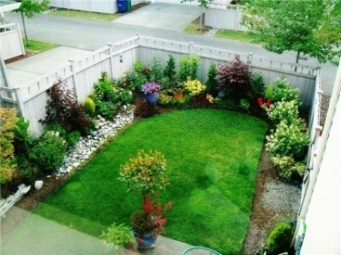We have a small _ _ _ _ _ _ behind our house.
200. How _ _ d is she? – She’s nine years old.

IOE K3 SỐ 30
1. Who/ over there?/ the woman/ is/
2. Ảnh: Her father is in the livi_ _ room.
3. Nghe: Nhấn giữ Ctrl và bấm chuột để nghe: We need to ___ this room.
A. close B. open C. hide D. tidy
4. Tom is my best _ _ _ _ _ _ .
5. That is my s_ _ _ _ _ library.
6. My brother is th_ _ e years old.
7. on the/ Are there/ water/ any/ moon?/
8. This is ... eraser. It’s not my eraser.
A. this B. he C. me D. your
9. Ảnh: 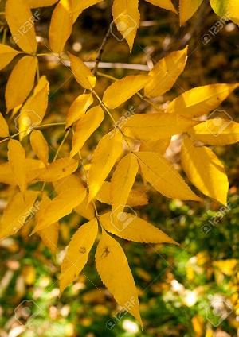In autumn, the leaves are y_ _ _ _ _ .
10. Is your house big … small?
A. and B. or C. but D. of
11. That man is _______.
A. fifty one B. fifteen one C. five ten one D. five one
12. Which word has the underlined part pronounced LIKE the letter U in RUBBER
A. picture B. colour C. sun D. ruler
13. Is this your bag? - … .
A. No, thanks B. Sure C. No, it is D. Yes, it is
14. Nghe: Nhấn giữ Ctrl và bấm chuột để nghe: His name is ... .
A. Abramson B. Abraham C. Apranson D. Adramsun
15. are/ nice/ Those/ oranges.
16. pencil/ is/ sharpener/ old./ My/
17. Lan: What are they? Huong: They are my ... .
A. teachers B. friends C. pencil cases D. Lan and Mai
18. Your/ mother/ is/ nice.
19. Good bye, Nam. _ _ _ you later.
20. Let’s go to the Art room. I wan to draw a pic_ _ _ _ .
21. Peter: What _ _ _ _ _ _ is your pen? - Mary: It’s red.
22. Why/ bears?/ does/ Nam/ like
23. My brother ... to play the piano.
A. like B. to like C. likes D. is like
24. _ _ _ _ bye, Mrs. Brown.
25. like in/ weather/ What's/ winter?/ the/
26. bluff./ blind man’s/ play/ Let’s/
27. Let’s ... English.
A. say B. speak C. listen D. show
28. My friend _______ chess in his free time.
A. does plays B. plays C. is play D. play
29. _ _ _ _ is the date today, Sam?
30. Does Jane like eating sweets? - Yes, she _ _ _ _ .
31. Is … an alarm clock in your room?
A. these B. this C. that D. there
32. Ảnh: That is my pencil s_ _ _ _ _ _ _ _ .
33. Ảnh: These are my … .
A. pens B. chalks C. posters D. notebooks
34. What’s this? - ... .
A. It’s a pen B. Yes, it is C. No, it isn’t D. They are pens
35. Hello. My name is Nga. - ... .
A. See you later B. Hi. I am Alice C. Goodbye D. Good night
36. Choose the odd one out:
A. library B. bathroom C. bedroom D. dining room
37. tall./ is/ friend/ My/
38. Nghe: Nhấn giữ Ctrl và bấm chuột để nghe: This is his _ _ _ _ _ _ _ .
39. Nghe: Nhấn giữ Ctrl và bấm chuột để nghe: _ _ _ _ _ _
40. Ảnh: What is this? - It’s a _ _ _ _ _ _ .
41. Ảnh: A bird can _ _ _ , but it can't swim.
42. Nghe: Nhấn giữ Ctrl và bấm chuột để nghe: Listen and tick:
A. shy B. sit C. six D. soup
43. It is a brown in_ pot.
44. Ảnh: On the t_ _ _ , the birds are singing.
45. He is David. He is my ... .
A. school B. name C. book D. friend
46. Long is opposite to short, then large is to … .
A. narrow B. big C. new D. fine
47. Put your book a_ _ y.
48. Nghe: Nhấn giữ Ctrl và bấm chuột để nghe: They are ____.
A. 12 B. 13 C. 14 D. 15
49. What is that? - ….
A. It is my cat B. That is my friend C. They are my cats D. It is Kevin
50. My pencil/ case/ backpack./ is in/ my
51. the evening?/ she do/ in/ does/ What/
52. Which word has the underlined part pronounced LIKE the letter O in ROBOT?
A. snow B. room C. for D. school
53. Nghe: Nhấn giữ Ctrl và bấm chuột để nghe: A _______
A. APPLE B. PINEAPPLE C. CANDY D. CAKE
54. but/ very nice./ big/ is not/ My school/
55. Here are your shoes. – _ _ _ _ _ _ .
56. What colour ______? - Black.
A. is your shoes B. are your shoes C. are your shoe D. your shoes
57. Would you like to come to _ _ _ bookstore with me?
58. How many/ planes/ the toybox?/ in/ are there/
59. come/ teacher/ in?/ . May I/ Good morning/
60. Ảnh: What colour is the armchair?
A. yellow B. red C. black D. white
61. Ảnh: 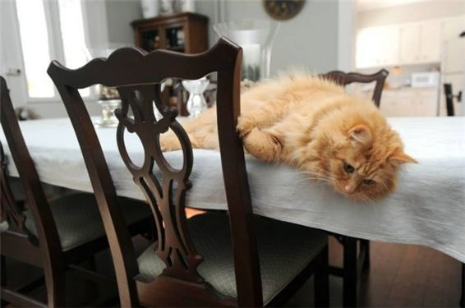The cat is lying on the _ _ _ _ _ .
62. What is this box? - … a present for mom on Christmas Day.
A. She’s B. He’s C. It’s D. I’m
63. I’m fine, thank you. ... ?
A. You B. And you C. And D. Are
64. How mu_ _ milk would you like?
65. ruler/ eraser./ and/ your/ Pick up/
66. Which is your house? – That … .
A. two B. three C. one D. four
67. Nghe: Nhấn giữ Ctrl và bấm chuột để nghe: Listen and tick the word(s) you hear:
A. a plane B. a train C. a fan D. a chair
68. Be q_ _ et, please.
69. She's ten _ _ _ _ _ old.
70. my/ aren’t/ Those/ kites.
71. Ảnh: Her brother is _ _ _ _ _ _ _ years old.
72. Ảnh: In autumn, the sky is very _____.
A. black B. white C. green D. blue
73. my bag./ pencils/ two/ in/ There are/
74. _ _ _ _ _ pencils are these? – They’re mine.
75. My si_ ter’s name is Mary.
76. not/ black./ Her/ hair/ is/
77. These are their _____.
A. schoolbag B. school bags C. schools bag D. schools bags
78. Ảnh: We are on the _ _ _ _ _ because it’s very hot today.
79. her/ that boy/ brother?/ Is/
80. Nghe: Nhấn giữ Ctrl và bấm chuột để nghe: GUITA_
81. This isn’t ... bag. It’s my bag.
A. he B. his C. me D. you
82. Choose the odd one out:
A. apple B. bird C. cat D. dog
83. on/ the/ wall./ is/ The fan/
84. … is my friend.
A. This B. Those C. These D. There
85. Hello. I _ _ Peter. Nice to meet you.
86. She/ today./ looks/ tired/
87. This pen _ _ blue.
88. Nghe: Nhấn giữ Ctrl và bấm chuột để nghe: Heidi's ____ is Alex.
A. Mom B. sister C. brother D. Dad
89. There … a small garden in front of the house.
A. is B. are C. am D. has
90. Nice to meet you, Paul. - Nice to meet you, t_ _ .
91. Where is your school libra_ _ ?
92. W_ _ is he? – He is my best friend.
93. Peter: How are you? - Huong: I’m fine. ... you?
A. Thank B. Thanks C. And D. Welcome
94. the name/ of your/ book?/ favourite/ What is/
95. This is Jane. _ _ _ is my friend.
96. Ảnh: 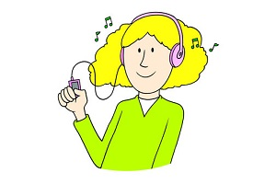You use your ____ to listen.
A. eyes B. head C. arm D. ears
97. I ... fine, thanks.
A. am B. is C. are D. the
98. I have _ cat.
99. 10th of/ is/ 2015./ Today/ January
100. do you/ subject/ What/ the most?/ like
101. How many/ does/ have?/ floors/ your school
102. Nghe: Nhấn giữ Ctrl và bấm chuột để nghe: Listen and tick:
A. moon B. jump C. sun D. run
103. Peter: How …are you? - Hoa: I’m eight years old.
A. all B. old C. tall D. small
104. Nam/ bears?/ like/ Does/
105. How do … spell … name, Peter?
A. you / your B. he / his C. she / her D. they / their
106. Odd one out:
A. fish B. dolphin C. monkey D. shark
107. They like frogs … they don’t like spiders.
A. but B. and C. so D. or
108. to school/ I/ usually/ go/ by bike./
109. Look … the picture, Mary.
A. to B. on C. for D. at
110. Ảnh: Sally has _ _ _ _ eyes and blonde hair.
111. H_ _ full name is Peter Brown.
112. How _ _ _ _ bananas are there in the fridge?
113. … many desks are there in your classroom?
A. How B. What C. Who D. Which
114. Ảnh: There are four people in my fa_ _ _ _ : my father, my mother, my sister and I.
115. Listen ... the teacher, please.
A. on B. at C. to D. for
116. The/ chess./ children/ playing/ are/
117. Nghe: Nhấn giữ Ctrl và bấm chuột để nghe: My eyes are _ _ _ _ .
118. Are you happy?
A. Yes, I am. B. Yes, am. C. Yes, I I’m. D. Yes, it’s me.
119. There is/ the/ window./ near/ a TV/
120. ... John from Canada? - No, he isn’t.
A. Are B. This C. Is D. It
121. Jim’s children _ _ _ watching TV and playing in the living room.
122. What/ is/ your/ colour/ new pen?/
123. Ảnh: 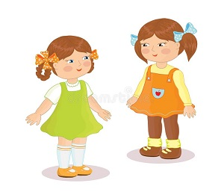The gi_ _ _ over there are my sisters.
124. ... photo is this? – It’s Jerry’s.
A. Whose B. What C. Which D. Who
125. What c_ _ _ _ are you in? - I'm in 3B.
126. Nghe: Nhấn giữ Ctrl và bấm chuột để nghe: I like playing _ _ _ _ _ _ _ _ _ _ at break time.
127. run/ The dogs/ the yard./ in/
128. They aren't in the classroom _ _ break time.
129. How many people _ _ _ there in your family?
130. Thank you. – You are w_ _ come.
131. Nghe: Nhấn giữ Ctrl và bấm chuột để nghe: A _____
A. MANGO B. BOOK C. RULER D. RUBBER
132. Mary is _ _ English teacher.
133. sport?/ favourite/ your/ What's/
134. What toys do you have?
A. I have a dog, a cat and a rabbit. B. I have a doll, a teddy bear and a yo-yo. C. I have a book, a yo-yo and a toy train. D. I have a doll, a dog and a goldfish.
135. Nghe: Nhấn giữ Ctrl và bấm chuột để nghe: Listen and tick:
A. sheep B. tiger C. lion D. cow
136. These ... my pencils.
A. and B. is C. are D. am
137. Wa_ _ your hands, please.
138. My favorite colour is g_ _ _ n.
139. What time/ do/ sleep?/ go to/ you/
140. Nghe: Nhấn giữ Ctrl và bấm chuột để nghe: _ _ _ are you?
141. My friends are _ _ the school library now.
142. Tom: Wh_ ’s that? - Lan: That’s my friend Nam.
143. I have a cat _ _ d a dog.
144. play/ hide-and-seek/ schoolyard./ in the/ We/
145. Ảnh: It’s _ _ _ outside.
146. My school is ... .
A. new’s B. new C. news D. names
147. Those _ _ _ my bags.
148. have/ Do you/ Susan?/ any/ pets,
149. often/ my brother./ with/ do puzzles/ I/
150. Ảnh: You need a rope to play _ _ _ _ ping.
151. you do/ What do/ in your/ time?/ free
152. I’m fine, thanks. _ _ _ you?
153. favourite/ the name/ book?/ of your/ What is/
154. Can you _ _ _ _ _ from one to one hundred?
155. How … students are there in your classroom?
A. much B. many C. more D. some
156. Collin: ... is your desk? - Tommy: It’s blue.
A. What B. What’s C. What colour D. What size
157. Ảnh: Close the _ _ _ _ , please!
158. _ _ my lunchbox, I have a banana and a sandwich.
159. I’m _ _ _ e, thanks. And you?
160. this/ Is/ David?/ sister,/ your/
161. Ảnh: 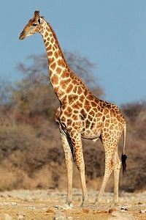There are many animals in the zoo such as elephants, monkeys, kangaroos and _____.
A. giraffes B. boxes C. money D. castles
162. Nghe: Nhấn giữ Ctrl và bấm chuột để nghe: There is a _____ next to my bed.
A. table B. desk C. shelf D. book
163. Her shirts/ are/ aren't pink./ white. They/
164. His/ is/ name/ David.
165. How/ many/ cats/ you have?/ do
166. My school is l_ _ _ e. Your school is small.
167. Choose the odd one out:
A. computer room B. park C. zoo D. playground
168. Teacher: Please….in, Peter. - Peter:Thank you, teacher.
A. sit B. stand C. come D. go
169. Nghe: Nhấn giữ Ctrl và bấm chuột để nghe: _ _ _ _ _ _ _
170. What’s the matter? – I’m … .
A. tired B. teacher C. student D. Kevin
171. do?/ What/ can/ Ryan/
172. Ảnh: Rosy’s ice cream is _ _ _ _ .
173. Mai: How old is Linda? - Hoa: She’s … years old.
A. fine B. five C. nice D. night
174. Tony puts some toothpaste on his toothbrush. He is going to _ _ _ _ _ his teeth.
175. Is/ your/ room/ or narrow?/ large
176. the rain./ photos/ We can’t/ take any/ because of
177. Ảnh: The ball is _ _ the box.
178. This is my pen and these ... their pens.
A. is B. are C. am D. be
179. Ảnh: David's grandmother isn't young. She's o_ _ .
180. _ _ s name is John.
181. Ảnh: That’s a pencil sharp_ _ _ _ .
182. The map is on the wa_ _ .
183. Nghe: Nhấn giữ Ctrl và bấm chuột để nghe: She goes running at seven _____.
A. fifteen B. fiveteen C. fourteen D. forteen
184. Why don’t you like the weather there? – … it’s too cold.
A. So B. But C. And D. Because
185. How many flowers ... there in the vase?
A. it B. are C. is D. am
186. the song about/ Sing/ our country,/ please.
187. doll/ My/ pink./ is/
188. flowers/ There are/ garden./ many/ in the
189. Ảnh: What’s in the schoolbag? – My books and a c_ _ _ _ _ _ .
190. What are these? - _______ cakes.
A. These B. There are C. It’s D. They are
191. would/ a/ Peter/ hamburger./ like/
192. Thank you for this beautiful gift. – You are wel_ _ me.
193. Nghe: Nhấn giữ Ctrl và bấm chuột để nghe: His sister’s _ _ _ _ is in the tree.
194. How ... chairs in your classroom?
A. much B. very C. old D. many
195. What are those? - …
A. It’s my notebook. B. They are crayons. C. These are my pens. D. They are blue and red.
196. Ảnh: That is the ph_ _ _ of my family.
197. Ảnh: My grand_ _ _ _ er is in the garden.
198. Choose the odd one out
A. Sixty B. Book C. Seventeen D. Nineteen
199. room/ The/ beautiful./ living/ is
200. Is this a bag? - ... .
A. Nice to meet you B. Yes, it is C. Yes, isn’t D. No, It is

IOE K3 SỐ 31
1. The new music room is _______.
A. new B. ten C. old D. large
2. Don't make a mess. - _______
A. Thanks. B. Yes, please. C. Yes, you can. D. Sorry.
3. How o_ _ are you?
4. How _ _ d is your sister?
5. teacher./ the/ Point/ to/
6. Choose the letter(s) to make a correct word: bla__
A. kk B. cc C. kc D. ck
7. She never stays _ _ late at night.
8. How are you? – I’m … .
A. six B. happy C. yellow D. new
9. Which word has the underlined part pronounced LIKE the letter ’A’ in ’SMALL’?
A. tall B. classroom C. play D. father
10. come/ May/ in?/ I/
11. Ảnh: What are they doing? - They are sw_ _ _ _ _ _ .
12. Nghe: Nhấn giữ Ctrl và bấm chuột để nghe: How many cakes are there in total?
A. There are twenty-nine. B. There are ninety. C. There are thirty-nine. D. There are ninety-nine.
13. Let’s/ sing/ a/ song.
14. books/ are/ my/ Those/
15. Students all ________ when their English teacher comes in.
A. stand up B. sit down C. go out D. come in
16. We/ like/ playing/ at break time./ games
17. I’m ha_ _ y.
18. Which is your school? - … one.
A. The B. A C. An D. This
19. Ảnh: The school playground is crowded at _ _ _ _ _ time.
20. I have _ _ ice cream.
21. Ảnh: May I _ _ _ _ in?
22. Peter: Let’s dr_ _ a picture. - Nam: Yes, let’s.
23. Ảnh: R_ _ _ _
24. spell/ you/ How/ do/ her name?/
25. Let’s go fishing. – That’s a good i_ _ _ .
26. Choose the odd one out.
A. Father B. Mother C. Brother D. Uncle
27. Ảnh: There is NOT _______ in the picture.
A. a ball B. a baby C. a desk D. a chair
28. The cats are white. _ _ _ _ are very beautiful.
29. sentences./ the/ Reorder/
30. Miss/ you,/ How/ are/ Smith?/
31. A: … is your school? - B: … is big and new.
A. Where – He B. How – It C. What – She D. Who - That
32. These chairs … small.
A. are B. is C. am D. not
33. Ảnh: There are _ _ _ _ toes on a foot.
34. the living room./ kitchen/ next to/ The/ is/
35. Ảnh: Her sister can’t d_ _ _ e.
36. I have an English friend. _ _ _ name is Kate.
37. ... your teeth, Tommy.
A. Read B. Listen C. Stand D. Brush
38. Ảnh: You use your _____ to write.
A. head B. hand C. eyes D. foot
39. There is ___ pen in the pencil case.
A. one B. two C. three D. four
40. are/ playing/ chess./ children/ The/
41. Nghe: Nhấn giữ Ctrl và bấm chuột để nghe: Sue _ _ _ _ _ up at seven o’clock in the morning.
42. _ _ . Nice to meet you.
43. Nghe: Nhấn giữ Ctrl và bấm chuột để nghe: There are … people in her family.
A. four B. five C. six D. three
44. your bags/ Are/ in/ the car?
45. W_ _ is he? – He is my best friend.
46. give/ more water./ Please,/ me/ some
47. My cla_ _ _ _ _ m is small.
48. Show/ me/ cards,/ your/ please./
49. Nghe: Nhấn giữ Ctrl và bấm chuột để nghe: Andy is _ _ _ _ _ .
50. Nghe: Nhấn giữ Ctrl và bấm chuột để nghe: The library is _ _ _ .
51. Ảnh: That’s my pencil _ _ g!
52. in/ I/ two pens/ have/ my bag./
53. Nice to m_ _ _ you, too.
54. Peter/ and Tommy/ new/ friends./ are my/
55. your/ colour/ are/ lunch boxes?/ What/
56. Mandy/ dolls/ have?/ How many/ does/
57. Those _ _ _ my pens and pencils.
58. ... are you from, Jean? – I’m from Canada.
A. What B. How C. Where D. When
59. There … some cheese in the fridge.
A. are B. is C. be D. have
60. John: This is my sister. Peter: What is _ _ r name?
61. I ... John. Nice to meet you.
A. is B. am C. be D. are
62. _ _ _ are you? - I’m fine, thanks.
63. I ... my teeth in the morning.
A. do B. brush C. have D. does
64. Ảnh: There are five _ _ _ _ in the armchair.
65. class/ 3A./ in/ My sister/ is/
66. I/ don’t/ on Sunday./ go to/ school
67. Ảnh: My pencil is _ _ _ _ . Her pencil is short.
68. well/ I do/ feel/ today./ not/
69. Nghe: Nhấn giữ Ctrl và bấm chuột để nghe: It’s a … book.
A. little B. small C. big D. large
70. The children like playing in the park because … very large.
A. it is B. they are C. he is D. she is
71. My friend is ten _ _ _ _ _ old.
72. Write your name _ _ the board, please.
73. Gi_ e me the book, please.
74. sister's/ What/ is/ name?/ your/
75. Where is your school libra_ _ ?
76. There … some cheese in the fridge.
A. are B. is C. be D. have
77. Nghe: Nhấn giữ Ctrl và bấm chuột để nghe: That is my _____.
A. notebook B. computer C. pencil case D. rubber
78. three/ are/ on the wall./ pictures/ They/
79. books./ my/ are/ Those/
80. Who is your …? – The man over there.
A. father B. mother C. aunt D. sister
81. Nga: Do you play football? - Huong: No, I … I like basketball.
A. don’t B. am not C. doesn’t D. isn’t
82. _ _ _ _ time do you go to bed?
83. Which word has the underlined part pronounced LIKE the letter I in BIG
A. his B. nine C. kite D. nice
84. Peter has _ _ work all day in the factory.
85. These are my s_ _ ters.
86. This/ my/ Jane./ is/ new friend
87. What are these ? - ….
A. It’s a motorbike B. They’re motorbikes C. They’re motorbike D. It is motorbike
88. flowers./ three/ have/ I/
89. Nghe: Nhấn giữ Ctrl và bấm chuột để nghe: _ _
90. Nghe: Nhấn giữ Ctrl và bấm chuột để nghe: Listen and tick the word(s) you hear:
A. lion B. lamp C. ruler D. cloudy
91. Ảnh: What colour is the fence?
A. Blue B. Black C. White D. Yellow
92. Be … Don’t make noise.
A. lazy B. quiet C. funny D. angry
93. Choose the letter(s) to make a correct word: cent__l
A. ra B. re C. aa D. ar
94. free/ in your/ What do/ time?/ you do/
95. _ _ _ t’s your name? – My name’s Sean.
96. _ _ _ _ _ are you going to stay? - In a hotel.
97. R_ _ se your hands, please.
98. What do you do in … free time?
A. you B. yours C. you’re D. your
99. is/ the tall girl/ over/ there?/ Who/
100. favourite/ is/ Hamburger/ my/ food./
101. Choose the INCORRECT word or phrase in the following sentence: Our living room are very big and beautiful.
A. are B. very C. and D. beautiful
102. Ảnh: The cup is here, __ the table.
A. in B. on C. behind D. under
103. I like my school _ _ _ _ much.
104. Ảnh: The _ _ _ is on the table.
105. you,/ old/ are/ How/ Duong?/
106. Is that a purple flower? – ..., it is.
A. No B. Yes C. Not D. No, it isn’t
107. Ảnh: _ _ _
108. Let’s make a ci_ _ le.
109. This is Tom and _ _ _ cute dog, Rex.
110. Can you give me some pens, pl_ _ se?
111. Who _ _ _ those people?
112. What is your school’s n_ _ _ ? – It’s Oxford Primary School.
113. Peter: What _ _ _ _ _ _ is your pen? - Mary: It’s red.
114. My school bag _ _ new.
115. Are there any fruits on the table? - Yes, ______.
A. there is B. are there C. is there D. there are
116. class./ quiet,/ Be/
117. GRAN___THER
A. TFA B. DMA C. DFO D. DMO
118. This gift is for you. - Thank you very _ _ _ _ .
119. Do you ____ a comic book? - Yes, I do.
A. having B. like C. knows D. are
120. There _ _ one lamp on the desk.
121. Lan's eraser/ small./ white. It's/ is/
122. Is that a crayon? - ... .
A. No, they are B. Yes, they are C. Yes, it is D. No, they aren’t
123. books/ there?/ are/ many/ How/
124. Nghe: Nhấn giữ Ctrl và bấm chuột để nghe: This is my _ _ _ _ _ _ _ _ _ _ _ .
125. There ... three cats in the box.
A. am B. is C. are D. there
126. your mother?/ next to/ your aunt/ Is/
127. My uncle doesn’t work … Saturday.
A. at B. in C. on D. of
128. What …? – They are my crayons.
A. are those B. is this C. is that D. are there
129. _ _ _ sun is shining.
130. Which is your house? – That __________.
A. one B. two C. three D. four
131. Nghe: Nhấn giữ Ctrl và bấm chuột để nghe: Is she a _ _ _ _ _ _ _ ?
132. Ảnh: Those are our ch_ _ _ _ .
133. Stand/ up,/ please./
134. do/ you/ spell/ your name?/ How/
135. Linda _____ a little cat.
A. have B. do C. has D. am
136. Thank you very much – You’re ... .
A. welcome’s B. welcomes C. welcome D. welcome’re
137. I often play sports _ _ Tuesday afternoons.
138. Ảnh: BOOK_ _ _ _
139. Choose the odd one out
A. Mother B. Father C. Teacher D. Grandmother
140. Her father goes to work _ _ 6 o’clock.
141. My aunt is a _ _ _ ter of my mother.
142. One plus one makes _ _ _ .
143. beautiful./ flower/ is/ This/ very
144. Nghe: Nhấn giữ Ctrl và bấm chuột để nghe: His _ _ _ is in the football net.
145. Can you remem_ _ r my birthday?
146. How … fans are there? – Three.
A. many B. much C. old D. long
147. Do you like listening to music?
A. Yes, I am. B. No, I do. C. No, I don't. D. Yes, it is.
148. My parents are _ _ the living room.
149. Nghe: Nhấn giữ Ctrl và bấm chuột để nghe: Listen and tick the word(s) you hear:
A. classroom B. bathroom C. living room D. bedroom
150. Which word has the underlined part pronounced LIKE the letter E in SISTER
A. nice B. brother C. new D. bedroom
151. Don't be late __ school.
A. at B. in C. for D. with
152. I ... fine, thanks.
A. am B. is C. are D. the
153. What … her name? – She is Mai Anh.
A. are B. is C. am D. does
154. Ảnh: MOUS_
155. _ _ ke out your book.
156. Choose the INCORRECT word or phrase in the following sentence: They are my ball, Daddy.
A. They B. my C. ball D. Daddy
157. with/ Can/ a yo yo?/ you/ play/
158. Nghe: Nhấn giữ Ctrl và bấm chuột để nghe: Here is his _ _ _ _ _ _ .
159. Spe_ _ your name, please.
160. How do you _ _ _ ll your name?
161. Let’s go t_ the library.
162. Nghe: Nhấn giữ Ctrl và bấm chuột để nghe: Pat is in the _ _ _ _ _ _ room.
163. is/ Miss Lien/ new/ teacher./ my/
164. green. They/ Your rulers/ are/ are in the bag.
165. Hello. My name’s Betty. - ....
A. Bye, see you again B. See you soon C. Hi. I am Susan. Nice to meet you D. Goodbye
166. What/ school's/ is/ their/ name?/
167. Ảnh: His cat has gr_ _ _ eyes.
168. that boy/ Is/ her/ brother?
169. Ảnh: The _ _ _ _ is beautiful.
170. Nghe: Nhấn giữ Ctrl và bấm chuột để nghe: My brother is thir_ _ _ _ years old.
171. There/ a/ kitchen./ is/
172. to the/ The radio/ windows./ is/ next/
173. Nghe: Nhấn giữ Ctrl và bấm chuột để nghe: Listen and tick:
A. boat B. cook C. book D. look
174. is/ name?/ her/ What/
175. Nghe: Nhấn giữ Ctrl và bấm chuột để nghe: The girl is fif_ _ _ _ .
176. Nam: What’s his _ _ _ _ ? - Hoa: Tony.
177. Ảnh: These are three pencil _ _ _ _ _ in my school bag.
178. Can you speak English? - Yes,... can.
A. he B. she C. you D. I
179. The pencil is long and the rubber is sh_ _ _ .
180. are swimming/ in the/ The fish/ pond.
181. I like Maths but my friends ….
A. isn’t B. doesn’t C. don’t D. aren’t
182. This is _ book. It’s green.
183. Is your house big … small?
A. and B. or C. but D. of
184. in/ It's/ summer./ sunny/
185. Art/ on/ Friday./ have/ I don’t/
186. What/ does/ she do/ the evening?/ in
187. Good morning, children. - ... .
A. Good morning, teacher B. Hello C. Hi D. Bye
188. Allie./ Her/ name/ is/
189. My favorite colour is g_ _ _ n.
190. A: What is this? - B: …
A. It’s yellow. B. It’s a blue pencil. C. It’s very nice. D. It’s my friend.
191. What _______ at break time?
A. do you do B. is he do C. are you do D. are they do
192. Your sister is pre_ _ y.
193. ... at the board, please.
A. Put B. Look C. Stand D. Sit
194. name,/ please./ your/ Write/
195. Nghe: Nhấn giữ Ctrl và bấm chuột để nghe: Who likes drawing?
A. Mr. Macaroni. B. Meg. C. Tom. D. Mrs. Green.
196. Orange juice is my favourite ... .
A. drink B. food C. apple D. milk
197. _____ Lisa like going out with you?
A. Do B. Are C. Is D. Does
198. Nghe: Nhấn giữ Ctrl và bấm chuột để nghe: Listen and tick the word(s) you hear:
A. sunny B. Sunday C. summer D. seven
199. How _ _ ny bananas are there in the box?
200. What is this? - ….
A. It a orange B. Is a orange C. It’s a orange D. It’s an orange

IOE K3 SỐ 32
1. _ _ ke out your book.
2. Ảnh: I don’t like sk_ _ _ _ _ _ .
3. They are ... chairs.
A. my B. a C. an D. one
4. Is the w_ _ _ _ over there your mother?
5. Nghe: Nhấn giữ Ctrl và bấm chuột để nghe: Listen and tick the word(s) you hear:
A. lion B. lamp C. ruler D. cloudy
6. There are many trees _ _ the forest.
7. Nghe: Nhấn giữ Ctrl và bấm chuột để nghe: This is her grand_ _ _ _ _ _ .
8. _ _ o is that? – That’s my brother.
9. Nghe: Nhấn giữ Ctrl và bấm chuột để nghe: The bus is _ _ _ _ .
10. Ảnh: The _ _ _ _ _ _ is swinging.
11. Choose the INCORRECT word or phrasein the following sentence: How many lamp are there in the room?
A. lamp B. are C. in D. room
12. These are my friends. The_ _ names are Lan and Phuong.
13. where/ Excuse me,/ the/ is/ principal’s room?/
14. ... old is your sister? – She is nine years old.
A. When B. What C. Where D. How
15. Where are you from, Peter? – I’m _ _ _ _ England.
16. help/ Can/ you/ me?
17. Choose the odd one out:
A. its B. his C. she D. her
18. Nghe: Nhấn giữ Ctrl và bấm chuột để nghe: That is my _____.
A. notebook B. computer C. pencil case D. rubber
19. Wow! A robot. Thank _ _ _ .
20. What's there next _ _ the door?
21. Ảnh: I have a y_ _ _ _ _ lamp next to my bed
22. Are t_ _ _ students?
23. What do you do at …? – I play football.
A. break time B. school time C. English lessons D. the home
24. My mother gets up at 5 o’clock … the morning.
A. at B. on C. in D. from
25. school bag./ in/ my/ two rulers/ There are/
26. What colour are your pencils? - They _________ blue and green.
A. are B. is C. aren’t D. does
27. The/ school gym/ new./ is/
28. have/ three/ flowers./ I/
29. Go _ _ the door, please.
30. Nghe: Nhấn giữ Ctrl và bấm chuột để nghe: Is she a _ _ _ _ _ _ _ ?
31. Choose the odd one out:
A. is B. am C. are D. those
32. study/ at/ many subjects/ I/ school./
33. Ảnh: How many cats are there in the picture? - _ _ _ _ _ .
34. Ảnh: There is a big poster in ____ of the shop.
A. at B. on C. front D. out
35. What/ do/ have/ on Thursday?/ we/
36. sport?/ her/ favourite/ is/ What/
37. Is this a book? - ... .
A. No, it is B. Yes, it isn’t C. Yes, it is D. No, they are
38. Are these _ _ _ _ posters? – Yes, they are my posters.
39. _ _ _ re is Peter from? – He’s from England.
40. Nghe: Nhấn giữ Ctrl và bấm chuột để nghe: Listen and tick the word(s) you hear:
A. draw B. write C. see D. hear
41. Who/ is/ the tall girl/ there?/ over
42. Choose the letter(s) to make a correct word: KI_CHEN
A. C B. X C. T D. O
43. _ _ _ _ color is it? - It’s red.
44. Her father goes to work _ _ 6 o’clock.
45. Nghe: Nhấn giữ Ctrl và bấm chuột để nghe: My school _ _ _ is very long.
46. I/ not/ tigers./ like/ do/
47. _ _ _ sun is shining.
48. Is/ big?/ classroom/ your/
49. ..., students. See you later.
A. Good morning B. Good night C. Goodbye D. Nice to meet you
50. door,/ the/ Close/ please!
51. What do you do at b_ _ _ _ _ _ _ _ ?
52. There are many gray _ _ _ _ _ _ in the sky. It's going to rain.
53. Tom can ... a bicycle.
A. bye B. ride C. drive D. rides
54. Ảnh: _ _ _ _ _ _
55. I like to eat pizza v_ _ y much.
56. I don’t/ my bedroom./ have a/ in/ bookcase/
57. What colour is this? - … .
A. It yellow B. It’s yellow C. Is yellow D. It is a yellow
58. That’s my new friend. H_ _ name’s Jenny.
59. The boys/ and girls/ and short./ tall/ are/
60. a/ ball?/ big/ this/ Is/
61. Nga: ... play chess! - Peter: Yes, let’s.
A. Do you B. Don’t you C. Let’s D. Are you
62. My ruler is ye_ _ ow.
63. Ảnh: Under your head, it's your ne_ _ .
64. The dog/ in front/ of the/ desk./ is/
65. Where is Sandra? – ... at school.
A. He B. She C. He’s D. She’s
66. How are …? - … am fine, thanks.
A. they / He B. we / We C. you / I D. him / He
67. Do you like _ oing Maths?
68. Ảnh: Those are our ch_ _ _ _ .
69. Nghe: Nhấn giữ Ctrl và bấm chuột để nghe: My eyes are _ _ _ _ .
70. Is that y_ _ _ school? – Yes, it is.
71. The swimming pool/ is/ big./ very/
72. Choose the letter(s) to make a correct word: POS_ER
A. R B. S C. T D. N
73. Art/ Friday./ have/ I don’t/ on
74. We have English _ _ Friday.
75. in/ What/ bedroom?/ is/ her
76. He_ _ _ , I’m Micheal. Nice to meet you..
77. Ảnh: There are many animals in the zoo such as elephants, monkeys, kangaroos and _____.
A. giraffes B. boxes C. money D. castles
78. Linh: Can you ... the window? It’s hot. - Lan: OK.
A. open B. play C. read D. listen
79. Are there any fruits on the table? - Yes, ______.
A. there is B. are there C. is there D. there are
80. _ _ _ _ colour is it? - It’s red.
81. the/ windows?/ I/ May/ open/
82. I like doing karate. - ... .
A. No, thanks B. Me too C. Yes, please D. Sorry
83. Ảnh: That’s not my _ _ _ _ _ .
84. Her birthday is ... June.
A. on B. in C. at D. to
85. What/ Ryan/ do?/ can/
86. _________ - She's forty.
A. How many books are there? B. How old are you? C. What is her name? D. How old is she?
87. John: Are you a student? - Jane: Yes,... .
A. Yes, I am B. I am C. I’m student D. Yes, I
88. R_ _ se your hands, please.
89. _ _ _ is that? – It’s Alice.
90. Please, sit ... .
A. at B. in C. down D. on
91. May I go out? - … .
A. Hello B. Nice to meet you C. Fine, thanks D. Sure
92. Peter: Let’s dr_ _ a picture. - Nam: Yes, let’s.
93. Nghe: Nhấn giữ Ctrl và bấm chuột để nghe: How do you _ _ _ _ _ your name?
94. My father raises some fish in the _____.
A. garden B. forest C. pond D. yard
95. She's ten _ _ _ _ _ old.
96. My/ is/ nurse./ mom/ a
97. Choose the odd one out:
A. America B. English C. Canada D. Vietnam
98. It's not my pen. It's y_ _ _ pen.
99. Nghe: Nhấn giữ Ctrl và bấm chuột để nghe: It’s _ _ _ _ _ _ today.
100. ... you tomorrow, children. – Goodbye, teacher.
A. See B. See’s C. See you D. Bye
101. cakes?/ these/ Do/ you like/
102. What’s y_ _ r name? – My name’s David.
103. My mother li_ es jogging.
104. Ảnh: The st_ _ is bright at night.
105. Nghe: Nhấn giữ Ctrl và bấm chuột để nghe: The _____ trainers are mine.
A. green B. black C. blue D. white
106. Let's/ juice./ have/ some/
107. A: Is your school …? – B: No, it is a bit small.
A. small B. big C. pretty D. new
108. Choose the odd one out.
A. Mother B. Father C. Sister D. Ruler
109. Ảnh: What’s the weather like? - It’s _ _ _ _ _ .
110. This is the com_ _ _ _ _ room. You can surf the internet here.
111. Linda: Do your friends play games at school? - Hoa: Yes,they ... .
A. do B. does C. are D. is
112. I’m OK, … you.
A. thanking B. thanks C. thank D. to thank
113. How _ _ _ _ bananas are there in the fridge?
114. . Good bye,/ Well!/ Peter./ This is my/ school bus/
115. Nghe: Nhấn giữ Ctrl và bấm chuột để nghe: Listen and tick:
A. brown B. red C. orange D. black
116. Let’s listen _ _ some music.
117. That is my father. … name is Jame.
A. Her B. She C. He D. His
118. Ảnh: 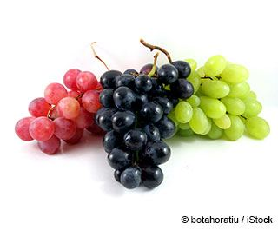The _ _ _ _ _ _ look good. I’d like to eat them.
119. Nghe: Nhấn giữ Ctrl và bấm chuột để nghe: Listen and choose the word that is NOT in the recording.
A. egg B. dog C. cat D. bag
120. Are you a student or a teacher?
A. Yes, I am. B. No, I am not. C. I’m a student. D. Yes, I.
121. Do you want to play ...?
A. camping B. soccer C. skiing D. swimming
122. Does/ new sandals?/ have/ she/
123. Peter: Do you speak English? - Loan: ... .
A. Yes, I don’t B. No, I am not C. No, I do D. Yes, I do
124. likes comics./ fairy tales/ likes/ and Rosy/ Shelly/
125. We go to school __ the morning.
A. on B. at C. in D. to
126. May I come in? - …
A. No, thanks. B. Yes, please. C. Yes, you are. D. No, you don’t.
127. are/ relatives./ my/ These/
128. How m_ _ y dogs do you have?
129. a/ dress./ blue/ wants/ My mother/
130. How _ o you spell your name?
131. What _ _ your favourite game?
132. like/ much./ I/ very/ chocolate/
133. ... you like some milk? - No, thanks.
A. Can B. Are C. Is D. Would
134. Choose the odd one out
A. Picture B. Photo C. Table D. School
135. very/ family/ I love/ my/ much./
136. Here you are. - Thank _ _ _ very much.
137. Ảnh: 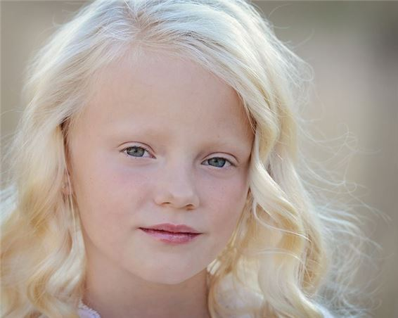Does she have bl_ _ _ _ hair?
138. How _ _ _ your parents?
139. this/ is/ new classmate?/ Alex,/ your
140. Nghe: Nhấn giữ Ctrl và bấm chuột để nghe: Pat is in the _ _ _ _ _ _ room.
141. Ảnh: We can see a _ _ _ _ _ _ _ _ in Australia.
142. football/ and James/ likes basketball./ likes/ Jacob/
143. It is a brown in_ pot.
144. Ảnh: It's my aunt's birthday today. She's ____ years old.
A. thirty-two B. thirteen-two C. three-two D. threety-two
145. Nghe: Nhấn giữ Ctrl và bấm chuột để nghe: I’ve got an _ _ _ _ _ .
146. O_ _ n your book, please.
147. My/ tall./ friend/ is/
148. … to the teacher, please.
A. Listen B. Watch C. Look D. Read
149. The big tree is beh_ nd my house.
150. words/ Check/ you/ the/ hear./
151. Their backpacks are in the _ _ _ boards.
152. He/ a/ reads/ evening./ book/ every/
153. Alice is my friend, _ _ o.
154. please./ Give/ that/ red car,/ me/
155. Do you like my new red dress? - …
A. Where is from? B. No, it isn’t. C. Yes, it looks good on you. D. Of course, I am.
156. What is this? - T_ _ s is a kite.
157. to sing/ We/ songs./ like/ English
158. Our bedroom is very … .
A. tired B. slim C. large D. well
159. ... are their desks.
A. It B. This C. Those D. That
160. _ _ _ those my pens?
161. My parents are _ _ the living room.
162. Ảnh: It's under the ____.
A. book B. bookcase C. table D. sofa
163. Nghe: Nhấn giữ Ctrl và bấm chuột để nghe: Listen and tick:
A. moon B. man C. meet D. new
164. Choose the odd one out:
A. sing B. he C. they D. she
165. _ _ _ _ _ are you going to stay? - In a hotel.
166. … is the pencil? - It’s in your schoolbag.
A. What B. Where C. How D. Whose
167. Nghe: Nhấn giữ Ctrl và bấm chuột để nghe: Which sport does he like?
A. Volleyball B. Football C. Basketball D. Handball
168. are yellow./ are/ new. They/ Their pegs/
169. What colour ______? - Black.
A. is your shoes B. are your shoes C. are your shoe D. your shoes
170. these/ Peter?/ your/ Are/ pencil cases,
171. Choose the incorrect word or phrase in the following sentence: The gates of the house is blue.
A. The B. of C. house D. is
172. They/ clean/ their classroom/ after school.
173. What ... their …?
A. is name B. are / names C. is / names D. are / name
174. Billy: Are they your pencils? - Minh: No, they ... .They’re my pens.
A. don’t B. have C. do D. aren’t
175. What is this? – It is ... ice-cream.
A. a B. an C. this D. that
176. Nghe: Nhấn giữ Ctrl và bấm chuột để nghe: Listen and tick:
A. shy B. sit C. six D. soup
177. This is ... eraser. It’s not my eraser.
A. this B. he C. me D. your
178. This is my new fr_ _ _ d.
179. Lan's/ How/ old/ brother?/ is/
180. red/ is/ This/ book./ a/
181. My school bag is _ _ all. Your school bag is big.
182. Tom is my fr_ _ _ _ . He’s from England.
183. Nghe: Nhấn giữ Ctrl và bấm chuột để nghe: Look at _ _ _ _ photo.
184. Thank you. – You are w_ _ come.
185. My sister is happy ... today is her birthday.
A. but B. and C. because D. for
186. W_ _ is that? – That’s Jenny. She is my friend.
187. puzzles/ evening./ does/ Thomas/ in the
188. Ảnh: Can you play ______?
A. the piano B. baseball C. the guitar D. the trumpet
189. stamps?/ these/ want/ Do you/
190. This/ is/ a/ pink/ book./
191. This is my fa_ _ er. He is an engineer.
192. her/ kitten/ in the yard?/ Is/
193. My mother buys many school things such as notebooks, pens, pencils and _________.
A. hamburger B. shoes C. balls D. rubbers
194. Let’s s_ ng a song, Mary.
195. _ _ _ _ is the date today, Sam?
196. What/ sneakers?/ those/ are/ colour/
197. Do you like _______?
A. play football B. playing football C. to playing football D. to play the football
198. How many/ are there/ the box?/ in/ rubbers/
199. is/ not/ room/ big./ My/
200. Nghe: Nhấn giữ Ctrl và bấm chuột để nghe: Listen and tick:
A. grandmother B. teacher C. grandfather D. doctor

IOE K3 SỐ 33
1. Nghe: Nhấn giữ Ctrl và bấm chuột để nghe: His name is … Jackson.
A. Louise B. Louis C. Lous D. Luois
2. my/ is/ friend./ She/ new
3. Those/ big/ are/ clouds.
4. Nghe: Nhấn giữ Ctrl và bấm chuột để nghe: Tony has a lot of books and he likes _ _ _ _ _ _ _ hip hop.
5. 'What _ _ _ _ ur is your pen?' - 'It’s red.'
6. Nghe: Nhấn giữ Ctrl và bấm chuột để nghe: Listen and tick:
A. three B. two C. shoes D. zoo
7. Peter is _ _ the classroom now.
8. The pencil is long and the rubber is sh_ _ _ .
9. Choose the odd one out:
A. nice B. you C. he D. she
10. Linda: Do your friends play games at school? - Hoa: Yes,they ... .
A. do B. does C. are D. is
11. at break time?/ What/ do you/ do/
12. He drinks a g_ _ _ _ of apple juice every afternoon.
13. Are there any maps __ your classroom?
A. on B. in C. at D. of
14. Ảnh: _ _ the table, there is a plate of fruits.
15. What do you do at b_ _ _ _ _ _ _ _ ?
16. Nghe: Nhấn giữ Ctrl và bấm chuột để nghe: _ _ _ _ _
17. Why ... we come and visit Uncle Tom? - That’s a good idea.
A. don’t B. have C. do D. aren’t
18. I have ___ black inkpot.
A. a B. an C. two D. some
19. Hello, My name’s Kate. I am ten _ _ _ _ _ old.
20. These/ puzzles./ my/ are/
21. your/ Are/ rulers?/ those/
22. many/ can/ draw/ My brother/ pictures./
23. Nghe: Nhấn giữ Ctrl và bấm chuột để nghe: _ _ _ are you?
24. Ảnh: _ _ _ _ is good for your health.
25. My sister can play the ... .
A. book B. chess C. piano D. football
26. father/ a/ doctor./ My/ is/
27. Nghe: Nhấn giữ Ctrl và bấm chuột để nghe: Listen and tick the word(s) you hear:
A. mirror B. under C. fisher D. soldier
28. Do you like music?
A. Ye, I am. B. Yes, I don’t. C. Yes, I do. D. Yes, I can.
29. Do you __ to school?
A. see B. listen C. go D. look
30. Choose the odd one out:
A. am B. is C. are D. this
31. dog?/ is/ brown/ her/ Where/
32. _______ is the new table? - It’s in the dining room.
A. What B. Who C. When D. Where
33. It _ _ my toy.
34. old./ eleven/ years/ My sister/ is/
35. How many flowers ... there in the vase?
A. it B. are C. is D. am
36. Ảnh: There are _ _ _ _ rooms in my house.
37. Open ... books, please.
A. your B. you’re C. you D. yours
38. Ảnh: F_ SH
39. Nghe: Nhấn giữ Ctrl và bấm chuột để nghe: Listen and tick:
A. a plane B. a train C. a fan D. a chair
40. birthday present./ is my/ ship. It/ a new/ It's/
41. My/ is/ cat./ favourite animal/
42. How _ _ d is your sister?
43. How _ _ d is she? – She’s nine years old.
44. Nghe: Nhấn giữ Ctrl và bấm chuột để nghe: His favourite sport is _ _ _ _ _ _ _ _ _ .
45. What ________ _________ name?
A. are - their B. is - she C. is - his D. are - your
46. The/ book/ is/ in/ the bag./
47. _ _ _ _ _ are you going to stay? - In a hotel.
48. What's there next _ _ the door?
49. ..., teacher? – Sure.
A. Stand up B. Open your book C. Who is he D. May I go out
50. What/ you/ subject/ do/ like?/
51. Choose the odd one out:
A. how B. many C. what D. where
52. Choose the letter(s) to make a correct word: BA_HROOM
A. D B. T C. H D. N
53. Ảnh: Her pencil _ _ _ _ is pink.
54. How are you, David? - …
A. I am six years old. B. I am fine, thanks. C. I like blue and green. D. I am in the classroom.
55. Linda: Do you like skating? - Phuong: Yes, ... .
A. you do B. I want C. I do D. I can
56. Ảnh: 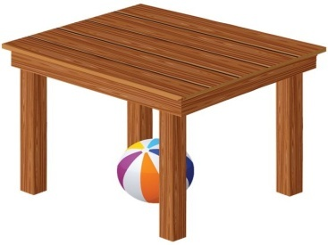The ball is ________ the table.
A. on B. behind C. next to D. under
57. What’s y_ _ _ name? – My name’s Shane.
58. This is my brother and this is _______ bike.
A. he B. his C. him D. its
59. chess/ I/ school./ at/ play/
60. ... are you? – Fine, thanks.
A. Who B. Is C. Are D. How
61. Does she have any _______?
A. banana B. bananas C. bananas’ D. banana’s
62. Ảnh: The Children's Day is in _____.
A. April B. May C. June D. July
63. My ... is Tim. Nice to meet you.
A. name’s B. names C. name D. is name
64. Don’t be late … your lesson!
A. on B. for C. to D. at
65. My father/ on the wall./ the clock/ hangs/
66. Hi, my name is Phuong. - … .
A. Goodbye B. Hi, I’m Tom C. See you later D. Fine, thanks
67. Hello, my na_ _ is Ha.
68. Linda: Is your school b_ _ ? - Nam: No, it isn’t. It’s small.
69. How do … spell … name, Peter?
A. you – your B. he – your C. she – his D. they – our
70. Hi, _ _ _ are you? – I’m fine, thanks.
71. silent,/ Keep/ please!/
72. is/ brother/ His/ ten/ years old./
73. room/ very/ The/ old./ is/
74. Mary _ _ s born in America.
75. Ảnh: It's great to play sk_ _ _ ing with you.
76. I’m _ _ _ _ _ , I’m late.
77. This is my sister and this is … bike.
A. her B. his C. their D. its
78. My school y_ _ _ is small.
79. How do ________ spell _________ name, Peter? - R-O-S-Y.
A. she - her B. you - her C. they - she D. you - he
80. The trees ___ green.
A. is B. are C. am D. do
81. Choose the letter(s) to make a correct word: HOU_E
A. E B. O C. S D. U
82. The p_ _ _ are in the pencil case.
83. Ảnh: This is the play_ _ _ _ _ _ .
84. Your cat is _ _ _ small. It’s big.
85. These are my … .
A. book B. pencil case C. poster D. bags
86. Ảnh: This rabbit has an orange _ _ _ .
87. that is/ This is/ and/ her pencil./ my pen/
88. Ảnh: CHIC_ _ _
89. Nghe: Nhấn giữ Ctrl và bấm chuột để nghe: Ben’s _ _ _ _ _ years old today.
90. Ảnh: What colour is the grass?
A. Green B. Brown C. Yellow D. Red
91. Ảnh: The children are playing … now.
A. badminton B. volleyball C. hide-and-seek D. break time
92. I … a blue pencil and a white ruler.
A. has B. have C. don’t have D. doesn’t have
93. H_ _ _ _ , Alex. How are you?
94. two rulers/ my/ There are/ school bag./ in/
95. There is _ _ apple on the table.
96. is/ My/ classroom/ not/ small./
97. your mother,/ How/ Ben?/ is/
98. these/ Do/ cakes?/ you like/
99. not/ do/ I/ like/ tigers./
100. Ảnh: 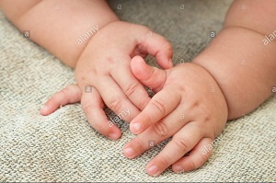My little sister has two small _____.
A. books B. pens C. rulers D. hands
101. _ _ _ many bottles of milk are there?
102. Ảnh: 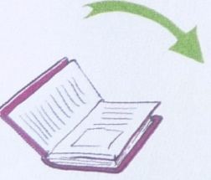_ _ _ _ _ your book, please.
103. Hi. What's your _ _ _ _ ? - I'm Peter.
104. dance but/ play football./ cannot/ Hung can/
105. It _ _ my birthday today.
106. Their backpacks are in the _ _ _ boards.
107. and short./ and girls/ tall/ are/ The boys/
108. The classroom is modern … large.
A. and B. but C. so D. or
109. Ảnh: Close the _ _ _ _ , please!
110. They are her _______.
A. pencil case B. pencils case C. pencils cases D. pencil cases
111. Yes, _ _ is a new notebook.
112. Let’s ma_ e a circle.
113. There are ... students in my class. Twenty boys and twenty girls.
A. twenty B. thirty C. forty D. fifty
114. He is Simon. He is my ... .
A. school B. name C. book D. friend
115. I have a cat _ _ d a dog.
116. big./ classroom/ is/ very/ My/
117. David can play ... .
A. desk B. chair C. pencil D. football
118. Mai./ picture,/ draw/ Let’s/ a/
119. Nghe: Nhấn giữ Ctrl và bấm chuột để nghe: It’s the _ _ _ _ _ _ _ _ room.
120. Ảnh: Can you make a _ _ _ _ ?
121. I like doing karate. - ... .
A. No, thanks B. Me too C. Yes, please D. Sorry
122. They go to school _ _ _ _ Monday to Friday.
123. C_ _ se your bag, Tom.
124. ___ I use your computer?
A. May B. Cannot C. Am D. Canot
125. Nghe: Nhấn giữ Ctrl và bấm chuột để nghe: Which number is NOT in the recording?
A. 14 B. 13 C. 12 D. 11
126. Wr_ _ _ your name here, please.
127. Tho_ _ are my crayons.
128. Ảnh: It's _ pink cup.
129. What time _ _ you get up?
130. red/ This/ flower./ a/ is/
131. Nghe: Nhấn giữ Ctrl và bấm chuột để nghe: Sue is in the … room.
A. living B. dining C. sitting D. bed
132. Is that your father? – No, … .
A. it is B. it isn’t C. that is D. is that
133. Ảnh: On the t_ _ _ , the birds are singing.
134. Tom: _ _ _ _ colour is your pencil case? - Jenny: It’s green.
135. How many months are there in a year?
A. 10 B. 11 C. 12 D. 13
136. are/ new. They/ Her notebooks/ are on/ the bookcase./
137. Is this a book? - ... .
A. No, it is B. Yes, it isn’t C. Yes, it is D. No, they are
138. Nghe: Nhấn giữ Ctrl và bấm chuột để nghe: This is my ___.
A. ice B. light C. knife D. kite
139. are/ tall trees./ These/ five/
140. large./ very/ is/ The/ room/
141. _ _ _ _ do you usually do in your free time?
142. Pictures of my family _ _ _ on the wall.
143. My pictures are ... the wall.
A. on B. in C. for D. to
144. Nghe: Nhấn giữ Ctrl và bấm chuột để nghe: Listen and tick the word(s) you hear:
A. happy B. hide-and-seek C. zero D. hero
145. Ảnh: 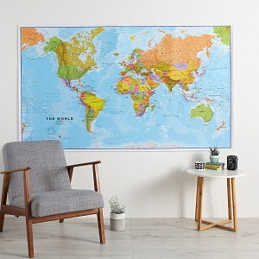The _ ap is on the wall.
146. in your/ a park/ Is there/ town?
147. we/ go to/ This is/ the way/ school./
148. I like _______ hide-and-seek with my friends.
A. playing B. plays C. play D. to playing
149. _ _ _ _ is it? – It is a kite.
150. your/ big?/ Is/ classroom/
151. What ... it? – It’s a desk.
A. is B. hi C. bye D. hello
152. Let’s ... a picture, Daisy.
A. sit B. read C. draw D. stand
153. Nghe: Nhấn giữ Ctrl và bấm chuột để nghe: My school _ _ _ is very long.
154. Billy is th_ _ e years old.
155. My school library is b_ _ . Your library is small.
156. at/ the/ Look/ board.
157. Ảnh: Every classroom has a bl_ _ _ board
158. Ảnh: 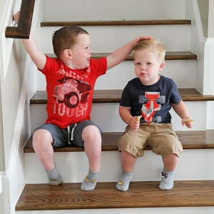Who are the bo_ _ over there? - They're my brothers.
159. P__STER
A. L B. A C. O D. E
160. isn’t/ classmate./ That/ girl/ my
161. My brother’s name is … .
A. Daisy B. Mary C. Ben D. Nicole
162. there?/ dolls/ How/ many/ are
163. Nghe: Nhấn giữ Ctrl và bấm chuột để nghe: They are ____.
A. 12 B. 13 C. 14 D. 15
164. Ảnh: _ _ _ _ _ _
165. I like to eat pizza v_ _ y much.
166. Lis_ _ _ to the teacher, please.
167. book/ is/ boring./ The/
168. _ _ _ _ do you do at school?
169. your/ they/ Are/ new/ classmates?/
170. green. They/ are/ are in the bag./ Your rulers/
171. Nghe: Nhấn giữ Ctrl và bấm chuột để nghe: His sister’s _ _ _ _ is in the tree.
172. Ảnh: _ _ _
173. she/ a/ Is/ teacher?
174. These _ _ _ two dolls.
175. The kittens/ balcony./ sleep/ in the/
176. Roses are … and grapes are purple.
A. sweet B. nice C. red D. lovely
177. love/ We/ very much./ break time/
178. How many chairs are there in your living room? - _______
A. I'm great today. B. There are five chairs. C. There are two days. D. It's large and big.
179. Ảnh: She likes _ red dress.
180. __________ - Green.
A. What's your favourite colour? B. Good morning! C. Goodbye! D. Sorry!
181. Ảnh: 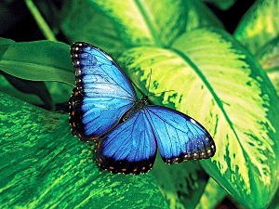BUTTERFL_
182. Linh: Can you ... the window? It’s hot. - Lan: OK.
A. open B. play C. read D. listen
183. Does/ bananas?/ like/ Mary/
184. match./ Listen/ and/
185. What does she do _ t break time?
186. I ... my teeth in the morning.
A. do B. brush C. have D. does
187. Nghe: Nhấn giữ Ctrl và bấm chuột để nghe: He is ____.
A. 12 B. 13 C. 14 D. 15
188. Nghe: Nhấn giữ Ctrl và bấm chuột để nghe: My _ _ _ _ is green.
189. These ... my pencils.
A. and B. is C. are D. am
190. This is my/ new/ pencil/ box.
191. Math teacher?/ How/ is/ old/ your
192. I’d like _ _ apple, please.
193. Nghe: Nhấn giữ Ctrl và bấm chuột để nghe: Listen and tick the word(s) you hear:
A. large B. cycle C. clean D. jeans
194. There is a big tree next _ _ the pond.
195. Is this _ _ eraser? – No, it isn’t.
196. My brother __ to school today.
A. go B. goes C. play D. plays
197. Hoa?/ Is/ Miss/ that/
198. bedroom/ Is/ her/ or small?/ big
199. Peter: Are those your notebooks? - Jane: No, ... .
A. it is B. it isn’t C. they are D. they aren’t
200. The big tree is beh_ nd my house.

IOE K3 SỐ 34
1. What time …?
A. are they B. is it C. aren’t they D. isn’t it
2. John: Are you a student? - Jane: Yes,... .
A. Yes, I am B. I am C. I’m student D. Yes, I
3. Ảnh: It's Alex's ru_ _ _ _ .
4. your/ school/ it/ Is/ bag?/
5. two rulers/ in/ my/ school bag./ There are/
6. Good af_ _ _ _ _ _ _ Mr. Smith.
7. The/ is on/ the/ cat/ sofa./
8. How/ many/ there?/ rulers/ are
9. Nghe: Nhấn giữ Ctrl và bấm chuột để nghe: My new _ _ _ _ _ _ is Adam.
10. Ảnh: Two ha_ _ _ have ten fingers.
11. book./ a/ This/ pink/ is/
12. are/ Those/ big/ clouds.
13. These are my … .
A. book B. pencil case C. poster D. bags
14. Ảnh: ELEPH_ _ _
15. Teacher: Is your school library big? - Tommy: No, it … .
A. don’t B. am not C. doesn’t D. isn’t
16. Is this your bag? - … .
A. No, thanks B. Sure C. No, it is D. Yes, it is
17. Ảnh: D_ _ _ a flower on your sheet.
18. Goo_ _ _ e. See you tomorrow, students.
19. schoolyard/ is/ The/ not/ large./
20. Is your classroom big? – No, it _ _ n’t.
21. Pick … your pencil, John.
A. on B. in C. of D. up
22. Listen _____ repeat.
A. or B. and C. with D. now
23. Nghe: Nhấn giữ Ctrl và bấm chuột để nghe: Ben’s _ _ _ _ _ years old today.
24. Nice to meet you. - ... .
A. Goodbye B. See you later C. Nice to meet you, too D. Good morning
25. your aunt/ Is/ your mother?/ next to/
26. We/ break time/ very much./ love/
27. The _________ is Jane.
A. me B. boy C. girl D. she
28. with his friend/ basketball/ plays/ after school./ Tuan/
29. Does she have any _______?
A. banana B. bananas C. bananas’ D. banana’s
30. Ảnh: That _ _ _ _ _ pen is not mine.
31. W_ _ _ _ is Mary from?
32. 'Do you play badminton at break time?' - '_________.'
A. No, you can’t. B. Yes, you do. C. Yes, I do. D. Yes, I am.
33. The computer/ room/ large./ is/
34. _ _ _ _ is your name? - My name is Jerry.
35. How many flowers _ _ _ there in the vase?
36. _ _ _ are you? - I'm John's brother.
37. Nghe: Nhấn giữ Ctrl và bấm chuột để nghe: _ _ _ _ _ _ _ _ _
38. Jane: What _ _ _ our is your desk? - Linda: It is pink.
39. the garden./ many/ There are/ flowers/ in
40. Ảnh: The child is _ _ the box.
41. Which word is odd one out?
A. pig B. men C. chicken D. fish
42. Ảnh: Come and see the pho_ _ of my family.
43. Are you a student or a teacher?
A. Yes, I am. B. No, I am not. C. I’m a student. D. Yes, I.
44. _ _ _ is she? – She’s Ms. Wilson. She’s my English teacher.
45. these/ stamps?/ want/ Do you/
46. Ảnh: We can see a _ _ _ _ _ _ _ _ in Australia.
47. Choose the incorrect word or phrase in the following sentence: They play badminton in break time.
A. play B. badminton C. in D. time
48. Nghe: Nhấn giữ Ctrl và bấm chuột để nghe: _ _ _ _ _ _ _ _
49. A: Is your school …? – B: Yes, there are four big buildings and a big schoolyard.
A. small B. little C. large D. narrow
50. At break time, we ___ different games and sports.
A. do B. get C. go D. play
51. David?/ sister,/ your/ Is/ this/
52. Nghe: Nhấn giữ Ctrl và bấm chuột để nghe: They’ve got two _ _ _ sins, Amy and Leo.
53. Nghe: Nhấn giữ Ctrl và bấm chuột để nghe: Listen and tick:
A. hat B. hot C. red D. cat
54. The big tree is beh_ nd my house.
55. Her/ from/ friends/ are/ France./
56. What/ do/ every/ do you/ evening?/
57. Ảnh: What’s the weather like? - It’s _ _ _ _ _ .
58. Nghe: Nhấn giữ Ctrl và bấm chuột để nghe: Polly is my best _ _ _ _ _ _ .
59. Choose the odd one out:
A. Vietnam B. England C. America D. Vietnamese
60. ______ my uncle next to my father.
A. They are B. There are C. It is D. Is there
61. one garden/ Is there/ your school?/ in/
62. Would you _ _ _ _ some water?
63. How many months are there in a year?
A. 10 B. 11 C. 12 D. 13
64. A: Goodbye. - B: Bye. _________
A. See you tomorrow. B. Thank you. C. Sorry. D. Nice to meet you.
65. Let’s listen _ _ some music.
66. I like my school _ _ _ _ much.
67. in/ pens/ the box?/ are there/ How many/
68. cakes and/ in a/ We eat/ coffee shop./ drink tea/
69. B_ _ . See you later.
70. Mary often gets _ _ early in the morning.
71. I … a blue pencil and a white ruler.
A. has B. have C. don’t have D. doesn’t have
72. ____ do you like? - This one.
A. What B. Where C. How D. Which
73. Nghe: Nhấn giữ Ctrl và bấm chuột để nghe: The ____ watch is mine.
A. blue B. yellow C. black D. white
74. sentences./ Reorder/ the/
75. Your father’s brother is your _ _ _ _ _ .
76. Ảnh: The children like building a sand_ _ _ _ _ _ on the beach.
77. Choose the odd one out:
A. song B. subjects C. animal D. plant
78. Ảnh: He is wearing an o_ _ _ _ _ T-shirt.
79. Linda: How are you? - Jane: I’m _ _ _ _ , thanks.
80. _ _ _ _ _ are you from? - I'm from Vietnam.
81. Put/ away,/ children./ your/ pencils/
82. new/ These/ pens./ my/ are/
83. Nghe: Nhấn giữ Ctrl và bấm chuột để nghe: Sue is in the _ _ _ _ _ _ car
84. brother/ These/ are/ and sister./ my/
85. I ... my teeth in the morning.
A. do B. brush C. have D. does
86. Where _ _ you study, Trang?
87. Rai_ e your hand, please.
88. May I _ _ me in?
89. Which … their pencil sharpeners?
A. are B. am C. is D. have
90. Lien: _ _ you like badminton? - Mary: Yes, I do.
91. the sky./ in/ There are/ six/ kites/
92. Choose the incorrect word(s) in the following sentence: My uncle is thirty year old.
A. My B. is C. year D. old
93. This is ... eraser. It’s not my eraser.
A. this B. he C. me D. your
94. My mother li_ es jogging.
95. Nghe: Nhấn giữ Ctrl và bấm chuột để nghe: Meg is _ _ _ _ _ years old.
96. How mu_ _ milk would you like?
97. My family have dinner in the ____.
A. living room B. bedroom C. basement D. dining room
98. your/ pencil sharpener?/ What/ is/ colour/
99. Ảnh: My grandfather is ______ years old.
A. seventeen B. seventy C. seventy-one D. seven-one
100. is/ new/ my/ She/ friend./
101. Is this ... classroom?
A. are B. a C. am D. an
102. a glass/ of milk./ is/ It/
103. Nghe: Nhấn giữ Ctrl và bấm chuột để nghe: Listen and tick the word(s) you hear:
A. a pet B. a bed C. a bird D. a bage
104. Max and his friends/ playground./ badminton/ play/ in the
105. is/ Living room/ my/ favourite room.
106. Hamburger/ is/ my/ food./ favourite
107. This is ... orange.
A. a B. an C. is D. are
108. The board is big and n_ _ .
109. have/ don't/ lunchbox./ my/ I/
110. red/ is/ This/ a/ flower./
111. My father raises some fish in the _____.
A. garden B. forest C. pond D. yard
112. Can/ one to ten?/ you count/ from/
113. Ảnh: My grand_ _ _ _ er is in the garden.
114. years/ is/ eleven/ My brother/ old./
115. Let’s make a cir_ le.
116. Four and five are n_ _ _ .
117. Which sentence is correct?
A. Santa Claus flying over the town. B. Santa Claus is riding his sleigh. C. Santa Claus is ride a reindeer. D. Santa Claus is walking in the sky.
118. That is my mother. _ _ _ is a teacher.
119. How are you? - I _ _ fine.
120. Ảnh: It is a beautiful purp_ _ flower.
121. How many days are there in _ week?
122. at/ play/ break time./ hide-and-seek/ Let's/
123. Raise your ..., please.
A. hand B. sit C. stand D. open
124. Ảnh: Let's make paper bo_ ts.
125. Choose the odd one out.
A. numbers B. twenty C. thirteen D. seven
126. is/ old/ brother?/ Lan's/ How/
127. Yes, _ _ is a new notebook.
128. on/ The cat/ is/ bench./ that
129. Ảnh: You are in the water to play this sport. What sport is it?
A. Badminton B. Volleyball C. Table tennis D. Swimming
130. They like frogs … they don’t like spiders.
A. but B. and C. so D. or
131. Choose the letter(s) to make a correct word: G__NDFATHER
A. AR B. OR C. RO D. RA
132. My bedroom is not big. It’s sm_ _ _ .
133. … does your father do in his free time? – He plays tennis.
A. What B. Who C. When D. Where
134. you/ like?/ What/ colour do/
135. _ _ you like playing football?
136. W_ _ _ _ is Mary from? - She’s from England.
137. Her ruler _ _ n't new. It's old.
138. Nghe: Nhấn giữ Ctrl và bấm chuột để nghe: The ___ T-shirt is William's.
A. red B. yellow C. black D. white
139. Nghe: Nhấn giữ Ctrl và bấm chuột để nghe: She’s got _ _ _ _ _ eyes.
140. How old is his grandmother? - _______
A. She's fine. B. There are some tables in the room. C. She's sixty now. D. Thank you very much.
141. How/ of this animal?/ spell/ the name/ do you/
142. Goodb_ e, Tommy. See you later.
143. My school bag is _ _ all. Your school bag is big.
144. What colour is this? - … .
A. It blue B. It’s blue C. Is blue D. It is a blue
145. Nghe: Nhấn giữ Ctrl và bấm chuột để nghe: Listen and tick:
A. pen B. pencil C. pen case D. ruler
146. Choose the odd one out:
A. play B. quiet C. talk D. stand
147. Ảnh: Shhh! The baby is _ _ _ _ _ _ _ _ .
148. Tom./ hands,/ Wash/ your/
149. We go to school ... .
A. alone B. together C. gether D. by me
150. Ảnh: fourteen, _______, sixteen.
A. fiveteen B. fifteen C. fifty D. fourty
151. Ảnh: She has a beautiful _ _ _ _ .
152. This is m_ cat.
153. my/ is/ He/ friend,/ too./
154. How _ _ d is she? – She’s nine years old.
155. I am .... I want a cake.
A. thirsty B. tired C. happy D. hungry
156. Nghe: Nhấn giữ Ctrl và bấm chuột để nghe: His sister’s _ _ _ _ is in the tree.
157. Is/ she/ teacher?/ the/ new
158. a/ need/ sofa./ new/ I/
159. Peter: What are their …? - Hoa: Mai and Huong.
A. name B. names C. your name D. your names
160. do/ you/ a/ Can/ puzzle?/
161. Nghe: Nhấn giữ Ctrl và bấm chuột để nghe: _ _ _ _ _ _
162. Choose the INCORRECT word or phrase in the following sentence: These are Peter's picture on the shelf.
A. These B. picture C. on D. shelf
163. Ảnh: Her pencil _ _ _ _ is pink.
164. There are four people _ _ my family.
165. This/ is/ ruler/ pink.
166. Nghe: Nhấn giữ Ctrl và bấm chuột để nghe: Look at _ _ _ _ photo.
167. Which is your school? – This _ _ _ .
168. David can play ... .
A. desk B. chair C. pencil D. football
169. What is your favourite ...? – I like milk very much.
A. food B. drink C. subject D. colour
170. Ảnh: He _____ some words on the blackboard.
A. listens B. writes C. goes D. plays
171. The flowers are colourful in _ _ _ garden.
172. My elder brother h_ _ a goldfish.
173. Nghe: Nhấn giữ Ctrl và bấm chuột để nghe: This is her grand_ _ _ _ _ _ .
174. Nghe: Nhấn giữ Ctrl và bấm chuột để nghe: _ _ _ _ _
175. What time _ _ _ _ the library open?
176. Nam: May I _ _ out? - Teacher: Yes, please.
177. A: Do you like bananas? - B: ______
A. I like bananas. B. I don't like bananas. C. Yes, I do. D. Yes, I am.
178. Choose the odd one out:
A. am B. is C. are D. this
179. Choose the odd one out:
A. bag B. book C. big D. pencil
180. Ảnh: R_ _ _ _
181. is/ a/ blue/ eraser./ It/
182. Put/ away,/ please./ books/ your/
183. Nghe: Nhấn giữ Ctrl và bấm chuột để nghe: Which number is NOT in the recording?
A. 16 B. 17 C. 18 D. 19
184. Let’s ... English.
A. say B. speak C. tell D. sing
185. Mary ... to school every morning.
A. go B. go’s C. goes D. goes to
186. Ảnh: F_ SH
187. Those/ big/ are/ clouds.
188. the wall./ pictures/ are/ on/ The/
189. Ảnh: His mother is in the kitch_ _ .
190. Ảnh: This is your …, Tom.
A. bench B. desk C. chair D. board
191. This is m_ pen. It’s not your pen.
192. Do you like _ oing Maths?
193. Is that y_ _ _ nephew?
194. Odd one out:
A. fish B. dolphin C. monkey D. shark
195. What can you do … English? – I can count to 100, sing an English song.
A. in B. at C. on D. by
196. Write the an_ _ _ rs, please.
197. My mother buys many school things such as notebooks, pens, pencils and _________.
A. hamburger B. shoes C. balls D. rubbers
198. English?/ Alice/ Why/ does/ like
199. My class is …: ten girls and eleven boys.
A. nice B. tidy C. big D. new
200. They aren't her books. They are _ _ s books.

IOE K3 SỐ 35
1. Quyen is playing _ _ _ piano.
2. Jim/ from/ London./ isn’t/
3. the music room?/ boys/ How many/ in/ are there/
4. … do you do at lunch time?
A. What B. How C. Where D. When
5. likes to/ play/ sister/ dolls./ My/
6. Who is tall_ _ , Jack or Jim?
7. When/ Lan’s/ birthday?/ is/
8. Ảnh: 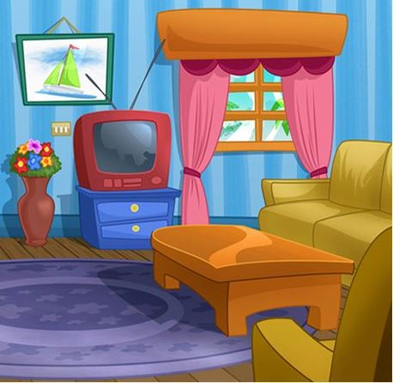There is a p_ _ _ _ _ e above the television.
9. There are s_ _ en days in a week.
10. Nghe: Nhấn giữ Ctrl và bấm chuột để nghe: Where are the _ _ _ _ _ _ ?
11. near/ Ninh Binh?/ Is/ Hoa Binh/
12. This is/ bag./ a purple/
13. is/ very/ bedroom/ large./ Mary’s/
14. ... is that? - It’s a blue ball.
A. How B. When C. What D. Where
15. Nghe: Nhấn giữ Ctrl và bấm chuột để nghe: _ _ _ _ _
16. Ảnh: 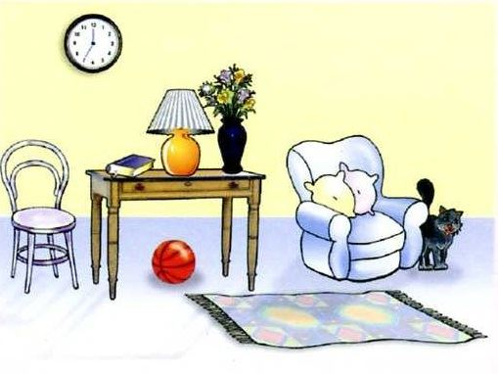Look at the picture and choose the FALSE statement.
A. There is a book on the table. B. There is a picture on the wall. C. There is a cat next to the armchair. D. There is a ball under the table.
17. Gi_ e me the eraser.
18. My family/ the drawer./ album/ in/ is/
19. mother/ kitchen./ the/ My/ is in/
20. Ảnh: My sister is _ _ _ _ _ _ _ years old.
21. Is your school ...? - No, it is big.
A. small B. on C. bye D. this
22. Some _ _ _ chers are in the hall.
23. Nghe: Nhấn giữ Ctrl và bấm chuột để nghe: The cat walks _ _ _ _ to the ball.
24. now./ out/ go/ cannot/ You/
25. Is your school small or la_ _ _ ?
26. We learn h_ _ to read at school.
27. A: What does your aunt …? - B: She is very sporty.
A. like B. look like C. likes D. like looking
28. cold/ is/ The weather/ very/ today./
29. What is the name … your school?
A. about B. to C. of D. at
30. your bedroom?/ Why/ you/ like/ don’t/
31. May I come _ n? – Yes, please.
32. Ảnh: 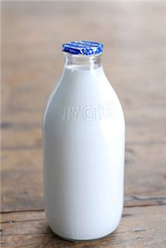Give me a b_ _ _ _ _ of milk, please.
33. not/ Rosie’s/ It’s/ teddy/ bear./
34. Nghe: Nhấn giữ Ctrl và bấm chuột để nghe: Sally has got a _ _ _ _ _ dog.
35. Nghe: Nhấn giữ Ctrl và bấm chuột để nghe: There is a desk _ _ _ _ to my bed.
36. It’s always … in summer.
A. cold B. red C. icy D. hot
37. What are these? - T_ _ se are my crayons.
38. A: What is … name? – B: My name is Tommy.
A. we B. you C. your D. they
39. Ảnh: She _ _ _ _ _ _ around the park.
40. What’s/ name?/ your/ friend’s/
41. A_ _ you a student at Oxford Primary School?
42. I’m ... a letter to my friend at the moment.
A. writing B. writes C. written D. to write
43. is/ name?/ your/ aunt’s/ What/
44. Which word has ‘ch’ pronounced as the letter ‘k’ in \"clock\"?
A. chair B. chess C. school D. kitchen
45. Ảnh: My mother is _ _ _ _ _ _ _ for dinner.
46. Choose the odd one out.
A. cat B. dog C. car D. hen
47. Nghe: Nhấn giữ Ctrl và bấm chuột để nghe: Look at the _ _ _ _ in the tree.
48. _ _ she your new classmate?
49. We catch a bus _ _ school every schoolday.
50. Choose the letter(s) to make a correct word: ru__ing
A. n B. nn C. mm D. mn
51. My sister can … a pony.
A. my B. ride C. ride’s D. I
52. Long An/ Viet Nam./ is/ south/ in/
53. Nghe: Nhấn giữ Ctrl và bấm chuột để nghe: Nina is a _ _ _ .
54. What do you have _ _ _ lunch?
55. Ảnh: 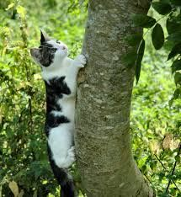A cat can cl_ _ b a tree.
56. Nghe: Nhấn giữ Ctrl và bấm chuột để nghe: _ _ love pets.
57. What grade … your twin brothers in?
A. am B. is C. are D. do
58. What’s the matter ... your eyes?
A. with B. to C. at D. for
59. What are those? – They are rub_ _ _ _ .
60. A … helps people with sickness.
A. doctor B. worker C. farmer D. housewife
61. my bedroom/ that is/ and/ This is/ my brother’s./
62. Nghe: Nhấn giữ Ctrl và bấm chuột để nghe: The sky is _ _ _ _ .
63. Choose the incorrect word(s) in the following sentence: My friend, Quynh, doesn’t has any comic books.
A. My B. has C. any D. books
64. Odd one out:
A. a B. this C. an D. the
65. … are you? – I’m fine, thanks.
A. What B. How C. Who D. Where
66. ... is it from your house to the bakery?
A. How often B. How far C. How D. How much
67. Your school and your library is big. – Yes, t_ _ _ are very big and nice.
68. I _ _ _ _ breakfast with my sister.
69. What/ do/ you/ have?/ pets/
70. doing?/ teacher/ her/ is/ What/
71. I don’t like the music room. It is so s_ _ _ l.
72. Nghe: Nhấn giữ Ctrl và bấm chuột để nghe: Egg is playing the ….
A. guitar B. violin C. piano D. drum
73. play/ time./ They often/ at break/ volleyball/
74. Can you he_ p me?
75. teacher./ English/ Miss Paula/ is/ my/
76. My friends and I … a new way to learn English.
A. go B. look C. find D. do
77. This is my aunt. …. twenty-six years old.
A. They are B. He is C. You are D. She is
78. What toy do you like?
A. Tom and Jerry. B. Gold fish C. A rabbit. D. A yo-yo.
79. chicken?/ like/ you/ Do/
80. Ảnh: 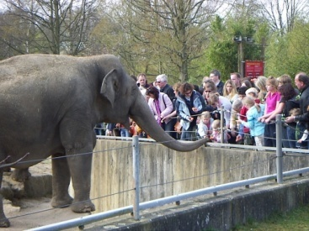______ do you see elephants? – In the zoo.
A. When B. How C. Where D. What
81. on/ is taking/ a nap/ My dad/ the sofa./
82. chairs and a table/ are/ There/ eight/ in my dining room./
83. _ s your school small? – Yes, it is small.
84. Ảnh: 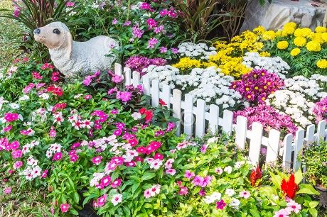There are many beautiful _ _ _ _ _ _ _ in the garden.
85. Listen ... the teacher, please.
A. on B. in C. to D. for
86. _ _ _ ’t talk. It’s so noisy.
87. Nghe: Nhấn giữ Ctrl và bấm chuột để nghe: They’re ....
A. hungry B. happy C. lucky D. sad
88. Choose the incorrect word(s) in the following sentence: What do Linda do after school? – She cooks.
A. do B. do after C. She D. cooks
89. doesn’t/ Tim/ coffee./ like/
90. Ảnh: 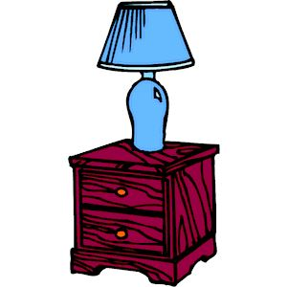The lamp is … the cupboard.
A. next to B. on C. under D. over
91. R_ ad after me, children.
92. Ảnh: This big _ _ _ is very funny.
93. I wash/ every/ my hair/ days./ two
94. These … members of my family.
A. is B. are C. am D. be
95. This is a photo _ _ my class.
96. Great to see you ________, Jane.
A. too B. and C. again D. but
97. in/ my classroom./ are/ There/ twenty desks/
98. Li_ ten to the teacher, please.
99. Nghe: Nhấn giữ Ctrl và bấm chuột để nghe: Wooly runs _ _ _ _ .
100. a song/ for/ I like/ you./ to sing/
101. Ảnh: 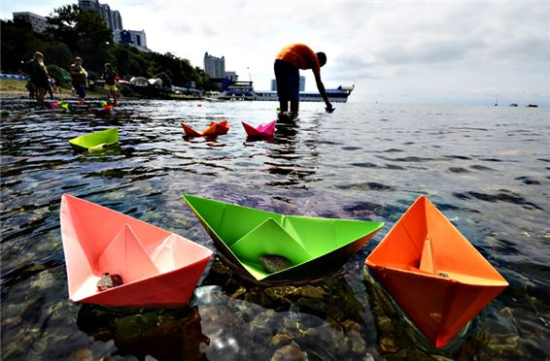Do you like playing …?
A. football B. paper boats C. chess D. hide-and-seek
102. Peter is my friend, t_ _ .
103. Ảnh: 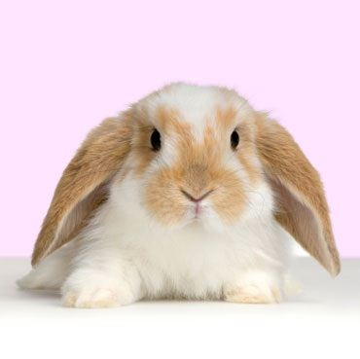It is a cute _ _ _ _ _ _ with two long ears.
104. My brother can play the piano but … play the guitar.
A. can B. can not C. cannot D. cant’
105. Ảnh: 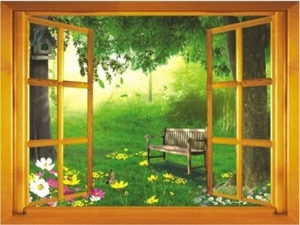I can see two big tr_ _ _ through the window.
106. She _______ a picture.
A. take B. drawing C. is drawing D. draw
107. cannot/ football./ play/ My father/
108. Nghe: Nhấn giữ Ctrl và bấm chuột để nghe: The boy’s name is _ _ _ _ .
109. the park./ in/ is/ cycling fast/ A girl/
110. Hi_ name is Peter.
111. and/ go to/ watch the new video./ Let's/ the library/
112. Can the cat _ _ _ _ _ a tree? – Yes, it can.
113. Choose the odd one out.
A. bedroom B. bathroom C. kitchen D. garden
114. Nghe: Nhấn giữ Ctrl và bấm chuột để nghe: _ _ _ _ _ _ _
115. toybox./ We have/ a red/ in our/ plane/
116. Choose the odd one out:
A. living room B. bedroom C. garden D. kitchen
117. the/ I/ play/ can/ piano./
118. What’s her ...?
A. old B. name C. there D. age
119. When is your birth day, Tommy? – Well, Taylor, it’s … December 5th.
A. in B. like C. on D. at
120. Mai/ doing?/ What’s/
121. This is my school b_ g.
122. Which pen is your pen? – This o_ _ .
123. They are ... the beach this summer.
A. going B. going to C. visiting D. go
124. Nghe: Nhấn giữ Ctrl và bấm chuột để nghe: My house has a ... yard.
A. small B. fat C. large D. big
125. Nghe: Nhấn giữ Ctrl và bấm chuột để nghe: What colour is her hair? - _ _ _ _ _ .
126. The/ picture/ is/ the clock./ above
127. _ _ _ _ is Nga doing? - She’s doing her homework.
128. Nghe: Nhấn giữ Ctrl và bấm chuột để nghe: What colour are her eyes? - _ _ _ _ .
129. Ảnh: 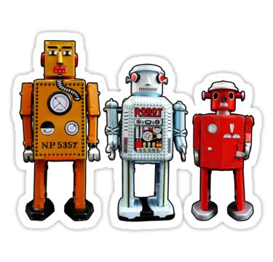I have t_ _ _ _ robots.
130. Listen _ _ the teacher, please.
131. _ _ _ _ _ is a doll.
132. Glad to meet you. – Glad to meet you, _ _ _ .
133. The opposite of OUT is _ _ .
134. Nghe: Nhấn giữ Ctrl và bấm chuột để nghe: Can I borrow you ruler? – Yes, but don’t forget to give it _ _ _ _ .
135. a pond/ of/ Is there/ in front/ your house?/
136. _______ pet do you like? – I like cats.
A. What B. Who C. Where D. When
137. Ảnh: 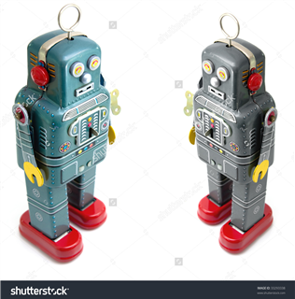My brother has _ _ _ robots.
138. Let’s/ after/ play/ dinner./ chess/
139. What/ does/ Beck/ like?/ look
140. Would you like ... to the movies tonight?
A. go B. going C. to go D. goes
141. Good m_ _ ning, everyone.
142. Choose the incorrect word(s) in the following sentence: There are one robot in my house. Its name is Toro.
A. are B. in C. Its D. is
143. Ảnh: 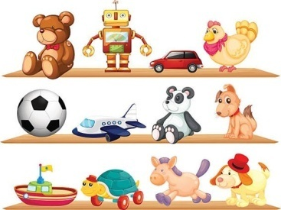Peter has many toys. He puts them on the sh_ _ _ .
144. My father can dr_ _ e a car.
145. Mary … breakfast at 7 o’clock.
A. have B. does C. plays D. has
146. He is David. He is my ... .
A. school B. name C. book D. friend
147. sing/ an English/ song?/ you/ Can/
148. Nghe: Nhấn giữ Ctrl và bấm chuột để nghe: The car behind the _ _ _ _ _ is white.
149. school bus./ is/ a/ It/ red
150. …. I can’t do this puzzle.
A. Can you play? B. May you help me? C. Do you like these? D. How are you?
151. Ảnh: 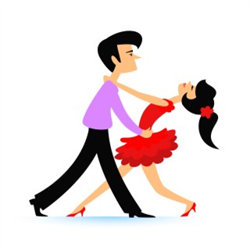_ _ _ cing is their hobby.
152. is/ brother/ nine/ years old./ My/
153. new/ classroom/ Is/ big?/ your/
154. Mai is laughing. She is ______.
A. hungry B. sad C. happy D. nervous
155. Ảnh: 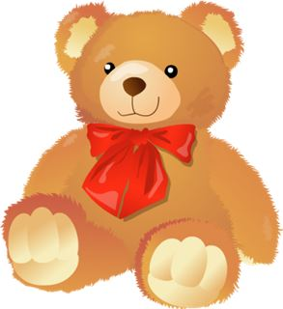Oh, this teddy _ _ _ _ is cute. Can you buy it for me, Mum?
156. What s_ _ _ _ _ ts do you like? – I like Maths and English.
157. _ _ _ _ is your favourite drink? – I like orange juice.
158. is/ a long/ It/ pen./ red
159. Which word has the underlined part pronounced like the letter ‘A’ in “RAINY”?
A. skating B. bathroom C. garden D. sofa
160. Can you _ _ _ _ a bicycle?
161. Is that a bag? – No, it is _ _ _ .
162. This is Mary. ... is my friend.
A. I B. You C. She D. He
163. Good_ _ _ Mary. See you later.
164. This living room is s_ big.
165. Lan is a … at Thong Nhat primary school.
A. farmer B. worker C. student D. doctor
166. Choose the odd one out:
A. ruler B. rabbit C. cat D. dog
167. Choose the odd one out:
A. paint B. draw C. write D. walk
168. Odd one out:
A. is B. do C. he D. go
169. Tony ... football at break time but today he … basketball.
A. plays - is playing B. plays - plays C. is playing - plays D. is playing - is playing
170. Rosie is having a shower in the ….
A. kitchen B. bathroom C. bedroom D. playground
171. What’s the weather _______ in your city?
A. be B. like C. round D. All are incorrect.
172. He/ is/ tall/ and/ young./
173. name/ your/ here/ , please./ Write/
174. Where does Minh study? – He studies at Sunrise Pri_ _ _ _ School.
175. This pen is _ _ _ blue. It’s green.
176. Ảnh: There are se_ _ _ people in my family.
177. F__TY
A. O B. OUR C. OR D. UR
178. Nam./ outside,/ go/ Let’s/
179. trucks./ have/ any/ don’t/ I/
180. Ảnh: 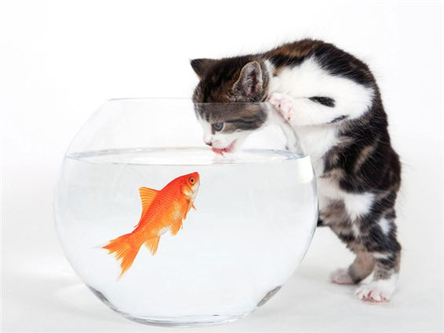My cat likes _ _ sh very much.
181. She is pre_ _ y.
182. How are ..., Mary? – I’m fine, thanks.
A. he B. she C. you D. his
183. Sing wit_ me.
184. beautiful./ Those/ kites/ very/ are/
185. Odd one out:
A. school B. cinema C. place D. circus
186. Her/ birthday/ in/ June./ is/
187. How m_ _ _ dogs do you have?
188. Ảnh: 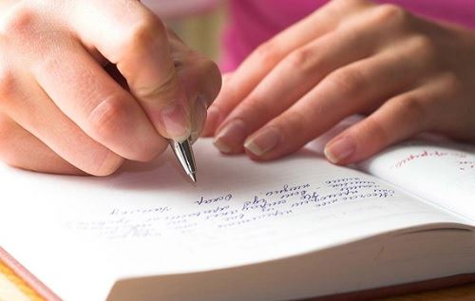_ _ _ _ _ your answer, please.
189. Nghe: Nhấn giữ Ctrl và bấm chuột để nghe: Jenny is _ _ _ _ ing with her friends.
190. The gym is big and n_ _ .
191. Ảnh: The mouse is _ _ _ ind the box.
192. it/ Is/ outside?/ raining/
193. How ______ is she? – She’s nine.
A. new B. small C. big D. old
194. I do _ _ t go to school on Sunday.
195. How ... dogs do you have?
A. many B. five C. bird D. much
196. I’m … I want rice and chicken.
A. hungry B. fine C. thirsty D. good
197. She’s learning how to _ _ _ _ spaghetti.
198. _ _ _ _ is your name?
199. ... do you learn how to write? – At school.
A. What B. Where C. How D. When
200. Is the w_ _ _ _ over there your mother?

IOE K3 SỐ 36
1. ... is she? – She’s Margaret.
A. Who’s B. What C. What’s D. Who
2. A: What is your father’s name? – B: His … is Brown.
A. name B. names C. nice D. nine
3. ... is that? - It’s a pen.
A. How B. When C. What D. Where
4. A: What is _ _ _ hobby? - B: She likes dancing.
5. Nghe: Nhấn giữ Ctrl và bấm chuột để nghe: Baz’s boat is in his _ _ _ _ .
6. Show me _ _ _ r pens, children.
7. Ha: _ _ _ _ colour is that pen? - Mai: It is a blue.
8. My birthday is in _ _ cember.
9. Do you _ _ _ _ playing hide-and-seek?
10. Odd one out:
A. age B. her C. his D. your
11. in/ the kitchen./ are/ They/ talking/
12. upstairs./ bedroom/ Our/ is/
13. Is this a red pencil? - ..., it is.
A. No B. Not C. Yes D. No, it isn’t
14. Ảnh: This family has two _ _ _ _ . They are brown and white.
15. I _ _ _ _ breakfast with my sister.
16. Nghe: Nhấn giữ Ctrl và bấm chuột để nghe: _ _ _ _ _
17. My uncle is going to make a cake … me.
A. from B. at C. for D. on
18. Nice _ _ meet you, Tom.
19. What … is that? – It’s a monkey.
A. holiday B. subject C. sport D. animal
20. Rosie’s mother looks so ….
A. new B. young C. large D. long
21. _______ is his coat? - It’s on his bed.
A. When B. Where C. Who D. What
22. What do they usually do ... summer?
A. at B. on C. in D. to
23. Nghe: Nhấn giữ Ctrl và bấm chuột để nghe: She’s carrying a(n) ….
A. handbag B. basket C. raincoat D. umbrella
24. drives/ My father/ to work./ his/ car
25. Ảnh: 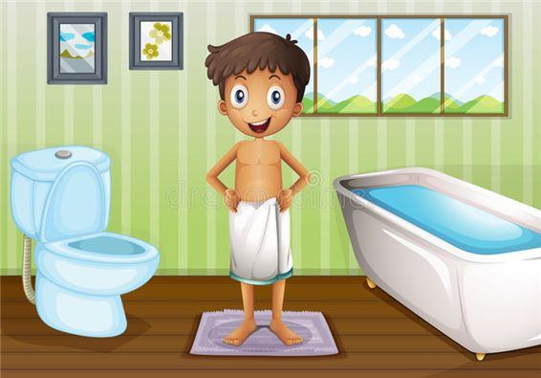A: Where’s your brother? - B: He’s in the _ _ _ _ room.
26. Ảnh: The apple is ________ the box.
A. under B. in front of C. beside D. behind
27. My mother _ _ a teacher.
28. Mary is a ... at London Primary School.
A. boy B. toy C. student D. she
29. Nghe: Nhấn giữ Ctrl và bấm chuột để nghe: Doll is swimming in the _ _ _ .
30. have?/ How many/ you/ do/ sisters/
31. Ảnh: 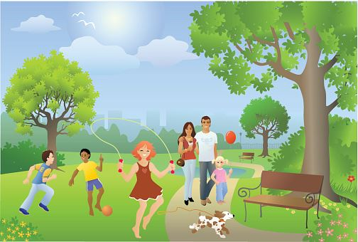Choose the TRUE statement.
A. Two boys are playing baseball. B. The girl is dancing. C. The dog is eating. D. The couples are walking.
32. … are they? – They’re my friends.
A. Who B. What C. Which D. Where
33. book?/ it/ Is/ a/
34. Wh_ _ _ are the maps? – They are on the wall.
35. What is this? - ….
A. It’s a mobile phone. B. This is nice book. C. That is a big table. D. Its a ruler.
36. These are my s_ _ ters.
37. Ảnh: She _ _ _ _ _ _ around the park.
38. Nghe: Nhấn giữ Ctrl và bấm chuột để nghe: The sky is _ _ _ _ .
39. Do you like playing puz_ _ _ _ ?
40. Nghe: Nhấn giữ Ctrl và bấm chuột để nghe: Her name ... Linda.
A. are B. is C. am D. it
41. Who is tall_ _ , Jack or Jim?
42. beautiful?/ Is/ your/ school garden/
43. Ảnh: 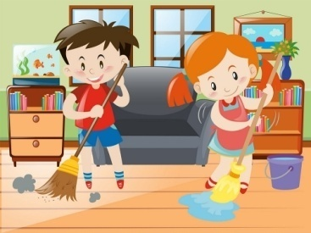We help our mother with the _ _ _ _ _ _ _ _ _ .
44. likes/ games./ playing/ computer/ Tim/
45. That is my s_ _ _ _ _ library.
46. Ảnh: The mouse is _ _ _ ind the box.
47. the/ mother/ is in/ My/ kitchen./
48. Are you free _ _ Monday evening?
49. I am sorry. I am late. - … in please!
A. Do B. Go C. Come D. Study
50. Let’s p_ ay outside, children.
51. I don’t like the music room. It is so s_ _ _ l.
52. a picture/ There/ the wall./ on/ is/
53. What ... this? - This is a pen.
A. it B. iss C. is D. are
54. five/ members./ has/ family/ My/
55. What’s y_ _ r name? – My name’s Tom.
56. There is o_ e cat in that box.
57. is/ doll./ This/ a/
58. many/ are/ desks/ How/ there in your classroom?/
59. Nghe: Nhấn giữ Ctrl và bấm chuột để nghe: He eats his breakfast in the _ _ _ _ _ _ _ .
60. for/ a song/ you./ to sing/ I like/
61. Let’s listen _ _ some music.
62. Come/ and/ in/ please./ sit down,
63. I have many _ _ _ _ : a cat, a dog, two birds and four goldfish.
64. Music./ and/ I have/ Today/ Maths/
65. The opposite of IN FRONT OF is _ _ _ _ _ _ .
66. cousin./ over there/ my/ is/ The girl/
67. is/ The/ weather/ good./ today/
68. Does Jim like ______ with paper planes?
A. play B. plays C. playing D. on playing
69. Nghe: Nhấn giữ Ctrl và bấm chuột để nghe: My _ _ _ _ is large.
70. My sister is very bea_ tiful.
71. Jenny is my new f_ _ end.
72. Nghe: Nhấn giữ Ctrl và bấm chuột để nghe: I’ve got two big _ _ _ _ .
73. Ảnh: 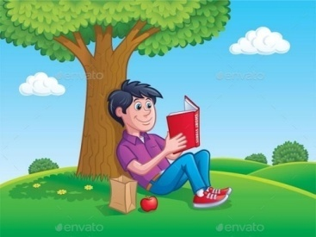He’s sitting under a tree and _ _ _ _ ing a book.
74. This is Mary. ... is my friend.
A. I B. You C. She D. He
75. How … her grandmother?
A. are B. is C. am D. be
76. birthday/ Is/ today?/ your/
77. ... your school bags, please.
A. Close B. Stand C. Sit D. See
78. computer/ room./ our/ It’s/
79. Which word has the letters ’e’ pronounced as the letter ’e’ in 'pen'?
A. kitchen B. chicken C. bookshelf D. new
80. … room is your computer room? – That big room over there.
A. Which B. What C. How D. When
81. How are you today, John? – I’m ..., thanks.
A. nice B. nice’s C. fine D. fine’s
82. Ảnh: Where are the maps? - They are on the _ _ _ _ .
83. Ảnh: 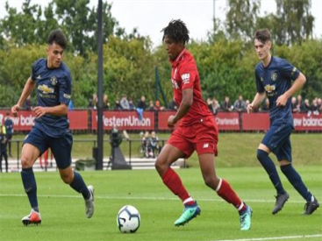My brother can play _ _ _ _ _ _ _ _ .
84. A: Do you have a cat? - B: No, I _ _ _ ’t.
85. There ______ keys on the desk.
A. is B. isn’t C. aren’t D. be
86. The picture is _ _ _ _ _ _ _ the window and the shelf.
87. It’s _______ in Hanoi today.
A. cloud B. funny C. sunny D. snow
88. Ảnh: My cat likes _ _ sh very much.
89. Ảnh: 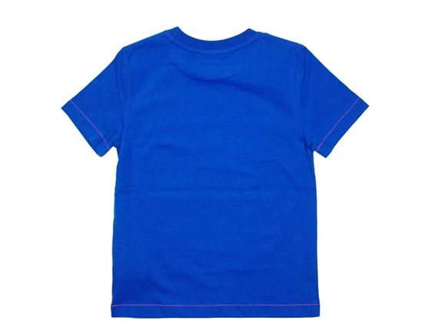What is that? – It’s a white _ _ _ rt for Jimmy.
90. Ha Noi is in n_ _ _ _ Viet Nam.
91. She lives ... the sea.
A. in B. on C. near D. at
92. some/ milk?/ like/ Would/ you/
93. tree/ There is/ in/ a big/ my garden./
94. old./ is/ school/ Their/
95. Choose the odd one out.
A. bedroom B. bathroom C. kitchen D. garden
96. These _____ old notebooks.
A. am B. is C. are D. have
97. This pen is _ _ _ blue. It’s green.
98. There are ... chairs in my living room.
A. one B. five C. a D. an
99. ... I go out?
A. May B. My C. Me D. Mai
100. A: What is … name? – B: My name is Tommy.
A. we B. you C. your D. they
101. carefully./ teacher/ to/ Listen/ the/
102. Ảnh: 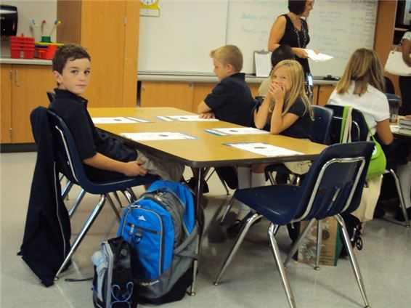Henry, Mary and I sit … tables.
A. in B. at C. on D. by
103. _ _ o is that? – That’s Mary.
104. Let’s go through the … into the garden.
A. gate B. yard C. pond D. fence
105. What is his date … birth?
A. on B. of C. at D. in
106. My home village has a lot of _ _ _ _ tains.
107. from?/ Where/ are/ students/ the new/
108. with Nhung./ I always/ go/ school/ to/
109. Look ... that map, David.
A. to B. in C. for D. at
110. The ... is Peter.
A. boy B. girl C. toy D. he
111. Ảnh: 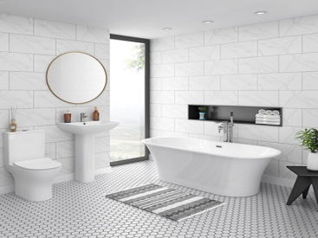Your _ _ _ _ _ _ _ _ is so beautiful.
112. a/ Let’s/ make/ paper lion.
113. some/ wants/ Peter/ food.
114. Lang Son is far _ _ _ _ Quang Binh.
115. May I ... out?
A. ride B. go C. meet D. come
116. My sister can … a pony.
A. my B. ride C. ride’s D. I
117. fun/ It's/ to be/ with Linda.
118. You don’t look well. ….
A. Are you ok? B. How old are you? C. What’s your name? D. What is that?
119. Choose the incorrect word(s) in the following sentence: What do Linda do after school? – She cooks.
A. do B. do after C. She D. cooks
120. _ _ _ _ colour is your teddy bear?
121. What col_ _ r is this book? – It’s red.
122. Nghe: Nhấn giữ Ctrl và bấm chuột để nghe: I can draw a ....
A. cat B. hat C. map D. bat
123. Nghe: Nhấn giữ Ctrl và bấm chuột để nghe: Tom and Lee are playing ….
A. volleyball B. baseball C. football D. basketball
124. Thes_ are my cats.
125. Thai Phien is a big _ _ _ _ ary school in Hai Phong.
126. Nghe: Nhấn giữ Ctrl và bấm chuột để nghe: Listen and choose the correct phrases you hear:
A. It’s a B. I am C. I can D. I do
127. What _ _ you do during English lessons?
128. on/ Her birthday/ the nineteenth/ of March./ is/
129. Odd one out:
A. cloud B. rainy C. sunny D. windy
130. Nghe: Nhấn giữ Ctrl và bấm chuột để nghe: Julie has got a _ _ _ _ _ dog.
131. Nghe: Nhấn giữ Ctrl và bấm chuột để nghe: My _ _ _ is blue.
132. Australia?/ from/ she/ Is/
133. Ảnh: 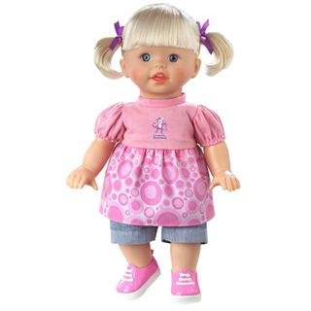Do you have toys? – Yes, I have a _ _ _ _ .
134. Nghe: Nhấn giữ Ctrl và bấm chuột để nghe: ... are you?
A. who B. where C. how D. what
135. Ảnh: 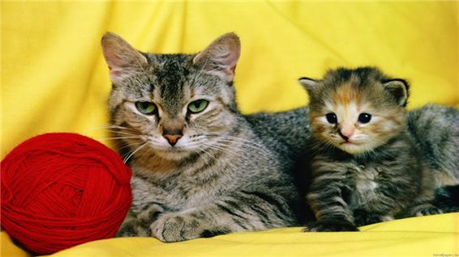This is a mo_ _ _ _ cat. That is its baby.
136. Ảnh: 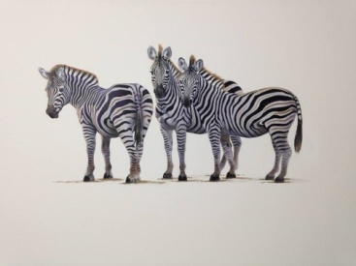_______ zebras are there in the picture? – There are three zebras.
A. How B. What C. Where D. How many
137. Boy: M_ _ I play football here? - Man: No, you can’t.
138. It’s time … lunch, Peter.
A. to B. in C. on D. for
139. This birthday cake is … you.
A. for B. on C. of D. to
140. My pen/ desk./ is/ that/ on/
141. How m_ _ y crayons are there? – There are 3 crayons.
142. A bird can f_ y.
143. Nga is singing a nice s_ _ _ .
144. That girl is from Australia. _ _ _ is my new friend.
145. How o_ _ is she? – She’s six.
146. What is her favourite subject? – She likes … .
A. January B. Sunday C. Korea D. PE
147. My pet is a ... .
A. bird B. ship C. robot D. doll
148. Are you ______? – No. I’m full.
A. thirsty B. hungry C. hot D. tired
149. school’s/ name?/ is/ What/ your/
150. Nghe: Nhấn giữ Ctrl và bấm chuột để nghe: Can you see it _ _ _ _ ?
151. Ảnh: 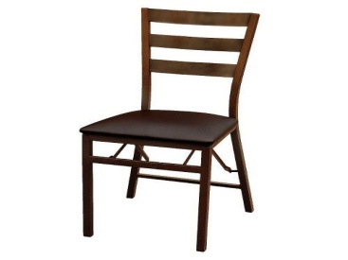My chair is _ _ _ _ _ .
152. in/ like/ walking/ the rain./ I don’t/
153. ________ subjects do you like the most?
A. What B. When C. Why D. Who
154. My father can dr_ _ e a car.
155. The opposite of \"tall\" is \"_ _ _ _ _ \".
156. Please c_ _ _ t from 1 to 10 in English.
157. _ _ _ _ _ is the poster? – It’s on the wall.
158. Ảnh: 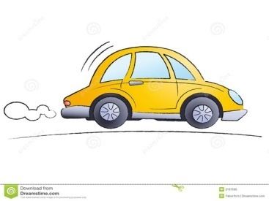My father can drive a _ _ _ .
159. Your garden is _ _ beautiful.
160. Nghe: Nhấn giữ Ctrl và bấm chuột để nghe: Mary’s gloves are _ _ _ .
161. Nam: Your school and your library is big. - Nga: Yes, t_ _ _ are very big and nice.
162. What … is it? – It’s eleven o’clock.
A. name B. colour C. time D. day
163. Taylor is from England. She … me every month.
A. calls B. write C. read D. speak
164. School./ is/ school/ My/ Nguyen Gia Thieu
165. Ảnh: 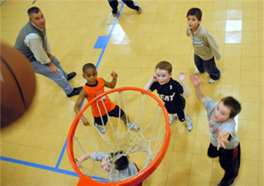My brother likes playing _ _ _ _ _ _ ball in the yard.
166. Tom is nine … old.
A. year B. year’s C. yeah D. years
167. ... that a pink pencil? – No, it isn’t.
A. Are B. Is C. Who D. When
168. is/ my parents./ my birthday present/ from/ The cat/
169. like/ Does/ cat/ vegetables?/ your/
170. my toys/ very/ much./ I/ love/
171. Ảnh: 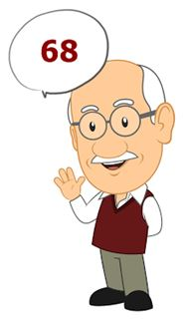My grandpa is … years old.
A. eighty-six B. sixty-eight C. fifty-eight D. fifty-six
172. a bowl./ is swimming/ A small/ fish/ in
173. bedroom/ is/ large./ very/ Mary’s/
174. new/ classroom/ your/ big?/ Is/
175. Nghe: Nhấn giữ Ctrl và bấm chuột để nghe: We’re playing football in the _ _ _ _ _ _ _ _ _ _ .
176. swim./ dance/ I can’t/ I can/ but/
177. are/ the wall./ on/ There/ two clocks/
178. ... is that? - It’s a blue ball.
A. How B. When C. What D. Where
179. on/ your name/ the paper./ Write/
180. school/ is/ festival/ very fun./ My/
181. Ảnh: 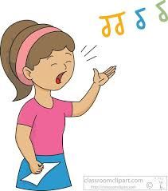What do you do during Music lessons? – I learn to _ _ _ _ .
182. in a/ your sister/ work/ factory?/ Does/
183. I like to s_ ng.
184. Ảnh: 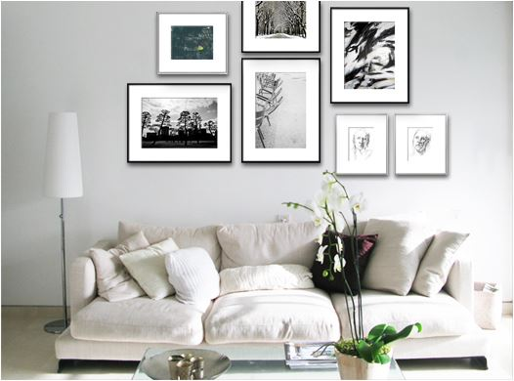There are seven _ _ _ tures on the wall.
185. My little brother often … his kite when he’s not busy.
A. does B. plays C. goes D. flies
186. These … members of my family.
A. is B. are C. am D. be
187. Let’s play h_ _ e-and-seek.
188. the/ name of/ What is/ school?/ your
189. Choose the odd one out:
A. is B. are C. am D. name
190. Odd one out:
A. mine B. hers C. your D. Tom’s
191. beautiful/ “Twinkle Twinkle Little Star”/ a/ is/ song./
192. Quan is _ _ _ _ _ his homework in his room.
193. doesn't/ weather./ like/ hot/ He/
194. Nghe: Nhấn giữ Ctrl và bấm chuột để nghe: Our school bus is _ _ _ _ .
195. T_ _ s is a board.
196. Mary is … . She wants some water.
A. hungry B. thirsty C. sick D. pretty
197. Van: What’s that tall building there? - Lan: It’s _ _ new school
198. Nghe: Nhấn giữ Ctrl và bấm chuột để nghe: The girl’s T-shirt is in the _ _ _ .
199. My/ red./ favourite/ colour/ is
200. Let’s/ book./ read/ the/

IOE K3 SỐ 37
1. It/ is/ not/ my/ bedroom./
2. See you tomo_ _ ow.
3. I’m/ in?/ sorry/ . May I come/ I’m late/
4. What ... it? – It’s my book.
A. is B. hi C. bye D. hello
5. It is _ desk.
6. How many _______ does Quang have?
A. book B. balls C. frog D. schoolbag
7. These … members of my family.
A. is B. are C. am D. be
8. Choose the odd one out:
A. skipping B. table tennis C. badminton D. tennis
9. his friends/ Kevin and/ doing?/ What/ are/
10. and/ in the living room./ There are/ one table/ five chairs/
11. What do you have _ _ _ lunch?
12. the school/ all/ yard./ in/ We’re/
13. Nghe: Nhấn giữ Ctrl và bấm chuột để nghe: Look! This is Mum’s _ _ _ _ .
14. Nghe: Nhấn giữ Ctrl và bấm chuột để nghe: Who's _ _ _ _ _ _ _ _ , you or your brother?
15. Do you know _ _ _ _ my name is?
16. What ab_ _ t an apple? – Yes, please.
17. Choose the odd one out:
A. tidy B. nice C. clean D. dirty
18. Rai_ e your hand, please.
19. Don’t/ in/ room./ that/ come/
20. “Twinkle Twinkle Little Star”/ a/ beautiful/ is/ song./
21. Do you have _ _ _ cats?
22. The computer room is new, but the art room is _ _ _ .
23. is/ young./ He/ tall/ and
24. A: How old … you? – B: I am nine years old.
A. am B. are C. is D. it
25. May I c_ _ _ in and study?
26. Nghe: Nhấn giữ Ctrl và bấm chuột để nghe: _ _ _
27. Nghe: Nhấn giữ Ctrl và bấm chuột để nghe: What colour are her eyes? - _ _ _ _ .
28. Ảnh: Don’t play outside, son. It’s ….
A. raining B. snowing C. windy D. stormy
29. Ảnh: I like _ _ _ _ _ _ _ _ in the pool in summer.
30. Ảnh: 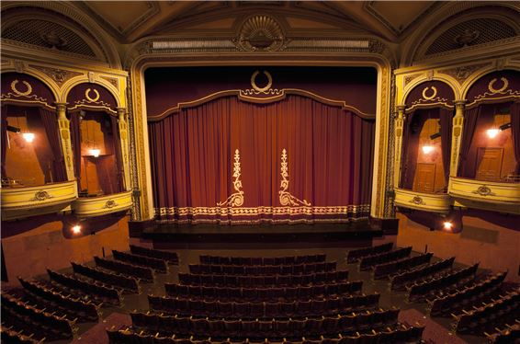A: Where are you going now? - B: I’m going to the ….
A. cinema B. theatre C. temple D. hospital
31. eight/ are/ There/ in my dining room./ chairs and a table
32. How many wardrobes ________? - There is one.
A. is there B. there is C. there are D. are there
33. _ _ _ _ _ pencils are these? – They’re my pencils.
34. W_ _ t do you do during Music lessons?
35. What colour is that pencil? – It’s ... .
A. book B. crayon C. ruler D. blue
36. Do you have _ _ _ brothers?
37. a TV/ my/ living room./ There is/ in/
38. Choose the letter(s) to make a correct word: hor__
A. si B. ce C. se D. ci
39. Our English teacher is a very frien_ _ _ person.
40. Ảnh: I’m a student and my friends are _ _ _ _ _ _ _ _ too.
41. that/ the box?/ What/ is/ in
42. Miss Carol is my Engli_ _ teacher.
43. Nghe: Nhấn giữ Ctrl và bấm chuột để nghe: I ... orange.
A. love B. like C. hate D. eat
44. do/ you/ puzzles?/ Can/
45. Choose the odd one out:
A. thirty B. seventy C. eighty D. twelve
46. That is Lan. _ _ _ is my friend.
47. Hai Phong is in _ _ _ _ _ Vietnam.
48. Ảnh: What pets do you have?
A. I have two cats. B. I have a cat and a dog. C. I have two dogs. D. I have two cats or two dogs.
49. Are Philip and Tony watching TV?
A. Yes, he is. B. Yes, they are. C. No, he and he are not. D. No, they not.
50. cannot/ out/ go/ now./ You/
51. Nghe: Nhấn giữ Ctrl và bấm chuột để nghe: _ _ _ _
52. Your/ is/ bedroom/ nice./ very
53. Nghe: Nhấn giữ Ctrl và bấm chuột để nghe: Which is NOT mentioned in the recording?
A. garden B. bathroom C. bedroom D. kitchen
54. Nghe: Nhấn giữ Ctrl và bấm chuột để nghe: This is my _ _ _ _ _ .
55. Tommy is playing in the play_ _ _ _ _ _ with his friends.
56. your name?/ spell/ do/ I/ How/
57. Let’s listen _ _ some music.
58. ... is that? - It’s a blue ball.
A. How B. When C. What D. Where
59. How often ... you play badminton?
A. do B. am C. is D. are
60. This is my father. ... name is Lam.
A. Her B. His C. This D. My
61. Nghe: Nhấn giữ Ctrl và bấm chuột để nghe: The ... is yellow.
A. bag B. bat C. bus D. book
62. This/ doll/ for/ is/ you./
63. Let’s play h_ _ e-and-seek.
64. Lo_ _ . There are Linh’s new school things.
65. Ma_ I go out, please?
66. W_ _ t is that? – It’s a teddy bear.
67. Thank you very much. – You’re w_ _ _ _ me.
68. That is an ora_ _ e pencil.
69. Santa Claus/ coffee?/ drinking/ like/ Does/
70. Ảnh: 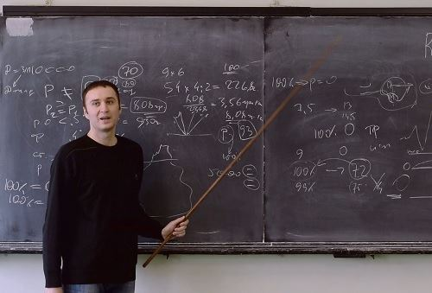Look at the _ _ _ _ _ , please.
71. A: … do you go shopping? – B: Once a week.
A. How many B. What C. How often D. When
72. Ảnh: 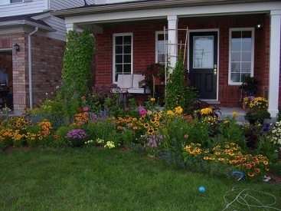There is a flower garden … the house.
A. behind B. next to C. in front of D. under
73. the dining/ room?/ in/ Rosy/ Is/
74. on/ the pond./ is swimming/ Look!/ The duck/
75. is/ Her/ years old./ sister/ twelve
76. _______ are they? - They are in the library.
A. Who B. What C. When D. Where
77. good/ It’s/ Hoa./ to/ see you,
78. Do you like ______ a kite?
A. playing B. riding C. flying D. doing
79. Ảnh: _ _ _ cing is their hobby.
80. Nghe: Nhấn giữ Ctrl và bấm chuột để nghe: Which is the most _ _ _ , video games, reading or studying?
81. with me./ often/ My sister/ goes/ to school
82. How/ old/ eldest brother?/ is/ your
83. Hi, _ _ _ are you Sean? – I’m fine, thanks.
84. That is my new friend. H_ _ name is Alice.
85. Ảnh: 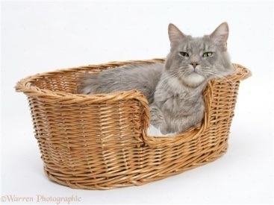There is a cat … the basket.
A. on B. at C. in D. of
86. Ảnh: 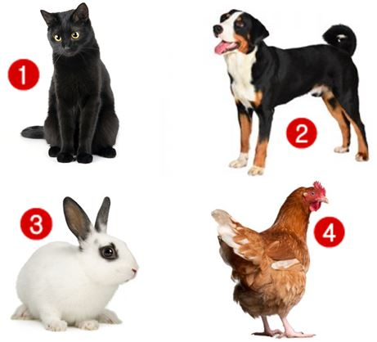Linda has a rabbit. It’s very cute.
A. Picture 1 B. Picture 2 C. Picture 3 D. Picture 4
87. How are your friends? … are all ok.
A. We B. They C. He D. You
88. your/ Open/ book,/ please.
89. Nghe: Nhấn giữ Ctrl và bấm chuột để nghe: Wooly runs _ _ _ _ .
90. The opposite of OUT is _ _ .
91. Nghe: Nhấn giữ Ctrl và bấm chuột để nghe: He carries a baby in his _ _ _ _ .
92. I … music. It is wonderful.
A. see B. like C. look D. go
93. Nghe: Nhấn giữ Ctrl và bấm chuột để nghe: Choose the correct sentence.
A. This is my father. B. This is my mother. C. This is my brother. D. This is my sister.
94. Choose the odd one out.
A. brother B. sister C. mother D. teacher
95. The white cat/ that/ is/ desk./ on/
96. This ruler is gr_ en.
97. Ảnh: My mother is _ _ _ _ _ _ _ for dinner.
98. Nghe: Nhấn giữ Ctrl và bấm chuột để nghe: How _ _ you go to school?
99. On _ _ _ wall, there is a clock.
100. you/ ice cream?/ Would/ an/ like/
101. Ảnh: This big _ _ _ is very funny.
102. girl/ in the/ that/ corner?/ Who’s/
103. The books are _ _ the shelves.
104. Sunrise is a _ _ _ _ ary school in Hai Phong.
105. This is ______ room. It’s her room.
A. my B. his C. she D. not my
106. This _ _ Linda.
107. is/ The poster/ the shelf./ above/
108. I/ much./ English/ like/ very
109. My school/ new./ all/ are/ things/
110. short/ but/ is/ big./ She/
111. and/ Let's/ go to/ watch the new video./ the library/
112. John/ soon./ will/ better/ get/
113. How … her grandmother?
A. are B. is C. am D. be
114. apples/ the kitchen?/ there in/ are/ How many/
115. How m_ _ _ apples do you want?
116. Ảnh: 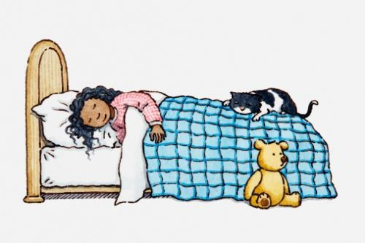Choose the correct sentence.
A. The girl is reading on the bed. B. The cat is sleeping on the bed. C. The teddy is lying next to the cat. D. The girl is holding the cat.
117. … subjects do you have on Friday?
A. What B. How C. Who D. Where
118. Ảnh: 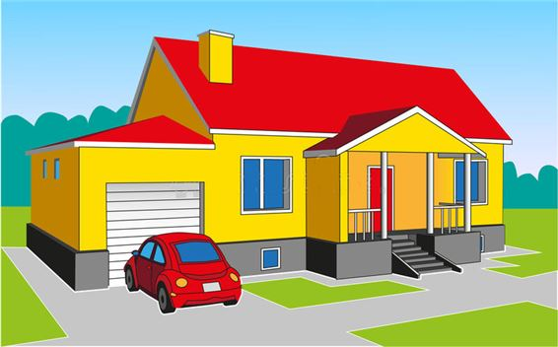Don’t forget put the car in the ….
A. kitchen B. garden C. bedroom D. garage
119. _ hat’s your name?
120. Choose the odd one out:
A. ride B. go C. bike D. run
121. Look! My doll is in fr_ _ _ of Lily’s.
122. Let’s ma_ e a circle.
123. Nghe: Nhấn giữ Ctrl và bấm chuột để nghe: _ _ _ _ _ _ _ _
124. How do you feel? – I’m very ______?
A. hungry B. short C. pretty D. tall
125. Stand _ _ , please.
126. Is/ Tony?/ box/ green,/ your/
127. These are four pencil box_ _ .
128. are/ kites/ beautiful./ Those/ very
129. How is the weather ... London today?
A. at B. on C. in D. to
130. The o_ _ computer is very slow.
131. Have ... nice day, Tim. – Thank you.
A. an B. the C. a D. are
132. What ... is this pencil? – It’s green.
A. ruler B. name C. colour D. colour’s
133. Ảnh: 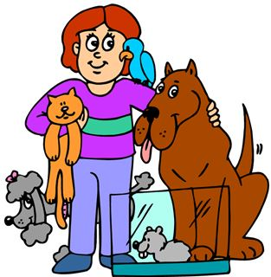She has five ….
A. toys B. pets C. dogs D. cats
134. This is my aunt. …. twenty-six years old.
A. They are B. He is C. You are D. She is
135. The picture is _ _ the wall.
136. This is my ... . His name is Tommy.
A. sister B. brother C. mother D. ruler
137. milk?/ like/ some/ you/ Would/
138. Loan?/ How/ your name,/ do you/ spell/
139. is/ my new/ friend,/ Hoang./ This/
140. Ảnh: 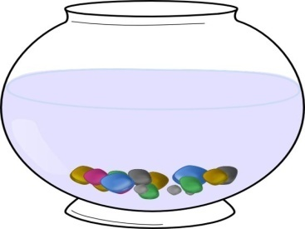There are lots of colourful pebbles in the fish t_ _ _ .
141. My sister is … doctor at Bach Mai hospital.
A. a B. an C. the D. in
142. here,/ Your/ are/ on the desk./ school things/
143. Ảnh: _______ zebras are there in the picture? – There are three zebras.
A. How B. What C. Where D. How many
144. My father/ in/ works/ a local/ hospital./
145. December./ His/ in/ is not/ birthday/
146. Nghe: Nhấn giữ Ctrl và bấm chuột để nghe: Listen and tick the correct word you hear:
A. Goodbye B. Hello C. Hi D. Bye
147. A: Is he Tony? – B: No, … .
A. he is B. he isn’t C. he not is D. not he is
148. ______ backpacks does Linh have? – She has one.
A. What B. Which C. How D. How many
149. I/ open/ May/ the/ windows?/
150. Ảnh: I have three cups. They are blue, red and ye_ _ _ _ .
151. Odd one out:
A. your B. me C. us D. him
152. Teacher: Nam, go to the b_ _ _ _ and write your sentence. - Nam: Yes, Miss.
153. Hi, my name’s Sean. - ... .
A. See you tomorrow B. Good night C. Hi, I’m Peter D. Goodbye
154. Look at t_ e cat.
155. Hello. I _ _ Mai.
156. Ảnh: 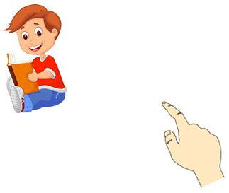A: Who’s th_ _ ? - B: It’s my brother.
157. How ______ is she? – She’s nine.
A. new B. small C. big D. old
158. Nghe: Nhấn giữ Ctrl và bấm chuột để nghe: You are reading a _ _ _ _ _ now.
159. My aunt is a housew_ _ _ .
160. Is this your grandfather? – Yes, he _ _ .
161. Are those his school bags? - ________
A. Yes, it is. B. Yes, they are. C. Yes, are they. D. No, they are.
162. Nghe: Nhấn giữ Ctrl và bấm chuột để nghe: How _ _ _ are you?
163. Ảnh: 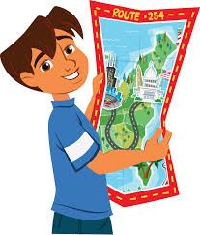The boy is reading a _ _ _ .
164. Ảnh: 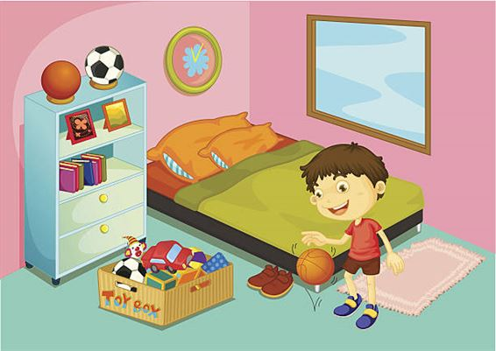A: Where is Adam? - B: He’s in the ….
A. bathroom B. bedroom C. living room D. dining room
165. erasers/ have?/ do you/ many/ How/
166. How is the weather in Hanoi today? – It’s … .
A. rainy B. rain C. sun D. wind
167. My school is next _ _ a park.
168. Ảnh: 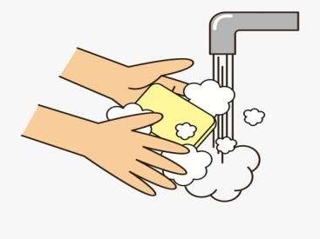You should _______ after you play with your pets.
A. wash your leg B. wash your hair C. wash your face D. wash your hands
169. her/ house./ in/ There are/ six rooms/
170. What is that? – It is ... orange.
A. a B. an C. am D. are
171. There is a flower va_ e on the table.
172. boys/ in/ the music room?/ are there/ How many/
173. My bedroom is small. It’s not _ _ _ .
174. Choose the odd one out:
A. bathroom B. music room C. art room D. classroom
175. The children are reading Engl_ _ _ in their room.
176. Nghe: Nhấn giữ Ctrl và bấm chuột để nghe: It’s ... today.
A. rainy B. foggy C. sunny D. cloudy
177. A: Are they your friends? – B: No, … aren’t.
A. we B. you C. your D. they
178. How m_ _ _ dogs do you have?
179. Who’s she? – She’s my ______.
A. aunt B. brother C. uncle D. grandfather
180. My brother likes to dri_ _ milk very much.
181. Odd one out:
A. Vietnam B. English C. America D. China
182. tidy./ but/ Her/ room is/ small/
183. How many … are there on the table?
A. flower B. flowers C. ruler D. eraser
184. The/ is far/ sweet shop/ flat./ from our
185. Thank you. – You’re ... .
A. welcome’s B. welcomes C. welcome D. welcome’re
186. This is ... chair.
A. he B. she C. it D. my
187. It is ... blue desk.
A. a B. am C. are D. is
188. Ảnh: 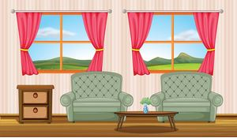There are two armchairs and two _ _ _ _ _ _ s in the room.
189. Ảnh: 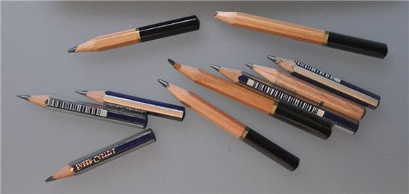These pencils aren’t very long. Are they _ _ d?
190. Nghe: Nhấn giữ Ctrl và bấm chuột để nghe: The house is on _ _ _ _ .
191. I go _ _ school every morning.
192. the/ fourth/ of July./ Today/ is/
193. Vinh: What is that? - Binh: It’s _ big red ball.
194. Is that his name? – Yes, _ _ is.
195. ... is she? – She’s Margaret.
A. Who’s B. What C. What’s D. Who
196. Kevin _ _ _ _ _ football with his classmates in the yard behind his school.
197. too./ very/ am/ I/ well
198. This is a de_ k.
199. Close _ _ at door, please.
200. Ảnh: 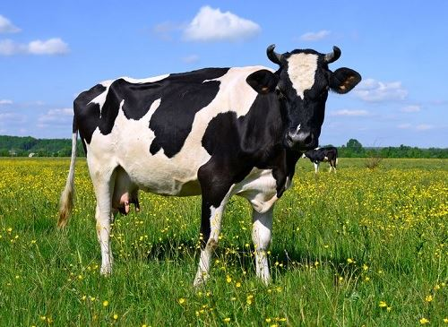That’s a _ _ _ . It’s big.

IOE K3 SỐ 38
1. W_ _ h your hands carefully, Kate.
2. A: How many chairs are there? - B: Let me co_ _ _ them. One, two, three, …. There are five.
3. Ảnh: 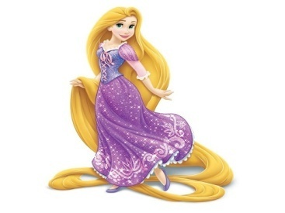Rapunzel ______ long straight blonde hair.
A. has B. have C. haves D. is has
4. How/ do/ many/ you have?/ skirts/
5. long/ My cat/ tail./ has/ a/
6. Odd one out:
A. Vietnam B. English C. America D. China
7. What are they? – They are ….
A. red B. small C. stars D. big
8. I _ _ Chi. I am in class 3A.
9. What grade … your twin brothers in?
A. am B. is C. are D. do
10. Mary and Peter can … Vietnamese.
A. speaks B. speak C. to speak D. a speak
11. classroom?/ students/ How many/ are there/ in your
12. Rosie is having a shower in the ….
A. kitchen B. bathroom C. bedroom D. playground
13. _ _ _ _ colour is your teddy bear?
14. What … is it? – It’s eleven o’clock.
A. name B. colour C. time D. day
15. playing/ and Sarah/ Linda/ board games./ are/
16. Dr_ _ a big brown dog, please.
17. Ảnh: 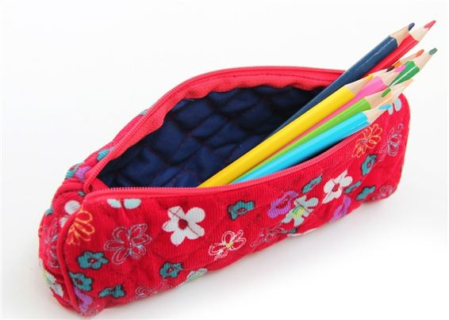What is that? – It is a ….
A. pencil case B. ruler C. pen D. book
18. They are ... the beach this summer.
A. going B. going to C. visiting D. go
19. summer./ sunny/ in/ always/ It is/
20. Nam: Is that girl new? - Lien: I don’t kn_ _ . Ask Hoa.
21. Ảnh: Cinderella is ______ with the prince at the party.
A. dance B. dances C. dancing D. danceing
22. Sing wit_ me.
23. My sister _ _ _ a doll.
24. Goodbye, David. See y_ u later.
25. I like to s_ ng.
26. Odd one out:
A. your B. me C. us D. him
27. Come and _ _ at with your friends.
28. My brother likes to dri_ _ milk very much.
29. Informatics./ My/ subject/ is/ favourite/
30. Nghe: Nhấn giữ Ctrl và bấm chuột để nghe: When it’s sunny, the sky is _ _ _ _ .
31. A: What does your aunt …? - B: She is very sporty.
A. like B. look like C. likes D. like looking
32. Who is he? - ... .
A. He my friend B. She my friend C. He is Simon. He is my good friend D. She’s Mary
33. This is an ora_ ge book.
34. W_ _ is she, Peter? – She’s is Alice.
35. _ _ _ _ _ _ close your notebook.
36. I a_ nine years old. How old are you?
37. Nghe: Nhấn giữ Ctrl và bấm chuột để nghe: _ _ _ _
38. Ảnh: 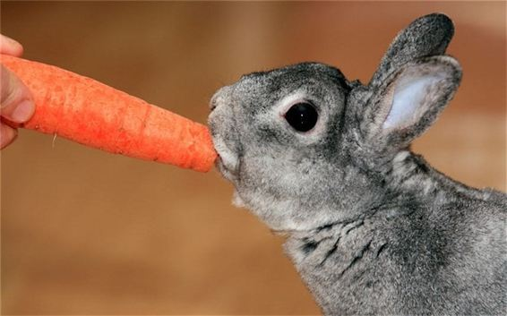Rabbits like car_ _ _ _ very much.
39. This/ our/ classroom./ is/
40. … and listen to your teacher, please.
A. Opening your book B. Sit still C. Reading aloud D. Not speaking
41. is/ This/ green./ shirt/
42. Sally is standing n_ _ _ to David.
43. my neighborhood./ in/ any theatres/ aren’t/ There/
44. Ảnh: 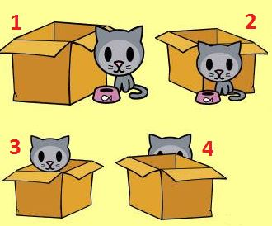A: Where is the cat? - B: It’s behind the box.
A. Picture 1 B. Picture 2 C. Picture 3 D. Picture 4
45. old./ very/ grandparents/ My/ are/
46. Those are my blue balloo_ _ .
47. Ảnh: Do you like playing …?
A. football B. paper boats C. chess D. hide-and-seek
48. Hamburger/ my/ is/ favourite/ food./
49. Nghe: Nhấn giữ Ctrl và bấm chuột để nghe: Mai likes ... flowers.
A. beautiful B. wonderful C. colorful D. blue
50. Listen ... the teacher.
A. to B. me C. you D. he
51. Listen/ to/ carefully./ teacher/ the/
52. Is this your grandfather? – Yes, he _ _ .
53. sixty-seven/ is/ old./ years/ My grandfather/
54. ... are you? – Fine, thanks.
A. Who B. Is C. Are D. How
55. He/ ten/ old./ years/ is/
56. Choose the odd one out:
A. thirty B. seventy C. eighty D. twelve
57. Let’s/ a song/ with/ me./ sing/
58. ... your teeth, John.
A. Read B. Listen C. Stand D. Brush
59. Choose the word which has the same sound with the word ’’wait’’.
A. talk B. kite C. late D. cold
60. This is a r_ ler.
61. Look!/ on/ the pond./ is swimming/ The duck/
62. Nghe: Nhấn giữ Ctrl và bấm chuột để nghe: It has _ _ _ _ _ _ _ _ of many animals.
63. My school is next _ _ a park.
64. A: How old is she? - B: She is ten … old.
A. yeasr B. yares C. yreas D. years
65. ... this a desk? – Yes, it is.
A. Is B. Are C. How D. Whatname’s
66. There is o_ e kitchen in his house.
67. It's/ with Linda./ to be/ fun/
68. How are you? - ... .
A. I’m Binh B. She’s my sister C. I’m fine, thank you D. Goodbye
69. Nghe: Nhấn giữ Ctrl và bấm chuột để nghe: The boy’s name is _ _ _ _ .
70. 1st/ Day./ Children’s/ is/ June/
71. Can the cat _ _ _ _ _ a tree? – Yes, it can.
72. Who is/ now?/ with Chi/ right/ talking/
73. A: Is your house _ _ _ _ the cinema? - B: No, it’s very far.
74. Choose the odd one out:
A. book B. pen C. ruler D. Mary
75. Ảnh: Let’s go to the _ _ _ _ _ _ _ with me. It has a lot of interesting books.
76. A: Are David and James singing? - B: Yes, ….
A. they aren’t B. they are C. he is D. he isn’t
77. Take ou_ your books, children.
78. Ảnh: 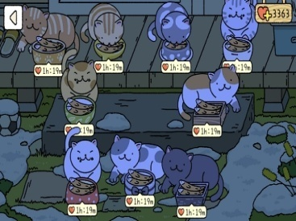How many cats are there in the yard? - There are _ _ _ _ cats. They are eating fish.
79. Nghe: Nhấn giữ Ctrl và bấm chuột để nghe: The girl’s T-shirt is in the _ _ _ .
80. May we _ _ to school together?
81. Choose the odd one out.
A. brother B. sister C. mother D. teacher
82. Is the girl o_ _ _ there your classmate, Rosie?
83. his friends./ in the playground/ John/ is playing/ with
84. Some _ _ _ chers are in the hall.
85. yellow./ is/ dog/ The/
86. Nghe: Nhấn giữ Ctrl và bấm chuột để nghe: This is my _ _ _ _ _ .
87. favourite/ subject?/ What/ is/ your/
88. I’m fine, than_ _ .
89. Nine and three is _ _ _ _ _ _ .
90. Nghe: Nhấn giữ Ctrl và bấm chuột để nghe: _ _ _ _ _ _
91. These _____ old notebooks.
A. am B. is C. are D. have
92. Nghe: Nhấn giữ Ctrl và bấm chuột để nghe: Which _ _ _ _ _ is Sam in?
93. This is my d_ ll.
94. has/ doll./ a/ Alice/ pink
95. Nghe: Nhấn giữ Ctrl và bấm chuột để nghe: Put the computer in the ….
A. wardrobe B. bookcase C. table D. cupboard
96. I/ would like/ a/ of milk./ glass
97. Pl_ _ _ _ give me that old black pen.
98. two/ robots./ I/ have/
99. My new _ _ _ _ _ _ is Adam.
100. ... you want to ride a bike with me?
A. Can B. Do C. Are D. Am
101. green/ This/ is a/ book.
102. … full name is Mary Jane.
A. Her B. She’s C. She is D. She has
103. Ảnh: 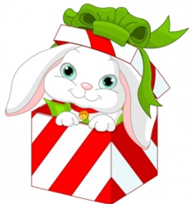A: Where is the _ _ _ bit? - B: It’s in the box.
104. Ảnh: We help our mother with the _ _ _ _ _ _ _ _ _ .
105. Choose the odd one out.
A. ship B. truck C. plane D. duck
106. How/ father?/ your/ is/ old/
107. again?/ meet/ Can/ I/ you
108. Odd one out:
A. he B. she C. they D. me
109. A: How old … you? – B: I am nine years old.
A. am B. are C. is D. it
110. Nghe: Nhấn giữ Ctrl và bấm chuột để nghe: Choose the TRUE statement.
A. There are two armchairs, a sofa and a window in the living room. B. There are two sofas, an armchair and a window in the living room. C. There are two windows, a sofa and an armchair in the living room. D. There are two armchairs, two sofas and a window in the living room.
111. Would you like some …? – No, thanks. I hate sweets.
A. coffee B. lemonade C. chocolate D. chicken
112. Ảnh: 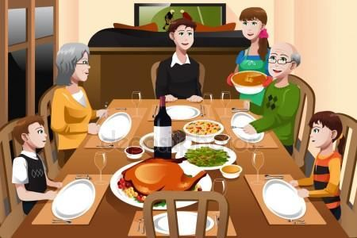My family is having dinner in the _ _ _ _ ng room.
113. Nghe: Nhấn giữ Ctrl và bấm chuột để nghe: Can I borrow your _ _ _ _ for a minute? – Sure.
114. The books are _ _ the shelves.
115. Ảnh: A: Who’s th_ _ ? - B: It’s my brother.
116. Come ov_ r here.
117. Tom can swim … dance.
A. but B. and C. for D. to
118. Nghe: Nhấn giữ Ctrl và bấm chuột để nghe: There are six _ _ _ _ _ _ _ on top.
119. table tennis?/ Do/ you/ playing/ like/
120. you/ “Tom and Jerry”?/ Do/ like/
121. Wh_ _ do you have Maths? – I have it on Monday.
122. What’s the matter _ _ _ _ your eyes?
123. rulers/ on the/ table./ are/ The/
124. five chairs/ There are/ one table/ and/ in the living room./
125. How many balls are _ _ _ _ _ in the basket?
126. like/ doesn’t/ cats./ My/ brother/
127. This is a de_ k.
128. Nghe: Nhấn giữ Ctrl và bấm chuột để nghe: Which is the _ _ _ _ _ _ _ , a giraffe, an elephant or a monkey? – Of course, a giraffe.
129. Ảnh: This is a mo_ _ _ _ cat. That is its baby.
130. The school is far _ _ _ _ the cinema.
131. Tho_ _ books are mine. These books are yours.
132. Do/ your/ you/ house?/ like/
133. That is an ora_ _ e pencil.
134. What a_ _ _ t an apple? – Yes, please.
135. colouring/ now./ Alex is/ his/ pictures
136. hide-and-seek?/ Do you/ play/ like/ to/
137. Ảnh: 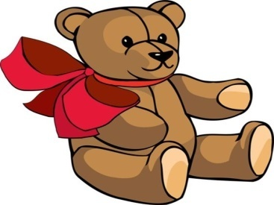The teddy bear has a r_ _ tie.
138. Are … four people in your family, Jack?
A. it B. they C. we D. there
139. to/ Do you/ music?/ like/ listening/
140. very/ are/ These/ beautiful./ flowers/
141. Nghe: Nhấn giữ Ctrl và bấm chuột để nghe: _ _ _ _ _ _
142. Can/ you/ do/ puzzles?
143. This is ... doll.
A. she B. me C. my D. hi
144. Ảnh: 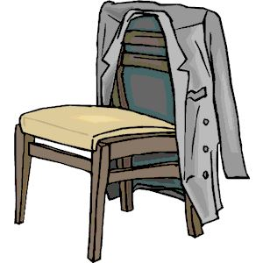The c_ _ _ is on the chair.
145. This is _ _ _ way we go to school.
146. I have m_ _ y toys.
147. Is … bedroom large? – Yes, it is.
A. Jimmy B. Minh’s C. my friend D. house
148. May I go o_ _ for a while?
149. I’m fine, thanks. ... you?
A. End B. And C. On D. Ten
150. That is a gr_ _ n doll.
151. Is your school big? - ..., it is.
A. No B. Not C. Yes D. No, it isn’t
152. Choose the incorrect word(s) in the following sentence: My friend, Quynh, doesn’t has any comic books.
A. My B. has C. any D. books
153. ... you like chicken?
A. Do B. Does C. Are D. Is
154. Is this your sister? – Yes, _______.
A. it is B. it’s not C. he is D.
155. Choose the odd one out:
A. paint B. draw C. write D. walk
156. Is/ it/ today?/ stormy/
157. Do you like playing puz_ _ _ _ ?
158. Choose the odd one out:
A. on B. where C. under D. behind
159. a pen/ to/ Write/ friend./ a postcard/
160. after work?/ does/ What/ do/ Khai/
161. Choose the odd one out:
A. ruler B. crayon C. sing D. eraser
162. Ha: _ _ _ _ colour is that pen? - Mai: It is a blue.
163. He _______ to the zoo in the morning.
A. go B. ride C. has D. walks
164. ... is that? - It’s a pen.
A. How B. When C. What D. Where
165. Nghe: Nhấn giữ Ctrl và bấm chuột để nghe: The chairs are _ _ _ _ the table.
166. friends/ Her/ from/ France./ are/
167. Ảnh: 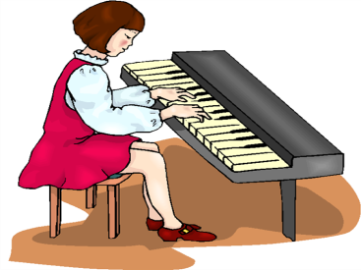She is playing the pi_ _ _ .
168. Taylor is from England. She … me every month.
A. calls B. write C. read D. speak
169. Tom re_ _ _ books in the library in the afternoon.
170. Ảnh: 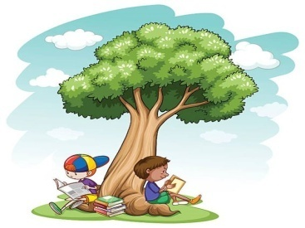Two boys are reading their books _ _ _ _ _ the tree.
171. Nghe: Nhấn giữ Ctrl và bấm chuột để nghe: _ _ _ _
172. There are ... chairs in my living room.
A. one B. five C. a D. an
173. Nghe: Nhấn giữ Ctrl và bấm chuột để nghe: I’ve got two big _ _ _ _ .
174. Nghe: Nhấn giữ Ctrl và bấm chuột để nghe: Look at the _ _ _ _ in the tree.
175. draw/ I/ can/ a/ picture./
176. Hello. My ... is Tom.
A. name B. is C. am D. are
177. after/ dinner./ play/ Let’s/ volleyball/
178. Choose the odd one out:
A. how B. hello C. hi D. good morning
179. This is my father. _ _ _ name is John.
180. has/ My/ toys./ brother/ many
181. Odd one out:
A. they B. ten C. we D. you
182. My pictures _ _ _ on the wall.
183. tidy./ but/ small/ room is/ Her/
184. Ảnh: 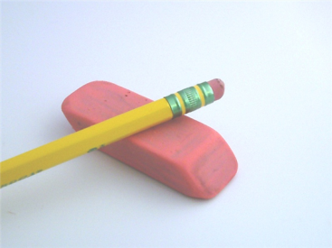It is an old rub_ _ _ .
185. Simon is my friend, t_ _ .
186. I go … school early in the morning.
A. in B. at C. to D. from
187. The opposite of \"on\" is \"_ _ _ _ _ \".
188. What’s/ the/ Mary?/ time/ now,
189. Which word has the letter ‘e’ pronounced as the letter ‘e’ in \"yes\"?
A. new B. orange C. come D. bed
190. Is it the music room? - …. It’s the computer room.
A. Yes, it is. B. No, it isn’t. C. No, it doesn’t. D. Yes, it does.
191. What toys/ not/ he/ like?
A. What toys doesn’t he like? B. What toys don’t he likes? C. What toys isn’t he like? D. What toys aren’t he likes?
192. These are my classmates. … in class 3D.
A. He is B. She is C. We are D. You are
193. What col_ _ r is this book? – It’s red.
194. …. - Yes, my book is new.
A. Is your shoe new? B. Are these books new? C. Is that new? D. Are those new?
195. Choose the odd one out.
A. chicken B. beef C. pork D. food
196. Dolly/ now?/ Is/ fine/
197. The/ game/ very/ exciting./ is/
198. Nghe: Nhấn giữ Ctrl và bấm chuột để nghe: Her English teacher is Mr. _ _ _ _ .
199. Ảnh: Oh, this teddy _ _ _ _ is cute. Can you buy it for me, Mum?
200. I k_ _ _ little English and French.

IOE K3 SỐ 39
1. Ảnh: My family is having dinner in the _ _ _ _ ng room.
2. Sit _ _ _ _ , please.
3. What co_ our is this? – It’s pink.
4. but/ It’s sunny/ in Ha Noi/ it’s rainy/ in Ho Chi Minh City./
5. are/ Where/ pictures?/ the/
6. Nghe: Nhấn giữ Ctrl và bấm chuột để nghe: Let’s play ....
A. basketball B. football C. volleyball D. ball
7. See you later. _ _ e.
8. ... is that? - It’s a pen.
A. How B. When C. What D. Where
9. Would you like … cup of coffee, Mary?
A. a B. an C. some D. any
10. Do you/ listening/ like/ to/ music?/
11. Nghe: Nhấn giữ Ctrl và bấm chuột để nghe: This is my _ _ _ _ _ .
12. Nghe: Nhấn giữ Ctrl và bấm chuột để nghe: The girl has got ….
A. one brother and two sisters B. two brothers and two sisters C. two brothers and one sister D. one brother and one sister
13. Lang Son is far _ _ _ _ Quang Binh.
14. 1 to/ from/ 100?/ Can you/ count/
15. Is your school big? - ..., it is.
A. No B. Not C. Yes D. No, it isn’t
16. There are ten des...s in my classroom.
A. t B. k C. q D. p
17. bathroom/ Is/ new?/ your/
18. Let’s ma_ e a circle.
19. rice?/ I have/ more/ some/ Can/
20. Nghe: Nhấn giữ Ctrl và bấm chuột để nghe: What colour is her hair? - _ _ _ _ _ .
21. Let’s make a li_ e, children.
22. has a/ lot/ He/ at school./ of friends
23. near Hue/ from Ca Mau./ but/ very far/ Da Nang is/
24. Is it a r_ _ nd box? – No, it is a square box.
25. You are happy and I am … too.
A. tired B. big C. new D. happy
26. a/ I/ glass/ of milk./ would like/
27. H_ w are you? - Fine, thanks.
28. ______ fences in your house?
A. There is B. There are C. Is there D. Are there
29. Nghe: Nhấn giữ Ctrl và bấm chuột để nghe: Which is NOT mentioned in the recording?
A. ball B. doll C. puzzle D. teddy
30. _ _ _ _ Mr. Black have a new car?
31. Se_ you tomorrow, children.
32. Hai Phong is in _ _ _ _ _ Vietnam.
33. desk./ is/ that/ on/ My pen/
34. Nghe: Nhấn giữ Ctrl và bấm chuột để nghe: Anna is drawing a _ _ _ _ _ .
35. Tim: How are you? – Jane: I … fine, thank you. And you?
A. are B. am C. is D. in
36. ... is this? – It’s an apple.
A. How B. Who C. What D. Is
37. This is Mary. She ... my friend.
A. is B. are C. the D. a
38. Ảnh: 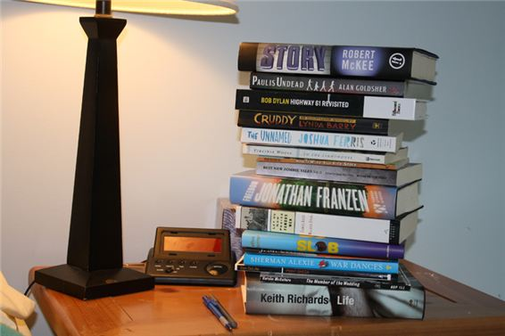Where are my books? – They are ….
A. on the table B. on the chair C. under the table D. on the floor
39. Ảnh: Don’t forget put the car in the ….
A. kitchen B. garden C. bedroom D. garage
40. _ _ _ many books on your bookshelf? – There are 10 books.
41. That is my s_ _ _ _ _ library.
42. Thomas … to music now.
A. is listening B. listen C. listens D. to listen
43. Ảnh: 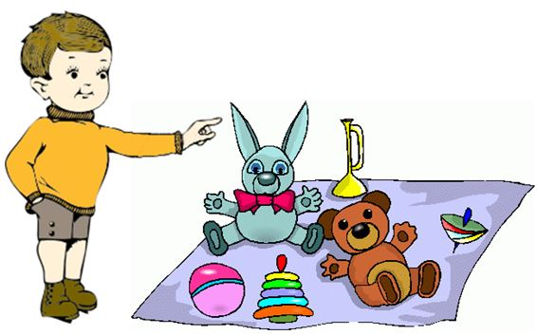A: Are _ _ _ _ _ your toys? - B: Yes, they are.
44. A: What are you doing, Daniel? - B: …
A. He is listening to the radio. B. Daniel is listening to the radio. C. I’m listening to the radio. D. You are listening to the radio.
45. the table?/ is/ What/ on/ that/
46. is/ My/ teacher./ a/ mother/
47. Nghe: Nhấn giữ Ctrl và bấm chuột để nghe: Nina is a _ _ _ .
48. a/ your house/ have/ Does/ garage?/
49. Susan/ like/ wearing/ shirts?/ Does/
50. Nghe: Nhấn giữ Ctrl và bấm chuột để nghe: Let’s all go _ _ _ _ now.
51. Is this a bag? - ... .
A. Yes, it is B. Yes, isn’t C. No, it is D. Not, it isn’t
52. your little sister/ Which/ is/ in?/ grade/
53. My family lives in _ house in Thai Binh Province.
54. Does she like f_ _ _ ts? - B: Yes, she does. She likes eating apples very much.
55. Kien: Is this your dog? - Thanh: Yes, _ _ is.
56. M_ y I go out?
57. doing?/ is/ he/ What/
58. This is Tom. _ _ is my new friend.
59. everyday./ watching/ TV/ likes/ She/
60. May I ... out?
A. ride B. go C. meet D. come
61. … full name is Catherine Jones.
A. Her B. Hers C. She D. She’s
62. Excuse me. - …?
A. No B. Not C. Yes D. Thanks
63. ... is its name?
A. What B. How C. When D. Where
64. The lamp is _ _ _ ween the sofa and the armchair.
65. Nghe: Nhấn giữ Ctrl và bấm chuột để nghe: _ _ _ _ _
66. the fish/ above/ is/ The picture/ tank./
67. is/ Who/ boy?/ that/ little
68. Ảnh: The teddy bear has a r_ _ tie.
69. My sch_ _ l is big.
70. a song/ with/ sing/ Let’s/ me./
71. above/ is/ picture/ The/ the clock./
72. picture./ The poster/ is/ under/ the
73. This is my father. ... name is Lam.
A. Her B. His C. This D. My
74. Nghe: Nhấn giữ Ctrl và bấm chuột để nghe: How _ _ you go to school?
75. Tom re_ _ _ books in the library in the afternoon.
76. in/ a dining/ room/ my house./ There is/
77. our/ music/ That/ room./ is/
78. Our children aren’t watching a cartoon. _ _ _ _ are doing their homework.
79. This/ book./ a brown/ is/
80. This is my friend James. … is a nice boy.
A. He B. She C. They D. It
81. school’s/ is/ What/ name?/ your/
82. Is this a glass of water? - ..., it is.
A. No B. Not C. Yes D. No, it is
83. _ _ _ _ _ pencils are these? – They’re my pencils.
84. The book/ is/ between/ the pencil and/ the lamp./
85. …. - It’s in my bag.
A. What is that? B. How are you? C. Where is my book? D. Who is he?
86. book./ is a/ This/ green/
87. _ _ at’s her name? – She is Mary.
88. What is your ...? – I’m Peter.
A. name B. name’s C. meet D. friend
89. Ảnh: 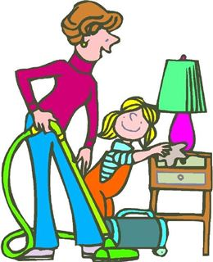My mother and I are _ _ _ _ ning our house.
90. Ảnh: What pets do you have?
A. I have two cats. B. I have a cat and a dog. C. I have two dogs. D. I have two cats or two dogs.
91. He _ _ _ swim but he can’t dance.
92. May I speak to you now? - ….
A. No, you may not. B. Yes, you may. C. No, I am not. D. Sure. You can.
93. the wall./ on/ Your/ pictures/ are/
94. B_ _ . See you later.
95. Ảnh: 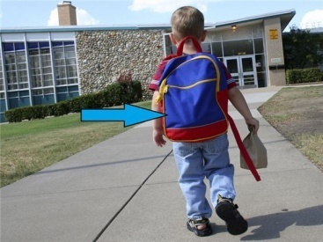What is this? - It’s my school _ _ g.
96. _ _ _ _ is your name?
97. … your brother swim?- Yes, he can.
A. Will B. Does C. Is D. Can
98. What grade are you ________, James?
A. at B. on C. of D. in
99. I can … a kite.
A. this B. fly C. the D. a
100. has/ beautiful/ Daisy/ a/ hat./
101. … are they? – They’re my friends.
A. Who B. What C. Which D. Where
102. That’s Peter. ... is my friend.
A. I B. You C. She D. He
103. Nghe: Nhấn giữ Ctrl và bấm chuột để nghe: Jenny is _ _ _ _ ing with her friends.
104. My school/ things/ all/ are/ new./
105. When is your birth day, Tommy? – Well, Taylor, it’s … December 5th.
A. in B. like C. on D. at
106. A: Do you … fun at school? – B: Yes, I do.
A. are B. play C. have D. go
107. Nghe: Nhấn giữ Ctrl và bấm chuột để nghe: There aren’t any _ _ _ _ here.
108. _ s your school small? – Yes, it is small.
109. this/ Can/ eat/ mooncake?/ I/
110. in/ Is/ a bathroom/ your house?/ there/
111. Bella likes playing _ _ _ guitar.
112. Choose the odd one out:
A. he B. she C. its D. they
113. Viet Nam./ Long An/ in/ is/ south
114. a/ is/ teacher./ good/ Mr. Manh/
115. Nghe: Nhấn giữ Ctrl và bấm chuột để nghe: The phone is … in the dining room.
A. on the chair B. on the table C. under the chair D. under the table
116. How ... you today? – I’m fine, thanks.
A. am B. is C. are D. fine
117. weather/ nice/ It’s/ today.
118. Nghe: Nhấn giữ Ctrl và bấm chuột để nghe: Sue is painting her ….
A. doll B. bus C. truck D. ball
119. What’s y_ ur name?
120. This is m_ cat.
121. Do you like the new girl? - ….
A. Yes, he is very friendly. B. Yes, I do. She is very funny. C. Yes, he is nice D. No, I like.
122. The computer room is new, but the art room is _ _ _ .
123. Goodbye. See you aga_ _ .
124. Choose the odd one out:
A. eraser B. notebook C. crayon D. England
125. three times/ He/ English/ a week./ has/
126. There are many fish _ _ the pond.
127. Her favourite _ _ _ _ _ _ _ is Art.
128. Happy/ birthday/ you,/ to/ Jimmy./
129. Ảnh: 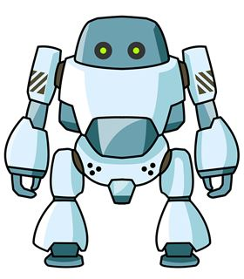There is a _ _ _ ot.
130. Hoa: May I come back home? - Teacher: _ _ , you can’t.
131. Good morning, Peter. - ... .
A. Good morning, Jean B. Good night, Jean C. My name’s Jean D. Jean, this is my pen
132. Ảnh: 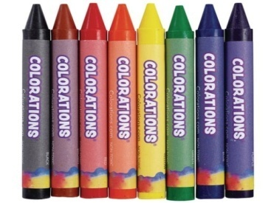How many crayons _______ you have? – I have 8.
A. do B. does C. are D. are there
133. Ảnh: A: Where are you going now? - B: I’m going to the ….
A. cinema B. theatre C. temple D. hospital
134. favourite/ of your/ song?/ the name/ What is/
135. A: What’s the w_ _ _ _ er like today? - B: It’s sunny.
136. Nghe: Nhấn giữ Ctrl và bấm chuột để nghe: Listen and choose the best response.
A. Yes, it does. B. Yes, they are. C. No, it isn’t. D. No, they don’t.
137. Nghe: Nhấn giữ Ctrl và bấm chuột để nghe: Mrs Boot opens the _ _ _ _ .
138. John is a st_ _ _ nt at Oxford Primary School.
139. Look that woman! _ _ _ ’s my teacher.
140. Choose the odd one out:
A. bird B. desk C. cat D. dog
141. Ảnh: A: Where’s your brother? - B: He’s in the _ _ _ _ room.
142. fun/ to be/ with Linda./ It's/
143. on/ The white cat/ is/ that/ desk./
144. Ảnh: Give me a b_ _ _ _ _ of milk, please.
145. too./ meet/ you,/ to/ Nice/
146. Hoa: What are these? - Nam: They are my sc_ _ _ _ things for this new year.
147. … subjects do you have on Friday?
A. What B. How C. Who D. Where
148. GA__EN
A. AR B. RD C. RT D. D
149. My be_ _ oom is small.
150. What ... your name?
A. are B. amfriend C. is D. butmee
151. ... does your father get up? – At 5:30 every day.
A. How old B. What time C. How often D. What grade
152. Choose the letter(s) to make a correct word: chi__en
A. sk B. ck C. cc D. kk
153. Ảnh: We help our mother with the _ _ _ _ _ _ _ _ _ .
154. H_ _ _ y birthday to you. – Thank you.
155. Nghe: Nhấn giữ Ctrl và bấm chuột để nghe: _ _ _ are you?
156. Peter is my friend, t_ _ .
157. Odd one out:
A. nice B. glad C. beautiful D. pretty
158. Nghe: Nhấn giữ Ctrl và bấm chuột để nghe: Tom and Lee are playing ….
A. volleyball B. baseball C. football D. basketball
159. Does Jim like ______ with paper planes?
A. play B. plays C. playing D. on playing
160. There ______ a book on the bookshelf.
A. is B. are C. aren’t D. am
161. _ _ _ ’t talk. It’s so noisy.
162. This gift is for you. – Thank you very m_ _ h.
163. What … do you go to school?
A. name B. time C. subjects D. many
164. Choose the odd one out:
A. am B. is C. are D. name
165. Sunrise is a _ _ _ _ ary school in Hai Phong.
166. The picture is _ _ the wall.
167. This is our w_ _ home from school.
168. Ảnh: Her pens are on the tab_ _ .
169. Close the d_ _ _ , please.
170. Wh_ _ _ are the maps? – They are on the wall.
171. Ha Noi is in n_ _ _ _ Viet Nam.
172. The/ weather/ is/ today/ good./
173. are/ two chairs./ and/ There/ two tables/
174. are/ the bus/ We/ all at/ stop./
175. My b_ _ thday is in May.
176. place./ nice/ My university/ a/ is/
177. Ảnh: My brother can play _ _ _ _ _ _ _ _ .
178. Ảnh: These pencils aren’t very long. Are they _ _ d?
179. Odd one out:
A. from B. in C. at D. want
180. Does/ he/ football after school?/ play/
181. Ảnh: It’s _ _ _ _ _ at Christmas.
182. Nam is/ his friends./ the park/ in/ with
183. Great … you again.
A. sees B. to see C. to seeing D. on seeing
184. Nghe: Nhấn giữ Ctrl và bấm chuột để nghe: Linda has a _ _ _ _ _ _ .
185. She can play chess but … do puzzles.
A. can B. cannot C. can-not D. cant’
186. This pen is _ _ _ blue. It’s green.
187. What/ you/ pets/ have?/ do/
188. Is this a book? - ... .
A. Yes, it is B. Yes, isn’t C. No, it is D. Bye
189. Ảnh: 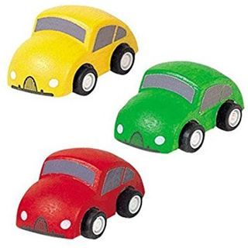I have three toy cars. They are green, red and ye_ _ _ _ .
190. Nghe: Nhấn giữ Ctrl và bấm chuột để nghe: This is John. He is a _ _ _ _ _ _ .
191. Odd one out:
A. Vietnam B. English C. America D. China
192. Sing wit_ me.
193. Che_ _ the words you hear.
194. _______ - It’s in the city.
A. Where is your house? B. Where are you? C. Where is Hanoi? D. Where is Vietnam?
195. Come and _ _ at with your friends.
196. What … is it? – It’s green.
A. time B. name C. day D. colour
197. Oh, I want pizza, milk … candy.
A. an B. and C. for D. to
198. Let’s ______ a song together.
A. read B. watch C. sing D. write
199. Sing with ..., Simon .
A. he B. she C. I D. me
200. a/ apple./ This/ red/ is/

IOE K3 SỐ 40
1. A: What is … name? – B: My name is Tommy.
A. we B. you C. your D. they
2. Nghe: Nhấn giữ Ctrl và bấm chuột để nghe: Look at the _ _ _ _ _ , Rosy.
3. Nghe: Nhấn giữ Ctrl và bấm chuột để nghe: Today it’s very _ _ _ _ _ .
4. … are they? – They’re my friends.
A. Who B. What C. Which D. Where
5. Boy: M_ _ I play football here? - Man: No, you can’t.
6. How ... you today? – I’m fine, thanks.
A. am B. is C. are D. fine
7. _ _ _ you twelve years old?
8. colours./ orange/ I/ and blue/ like/
9. Nghe: Nhấn giữ Ctrl và bấm chuột để nghe: That’s a nice fence _ _ _ _ _ _ the house.
10. You don’t look well. ….
A. Are you ok? B. How old are you? C. What’s your name? D. What is that?
11. is taking/ a nap/ My dad/ the sofa./ on
12. … do you go to school? – It’s early in the morning.
A. What B. Which C. How D. When
13. Let’s sing an English s_ _ g.
14. These are four pencil box_ _ .
15. What’s y_ _ r name? – My name’s Tom.
16. to/ Nice/ you,/ meet/ Alex./
17. subjects/ today?/ have/ do you/ What/
18. you,/ How/ old/ are/ Quang?/
19. Ảnh: 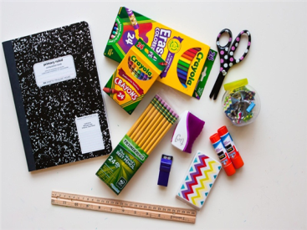What are these? – These are ….
A. school things B. pencil cases C. flowers D. pens
20. Ảnh: My p_ _ _ _ ts are between my sister and me.
21. car/ drives/ to work./ My father/ his/
22. My father is a ... . He works hard in the field.
A. worker B. farmer C. doctor D. teacher
23. I can sing and I _ _ _ dance.
24. school/ that blue/ bag./ Give me/
25. Our children aren’t watching a cartoon. _ _ _ _ are doing their homework.
26. you/ do at/ What/ do/ break time?/
27. How/ many/ does Tim/ have?/ toys/
28. ... is that? - It’s a blue ball.
A. How B. When C. What D. Where
29. My family/ watching/ now./ is/ TV
30. What books are they? - T_ _ _ are Maths books.
31. like?/ What/ does/ Lan/ pets/
32. Great … you again.
A. sees B. to see C. to seeing D. on seeing
33. the/ the books/ Put/ shelf./ on/
34. May I c_ _ _ in and study?
35. Ảnh: She has five ….
A. toys B. pets C. dogs D. cats
36. What colour ... that chair? – It’s yellow.
A. it B. is C. that D. hi
37. you/ right now?/ at home/ Are/
38. Nghe: Nhấn giữ Ctrl và bấm chuột để nghe: Where are the _ _ _ _ _ s?
39. W_ _ t is that? – It’s a teddy bear.
40. I’m fine, thank_ .
41. Are those your pencil sharpeners?
A. Yes, it is. B. No, it isn’t. C. Yes, they are. D. No, they are.
42. ... your school bags, please.
A. Close B. Stand C. Sit D. See
43. My primary/ a nice/ is/ school/ place./
44. That is m_ . My name is Peter.
45. T_ _ s is a board.
46. Nghe: Nhấn giữ Ctrl và bấm chuột để nghe: Sam is riding a …
A. bike B. bus C. horse D. boat
47. Ảnh: My brother has _ _ _ robots.
48. Let’s p_ ay outside, children.
49. Her name ... Sarah.
A. are B. is C. be D. am
50. Nghe: Nhấn giữ Ctrl và bấm chuột để nghe: Where is Nick?
A. He is in the garden. B. He is in the bedroom. C. He is in the bathroom. D. He is in the kitchen.
51. Do you have … today?
A. Art B. write C. sing D. read
52. This/ is/ pencil/ green.
53. game/ is/ The/ very/ exciting./
54. He is Peter. He is my ... .
A. name B. family C. friend D. book
55. The _ _ _ of my father is my brother.
56. Choose the odd one out:
A. skipping B. table tennis C. badminton D. tennis
57. Ảnh: 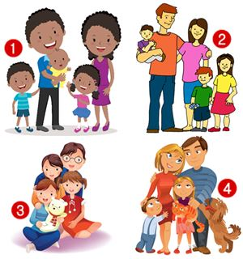I’m Rosie. There are four people in my family. We have a dog and a cat.
A. Picture 1 B. Picture 2 C. Picture 3 D. Picture 4
58. Choose the odd one out:
A. thirty B. seventy C. eighty D. twelve
59. Tell me a_ _ _ _ the things in your bedroom.
60. dog./ my/ Look/ at/
61. my/ my sister’s./ This is/ and that is/ bedroom/
62. Nghe: Nhấn giữ Ctrl và bấm chuột để nghe: Let’s go to _ _ _ _ _ _ together.
63. Thank you. – You are w_ _ _ _ me.
64. FRI_ ND
65. St_ _ d up, please.
66. old./ twenty-five/ years/ My teacher/ is/
67. How ... books are there in your school bag?
A. much B. is C. are D. many
68. Choose the odd one out:
A. living room B. bedroom C. garden D. kitchen
69. Nghe: Nhấn giữ Ctrl và bấm chuột để nghe: How _ _ _ are you?
70. Are you happy? – Yes, I _ _ .
71. What is her fa_ _ _ rite sport? – She likes doing yoga best.
72. Nghe: Nhấn giữ Ctrl và bấm chuột để nghe: What letter do you hear?
A. I B. A C. E D. O
73. work/ Do/ a company?/ your parents/ in
74. It’s a b_ ue pencil.
75. Hello, I am Mai. - …
A. Goodbye and see you later. B. I don’t know. C. Hi, I am fine. Thanks D. Nice to see you.
76. My sister _ _ _ a doll.
77. My pencils are _ _ the table.
78. pets./ have/ doesn't/ She/ any
79. _ _ _ is wearing a red T-shirt? – My dad.
80. That shirt _ _ green.
81. Nghe: Nhấn giữ Ctrl và bấm chuột để nghe: _ _ _ _ _ _ _
82. This/ my/ grandmother./ is/
83. flowers/ very/ These/ are/ beautiful./
84. is/ not/ It/ bedroom./ my
85. The books are _ _ the shelves.
86. Goodbye, David. See y_ u later.
87. They are/ fishing/ at the pond/ their house./ near
88. many/ there?/ How/ apples/ are
89. Ảnh: I like _ _ _ _ _ _ _ _ in the pool in summer.
90. Can you _ _ _ _ a bicycle?
91. my/ This is/ uncle/ his daughter./ and
92. M_ _ I play football here? - No, you can’t.
93. My brother is tall … slim.
A. then B. and C. so D. or
94. Good morning, Peter. - ... .
A. Good morning, Jean B. Good night, Jean C. My name’s Jean D. Jean, this is my pen
95. Can the cat _ _ _ _ _ a tree? – Yes, it can.
96. I have a book in my schoo_ bag.
97. It’s time … lunch, Peter.
A. to B. in C. on D. for
98. Nghe: Nhấn giữ Ctrl và bấm chuột để nghe: My ... is very tall.
A. father B. brother C. sister D. mother
99. ice-cream./ I/ chocolate/ and/ love/
100. Are there _________ pictures on the wall?
A. a B. any C. some D. an
101. What’s the weather _ _ _ _ in Ho Chi Minh City?
102. Let’s ma_ e a circle.
103. Khai/ after work?/ does/ What/ do
104. The students are sp_ _ king English.
105. There is o_ e cat in that box.
106. Choose the odd one out:
A. he B. you C. I D. yes
107. ... morning, Peter.
A. Good’s B. Bye C. Hi D. Good
108. Goodbye Tommy. See you s_ _ _ .
109. this/ I/ dress./ like/ pink
110. The lamp is _ _ _ ween the sofa and the armchair.
111. near/ Is/ Hoa Binh/ Ninh Binh?
112. I’d l_ _ e an orange, please.
113. …. - Yes, my book is new.
A. Is your shoe new? B. Are these books new? C. Is that new? D. Are those new?
114. What ... this? - This is a pen.
A. it B. iss C. is D. are
115. Nghe: Nhấn giữ Ctrl và bấm chuột để nghe: They go to school by _ _ _ .
116. There is a flower va_ e on the table.
117. I see a rainbow. It … beautiful.
A. sees B. sounds C. has D. looks
118. Pizza is my favourite ... .
A. drink B. food C. water D. milk
119. This is m_ cat.
120. My dog’s _ _ _ _ is Barkie.
121. friend?/ your/ new/ this/ Is/
122. What’s ... name? - It’s Quang Trung Primary School.
A. it B. it’s C. its D. his
123. Nghe: Nhấn giữ Ctrl và bấm chuột để nghe: Is it day or _ _ _ _ _ ?
124. Jane is short. Alice is … .
A. slimmer B. stronger C. shorter D. bigger
125. old/ It’s an/ television./ black/ and white
126. Nghe: Nhấn giữ Ctrl và bấm chuột để nghe: Can I borrow you ruler? – Yes, but don’t forget to give it _ _ _ _ .
127. How/ are/ desks/ there in your classroom?/ many/
128. How do you know my n_ _ e?
129. … your brother swim?- Yes, he can.
A. Will B. Does C. Is D. Can
130. A: How old are you? – B: I am … years old.
A. a B. an C. eight D. one
131. Minh … like fish and beef very much.
A. isn’t B. doesn’t C. don’t D. never
132. Is this your grandfather? – Yes, he _ _ .
133. _______ is his coat? - It’s on his bed.
A. When B. Where C. Who D. What
134. know/ the story/ “Harry Potter”?/ Do/ you/
135. Nghe: Nhấn giữ Ctrl và bấm chuột để nghe: This is my _ _ _ _ pen.
136. Have ... nice day, Tim. – Thank you.
A. an B. the C. a D. are
137. Nghe: Nhấn giữ Ctrl và bấm chuột để nghe: _ _ _ _ _ _ _
138. Is your school bag big or sm_ _ _ ?
139. Nghe: Nhấn giữ Ctrl và bấm chuột để nghe: I can draw a ....
A. cat B. hat C. map D. bat
140. bag?/ colour/ What/ school/ is your/
141. There _ _ a book on my desk.
142. What is your … drink? – I like orange juice the most.
A. name B. favourite C. much D. many
143. Children’s/ June/ is/ Day./ 1st/
144. How’s the wea_ _ er today? – It’s sunny.
145. Choose the incorrect word(s) in the following sentence: What are you doing? – I’m skateing with my friends in the park.
A. are B. doing C. skateing D. with
146. , please./ Write/ name/ here/ your/
147. Ảnh: _______ zebras are there in the picture? – There are three zebras.
A. How B. What C. Where D. How many
148. is/ a/ doll./ This/
149. Is this a bag? - ... .
A. Yes, it is B. Yes, isn’t C. No, it is D. Not, it isn’t
150. A: Are they your friends? – B: No, … aren’t.
A. we B. you C. your D. they
151. … to meet you, Alice.
A. Well B. Fine C. Nice D. Kind
152. Nancy has a pet. It can catch a mouse. It’s a _ _ _ .
153. Where do you live? – I live … 107 Tran Dang Ninh Street with my parents.
A. on B. in C. at D. to
154. It is ... blue desk.
A. a B. am C. are D. is
155. Listen ... the teacher, please.
A. on B. in C. to D. for
156. How m_ _ y dogs are there in the garden?
157. Who can cl_ _ _ a tree?
158. Ảnh: 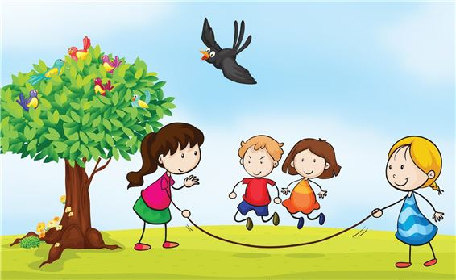The children are ….
A. playing hide-and-seek B. playing blind man’s buff C. skipping rope D. skateboarding
159. How are Tom and Linda? - _ _ _ y are fine.
160. from our/ is far/ flat./ sweet shop/ The/
161. There _ _ _ eleven chairs in my class.
162. picture./ a/ Let’s/ draw/
163. Ảnh: Linda has a rabbit. It’s very cute.
A. Picture 1 B. Picture 2 C. Picture 3 D. Picture 4
164. How do you feel? – I’m very ______?
A. hungry B. short C. pretty D. tall
165. Choose the odd one out:
A. blue B. pink C. green D. book
166. Ảnh: 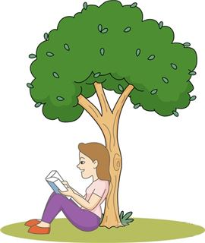She is _ _ _ ding under the tree.
167. goldfish/ tank./ his/ in the/ Peter keeps/
168. I am … England. I am English.
A. from B. to C. in D. at
169. Nghe: Nhấn giữ Ctrl và bấm chuột để nghe: She has _ _ _ cats.
170. Hi_ name is Peter.
171. school?/ name of/ the/ What is/ your
172. Ảnh: That’s a _ _ _ . It’s big.
173. is/ in?/ class/ What/ she
174. Thai Phien is a big _ _ _ _ ary school in Hai Phong.
175. This/ book./ green/ is a/
176. It’s _ _ _ today. Please turn on the fan.
177. Ảnh: 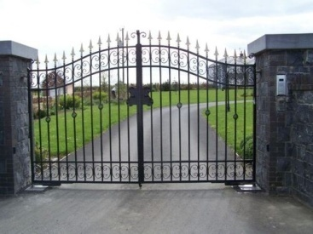Unscramble this word: egta ---> _ _ _ _
178. I have a dog and my friend has a dog t_ _ .
179. very/ Those/ kites/ beautiful./ are/
180. This is o_ r classroom.
181. I don’t like cooking but I ... singing.
A. likes B. like C. do D. to like
182. Choose the odd one out:
A. eraser B. notebook C. crayon D. England
183. This _ _ my school library.
184. borrow/ of/ your notebook/ May I/ Maths?/
185. Can you remem_ _ r my birthday?
186. Do you like football or basketball?
A. I don’t like. B. I like it. C. No, I don’t. D. I like volleyball.
187. I’m so_ _ y. I’m late.
188. tells/ a nice/ me/ My teacher/ story./
189. Nghe: Nhấn giữ Ctrl và bấm chuột để nghe: It’s a nice _ _ _ _ _ _ room.
190. This is an ora_ ge book.
191. Nghe: Nhấn giữ Ctrl và bấm chuột để nghe: I _ _ _ _ a cat.
192. Ảnh: A: Where are you going now? - B: I’m going to the ….
A. cinema B. theatre C. temple D. hospital
193. Let’s play _______ piano together.
A. some B. a C. the D. with
194. You’re so noisy. _______, please.
A. Stand up B. Be quiet C. Close your book D. Let’s sing
195. for/ is/ robot/ you./ This/
196. My brother is th_ _ e years old.
197. white./ are/ These/ eggs/
198. Helen often _ _ _ _ to school with her friend, Elle.
199. Is that lit_ _ _ boy your friend? – Yes, his name is Tom.
200. This is Mary. ... is my friend.
A. I B. You C. She D. He

IOE K3 SỐ 41
1. fish/ many/ There are/ in the/ lake./
2. in,/ I/ come/ May/ please?/
3. I’m fine, thanks. How a_ _ _ t you?
4. Nghe: Nhấn giữ Ctrl và bấm chuột để nghe: _ _ _ _ _ _ _
5. During M_ _ _ s lessons, I learn about numbers.
6. How is the weather ... London today?
A. at B. on C. in D. to
7. Choose the odd one out:
A. tidy B. nice C. clean D. dirty
8. Nghe: Nhấn giữ Ctrl và bấm chuột để nghe: Anna is drawing a _ _ _ _ _ .
9. Ảnh: Henry, Mary and I sit … tables.
A. in B. at C. on D. by
10. See/ tomorrow./ you/
11. Ha Noi is in n_ _ _ _ Viet Nam.
12. Hi, my name’s Sean. - ... .
A. See you tomorrow B. Good night C. Hi, I’m Peter D. Goodbye
13. Can you come and s_ _ _ a song with me?
14. Gi_ _ me the book, please. – Here you are.
15. ten o’clock./ goes to/ Mary/ bed/ at
16. What ... this? - This is a pen.
A. it B. iss C. is D. are
17. in/ Yen So Park?/ cycling/ like/ Do you/
18. large./ of/ our house/ The pond/ is
19. Goodbye. See you to_ _ rrow.
20. Nghe: Nhấn giữ Ctrl và bấm chuột để nghe: I can draw a ....
A. cat B. hat C. map D. bat
21. Taylor is _ _ the school yard right now.
22. … your name on the board?
A. Is B. Are C. What D. How
23. How many … are there on the table?
A. flower B. flowers C. ruler D. eraser
24. It/ red/ is a/ ruler.
25. outside?/ Is/ it/ raining/
26. Nghe: Nhấn giữ Ctrl và bấm chuột để nghe: He’s wearing a white _ _ _ _ .
27. What colour ... that chair? – It’s yellow.
A. it B. is C. that D. hi
28. Do you have any rubbers? – Yes, here t_ _ _ are.
29. WR__ING
A. ET B. ETI C. ITE D. IT
30. Nghe: Nhấn giữ Ctrl và bấm chuột để nghe: David and Simon are ….
A. playing football B. having lunch C. drawing their pictures D. read the books
31. _ _ at’s her name? – She is Mary.
32. is/ there./ coat/ Your/ over
33. That is Lan. _ _ _ is my friend.
34. to be/ fun/ It's/ with Linda.
35. is/ old/ your/ brother?/ How/
36. likes/ playing/ robots with/ Minh/ his friends./
37. Ảnh: Tommy has three cats and four d_ _ _ .
38. These books are for you. – Thank you very m_ _ h.
39. the table./ There/ is a/ next to/ cat/
40. many/ do/ you have?/ How/ skirts/
41. …? - It is on the table.
A. Where are my apples B. Where is your ruler C. What are you doing D. How are you
42. What … do you go to school?
A. name B. time C. subjects D. many
43. a/ has/ long/ tail./ My cat/
44. December./ born/ in/ was/ I/
45. Goodbye. See you l_ _ _ r.
46. Nam usually … badminton in the afternoon.
A. played B. plays C. playing D. to play
47. Nga is singing a nice s_ _ _ .
48. Ảnh: 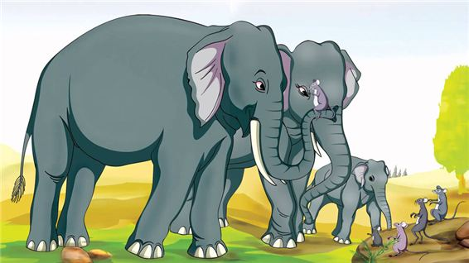An elephant is b_ _ and a mouse is small.
49. Let’s go to school t_ _ _ _ _ _ _ !
50. Your doll is gr_ _ n and my doll is yellow.
51. cooking/ doesn’t/ He/ like/ at home./
52. Is this a book? - ... .
A. Yes, it is B. Yes, isn’t C. No, it is D. Bye
53. Do you like Tet? - ….
A. Yes, I love Tet B. Yes, I am C. No, he doesn’t D. No, I am not sure
54. has twenty/ girls./ boys and/ My class/ twenty-two
55. Ảnh: 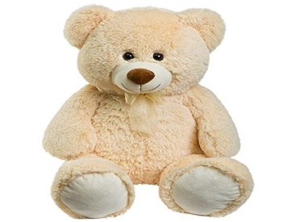I have a lovely teddy _ _ _ _ .
56. Minh: Where are you? - Nga: I am w_ _ _ my friends.
57. Ảnh: 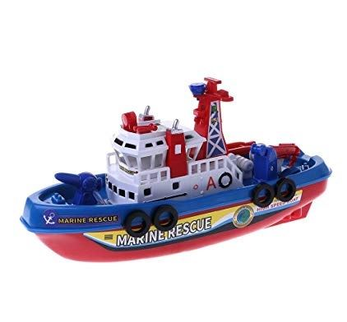He has a toy _ _ _ _ .
58. Nghe: Nhấn giữ Ctrl và bấm chuột để nghe: Look at the _ _ _ _ in the tree.
59. Mary likes to read books in the school li_ _ ary.
60. Nghe: Nhấn giữ Ctrl và bấm chuột để nghe: The chairs are _ _ _ _ the table.
61. When/ birthday?/ is/ Lan’s/
62. does/ pet/ like?/ Khoi/ What/
63. _ _ _ _ is your name?
64. Sing wit_ me.
65. the/ and/ Listen/ pictures./ number/
66. Great to see you …, Jane.
A. too B. again C. but D. and
67. Let’s go out for _ _ _ ner. I’m hungry now.
68. How do you know my n_ _ e?
69. My uncle is going to make a cake … me.
A. from B. at C. for D. on
70. There are four room_ in my house.
71. _ _ _ _ _ pencils are these? – They’re my pencils.
72. Choose the odd one out:
A. skipping B. table tennis C. badminton D. tennis
73. Li_ ten to the teacher, please.
74. … is that boy? – He is my new friend from school.
A. What B. Which C. Who D. Where
75. Ảnh: Give me a b_ _ _ _ _ of milk, please.
76. Bring an um_ _ _ lla in case rains.
77. Does David ______ any ships? – Yes, he does.
A. have B. having C. has D. haves
78. Circle the ans_ er, please.
79. Can you swim _ _ _ play chess?
80. ... is it from your house to the bakery?
A. How often B. How far C. How D. How much
81. Don’t eat too … sugar.
A. much B. many C. lots of D. a lot
82. Is ... a yellow kite? – No, it isn’t. That is a green kite.
A. that’s B. that C. this D. this is
83. in/ lots of/ my hometown./ There are/ mountains/
84. bluff?/ like/ Do you/ man’s/ blind/
85. T_ _ s is a board.
86. playing/ likes/ Tim/ computer/ games./
87. Take _ look at the picture in your book.
88. Who is tall_ _ , Jack or Jim?
89. Ảnh: 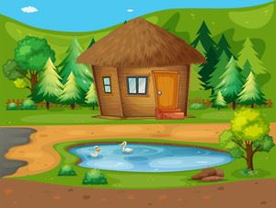There is a p_ _ _ in front of the house.
90. the/ living/ house./ room in/ There is a/
91. Choose the letter(s) to make a correct word: e__phant
A. lle B. li C. lli D. le
92. You don’t look well. ….
A. Are you ok? B. How old are you? C. What’s your name? D. What is that?
93. Choose the odd one out.
A. ship B. truck C. plane D. duck
94. A: How _ _ _ is your grandpa? - B: He’s sixty.
95. all/ new./ are/ things/ My school/
96. His/ birthday/ is not/ in/ December./
97. ... is that? - It’s a blue ball.
A. How B. When C. What D. Where
98. What _______ do you like best? – It’s blue.
A. pet B. colour C. toy D. book
99. I have Maths _ _ Monday.
100. ...? - He’s from France.
A. Where is he from B. What’s his name C. What does he do D. What’s his nationality
101. Ảnh: Cinderella is ______ with the prince at the party.
A. dance B. dances C. dancing D. danceing
102. Ảnh: The apple is ________ the box.
A. under B. in front of C. beside D. behind
103. Choose the odd one out:
A. Peter B. Tim C. Alan D. Monday
104. of March./ Her birthday/ is/ on/ the nineteenth
105. Nghe: Nhấn giữ Ctrl và bấm chuột để nghe: There are six _ _ _ _ _ _ _ on top.
106. Draw a pict_ _ e of yourself.
107. Nghe: Nhấn giữ Ctrl và bấm chuột để nghe: Is it day or _ _ _ _ _ ?
108. May I go o_ _ for a while?
109. Your pictures are ... the wall.
A. on B. in C. for D. to
110. You and … are friends forever.
A. me B. my C. I D. myself
111. Peter is my friend, t_ _ .
112. _ _ _ ’s the weather? – It’s sunny.
113. He can … with a yo-yo.
A. play B. catch C. do D. say
114. What’s the weather _ _ _ _ in Ho Chi Minh City?
115. My friends and I … a new way to learn English.
A. go B. look C. find D. do
116. A: Is your house _ _ _ _ the cinema? - B: No, it’s very far.
117. This pen is _ _ _ blue. It’s green.
118. _ _ dog is two years old.
119. My brother can play the piano but … play the guitar.
A. can B. can not C. cannot D. cant’
120. This _ _ Linda.
121. Choose the odd one out:
A. seven B. eleven C. fourteen D. seventeen
122. My father … to work at 6 o’clock.
A. go B. play C. goes D. plays
123. Peter and Mary/ are/ at/ gate./ the school
124. Put your books s a_ _ y, please.
125. What is Mary’s … of birth?
A. day B. date C. today D. birthday
126. Do you have … today?
A. Art B. write C. sing D. read
127. Look at the board. – Y_ _ , Miss.
128. food./ wants/ some/ Peter/
129. ________ subjects do you like the most?
A. What B. When C. Why D. Who
130. Nghe: Nhấn giữ Ctrl và bấm chuột để nghe: The garden is very _ _ _ _ _ _ _ _ _ .
131. Take/ , Alan./ your/ notebooks/ out/
132. This ... a house.
A. are B. is C. you D. here
133. My brother is th_ _ e years old.
134. Nghe: Nhấn giữ Ctrl và bấm chuột để nghe: _ _ _ _ _
135. My sister is very bea_ tiful.
136. Ảnh: 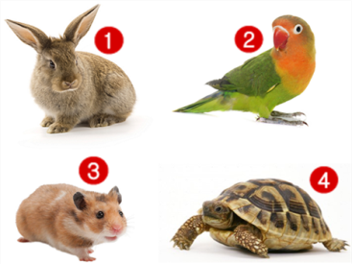Which is Peter’s pet? Peter has a lovely pet. It can fly in the sky.
A. Picture 1 B. Picture 2 C. Picture 3 D. Picture 4
137. ... this a desk? – Yes, it is.
A. Is B. Are C. How D. Whatname’s
138. Ảnh: The mouse is _ _ _ ind the box.
139. Which word has the letters 'w' pronounced as the letter ’w’ in 'who'?
A. write B. where C. when D. what
140. new/ she/ your/ Is/ friend?/
141. Tommy can _ _ _ _ _ Vietnamese.
142. Nghe: Nhấn giữ Ctrl và bấm chuột để nghe: _ _ _ _ _ _
143. How _ _ _ _ dogs do you have? – I don’t have any dogs.
144. The map is on the w_ _ _ .
145. … your brother swim?- Yes, he can.
A. Will B. Does C. Is D. Can
146. My pictures _ _ _ on the wall.
147. Sally is standing n_ _ _ to David.
148. Ảnh: Rapunzel ______ long straight blonde hair.
A. has B. have C. haves D. is has
149. Nghe: Nhấn giữ Ctrl và bấm chuột để nghe: He carries a baby in his _ _ _ _ .
150. cloudy/ in/ It’s/ and windy/ Ha Noi./
151. Choose the odd one out:
A. bathroom B. music room C. art room D. classroom
152. My teacher/ years/ is/ twenty-five/ old./
153. She can play chess but … do puzzles.
A. can B. cannot C. can-not D. cant’
154. Nghe: Nhấn giữ Ctrl và bấm chuột để nghe: _ _ _ _ _ _ _ _ _
155. My family/ has a big/ every Sunday./ always/ dinner
156. school/ colour/ bag?/ is your/ What/
157. The main character is funny _ _ _ gentle.
158. Ảnh: 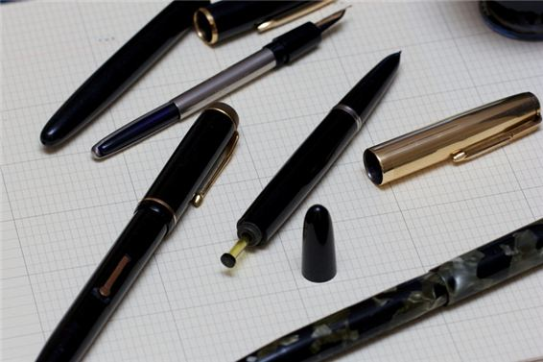What are these? – These are my old _ _ _ _ .
159. have/ a/ Emma/ Does/ goldfish?/
160. It is ... blue desk.
A. a B. am C. are D. is
161. Tom re_ _ _ books in the library in the afternoon.
162. ... is this? – It’s an apple.
A. How B. Who C. What D. Is
163. Nghe: Nhấn giữ Ctrl và bấm chuột để nghe: _ _ _ _ _ _
164. Ảnh: My chair is _ _ _ _ _ .
165. Ảnh: 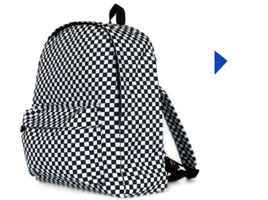Is this black and white bac_ _ _ _ _ yours?
166. old./ is/ years/ He/ ten/
167. Nghe: Nhấn giữ Ctrl và bấm chuột để nghe: How many hot dogs does he take out of the package?
A. Three B. Two C. One D. Four
168. are/ pencils/ on/ the table./ His/
169. pen/ Which/ is/ yours?
170. Is your school big? - _ _ _ , it is.
171. We often play football in the schoolyard at … time.
A. free B. break C. spare D. any
172. Golf _ _ my father’s favourite sport.
173. Choose the odd one out:
A. are B. you C. am D. is
174. ... are you today? – I’m fine, thanks.
A. Who B. That C. How D. Where
175. fly?/ can/ animals/ What/
176. A: … rooms are there in your house? - B: Five.
A. How much B. How many C. How old D. How long
177. What’s y_ _ r name? – My name’s Tom.
178. black cat/ is/ under/ The/ the bed./
179. Oh, I want pizza, milk … candy.
A. an B. and C. for D. to
180. run./ but/ it can’t/ A goldfish/ can swim,/
181. Ảnh: My friend loves _ _ _ _ ing very much.
182. Choose the letter(s) to make a correct word: classm__e
A. ra B. ad C. et D. at
183. A: How old are you? – B: I am … years old.
A. a B. an C. eight D. one
184. That ... his family.
A. am B. is C. are D. and
185. friends/ Primary School./ My old/ at Kim Dong/ study/
186. … subjects do you have on Tuesday?
A. What B. How C. Who D. When
187. Nghe: Nhấn giữ Ctrl và bấm chuột để nghe: How many pages does the book have?
A. 52 B. 32 C. 42 D. 62
188. the wall./ There/ is/ a picture/ on
189. Nghe: Nhấn giữ Ctrl và bấm chuột để nghe: The tree has blown _ _ _ _ .
190. see/ it./ Come/ and/
191. Thank you very much. – You’re w_ _ _ _ me.
192. in/ Hue/ It’s/ cloudy/ today./
193. so/ It/ today./ is/ hot
194. house/ My/ quite/ large./ is/
195. Is that your m_ _ _ _ _ ? - No, she is my aunt.
196. Nghe: Nhấn giữ Ctrl và bấm chuột để nghe: My house has a ... yard.
A. small B. fat C. large D. big
197. That is her n_ w school.
198. brothers?/ Do/ have/ you/ any
199. Nghe: Nhấn giữ Ctrl và bấm chuột để nghe: Let’s go to _ _ _ _ _ _ together.
200. The child of my uncle is my c_ _ _ _ n.

IOE K3 SỐ 42
1. The school is far _ _ _ _ the cinema.
2. A: What … do you like? - B: I like ships.
A. sports B. games C. toys D. pets
3. You/ to me./ say/ hello/
4. having/ in/ Is she/ breakfast/ the dining room?/
5. I can … a kite.
A. this B. fly C. the D. a
6. What is your favourite _ _ _ _ ? - It’s hide-and-seek.
7. Do you like … puzzles?
A. playing B. doing C. do D. play
8. What/ does/ subject/ like best?/ Peter
9. Ảnh: These are … of my family.
A. posters B. photos C. maps D. papers
10. This is my ... . Her name is Alice.
A. mother B. father C. brother D. grandfather
11. Are there _________ clocks on the table?
A. a B. an C. some D. any
12. Ảnh: 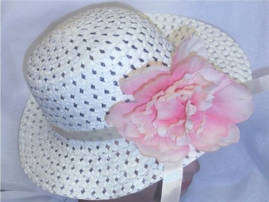Which one is your _ _ _ ? – It’s the one with a pink flower.
13. the music room?/ How many/ boys/ in/ are there/
14. our/ It’s/ room./ computer/
15. Ảnh: It is a cute _ _ _ _ _ _ with two long ears.
16. ______ - There are two pens over there.
A. What are over there? B. Where are two pens? C. Are there any pens over there? D. How many pens are there over there?
17. May I c_ _ _ in and study?
18. Nghe: Nhấn giữ Ctrl và bấm chuột để nghe: My _ _ _ _ _ _ is in the garden.
19. Ảnh: 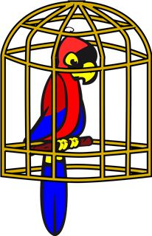I keep my parrot in a _ _ _ _ .
20. How many pictures are there _ _ the wall? – There are four pictures.
21. What’s the weather _ _ _ _ in Ho Chi Minh City?
22. repeat/ me./ after/ Please/
23. I can r_ _ e a bicycle.
24. Nghe: Nhấn giữ Ctrl và bấm chuột để nghe: Mai likes ... flowers.
A. beautiful B. wonderful C. colorful D. blue
25. Ảnh: My friend loves _ _ _ _ ing very much.
26. That is my s_ _ _ _ _ library.
27. What … your parents look like?
A. does B. do C. is D. are
28. in/ My/ father/ is/ the kitchen./
29. best./ Art/ I/ lessons/ like/
30. This ... my mother.
A. are B. am C. is D. and
31. Let’s play h_ _ e-and-seek.
32. Nghe: Nhấn giữ Ctrl và bấm chuột để nghe: Which is NOT mentioned in the recording?
A. garden B. bathroom C. bedroom D. kitchen
33. like/ to/ listening/ music?/ Do you/
34. It is _ desk.
35. Are you happy? – Yes, I _ _ .
36. May I borrow your books for some days? - ….
A. No, I don’t. B. Yes, I can. C. I am fine. Thank you. D. Yes, you can.
37. birthday/ My mother’s/ in/ February./ is/
38. Don’t/ much fast/ eat/ food./ too/
39. Ảnh: 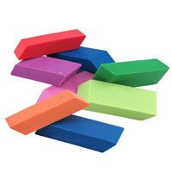They are … .
A. pencils B. sharpeners C. rulers D. erasers
40. This is m_ cat.
41. Ảnh: 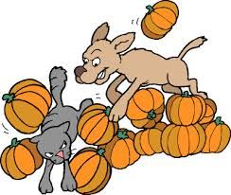The dog is ch_ _ _ ng the cat.
42. Where’s Bac Ninh Province? – It’s in ______ Vietnam.
A. north B. central C. south D. the
43. Are Philip and Tony watching TV?
A. Yes, he is. B. Yes, they are. C. No, he and he are not. D. No, they not.
44. He’s old./ My/ isn’t/ young./ grandfather/
45. What is your … drink? – I like orange juice the most.
A. name B. favourite C. much D. many
46. A dog has _______.
A. four eyes B. four noses C. four tails D. four legs
47. Che_ _ the words you hear.
48. _ s your school small? – Yes, it is small.
49. Nghe: Nhấn giữ Ctrl và bấm chuột để nghe: There is a desk _ _ _ _ to my bed.
50. Nghe: Nhấn giữ Ctrl và bấm chuột để nghe: I have a _ _ _ fridge.
51. She’s learning how to _ _ _ _ spaghetti.
52. The lamp is _ _ _ ween the sofa and the armchair.
53. This is ... doll.
A. she B. me C. my D. hi
54. Ảnh: 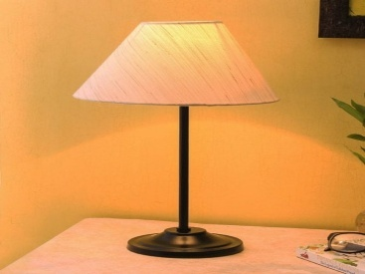Please turn on the _ _ _ _ . The room is dark.
55. What toys/ not/ he/ like?
A. What toys doesn’t he like? B. What toys don’t he likes? C. What toys isn’t he like? D. What toys aren’t he likes?
56. This is a_ ice cream.
57. What is that? - … is a new pen.
A. He B. It C. They D. These
58. Teacher: Nam, go to the b_ _ _ _ and write your sentence. - Nam: Yes, Miss.
59. are/ friends/ Where/ now?/ your/
60. too./ you,/ Nice/ meet/ to/
61. There are four win_ _ _ _ in my classroom.
62. Nghe: Nhấn giữ Ctrl và bấm chuột để nghe: What’s the name of the pupil? – She’s _ _ _ _ .
63. Rosie is having a shower in the ….
A. kitchen B. bathroom C. bedroom D. playground
64. Mary is … . She wants some water.
A. hungry B. thirsty C. sick D. pretty
65. … is your school? – That one.
A. What B. Where C. Which D. When
66. The gym is big and n_ _ .
67. Choose the letter(s) to make a correct word: clas__oom
A. ss B. rr C. rs D. sr
68. Ảnh: That’s a _ _ _ . It’s big.
69. There are four room_ in my house.
70. very/ beautiful./ are/ flowers/ These/
71. What … do you go to school?
A. name B. time C. subjects D. many
72. Mary is a ... at London Primary School.
A. boy B. toy C. student D. she
73. that/ the box?/ What/ in/ is/
74. Does Khanh/ bluff/ blind man’s/ play/ break time?/ at/
75. in/ Is/ room?/ Rosy/ the dining
76. Let’s go out for _ _ _ ner. I’m hungry now.
77. Are there a_ _ kites on the sky?
78. Are there _________ pictures on the wall?
A. a B. any C. some D. an
79. I like to s_ ng.
80. Nghe: Nhấn giữ Ctrl và bấm chuột để nghe: My _ _ _ is blue.
81. Is that girl new? – I don’t _ _ ow.
82. … subjects do you have on Tuesday?
A. What B. How C. Who D. When
83. Hi_ name is Peter.
84. Odd one out:
A. sun B. snowy C. cloud D. wind
85. There ... one ruler on that desk.
A. am B. an C. is D. are
86. Ảnh: 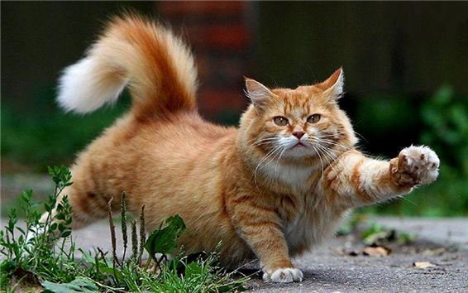There is a big fat c_ _ .
87. friend?/ new/ your/ Is/ this/
88. _______ is his coat? - It’s on his bed.
A. When B. Where C. Who D. What
89. I don’t like the music room. It is so s_ _ _ l.
90. This is my friend James. … is a nice boy.
A. He B. She C. They D. It
91. Is that your classroom? It is so _ _ _ ge.
92. This gift is for you. – Thank you very m_ _ h.
93. the radio./ to/ is/ listening/ She/
94. What’s the matter _ _ _ _ your eyes?
95. I/ am/ very/ now./ tired
96. Ảnh: 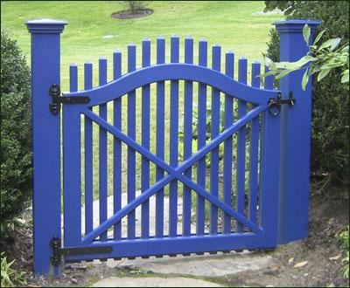Our house has a small blue _ _ _ _ .
97. Ảnh: Do you have toys? – Yes, I have a _ _ _ _ .
98. Do you _ _ _ w Phong? – Yes, I do. He is my classmate.
99. school/ with Nhung./ I always/ go/ to/
100. Nghe: Nhấn giữ Ctrl và bấm chuột để nghe: Who's _ _ _ _ _ _ _ _ , you or your brother?
101. How/ do/ spell/ your name?/ I/
102. What do you have _ _ _ breakfast? – I have sandwiches.
103. your/ birthday?/ is/ When/
104. May you play hide-and-seek w_ _ _ us?
105. My house _ _ _ _ _ ’t have a pond.
106. Where ______ you _______ on Sundays?
A. do – do B. does – do C. does - go D. do - go
107. Pizza is my favourite ... .
A. drink B. food C. water D. milk
108. Nghe: Nhấn giữ Ctrl và bấm chuột để nghe: How many pages does the book have?
A. 52 B. 32 C. 42 D. 62
109. That’s Peter. ... is my friend.
A. I B. You C. She D. He
110. Nghe: Nhấn giữ Ctrl và bấm chuột để nghe: These _ _ _ _ _ _ _ _ are in the USA.
111. Good morning, Peter. - ... .
A. Good morning, Jean B. Good night, Jean C. My name’s Jean D. Jean, this is my pen
112. These _ _ _ two yellow dolls.
113. a/ family./ happy/ We/ are/
114. Nghe: Nhấn giữ Ctrl và bấm chuột để nghe: He’s _ _ _ _ _ years old.
115. This is my aunt. …. twenty-six years old.
A. They are B. He is C. You are D. She is
116. BA__ROOM
A. TH B. T C. D D. TA
117. school/ bags./ are/ our/ Those/
118. Ảnh: How many crayons _______ you have? – I have 8.
A. do B. does C. are D. are there
119. is in/ school/ My/ the/ countryside./
120. A: … do you go shopping? – B: Once a week.
A. How many B. What C. How often D. When
121. Her favourite _ _ _ _ _ _ _ is Art.
122. Nghe: Nhấn giữ Ctrl và bấm chuột để nghe: His _ _ _ _ _ _ is in the kitchen with his mother.
123. I can sing and I _ _ _ dance.
124. Ảnh: 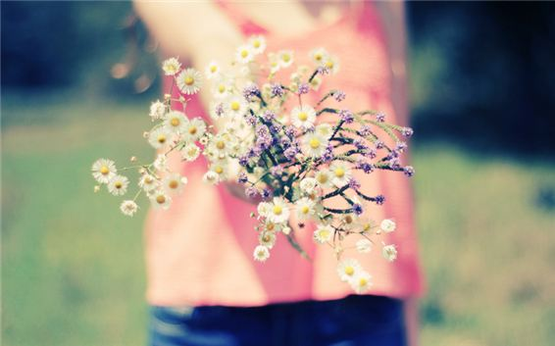Do you like …? – Yes, I do.
A. books B. flowers C. pencil cases D. ice-cream
125. Is _ _ _ _ e a park near your house?
126. like/ do/ football?/ Why/ you/
127. all at/ are/ the bus/ We/ stop./
128. W_ _ _ are these? – These are my new crayons.
129. Would you like … cup of coffee, Mary?
A. a B. an C. some D. any
130. Nghe: Nhấn giữ Ctrl và bấm chuột để nghe: She shows them the pictures in the _ _ _ _ .
131. _ _ _ _ Mr. Black have a new car?
132. like/ much?/ rats/ cats/ Does/
133. tigers./ I/ not/ like/ do/
134. is/ room./ our/ music/ That/
135. It’s always … in summer.
A. cold B. red C. icy D. hot
136. It’s _ _ _ _ dy today. You should bring your umbrella.
137. Nghe: Nhấn giữ Ctrl và bấm chuột để nghe: They’re ....
A. hungry B. happy C. lucky D. sad
138. ... is this? – It’s an apple.
A. How B. Who C. What D. Is
139. Nam: Your school and your library is big. - Nga: Yes, t_ _ _ are very big and nice.
140. red/ This/ is/ apple./ a/
141. What’s the matter ... your eyes?
A. with B. to C. at D. for
142. Is/ raining/ it/ outside?
143. Nghe: Nhấn giữ Ctrl và bấm chuột để nghe: This is John. He is a _ _ _ _ _ _ .
144. in/ Nam is/ his friends./ with/ the park/
145. I’m f_ ne, thank you.
146. name?/ your/ What’s/ teacher’s/
147. Does/ banana?/ Mary/ like/
148. How/ Jimmy’s/ old/ little brother?/ is/
149. They/ playing/ the violin/ very much./ like/
150. Ảnh: My cat likes _ _ sh very much.
151. How ... dogs do you have?
A. many B. five C. bird D. much
152. Vinh: What is that? - Binh: It’s _ big red ball.
153. Choose the odd one out:
A. how B. hello C. hi D. good morning
154. Mum?/ my/ parrot/ Is/ there,
155. Is your school blue ... white?
A. to B. or C. and D. but
156. Ảnh: 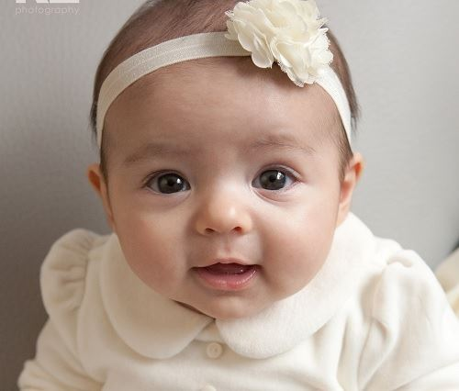That is my _ _ _ _ sister.
157. Thank you. – You are w_ _ come.
158. Nghe: Nhấn giữ Ctrl và bấm chuột để nghe: _ _ _ _ _
159. A: Is there a cupboard or a wardrobe in your bedroom? - B: …
A. Yes, there is. B. There are both of them. C. My clothes are in the wardrobe. D. My toys are in the cupboard.
160. Thang?/ is/ old/ How/
161. school/ is in her/ now./ Chi/ garden
162. Where … the candles? – They are on the cake.
A. do B. does C. are D. is
163. A: Is that Peter? – B: Yes, … .
A. he is B. is he C. is not D. he not
164. Is this a green pen? - ..., it is.
A. Not B. Yes C. No D. Yes, it isn’t
165. What is your _ _ _ _ _ _ _ _ _ drink, Sam? – I like lemonade the most.
166. teacher/ the/ Listen/ carefully./ to/
167. Choose the odd one out:
A. America B. England C. Vietnamese D. Singapore
168. Ảnh: 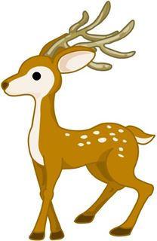This de_ _ is looking for his mom.
169. Ảnh: A: What is Mai doing now? - B: She is ….
A. reading a book B. doing her homework C. drawing a picture D. doing puzzles
170. Who is tall_ _ , Jack or Jim?
171. Ảnh: ______ do you see elephants? – In the zoo.
A. When B. How C. Where D. What
172. Ảnh: 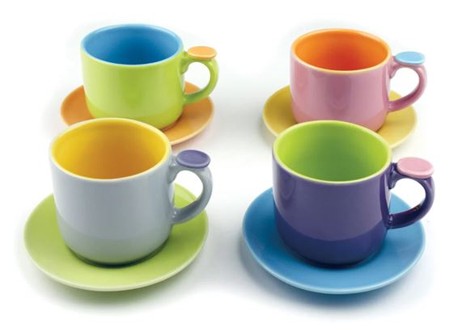There are four pretty _ _ _ s here.
173. Ảnh: My brother has _ _ _ robots.
174. He/ has/ three times/ English/ a week./
175. It’s … in Ho Chi Minh city.
A. pets B. toys C. rainy D. chairs
176. Nghe: Nhấn giữ Ctrl và bấm chuột để nghe: Sally has got a _ _ _ _ _ dog.
177. Ảnh: 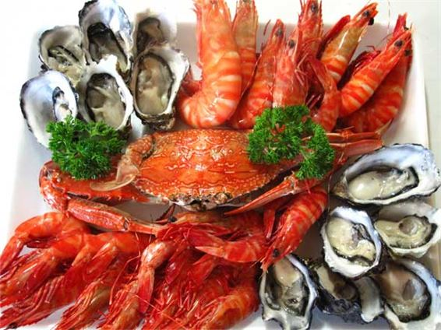Do you like s_ _ food?
178. What s_ _ _ _ _ ts do you like? – I like Maths and English.
179. paper lion./ a/ make/ Let’s/
180. is/ above/ The poster/ the shelf.
181. _______ - It’s in the city.
A. Where is your house? B. Where are you? C. Where is Hanoi? D. Where is Vietnam?
182. Be care_ _ _ ! A car is coming fast.
183. chess/ playing/ at break time./ likes/ Mary/
184. How’s the wea_ _ er today? – It’s sunny.
185. Her house is small but … is very nice.
A. he B. she C. they D. it
186. Do you want s_ _ e milk?
187. Tom/ likes/ playing games/ very/ much./
188. Peter/ Linda/ hide-and-seek/ now.
A. Peter and Linda is playing hide-and-seek now. B. Peter and Linda are playing with hide-and-seek now. C. Peter and Linda playing hide-and-seek now. D. Peter and Linda are playing hide-and-seek now.
189. meet/ Can/ again?/ you/ I/
190. Tom re_ _ _ books in the library in the afternoon.
191. Nghe: Nhấn giữ Ctrl và bấm chuột để nghe: Which is the slowest, a turtle, a _ _ _ _ _ _ or a cat?
192. Ảnh: The boy is washing his _ _ _ .
193. Nghe: Nhấn giữ Ctrl và bấm chuột để nghe: He is hungry. He wants something to _ _ _ .
194. Our school is _ _ north city.
195. pencils/ His/ on/ are/ the table./
196. My be_ _ oom is small.
197. What … your sister look like?
A. does B. do C. is D. are
198. This ... a house.
A. are B. is C. you D. here
199. Please … the window. It’s cold.
A. close B. open C. draw D. paint
200. Nghe: Nhấn giữ Ctrl và bấm chuột để nghe: Today, it is very _ _ _ _ .

IOE K3 SỐ 43
1. Let’s p_ ay outside, children.
2. Ảnh: I’m Rosie. There are four people in my family. We have a dog and a cat.
A. Picture 1 B. Picture 2 C. Picture 3 D. Picture 4
3. I/ ice-cream./ and/ love/ chocolate/
4. The books are _ _ the shelves.
5. Minh … like fish and beef very much.
A. isn’t B. doesn’t C. don’t D. never
6. My dog’s _ _ _ _ is Barkie.
7. Thank you. – You are w_ _ _ _ me.
8. Boy: M_ _ I play football here? - Man: No, you can’t.
9. T_ _ s is a board.
10. There is a flower va_ e on the table.
11. Put/ the/ shelf./ the books/ on/
12. she/ in?/ class/ What/ is/
13. There _ _ a book on my desk.
14. How m_ _ y dogs are there in the garden?
15. My father is a ... . He works hard in the field.
A. worker B. farmer C. doctor D. teacher
16. Nghe: Nhấn giữ Ctrl và bấm chuột để nghe: I can draw a ....
A. cat B. hat C. map D. bat
17. ... your school bags, please.
A. Close B. Stand C. Sit D. See
18. I/ colours./ like/ and blue/ orange/
19. Choose the odd one out:
A. eraser B. notebook C. crayon D. England
20. years/ My teacher/ twenty-five/ is/ old./
21. Is this your grandfather? – Yes, he _ _ .
22. That shirt _ _ green.
23. ... is that? - It’s a blue ball.
A. How B. When C. What D. Where
24. The students are sp_ _ king English.
25. What colour ... that chair? – It’s yellow.
A. it B. is C. that D. hi
26. It’s an/ old/ and white/ black/ television./
27. Look/ at/ my/ dog.
28. Goodbye, David. See y_ u later.
29. game/ very/ exciting./ The/ is/
30. Nghe: Nhấn giữ Ctrl và bấm chuột để nghe: Sam is riding a …
A. bike B. bus C. horse D. boat
31. Is that lit_ _ _ boy your friend? – Yes, his name is Tom.
32. Are those your pencil sharpeners?
A. Yes, it is. B. No, it isn’t. C. Yes, they are. D. No, they are.
33. These are four pencil box_ _ .
34. Nghe: Nhấn giữ Ctrl và bấm chuột để nghe: _ _ _ _ _ _ _
35. to/ you,/ meet/ Nice/ Alex./
36. Our children aren’t watching a cartoon. _ _ _ _ are doing their homework.
37. St_ _ d up, please.
38. Nghe: Nhấn giữ Ctrl và bấm chuột để nghe: My ... is very tall.
A. father B. brother C. sister D. mother
39. Let’s play _______ piano together.
A. some B. a C. the D. with
40. How’s the wea_ _ er today? – It’s sunny.
41. Do you like football or basketball?
A. I don’t like. B. I like it. C. No, I don’t. D. I like volleyball.
42. Nghe: Nhấn giữ Ctrl và bấm chuột để nghe: Look at the _ _ _ _ _ , Rosy.
43. bag./ school/ that blue/ Give me/
44. Choose the odd one out:
A. living room B. bedroom C. garden D. kitchen
45. Ảnh: She is _ _ _ ding under the tree.
46. This is m_ cat.
47. June/ is/ Children’s/ Day./ 1st/
48. Ảnh: She has five ….
A. toys B. pets C. dogs D. cats
49. Nghe: Nhấn giữ Ctrl và bấm chuột để nghe: Where is Nick?
A. He is in the garden. B. He is in the bedroom. C. He is in the bathroom. D. He is in the kitchen.
50. …. - Yes, my book is new.
A. Is your shoe new? B. Are these books new? C. Is that new? D. Are those new?
51. A: Are they your friends? – B: No, … aren’t.
A. we B. you C. your D. they
52. Is this a bag? - ... .
A. Yes, it is B. Yes, isn’t C. No, it is D. Not, it isn’t
53. Can you _ _ _ _ a bicycle?
54. This is Mary. ... is my friend.
A. I B. You C. She D. He
55. “Harry Potter”?/ know/ you/ Do/ the story
56. desks/ are/ many/ How/ there in your classroom?/
57. Are there _________ pictures on the wall?
A. a B. any C. some D. an
58. Do/ a company?/ work/ in/ your parents/
59. Nghe: Nhấn giữ Ctrl và bấm chuột để nghe: _ _ _ _ _ _ _
60. What is your … drink? – I like orange juice the most.
A. name B. favourite C. much D. many
61. Choose the incorrect word(s) in the following sentence: What are you doing? – I’m skateing with my friends in the park.
A. are B. doing C. skateing D. with
62. My sister _ _ _ a doll.
63. ... morning, Peter.
A. Good’s B. Bye C. Hi D. Good
64. at home/ right now?/ Are/ you/
65. … your brother swim?- Yes, he can.
A. Will B. Does C. Is D. Can
66. bag?/ What/ is your/ school/ colour/
67. goldfish/ his/ tank./ Peter keeps/ in the
68. … do you go to school? – It’s early in the morning.
A. What B. Which C. How D. When
69. Hi_ name is Peter.
70. a nice/ me/ story./ My teacher/ tells/
71. _______ is his coat? - It’s on his bed.
A. When B. Where C. Who D. What
72. How are Tom and Linda? - _ _ _ y are fine.
73. You don’t look well. ….
A. Are you ok? B. How old are you? C. What’s your name? D. What is that?
74. Goodbye Tommy. See you s_ _ _ .
75. Ảnh: Unscramble this word: egta ---> _ _ _ _
76. this/ your/ Is/ friend?/ new
77. This is an ora_ ge book.
78. doesn't/ She/ pets./ any/ have/
79. I don’t like cooking but I ... singing.
A. likes B. like C. do D. to like
80. I am … England. I am English.
A. from B. to C. in D. at
81. Choose the odd one out:
A. skipping B. table tennis C. badminton D. tennis
82. are/ there?/ How/ many/ apples/
83. green./ is/ pencil/ This/
84. They are/ their house./ near/ at the pond/ fishing/
85. May I c_ _ _ in and study?
86. does/ What/ do/ Khai/ after work?/
87. Nghe: Nhấn giữ Ctrl và bấm chuột để nghe: How _ _ _ are you?
88. Are you happy? – Yes, I _ _ .
89. Nghe: Nhấn giữ Ctrl và bấm chuột để nghe: Today it’s very _ _ _ _ _ .
90. I see a rainbow. It … beautiful.
A. sees B. sounds C. has D. looks
91. What ... this? - This is a pen.
A. it B. iss C. is D. are
92. My brother is tall … slim.
A. then B. and C. so D. or
93. Can you remem_ _ r my birthday?
94. on/ the sofa./ is taking/ a nap/ My dad/
95. Let’s sing an English s_ _ g.
96. Can the cat _ _ _ _ _ a tree? – Yes, it can.
97. Listen ... the teacher, please.
A. on B. in C. to D. for
98. It is ... blue desk.
A. a B. am C. are D. is
99. These/ white./ are/ eggs/
100. have?/ many/ How/ toys/ does Tim
101. Nghe: Nhấn giữ Ctrl và bấm chuột để nghe: I _ _ _ _ a cat.
102. Nghe: Nhấn giữ Ctrl và bấm chuột để nghe: Is it day or _ _ _ _ _ ?
103. He is Peter. He is my ... .
A. name B. family C. friend D. book
104. Ảnh: A: Where are you going now? - B: I’m going to the ….
A. cinema B. theatre C. temple D. hospital
105. A: What is … name? – B: My name is Tommy.
A. we B. you C. your D. they
106. Tell me a_ _ _ _ the things in your bedroom.
107. This is o_ r classroom.
108. Nghe: Nhấn giữ Ctrl và bấm chuột để nghe: This is my _ _ _ _ pen.
109. A: How old are you? – B: I am … years old.
A. a B. an C. eight D. one
110. Hoa Binh/ Is/ Ninh Binh?/ near/
111. There is o_ e cat in that box.
112. my/ It/ bedroom./ is/ not/
113. You’re so noisy. _______, please.
A. Stand up B. Be quiet C. Close your book D. Let’s sing
114. green/ This/ book./ is a/
115. Her name ... Sarah.
A. are B. is C. be D. am
116. This/ grandmother./ my/ is/
117. FRI_ ND
118. your/ Write/ , please./ here/ name/
119. It’s a b_ ue pencil.
120. I have a dog and my friend has a dog t_ _ .
121. Ảnh: I like _ _ _ _ _ _ _ _ in the pool in summer.
122. Have ... nice day, Tim. – Thank you.
A. an B. the C. a D. are
123. today?/ What/ have/ subjects/ do you/
124. How do you feel? – I’m very ______?
A. hungry B. short C. pretty D. tall
125. Where do you live? – I live … 107 Tran Dang Ninh Street with my parents.
A. on B. in C. at D. to
126. Ảnh: The children are ….
A. playing hide-and-seek B. playing blind man’s buff C. skipping rope D. skateboarding
127. I’m fine, thank_ .
128. What’s y_ _ r name? – My name’s Tom.
129. Hello, I am Mai. - …
A. Goodbye and see you later. B. I don’t know. C. Hi, I am fine. Thanks D. Nice to see you.
130. Do you have … today?
A. Art B. write C. sing D. read
131. Those/ are/ very/ kites/ beautiful./
132. The lamp is _ _ _ ween the sofa and the armchair.
133. I can sing and I _ _ _ dance.
134. Ảnh: What are these? – These are ….
A. school things B. pencil cases C. flowers D. pens
135. _ _ _ is wearing a red T-shirt? – My dad.
136. My pencils are _ _ the table.
137. I’m so_ _ y. I’m late.
138. What’s ... name? - It’s Quang Trung Primary School.
A. it B. it’s C. its D. his
139. Thai Phien is a big _ _ _ _ ary school in Hai Phong.
140. Helen often _ _ _ _ to school with her friend, Elle.
141. the/ name of/ What is/ your/ school?/
142. I’d l_ _ e an orange, please.
143. your notebook/ borrow/ May I/ of/ Maths?/
144. It’s time … lunch, Peter.
A. to B. in C. on D. for
145. from our/ The/ is far/ flat./ sweet shop/
146. Pizza is my favourite ... .
A. drink B. food C. water D. milk
147. Nghe: Nhấn giữ Ctrl và bấm chuột để nghe: Can I borrow you ruler? – Yes, but don’t forget to give it _ _ _ _ .
148. What books are they? - T_ _ _ are Maths books.
149. Jane is short. Alice is … .
A. slimmer B. stronger C. shorter D. bigger
150. Choose the odd one out:
A. blue B. pink C. green D. book
151. I have a book in my schoo_ bag.
152. How ... books are there in your school bag?
A. much B. is C. are D. many
153. Nghe: Nhấn giữ Ctrl và bấm chuột để nghe: It’s a nice _ _ _ _ _ _ room.
154. W_ _ t is that? – It’s a teddy bear.
155. Ảnh: Linda has a rabbit. It’s very cute.
A. Picture 1 B. Picture 2 C. Picture 3 D. Picture 4
156. These/ flowers/ very/ are/ beautiful./
157. a/ Let’s/ draw/ picture.
158. is/ a nice/ My primary/ school/ place./
159. It’s _ _ _ today. Please turn on the fan.
160. Nghe: Nhấn giữ Ctrl và bấm chuột để nghe: What letter do you hear?
A. I B. A C. E D. O
161. Great … you again.
A. sees B. to see C. to seeing D. on seeing
162. How do you know my n_ _ e?
163. Choose the odd one out:
A. he B. you C. I D. yes
164. Who can cl_ _ _ a tree?
165. My father/ drives/ car/ his/ to work./
166. Nancy has a pet. It can catch a mouse. It’s a _ _ _ .
167. … are they? – They’re my friends.
A. Who B. What C. Which D. Where
168. That is m_ . My name is Peter.
169. I/ like/ dress./ this/ pink
170. Let’s ma_ e a circle.
171. Nghe: Nhấn giữ Ctrl và bấm chuột để nghe: Let’s go to _ _ _ _ _ _ together.
172. uncle/ my/ This is/ his daughter./ and
173. This _ _ my school library.
174. Ảnh: My p_ _ _ _ ts are between my sister and me.
175. my sister’s./ and that is/ This is/ my/ bedroom/
176. Nghe: Nhấn giữ Ctrl và bấm chuột để nghe: That’s a nice fence _ _ _ _ _ _ the house.
177. do/ What/ you/ break time?/ do at
178. There _ _ _ eleven chairs in my class.
179. How ... you today? – I’m fine, thanks.
A. am B. is C. are D. fine
180. Ảnh: _______ zebras are there in the picture? – There are three zebras.
A. How B. What C. Where D. How many
181. Is your school bag big or sm_ _ _ ?
182. What is her fa_ _ _ rite sport? – She likes doing yoga best.
183. My brother is th_ _ e years old.
184. What’s the weather _ _ _ _ in Ho Chi Minh City?
185. Lan/ pets/ like?/ What/ does/
186. This/ is/ doll./ a/
187. Choose the odd one out:
A. thirty B. seventy C. eighty D. twelve
188. My family/ is/ TV/ now./ watching/
189. Nghe: Nhấn giữ Ctrl và bấm chuột để nghe: She has _ _ _ cats.
190. Nghe: Nhấn giữ Ctrl và bấm chuột để nghe: Where are the _ _ _ _ _ s?
191. Ảnh: That’s a _ _ _ . It’s big.
192. … to meet you, Alice.
A. Well B. Fine C. Nice D. Kind
193. is/ This/ robot/ you./ for
194. The _ _ _ of my father is my brother.
195. Ảnh: My brother has _ _ _ robots.
196. Good morning, Peter. - ... .
A. Good morning, Jean B. Good night, Jean C. My name’s Jean D. Jean, this is my pen
197. Nghe: Nhấn giữ Ctrl và bấm chuột để nghe: They go to school by _ _ _ .
198. How/ old/ you,/ are/ Quang?/
199. M_ _ I play football here? - No, you can’t.
200. _ _ _ you twelve years old?

IOE K3 SỐ 44
1. What col_ _ r is this book? – It’s red.
2. My little brother often … his kite when he’s not busy.
A. does B. plays C. goes D. flies
3. a look/ at that/ have/ May I/ shirt?/
4. Ha: _ _ _ _ colour is that pen? - Mai: It is a blue.
5. Is this a ruler? - ..., it is.
A. That B. Yes C. This D. His
6. often/ My sister/ to school/ goes/ with me./
7. Nghe: Nhấn giữ Ctrl và bấm chuột để nghe: He has five _ _ _ _ _ _ _ .
8. That is Lan. _ _ _ is my friend.
9. What do you have _ _ _ breakfast? – I have sandwiches.
10. in/ my bag./ a book/ I have/
11. Circle the ans_ er, please.
12. my class./ There are/ only/ in/ three girls/
13. is/ not near/ My/ the city./ home village/
14. What are they? – They are ….
A. red B. small C. stars D. big
15. Nghe: Nhấn giữ Ctrl và bấm chuột để nghe: _ _ _ _ _
16. Let’s ma_ e a circle.
17. H_ _ _ y birthday to you. – Thank you.
18. What colour is that pencil? – It’s ... .
A. book B. crayon C. ruler D. blue
19. Dr_ _ a big brown dog, please.
20. _ _ _ _ _ is the poster? – It’s on the wall.
21. It is _ desk.
22. Goodbye, John. See you ... .
A. agains B. again C. again’s D. see again
23. are/ on the/ apples/ table./ The/
24. _ s this a pencil? – Yes, it is.
25. Ảnh: 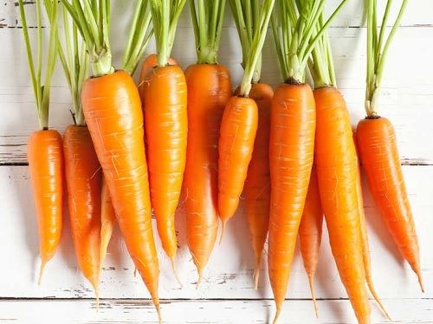Do you like _ _ _ _ _ _ s?
26. likes/ chess./ books about/ reading/ They/
27. Which word has the letter ‘g’ pronounced as the letter ‘g’ in \"gym\"?
A. orange B. go C. skating D. granddad
28. Nghe: Nhấn giữ Ctrl và bấm chuột để nghe: Nina is a _ _ _ .
29. Let’s go out for _ _ _ ner. I’m hungry now.
30. Nghe: Nhấn giữ Ctrl và bấm chuột để nghe: What colour are her eyes? - _ _ _ _ .
31. Nghe: Nhấn giữ Ctrl và bấm chuột để nghe: Her English teacher is Mr. _ _ _ _ .
32. any/ you/ pets?/ Do/ have/
33. These books are for you. – Thank you very m_ _ h.
34. Nghe: Nhấn giữ Ctrl và bấm chuột để nghe: _ _ _ _ _ _ _ _
35. Ảnh: A: Where is the cat? - B: It’s behind the box.
A. Picture 1 B. Picture 2 C. Picture 3 D. Picture 4
36. ...? - He’s from France.
A. Where is he from B. What’s his name C. What does he do D. What’s his nationality
37. A: Where’s my school bag, Mum? - B: ....
A. It’s very big and pretty. B. It’s red and orange. C. I have a small school bag. D. I don’t know, son.
38. Susan/ wearing/ shirts?/ Does/ like/
39. Sing wit_ me.
40. Nghe: Nhấn giữ Ctrl và bấm chuột để nghe: I _ _ _ _ a cat.
41. Is that your new pencil case? - No, it isn’t. It’s ….
A. my sister’s B. him C. her D. my brother
42. _ _ _ _ _ is a doll.
43. Ha Noi is in n_ _ _ _ Viet Nam.
44. Would you like ... to the movies tonight?
A. go B. going C. to go D. goes
45. The lamp is _ _ _ ween the sofa and the armchair.
46. Which word has the underlined part pronounced differently from the letter ‘U’ in “TRUCK”?
A. cupboard B. funny C. sunny D. picture
47. Nghe: Nhấn giữ Ctrl và bấm chuột để nghe: _ _ _ _ _ _ _
48. I can/ dance/ swim./ I can’t/ but/
49. room./ a bookcase/ my/ There’s/ in/
50. Ảnh: 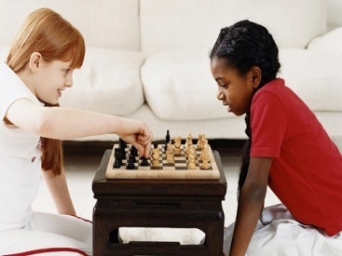We like playing _ _ _ _ _ after school.
51. These … members of my family.
A. is B. are C. am D. be
52. old/ are/ How/ and Peter?/ Tim
53. How do you spell the wo_ _ ’’MONKEY’’?
54. Look that woman! _ _ _ ’s my teacher.
55. Thank you very much. – You’re w_ _ _ _ me.
56. A: How old is your grandma? - B: … fifty-nine years old.
A. She is B. He is C. They are D. We are
57. These a_ _ pink desks.
58. Nghe: Nhấn giữ Ctrl và bấm chuột để nghe: Which is the _ _ _ _ _ _ _ , a giraffe, an elephant or a monkey? – Of course, a giraffe.
59. Would you like some …? – No, thanks. I hate sweets.
A. coffee B. lemonade C. chocolate D. chicken
60. What/ is/ teacher’s/ name?/ your/
61. Helen often _ _ _ _ to school with her friend, Elle.
62. Ảnh: 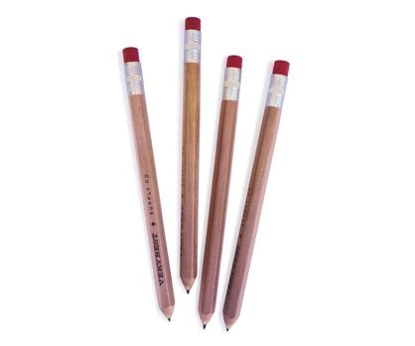I have four p_ _ _ _ _ _ in my school bag today
63. Ninh _ _ _ _ _ comic books in his classroom at break time.
64. the park/ Nam is/ his friends./ in/ with
65. They/ are/ in/ the kitchen./ talking/
66. Where is the chair? - It's _____ my bedroom.
A. on B. in C. at D. to
67. Ope_ your book.
68. Ảnh: My p_ _ _ _ ts are between my sister and me.
69. Linda is her _ _ me.
70. Pick _ _ your ruler.
71. A: Is he Tony? – B: No, … .
A. he is B. he isn’t C. he not is D. not he is
72. there?/ many/ keys/ are/ How/
73. Choose the letter(s) to make a correct word: chi__en
A. sk B. ck C. cc D. kk
74. a look/ Come in/ at/ my bedroom./ and take/
75. Ảnh: 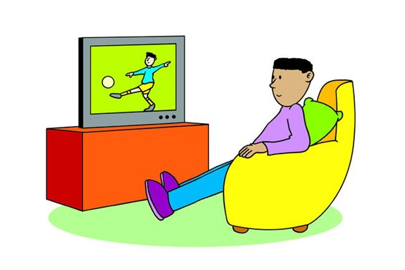Look at the picture and choose the TRUE statement.
A. He is watching a football match on TV. B. He is sitting on the chair. C. There is a teddy bear behind him. D. There is a computer in front of him.
76. Nghe: Nhấn giữ Ctrl và bấm chuột để nghe: ... are you?
A. who B. where C. how D. what
77. Nghe: Nhấn giữ Ctrl và bấm chuột để nghe: There are _ _ _ teen children in the girl’s class.
78. friends/ are/ Her/ France./ from
79. Come and _ _ at with your friends.
80. Do you like colouring? – Yes, it is so m_ _ _ fun.
81. and blue/ like/ orange/ I/ colours./
82. This/ is/ my/ friend./ new
83. books/ How/ have?/ many/ do you
84. ... I go out?
A. May B. My C. Me D. Mai
85. ... are you? – I’m fine, thanks.
A. When B. How C. What D. Who
86. What is her fa_ _ _ rite sport? – She likes doing yoga best.
87. Great … you again.
A. sees B. to see C. to seeing D. on seeing
88. We catch a bus _ _ school every schoolday.
89. family/ is/ his/ name?/ What/
90. Which word has the letter ‘e’ pronounced as the letter ‘e’ in \"yes\"?
A. new B. orange C. come D. bed
91. How are ..., Mary? – I’m fine, thanks.
A. he B. she C. you D. his
92. in the/ Do you/ late/ evening?/ come home/
93. My new _ _ _ _ _ _ is Adam.
94. Who can p_ _ _ the guitar? – Dad.
95. How’s the weather today?
A. It’s a cloud. B. It’s cloudy. C. It’s fine, thank you. D. It has a sun.
96. _ _ they have a pet?
97. Listen ... the teacher, please.
A. on B. in C. to D. for
98. All members of my family like d_ _ _ _ sports.
99. Nice to meet you. - ….
A. Bye. See you later. B. I am fine. Thank you. C. It’s rainy. D. Glad to meet you too.
100. forest./ is/ near the/ house/ The/
101. volleyball/ after/ He often/ plays/ school./
102. … are you? – I’m fine, thanks.
A. What B. How C. Who D. Where
103. How’s the wea_ _ er today? – It’s sunny.
104. like/ best./ I/ Art/ lessons
105. Nice to meet ..., too .
A. me B. he C. your D. you
106. the/ shelf./ the books/ Put/ on/
107. These _____ old notebooks.
A. am B. is C. are D. have
108. ... that a pink pencil? – No, it isn’t.
A. Are B. Is C. Who D. When
109. are/ cups/ These/ blue.
110. What is his friend’s name? - … name is Anna.
A. His B. Their C. Her D. She
111. Is school fun? - Yes, it is so _ _ ch fun.
112. Do/ “Tom and Jerry”?/ you/ like/
113. ... your teeth, John.
A. Read B. Listen C. Stand D. Brush
114. The picture is _ _ the wall.
115. Nghe: Nhấn giữ Ctrl và bấm chuột để nghe: Listen and choose the correct phrases you hear:
A. yellow bananas B. yellow brothers C. yellow apples D. yellow books
116. There ... one ruler on that desk.
A. am B. an C. is D. are
117. Is your school big? - _ _ _ , it is.
118. A: … do you go shopping? – B: Once a week.
A. How many B. What C. How often D. When
119. Nghe: Nhấn giữ Ctrl và bấm chuột để nghe: Flames come out of the _ _ _ _ _ _ .
120. My bedroom is ... big. It’s small.
A. no B. not C. yes D. hi
121. planting some flowers/ the garden./ My grandmother/ in/ is/
122. Ảnh: 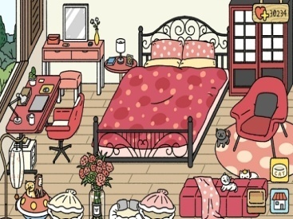How many beds are there in the room?
A. One. B. Two. C. Three. D. Four.
123. Dr_ _ a big brown dog, please.
124. Nghe: Nhấn giữ Ctrl và bấm chuột để nghe: _ _ love pets.
125. is/ favourite/ your/ What/ subject?/
126. Is this a bag? - ... .
A. Yes, it is B. Yes, isn’t C. No, it is D. Not, it isn’t
127. _ _ _ _ is your favourite drink? – I like orange juice.
128. Ảnh: _ _ _ _ _ your answer, please.
129. favourite/ Science/ your/ subject?/ Is/
130. GA__EN
A. AR B. RD C. RT D. D
131. Ảnh: Nguyet is _ _ _ _ _ _ _ _ the floor.
132. a/ Mary/ skirt./ has/ green
133. I’m ... a letter to my friend at the moment.
A. writing B. writes C. written D. to write
134. You and … are friends forever.
A. me B. my C. I D. myself
135. Bella likes playing _ _ _ guitar.
136. Glad to meet you. – Glad to meet you, _ _ _ .
137. Mary likes to read books in the school li_ _ ary.
138. Let’s play _______ piano together.
A. some B. a C. the D. with
139. It is/ sunny/ always/ in/ summer./
140. We like … to music in the morning.
A. listen B. listening C. listens D. not listen
141. Ảnh: Where is your sister? – She is sitting in the armchair ______ the living room.
A. in B. on C. at D. between
142. What day is it _ _ _ ay?
143. Is your bedroom big? – No, it’s s_ _ ll.
144. Nghe: Nhấn giữ Ctrl và bấm chuột để nghe: _ _ _ _ _
145. This/ is a/ grandparents and/ my uncles./ photo of my/
146. Nghe: Nhấn giữ Ctrl và bấm chuột để nghe: The cat walks _ _ _ _ to the ball.
147. Linda/ like/ play/ guitar
A. Linda likes playing guitar. B. Linda like playing the guitar. C. Linda likes playing a guitar. D. Linda like playing guitar.
148. P_ _ your hand down, Simon.
149. twelve/ in my class./ students/ are/ There/
150. give/ Please,/ me/ some/ more pencils./
151. How _ _ _ _ dogs do you have? – I don’t have any dogs.
152. Please c_ _ _ t from 1 to 10 in English.
153. … do you like to play? – I like to play hide-and-seek.
A. What B. Where C. When D. How
154. twelve/ is/ old./ She/ years
155. This is Mary. ... is my friend.
A. I B. You C. She D. He
156. Ảnh: 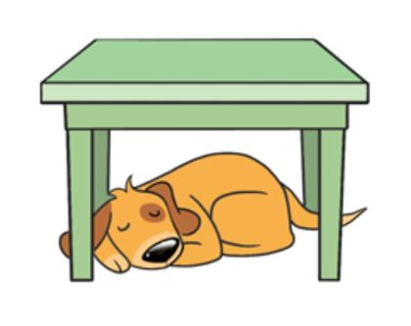My dog is sleeping _ _ _ _ _ the table.
157. Ảnh: What is it? – It’s a … .
A. pencil B. pen C. book D. crayon
158. Ảnh: 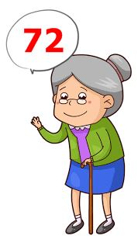A: Is your grandma … years old? - B: Yes, she is.
A. seventy-two B. twenty-seven C. seventy-seven D. twenty-two
159. Nghe: Nhấn giữ Ctrl và bấm chuột để nghe: My _ _ _ _ _ are black.
160. She’s learning how to _ _ _ _ spaghetti.
161. Ảnh: Do you have toys? – Yes, I have a _ _ _ _ .
162. Our school is _ _ north city.
163. A … helps people with sickness.
A. doctor B. worker C. farmer D. housewife
164. aloud./ Read/ chant/ the/
165. _ _ _ _ _ birthday to you, Katie.
166. Choose the odd one out:
A. living room B. bedroom C. garden D. kitchen
167. cousin./ my/ The girl/ is/ over there/
168. Lan is a … at Thong Nhat primary school.
A. farmer B. worker C. student D. doctor
169. It’s/ teddy/ Rosie’s/ not/ bear./
170. are/ playing/ badminton/ My friends/ at the court./
171. He _ _ _ swim but he can’t dance.
172. It is n_ t my chair.
173. M_ _ I go out?
174. How many wardrobes ________? - There is one.
A. is there B. there is C. there are D. are there
175. Choose the odd one out:
A. skipping B. table tennis C. badminton D. tennis
176. Nghe: Nhấn giữ Ctrl và bấm chuột để nghe: There are schools all _ _ _ _ _ _ the world.
177. … are my new books? - They are under the table.
A. What B. How C. When D. Where
178. My brother likes to dri_ _ milk very much.
179. I don’t like rock _ _ _ ic much.
180. How is the ______ today?
A. activity B. colour C. weather D. age
181. school/ our/ bags./ Those/ are/
182. in/ family./ There are/ five people/ Phong’s
183. A: Is your house _ _ _ _ the cinema? - B: No, it’s very far.
184. The o_ _ computer is very slow.
185. She sometimes goes to school ... foot.
A. by B. to C. on D. in
186. How/ old/ father?/ is/ your
187. Mary is … . She wants some water.
A. hungry B. thirsty C. sick D. pretty
188. Nghe: Nhấn giữ Ctrl và bấm chuột để nghe: My _ _ _ is blue.
189. Today,/ is/ the/ nice./ weather/
190. Nghe: Nhấn giữ Ctrl và bấm chuột để nghe: I’ve got an _ _ _ .
191. the/ bathroom?/ Is/ he/ in/
192. What colour ... this?
A. it B. this C. that D. is
193. She _______ a picture.
A. take B. drawing C. is drawing D. draw
194. you play/ badminton/ Do/ yard at break time?/ in the school
195. hobby?/ What/ is/ your/
196. This is our w_ _ home from school.
197. Which is your school? – This _ _ _ .
198. What’s your nam_ ?
199. My b_ _ thday is in May.
200. today./ The weather/ is/ very/ cold

IOE K3 SỐ 45
1. St_ _ d up, please.
2. What grade are you …, James?
A. on B. at C. of D. in
3. Nghe: Nhấn giữ Ctrl và bấm chuột để nghe: Listen and choose the correct phrases you hear:
A. It’s a B. I am C. I can D. I do
4. is far/ The/ from our/ sweet shop/ flat./
5. This pen is _ _ _ blue. It’s green.
6. What/ have?/ pets/ do/ you
7. bedroom/ is/ very/ large./ Mary’s/
8. over there?/ on the desk/ that/ Is/ your pencil sharpener/
9. your house/ a/ have/ Does/ garage?/
10. What is your favourite …? – I like pink.
A. food B. drink C. subject D. colour
11. … to meet you, Alice.
A. Well B. Fine C. Nice D. Kind
12. Nghe: Nhấn giữ Ctrl và bấm chuột để nghe: He’s ..... years old.
A. two B. nine C. late D. eight
13. Nghe: Nhấn giữ Ctrl và bấm chuột để nghe: The ... is yellow.
A. bag B. bat C. bus D. book
14. Mary and Peter can … Vietnamese.
A. speaks B. speak C. to speak D. a speak
15. May I ... out?
A. ride B. go C. meet D. come
16. Nghe: Nhấn giữ Ctrl và bấm chuột để nghe: How old is her grandfather? – He’s ______.
A. 51 B. 52 C. 53 D. 54
17. A: Do you have a cat? - B: No, I _ _ _ ’t.
18. There are s_ _ en days in a week.
19. Are there _________ clocks on the table?
A. a B. an C. some D. any
20. Let’s/ learn/ English./
21. Ảnh: 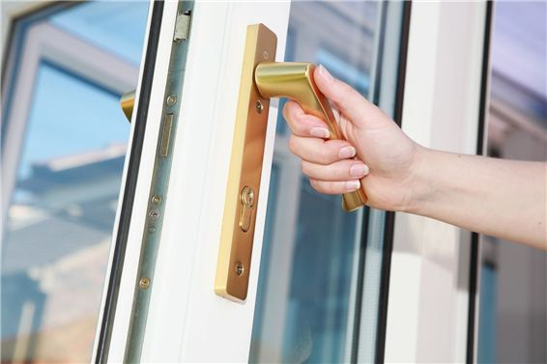May I open the …? – Yes, you can.
A. book B. pencil case C. notebook D. door
22. Is your classroom ...? - No, it is small.
A. big B. this C. bye D. nice
23. H_ _ many books are there in your bag?
24. brother/ nine/ My/ years old./ is/
25. How/ your/ name?/ do I/ spell/
26. Ảnh: They are … .
A. pencils B. sharpeners C. rulers D. erasers
27. Van: What’s that tall building there? - Lan: It’s _ _ new school
28. Glad to meet you. – Glad to meet you, _ _ _ .
29. Ảnh: Look at the picture and choose the FALSE statement.
A. There is a book on the table. B. There is a picture on the wall. C. There is a cat next to the armchair. D. There is a ball under the table.
30. Nancy has a pet. It can catch a mouse. It’s a _ _ _ .
31. ...at colour is this? – It’s blue.
A. Wt B. Ho C. Wh D. We
32. Ảnh: Please turn on the _ _ _ _ . The room is dark.
33. FRI_ ND
34. Ảnh: 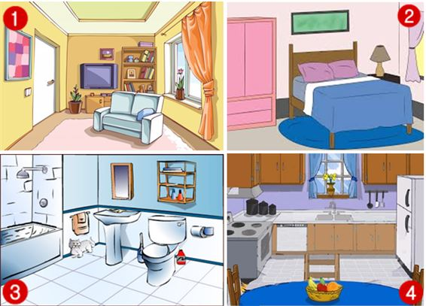Where is the cat?
A. Picture 1 B. Picture 2 C. Picture 3 D. Picture 4
35. _ _ y you help me? I can’t do it.
36. Choose the odd one out.
A. pencil B. door C. book D. ruler
37. Do you play _ _ _ guitar in the afternoon? – Yes, I do.
38. My father … to work at 6 o’clock.
A. go B. play C. goes D. plays
39. Gi_ e me the book, please.
40. What grade … your twin brothers in?
A. am B. is C. are D. do
41. It’s a b_ ue pencil.
42. bluff/ at/ break time?/ play/ blind man’s/ Does Khanh/
43. toybox./ a red/ We have/ in our/ plane/
44. birthday?/ is/ When/ your/
45. you/ like/ “Tom and Jerry”?/ Do/
46. Hello. My name’s Tommy. - ... .
A. See you later B. Good night C. Hi. I am Tim. Nice to meet you D. Goodbye
47. Nghe: Nhấn giữ Ctrl và bấm chuột để nghe: Mike’s favourite pet is his ….
A. dog B. parrot C. cat D. rabbit
48. Does/ your/ friend/ a robot?/ have
49. Ảnh: 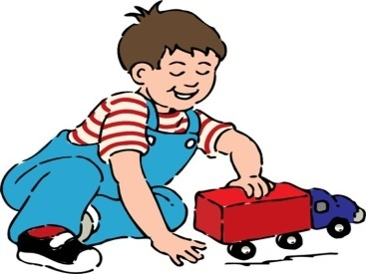My brother is playing with a ….
A. plane B. kite C. ship D. truck
50. Odd one out:
A. school B. cinema C. place D. circus
51. How are you, Tommy? - ... .
A. I’m ten years old B. She’s my sister C. I’m fine, thank you. And you? D. See you later
52. My birthday is in _ _ cember.
53. Do you/ man’s/ bluff?/ blind/ like/
54. How many ______ are there in your pencil case?
A. ruler B. pencil C. rubber D. markers
55. What’s his name? – H_ s name is Peter.
56. my birthday present/ The cat/ my parents./ is/ from
57. _________ likes doing yoga, mom or Uncle John? – My mom.
A. What B. Which C. Who D. When
58. my/ not/ Thanh/ sister./ is/
59. Are you ______? – No. I’m full.
A. thirsty B. hungry C. hot D. tired
60. Nghe: Nhấn giữ Ctrl và bấm chuột để nghe: Look! Here is a _ _ _ _ .
61. Look! Birds … in the sky.
A. flies B. fly C. is flying D. are flying
62. The pond/ is/ large./ our house/ of/
63. ... I go out?
A. May B. My C. Me D. Mai
64. Is your school bag blue? - Y_ _ , it is.
65. Goodbye. See you aga_ _ .
66. four paintings/ and a big poster/ on/ There are/ the wall./
67. Is he playing t_ _ _ e tennis in the gym?
68. classroom./ is/ This/ our/
69. the story/ Do/ know/ “Harry Potter”?/ you/
70. Ảnh: I keep my parrot in a _ _ _ _ .
71. I’m Mai. H_ _ are you? – I’m fine, thanks.
72. pencil case?/ in your/ Are/ there any/ crayons/
73. Who is bigger, Jane _ _ Alice?
74. Nghe: Nhấn giữ Ctrl và bấm chuột để nghe: Which is NOT mentioned in the recording?
A. garden B. bathroom C. bedroom D. kitchen
75. is/ bag/ Your/ pink./ school/
76. Ảnh: Do you like playing …?
A. football B. paper boats C. chess D. hide-and-seek
77. I have m_ _ y toys.
78. A: Is the dining room large? - B: No, it isn’t. It’s sm_ _ _ .
79. He can … with a yo-yo.
A. play B. catch C. do D. say
80. his friends./ with/ Nam is/ in/ the park/
81. old?/ your father/ Is/ years/ forty-one/
82. Ảnh: They are _ _ _ _ _ _ kites in the playground.
83. These fl_ _ ers are for you, Mary. – Thank you.
84. Her house is small but … is very nice.
A. he B. she C. they D. it
85. Nghe: Nhấn giữ Ctrl và bấm chuột để nghe: He’s _ _ _ _ _ years old.
86. Ảnh: What are these? - They are my sc_ _ _ _ things for this new year.
87. My father can dr_ _ e a car.
88. How _ _ _ _ pencils are there in the box?
89. That is my s_ _ _ _ _ library.
90. Thank you. – You are w_ _ _ _ me.
91. This _ _ my school library.
92. _ _ _ _ Mr. Black have a new car?
93. Could you tell me the way … the hospital?
A. on B. at C. to D. in
94. Would you _ _ _ _ some cakes?
95. Is that a yellow kite? - _ _ , it isn’t.
96. … subjects do you have on Tuesday?
A. What B. How C. Who D. When
97. near/ their house./ They are/ at the pond/ fishing/
98. He/ young./ and/ is/ tall/
99. My friends and I … a new way to learn English.
A. go B. look C. find D. do
100. Nghe: Nhấn giữ Ctrl và bấm chuột để nghe: This is a bike. It’s a _ _ _ _ bike.
101. wardrobe?/ colour/ is/ your/ What/
102. Hoa: Where does Minh study? - Nga: He studies at Le Ngoc Han Pri_ _ _ _ School.
103. How’s the weather today?
A. It’s a cloud. B. It’s cloudy. C. It’s fine, thank you. D. It has a sun.
104. sleeping in/ is/ Hieu/ bedroom./ his
105. These a_ _ pink desks.
106. Nghe: Nhấn giữ Ctrl và bấm chuột để nghe: Little cloud changes into a _ _ _ _ _ cloud.
107. What are you doing? – I am _ _ _ _ _ _ _ _ TV.
108. A: How many … do you have? - B: Six.
A. fish B. dog C. cat D. hen
109. in/ three girls/ my class./ only/ There are/
110. bedroom/ lovely./ Your/ is/
111. How is the weather ... London today?
A. at B. on C. in D. to
112. a big/ tree/ There is/ my garden./ in
113. The picture is _ _ _ _ _ _ _ the window and the shelf.
114. you,/ to/ Jimmy./ Happy/ birthday/
115. What is your ...? – I’m Peter.
A. name B. name’s C. meet D. friend
116. Is this your grandfather? – Yes, he _ _ .
117. The opposite of \"on\" is \"_ _ _ _ _ \".
118. Fine, thanks. A_ d you?
119. A: Does Peter have any ...? - B: Yes. He does. He has three.
A. rabbit B. parrot C. goldfish D. tortoise
120. R_ ad after me, children.
121. Nghe: Nhấn giữ Ctrl và bấm chuột để nghe: Choose the TRUE statement.
A. She has a big house and a big garden. B. She has a big house and a small garden. C. She has a small house and a big garden. D. She has a small house and a small garden.
122. … you swim? – No, I can’t.
A. Do B. Who C. When D. Can
123. L_ _ k at the board, please.
124. _______ you have any toys?
A. Does B. Do C. Are D. Is
125. doll./ is/ a/ This/
126. My wife/ cooking/ a chicken/ is/ for dinner./
127. The map is on the w_ _ _ .
128. that/ Who’s/ girl/ in the/ corner?/
129. Those are my blue balloo_ _ .
130. May I _ _ _ y the piano?
131. play/ me./ with/ Let’s/
132. Nghe: Nhấn giữ Ctrl và bấm chuột để nghe: Two ... are swimming in the water.
A. donkeys B. chickens C. bears D. monkeys
133. My brother is tall … slim.
A. then B. and C. so D. or
134. Mai is laughing. She is ______.
A. hungry B. sad C. happy D. nervous
135. I can … a kite.
A. this B. fly C. the D. a
136. Good m_ _ ning, everyone.
137. Nghe: Nhấn giữ Ctrl và bấm chuột để nghe: Listen and choose the correct phrases you hear:
A. What is B. How old C. Can you D. Would you
138. Is this a ruler? - ..., it is.
A. That B. Yes C. This D. His
139. Let’s w_ _ k to school today. My bike is broken.
140. I can r_ _ e a bicycle.
141. My brother can play the piano but … play the guitar.
A. can B. can not C. cannot D. cant’
142. It/ a/ school bus./ green/ is/
143. today/ good./ The/ weather/ is
144. Ảnh: I have three toy cars. They are green, red and ye_ _ _ _ .
145. His house _ _ not big.
146. Ảnh: 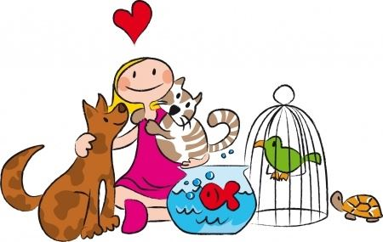Look at the picture. Which pet DOESN’T she have?
A. A tortoise. B. A dog. C. A fish. D. A chicken.
147. does/ Terry/ What/ have?/ books/
148. where/ are./ I/ your bag/ don’t know/
149. My mother likes chatting with ….
A. I B. she C. her friends D. Minh’s
150. Good_ _ _ Mary. See you later.
151. Stand _ _ , please.
152. Minh often plays football … his friends on Sunday.
A. with B. to C. of D. at
153. Nghe: Nhấn giữ Ctrl và bấm chuột để nghe: Listen and tick the word you hear:
A. Swim B. Fly C. Run D. Jump
154. ... that a pink pencil? – No, it isn’t.
A. Are B. Is C. Who D. When
155. birthday?/ my/ Can/ you/ remember/
156. A: How old are you? – B: I am … years old.
A. a B. an C. eight D. one
157. I am sorry. I am late. - … in please!
A. Do B. Go C. Come D. Study
158. I go _ _ school every morning.
159. There are a lot of trees a_ _ _ nd my house.
160. lessons/ like/ Art/ I/ best./
161. is playing/ with a/ My cat/ butterfly.
162. Nghe: Nhấn giữ Ctrl và bấm chuột để nghe: This is my school _ _ _ .
163. notebooks/ , Alan./ your/ Take/ out/
164. Nghe: Nhấn giữ Ctrl và bấm chuột để nghe: Can I borrow you ruler? – Yes, but don’t forget to give it _ _ _ _ .
165. A: What is your sister _ _ ing? - B: She’s listening to music.
166. Ảnh: Look at the _ _ _ _ _ , please.
167. Is the girl o_ _ _ there your classmate, Rosie?
168. I have Math on Monday and Friday. We have it ... a week.
A. once B. twice C. three times D. four times
169. Can the cat _ _ _ _ _ a tree? – Yes, it can.
170. This is my father. ... name is Lam.
A. Her B. His C. This D. My
171. Ảnh: There is a _ _ _ ot.
172. A: Is there a cupboard or a wardrobe in your bedroom? - B: …
A. Yes, there is. B. There are both of them. C. My clothes are in the wardrobe. D. My toys are in the cupboard.
173. is/ class/ What/ she/ in?/
174. Can you come and s_ _ _ a song with me?
175. time/ John./ homework,/ for/ It’s/
176. Choose the odd one out:
A. How B. What C. Who D. Jane
177. Who is he? - ... .
A. He my friend B. She my friend C. He is Simon. He is my good friend D. She’s Mary
178. two/ I wash/ my hair/ every/ days./
179. These … members of my family.
A. is B. are C. am D. be
180. Why does/ usually/ go to/ Jimmy/ the zoo?/
181. My uncle is going to make a cake … me.
A. from B. at C. for D. on
182. Nghe: Nhấn giữ Ctrl và bấm chuột để nghe: The dog’s name is S_ _ _ _ ge.
183. Ảnh: It’s a red _ _ _ _ _ . It’s ringing.
184. Do you like … puzzles?
A. playing B. doing C. do D. play
185. My cat/ tail./ has/ a/ long
186. Ảnh: 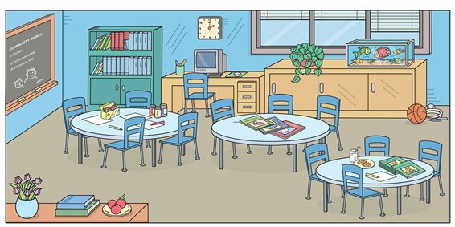There are … round tables and … chairs.
A. one - four B. four - eleven C. five - twelve D. three - twelve
187. Nghe: Nhấn giữ Ctrl và bấm chuột để nghe: A girl is eating _ _ _ ice-creams.
188. Nghe: Nhấn giữ Ctrl và bấm chuột để nghe: What is ... job?
A. her B. its C. his D. their
189. Ảnh: The _ _ _ _ is on the armchair.
190. He...o, my name’s Lan.
A. li B. ll C. lk D. lw
191. Ảnh: Which is not in the toy box?
A. The ball. B. The robot. C. The teddy bear. D. The truck.
192. Close the d_ _ _ , please.
193. C_ _ _ on. We don’t have much time.
194. pen/ yours?/ is/ Which/
195. What is this? - ….
A. It’s a mobile phone. B. This is nice book. C. That is a big table. D. Its a ruler.
196. Read the world a_ _ _ _ .
197. The opposite of IN FRONT OF is _ _ _ _ _ _ .
198. What’s y_ ur name?
199. _ _ _ _ do you do in the afternoon? – I play badminton.
200. Nghe: Nhấn giữ Ctrl và bấm chuột để nghe: He likes _ _ _ _ _ _ .

IOE K3 SỐ 46
1. There is a green kite ... the sky.
A. on B. at C. for D. in
2. Is this your dog? – Yes, _ _ is.
3. birthday?/ is/ your/ When/
4. My class/ boys and/ has twenty/ girls./ twenty-two
5. These fl_ _ ers are for you, Mary. – Thank you.
6. Lang Son is far _ _ _ _ Quang Binh.
7. Ảnh: Do you like s_ _ food?
8. Ảnh: Look at the picture and choose the FALSE statement.
A. There is a book on the table. B. There is a picture on the wall. C. There is a cat next to the armchair. D. There is a ball under the table.
9. What is your hobby? – I … walking the dog in the park.
A. like B. have C. can D. do
10. Play with m_ , please.
11. is reading/ book./ My friend,/ Linda,/ a
12. … subjects do you have on Tuesday?
A. What B. How C. Who D. When
13. Can you _ _ _ _ a bicycle?
14. _ _ _ _ _ birthday to you, Katie.
15. Taylor is from England. She … me every month.
A. calls B. write C. read D. speak
16. Nghe: Nhấn giữ Ctrl và bấm chuột để nghe: The cat is _ _ _ _ _ .
17. are there/ the music room?/ boys/ in/ How many/
18. Ảnh: 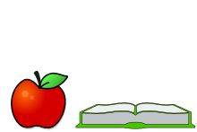The apple is … the book.
A. next to B. on C. under D. over
19. Ảnh: My brother likes playing _ _ _ _ _ _ ball in the school gym.
20. Nam: Is that girl new? - Lien: I don’t kn_ _ . Ask Hoa.
21. ... is that? - It’s a pen.
A. How B. When C. What D. Where
22. This birthday cake is … you.
A. for B. on C. of D. to
23. Play with m_ .
24. Are those his school bags? - ________
A. Yes, it is. B. Yes, they are. C. Yes, are they. D. No, they are.
25. Ảnh: 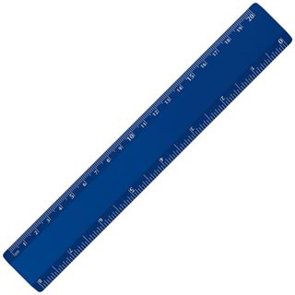My ruler is pink. Your ruler is _ _ _ _ .
26. Ảnh: My mother is _ _ _ _ _ _ _ for dinner.
27. Nghe: Nhấn giữ Ctrl và bấm chuột để nghe: He’s ..... years old.
A. two B. nine C. late D. eight
28. spell/ do you/ How/ Loan?/ your name,
29. During M_ _ _ s lessons, I learn about numbers.
30. You never know how _ _ _ _ I love you, my parents.
31. Let’s ma_ e a circle.
32. Nghe: Nhấn giữ Ctrl và bấm chuột để nghe: The ... is yellow.
A. bag B. bat C. bus D. book
33. A bird can f_ y.
34. Let’s sing an English s_ _ g.
35. boy?/ is/ Who/ little/ that/
36. Nghe: Nhấn giữ Ctrl và bấm chuột để nghe: Which is NOT mentioned in the recording?
A. ball B. doll C. puzzle D. teddy
37. shopping/ want to go/ Do you/ with me?
38. Ảnh: 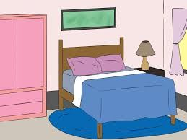This is my parents’_ _ _ room.
39. There are m_ _ y toys in my room.
40. Draw/ a picture/ of/ yourself.
41. Ha Long Bay is ______ from Hanoi.
A. near B. next to C. above D. far
42. Minh often plays football … his friends on Sunday.
A. with B. to C. of D. at
43. Choose the odd one out:
A. paint B. draw C. write D. walk
44. in my dining room./ chairs and a table/ There/ are/ eight/
45. How are you? - ... .
A. I’m Binh B. She’s my sister C. I’m fine, thank you D. Goodbye
46. Peter/ Linda/ hide-and-seek/ now.
A. Peter and Linda is playing hide-and-seek now. B. Peter and Linda are playing with hide-and-seek now. C. Peter and Linda playing hide-and-seek now. D. Peter and Linda are playing hide-and-seek now.
47. Nghe: Nhấn giữ Ctrl và bấm chuột để nghe: This is his house. It’s _ _ _ .
48. Ảnh: The children are ….
A. playing hide-and-seek B. playing blind man’s buff C. skipping rope D. skateboarding
49. Choose the odd one out.
A. play basketball B. listening to music C. drawing a picture D. reading a book
50. is/ the radio./ She/ listening/ to
51. toys/ she have?/ many/ does/ How/
52. Nghe: Nhấn giữ Ctrl và bấm chuột để nghe: Julie has got a _ _ _ _ _ dog.
53. Ảnh: 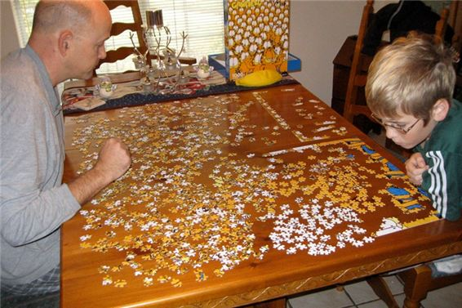This _ _ _ _ le is not easy. I can’t do it.
54. Our uncles are wor_ _ _ s. They work in a factory.
55. What is that? – It’s _ big red ball.
56. This/ green/ is a/ book.
57. The lamp is _ _ _ ween the sofa and the armchair.
58. … is your birthday?
A. Who B. When C. Where D. How
59. Minh: Where are you? - Nga: I am w_ _ _ my friends.
60. some/ Can/ rice?/ more/ I have/
61. Rosie’s/ It’s/ bear./ teddy/ not/
62. Ảnh: Cinderella is ______ with the prince at the party.
A. dance B. dances C. dancing D. danceing
63. Hi_ name is Peter.
64. Nghe: Nhấn giữ Ctrl và bấm chuột để nghe: The cat walks _ _ _ _ to the ball.
65. Nghe: Nhấn giữ Ctrl và bấm chuột để nghe: A girl is eating _ _ _ ice-creams.
66. Primary School./ friends/ study/ at Kim Dong/ My old/
67. My little brother often … his kite when he’s not busy.
A. does B. plays C. goes D. flies
68. is/ on/ the wall?/ this/ What/
69. Which word has the letter ‘i’ pronounced as the letter ‘i’ in ’’it’’?
A. I B. blind C. library D. big
70. Nghe: Nhấn giữ Ctrl và bấm chuột để nghe: _ _ _ _ _ _
71. Choose the letter(s) to make a correct word: voll__ball
A. ii B. ie C. ey D. iy
72. garden?/ there/ are/ in the/ What/
73. The new boy sits … me.
A. down B. next to C. up D. at
74. Linda and I are ….
A. brothers B. sister C. friends D. classmate
75. school?/ the/ What is/ your/ name of/
76. Nghe: Nhấn giữ Ctrl và bấm chuột để nghe: _ _ _ _ _ _ _ _ _
77. Can you _ _ _ _ _ your name, please? – Yes. P-E-T-E-R.
78. … is that boy? – He is my new friend from school.
A. What B. Which C. Who D. Where
79. Choose the odd one out:
A. How B. What C. Who D. Jane
80. See you tomo_ _ ow.
81. in/ There’s/ my/ room./ a bookcase/
82. birthday?/ his/ is/ When/
83. I _ _ Chi. I am in class 3A.
84. My bedroom is large _ _ _ beautiful.
85. of sports./ play/ can/ I/ a lot
86. Ảnh: Do you have toys? – Yes, I have a _ _ _ _ .
87. The opposite of \"small\" is \"_ _ _ \".
88. Peter is my friend, t_ _ .
89. Ảnh: Don’t forget put the car in the ….
A. kitchen B. garden C. bedroom D. garage
90. doing?/ What’s/ Mai/
91. What/ lessons?/ you do/ during English/ do/
92. Nghe: Nhấn giữ Ctrl và bấm chuột để nghe: Is your school big _ _ little?
93. Re_ _ der the sentences.
94. eggs/ These/ white./ are/
95. Unscramble this word: restpo -> _ _ _ _ _ _
96. in/ are/ the/ brown box./ My toys/
97. Choose the odd one out:
A. eraser B. notebook C. crayon D. England
98. Nghe: Nhấn giữ Ctrl và bấm chuột để nghe: Baz’s boat is in his _ _ _ _ .
99. Andy./ is/ My name/
100. My sister can … a pony.
A. my B. ride C. ride’s D. I
101. W_ _ t is that? – It’s a teddy bear.
102. I go _ _ school every morning.
103. I _ _ _ not play any sports.
104. Nghe: Nhấn giữ Ctrl và bấm chuột để nghe: Choose the TRUE statement.
A. There is some cola on the table. B. There are some cakes and cola on the table. C. There aren’t any cakes and cola on the table. D. There are some cakes on the table.
105. out/ your/ , Alan./ Take/ notebooks
106. What books are they? - T_ _ _ are Maths books.
107. This ... my mother.
A. are B. am C. is D. and
108. I have Math on Monday and Friday. We have it ... a week.
A. once B. twice C. three times D. four times
109. countryside./ school/ is in/ My/ the
110. coffee./ Tim/ doesn’t/ like/
111. blue/ It/ is/ phone./ a/
112. A: …? - B: No, he isn’t.
A. Does your father work on the farm? B. Is that your father? C. Is your father watching TV? D. Does your father have any pets?
113. Ảnh: I can hear with my _ _ _ s.
114. Let’s go to school t_ _ _ _ _ _ _ !
115. What is your … drink? – I like orange juice the most.
A. name B. favourite C. much D. many
116. Nghe: Nhấn giữ Ctrl và bấm chuột để nghe: ... is my house.
A. This B. That C. It D. These
117. doll/ for/ you./ This/ is/
118. father?/ your/ old/ is/ How/
119. _ hat’s your name?
120. _______ is Nam from? – He’s from Da Nang.
A. What B. When C. Where D. Who
121. Tom re_ _ _ books in the library in the afternoon.
122. What colour ... that chair? – It’s yellow.
A. it B. is C. that D. hi
123. My new _ _ _ _ _ _ is Adam.
124. Our/ is/ so much/ fun./ class/
125. Ảnh: 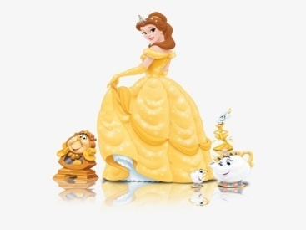Belle is wearing a beautiful y_ _ _ _ _ dress.
126. The cat is sitting ... the tree.
A. near to B. next C. in D. under
127. I’m fine, thank you. ... ?
A. You B. Bye C. And you D. Are
128. Ảnh: This big _ _ _ is very funny.
129. Ảnh: 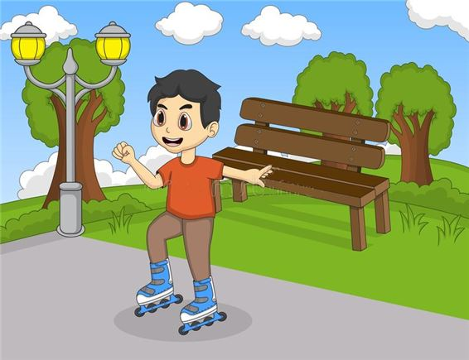He is _ _ _ _ ing in the park now.
130. Are you ______? – No. I’m full.
A. thirsty B. hungry C. hot D. tired
131. Ảnh: The c_ _ _ is on the chair.
132. Do you like _ _ _ _ _ _ _ hide-and-seek? – Yes, I do
133. Nghe: Nhấn giữ Ctrl và bấm chuột để nghe: There is a blue _ _ _ _ _ _ _ _ on the desk.
134. This/ is/ doll./ a/
135. read/ Let’s/ book./ the/
136. She lives ... the sea.
A. in B. on C. near D. at
137. I am … England. I am English.
A. from B. to C. in D. at
138. Jenny is my new f_ _ end.
139. It’s _______ in Hanoi today.
A. cloud B. funny C. sunny D. snow
140. your/ friend?/ new/ this/ Is/
141. Ảnh: They are … .
A. pencils B. sharpeners C. rulers D. erasers
142. Ảnh: She is _ _ _ ding under the tree.
143. Nghe: Nhấn giữ Ctrl và bấm chuột để nghe: My house has a ... yard.
A. small B. fat C. large D. big
144. May we _ _ to school together?
145. much/ coat?/ the/ How/ is/
146. These pictures a_ _ beautiful.
147. There is/ my garden./ dog/ in/ a big/
148. Ảnh: 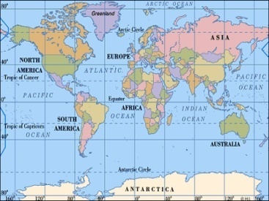Look at the _ _ _ , please.
149. Ảnh: My brother is playing with a ….
A. plane B. kite C. ship D. truck
150. Wh_ _ _ are the maps? – They are on the wall.
151. The books are _ _ the shelves.
152. Nghe: Nhấn giữ Ctrl và bấm chuột để nghe: I ... orange.
A. love B. like C. hate D. eat
153. What … your parents look like?
A. does B. do C. is D. are
154. How are you Hoa, Vinh and Nam? … fine. Thanks.
A. She is B. He is C. They are D. We are
155. What are they? – They are ….
A. red B. small C. stars D. big
156. I love strawberries juice. – Me t_ _ .
157. Nghe: Nhấn giữ Ctrl và bấm chuột để nghe: Which is the _ _ _ _ _ _ _ , a giraffe, an elephant or a monkey? – Of course, a giraffe.
158. Nghe: Nhấn giữ Ctrl và bấm chuột để nghe: There are three ... on the table.
A. rulers B. pencils C. erasers D. pens
159. old/ is/ eldest brother?/ How/ your
160. grandfather./ writing/ to my/ I am/ a letter/
161. Ảnh: Kim: What books are they? - Khoa: They are my English _ _ _ _ _ .
162. Ha Noi is in n_ _ _ _ Viet Nam.
163. How ma_ _ trees are there?
164. is/ shelf./ The radio/ the/ on/
165. My brother is short … sporty.
A. but B. while C. so D. or
166. This pen is _ _ _ blue. It’s green.
167. A dog has _______.
A. four eyes B. four noses C. four tails D. four legs
168. This ... a house.
A. are B. is C. you D. here
169. Pick _ _ your ruler.
170. My pet is a ... .
A. bird B. ship C. robot D. doll
171. I/ two/ have/ robots.
172. Peter _ _ s many rulers.
173. Do you like football or basketball?
A. I don’t like. B. I like it. C. No, I don’t. D. I like volleyball.
174. Read the world a_ _ _ _ .
175. Nghe: Nhấn giữ Ctrl và bấm chuột để nghe: Come on! We must _ _ _ _ him.
176. A: … is your birthday? – B: It’s in July.
A. What B. How C. When D. Where
177. like/ the/ weather./ I/ windy
178. Happy/ to/ you,/ Jimmy./ birthday/
179. Would you like some …? – No, thanks. I hate sweets.
A. coffee B. lemonade C. chocolate D. chicken
180. I … count to 100.
A. cannot B. cant C. can’s D.
181. What’s the matter _ _ _ _ your eyes?
182. Wh_ _ do you have Maths? – I have it on Monday.
183. the library?/ often/ Do/ go to/ you/
184. Ảnh: She has five ….
A. toys B. pets C. dogs D. cats
185. I a_ nine years old. How old are you?
186. There are four win_ _ _ _ in my classroom.
187. Odd one out:
A. large B. kitchen C. small D. big
188. ... are you? – I’m fine, thanks.
A. When B. How C. What D. Who
189. Odd one out:
A. October B. May C. Tom D. July
190. Is your school big? - ..., it is.
A. No B. Not C. Yes D. No, it isn’t
191. A: How _ _ _ is your grandpa? - B: He’s sixty.
192. Co_ plete the sentences.
193. Ảnh: They are … at the moment.
A. reading B. singing C. dancing D. drawing
194. his friends./ Minh/ robots with/ likes/ playing/
195. ... that a pink pencil? – No, it isn’t.
A. Are B. Is C. Who D. When
196. birthday?/ you/ remember/ my/ Can/
197. What/ is/ hobby?/ your/
198. The children are reading Engl_ _ _ in their room.
199. like/ “Tom and Jerry”?/ Do/ you/
200. This/ is a/ red apple./

IOE K3 2023 - 2024 SỐ 47
1. Ảnh: 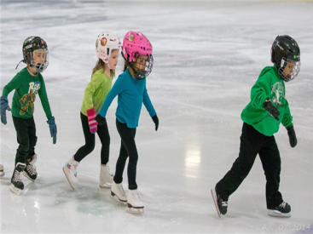They are … right now.
A. skating B. skipping C. singing D. dancing
2. My house _ s small.
3. Who ... that? – That’s Mary. She is my sister.
A. are B. is C. this D. and
4. Nghe: Nhấn giữ Ctrl và bấm chuột để nghe: You are reading a _ _ _ _ _ now.
5. There are two cat_ in that box.
6. the books/ on/ Put/ shelf./ the
7. Ảnh: There are four pretty _ _ _ s here.
8. In Vietnam, we don’t go to school on ... .
A. Monday B. Sunday C. Thursday D. Friday
9. He/ lot/ at school./ has a/ of friends
10. Mary’s/ very/ large./ is/ bedroom/
11. cake./ pink/ a/ It is/
12. of/ Is there/ your house?/ a pond/ in front/
13. you/ have?/ What/ do/ pets/
14. water/ Are there/ Moon?/ on the/ any/
15. Nghe: Nhấn giữ Ctrl và bấm chuột để nghe: Listen and choose the best response.
A. I keep it in the cage. B. It’s very lovely. C. It has brown hair. D. It’s two months ago.
16. How m_ _ _ books are there? – There are three books.
17. Nghe: Nhấn giữ Ctrl và bấm chuột để nghe: She shows them the pictures in the _ _ _ _ .
18. a mat./ on/ is/ Lucy/ sitting/
19. what/ to/ says./ Listen/ the teacher
20. Nghe: Nhấn giữ Ctrl và bấm chuột để nghe: They are in the ....
A. kitchen B. garden C. kitten D. house
21. This is a picture ______ my family.
A. in B. of C. on D. over
22. … subjects do you have on Tuesday?
A. What B. How C. Who D. When
23. go to/ We/ school/ a week./ five days
24. My friends and I … a new way to learn English.
A. go B. look C. find D. do
25. May we _ _ to school together?
26. Hi, ... name is John.
A. your B. my C. its D. me
27. Look! Birds … in the sky.
A. flies B. fly C. is flying D. are flying
28. mother./ this song/ with my/ I/ sing/
29. Ảnh: Where are the maps? - They are on the _ _ _ _ .
30. Is this a book? - ... .
A. Yes, it is B. Yes, isn’t C. No, it is D. Bye
31. your parents/ right now?/ at home/ Are/
32. Ha Noi./ and windy/ in/ cloudy/ It’s/
33. Ảnh: Rabbits like car_ _ _ _ very much.
34. brother/ and sister?/ are/ Where/ your/
35. Ảnh: That’s a _ _ _ . It’s big.
36. Jane never goes to bed l_ _ _ . Because he wants to get up early.
37. It is ... chair.
A. an B. a C. this D. it
38. Ảnh: It is an old rub_ _ _ .
39. Ảnh: She has five ….
A. toys B. pets C. dogs D. cats
40. Choose the odd one out:
A. how B. hello C. hi D. good morning
41. Hello, I am Mai. - …
A. Goodbye and see you later. B. I don’t know. C. Hi, I am fine. Thanks D. Nice to see you.
42. Ảnh: There is a cat … the basket.
A. on B. at C. in D. of
43. What’s your nam_ ?
44. a/ is/ yellow/ yo-yo./ This/
45. Ảnh: 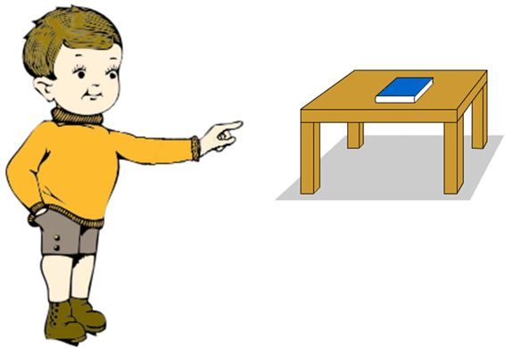The book is t_ _ _ _ , on the table.
46. What col_ _ r is this book? – It’s red.
47. Choose the odd one out:
A. balloon B. yo-yo C. doll D. school
48. Odd one out:
A. they B. ten C. we D. you
49. _ _ at’s her name? – She is Mary.
50. I have Maths _ _ Monday.
51. Ảnh: I’m a student and my friends are _ _ _ _ _ _ _ _ too.
52. Ảnh: 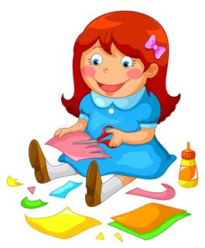Akiko is ….
A. putting her toys away B. making paper toys C. reading her books D. cooking a meal.
53. Is the w_ _ _ _ over there your mother?
54. Is that girl new? – I don’t _ _ ow.
55. and Sarah/ board games./ are/ playing/ Linda/
56. Look that woman! _ _ _ ’s my teacher.
57. Ảnh: Who’s he? - He’s my grand_ _ _ _ _ _ .
58. We have a _ _ _ of toys.
59. _ _ _ ’s that man? – He’s my brother.
60. Are you happy? - Yes, I _ _ .
61. Is the_ _ a dog? – No, there is not.
62. my sister/ my bedroom/ I share/ , Lucy./ with/
63. Let’s make a li_ e, children.
64. Nghe: Nhấn giữ Ctrl và bấm chuột để nghe: Which is NOT mentioned in the recording?
A. ball B. doll C. puzzle D. teddy
65. Ảnh: Cinderella is ______ with the prince at the party.
A. dance B. dances C. dancing D. danceing
66. My sister can … a pony.
A. my B. ride C. ride’s D. I
67. me/ Kids/ very much./ like/
68. Are there _________ clocks on the table?
A. a B. an C. some D. any
69. sitting on the bench?/ tall/ is that/ Who/ girl
70. Let’s/ a/ paper lion./ make/
71. desk/ your/ Touch/ , please.
72. My sister h_ s a new doll.
73. _ _ _ _ _ and eleven is sixty-one.
74. Ảnh: My p_ _ _ _ ts are between my sister and me.
75. May we _ _ out together?
76. Ảnh: Look at the _ _ _ _ _ , please.
77. This is a r_ ler.
78. Quan is _ _ _ _ _ his homework in his room.
79. cooking/ He/ like/ doesn’t/ at home./
80. Are these your ______? – No, they ______.
A. rubber – are B. rubber – is C. rubbers – don’t D. rubbers – aren’t
81. Rai_ _ your hands, please.
82. Ảnh: Two boys are reading their books _ _ _ _ _ the tree.
83. Nghe: Nhấn giữ Ctrl và bấm chuột để nghe: ... are the chairs?
A. Where B. There C. Here D. These
84. This is my aunt. …. twenty-six years old.
A. They are B. He is C. You are D. She is
85. is/ What/ your/ hobby?
86. _ _ o is that? – That’s Mary.
87. What is his date … birth?
A. on B. of C. at D. in
88. Nghe: Nhấn giữ Ctrl và bấm chuột để nghe: Do you have an _ _ _ _ _ _ ?
89. You and … are friends forever.
A. me B. my C. I D. myself
90. It’s always … in summer.
A. cold B. red C. icy D. hot
91. Ảnh: A: Are _ _ _ _ _ your toys? - B: Yes, they are.
92. There are ... chairs in my living room.
A. one B. five C. a D. an
93. Re_ _ der the sentences.
94. is/ name?/ your/ teacher’s/ What/
95. Nghe: Nhấn giữ Ctrl và bấm chuột để nghe: Mai is ....
A. running B. writing C. cycling D. reading
96. the/ puzzle./ Complete/ crossword/
97. Which word has the letter \"a\" pronounced as the letter \"a\" in \"that\"?
A. name B. ball C. orange D. apple
98. What is that? – It is ... orange.
A. a B. an C. am D. are
99. What ... your name?
A. are B. amfriend C. is D. butmee
100. Nghe: Nhấn giữ Ctrl và bấm chuột để nghe: Baz’s boat is in his _ _ _ _ .
101. ... is that? - It’s a pen.
A. How B. When C. What D. Where
102. Jenny is my new f_ _ end.
103. Nghe: Nhấn giữ Ctrl và bấm chuột để nghe: Her name ... Linda.
A. are B. is C. am D. it
104. Who is he? - ... .
A. He my friend B. She my friend C. He is Simon. He is my good friend D. She’s Mary
105. There is a green kite ... the sky.
A. on B. at C. for D. in
106. I’m fine, thank ... . And you?
A. your B. you are C. you’re D. you
107. My sister can f_ _ a kite.
108. bag/ is/ pink./ Your/ school/
109. What do they usually do ... summer?
A. at B. on C. in D. to
110. A: _ _ _ ’s that? - B: It’s my uncle.
111. Is this a bag? - ... .
A. Yes, it is B. Yes, isn’t C. No, it is D. Not, it isn’t
112. big/ I/ want/ a/ carrot./
113. very/ is/ The/ exciting./ game/
114. ... you like chicken?
A. Do B. Does C. Are D. Is
115. Nghe: Nhấn giữ Ctrl và bấm chuột để nghe: He’s _ _ _ _ _ years old.
116. Odd one out:
A. sun B. snowy C. cloud D. wind
117. likes/ My/ and candies./ friend/ fast food
118. _ _ _ _ do you do in the afternoon? – I play badminton.
119. Nghe: Nhấn giữ Ctrl và bấm chuột để nghe: It has _ _ _ _ _ _ _ _ of many animals.
120. Are those your pencil sharpeners?
A. Yes, it is. B. No, it isn’t. C. Yes, they are. D. No, they are.
121. My pictures _ _ _ on the wall.
122. her favourite/ I want/ film./ to/ know/
123. Nghe: Nhấn giữ Ctrl và bấm chuột để nghe: There is a concert in the _ _ _ _ .
124. and/ complete/ sentences./ Listen/ the
125. To_ _ _ is February 14th. Do you have any plan?
126. Linda is her _ _ me.
127. Who is she, Peter? - ... .
A. She Mary B. He’s Tom C. She’s Mary D. My name is Mary
128. chicken./ is/ His/ food/ favourite/
129. A: … do you go shopping? – B: Once a week.
A. How many B. What C. How often D. When
130. This is ... doll.
A. she B. me C. my D. hi
131. Ảnh: How many cats are there in the yard? - There are _ _ _ _ cats. They are eating fish.
132. It is my chai_ .
133. Ha can dance _ _ _ cannot play football.
134. Ảnh: 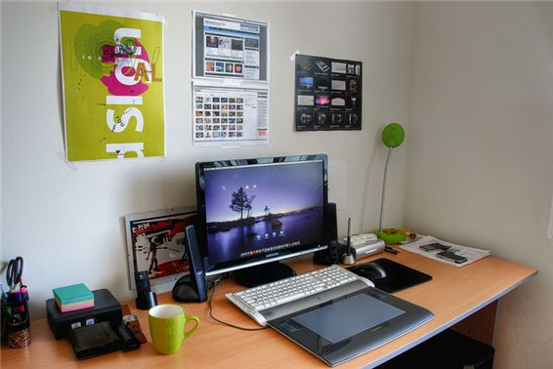This is my new co_ _ _ ter room.
135. Ảnh: 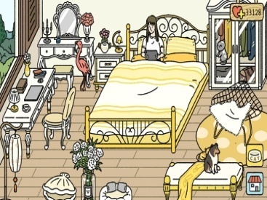There is a cat _ _ the wardrobe.
136. My mother _ _ a teacher.
137. Nghe: Nhấn giữ Ctrl và bấm chuột để nghe: ... is my house.
A. This B. That C. It D. These
138. house/ is/ near the/ The/ forest./
139. countryside./ in the/ We/ have/ wonderful time/
140. I/ read/ to/ books./ like/
141. What grade are you ________, James?
A. at B. on C. of D. in
142. Music/ his/ favourite/ Is/ subject?/
143. Ảnh: 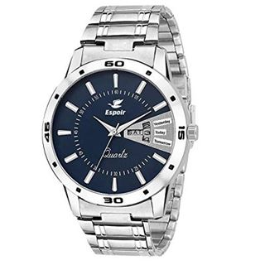Where is your _ _ _ _ _ ?
144. Can the cat _ _ _ _ _ a tree? – Yes, it can.
145. Ảnh: Nguyet is _ _ _ _ _ _ _ _ the floor.
146. Would you like an apple? - _ _ , thanks.
147. _ _ _ many dolls are there in that box? – There are three dolls.
148. Nghe: Nhấn giữ Ctrl và bấm chuột để nghe: Sue’s toy is a ... .
A. star B. far C. car D. bear
149. Is your school small or la_ _ _ ?
150. See/ tomorrow./ you/
151. Nghe: Nhấn giữ Ctrl và bấm chuột để nghe: This is an _ _ _ _ _ _ .
152. Nghe: Nhấn giữ Ctrl và bấm chuột để nghe: It has a big school _ _ _ _ _ _ _ _ _ _ .
153. photos./ taking/ He/ really/ likes/
154. birthday?/ Can/ you/ my/ remember/
155. What colour is that flower? – It’s yel_ _ w.
156. a garage/ have/ our car./ to keep/ We/
157. is/ the bed./ black cat/ under/ The/
158. after/ dinner./ Let’s/ play/ chess/
159. my/ toy./ This doll/ favourite/ is/
160. Ảnh: 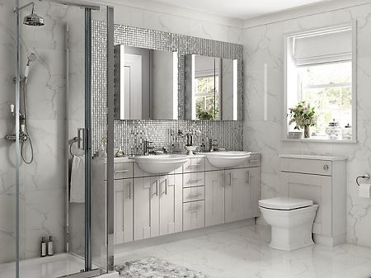What room is this?
A. It’s a living room. B. It’s a bathroom. C. It’s a kitchen. D. It’s a bedroom.
161. Look at tho_ _ black clouds in the sky.
162. 100?/ count/ Can you/ from/ 1 to
163. What’s the weather _ _ _ _ in Ho Chi Minh City?
164. Who is he? - ... .
A. She is Mary B. He my friend C. She my friend D. He’s Tom
165. What ... it? – It’s my book.
A. is B. hi C. bye D. hello
166. My teachers go to school ea_ _ _ in the morning.
167. She p_ _ _ _ badminton with her classmate in the gym.
168. That shirt _ _ green.
169. A: How _ _ _ are you? - B: I’m forty-five.
170. _ _ _ _ _ _ close your notebook.
171. a/ is reading/ Linda,/ book./ My friend,/
172. Who is tall_ _ , Jack or Jim?
173. It’s _______ in Hanoi today.
A. cloud B. funny C. sunny D. snow
174. … - J-E-N-N-I-F-E-R.
A. Spell your name, please. B. What is your name? C. What girl is it? D. Is that you Jennifer?
175. How/ your/ brother?/ old/ is/
176. do/ like/ Music lessons?/ Why/ you/
177. That is my new friend. H_ _ name is Alice.
178. Is that your desk? - ….
A. No, not my desk. B. No, it isn’t. C. No, I am not. D. Yes, it does.
179. of July./ the/ is/ fourth/ Today/
180. His name ... Tommy.
A. are B. is C. be D. and
181. Nghe: Nhấn giữ Ctrl và bấm chuột để nghe: She can _ _ _ _ .
182. My little brother often … his kite when he’s not busy.
A. does B. plays C. goes D. flies
183. Excuse me. - …?
A. No B. Not C. Yes D. Thanks
184. My b_ _ thday is in May.
185. The flowers are ... that vase.
A. on B. to C. for D. in
186. Odd one out:
A. October B. May C. Tom D. July
187. Sit _ _ _ _ , please.
188. Linda and I are ….
A. brothers B. sister C. friends D. classmate
189. Odd one out:
A. mother B. father C. sister D. family
190. hand/ down,/ your/ Simon./ Put/
191. Odd one out:
A. desk B. chair C. bedroom D. ruler
192. Nghe: Nhấn giữ Ctrl và bấm chuột để nghe: Listen and choose the best response.
A. Yes, it does. B. Yes, they are. C. No, it isn’t. D. No, they don’t.
193. How is the weather in Hanoi today? – It’s … .
A. rainy B. rain C. sun D. wind
194. Choose the odd one out:
A. on B. where C. under D. behind
195. the desk?/ under/ those/ are/ What/
196. What colour is that pencil? – It’s ... .
A. book B. crayon C. ruler D. blue
197. Mary likes doing … in her free time.
A. football B. volleyball C. music D. puzzles
198. Nghe: Nhấn giữ Ctrl và bấm chuột để nghe: At low tide, the ocean moves _ _ _ _ the beach.
199. Ảnh: Look at the _ _ _ , please.
200. Kevin _ _ _ _ _ football with his classmates in the yard behind his school.

IOE K3 2023 - 2024 SỐ 48
1. teacher./ morning,/ Good/
2. My dog’s _ _ _ _ is Barkie.
3. tank./ Peter keeps/ goldfish/ in the/ his/
4. happy/ family./ We/ are/ a/
5. She … two dogs and a cat.
A. have B. has C. is D. are
6. Choose the odd one out:
A. ride B. go C. bike D. run
7. Do/ chicken/ you/ like/ and milk?/
8. Where … the candles? – They are on the cake.
A. do B. does C. are D. is
9. Choose the odd one out:
A. eraser B. notebook C. crayon D. England
10. find/ in/ me/ Can you/ this photo?/
11. How are you, Lan? - I’m fine, t_ _ nks.
12. Please c_ _ _ t from 1 to 10 in English.
13. Nghe: Nhấn giữ Ctrl và bấm chuột để nghe: Look at those _ _ _ _ _ .
14. Which pen is your pen? – This o_ _ .
15. Is this a notebook? - ..., it is.
A. No B. Not C. Yes D. No, it is
16. I see a rainbow. It … beautiful.
A. sees B. sounds C. has D. looks
17. Ảnh: What is it? – It’s a … .
A. pencil B. pen C. book D. crayon
18. Ảnh: My brother likes playing _ _ _ _ _ _ ball in the yard.
19. Ảnh: The lamp is … the cupboard.
A. next to B. on C. under D. over
20. Quan is _ _ _ _ _ his homework in his room.
21. His house _ _ not big.
22. there/ are/ garden?/ in the/ What/
23. Are there _________ clocks on the table?
A. a B. an C. some D. any
24. A: … do you go shopping? – B: Once a week.
A. How many B. What C. How often D. When
25. Ảnh: The boy is washing his _ _ _ .
26. ... that a pink pencil? – No, it isn’t.
A. Are B. Is C. Who D. When
27. What a_ _ _ t an apple? – Yes, please.
28. is/ our/ That/ room./ music
29. desk./ The lamp/ is/ the/ behind/
30. Goodbye. See you l_ _ _ r.
31. I’m fine, thank you. ... ?
A. You B. Bye C. And you D. Are
32. Choose the odd one out:
A. school B. library C. classroom D. mother
33. Nghe: Nhấn giữ Ctrl và bấm chuột để nghe: What letter do you hear?
A. I B. A C. E D. O
34. Linda is her _ _ me.
35. FI__TEEN
A. T B. VE C. F D. S
36. Ảnh: 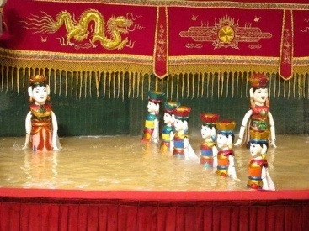A: Do you know what they are? - B: Yes. They’re water ….
A. dolls B. puppets C. teddies D. clowns
37. pen./ red/ is/ It/ a long/
38. the lamp./ The book/ between/ the pencil and/ is/
39. is/ Vietnamese/ Teacher’s Day./ 20th/ November/
40. Who ... that? – That’s Mary. She is my sister.
A. are B. is C. this D. and
41. love/ very/ much./ I/ my toys/
42. What is your favourite _ _ _ _ ? - It’s hide-and-seek.
43. My mother _ _ a teacher.
44. Ảnh: This de_ _ is looking for his mom.
45. My family often … TV in the evening.
A. looks B. sees C. watches D. hears
46. He...o, my name’s Lan.
A. li B. ll C. lk D. lw
47. How many pictures are there _ _ the wall? – There are four pictures.
48. I go … school early in the morning.
A. in B. at C. to D. from
49. Thai Phien is a big _ _ _ _ ary school in Hai Phong.
50. Nghe: Nhấn giữ Ctrl và bấm chuột để nghe: Look at the _ _ _ _ _ .
51. I _ _ _ not play any sports.
52. How are you today, John? – I’m ..., thanks.
A. nice B. nice’s C. fine D. fine’s
53. Nghe: Nhấn giữ Ctrl và bấm chuột để nghe: _ _ _ _ _
54. Ảnh: It’s _ _ _ _ _ at Christmas.
55. Let’s w_ _ k to school today. My bike is broken.
56. Which word has the underlined part pronounced like the letter ‘O’ in “PIANO”?
A. mother B. poster C. flower D. young
57. and/ young/ beautiful?/ Linda/ looks/
58. and/ yellow/ I love/ rubbers/ red pencils./
59. Nghe: Nhấn giữ Ctrl và bấm chuột để nghe: Can I borrow a _ _ _ _ _ _ ?
60. I have Maths _ _ Monday.
61. Is that a bag? – No, it is _ _ _ .
62. What ... it? – It’s my book.
A. is B. hi C. bye D. hello
63. … is Minh’s school? – It’s over there.
A. Where B. Which C. What D. How
64. school/ on Sunday./ don’t/ go to/ I/
65. There is a pen _ _ the desk.
66. Science lessons _ _ _ very interesting.
67. students/ the new/ are/ from?/ Where/
68. Let’s ______ a song together.
A. read B. watch C. sing D. write
69. Minh often plays football … his friends on Sunday.
A. with B. to C. of D. at
70. a/ Let’s/ draw/ picture.
71. Nghe: Nhấn giữ Ctrl và bấm chuột để nghe: He puts the hot dogs on a _ _ _ _ _ .
72. Nghe: Nhấn giữ Ctrl và bấm chuột để nghe: Put the _ _ _ _ in the bag.
73. Who is he? - ... .
A. He my friend B. She my friend C. He is Simon. He is my good friend D. She’s Mary
74. school/ pink./ bag/ is/ Your/
75. Let’s listen _ _ some music.
76. The cat/ under/ the/ is/ chair./
77. your/ Is/ new?/ bathroom/
78. Golf _ _ my father’s favourite sport.
79. Choose the odd one out:
A. skipping B. running C. cutting D. looking
80. Thank you very much. – You’re w_ _ _ _ me.
81. Ảnh: Where is your sister? – She is sitting in the armchair ______ the living room.
A. in B. on C. at D. between
82. large./ house/ My/ quite/ is/
83. Jane: Who is this? – Tom: … is Marry.
A. That B. This C. These D. Those
84. Open your school bag, ple_ _ e.
85. Nghe: Nhấn giữ Ctrl và bấm chuột để nghe: Tom is the boy with a _ _ _ .
86. That shirt _ _ green.
87. They/ at/ play/ break time./ tennis/
88. Nghe: Nhấn giữ Ctrl và bấm chuột để nghe: What’s the weather like? - It’s _ _ _ _ _
89. the city./ home village/ is/ My/ not near
90. Choose the odd one out:
A. balloon B. yo-yo C. doll D. school
91. A: Where’s my school bag, Mum? - B: ....
A. It’s very big and pretty. B. It’s red and orange. C. I have a small school bag. D. I don’t know, son.
92. Do you li_ _ playing hide-and-seek?
93. Choose the odd one out:
A. America B. England C. Vietnamese D. Singapore
94. Ảnh: I want to buy some _ _ _ sents for my baby sister.
95. ______ fences in your house?
A. There is B. There are C. Is there D. Are there
96. Who is tall_ _ , Jack or Jim?
97. Odd one out:
A. he B. she C. they D. me
98. Odd one out:
A. rice B. bread C. cake D. milk
99. Choose the odd one out:
A. bird B. desk C. cat D. dog
100. do you/ How/ erasers/ many/ have?/
101. Odd one out:
A. nice B. glad C. beautiful D. pretty
102. lessons/ like/ best./ Art/ I/
103. are/ pictures?/ Where/ the/
104. My family lives in _ house in Thai Binh Province.
105. Draw a pict_ _ e of yourself.
106. _ _ _ _ _ _ close your notebook.
107. A: How old … you? – B: I am nine years old.
A. am B. are C. is D. it
108. Nghe: Nhấn giữ Ctrl và bấm chuột để nghe: Julie is in the _ _ _ _ today.
109. Nghe: Nhấn giữ Ctrl và bấm chuột để nghe: There is a blue _ _ _ _ _ _ _ _ on the desk.
110. Ảnh: Do you like playing _ _ _ _ _ _ ton with me?
111. Do you have any rubbers? – Yes, here t_ _ _ are.
112. What is ... name?
A. she B. you C. he D. your
113. _ ash your hands, please.
114. I keep my goldfish in the fish ….
A. house B. tank C. cage D. room
115. Her birthday is in Ap_ _ _ .
116. Ảnh: There is a flower garden … the house.
A. behind B. next to C. in front of D. under
117. Good morning, c_ _ _ _ . Sit down, please.
118. … are you? – I’m fine, thanks.
A. What B. How C. Who D. Where
119. Greet/ your/ friend./
120. please?/ I/ sit/ Can/ here
121. Nghe: Nhấn giữ Ctrl và bấm chuột để nghe: _ _ _ _ _ _ _ _
122. Ảnh: The book is t_ _ _ _ , on the table.
123. Nghe: Nhấn giữ Ctrl và bấm chuột để nghe: _ _ _ _ _
124. The/ the clock./ is/ picture/ above
125. Tim/ doesn’t/ tea./ like/
126. Wr_ _ _ your name here, please.
127. Nghe: Nhấn giữ Ctrl và bấm chuột để nghe: What do you like? - I like _ _ _ _ _ _ _ _ .
128. very/ nice./ Your/ bedroom/ is/
129. ... are you? – I’m fine, thanks.
A. When B. How C. What D. Who
130. Ảnh: There are two armchairs and two _ _ _ _ _ _ s in the room.
131. new/ friend./ is/ This/ my/
132. That _ _ a long ruler.
133. What is/ matter/ the/ with/ your cat?/
134. A: Wh_ _ _ is my umbrella, Mum? - B: It’s over there, son.
135. How is the weather ... London today?
A. at B. on C. in D. to
136. Ảnh: Our house has a small blue _ _ _ _ .
137. is/ name?/ What/ your/ aunt’s
138. This ... a house.
A. are B. is C. you D. here
139. is/ dog/ yellow./ The/
140. Ảnh: Do you like _ _ _ _ _ _ s?
141. piano./ I/ can/ the/ play/
142. This is ... chair.
A. he B. she C. it D. my
143. Nghe: Nhấn giữ Ctrl và bấm chuột để nghe: She can _ _ _ _ .
144. Nghe: Nhấn giữ Ctrl và bấm chuột để nghe: Doll is swimming in the _ _ _ .
145. Would you like … cup of coffee, Mary?
A. a B. an C. some D. any
146. My school is next _ _ a park.
147. There’s a _ ed in my bedroom.
148. There … a big picture on the wall.
A. is B. are C. am D. be
149. toybox./ a red/ in our/ plane/ We have/
150. What is her name? - ... .
A. He name is Peter B. His name Peter C. Her name Sammy D. Her name is Sammy
151. your/ Is/ house?/ new/ that/
152. my/ There’s/ a bookcase/ in/ room./
153. _ _ _ many books on your bookshelf? – There are 10 books.
154. and/ my mom./ my/ I love/ dad/
155. I like _ _ ese books.
156. What is your … drink? – I like orange juice the most.
A. name B. favourite C. much D. many
157. Minh: Where are you? - Nga: I am w_ _ _ my friends.
158. his friends./ robots with/ playing/ likes/ Minh/
159. He _ _ _ swim but he can’t dance.
160. It is _ desk.
161. I am … England. I am English.
A. from B. to C. in D. at
162. don’t/ have/ pencils./ any/ I/
163. Ảnh: My friend loves _ _ _ _ ing very much.
164. Nghe: Nhấn giữ Ctrl và bấm chuột để nghe: It’s ... the table.
A. beside B. under C. next to D. behind
165. Wh_ _ do you have Maths? – I have it on Monday.
166. Close the d_ _ _ , please.
167. It/ is/ snowy/ today.
168. Look at the board. – Y_ _ , Miss.
169. dinner/ My family/ has a big/ every Sunday./ always/
170. What is this? – _ t is an eraser.
171. John … painting pictures.
A. like B. likes C. to like D. liking
172. Ảnh: They are … right now.
A. skating B. skipping C. singing D. dancing
173. is/ friend./ new/ Jenny/ my/
174. My mother a_ _ I go shopping every Sunday.
175. Nghe: Nhấn giữ Ctrl và bấm chuột để nghe: This is his house. It’s _ _ _ .
176. desk./ My pen/ on/ is/ that
177. A: What is Susan’s ho_ _ y? - B: She likes singing and playing the piano.
178. Sit d_ _ _ , Tommy.
179. Choose the odd one out:
A. grandfather B. teacher C. uncle D. cousin
180. The flowers are ... that vase.
A. on B. to C. for D. in
181. Does/ like/ drinking/ coffee?/ Santa Claus/
182. What is this? - ... .
A. It ruler B. It’s ruler C. It is a ruler D. It is rulers
183. scarf./ orange/ an/ Mary/ has/
184. Is/ a bathroom/ there/ your house?/ in
185. Do you like to play badminton? - ….
A. Let’s see. B. Sure. Let’s play. C. I can’t do that. D. I am fine. Thanks.
186. What are you doing? – I am _ _ _ _ _ _ _ _ TV.
187. I have … cat and … dog.
A. aa B. a / two C. a / an D. one / some
188. Ma_ I go out, please?
189. Ảnh: 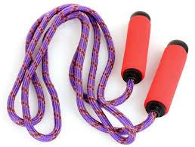I have got a skipping r_ _ e.
190. yard./ in/ We’re/ all/ the school
191. Ảnh: There are seven _ _ _ tures on the wall.
192. Choose the odd one out:
A. lunch B. breakfast C. doll D. dinner
193. What does his un_ _ _ look like?
194. They have _ _ _ _ _ at 12:00 everyday.
195. What’s your favourite …? – It’s milk.
A. food B. subject C. drink D. sport
196. Nghe: Nhấn giữ Ctrl và bấm chuột để nghe: The boy’s coloring the car on the table ….
A. green B. pink C. blue D. grey
197. Sing wit_ me.
198. Mum: Is school fun? - Boy: Yes, it is so _ _ ch fun.
199. Look at t_ e cat.
200. Nghe: Nhấn giữ Ctrl và bấm chuột để nghe: Linda has a _ _ _ _ _ _ .

IOE K3 2023 - 2024 SỐ 49
1. Nghe: Nhấn giữ Ctrl và bấm chuột để nghe: What do her parents do?
A. Sing a song B. Clap their hands C. Dance D. Sit down
2. my/ is/ It/ not/ bedroom./
3. Nghe: Nhấn giữ Ctrl và bấm chuột để nghe: Listen and choose the correct phrases you hear:
A. green bananas B. green monster C. green mother D. green monsters
4. Ảnh: 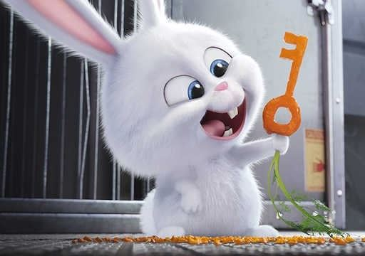Do you like _ _ _ _ _ _ _ ?
5. I’m fine, thanks. ... you?
A. End B. And C. On D. Ten
6. Nghe: Nhấn giữ Ctrl và bấm chuột để nghe: The sky is _ _ _ _ _ you.
7. They/ books about/ chess./ reading/ likes/
8. There are ... chairs in my living room.
A. one B. five C. a D. an
9. Nghe: Nhấn giữ Ctrl và bấm chuột để nghe: _ _ _ _ _ _ _
10. Peter/ Linda/ hide-and-seek/ now.
A. Peter and Linda is playing hide-and-seek now. B. Peter and Linda are playing with hide-and-seek now. C. Peter and Linda playing hide-and-seek now. D. Peter and Linda are playing hide-and-seek now.
11. Ảnh: That is my _ _ _ _ sister.
12. _ _ _ _ _ and eleven is sixty-one.
13. I have many _ _ _ _ : a cat, a dog, two birds and four goldfish.
14. Ảnh: 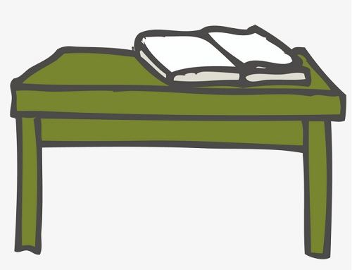My book is on the _ _ _ _ _ .
15. May we _ _ out together?
16. Are those your pencil sharpeners?
A. Yes, it is. B. No, it isn’t. C. Yes, they are. D. No, they are.
17. Ảnh: There is a white … around my house.
A. tree B. gate C. pond D. fence
18. Are Philip and Tony watching TV?
A. Yes, he is. B. Yes, they are. C. No, he and he are not. D. No, they not.
19. a/ phone./ is/ It/ blue
20. Vinh and I … at home right now.
A. am B. is C. are D. do
21. Tony ... football at break time but today he … basketball.
A. plays - is playing B. plays - plays C. is playing - plays D. is playing - is playing
22. Where are you? - I am w_ _ _ my friends.
23. I love dancing very _ _ _ _ .
24. Sing with ..., Simon .
A. he B. she C. I D. me
25. Nghe: Nhấn giữ Ctrl và bấm chuột để nghe: He puts the hot dogs on a _ _ _ _ _ .
26. C_ _ you ride a bike?
27. How many balls are _ _ _ _ _ in the basket?
28. Choose the odd one out:
A. tidy B. nice C. clean D. dirty
29. Ảnh: 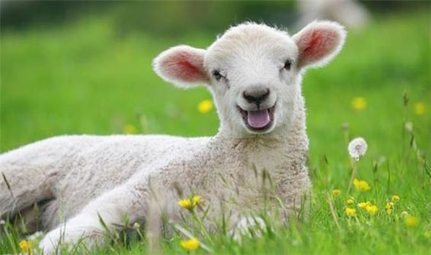This _ _ _ _ _ is cute. It says 'baa-baa'.
30. Put your books s a_ _ y, please.
31. Van: What’s that tall building there? - Lan: It’s _ _ new school
32. Nghe: Nhấn giữ Ctrl và bấm chuột để nghe: What colour do you hear?
A. Oil B. Yellow C. Black D. Orange
33. Ảnh: May you come and s_ _ _ with me?
34. _ _ _ _ is your name?
35. weather/ sunny/ today./ is/ The/
36. not near/ the city./ My/ home village/ is/
37. My be_ _ oom is small.
38. C_ _ _ on. We don’t have much time.
39. I have m_ _ y toys.
40. … fishing together now!
A. Let go B. Lets go C. Let’s go D. Let goes
41. …. - Yes, my book is new.
A. Is your shoe new? B. Are these books new? C. Is that new? D. Are those new?
42. is/ The gate of/ the house/ green./ dark
43. Ảnh: A: Who’s th_ _ ? - B: It’s my brother.
44. May you give me that pencil case? – Here y_ _ are.
45. Friday/ is/ day./ favourite/ my/
46. There are two cat_ in that box.
47. is/ How/ Thang?/ old/
48. Wh_ _ _ are the maps? – They are on the wall.
49. Look that woman! _ _ _ ’s my teacher.
50. Nghe: Nhấn giữ Ctrl và bấm chuột để nghe: Her sister is _ _ _ years old.
51. Odd one out:
A. they B. ten C. we D. you
52. Ảnh: Don’t play outside, son. It’s ….
A. raining B. snowing C. windy D. stormy
53. in front/ of/ a pond/ your house?/ Is there/
54. Thinh and ______ are twenty.
A. me B. I C. my D. your
55. Ảnh: Is it your new …?
A. mobile phone B. book C. table D. bed
56. This gift is for you. – Thank you very m_ _ h.
57. in the/ early/ Can you/ morning?/ get up/
58. bedroom./ his/ sleeping in/ is/ Hieu/
59. is/ This/ my/ new/ friend./
60. Lo_ k at the board, please.
61. Nghe: Nhấn giữ Ctrl và bấm chuột để nghe: May I _ _ _ _ a song?
62. … is Minh’s school? – It’s over there.
A. Where B. Which C. What D. How
63. Ảnh: Is this black and white bac_ _ _ _ _ yours?
64. yellow/ rubbers/ and/ red pencils./ I love/
65. ... you want to ride a bike with me?
A. Can B. Do C. Are D. Am
66. John ________ painting pictures.
A. like B. likes C. is liking D. to like
67. from/ not/ America./ She/ is/
68. The opposite of THESE is _ _ _ _ _ .
69. Ha Long Bay is ______ from Hanoi.
A. near B. next to C. above D. far
70. days/ a week./ in/ seven/ There are/
71. How’s the weather today?
A. It’s a cloud. B. It’s cloudy. C. It’s fine, thank you. D. It has a sun.
72. has/ hat./ beautiful/ Daisy/ a/
73. at the court./ are/ playing/ badminton/ My friends/
74. Ảnh: How’s the weather? – It’s _ _ _ _ _ .
75. This ... my mother.
A. are B. am C. is D. and
76. _ _ _ many posters are there in the room?
77. The o_ _ computer is very slow.
78. eight/ pictures/ There are/ the classroom./ in
79. Ảnh: Do you like _ _ _ _ _ _ s?
80. Show me _ _ _ r pens, children.
81. Nghe: Nhấn giữ Ctrl và bấm chuột để nghe: Sue’s toy is a ... .
A. star B. far C. car D. bear
82. A: Is there a cupboard or a wardrobe in your bedroom? - B: …
A. Yes, there is. B. There are both of them. C. My clothes are in the wardrobe. D. My toys are in the cupboard.
83. Choose the letter(s) to make a correct word: ta__ng
A. ki B. kei C. ke D. ci
84. birthday?/ you/ remember/ my/ Can/
85. Which word has ‘ch’ pronounced as the letter ‘k’ in \"clock\"?
A. chair B. chess C. school D. kitchen
86. I’m/ I’m late/ . May I come/ sorry/ in?/
87. Nghe: Nhấn giữ Ctrl và bấm chuột để nghe: How do you ... your name?
A. tell B. talk C. write D. spell
88. Look! My doll is in fr_ _ _ of Lily’s.
89. _ hat’s your name?
90. What is this? - ... .
A. It ruler B. It’s ruler C. It is a ruler D. It is rulers
91. flowers/ There are/ in our/ school./ many/
92. Our school is _ _ north city.
93. There is a flower va_ e on the table.
94. A: Is that Peter? – B: Yes, … .
A. he is B. is he C. is not D. he not
95. Ảnh: Give me a packet of _ _ _ _ , please.
96. _ _ _ _ _ pencils are these? – They’re my pencils.
97. What/ are/ on/ the shelf?/ those/
98. Nghe: Nhấn giữ Ctrl và bấm chuột để nghe: My house has a ... yard.
A. small B. fat C. large D. big
99. Nghe: Nhấn giữ Ctrl và bấm chuột để nghe: He’s wearing a white _ _ _ _ .
100. My pictures _ _ _ on the wall.
101. Odd one out:
A. sun B. snowy C. cloud D. wind
102. Are you going to visit Huong Pagoda ...?
A. today B. tomorrow C. now D. yesterday
103. is/ my/ toy./ This/
104. Ảnh: This is a mo_ _ _ _ cat. That is its baby.
105. The cat is sitting ... the tree.
A. near to B. next C. in D. under
106. … your hands before eating.
A. Brush B. Wash C. Catch D. Look at
107. a/ This/ is/ doll.
108. Choose the odd one out:
A. ruler B. rabbit C. cat D. dog
109. Is/ today?/ birthday/ your/
110. We may come back tog_ _ _ _ _ . It is very late now.
111. please?/ sit/ here/ I/ Can/
112. notebooks,/ Alan./ out/ your/ Take/
113. How _ _ _ _ children are there in the playground?
114. Ảnh: He has a toy _ _ _ _ .
115. Nghe: Nhấn giữ Ctrl và bấm chuột để nghe: Tom is the boy with a _ _ _ .
116. me/ some/ Please,/ give/ more pencils./
117. Nghe: Nhấn giữ Ctrl và bấm chuột để nghe: It’s a nice _ _ _ _ _ _ room.
118. Good_ _ _ Mary. See you later.
119. Ảnh: This de_ _ is looking for his mom.
120. How’s the wea_ _ er today? – It’s sunny.
121. These fl_ _ ers are for you, Mary. – Thank you.
122. … do you like to play? – I like to play hide-and-seek.
A. What B. Where C. When D. How
123. See you later. _ _ e.
124. in the playground/ is playing/ his friends./ with/ John/
125. green/ pen./ It is/ a/
126. cook/ meal./ big/ Let's/ a/
127. Who’s she? – She’s my ______.
A. aunt B. brother C. uncle D. grandfather
128. I keep my goldfish in the fish ….
A. house B. tank C. cage D. room
129. _______ is his coat? - It’s on his bed.
A. When B. Where C. Who D. What
130. Wh_ is that? – That’s David.
131. There are/ lake./ in the/ many/ fish/
132. chairs and a table/ There/ in my dining room./ eight/ are/
133. Choose the odd one out:
A. old B. nine C. ten D. six
134. R_ ad after me, children.
135. this song/ I/ with my/ mother./ sing/
136. My si_ _ er’s name is Mary.
137. is large/ new./ Our/ and/ school playground/
138. What col_ _ r is this book? – It’s red.
139. Ảnh: A: Is there a(n) … in your bedroom? - B: No, there isn’t.
A. window B. fan C. clock D. armchair
140. What … your sister look like?
A. does B. do C. is D. are
141. What … your parents look like?
A. does B. do C. is D. are
142. This is a photo _ _ my class.
143. the kitchen./ My/ in/ father/ is/
144. Choose the odd one out:
A. write B. sit C. read D. ruler
145. Quan is _ _ _ _ _ his homework in his room.
146. Linda is her _ _ me.
147. What is your … drink? – I like orange juice the most.
A. name B. favourite C. much D. many
148. Which word has the letter ‘e’ pronounced as the letter ‘e’ in \"yes\"?
A. new B. orange C. come D. bed
149. like?/ is/ Betty/ What/
150. Nghe: Nhấn giữ Ctrl và bấm chuột để nghe: The car behind the _ _ _ _ _ is white.
151. in/ June./ birthday/ is/ Her/
152. … room is your computer room? – That big room over there.
A. Which B. What C. How D. When
153. _ _ _ _ is it? – It is a chair.
154. Is that your classroom? It is so _ _ _ ge.
155. in/ Don’t/ come/ room./ that
156. He is se_ _ n years old.
157. It’s/ to school/ fun/ everyday./ to go/
158. Peter/ subject/ What/ like best?/ does/
159. Nghe: Nhấn giữ Ctrl và bấm chuột để nghe: There aren’t any _ _ _ _ here.
160. Mary is a ... at London Primary School.
A. boy B. toy C. student D. she
161. FI__TEEN
A. T B. VE C. F D. S
162. Ảnh: Hoa: What is this? - Lan: It’s my school _ _ _ . There are a lot of my school things.
163. Thanks _ _ _ _ much.
164. Ảnh: The apple is … the book.
A. next to B. on C. under D. over
165. Nghe: Nhấn giữ Ctrl và bấm chuột để nghe: When it’s sunny, the sky is _ _ _ _ .
166. Minh ______ drawing pictures of cats.
A. like B. likes C. is like D. is likes
167. your name,/ Loan?/ do you/ spell/ How/
168. These a_ _ pink desks.
169. Pick _ p your pencil, please.
170. Choose the odd one out:
A. thirty B. seventy C. eighty D. twelve
171. Ảnh: This is my new co_ _ _ ter room.
172. are./ your bag/ where/ don’t know/ I/
173. Have a n_ ce day.
174. Hi, ... name is John.
A. your B. my C. its D. me
175. What is your favourite _ _ _ _ ? - It’s hide-and-seek.
176. Nghe: Nhấn giữ Ctrl và bấm chuột để nghe: Which is NOT mentioned in the recording?
A. ball B. doll C. puzzle D. teddy
177. Nghe: Nhấn giữ Ctrl và bấm chuột để nghe: The girl is _ _ _ _ _ years old.
178. shelf./ Put/ the books/ on/ the
179. This is my friend James. … is a nice boy.
A. He B. She C. They D. It
180. May I speak to you now? - ….
A. No, you may not. B. Yes, you may. C. No, I am not. D. Sure. You can.
181. Nghe: Nhấn giữ Ctrl và bấm chuột để nghe: _ _ _ _
182. is/ name?/ your/ What/ teacher’s
183. Choose the odd one out:
A. book B. pen C. ruler D. Mary
184. very/ I/ much./ like/ English/
185. those/ are/ table?/ What/ the/ on
186. She lives ... the sea.
A. in B. on C. near D. at
187. Do you h_ _ e Maths today?
188. Tom can swim … dance.
A. but B. and C. for D. to
189. Ảnh: There are … round tables and … chairs.
A. one - four B. four - eleven C. five - twelve D. three - twelve
190. A: Is he Tony? – B: No, … .
A. he is B. he isn’t C. he not is D. not he is
191. _______ are they? - They are in the library.
A. Who B. What C. When D. Where
192. These are my classmates. … in class 3D.
A. He is B. She is C. We are D. You are
193. Choose the word which has the same sound with the word ’’wait’’.
A. talk B. kite C. late D. cold
194. Those _ _ _ my bags.
195. Are you five _ _ _ _ _ old?
196. _ _ she your new classmate?
197. Gi_ e me the book, please.
198. your father/ forty-one/ old?/ years/ Is/
199. come/ in,/ May/ please?/ I/
200. don’t/ your bedroom?/ Why/ you/ like

IOE K3 2023 - 2024 SỐ 50
1. pictures/ his/ now./ Alex is/ colouring/
2. Ảnh: A: Who’s th_ _ ? - B: It’s my brother.
3. Come and _ _ at with your friends.
4. Taylor is from England. She … me every month.
A. calls B. write C. read D. speak
5. A: How many chairs are there? - B: Let me co_ _ _ them. One, two, three, …. There are five.
6. ... are you? – Fine, thanks.
A. Who B. Is C. Are D. How
7. Nghe: Nhấn giữ Ctrl và bấm chuột để nghe: I’ve got two big _ _ _ _ .
8. ... your teeth, John.
A. Read B. Listen C. Stand D. Brush
9. These/ flowers/ beautiful./ are/ very
10. This is ... doll.
A. she B. me C. my D. hi
11. Nghe: Nhấn giữ Ctrl và bấm chuột để nghe: _ _ _ _ _ _
12. … and listen to your teacher, please.
A. Opening your book B. Sit still C. Reading aloud D. Not speaking
13. My new _ _ _ _ _ _ is Adam.
14. Do you/ like/ listening/ to/ music?/
15. Who is he? - ... .
A. He my friend B. She my friend C. He is Simon. He is my good friend D. She’s Mary
16. Would you like some …? – No, thanks. I hate sweets.
A. coffee B. lemonade C. chocolate D. chicken
17. What … is it? – It’s eleven o’clock.
A. name B. colour C. time D. day
18. This is an ora_ ge book.
19. Ảnh: A: Where is the _ _ _ bit? - B: It’s in the box.
20. Goodbye, David. See y_ u later.
21. My brother likes to dri_ _ milk very much.
22. have/ two/ I/ robots.
23. Choose the incorrect word(s) in the following sentence: My friend, Quynh, doesn’t has any comic books.
A. My B. has C. any D. books
24. does/ What/ Khai/ after work?/ do
25. _ _ _ _ colour is your teddy bear?
26. Ảnh: Do you like playing …?
A. football B. paper boats C. chess D. hide-and-seek
27. My pictures _ _ _ on the wall.
28. Nghe: Nhấn giữ Ctrl và bấm chuột để nghe: Her English teacher is Mr. _ _ _ _ .
29. Nghe: Nhấn giữ Ctrl và bấm chuột để nghe: The chairs are _ _ _ _ the table.
30. Choose the odd one out.
A. brother B. sister C. mother D. teacher
31. Odd one out:
A. Vietnam B. English C. America D. China
32. How/ is/ old/ your/ father?/
33. Tom re_ _ _ books in the library in the afternoon.
34. grandparents/ are/ My/ old./ very
35. aren’t/ There/ any theatres/ my neighborhood./ in
36. He _______ to the zoo in the morning.
A. go B. ride C. has D. walks
37. Informatics./ subject/ is/ favourite/ My/
38. glass/ of milk./ I/ would like/ a/
39. Nghe: Nhấn giữ Ctrl và bấm chuột để nghe: Can I borrow your _ _ _ _ for a minute? – Sure.
40. Those are my blue balloo_ _ .
41. I like to s_ ng.
42. Nghe: Nhấn giữ Ctrl và bấm chuột để nghe: Put the computer in the ….
A. wardrobe B. bookcase C. table D. cupboard
43. A: How old is she? - B: She is ten … old.
A. yeasr B. yares C. yreas D. years
44. Nghe: Nhấn giữ Ctrl và bấm chuột để nghe: _ _ _ _
45. There are/ and/ five chairs/ one table/ in the living room./
46. What’s the matter _ _ _ _ your eyes?
47. W_ _ is she, Peter? – She’s is Alice.
48. ... you want to ride a bike with me?
A. Can B. Do C. Are D. Am
49. rulers/ The/ on the/ are/ table./
50. Come ov_ r here.
51. Pl_ _ _ _ give me that old black pen.
52. Is it the music room? - …. It’s the computer room.
A. Yes, it is. B. No, it isn’t. C. No, it doesn’t. D. Yes, it does.
53. That is a gr_ _ n doll.
54. years/ is/ old./ My grandfather/ sixty-seven/
55. Nghe: Nhấn giữ Ctrl và bấm chuột để nghe: Look at the _ _ _ _ in the tree.
56. Nghe: Nhấn giữ Ctrl và bấm chuột để nghe: The boy’s name is _ _ _ _ .
57. A: Is your house _ _ _ _ the cinema? - B: No, it’s very far.
58. the/ teacher/ Listen/ carefully./ to/
59. Is this your grandfather? – Yes, he _ _ .
60. Nine and three is _ _ _ _ _ _ .
61. Is your school big? - ..., it is.
A. No B. Not C. Yes D. No, it isn’t
62. Ảnh: Rapunzel ______ long straight blonde hair.
A. has B. have C. haves D. is has
63. ... this a desk? – Yes, it is.
A. Is B. Are C. How D. Whatname’s
64. like/ play/ Do you/ hide-and-seek?/ to/
65. Ảnh: Two boys are reading their books _ _ _ _ _ the tree.
66. My sister _ _ _ a doll.
67. Do you like playing puz_ _ _ _ ?
68. Nghe: Nhấn giữ Ctrl và bấm chuột để nghe: Mai likes ... flowers.
A. beautiful B. wonderful C. colorful D. blue
69. It's/ with Linda./ fun/ to be/
70. Simon is my friend, t_ _ .
71. I a_ nine years old. How old are you?
72. Which word has the letter ‘e’ pronounced as the letter ‘e’ in \"yes\"?
A. new B. orange C. come D. bed
73. Choose the odd one out:
A. ruler B. crayon C. sing D. eraser
74. Choose the word which has the same sound with the word ’’wait’’.
A. talk B. kite C. late D. cold
75. Ảnh: The teddy bear has a r_ _ tie.
76. Choose the odd one out.
A. ship B. truck C. plane D. duck
77. volleyball/ dinner./ play/ after/ Let’s/
78. Choose the odd one out:
A. thirty B. seventy C. eighty D. twelve
79. Let’s/ with/ sing/ a song/ me./
80. talking/ right/ now?/ with Chi/ Who is/
81. Nam: Is that girl new? - Lien: I don’t kn_ _ . Ask Hoa.
82. Tho_ _ books are mine. These books are yours.
83. What are they? – They are ….
A. red B. small C. stars D. big
84. Nghe: Nhấn giữ Ctrl và bấm chuột để nghe: Choose the TRUE statement.
A. There are two armchairs, a sofa and a window in the living room. B. There are two sofas, an armchair and a window in the living room. C. There are two windows, a sofa and an armchair in the living room. D. There are two armchairs, two sofas and a window in the living room.
85. Nghe: Nhấn giữ Ctrl và bấm chuột để nghe: When it’s sunny, the sky is _ _ _ _ .
86. Ảnh: Oh, this teddy _ _ _ _ is cute. Can you buy it for me, Mum?
87. Nghe: Nhấn giữ Ctrl và bấm chuột để nghe: This is my _ _ _ _ _ .
88. are/ Her/ from/ France./ friends/
89. A: What does your aunt …? - B: She is very sporty.
A. like B. look like C. likes D. like looking
90. The school is far _ _ _ _ the cinema.
91. 1st/ June/ Children’s/ Day./ is/
92. Choose the odd one out:
A. how B. hello C. hi D. good morning
93. Mary and Peter can … Vietnamese.
A. speaks B. speak C. to speak D. a speak
94. Choose the odd one out.
A. chicken B. beef C. pork D. food
95. Ảnh: What is that? – It is a ….
A. pencil case B. ruler C. pen D. book
96. This is a de_ k.
97. Is this your sister? – Yes, _______.
A. it is B. it’s not C. he is D.
98. This is my father. _ _ _ name is John.
99. …. - Yes, my book is new.
A. Is your shoe new? B. Are these books new? C. Is that new? D. Are those new?
100. and Sarah/ playing/ are/ board games./ Linda/
101. That is an ora_ _ e pencil.
102. This is my d_ ll.
103. These are my classmates. … in class 3D.
A. He is B. She is C. We are D. You are
104. Can the cat _ _ _ _ _ a tree? – Yes, it can.
105. Nghe: Nhấn giữ Ctrl và bấm chuột để nghe: The girl’s T-shirt is in the _ _ _ .
106. Tom can swim … dance.
A. but B. and C. for D. to
107. Is … bedroom large? – Yes, it is.
A. Jimmy B. Minh’s C. my friend D. house
108. ... is that? - It’s a pen.
A. How B. When C. What D. Where
109. Ảnh: The c_ _ _ is on the chair.
110. W_ _ h your hands carefully, Kate.
111. table tennis?/ you/ like/ playing/ Do/
112. I’m fine, thanks. ... you?
A. End B. And C. On D. Ten
113. Nghe: Nhấn giữ Ctrl và bấm chuột để nghe: Which is the _ _ _ _ _ _ _ , a giraffe, an elephant or a monkey? – Of course, a giraffe.
114. They are ... the beach this summer.
A. going B. going to C. visiting D. go
115. Choose the odd one out:
A. book B. pen C. ruler D. Mary
116. is a/ This/ book./ green/
117. John/ in the playground/ his friends./ is playing/ with
118. a postcard/ Write/ friend./ to/ a pen
119. What a_ _ _ t an apple? – Yes, please.
120. Nghe: Nhấn giữ Ctrl và bấm chuột để nghe: It has _ _ _ _ _ _ _ _ of many animals.
121. game/ is/ The/ very/ exciting./
122. A: Are David and James singing? - B: Yes, ….
A. they aren’t B. they are C. he is D. he isn’t
123. green./ This/ is/ shirt/
124. Ha: _ _ _ _ colour is that pen? - Mai: It is a blue.
125. Ảnh: How many cats are there in the yard? - There are _ _ _ _ cats. They are eating fish.
126. Choose the odd one out:
A. on B. where C. under D. behind
127. I’m fine, than_ _ .
128. you/ your/ like/ Do/ house?/
129. What col_ _ r is this book? – It’s red.
130. How are you? - ... .
A. I’m Binh B. She’s my sister C. I’m fine, thank you D. Goodbye
131. Wh_ _ do you have Maths? – I have it on Monday.
132. Ảnh: This is a mo_ _ _ _ cat. That is its baby.
133. Ảnh: We help our mother with the _ _ _ _ _ _ _ _ _ .
134. There is o_ e kitchen in his house.
135. Odd one out:
A. your B. me C. us D. him
136. Odd one out:
A. he B. she C. they D. me
137. Choose the odd one out:
A. paint B. draw C. write D. walk
138. Ảnh: Rabbits like car_ _ _ _ very much.
139. do/ you have?/ How/ skirts/ many/
140. Nghe: Nhấn giữ Ctrl và bấm chuột để nghe: Which _ _ _ _ _ is Sam in?
141. Listen ... the teacher.
A. to B. me C. you D. he
142. Ảnh: My family is having dinner in the _ _ _ _ ng room.
143. Hello. My ... is Tom.
A. name B. is C. am D. are
144. Are … four people in your family, Jack?
A. it B. they C. we D. there
145. These _____ old notebooks.
A. am B. is C. are D. have
146. Some _ _ _ chers are in the hall.
147. on/ The duck/ Look!/ is swimming/ the pond./
148. are there/ in your/ students/ classroom?/ How many/
149. “Tom and Jerry”?/ you/ like/ Do/
150. _ _ _ _ _ _ close your notebook.
151. Ảnh: It is an old rub_ _ _ .
152. is/ He/ ten/ old./ years
153. I have m_ _ y toys.
154. May I go o_ _ for a while?
155. is/ The/ yellow./ dog/
156. cats./ like/ doesn’t/ My/ brother/
157. again?/ I/ Can/ meet/ you
158. ... you like chicken?
A. Do B. Does C. Are D. Is
159. always/ sunny/ in/ summer./ It is/
160. Dolly/ fine/ Is/ now?
161. many/ My/ brother/ toys./ has/
162. favourite/ your/ subject?/ is/ What/
163. Sing wit_ me.
164. Ảnh: She is playing the pi_ _ _ .
165. The opposite of \"on\" is \"_ _ _ _ _ \".
166. Nghe: Nhấn giữ Ctrl và bấm chuột để nghe: _ _ _ _ _ _
167. stormy/ Is/ today?/ it/
168. This/ is/ our/ classroom.
169. This is a r_ ler.
170. There are ... chairs in my living room.
A. one B. five C. a D. an
171. Nghe: Nhấn giữ Ctrl và bấm chuột để nghe: _ _ _ _
172. Rosie is having a shower in the ….
A. kitchen B. bathroom C. bedroom D. playground
173. Ảnh: A: Where is the cat? - B: It’s behind the box.
A. Picture 1 B. Picture 2 C. Picture 3 D. Picture 4
174. May we _ _ to school together?
175. I/ picture./ can/ draw/ a
176. What toys/ not/ he/ like?
A. What toys doesn’t he like? B. What toys don’t he likes? C. What toys isn’t he like? D. What toys aren’t he likes?
177. I _ _ Chi. I am in class 3A.
178. Nghe: Nhấn giữ Ctrl và bấm chuột để nghe: There are six _ _ _ _ _ _ _ on top.
179. My cat/ a/ tail./ long/ has/
180. This is _ _ _ way we go to school.
181. do/ you/ Can/ puzzles?
182. Dr_ _ a big brown dog, please.
183. Ảnh: Let’s go to the _ _ _ _ _ _ _ with me. It has a lot of interesting books.
184. Her/ small/ tidy./ but/ room is/
185. Take ou_ your books, children.
186. Odd one out:
A. they B. ten C. we D. you
187. Sally is standing n_ _ _ to David.
188. pink/ doll./ has/ a/ Alice/
189. Is the girl o_ _ _ there your classmate, Rosie?
190. I go … school early in the morning.
A. in B. at C. to D. from
191. I k_ _ _ little English and French.
192. A: How old … you? – B: I am nine years old.
A. am B. are C. is D. it
193. The books are _ _ the shelves.
194. My school is next _ _ a park.
195. the/ time/ Mary?/ now,/ What’s/
196. Hamburger/ my/ is/ favourite/ food./
197. What grade … your twin brothers in?
A. am B. is C. are D. do
198. How many balls are _ _ _ _ _ in the basket?
199. Ảnh: Cinderella is ______ with the prince at the party.
A. dance B. dances C. dancing D. danceing
200. … full name is Mary Jane.
A. Her B. She’s C. She is D. She has

