Trường TH Dương Hà
PHẾU ÔN TẬP
Môn: Tiếng Anh - Tuần 2 ( Từ 10/2/2020 - 14/2/2020)
ENGLISH 4
Exercise 1. Read and tick  or cross . There are two examples:
Examples:
  A. She has dinner at 7.30. | 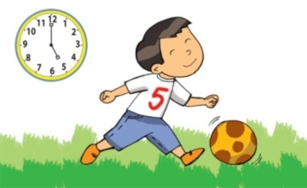  B. He plays football at noon.

  He gets up at five o’clock.  1.  | 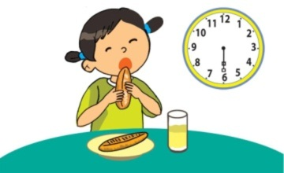  She goes to school at 6.30.  2. | 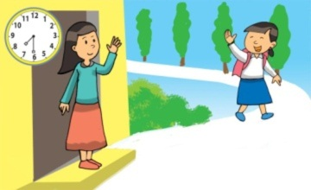  She goes home in the afternoon.  3.
  They read books in the school library at three o’clock.  4. | 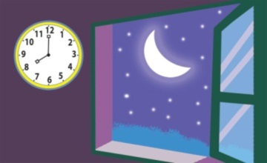  It’s eight p.m.  5.
Exercise 2. Order the words. There is one example.
Example: breakfast/ Tony/ at/ has/ 7 o’clock Tony has breakfast at 7 o’clock.
1. you/ what/ go/ do/ time/ school/ to
_____________________________________?
2. in/ do/ you/ do/ what/ morning/ the
_____________________________________?
3. time/ is/ what/ it
_____________________________________?
4. homework/ Linda/ at/ does/ 8 o’clock/ her
_____________________________________.
5. football/ Peter/ at/ plays/ 4:45
_____________________________________.
Exercise 3. Read and number the sentences in the correct order. The conversation begins with 0.
0 | A | Minh: What do you usually do on Saturday mornings, An?
 | B | An: At six o’clock. What time is it now?
 | C | Minh: I cycle, too. What time do you cycle?
 | D | An: Oh, no. We’re late for school. Let’s run now.
 | E | Minh: It’s seven fifty.
 | F | An: I usually cycle. What about you?
Exercise 4. Write the time
1. 5.00 five o'clock  2. 5.05 five five  3. 4.25 ______________  4. 5.15 _______________ | 5. 8.30 ________________  6. 9.35 _________________  7. 10.45 _________________  8. 3.50 ________________

Exercise 5. Read and match.
1. What's the time now?  2. What time do you get up?  3. What do you do in the afternoon?  4. Where were you yesterday?  5. What did you do last Sunday? | a. At six thirty.  b. I was on the beach.  c. I watched TV.  d. I play volleyball  e. It’s ten oclock | 1 -  2 -  3 -  4 -  5 -
Exercise 6. Order the words.
1. school/ He/ goes to /6.30/at
..................................................................................................................................
2. at/Lan/ has breakfast/ 6.15
..................................................................................................................................
3. You/at/ go to bed/ 10.00
..................................................................................................................................
4. They/ have lunch/ 11.30/at
..................................................................................................................................
5. at /Your father/ to work/ goes /7.30
...............................................................................................................................
Exercise 7. Look and write. There is one example
Example:
hnluc → l u n c h | 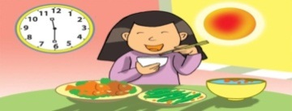

1. akasbreft → _ _ _ _ _ _ _ _ _ | 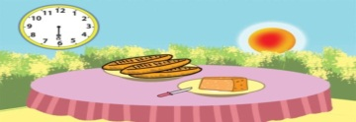
2. egt pu → _ _ _ _ _ | 
3. og ot edb → _ _ _ _ _ _ _ | 
4. og mhoe → _ _ _ _ _ _ | 
5. indner → _ _ _ _ _ _ | 
Exercise 8. Read and write YES or NO.
Hi, I’m Ha. I study at Hoa Sen Primary School. I usually get up at 7.00. After breakfast, I walk to school at 7.40. My school starts at 8.00. My friends and I play badminton at break time. We have three subjects in the afternoon. The school finishes at 4.30.

0. | Ha is a pupil at Hoa Sen Primary School. | YES
1. | She usually gets up at seven a.m. | ____
2. | She goes to school at seven fifteen. | ____
3. | Ha and her friends play volleyball at break time. | ____
4. | She studies four subjects in the afternoon. | ____
5. | Her school day finishes at four thirty. | ____

