Trường TH Dương Hà
PHẾU ÔN TẬP
Môn: Tiếng Anh - Tuần 6 ( Từ 9/3/2020 - 13/3/2020)

NEW WORDS:
- Get into pair: ghép thành đôi 11. Doctor: bác sĩ
- Interview: phỏng vấn 12. Tailor: thợ may
- Job: công việc, việc làm 13. Mechanic: thợ máy, thợ cơ khí
- Place of work: nơi làm việc 14. Policeman: cảnh sát
- Well done! : làm tốt lắm 15. Engineer: kỹ sư
- It’s your turn: Đến lượt bạn 16. Singer: ca sĩ
- Great: Tuyệt, tuyệt vời, to lớn, vĩ đại 17. Actor: diễn viên nam
- As you know: như bạn biết đấy 18. Actress: diễn viên nữ
- Report: bản báo cáo, biên bản 19. Security guard: nhân viên bảo vệ
- Thank you for + N/ V_{-ing}: Cảm ơn bạn vì điều gì đó/ vì đã… 20. Businessman: doanh nhân, người kinh doanh
(Thank you for listening :cảm ơn bạn vì đã lắng nghe; thank you for the gift: cảm ơn bạn vì món quà)
B. EXERCISE:
Ex 1: Put a suitable word under each picture: farmer, nurse, driver, factory worker, teacher, student, pupil, clerk
 |  |  | 
 |  |  | 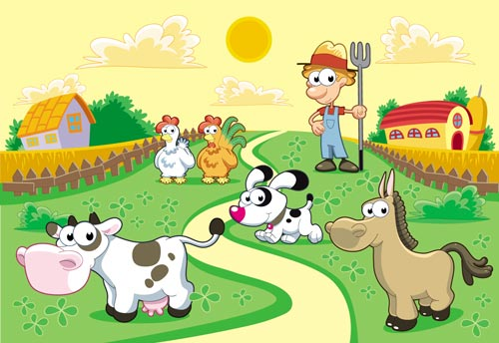

Ex 2: Odd one out:
1. a. farmer b. month c. nurse d. teacher
2. a. doctor b. hospital c. school d. nurse
3. a. ruler b. worker c. rubber d. book
4. a. father b. mother c. teacher d. grandma
5. a. pupil b. notebook c. pencil d. rubber
6. a. forty b. fourth c. fifteen d. twenty
7. a. get b. go c. stay d. early
8. a. where b. what c. went d. how
9. a. did b. goes c. got d. drew
10. a. factory b. clerk c. school d. hospital
Ex 3: Find and correct the mistake:
1. I go to school at 6.40 o’clock.
2. My school finish at 11.30.
3. What do your sister do? – She’s a pupil.
4. My father water the flowers yesterday morning.
5. He goes on bed at 9.45.
6. My mother gets up early on the morning.
7. Mr. Tuan is a doctor. He works in the field.
8. Her grandfather plants rice, vegetable and raises pig, chicken. He is a factory worker. …….........
9. Mr. Lien teaches English at my school. She is a pupil.
10. There is four people in my family: my father, my mother, my brother and me ………….
Ex 4: Odd one out:
1. a. office b. police c. doctor d. clerk
2. a. sister b. farmer c. worker d. singer
3. a. grandpa b. grandma c. pupil d. uncle
4. a. read b. at c. to d. past
5. a. dinner b. eat c. lunch d. breakfast
6. a. morning b. evening c. afternoon d. singing
7. a. finish b. start c. listen d. homework
8. a. milk b. in c. on d. at
9. a. field b. doctor c. hospital d. factory
10. a. she b. her c. his d. your
Ex 5: Read and match:
- What time did you go to school yesterday? | - It’s on the second of April.
- What time does she have breakfast? | - I work in a factory.
- Were you at the zoo this morning? | - At 9 p.m.
- Where does your mother work? | - No, he’s a student.
- Where do you work? | - She’s a clerk.
- What time is it now? | - At 6.30 a.m.
- What does your mother do? | - I went to school at 7.00.
- What time do you go to bed? | - It’s half past ten.
- Is your brother a farmer? | - No, I wasn’t. I stayed at home.
- When’s her birthday? | - She works in an office.

Ex 6: Make sentence using given words:
1. Nam and Quang/ student
2. Her uncle/ driver
3. My father and her uncle/ factory worker
4. My mother/ nurse
5. Mr. Huong/ doctor
6. I / teacher
7. Mr. Nam/ go to work/ 6.45
8. We/ get up/ 6.00
9. What/ her sister/ do/ ? – She/ student/.
10. What time/ Peter/ do homework/? - / 7/ evening/.
Ex 7: Answer questions about you:
1. What do you do?
2. What time do you get up?
3. What time do you go to bed?
4. What time do you have lunch?
5. What does your father do?
6. Where does your father work?
7. What subjects do you like?
8. When’s your birthday?

