Trường TH Dương Hà
PHẾU ÔN TẬP
Môn: Tiếng Anh - Tuần 8 ( Từ 23/3/2020 - 27/3/2020)

Ex1: Put a word under each picture: Vegetables, lemonade, noodles, apple, orange, rice, fish, bread, water, milk, chicken, banana
 | 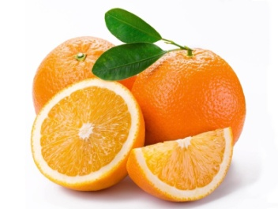 |  | 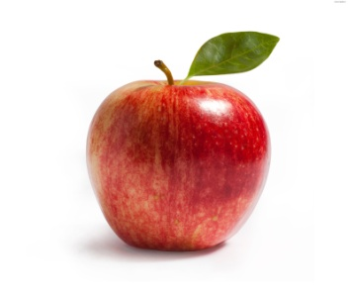
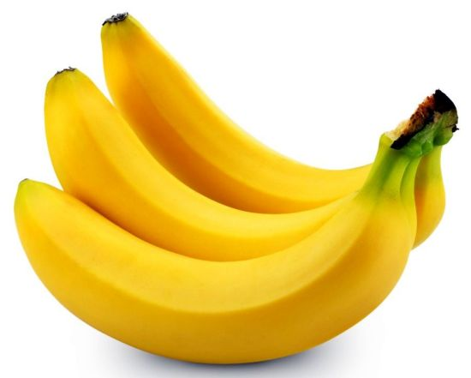 | 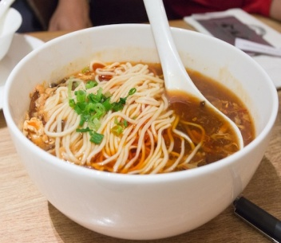 | 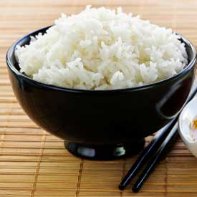 | 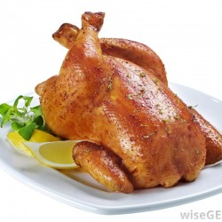
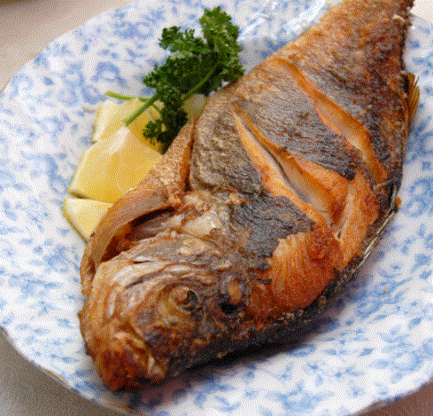 | 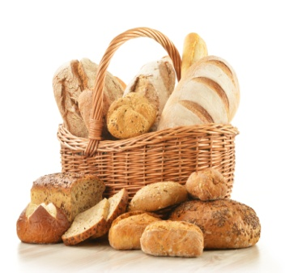 | 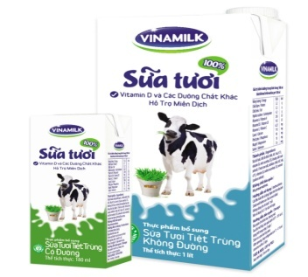 | 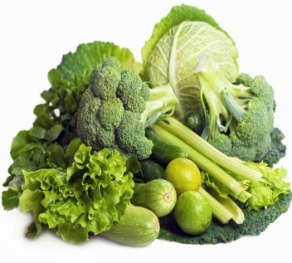

Ex 2: Odd one out:
- a. fish b. pork c. beef d. fruitjuice
2. a. bread b. nurse c. noodles d. food
3. a. doctor b. worker c. rubber d. teacher
4. a. clerk b. field c. factory d. office
5. a. drink b. milk c. water d. apple
6. a. banana b. apple c. fruit d. tailor
7. a. drink b. noodles c. bread d. fish
- a. lemonade b. fruitjucie c. lunch d. chicken
- a. vegetable b. breakfast c. lunch d. dinner
- a. rice b. orange c. banana d. apple
- a. orange juice b. milk c. water d. fish
- a. bread b. noodles c. hungry d. fish
- a. thirsty b. banana c. apple c. lemonade
- a. math b. teacher c. history d. music
- a. subject b. pencil c. rubber d. sharpener
- a. England b. America c. Japan d. China
- a. nationality b. his c. her d. your
- a. get up b. go home c. name d. sing
- a. PE b. IT c. On d. Art
- a. eat b. pork c. chicken d. bread
Ex 3: Put the words in correct order:
- like/ I / apple juice/ would/ some/.
- what/ your/ drink/ favourite/ is/?
- Mary’s/ food/ is/ what/ favourite/?
- drink/ is/ juice/ favourite/ my/ orange/.
- parents/ fish/ rice/ like/ my/ and/
- have/ you/ breakfast/ do/ what/ for/?
- is/ drink/ your/ favourite/ what/?
- mother/ home/ late/ goes/ evening/ the/ in/my/.
- her/ factory/ worker/ works/ in/, / he/ is/ father/ a/ a/.
- she/ some/ like/ water/ would/ and/ apple/.
Ex 4: Read and macth:
- What’s your favourite drink? | - Yes, please.
- Does she like her job? | - Yes, you can.
- Would you like some lemonade? | - In a factory.
- What does she do? | - Yes, please. I love noodles.
- May I come in, sir? | - It’s apple juice.
- Do you like your job? | - No, she doesn’t.
- Would you like some noodles? | - She’s a clerk.
- Where does he work? | - Yes, I do.
- What time do you go to school? | - On Tuesday and Thursday.
- Where are you from? | - No, she’s American.
- What did you do last night? | - It’s two fifty six.
- Did you go to school yesterday? | - I did my homework and watched TV.
- Is she Malaysian? | - At a quarter to seven.
- What time is it now? | - Yes, I did.
- When do you have English? | - Tokyo, Japan.

Ex 5: Choose the correct answer:
- Would you like ................. beef? (an/ a/ some/ any)
- My father ................. his job. (like/ loves/ do/ have)
- What ................. Lan do? (is/ am/ do/ does)
- Our friends ................. to school in the morning. (goes/ when/ go/ did)
- What ................. you do yesterday? (do/ does/ did/ doed)
- Lan ................. at the zoo last weekend. (is/ was/ beed/ am)
- My ................. drink is lemonade. (like/ favourite/ love/ drink)
- I go to ................. at 10 p.m. (school/ work/ bed/ the zoo)
- My grandfather is a farmer. He works in the ................. . (factory/ school/ office/ field)
- Every day I get ................. at 6 o’clock. (up/ in/ to/ next)
- His favourite drink is ................. . (chicken/ beef/ fruit juice/ beef)
- Sometimes I have some bread with milk for ................. . (school/ breakfast/ class/ friend)
- I am hungry. I would like some ................. . (water/ milk/ coffee/ noodles)
- Mr. Tuan is a doctor. He works in a ................. . (field/ factory/ hospital/ police station)
- My uncle is a ................. in a primary school. (tailor/ singer/ teacher/ driver)
- My grandparents are working in the rice ................. now. (field/ office/ hospital/ school)
- What ................. does your brother get up? (colour/ time/ food/ drink)
- ................. does she work? – in an office. (what/ who/ when/ where)
- My school starts at 7 o’clock and ................. at 11.15. (does/ teaches/ finishes/ watches)
- ................. dinner, I do my homework or listen to music. (at/ after/ before/ in)

