Trường TH Dương Hà
PHẾU ÔN TẬP
Môn: Tiếng Anh - Tuần 3 ( Từ 17/2/2020 - 21/2/2020)

Ex1. Hãy khoanh tròn từ khác loại trong nhóm từ sau.
1. teacher nurse cooker cook
2. white green sing red
3. Vietnam Singapore American England
4. dear year month week
Ex2. Khoanh tròn vào chữ cái trước câu trả lời đúng để hoàn thành câu.
1. ............................ is that? – It’s my teacher.
A. What B. Who C. Where D. How
2. Does she like sandwiches? - ............................
A. Yes, she do B. Yes, he is C. Yes, she does D. Yes, she is
3. This is Mai ............................ mother is a doctor.
A. his B. she C. he D. his
4. She ............................ a banana.
A. wants B. want C. to want D. wantes
5. What is it? Itis ............................
A. eraser B. an eraser C. erasers D. a eraser
Ex3. Chọn câu trả lời đúng nhất.
1. I have toothache. – So, you should go to a ........................
A.dentist B. opitcian C. doctor D. teacher
2. I like English because it is ............................
A.playing B. hot C. interesting D. hungry
3. How ............................ in the schoolbag?
A. many B. much C. often D. old
4. Nam is a ............................ at Holmes primary school.
A. student B. farmer C. worker D. postman
5.Her brother is a ............................ at Viet-Phap hospital.
A. police officer B. singer C. dancer D. doctor
Ex4. Hãy sắp xếp các câu ở cột B sao cho phù hợp với nội dung các câu trong cột A.
A |  | B
1.Where are you from? |  | A. Because I want a hamburger.
2.How often do you play football? |  | B. It’s my favourite drink.
3.I like milk very much. |  | C. I’m from London.
4.What did you do yesterday? |  | D. Yes, I am.
5.Are you going to ride a bike tomorrow? |  | E. Sometimes.
6.Why do you go to the food stall? |  | F. We went to the cinema.

1. ......... .2. .......... 3. ......... 4. ........... 5. ............. 6. ...........

Ex5. Trả lời những câu hỏi sau.
1.What is your favourite subject?
...................................................................................................................
2.What is your favourite sport?
...................................................................................................................
3. What is your job?
...................................................................................................................
4. Do you like English?
...................................................................................................................
5. What does your mother do?
...................................................................................................................
6. What is your father’s job?
...................................................................................................................
7. What is the date today?
...................................................................................................................
8. What are you doing now?
...................................................................................................................
Ex6. Đọc đoạn văn và đánh T vào câu đúng và F vào câu sai.
Linda is a student at Star Primary School. She is from England. She is eleven years old. Her birthday is on 25th February. She lives in a small town. Her mother is a nurse and her father is a doctor. She studies many subjects such as Math, English, Science, Art and Music. She likes listening to music. Music is her favorite subject at school. She wants to be a singer but her mother wants her to be a teacher. She can sing and dance. She likes sandwiches and ice creams.
1. | Linda studies at Star Primary school.
2. | She is English.
3. | Her mother is a doctor.
4. | She likes Music very much.
5. | She wants to be a teacher.
6. | She can sing and dance.
7. | She doesn’t like sandwiches.

Ex7. Nối mỗi câu với một bức tranh phù hợp.

1. He has got a headache.  . | A. | 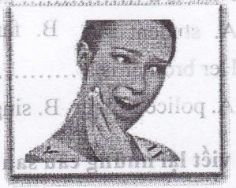
2. He’s got a toothache. | B. | 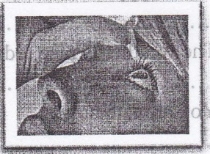
3.She has got sore eye. | C. | 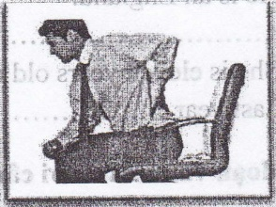
4. He’s got backache. | D. | 

Ex8. Hãy viết lại những câu sau dùng dạng quá khứ của động từ “TO BE”.
1. I am happy now.
.......................................................................................... last night.
2. The weather is nice today.
.......................................................................................... yesterday.
3. You are late now.
..................................................................................... last Saturday.
4. He is an England.
.............................................................................................. in 1998.
5. She is eleven years old now.
Last year ...........................................................................................

