Trường TH Dương Hà
PHẾU ÔN TẬP
Môn: Tiếng Anh - Tuần 6 ( Từ 9/3/2020 - 13/3/2020)

Ex1. Sắp xếp lại các chữ cái sau để tạo thành từ có nghĩa.
1. a m r: ............................
2. m o t h u: ............................
3. n s e o: ............................
4. n e k c: ............................
5. e r a: ............................
6. h a d e a c h e: ............................
Ex2. Chọn đáp án đúng A, B, C hoặc D.
1. What does your mother ............................? – She’s a doctor.
A. do B. does C. did D. is
2. My brother works in a factory. He’s a ............................
A. worker B. farmer C. teacher D. nurse
3. My sister works at a hospital. She’s a ............................
A. worker B. farmer C. teacher D. nurse
4. She ............................ fish and beef very much.
A. like B. likes C. to like D. liking
5. ............................ do you have English? -I have it on Monday and Friday.
A. What B. Who C. When D. How
6. He always ............................ his teeth before going to bed
A. cleaning B. clean C. cleans D. cleaned
7. He wants to be a ............................ in the future.
A. artist B. actor C. pilot D. engineer
8. They are ............................ clean the house at the weekend.
A. going to B. going C. going for D. will to
Ex3. Hãy sắp xếp lại các từ sau để tạo thành câu hoàn chỉnh.
1.visited/ his grandparents/ Kevin/ yesterday.
..............................................................................................................
2.went/there/ Jenny/ her/ with/ friends.
..............................................................................................................
3.bought/many/ they/ things.
..............................................................................................................
4. were/ the/ laughing/ we/ all/ time.
...................................................................................................................
5. going/ I’m/ to/ the/ visit/museum. ..............................................................................................................
6. want/ to/ they/ have/ good/ a/ time.
..............................................................................................................
7.go/ zoo/ Did/ the/ to/ she/ yesterday?
..............................................................................................................
8. me/ go/ the/ to/ cinema/ Do/ with?
...................................................................................................................
9. with/ what/you/ is/ the matter/? ..............................................................................................................
10. backache/ have/ a/ I/.
..............................................................................................................
11.should/ dentist/ go/ the/ she/ to/.
..............................................................................................................
12.violon/ the/ he/ playing/ is/ now/.
..................................................................................................................
Ex4. Đọc đoạn văn và trả lời câu hỏi.
Hello. My name’s Jame. Last summer, I went to Nha Trang beach with my family. We went by plane. We stayed in a big hotel. The weather was fine. In the early morning, we went for a walk along the beach, and then we went swimming. In the afternoon, we saw the sunset. It was romantic. We also took a lot of photos. I bought some souvenirs for my friends. We had a good time.
1.Where did Jame’s family go last summer?
..............................................................................................................
2.How did they go?
..............................................................................................................
3. What did they do in the morning?
..............................................................................................................
4. What did they do in the afternoon?
..............................................................................................................
5. What did Jame buy for his friends?
..............................................................................................................
Ex5. Điền các chữ cái thích hợp để hoàn thành các từ sau.

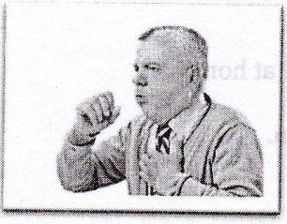 |  |  | 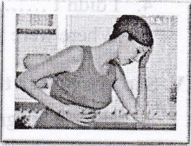
1. co_gh | 2. h_adach_ |  | 3. st_m_ch_ch_
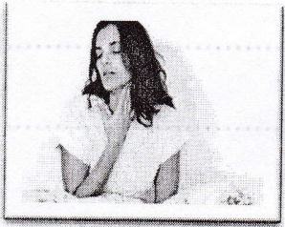 | 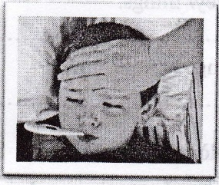 |  | 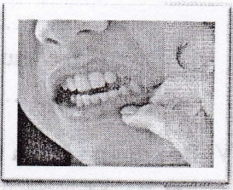
4. s_re thr_ _t | 5. f_ver |  | 6. tooth_che

Ex7. Mỗi câu có một lỗi sai, hãy gạch chân và sửa lại.
- They are going to playing chess.
..............................................................................................................
2. What do you going to do tomorrow?
..............................................................................................................
3.She stays at home last night.
..............................................................................................................
4. It’s going to rain soon.
...................................................................................................................
Ex8. Tìm từ không cùng nhóm với từ còn lại.
1.A. chicken B. bread C. food D. rice
2.A. math B. subject C. science D. music
3.A. breakfast B. lunch C. dinner D. have
4. A. house B. father C. mother D. brother
5. A. headache B. toothache C. doctor D. fever

