Trường TH Dương Hà
PHẾU ÔN TẬP
Môn: Tiếng Anh - Tuần 6 ( Từ 9/3/2020 - 13/3/2020)

Ex1. Fill in the blanks
1. There ….. my bedroom.
A. am B. is C.are
2. - …. there a garden?
- Yes, ….. is.
A. Is – there B. Are – this C. Am – these
3. - ………… tables are there?
- There are five.
A. How long B. How far C. How many
4. - How many …. do you have?
- I have five
A. doll B. kites C. plane
5. - There are four ……
A. windows B. window C. door
6 . - ……. are the posters?
- They’re on the bed.
A. What B. When C. Where
7. - Where …. the cat?
- It’s under the table.
A. am B. is C.are
8. - Where are the ……?
- They’re in the cage.
A. parrots B. parrot C. rabbit
9. - …… is Ha Long Bay ?
- It’s in north Viet Nam
A. What B. When C. Where
10. - Where’s Hue?
- It’s in ….. … Viet Nam
Exx2. Fill preposition “on, near, under, behind” in the blank
1………  2………  3………  4………  5……… | 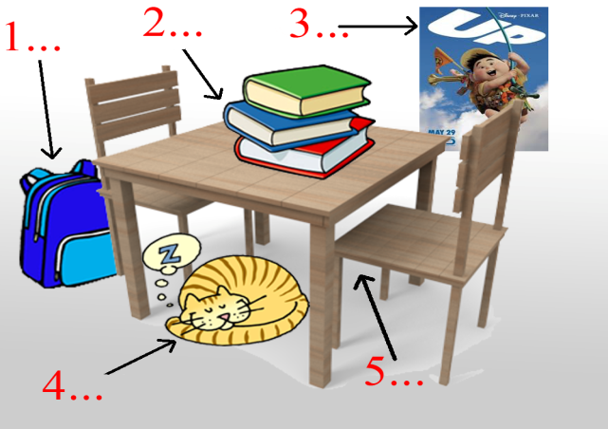
Ex3. Look and write
 |  |  | 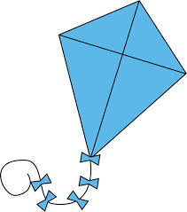
 | 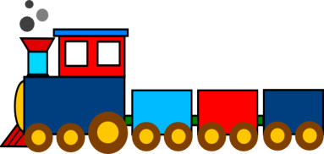 |  | 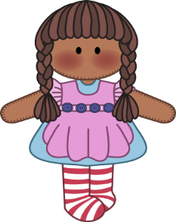

a. robot b. kite c. doll d.puzzle e. plane
f. ship g. train h. yo-yo

Ex4. Write the names of animals
C | D | R | G | P
T | G
 |  | T |  | T
 |  |  | H
Ex5. Choose the correct answer
1. - Are there ….. maps in your room?
- Yes, there are
A. this B. any C. that
2. - Are there any sofas in your living room?
- No, there …..
A. are B. is C. aren’t
3. - ….. you have a robot?
- Yes, I ….
A. Does – do B. Do – do C. Do – does
4. - Do you have a doll?
- …., I don’t
A. Yes B. No
5. - ….. he have a plane?
- No, he ….
A. Do – does B. Does – does C. Does – doesn’t
6. - Do you have …. pets?
- Yes, I do.
A. this B. any C. that
7. - Do you have any ….. ?
- No, I don’t.
A. parrots B. parrot C. cat
8. - What toys do you like ?
- I like ….
A. cat B. goldfish C. truck
9. - What ….. do you like?
- I like rabbit
A. pets B.toys
10. - …. are you doing?
- I’m reading
A. What B. When C. Where

