Trường TH Dương Hà
PHẾU ÔN TẬP
Môn: Tiếng Anh - Tuần 7 ( Từ 16/3/2020 - 20/3/2020)

Ex1.Choose the word different from others in each line.
1. A. pen B. ruler C. eraser D. school
2. A. tall B. big C. old D. bag
3. A. child B. cakes C. candies D. books
4. A. father B. sister C. son D. friend
5. A. cat B. dog C. buffalo D. fish
Ex2. Choose one word to complete the sentence.
1. - What are Peter and Jane doing?
- They are …………….. volleyball.
A. playing B. play
2. - What is he doing?
- He …………….. playing with paper boats.
A. are B. is
3. - Where are they now?
- They are …………….. the garden.
A. in B. on
4. - Are they playing badminton?
- Yes, they
A. aren’t B. are
5. - Is she skipping?
- No, she …………….. She is cycling.
A. isn’t B. is
Ex3. Match the pictures with the sentences and say aloud.

1. | 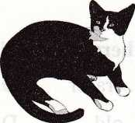 | A. I’ve got a tortoise.
2. | 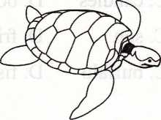 | B. I’ve got a cat.
3. | 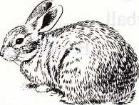 | C. I’ve got three goldfishes.
4. | 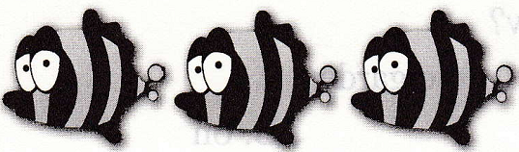 | D. I’ve got two dogs.
 | 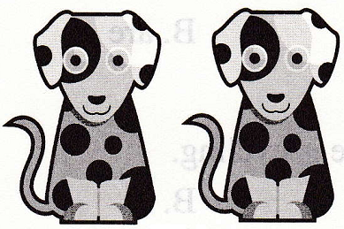 | E. I’ve got a rabbit.

Ex4. Read and complete the sentences.

Mary has a little pet. It is a rabbit. Its name is Lucy. Lucy likes to eat carrot. She loves to watch when it is asleeping. Mary plays with Lucy every evening.  1. Mary has a little ……………..  2. Rabbit’s name is ……………..  3. Lucy likes to eat ……………..  4. …………….. plays with Lucy every evening. |  | 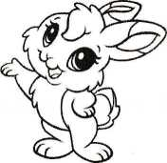

Ex5. Rearrange the words given to make sentences.
1.

……………………………………………………………………………………

2.

……………………………………………………………………………………

3.

……………………………………………………………………………………

4.

……………………………………………………………………………………
Ex6. Find the opposite to these words.
1. Open >< ……………..
2. Sit down >< ……………..
3. Small >< ……………..
4. Fat >< ……………..
5. Left >< ……………..

Ex7. Make questions for the following answers.
1. I have three cats.
……………………………………………………………………………………
2. It’s cloudy today.
……………………………………………………………………………………
3. Her name is Anna.
……………………………………………………………………………………
4. Yes, these ships are nice.
……………………………………………………………………………………
5. My sister is seven.
……………………………………………………………………………………
IV. Complete the passage using the given words in the box.
theyhavebigtoys

Hello. My name’s Peter. I have many (1) …………….. I (2) …………….. a bear. It is white. I have an aeroplane. It is (3) …………….. I have three dolls. (4) …………….. are lovely. I have a long train. It can run. I love toys very much.

