Trường TH Dương Hà
PHẾU ÔN TẬP
Môn: Tiếng Anh - Tuần 8 ( Từ 23/3/2020 - 27/3/2020)

Ex1. Odd one out.
1. father teacher mother brother
2. big friend small young
3. pen cat book ruler
4. cloudy sunny rainy weather
5. How What many Where
Ex2. Choose the best answer to complete the following sentences.
1. (How old/How/How many) are you? I’m fine, thanks.
2. (They/ Their/He) are Tom and Peter.
3. (Sit/ Stand/ Open) down, please.
4. That’s Alan. (He/It/She) is my friend.
5. There (am/ is/ are) three dogs.
6. (Do/ Am/ Are) you have a cat?
Ex3. Rearrange the letters to make the words.

1. ogd ____________ |  | 
2. tac ____________ |  | 
3. ghoslidt ____________ |  | 
4. rroatp ____________ |  | 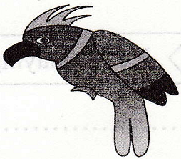
5. ribatb ____________ |  | 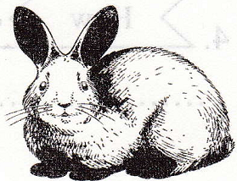

Ex4. Draw a line to match two parts of each sentence.

 | A |  |  |  | B
1. I’ve …………….. |  |  | A. …………….. and a robot.
2. My sister …………….. |  |  | B. …………….. the book?
3. They’ve got a ship …………... |  |  | C. …………….. got two robots.
4. Where is …………….. |  |  | D. …………….. the balls?
5. Where are …………….. |  |  | E. …………... has got many toys.

1->……. 2-> ……… 3->…….. 4-> …….. 5->………..

Ex 5. Choose the best answers to complete the following sentences.
1. They …………….. three dogs and five cats.
A have B. has C. to have D. having
2. This is Daisy …………….. is my friend.
A. They B. She’s C. She D. It
3. What colour is this? - It’s ……………..
A. book B. crayon C. ruler D. green
4. Come …………….., please.
A. to B. in C. go D. for
5. My …………….. is happy.
A. five B. fam C. four D. family
Ex6. Choose the words different from the rest in each line.
1. A. is B. am C. are D. meet
2. A. hat B. hot C. cat D. ruler
3. A. has B. wants C. learn D. keeps
4. A. big B. small C. sun D. tall
5. A. one B. three C. tenth D. four
Ex7. Fill in the blanks with suitable letters to complete the sentences.
1. What colour is that book? - It is a gr_ _n.
2. That is my hou_e.
3. Your doll is be_ _tiful.
4. M_ _ I go out, please?
5. How _r_ you? - I’m fine, thanks.
Ex8. Leave ONE unnecessary letter in these words to make them correct.

1. 

………………………………………………………………………………...

2.

………………………………………………………………………………...

3. 

………………………………………………………………………………...

4.

………………………………………………………………………………...

5. 

………………………………………………………………………………...

