KEY IOE K3 2023 - 2024 SỐ 01
1. Which word has the underlined part pronounced like the letter ‘e’ in ’’red’’?
A. table B. bed C. quiet D. listen
Đáp án: bed
2. What/ this?/ is/ colour/
Đáp án: What colour is this?
3. See you la_ er.
Đáp án: t
4. Ảnh: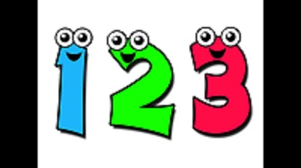ON_ , TWO, THREE
Đáp án: E
5. I want to st_ y at home.
Đáp án: a
6. Nghe:Nhấn giữ Ctrl và bấm chuột để nghe: _ _ _ _
Đáp án: that
7. Thank you very much. - You ... welcome.
A. is B. am C. are D. isn’t
Đáp án: are
8. Nghe:Nhấn giữ Ctrl và bấm chuột để nghe: _ _ _ _
Đáp án: ball
9. Is your ruler short? - No, it isn't. It's ____ .
A. large B. big C. long D. small
Đáp án: long
10. Thank you very m_ _ h.
Đáp án: uc
11. you/ song?/ Can/ sing/ a
Đáp án: Can you sing a song?
12. ... to meet you!
A. How B. Go C. Nice D. Get
Đáp án: Nice
13. This is m_ cat.
Đáp án: y
14. Ảnh:Do you like ... TV? – Yes, I do.
A. seeing B. looking C. watching D. reading
Đáp án: watching
15. _ _ this a ruler? – Yes, it is.
Đáp án: Is
16. Nghe:Nhấn giữ Ctrl và bấm chuột để nghe: This is the _ _ _ _ _ _ _ _ room.
Đáp án: computer
17. A: _________. - B: Yes, you can
A. Open your book! B. Stand up! C. May I go out? D. Be quiet!
Đáp án: May I go out?
18. Ảnh:_ _ _ _ the words aloud.
Đáp án: read
19. Wh_ is that? – It’s Mary.
Đáp án: o
20. Nghe:Nhấn giữ Ctrl và bấm chuột để nghe: _______ table tennis.
A. Peter plays B. I play C. Mai plays D. My friends play
Đáp án: I play
21. G_ _ e me the book, please.
Đáp án: iv
22. Ảnh: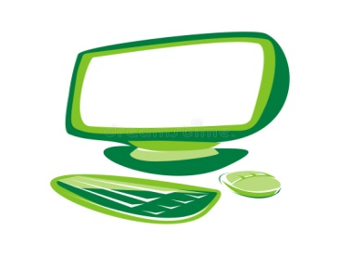It's a ____ computer.
A. black B. blue C. red D. green
Đáp án: Chọn ý: D
23. This is _ green doll.
Đáp án: a
24. I am fine. ... you?
A. End B. And C. An D. At
Đáp án: And
25. Choose the odd one out:
A. are B. you C. am D. is
Đáp án: you
26. C_ _ e over here.
Đáp án: om
27. It is _ _ ice-cream.
Đáp án: an
28. yellow/ This/ hat./ is/ a/
Đáp án: This is a yellow hat.
29. There are t_ _ ee crayons in my bags.
Đáp án: hr
30. L_ _ k at the board, please.
Đáp án: oo
31. Nghe:Nhấn giữ Ctrl và bấm chuột để nghe: There are _ _ _ _ books in the bookcase.
Đáp án: five
32. Ảnh:____ brown books.
A. There are B. They are C. It is D. It's is
Đáp án: They are
33. Choose the odd one out:
A. frog B. desk C. tiger D. lion
Đáp án: desk
34. Jack ___ in the playground.
A. are B. am C. is D. be
Đáp án: is
35. ask you/ a question?/ I/ May/
Đáp án: May I ask you a question?
36. is/ new/ my/ backpack./ That/
Đáp án: That is my new backpack.
37. Ảnh: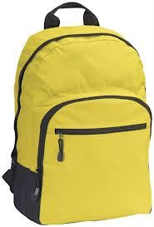Is your school bag y_ _ _ _ _ ? - Yes, it is.
Đáp án: ellow
38. That/ ruler/ is/ pink.
Đáp án: That ruler is pink.
39. What’s ... name?
A. she B. he C. you D. her
Đáp án: Chọn ý: D
40. I have _ _ apple.
Đáp án: an
41. Nghe:Nhấn giữ Ctrl và bấm chuột để nghe: He’s _ _ _ _ _ years old.
Đáp án: eight
42. seven/ Quan/ is/ years old.
Đáp án: Quan is seven years old.
43. make/ a/ Let’s/ circle.
Đáp án: Let’s make a circle.
44. I_ is a crayon.
Đáp án: t
45. Ảnh: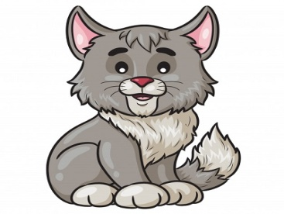CA_
Đáp án: T
46. Se_ you again.
Đáp án: e
47. To_ _ h your desk, please.
Đáp án: uc
48. Choose the incorrect word(s) in the following sentence: These are my notebook.
A. These B. are C. my D. notebook
Đáp án: Chọn ý: D
49. This is my classr_ _ m.
Đáp án: oo
50. …, students. See you tomorrow.
A. Good morning B. Good night C. Goodbye D. Nice to meet you
Đáp án: Goodbye
51. ... ? – It’s yellow.
A. What colour is it B. What is this C. Is this yellow D. This is yellow pen
Đáp án: What colour is it
52. Ảnh: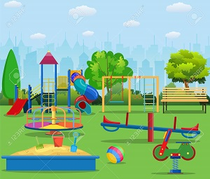We are ______ at break time.
A. in the classroom B. in the computer room C. in the playground D. on the roof
Đáp án: in the playground
53. Close your ..., please.
A. name B. book C. ball D. took
Đáp án: book
54. Ảnh:Unscramble this word: ’’AERSRE’’ -> ’’ERAS_ _ ’’.
Đáp án: ER
55. Is that your pencil? – No, it is _ _ _ .
Đáp án: not
56. My school isn't new. It's _ ld.
Đáp án: o
57. I … a blue pencil and a white ruler.
A. has B. have C. don’t have D. doesn’t have
Đáp án: have
58. Do you like _______ TV?
A. playing B. watching C. reading D. talking
Đáp án: watching
59. Look … your book, please.
A. of B. in C. on D. at
Đáp án: Chọn ý: D
60. He has a ... .
A. sunny B. cloudy C. windy D. doll
Đáp án: Chọn ý: D
61. Nghe:Nhấn giữ Ctrl và bấm chuột để nghe: Who’s that?
A. Mary B. Jane C. Linda D. Ellie
Đáp án: Linda
62. Ảnh:These are th_ _ _ dogs.
Đáp án: ree
63. That is my fr_ _ nd.
Đáp án: ie
64. Ảnh: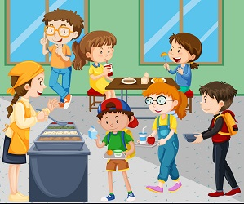It's my school ____ room.
A. music B. art C. lunch D. computer
Đáp án: lunch
65. What is her name? - ... .
A. He name is Peter B. His name Peter C. Her name Sammy D. Her name is Sammy
Đáp án: Chọn ý: D
66. Nghe:Nhấn giữ Ctrl và bấm chuột để nghe: What AREN’T the students doing?
A. Running B. Jumping C. Laughing D. Studying
Đáp án: Chọn ý: D
67. class 3A./ in/ Tony and I/ are/
Đáp án: Tony and I are in class 3A.
68. Is your classroom big? - …, it isn't. It’s small.
A. Yes B. Yes, it isn’t C. No, it is D. No
Đáp án: Chọn ý: D
69. You ... Richard. You are a new student in my class.
A. is B. be C. are D. am
Đáp án: are
70. Please, be q_ _ et.
Đáp án: ui
71. Nghe:Nhấn giữ Ctrl và bấm chuột để nghe: Th_ _ _ are my pencils.
Đáp án: ose
72. TEACH_ R
Đáp án: E
73. your/ close/ books./ Please/
Đáp án: Please close your books.
74. What’s _______ name?
A. you B. I C. his D. he
Đáp án: his
75. She is my tea_ _ er.
Đáp án: ch
76. Ảnh: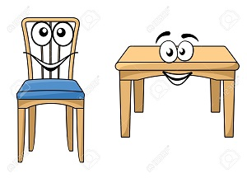TABLE AND CHAI_
Đáp án: R
77. What do you do ... English lessons?
A. on B. to C. near D. during
Đáp án: Chọn ý: D
78. There _ _ a pen in my school bag.
Đáp án: is
79. My pen is o_ the desk.
Đáp án: n
80. This is the way we go _ _ school.
Đáp án: to
81. Put your book a_ _ y please.
Đáp án: wa
82. Gi_ e me the book, please.
Đáp án: v
83. Ảnh:That's my computer _ oom.
Đáp án: r
84. student./ am/ I/ a/
Đáp án: I am a student.
85. Ảnh: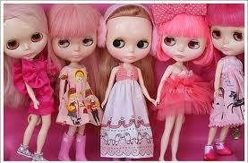What are these? – These are pink _ _ _ _ _ .
Đáp án: dolls
86. are/ Mary./ Hi,/ you?/ How/
Đáp án: Hi, Mary. How are you?
87. I'm/ thank/ you./ fine,/
Đáp án: I'm fine, thank you.
88. That is a big tr...e.
A. a B. u C. e D. i
Đáp án: e
89. Who is she? – S_ e is Mary.
Đáp án: h
90. Ảnh:Our _ _ _ _ _ _ _ _ is not big.
Đáp án: bathroom
91. A: Is that _ _ y your friend? - B: No, he isn’t.
Đáp án: bo
92. John./ How/ are/ Hi, I’m/ you?/
Đáp án: Hi, I’m John. How are you?
93. you./ meet/ Nice/ to/
Đáp án: Nice to meet you.
94. May I go out? - Yes, ….
A. you can B. you can’t C. you aren’t D. it is
Đáp án: you can
95. Tom is my friend, t_ _ .
Đáp án: oo
96. My name is Jane. This is … family.
A. I B. my C. mine D. me
Đáp án: my
97. have/ I/ in/ two books/ my bag./
Đáp án: I have two books in my bag.
98. a/ pen./ is/ This/
Đáp án: This is a pen.
99. Nghe:Nhấn giữ Ctrl và bấm chuột để nghe: gi_ _
Đáp án: rl
100. There are ... books on the desk.
A. a B. one C. much D. many
Đáp án: Chọn ý: D
101. Is/ that/ Viet?/
Đáp án: Is that Viet?
102. very/ teacher/ My/ tall./ is/
Đáp án: My teacher is very tall.
103. Nghe:Nhấn giữ Ctrl và bấm chuột để nghe: Listen and tick:
A. This is my school bag. B. This is my school bus. C. This is my school car. D. This is my school book.
Đáp án: This is my school bag.
104. May I come _ n? – Yes, please.
Đáp án: i
105. This is my sister. _ _ _ name is Alice.
Đáp án: her
106. These are ....
A. cat B. cats C. cat’s D. a cat
Đáp án: cats
107. the/ at/ picture./ Look/
Đáp án: Look at the picture.
108. This rose ... for you. - Thank you very much.
A. are B. and C. is D. this
Đáp án: is
109. is/ my/ This/ classroom.
Đáp án: This is my classroom.
110. Nghe:Nhấn giữ Ctrl và bấm chuột để nghe: F_ ur brothers and 4 sisters.
Đáp án: o
111. morning./ every/ I/ school/ go to/
Đáp án: I go to school every morning.
112. A parrot can f_ _ .
Đáp án: ly
113. food./ some/ wants/ Peter/
Đáp án: Peter wants some food.
114. Ảnh: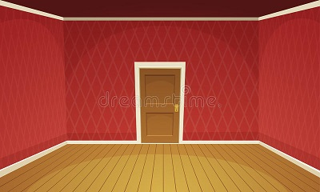A LARG_ ROOM
Đáp án: E
115. ___ is my sister, Hoa.
A. Her B. He C. She D. His
Đáp án: She
116. What/ have?/ does/ subjects/ he
Đáp án: What subjects does he have?
117. ... you like a candy? – No, thanks.
A. Who B. When C. Would D. How
Đáp án: Would
118. Sit down/ and/ please!/ open/ your book,
Đáp án: Sit down and open your book, please!
119. Nghe:Nhấn giữ Ctrl và bấm chuột để nghe: Is the school gym _______?
A. large B. big C. lag D. larg
Đáp án: large
120. Nghe:Nhấn giữ Ctrl và bấm chuột để nghe: That is my _ _ _ _ _ _ _ .
Đáp án: teacher
121. Ảnh: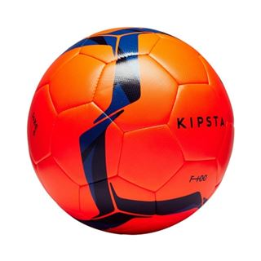This is a ______.
A. ball B. hat C. book D. table
Đáp án: ball
122. and Linda/ years old./ are/ eight/ Peter/
Đáp án: Peter and Linda are eight years old.
123. The bag is p...nk.
A. u B. i C. e D. o
Đáp án: i
124. at/ that/ blue/ picture./ Look/
Đáp án: Look at that blue picture.
125. No, it is n_ _ .
Đáp án: ot
126. How are y_ _ ?
Đáp án: ou
127. two/ There/ are/ pencil boxes.
Đáp án: There are two pencil boxes.
128. This isn’t ... ruler. It’s my ruler.
A. he’s B. his C. me’s D. you’s
Đáp án: his
129. I/ am/ thirsty/ now.
Đáp án: I am thirsty now.
130. Let’s make a ci_ cle.
Đáp án: r
131. What are _ _ _ se? – These are pink dolls.
Đáp án: the
132. is/ your teacher?/ old/ How/
Đáp án: How old is your teacher?
133. Is this a book? - _ _ , it isn’t.
Đáp án: no
134. Be qu_ et, please.
Đáp án: i
135. is/ new/ and/ nice./ The school library/
Đáp án: The school library is new and nice.
136. Choose the odd one out:
A. cat B. dog C. pencil D. parrot
Đáp án: pencil
137. How _ _ _ you?
Đáp án: are
138. Nghe:Nhấn giữ Ctrl và bấm chuột để nghe: _ _
Đáp án: is
139. in/ There/ that box./ are/ many toys/
Đáp án: There are many toys in that box.
140. Good morning, te...cher.
A. u B. a C. e D. o
Đáp án: a
141. a/ It/ box./ big/ is/
Đáp án: It is a big box.
142. Stand in line, pl_ _ _ _ .
Đáp án: ease
143. What is ... name? – My name is Simon.
A. I B. he C. my D. your
Đáp án: Chọn ý: D
144. She is _ _ new friend.
Đáp án: my
145. Put your book a_ _ y.
Đáp án: wa
146. The pencil sharpener/ is in/ my pencil case./
Đáp án: The pencil sharpener is in my pencil case.
147. Bob: What is this? - Peter: ...
A. His name is Hien. B. It is a ruler. C. It’s an ruler. D. It is my friend.
Đáp án: It is a ruler.
148. colour/ My favourite/ is blue./
Đáp án: My favourite colour is blue.
149. A fish can s_ _ m but it can’t run.
Đáp án: wi
150. Is this a bag? - ... .
A. Yes, it is B. Yes, isn’t C. No, it is D. Nice to meet you.
Đáp án: Yes, it is
151. Ảnh:SCHOOL TH_ NGS
Đáp án: I
152. These/ kites/ beautiful./ are/
Đáp án: These kites are beautiful.
153. Look _ _ that map on the wall, please.
Đáp án: at
154. May I/ pencil/ close/ box?/ your/
Đáp án: May I close your pencil box?
155. Nghe:Nhấn giữ Ctrl và bấm chuột để nghe: _ _ _ _
Đáp án: play
156. These/ are/ my sister's/ dolls./ pink
Đáp án: These are my sister's pink dolls.
157. are/ relatives./ my/ These/
Đáp án: These are my relatives.
158. GR_EN
A. I B. O C. E D. A
Đáp án: E
159. Nghe:Nhấn giữ Ctrl và bấm chuột để nghe: They are _ _ own.
Đáp án: br
160. name, Nam?/ your/ How do/ you spell/
Đáp án: How do you spell your name, Nam?
161. He can play football … can’t play chess.
A. and B. but C. so D. or
Đáp án: but
162. … brother is very tall.
A. My B. I C. Me D. Mine
Đáp án: My
163. My favourite colour is ____.
A. oranges B. red C. apple D. back
Đáp án: red
164. What is your f_ _ _ _ _ _ _ e food?
Đáp án: avourit
165. Close/ your book,/ please!/
Đáp án: Close your book, please!
166. small./ school/ Her/ new/ is
Đáp án: Her new school is small.
167. Be q_ _ et, please.
Đáp án: ui
168. I ... Simon. Nice to meet you.
A. am B. you C. she D. he
Đáp án: am
169. L_ _ k, listen and repeat.
Đáp án: oo
170. that/ his/ Is/ teacher?
Đáp án: Is that his teacher?
171. Nghe:Nhấn giữ Ctrl và bấm chuột để nghe: This is my _ _ _ _ _ .
Đáp án: ruler
172. books/ Are there/ your bedroom?/ any/ in
Đáp án: Are there any books in your bedroom?
173. you/ later./ See/ Goodbye./
Đáp án: Goodbye. See you later.
174. ... is that? - It’s a chair.
A. Who B. Where C. What D. When
Đáp án: What
175. Nghe:Nhấn giữ Ctrl và bấm chuột để nghe: Listen and tick:
A. This toy is Nam. B. This friend is Nam. C. This girl is Nam. D. This boy is Nam.
Đáp án: Chọn ý: D
176. I ... Andy.
A. are B. am C. is D. you
Đáp án: am
177. Co_ plete the sentences.
Đáp án: m
178. How are y_ _ ?
Đáp án: ou
179. _ _ es she like table tennis?
Đáp án: do
180. gym/ the/ Is/ large?
Đáp án: Is the gym large?
181. Ảnh: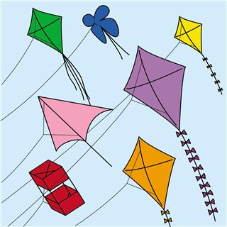There are many k_ _ _ _ in the sky.
Đáp án: ites
182. mess./ a/ Don’t/ make/
Đáp án: Don’t make a mess.
183. … is your name? – My name is Jenny.
A. How B. Where C. Who D. What
Đáp án: Chọn ý: D
184. This is ... cat.
A. he B. she C. my D. you
Đáp án: my
185. _______ the tables old?
A. Am B. Is C. Are D. It
Đáp án: Are
186. Good mo_ _ ing, children!
Đáp án: rn
187. today./ very/ It/ hot/ is/
Đáp án: It is very hot today.
188. Ảnh: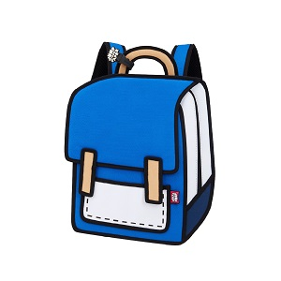BACK_ ACK
Đáp án: P
189. This gift is for you. - Thank you very _ _ _ _ .
Đáp án: much
190. Listen/ please./ teacher,/ the/ to/
Đáp án: Listen to the teacher, please.
191. I'm _____ so I don’t go to school today.
A. fine B. good C. well D. sick
Đáp án: Chọn ý: D
192. What color is this? - It’s ... .
A. book B. pen C. green D. pencil
Đáp án: green
193. Is this a book? - ... .
A. Yes, it is B. Yes, isn’t C. No, It is D. Nice to meet you.
Đáp án: Yes, it is
194. Green./ Miss/ Goodbye,/
Đáp án: Goodbye, Miss Green.
195. He is ... .
A. Peter B. It C. Mai D. She
Đáp án: Peter
196. Nice to me_ t you.
Đáp án: e
197. What is this? – It is … ice cream.
A. a B. an C. these D. that
Đáp án: an
198. _______. See you again.
A. Good morning B. Good afternoon C. Good evening D. Goodbye
Đáp án: Chọn ý: D
199. Nghe:Nhấn giữ Ctrl và bấm chuột để nghe: They are in the _ _ _ _ _ _ _ .
Đáp án: library
200. That’_ his brother.
Đáp án: s

KEY IOE K3 2023 - 2024 SỐ 02
1. What’s y_ ur name?
Đáp án: o
2. Nghe:Nhấn giữ Ctrl và bấm chuột để nghe: Let’s go to the school _ _ _ _ _ _ _ .
Đáp án: library
3. I draw a pictu_ _ in the room.
Đáp án: re
4. _ _ at is your name? - My name is Hung.
Đáp án: Wh
5. your book,/ Open/ please!/
Đáp án: Open your book, please!
6. May I ___ the book?
A. open B. stand C. play D. sit
Đáp án: open
7. That is a big tr...e.
A. a B. u C. e D. i
Đáp án: e
8. _______ fine, thanks.
A. I am B. I C. I’m am D. I I’m
Đáp án: I am
9. Odd one out:
A. fish B. cat C. dog D. book
Đáp án: Chọn ý: D
10. school./ we/ This is/ go to/ the way/
Đáp án: This is the way we go to school.
11. Ảnh:Sit _ _ wn , please!
Đáp án: do
12. Choose the odd one out:
A. she B. my C. he D. you
Đáp án: my
13. How _ _ _ are you? – I’m seven years old.
Đáp án: old
14. am fine/ , thanks./ I/ you?/ And
Đáp án: I am fine , thanks. And you?
15. ... are you? – I’m fine, thanks.
A. Hi B. Hello C. How D. How’s
Đáp án: How
16. Ảnh: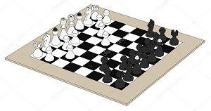CH_ SS
Đáp án: E
17. and/ My brother/ two dogs./ has/ a cat/
Đáp án: My brother has a cat and two dogs.
18. A/ in the classroom./ is/ black board/
Đáp án: A black board is in the classroom.
19. Ảnh: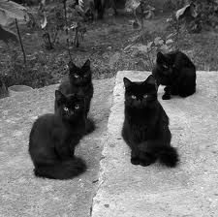These cats are _ _ _ _ _ .
Đáp án: black
20. new/ my/ teacher./ is/ Miss Lien/
Đáp án: Miss Lien is my new teacher.
21. A: _ _ _ _ ’s it? - B: It’s my notebook.
Đáp án: What
22. Point _ _ the teacher.
Đáp án: to
23. Is your school new? - No. It's _____.
A. new B. old C. not D. is
Đáp án: old
24. … that woman your new teacher?
A. Is B. Has C. Who’s D. Does
Đáp án: Is
25. Stand u_ , please.
Đáp án: p
26. Is your classroom big? - …, it isn't. It’s small.
A. Yes B. Yes, it isn’t C. No, it is D. No
Đáp án: Chọn ý: D
27. your/ to/ friend./ Listen/
Đáp án: Listen to your friend.
28. I’m ... , thank you. And you?
A. nice B. bye C. fine D. hi
Đáp án: fine
29. … ? – It’s black.
A. What colour is it B. What is this C. How are you D. How many
Đáp án: What colour is it
30. Simon./ Come/ over/ here,/
Đáp án: Come over here, Simon.
31. Is this your ruler? - No, ____ isn't
A. it B. that C. its D. it's
Đáp án: it
32. the pink/ pen,/ please./ Give/ me/
Đáp án: Give me the pink pen, please.
33. Ảnh: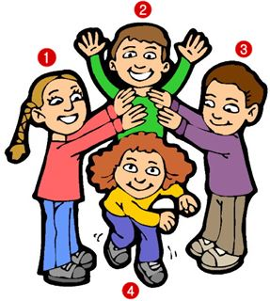A: Who’s Tracy? - B: The girl is in the yellow shirt.
A. 1 B. 2 C. 3 D. 4
Đáp án: Chọn ý: D
34. Don't/ girls!/ in class,/ talk/
Đáp án: Don't talk in class, girls!
35. Is it _ ruler? – No, it isn’t.
Đáp án: a
36. Jack ___ in the playground.
A. are B. am C. is D. be
Đáp án: is
37. I go to school ___ my classmates.
A. in B. and C. but D. with
Đáp án: Chọn ý: D
38. W_ _ t is this? – This is a marker.
Đáp án: ha
39. May I go out? - ... .
A. Hello B. Nice to meet you C. Fine, thanks D. Sure
Đáp án: Chọn ý: D
40. That’s my fathe_ .
Đáp án: r
41. that,/ Who's/ Peter?/
Đáp án: Who's that, Peter?
42. I go to school library to ... books.
A. read’s B. reads C. read D. read to
Đáp án: read
43. Are/ sick/ you/ today?
Đáp án: Are you sick today?
44. books/ How/ there?/ many/ are
Đáp án: How many books are there?
45. Hi, I’m Collin. Nice to meet ....
A. me B. they C. he D. you
Đáp án: Chọn ý: D
46. ... this a pencil?
A. Are B. You C. Is D. My
Đáp án: Is
47. Nghe:Nhấn giữ Ctrl và bấm chuột để nghe: I’m standing in a ... .
A. living room B. classroom C. room D. bedroom
Đáp án: classroom
48. Nghe:Nhấn giữ Ctrl và bấm chuột để nghe: I like basketba_ _ .
Đáp án: ll
49. Nghe:Nhấn giữ Ctrl và bấm chuột để nghe: The school _______ is large.
A. gym B. school C. room D. library
Đáp án: gym
50. the teacher/ Write/ what/ says.
Đáp án: Write what the teacher says.
51. Unscramble this word: ’’YBEDOGO’’ -> ’’GOOD_ _ _ ’’.
Đáp án: BYE
52. A: … that boy your friend? - B: Yes, ….
A. Are – they are B. Are – they aren’t C. Is – he isn’t D. Is – he is
Đáp án: Chọn ý: D
53. My school _ _ new.
Đáp án: is
54. Odd one out:
A. fish B. cat C. dog D. book
Đáp án: Chọn ý: D
55. Nghe:Nhấn giữ Ctrl và bấm chuột để nghe: It’s a _ _ _ blue green ball.
Đáp án: big
56. Lan and Hoa ___ in class 3C.
A. is B. am C. are D. on
Đáp án: are
57. Ảnh:That is a blue s_ _ _ .
Đáp án: hip
58. Let’s make a ci_ cle.
Đáp án: r
59. Ảnh:Put your books on the tabl_ .
Đáp án: e
60. Ảnh: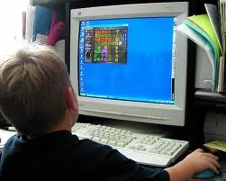My brother likes playing _ _ _ _ _ _ _ _ games.
Đáp án: computer
61. Goodbye. ...
A. Nice to meet you B. See you later C. Good morning D. Good evening
Đáp án: See you later
62. Ảnh:Our _ _ _ _ _ _ _ _ is not big.
Đáp án: bathroom
63. Ảnh: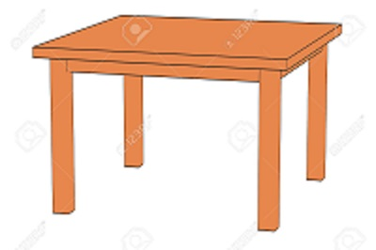TA_LE
A. P B. B C. C D. G
Đáp án: B
64. Gale ______ books in the school library.
A. listens B. speaks C. says D. reads
Đáp án: Chọn ý: D
65. ____ are his pets.
A. These B. This C. That D. It
Đáp án: These
66. is/ name?/ your/ What/ mother's
Đáp án: What is your mother's name?
67. Is this _ _ eraser?
Đáp án: an
68. my/ friends./ are/ These/
Đáp án: These are my friends.
69. Nghe:Nhấn giữ Ctrl và bấm chuột để nghe: Put the books … the table.
A. under B. on C. next to D. behind
Đáp án: on
70. This is ... school bag.
A. he’s B. my’s C. me D. my
Đáp án: Chọn ý: D
71. Ảnh:The ball is ___ the box.
A. in B. on C. at D. of
Đáp án: in
72. Nghe:Nhấn giữ Ctrl và bấm chuột để nghe: Listen and tick:
A. This is my T-shirt. B. This is my shirt. C. This is my skirt. D. This is my jeans.
Đáp án: This is my T-shirt.
73. There is a picture … the wall.
A. in B. at C. on D. of
Đáp án: on
74. Is this a pencil box? – ..., it is.
A. No B. Not C. Yes D. No’s
Đáp án: Yes
75. Choose the odd one out
A. Green B. Yellow C. Apple D. Blue
Đáp án: Apple
76. like/ My/ doesn’t/ brother/ cats./
Đáp án: My brother doesn’t like cats.
77. school/ large?/ Is/ your/
Đáp án: Is your school large?
78. Choose the letter(s) to make a correct word: blac__
A. c B. t C. k D. h
Đáp án: k
79. _ _ _ do you spell your name, Sam? - It’s S-A-M.
Đáp án: How
80. Listen and ti_ _ .
Đáp án: ck
81. Let’s ma_ _ a line, students.
Đáp án: ke
82. eight/ I/ am/ years old.
Đáp án: I am eight years old.
83. me./ after/ repeat/ Please/
Đáp án: Please repeat after me.
84. Bye. S_ _ you later.
Đáp án: ee
85. My classroom is … .
A. name B. news C. new D. names
Đáp án: new
86. Nice _ _ see you.
Đáp án: to
87. Put/ your/ down./ hand/
Đáp án: Put your hand down.
88. Nghe:Nhấn giữ Ctrl và bấm chuột để nghe: There are ... boats on the sea.
A. twenty B. three C. two D. twelve
Đáp án: three
89. That/ green/ a/ is/ chair./
Đáp án: That is a green chair.
90. Nghe:Nhấn giữ Ctrl và bấm chuột để nghe: These are your new … and ….
A. bookcases – boards B. tables – computers C. beds – chairs D. tables – chairs
Đáp án: Chọn ý: D
91. I’m fine, th_ _ k you.
Đáp án: an
92. There are two books o_ the table.
Đáp án: n
93. on/ are there/ erasers/ How many/ the table?/
Đáp án: How many erasers are there on the table?
94. Nghe:Nhấn giữ Ctrl và bấm chuột để nghe: Listen and tick:
A. My father is a teacher. B. My mother is a teacher C. My father is a doctor. D. My brother is a teacher.
Đáp án: My father is a doctor.
95. Nghe:Nhấn giữ Ctrl và bấm chuột để nghe: She wears a big ___ hat.
A. black B. blue C. green D. yellow
Đáp án: blue
96. This isn’t ... bag.
A. he B. his C. this D. he’s
Đáp án: his
97. I’m fine, thank you. ... ?
A. You B. And you C. Are you D. Bye
Đáp án: And you
98. Ảnh:Look! That flower is ....
A. pink B. blue C. green D. black
Đáp án: blue
99. How _ _ you spell your name?
Đáp án: do
100. Raise/ your/ hands,/ please
Đáp án: Raise your hands, please
101. Nghe:Nhấn giữ Ctrl và bấm chuột để nghe: There are … sweets.
A. three B. two C. four D. no
Đáp án: two
102. Nghe:Nhấn giữ Ctrl và bấm chuột để nghe: Point and s_ y.
Đáp án: a
103. ... your name?
A. What B. What’s C. How’s D. Why’s
Đáp án: What’s
104. Nice to/ Mary./ meet you./ Hi,/
Đáp án: Hi, Mary. Nice to meet you.
105. Choose the odd one out:
A. you B. I C. she D. my
Đáp án: Chọn ý: D
106. I’m fine, _ _ _ _ k you.
Đáp án: than
107. I ... Maths and Arts on Monday.
A. play B. say C. study D. look
Đáp án: study
108. is short./ is small/ My rubber/ and my ruler/
Đáp án: My rubber is small and my ruler is short.
109. I’m fine, thank ... .
A. yous B. you’s C. you’re D. you
Đáp án: Chọn ý: D
110. Sit do_ n, please.
Đáp án: w
111. my/ is/ friend./ Jenny/
Đáp án: Jenny is my friend.
112. May/ I/ borrow/ your notebook?
Đáp án: May I borrow your notebook?
113. your/ Where/ are/ books?
Đáp án: Where are your books?
114. bag./ a purple/ This is/
Đáp án: This is a purple bag.
115. Where are ... from?
A. and B. my C. you D. she
Đáp án: you
116. Mai and Phong?/ How/ you today,/ are/
Đáp án: How are you today, Mai and Phong?
117. Bye. _ _ _ you later.
Đáp án: see
118. after/ repeat/ me./ Please/
Đáp án: Please repeat after me.
119. A: What colour is this? - B: It’s ... .
A. book B. a green C. green D. pencil
Đáp án: green
120. Open ... book, please.
A. you B. your C. you’s D. your’s
Đáp án: your
121. _ _ this a ruler? – Yes, it is.
Đáp án: Is
122. Listen _ _ me, please.
Đáp án: to
123. Ảnh: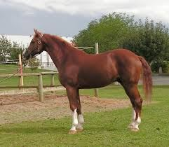That is my ho_ _ e.
Đáp án: rs
124. Nghe:Nhấn giữ Ctrl và bấm chuột để nghe: Nam's pencils are_____ .
A. black B. blue C. green D. red
Đáp án: green
125. Nghe:Nhấn giữ Ctrl và bấm chuột để nghe: Where is the ...?
A. bus B. class C. lab D. tab
Đáp án: lab
126. Ảnh:E_ GHT
Đáp án: I
127. How do you … your name? – That’s A-N-N-E.
A. spell B. read C. call D. say
Đáp án: spell
128. your/ Raise/ hand./
Đáp án: Raise your hand.
129. Choose the odd one out
A. Ruler B. Pen C. Book D. Library
Đáp án: Chọn ý: D
130. LIS_ EN
Đáp án: T
131. Nam’s pencil is _ _ _ _ but mine is short.
Đáp án: long
132. Gi_ e me the book, please.
Đáp án: v
133. My n_ me is Hieu.
Đáp án: a
134. Ảnh: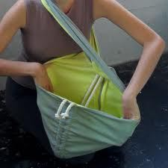_ _ _ _ the bag, please.
Đáp án: Open
135. go to/ school/ don't/ I/ today./
Đáp án: I don't go to school today.
136. teacher./ Listen to/ the/
Đáp án: Listen to the teacher.
137. This isn’t ... ruler. It’s my ruler.
A. he’s B. his C. me’s D. you’s
Đáp án: his
138. Mary is at sch_ _ l.
Đáp án: oo
139. David and Tony p_ _ _ football after school.
Đáp án: lay
140. are/ My/ pink./ shoes/ new/
Đáp án: My new shoes are pink.
141. Gi_ e me a pen, please.
Đáp án: v
142. St_ _ d up, please.
Đáp án: an
143. Is th_ _ _ any water in the fridge, mom?
Đáp án: ere
144. _ _ _ many students are there in your classroom?
Đáp án: How
145. …, students. See you tomorrow.
A. Good morning B. Good night C. Goodbye D. Nice to meet you
Đáp án: Goodbye
146. your/ Don't/ bike/ too fast./ ride/
Đáp án: Don't ride your bike too fast.
147. She is my tea_ _ er.
Đáp án: ch
148. M_ THER
Đáp án: O
149. books/ in/ your school bag?/ are there/ How many/
Đáp án: How many books are there in your school bag?
150. down./ Put/ your pencil/
Đáp án: Put your pencil down.
151. Ảnh: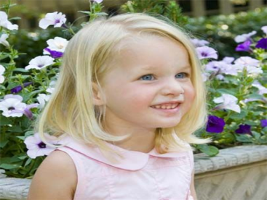Does she have bl_ _ _ _ hair?
Đáp án: onde
152. Pl_ _ _ ed to meet you, Linda.
Đáp án: eas
153. Ảnh: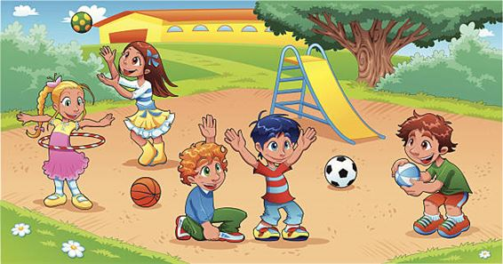My school .... is small.
A. playground B. library C. classroom D. gym
Đáp án: playground
154. Nghe:Nhấn giữ Ctrl và bấm chuột để nghe: _ _ _ _ _ are my crayons.
Đáp án: Those
155. Does/ basketball?/ she like/ volleyball/ or
Đáp án: Does she like volleyball or basketball?
156. This is ... cat.
A. he B. she C. my D. you
Đáp án: my
157. Choose the odd one out:
A. eraser B. ruler C. name D. pen
Đáp án: name
158. an/ like/ ice cream?/ you/ Would/
Đáp án: Would you like an ice cream?
159. _ _ _ , he is.
Đáp án: Yes
160. My brother likes to play computer g_ _ _ _ .
Đáp án: ames
161. Ảnh: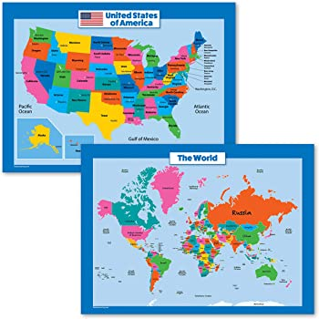Two maps __ on the wall.
A. are B. is C. re D. am
Đáp án: are
162. Choose the odd one out:
A. how B. hello C. hi D. good morning
Đáp án: how
163. Choose the odd one out:
A. book B. pencil C. rubber D. library
Đáp án: Chọn ý: D
164. Choose the odd one out:
A. you B. hi C. I D. She
Đáp án: hi
165. W_ _ _ are these? – These are pencil cases.
Đáp án: hat
166. Choose the odd one out:
A. young B. white C. pink D. gray
Đáp án: young
167. Come here and _ _ _ _ an English song now.
Đáp án: sing
168. Don't talk _ _ class!
Đáp án: in
169. Fine, th_ nks.
Đáp án: a
170. Choose the letter(s) to make a correct word: pencil c__se
A. a B. e C. i D. o
Đáp án: a
171. Look/ at/ the/ board.
Đáp án: Look at the board.
172. A: Who’s that boy? - B: _ _ ’s Peter.
Đáp án: He
173. too./ The window/ is/ new,/
Đáp án: The window is new, too.
174. Choose the incorrect word(s) in the following sentence: Do you like hide seek?
A. Do B. you C. like D. hide seek
Đáp án: Chọn ý: D
175. Unscramble this word: ’’HOLOCS’’ -> ’’SCHO_ _ ’’.
Đáp án: OL
176. Nghe:Nhấn giữ Ctrl và bấm chuột để nghe: Is this ___ bike? - No, it isn't.
A. his B. your C. my D. her
Đáp án: your
177. Ảnh: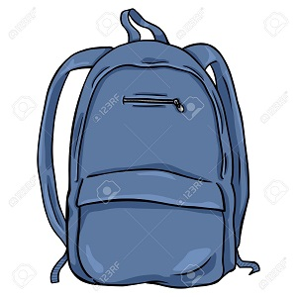My bag is ______.
A. blue B. gray C. black D. yellow
Đáp án: blue
178. Nghe:Nhấn giữ Ctrl và bấm chuột để nghe: Choose the sentence that you hear:
A. I’m fine. B. I’m fine, thanks. C. Fine, thank you. D. I am fine, thank you.
Đáp án: Fine, thank you.
179. How are y_ _ ?
Đáp án: ou
180. pet./ is/ my/ This/
Đáp án: This is my pet.
181. Ảnh: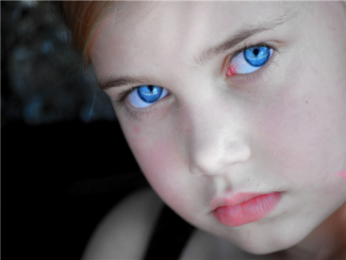Sally has bl_ _ eyes and blonde hair.
Đáp án: ue
182. Odd one out:
A. meet B. I C. you D. he
Đáp án: meet
183. It's a brow_ teddy bear.
Đáp án: n
184. Horses and sheep live on the _ _ _ _ .
Đáp án: farm
185. read/ Let’s/ the/ book.
Đáp án: Let’s read the book.
186. Tha_ is my doll.
Đáp án: t
187. open/ your/ Stand up/ book./ and/
Đáp án: Stand up and open your book.
188. very/ tidy./ isn’t big/ My school/ but/
Đáp án: My school isn’t big but very tidy.
189. want/ I/ the world./ around/ to travel/
Đáp án: I want to travel around the world.
190. It _ _ a pencil.
Đáp án: is
191. List_ _ carefully.
Đáp án: en
192. SCHOOL-B_ G
Đáp án: A
193. Nghe:Nhấn giữ Ctrl và bấm chuột để nghe: This is my ... .
A. class B. school C. room D. desk
Đáp án: school
194. a pupil/ Primary School./ I am/ at Quang Trung/
Đáp án: I am a pupil at Quang Trung Primary School.
195. What does he do during ... lessons? - He learns about numbers.
A. Maths B. English C. Arts D. Music
Đáp án: Maths
196. We write \"06:20\" and we say \"It’s twenty _ _ _ _ six\".
Đáp án: past
197. Nghe:Nhấn giữ Ctrl và bấm chuột để nghe: What colour is ______?
A. they B. that C. it D. these
Đáp án: it
198. Ảnh: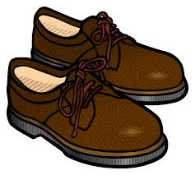_ _ OWN SHOES
Đáp án: BR
199. That is my fa_ _ er.
Đáp án: th
200. nice/ a/ puppy./ It's/
Đáp án: It's a nice puppy.

KEY IOE K3 2023 - 2024 SỐ 03
1. Mary/ English songs./ dance and/ sing/ likes to/
Đáp án: Mary likes to dance and sing English songs.
2. I _ _ Mai.
Đáp án: am
3. name's/ My/ Elizabeth./
Đáp án: My name's Elizabeth.
4. Ảnh: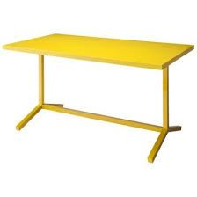This is a ... desk.
A. pink B. yellow C. blue D. green
Đáp án: yellow
5. Ảnh:Jimmy wants a hel_ _ _ _ _ _ _ for his birthday.
Đáp án: icopter
6. A: Is that your classmate? - B: ...
A. Yes, he isn't. B. No, she isn’t. C. Yes, it is. D. No, I’m not.
Đáp án: Yes, it is.
7. ... your name?
A. What B. What’s C. How’s D. Why’s
Đáp án: What’s
8. Nice to ... you!
A. meet B. go C. for D. come
Đáp án: meet
9. after school./ Peter/ and I/ don't/ play baseball
Đáp án: Peter and I don't play baseball after school.
10. new/ This is/ my/ school bag.
Đáp án: This is my new school bag.
11. … many desks are there in your classroom?
A. How B. What C. Who D. Which
Đáp án: How
12. What/ he/ doing?/ is/
Đáp án: What is he doing?
13. … many books are there on the bookshelf?
A. Who B. How C. Where D. What
Đáp án: How
14. That is Lan. _ _ _ is my friend.
Đáp án: she
15. Where is Simon f_ _ m? – He’s from England.
Đáp án: ro
16. How/ spell/ do you/ his name?
Đáp án: How do you spell his name?
17. Ảnh:_ pen your book, please!
Đáp án: O
18. Hi, _ _ _ are you? – Fine, thanks.
Đáp án: how
19. Stand _ _ , please.
Đáp án: up
20. Th_ t is my school. It’s very big.
Đáp án: a
21. your/ room?/ it/ Is/ computer
Đáp án: Is it your computer room?
22. Choose the correct sentence.
A. I like play basketball. B. My brother is twelve year old. C. Tony plays football at break time. D. What are your name?
Đáp án: Tony plays football at break time.
23. What colour ... this?
A. it B. is C. that D. hi
Đáp án: is
24. Let’s ma_ e a circle.
Đáp án: k
25. Is th_ _ _ any water in the fridge, mom?
Đáp án: ere
26. Happy birthday, Alice. This doll is for ... .
A. I B. you C. he D. she
Đáp án: you
27. My friends are in the pla_ ground.
Đáp án: y
28. This _ _ a pen.
Đáp án: is
29. is/ room?/ your/ What colour/
Đáp án: What colour is your room?
30. my/ not/ It/ is/ school bag./
Đáp án: It is not my school bag.
31. Ma_ I go out, please?
Đáp án: y
32. Whe_ _ is your book? - It's on the shelf.
Đáp án: re
33. What’s _______ name?
A. you B. I C. his D. he
Đáp án: his
34. Ảnh: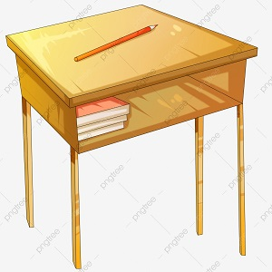D_SK
A. E B. A C. O D. U
Đáp án: E
35. Nghe:Nhấn giữ Ctrl và bấm chuột để nghe: … is my father.
A. This B. That C. It D. He
Đáp án: This
36. They/ in the/ classroom./ aren't/
Đáp án: They aren't in the classroom.
37. Look _ _ the board.
Đáp án: at
38. Ảnh:TABLE AND CHAI_
Đáp án: R
39. Listen ... the teacher.
A. to B. me C. you D. he
Đáp án: to
40. Nghe:Nhấn giữ Ctrl và bấm chuột để nghe: Choose the sentence that you hear:
A. I’m fine. B. I’m fine, thanks. C. Fine, thank you. D. I am fine, thank you.
Đáp án: Fine, thank you.
41. Ảnh:YE_ _ OW
Đáp án: ll
42. Take/ pens,/ out/ your/ Henry./
Đáp án: Take out your pens, Henry.
43. My cla_ _ room is small.
Đáp án: ss
44. Good m_ rning, teacher!
Đáp án: o
45. He's 8 years _ _ _ .
Đáp án: old
46. Ảnh: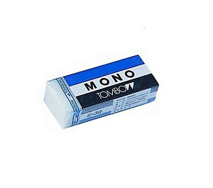RU_ BER
Đáp án: B
47. Ảnh: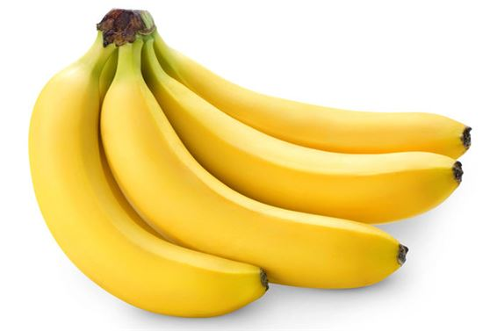Monkeys’ favourite fruits are ba_ _ nas.
Đáp án: na
48. please./ some/ me/ Give/ chalks,
Đáp án: Give me some chalks, please.
49. erasers/ on/ How many/ are there/ the table?/
Đáp án: How many erasers are there on the table?
50. that/ Miss/ Is/ Lan?
Đáp án: Is that Miss Lan?
51. How _ _ _ _ crayons are there?
Đáp án: many
52. He is ... farmer.
A. an B. a C. this D. am
Đáp án: a
53. Good ..., Jame. - Hi, Tom. How are you?
A. nice B. morning C. see D. my
Đáp án: morning
54. Does/ volleyball/ or/ she like/ basketball?/
Đáp án: Does she like volleyball or basketball?
55. large?/ school/ your/ Is/
Đáp án: Is your school large?
56. My sister … books in the school library.
A. read B. reads C. to read D. reading
Đáp án: reads
57. don't/ go to/ today./ I/ school
Đáp án: I don't go to school today.
58. his friends/ don’t like/ basketball./ Peter/ and/
Đáp án: Peter and his friends don’t like basketball.
59. You are wel_ _ me.
Đáp án: co
60. the/ at/ please!/ Look/ board,
Đáp án: Look at the board, please!
61. He/ likes/ swimming./
Đáp án: He likes swimming.
62. a/ That/ brown/ cat./ is/
Đáp án: That is a brown cat.
63. Nghe:Nhấn giữ Ctrl và bấm chuột để nghe: LI_ _ _ _ _
Đáp án: brary
64. Who’s that? - That’s ... .
A. my’s teacher B. me’s teacher C. my teacher D. me teacher
Đáp án: my teacher
65. Write/ the teacher/ says./ what/
Đáp án: Write what the teacher says.
66. Let’s mak_ a line.
Đáp án: e
67. bag./ is/ That/ school/ a green/
Đáp án: That is a green school bag.
68. Choose the correct order.
A. L, M, N, O, P, Q B. M, L, N, O, Q, P C. N, M, L, P, Q, O D. O, L, M, N, P, Q
Đáp án: L, M, N, O, P, Q
69. He __ a newcomer.
A. are B. am C. is D. do
Đáp án: is
70. Ảnh: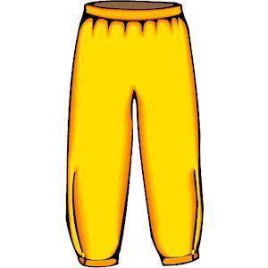What colour are the trousers? - They are _ _ _ _ _ _ .
Đáp án: yellow
71. Collins: Hello. My name is Collins.Barry: ... .
A. Nice to meet you B. Hi. See you later C. Goodbye D. Bye
Đáp án: Nice to meet you
72. Unscramble this word: ’’OOBETKNO’’ -> ’’NOTEBO_ _ ’’.
Đáp án: OK
73. repeat/ me./ after/ Please/
Đáp án: Please repeat after me.
74. _ _ _ , he is.
Đáp án: Yes
75. go to/ This is/ school./ we/ the way/
Đáp án: This is the way we go to school.
76. Ảnh:Put your books on the tabl_ .
Đáp án: e
77. Odd one out:
A. footballer B. singer C. teacher D. cooker
Đáp án: Chọn ý: D
78. is/ old./ three/ years/ My brother/
Đáp án: My brother is three years old.
79. your/ hands/ the table./ Put/ on
Đáp án: Put your hands on the table.
80. What’s this? - ... .
A. That a picture B. These are pictures C. There are picture D. This is a picture
Đáp án: Chọn ý: D
81. I’d like some strawberries. – Here … are.
A. they B. them C. those D. these
Đáp án: they
82. What is this? - ... .
A. It a apple B. Is a apple C. It’s a apple D. It’s an apple
Đáp án: Chọn ý: D
83. We play _______ in the playground.
A. badminton B. football C. hide-and-seek D. baseball
Đáp án: hide-and-seek
84. ruler?/ your/ Is/ it/
Đáp án: Is it your ruler?
85. I have ... robot.
A. a B. an C. two D. and
Đáp án: a
86. Nghe:Nhấn giữ Ctrl và bấm chuột để nghe: Lucy and her ... draw picture in classroom.
A. boys B. teachers C. friends D. girls
Đáp án: friends
87. Nghe:Nhấn giữ Ctrl và bấm chuột để nghe: She is in _ _ _ music room.
Đáp án: the
88. Be/ quiet,/ boys!/
Đáp án: Be quiet, boys!
89. in/ the sky./ many/ There are/ clouds/
Đáp án: There are many clouds in the sky.
90. Please dr_ _ a picture, children.
Đáp án: aw
91. Can you he_ p me?
Đáp án: l
92. Is ... a chair? - Yes, it is.
A. are B. it C. it’s D. his
Đáp án: it
93. What colou... is this? – It’s pink.
A. t B. q C. r D. p
Đáp án: r
94. That’s Peter. ... is my friend.
A. I B. You C. She D. He
Đáp án: Chọn ý: D
95. is/ friend./ my/ Jenny/
Đáp án: Jenny is my friend.
96. Ảnh:The elephant ___ big and the mouse ___ small.
A. are - is B. are - are C. is - are D. is - is
Đáp án: Chọn ý: D
97. Mary often gets up early so she _ _ never late for shool.
Đáp án: is
98. This _ _ my new school. I love my new school.
Đáp án: is
99. Is ... a flower? – Yes. That is a flower.
A. that’s B. that C. this D. this is
Đáp án: that
100. My brother is ______ years old.
A. two B. to C. too D. do
Đáp án: two
101. Simon can sing ... he cannot swim.
A. and B. end C. but D. or
Đáp án: but
102. my/ book?/ I/ May/ close/
Đáp án: May I close my book?
103. Can you swim? - _ _ , I can’t.
Đáp án: no
104. Hello, ... name is Scott.
A. he B. she C. it D. my
Đáp án: Chọn ý: D
105. Is this a book? – Yes, ... .
A. I am B. is it C. it is D. it isn’t
Đáp án: it is
106. The teddy is betw_ _ _ the car and the robot.
Đáp án: een
107. They _ _ _ my good friends.
Đáp án: are
108. Nghe:Nhấn giữ Ctrl và bấm chuột để nghe: That's my ______.
A. schoolbag B. school gym C. school playground D. school
Đáp án: Chọn ý: D
109. Nghe:Nhấn giữ Ctrl và bấm chuột để nghe: Her old car is a ___ Honda.
A. red B. black C. white D. pink
Đáp án: white
110. Nghe:Nhấn giữ Ctrl và bấm chuột để nghe: Loo_ at the school.
Đáp án: k
111. May I come ...?
A. in B. at C. on D. to
Đáp án: in
112. W_ _ is she? – She is my new teacher.
Đáp án: ho
113. teacher?/ Is/ your/ he/
Đáp án: Is he your teacher?
114. Here/ my/ is/ notebook.
Đáp án: Here is my notebook.
115. Lan’s school _ _ _ _ ground is large.
Đáp án: play
116. Nghe:Nhấn giữ Ctrl và bấm chuột để nghe: Listen and choose the correct response
A. Yes, I am. B. This is my teddy. C. No, it isn’t. D. The teddy is Peter’s.
Đáp án: No, it isn’t.
117. Nghe:Nhấn giữ Ctrl và bấm chuột để nghe: Listen and tick:
A. My father is a teacher. B. My mother is a teacher C. My father is a doctor. D. My brother is a teacher.
Đáp án: My father is a doctor.
118. I like to s_ ng.
Đáp án: i
119. Sit d_ _ _ , Tommy.
Đáp án: own
120. from/ My new/ is/ friend/ France./
Đáp án: My new friend is from France.
121. Let's/ play./ outside/ go/ and
Đáp án: Let's go outside and play.
122. Ảnh:That is a blue s_ _ _ .
Đáp án: hip
123. Nghe:Nhấn giữ Ctrl và bấm chuột để nghe: _ _ _ _ _ are my crayons.
Đáp án: Those
124. That is my school gym. ___ new.
A. Its B. It's is C. It's D. Its's
Đáp án: It's
125. My friends/ in/ the playground./ are/
Đáp án: My friends are in the playground.
126. Ảnh: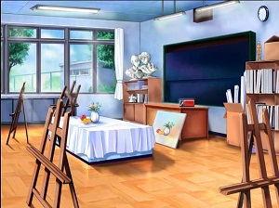It's the _ rt room.
Đáp án: a
127. Nghe:Nhấn giữ Ctrl và bấm chuột để nghe: These are your new … and ….
A. bookcases – boards B. tables – computers C. beds – chairs D. tables – chairs
Đáp án: Chọn ý: D
128. Hello my fr...end.
A. u B. i C. w D. o
Đáp án: i
129. May I co_ _ in?
Đáp án: me
130. ______ colour is your bag?
A. What B. Where C. When D. How
Đáp án: What
131. Gi_ e me the book, please.
Đáp án: v
132. down./ your pencil/ Put/
Đáp án: Put your pencil down.
133. my pencils./ those are/ her crayons/ These are/ and/
Đáp án: These are her crayons and those are my pencils.
134. What’s your nam_ ? - My name is Alan.
Đáp án: e
135. cats/ many/ How/ there?/ are
Đáp án: How many cats are there?
136. learn/ the gym./ in/ PE lessons/ We/
Đáp án: We learn PE lessons in the gym.
137. Nghe:Nhấn giữ Ctrl và bấm chuột để nghe: The ... is short.
A. ruler B. pencil C. pen D. rubber
Đáp án: pencil
138. _ _ at is my ruler.
Đáp án: Th
139. I’m fine, thanks. How a_ _ _ t you?
Đáp án: bou
140. Nghe:Nhấn giữ Ctrl và bấm chuột để nghe: Listen and tick:
A. Is that girl Mary? - Yes, she is. B. Is that boy Mary? - Yes, he is. C. Is that pen Mary? - Yes, it is. D. Is that room Mary? - Yes, it is.
Đáp án: Is that girl Mary? - Yes, she is.
141. Nghe:Nhấn giữ Ctrl và bấm chuột để nghe: _ ite
Đáp án: k
142. Nghe:Nhấn giữ Ctrl và bấm chuột để nghe: b_ g
Đáp án: a
143. bag/ My/ small./ is/ school/
Đáp án: My school bag is small.
144. three crayons/ are/ There/ the table./ on
Đáp án: There are three crayons on the table.
145. … do you like? – I like riding a horse.
A. When B. How C. What D. Who
Đáp án: What
146. Nghe:Nhấn giữ Ctrl và bấm chuột để nghe: What is her favorite colour?
A. red B. orange C. yellow D. green
Đáp án: orange
147. Ảnh: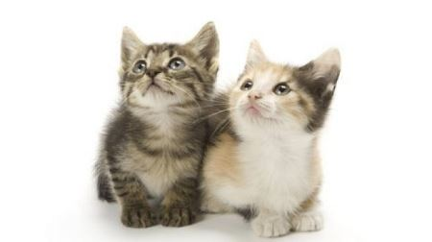_ _ _ CATS
Đáp án: two
148. sch_ _ l
Đáp án: oo
149. play/ together./ Let’s/ chess/
Đáp án: Let’s play chess together.
150. _ _ that your new friend? - No, he isn’t.
Đáp án: Is
151. Do you like goldfish?
A. Yes, I am. B. Yes, I can. C. Yes, it is. D. Yes, I do.
Đáp án: Chọn ý: D
152. Good mo...ning, Peter.
A. w B. t C. r D. q
Đáp án: r
153. Ảnh:We are on the _ _ _ _ _ because it’s very hot today.
Đáp án: beach
154. clap your hands./ and/ Sing/
Đáp án: Sing and clap your hands.
155. Gi_ e me the book, please.
Đáp án: v
156. Circle the ans_ er.
Đáp án: w
157. Ảnh: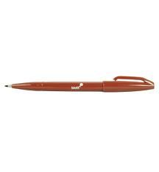That pen is ... .
A. yellow B. pink C. black D. brown
Đáp án: Chọn ý: D
158. _____ are my shoes.
A. This B. That C. It D. These
Đáp án: Chọn ý: D
159. This gift is ... you.
A. on B. in C. for D. at
Đáp án: for
160. Goodbye! - Bye, see you ... .
A. hi B. later C. hello D. good
Đáp án: later
161. I/ play chess/ in the classroom./
Đáp án: I play chess in the classroom.
162. Cl_ _ n your teeth, please.
Đáp án: ea
163. Nghe:Nhấn giữ Ctrl và bấm chuột để nghe: That is a small ... .
A. board B. bus C. box D. boat
Đáp án: Chọn ý: D
164. Sit/ , please./ down/
Đáp án: Sit down , please.
165. Ảnh: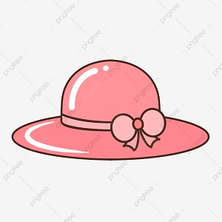It's a pink ha_ .
Đáp án: t
166. … is she? – She is my sister.
A. What B. When C. Who D. How
Đáp án: Who
167. my/ classroom./ is/ This/
Đáp án: This is my classroom.
168. Hello, how a..e you?
A. u B. r C. e D. i
Đáp án: r
169. What is your name? - ... .
A. Her name is Mary. B. His name is Alan. C. My name is Lan. D. Your name is Peter.
Đáp án: My name is Lan.
170. This ... my school.
A. are B. is C. you D. bye
Đáp án: is
171. H...llo, how are you?
A. u B. e C. i D. a
Đáp án: e
172. It is _ _ ice-cream.
Đáp án: an
173. What ... is this? – It’s blue.
A. colour B. colours C. colour’s D. coulor
Đáp án: colour
174. These are t_ o cats.
Đáp án: w
175. Nice to m_ _ t you!
Đáp án: ee
176. This is Tom and that … Mary.
A. am B. is C. are D. have
Đáp án: is
177. She ... my friend.
A. are B. is C. me D. I
Đáp án: is
178. I draw a pictu_ _ in the room.
Đáp án: re
179. Nice ... meet you, too.
A. for B. to C. from D. me
Đáp án: to
180. Look/ at/ picture./ that/ blue
Đáp án: Look at that blue picture.
181. Bob: What is this? - Peter: ...
A. His name is Hien. B. It is a ruler. C. It’s an ruler. D. It is my friend.
Đáp án: It is a ruler.
182. Does/ have/ hair?/ she/ long
Đáp án: Does she have long hair?
183. Those are f_ ve boxes.
Đáp án: i
184. Is t_ is your eraser?
Đáp án: h
185. What is this? – It is ... ice cream.
A. a B. an C. these D. that
Đáp án: an
186. Nghe:Nhấn giữ Ctrl và bấm chuột để nghe: Listen and tick:
A. I’ve got two rulers. B. I’ve got two erasers. C. I’ve got two scissors. D. I’ve got two eggs.
Đáp án: I’ve got two erasers.
187. Ảnh: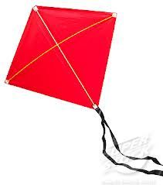Look! That is a ... kite!
A. green B. red C. blue D. brown
Đáp án: red
188. Nice to meet you, t_ _ .
Đáp án: oo
189. Be … Don’t make noise.
A. lazy B. quiet C. funny D. angry
Đáp án: quiet
190. Listen _ _ the teacher carefully.
Đáp án: to
191. Giv_ me the crayon, please.
Đáp án: e
192. ... do you like? – I like milk.
A. How B. What C. When D. Who
Đáp án: What
193. Nghe:Nhấn giữ Ctrl và bấm chuột để nghe: _ _ ain
Đáp án: tr
194. H_ _ many students in your class?
Đáp án: ow
195. Ảnh:I'm five years _ ld.
Đáp án: o
196. I have _ _ apple.
Đáp án: an
197. What do you do at b_ _ _ k time?
Đáp án: rea
198. Is your school new? - Yes, ______ .
A. is it B. its is C. it is D. is its
Đáp án: it is
199. SCHOOL-B_ G
Đáp án: A
200. Point to your frie_ _ , please.
Đáp án: nd

KEY IOE K3 2023 - 2024 SỐ 04
1. Ảnh:My teacher goes to work by _ _ _ _ _ .
Đáp án: train
2. new/ Is/ your/ school/ big?/
Đáp án: Is your new school big?
3. a/ there/ dog?/ Is/
Đáp án: Is there a dog?
4. Give ... that pink crayon.
A. he B. she C. me D. the
Đáp án: me
5. Ảnh:They are ni_ _ years old.
Đáp án: ne
6. How/ mother/ today?/ is/ your/
Đáp án: How is your mother today?
7. Nghe:Nhấn giữ Ctrl và bấm chuột để nghe: Which is NOT mentioned in the recording?
A. bike B. train C. kite D. truck
Đáp án: Chọn ý: D
8. Is ______ house old? – Yes, it is.
A. it B. Nga C. her D. she
Đáp án: her
9. What c_ _ _ ur is this? – It’s green.
Đáp án: olo
10. Nghe:Nhấn giữ Ctrl và bấm chuột để nghe: _ _ _ da
Đáp án: pan
11. Ảnh:This is a ... desk.
A. pink B. yellow C. blue D. green
Đáp án: yellow
12. Stand up now and open ... book, Tom.
A. you B. your C. you’s D. you’re
Đáp án: your
13. and new./ large/ My bedroom/ is/
Đáp án: My bedroom is large and new.
14. What does he do during ... lessons? - He learns about numbers.
A. Maths B. English C. Arts D. Music
Đáp án: Maths
15. Come ..., please.
A. out B. in C. to D. under
Đáp án: in
16. two dogs./ a cat/ and/ My brother/ has/
Đáp án: My brother has a cat and two dogs.
17. Who/ that?/ is/
Đáp án: Who is that?
18. Goodbye Sally. See ... later.
A. hi B. my C. your D. you
Đáp án: Chọn ý: D
19. This is Alice. _ _ _ is my friend.
Đáp án: she
20. Nghe:Nhấn giữ Ctrl và bấm chuột để nghe: a_ _ le
Đáp án: pp
21. go out?/ me!/ Excuse/ I/ May/
Đáp án: Excuse me! May I go out?
22. ... are you from, Jean? – I’m from Canada.
A. Where B. What C. How D. When
Đáp án: Where
23. Happy birthday _ _ you, Alan. – Thank you.
Đáp án: to
24. Nghe:Nhấn giữ Ctrl và bấm chuột để nghe: Fine, ________.
A. thank B. thank you C. thanks D. thanks you
Đáp án: thank you
25. Ảnh:_ _ ITE
Đáp án: WH
26. Nghe:Nhấn giữ Ctrl và bấm chuột để nghe: _ _ _ are you?
Đáp án: How
27. Goodbye, chi_ _ ren. See you later.
Đáp án: ld
28. Nghe:Nhấn giữ Ctrl và bấm chuột để nghe: Choose the sentence that you hear:
A. How do you spell her name? B. How do you spell his name? C. How do you spell its name? D. How do you spell your name?
Đáp án: How do you spell his name?
29. She doesn’t like ma_ _ ng paper boat.
Đáp án: ki
30. Choose the odd one out:
A. Hello B. Hi C. Goodbye D. Green
Đáp án: Chọn ý: D
31. Nghe:Nhấn giữ Ctrl và bấm chuột để nghe: Good ______, class.
A. afternoon B. evening C. morning D. bye
Đáp án: morning
32. How are you? - ... .
A. I’m Binh B. She’s my sister C. I’m fine, thank you D. Goodbye
Đáp án: I’m fine, thank you
33. That is her n_ w school.
Đáp án: e
34. dancing./ I/ Yes,/ like/
Đáp án: Yes, I like dancing.
35. What/ are/ those?/
Đáp án: What are those?
36. Put/ please./ hands/ down,/ your/
Đáp án: Put your hands down, please.
37. Ảnh: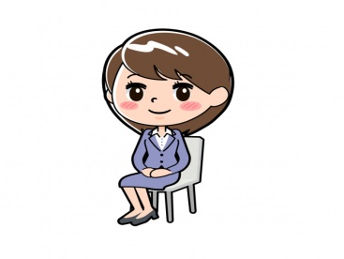______ down, please!
A. Stand B. Get C. Close D. Sit
Đáp án: Chọn ý: D
38. Ảnh:_ EVEN
Đáp án: S
39. Wr_ _ _ the names in the blanks.
Đáp án: ite
40. ____ teacher is fine.
A. Me B. Her C. Him D. You
Đáp án: Her
41. May I _ _ me in?
Đáp án: co
42. Nice to meet ..., too .
A. me B. he C. your D. you
Đáp án: Chọn ý: D
43. Is this a school bag? - ... .
A. Yes, she is B. No, it isn’t C. Yes, I am D. No, he isn’t
Đáp án: No, it isn’t
44. make/ mess./ a/ Don’t/
Đáp án: Don’t make a mess.
45. Choose the letter(s) to make a correct word: win__ow
A. t B. d C. c D. h
Đáp án: d
46. English/ some/ songs./ sing/ Let's/
Đáp án: Let's sing some English songs.
47. A: Is that your classmate? - B: ...
A. Yes, he isn't. B. No, she isn’t. C. Yes, it is. D. No, I’m not.
Đáp án: Yes, it is.
48. my/ Simon/ is/ friend./ new
Đáp án: Simon is my new friend.
49. I_ is a crayon.
Đáp án: t
50. Choose the incorrect word(s) in the following sentence: Those are my pencil.
A. Those B. are C. my D. pencil
Đáp án: Chọn ý: D
51. Hello, ... Kate.
A. my name B. I C. I’m D. me
Đáp án: I’m
52. How are you, Sandy? - ... .
A. I’m fine, thank B. Fine, thank C. Fine, thanks D. I fine, thank
Đáp án: Fine, thanks
53. Ảnh: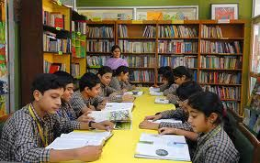This is my school _ _ _ _ _ _ _ .
Đáp án: library
54. Ảnh: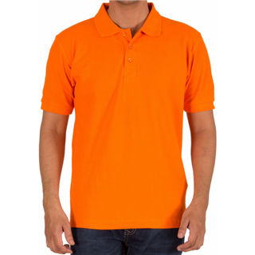He is wearing an o_ _ _ _ _ T-shirt.
Đáp án: range
55. Ảnh: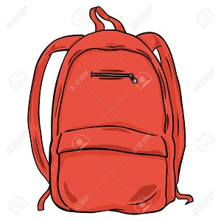BA_ KPACK
Đáp án: C
56. What colour ... this?
A. it B. is C. that D. hi
Đáp án: is
57. This ... a house.
A. are B. is C. you D. here
Đáp án: is
58. Nghe:Nhấn giữ Ctrl và bấm chuột để nghe: I’m standing in a ... .
A. living room B. classroom C. room D. bedroom
Đáp án: classroom
59. Ảnh: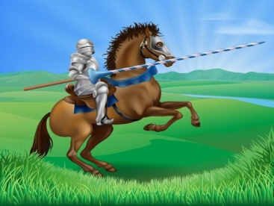Who is this?
A. A prince B. A princess C. A knight D. A monster
Đáp án: A knight
60. I go to school library to ... books.
A. read’s B. reads C. read D. to read
Đáp án: read
61. _ _ _ Mai and Hoa your friend?
Đáp án: Are
62. ... , I’m Lan.
A. Hi B. Goodbye! C. See you D. Goodnight!
Đáp án: Hi
63. That is a br_ _ n book.
Đáp án: ow
64. my/ friend/ This/ , Peter./ is/
Đáp án: This is my friend , Peter.
65. The pencils are ____ my pencil case.
A. in B. on C. at D. of
Đáp án: in
66. I ... watching television.
A. is B. are C. am D. aren’t
Đáp án: am
67. May/ I/ you/ your name?/ ask/
Đáp án: May I ask you your name?
68. A: Do you like skating or skipping? - B: …
A. Yes, I do. B. No, I don’t. C. I like skipping. D. I skip at break time.
Đáp án: I like skipping.
69. Let’s co_ nt the boys.
Đáp án: u
70. Peter is my friend, t_ _ .
Đáp án: oo
71. Where _ _ your cat?
Đáp án: is
72. What’s ... name?
A. she B. he C. you D. her
Đáp án: Chọn ý: D
73. Sit d_ _ _ , Tommy.
Đáp án: own
74. Hi, I’m Richard. Nice ... meet you.
A. to B. at C. on D. in
Đáp án: to
75. she/ Is/ your sister?/
Đáp án: Is she your sister?
76. Is this a d_ sk? - Yes, it is.
Đáp án: e
77. Nghe:Nhấn giữ Ctrl và bấm chuột để nghe: This is my new ….
A. pencil B. pencil case C. rubber D. pencil sharpener
Đáp án: pencil case
78. That is my fr_ _ nd.
Đáp án: ie
79. Ảnh:TEA_ _ ER
Đáp án: ch
80. is/ friend/ very nice./ new/ My/
Đáp án: My new friend is very nice.
81. _ _ _ t’s your name? – My name’s Tom.
Đáp án: Wha
82. answer,/ the/ Circle/ children.
Đáp án: Circle the answer, children.
83. Circle the an_ _ er.
Đáp án: sw
84. A: This is my school. - B: ….
A. Wow! It’s very nice. B. I’m fine, thanks. C. Let’s go. D. I don’t like it.
Đáp án: Wow! It’s very nice.
85. What do you do in … free time?
A. you B. yours C. you’re D. your
Đáp án: Chọn ý: D
86. any/ Are there/ your bedroom?/ in/ books/
Đáp án: Are there any books in your bedroom?
87. _ _ _ are you? - Fine, thanks.
Đáp án: How
88. See/ tomorrow./ Goodbye./ you/
Đáp án: Goodbye. See you tomorrow.
89. Ảnh:_ _ _ _
Đáp án: five
90. I have Art ... Friday.
A. in B. at C. to D. on
Đáp án: Chọn ý: D
91. Ảnh: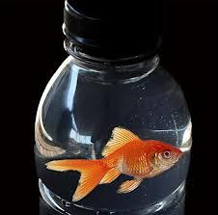The f_ _ _ is in the bottle.
Đáp án: ish
92. is/ your/ What/ name?
Đáp án: What is your name?
93. This/ a/ pen./ is/
Đáp án: This is a pen.
94. Ảnh: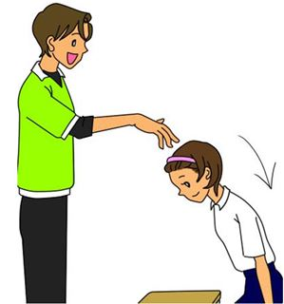Please, _ _ _ down.
Đáp án: sit
95. a book/ I have/ my bag./ in/
Đáp án: I have a book in my bag.
96. Anna doesn’t play skipping at br_ _ _ time.
Đáp án: eak
97. Ảnh:BAD_INTON
A. M B. N C. T D. D
Đáp án: M
98. Ảnh: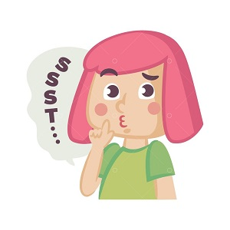Be q_ iet , boys!
Đáp án: u
99. There is ... dog in my house.
A. a B. are C. two D. is
Đáp án: a
100. sentences/ Reorder/ the/ , please.
Đáp án: Reorder the sentences , please.
101. Put/ hand/ your/ down.
Đáp án: Put your hand down.
102. Is that you_ friend?
Đáp án: r
103. My school is near _ bakery.
Đáp án: a
104. Nghe:Nhấn giữ Ctrl và bấm chuột để nghe: _ play basketball.
Đáp án: I
105. Nghe:Nhấn giữ Ctrl và bấm chuột để nghe: There are … people in her family.
A. seven B. six C. five D. eight
Đáp án: seven
106. Nice … meet you, Susan.
A. too B. to C. two D. toe
Đáp án: to
107. are/ Peter’s/ pencil/ Those/ cases./
Đáp án: Those are Peter’s pencil cases.
108. W_ _ is he? – He is my best friend.
Đáp án: ho
109. Peter./ you,/ Thank/
Đáp án: Thank you, Peter.
110. please!/ and/ Sit down/ your book,/ open/
Đáp án: Sit down and open your book, please!
111. Pick … your pencil.
A. at B. up C. on D. for
Đáp án: up
112. It is ... desk.
A. an B. a C. two D. you
Đáp án: a
113. This is a b_ cycle.
Đáp án: i
114. This/ is/ school/ my/ bus./
Đáp án: This is my school bus.
115. Come ov_ r here.
Đáp án: e
116. This isn’t ... bag.
A. he B. his C. me D. you
Đáp án: his
117. Listen _ _ your friends, please.
Đáp án: to
118. my school bag./ There are/ pencils/ ten/ in
Đáp án: There are ten pencils in my school bag.
119. Choose the incorrect word(s) in the following sentence: These are my notebook.
A. These B. are C. my D. notebook
Đáp án: Chọn ý: D
120. Ảnh: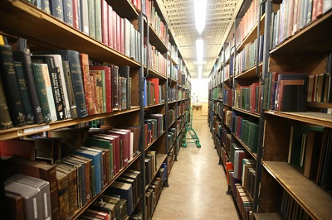LIBRAR_
Đáp án: Y
121. What is her j_ _ ? – She is a teacher.
Đáp án: ob
122. Nghe:Nhấn giữ Ctrl và bấm chuột để nghe: Emma doesn’t like playing _ _ _ _ _ _ .
Đáp án: tennis
123. Hello, ... name is Scott.
A. he B. she C. it D. my
Đáp án: Chọn ý: D
124. A: May I ask a question, Miss Nga? - B: Yes, you ...
A. may B. can C. are D. do
Đáp án: can
125. Miss Lan is my new t_ _ _ her.
Đáp án: eac
126. Choose the odd one out:
A. fine B. read C. meet D. play
Đáp án: fine
127. Si_ down!
Đáp án: t
128. _ _ n't be late!
Đáp án: do
129. Ảnh:The rain_ _ _ is beautiful.
Đáp án: bow
130. Clean/ your/ teeth/ , please.
Đáp án: Clean your teeth , please.
131. Don’t/ make/ a/ mess.
Đáp án: Don’t make a mess.
132. Nghe:Nhấn giữ Ctrl và bấm chuột để nghe: Listen and tick:
A. There are two bathrooms. B. There are three bedrooms. C. There are two bedrooms. D. There are two living rooms.
Đáp án: There are two bedrooms.
133. This is Tom and that … Mary.
A. am B. is C. are D. have
Đáp án: is
134. apple./ This/ is/ a/ red
Đáp án: This is a red apple.
135. _ _ _ you happy today? - Yes, I am.
Đáp án: are
136. is/ old/ brother?/ your/ How/
Đáp án: How old is your brother?
137. Is it _ ruler? – No, it isn’t.
Đáp án: a
138. What/ time/ the/ now?/ is/
Đáp án: What is the time now?
139. Ảnh: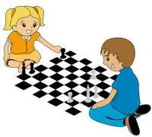What do you do at break time? – I ... .
A. play tennis B. play football C. play chess D. swim
Đáp án: play chess
140. SCHO_ L
Đáp án: O
141. Goodbye. See you tomorr_ w.
Đáp án: o
142. name/ Write/ please./ your/ here,
Đáp án: Write your name here, please.
143. my/ These/ notebooks/ are/ and pencils./
Đáp án: These are my notebooks and pencils.
144. I have/ a glass of juice?/ May/
Đáp án: May I have a glass of juice?
145. Nghe:Nhấn giữ Ctrl và bấm chuột để nghe: What’s his name?
A. Pitir B. Peter C. Beter D. Bitia
Đáp án: Peter
146. This is my new bicycle. – O_ , it’s very nice.
Đáp án: h
147. Ảnh:Sally has bl_ _ eyes and blonde hair.
Đáp án: ue
148. This is ... desk.
A. an B. he C. he’s D. a
Đáp án: Chọn ý: D
149. What’s h_ _ name? – She is Hoa.
Đáp án: er
150. stand/ please./ Let's/ up,/
Đáp án: Let's stand up, please.
151. How ... is she? – She’s nine years old.
A. years B. and C. but D. old
Đáp án: Chọn ý: D
152. My school _ _ new.
Đáp án: is
153. What is your ...? – I’m Peter.
A. name B. name’s C. meet D. friend
Đáp án: name
154. Is this a pen? - _ _ _ , it is.
Đáp án: yes
155. - Hello, Lan. - _______
A. Bye, Phuong. B. Good night, Phuong. C. Hi, Phuong. D. Yes, you.
Đáp án: Hi, Phuong.
156. How m_ _ y pens do you have?
Đáp án: an
157. Nghe:Nhấn giữ Ctrl và bấm chuột để nghe: I like skipp_ _ _ .
Đáp án: ing
158. Nghe:Nhấn giữ Ctrl và bấm chuột để nghe: Choose the sentence that you hear:
A. This is Peter. And that’s Tony. B. That’s Peter. And that’s Tony. C. That’s Peter. And that’s Mary. D. That’s Tony. And that’s Mary.
Đáp án: That’s Peter. And that’s Tony.
159. Po_ _ t to the teacher.
Đáp án: in
160. playing/ football./ They/ are/
Đáp án: They are playing football.
161. This is Tom. _ _ is my friend.
Đáp án: he
162. Choose the letter(s) to make a correct word: sk__te
A. a B. e C. o D. u
Đáp án: a
163. Sing a ..., please.
A. you B. me C. song D. he
Đáp án: song
164. Ảnh:That is a blue s_ _ _ .
Đáp án: hip
165. Good ev_ _ ing, Tom.
Đáp án: en
166. How ... robots are there?
A. many B. much C. any D. very
Đáp án: many
167. Nghe:Nhấn giữ Ctrl và bấm chuột để nghe: b_ g
Đáp án: a
168. I want to st_ y at home.
Đáp án: a
169. _ _ y I go out? – Yes, please.
Đáp án: Ma
170. my bag./ The books/ in/ are/
Đáp án: The books are in my bag.
171. in/ is/ the blue T-shirt/ my brother./ The boy/
Đáp án: The boy in the blue T-shirt is my brother.
172. This is ... chair.
A. he B. she C. it D. my
Đáp án: Chọn ý: D
173. Nghe:Nhấn giữ Ctrl và bấm chuột để nghe: I'm _ _ ven.
Đáp án: se
174. It’s ______ ball.
A. a B. an C. two D. Ø
Đáp án: a
175. This is m_ blue book.
Đáp án: y
176. H_ _ are you? – I’m fine, thanks.
Đáp án: ow
177. That/ box./ my/ is/
Đáp án: That is my box.
178. They ___ in the living room.
A. are B. is C. am D. on
Đáp án: are
179. Ảnh: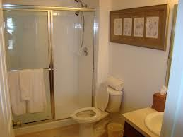Her _ _ _ _ _ _ _ _ is small.
Đáp án: bathroom
180. Ảnh: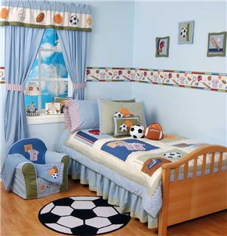Her _ _ _ _ _ _ _ is small.
Đáp án: bedroom
181. Nghe:Nhấn giữ Ctrl và bấm chuột để nghe: _____ and write.
A. Read B. Look C. Listen D. Point
Đáp án: Listen
182. Hi, how _ _ _ you?
Đáp án: are
183. is/ pretty./ Mary/ very/
Đáp án: Mary is very pretty.
184. Nghe:Nhấn giữ Ctrl và bấm chuột để nghe: Listen and tick:
A. My father is a teacher. B. My mother is a teacher C. My father is a doctor. D. My brother is a teacher.
Đáp án: My father is a doctor.
185. She/ old./ ten/ years/ is/
Đáp án: She is ten years old.
186. _ _ _ t colour is this? – It’s pink.
Đáp án: Wha
187. This is ... orange pen.
A. an B. a C. the D. this
Đáp án: an
188. old./ years/ seven/ I’m/
Đáp án: I’m seven years old.
189. Would you like some milk? – Yes, ... .
A. his B. please C. this D. is
Đáp án: please
190. the school gate./ Peter and Mary/ are/ at/
Đáp án: Peter and Mary are at the school gate.
191. Choose the odd one out:
A. classroom B. bedroom C. bathroom D. living room
Đáp án: classroom
192. _ _ o is that? – That’s Mary.
Đáp án: Wh
193. _ _ ese are my pencil boxes.
Đáp án: Th
194. We go to school to ... .
A. stay B. study C. sit D. go
Đáp án: study
195. is/ That/ apple./ red/ a/
Đáp án: That is a red apple.
196. What is this? – It is … eraser.
A. a B. an C. this D. that
Đáp án: an
197. down/ Copy/ the/ words.
Đáp án: Copy down the words.
198. Henry./ pens,/ out/ your/ Take/
Đáp án: Take out your pens, Henry.
199. I’m fine, thank you. ... ?
A. You B. And you C. Are D. Bye
Đáp án: And you
200. Thank you very m_ _ h.
Đáp án: uc

KEY IOE K3 2023 - 2024 SỐ 05
1. Nghe:Nhấn giữ Ctrl và bấm chuột để nghe: There are _ _ _ _ books in the bookcase.
Đáp án: five
2. Is/ this/ pencil,/ your/ Tom?/
Đáp án: Is this your pencil, Tom?
3. you/ See/ Bye./ later.
Đáp án: Bye. See you later.
4. songs./ English/ some/ sing/ Let's/
Đáp án: Let's sing some English songs.
5. Ảnh: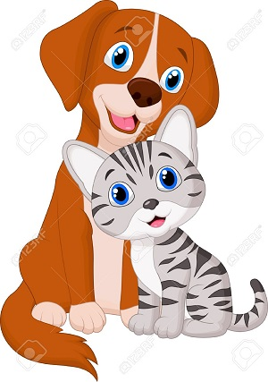I have a ____ and a ______ .
A. cat - dog B. cat - bird C. cat - chicken D. dog - pig
Đáp án: cat - dog
6. Open the b_ _ k.
Đáp án: oo
7. There is a fence … of my house.
A. before B. in front C. between D. next to
Đáp án: in front
8. Ảnh:These are th_ _ _ dogs.
Đáp án: ree
9. Nghe:Nhấn giữ Ctrl và bấm chuột để nghe: This is my school _ _ _ .
Đáp án: bag
10. This is _ _ eraser.
Đáp án: an
11. Ảnh: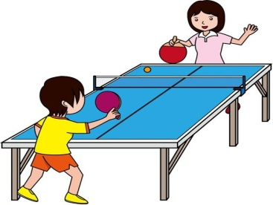Let’s play _ _ _ _ _ tennis.
Đáp án: table
12. Peter/ and I/ after school./ don't/ play baseball
Đáp án: Peter and I don't play baseball after school.
13. Let’s sing a s_ ng.
Đáp án: o
14. , too./ Trang/ England/ is/ from/
Đáp án: Trang is from England , too.
15. Bye. See you aga_ n.
Đáp án: i
16. A: How are you? - B: I’m ..., thank you.
A. Adam B. at home C. OK D. nine
Đáp án: OK
17. ____ do you spell your name?
A. How B. What C. Who D. Which
Đáp án: How
18. His n_ _ e is Tommy.
Đáp án: am
19. Nghe:Nhấn giữ Ctrl và bấm chuột để nghe: Listen and tick:
A. There are two bathrooms. B. There are three bedrooms. C. There are two bedrooms. D. There are two living rooms.
Đáp án: There are two bedrooms.
20. Ảnh: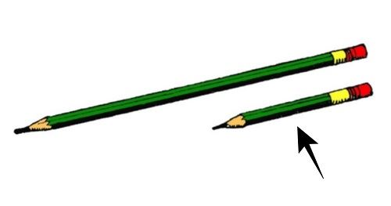It’s a _ _ _ _ _ pencil.
Đáp án: short
21. Ảnh:Unscramble this word: ’’AERSRE’’ -> ’’ERAS_ _ ’’.
Đáp án: ER
22. ___ old are you?
A. Who B. What C. When D. How
Đáp án: Chọn ý: D
23. Please, be q_ _ et.
Đáp án: ui
24. This is Tony and this is Hoa. _ _ _ _ are my friends.
Đáp án: They
25. Ảnh:_ LUE
Đáp án: B
26. Nghe:Nhấn giữ Ctrl và bấm chuột để nghe: ___ name is Simon.
A. His B. Her C. My D. Your
Đáp án: My
27. Happy birthday _ _ you, Alan. – Thank you.
Đáp án: to
28. Jane is not ... name.
A. he B. her C. I D. you
Đáp án: her
29. There _ _ _ twenty chairs.
Đáp án: are
30. and/ those are/ my pencils./ her crayons/ These are/
Đáp án: These are her crayons and those are my pencils.
31. Do you like milk? – No, I ... .
A. do B. does C. doesn’t D. don’t
Đáp án: Chọn ý: D
32. This is my r_ ler.
Đáp án: u
33. _ _ _ t colour is this? – It’s pink.
Đáp án: Wha
34. Nghe:Nhấn giữ Ctrl và bấm chuột để nghe: She asks you to put the _ _ _ _ _ _ under the chair.
Đáp án: pencil
35. Count the ..., please.
A. she B. they C. boy D. boys
Đáp án: Chọn ý: D
36. Ảnh:I have got a skipping r_ _ e.
Đáp án: op
37. These are green hat_ .
Đáp án: s
38. I like football, ... I don’t like baseball.
A. and B. or C. but D. so
Đáp án: but
39. SCHO_ L
Đáp án: O
40. Ảnh: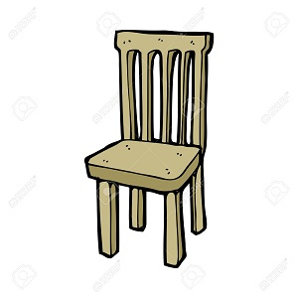_ _ AIR
Đáp án: CH
41. ... Nam. How are you?
A. See B. Fine C. Hello D. Bye
Đáp án: Hello
42. Is your school white? - ... .
A. Yes, it isn’t B. No, it is C. No, is it not D. Yes, it is
Đáp án: Chọn ý: D
43. and Quang/ brothers./ are/ Quan/
Đáp án: Quan and Quang are brothers.
44. What is this? - ... .
A. His name is Tom B. It is a ruler C. It’s an ruler D. It’s Tom
Đáp án: It is a ruler
45. Nice to _ _ _ t you, Hans.
Đáp án: mee
46. today./ Henry/ goes swimming/
Đáp án: Henry goes swimming today.
47. I/ now./ am/ thirsty/
Đáp án: I am thirsty now.
48. is/ new/ friend./ Tony/ my/
Đáp án: Tony is my new friend.
49. Goo...bye. See you later.
A. t B. h C. d D. s
Đáp án: d
50. Ảnh: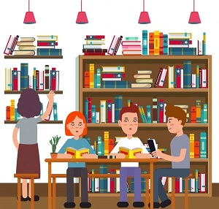LIBRA_ _
Đáp án: RY
51. May I go out? - Yes, ….
A. you can B. you can’t C. you are D. it is
Đáp án: you can
52. Let’s/ together./ chess/ play/
Đáp án: Let’s play chess together.
53. Ảnh: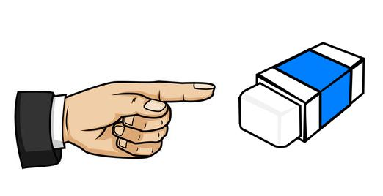Th_ _ is my rubber.
Đáp án: is
54. Nghe:Nhấn giữ Ctrl và bấm chuột để nghe: _ _ _ _
Đáp án: nine
55. Ảnh: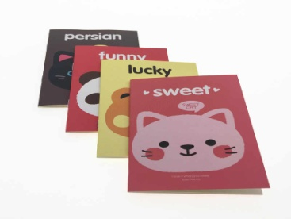Thomas has _ _ _ _ notebooks.
Đáp án: four
56. This _ _ a pencil case.
Đáp án: is
57. songs./ some/ sing/ Let's/ English
Đáp án: Let's sing some English songs.
58. Nghe:Nhấn giữ Ctrl và bấm chuột để nghe: F_ ur brothers and 4 sisters.
Đáp án: o
59. Nghe:Nhấn giữ Ctrl và bấm chuột để nghe: R_ _ _ _
Đáp án: uler
60. I like Maths the mo_ t.
Đáp án: s
61. baby/ This/ is/ my/ brother./
Đáp án: This is my baby brother.
62. the/ on/ There is/ a lamp/ table./
Đáp án: There is a lamp on the table.
63. classmates./ not/ are/ They/ my
Đáp án: They are not my classmates.
64. her/ bag./ This/ is/
Đáp án: This is her bag.
65. What colour is this? - ... .
A. It’s a pink B. It’s pink C. It pink D. Is pink
Đáp án: It’s pink
66. Remember … wash your hands before meals. – Yes, Mum.
A. to B. in C. for D. on
Đáp án: to
67. That is my school bag. _______ brown.
A. Its B. It’s C. It’s is D. Its is
Đáp án: It’s
68. like/ doesn’t/ tennis./ Mike/
Đáp án: Mike doesn’t like tennis.
69. Peter/ new friend./ is/ my/
Đáp án: Peter is my new friend.
70. Pick _ _ your pen, San.
Đáp án: up
71. The flower vase is ... the table.
A. at B. for C. on D. to
Đáp án: on
72. colour/ is/ this?/ What/
Đáp án: What colour is this?
73. Ảnh: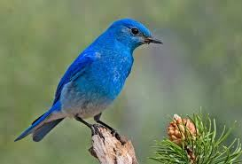That is my bird. It’s _ _ _ _ .
Đáp án: blue
74. Ảnh:This is my school _ _ _ _ _ _ _ .
Đáp án: library
75. rubbers/ small?/ Are/ your/
Đáp án: Are your rubbers small?
76. … do you like? – I like riding a horse.
A. When B. How C. What D. Who
Đáp án: What
77. We like to _ _ _ _ books at the school library.
Đáp án: read
78. Nghe:Nhấn giữ Ctrl và bấm chuột để nghe: _ octor
Đáp án: d
79. Say hell... to Alice.
A. e B. o C. u D. t
Đáp án: o
80. Look ... the map on the wall.
A. at B. to C. on D. in
Đáp án: at
81. chant/ aloud./ Read/ the/
Đáp án: Read the chant aloud.
82. Henry./ Take/ pens,/ your/ out/
Đáp án: Take out your pens, Henry.
83. Please be q_ _ te.
Đáp án: ui
84. These _ _ _ two pencil cases.
Đáp án: are
85. Peter is my friend, t_ _ .
Đáp án: oo
86. What/ colour/ it?/ is/
Đáp án: What colour is it?
87. How are y_ _ ?
Đáp án: ou
88. Listen t_ the teacher.
Đáp án: o
89. It is ... desk.
A. bye B. me C. a D. hi
Đáp án: a
90. Who/ is/ Linda?/ that,/
Đáp án: Who is that, Linda?
91. How old ... she? - She’s 9 years old.
A. is B. are C. am D. be
Đáp án: is
92. Ảnh:I have a bl_ _ ball.
Đáp án: ue
93. How ... is she? – She’s nine years old.
A. years B. and C. but D. old
Đáp án: Chọn ý: D
94. _ ootball
Đáp án: f
95. ... is she? – She is my little sister.
A. What B. When C. Who D. How
Đáp án: Who
96. Ảnh:F__TBALL
A. OO B. EE C. II D. UU
Đáp án: OO
97. This is m_ ruler.
Đáp án: y
98. notebooks,/ please./ Take/ out/ your/
Đáp án: Take out your notebooks, please.
99. What is the name … your school?
A. at B. to C. for D. of
Đáp án: Chọn ý: D
100. Is that Nam? - Yes, _ _ is.
Đáp án: it
101. the paper./ on/ Write/ your name/
Đáp án: Write your name on the paper.
102. my brother./ I/ play football/ often/ with
Đáp án: I often play football with my brother.
103. T_ is is a pencil.
Đáp án: h
104. _____ are my shoes.
A. This B. That C. It D. These
Đáp án: Chọn ý: D
105. Ảnh:We are ______ at break time.
A. in the classroom B. in the computer room C. in the playground D. on the roof
Đáp án: in the playground
106. is/ That/ a/ red/ apple./
Đáp án: That is a red apple.
107. notebook./ Write/ your/ answer/ into the
Đáp án: Write your answer into the notebook.
108. What is _ _ _ _ name? - My name is Tom.
Đáp án: your
109. Nghe:Nhấn giữ Ctrl và bấm chuột để nghe: Choose the sentence that you hear:
A. What is your name? B. What’s your name? C. What’s your school name? D. What is your school name?
Đáp án: What’s your name?
110. that,/ Who's/ Peter?/
Đáp án: Who's that, Peter?
111. Ảnh:There is a cl_ _ _ on the wall.
Đáp án: ock
112. Choose the correct sentence
A. They is my toys. B. They are my toys. C. They are my toy. D. Them is my toy.
Đáp án: They are my toys.
113. to/ number/ count/ ten./ Let’s/
Đáp án: Let’s count to number ten.
114. Ảnh: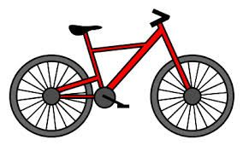Show me your new ... .
A. ruler B. bike C. pen D. school
Đáp án: bike
115. How are you? - ... .
A. I’m Binh B. She’s my sister C. I’m fine, thank you D. Goodbye
Đáp án: I’m fine, thank you
116. Good ni_ _ t, Owen.
Đáp án: gh
117. Let’s ... a song.
A. look B. sing C. stand D. sit
Đáp án: sing
118. Wa_ _ your hands, please.
Đáp án: sh
119. Ảnh: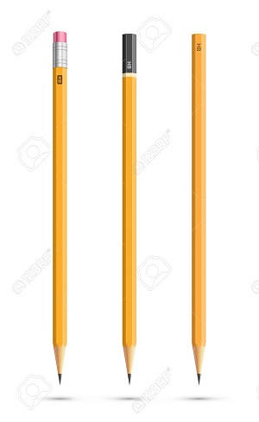THREE PENCIL_
Đáp án: S
120. Ảnh:BR__N
A. WO B. WW C. OO D. OW
Đáp án: Chọn ý: D
121. The art room is small b_ _ new.
Đáp án: ut
122. There are many toys he_ e.
Đáp án: r
123. Ảnh: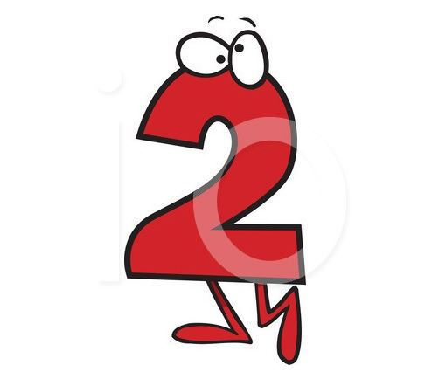_ _ _
Đáp án: two
124. Nghe:Nhấn giữ Ctrl và bấm chuột để nghe: Put the books … the table.
A. under B. on C. next to D. behind
Đáp án: on
125. Nghe:Nhấn giữ Ctrl và bấm chuột để nghe: She likes to eat ______ apples.
A. big red B. small red C. big green D. small green
Đáp án: big red
126. PEN_ IL
Đáp án: C
127. Nghe:Nhấn giữ Ctrl và bấm chuột để nghe: It’s not a white _ _ _ _ _ _ _ _ .
Đáp án: computer
128. They ___ in the living room.
A. are B. is C. am D. on
Đáp án: are
129. Ảnh:She is in the _ ym .
Đáp án: g
130. ... your hand, please.
A. Goodbye B. Hi C. Wash D. Study
Đáp án: Wash
131. This … a cassette.
A. are B. is C. am D. an
Đáp án: is
132. Choose the letter(s) to make a correct word: NI_E
A. V B. C C. M D. Z
Đáp án: C
133. My school ______ Ngo Gia Tu School.
A. am B. is C. are D. that
Đáp án: is
134. Nice to meet ... .
A. I B. me C. he D. you
Đáp án: Chọn ý: D
135. Jenny./ Her/ is/ name/
Đáp án: Her name is Jenny.
136. T...is is a desk.
A. e B. w C. h D. n
Đáp án: h
137. What’s this? – It’s an … .
A. table B. orange C. ruler D. crayon
Đáp án: orange
138. Ảnh:SIX ______
A. PUPILS B. PUPIL C. STUDENT D. TEACHER
Đáp án: PUPILS
139. A: I’m Linda. And your n_ _ _ ? - B: Peter.
Đáp án: ame
140. May I co_ _ in?
Đáp án: me
141. She's ten y__rs old.
A. ae B. eo C. oe D. ea
Đáp án: Chọn ý: D
142. Ảnh: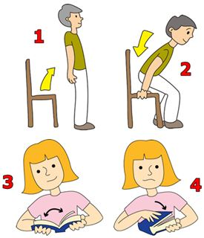’’Open your book, please.’’
A. Picture 1 B. Picture 2 C. Picture 3 D. Picture 4
Đáp án: Picture 3
143. Ảnh:_ _ OWN SHOES
Đáp án: BR
144. is/ brown/ a/ That/ cat./
Đáp án: That is a brown cat.
145. Ảnh: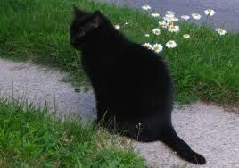That cat is ... .
A. brown B. yellow C. green D. black
Đáp án: Chọn ý: D
146. Nghe:Nhấn giữ Ctrl và bấm chuột để nghe: … is she?
A. How B. Where C. Who D. What
Đáp án: Who
147. is/ What/ your/ name?
Đáp án: What is your name?
148. Write the an_ _ _ rs.
Đáp án: swe
149. Is/ this/ your/ pen?
Đáp án: Is this your pen?
150. She can ________ a picture.
A. draw B. listen C. read D. cycle
Đáp án: draw
151. there?/ are/ How/ crayons/ many/
Đáp án: How many crayons are there?
152. Nghe:Nhấn giữ Ctrl và bấm chuột để nghe: Listen and tick:
A. I can’t find my pen. - It’s here B. I can’t find my ball. - It’s here. C. I can’t find my phone. - It’s here. D. I can’t find my school. - It’s here.
Đáp án: I can’t find my ball. - It’s here.
153. Ảnh:LIBRAR_
Đáp án: Y
154. What’s h_ _ name? – She is Hoa.
Đáp án: er
155. Nghe:Nhấn giữ Ctrl và bấm chuột để nghe: _ _ _ gry
Đáp án: hun
156. Ảnh:This is a _______ house.
A. pink B. yellow C. white D. blue
Đáp án: yellow
157. What's/ your/ name?/
Đáp án: What's your name?
158. Look _ _ that kite. It’s so beautiful.
Đáp án: at
159. These bags ____ small.
A. is B. its C. are D. re
Đáp án: are
160. How are you today? - ... .
A. Very good B. Fine, thanks C. Good, thanks D. No, thanks
Đáp án: Fine, thanks
161. How ... you? – Fine, thanks.
A. are B. am C. is D. this
Đáp án: are
162. A: … - B: I like badminton.
A. What sport do you like? B. Do you like badminton? C. Why do you like badminton? D. What do you do at break time?
Đáp án: What sport do you like?
163. Nghe:Nhấn giữ Ctrl và bấm chuột để nghe: Listen and tick:
A. Is that girl Mary? - Yes, she is. B. Is that boy Mary? - Yes, he is. C. Is that pen Mary? - Yes, it is. D. Is that room Mary? - Yes, it is.
Đáp án: Is that girl Mary? - Yes, she is.
164. volleyball/ fun./ is/ Playing/
Đáp án: Playing volleyball is fun.
165. Let’s co_ nt the boys.
Đáp án: u
166. name/ Long./ is/ His/
Đáp án: His name is Long.
167. my/ uncle/ his son./ This is/ and
Đáp án: This is my uncle and his son.
168. The blackboard is _ _ the wall.
Đáp án: on
169. my/ father./ That/ is/
Đáp án: That is my father.
170. evening,/ students!/ Good/
Đáp án: Good evening, students!
171. _ _ , Mai. I’m Nhung.
Đáp án: Hi
172. Nghe:Nhấn giữ Ctrl và bấm chuột để nghe: The _ _ _ _ _ _ _ _ are in the classroom.
Đáp án: children
173. Nghe:Nhấn giữ Ctrl và bấm chuột để nghe: Where is your _ _ _ _ _ _ ?
Đáp án: school
174. two pens/ school bag./ in/ There are/ my
Đáp án: There are two pens in my school bag.
175. Don’t s_ _ on that chair.
Đáp án: it
176. ___ he a newcomer?
A. Is B. Are C. Am D. Be
Đáp án: Is
177. Ảnh:How old are you? - I'm eigh_ .
Đáp án: t
178. Sing with ... .
A. he B. she C. I D. me
Đáp án: Chọn ý: D
179. like/ dogs./ My/ father/ doesn’t/
Đáp án: My father doesn’t like dogs.
180. Ảnh: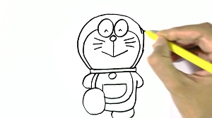I dra_ a picture in the art room.
Đáp án: w
181. Choose the letter(s) to make a correct word: pencil c__se
A. a B. e C. i D. o
Đáp án: a
182. Those/ books./ my/ aren’t/
Đáp án: Those aren’t my books.
183. present./ birthday/ This doll/ your/ is/
Đáp án: This doll is your birthday present.
184. My mother’s b_ _ _ _ day is in October.
Đáp án: irth
185. Nghe:Nhấn giữ Ctrl và bấm chuột để nghe: This is a … .
A. dot B. dog C. door D. down
Đáp án: dog
186. These/ short./ pencils/ are/
Đáp án: These pencils are short.
187. book./ It/ a/ is/ small
Đáp án: It is a small book.
188. Bye, see you … .
A. later B. late C. laters D. later’s
Đáp án: later
189. A: What is y_ _ r name? B: My name is Trang.
Đáp án: ou
190. My school is very _ _ _ _ tiful.
Đáp án: beau
191. This gift is ... you.
A. on B. in C. for D. at
Đáp án: for
192. Would you like some m_ _ k? – Yes, please.
Đáp án: il
193. I'm/ five,/ too./
Đáp án: I'm five, too.
194. M_ y I go out? Yes, please.
Đáp án: a
195. Nga: How do you spell … name, Robert? - Robert: R-O-B-E-R-T.
A. him B. his C. your D. yours
Đáp án: your
196. aren't/ in the/ They/ classroom.
Đáp án: They aren't in the classroom.
197. Ảnh:ru_ _ er
Đáp án: bb
198. Choose the incorrect word(s) in the following sentence: He are at school today.
A. are B. at C. school D. today
Đáp án: are
199. B_ OK
Đáp án: O
200. It ... a ball.
A. are B. an C. be D. is
Đáp án: Chọn ý: D

KEY IOE K3 2023 - 2024 SỐ 06
1. M_ y I go out, please?
Đáp án: a
2. Nghe:Nhấn giữ Ctrl và bấm chuột để nghe: We are a … family.
A. big B. happy C. large D. wonderful
Đáp án: happy
3. teacher./ my/ English/ Mr. John/ is/
Đáp án: Mr. John is my English teacher.
4. I'm eight. Tony is eight, ___ .
A. to B. two C. tow D. too
Đáp án: Chọn ý: D
5. There is ... dog in my house.
A. a B. are C. two D. is
Đáp án: a
6. What is your name?
A. Her name is Mary. B. His name is Alan. C. My name is Lan. D. Your name is Peter.
Đáp án: My name is Lan.
7. Open ... book, please.
A. you B. your C. you’s D. your’s
Đáp án: your
8. What’s _______ name?
A. you B. I C. his D. he
Đáp án: his
9. Choose the correct sentence.
A. These are my pens. B. This is my pens. C. That is my pencils. D. These are my pencil.
Đáp án: These are my pens.
10. She/ nice./ is/
Đáp án: She is nice.
11. Can you ... a picture?
A. draw B. look C. on D. when
Đáp án: draw
12. That hat is ye_ _ ow.
Đáp án: ll
13. She ... Lan. She is a new student in my class.
A. am B. is C. are D. be
Đáp án: is
14. A: Do you like skating or skipping? - B: …
A. Yes, I do. B. No, I don’t. C. I like skipping. D. I skip at break time.
Đáp án: I like skipping.
15. Good_ ye. See you tomorrow.
Đáp án: b
16. ... many pens are there in your school bag? – There are 3 pens.
A. How B. What C. Who D. When
Đáp án: How
17. She doesn’t like ma_ _ ng paper boat.
Đáp án: ki
18. Nghe:Nhấn giữ Ctrl và bấm chuột để nghe: Peter is ______ years old
A. 5 B. 6 C. 7 D. 8
Đáp án: 7
19. My father likes to _ _ _ _ _ a car.
Đáp án: drive
20. He_ _ o, my name’s Richard. - Nice to meet you.
Đáp án: ll
21. Nghe:Nhấn giữ Ctrl và bấm chuột để nghe: … your books.
A. Open B. Close C. Read D. Keep
Đáp án: Open
22. How old is Nam? – ... is 10 years old.
A. He B. She C. I D. They
Đáp án: He
23. Nghe:Nhấn giữ Ctrl và bấm chuột để nghe: That is a small ... .
A. board B. bus C. box D. boat
Đáp án: Chọn ý: D
24. school gym/ your/ new?/ Is/
Đáp án: Is your school gym new?
25. a/ is/ father/ My/ worker./
Đáp án: My father is a worker.
26. Ảnh: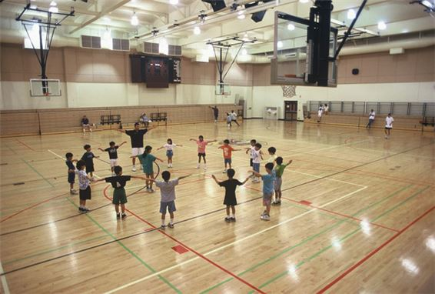We learn P.E in the _ _ _ . It is very large.
Đáp án: gym
27. This is ... teddy bear.
A. she B. me C. my D. hi
Đáp án: my
28. son./ watch/ TV,/ Don't/
Đáp án: Don't watch TV, son.
29. Hello. My name’s Thompson. - Hi, ….
A. What’s that? B. Goodbye C. I’m Collin. Nice to meet you D. See you later
Đáp án: I’m Collin. Nice to meet you
30. Nghe:Nhấn giữ Ctrl và bấm chuột để nghe: ... is a pupil.
A. She B. He C. Me D. I’m
Đáp án: She
31. beautiful./ school/ is/ Her/
Đáp án: Her school is beautiful.
32. Nghe:Nhấn giữ Ctrl và bấm chuột để nghe: How old are you? - I’m ________ years old.
A. 4 B. 5 C. 6 D. 7
Đáp án: Chọn ý: D
33. Unscramble this word: ’’ISUCM’’ -> ’’_ _ SIC’’.
Đáp án: MU
34. Wa_ _ your hands, please.
Đáp án: sh
35. Ảnh:Can I borrow your pencil _ _ _ _ _ _ _ _ _ ?
Đáp án: sharpener
36. Bye, see you tomo_ _ ow.
Đáp án: rr
37. Nghe:Nhấn giữ Ctrl và bấm chuột để nghe: _ _ _ gry
Đáp án: hun
38. some/ food./ Peter/ wants/
Đáp án: Peter wants some food.
39. He ___ seven years old.
A. are B. am C. be D. is
Đáp án: Chọn ý: D
40. Ảnh: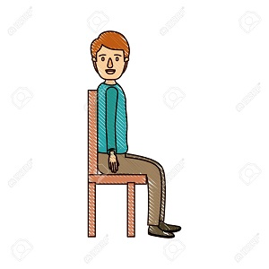S_ T DOWN
Đáp án: I
41. My name _ s Adam.
Đáp án: i
42. Ảnh: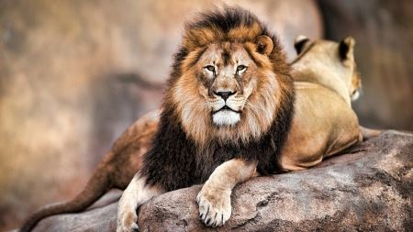That’s a(n) _______.
A. cat B. bird C. elephant D. lion
Đáp án: Chọn ý: D
43. Ảnh:There is a _ _ _ ck on the wall.
Đáp án: clo
44. Is your school new? - Yes, ______ .
A. is it B. its is C. it is D. is its
Đáp án: it is
45. ... is my school.
A. How B. Too C. When D. This
Đáp án: Chọn ý: D
46. Ảnh: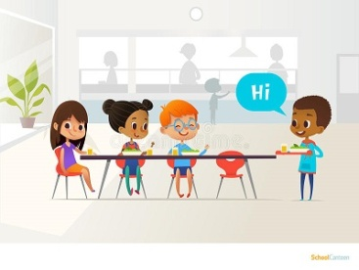NEWCOM_ R
Đáp án: E
47. mess./ Don't/ a/ make/
Đáp án: Don't make a mess.
48. What colour ... this?
A. it B. is C. that D. hi
Đáp án: is
49. This is my fa_ _ _ r.
Đáp án: the
50. Choose the letter(s) to make a correct word: rea__
A. t B. h C. d D. c
Đáp án: d
51. I’m fine, th_ _ k you.
Đáp án: an
52. Thank you very much. - You ... welcome.
A. is B. am C. are D. isn’t
Đáp án: are
53. Bru_ h your teeth, Tom.
Đáp án: s
54. My/ teacher/ is/ very/ tall./
Đáp án: My teacher is very tall.
55. I'm/ Hello./ Peter./
Đáp án: Hello. I'm Peter.
56. What _ _ it? - It’s a pink ruler.
Đáp án: is
57. Choose the letter(s) to make a correct word: FIV_
A. O B. I C. W D. E
Đáp án: Chọn ý: D
58. What are those? – _ _ _ _ ’re my books.
Đáp án: they
59. I have ... pink doll.
A. a B. an C. two D. and
Đáp án: a
60. ... you like some bread? – No, I don't.
A. Does B. Do C. Are D. Is
Đáp án: Do
61. Thank you very _ _ _ _ for your lovely birthday gift.
Đáp án: much
62. Nghe:Nhấn giữ Ctrl và bấm chuột để nghe: The boy loves ba_ _ _ _ _ on.
Đáp án: dmint
63. Ope_ your books, children.
Đáp án: n
64. Ảnh: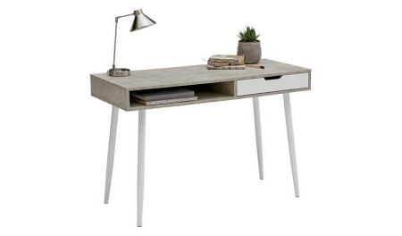D_ SK
Đáp án: e
65. Choose the letter(s) to make a correct word: r__ler
A. a B. o C. p D. u
Đáp án: Chọn ý: D
66. Nghe:Nhấn giữ Ctrl và bấm chuột để nghe: Choose the sentence that you hear:
A. What is your name? B. What’s your name? C. What’s your school name? D. What is your school name?
Đáp án: What’s your name?
67. CLASSR_ OM
Đáp án: o
68. Wh_ t’s your name? - My name’s John.
Đáp án: a
69. a yo-yo./ He/ play/ with/ can/
Đáp án: He can play with a yo-yo.
70. beautiful./ song/ The/ is/
Đáp án: The song is beautiful.
71. - Hello, _ am Peter. - Nice to meet you, Peter.
Đáp án: I
72. Ảnh: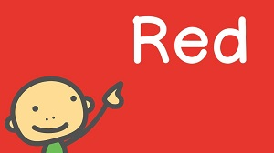My favourite _ _ lour is red.
Đáp án: co
73. Nice to _______ you.
A. mit B. meat C. meet D. miit
Đáp án: meet
74. ... you Lan?
A. Is B. Are C. He D. She
Đáp án: Are
75. eraser./ an/ is/ This/
Đáp án: This is an eraser.
76. Ảnh: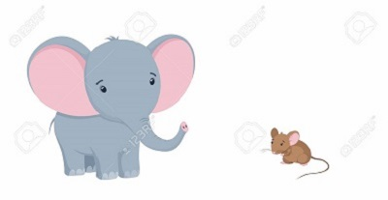A SMAL_ MOUSE
Đáp án: L
77. Are those your rubbers? - No, they ___ .
A. are B. aren't C. is D. isn't
Đáp án: aren't
78. box?/ Is/ pencil/ your/ that/
Đáp án: Is that your pencil box?
79. Choose the odd one out:
A. repeat B. listen C. read D. am
Đáp án: Chọn ý: D
80. The rabbit _________ white.
A. are B. am C. not D. is
Đáp án: Chọn ý: D
81. Where are your father and mother? - ... are in the living room.
A. He B. She C. We D. They
Đáp án: Chọn ý: D
82. This ... a blue pencil.
A. are B. is C. am D. the
Đáp án: is
83. Good ev_ _ ing, Tom.
Đáp án: en
84. My n_ me is Lan.
Đáp án: a
85. May I go _____?
A. out B. of C. in D. at
Đáp án: out
86. The … is John.
A. me B. boy C. I D. girl
Đáp án: boy
87. I am fi_ e, thanks.
Đáp án: n
88. in/ the school bag./ Put/ your/ school things/
Đáp án: Put your school things in the school bag.
89. has/ cat./ sister/ one/ My/
Đáp án: My sister has one cat.
90. to school./ we go/ the way/ This is/
Đáp án: This is the way we go to school.
91. Nghe:Nhấn giữ Ctrl và bấm chuột để nghe: Listen and tick:
A. This toy is Nam. B. This friend is Nam. C. This girl is Nam. D. This boy is Nam.
Đáp án: Chọn ý: D
92. Choose the letter(s) to make a correct word: RU__ER
A. PP B. BB C. LL D. MM
Đáp án: BB
93. is/ school./ my/ That/
Đáp án: That is my school.
94. That is my classroom. It’s not small. It’s _ _ g.
Đáp án: bi
95. N_ ce to meet you.
Đáp án: i
96. listen/ often/ music./ I/ to
Đáp án: I often listen to music.
97. Nghe:Nhấn giữ Ctrl và bấm chuột để nghe: _ _ ain
Đáp án: tr
98. How/ his name?/ do you/ spell/
Đáp án: How do you spell his name?
99. have?/ your sister/ How many/ apples/ does/
Đáp án: How many apples does your sister have?
100. Nghe:Nhấn giữ Ctrl và bấm chuột để nghe: What are they? - They’re _ _ _ _ .
Đáp án: pens
101. See/ you/ tomorrow./
Đáp án: See you tomorrow.
102. Who is ...? – He’s my father.
A. she B. it C. he D. they
Đáp án: he
103. a blue/ is/ It/ ball.
Đáp án: It is a blue ball.
104. Is your classroom big? – No, it’s s_ _ ll.
Đáp án: ma
105. are/ in/ the schoolyard./ Linh and Nhi/
Đáp án: Linh and Nhi are in the schoolyard.
106. What is _ _ _ s? – This is a bag.
Đáp án: thi
107. Is your school new? - No. It's _____.
A. new B. old C. not D. is
Đáp án: old
108. Choose the incorrect word(s) in the following sentence: He is six year old.
A. He B. is C. year D. old
Đáp án: year
109. Nghe:Nhấn giữ Ctrl và bấm chuột để nghe: Listen and tick
A. How are you? B. What are they? C. How old are you? D. Who are you?
Đáp án: How old are you?
110. My music room _ _ old.
Đáp án: is
111. Go ... the door, children.
A. to B. too C. two D. at
Đáp án: to
112. pencil./ Pick/ up/ your/
Đáp án: Pick up your pencil.
113. Clo_ e your book, please.
Đáp án: s
114. M_ classroom is big.
Đáp án: y
115. your/ Clap/ hands./
Đáp án: Clap your hands.
116. She is tw_ years old.
Đáp án: o
117. S_ _ you again.
Đáp án: ee
118. There/ are/ ten/ books.
Đáp án: There are ten books.
119. old/ your/ is/ baby sister?/ How/
Đáp án: How old is your baby sister?
120. Choose the letter(s) to make a correct word: CLO__
A. SS B. SA C. SE D. EE
Đáp án: SE
121. Would/ like/ you/ milk?/ some
Đáp án: Would you like some milk?
122. Bye, _ _ _ you later.
Đáp án: see
123. This ruler is b_ _ wn. That ruler is pink.
Đáp án: ro
124. Hi, Molly. _ _ w are you?
Đáp án: ho
125. is/ My/ blue./ colour/ favourite/
Đáp án: My favourite colour is blue.
126. … go to school together.
A. Can B. We C. Let’s D. Hi
Đáp án: Let’s
127. open/ please!/ Sit down/ your book,/ and/
Đáp án: Sit down and open your book, please!
128. Nghe:Nhấn giữ Ctrl và bấm chuột để nghe: I’m fine, _ _ _ _ _ _ .
Đáp án: thanks
129. This gift is for you. - Thank you very _ _ _ _ .
Đáp án: much
130. Miss/ that/ Is/ Lan?
Đáp án: Is that Miss Lan?
131. some/ has/ chalks./ He/
Đáp án: He has some chalks.
132. How m_ _ y crayons are there?
Đáp án: an
133. Count the ... in the class, please.
A. she B. boys C. girl D. he
Đáp án: boys
134. Ảnh:____ quiet, please!
A. Do B. Don't C. Be D. Being
Đáp án: Be
135. Ảnh: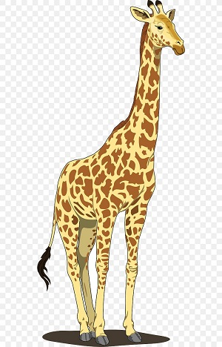L_ NG
Đáp án: O
136. Are your pencils long? – No, they ___________. They’re short.
A. is B. are C. isn’t D. aren’t
Đáp án: Chọn ý: D
137. H_ _ ’s the weather in Hanoi?
Đáp án: ow
138. I don’t like playing b_ _ _ _ man’s bluff. It’s boring.
Đáp án: lind
139. Nghe:Nhấn giữ Ctrl và bấm chuột để nghe: _ _ _ da
Đáp án: pan
140. W_ _ _ are these? – These are pencil cases.
Đáp án: hat
141. name?/ What’s/ your/
Đáp án: What’s your name?
142. Nghe:Nhấn giữ Ctrl và bấm chuột để nghe: Do you _ _ _ _ at break time?
Đáp án: skip
143. How m_ _ _ books are there on the bookshelf? – There are four books.
Đáp án: any
144. doesn’t/ My/ father/ like/ dogs./
Đáp án: My father doesn’t like dogs.
145. Point to your frie_ _ , please.
Đáp án: nd
146. C_ me here, Peter. Let’s play with us.
Đáp án: o
147. This dress is ve_ _ beautiful.
Đáp án: ry
148. Ảnh:N_ _ EBOOK
Đáp án: OT
149. … is your notebook? – It’s on the desk.
A. Where B. What C. Who D. When
Đáp án: Where
150. Ảnh:YE_ _ OW
Đáp án: LL
151. Look at that girl. ... name’s Jasmine.
A. Her B. Your C. His D. My
Đáp án: Her
152. I ... fine. How are you?
A. is B. are C. am D. a
Đáp án: am
153. This cak_ is for you. - Thank you very much.
Đáp án: e
154. is/ new/ That/ backpack./ my/
Đáp án: That is my new backpack.
155. Thes_ are my dolls.
Đáp án: e
156. to school/ my friends./ to go/ with/ I like/
Đáp án: I like to go to school with my friends.
157. What su_ _ ect do you like the most?
Đáp án: bj
158. my/ new/ These/ pencil box./ are/
Đáp án: These are my new pencil box.
159. need/ pencil/ sharpener./ a new/ I/
Đáp án: I need a new pencil sharpener.
160. This/ family./ is/ my/
Đáp án: This is my family.
161. I like to s_ ng a song with Peter.
Đáp án: i
162. Nghe:Nhấn giữ Ctrl và bấm chuột để nghe: He’s _ _ _ _ _ years old.
Đáp án: eight
163. Ảnh:Her _ _ _ _ _ _ _ _ is small.
Đáp án: bathroom
164. How/ today?/ is/ your/ mother
Đáp án: How is your mother today?
165. May I come in? - Yes, you ______ .
A. can't B. can C. may D. may not
Đáp án: can
166. large?/ playground/ Is/ your/
Đáp án: Is your playground large?
167. May I sit here? - ______
A. Yes, I can. B. Yes, you are. C. Yes, you can. D. Yes, you here.
Đáp án: Yes, you can.
168. an/ orange cat./ is/ This/
Đáp án: This is an orange cat.
169. I _ _ in the computer room.
Đáp án: am
170. Ảnh:My school is ne_ .
Đáp án: w
171. Goodbye, chi_ _ ren. See you later.
Đáp án: ld
172. This _ _ my school.
Đáp án: is
173. W_ sh your hand, please.
Đáp án: a
174. What colour ... this?
A. it B. is C. that D. hi
Đáp án: is
175. late!/ be/ Don't/
Đáp án: Don't be late!
176. black./ My/ shoes/ are/
Đáp án: My shoes are black.
177. at/ David/ school/ now./ is/
Đáp án: David is at school now.
178. Jane is not ... name.
A. he B. her C. she D. you
Đáp án: her
179. Look … your book, please.
A. of B. in C. on D. at
Đáp án: Chọn ý: D
180. Ảnh: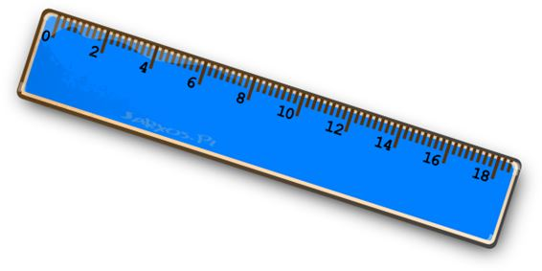A: What colour is the ruler? - B: It’s ....
A. green B. red C. blue D. brown
Đáp án: blue
181. the playground/ play football/ at break time./ We/ in/
Đáp án: We play football in the playground at break time.
182. Ma_ I go out?
Đáp án: y
183. Choose the odd one out:
A. white B. new C. yellow D. green
Đáp án: new
184. My books are on the ta_ _ e.
Đáp án: bl
185. Hi, I’_ Nam. Nice to meet you.
Đáp án: m
186. Nghe:Nhấn giữ Ctrl và bấm chuột để nghe: My ... is a teacher.
A. mother B. father C. brother D. sister
Đáp án: mother
187. Fine, thanks. A...d you?
A. n B. d C. a D. o
Đáp án: n
188. plays chess/ Tony/ at break time./
Đáp án: Tony plays chess at break time.
189. ... is this? – It is a pen.
A. When B. Who C. How D. What
Đáp án: Chọn ý: D
190. I _______ Mary.
A. am B. is C. are D. m
Đáp án: am
191. are on/ The pictures/ the wall./ my family/ of/
Đáp án: The pictures of my family are on the wall.
192. Ra_ _ e your hand, please.
Đáp án: is
193. Nghe:Nhấn giữ Ctrl và bấm chuột để nghe: Which DON’T they have for the picnic?
A. Grapes. B. Orange juice. C. Sandwiches D. Bananas.
Đáp án: Chọn ý: D
194. How many ... are there in your class?
A. students B. student C. teacher D. chair
Đáp án: students
195. Nghe:Nhấn giữ Ctrl và bấm chuột để nghe: She likes to eat ______ apples.
A. big red B. small red C. big green D. small green
Đáp án: big red
196. Hi, I _ _ Tom.
Đáp án: am
197. Is it _______rubber?
A. your B. you C. Lan D. I
Đáp án: your
198. Who is …? – He’s Phillip. He is my friend.
A. she B. she’s C. he D. he’s
Đáp án: he
199. Choose the letter(s) to make a correct word: P_NCIL CASE
A. E B. A C. I D. O
Đáp án: E
200. is/ The/ bookcase/ brown.
Đáp án: The bookcase is brown.

KEY IOE K3 2023 - 2024 SỐ 07
1. Good/ morning,/ teacher!/
Đáp án: Good morning, teacher!
2. What colour is this? - ... .
A. It’s big B. It’s small C. It’s blue D. It’s nice
Đáp án: It’s blue
3. Lisa./ Her/ is/ name/
Đáp án: Her name is Lisa.
4. Nice _ _ meet you, Alan.
Đáp án: to
5. Nice ... meet you.
A. for B. to C. from D. on
Đáp án: to
6. This is _ _ eraser.
Đáp án: an
7. The book/ table./ is/ on the/
Đáp án: The book is on the table.
8. kites/ are/ beautiful./ These/
Đáp án: These kites are beautiful.
9. Ảnh:TWO B_ LLS
Đáp án: A
10. Her room is small _______ tidy.
A. but B. and C. are D. on
Đáp án: but
11. I’m fine, thank you. How ... you?
A. out B. about C. and D. end
Đáp án: about
12. ... your name?
A. Who B. How C. What’s D. Why
Đáp án: What’s
13. Nghe:Nhấn giữ Ctrl và bấm chuột để nghe: That is my _ _ _ _ _ _ _ .
Đáp án: teacher
14. Nghe:Nhấn giữ Ctrl và bấm chuột để nghe: Listen and tick:
A. My mother sits on her chair. B. Mai’s brother sits on his chair. C. May’s mother sits on her chair. D. May’s mother sit on the chair.
Đáp án: May’s mother sits on her chair.
15. Hello, ... name is Scott.
A. he B. she C. it D. my
Đáp án: Chọn ý: D
16. Nghe:Nhấn giữ Ctrl và bấm chuột để nghe: We are a … family.
A. big B. happy C. large D. wonderful
Đáp án: happy
17. Who’s that? - That’s ... .
A. my’s teacher B. me’s teacher C. my teacher D. me teacher
Đáp án: my teacher
18. This's my friend. ___ name is Jack.
A. Her B. My C. Their D. His
Đáp án: Chọn ý: D
19. is/ teacher./ my/ Mr. Loc/
Đáp án: Mr. Loc is my teacher.
20. Ảnh:That is a red cu_ _ ain.
Đáp án: rt
21. It i... a book.
A. i B. s C. r D. t
Đáp án: s
22. The picture is o_ the wall.
Đáp án: n
23. Nghe:Nhấn giữ Ctrl và bấm chuột để nghe: _ _ o is that?
Đáp án: wh
24. Come ..., please.
A. out B. in C. to D. under
Đáp án: in
25. are/ and pencils./ my notebooks/ These/
Đáp án: These are my notebooks and pencils.
26. Pick ... your pencil, Tommy.
A. on B. to C. up D. down
Đáp án: up
27. This is ______ apple and that is ______ orange.
A. a – a B. a – an C. an – an D. an - Ø
Đáp án: an – an
28. Ảnh:TW_
Đáp án: O
29. stand up./ close the book/ We/ and/
Đáp án: We close the book and stand up.
30. Nghe:Nhấn giữ Ctrl và bấm chuột để nghe: gi_ _
Đáp án: rl
31. Ảnh: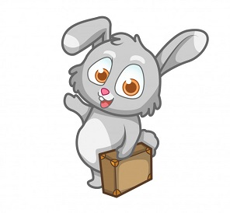Bye. See you _____ .
A. later B. to C. late D. too
Đáp án: later
32. Would you like … coffee? – No, thanks.
A. some B. any C. an D. the
Đáp án: some
33. This is _ desk.
Đáp án: a
34. May I go out? - Yes, ….
A. you can B. you can’t C. you are D. it is
Đáp án: you can
35. Is this a book? - ... .
A. Yes, it is B. Yes, isn’t C. No, it is D. Yes, that is
Đáp án: Yes, it is
36. you/ How/ do/ your name?/ spell
Đáp án: How do you spell your name?
37. It’s ______ ball.
A. a B. an C. two D. Ø
Đáp án: a
38. I/ come/ May/ in?
Đáp án: May I come in?
39. This gift is for you. - ... .
A. How are you B. Fine, thanks C. Thank you D. Thank
Đáp án: Thank you
40. are on/ The pictures/ of/ the wall./ my family/
Đáp án: The pictures of my family are on the wall.
41. B_ OK
Đáp án: O
42. Bye. See you aga_ _ .
Đáp án: in
43. Is this a bag? - ...
A. Yes, it is B. Yes, isn’t C. No, it is D. Nice to meet you
Đáp án: Yes, it is
44. How are y_ _ ? – Fine, thanks.
Đáp án: ou
45. Jenny is a … at London Primary School.
A. boy B. toy C. student D. she
Đáp án: student
46. words./ down/ the/ Copy/
Đáp án: Copy down the words.
47. Ma_ I go out?
Đáp án: y
48. This is my school. It_ name is London Primary School.
Đáp án: s
49. gym. It's/ a/ This/ is/ new./
Đáp án: This is a gym. It's new.
50. List_ _ carefully.
Đáp án: en
51. your/ Is/ teacher?/ he/
Đáp án: Is he your teacher?
52. Ảnh:bas_ _ _ _ _ _ _
Đáp án: ketball
53. May _ go out? - Yes, you can.
Đáp án: I
54. It’s an e_ _ _ _ r.
Đáp án: rase
55. Anne has long … hair.
A. nice B. slim C. curly D. sunny
Đáp án: curly
56. the/ Who/ new/ pupil?/ is/
Đáp án: Who is the new pupil?
57. _ _ she a newcomer?
Đáp án: is
58. What ... is this? – It’s blue.
A. colour B. colours C. colour’s D. coulor
Đáp án: colour
59. My classroom is … .
A. name B. news C. new D. names
Đáp án: new
60. His/ is/ name/ Tommy.
Đáp án: His name is Tommy.
61. Nghe:Nhấn giữ Ctrl và bấm chuột để nghe: The boy likes ….
A. badminton B. tennis C. baseball D. table tennis
Đáp án: tennis
62. , please./ the/ answer/ Circle/
Đáp án: Circle the answer , please.
63. She/ my/ is/ teacher/ too./
Đáp án: She is my teacher too.
64. Let’s ma_ e a circle.
Đáp án: k
65. Listen ... the teacher.
A. to B. me C. you D. he
Đáp án: to
66. Nghe:Nhấn giữ Ctrl và bấm chuột để nghe: He is _ _ _ _ _ years old.
Đáp án: seven
67. My sister _ _ kes eating candies.
Đáp án: li
68. I like to s_ _ g English song.
Đáp án: in
69. Ảnh:TABLE AND CHAI_
Đáp án: R
70. learn/ Let’s/ English./
Đáp án: Let’s learn English.
71. Ảnh:Does she have bl_ _ _ _ hair?
Đáp án: onde
72. His/ is/ in/ birthday/ May./
Đáp án: His birthday is in May.
73. How are y_ _ ?
Đáp án: ou
74. Write w_ _ t the teacher says.
Đáp án: ha
75. fish/ The/ in/ is/ the bottle./
Đáp án: The fish is in the bottle.
76. Nghe:Nhấn giữ Ctrl và bấm chuột để nghe: The _ _ _ room is over there.
Đáp án: art
77. I have/ May/ a glass of juice?/
Đáp án: May I have a glass of juice?
78. Point/ say./ and/
Đáp án: Point and say.
79. yellow/ Their bags/ are/ and green.
Đáp án: Their bags are yellow and green.
80. H_ , I’m Simon. Nice to meet you.
Đáp án: i
81. This is ... red apple.
A. are B. a C. am D. an
Đáp án: a
82. What co_ _ _ _ is that bag? - It’s green.
Đáp án: lour
83. This is an appl...
A. t B. u C. e D. a
Đáp án: e
84. It’s a _ _ _ puter room.
Đáp án: com
85. Nghe:Nhấn giữ Ctrl và bấm chuột để nghe: Listen and tick
A. Monday B. Thursday C. Friday D. Sunday
Đáp án: Friday
86. This is _ _ orange.
Đáp án: an
87. ... a tree, please.
A. Stand B. Sit C. Write D. Draw
Đáp án: Chọn ý: D
88. _ re those your rubbers?
Đáp án: A
89. purple/ a/ scarf./ is/ This/
Đáp án: This is a purple scarf.
90. Ảnh: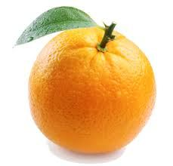Is this an _ _ _ _ _ _ ?
Đáp án: orange
91. What colour is your skirt?
A. It’s new. B. It’s white. C. It’s fine. D. It’s two years old.
Đáp án: It’s white.
92. to work./ his/ drives/ car/ My father/
Đáp án: My father drives his car to work.
93. This is Alice. _ _ _ is my friend.
Đáp án: she
94. My pencil is lo_ _ , but his pencil is short.
Đáp án: ng
95. What/ your/ is/ name?
Đáp án: What is your name?
96. Ảnh:We are ______ at break time.
A. in the classroom B. in the computer room C. in the playground D. on the roof
Đáp án: in the playground
97. Ảnh: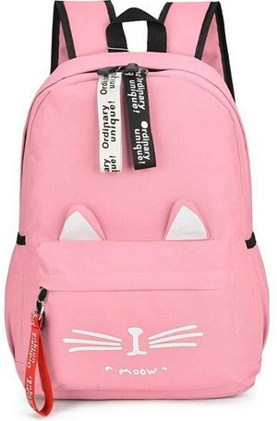A _ INK SCHOOL BAG
Đáp án: P
98. This is my b_ ok.
Đáp án: o
99. Ảnh:What do you do at break time? – I ... .
A. play tennis B. play football C. play chess D. swim
Đáp án: Chọn ý: D
100. Point _ _ the teacher.
Đáp án: to
101. _ _ _ is she? – She is my teacher.
Đáp án: Who
102. … this word after me: ’’compass’’.
A. Do B. Write C. Copy D. Read
Đáp án: Chọn ý: D
103. often/ It is/ rainy/ July./ in
Đáp án: It is often rainy in July.
104. My hat is gr_ en.
Đáp án: e
105. How m_ _ y pens do you have?
Đáp án: an
106. Choose the odd one out
A. Cat B. Dog C. Chicken D. Table
Đáp án: Chọn ý: D
107. There are t_ _ ee crayons in my bags.
Đáp án: hr
108. H_ _ ’s the weather in Hanoi?
Đáp án: ow
109. Nghe:Nhấn giữ Ctrl và bấm chuột để nghe: The gym is sm_ ll.
Đáp án: a
110. What _ _ it? - It’s a pen.
Đáp án: is
111. Close your ..., please.
A. name B. book C. ball D. took
Đáp án: book
112. John likes to play games v_ _ _ much.
Đáp án: ery
113. My sister’s n_ _ _ is Lily.
Đáp án: ame
114. These shoes … green and yellow.
A. am B. are C. is D. do
Đáp án: are
115. Nghe:Nhấn giữ Ctrl và bấm chuột để nghe: Who’s that?
A. It’s Mr Loc. B. It’s Tony. C. It’s Peter. D. It’s Quan.
Đáp án: It’s Peter.
116. Nice _ _ see you.
Đáp án: to
117. Nghe:Nhấn giữ Ctrl và bấm chuột để nghe: Listen and tick:
A. There are two bathrooms. B. There are three bedrooms. C. There are two bedrooms. D. There are two living rooms.
Đáp án: There are two bedrooms.
118. Nghe:Nhấn giữ Ctrl và bấm chuột để nghe: The teacher is ... .
A. hall B. tall C. small D. cold
Đáp án: tall
119. to school/ go/ We/ early./ so
Đáp án: We go to school so early.
120. These are my cats. _______ white and yellow.
A. They are B. It is C. Cats D. Are
Đáp án: They are
121. Nghe:Nhấn giữ Ctrl và bấm chuột để nghe: Dan and Lily are having a … in the garden.
A. barbecue B. party C. lesson D. picnic
Đáp án: party
122. my/ These/ new/ pencil box./ are/
Đáp án: These are my new pencil box.
123. She _ _ from Hanoi.
Đáp án: is
124. Re_ d after me, children.
Đáp án: a
125. It is a de_ k.
Đáp án: s
126. is/ green/ a/ table./ That/
Đáp án: That is a green table.
127. During Ma_ _ s lessons, I learn about numbers.
Đáp án: th
128. Good morning, Peter. - ... .
A. Good morning, Jean B. Good night, Jean C. My name’s Jean D. Jean, this is my pen
Đáp án: Good morning, Jean
129. chalks./ He/ has/ some/
Đáp án: He has some chalks.
130. Unscramble this word: ’’ERBBRU’’ -> ’’RUBB_ _ ’’.
Đáp án: ER
131. Let’s go t_ _ _ ther, Mary.
Đáp án: oge
132. This isn’t ... bag.
A. he’s B. his C. me’s D. you’s
Đáp án: his
133. Odd one out:
A. you B. hi C. I D. She
Đáp án: hi
134. and pencils./ These/ my/ are/ notebooks
Đáp án: These are my notebooks and pencils.
135. Nghe:Nhấn giữ Ctrl và bấm chuột để nghe: _______ table tennis.
A. Peter plays B. I play C. Mai plays D. My friends play
Đáp án: I play
136. thank you./ I'm/ fine,/
Đáp án: I'm fine, thank you.
137. This is my fam_ _ y.
Đáp án: il
138. They are Jane ... Lily.
A. are B. is C. and D. bye
Đáp án: and
139. is/ not/ my/ name./ Jane/
Đáp án: Jane is not my name.
140. school?/ What’s/ the/ your/ name of/
Đáp án: What’s the name of your school?
141. How are ... ?
A. he B. Lan C. you D. bye
Đáp án: you
142. Ảnh:Good _____!
A. afternoon B. evening C. night D. morning
Đáp án: Chọn ý: D
143. Nghe:Nhấn giữ Ctrl và bấm chuột để nghe: Choose the correct response.
A. I’m fine, thank you. B. Goodbye, Sally. C. I don’t know you. D. Hi, Sally. Nice to meet you.
Đáp án: Chọn ý: D
144. G_ _ _ bye, see you later.
Đáp án: ood
145. hot/ in/ Is/ summer?/ it/
Đáp án: Is it hot in summer?
146. Ảnh:It’s my _ _ _ book.
Đáp án: red
147. Nghe:Nhấn giữ Ctrl và bấm chuột để nghe: The teddy is … and ….
A. small – brown B. big – brown C. small – purple D. big – purple
Đáp án: small – purple
148. It’s big./ The house/ isn’t/ small./
Đáp án: The house isn’t small. It’s big.
149. Goodbye, John. - ... .
A. Hello B. How are you C. Good morning D. Bye Tom. See you later
Đáp án: Chọn ý: D
150. wants/ food./ some/ Peter/
Đáp án: Peter wants some food.
151. Tom _ _ d Minh can play football.
Đáp án: an
152. What colour ______ your eyes?
A. are B. is C. to D. two
Đáp án: are
153. Look _ _ the board, please.
Đáp án: at
154. Ảnh:We are on the _ _ _ _ _ because it’s very hot today.
Đáp án: beach
155. Nice to m__t you.
A. ee B. ii C. oo D. aa
Đáp án: ee
156. in?/ come/ I/ May/
Đáp án: May I come in?
157. favourite/ is/ blue./ colour/ My/
Đáp án: My favourite colour is blue.
158. Gi_ e me that yellow pen, please.
Đáp án: v
159. picture./ this/ Let’s/ and colour/ draw/
Đáp án: Let’s draw and colour this picture.
160. pink/ cake./ a/ It is/
Đáp án: It is a pink cake.
161. Can you he_ p me?
Đáp án: l
162. My teacher is v_ _ y beautiful.
Đáp án: er
163. pen. It’s not/ This is/ my/ your pen.
Đáp án: This is my pen. It’s not your pen.
164. Nghe:Nhấn giữ Ctrl và bấm chuột để nghe: They are in the _ _ _ _ _ _ .
Đáp án: garden
165. on/ run/ the/ Don't/ street./
Đáp án: Don't run on the street.
166. Bob: What is this? - Peter: ...
A. His name is Hien. B. It is a ruler. C. It’s an ruler. D. It is my friend.
Đáp án: It is a ruler.
167. Is this a d_ sk? - Yes, it is.
Đáp án: e
168. Linh is in the computer ____.
A. school B. gym C. library D. room
Đáp án: Chọn ý: D
169. These flowers are be_ _ _ iful.
Đáp án: aut
170. G_ _ dbye. See you later.
Đáp án: oo
171. Ảnh:The flower ... is beautiful.
A. case B. say C. vase D. play
Đáp án: vase
172. Bye./ See/ tomorrow./ you/
Đáp án: Bye. See you tomorrow.
173. it/ ?/ is/ What/
Đáp án: What is it ?
174. Raise you h_ _ d, please.
Đáp án: an
175. What is this? –This is ... .
A. a pen B. pen C. pens D. an pen
Đáp án: a pen
176. They are Jane ... Tim.
A. is B. and C. or D. too
Đáp án: and
177. We must stay here ... 8.30 to 9.
A. between B. before C. from D. on
Đáp án: from
178. please./ Let’s/ circles,/ make/ two/
Đáp án: Let’s make two circles, please.
179. Ảnh: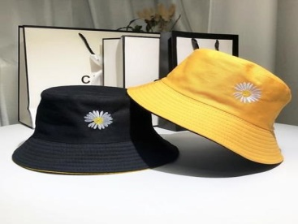
They are _____ hats.A. green and yellow B. green and black C. black and yellow D. yellow and red
Đáp án: black and yellow
180. ... morning, Simon!
A. But B. Good C. Shut D. Hi
Đáp án: Good
181. Is it _ ruler? – No, it isn’t.
Đáp án: a
182. Nghe:Nhấn giữ Ctrl và bấm chuột để nghe: Listen and tick:
A. My father is a teacher. B. My mother is a teacher C. My father is a doctor. D. My brother is a teacher.
Đáp án: My father is a doctor.
183. Ảnh: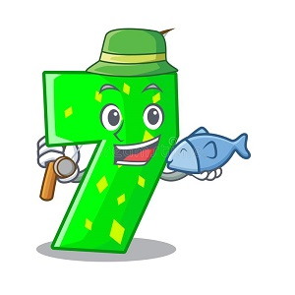Minh is ____ years old.
A. five B. six C. seven D. eight
Đáp án: seven
184. The computer/ room/ big./ is not/
Đáp án: The computer room is not big.
185. Thank you. – You’re ... .
A. welcome’s B. welcomes C. welcome D. welcome’re
Đáp án: welcome
186. Choose the odd one out
A. Pencil B. Black C. Book D. Ruler
Đáp án: Black
187. Nghe:Nhấn giữ Ctrl và bấm chuột để nghe: _ _ _ _ ball
Đáp án: foot
188. His classroom is s_ all.
Đáp án: m
189. Ảnh:It _ _ a black cat.
Đáp án: is
190. It is my chai...
A. t B. w C. r D. s
Đáp án: r
191. What’s __________ name?
A. you B. its C. she D. dog
Đáp án: its
192. Ảnh:Th_ _ is my rubber.
Đáp án: is
193. Is this a penc_ l?
Đáp án: i
194. There/ my family./ four people/ in/ are/
Đáp án: There are four people in my family.
195. That is my school gym. ___ new.
A. Its B. It's is C. It's D. Its's
Đáp án: It's
196. See you l_ _ er, Jack.
Đáp án: at
197. I can play ... a ball.
A. to B. on C. in D. with
Đáp án: Chọn ý: D
198. Ảnh:My _ _ _ _ _ lator is next to the book. It’s green.
Đáp án: calcu
199. you/ Do/ badminton?/ like/
Đáp án: Do you like badminton?
200. How are ... ? - I’m fine, thanks.
A. he B. Lan C. you D. bye
Đáp án: you

KEY IOE K3 2023 - 2024 SỐ 08
1. What’s her name ? – ....
A. I’m fine, thanks B. Her name is Daisy C. See you later D. My name is Daisy
Đáp án: Her name is Daisy
2. Let’s co_ nt the boys.
Đáp án: u
3. books./ close/ your/ Please/
Đáp án: Please close your books.
4. Who _ re they?
Đáp án: a
5. … that your friend? – No, he isn’t.
A. Are B. Am C. Is D. It
Đáp án: Is
6. in/ the bottle./ is/ The/ fish/
Đáp án: The fish is in the bottle.
7. are/ My friends/ in/ the playground.
Đáp án: My friends are in the playground.
8. May I go out? - ... .
A. Hello B. Nice to meet you C. Fine, thanks D. Sure
Đáp án: Chọn ý: D
9. I/ have/ two/ robots.
Đáp án: I have two robots.
10. That’s Peter. ... is my friend.
A. I B. You C. She D. He
Đáp án: Chọn ý: D
11. Listen ... the teacher.
A. to B. me C. you D. he
Đáp án: to
12. Let’s play with … .
A. she B. he C. me D. see
Đáp án: me
13. _ s this a desk? – No, it isn’t.
Đáp án: I
14. What c_ _ _ _ _ is this? - It’s green.
Đáp án: olour
15. W_ o is she? – She’s my teacher.
Đáp án: h
16. Clo_ e the door, Mary.
Đáp án: s
17. please./ hands,/ Wash/ your/
Đáp án: Wash your hands, please.
18. _ _ _ t’s your name? – My name’s Tom.
Đáp án: Wha
19. How _ _ _ _ crayons are there?
Đáp án: many
20. Give ... that pink crayon.
A. he B. she C. me D. the
Đáp án: me
21. classroom/ is/ My/ small.
Đáp án: My classroom is small.
22. Choose the letter(s) to make a correct word: swi__ing
A. m B. mm C. k D. kk
Đáp án: mm
23. white./ The/ rabbit/ is/
Đáp án: The rabbit is white.
24. a/ puppy./ It's/ nice/
Đáp án: It's a nice puppy.
25. Goodbye, Alice. – Bye. See you ... .
A. later B. later’s C. laters D. a later
Đáp án: later
26. Hello. My n____ is Nam.
A. ema B. ane C. ame D. eam
Đáp án: ame
27. This is Harry. ... is my friend.
A. They B. He C. She D. It
Đáp án: He
28. Nghe: Nhấn giữ Ctrl và bấm chuột để nghe: This is my ... .
A. class B. school C. room D. desk
Đáp án: school
29. Please,/ aloud./ this/ word/ read/
Đáp án: Please, read this word aloud.
30. Ảnh:These are th_ _ _ dogs.
Đáp án: ree
31. W_ _ t is this? – This is a marker.
Đáp án: ha
32. Hello, ... Kate.
A. my name B. I C. I’m D. me
Đáp án: I’m
33. Nghe:Nhấn giữ Ctrl và bấm chuột để nghe: Is this your _ _ _ _ _ ? - Yes, it is.
Đáp án: house
34. This is the way we go _ _ school.
Đáp án: to
35. May/ I/ my/ book?/ open/
Đáp án: May I open my book?
36. Nga _ _ _ _ s hide-and-seek with her friends.
Đáp án: play
37. N_W
A. A B. E C. I D. U
Đáp án: E
38. What’s your n_ _ e? - My name is Hoa.
Đáp án: am
39. May I ___ the book?
A. open B. stand C. play D. sit
Đáp án: open
40. Listen _ _ the teacher carefully.
Đáp án: to
41. Nghe:Nhấn giữ Ctrl và bấm chuột để nghe: Listen and tick:
A. Is that girl Mary? - Yes, she is. B. Is that boy Mary? - Yes, he is. C. Is that pen Mary? - Yes, it is. D. Is that room Mary? - Yes, it is.
Đáp án: Is that girl Mary? - Yes, she is.
42. Ảnh:My sister is _ _ _ _ years old.
Đáp án: four
43. Good ..., Alice. How are you today?
A. mornings B. bye C. morning D. hi
Đáp án: morning
44. Ảnh: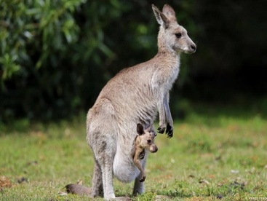We can see a kang_ _ _ _ in Australia.
Đáp án: aroo
45. I am ... now. I want some water.
A. hungry B. thirsty C. happy D. pink
Đáp án: thirsty
46. My father is a taxi _ _ _ _ _ _ .
Đáp án: driver
47. ... is a bird.
A. You B. He C. It D. She
Đáp án: It
48. ___ is his name?
A. What B. Where C. How D. Why
Đáp án: What
49. Give ... a pen.
A. he B. me C. she D. they
Đáp án: me
50. sister/ friend./ my/ is/ Her/
Đáp án: Her sister is my friend.
51. Let’s stand ... !
A. down B. up C. in D. on
Đáp án: up
52. Nice to ... you!
A. meet B. go C. for D. come
Đáp án: meet
53. Ảnh: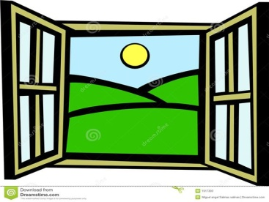We need a new _ _ _ dow.
Đáp án: win
54. classroom/ My/ is/ big.
Đáp án: My classroom is big.
55. ... your name?
A. What B. What’s C. How’s D. Why’s
Đáp án: What’s
56. Our classr_ _ m is big.
Đáp án: oo
57. Nghe:Nhấn giữ Ctrl và bấm chuột để nghe: Loo_ at the school.
Đáp án: k
58. Hi, how are you? – I’m very ..., thanks.
A. when B. well C. and D. how
Đáp án: well
59. very/ tall./ is/ teacher/ My/
Đáp án: My teacher is very tall.
60. Nghe:Nhấn giữ Ctrl và bấm chuột để nghe: It’s beau_ _ _ _ _ .
Đáp án: tiful
61. My rubber/ and my ruler/ is short./ is small/
Đáp án: My rubber is small and my ruler is short.
62. Nghe:Nhấn giữ Ctrl và bấm chuột để nghe: Listen and tick:
A. How are you? B. How old are you? C. How school are you? D. How room are you?
Đáp án: How are you?
63. _ ESK
Đáp án: D
64. you./ meet/ Nice/ to/
Đáp án: Nice to meet you.
65. the/ Let’s/ to/ go/ library./
Đáp án: Let’s go to the library.
66. My/ is/ name/ Billy.
Đáp án: My name is Billy.
67. I go … school in the morning.
A. from B. to C. at D. in
Đáp án: to
68. I/ volleyball/ to play/ like/ in the evening./
Đáp án: I like to play volleyball in the evening.
69. Alice can ri_ _ a bicycle.
Đáp án: de
70. bookcase/ is/ The/ brown.
Đáp án: The bookcase is brown.
71. now/ Stand up/ books, please./ and open/ your
Đáp án: Stand up now and open your books, please.
72. Choose the odd one out:
A. blue B. pink C. green D. book
Đáp án: Chọn ý: D
73. flowers?/ those/ are/ What colour/
Đáp án: What colour are those flowers?
74. Who’s that? - That’s ... .
A. my’s new teacher B. me’s new teacher C. my new teacher D. me new teacher
Đáp án: my new teacher
75. That’s Miss White. She is my _ ew teacher.
Đáp án: n
76. school gym./ in the/ are/ The students/
Đáp án: The students are in the school gym.
77. Nghe:Nhấn giữ Ctrl và bấm chuột để nghe: Look at the _____.
A. gym B. school C. room D. library
Đáp án: Chọn ý: D
78. my/ not/ It/ is/ chair./
Đáp án: It is not my chair.
79. Nghe:Nhấn giữ Ctrl và bấm chuột để nghe: _ _ _ gry
Đáp án: hun
80. Be … Don’t make noise.
A. lazy B. quiet C. funny D. angry
Đáp án: quiet
81. green kites./ two/ They/ are/
Đáp án: They are two green kites.
82. TH_T
A. I B. A C. E D. O
Đáp án: A
83. ... your hand, please.
A. Goodbye B. Hi C. Wash D. Study
Đáp án: Wash
84. Happy birthday. This robot is for you, Richard. – Thank you very m_ _ _ .
Đáp án: uch
85. Nghe:Nhấn giữ Ctrl và bấm chuột để nghe: His brother’s name is _ _ _ _ .
Đáp án: Nick
86. Is that Nam? - Yes, _ _ is.
Đáp án: it
87. These _ _ _ my toy planes.
Đáp án: are
88. a red/ That/ is/ pencil.
Đáp án: That is a red pencil.
89. children./ Circle/ answer,/ the/
Đáp án: Circle the answer, children.
90. _ _ she a newcomer?
Đáp án: is
91. Nghe:Nhấn giữ Ctrl và bấm chuột để nghe: There are _ _ _ _ books in the bookcase.
Đáp án: five
92. This is Mary. ... is my friend.
A. They B. He C. She D. It
Đáp án: She
93. circles,/ make/ Let’s/ please./ two/
Đáp án: Let’s make two circles, please.
94. W_ _ t is this? - This is a pen.
Đáp án: ha
95. The books are o_ the table.
Đáp án: n
96. Che_ _ the words you hear.
Đáp án: ck
97. Odd one out:
A. small B. short C. tall D. yellow
Đáp án: Chọn ý: D
98. That is my s_ _ ter. Her name is Mandy.
Đáp án: is
99. She/ friend./ is/ new/ my/
Đáp án: She is my new friend.
100. Odd one out:
A. you B. hi C. I D. She
Đáp án: hi
101. Nice to meet you, Hai. – Nice to meet you, ... .
A. to B. two C. too D. those
Đáp án: too
102. _ _ _ are they? - They are our new teachers.
Đáp án: Who
103. How are you? - ... .
A. My name is Mary B. She’s my friend C. I’m fine, thank you D. Bye. See you later
Đáp án: I’m fine, thank you
104. Ảnh:N_ _ EBOOK
Đáp án: OT
105. My books are o_ the table.
Đáp án: n
106. My bedroom/ large/ is/ and new.
Đáp án: My bedroom is large and new.
107. Lis_ en to me, please.
Đáp án: t
108. Choose the odd one out:
A. May B. July C. April D. Jimmy
Đáp án: Chọn ý: D
109. I’m/ thank/ you?/ you. And/ fine,/
Đáp án: I’m fine, thank you. And you?
110. What are those? – _ _ _ _ ’re my books.
Đáp án: they
111. How m_ _ y rulers are there?
Đáp án: an
112. Is this Phong? - No, it ___.
A. is B. are C. aren't D. isn't
Đáp án: Chọn ý: D
113. _ _ _ they fine?
Đáp án: are
114. Ảnh:_ ELLOW
Đáp án: Y
115. are/ These/ relatives./ my/
Đáp án: These are my relatives.
116. Nghe:Nhấn giữ Ctrl và bấm chuột để nghe: a_ _ le
Đáp án: pp
117. Ảnh:What is that? - It is a/an … .
A. ruler B. eraser C. pencil D. crayon
Đáp án: eraser
118. Nice to meet ..., too .
A. you’s B. you’re C. your D. you
Đáp án: Chọn ý: D
119. May I read the book aloud? – Yes, you ca_ .
Đáp án: n
120. like/ Do/ playing/ you/ robots?/
Đáp án: Do you like playing robots?
121. This is ... cat.
A. he B. she C. my D. you
Đáp án: my
122. Can you he_ p me?
Đáp án: l
123. ... is that? – That’s Mary. She is my friend.
A. How B. When C. Who D. Where
Đáp án: Who
124. Ảnh:ru_ _ er
Đáp án: bb
125. This is _ pen.
Đáp án: a
126. class./ please./ Good morning,/ down,/ Sit/
Đáp án: Good morning, class. Sit down, please.
127. This is m_ blue book.
Đáp án: y
128. Ảnh:This is my new h_ _ _ e.
Đáp án: ous
129. How ____ are you? - I'm eight years old.
A. old B. long C. much D. many
Đáp án: old
130. is/ Peter./ My/ brother’s/ name/
Đáp án: My brother’s name is Peter.
131. Nghe:Nhấn giữ Ctrl và bấm chuột để nghe: LI_ _ _ _ _
Đáp án: brary
132. my/ in/ two pens/ There are/ school bag./
Đáp án: There are two pens in my school bag.
133. am/ I/ Hello,/ Andy.
Đáp án: Hello, I am Andy.
134. May I come ...?
A. in B. at C. on D. to
Đáp án: in
135. Wh_ t is your favourite food? - I like noodles the most.
Đáp án: a
136. Nghe:Nhấn giữ Ctrl và bấm chuột để nghe: a b_ g
Đáp án: a
137. Choose the odd one out:
A. house B. gym C. library D. music room
Đáp án: house
138. I sin_ a song.
Đáp án: g
139. Nghe:Nhấn giữ Ctrl và bấm chuột để nghe: I’ve got two ... .
A. hats B. apples C. oranges D. balls
Đáp án: apples
140. you/ fine/ Are/ today?
Đáp án: Are you fine today?
141. your/ Raise/ hands,/ please
Đáp án: Raise your hands, please
142. Nice to ... you too.
A. bye B. meet C. later D. hello
Đáp án: meet
143. How are you to_ _ y, Tom? – I’m fine, thanks.
Đáp án: da
144. Nghe:Nhấn giữ Ctrl và bấm chuột để nghe: There are _ _ _ _ books in the bookcase.
Đáp án: five
145. Septem_ _ _ is the ninth month in a year.
Đáp án: ber
146. _____ colour are your pens?
A. Who B. What C. How D. Why
Đáp án: What
147. the teacher./ Point/ to/
Đáp án: Point to the teacher.
148. Choose the odd one out:
A. Maths B. Science C. Vietnam D. Arts
Đáp án: Vietnam
149. ... you David? - Yes, I am.
A. Is B. Are C. He D. She
Đáp án: Are
150. T_ ank you very much.
Đáp án: h
151. EI_ HT
Đáp án: G
152. playground/ Is/ large?/ your/
Đáp án: Is your playground large?
153. Nghe:Nhấn giữ Ctrl và bấm chuột để nghe: Lisa loves to go _____ .
A. to school B. home C. fishing D. shopping
Đáp án: Chọn ý: D
154. are/ There/ books./ ten/
Đáp án: There are ten books.
155. ... is she? – She’s Mary. She’s my friend.
A. How B. Who C. What D. Hi
Đáp án: Who
156. Nghe:Nhấn giữ Ctrl và bấm chuột để nghe: Listen and tick:
A. I’ve got two rulers. B. I’ve got two erasers. C. I’ve got two scissors. D. I’ve got two eggs.
Đáp án: I’ve got two erasers.
157. Where is Simon f_ _ m? – He’s from England.
Đáp án: ro
158. There’s a garden in fr_ nt of my house.
Đáp án: o
159. Flowers in the park _ _ _ very beautiful.
Đáp án: are
160. Those/ my/ aren't/ rulers.
Đáp án: Those aren't my rulers.
161. During Ma_ _ s lessons, I learn about numbers.
Đáp án: th
162. red/ are there?/ many/ How/ apples
Đáp án: How many red apples are there?
163. Ảnh:S_ T DOWN
Đáp án: I
164. What … is it? – It’s green.
A. a colour B. colour C. colours D. two colours
Đáp án: colour
165. We learn about _ _ _ _ _ _ _ in Maths.
Đáp án: numbers
166. big./ classroom/ not/ Your/ is/
Đáp án: Your classroom is not big.
167. ... that a dog? – No, it isn’t.
A. Are B. Is C. Who D. When
Đáp án: Is
168. ... your hand, please.
A. Read B. Listen C. Raise D. Write
Đáp án: Raise
169. Be q_ _ et, please.
Đáp án: ui
170. Look at the boa_ d.
Đáp án: r
171. name/ here,/ please/ Write/ your/
Đáp án: Write your name here, please
172. Read and an_ _ _ _ my question.
Đáp án: swer
173. Hi, Molly. _ _ w are you?
Đáp án: ho
174. Today's children, _______'s future.
A. today B. tomorrow C. yesterday D. next day
Đáp án: tomorrow
175. It is my chai...
A. t B. w C. r D. s
Đáp án: r
176. He_ _ o, my name’s Richard. - Nice to meet you.
Đáp án: ll
177. Linda and Mary _____ my friends.
A. is B. am C. are D. do
Đáp án: are
178. Ảnh:We learn P.E in the _ _ _ . It is very large.
Đáp án: gym
179. Read/ aloud/ sit down./ then/ and/
Đáp án: Read aloud and then sit down.
180. a pupil/ primary school./ at a/ He's/
Đáp án: He's a pupil at a primary school.
181. Nghe:Nhấn giữ Ctrl và bấm chuột để nghe: They’re my _ _ _ _ _ _ things.
Đáp án: school
182. Nghe:Nhấn giữ Ctrl và bấm chuột để nghe: It's _______.
A. orange B. oranges C. black D. brown
Đáp án: orange
183. Mary likes skat_ _ _ but Sarah doesn’t.
Đáp án: ing
184. Would you like some m_ _ k? – Yes, please.
Đáp án: il
185. Do you want ... milk?
A. an B. a C. some D. it
Đáp án: some
186. my sisters,/ Mai and Lan./ These/ are/
Đáp án: These are my sisters, Mai and Lan.
187. Is Tom from Cananda? - ….
A. Yes, he is B. Yes, he does C. No, he is D. Yes,he isn’t
Đáp án: Yes, he is
188. Let’s make a ci_ _ le.
Đáp án: rc
189. ...at colour is this? – It’s blue.
A. Wt B. Ho C. Wh D. We
Đáp án: Wh
190. May I come ...?
A. in B. at C. on D. to
Đáp án: in
191. name/ Green./ Louis/ is/ My/
Đáp án: My name is Louis Green.
192. My bedroom is new ______ nice.
A. but B. and C. not D. no
Đáp án: and
193. Sparks./ dog,/ my/ is/ This/
Đáp án: This is my dog, Sparks.
194. It's a brow_ teddy bear.
Đáp án: n
195. This _ _ a pencil case.
Đáp án: is
196. Ảnh: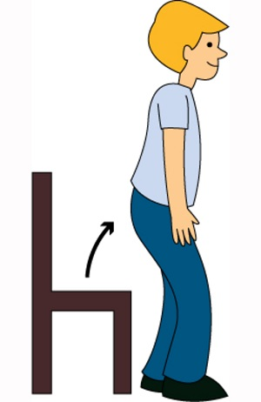_ _ and up!
Đáp án: st
197. Nghe:Nhấn giữ Ctrl và bấm chuột để nghe: What’s this?
A. It’s a pink doll. B. It’s a pink boat. C. It’s a pink boot. D. It’s a pink nose.
Đáp án: It’s a pink boat.
198. ... this a pencil? – No, it isn’t.
A. Are B. Is C. It D. The
Đáp án: Is
199. W_ _ _ _ on the board, please.
Đáp án: rite
200. Let’s ma_ _ a circle.
Đáp án: ke

KEY IOE K3 2023 - 2024 SỐ 09
1. are/ school gym./ The students/ in the/
Đáp án: The students are in the school gym.
2. Who is he? - ... .
A. She is my friend B. He my friend C. She my friend D. He’s my friend
Đáp án: Chọn ý: D
3. My br_ _ her’s name is John.
Đáp án: ot
4. Come ov_ r here.
Đáp án: e
5. Nghe:Nhấn giữ Ctrl và bấm chuột để nghe: My school is _ _ _ _ _ .
Đáp án: small
6. Is/ in the room?/ Tony/
Đáp án: Is Tony in the room?
7. Choose the odd one out
A. ruler B. rubber C. notebook D. long
Đáp án: Chọn ý: D
8. a question?/ ask/ May/ I/
Đáp án: May I ask a question?
9. Choose the odd one out.
A. Don’t talk! B. Be quiet! C. Keep silent! D. Stand up!
Đáp án: Chọn ý: D
10. Jenny/ is/ my/ new/ friend./
Đáp án: Jenny is my new friend.
11. That’s/ Peter./ He/ my friend./ is
Đáp án: That’s Peter. He is my friend.
12. What _ s this?
Đáp án: i
13. Is that a pen? - ..., it isn’t.
A. Yes B. Yes, it is C. Not D. No
Đáp án: Chọn ý: D
14. Nghe:Nhấn giữ Ctrl và bấm chuột để nghe: She likes to eat ______ apples.
A. big red B. small red C. big green D. small green
Đáp án: big red
15. Ảnh: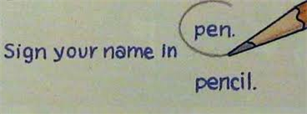Ci_ _ le the answer, John.
Đáp án: rc
16. Is ... a chair? - Yes, it is.
A. are B. it C. it’s D. his
Đáp án: it
17. Lis_ _ _ to the teacher, please.
Đáp án: ten
18. my/ This/ is/ classroom.
Đáp án: This is my classroom.
19. Thank/ you,/ Peter./
Đáp án: Thank you, Peter.
20. Peter/ and Linda/ years old./ are/ eight
Đáp án: Peter and Linda are eight years old.
21. A: How _ _ _ are you? - B: I’m eight.
Đáp án: old
22. My brother’s name is ... .
A. Alice B. Mary C. Daisy D. Tom
Đáp án: Chọn ý: D
23. Hi,/ How/ you?/ are/ Mary./
Đáp án: Hi, Mary. How are you?
24. It is ... desk.
A. bye B. me C. a D. hi
Đáp án: a
25. What _ _ your name?
Đáp án: is
26. I have f...ve dogs.
A. u B. i C. e D. a
Đáp án: i
27. Play with ...
A. to B. hi C. me D. hello
Đáp án: me
28. Some b_ _ _ s can fly but they can’t swim.
Đáp án: ird
29. Put on your coat … you’ll get cold.
A. but B. or C. and D. so
Đáp án: or
30. It ... a ball.
A. are B. hi C. goodbye D. is
Đáp án: Chọn ý: D
31. How/ many/ cats/ there?/ are
Đáp án: How many cats are there?
32. A: What _ _ _ our is your pen? - B: It’s brown.
Đáp án: col
33. This gift is ... you.
A. on B. in C. for D. at
Đáp án: for
34. To_ ch your desk.
Đáp án: u
35. Ảnh:CLASSROO_
Đáp án: M
36. Ảnh: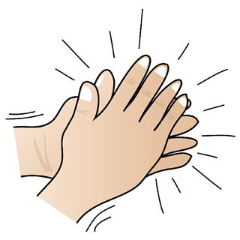Clap your h_ _ _ _ , please.
Đáp án: ands
37. This is m_ blue book.
Đáp án: y
38. Is that your pencil box? - _ _ , it isn’t.
Đáp án: no
39. black board/ is/ in the classroom./ A/
Đáp án: A black board is in the classroom.
40. Ảnh:Put your books on the tabl_ .
Đáp án: e
41. Choose the odd one out
A. Green B. Yellow C. Apple D. Blue
Đáp án: Apple
42. Ảnh:Can I borrow your pencil _ _ _ _ _ _ _ _ _ ?
Đáp án: sharpener
43. Ảnh: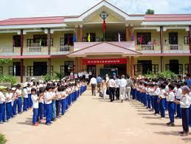That is her new _ _ _ _ _ _ .
Đáp án: school
44. That is a br_ _ n book.
Đáp án: ow
45. Ảnh: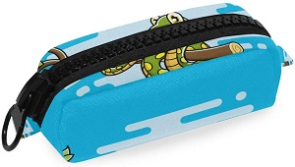Is that a blue pencil case? - ______
A. Yes, its is. B. Yes, it's is. C. Yes, it is D. Yes, it isn't
Đáp án: Yes, it is
46. Hi, Alice. I _ _ Tommy.
Đáp án: am
47. Nice to meet you to_ .
Đáp án: o
48. is/ nine/ Nam/ years/ old./
Đáp án: Nam is nine years old.
49. Do you like milk? – No, I ... .
A. do B. does C. doesn’t D. don’t
Đáp án: Chọn ý: D
50. Hello, ... Sean.
A. you B. am C. I’m D. I
Đáp án: I’m
51. Nghe:Nhấn giữ Ctrl và bấm chuột để nghe: Look at the _____.
A. gym B. school C. room D. library
Đáp án: Chọn ý: D
52. I chat ______ my friends in our classroom.
A. and B. are C. with D. Ø
Đáp án: with
53. How are you? - ... .
A. I’m Binh B. She’s my sister C. I’m fine, thank you D. Goodbye
Đáp án: I’m fine, thank you
54. _ _ that your new friend? - No, he isn’t.
Đáp án: Is
55. Thank you very m_ _ h.
Đáp án: uc
56. book/ Put/ your/ away.
Đáp án: Put your book away.
57. boys./ Don’t/ talk,/
Đáp án: Don’t talk, boys.
58. Ảnh:T_O BOOKS
A. O B. E C. U D. W
Đáp án: Chọn ý: D
59. Good mor_ ing everyone.
Đáp án: n
60. Nghe:Nhấn giữ Ctrl và bấm chuột để nghe: This is my ….
A. bookcase B. pencil case C. notebook D. pencil
Đáp án: pencil case
61. A: _________. - B: Yes, you can
A. Open your book! B. Stand up! C. May I go out? D. Be quiet!
Đáp án: May I go out?
62. Thes_ are my cats.
Đáp án: e
63. my/ That/ grandmother./ is/
Đáp án: That is my grandmother.
64. books/ three/ on the/ table./ There are/
Đáp án: There are three books on the table.
65. This ruler is b_ _ wn. That ruler is pink.
Đáp án: ro
66. but/ small/ nice./ house is/ My/
Đáp án: My house is small but nice.
67. I like skating _ _ _ I don’t like skipping.
Đáp án: but
68. Close the ..., Philip.
A. name B. book C. ball D. look
Đáp án: book
69. Ảnh: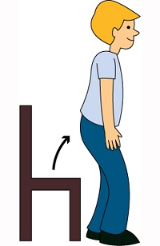Stan_ up, please!
Đáp án: d
70. B_ _ , Lan. See you soon.
Đáp án: ye
71. teacher/ to/ Listen/ the/ carefully./
Đáp án: Listen to the teacher carefully.
72. Look _ _ that kite. It’s so beautiful.
Đáp án: at
73. My/ beautiful./ is/ mother/
Đáp án: My mother is beautiful.
74. Sing a ..., please.
A. you B. me C. song D. he
Đáp án: song
75. My _ ame is Peter.
Đáp án: n
76. today./ It/ is cold/
Đáp án: It is cold today.
77. Bye./ later./ See/ you/
Đáp án: Bye. See you later.
78. Ảnh: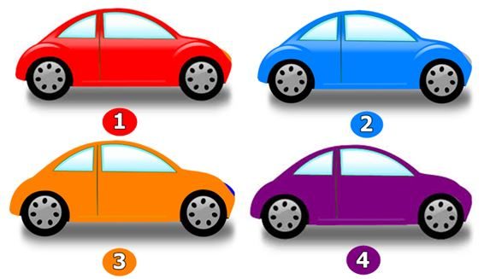A: Which car is Peter’s? - B: The orange one.
A. 1 B. 2 C. 3 D. 4
Đáp án: 3
79. My pen is o_ the desk.
Đáp án: n
80. ... is that? – That’s Mary. She is my friend.
A. How B. When C. Who D. Where
Đáp án: Who
81. Nghe:Nhấn giữ Ctrl và bấm chuột để nghe: Listen and choose the best response.
A. Goodbye! See you later. B. I’m fine, thanks. C. This is my friend, Lan. D. Hi! My name’s Lan.
Đáp án: Chọn ý: D
82. May I go out? - _______
A. Yes, you can. B. No, you can. C. Thank you. D. Sorry.
Đáp án: Yes, you can.
83. are/ There/ in/ my family./ four people/
Đáp án: There are four people in my family.
84. dog./ My/ brother/ doesn’t/ like
Đáp án: My brother doesn’t like dog.
85. Is your classroom big? - …, it isn't. It’s small.
A. Yes B. Yes, it isn’t C. No, it is D. No
Đáp án: Chọn ý: D
86. We play football in the play_ _ _ _ _ _ after school.
Đáp án: ground
87. you/ Bye./ tomorrow./ See/
Đáp án: Bye. See you tomorrow.
88. is mine/ the blue one/ is Phong’s./ and/ The red ruler/
Đáp án: The red ruler is mine and the blue one is Phong’s.
89. is/ That/ Jack./ boy/
Đáp án: That boy is Jack.
90. What is your f_ _ _ _ _ _ _ e food?
Đáp án: avourit
91. How are you? - ____, thank you.
A. Yes B. No C. Good D. Fine
Đáp án: Chọn ý: D
92. Nice to me_ t you.
Đáp án: e
93. This is my sch...ol.
A. o B. u C. i D. e
Đáp án: o
94. Hi, n_ _ _ to meet you.
Đáp án: ice
95. Mary is ... friend.
A. I B. my C. he’s D. she
Đáp án: my
96. Tom _ _ d Minh can play football.
Đáp án: an
97. in/ class 3B./ She/ is/
Đáp án: She is in class 3B.
98. Ảnh:Her _ _ _ _ _ _ _ _ is small.
Đáp án: bathroom
99. Ảnh:He is a newcom_ _ .
Đáp án: er
100. are/ lunch boxes?/ What colour/ your/
Đáp án: What colour are your lunch boxes?
101. in/ my bag./ are/ The books/
Đáp án: The books are in my bag.
102. Nghe:Nhấn giữ Ctrl và bấm chuột để nghe: What's ____ name?
A. his B. her C. your D. their
Đáp án: your
103. I want ... ice-cream, please.
A. a B. is C. it D. an
Đáp án: Chọn ý: D
104. Ảnh:BACK_ ACK
Đáp án: P
105. Choose the odd one out:
A. book B. pen C. ruler D. Mary
Đáp án: Chọn ý: D
106. I’m fine, _ _ _ nk you. And you?
Đáp án: tha
107. Nghe:Nhấn giữ Ctrl và bấm chuột để nghe: ... are my books.
A. They B. These C. Those D. They’re
Đáp án: These
108. Nghe:Nhấn giữ Ctrl và bấm chuột để nghe: He plays c_ _ _ _ at break time.
Đáp án: hess
109. but it's/ new./ isn't big/ My room/
Đáp án: My room isn't big but it's new.
110. your pet?/ Is/ this/
Đáp án: Is this your pet?
111. Ảnh:What is that? - It is a/an … .
A. ruler B. eraser C. pencil D. crayon
Đáp án: eraser
112. the room./ He/ in/ is not/
Đáp án: He is not in the room.
113. How are ..., Tom? – I’m fine, thank you.
A. he B. she C. you D. his
Đáp án: you
114. This is ... purple bag.
A. a B. an C. two D. this
Đáp án: a
115. I like to s...ng.
A. o B. i C. y D. e
Đáp án: i
116. Listen ... the teacher.
A. to B. me C. you D. he
Đáp án: to
117. Unscramble this word: ’’RYRALIB’’ -> ’’_ _ BRARY’’.
Đáp án: LI
118. like/ you/ some/ butter?/ Do/
Đáp án: Do you like some butter?
119. Who is she, Peter? - ... .
A. She Mary B. He’s Tom C. She’s Mary D. My name is Mary
Đáp án: She’s Mary
120. These shoes … green and yellow.
A. am B. are C. is D. do
Đáp án: are
121. Nghe:Nhấn giữ Ctrl và bấm chuột để nghe: What colour is ______?
A. they B. that C. it D. these
Đáp án: it
122. That’s is Mary. _ _ _ is my friend.
Đáp án: she
123. What colour is this? – It’s ... .
A. book B. crayon C. ruler D. pink
Đáp án: Chọn ý: D
124. Choose the letter(s) to make a correct word: cla__
A. rr B. ss C. hs D. s
Đáp án: ss
125. name/ Hello,/ Peter Smith./ is/ my/
Đáp án: Hello, my name is Peter Smith.
126. My classroom is ... .
A. bigs B. a big C. the big D. big
Đáp án: Chọn ý: D
127. Listen ... your friend, Tom.
A. on B. of C. to D. for
Đáp án: to
128. Nghe:Nhấn giữ Ctrl và bấm chuột để nghe: fi_ _
Đáp án: sh
129. I can sing but I _ _ _ _ _ _ dance.
Đáp án: cannot
130. new/ my/ is/ Tony/ friend./
Đáp án: Tony is my new friend.
131. Ảnh:TA_LE
A. P B. B C. C D. G
Đáp án: B
132. Nice to meet you, Miss Lan. – Nice to meet you, t_ _ .
Đáp án: oo
133. It's _ blue rubber.
Đáp án: a
134. Nghe:Nhấn giữ Ctrl và bấm chuột để nghe: _ _ _ _
Đáp án: your
135. a purple/ bag./ This is/
Đáp án: This is a purple bag.
136. Nghe:Nhấn giữ Ctrl và bấm chuột để nghe: Listen and tick:
A. Tom, have you got any pens? B. Tom, have you got any pencils? C. Tom, have you got any pen cases? D. Tom, have you got any pencil cases?
Đáp án: Tom, have you got any pens?
137. What ... these? – They are my pens.
A. is B. are C. and D. am
Đáp án: are
138. her rubbers/ and rulers./ aren't/ These/
Đáp án: These aren't her rubbers and rulers.
139. be/ late!/ Don't/
Đáp án: Don't be late!
140. play chess/ I/ in the classroom./
Đáp án: I play chess in the classroom.
141. Those are f_ ve boxes.
Đáp án: i
142. Hello. My name’s Thompson. - Hi, ….
A. What’s that? B. I’m Simon. Nice to meet you C. Goodbye. D. See you later
Đáp án: I’m Simon. Nice to meet you
143. My _ ame is Tony.
Đáp án: n
144. I/ to play/ volleyball/ in the evening./ like/
Đáp án: I like to play volleyball in the evening.
145. Nghe:Nhấn giữ Ctrl và bấm chuột để nghe: It’s … .
A. cloudy B. rainy C. windy D. stormy
Đáp án: windy
146. Henry doesn’t work _ _ Saturday and Sunday.
Đáp án: on
147. Choose the letter(s) to make a correct word: PL_Y
A. E B. U C. A D. I
Đáp án: A
148. Do you like … a bicycle?
A. playing B. riding C. making D. doing
Đáp án: riding
149. Do Peter and Tony go to the park? - No, they _ _ _ ’t.
Đáp án: don
150. There is a picture … the wall.
A. in B. at C. on D. of
Đáp án: on
151. My sister likes to go sw_ _ _ _ ng in summer.
Đáp án: immi
152. Happy birthday, Alice. This doll is for ... .
A. I B. you C. he D. she
Đáp án: you
153. _______ you like dolls?
A. Do B. Are C. Is D. Don’t
Đáp án: Do
154. My school is near _ bakery.
Đáp án: a
155. W_ _ _ _ on the board, please.
Đáp án: rite
156. _ _ ce to meet you, Lan Anh.
Đáp án: Ni
157. Nghe:Nhấn giữ Ctrl và bấm chuột để nghe: Let’s go to the _ _ _ _ _ _ library.
Đáp án: school
158. Nghe:Nhấn giữ Ctrl và bấm chuột để nghe: How do you ... your name?
A. spend B. ten C. spell D. tell
Đáp án: spell
159. old/ beautiful./ but/ is/ The classroom/
Đáp án: The classroom is old but beautiful.
160. Ảnh:That's my computer _ oom.
Đáp án: r
161. Nghe:Nhấn giữ Ctrl và bấm chuột để nghe: My school _ _ _ is very long.
Đáp án: bus
162. What _ _ you do at break time?
Đáp án: do
163. Good_ ye. See you tomorrow.
Đáp án: b
164. _ _ _ ’t play football in the classroom.
Đáp án: Don
165. _ _ your school big? – No, it isn’t.
Đáp án: Is
166. I/ Laura./ am/
Đáp án: I am Laura.
167. Ảnh:This is a ... desk.
A. pink B. yellow C. blue D. green
Đáp án: yellow
168. _______ are our flowers.
A. This B. That C. It D. Those
Đáp án: Chọn ý: D
169. Is it _______rubber?
A. your B. you C. Lan D. I
Đáp án: your
170. Listen to the teacher carefull_ .
Đáp án: y
171. Simon can sing ... he cannot swim.
A. and B. end C. but D. or
Đáp án: but
172. Ảnh:There are many k_ _ _ _ in the sky.
Đáp án: ites
173. today?/ do you/ subjects/ What/ have
Đáp án: What subjects do you have today?
174. your/ Write/ school./ about/
Đáp án: Write about your school.
175. is/ My/ school/ new and big.
Đáp án: My school is new and big.
176. Where’s she today? - ... .
A. She’s at school B. Yes. She’s from America C. She’s nine years old today D. She can swim
Đáp án: She’s at school
177. Look _ t the board.
Đáp án: a
178. Let’s ma...e a circle.
A. g B. r C. t D. k
Đáp án: Chọn ý: D
179. Here we _ _ _ together.
Đáp án: are
180. Take ... your books, children.
A. on B. at C. out D. for
Đáp án: out
181. Nghe:Nhấn giữ Ctrl và bấm chuột để nghe: _ octor
Đáp án: d
182. Choose the odd one out
A. Nine B. Bird C. Five D. Three
Đáp án: Bird
183. Nghe:Nhấn giữ Ctrl và bấm chuột để nghe: Listen and tick
A. What're they? B. What's that? C. What's it? D. What's this?
Đáp án: Chọn ý: D
184. Mary/ to school/ goes/ every/ morning./
Đáp án: Mary goes to school every morning.
185. There is _ pen in my school bag.
Đáp án: a
186. I’m fine, thanks. How a_ _ _ t you?
Đáp án: bou
187. girls!/ talk/ Don't/ in class,/
Đáp án: Don't talk in class, girls!
188. the library./ place/ favourite/ is/ My/
Đáp án: My favourite place is the library.
189. Is this a book? - ... .
A. Yes, it is B. Yes, isn’t C. No, it is D. Yes, that is
Đáp án: Yes, it is
190. meet/ Pleased/ you, Miu./ to/
Đáp án: Pleased to meet you, Miu.
191. Th_ _ _ are three pens on the desk.
Đáp án: ere
192. Ảnh:We are on the _ _ _ _ _ because it’s very hot today.
Đáp án: beach
193. Look _ _ the picture, please.
Đáp án: at
194. the/ classroom/ in/ She is/ now./
Đáp án: She is in the classroom now.
195. Nghe:Nhấn giữ Ctrl và bấm chuột để nghe: Mon_ _ _
Đáp án: day
196. Nghe:Nhấn giữ Ctrl và bấm chuột để nghe: Let’s play _ _ _ _ _ .
Đáp án: chess
197. Is t_ _ s a desk?
Đáp án: hi
198. Ảnh:Who is she? – She is Lan. She is my t_ _ _ _ _ _ .
Đáp án: eacher
199. A: What colour … these flowers? - B: … purple.
A. are – They’re B. is – It’s C. are – It’s D. is – They’re
Đáp án: are – They’re
200. Let’s say hel_ _ to Peter, students.
Đáp án: lo

KEY IOE K3 2023 - 2024 SỐ 10
1. Ảnh:This is number _ _ _ .
Đáp án: ten
2. This is my class_ _ _ _ . It’s small.
Đáp án: room
3. Nghe:Nhấn giữ Ctrl và bấm chuột để nghe: Listen and tick:
A. Tom, have you got any pens? B. Tom, have you got any pencils? C. Tom, have you got any pen cases? D. Tom, have you got any pencil cases?
Đáp án: Tom, have you got any pens?
4. Choose the odd one out:
A. on B. to C. in D. read
Đáp án: Chọn ý: D
5. Which is a kind of fruit?
A. blue B. green C. orange D. pink
Đáp án: orange
6. Nice ... meet you.
A. for B. to C. from D. on
Đáp án: to
7. Close the ..., Philip.
A. name B. book C. ball D. look
Đáp án: book
8. Nam’s pencil is _ _ _ _ but mine is short.
Đáp án: long
9. my/ is/ teacher./ Miss Lien/ new
Đáp án: Miss Lien is my new teacher.
10. Don’t make ... mess.
A. an B. the C. a D. this
Đáp án: a
11. … that woman your new teacher?
A. Is B. Has C. Who’s D. Does
Đáp án: Is
12. These are t_ o cats.
Đáp án: w
13. Gi...e me the book, please.
A. t B. v C. n D. b
Đáp án: v
14. It’s ... ruler.
A. are B. a C. an D. is
Đáp án: a
15. Let’s s_ y ’’Hello’’ to Tom.
Đáp án: a
16. What is your name?
A. Her name is Mary. B. His name is Alan. C. My name is Lan. D. Your name is Peter.
Đáp án: My name is Lan.
17. Choose the odd one out:
A. read B. sing C. draw D. book
Đáp án: Chọn ý: D
18. Linda and her sister like jumping rope in _ _ _ _ _ free time.
Đáp án: their
19. What _ _ it? - It’s a pen.
Đáp án: is
20. is/ My/ classroom/ small.
Đáp án: My classroom is small.
21. Ảnh: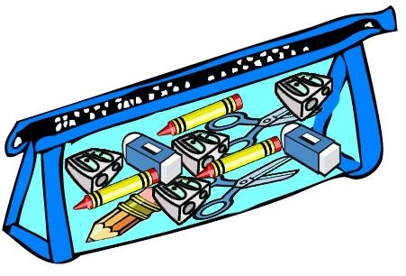This is my _ _ _ cil case.
Đáp án: pen
22. _ _ your school big? – No, it isn’t.
Đáp án: Is
23. Nghe:Nhấn giữ Ctrl và bấm chuột để nghe: Listen and tick:
A. There are two bathrooms. B. There are three bedrooms. C. There are two bedrooms. D. There are two living rooms.
Đáp án: There are two bedrooms.
24. Ảnh: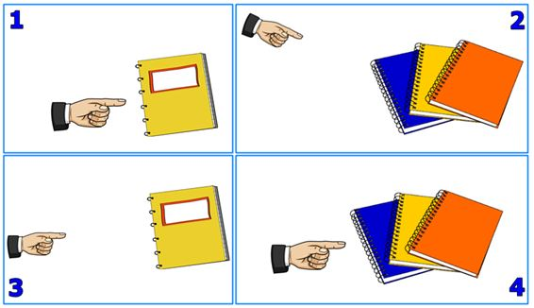Those notebooks are Sarah’s.
A. Picture 1 B. Picture 2 C. Picture 3 D. Picture 4
Đáp án: Picture 2
25. your pet?/ Is/ this/
Đáp án: Is this your pet?
26. Have a n_ _ e day.
Đáp án: ic
27. Ảnh: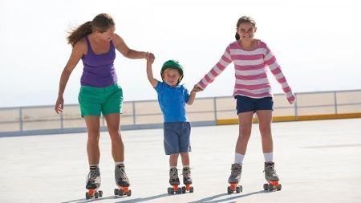Do you like ska_ _ ng?
Đáp án: ti
28. a/ draw/ , please./ Let’s/ picture
Đáp án: Let’s draw a picture , please.
29. go/ fishing/ I don't/ weekends./ at
Đáp án: I don't go fishing at weekends.
30. Sing wit_ me.
Đáp án: h
31. Nghe:Nhấn giữ Ctrl và bấm chuột để nghe: Is it _ _ _ ? – Yes, it is.
Đáp án: big
32. This/ red./ pen. It's/ is my/
Đáp án: This is my pen. It's red.
33. Ảnh:BACK_ ACK
Đáp án: P
34. Can/ your pen?/ I borrow/
Đáp án: Can I borrow your pen?
35. ... is Mary.
A. You B. He C. She D. My
Đáp án: She
36. Who is ...? – She’s Mary.
A. he B. she C. his D. her
Đáp án: she
37. Goodbye./ tomorrow./ See/ you/
Đáp án: Goodbye. See you tomorrow.
38. pens./ blue/ are/ my/ These/
Đáp án: These are my blue pens.
39. ... to meet you!
A. How B. Go C. Nice D. Get
Đáp án: Nice
40. There a_ _ five flowers in the vase.
Đáp án: re
41. Nghe:Nhấn giữ Ctrl và bấm chuột để nghe: Emma doesn’t like playing _ _ _ _ _ _ .
Đáp án: tennis
42. her/ notebooks./ are/ These/
Đáp án: These are her notebooks.
43. Li_ ten to the teacher, please.
Đáp án: s
44. Put/ your/ down./ hand/
Đáp án: Put your hand down.
45. Look ... the cat, Tom.
A. in B. on C. to D. at
Đáp án: Chọn ý: D
46. Nghe:Nhấn giữ Ctrl và bấm chuột để nghe: Let’s go to the school _ _ _ _ _ _ _ .
Đáp án: library
47. Gr...et your friend, please.
A. a B. e C. u D. i
Đáp án: e
48. He/ is not/ in/ the room.
Đáp án: He is not in the room.
49. What’s/ name?/ your/
Đáp án: What’s your name?
50. W...o is she? - She is Mary.
A. t B. h C. w D. q
Đáp án: h
51. Hi. I am Peter. – Hello. I ... Alice.
A. is B. are C. am D. be
Đáp án: am
52. Sit d_ _ _ , Tommy.
Đáp án: own
53. Ảnh: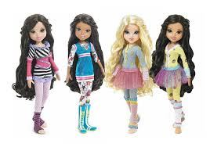Those do_ _ _ are small.
Đáp án: lls
54. Odd one out:
A. chair B. table C. black board D. football
Đáp án: Chọn ý: D
55. How _ _ _ you today? - Fine, thanks. And you?
Đáp án: are
56. Is/ your/ this/ pen?
Đáp án: Is this your pen?
57. Thank you very m_ _ h.
Đáp án: uc
58. This is yo_ r book.
Đáp án: u
59. Have ... nice day!
A. a B. an C. the D. this
Đáp án: a
60. Nghe:Nhấn giữ Ctrl và bấm chuột để nghe: Listen and tick:
A. Is that girl Mary? - Yes, she is. B. Is that boy Mary? - Yes, he is. C. Is that pen Mary? - Yes, it is. D. Is that room Mary? - Yes, it is.
Đáp án: Is that girl Mary? - Yes, she is.
61. Is this a notebook? – No, ... .
A. it isn’t B. it is C. it does D. it doesn’t
Đáp án: it isn’t
62. a/ dog?/ there/ Is/
Đáp án: Is there a dog?
63. These are three pencil box_ _ .
Đáp án: es
64. are/ Five/ on the desk./ pens/
Đáp án: Five pens are on the desk.
65. How ... students are there in your class? - There are twenty five students.
A. much B. very C. old D. many
Đáp án: Chọn ý: D
66. large./ is/ lunch room/ My/
Đáp án: My lunch room is large.
67. Nghe:Nhấn giữ Ctrl và bấm chuột để nghe: _ _ _ _
Đáp án: nine
68. This __ his book.
A. it B. its C. is D. it's
Đáp án: is
69. Ảnh:THREE PENCIL_
Đáp án: S
70. Sta_ _ up now and open your book.
Đáp án: nd
71. now/ books, please./ and open/ your/ Stand up/
Đáp án: Stand up now and open your books, please.
72. Let's/ book./ read/ a/ comic
Đáp án: Let's read a comic book.
73. Ảnh:I'm five years _ ld.
Đáp án: o
74. Read/ and/ sit down./ aloud/ then
Đáp án: Read aloud and then sit down.
75. Can/ open/ the door?/ I/
Đáp án: Can I open the door?
76. Ảnh:_ _ _ _ _ _
Đáp án: pencil
77. Where is Peter? – ... at school.
A. He B. She C. He’s D. She’s
Đáp án: He’s
78. Nghe:Nhấn giữ Ctrl và bấm chuột để nghe: The_ _ are my rulers.
Đáp án: se
79. ___________ to meet you.
A. Nie B. Nine C. Nice D. Like
Đáp án: Nice
80. the/ Point/ to/ teacher.
Đáp án: Point to the teacher.
81. in/ are/ They/ the park.
Đáp án: They are in the park.
82. Here is their s_ _ ool.
Đáp án: ch
83. My friends are in the pla_ ground.
Đáp án: y
84. … I open my book? – Yes, you can.
A. Do B. What C. Could D. May
Đáp án: Chọn ý: D
85. I ... Mai.
A. am B. am’s C. are D. is
Đáp án: am
86. Clo_ e your book, please.
Đáp án: s
87. Anna doesn’t play skipping at br_ _ _ time.
Đáp án: eak
88. Wh_ is that? – It’s Mary.
Đáp án: o
89. Is/ large?/ classroom/ his/
Đáp án: Is his classroom large?
90. His classroom is s_ all.
Đáp án: m
91. Nghe:Nhấn giữ Ctrl và bấm chuột để nghe: BOO_
Đáp án: K
92. Ảnh:The rain_ _ _ is beautiful.
Đáp án: bow
93. Don't/ knife./ the/ with/ play/
Đáp án: Don't play with the knife.
94. How/ Hien?/ Miss/ old/ is/
Đáp án: How old is Miss Hien?
95. Take/ pens,/ out/ Henry./ your/
Đáp án: Take out your pens, Henry.
96. Where __________ your brothers?
A. am B. is C. are D. its
Đáp án: are
97. Goodbye Sally. See ... later.
A. hi B. my C. your D. you
Đáp án: Chọn ý: D
98. Is … a library at your school?
A. these B. this C. there D. that
Đáp án: there
99. M_ y I go out? Yes, please.
Đáp án: a
100. That/ a/ chair./ green/ is/
Đáp án: That is a green chair.
101. _______ up, please.
A. Sit B. Open C. Close D. Stand
Đáp án: Chọn ý: D
102. very/ much./ you/ Thank/
Đáp án: Thank you very much.
103. There are t_ _ ee crayons in my bags.
Đáp án: hr
104. Nghe:Nhấn giữ Ctrl và bấm chuột để nghe: B_ E
Đáp án: Y
105. subjects/ does/ What/ he/ have?/
Đáp án: What subjects does he have?
106. Is this your ruler? - No, ____ isn't
A. it B. that C. its D. it's
Đáp án: it
107. My/ not/ bedroom/ is/ big./
Đáp án: My bedroom is not big.
108. the board./ on/ Write/ name/ your/
Đáp án: Write your name on the board.
109. Where/ your/ school?/ is/ primary
Đáp án: Where is your primary school?
110. are/ What colour/ these dogs?/
Đáp án: What colour are these dogs?
111. Nghe:Nhấn giữ Ctrl và bấm chuột để nghe: A: What’s that? - B: It’s a … .
A. cat B. bag C. rat D. bat
Đáp án: cat
112. ... pictures are there on the wall?
A. Who B. How C. How many D. How much
Đáp án: How many
113. B_ OK
Đáp án: O
114. I’m David. This is … family.
A. I B. my C. mine D. me
Đáp án: my
115. What ... is this? – It’s black.
A. colour B. age C. old D. school
Đáp án: colour
116. bedroom/ My/ big./ is/ not
Đáp án: My bedroom is not big.
117. Choose the correct sentence.
A. I like play basketball. B. My brother is twelve year old. C. Tony plays football at break time. D. What are your name?
Đáp án: Tony plays football at break time.
118. Nghe:Nhấn giữ Ctrl và bấm chuột để nghe: His book is ________.
A. pink B. blue C. green D. white
Đáp án: green
119. _ _ r baby sister is young.
Đáp án: He
120. ... name is Linda.
A. You B. He C. Her D. She
Đáp án: Her
121. Do you like cats?
A. Yes, I am. B. No, I’m not. C. Yes, I do. D. No, I like.
Đáp án: Yes, I do.
122. fine./ and John/ are/ Linda/
Đáp án: Linda and John are fine.
123. not/ red./ His/ is/ pen/
Đáp án: His pen is not red.
124. This is _ _ apple.
Đáp án: an
125. Nghe:Nhấn giữ Ctrl và bấm chuột để nghe: ___ name is Simon.
A. His B. Her C. My D. Your
Đáp án: My
126. Let’s dr_ _ a picture.
Đáp án: aw
127. The room is _ _ _ _ _ . It isn’t big.
Đáp án: small
128. Let’s … a picture.
A. draw B. sit C. stand D. go
Đáp án: draw
129. Is this a pen? – No, ... isn’t.
A. this B. it’s C. its D. it
Đáp án: Chọn ý: D
130. there./ over/ The/ is/ bookshelf/
Đáp án: The bookshelf is over there.
131. What’s this? – It’s an ... .
A. crayon B. table C. ruler D. eraser
Đáp án: Chọn ý: D
132. ... , I’m Alice. – Nice to meet you.
A. Hi B. Goodbye C. See you D. Bye
Đáp án: Hi
133. Nice to meet ... .
A. I B. me C. he D. you
Đáp án: Chọn ý: D
134. ______ to meet you.
A. Nice B. Nine C. Night D. Naive
Đáp án: Nice
135. Nghe:Nhấn giữ Ctrl và bấm chuột để nghe: I’m standing in a ... .
A. living room B. classroom C. room D. bedroom
Đáp án: classroom
136. How m_ _ y rulers are there?
Đáp án: an
137. a/ gym. It's/ new./ This/ is/
Đáp án: This is a gym. It's new.
138. This is _ desk.
Đáp án: a
139. Is this your _ _ ayon?
Đáp án: cr
140. are on/ The pictures/ the wall./ of/ my family/
Đáp án: The pictures of my family are on the wall.
141. Look _ _ my house.
Đáp án: at
142. I’m fine, th_ _ k you.
Đáp án: an
143. football./ I do/ like/ playing/ not/
Đáp án: I do not like playing football.
144. That is a white _ _ d pink pen.
Đáp án: an
145. Sit do_ n, please.
Đáp án: w
146. T_ _ e out your books, students.
Đáp án: ak
147. is/ my brother/ I’m ten/ and/ fifteen./
Đáp án: I’m ten and my brother is fifteen.
148. I’m fin_ , thanks.
Đáp án: e
149. I’m fine, th_ _ k you.
Đáp án: an
150. It ... Oxford Primary school.
A. is B. a C. are D. an
Đáp án: is
151. Goodn_ _ _ _ , mommy.
Đáp án: ight
152. I _ _ Mai.
Đáp án: am
153. Nghe:Nhấn giữ Ctrl và bấm chuột để nghe: _ _ _ are you?
Đáp án: How
154. Ảnh: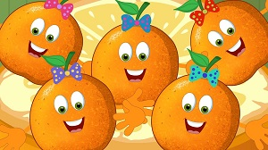FI_ _ ORANGES
Đáp án: VE
155. Come/ class,/ please./ to/
Đáp án: Come to class, please.
156. Nghe:Nhấn giữ Ctrl và bấm chuột để nghe: _ en
Đáp án: p
157. Ảnh: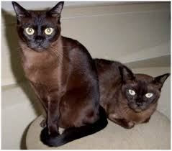These cats are _ _ _ _ _ .
Đáp án: brown
158. Good morning. … are you? - I’m fine.
A. Who B. Where C. What D. How
Đáp án: Chọn ý: D
159. Nghe:Nhấn giữ Ctrl và bấm chuột để nghe: Lucy and her ... draw picture in classroom.
A. boys B. teachers C. friends D. girls
Đáp án: friends
160. How m_ _ _ books are there on the bookshelf? – There are four books.
Đáp án: any
161. _ _ _ do you spell your name, Sam? - It’s S-A-M.
Đáp án: How
162. … do you play badminton with?
A. Whom B. When C. Which D. What
Đáp án: Whom
163. Hello. I a... Mai.
A. n B. m C. p D. q
Đáp án: m
164. The teddy is betw_ _ _ the car and the robot.
Đáp án: een
165. A: … is that? - B: It’s Tony.
A. Which B. Where C. Whom D. Who
Đáp án: Chọn ý: D
166. Hi, how are you? – I’m very ..., thanks.
A. when B. well C. and D. how
Đáp án: well
167. ... this a chair? – No, it isn’t.
A. What B. How C. Is D. Are
Đáp án: Is
168. What _ _ lour is it?
Đáp án: co
169. Can I have … cookies, Mom? – Of course, dear.
A. any B. some C. a D. an
Đáp án: some
170. My n_ me is Hieu.
Đáp án: a
171. Let’s .... outside, children.
A. bye B. play C. hi D. hello
Đáp án: play
172. is/ beautiful./ very/ Betty/
Đáp án: Betty is very beautiful.
173. Her name is Alice. _ _ _ is my friend.
Đáp án: she
174. the desk./ lamp/ The/ is/ on
Đáp án: The lamp is on the desk.
175. How do you … your name? – That’s A-N-N-E.
A. spell B. read C. call D. say
Đáp án: spell
176. How many/ are/ the desk?/ there on/ erasers/
Đáp án: How many erasers are there on the desk?
177. This is my friend. ... name is Lisa.
A. She B. He C. Her D. His
Đáp án: Her
178. Nghe:Nhấn giữ Ctrl và bấm chuột để nghe: _ _ _ _
Đáp án: ball
179. What is your f_ _ _ _ _ _ _ e food?
Đáp án: avourit
180. your/ Take/ book./ out/
Đáp án: Take out your book.
181. my notebooks/ are/ and pencils./ These/
Đáp án: These are my notebooks and pencils.
182. My ... is Bruce. Nice to meet you.
A. names B. name C. game D. name’s
Đáp án: name
183. Ảnh:I am _ _ the playground.
Đáp án: in
184. apples/ There are/ some/ the cupboard./ in
Đáp án: There are some apples in the cupboard.
185. This ... a house.
A. are B. is C. you D. here
Đáp án: is
186. My n_ me is Peter.
Đáp án: a
187. Nice to _______ you.
A. mit B. meat C. meet D. miit
Đáp án: meet
188. M_ _ I close my book? - Yes, please.
Đáp án: ay
189. What’s y_ _ r name? – My name’s Tom.
Đáp án: ou
190. My ... is Jean.
A. name’s B. names C. name D. namese
Đáp án: name
191. Ảnh:_ _ _ CIL SHARPENER
Đáp án: PEN
192. are/ two/ These/ little puppies.
Đáp án: These are two little puppies.
193. My school isn't new. It's _ ld.
Đáp án: o
194. This cak_ is for you. - Thank you very much.
Đáp án: e
195. ___ this your pen? - No, _____ .
A. Is - it isn't B. Is - it is C. Are - its D. Are - it are
Đáp án: Is - it isn't
196. Nghe:Nhấn giữ Ctrl và bấm chuột để nghe: The box is re_ .
Đáp án: d
197. I _ _ _ ’t like skipping.
Đáp án: don
198. Nghe:Nhấn giữ Ctrl và bấm chuột để nghe: e_ _
Đáp án: gg
199. What _ _ his name? - He is Jean.
Đáp án: is
200. Ảnh:N_ _ _ BOOK
Đáp án: OTE

KEY IOE K3 2023 - 2024 SỐ 11
1. Nghe:Nhấn giữ Ctrl và bấm chuột để nghe: What colour is ______?
A. they B. that C. it D. these
Đáp án: it
2. My/ is/ blue./ colour/ favourite/
Đáp án: My favourite colour is blue.
3. Ảnh:_ _ _ _
Đáp án: five
4. fish/ the bottle./ is/ The/ in
Đáp án: The fish is in the bottle.
5. Nghe:Nhấn giữ Ctrl và bấm chuột để nghe: ... your books, please.
A. open B. listen C. close D. go
Đáp án: open
6. W_ _ t is that? – It’s a robot.
Đáp án: ha
7. from/ Where/ you/ are/ , Tommy?/
Đáp án: Where are you from , Tommy?
8. th_ nks
Đáp án: a
9. How are y_ _ ?
Đáp án: ou
10. Nghe:Nhấn giữ Ctrl và bấm chuột để nghe: It’s beau_ _ _ _ _ .
Đáp án: tiful
11. ... your name?
A. Who B. How C. What’s D. Why
Đáp án: What’s
12. Choose the odd one out:
A. May B. July C. April D. Jimmy
Đáp án: Chọn ý: D
13. this./ a rubber./ Look/ It’s/ at/
Đáp án: Look at this. It’s a rubber.
14. Be q_ _ et, please.
Đáp án: ui
15. Cl_ _ n your teeth, please.
Đáp án: ea
16. Who is he? - ... .
A. She is Mary B. He my friend C. She my friend D. He’s Tom
Đáp án: Chọn ý: D
17. are/ on the table?/ the books/ What colour/
Đáp án: What colour are the books on the table?
18. Choose the odd one out:
A. white B. new C. yellow D. green
Đáp án: new
19. Nghe:Nhấn giữ Ctrl và bấm chuột để nghe: Do you _ _ _ _ at break time?
Đáp án: skip
20. I’m fine. How ab_ _ t you?
Đáp án: ou
21. They/ yellow./ are/
Đáp án: They are yellow.
22. Choose the odd one out:
A. mother B. father C. brother D. teacher
Đáp án: Chọn ý: D
23. I’d like some strawberries. – Here … are.
A. they B. them C. those D. these
Đáp án: they
24. new/ The school library/ nice./ is/ and
Đáp án: The school library is new and nice.
25. ... you like some bread? – No, I don't.
A. Does B. Do C. Are D. Is
Đáp án: Do
26. Good/ morning,/ teacher!/
Đáp án: Good morning, teacher!
27. Nice _ _ meet you, Alan.
Đáp án: to
28. Wa_ _ your hands, please.
Đáp án: sh
29. Nghe:Nhấn giữ Ctrl và bấm chuột để nghe: I’ve got two ... .
A. hats B. apples C. oranges D. balls
Đáp án: apples
30. my/ This/ school/ is/ library./
Đáp án: This is my school library.
31. She/ every/ afternoon./ does/ puzzles/
Đáp án: She does puzzles every afternoon.
32. Listen to the teac_ er.
Đáp án: h
33. L_ _ k at the board.
Đáp án: oo
34. go/ to school./ This is/ we/ the way/
Đáp án: This is the way we go to school.
35. is/ That/ bicycle./ a/
Đáp án: That is a bicycle.
36. Ảnh:We learn P.E in the _ _ _ . It is very large.
Đáp án: gym
37. … make a mess in class.
A. Are B. Is C. Do D. Don't
Đáp án: Chọn ý: D
38. This is Richard. _ _ is my new friend.
Đáp án: he
39. Good morning teacher! - ... .
A. Goodbye B. See you later C. Good morning D. Fine, thanks
Đáp án: Good morning
40. What’s _ _ _ _ name? - My name is Peter.
Đáp án: your
41. Henry doesn’t work _ _ Saturday and Sunday.
Đáp án: on
42. This is _ book.
Đáp án: a
43. Hello./ Mary./ I/ am/
Đáp án: Hello. I am Mary.
44. Ten, eleven, twelve, ..., fourteen, fifteenThe missing number is:
A. 12 B. 13 C. 14 D. 15
Đáp án: 13
45. like/ doesn’t/ tennis./ Mike/
Đáp án: Mike doesn’t like tennis.
46. you/ tomorrow,/ See/ Peter.
Đáp án: See you tomorrow, Peter.
47. Her ruler is short, but my ruler is l_ _ _ .
Đáp án: ong
48. Nghe:Nhấn giữ Ctrl và bấm chuột để nghe: ______ are my notebooks.
A. They B. These C. Those D. That
Đáp án: Those
49. N_ _ e to meet you, Sam.
Đáp án: ic
50. Miss Lan is my new t_ _ _ her.
Đáp án: eac
51. Peter _ _ from America.
Đáp án: is
52. BOA_ D
Đáp án: R
53. My ... is Tim. Nice to meet you.
A. name’s B. names C. name D. namese
Đáp án: name
54. Nghe:Nhấn giữ Ctrl và bấm chuột để nghe: The girl’s favourite toy is ….
A. kite B. teddy C. doll D. robot
Đáp án: teddy
55. Nghe:Nhấn giữ Ctrl và bấm chuột để nghe: What are these? - They are my _ _ _ _ _ _ _ .
Đáp án: pencils
56. backpack/ My/ is/ green./ new/
Đáp án: My new backpack is green.
57. are/ Huong?/ How/ you,/ old/
Đáp án: How old are you, Huong?
58. is long./ Her/ pencil/
Đáp án: Her pencil is long.
59. Ảnh:BAD_ INTON
Đáp án: m
60. are/ in/ the gym./ My friends/
Đáp án: My friends are in the gym.
61. Is this a pencil box? – ..., it is.
A. No B. Not C. Yes D. No’s
Đáp án: Yes
62. Write w_ _ t the teacher says.
Đáp án: ha
63. the school garden./ are/ in/ They/
Đáp án: They are in the school garden.
64. Nghe:Nhấn giữ Ctrl và bấm chuột để nghe: This is a … .
A. dot B. dog C. door D. down
Đáp án: dog
65. Good ni_ _ _ , children.
Đáp án: ght
66. ... this a chair? – No, it isn’t.
A. What B. How C. Is D. Are
Đáp án: Is
67. Lo...k at the board, please.
A. u B. o C. e D. i
Đáp án: o
68. new/ my/ book./ is/ This/
Đáp án: This is my new book.
69. Choose the odd one out:
A. young B. out C. big D. short
Đáp án: out
70. I’m fine, thanks. How a_ _ _ t you?
Đáp án: bou
71. How do you sp_ll your name?
A. e B. o C. u D. a
Đáp án: e
72. What is _ _ _ _ name? - My name is Tom.
Đáp án: your
73. What's your name? - ______ name is Nam.
A. My B. His C. Her D. Your
Đáp án: My
74. Ảnh:_ _ _ CATS
Đáp án: two
75. Nghe:Nhấn giữ Ctrl và bấm chuột để nghe: Good ______, class.
A. afternoon B. evening C. morning D. bye
Đáp án: morning
76. Choose the letter(s) to make a correct word: pencil c__se
A. a B. e C. i D. o
Đáp án: a
77. How are ...u? - Fine, thanks.
A. yu B. ye C. yo D. yi
Đáp án: yo
78. I’m fine, thank ... .
A. you B. you’re C. you are D. your
Đáp án: you
79. This gift is for you. - ... .
A. How are you B. Fine, thanks C. Thank you D. Thank
Đáp án: Thank you
80. Ảnh: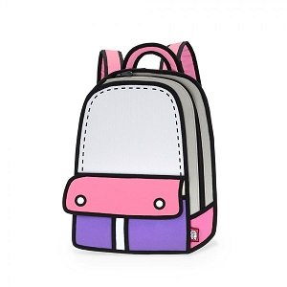BACKPA_ _
Đáp án: CK
81. Nghe:Nhấn giữ Ctrl và bấm chuột để nghe: He plays c_ _ _ _ at break time.
Đáp án: hess
82. are/ Their/ brown./ backpacks/
Đáp án: Their backpacks are brown.
83. Happy birthday _ _ you, Tommy.
Đáp án: to
84. Can/ I/ the door?/ open/
Đáp án: Can I open the door?
85. This is _ banana.
Đáp án: a
86. in the playground./ My friends/ and I/ are/
Đáp án: My friends and I are in the playground.
87. This is ... ruler.
A. a B. an C. and D. end
Đáp án: a
88. Ảnh: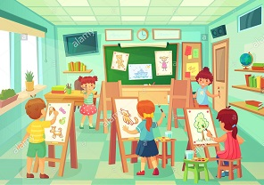AR_ ROOM
Đáp án: T
89. is/ new and big./ My/ school/
Đáp án: My school is new and big.
90. Ảnh:_ UBBER
Đáp án: R
91. Nghe:Nhấn giữ Ctrl và bấm chuột để nghe: There are _ _ _ _ books in the bookcase.
Đáp án: five
92. It ... Oxford Primary school.
A. is B. a C. are D. an
Đáp án: is
93. is/ Minh./ my friend./ This/ He’s
Đáp án: This is Minh. He’s my friend.
94. song./ that/ like/ don't/ I/
Đáp án: I don't like that song.
95. Nghe:Nhấn giữ Ctrl và bấm chuột để nghe: Listen and tick:
A. Both Mary and Tom love cats very much. B. Both Mary and Tom love cars very much. C. Both Mary and Tom love buses very much. D. Both Mary and Tom love pets very much.
Đáp án: Chọn ý: D
96. Nghe:Nhấn giữ Ctrl và bấm chuột để nghe: My _ _ _ _ _ _ _ _ _ is large.
Đáp án: classroom
97. … do you spell your name?
A. How B. What C. Who D. Why
Đáp án: How
98. Is this a notebook? …, it is.
A. No B. Not C. Yes D. No, it is
Đáp án: Yes
99. Don't talk _ _ class!
Đáp án: in
100. … many books are there on the bookshelf?
A. Who B. How C. Where D. What
Đáp án: How
101. Choose the odd one out
A. Pig B. Dog C. Cat D. Book
Đáp án: Chọn ý: D
102. is/ The/ bookshelf/ over/ there./
Đáp án: The bookshelf is over there.
103. Nghe:Nhấn giữ Ctrl và bấm chuột để nghe: Listen and tick:
A. This is my pencil. B. This is my pen case. C. This is my pen. D. This is my ball.
Đáp án: This is my pen.
104. A: _ _ _ _ ’s it? - B: It’s my notebook.
Đáp án: What
105. That's Susan. ___ is eight.
A. Her B. She C. Him D. His
Đáp án: She
106. … out your book, children.
A. Take B. To take C. Takes D. Taking
Đáp án: Take
107. books,/ please./ Show/ me/ your/
Đáp án: Show me your books, please.
108. That is a br_ _ n book.
Đáp án: ow
109. How many/ your school bag?/ books/ in/ are there/
Đáp án: How many books are there in your school bag?
110. Good morning, Peter. - ... .
A. Good morning, Jean B. Good night, Jean C. My name’s Jean D. Jean, this is my pen
Đáp án: Good morning, Jean
111. How ...re you?
A. e B. s C. a D. o
Đáp án: a
112. Linda and her sister like jumping rope in _ _ _ _ _ free time.
Đáp án: their
113. H_ _ ’s the weather in Hanoi?
Đáp án: ow
114. Let’s play with … .
A. she B. he C. me D. see
Đáp án: me
115. It’s su_ ny in Hue.
Đáp án: n
116. Bye. ___ you soon.
A. See B. Get C. Meet D. Have
Đáp án: See
117. answer,/ children./ Circle/ the/
Đáp án: Circle the answer, children.
118. Jenny has t...o dolls.
A. u B. w C. y D. o
Đáp án: w
119. you./ fine,/ I’m/ thank/
Đáp án: I’m fine, thank you.
120. Please/ books./ close/ your/
Đáp án: Please close your books.
121. Ảnh:Look! That flower is ....
A. pink B. blue C. green D. black
Đáp án: blue
122. APP_ E
Đáp án: L
123. a book. It/ is a/ It isn’t/ notebook.
Đáp án: It isn’t a book. It is a notebook.
124. Odd one out:
A. footballer B. singer C. teacher D. cooker
Đáp án: Chọn ý: D
125. These are three pencil box_ _ .
Đáp án: es
126. I … a blue pencil and a white ruler.
A. has B. have C. don’t have D. doesn’t have
Đáp án: have
127. How are you, Sandy? - ... .
A. I’m fine, thank B. Fine, thank C. Fine, thanks D. I fine, thank
Đáp án: Fine, thanks
128. Choose the odd one out:
A. black B. stand C. read D. listen
Đáp án: black
129. your/ Open/ , Peter./ schoolbag/
Đáp án: Open your schoolbag , Peter.
130. They/ are/ dogs./ small/ cats and
Đáp án: They are small cats and dogs.
131. Pick … your pencil.
A. at B. up C. on D. for
Đáp án: up
132. Choose the correct sentence.
A. I'm eight years old. B. I'm eight year old. C. He are a student. D. They is my friends.
Đáp án: I'm eight years old.
133. What is _ _ _ name? – He is Tony.
Đáp án: his
134. This is my ... house.
A. a new B. new C. news D. new’s
Đáp án: new
135. these/ his pens and/ Are/ pencils?
Đáp án: Are these his pens and pencils?
136. Nghe:Nhấn giữ Ctrl và bấm chuột để nghe: I’m fine, ________.
A. thank B. thank you C. thanks D. thanks you
Đáp án: thanks
137. Bye. See you l_ _ _ r.
Đáp án: ate
138. Let’s make a ci_ _ le.
Đáp án: rc
139. Yes./ are my/ new/ They/ books./
Đáp án: Yes. They are my new books.
140. Nghe:Nhấn giữ Ctrl và bấm chuột để nghe: The boy loves ba_ _ _ _ _ on.
Đáp án: dmint
141. ... up, students.
A. Sit B. Open C. Stand D. Read
Đáp án: Stand
142. We sing many songs ... Music lessons.
A. to B. during C. so D. and
Đáp án: during
143. See/ you/ tomorrow,/ Peter.
Đáp án: See you tomorrow, Peter.
144. These are green hat_ .
Đáp án: s
145. Hello, Mary. How _ _ _ you?
Đáp án: are
146. are/ pencil boxes./ There/ two/
Đáp án: There are two pencil boxes.
147. This is ... brother. His name is Richard.
A. I B. my C. me D. am
Đáp án: my
148. Clo_ _ your book, please.
Đáp án: se
149. Ảnh:Does she have bl_ _ _ _ hair?
Đáp án: onde
150. ... morning, Simon!
A. But B. Good C. Shut D. Hi
Đáp án: Good
151. W_ _ is he? – He is my best friend.
Đáp án: ho
152. What colour ... this? - It’s yellow.
A. it B. is C. that D. hi
Đáp án: is
153. Is that Linda? - _ _ , it isn't.
Đáp án: no
154. Ảnh: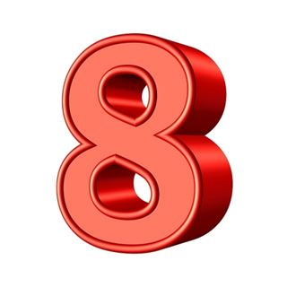_ _ _ _ _
Đáp án: eight
155. Hello. I … Mary.
A. is B. are C. am D. do
Đáp án: am
156. your friend./ say/ to/ ’Hello!’/ Let’s/
Đáp án: Let’s say ’Hello!’ to your friend.
157. Odd one out:
A. You B. I C. Hi D. She
Đáp án: Hi
158. kittens?/ What colour/ are your/
Đáp án: What colour are your kittens?
159. Thank you very _ _ _ _ for your lovely birthday gift.
Đáp án: much
160. Nghe:Nhấn giữ Ctrl và bấm chuột để nghe: Listen and tick:
A. My father is a teacher. B. My mother is a teacher C. My father is a doctor. D. My brother is a teacher.
Đáp án: My father is a doctor.
161. _ _ quiet, please.
Đáp án: Be
162. Nghe:Nhấn giữ Ctrl và bấm chuột để nghe: She’s ... a kite.
A. making B. flying C. playing D. drawing
Đáp án: flying
163. ___________ do you do after school?
A. What B. Who C. How D. How old
Đáp án: What
164. Choose the letter(s) to make a correct word: CLO__
A. SS B. SA C. SE D. EE
Đáp án: SE
165. This is a blue ... white book.
A. and B. an C. a D. am
Đáp án: and
166. It ... a green pencil.
A. am B. are C. is D. an
Đáp án: is
167. Circle the ans_ er.
Đáp án: w
168. Ảnh:Good _____!
A. afternoon B. evening C. night D. morning
Đáp án: Chọn ý: D
169. A: _ _ _ ’s it going? - B: Great. Thank you.
Đáp án: How
170. ... are you? – I’m fine, thanks.
A. Hi B. Hello C. How D. How’s
Đáp án: How
171. the/ words./ down/ Copy/
Đáp án: Copy down the words.
172. Open the b_ _ k.
Đáp án: oo
173. volleyball/ or/ basketball?/ she like/ Does/
Đáp án: Does she like volleyball or basketball?
174. That is my school gym. ___ new.
A. Its B. It's is C. It's D. Its's
Đáp án: It's
175. Nghe:Nhấn giữ Ctrl và bấm chuột để nghe: My school _ _ _ is very long.
Đáp án: bus
176. W_ _ _ _ on the board, please.
Đáp án: rite
177. Look _ _ the blackboard, please.
Đáp án: at
178. big?/ your/ Is/ new/ school
Đáp án: Is your new school big?
179. Ảnh: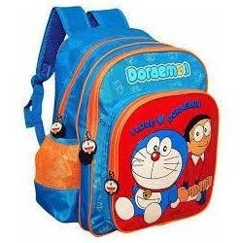_ AG
Đáp án: B
180. _ _ _ _ is the date today, Sam?
Đáp án: what
181. _ _ _ ’t play football in the classroom.
Đáp án: Don
182. name/ Her/ Lisa./ is/
Đáp án: Her name is Lisa.
183. They ____ a song in the classroom.
A. point B. read C. look D. sing
Đáp án: Chọn ý: D
184. Ảnh: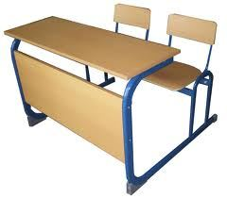This is a _ _ _ _ .
Đáp án: desk
185. Ảnh:Is that a black _ _ _ _ ?
Đáp án: ball
186. I’m fine, thanks. _ _ d you?
Đáp án: an
187. with/ play/ me./ Let’s/
Đáp án: Let’s play with me.
188. Choose the odd one out
A. dog B. cat C. friend D. chicken
Đáp án: friend
189. Stand _ _ , please.
Đáp án: up
190. Don't ma_ _ noise in class.
Đáp án: ke
191. Ảnh: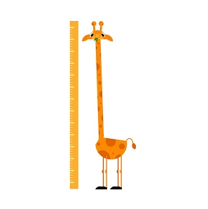A _ ONG NECK
Đáp án: L
192. Is this yo_ _ book? - Yes, it is.
Đáp án: ur
193. are/ kites/ beautiful./ These/
Đáp án: These kites are beautiful.
194. Can you he_ p me?
Đáp án: l
195. We _ _ _ pupils.
Đáp án: are
196. Ảnh: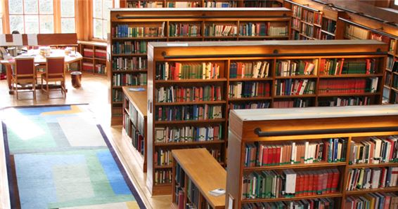My school l_ _ _ ary is big.
Đáp án: ibr
197. Open ... books, please.
A. am B. I C. you D. your
Đáp án: Chọn ý: D
198. Jane/ and Tim./ are/ These/
Đáp án: These are Jane and Tim.
199. name?/ What's/ its/
Đáp án: What's its name?
200. Can you ride a bicycle? - ... .
A. No, I can B. No, thanks C. Yes, I can D. Yes, I can’t
Đáp án: Yes, I can

KEY IOE K3 2023 - 2024 SỐ 12
1. Don't talk _ _ class!
Đáp án: in
2. The...e are four books on the table.
A. t B. w C. y D. r
Đáp án: Chọn ý: D
3. SCHOOL-B_ G
Đáp án: A
4. Nghe:Nhấn giữ Ctrl và bấm chuột để nghe: _ _ ain
Đáp án: tr
5. Keep silent = Don't ___.
A. look B. see C. talk D. go
Đáp án: talk
6. _ _ _ name is Lisa.
Đáp án: Her
7. How old ... Peter? – He’s twelve years old.
A. is B. are C. isn’t D. am
Đáp án: is
8. like/ Would/ you/ ice-cream?/ an
Đáp án: Would you like an ice-cream?
9. Can you he_ p me?
Đáp án: l
10. the books/ on the table?/ are/ What colour/
Đáp án: What colour are the books on the table?
11. _ _ _ are they? - They are our new teachers.
Đáp án: Who
12. later,/ Goodbye./ you/ Simon./ See/
Đáp án: Goodbye. See you later, Simon.
13. Nghe:Nhấn giữ Ctrl và bấm chuột để nghe: What colour is ______?
A. they B. that C. it D. these
Đáp án: it
14. Nice to _ _ _ t you, too.
Đáp án: mee
15. Ảnh:What do you do at break time? – I ... .
A. play tennis B. play football C. play chess D. swim
Đáp án: play chess
16. like/ dog./ brother/ My/ doesn’t/
Đáp án: My brother doesn’t like dog.
17. Three pen_
Đáp án: s
18. M... name is Collin.
A. o B. i C. y D. e
Đáp án: y
19. ... your school bag, Alice.
A. Point B. Stand C. Sit D. Open
Đáp án: Chọn ý: D
20. _ _ ve me the pencil, please.
Đáp án: Gi
21. I/ hungry/ now./ am/
Đáp án: I am hungry now.
22. ... this a desk? - Yes, it is.
A. Is B. Are C. Am D. What
Đáp án: Is
23. Be qu_ _ t. Listen to the teacher, please.
Đáp án: ie
24. Listen _ _ the teacher carefully.
Đáp án: to
25. this/ and colour/ picture./ draw/ Let’s/
Đáp án: Let’s draw and colour this picture.
26. name?/ What/ is/ your/
Đáp án: What is your name?
27. Nghe:Nhấn giữ Ctrl và bấm chuột để nghe: The girl is … years old.
A. 7 B. 8 C. 9 D. 10
Đáp án: 8
28. Her family n_ _ _ is Green.
Đáp án: ame
29. Is this a de_ k?
Đáp án: s
30. Peter/ food./ wants/ some/
Đáp án: Peter wants some food.
31. My father likes to _ _ _ _ _ a car.
Đáp án: drive
32. we/ go/ This is/ the way/ to school./
Đáp án: This is the way we go to school.
33. notebooks,/ your/ out/ Take/ please./
Đáp án: Take out your notebooks, please.
34. How are you?
A. I’m Philip. B. I’m fine, thanks. C. I’m seven. D. I’m a pupil.
Đáp án: I’m fine, thanks.
35. My schoolbag is n_ _ orange. It’s red.
Đáp án: ot
36. new/ books./ are my/ Yes./ They/
Đáp án: Yes. They are my new books.
37. your/ is/ school?/ primary/ Where/
Đáp án: Where is your primary school?
38. … make a mess in class.
A. Are B. Is C. Do D. Don't
Đáp án: Chọn ý: D
39. This is my fam_ _ y.
Đáp án: il
40. Choose the odd one out
A. Pencil case B. Ruler C. Rubber D. School
Đáp án: Chọn ý: D
41. _____ are my rulers.
A. This B. That C. Those D. It
Đáp án: Those
42. name/ on/ the paper./ Write/ your/
Đáp án: Write your name on the paper.
43. the bookcase./ on/ The books/ are/
Đáp án: The books are on the bookcase.
44. Ảnh:This is a ... desk.
A. pink B. yellow C. blue D. green
Đáp án: yellow
45. Tommy is happy bec_ _ se today is her birthday.
Đáp án: au
46. is/ He/ my/ father.
Đáp án: He is my father.
47. Nghe:Nhấn giữ Ctrl và bấm chuột để nghe: The school is______.
A. new B. big C. large D. old
Đáp án: Chọn ý: D
48. please./ your/ name/ Write/ here,
Đáp án: Write your name here, please.
49. Wr_ _ _ the names in the blanks.
Đáp án: ite
50. the/ sentences./ Reorder/
Đáp án: Reorder the sentences.
51. Good ev_ _ ing, Tom.
Đáp án: en
52. Copy/ down/ words./ the/
Đáp án: Copy down the words.
53. Thank you very m_ _ h.
Đáp án: uc
54. Ảnh:NEWCOM_ R
Đáp án: E
55. Hello, I’m John. ... J-O-H-N.
A. This B. That C. It D. That’s
Đáp án: Chọn ý: D
56. Who is he? - ... .
A. He’s my father B. She’s my mother C. This is my mother D. He is tall
Đáp án: He’s my father
57. I’m fine, thank ... .
A. he B. she C. it D. you
Đáp án: Chọn ý: D
58. _______ name’s Elsa.
A. I B. My C. He D. Friend
Đáp án: My
59. Who is he? - ... .
A. She is Mary B. He my friend C. She my friend D. He’s Tom
Đáp án: Chọn ý: D
60. My school is ... .
A. name B. new C. news D. names
Đáp án: new
61. Nghe:Nhấn giữ Ctrl và bấm chuột để nghe: My ... is a teacher.
A. mother B. father C. brother D. sister
Đáp án: mother
62. Wh_ t is this?
Đáp án: a
63. Ảnh: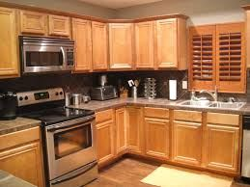Is that your …? - Yes, it is.
A. bathroom B. bedroom C. kitchen D. library
Đáp án: kitchen
64. _ _ _ do you spell your name, Sam? - It’s S-A-M.
Đáp án: How
65. is/ large./ My/ school garden/
Đáp án: My school garden is large.
66. Ảnh:That is a b_ _ _ curtain.
Đáp án: lue
67. A: How _ _ _ are you? - B: I’m eight.
Đáp án: old
68. Nghe:Nhấn giữ Ctrl và bấm chuột để nghe: What's ____ name?
A. his B. her C. your D. their
Đáp án: your
69. Let’s sing a s_ ng.
Đáp án: o
70. Nghe:Nhấn giữ Ctrl và bấm chuột để nghe: There are sweets, _ _ _ _ _ and lollipops.
Đáp án: cakes
71. Choose the incorrect word(s) in the following sentence: This is my friends Linda.
A. This B. my C. friends D. Linda
Đáp án: friends
72. I’d like _ _ apple.
Đáp án: an
73. Odd one out:
A. fish B. cat C. dog D. book
Đáp án: Chọn ý: D
74. Ảnh:FI_ _ ORANGES
Đáp án: VE
75. H_ _ name is Nam.
Đáp án: is
76. Where are ... from?
A. and B. my C. you D. she
Đáp án: you
77. It ... a ball.
A. am B. is C. are D. but
Đáp án: is
78. box?/ pencil/ your/ Is/ that/
Đáp án: Is that your pencil box?
79. Nghe:Nhấn giữ Ctrl và bấm chuột để nghe: This is your … and this is your ….
A. teddy – doll B. doll– ball C. ball – book D. teddy – book
Đáp án: doll– ball
80. Sing a s...ng.
A. o B. w C. u D. q
Đáp án: o
81. Here we _ _ _ together.
Đáp án: are
82. My school isn't new. It's _ ld.
Đáp án: o
83. What is _ _ _ name? – He is Tony.
Đáp án: his
84. Flowers in the park _ _ _ very beautiful.
Đáp án: are
85. small./ isn’t/ It’s big./ The house/
Đáp án: The house isn’t small. It’s big.
86. ... morning, Simon!
A. But B. Good C. Shut D. Hi
Đáp án: Good
87. ... this a pencil? – No, it isn’t.
A. Are B. Is C. It D. The
Đáp án: Is
88. teacher./ Mr. Loc/ is/ my/
Đáp án: Mr. Loc is my teacher.
89. These cats a_ _ black.
Đáp án: re
90. Nghe:Nhấn giữ Ctrl và bấm chuột để nghe: f_ _ e
Đáp án: in
91. My friends/ and I/ go home/ together.
Đáp án: My friends and I go home together.
92. Nghe:Nhấn giữ Ctrl và bấm chuột để nghe: _ _ , Mr. Robot.
Đáp án: hi
93. Choose the odd one out:
A. dog B. pen C. ruler D. desk
Đáp án: dog
94. Give ... that pink crayon.
A. he B. she C. me D. the
Đáp án: me
95. Choose the odd one out:
A. small B. talk C. large D. old
Đáp án: talk
96. Ảnh:NI_ E BOOKS
Đáp án: N
97. Nice _______ you.
A. meet B. meeting C. to meet D. is meet
Đáp án: to meet
98. Odd one out:
A. meet B. I C. you D. he
Đáp án: meet
99. H_ _ many cats are there? – There are 2 cats.
Đáp án: ow
100. a/ want/ carrot./ I/ big
Đáp án: I want a big carrot.
101. Ảnh:He is a newcom_ _ .
Đáp án: er
102. ... to ... you, Nam.
A. Nice - meet B. Fine - hi C. You - me D. He - she
Đáp án: Nice - meet
103. small./ is/ school/ Her/ new/
Đáp án: Her new school is small.
104. She is _ _ new friend.
Đáp án: my
105. Look,/ and repeat./ listen/
Đáp án: Look, listen and repeat.
106. like/ apple,/ please./ an/ I’d/
Đáp án: I’d like an apple, please.
107. Linda/ today./ goes/ to school/
Đáp án: Linda goes to school today.
108. Happy birthday. This robot is for you, Richard. – Thank you very m_ _ _ .
Đáp án: uch
109. L_ _ _ ! It’s our new teacher, Miss Hien.
Đáp án: ook
110. new/ That/ my/ school./ is/
Đáp án: That is my new school.
111. Ảnh:This is a mar_ _ r.
Đáp án: ke
112. H_ _ is your mother? – She’s fine.
Đáp án: ow
113. ... name is Linda.
A. You B. He C. Her D. She
Đáp án: Her
114. Which is your book? - … one.
A. The B. A C. An D. This
Đáp án: Chọn ý: D
115. large/ Is/ and new?/ your room/
Đáp án: Is your room large and new?
116. My new school is n_ _ big. It’s small.
Đáp án: ot
117. This is Tony and this is Hoa. _ _ _ _ are my friends.
Đáp án: They
118. my/ bicycle./ That/ is/
Đáp án: That is my bicycle.
119. See/ Goodbye./ you/ later.
Đáp án: Goodbye. See you later.
120. I’m fine, thank you. ... ?
A. Hi you B. How C. And you D. Bye
Đáp án: And you
121. I like to s_ _ g English song.
Đáp án: in
122. Choose the correct order.
A. L, M, N, O, P, Q B. M, L, N, O, Q, P C. N, M, L, P, Q, O D. O, L, M, N, P, Q
Đáp án: L, M, N, O, P, Q
123. My _______’s Kevin.
A. old B. name C. class D. school
Đáp án: name
124. The pictures/ on/ are/ the wall./ not/
Đáp án: The pictures are not on the wall.
125. My brother/ is/ old./ seven/ years
Đáp án: My brother is seven years old.
126. My teacher is v_ _ y beautiful.
Đáp án: er
127. Ảnh:These cats are _ _ _ _ _ .
Đáp án: black
128. shoes/ My/ are/ pink./ new/
Đáp án: My new shoes are pink.
129. Nghe:Nhấn giữ Ctrl và bấm chuột để nghe: … your books.
A. Open B. Close C. Read D. Keep
Đáp án: Open
130. Nghe:Nhấn giữ Ctrl và bấm chuột để nghe: That is a small ... .
A. board B. bus C. box D. boat
Đáp án: Chọn ý: D
131. See you tomo_ _ ow.
Đáp án: rr
132. is/ wall./ The picture/ on/ the
Đáp án: The picture is on the wall.
133. Lan?/ that/ Miss/ Is/
Đáp án: Is that Miss Lan?
134. you/ later./ Bye./ See/
Đáp án: Bye. See you later.
135. It’s an e_ _ _ _ r.
Đáp án: rase
136. Hello, _ am Peter.
Đáp án: I
137. Ảnh: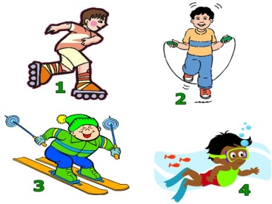Nam: Do you like swimming or skipping? - Adam: Oh, I like skipping.
A. Picture 1 B. Picture 2 C. Picture 3 D. Picture 4
Đáp án: Picture 2
138. May I go out? - Yes, ….
A. you can B. you can’t C. you aren’t D. it is
Đáp án: you can
139. the table./ on/ There/ three crayons/ are/
Đáp án: There are three crayons on the table.
140. This ... a pen.
A. is B. are C. he D. she
Đáp án: is
141. Goodbye. See you la_ _ r!
Đáp án: te
142. This _ _ Tom. He is my new friend.
Đáp án: is
143. cats/ that box?/ are there/ in/ How many/
Đáp án: How many cats are there in that box?
144. Nghe:Nhấn giữ Ctrl và bấm chuột để nghe: bad_ _ _ _ _ _
Đáp án: minton
145. kite?/ What/ colour/ that/ is/
Đáp án: What colour is that kite?
146. Peter: Lan is my friend. - John: She’s my friend, ....
A. two B. to C. too D. who
Đáp án: too
147. I can ri_ _ a bicycle.
Đáp án: de
148. May I co_ _ in?
Đáp án: me
149. I’m fine, thank you. ... ?
A. You B. And you C. Are D. Bye
Đáp án: And you
150. Can you dance, Kate? - ..., I can’t.
A. No B. Not C. Yes D. Hi
Đáp án: No
151. My/ is/ teacher/ nice.
Đáp án: My teacher is nice.
152. I’m fine, thanks. A_ _ you?
Đáp án: nd
153. What does he do ... Maths lessons?
A. from B. and C. during D. end
Đáp án: during
154. Nghe:Nhấn giữ Ctrl và bấm chuột để nghe: _ _ _ da
Đáp án: pan
155. are/ What/ they?/ colour/
Đáp án: What colour are they?
156. Is your classroom big? – No, it’s s_ _ ll.
Đáp án: ma
157. students!/ Good/ evening,/
Đáp án: Good evening, students!
158. Goodbye, Alice. – Bye. See you ... .
A. later B. later’s C. laters D. a later
Đáp án: later
159. What _ _ you do at break time?
Đáp án: do
160. I’m fine, ... you.
A. thank B. thanks C. good D. bye
Đáp án: thank
161. Ảnh:That ___ my pen.
A. is B. are C. am D. do
Đáp án: is
162. Nghe:Nhấn giữ Ctrl và bấm chuột để nghe: Choose the sentence that you hear:
A. I’m fine. B. I’m fine, thanks. C. Fine, thank you. D. I am fine, thank you.
Đáp án: Fine, thank you.
163. Ảnh: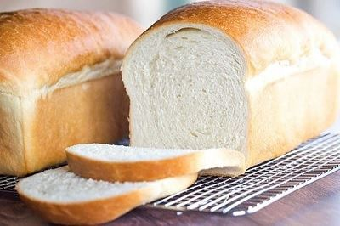I like having br_ _ _ for breakfast.
Đáp án: ead
164. What c...lour is this? - It’s blue.
A. u B. o C. e D. i
Đáp án: o
165. Ảnh:_ _ _ _ _ _
Đáp án: pencil
166. Ảnh:There are many k_ _ _ _ in the sky.
Đáp án: ites
167. the/ large?/ Is/ playground/
Đáp án: Is the playground large?
168. It is ... mine.
A. and B. not C. see D. nice
Đáp án: not
169. Ảnh:We often play chess in our c_ _ _ _ room.
Đáp án: lass
170. Odd one out:
A. stand B. sit C. come D. book
Đáp án: Chọn ý: D
171. Nghe:Nhấn giữ Ctrl và bấm chuột để nghe: Her old car is a ___ Honda.
A. red B. black C. white D. pink
Đáp án: white
172. Odd one out:
A. what B. orange C. blue D. yellow
Đáp án: what
173. Nghe:Nhấn giữ Ctrl và bấm chuột để nghe: Choose the sentence that you hear:
A. What is your name? B. What’s your name? C. What’s your school name? D. What is your school name?
Đáp án: What’s your name?
174. What colour ... this?
A. it B. is C. that D. hi
Đáp án: is
175. Let’s draw ... picture.
A. a B. an C. the D. her
Đáp án: a
176. ___ you later.
A. Meet B. See C. Know D. Saw
Đáp án: See
177. Is this an eraser? - ... .
A. Yes, it is not B. No, it isn’t C. Yes, they are D. No, it is
Đáp án: No, it isn’t
178. your/ Write/ here./ name/
Đáp án: Write your name here.
179. W_ _ te your name, please.
Đáp án: ri
180. C_ me here!
Đáp án: o
181. there?/ How/ many/ are/ cats/
Đáp án: How many cats are there?
182. Nghe:Nhấn giữ Ctrl và bấm chuột để nghe: What are they? - They’re _ _ _ _ .
Đáp án: pens
183. Nghe:Nhấn giữ Ctrl và bấm chuột để nghe: How many people are having lunch?
A. Five B. Six C. Four D. Seven
Đáp án: Six
184. Can you play chess? - No, I _______.
A. may B. can C. can’t D. don’t
Đáp án: can’t
185. Nghe:Nhấn giữ Ctrl và bấm chuột để nghe: Listen and choose.
A. Go out! B. Come in! C. Stand up! D. Sit down!
Đáp án: Chọn ý: D
186. Ảnh:Keep silen_ , please!
Đáp án: t
187. Gi_ e me the book, please.
Đáp án: v
188. - Hello, _ am Peter. - Nice to meet you, Peter.
Đáp án: I
189. is/ My/ name/ Simon.
Đáp án: My name is Simon.
190. _ i, I’m Peter.
Đáp án: H
191. in/ are/ the school garden./ They/
Đáp án: They are in the school garden.
192. I’m f_ _ e, thank you.
Đáp án: in
193. Those are f_ ve boxes.
Đáp án: i
194. What ... do you have today? – Today I have Music and Maths.
A. names B. times C. subjects D. school
Đáp án: subjects
195. I _ _ Mai.
Đáp án: am
196. There are two book... on the desk.
A. t B. s C. r D. k
Đáp án: s
197. Take ... your books, children.
A. on B. out C. for D. at
Đáp án: out
198. Happy birthday. This robot is for you, Richard. – Thank you very m_ _ _ .
Đáp án: uch
199. fishing/ go/ with him./ I/
Đáp án: I go fishing with him.
200. ... is Mary.
A. You B. He C. She D. My
Đáp án: She

KEY IOE K3 2023 - 2024 SỐ 13
1. cats/ in/ are there/ that box?/ How many/
Đáp án: How many cats are there in that box?
2. I’m fin_ , thanks.
Đáp án: e
3. a/ Can/ she/ book?/ read/
Đáp án: Can she read a book?
4. Nghe:Nhấn giữ Ctrl và bấm chuột để nghe: That is a small ... .
A. board B. bus C. box D. boat
Đáp án: Chọn ý: D
5. I’m fine, thank you. _ _ _ you?
Đáp án: And
6. come/ I/ May/ in?
Đáp án: May I come in?
7. I can ... English.
A. speaks B. speak C. to speak D. speaking
Đáp án: speak
8. What colour is this? - ... .
A. It’s big B. It’s small C. It’s blue D. It’s nice
Đáp án: It’s blue
9. May I go out? - _______
A. Yes, you can. B. No, you can. C. Thank you. D. Sorry.
Đáp án: Yes, you can.
10. Ảnh: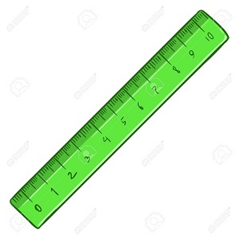That's a rul_ _ .
Đáp án: er
11. That _ _ my new book. I like it very much.
Đáp án: is
12. you?/ I’m/ fine,/ you. And/ thank/
Đáp án: I’m fine, thank you. And you?
13. Choose the odd one out:
A. classroom B. bedroom C. bathroom D. living room
Đáp án: classroom
14. ... I come in? - Yes, please.
A. My B. May C. Me D. Mai
Đáp án: May
15. Nghe:Nhấn giữ Ctrl và bấm chuột để nghe: _ _ _ _
Đáp án: this
16. My backpack ___ red and my rubber is yellow.
A. is B. am C. are D. not
Đáp án: is
17. This is _ green doll.
Đáp án: a
18. a/ This/ is/ doll.
Đáp án: This is a doll.
19. _ _ at is your name?
Đáp án: wh
20. What is her j_ _ ? – She is a teacher.
Đáp án: ob
21. Nghe:Nhấn giữ Ctrl và bấm chuột để nghe: How old are you? - I’m ________ years old.
A. 10 B. 9 C. 8 D. 7
Đáp án: 10
22. ... is that? – That’s Mary. She is my friend.
A. How B. When C. Who D. Where
Đáp án: Who
23. Choose the odd one out:
A. is B. it C. am D. are
Đáp án: it
24. W_ sh your hand, please.
Đáp án: a
25. is/ That boy/ Peter./
Đáp án: That boy is Peter.
26. _______, Nam. I’m Phong.
A. Bye B. Hello C. I D. Goodbye
Đáp án: Hello
27. Open ... book, please.
A. my B. your C. its D. is
Đáp án: your
28. Is that a pink pen? - ..., it is.
A. Yes, it is B. No, it is C. No, it isn’t D. Yes
Đáp án: Chọn ý: D
29. ... that a round box? – No, it isn’t.
A. What B. How C. Is D. Are
Đáp án: Is
30. Co_ plete the sentences.
Đáp án: m
31. Nghe:Nhấn giữ Ctrl và bấm chuột để nghe: The girl’s school has got a big _ _ _ _ _ ter room.
Đáp án: compu
32. I ... Maths and Arts on Monday.
A. play B. say C. study D. look
Đáp án: study
33. Good morning, teacher! - ... .
A. Goodbye B. See you later C. Good morning D. Fine, thanks
Đáp án: Good morning
34. Ảnh: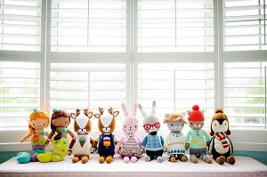NI_E DOLLS
A. D B. V C. M D. N
Đáp án: Chọn ý: D
35. shirt./ It/ a/ is/ red
Đáp án: It is a red shirt.
36. ... night, children.
A. Bye B. Hi C. Good D. Fine
Đáp án: Good
37. Ảnh:BA_ KPACK
Đáp án: C
38. Ảnh:This is my _ _ _ cil case.
Đáp án: pen
39. _______ do you spell your name?
A. How B. What C. Who D. Are
Đáp án: How
40. M_ _ I close my book? - Yes, please.
Đáp án: ay
41. Circle the an_ _ er, Sam.
Đáp án: sw
42. Close your ..., please.
A. name B. book C. ball D. took
Đáp án: book
43. … is the weather like today? – It’s sunny.
A. What B. How C. When D. Where
Đáp án: What
44. Nghe:Nhấn giữ Ctrl và bấm chuột để nghe: My school is _ _ _ _ _ .
Đáp án: small
45. Gi_ e me that yellow pen, please.
Đáp án: v
46. Choose the odd one out
A. Computer room B. Library C. Classroom D. Chair
Đáp án: Chọn ý: D
47. Ảnh: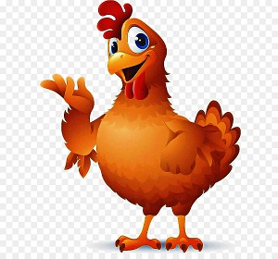That is a _____ .
A. pig B. chicken C. cat D. dog
Đáp án: chicken
48. Where is Simon f_ _ m? – He’s from England.
Đáp án: ro
49. that/ bag?/ your/ Is/
Đáp án: Is that your bag?
50. She is _ _ new friend.
Đáp án: my
51. What does he do during ... lessons? - He learns about numbers.
A. Maths B. English C. Arts D. Music
Đáp án: Maths
52. A: Do you like skating or skipping? - B: …
A. Yes, I do. B. No, I don’t. C. I like skipping. D. I skip at break time.
Đáp án: I like skipping.
53. Listen _ _ the teacher, please.
Đáp án: to
54. How many pens _ _ you have?
Đáp án: do
55. These are three pencil box_ _ .
Đáp án: es
56. ... fine, thank you
A. Hi B. I C. I’m D. Am
Đáp án: I’m
57. Nghe:Nhấn giữ Ctrl và bấm chuột để nghe: Which toy is orange?
A. The ball. B. The doll. C. The car. D. The teddy.
Đáp án: Chọn ý: D
58. Anne is f_ _ r years old.
Đáp án: ou
59. _ _ _ _ your grandpa like fishing?
Đáp án: Does
60. ..., students. See you tomorrow.
A. Good morning B. Good night C. Goodbye D. Nice to meet you
Đáp án: Goodbye
61. Ảnh:What is that? - It’s a ….
A. chair B. desk C. door D. television
Đáp án: desk
62. A: What colour is the dress? - B: ....
A. It’s too long. B. It’s very cheap. C. It’s bright yellow. D. It’s very nice.
Đáp án: It’s bright yellow.
63. _ _ n't be late!
Đáp án: do
64. How are ..., Tom? – Fine, thanks. And you?
A. you B. you’re C. your D. yous
Đáp án: you
65. these?/ are/ What/
Đáp án: What are these?
66. Ảnh: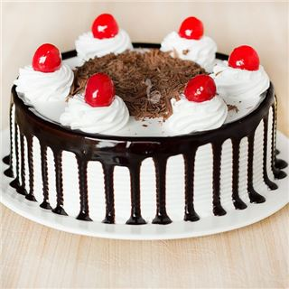It’s a _ _ _ _ .
Đáp án: cake
67. your/ sister?/ How/ old/ is/
Đáp án: How old is your sister?
68. Ảnh:A: Are those bookcases? - B: ....
A. Yes, they are. B. No, they aren’t. C. Yes, it is. D. No, it isn’t.
Đáp án: No, they aren’t.
69. and/ Sit down/ please!/ open/ your book,
Đáp án: Sit down and open your book, please!
70. Ảnh:It's my school ____ room.
A. music B. art C. lunch D. computer
Đáp án: lunch
71. your/ big?/ Is/ school/
Đáp án: Is your school big?
72. ... are you? – I’m fine, thanks.
A. When B. How C. What D. Who
Đáp án: How
73. Nghe:Nhấn giữ Ctrl và bấm chuột để nghe: … your books.
A. Open B. Close C. Read D. Keep
Đáp án: Open
74. is a/ This/ red apple./
Đáp án: This is a red apple.
75. That is her n_ w school.
Đáp án: e
76. Op_ _ your books, children.
Đáp án: en
77. Her eyes/ aren't/ brown. They/ are/ blue./
Đáp án: Her eyes aren't brown. They are blue.
78. Nghe:Nhấn giữ Ctrl và bấm chuột để nghe: That is my _ _ _ _ _ _ _ .
Đáp án: teacher
79. Clo_ _ your pencil boxes, children.
Đáp án: se
80. Ảnh:It’s _ _ _ ny today.
Đáp án: rai
81. Nghe:Nhấn giữ Ctrl và bấm chuột để nghe: _ _ _
Đáp án: pen
82. Ảnh: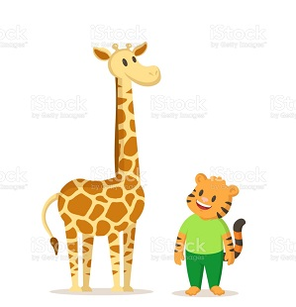SHOR_
Đáp án: T
83. Nghe:Nhấn giữ Ctrl và bấm chuột để nghe: _ ake
Đáp án: c
84. Choose the odd one out
A. Jack B. Lisa C. Linda D. Mary
Đáp án: Jack
85. swim./ can/ dance/ I can’t/ but I/
Đáp án: I can’t dance but I can swim.
86. Ảnh:Peter’s pencil is … and Mary’s is ….
A. long – short B. short – long C. big – small D. small – big
Đáp án: short – long
87. They’re on the left and we’re on the _ _ _ _ _ .
Đáp án: right
88. M_ THER
Đáp án: O
89. My classma_ _ s are in the music room.
Đáp án: te
90. colour/ it?/ What/ is/
Đáp án: What colour is it?
91. What colour is this? - ... .
A. It blue B. It’s blue C. Is blue D. It is a blue
Đáp án: It’s blue
92. to buy/ I want/ a blue scarf/ for me./ my mother/
Đáp án: I want my mother to buy a blue scarf for me.
93. Nghe:Nhấn giữ Ctrl và bấm chuột để nghe: Listen and tick:
A. This is my school bag. B. This is my school bus. C. This is my school car. D. This is my school book.
Đáp án: This is my school bag.
94. Nghe:Nhấn giữ Ctrl và bấm chuột để nghe: The boy’s favourite colour is ….
A. green B. pink C. red D. blue
Đáp án: red
95. Do you like to _ _ ng an English song?
Đáp án: si
96. When is your birthday? - ….
A. It’s on September B. It’s in October C. It’s second of June D. It’s in third of June
Đáp án: It’s in October
97. I like to s_ ng.
Đáp án: i
98. This is my pe_ _ _ l. It’s short.
Đáp án: nci
99. She/ is/ my teacher./
Đáp án: She is my teacher.
100. like/ you/ ice-cream?/ an/ Would/
Đáp án: Would you like an ice-cream?
101. David/ school/ now./ is/ at/
Đáp án: David is at school now.
102. How _ _ _ you?
Đáp án: are
103. his/ large?/ Is/ classroom/
Đáp án: Is his classroom large?
104. How are you? - I’m _ _ _ _ , thank you.
Đáp án: fine
105. What _______ these?
A. is B. are C. ant D. aunt
Đáp án: are
106. Don’t s_ _ on that chair.
Đáp án: it
107. meet/ pleased/ to/ you./ I’m/
Đáp án: I’m pleased to meet you.
108. Bye. S_ _ you later.
Đáp án: ee
109. When the teacher wants my class not to talk, she says: ’’…’’
A. Be quiet! B. Come here! C. Sit down! D. Stand up!
Đáp án: Be quiet!
110. Nghe:Nhấn giữ Ctrl và bấm chuột để nghe: DO_ N
Đáp án: W
111. My new classroom is very _ _ _ tty.
Đáp án: pre
112. school/ big./ is/ My/
Đáp án: My school is big.
113. Ảnh:This is my fa_ _ _ y.
Đáp án: mil
114. My cats/ yellow./ are/
Đáp án: My cats are yellow.
115. Which is NOT outdoor activity for kids?
A. Playing soccer B. Doing yoga C. Fishing D. Climbing mountains
Đáp án: Doing yoga
116. Nghe:Nhấn giữ Ctrl và bấm chuột để nghe: shar_ _ _ _ _
Đáp án: pener
117. A: Is that your classmate? - B: ...
A. Yes, he isn't. B. No, she isn’t. C. Yes, it is. D. No, I’m not.
Đáp án: Yes, it is.
118. Let’s ma_ e a circle.
Đáp án: k
119. Nghe:Nhấn giữ Ctrl và bấm chuột để nghe: Who’s that?
A. Mary B. Jane C. Linda D. Ellie
Đáp án: Linda
120. Nice to m_ _ _ you, too.
Đáp án: eet
121. This is a b_ cycle.
Đáp án: i
122. is/ friend/ my/ , Peter./ This/
Đáp án: This is my friend , Peter.
123. birthday?/ your/ is/ When/
Đáp án: When is your birthday?
124. are/ skirts?/ your/ What colour/
Đáp án: What colour are your skirts?
125. Ảnh:I like having br_ _ _ for breakfast.
Đáp án: ead
126. isn't big/ My room/ new./ but it's/
Đáp án: My room isn't big but it's new.
127. ... is that kite? - It’s green.
A. How many B. How C. What D. What colour
Đáp án: Chọn ý: D
128. grandmother./ That/ my/ is/
Đáp án: That is my grandmother.
129. the schoolyard./ in/ are/ Linh and Nhi/
Đáp án: Linh and Nhi are in the schoolyard.
130. Listen/ teacher carefully./ the/ to/
Đáp án: Listen to the teacher carefully.
131. _ _ _ _ _ birthday to you, Alice.
Đáp án: happy
132. It’s _ _ ice cream.
Đáp án: an
133. am/ I/ Hello,/ Andy.
Đáp án: Hello, I am Andy.
134. Nghe:Nhấn giữ Ctrl và bấm chuột để nghe: This is the _ _ _ _ _ _ _ _ room.
Đáp án: computer
135. father./ is/ my/ That/
Đáp án: That is my father.
136. Odd one out:
A. stand B. sit C. come D. book
Đáp án: Chọn ý: D
137. Tram is my fr_ _ nd.
Đáp án: ie
138. What’s her name ? – ....
A. I’m fine, thanks B. Her name is Daisy C. See you later D. My name is Daisy
Đáp án: Her name is Daisy
139. I have t_ o cats.
Đáp án: w
140. I’m ... , thank you. And you?
A. nice B. bye C. fine D. hi
Đáp án: fine
141. Peter can speak Vietname_ _ .
Đáp án: se
142. Ảnh:COL_ _ R
Đáp án: ou
143. Nghe:Nhấn giữ Ctrl và bấm chuột để nghe: The boy likes ….
A. badminton B. tennis C. baseball D. table tennis
Đáp án: tennis
144. Nghe:Nhấn giữ Ctrl và bấm chuột để nghe: SCHOOL BA_ S
Đáp án: G
145. What's/ name?/ his/
Đáp án: What's his name?
146. The living room ______ big _____ old.
A. and – and B. but – but C. and - are D. is - but
Đáp án: Chọn ý: D
147. The w_ _ ther is really cold.
Đáp án: ea
148. Let’s/ room./ go to/ computer/ the/
Đáp án: Let’s go to the computer room.
149. children./ your/ Close/ books,/
Đáp án: Close your books, children.
150. Is this a bag? - ...
A. Yes, it is B. Yes, isn’t C. No, it is D. Nice to meet you
Đáp án: Yes, it is
151. Sing wit_ me.
Đáp án: h
152. Ảnh:What colour is your pencil? - It’s ye_ _ _ _ .
Đáp án: llow
153. Ảnh:My book i_ green.
Đáp án: s
154. Choose the odd one out:
A. white B. new C. yellow D. green
Đáp án: new
155. here./ name/ Write/ your/
Đáp án: Write your name here.
156. Whose rulers _ _ _ these? – They’re mine.
Đáp án: are
157. The girl/ years/ three/ is/ old./
Đáp án: The girl is three years old.
158. Nghe:Nhấn giữ Ctrl và bấm chuột để nghe: Listen and tick:
A. This is my pencil. B. This is my pen case. C. This is my pen. D. This is my ball.
Đáp án: This is my pen.
159. Ảnh:THA_ _ YOU
Đáp án: NK
160. There are/ two pens/ my/ in/ school bag./
Đáp án: There are two pens in my school bag.
161. ____ those your parents? - Yes, _______
A. Is - he is B. Is - she is C. Are - they are D. Are - they aren't
Đáp án: Are - they are
162. I … a blue pencil and a white ruler.
A. has B. have C. don’t have D. doesn’t have
Đáp án: have
163. Please/ come/ Mr Smith./ in,/
Đáp án: Please come in, Mr Smith.
164. Choose the odd one out
A. Father B. Ten C. Teacher D. Friend
Đáp án: Ten
165. There are ten books _ _ my bag.
Đáp án: in
166. Your ... Peter.
A. name B. names C. name is D. is name
Đáp án: name is
167. Hi, _ y name is Alan.
Đáp án: m
168. Wh_ t’s your name?
Đáp án: a
169. Please, s_ _ _ l your name again.
Đáp án: pel
170. Your classr_ _ _ is big.
Đáp án: oom
171. years/ old./ ten/ is/ She/
Đáp án: She is ten years old.
172. Let’s s_ y ’’Hello’’ to Tom.
Đáp án: a
173. Look … your book, please.
A. of B. in C. on D. at
Đáp án: Chọn ý: D
174. These are ....
A. cat B. cats C. cat’s D. a cat
Đáp án: cats
175. case is/ is old./ This pencil/ new. That/ pencil case
Đáp án: This pencil case is new. That pencil case is old.
176. name/ Write/ here./ your/
Đáp án: Write your name here.
177. Lis_ _ _ to the teacher, please.
Đáp án: ten
178. This ... a blue pencil.
A. are B. is C. am D. the
Đáp án: is
179. drives/ car/ his/ My father/ to work./
Đáp án: My father drives his car to work.
180. I’m ... , thank you. And you?
A. nice B. bye C. fine D. hi
Đáp án: fine
181. is/ What/ your primary school?/ of/ the name/
Đáp án: What is the name of your primary school?
182. These/ and rulers./ aren't/ her rubbers/
Đáp án: These aren't her rubbers and rulers.
183. Choose the odd one out
A. Pencils B. Pencil sharpeners C. Classroom D. Rulers
Đáp án: Classroom
184. Please ______ the window.
A. opening B. open C. to open D. opens
Đáp án: open
185. Nghe:Nhấn giữ Ctrl và bấm chuột để nghe: Listen and tick:
A. Both Mary and Tom love cats very much. B. Both Mary and Tom love cars very much. C. Both Mary and Tom love buses very much. D. Both Mary and Tom love pets very much.
Đáp án: Chọn ý: D
186. _ _ that a ruler? - No, it isn’t.
Đáp án: Is
187. Is this a bag? - … .
A. Yes B. Yes, it is C. No, it is D. Nice to meet you.
Đáp án: Yes, it is
188. you./ to/ meet/ Nice/
Đáp án: Nice to meet you.
189. Be qu_ _ t, please.
Đáp án: ie
190. Ảnh:The elephant is b_ _ .
Đáp án: ig
191. How do you ... your name? - It’s J-O-H-N.
A. spend B. spell C. send D. she
Đáp án: spell
192. H_ s name is Tom.
Đáp án: i
193. ______ are they? - They are black.
A. What B. What's colour C. How colour D. What colour
Đáp án: Chọn ý: D
194. some/ has/ chalks./ He/
Đáp án: He has some chalks.
195. P_ _ your books down, please.
Đáp án: ut
196. pencil./ a/ That/ is/ green
Đáp án: That is a green pencil.
197. Draw _ mouse in your notebook.
Đáp án: a
198. Are/ those/ your/ friends?
Đáp án: Are those your friends?
199. Is your classroom big? – No, it’s s_ _ ll.
Đáp án: ma
200. What colour ... this?
A. it B. is C. that D. hi
Đáp án: is

KEY IOE K3 2023 - 2024 SỐ 14
1. Let’s cou_ _ the boys.
Đáp án: nt
2. Nghe:Nhấn giữ Ctrl và bấm chuột để nghe: Listen and tick
A. How are you? B. What are they? C. How old are you? D. Who are you?
Đáp án: How old are you?
3. My _ _ _ e is John.
Đáp án: nam
4. Have a n_ _ _ day!
Đáp án: ice
5. Unscramble this word: ’’RYRALIB’’ -> ’’_ _ BRARY’’.
Đáp án: LI
6. Let’s ... a song.
A. look B. open C. sing D. sit
Đáp án: sing
7. She is/ classroom/ the/ now./ in/
Đáp án: She is in the classroom now.
8. I’m fine. How ab_ _ t you?
Đáp án: ou
9. This is a ca...ot.
A. rt B. rs C. rr D. rq
Đáp án: rr
10. Ảnh: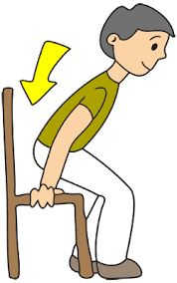Choose the best answer:
A. Come in B. Go out C. Sit down D. Stand up
Đáp án: Sit down
11. _ _ _ you OK, John?
Đáp án: Are
12. Those/ my/ pencils./ aren't/
Đáp án: Those aren't my pencils.
13. Good mo_ _ ing, children!
Đáp án: rn
14. May/ open/ the book,/ I/ Miss Brown?/
Đáp án: May I open the book, Miss Brown?
15. Hello. What is ____ name?
A. your B. you C. me D. him
Đáp án: your
16. It is so mu_ _ fun.
Đáp án: ch
17. my/ are/ Tony and Peter/ best friends.
Đáp án: Tony and Peter are my best friends.
18. Nice _ _ meet you!
Đáp án: to
19. school/ Is your/ bag/ brown/ or black?/
Đáp án: Is your school bag brown or black?
20. How are you?
A. I’m Philip. B. I’m fine, thanks. C. I’m seven. D. I’m a pupil.
Đáp án: I’m fine, thanks.
21. Where _ _ _ you from? - I’m from England.
Đáp án: are
22. has/ dolls./ two/ Mary/
Đáp án: Mary has two dolls.
23. Cl_ _ e your books, please.
Đáp án: os
24. What are those? – ... .
A. They’re blue pen B. They’re blue pens C. It’s blue pens D. It is a blue pen
Đáp án: They’re blue pens
25. _ _ _ old are you? - I’m eleven years old.
Đáp án: How
26. Nghe:Nhấn giữ Ctrl và bấm chuột để nghe: Listen and tick:
A. Nice to know you, Li Li. B. Nice to meet you, Li Li. C. Nice to see you, Li Li. D. Nice to have you, Li Li.
Đáp án: Nice to meet you, Li Li.
27. Nghe:Nhấn giữ Ctrl và bấm chuột để nghe: LI_ _ _ _ _
Đáp án: brary
28. Nghe:Nhấn giữ Ctrl và bấm chuột để nghe: He’s _ _ _ _ _ years old.
Đáp án: eight
29. your/ and open/ Stand up/ now/ books, please./
Đáp án: Stand up now and open your books, please.
30. Is it _ ruler? – No, it isn’t.
Đáp án: a
31. ...at colour is this? – It’s blue.
A. Wt B. Ho C. Wh D. We
Đáp án: Wh
32. your/ is/ name?/ mother's/ What/
Đáp án: What is your mother's name?
33. Ảnh: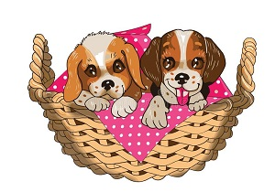T_ O PUPPIES
Đáp án: W
34. My/ backpack/ black and/ is/ white./
Đáp án: My backpack is black and white.
35. Count the ... in the class, please.
A. she B. boys C. girl D. he
Đáp án: boys
36. fishing/ Let's/ this/ go/ afternoon./
Đáp án: Let's go fishing this afternoon.
37. ______ old are you?
A. How B. What C. Which D. When
Đáp án: How
38. Nghe:Nhấn giữ Ctrl và bấm chuột để nghe: _ _
Đáp án: is
39. It is my chai...
A. t B. w C. r D. s
Đáp án: r
40. Nghe:Nhấn giữ Ctrl và bấm chuột để nghe: Listen and tick:
A. What’s that? -That’s my pet. B. What’s that? -That’s my desk. C. What’s that? - That’s my bag. D. What’s that? - That’s my bus.
Đáp án: What’s that? -That’s my desk.
41. Nghe:Nhấn giữ Ctrl và bấm chuột để nghe: F_VE
A. I B. O C. E D. A
Đáp án: I
42. Ảnh:There is a vase of flowers on the t_ _ _ _ .
Đáp án: able
43. Have ... nice day!
A. a B. an C. the D. this
Đáp án: a
44. What colour is this ruler? - It is ... .
A. big B. small C. green D. short
Đáp án: green
45. Nghe:Nhấn giữ Ctrl và bấm chuột để nghe: Listen and tick:
A. My brother is very tall. B. My father is very tall. C. My brother isn’t very tall. D. My mother is very tall.
Đáp án: My brother is very tall.
46. My sister likes to go sw_ _ _ _ ng in summer.
Đáp án: immi
47. Let’s make a li_ e.
Đáp án: n
48. Bru_ h your teeth, Tom.
Đáp án: s
49. I/ Rosie./ Hi./ am/
Đáp án: Hi. I am Rosie.
50. This _ _ my new school.
Đáp án: is
51. very/ well,/ you./ thank/ I am/
Đáp án: I am very well, thank you.
52. W_ o is she? – She’s my teacher.
Đáp án: h
53. Is/ a desk?/ this/
Đáp án: Is this a desk?
54. Ảnh: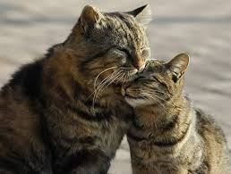These are t_ _ cats.
Đáp án: wo
55. I have _ _ apple.
Đáp án: an
56. Nice to m__t you.
A. ee B. ii C. oo D. aa
Đáp án: ee
57. can/ I can’t/ swim./ but I/ dance/
Đáp án: I can’t dance but I can swim.
58. There are ten books _ _ my bag.
Đáp án: in
59. to/ meet/ Sam./ Nice/ you today,
Đáp án: Nice to meet you today, Sam.
60. I go to school with my _ riends.
Đáp án: f
61. Nghe:Nhấn giữ Ctrl và bấm chuột để nghe: Choose the correct response.
A. I’m fine, thank you. B. Goodbye, Sally. C. I don’t know you. D. Hi, Sally. Nice to meet you.
Đáp án: Chọn ý: D
62. My classmates like to _ _ ay hide-and-seek.
Đáp án: pl
63. What are _ _ _ se? – These are pink dolls.
Đáp án: the
64. Nghe:Nhấn giữ Ctrl và bấm chuột để nghe: The _ _ _ room is over there.
Đáp án: art
65. These/ pencils/ are/ short.
Đáp án: These pencils are short.
66. Ảnh:SILE_ T
Đáp án: N
67. Odd one out:
A. Daisy B. Michael C. Jenny D. Mary
Đáp án: Michael
68. I'm in ___ 3C.
A. grade B. class C. classroom D. school
Đáp án: class
69. for you,/ John./ pink pen/ This/ is/
Đáp án: This pink pen is for you, John.
70. It’s _ _ ice cream.
Đáp án: an
71. I ... Andy.
A. are B. am C. is D. you
Đáp án: am
72. Ảnh:A: Who’s Tracy? - B: The girl is in the yellow shirt.
A. 1 B. 2 C. 3 D. 4
Đáp án: Chọn ý: D
73. What is your name? - ... .
A. Her name is Mary B. His name is Peter C. My name is Harry D. Your name is Simon
Đáp án: My name is Harry
74. _______ quiet, please.
A. Be B. Don’t C. No D. Do
Đáp án: Be
75. brown. They/ are/ blue./ aren't/ Her eyes/
Đáp án: Her eyes aren't brown. They are blue.
76. Ảnh:Her _ _ _ _ _ _ _ _ is small.
Đáp án: bathroom
77. new friends./ They/ are/ my/
Đáp án: They are my new friends.
78. is/ apple./ a/ red/ That/
Đáp án: That is a red apple.
79. Ảnh:Those notebooks are Sarah’s.
A. Picture 1 B. Picture 2 C. Picture 3 D. Picture 4
Đáp án: Picture 2
80. ... to ... you, Simon. How are you?
A. Nice – meet B. Fine – hi C. You – me D. He – She
Đáp án: Nice – meet
81. Do you have toys? – Yes, I h_ _ _ a doll.
Đáp án: ave
82. That is a cha...r.
A. e B. a C. i D. u
Đáp án: i
83. This isn’t ... bag.
A. her B. he C. she D. this
Đáp án: her
84. And/ fine,/ thank you./ you?/ I’m/
Đáp án: I’m fine, thank you. And you?
85. Ảnh:Molly’s favourite sport is bask_ _ _ _ _ _ .
Đáp án: etball
86. ... is his name? – His name is John.
A. Where B. What C. When D. Who
Đáp án: What
87. Nghe:Nhấn giữ Ctrl và bấm chuột để nghe: H_ LLO
Đáp án: e
88. , Peter./ your/ Open/ schoolbag/
Đáp án: Open your schoolbag , Peter.
89. Nghe:Nhấn giữ Ctrl và bấm chuột để nghe: _ _ _ gry
Đáp án: hun
90. A: Who’s in the _ _ _ puter room? - B: My teacher, Mr. Tuan.
Đáp án: com
91. How _______ Hai?
A. am B. is C. are D. and
Đáp án: is
92. It ... a ball.
A. are B. an C. be D. is
Đáp án: Chọn ý: D
93. It is _ _ ice cream.
Đáp án: an
94. Ảnh:SC_ OOL
Đáp án: H
95. This is m_ cat.
Đáp án: y
96. Be qu_ _ t, please.
Đáp án: ie
97. These are three pencil box_ _ .
Đáp án: es
98. See you tomo_ _ ow.
Đáp án: rr
99. are/ those?/ Who/
Đáp án: Who are those?
100. Let’s look ... read.
A. and B. end C. an D. hello
Đáp án: and
101. so/ My/ big./ is/ classroom/
Đáp án: My classroom is so big.
102. is/ old./ three/ The girl/ years
Đáp án: The girl is three years old.
103. A: Who’s that _ _ _ _ ? - B: She’s Linda.
Đáp án: girl
104. are/ in/ My/ notebooks/ my school bag./
Đáp án: My notebooks are in my school bag.
105. and I/ are/ in the playground./ My friends/
Đáp án: My friends and I are in the playground.
106. Nghe:Nhấn giữ Ctrl và bấm chuột để nghe: policema_
Đáp án: n
107. ... morning, Adam!
A. Hello B. Hi C. Good D. You
Đáp án: Good
108. These shoes are yours, not _ _ _ _ .
Đáp án: mine
109. Sit down/ your book,/ open/ and/ please!/
Đáp án: Sit down and open your book, please!
110. ... your name?
A. Who B. How C. What’s D. Why
Đáp án: What’s
111. ... are you? – I’m fine, thanks.
A. Who B. What C. How D. When
Đáp án: How
112. His/ Peter./ is/ name/
Đáp án: His name is Peter.
113. my/ pens./ are/ These/
Đáp án: These are my pens.
114. I’m fine, ... you. And you?
A. thanks B. thank C. thank you D. thanks you
Đáp án: thank
115. brown./ is/ bookcase/ The/
Đáp án: The bookcase is brown.
116. ... is her name? – Her name is Joane.
A. How B. What C. When D. Who
Đáp án: What
117. Is this a notebook? – No, ... .
A. it isn’t B. it is C. it does D. it doesn’t
Đáp án: it isn’t
118. How m...ny pets do you have? – I have one cat.
A. u B. i C. a D. e
Đáp án: a
119. Is this a bag? - ... .
A. Yes, it is B. Yes, isn’t C. No, it is D. Nice to meet you.
Đáp án: Yes, it is
120. Nghe:Nhấn giữ Ctrl và bấm chuột để nghe: Who’s that?
A. Mary B. Jane C. Linda D. Ellie
Đáp án: Linda
121. Come ..., please.
A. out B. in C. to D. under
Đáp án: in
122. Jenny is a … at London Primary School.
A. boy B. toy C. student D. she
Đáp án: student
123. Ảnh:TWO B_ LLS
Đáp án: A
124. ... many pens are there in your school bag? – There are 3 pens.
A. How B. What C. Who D. When
Đáp án: How
125. What/ is/ doing?/ he/
Đáp án: What is he doing?
126. _ ice to meet you.
Đáp án: n
127. Minh has a blue shirt, a red shirt and a black shirt. He has ____ shirts.
A. three B. four C. five D. six
Đáp án: three
128. What school is _ _ ?
Đáp án: it
129. Make two …, please.
A. bye B. lines C. fine D. five
Đáp án: lines
130. There/ my family./ four people/ in/ are/
Đáp án: There are four people in my family.
131. Look ... the board, please.
A. on B. in C. at D. to
Đáp án: at
132. your rulers/ and/ they/ your book?/ Are/
Đáp án: Are they your rulers and your book?
133. His na_ _ is Peter.
Đáp án: me
134. house/ is/ big./ not/ Her/
Đáp án: Her house is not big.
135. Ảnh:I have a bl_ _ ball.
Đáp án: ue
136. I _ _ Simon. I am in class 3A.
Đáp án: am
137. How many notebooks are there? - ... .
A. Three bags B. Three books C. Three notebooks D. Three pens
Đáp án: Three notebooks
138. Stand _ _ , please.
Đáp án: up
139. What colour is your teddy bear?
A. It brown. B. It is brown. C. Its brown. D. Is brown.
Đáp án: It is brown.
140. your/ book./ new/ is/ Here/
Đáp án: Here is your new book.
141. your/ hands,/ Wash/ Tom.
Đáp án: Wash your hands, Tom.
142. What c_ _ _ ur is this? – It is pink.
Đáp án: olo
143. How are you? - ... .
A. I’m Binh B. She’s my sister C. I’m fine, thank you D. Goodbye
Đáp án: I’m fine, thank you
144. W_ _ _ are these? – These are pencil cases.
Đáp án: hat
145. Nghe:Nhấn giữ Ctrl và bấm chuột để nghe: It’s a _ _ _ blue green ball.
Đáp án: big
146. How are ... ?
A. he B. Lan C. you D. bye
Đáp án: you
147. Ảnh: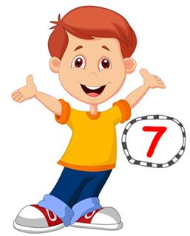He’s se_ _ _ years old.
Đáp án: ven
148. That is a big tr...e.
A. a B. u C. e D. i
Đáp án: e
149. My n_ me is Hieu.
Đáp án: a
150. sing/ English songs./ likes to/ dance and/ Mary/
Đáp án: Mary likes to dance and sing English songs.
151. Ảnh:CA_
Đáp án: T
152. Please ______ the window.
A. opening B. open C. to open D. opens
Đáp án: open
153. years/ seven/ is/ old./ Peter/
Đáp án: Peter is seven years old.
154. _ _ _ , he is.
Đáp án: Yes
155. in the room?/ Is/ Tony/
Đáp án: Is Tony in the room?
156. mum/ My/ cook./ can/
Đáp án: My mum can cook.
157. Ảnh: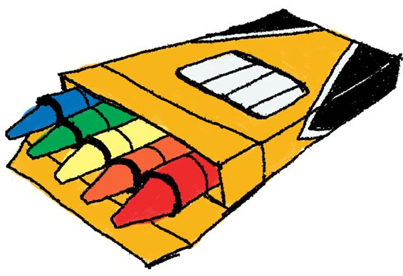You use cr_ _ _ _ s to colour the pictures.
Đáp án: ayon
158. go/ May/ out?/ I/
Đáp án: May I go out?
159. Peter is ___ the classroom.
A. in B. for C. on D. at
Đáp án: in
160. Ảnh:Keep silen_ , please!
Đáp án: t
161. Ảnh: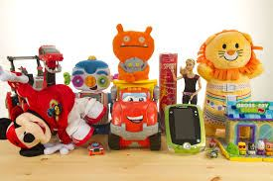I have many t_ _ s.
Đáp án: oy
162. Stand ____!
A. down B. up C. on D. in
Đáp án: up
163. Ảnh:It's the _ rt room.
Đáp án: a
164. you hear/ words/ , please./ the/ Check/
Đáp án: Check the words you hear , please.
165. A: What colour are those T-shirts? - B: ... are brown.
A. Those B. These C. We D. They
Đáp án: Chọn ý: D
166. OR_ NGE
Đáp án: A
167. Go to t_ e door, please.
Đáp án: h
168. B_ OK
Đáp án: O
169. My/ doctor./ a/ father/ is/
Đáp án: My father is a doctor.
170. W_ _ is that? – That’s Jenny. She is my friend.
Đáp án: ho
171. Nghe:Nhấn giữ Ctrl và bấm chuột để nghe: Let’s go to _ _ _ _ _ _ together.
Đáp án: school
172. I ... Monday and Wednesday because I have Maths lessons then.
A. fun B. bye C. like D. buy
Đáp án: like
173. Nghe:Nhấn giữ Ctrl và bấm chuột để nghe: Listen and tick:
A. The ball is green. B. The doll is green. C. The boy is brown. D. The ball is brown.
Đáp án: The ball is green.
174. Open ... book, please.
A. your B. I C. you D. your’s
Đáp án: your
175. My father likes to _ _ _ _ _ a car.
Đáp án: drive
176. Is your school new? - No. It's _____.
A. new B. old C. not D. is
Đáp án: old
177. Jane is not ... name.
A. he B. her C. I D. you
Đáp án: her
178. Ảnh: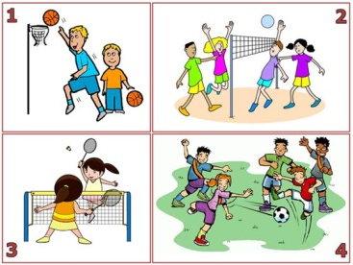They like playing volleyball.
A. Picture 1 B. Picture 2 C. Picture 3 D. Picture 4
Đáp án: Picture 2
179. is/ What/ your/ name?/ friend’s
Đáp án: What is your friend’s name?
180. My/ new and big./ school/ is/
Đáp án: My school is new and big.
181. _ i, I’m Peter.
Đáp án: H
182. Ảnh:This is my book_ _ _ _ .
Đáp án: case
183. ... is a bird.
A. You B. He C. It D. She
Đáp án: It
184. Wash/ your/ hands,/ Tom.
Đáp án: Wash your hands, Tom.
185. Nghe:Nhấn giữ Ctrl và bấm chuột để nghe: _ _ _ _
Đáp án: your
186. What is this? – It is … ice cream.
A. a B. an C. these D. that
Đáp án: an
187. Ảnh:My brother likes to play _ _ _ _ _ .
Đáp án: robot
188. Write ... the teacher says.
A. what’s B. you C. where’s D. what
Đáp án: Chọn ý: D
189. What's your name? - My _____ Hoa.
A. name B. name's C. name're D. name are
Đáp án: name's
190. Nghe:Nhấn giữ Ctrl và bấm chuột để nghe: Listen and tick:
A. Both Mary and Tom love cats very much. B. Both Mary and Tom love cars very much. C. Both Mary and Tom love buses very much. D. Both Mary and Tom love pets very much.
Đáp án: Chọn ý: D
191. Nghe:Nhấn giữ Ctrl và bấm chuột để nghe: ... your books, please.
A. Open B. Close C. Listen D. Go
Đáp án: Open
192. please./ I’d/ like/ apple,/ an/
Đáp án: I’d like an apple, please.
193. Who’s that? That’s ... .
A. my’s teacher B. me’s teacher C. my teacher D. me teacher
Đáp án: my teacher
194. H_ _ many students in your class?
Đáp án: ow
195. song./ sing/ English/ an/ Let’s/
Đáp án: Let’s sing an English song.
196. She is _ student.
Đáp án: a
197. Ảnh: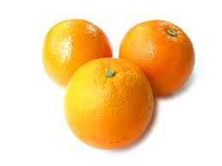There are _ _ _ _ _ oranges on the table.
Đáp án: three
198. his/ old shoes./ are/ They/
Đáp án: They are his old shoes.
199. Be qu_ _ t. Listen to the teacher, please.
Đáp án: ie
200. Cl_ _ n your teeth, please.
Đáp án: ea

KEY IOE K3 2023 - 2024 SỐ 15
1. This is my brother and this is … bike.
A. her B. his C. their D. its
Đáp án: his
2. This _ _ my new school.
Đáp án: is
3. Circle the an_ _ er.
Đáp án: sw
4. is/ eraser./ That/ an/
Đáp án: That is an eraser.
5. Ảnh:That's my computer _ oom.
Đáp án: r
6. Let’s/ learn/ English./
Đáp án: Let’s learn English.
7. What does he do ... Maths lessons?
A. from B. and C. during D. end
Đáp án: during
8. Do you like cakes? – Yes, I ... .
A. am B. is C. are D. do
Đáp án: Chọn ý: D
9. This is _ _ apple.
Đáp án: an
10. Let’s dr_ _ a picture.
Đáp án: aw
11. Hi, Alice. I _ _ Tommy.
Đáp án: am
12. I go … school in the morning.
A. in B. at C. on D. to
Đáp án: Chọn ý: D
13. ___ is his name?
A. What B. Where C. How D. Why
Đáp án: What
14. do/ you/ What/ subjects/ like?/
Đáp án: What subjects do you like?
15. the/ is/ table./ The computer/ on/
Đáp án: The computer is on the table.
16. at/ Look/ teacher./ the/
Đáp án: Look at the teacher.
17. Nghe:Nhấn giữ Ctrl và bấm chuột để nghe: These are my ____.
A. rubbers B. rulers C. pens D. pencils
Đáp án: rulers
18. St_ _ d up, please.
Đáp án: an
19. to play/ I/ like/ volleyball/ in the evening./
Đáp án: I like to play volleyball in the evening.
20. Nghe:Nhấn giữ Ctrl và bấm chuột để nghe: May I s_ t down?
Đáp án: i
21. you./ thank/ am/ I/ fine,/
Đáp án: I am fine, thank you.
22. Thomas plays hide-and-_ _ _ _ with his friends at weekend.
Đáp án: seek
23. am/ I/ Mary./ Hello./
Đáp án: Hello. I am Mary.
24. from/ friend/ My new/ France./ is/
Đáp án: My new friend is from France.
25. Those are f_ ve boxes.
Đáp án: i
26. G_ _ dbye.
Đáp án: oo
27. So_ _ y. I am late.
Đáp án: rr
28. _ _ _ t is your name?
Đáp án: Wha
29. ... morning, Simon!
A. But B. Good C. Shut D. Hi
Đáp án: Good
30. Give/ your/ me/ notebooks.
Đáp án: Give me your notebooks.
31. Stand _ _ , please!
Đáp án: up
32. Nghe:Nhấn giữ Ctrl và bấm chuột để nghe: This _ _ _ is pink and yellow.
Đáp án: one
33. Is your school big? - _ _ _ , it is.
Đáp án: yes
34. Nghe:Nhấn giữ Ctrl và bấm chuột để nghe: _ _ _ are you?
Đáp án: How
35. Bella'_ in her bedroom.
Đáp án: s
36. She is _ _ new friend.
Đáp án: my
37. Nghe:Nhấn giữ Ctrl và bấm chuột để nghe: Peter likes _ _ _ _ _ _ _ _ but Lulu doesn’t.
Đáp án: football
38. G_ _ _ bye, see you later.
Đáp án: ood
39. Nghe:Nhấn giữ Ctrl và bấm chuột để nghe: _ at
Đáp án: c
40. morning,/ Hien./ Miss/ Good/
Đáp án: Good morning, Miss Hien.
41. This/ is a/ book./ green/
Đáp án: This is a green book.
42. What do you play ... break time?
A. on B. at C. in D. by
Đáp án: at
43. on/ the paper./ your name/ Write/
Đáp án: Write your name on the paper.
44. Ảnh:She is my new tea_ _ er.
Đáp án: ch
45. My n_ me is Lan.
Đáp án: a
46. Is your school ...? - No, it is small.
A. big B. this C. bye D. these
Đáp án: big
47. some/ He/ chalks./ has/
Đáp án: He has some chalks.
48. A: Is that your classmate? - B: ...
A. Yes, he isn't. B. No, she isn’t. C. Yes, it is. D. No, I’m not.
Đáp án: Yes, it is.
49. Nghe:Nhấn giữ Ctrl và bấm chuột để nghe: How old are you? - I’m ________ years old.
A. 4 B. 5 C. 6 D. 7
Đáp án: Chọn ý: D
50. is/ my/ Mr. Loc/ teacher.
Đáp án: Mr. Loc is my teacher.
51. Do you like milk? – No, I ... .
A. do B. does C. doesn’t D. don’t
Đáp án: Chọn ý: D
52. How … people are there in your family?
A. much B. are C. many D. old
Đáp án: many
53. my school bag./ There are/ in/ ten/ pencils/
Đáp án: There are ten pencils in my school bag.
54. Take/ notebooks,/ out/ please./ your/
Đáp án: Take out your notebooks, please.
55. the/ on/ is/ The picture/ wall./
Đáp án: The picture is on the wall.
56. Choose the correct sentence
A. They are two pens. B. They are two pen. C. It is two pen. D. It is two pens.
Đáp án: They are two pens.
57. _ _ _ _ your grandpa like fishing?
Đáp án: Does
58. How old is your sister? - … is fifteen years old.
A. He B. She C. They D. It
Đáp án: She
59. Ảnh: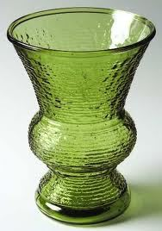That is a green flower v_ _ _ .
Đáp án: ase
60. How are you? - ... .
A. I’m Binh B. She’s my sister C. I’m fine, thank you D. Goodbye
Đáp án: I’m fine, thank you
61. We learn about _ _ _ _ _ _ _ in Maths.
Đáp án: numbers
62. Is this a book? – Yes, … .
A. I am B. it is C. is it D. it isn’t
Đáp án: it is
63. aren't/ Those/ pencils./ my/
Đáp án: Those aren't my pencils.
64. Bye, Tommy. - Bye. ... you later.
A. See’s B. Sees C. See D. To see
Đáp án: See
65. the blue/ book,/ me/ please./ Give/
Đáp án: Give me the blue book, please.
66. What/ is/ name?/ your/
Đáp án: What is your name?
67. Nghe:Nhấn giữ Ctrl và bấm chuột để nghe: My school _ _ _ is very long.
Đáp án: bus
68. Ảnh:The rainbow has many colo_ _ s.
Đáp án: ur
69. How ol_ are you?
Đáp án: d
70. Nice to meet you _ _ o.
Đáp án: to
71. Put your book a_ _ y please.
Đáp án: wa
72. She is tw_ years old.
Đáp án: o
73. Co_ plete the sentences.
Đáp án: m
74. Ảnh: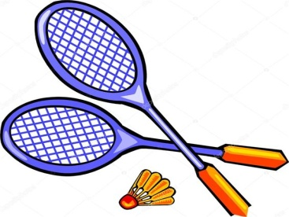A: Does Peter like badm_ _ _ _ _ ? - B: Yes, he does.
Đáp án: inton
75. I like/ my friends./ to go/ with/ to school/
Đáp án: I like to go to school with my friends.
76. Who is he? - ... .
A. She is Mary B. He my friend C. She my friend D. He’s Tom
Đáp án: Chọn ý: D
77. Don’t/ a/ make/ mess.
Đáp án: Don’t make a mess.
78. That’s Miss White. She is my _ ew teacher.
Đáp án: n
79. The doctor _ _ nice.
Đáp án: is
80. Nghe:Nhấn giữ Ctrl và bấm chuột để nghe: _ _ _ _ _
Đáp án: close
81. My school _ _ new.
Đáp án: is
82. _ _ _ you OK, Henry?
Đáp án: Are
83. You are wel_ _ me.
Đáp án: co
84. are/ my school bag./ notebooks/ in/ My/
Đáp án: My notebooks are in my school bag.
85. Have ... nice day!
A. a B. an C. the D. this
Đáp án: a
86. that/ girl?/ is/ Who/
Đáp án: Who is that girl?
87. Ảnh:’’Open your book, please.’’
A. Picture 1 B. Picture 2 C. Picture 3 D. Picture 4
Đáp án: Picture 3
88. Odd one out:
A. fish B. cat C. dog D. book
Đáp án: Chọn ý: D
89. Nghe:Nhấn giữ Ctrl và bấm chuột để nghe: shar_ _ _ _ _
Đáp án: pener
90. Is that a pink pen? - ..., it is.
A. Yes, it is B. No, it is C. No, it isn’t D. Yes
Đáp án: Chọn ý: D
91. Is this a bag? - … .
A. Yes B. Yes, it is C. No, it is D. Nice to meet you.
Đáp án: Yes, it is
92. isn’t/ ten. He’s/ My/ nine./ brother/
Đáp án: My brother isn’t ten. He’s nine.
93. What colour ... this? - It’s yellow.
A. it B. is C. that D. hi
Đáp án: is
94. His n_ _ e is Tommy.
Đáp án: am
95. Good m_ _ ning, everyone.
Đáp án: or
96. Nghe:Nhấn giữ Ctrl và bấm chuột để nghe: The _ _ _ room is over there.
Đáp án: art
97. Ảnh:_ _ _ _ _
Đáp án: eight
98. Ảnh:You use cr_ _ _ _ s to colour the pictures.
Đáp án: ayon
99. Nghe:Nhấn giữ Ctrl và bấm chuột để nghe: policema_
Đáp án: n
100. Nghe:Nhấn giữ Ctrl và bấm chuột để nghe: My ... is a teacher.
A. mother B. brother C. father D. sister
Đáp án: mother
101. How m...ny pets do you have? – I have one cat.
A. u B. i C. a D. e
Đáp án: a
102. Peter: Lan is my friend. John: She’s my friend, ... .
A. too B. to C. two D. who
Đáp án: too
103. Look at t_ e blue kite.
Đáp án: h
104. It’s ... ruler.
A. are B. a C. an D. is
Đáp án: a
105. My _ ame is Tony.
Đáp án: n
106. Nghe:Nhấn giữ Ctrl và bấm chuột để nghe: _ _ _ _ _
Đáp án: brown
107. Choose the odd one out
A. school B. teacher C. student D. bedroom
Đáp án: Chọn ý: D
108. I go to school library to ... books.
A. read’s B. reads C. read D. read to
Đáp án: read
109. T_ _ e out your notebooks, children.
Đáp án: ak
110. this?/ colour/ is/ What/
Đáp án: What colour is this?
111. spell/ his name?/ How/ do you/
Đáp án: How do you spell his name?
112. Hello, my name _ _ Tom.
Đáp án: is
113. W_ AT
Đáp án: H
114. _ _ _ is Tim happy today? - Because today is his birthday.
Đáp án: Why
115. I’m fine, ... you.
A. thanks B. thank C. thank you D. thanks you
Đáp án: thank
116. My ... is Jean.
A. name’s B. names C. name D. namese
Đáp án: name
117. I like to s_ _ g English song.
Đáp án: in
118. Let’s sing with ... .
A. he B. I C. me D. she
Đáp án: me
119. It’s/ to/ you./ see/ nice/
Đáp án: It’s nice to see you.
120. T_ ank you very much.
Đáp án: h
121. Give/ me/ chalks,/ please./ some/
Đáp án: Give me some chalks, please.
122. Ảnh:
W_ _ t is this? – This is a red marker.Đáp án: ha
123. That woman _ _ my teacher, Alice.
Đáp án: is
124. P_ _ your books down, please.
Đáp án: ut
125. Good_ ye. See you tomorrow.
Đáp án: b
126. his/ is/ robot./ This/
Đáp án: This is his robot.
127. Kevin and Mark ___________ my friends.
A. am B. is C. are D. it
Đáp án: are
128. Ms. Hoa?/ come in,/ May I/
Đáp án: May I come in, Ms. Hoa?
129. teacher/ She/ is/ my/ , too./
Đáp án: She is my teacher , too.
130. Her family n_ _ _ is Green.
Đáp án: ame
131. It’s nice to s_ _ you.
Đáp án: ee
132. Put your pencils a_ ay, please.
Đáp án: w
133. _ _ n't be late!
Đáp án: do
134. _ _ o is that? – That’s Mary.
Đáp án: Wh
135. I ... Mai.
A. am B. am’s C. are D. is
Đáp án: am
136. hungry/ am/ very/ now./ I/
Đáp án: I am very hungry now.
137. Nghe:Nhấn giữ Ctrl và bấm chuột để nghe: Choose the sentence that you hear:
A. I’m fine. B. I’m fine, thanks. C. Fine, thank you. D. I am fine, thank you.
Đáp án: Fine, thank you.
138. What is this? - ... .
A. My name is Andy B. It is a doll C. It’s an doll D. This is Mary
Đáp án: It is a doll
139. Ảnh:I have got a skipping r_ _ e.
Đáp án: op
140. you./ to/ Nice/ meet/
Đáp án: Nice to meet you.
141. Please dr_ _ a picture, children.
Đáp án: aw
142. What’s the ... with Carol? – She is sick.
A. matters B. matter C. a matter D. matter’s
Đáp án: matter
143. Look _ _ my house.
Đáp án: at
144. three/ books/ table./ There are/ on the
Đáp án: There are three books on the table.
145. Nghe:Nhấn giữ Ctrl và bấm chuột để nghe: I’ve got two ... .
A. hats B. apples C. oranges D. balls
Đáp án: apples
146. our/ is/ teacher./ new/ Mrs. Samantha/
Đáp án: Mrs. Samantha is our new teacher.
147. How are ...? - Fine, thanks.
A. you B. you’s C. your D. you’re
Đáp án: you
148. are/ the table./ on/ The school things/
Đáp án: The school things are on the table.
149. Give ... a pen.
A. he B. me C. she D. they
Đáp án: me
150. Choose the odd one out
A. Pencil case B. Ruler C. Rubber D. School
Đáp án: Chọn ý: D
151. ... is that? – It is a bird.
A. When B. Who C. How D. What
Đáp án: Chọn ý: D
152. N...ce to meet you!
A. u B. w C. e D. i
Đáp án: Chọn ý: D
153. Those/ aren't/ my/ rulers.
Đáp án: Those aren't my rulers.
154. He ...Tom. He’s my new friend.
A. is B. are C. be D. am
Đáp án: is
155. How _ _ you spell your name?
Đáp án: do
156. Choose the odd one out:
A. are B. am C. is D. I
Đáp án: Chọn ý: D
157. SO_ G
Đáp án: N
158. Let's/ English/ songs./ sing/ some/
Đáp án: Let's sing some English songs.
159. Odd one out:
A. what B. orange C. blue D. yellow
Đáp án: what
160. ..., I’m Tom.
A. Hi B. Goodbye C. See you D. Bye
Đáp án: Hi
161. Is this a bag? - ...
A. Yes, it is B. Yes, isn’t C. No, it is D. Nice to meet you
Đáp án: Yes, it is
162. school playground/ your/ large?/ Is/
Đáp án: Is your school playground large?
163. Her school is not big. It’s ... .
A. a small B. small C. is small D. it’s small
Đáp án: small
164. Who __ that?
A. are B. is C. do D. doing
Đáp án: is
165. like/ noodles?/ Do/ you/ eating
Đáp án: Do you like eating noodles?
166. new/ friend./ She/ is/ my/
Đáp án: She is my new friend.
167. _ _ ce to meet you, Lan Anh.
Đáp án: Ni
168. Ảnh: They are in th_ classroom.
Đáp án: e
169. pencil./ a/ That/ is/ green
Đáp án: That is a green pencil.
170. Nice/ to/ Tommy./ you,/ meet/
Đáp án: Nice to meet you, Tommy.
171. Eleven, thirteen, ..., seventeen, nineteenThe missing number is:
A. 10 B. 11 C. 14 D. 15
Đáp án: Chọn ý: D
172. Choose the odd one out:
A. classroom B. bedroom C. bathroom D. living room
Đáp án: classroom
173. These/ are/ my blue/ pencil/ cases./
Đáp án: These are my blue pencil cases.
174. This … a cassette.
A. are B. is C. am D. an
Đáp án: is
175. What ... is this? – It’s blue.
A. colour B. colours C. colour’s D. coulor
Đáp án: colour
176. Three pen_
Đáp án: s
177. Nghe:Nhấn giữ Ctrl và bấm chuột để nghe: Look at the ….
A. classroom B. bathroom C. bedroom D. music room
Đáp án: classroom
178. _______. See you again.
A. Good morning B. Good afternoon C. Good evening D. Goodbye
Đáp án: Chọn ý: D
179. Nghe:Nhấn giữ Ctrl và bấm chuột để nghe: Listen and tick:
A. We’re a happy family. B. We’re a happy class. C. We’re a happy school. D. We’re happy friends.
Đáp án: We’re a happy family.
180. TEACH_ R
Đáp án: E
181. Choose the odd one out:
A. cake B. pizza C. cheese D. bottle
Đáp án: Chọn ý: D
182. Ảnh:Be q_ iet , boys!
Đáp án: u
183. but/ house is/ small/ nice./ My/
Đáp án: My house is small but nice.
184. What is ... name? – My name is Simon.
A. I B. he C. my D. your
Đáp án: Chọn ý: D
185. May I go ______?
A. out B. in C. off D. on
Đáp án: out
186. Ảnh:What are these? - They are ….
A. erasers B. pens C. rulers D. pencils
Đáp án: rulers
187. Ảnh:N_ _ EBOOK
Đáp án: OT
188. Nghe:Nhấn giữ Ctrl và bấm chuột để nghe: H_ LLO
Đáp án: E
189. SCHOOL-B_ G
Đáp án: A
190. How are you? - ...
A. Five, thanks B. Fine, thanks you C. Five, thanks you D. Fine, thanks.
Đáp án: Chọn ý: D
191. need/ I/ sharpener./ pencil/ a new/
Đáp án: I need a new pencil sharpener.
192. My sister … go to the zoo at the weekend.
A. don’t B. doesn’t C. aren’t D. isn’t
Đáp án: doesn’t
193. We play football in the play_ _ _ _ _ _ after school.
Đáp án: ground
194. please!/ Say/ something,/
Đáp án: Say something, please!
195. Nghe:Nhấn giữ Ctrl và bấm chuột để nghe: Hello, Mr Ro_ _ _ .
Đáp án: bot
196. H_ _ name is Tom.
Đáp án: is
197. ... are you from, Nichols? – I’m from Australia.
A. When B. Who C. Where D. How
Đáp án: Where
198. Ảnh:B_ ACK
Đáp án: L
199. Choose the odd one out
A. Ruler B. Pen C. Book D. Library
Đáp án: Chọn ý: D
200. sharpener/ pink./ is/ The pencil/
Đáp án: The pencil sharpener is pink.

KEY IOE K3 2023 - 2024 SỐ 16
1. Ảnh:FI_ _ ORANGES
Đáp án: VE
2. cats and dogs?/ her/ Are/ those/
Đáp án: Are those her cats and dogs?
3. red and white/ is/ ruler./ This/ a/
Đáp án: This is a red and white ruler.
4. Nice … meet you, Susan.
A. too B. to C. two D. toe
Đáp án: to
5. It’s _ _ ice cream.
Đáp án: an
6. These are my dol_ _ .
Đáp án: ls
7. Choose the letter(s) to make a correct word: RU__ER
A. PP B. BB C. LL D. MM
Đáp án: BB
8. out,/ Sir?/ I/ May/ go/
Đáp án: May I go out, Sir?
9. Let’s … to music, Harry.
A. come B. listen C. write D. go
Đáp án: listen
10. Ảnh: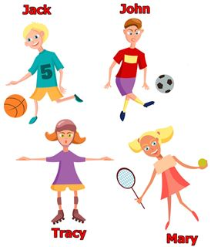Look at the picture and choose the FALSE sentence.
A. Jack likes baseball. B. John likes football. C. Tracy likes skating. D. Mary likes tennis.
Đáp án: Jack likes baseball.
11. your/ name./ down/ write/ Please,/
Đáp án: Please, write down your name.
12. I ... watching television.
A. is B. are C. am D. aren’t
Đáp án: am
13. Nghe:Nhấn giữ Ctrl và bấm chuột để nghe: She is in _ _ _ music room.
Đáp án: the
14. Good ev_ _ ing, Tom.
Đáp án: en
15. _________ my cats.
A. That is B. This are C. They are D. Those is
Đáp án: They are
16. fish/ in/ The/ is/ the bottle./
Đáp án: The fish is in the bottle.
17. Ảnh: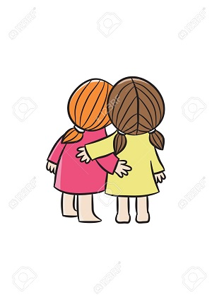FRI_ ND
Đáp án: E
18. Choose the odd one out:
A. frog B. desk C. tiger D. lion
Đáp án: desk
19. Mary/ the school/ is/ at/ gate./
Đáp án: Mary is at the school gate.
20. I _ _ _ _ breakfast with my sister.
Đáp án: have
21. This _ _ my new school.
Đáp án: is
22. TH_T
A. I B. A C. E D. O
Đáp án: A
23. your classroom?/ students/ How many/ in/ are there/
Đáp án: How many students are there in your classroom?
24. Mary is at sch_ _ l.
Đáp án: oo
25. Can you sing English songs, Jane? – Yes, I ....
A. can’t B. can’s C. can D. cans
Đáp án: can
26. Goodbye, _ _ _ you later.
Đáp án: see
27. A: What _ _ _ our is your pen? - B: It’s brown.
Đáp án: col
28. Nghe:Nhấn giữ Ctrl và bấm chuột để nghe: _ _ LER
Đáp án: RU
29. Bob: What is this? - Peter: ...
A. His name is Hien. B. It is a ruler. C. It’s an ruler. D. It is my friend.
Đáp án: It is a ruler.
30. Is this a bag? - ... .
A. Yes, it is B. Yes, isn’t C. No, it is D. See you later
Đáp án: Yes, it is
31. My name _ s Adam.
Đáp án: i
32. Nghe:Nhấn giữ Ctrl và bấm chuột để nghe: Where is Amy now?
A. In her room. B. In the yard. C. Under a tree. D. In the garden.
Đáp án: Chọn ý: D
33. Goodbye. See you tomo_ _ ow.
Đáp án: rr
34. Ảnh:What do you do at break time? – I ... .
A. play tennis B. play football C. play chess D. swim
Đáp án: play chess
35. Ảnh:NEWCOM_ R
Đáp án: E
36. Nghe:Nhấn giữ Ctrl và bấm chuột để nghe: They are in the _ _ _ _ _ _ .
Đáp án: garden
37. _ pen your books, please.
Đáp án: O
38. How/ there?/ books/ are/ many/
Đáp án: How many books are there?
39. Ảnh:Is that a blue pencil case? - ______
A. Yes, its is. B. Yes, it's is. C. Yes, it is D. Yes, it isn't
Đáp án: Yes, it is
40. This is ... red apple.
A. are B. a C. am D. an
Đáp án: a
41. old/ your/ is/ How/ baby sister?/
Đáp án: How old is your baby sister?
42. How are you? - ... .
A. My name is Mary B. She’s my friend C. I’m fine, thank you D. Bye. See you later
Đáp án: I’m fine, thank you
43. after/ me./ Please/ repeat/
Đáp án: Please repeat after me.
44. Good ni_ _ _ , children.
Đáp án: ght
45. Hello. My name’s Tommy. - ...
A. See you later. B. Good night. C. Hi. I am Peter. D. Goodbye.
Đáp án: Hi. I am Peter.
46. Nghe:Nhấn giữ Ctrl và bấm chuột để nghe: The _ _ _ _ _ _ _ _ are in the classroom.
Đáp án: children
47. See/ Goodbye./ you/ later.
Đáp án: Goodbye. See you later.
48. Ảnh: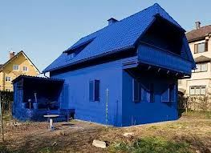My house is _ _ _ _ .
Đáp án: blue
49. L_ ok at the board.
Đáp án: o
50. Bye. ___ you soon.
A. See B. Get C. Meet D. Have
Đáp án: See
51. W_ sh your hand, please.
Đáp án: a
52. your/ a/ mum/ nurse?/ Is/
Đáp án: Is your mum a nurse?
53. Today's children, _______'s future.
A. today B. tomorrow C. yesterday D. next day
Đáp án: tomorrow
54. Please/ come/ in,/ Mr Smith.
Đáp án: Please come in, Mr Smith.
55. Ảnh:They are in the pl_ _ ground .
Đáp án: ay
56. Nguyen Du Primary School./ I am/ at/ a/ student/
Đáp án: I am a student at Nguyen Du Primary School.
57. How are ...? - Fine, thanks.
A. you B. you’s C. your D. you’re
Đáp án: you
58. Ảnh:That is a green _ _ _ .
Đáp án: car
59. Would/ like/ ice-cream?/ you/ an
Đáp án: Would you like an ice-cream?
60. The computer room is small ____ new.
A. and B. with C. but D. in
Đáp án: but
61. television./ is/ She/ watching/
Đáp án: She is watching television.
62. How are ..., Tom? – I’m fine, thank you.
A. he B. she C. you D. his
Đáp án: you
63. Nice to meet you. - Nice to meet you, _ _ _ .
Đáp án: too
64. Nghe:Nhấn giữ Ctrl và bấm chuột để nghe: She’s ... a kite.
A. making B. flying C. playing D. drawing
Đáp án: flying
65. Nghe:Nhấn giữ Ctrl và bấm chuột để nghe: My pencil is _ _ _ _ _ .
Đáp án: short
66. A: Goodbye! - B: _________
A. Fine, thanks. B. See you later. C. Good morning! D. Thank you!
Đáp án: See you later.
67. up/ and come/ here./ Stand/
Đáp án: Stand up and come here.
68. This is ______ apple and that is ______ orange.
A. a – a B. a – an C. an – an D. an - Ø
Đáp án: an – an
69. from/ are/ They/ America.
Đáp án: They are from America.
70. a red/ That/ pencil./ is/
Đáp án: That is a red pencil.
71. Nam is/ years old,/ ten/ too.
Đáp án: Nam is ten years old, too.
72. Lan and Hoa skip at br_ _ _ time.
Đáp án: eak
73. _ _ _ Mai and Hoa your friend?
Đáp án: Are
74. Jenny is my friend. _ _ _ is from Hanoi.
Đáp án: she
75. Are they your new _______?
A. friends B. teacher C. pen D. listen
Đáp án: friends
76. Ảnh:Who is she? – She is Lan. She is my t_ _ _ _ _ _ .
Đáp án: eacher
77. This is a b...y.
A. u B. o C. i D. e
Đáp án: o
78. They are Jane ... Lily.
A. are B. is C. and D. bye
Đáp án: and
79. This is my sc_ _ _ l.
Đáp án: hoo
80. Nghe:Nhấn giữ Ctrl và bấm chuột để nghe: Let’s go to the school _ _ _ _ _ _ _ .
Đáp án: library
81. is/ This/ my/ best friend.
Đáp án: This is my best friend.
82. pen./ that/ Look at/ green/
Đáp án: Look at that green pen.
83. Nghe:Nhấn giữ Ctrl và bấm chuột để nghe: Choose the sentence that you hear:
A. This is Peter. And that’s Tony. B. That’s Peter. And that’s Tony. C. That’s Peter. And that’s Mary. D. That’s Tony. And that’s Mary.
Đáp án: That’s Peter. And that’s Tony.
84. My/ school/ new and big./ is/
Đáp án: My school is new and big.
85. Is that a pen? - ..., it isn’t.
A. Yes B. Yes, it is C. Not D. No
Đáp án: Chọn ý: D
86. We go to school to ... .
A. stay B. study C. sit D. go
Đáp án: study
87. Is this a pen? – No, ... isn’t.
A. this B. it’s C. its D. it
Đáp án: Chọn ý: D
88. Ảnh:There are f_ _ _ coloured pencils in the pencil case.
Đáp án: our
89. Nice to _______ you.
A. mit B. meat C. meet D. miit
Đáp án: meet
90. Goodbye. See you tomo_ _ ow.
Đáp án: rr
91. H_ , I’m Simon. Nice to meet you.
Đáp án: i
92. Ảnh:It's the _ rt room.
Đáp án: a
93. is/ new/ gym/ large./ The/
Đáp án: The new gym is large.
94. That hat is pi_ k.
Đáp án: n
95. How do you ... your name? - It’s J-O-H-N.
A. spend B. spell C. send D. she
Đáp án: spell
96. goes/ Sue/ at/ to school/ 7 o'clock./
Đáp án: Sue goes to school at 7 o'clock.
97. Look _ _ the picture, please.
Đáp án: at
98. a yo-yo./ play/ can/ He/ with
Đáp án: He can play with a yo-yo.
99. Is that your friend? - _ _ _ , he is.
Đáp án: Yes
100. Hi,/ you?/ How/ Mary./ are
Đáp án: Hi, Mary. How are you?
101. Nghe:Nhấn giữ Ctrl và bấm chuột để nghe: Her old car is a ___ Honda.
A. red B. black C. white D. pink
Đáp án: white
102. What is your name? - ... .
A. Her name is Mary B. His name is Peter C. My name is Harry D. Your name is Simon
Đáp án: My name is Harry
103. This is a ca...ot.
A. rt B. rs C. rr D. rq
Đáp án: rr
104. Is/ your new/ friend?/ that/
Đáp án: Is that your new friend?
105. How old is Minh? - He’s _______.
A. tent B. for C. four D. too
Đáp án: four
106. These are my new ...: Adam, Alex and Anna.
A. friends B. friends’s C. friend D. friend’s
Đáp án: friends
107. L_ _ k at the blackboard and read after me.
Đáp án: oo
108. Nghe:Nhấn giữ Ctrl và bấm chuột để nghe: Listen and choose the school thing which is NOT in the recording.
A. rubber B. ruler C. pencil D. crayon
Đáp án: Chọn ý: D
109. Nghe:Nhấn giữ Ctrl và bấm chuột để nghe: Listen and tick:
A. What are these? -They are my pencils B. What are these? - They are my pens. C. What are these? - They are my bags. D. What are these? - They are my balls.
Đáp án: What are these? -They are my pencils
110. Listen _ _ _ repeat.
Đáp án: and
111. Nghe:Nhấn giữ Ctrl và bấm chuột để nghe: _ octor
Đáp án: d
112. Open your book, … .
A. for B. please C. no D. how
Đáp án: please
113. Ha_ _ y birthday to you, Peter.
Đáp án: pp
114. Hello, my name _ _ Tom.
Đáp án: is
115. How are ... ? - I’m fine, thanks.
A. he B. Lan C. you D. bye
Đáp án: you
116. … father can’t fly.
A. He B. Hi C. You D. My
Đáp án: Chọn ý: D
117. A: Is your school big? - B: _ _ _ , it is.
Đáp án: Yes
118. I ha_ _ an apple.
Đáp án: ve
119. ball./ is/ a blue/ It/
Đáp án: It is a blue ball.
120. Nghe:Nhấn giữ Ctrl và bấm chuột để nghe: How do you ... your name?
A. spend B. ten C. spell D. tell
Đáp án: spell
121. Choose the odd one out:
A. orange juice B. apple C. water D. milk
Đáp án: apple
122. _ _ w do you spell your name?
Đáp án: ho
123. Would you like some m_ _ k? – Yes, please.
Đáp án: il
124. Let’s mak_ a line.
Đáp án: e
125. Nghe:Nhấn giữ Ctrl và bấm chuột để nghe: Let’s go to _ _ _ _ _ _ together.
Đáp án: school
126. The flower vase is ... the table.
A. at B. for C. on D. to
Đáp án: on
127. She is ... the classroom now.
A. in B. on C. for D. to
Đáp án: in
128. Stand up/ your/ and open/ now/ books, please./
Đáp án: Stand up now and open your books, please.
129. Ảnh:CLA_ _ ROOM
Đáp án: SS
130. That is ... orange pencil sharpener.
A. a B. an C. the D. no article
Đáp án: an
131. It ... a ball.
A. are B. an C. be D. is
Đáp án: Chọn ý: D
132. _ _ _ those our new comic books?
Đáp án: Are
133. Ảnh: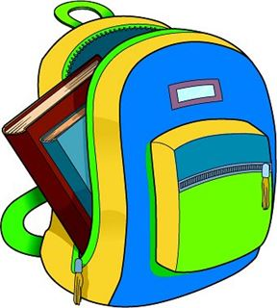There are _ _ _ books in my packback.
Đáp án: two
134. house/ not/ big./ Her/ is/
Đáp án: Her house is not big.
135. Keep silent = Don't ___.
A. look B. see C. talk D. go
Đáp án: talk
136. He is n_ _ Linda’s friend.
Đáp án: ot
137. Nice to m_ _ t you, too.
Đáp án: ee
138. Hello! ... Nga. Nice to meet you.
A. He’s B. She’s C. It’s D. I’m
Đáp án: Chọn ý: D
139. She ... Mary.
A. am B. is C. are D. he
Đáp án: is
140. Po_ _ t to the teacher.
Đáp án: in
141. How _ _ ny books are there? – There are 2 books.
Đáp án: ma
142. Nghe:Nhấn giữ Ctrl và bấm chuột để nghe: My ... likes playing game.
A. sister B. brother C. mother D. father
Đáp án: brother
143. room./ computer/ is/ my brother's/ This/
Đáp án: This is my brother's computer room.
144. your/ is/ name?/ What/ friend’s
Đáp án: What is your friend’s name?
145. A: Is the library new? - B: No, it isn’t. It’s ....
A. big B. small C. large D. old
Đáp án: Chọn ý: D
146. doll./ a/ This/ is/
Đáp án: This is a doll.
147. again./ you/ Sandy./ Goodbye/ See/
Đáp án: Goodbye Sandy. See you again.
148. Ảnh: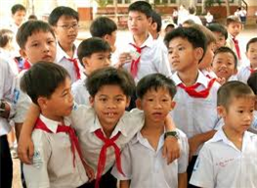Who are they? – They are….
A. boys B. men C. girls D. boy
Đáp án: boys
149. Loo_ at the dog.
Đáp án: k
150. What’s _ _ _ _ name? - My name is Peter.
Đáp án: your
151. is/ cat./ a/ That/ black
Đáp án: That is a black cat.
152. Choose the odd one out:
A. ruler B. rubber C. tennis D. notebook
Đáp án: tennis
153. Write ... the teacher says.
A. what’s B. you C. where’s D. what
Đáp án: Chọn ý: D
154. Do you like ______ a bike?
A. ride B. rideing C. riding D. ridding
Đáp án: riding
155. art room./ draws pictures/ in the/ He/
Đáp án: He draws pictures in the art room.
156. Those/ red./ balloons/ are/
Đáp án: Those balloons are red.
157. Nghe:Nhấn giữ Ctrl và bấm chuột để nghe: Nice to _ _ _ _ you.
Đáp án: meet
158. Peter’s./ are/ Those/ orange/ notebooks/
Đáp án: Those orange notebooks are Peter’s.
159. How many kit_ _ are there in the sky?
Đáp án: es
160. is/ This/ my/ bedroom.
Đáp án: This is my bedroom.
161. pencils./ Those/ my/ aren't/
Đáp án: Those aren't my pencils.
162. Nghe:Nhấn giữ Ctrl và bấm chuột để nghe: _ _ _ _
Đáp án: ball
163. Fine, t_ _ _ _ s.
Đáp án: hank
164. I’m fine, thanks. How a_ _ _ t you?
Đáp án: bou
165. Ảnh: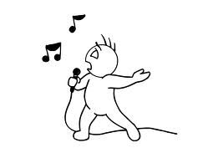Come here and _ _ _ _ a song now.
Đáp án: sing
166. Which word has the underlined part pronounced like the letter ‘o’ in ’’clock’’?
A. open B. one C. go D. boys
Đáp án: Chọn ý: D
167. That is a white _ _ d pink pen.
Đáp án: an
168. on/ the board./ Write/ name/ your/
Đáp án: Write your name on the board.
169. _ _ that your new friend? - No, he isn’t.
Đáp án: Is
170. He_ _ o, my name’s Richard. - Nice to meet you.
Đáp án: ll
171. Wh_ t’s your name?
Đáp án: a
172. Ảnh:My teacher goes to work by _ _ _ _ _ .
Đáp án: train
173. The pen/ table./ is/ on the/
Đáp án: The pen is on the table.
174. H_ _ _ _ ! I’m David.
Đáp án: ello
175. Good mo_ _ ing, children!
Đáp án: rn
176. is/ Their/ school/ a little/ small./
Đáp án: Their school is a little small.
177. down/ , please./ Sit/
Đáp án: Sit down , please.
178. in the classroom/ Is she/ at break time?/
Đáp án: Is she in the classroom at break time?
179. What is this? - ... .
A. His name is Hien B. It is a ruler C. It’s an ruler D. This is Mai
Đáp án: It is a ruler
180. Nghe:Nhấn giữ Ctrl và bấm chuột để nghe: Nam's pencils are_____ .
A. black B. blue C. green D. red
Đáp án: green
181. Harry is my fri_ _ d, too.
Đáp án: en
182. Ảnh:Those are _ _ _ _ _ flags.
Đáp án: green
183. There _ _ _ twenty chairs.
Đáp án: are
184. is/ in the classroom./ A/ black board/
Đáp án: A black board is in the classroom.
185. This is Jane ... Tim.
A. is B. and C. or D. two
Đáp án: and
186. That/ blue./ not/ eraser/ is/
Đáp án: That eraser is not blue.
187. Flowers in the park _ _ _ very beautiful.
Đáp án: are
188. Linda./ is/ Your/ name/
Đáp án: Your name is Linda.
189. Choose the letter(s) to make a correct word: __hat
A. w B. h C. o D. a
Đáp án: w
190. Tuan is 7 _______ old.
A. year B. years C. yeah D. you
Đáp án: years
191. Look at t..e cat.
A. w B. h C. q D. s
Đáp án: h
192. Let’s say he_ _ o to Tom.
Đáp án: ll
193. My bedroom is new b_ _ small.
Đáp án: ut
194. Why is Sam happy? - She is ha_ _ y because today is her birthday.
Đáp án: pp
195. ____ are his pets.
A. These B. This C. That D. It
Đáp án: These
196. Nghe:Nhấn giữ Ctrl và bấm chuột để nghe: Listen and tick:
A. This is my school bag. B. This is my school bus. C. This is my school car. D. This is my school book.
Đáp án: This is my school bag.
197. Come and … a song now.
A. say B. sing C. stand D. sit
Đáp án: sing
198. Have ... nice day!
A. a B. am C. the D. an
Đáp án: a
199. Greet/ your/ friend./
Đáp án: Greet your friend.
200. Ảnh:N_ _ EBOOK
Đáp án: OT

KEY IOE K3 2023 - 2024 SỐ 17
1. Nghe:Nhấn giữ Ctrl và bấm chuột để nghe: Listen and tick:
A. My grandpa is in the school. B. My grandpa is in the room. C. My father is in the garden. D. My grandpa is in the garden.
Đáp án: Chọn ý: D
2. My school is near _ bakery.
Đáp án: a
3. Ảnh:Who is he? - He’s a ... .
A. teacher B. doctor C. friend D. man
Đáp án: doctor
4. H_ _ many cats are there? – There are 2 cats.
Đáp án: ow
5. ____ talk in class!
A. Do B. Don't C. Doing D. To do
Đáp án: Don't
6. your/ Is/ green?/ pencil/
Đáp án: Is your pencil green?
7. Put your book a_ _ y.
Đáp án: wa
8. How/ do/ you have?/ many/ dogs/
Đáp án: How many dogs do you have?
9. your/ is/ room?/ What colour/
Đáp án: What colour is your room?
10. Let’s ... a song.
A. look B. sing C. stand D. sit
Đáp án: sing
11. This is/ to school./ go/ the way/ we/
Đáp án: This is the way we go to school.
12. What … is it? – Oxford Primary School.
A. chair B. school C. library D. room
Đáp án: school
13. Nice to meet you. - Nice to meet you, _______.
A. to B. two C. too D. true
Đáp án: too
14. Minh has a blue shirt, a red shirt and a black shirt. He has ____ shirts.
A. three B. four C. five D. six
Đáp án: three
15. I go … school in the morning.
A. in B. at C. on D. to
Đáp án: Chọn ý: D
16. do/ spell/ you/ that name?/ How/
Đáp án: How do you spell that name?
17. Ảnh:Two maps __ on the wall.
A. are B. is C. re D. am
Đáp án: are
18. Let’s/ ’Hello!’/ to/ your friend./ say/
Đáp án: Let’s say ’Hello!’ to your friend.
19. My name _ _ Peter.
Đáp án: is
20. is/ and pink./ yellow/ This box/
Đáp án: This box is yellow and pink.
21. I sin_ a song.
Đáp án: g
22. A: May I come in? - B: …
A. No, you don’t. B. Yes, please. C. Yes, you are. D. No, you aren’t.
Đáp án: Yes, please.
23. His classroom is s_ all.
Đáp án: m
24. Is/ new?/ school gym/ her/
Đáp án: Is her school gym new?
25. Nghe:Nhấn giữ Ctrl và bấm chuột để nghe: shar_ _ _ _ _
Đáp án: pener
26. Wh_ _ e is David from? - He is from England.
Đáp án: er
27. What colour is this ruler? - It is ... .
A. big B. small C. green D. short
Đáp án: green
28. My classmates like to _ _ ay hide-and-seek.
Đáp án: pl
29. Look _ t the board.
Đáp án: a
30. Listen and ti_ _ .
Đáp án: ck
31. What colour is this? - ... .
A. It’s big B. It’s small C. It’s blue D. It’s nice
Đáp án: It’s blue
32. How are you? - ...
A. Five, thanks B. Fine, thanks you C. Five, thanks you D. Fine, thanks.
Đáp án: Chọn ý: D
33. Open the b_ _ k.
Đáp án: oo
34. I can sing but I _ _ _ _ _ _ dance.
Đáp án: cannot
35. Nghe:Nhấn giữ Ctrl và bấm chuột để nghe: There are … sweets.
A. three B. two C. four D. no
Đáp án: two
36. and/ uncle/ my/ This is/ his son./
Đáp án: This is my uncle and his son.
37. Ảnh:My mother’s birthday is on the f_ _ _ t of January.
Đáp án: irs
38. like/ football./ I do/ playing/ not/
Đáp án: I do not like playing football.
39. bedroom./ This/ is/ my/
Đáp án: This is my bedroom.
40. Ảnh:I dra_ a picture in the art room.
Đáp án: w
41. can't/ a bike./ The/ ride/ dog/
Đáp án: The dog can't ride a bike.
42. May I write it on your not_ _ _ _ k?
Đáp án: eboo
43. Ảnh:We are ______ at break time.
A. in the classroom B. in the computer room C. in the playground D. on the roof
Đáp án: in the playground
44. close/ door?/ the/ May/ I/
Đáp án: May I close the door?
45. Nghe:Nhấn giữ Ctrl và bấm chuột để nghe: The ... is short.
A. ruler B. pencil C. pen D. rubber
Đáp án: pencil
46. _ _ you like Music? – Yes, I do.
Đáp án: Do
47. Nghe:Nhấn giữ Ctrl và bấm chuột để nghe: The teddy is … and ….
A. small – brown B. big – brown C. small – purple D. big – purple
Đáp án: small – purple
48. It/ today./ is/ very/ hot
Đáp án: It is very hot today.
49. John./ you?/ How/ Hi, I’m/ are
Đáp án: Hi, I’m John. How are you?
50. How/ do you/ her name?/ spell/
Đáp án: How do you spell her name?
51. Nghe:Nhấn giữ Ctrl và bấm chuột để nghe: I'm _ _ ven.
Đáp án: se
52. Is it _ ruler? – No, it isn’t.
Đáp án: a
53. Listen to the teacher ..., children.
A. down B. up C. quiet D. carefully
Đáp án: Chọn ý: D
54. a/ song./ Sing/
Đáp án: Sing a song.
55. Nghe:Nhấn giữ Ctrl và bấm chuột để nghe: Yes, they _ _ _ .
Đáp án: are
56. Nghe:Nhấn giữ Ctrl và bấm chuột để nghe: The_ _ are my rulers.
Đáp án: se
57. ... fine, thank you
A. Hi B. I C. I’m D. Am
Đáp án: I’m
58. Lis_ _ n to the teacher.
Đáp án: te
59. That is her n_ w school.
Đáp án: e
60. Let’s ma_ e a circle.
Đáp án: k
61. friend./ to/ your/ Listen/
Đáp án: Listen to your friend.
62. Let’s play with … .
A. she B. he C. me D. see
Đáp án: me
63. Hello. I … Mary.
A. is B. are C. am D. do
Đáp án: am
64. Nghe:Nhấn giữ Ctrl và bấm chuột để nghe: It’s not a white _ _ _ _ _ _ _ _ .
Đáp án: computer
65. Ảnh:BACKPA_ _
Đáp án: CK
66. There _ _ e many things in my room.
Đáp án: ar
67. Nghe:Nhấn giữ Ctrl và bấm chuột để nghe: She asks you to put the _ _ _ _ _ _ under the chair.
Đáp án: pencil
68. and pencils./ my/ notebooks/ are/ These/
Đáp án: These are my notebooks and pencils.
69. L_ _ k, listen and repeat.
Đáp án: oo
70. me/ Give/ your/ notebooks.
Đáp án: Give me your notebooks.
71. Ảnh: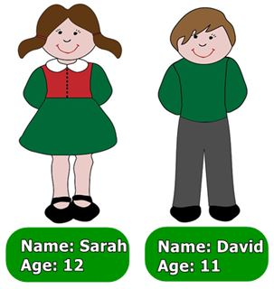Which is not TRUE?
A. The girl is Sarah. B. The boy is David. C. The girl is twenty. D. The boy is eleven.
Đáp án: The girl is twenty.
72. can/ fly?/ animals/ What/
Đáp án: What animals can fly?
73. She likes _________ tennis.
A. playing the B. play C. plays the D. playing
Đáp án: Chọn ý: D
74. Ảnh:Wash your _ _ _ _ _ before eating, please.
Đáp án: hands
75. Choose the odd one out:
A. cat B. dog C. pencil D. parrot
Đáp án: pencil
76. for me./ to buy/ my mother/ I want/ a blue scarf
Đáp án: I want my mother to buy a blue scarf for me.
77. Wh_ t’s your name?
Đáp án: a
78. Odd one out:
A. it’s B. his C. her D. its
Đáp án: it’s
79. Listen ... your friend, Tom.
A. on B. of C. to D. for
Đáp án: to
80. L_ _ k, listen and repeat.
Đáp án: oo
81. ... pictures are there on the wall?
A. Who B. How C. How many D. How much
Đáp án: How many
82. Nghe:Nhấn giữ Ctrl và bấm chuột để nghe: _ _ at colour are your pencils?
Đáp án: wh
83. on the/ is/ table./ The pen/
Đáp án: The pen is on the table.
84. Choose the odd one out:
A. frog B. desk C. tiger D. lion
Đáp án: desk
85. ..., I’m Tom.
A. Hi B. Goodbye C. See you D. Bye
Đáp án: Hi
86. What’s y_ _ r name? - My name’s Frank. Nice to meet you.
Đáp án: ou
87. ... morning, Adam!
A. Hello B. Hi C. Good D. You
Đáp án: Good
88. There are t_ o pens in my bag.
Đáp án: w
89. books?/ they/ Are/ your/
Đáp án: Are they your books?
90. _ _ e they your friends?
Đáp án: ar
91. Nice to meet you, Hai. – Nice to meet you, ... .
A. to B. two C. too D. those
Đáp án: too
92. Good ni_ _ _ , children.
Đáp án: ght
93. W_ _ is that? – That’s Jenny. She is my friend.
Đáp án: ho
94. C_ me here, John.
Đáp án: o
95. Nghe:Nhấn giữ Ctrl và bấm chuột để nghe: Who is this? - It’s my … .
A. sister B. brother C. father D. mother
Đáp án: sister
96. Please,/ quiet/ students./ be/
Đáp án: Please, be quiet students.
97. quiet,/ boys!/ Be/
Đáp án: Be quiet, boys!
98. Let’s mak_ a line.
Đáp án: e
99. Those pencil sharpeners _ _ _ purple.
Đáp án: are
100. It is ... mine.
A. and B. not C. see D. nice
Đáp án: not
101. Ảnh:_ _ OWN SHOES
Đáp án: BR
102. I’m ... Vietnam.
A. down B. up C. from D. under
Đáp án: from
103. Ảnh:_ _ _ _ _ what the teacher says.
Đáp án: Write
104. is/ It/ lunch room./ my school/
Đáp án: It is my school lunch room.
105. lunch room/ is/ large./ My/
Đáp án: My lunch room is large.
106. your/ out/ Take/ book.
Đáp án: Take out your book.
107. Wh_ _ colour is this?
Đáp án: at
108. ... is she? – She’s Margaret.
A. Who’s B. What C. What’s D. Who
Đáp án: Chọn ý: D
109. Wh_ t’s your name?
Đáp án: a
110. Wr_ _ _ the names in the blanks.
Đáp án: ite
111. A: Who’s that _ _ _ _ ? - B: She’s Linda.
Đáp án: girl
112. Choose the odd one out:
A. who B. how C. what D. ruler
Đáp án: Chọn ý: D
113. What su_ _ ect do you like the most?
Đáp án: bj
114. Don’t make ... mess.
A. an B. the C. a D. this
Đáp án: a
115. noise. Our/ is/ tired./ Don't make/ grandmother/
Đáp án: Don't make noise. Our grandmother is tired.
116. _ _ quiet, please.
Đáp án: Be
117. Choose the odd one out:
A. I B. my C. he D. they
Đáp án: my
118. Look/ at/ teacher./ the/
Đáp án: Look at the teacher.
119. What colour is this? - ... .
A. It’s a kite B. It’s a book C. There are two pens D. It’s green
Đáp án: Chọn ý: D
120. Nice ... meet you too.
A. for B. to C. from D. on
Đáp án: to
121. Ảnh:They are in the pl_ _ ground .
Đáp án: ay
122. Nghe:Nhấn giữ Ctrl và bấm chuột để nghe: _ _ _ _
Đáp án: nine
123. Ảnh: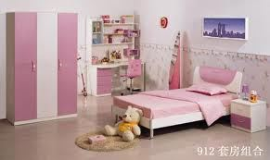Our _ _ _ _ _ _ _ is not big.
Đáp án: bedroom
124. ... is she? – She is my teacher.
A. Who B. What C. Which D. Where
Đáp án: Who
125. colour/ is/ What/ this?
Đáp án: What colour is this?
126. Nghe:Nhấn giữ Ctrl và bấm chuột để nghe: Listen and choose the best response.
A. Goodbye! See you later. B. I’m fine, thanks. C. This is my friend, Lan. D. Hi! My name’s Lan.
Đáp án: Chọn ý: D
127. Ảnh:This is a _ _ _ _ .
Đáp án: desk
128. Ảnh: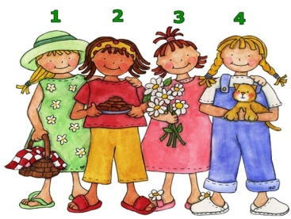A: Who is your friend? - B: The girl in the pink dress.
A. 1 B. 2 C. 3 D. 4
Đáp án: 3
129. small?/ her/ Is/ school library/
Đáp án: Is her school library small?
130. Ảnh: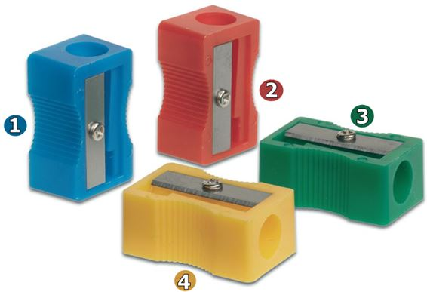My pencil sharpener is yellow.
A. 1 B. 2 C. 3 D. 4
Đáp án: Chọn ý: D
131. ... is her name? – Her name is Joane.
A. How B. What C. When D. Who
Đáp án: What
132. you/ See/ Peter./ tomorrow,/
Đáp án: See you tomorrow, Peter.
133. She ... five dolls.
A. have B. has C. is D. are
Đáp án: has
134. Ảnh: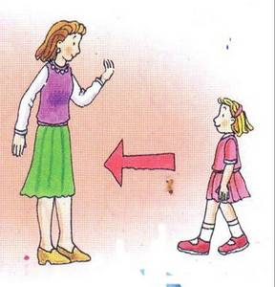____ here, please!
A. Coming B. To come C. Come D. Have
Đáp án: Come
135. teacher./ the/ Look/ at/
Đáp án: Look at the teacher.
136. my/ ruler is/ in/ My new/ pencil case./
Đáp án: My new ruler is in my pencil case.
137. Ảnh:A LARG_ ROOM
Đáp án: E
138. bag./ a green/ That/ is/ school
Đáp án: That is a green school bag.
139. Ảnh:What is that? - It’s a ….
A. bus B. school bus C. bike D. car
Đáp án: Chọn ý: D
140. How old are you?
A. My name’s Mai. B. I’m very well, thanks. C. I’m dancing. D. I am nine years old.
Đáp án: Chọn ý: D
141. Henry doesn’t work _ _ Saturday and Sunday.
Đáp án: on
142. Ảnh:There is a d_ sk in my room.
Đáp án: e
143. your book/ and read/ aloud./ Open/
Đáp án: Open your book and read aloud.
144. you have?/ many/ do/ How/ dogs/
Đáp án: How many dogs do you have?
145. P_ _ your books down, please.
Đáp án: ut
146. Which is a kind of fruit?
A. blue B. green C. orange D. pink
Đáp án: orange
147. Ảnh:That's a rul_ _ .
Đáp án: er
148. W_ _ is she, Peter? – She’s is Alice.
Đáp án: ho
149. Ảnh:What colour are the trousers? - They are _ _ _ _ _ _ .
Đáp án: yellow
150. ... morning, Peter.
A. Good’s B. Bye C. Hi D. Good
Đáp án: Chọn ý: D
151. Ảnh:Do you like flying a kite? – No, I don’t. I like doing puz_ _ _ s.
Đáp án: zle
152. Nghe:Nhấn giữ Ctrl và bấm chuột để nghe: Peter likes _ _ _ _ _ _ _ _ but Lulu doesn’t.
Đáp án: football
153. This is Mary. _ _ e is my friend.
Đáp án: sh
154. Hi, my name ... Nam.
A. are B. is C. be D. and
Đáp án: is
155. our/ is/ Mrs. Samantha/ new/ teacher./
Đáp án: Mrs. Samantha is our new teacher.
156. My _______ is Tony.
A. school B. friend C. bag D. class
Đáp án: friend
157. Wh_ _ are they? - They are my pens.
Đáp án: at
158. H_ _ is your mother? – She’s fine.
Đáp án: ow
159. A: _ _ _ I close my book? - B: Yes, please.
Đáp án: May
160. Is that your pencil? – No, it is _ _ _ .
Đáp án: not
161. Nghe:Nhấn giữ Ctrl và bấm chuột để nghe: _ _ _ _ ing
Đáp án: skat
162. Choose the letter(s) to make a correct word: na__
A. mi B. me C. em D. im
Đáp án: me
163. A: May I come here? - B: No, you _ _ _ ’t.
Đáp án: can
164. ..., teacher? – Yes, please.
A. Stand up B. Open your book C. Who is he D. May I go out
Đáp án: Chọn ý: D
165. Nghe:Nhấn giữ Ctrl và bấm chuột để nghe: C_ ME
Đáp án: O
166. Nghe:Nhấn giữ Ctrl và bấm chuột để nghe: _ _ _ _
Đáp án: your
167. Ảnh: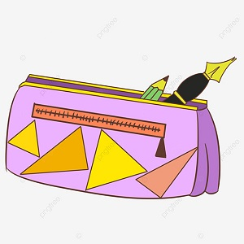What is this? - It's a _____.
A. pen B. pencil C. pencil case D. pencil sharpener
Đáp án: pencil case
168. When is your birthday? - ….
A. It’s on September B. It’s in October C. It’s second of June D. It’s in third of June
Đáp án: It’s in October
169. My/ a/ doctor./ father/ is/
Đáp án: My father is a doctor.
170. Count the ..., please.
A. she B. they C. boy D. boys
Đáp án: Chọn ý: D
171. Check/ you hear/ words/ , please./ the/
Đáp án: Check the words you hear , please.
172. Can the cat fly? - ... .
A. No, it can B. No, it does C. No, it can’t D. No, it doesn’t
Đáp án: No, it can’t
173. That is my classroom. It’s not small. It’s _ _ g.
Đáp án: bi
174. We play football in the play_ _ _ _ _ _ after school.
Đáp án: ground
175. Choose the odd one out:
A. house B. gym C. library D. music room
Đáp án: house
176. colour/ What/ sneakers?/ are/ those
Đáp án: What colour are those sneakers?
177. Is this a round bag? - ... .
A. Yes, it is B. Yes, it isn’t C. No, it is D. Not, it isn’t
Đáp án: Yes, it is
178. and I/ are/ My friends/ in the playground.
Đáp án: My friends and I are in the playground.
179. Are they your _________?
A. box B. boxs C. boxes D. boxe
Đáp án: boxes
180. Is this a book? – Yes, … .
A. I am B. it is C. is it D. it isn’t
Đáp án: it is
181. He is P_ ter.
Đáp án: e
182. My pencil is lo_ _ , but his pencil is short.
Đáp án: ng
183. birthday/ present./ This doll/ your/ is/
Đáp án: This doll is your birthday present.
184. Ảnh:It's the _ rt room.
Đáp án: a
185. I like to s_ ng.
Đáp án: i
186. Let’s make a li_ e.
Đáp án: n
187. What ... it? – It’s a red pencil.
A. is B. hi C. bye D. hello
Đáp án: is
188. Choose the odd one out:
A. tree B. kite C. yo-yo D. doll
Đáp án: tree
189. Who _ re they?
Đáp án: a
190. Choose the odd one out:
A. library B. ruler C. rubber D. notebook
Đáp án: library
191. It is so mu_ _ fun.
Đáp án: ch
192. Miss Lan is my new t_ _ _ her.
Đáp án: eac
193. Nghe:Nhấn giữ Ctrl và bấm chuột để nghe: I play ______ .
A. basketball B. badminton C. skipping D. football
Đáp án: basketball
194. my/ at/ Look/ dog.
Đáp án: Look at my dog.
195. in the classroom./ I/ play chess/
Đáp án: I play chess in the classroom.
196. Write/ a/ postcard/ a pen friend./ to
Đáp án: Write a postcard to a pen friend.
197. Nghe:Nhấn giữ Ctrl và bấm chuột để nghe: Listen and tick
A. This B. That C. These D. Those
Đáp án: These
198. a/ is/ teacher./ father/ My/
Đáp án: My father is a teacher.
199. These trousers are too big _ _ _ me now.
Đáp án: for
200. weather/ The/ is/ hot/ today./
Đáp án: The weather is hot today.

KEY IOE K3 2023 - 2024 SỐ 18
1. This is m_ ruler.
Đáp án: y
2. I often play football _ _ Tuesday afternoons.
Đáp án: on
3. Nghe:Nhấn giữ Ctrl và bấm chuột để nghe: HOU_ _
Đáp án: SE
4. A: What are …? - B: … are my pencils.
A. those – Here B. these – They C. there – There D. there – Here
Đáp án: these – They
5. Choose the odd one out:
A. Good morning. B. Goodbye. C. See you again. D. See you soon.
Đáp án: Good morning.
6. Ảnh: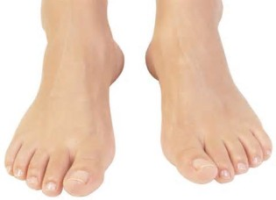There are _ _ _ _ toes on a foot.
Đáp án: five
7. _ _ _ often do you do morning exercise in the summer?
Đáp án: How
8. a teacher./ I/ to/ be/ want/
Đáp án: I want to be a teacher.
9. some vegetables/ in the garden./ My grandmother/ grows/
Đáp án: My grandmother grows some vegetables in the garden.
10. How m_ _ _ dogs do you have?
Đáp án: any
11. S_ _ you again, students.
Đáp án: ee
12. Nghe:Nhấn giữ Ctrl và bấm chuột để nghe: Here is his _ _ _ _ er.
Đáp án: sist
13. are on/ the bookcase./ new. They/ are/ Her notebooks/
Đáp án: Her notebooks are new. They are on the bookcase.
14. That man is _______.
A. fifty one B. fifteen one C. five ten one D. five one
Đáp án: fifty one
15. This is _ book.
Đáp án: a
16. old/ miss/ friend Lizzie./ my/ I/
Đáp án: I miss my old friend Lizzie.
17. Nghe:Nhấn giữ Ctrl và bấm chuột để nghe: This is my _ _ _ _ _ _ .
Đáp án: school
18. the wall./ clock on/ There is/ a/ beautiful/
Đáp án: There is a beautiful clock on the wall.
19. How ... pens do you have?
A. are B. many C. much D. so
Đáp án: many
20. ________ is your grandfather? - He's seventy.
A. How many B. How much C. How old D. How age
Đáp án: How old
21. One plus one makes _ _ _ .
Đáp án: two
22. beautiful./ kites/ are/ These/
Đáp án: These kites are beautiful.
23. a/ desk./ is/ small/ This/
Đáp án: This is a small desk.
24. you/ What/ play?/ do/ sport/
Đáp án: What sport do you play?
25. My room is n_ _ big. It’s small.
Đáp án: ot
26. eleven/ Her/ are/ cousins/ years old./
Đáp án: Her cousins are eleven years old.
27. Choose the odd one out:
A. blind man’s bluff B. chess C. hide-and-seek D. skating
Đáp án: Chọn ý: D
28. _ _ s name is John.
Đáp án: Hi
29. This is _ doll.
Đáp án: a
30. Science/ favourite/ subject./ his/ is/
Đáp án: Science is his favourite subject.
31. T_ _ _ are my uncle and aunt.
Đáp án: hey
32. Ảnh:A person has _ _ _ legs.
Đáp án: two
33. Nghe:Nhấn giữ Ctrl và bấm chuột để nghe: What DOESN’T Polly like?
A. Cats and dogs. B. Cats and spiders. C. Dogs and spiders. D. Cats, dogs and spiders.
Đáp án: Cats and spiders.
34. my/ favourite room./ Living room/ is/
Đáp án: Living room is my favourite room.
35. It’s m_ umbrella.
Đáp án: y
36. Nghe:Nhấn giữ Ctrl và bấm chuột để nghe: My pencil is ye_ _ _ _ .
Đáp án: llow
37. My school bag _ _ new.
Đáp án: is
38. book/ What/ she read?/ does/
Đáp án: What book does she read?
39. an egg/ It/ in/ the bowl./ is/
Đáp án: It is an egg in the bowl.
40. you./ It’s/ to/ nice/ meet
Đáp án: It’s nice to meet you.
41. What is it? - …
A. It’s a rubber. B. I am fine, thanks. C. She is my friend. D. Yes, it is.
Đáp án: It’s a rubber.
42. What's there next _ _ the door?
Đáp án: to
43. Let’s chan_ .
Đáp án: t
44. Ảnh:I like _______.
A. skating B. skate C. swimming D. swim
Đáp án: swimming
45. Are those your notebooks? - No, ... .
A. it is B. it isn’t C. they are D. they aren’t
Đáp án: Chọn ý: D
46. Goodbye./ later./ See/ you/
Đáp án: Goodbye. See you later.
47. Is this ... book? - Yes,it’s my book.
A. her B. my C. his D. your
Đáp án: Chọn ý: D
48. where/ the/ Excuse me,/ principal’s room?/ is/
Đáp án: Excuse me, where is the principal’s room?
49. Nghe:Nhấn giữ Ctrl và bấm chuột để nghe: Dave is _ _ _ _ _ _ _ _ years old.
Đáp án: nineteen
50. This is/ we/ school./ the way/ go to
Đáp án: This is the way we go to school.
51. My schoo_ is small.
Đáp án: l
52. Ảnh: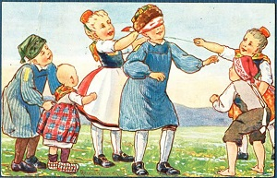The children are playing ______ in the garden.
A. the guitar B. blind man's bluff C. chess D. with some toys
Đáp án: blind man's bluff
53. John: Are those your pencils? - Sam: Yes, ... .
A. it’s B. it are C. its D. they are
Đáp án: Chọn ý: D
54. Wh_ _ is there next to your book? - A ruler.
Đáp án: at
55. your names/ in/ blanks./ the/ Write/
Đáp án: Write your names in the blanks.
56. my/ new/ is/ This/ friend./
Đáp án: This is my new friend.
57. Wh_ _ _ are the maps? – They are on the wall.
Đáp án: ere
58. This is my friend. ... name is Jane.
A. Her B. Its C. His D. This
Đáp án: Her
59. Nghe:Nhấn giữ Ctrl và bấm chuột để nghe: It’s the _ _ _ _ _ _ _ _ room.
Đáp án: computer
60. Is this your robot? – No, it is _ _ _ .
Đáp án: not
61. Peter is _ _ the classroom now.
Đáp án: in
62. Tom?/ friend,/ How/ your/ is/
Đáp án: How is your friend, Tom?
63. How _ _ _ you? - I’m fine, thank you.
Đáp án: are
64. Ảnh: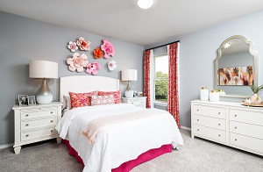This is my b_ droom.
Đáp án: e
65. My house _ s small.
Đáp án: i
66. Choose the INCORRECT word or phrase in the following sentence: Three little cat are in the yard.
A. cat B. are C. in D. yard
Đáp án: cat
67. Choose the letter(s) to make a correct word: LIT_LE
A. F B. M C. N D. T
Đáp án: Chọn ý: D
68. Ảnh: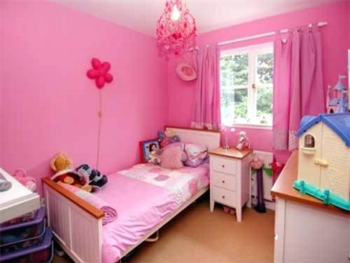What a lovely _ _ _ _ !
Đáp án: room
69. Nam:... your name? - Peter: My name’s Peter.
A. Who B. Who’s C. What D. What’s
Đáp án: Chọn ý: D
70. Go _ _ the door, please.
Đáp án: to
71. ______ my uncle next to my father.
A. They are B. There are C. It is D. Is there
Đáp án: It is
72. How/ do you/ spell/ his teacher's/ name?/
Đáp án: How do you spell his teacher's name?
73. your teacher's/ Where/ is/ bag?
Đáp án: Where is your teacher's bag?
74. _ _ _ t is that? – That is a red apple.
Đáp án: Wha
75. My ... is Tim. Nice to meet you.
A. name’s B. names C. name D. is name
Đáp án: name
76. Ảnh: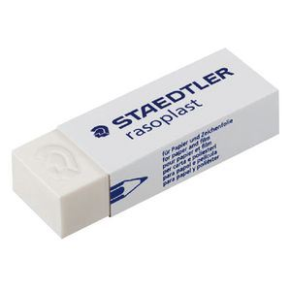What’s that? - It’s an _ _ _ _ _ _ .
Đáp án: eraser
77. Choose the INCORRECT word or phrase in the following sentence: They are my ball, Daddy.
A. They B. my C. ball D. Daddy
Đáp án: ball
78. Choose the letter(s) to make a correct word: bla__
A. kk B. cc C. kc D. ck
Đáp án: Chọn ý: D
79. is/ large./ not/ school/ Our/
Đáp án: Our school is not large.
80. Teacher: What’s this? - Minh: It’s _ pencil sharperner
A. on B. in C. a D. an
Đáp án: a
81. ... this a desk? – Yes, it is.
A. Is B. Are C. How D. What
Đáp án: Is
82. This is m_ pen. It’s not your pen.
Đáp án: y
83. are./ Here/ you/
Đáp án: Here you are.
84. Ảnh:_________
A. Happy New Year! B. Merry Christmas! C. Happy birthday! D. Happy day!
Đáp án: Merry Christmas!
85. plays/ basketball/ with his friend/ Tuan/ after school./
Đáp án: Tuan plays basketball with his friend after school.
86. That yo yo is gre_ n.
Đáp án: e
87. Which word has the underlined part pronounced LIKE the letter O in MOTHER
A. robot B. school C. forty D. front
Đáp án: Chọn ý: D
88. My uncle doesn’t work … Saturday.
A. at B. in C. on D. of
Đáp án: on
89. is/ long./ hair/ Her/ not
Đáp án: Her hair is not long.
90. red/ crayons./ are/ These/
Đáp án: These are red crayons.
91. Peter: Let’s play ch_ _ _ !. - Nam: Yes, let’s.
Đáp án: ess
92. Write your name _ _ the board, please.
Đáp án: on
93. is/ That/ pink./ ruler/
Đáp án: That ruler is pink.
94. Where is my b_ _ _ pack?
Đáp án: ack
95. garden./ many/ flowers/ in the/ There are/
Đáp án: There are many flowers in the garden.
96. These are their _____.
A. schoolbag B. school bags C. schools bag D. schools bags
Đáp án: school bags
97. Nghe:Nhấn giữ Ctrl và bấm chuột để nghe: Look at _ _ _ _ photo.
Đáp án: this
98. Stand _ _ , please!
Đáp án: up
99. eleven, twelve, thirteen, _ _ _ _ _ _ _ _
Đáp án: fourteen
100. Ảnh:The st_ _ is bright at night.
Đáp án: ar
101. At break time, we play many games and sports such as hide-and-seek, football and _____.
A. lunch room B. table tennis C. computer D. eraser
Đáp án: table tennis
102. Nghe:Nhấn giữ Ctrl và bấm chuột để nghe: There are many _ _ _ _ in the pencil case.
Đáp án: pens
103. _ _ you have pets? - Yes, I do.
Đáp án: Do
104. Reorder the words to make a complete sentence: friend / My / playing / likes / badminton.
A. Friend my likes playing badminton. B. My friend likes playing badminton. C. My friend likes badminton playing. D. Playing badminton my friend likes.
Đáp án: My friend likes playing badminton.
105. Nghe:Nhấn giữ Ctrl và bấm chuột để nghe: _ _ _ _ _
Đáp án: white
106. Circle/ answer,/ children./ the/
Đáp án: Circle the answer, children.
107. Ảnh:The children are happy ________.
A. on Children's Day B. on Teachers' Day C. on Christmas Day D. on school day
Đáp án: on Christmas Day
108. Ảnh: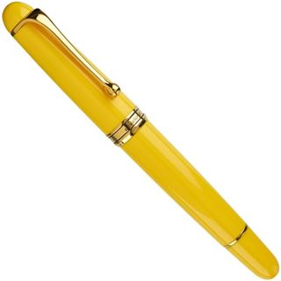My pen is _ _ _ _ _ _ .
Đáp án: yellow
109. The trees ___ green.
A. is B. are C. am D. do
Đáp án: are
110. butterfly./ is playing/ with a/ My cat/
Đáp án: My cat is playing with a butterfly.
111. … this word after me: ’’Name’’.
A. Do B. Write C. Copy D. Read
Đáp án: Chọn ý: D
112. Nghe:Nhấn giữ Ctrl và bấm chuột để nghe: Today is Emily’s _ _ _ _ _ birthday.
Đáp án: third
113. now./ is/ the classroom/ Mr. Gerhard/ in/
Đáp án: Mr. Gerhard is in the classroom now.
114. Please, … down on the floor.
A. sit B. stand C. open D. close
Đáp án: sit
115. The/ the shelf./ maps/ on/ are/
Đáp án: The maps are on the shelf.
116. Are you a student or a teacher?
A. Yes, I am. B. No, I amn’t, C. I’m a teacher. D. I’m fine, thank.
Đáp án: I’m a teacher.
117. Nghe:Nhấn giữ Ctrl và bấm chuột để nghe: Listen and tick:
A. shy B. sit C. six D. soup
Đáp án: six
118. Her grandmother _____ cooking.
A. like B. are C. likes D. am
Đáp án: likes
119. to play/ piano./ I/ the/ like/
Đáp án: I like to play the piano.
120. Ảnh:I’ve got an _ _ _ _ _ .
Đáp án: apple
121. Is he your uncle? – No, he _ _ _ ’t.
Đáp án: isn
122. Ảnh: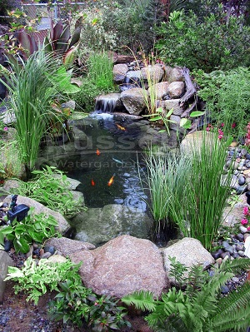There is a small pon_ behind Nam's house.
Đáp án: d
123. many/ at break time./ The children/ different games/ play/
Đáp án: The children play many different games at break time.
124. How/ many/ dolls/ there?/ are
Đáp án: How many dolls are there?
125. many/ in/ flowers/ There are/ the garden./
Đáp án: There are many flowers in the garden.
126. Choose the odd one out
A. Pictures B. Pencils C. Markers D. Crayons
Đáp án: Pictures
127. Those _ _ _ my bags.
Đáp án: are
128. Ảnh: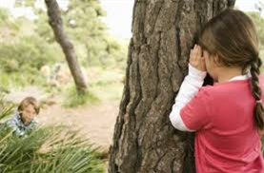The children are playing … now.
A. badminton B. volleyball C. hide-and-seek D. break time
Đáp án: hide-and-seek
129. Ảnh:The dog is _____ the bed.
A. in B. under C. on D. behind
Đáp án: under
130. likes chess./ likes/ and Max/ table tennis/ Alex/
Đáp án: Alex likes table tennis and Max likes chess.
131. Nghe:Nhấn giữ Ctrl và bấm chuột để nghe: The _ _ _ _ _ _ _ is very tidy.
Đáp án: kitchen
132. I ... my teeth in the morning.
A. do B. brush C. have D. does
Đáp án: brush
133. __TCHEN
A. KE B. KA C. KU D. KI
Đáp án: Chọn ý: D
134. Nghe:Nhấn giữ Ctrl và bấm chuột để nghe: Sue is in the … room.
A. living B. dining C. sitting D. bed
Đáp án: living
135. Choose the odd one out.
A. Teacher B. Pencil C. Rubber D. Ruler
Đáp án: Teacher
136. Pictures of my family _ _ _ on the wall.
Đáp án: are
137. I have three toy_ .
Đáp án: s
138. She _ _ _ _ not love music at all.
Đáp án: does
139. Wh_ _ _ are your pens? - They're in my pencil case.
Đáp án: ere
140. bird in/ blue/ is a/ the sky./ There/
Đáp án: There is a blue bird in the sky.
141. He _ _ my brother.
Đáp án: is
142. We like Art bec_ _ _ e we like to draw pictures.
Đáp án: aus
143. ..., teacher? – Sure.
A. Stand up B. Open your book C. Who is he D. May I go out
Đáp án: Chọn ý: D
144. Ảnh: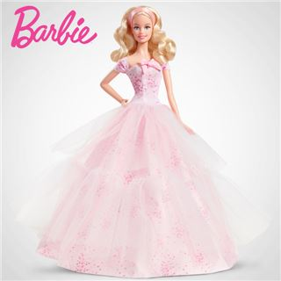She has a beautiful _ _ _ _ .
Đáp án: doll
145. Is this _ _ eraser? – No, it isn’t.
Đáp án: an
146. It/ Monday/ is/ today.
Đáp án: It is Monday today.
147. Ảnh: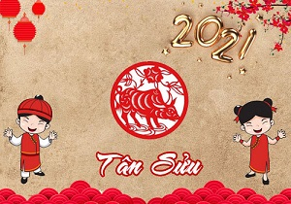__________
A. Happy New Year! B. Merry Christmas! C. Happy birthday! D. Happy day!
Đáp án: Happy New Year!
148. Hello, I'm Mai. - ______
A. Thank you! B. Nice to meet you. C. Sorry! D. Goodbye
Đáp án: Nice to meet you.
149. My brother … got two new robots.
A. have B. is C. has D. am
Đáp án: has
150. Choose the incorrect word(s) in the following sentence: My uncle is thirty year old.
A. My B. is C. year D. old
Đáp án: year
151. When is your sister’s birthday? – H_ _ birthay is in July.
Đáp án: er
152. Nghe:Nhấn giữ Ctrl và bấm chuột để nghe: Listen and tick:
A. close B. old C. cold D. rose
Đáp án: close
153. Lan: Is this your school bag? - Nga: …, it is.
A. Yes B. No C. Yes, it D. Yes, it’s
Đáp án: Yes
154. Peter: How …are you? - Hoa: I’m eight years old.
A. all B. old C. tall D. small
Đáp án: old
155. Let’s ... English.
A. say B. speak C. listen D. show
Đáp án: speak
156. Choose the letter(s) to make a correct word: par__t
A. ao B. ra C. or D. ro
Đáp án: Chọn ý: D
157. and/ number./ Listen/
Đáp án: Listen and number.
158. Raise your ..., please.
A. hand B. sit C. stand D. open
Đáp án: hand
159. Nghe:Nhấn giữ Ctrl và bấm chuột để nghe: My mother makes a great cake. She is a good _ _ _ _ .
Đáp án: cook
160. Nghe:Nhấn giữ Ctrl và bấm chuột để nghe: _ _ _ _ _ _
Đáp án: thirty
161. her/ relatives./ are/ not/ These/
Đáp án: These are not her relatives.
162. Which is your school? – This _ _ _ .
Đáp án: one
163. my/ These/ are/ puzzles.
Đáp án: These are my puzzles.
164. Nghe:Nhấn giữ Ctrl và bấm chuột để nghe: There are _ _ _ _ teen students in their class.
Đáp án: thir
165. a/ desk./ is/ It/ new
Đáp án: It is a new desk.
166. Nghe:Nhấn giữ Ctrl và bấm chuột để nghe: My _ _ _ _ is green.
Đáp án: ball
167. that/ Do/ you/ white blouse?/ like/
Đáp án: Do you like that white blouse?
168. you/ do/ pets/ What/ have?/
Đáp án: What pets do you have?
169. You are welc_ me.
Đáp án: o
170. What … her name? – She is Mai Anh.
A. are B. is C. am D. does
Đáp án: is
171. How is _________? - ________ is fine, thanks.
A. she - Her B. you - I C. they - We D. Nga - She
Đáp án: Chọn ý: D
172. Ảnh: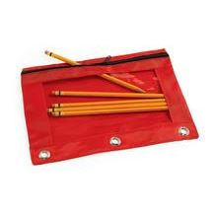That’s my pencil _ _ g!
Đáp án: ba
173. Is that a pen? - ..., it isn’t.
A. Yes B. Yes, it is C. Not D. No
Đáp án: Chọn ý: D
174. Ảnh: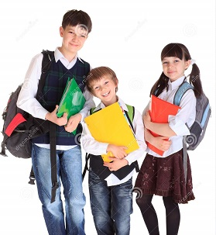We go to school ________.
A. on my classmates B. on my parents C. on my friends D. on school day
Đáp án: Chọn ý: D
175. Ảnh: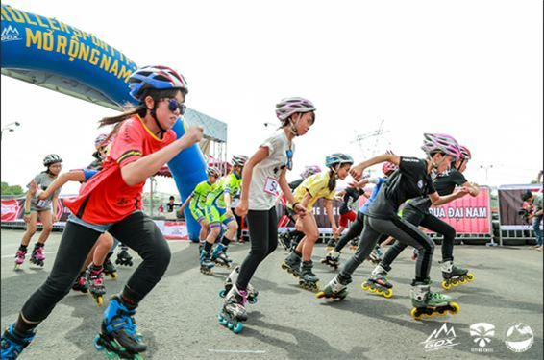Do they like _ _ _ _ _ _ _ ? - Yes, they do
Đáp án: skating
176. Ảnh: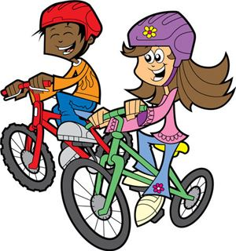They _ _ _ _ _ to school every morning.
Đáp án: cycle
177. Ảnh: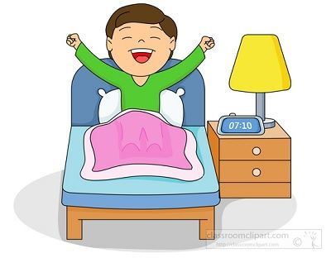I have a y_ _ _ _ _ lamp next to my bed
Đáp án: ellow
178. books./ my/ favourite/ some of/ These are/
Đáp án: These are some of my favourite books.
179. Ảnh:A person has _ _ _ hands.
Đáp án: two
180. Dogs, cats, rabbits and hamsters are … .
A. birds B. vets C. pets D. turtles
Đáp án: pets
181. How o_ _ are you?
Đáp án: ld
182. Ảnh: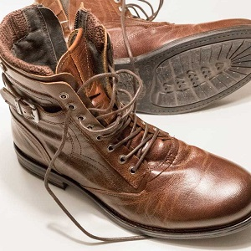His shoes are _ _ _ _ _ .
Đáp án: brown
183. There are some photos _ _ the wall.
Đáp án: on
184. May I help you? - ….
A. Yes, please. Can you give me a hand? B. I don’t like too. C. No, you are not. D. No, I can’t. Please go away.
Đáp án: Yes, please. Can you give me a hand?
185. Choose the odd one out:
A. you B. hi C. I D. She
Đáp án: hi
186. His books are ... the table.
A. at B. in C. down D. on
Đáp án: Chọn ý: D
187. go/ gym./ to/ Let’s/ the
Đáp án: Let’s go to the gym.
188. Goodbye. See you lat_ _ !
Đáp án: er
189. Let’s dr_ _ a picture.
Đáp án: aw
190. That kite is bro_ n.
Đáp án: w
191. May I go _ _ t? - Yes, please.
Đáp án: ou
192. This is Mary. _ _ _ is my friend.
Đáp án: she
193. It's/ jacket/ in the wardrobe./ his/
Đáp án: It's his jacket in the wardrobe.
194. These are my friends. The_ _ names are Lan and Phuong.
Đáp án: ir
195. Nam, go to ….. blackboard, please.
A. a B. an C. some D. the
Đáp án: Chọn ý: D
196. Ảnh:CIRCL_
Đáp án: E
197. There _ _ a garden behind my house.
Đáp án: is
198. Nghe:Nhấn giữ Ctrl và bấm chuột để nghe: My _ _ _ _ _ _ is cooking.
Đáp án: mother
199. Choose the odd one out
A. Sixty B. Book C. Seventeen D. Nineteen
Đáp án: Book
200. your/ hand/ down./ Put/
Đáp án: Put your hand down.

KEY IOE K3 2023 - 2024 SỐ 19
1. in/ many cats/ are there/ How/ that box?/
Đáp án: How many cats are there in that box?
2. What’s this? - ... .
A. It’s a pen B. Yes, it is C. No, it isn’t D. They are pens
Đáp án: It’s a pen
3. How … fans are there? – Three.
A. many B. much C. old D. long
Đáp án: many
4. Nghe:Nhấn giữ Ctrl và bấm chuột để nghe: _ _ _ _ _ _
Đáp án: yellow
5. Nghe:Nhấn giữ Ctrl và bấm chuột để nghe: Jamie is celebrating her _ _ _ _ _ birthday party.
Đáp án: sixth
6. Nghe:Nhấn giữ Ctrl và bấm chuột để nghe: They go to school by _ _ _ .
Đáp án: bus
7. Nghe:Nhấn giữ Ctrl và bấm chuột để nghe: Phuong is reading a _ _ _ _ .
Đáp án: book
8. There _ _ _ many flowers in spring.
Đáp án: are
9. Nghe:Nhấn giữ Ctrl và bấm chuột để nghe: My _ _ _ _ is green.
Đáp án: ball
10. May I come in? - _ _ _ , please.
Đáp án: yes
11. Ảnh:That’s a pencil sharp_ _ _ _ .
Đáp án: ener
12. on/ are/ The/ the wall./ pictures/
Đáp án: The pictures are on the wall.
13. Nghe:Nhấn giữ Ctrl và bấm chuột để nghe: Tom is in the … .
A. living room B. bedroom C. kitchen D. bathroom
Đáp án: bedroom
14. What do you do in … free time?
A. you B. yours C. you’re D. your
Đáp án: Chọn ý: D
15. your/ relative?/ he/ Is/
Đáp án: Is he your relative?
16. Is/ big?/ your/ school/ new/
Đáp án: Is your new school big?
17. This/ a photo/ of/ is/ my school./
Đáp án: This is a photo of my school.
18. ruler/ is/ pink./ This/
Đáp án: This ruler is pink.
19. your cat/ on the roof?/ sleep/ Does/
Đáp án: Does your cat sleep on the roof?
20. The dog is standing _ _ front of the mirror.
Đáp án: in
21. Nghe:Nhấn giữ Ctrl và bấm chuột để nghe: _ _ _ _ _ _ _ _ _ _
Đáp án: basketball
22. There _ _ a garden behind my house.
Đáp án: is
23. his free time./ often/ reads books/ in/ My father/
Đáp án: My father often reads books in his free time.
24. to/ Listen/ what/ the teacher/ says./
Đáp án: Listen to what the teacher says.
25. How old is your father?
A. He’s fine. B. He’s three ten. C. He’s forty. D. He’s four five.
Đáp án: He’s forty.
26. Choose the letter(s) to make a correct word: DE__
A. KS B. SK C. KA D. AK
Đáp án: SK
27. There are 20 boys and 23 _ _ _ _ _ in my class.
Đáp án: girls
28. David can play ... .
A. desk B. chair C. pencil D. football
Đáp án: Chọn ý: D
29. and pick up/ the wardrobe/ I open/ a shirt.
Đáp án: I open the wardrobe and pick up a shirt.
30. an/ English/ song./ sing/ Let’s/
Đáp án: Let’s sing an English song.
31. T_ _ _ are my uncle and aunt.
Đáp án: hey
32. These girls are _ _ classmates.
Đáp án: my
33. friends?/ they/ his/ Are/
Đáp án: Are they his friends?
34. … My name is Alan. I’m eight … old.
A. Hello - years B. Bye - months C. Hi - weeks D. Good morning - days
Đáp án: Hello - years
35. What time/ up?/ you/ get/ do/
Đáp án: What time do you get up?
36. How are …, Tom? – Fine, thanks. And you?
A. you B. you’re C. your D. you are
Đáp án: you
37. Lan: _ ow are you, Hoa? - Hoa: Fine, thanks. And you?
Đáp án: H
38. When you meet your friend at 9 a.m, you say:
A. Good morning B. Good evening C. Good afternoon D. Good night
Đáp án: Good morning
39. 'What sports do you _ _ _ _ , Billy?' - 'I like football.'
Đáp án: like
40. How do … spell … name, Peter?
A. you – your B. he – your C. she – his D. they – our
Đáp án: you – your
41. please./ circles,/ Let’s/ two/ make/
Đáp án: Let’s make two circles, please.
42. My/ is/ blue and/ schoolbag/ orange./
Đáp án: My schoolbag is blue and orange.
43. Ảnh: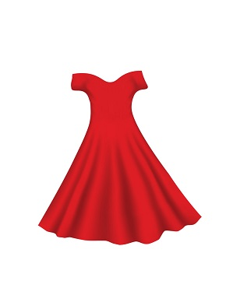She likes _ red dress.
Đáp án: a
44. How ______ is your sister? – She’s three years old.
A. many B. long C. old D. much
Đáp án: old
45. very/ My/ new friends/ are/ kind./
Đáp án: My new friends are very kind.
46. Mary _ _ s born in America.
Đáp án: wa
47. What/ her/ name?/ is/
Đáp án: What is her name?
48. Where/ is/ your/ house?
Đáp án: Where is your house?
49. I l_ _ _ swimming very much.
Đáp án: ike
50. What animal can fly?
A. A frog B. A butterfly C. A tiger D. A goldfish
Đáp án: A butterfly
51. Ảnh:My _ _ _ likes running on grass.
Đáp án: dog
52. Let’s go ... .
A. fishing B. skip C. where D. what
Đáp án: fishing
53. is/ over/ robot/ My/ there./
Đáp án: My robot is over there.
54. We s_ _ _ a song in Music lesson.
Đáp án: ing
55. What colour is this? - ... .
A. It red B. It’s red C. It reds D. It is a red
Đáp án: It’s red
56. Is it a __________? - No, it isn’t. It’s a long ruler.
A. big poster B. small TV C. short ruler D. long car
Đáp án: short ruler
57. isn't/ There/ any water/ in the bottle.
Đáp án: There isn't any water in the bottle.
58. Ảnh:You use your nos_ to smell.
Đáp án: e
59. play/ chess/ in the bedroom./ John and Jane/
Đáp án: John and Jane play chess in the bedroom.
60. What … those? – They are kites.
A. are B. is C. am D. have
Đáp án: are
61. Lan: How do you ... your name? - Peter: That’s P_E_T_E_R.
A. write B. read C. spell D. draw
Đáp án: spell
62. Ảnh:What activity do they play?
A. Chess B. Hide-and-seek C. Table tennis D. Blind man's bluff
Đáp án: Chess
63. break time/ We/ very much./ love/
Đáp án: We love break time very much.
64. My father can s_ im.
Đáp án: w
65. Do you ____ a comic book? - Yes, I do.
A. having B. like C. knows D. are
Đáp án: like
66. Nghe:Nhấn giữ Ctrl và bấm chuột để nghe: Choose the correct question.
A. Where is the garden? B. Where’s Peter? C. What is Peter doing? D. Is there a garden?
Đáp án: Where’s Peter?
67. Nghe:Nhấn giữ Ctrl và bấm chuột để nghe: Listen and tick the word(s) you hear:
A. sunny B. Sunday C. summer D. seven
Đáp án: Sunday
68. Can you ... English, Philips? – Yes, I can.
A. sit B. stand C. speak D. say
Đáp án: speak
69. Nghe:Nhấn giữ Ctrl và bấm chuột để nghe: A _______
A. APPLE B. PINEAPPLE C. CANDY D. CAKE
Đáp án: PINEAPPLE
70. Where is Paul? – He’s … puzzles in the living room.
A. making B. doing C. playing D. taking
Đáp án: doing
71. W_ _ _ _ are the children? - They are at school.
Đáp án: here
72. Nghe:Nhấn giữ Ctrl và bấm chuột để nghe: B: I’m … . Thank you. And you? - A: I’m very … . Thank you.
A. fine – fine B. fine – well C. well – well D. well – fine
Đáp án: fine – well
73. What …? – They are my crayons.
A. are those B. is this C. is that D. are there
Đáp án: are those
74. your/ When/ is/ birthday?
Đáp án: When is your birthday?
75. There are ten pencils … the desk.
A. to B. at C. on D. for
Đáp án: on
76. Ảnh:In autumn, the sky is very _____.
A. black B. white C. green D. blue
Đáp án: Chọn ý: D
77. Nghe:Nhấn giữ Ctrl và bấm chuột để nghe: HOU_ _
Đáp án: SE
78. Is t_ _ s a chair? – Yes, it is.
Đáp án: hi
79. name?/ is/ What/ his/
Đáp án: What is his name?
80. Dogs are bigger than ants. Ants are … .
A. small B. big C. old D. young
Đáp án: small
81. _ _ at is that? – It’s a compass.
Đáp án: wh
82. Ảnh:The dog is running after the _ _ _ .
Đáp án: cat
83. school bag?/ Are there/ in the/ books/ any/
Đáp án: Are there any books in the school bag?
84. Hello,/ is/ my name/ Giang.
Đáp án: Hello, my name is Giang.
85. This/ classroom./ is/ new/ my/
Đáp án: This is my new classroom.
86. 'Do your friends play games at school?' - 'Yes,they _________.'
A. do B. like C. are D. can
Đáp án: do
87. Ảnh: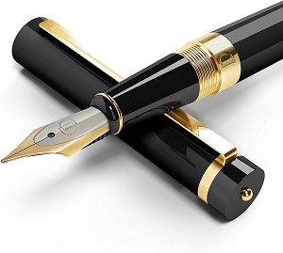_ _ _
Đáp án: PEN
88. _ _ o is that? – That’s Tommy. He is my friend.
Đáp án: Wh
89. Nghe:Nhấn giữ Ctrl và bấm chuột để nghe: He likes this ___.
A. ball B. apple C. mango D. orange
Đáp án: mango
90. What is his _ _ _ _ ? – He is Eddie Murray.
Đáp án: name
91. Here are your shoes. – _ _ _ _ _ _ .
Đáp án: Thanks
92. Is that a bag? – No, it is _ _ _ .
Đáp án: not
93. There ... three cats in the box.
A. am B. is C. are D. there
Đáp án: are
94. My sister h_ _ one cat.
Đáp án: as
95. There is a big tree next _ _ the pond.
Đáp án: to
96. ... you like some milk? - No, thanks.
A. Can B. Are C. Is D. Would
Đáp án: Chọn ý: D
97. Nghe:Nhấn giữ Ctrl và bấm chuột để nghe: There are _ _ _ _ teen students in their class.
Đáp án: thir
98. My aunt’s daughters _ _ _ my cousins.
Đáp án: are
99. Here are your shoes. – _ _ _ _ _ _ .
Đáp án: Thanks
100. Do you want ice cream? Yes, ....
A. you do B. I want C. I do D. I can
Đáp án: I do
101. I have _ cat.
Đáp án: a
102. Nghe:Nhấn giữ Ctrl và bấm chuột để nghe: Heidi's ____ is Alex.
A. Mom B. sister C. brother D. Dad
Đáp án: Chọn ý: D
103. That is n_ _ my notebook.
Đáp án: ot
104. Nghe:Nhấn giữ Ctrl và bấm chuột để nghe: The _____ trainers are mine.
A. green B. black C. blue D. white
Đáp án: Chọn ý: D
105. My elder brother h_ _ a goldfish.
Đáp án: as
106. book?/ is/ What/ colour/ your
Đáp án: What colour is your book?
107. My parents are _ _ the living room.
Đáp án: in
108. Can you drink ...? - Yes, I can.
A. orange juice B. rice C. chicken D. bread
Đáp án: orange juice
109. Tha_ is my picture. It’s on the wall.
Đáp án: t
110. My sister can f_ _ a kite.
Đáp án: ly
111. this/ is/ your/ Alex,/ new classmate?/
Đáp án: Alex, is this your new classmate?
112. What animal can fly? - … .
A. A bird B. A fish C. A dog D. A cat
Đáp án: A bird
113. Pick _ _ your ruler.
Đáp án: up
114. What _ _ _ _ your father do?
Đáp án: does
115. What do you _ _ in your free time?
Đáp án: do
116. do puzzles/ my brother./ often/ with/ I/
Đáp án: I often do puzzles with my brother.
117. What is your f_ _ _ _ _ name?
Đáp án: amily
118. These chairs … small.
A. are B. is C. am D. not
Đáp án: are
119. How many days are there in a week?
A. 5 B. 6 C. 7 D. 8
Đáp án: 7
120. Choose the odd one out.
A. Teacher B. Pencil C. Rubber D. Ruler
Đáp án: Teacher
121. _ _ they like apples?
Đáp án: Do
122. This gift is for you. - Thank you very _ _ _ _ .
Đáp án: much
123. teacher./ Miss Lien/ new/ my/ is/
Đáp án: Miss Lien is my new teacher.
124. How old ... you? – I’m seven.
A. are B. is C. am D. an
Đáp án: are
125. like/ pizza?/ Does/ Mary/
Đáp án: Does Mary like pizza?
126. Where _ _ you study, Trang?
Đáp án: do
127. Nghe:Nhấn giữ Ctrl và bấm chuột để nghe: Are _ _ _ _ _ your books?
Đáp án: those
128. Her/ Allie./ name/ is/
Đáp án: Her name is Allie.
129. are/ These/ classmates./ my/
Đáp án: These are my classmates.
130. is/ very/ beautiful./ flower/ This/
Đáp án: This flower is very beautiful.
131. Nghe:Nhấn giữ Ctrl và bấm chuột để nghe: They are playing ….
A. volleyball B. football C. basketball D. baseball
Đáp án: football
132. Ảnh:What colour is the grass?
A. Green B. Brown C. Yellow D. Red
Đáp án: Green
133. … is that? – That’s Jane. She is my friend.
A. How B. When C. Who D. Where
Đáp án: Who
134. This is an ... .
A. pencil B. orange C. pen D. hat
Đáp án: orange
135. What time _ _ you get up?
Đáp án: do
136. it?/ What/ is/ book/
Đáp án: What book is it?
137. Ảnh:Look. That’s a blue ba_ _ _ _ _ .
Đáp án: lloon
138. Susan is a nice ... .
A. boy B. he C. she D. girl
Đáp án: Chọn ý: D
139. Are these dolls? – Yes, th_ y are.
Đáp án: e
140. When is your sister’s birthday? – H_ _ birthay is in July.
Đáp án: er
141. The trees/ behind/ are/ the statue.
Đáp án: The trees are behind the statue.
142. What colour is this? - … .
A. It blue B. It’s blue C. Is blue D. It is a blue
Đáp án: It’s blue
143. brother?/ old/ Lan's/ How/ is/
Đáp án: How old is Lan's brother?
144. doctor./ My/ is/ father/ a
Đáp án: My father is a doctor.
145. A: What are …? - B: … are my pencils.
A. those – Here B. these – They C. there – There D. there – Here
Đáp án: these – They
146. the bed./ is/ coat/ His/ under
Đáp án: His coat is under the bed.
147. Don't be late __ school.
A. at B. in C. for D. with
Đáp án: for
148. Choose the odd one out:
A. you B. I C. fine D. he
Đáp án: fine
149. Andy is my friend. _________ is short.
A. I B. He C. It D. You
Đáp án: He
150. Nghe:Nhấn giữ Ctrl và bấm chuột để nghe: I have _ _ _ books.
Đáp án: six
151. Please, _ _ _ down!
Đáp án: sit
152. Ảnh:Uncle Tom is a _ _ _ _ _ driver.
Đáp án: truck
153. Nghe:Nhấn giữ Ctrl và bấm chuột để nghe: _ _ _
Đáp án: old
154. Choose the odd one out
A. Photo B. Teacher C. Picture D. Poster
Đáp án: Teacher
155. She ... long hair.
A. have B. has C. is D. with
Đáp án: has
156. Ảnh:It is snow_ in winter.
Đáp án: y
157. Which is your school? - … one.
A. The B. A C. An D. This
Đáp án: Chọn ý: D
158. is in/ cage./ parrot/ the/ The/
Đáp án: The parrot is in the cage.
159. Raise your ..., please.
A. hand B. sit C. stand D. open
Đáp án: hand
160. This is my _ _ _ ssroom.
Đáp án: cla
161. Ảnh:The player throws the ball into the basket. What sport is it?
A. Basketball B. Baseball C. Badminton D. Football
Đáp án: Basketball
162. songs./ to sing/ English/ like/ We/
Đáp án: We like to sing English songs.
163. Ảnh: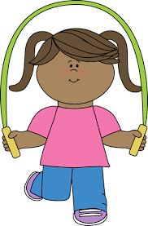The girl is … .
A. doing puzzles B. playing basketball C. playing hide-and-seek D. skipping rope
Đáp án: Chọn ý: D
164. Ảnh: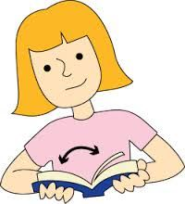Can you o_ _ _ your book?
Đáp án: pen
165. a/ is/ This/ red/ book./
Đáp án: This is a red book.
166. Nice to ... you, Mary.
A. meeting B. meets C. meet D. met
Đáp án: meet
167. Do/ any/ have/ you/ toys?/
Đáp án: Do you have any toys?
168. What sp_ _ _ do you play at break time? - I play badminton.
Đáp án: ort
169. What ________ _________ name?
A. are - their B. is - she C. is - his D. are - your
Đáp án: is - his
170. Ảnh:There is a lovely golden _ _ _ _ in a bowl
Đáp án: fish
171. _ _ _ _ do you do at school?
Đáp án: what
172. Would you _ _ _ _ some water?
Đáp án: like
173. Good_ _ _ , Tom.
Đáp án: bye
174. new/ my/ She/ friend./ is/
Đáp án: She is my new friend.
175. R_ _ d after me, please.
Đáp án: ea
176. 'Are you a student?' - 'Yes, I _ _ .'
Đáp án: am
177. How old is his grandmother? - _______
A. She's fine. B. There are some tables in the room. C. She's sixty now. D. Thank you very much.
Đáp án: She's sixty now.
178. Choose the odd one out:
A. how B. hello C. hi D. good morning
Đáp án: how
179. Is your house big … small?
A. and B. or C. but D. of
Đáp án: or
180. does/ puzzles/ evening./ in the/ Thomas/
Đáp án: Thomas does puzzles in the evening.
181. Ảnh:Let’s count to t_ _ _ ty.
Đáp án: wen
182. My pencil/ table./ is on/ the/ case/
Đáp án: My pencil case is on the table.
183. Pick … your pencil, Colin.
A. on B. to C. up D. down
Đáp án: up
184. Is your classroom big? – No, it _ _ n’t.
Đáp án: is
185. Wr_ _ _ your name here, please.
Đáp án: ite
186. My bedroom is not big. It’s sm_ _ _ .
Đáp án: all
187. on/ There are/ the table./ five/ books/
Đáp án: There are five books on the table.
188. Are these _ _ _ _ posters? – Yes, they are my posters.
Đáp án: your
189. Linh: What ... is this bag? - Jame: It’s white.
A. you B. colour C. birthday D. old
Đáp án: colour
190. How o_ _ are you?
Đáp án: ld
191. St_ _ _ up, please.
Đáp án: and
192. _ _ you like playing football?
Đáp án: do
193. She is angry because they are too late _ _ _ the class.
Đáp án: for
194. Ảnh: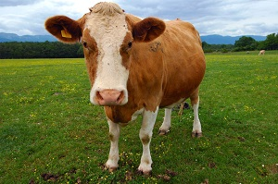C_ W
Đáp án: O
195. How many ... are there ? - There is one peach.
A. crayons B. peachs C. peach D. peaches
Đáp án: Chọn ý: D
196. Pick ... your notebook, Helen.
A. on B. to C. up D. and
Đáp án: up
197. two/ on/ pencils/ the table./ There are/
Đáp án: There are two pencils on the table.
198. My sister/ dolls./ with/ doesn't like/ playing/
Đáp án: My sister doesn't like playing with dolls.
199. Ảnh: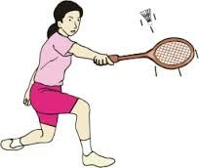Do you play bad_ _ _ _ _ _ at breaktime?
Đáp án: minton
200. A: How do you spell your … name?- B: … Carter.
A. family - It’s B. surname - I’m C. first - He’s D. full - That’s
Đáp án: family - It’s

KEY IOE K3 2023 - 2024 SỐ 20
1. Nghe:Nhấn giữ Ctrl và bấm chuột để nghe: _ _ _ _ _
Đáp án: small
2. How are you to_ _ y, David? – I’m fine, thank you.
Đáp án: da
3. Linda: Is this a book? - Phuong: ….
A. Yes, its B. Yes, it C. Yes, it is D. Yes, it isn’t
Đáp án: Yes, it is
4. Does/ stand/ over there?/ his uncle/
Đáp án: Does his uncle stand over there?
5. Clo_ e the door, please.
Đáp án: s
6. _ _ you have any comic books?
Đáp án: Do
7. Mary: Hello, Sam. … are you? - Sam: Hi, Mary. I’m very … . Thanks.
A. How - well B. Who - fine C. What – so-so D. Where - OK
Đáp án: How - well
8. What/ sister's/ your/ name?/ is/
Đáp án: What is your sister's name?
9. T_ _ _ are my uncle and aunt.
Đáp án: hey
10. Which word has the underlined part pronounced LIKE the letter A in FATHER
A. chair B. eraser C. table D. garden
Đáp án: Chọn ý: D
11. Good af_ _ _ _ _ _ _ Mr. Smith.
Đáp án: ternoon
12. Yes, _ _ is a new notebook.
Đáp án: it
13. Are you happy?
A. Yes, I am. B. Yes, am. C. Yes, I I’m. D. Yes, it’s me.
Đáp án: Yes, I am.
14. Listen/ the/ to/ teacher/ please./
Đáp án: Listen to the teacher please.
15. Ảnh: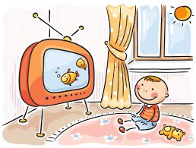The children like watching … .
A. TV B. music C. radio D. books
Đáp án: TV
16. Nghe:Nhấn giữ Ctrl và bấm chuột để nghe: It’s my _ _ _ _ _ _ _ _ room.
Đáp án: computer
17. Billy: Are they your pencils? - Minh: No, they ... .They’re my pens.
A. don’t B. have C. do D. aren’t
Đáp án: Chọn ý: D
18. How … is your grandmother? – She’s 74 years old.
A. young B. old C. much D. many
Đáp án: old
19. … are my classmates.
A. This B. That C. These D. There
Đáp án: These
20. your/ really/ Is/ school/ big?/
Đáp án: Is your school really big?
21. Ảnh:It's __ the box.
A. in B. on C. behind D. under
Đáp án: in
22. Jacob/ is fifteen./ isn't/ fourteen. He/
Đáp án: Jacob isn't fourteen. He is fifteen.
23. Nghe:Nhấn giữ Ctrl và bấm chuột để nghe: The monkey has ___ at the front of its head.
A. ears B. eyes C. nose D. mouth
Đáp án: eyes
24. Nghe:Nhấn giữ Ctrl và bấm chuột để nghe: Listen and tick:
A. close B. old C. cold D. rose
Đáp án: close
25. Put/ pencils/ your/ away,/ children./
Đáp án: Put your pencils away, children.
26. How o_ _ are you?
Đáp án: ld
27. are./ Here/ you/
Đáp án: Here you are.
28. like/ those/ I/ pictures.
Đáp án: I like those pictures.
29. Choose the letter(s) to make a correct word: par__t
A. ao B. ra C. or D. ro
Đáp án: Chọn ý: D
30. That is _ bicycle.
Đáp án: a
31. Do you like _______?
A. play football B. playing football C. to playing football D. to play the football
Đáp án: playing football
32. That ... a chair.
A. is B. am C. it D. are
Đáp án: is
33. How _ _ _ _ pens are there in your pencil case?
Đáp án: many
34. Xuan: How _ _ _ you, Lan? - Lan: Fine, thanks.
Đáp án: are
35. Ảnh:My Mom puts my clothes in the wardr_ _ _ .
Đáp án: obe
36. Is the_ _ a dog? – No, there is not.
Đáp án: re
37. Do you like my new ball? - _ _ _ , I do.
Đáp án: yes
38. You are welc_ me.
Đáp án: o
39. your/ sister's/ What/ name?/ is/
Đáp án: What is your sister's name?
40. Look _ _ the picture, John. This is my sister.
Đáp án: at
41. I smile when I am hap_ _ .
Đáp án: py
42. Ảnh: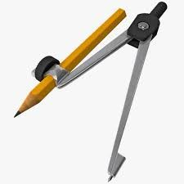Is this your …, Ron?
A. compass B. ruler C. pencil D. paint
Đáp án: compass
43. … does your father do in his free time? – He plays tennis.
A. What B. Who C. When D. Where
Đáp án: What
44. to school/ goes/ morning./ every/ Daisy/
Đáp án: Daisy goes to school every morning.
45. Jim can speak Eng_ _ _ h but cannot speak Vietnamese.
Đáp án: lis
46. Phong ____ a new school bag.
A. have B. do C. has D. does
Đáp án: has
47. ... is she? – She’s Ms. Mitchell. She’s my new teacher.
A. Who’s B. What C. What’s D. Who
Đáp án: Chọn ý: D
48. At break time, we ___ different games and sports.
A. do B. get C. go D. play
Đáp án: Chọn ý: D
49. How/ the/ weather/ is/ today?/
Đáp án: How is the weather today?
50. Nice to ... you, Mary.
A. meeting B. meets C. meet D. met
Đáp án: meet
51. many/ at break time./ play/ different games/ The children/
Đáp án: The children play many different games at break time.
52. Linda ______ swim.
A. cans B. is C. plays D. can
Đáp án: Chọn ý: D
53. it?/ is/ book/ What/
Đáp án: What book is it?
54. Ảnh: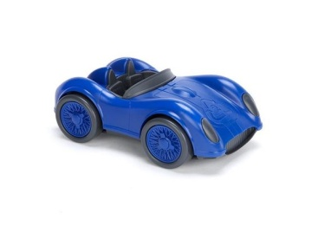This is my new car toy. It’s _ _ _ _ .
Đáp án: blue
55. Nghe:Nhấn giữ Ctrl và bấm chuột để nghe: A ____
A. CANDY B. PEN C. CAKE D. BOOK
Đáp án: CAKE
56. … school is that? – It’s Khuong Mai primary school.
A. What B. Who C. How D. Where
Đáp án: What
57. Choose the odd one out
A. Photo B. Teacher C. Picture D. Poster
Đáp án: Teacher
58. your/ father?/ How/ is/ old/
Đáp án: How old is your father?
59. How/ many/ are/ there?/ rulers/
Đáp án: How many rulers are there?
60. I want to be a musician in _ _ _ future.
Đáp án: the
61. Tom is my best _ _ _ _ _ _ .
Đáp án: friend
62. Ảnh:Max’s favorite colour is _ _ _ _ _ .
Đáp án: green
63. Who’s that? – My _ _ _ _ ew, Johny.
Đáp án: neph
64. Nghe:Nhấn giữ Ctrl và bấm chuột để nghe: Tom is _ _ _ years old.
Đáp án: six
65. Choose the odd one out
A. Mother B. Father C. Teacher D. Grandmother
Đáp án: Teacher
66. want/ to/ I/ be/ a teacher./
Đáp án: I want to be a teacher.
67. Ảnh: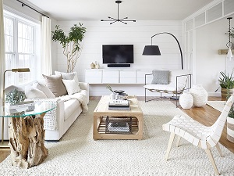Her father is in the livi_ _ room.
Đáp án: ng
68. My brother h_ _ a fish.
Đáp án: as
69. Ảnh:Tom, my little brother, likes doing _ _ _ _ _ es.
Đáp án: puzzl
70. Ảnh: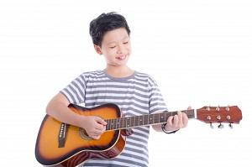The boy plays ____ very well.
A. the piano B. piano C. guitar D. the guitar
Đáp án: Chọn ý: D
71. This is my uncle. _ _ is clever.
Đáp án: he
72. That yo yo is gre_ n.
Đáp án: e
73. Ảnh: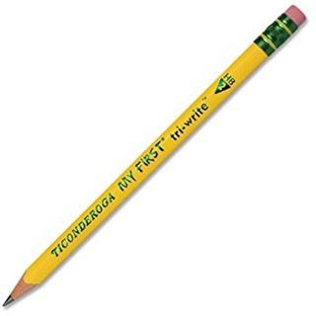What is this? - It’s a _ _ _ _ _ _ .
Đáp án: pencil
74. What pet do you have?
A. I have a doll. B. I have blue eyes. C. I have a pencil case. D. I have a cat.
Đáp án: Chọn ý: D
75. Nghe:Nhấn giữ Ctrl và bấm chuột để nghe: This is her grand_ _ _ _ _ _ .
Đáp án: mother
76. Do/ with a robot?/ you/ playing/ like/
Đáp án: Do you like playing with a robot?
77. Ảnh:Juliet has one hun_ _ _ _ stamps.
Đáp án: dred
78. Nghe:Nhấn giữ Ctrl và bấm chuột để nghe: Which number is NOT in the recording?
A. 16 B. 17 C. 18 D. 19
Đáp án: 16
79. Pick … your pencil, Colin.
A. on B. to C. up D. down
Đáp án: up
80. He has dinner _ _ home.
Đáp án: at
81. very/ badminton/ much./ like/ I/
Đáp án: I like badminton very much.
82. '_________ are you?' - 'I’m 8 years old.'
A. How B. How old C. What D. How age
Đáp án: How old
83. David can play ... .
A. desk B. chair C. pencil D. football
Đáp án: Chọn ý: D
84. My _ _ _ _ is Linda.
Đáp án: name
85. Is/ eraser?/ this/ an/
Đáp án: Is this an eraser?
86. Ảnh: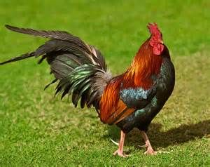CHIC_ _ _
Đáp án: KEN
87. Is this a ch_ ir? - Yes, it is.
Đáp án: a
88. This is my new f_ _ _ _ d, Tony.
Đáp án: rien
89. our/ clean/ room./ Let's/
Đáp án: Let's clean our room.
90. Let’s ... English.
A. say B. speak C. listen D. show
Đáp án: speak
91. Great to s_ _ you.
Đáp án: ee
92. How m_ _ _ dogs do you have?
Đáp án: any
93. This _ _ my new book.
Đáp án: is
94. Ảnh:_ _ _ _ is good for your health.
Đáp án: fish
95. Good_ _ _ . See you again.
Đáp án: bye
96. Why do you want _ _ go to the post office?
Đáp án: to
97. have/ dolls./ I/ two/
Đáp án: I have two dolls.
98. How/ do you/ have?/ many/ erasers/
Đáp án: How many erasers do you have?
99. Let’s _ _ _ _ badminton.
Đáp án: play
100. Your/ mother/ is/ nice.
Đáp án: Your mother is nice.
101. Nghe:Nhấn giữ Ctrl và bấm chuột để nghe: Do you go to school in the _ _ _ _ _ _ _ _ _ ?
Đáp án: afternoon
102. Nghe:Nhấn giữ Ctrl và bấm chuột để nghe: Listen and tick the word(s) you hear:
A. draw B. write C. see D. hear
Đáp án: draw
103. Nghe:Nhấn giữ Ctrl và bấm chuột để nghe: Today is Emily’s _ _ _ _ _ birthday.
Đáp án: third
104. Nghe:Nhấn giữ Ctrl và bấm chuột để nghe: Sue is in the … room.
A. living B. dining C. sitting D. bed
Đáp án: living
105. Is … a chair? - Yes, it is.
A. are B. it C. it’s D. his
Đáp án: it
106. It's not my pen. It's y_ _ _ pen.
Đáp án: our
107. Nghe:Nhấn giữ Ctrl và bấm chuột để nghe: How many ____ are there on your farm?
A. animals B. notebooks C. animal D. pencil
Đáp án: animals
108. Ảnh: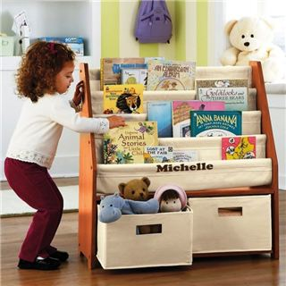Jennifer gets a book from a book_ _ _ _ _ .
Đáp án: shelf
109. _ _ _ _ is the date today, Sam?
Đáp án: What
110. Where ________? - Behind my house.
A. are your bikes B. is your bikes C. are your bike D. your bikes
Đáp án: are your bikes
111. How are you today, Peter? – I’m ..., thanks.
A. nice B. nice’s C. fine D. fine’s
Đáp án: fine
112. singing/ much./ very/ like/ I/
Đáp án: I like singing very much.
113. Max and his friends/ in the/ badminton/ play/ playground./
Đáp án: Max and his friends play badminton in the playground.
114. My brother is th_ _ e years old.
Đáp án: re
115. Choose the odd one out
A. Games B. Swimming C. Skipping D. Chess
Đáp án: Games
116. ____ many trees are there in the garden?
A. How B. What C. Why D. Which
Đáp án: How
117. Give me some more honey, please. - H_ _ _ you are.
Đáp án: ere
118. Nghe:Nhấn giữ Ctrl và bấm chuột để nghe: My school _ _ _ is very long.
Đáp án: bus
119. Nghe:Nhấn giữ Ctrl và bấm chuột để nghe: _ _ _ _ _ _ _ _ _ _
Đáp án: basketball
120. Do you have any pets?
A. Yes, I am. I have two parrots. B. Yes, I have. I have a yo-yo. C. Yes, I do. I have one cat and one rabbit. D. Yes. I don’t have any pets.
Đáp án: Yes, I do. I have one cat and one rabbit.
121. Which is your school? – This _ _ _ .
Đáp án: one
122. Peter has _ _ work all day in the factory.
Đáp án: to
123. to sing/ We/ like/ song./ English
Đáp án: We like to sing English song.
124. The park is large _ _ _ new.
Đáp án: and
125. Ảnh: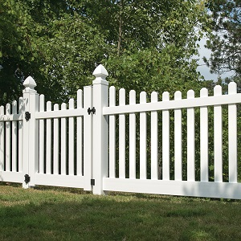What colour is the fence?
A. Blue B. Black C. White D. Yellow
Đáp án: White
126. room/ Is/ large/ your/ or narrow?/
Đáp án: Is your room large or narrow?
127. Choose the INCORRECT word or phrase in the following sentence: These are a cup on the table.
A. These are B. cup C. on D. table
Đáp án: These are
128. Choose the odd one out.
A. numbers B. twenty C. thirteen D. seven
Đáp án: numbers
129. Which word has the underlined part pronounced LIKE the letter A in TABLE
A. library B. class C. plane D. chair
Đáp án: plane
130. are/ photos/ Those/ the old/ of my family./
Đáp án: Those are the old photos of my family.
131. ______ up, please!
A. Stand B. Sit C. Open D. Close
Đáp án: Stand
132. pupil?/ Do/ know/ you/ that
Đáp án: Do you know that pupil?
133. Do you like eating …, Chi?
A. fish B. fishes C. fishs D. fishies
Đáp án: fish
134. posters?/ Are/ these/ our/
Đáp án: Are these our posters?
135. My/ is/ grandmother/ old.
Đáp án: My grandmother is old.
136. Let’s chan_ .
Đáp án: t
137. Ảnh: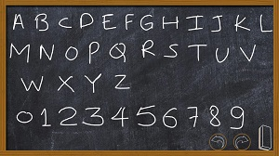Every classroom has a bl_ _ _ board
Đáp án: ack
138. He can play football ________ he can play chess, too.
A. but B. so C. and D. how
Đáp án: and
139. Does/ playing/ like/ volleyball?/ Lan/
Đáp án: Does Lan like playing volleyball?
140. Is that Peter’s pen? – Yes, it’s _ _ _ pen.
Đáp án: his
141. Nghe:Nhấn giữ Ctrl và bấm chuột để nghe: _ _ _ _ _ _ _ _ _
Đáp án: afternoon
142. My/ are red./ aren't/ yellow. They/ umbrellas/
Đáp án: My umbrellas aren't yellow. They are red.
143. Can you swim? - ... .
A. No, I can B. No, thanks C. Yes, I can’t D. Yes, I can
Đáp án: Chọn ý: D
144. Pick ... your notebook, Harry.
A. on B. to C. up D. down
Đáp án: up
145. Does your father like p_ _ _ ing sports?
Đáp án: lay
146. pen?/ your/ What/ is/ colour/
Đáp án: What colour is your pen?
147. Ảnh: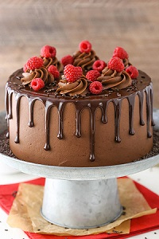CA_ _
Đáp án: KE
148. Every Tuesday, I play soccer ... school.
A. in B. for C. to D. after
Đáp án: Chọn ý: D
149. ... this a desk? – Yes, it is.
A. Is B. Are C. How D. What
Đáp án: Is
150. W_ _ te your name here, please.
Đáp án: ri
151. Listen _ _ me, please.
Đáp án: to
152. a/ Don’t/ make/ mess.
Đáp án: Don’t make a mess.
153. your/ Put/ down./ hand/
Đáp án: Put your hand down.
154. I have _ _ ice cream.
Đáp án: an
155. Nghe:Nhấn giữ Ctrl và bấm chuột để nghe: His name is ... .
A. Abramson B. Abraham C. Apranson D. Adramsun
Đáp án: Abramson
156. How _ _ _ you today?
Đáp án: are
157. We … football at break time.
A. do B. make C. play D. go
Đáp án: play
158. My sister likes milk very _ _ _ h.
Đáp án: muc
159. my/ in the/ morning./ house/ I clean/
Đáp án: I clean my house in the morning.
160. puts/ on the table./ She/ her bag/
Đáp án: She puts her bag on the table.
161. John./ is/ my/ new friend,/ This/
Đáp án: This is my new friend, John.
162. Ảnh:What colour is the grass?
A. Green B. Brown C. Yellow D. Red
Đáp án: Green
163. Nghe:Nhấn giữ Ctrl và bấm chuột để nghe: This is my _ _ _ _ _ _ .
Đáp án: school
164. My sister can _ _ _ e a bicycle.
Đáp án: rid
165. Come __, please!
A. at B. in C. for D. with
Đáp án: in
166. Which word has the underlined part pronounced LIKE the letter O in MOTHER
A. robot B. school C. forty D. front
Đáp án: Chọn ý: D
167. say?/ cat/ What/ a/ does/
Đáp án: What does a cat say?
168. _ _ _ your books pink? – Yes, they are.
Đáp án: Are
169. I/ a/ at me./ monkey looking/ see/
Đáp án: I see a monkey looking at me.
170. My/ are/ the table./ on/ pencils/
Đáp án: My pencils are on the table.
171. to/ gym./ Let’s/ the/ go/
Đáp án: Let’s go to the gym.
172. I like my school _ _ _ _ much.
Đáp án: very
173. Are those your notebooks? - No, ... .
A. it is B. it isn’t C. they are D. they aren’t
Đáp án: Chọn ý: D
174. What/ is/ school/ it?
Đáp án: What school is it?
175. Nice to ... you.
A. meet B. meet’s C. meets D. to meet
Đáp án: meet
176. Listen ... the teacher, please.
A. on B. in C. to D. for
Đáp án: to
177. How … students are there in your classroom?
A. much B. many C. more D. some
Đáp án: many
178. Nghe:Nhấn giữ Ctrl và bấm chuột để nghe: Today is Carla’s _ _ _ _ _ _ birthday.
Đáp án: eighth
179. it/ school/ bag?/ your/ Is/
Đáp án: Is it your school bag?
180. Can you drink ...? - Yes, I can.
A. orange juice B. rice C. chicken D. bread
Đáp án: orange juice
181. She is angry because they are too late _ _ _ the class.
Đáp án: for
182. W_ _ is that? – That’s my sister.
Đáp án: ho
183. Look … the picture, Mary.
A. to B. on C. for D. at
Đáp án: Chọn ý: D
184. The fish/ are swimming/ pond./ in the/
Đáp án: The fish are swimming in the pond.
185. Is this your green ruler? No, it is _ _ _ .
Đáp án: not
186. Are you a student or a teacher?
A. Yes, I am. B. No, I am not. C. I’m a student. D. Yes, I.
Đáp án: I’m a student.
187. Ảnh:She has a beautiful _ _ _ _ .
Đáp án: doll
188. Ảnh:You use your ____ to see.
A. eyes B. head C. arm D. ears
Đáp án: eyes
189. Listen/ and/ number./
Đáp án: Listen and number.
190. Wh_ _ _ are your pens? - They're in my pencil case.
Đáp án: ere
191. Lan: What are they? Huong: They are my ... .
A. teachers B. friends C. pencil cases D. Lan and Mai
Đáp án: pencil cases
192. I’m fine, thanks. ... you?
A. End B. And C. On D. Ten
Đáp án: And
193. How are …? - … am fine, thanks.
A. they / He B. we / We C. you / I D. him / He
Đáp án: you / I
194. How/ old/ is/ grandfather?/ your
Đáp án: How old is your grandfather?
195. They are my _ _ _ _ tives.
Đáp án: rela
196. Nghe:Nhấn giữ Ctrl và bấm chuột để nghe: Listen and tick:
A. sunny B. Sunday C. summer D. seven
Đáp án: Sunday
197. your/ Open/ please./ books,/
Đáp án: Open your books, please.
198. Ảnh: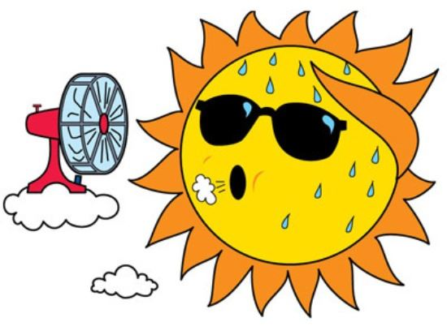It’s _ _ _ outside.
Đáp án: hot
199. This is m_ ruler.
Đáp án: y
200. his/ blue?/ Is/ pencil case/
Đáp án: Is his pencil case blue?

KEY IOE K3 2023 - 2024 SỐ 21
1. sofa./ need/ I/ new/ a/
Đáp án: I need a new sofa.
2. Nghe:Nhấn giữ Ctrl và bấm chuột để nghe: Meg is _ _ _ _ _ years old.
Đáp án: eight
3. My father raises some fish in the _____.
A. garden B. forest C. pond D. yard
Đáp án: pond
4. the sky./ kites/ in/ There are/ six/
Đáp án: There are six kites in the sky.
5. How many months are there in a year?
A. 10 B. 11 C. 12 D. 13
Đáp án: 12
6. Nghe:Nhấn giữ Ctrl và bấm chuột để nghe: Ben’s _ _ _ _ _ years old today.
Đáp án: seven
7. I … a blue pencil and a white ruler.
A. has B. have C. don’t have D. doesn’t have
Đáp án: have
8. is/ pink/ a/ book./ This/
Đáp án: This is a pink book.
9. Ảnh:The children like building a sand_ _ _ _ _ _ on the beach.
Đáp án: castle
10. What time _ _ _ _ the library open?
Đáp án: does
11. Choose the odd one out.
A. numbers B. twenty C. thirteen D. seven
Đáp án: numbers
12. There are/ many/ in/ flowers/ the garden./
Đáp án: There are many flowers in the garden.
13. Choose the letter(s) to make a correct word: G__NDFATHER
A. AR B. OR C. RO D. RA
Đáp án: Chọn ý: D
14. Choose the odd one out:
A. am B. is C. are D. this
Đáp án: Chọn ý: D
15. My class is …: ten girls and eleven boys.
A. nice B. tidy C. big D. new
Đáp án: big
16. Let’s ... English.
A. say B. speak C. tell D. sing
Đáp án: speak
17. Nghe:Nhấn giữ Ctrl và bấm chuột để nghe: Listen and tick:
A. hat B. hot C. red D. cat
Đáp án: hat
18. Which … their pencil sharpeners?
A. are B. am C. is D. have
Đáp án: are
19. Choose the odd one out:
A. play B. quiet C. talk D. stand
Đáp án: quiet
20. This is ... orange.
A. a B. an C. is D. are
Đáp án: an
21. B_ _ . See you later.
Đáp án: ye
22. This is m_ pen. It’s not your pen.
Đáp án: y
23. Nghe:Nhấn giữ Ctrl và bấm chuột để nghe: The ____ watch is mine.
A. blue B. yellow C. black D. white
Đáp án: yellow
24. She/ friend./ my/ new/ is/
Đáp án: She is my new friend.
25. Mary ... to school every morning.
A. go B. go’s C. goes D. goes to
Đáp án: goes
26. Do you/ stamps?/ want/ these/
Đáp án: Do you want these stamps?
27. Which is your school? – This _ _ _ .
Đáp án: one
28. Your father’s brother is your _ _ _ _ _ .
Đáp án: uncle
29. Lan's/ How/ is/ brother?/ old/
Đáp án: How old is Lan's brother?
30. There are four people _ _ my family.
Đáp án: in
31. Ảnh:He is wearing an o_ _ _ _ _ T-shirt.
Đáp án: range
32. in/ Is there/ your school?/ one garden/
Đáp án: Is there one garden in your school?
33. Ảnh: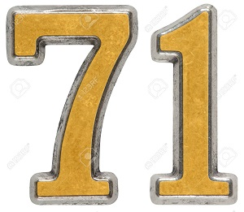My grandfather is ______ years old.
A. seventeen B. seventy C. seventy-one D. seven-one
Đáp án: seventy-one
34. years/ My brother/ eleven/ is/ old./
Đáp án: My brother is eleven years old.
35. … does your father do in his free time? – He plays tennis.
A. What B. Who C. When D. Where
Đáp án: What
36. Nghe:Nhấn giữ Ctrl và bấm chuột để nghe: _ _ _ _ _ _ _ _
Đáp án: bathroom
37. We/ love/ very much./ break time/
Đáp án: We love break time very much.
38. ______ my uncle next to my father.
A. They are B. There are C. It is D. Is there
Đáp án: It is
39. Is this ... classroom?
A. are B. a C. am D. an
Đáp án: a
40. Which sentence is correct?
A. Santa Claus flying over the town. B. Santa Claus is riding his sleigh. C. Santa Claus is ride a reindeer. D. Santa Claus is walking in the sky.
Đáp án: Santa Claus is riding his sleigh.
41. This is ... eraser. It’s not my eraser.
A. this B. he C. me D. your
Đáp án: Chọn ý: D
42. pencil sharpener?/ is/ What/ colour/ your
Đáp án: What colour is your pencil sharpener?
43. Ảnh: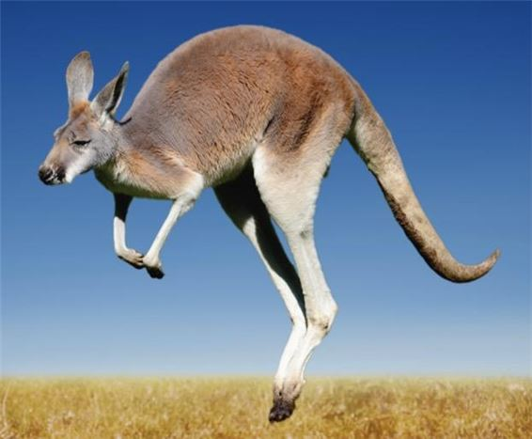We can see a _ _ _ _ _ _ _ _ in Australia.
Đáp án: kangaroo
44. of milk./ a glass/ is/ It/
Đáp án: It is a glass of milk.
45. in a/ coffee shop./ cakes and/ We eat/ drink tea/
Đáp án: We eat cakes and drink tea in a coffee shop.
46. do/ a/ you/ Can/ puzzle?/
Đáp án: Can you do a puzzle?
47. Ảnh:Shhh! The baby is _ _ _ _ _ _ _ _ .
Đáp án: sleeping
48. _ _ _ is she? – She’s Ms. Wilson. She’s my English teacher.
Đáp án: Who
49. Goodb_ e, Tommy. See you later.
Đáp án: y
50. Nghe:Nhấn giữ Ctrl và bấm chuột để nghe: Which number is NOT in the recording?
A. 16 B. 17 C. 18 D. 19
Đáp án: 16
51. My elder brother h_ _ a goldfish.
Đáp án: as
52. Choose the odd one out:
A. bag B. book C. big D. pencil
Đáp án: big
53. Ảnh: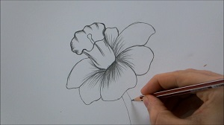D_ _ _ a flower on your sheet.
Đáp án: raw
54. away,/ books/ please./ Put/ your/
Đáp án: Put your books away, please.
55. What can you do … English? – I can count to 100, sing an English song.
A. in B. at C. on D. by
Đáp án: Chọn ý: D
56. Good af_ _ _ _ _ _ _ Mr. Smith.
Đáp án: ternoon
57. A: Is your school …? – B: Yes, there are four big buildings and a big schoolyard.
A. small B. little C. large D. narrow
Đáp án: large
58. Is that y_ _ _ nephew?
Đáp án: our
59. The big tree is beh_ nd my house.
Đáp án: i
60. Ảnh: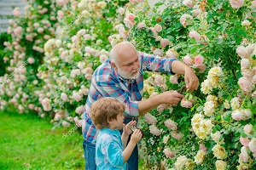My grand_ _ _ _ er is in the garden.
Đáp án: fath
61. the/ sentences./ Reorder/
Đáp án: Reorder the sentences.
62. Ảnh: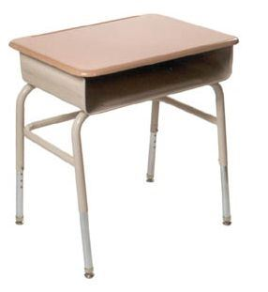This is your …, Tom.
A. bench B. desk C. chair D. board
Đáp án: desk
63. The flowers are colourful in _ _ _ garden.
Đáp án: the
64. Nghe:Nhấn giữ Ctrl và bấm chuột để nghe: They’ve got two _ _ _ sins, Amy and Leo.
Đáp án: cou
65. Where _ _ you study, Trang?
Đáp án: do
66. Nghe:Nhấn giữ Ctrl và bấm chuột để nghe: Look at _ _ _ _ photo.
Đáp án: this
67. Ảnh:Come and see the pho_ _ of my family.
Đáp án: to
68. How many days are there in _ week?
Đáp án: a
69. Nghe:Nhấn giữ Ctrl và bấm chuột để nghe: My new _ _ _ _ _ _ is Adam.
Đáp án: friend
70. Nghe:Nhấn giữ Ctrl và bấm chuột để nghe: This is her grand_ _ _ _ _ _ .
Đáp án: mother
71. Nghe:Nhấn giữ Ctrl và bấm chuột để nghe: Sue is in the _ _ _ _ _ _ car
Đáp án: yellow
72. How many/ the box?/ pens/ are there/ in
Đáp án: How many pens are there in the box?
73. I like my school _ _ _ _ much.
Đáp án: very
74. Ảnh:ELEPH_ _ _
Đáp án: ANT
75. friends/ are/ France./ Her/ from
Đáp án: Her friends are from France.
76. Mary often gets _ _ early in the morning.
Đáp án: up
77. Nghe:Nhấn giữ Ctrl và bấm chuột để nghe: She’s got _ _ _ _ _ eyes.
Đáp án: brown
78. W_ _ _ _ is Mary from? - She’s from England.
Đáp án: here
79. Choose the odd one out:
A. Vietnam B. England C. America D. Vietnamese
Đáp án: Chọn ý: D
80. Ảnh: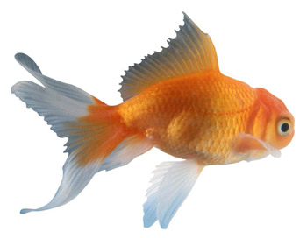F_ SH
Đáp án: I
81. Pick … your pencil, John.
A. on B. in C. of D. up
Đáp án: Chọn ý: D
82. Is this your bag? - … .
A. No, thanks B. Sure C. No, it is D. Yes, it is
Đáp án: Chọn ý: D
83. Nghe:Nhấn giữ Ctrl và bấm chuột để nghe: His sister’s _ _ _ _ is in the tree.
Đáp án: kite
84. Ảnh:You are in the water to play this sport. What sport is it?
A. Badminton B. Volleyball C. Table tennis D. Swimming
Đáp án: Chọn ý: D
85. We go to school ... .
A. alone B. together C. gether D. by me
Đáp án: together
86. Write the an_ _ _ rs, please.
Đáp án: swe
87. Goo_ _ _ e. See you tomorrow, students.
Đáp án: dby
88. My mother li_ es jogging.
Đáp án: k
89. like?/ you/ colour do/ What/
Đáp án: What colour do you like?
90. Nghe:Nhấn giữ Ctrl và bấm chuột để nghe: The ___ T-shirt is William's.
A. red B. yellow C. black D. white
Đáp án: black
91. My bedroom is not big. It’s sm_ _ _ .
Đáp án: all
92. I ... my teeth in the morning.
A. do B. brush C. have D. does
Đáp án: brush
93. Her ruler _ _ n't new. It's old.
Đáp án: is
94. Is your classroom big? – No, it _ _ n’t.
Đáp án: is
95. basketball/ Tuan/ after school./ with his friend/ plays/
Đáp án: Tuan plays basketball with his friend after school.
96. That is my mother. _ _ _ is a teacher.
Đáp án: she
97. a/ flower./ red/ This/ is/
Đáp án: This is a red flower.
98. your mother?/ Is/ next to/ your aunt/
Đáp án: Is your aunt next to your mother?
99. Ảnh:That _ _ _ _ _ pen is not mine.
Đáp án: green
100. is/ This/ ruler/ pink.
Đáp án: This ruler is pink.
101. Those/ are/ big/ clouds.
Đáp án: Those are big clouds.
102. not/ The/ schoolyard/ is/ large./
Đáp án: The schoolyard is not large.
103. _ _ _ are you? - I'm John's brother.
Đáp án: Who
104. Nghe:Nhấn giữ Ctrl và bấm chuột để nghe: Listen and tick the word(s) you hear:
A. a pet B. a bed C. a bird D. a bage
Đáp án: a bird
105. How many flowers _ _ _ there in the vase?
Đáp án: are
106. every/ do you/ evening?/ do/ What/
Đáp án: What do you do every evening?
107. that/ bench./ on/ is/ The cat/
Đáp án: The cat is on that bench.
108. _ _ _ _ is your name? - My name is Jerry.
Đáp án: What
109. two rulers/ in/ school bag./ my/ There are/
Đáp án: There are two rulers in my school bag.
110. new/ teacher?/ the/ Is/ she/
Đáp án: Is she the new teacher?
111. Nice to meet you. - ... .
A. Goodbye B. See you later C. Nice to meet you, too D. Good morning
Đáp án: Nice to meet you, too
112. eraser./ a/ is/ blue/ It/
Đáp án: It is a blue eraser.
113. Ảnh:fourteen, _______, sixteen.
A. fiveteen B. fifteen C. fifty D. fourty
Đáp án: fifteen
114. Ảnh:It is a beautiful purp_ _ flower.
Đáp án: le
115. How are you? - I _ _ fine.
Đáp án: am
116. Ảnh: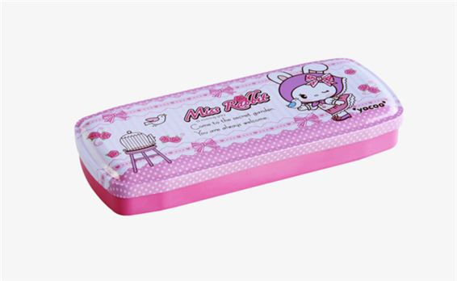Her pencil _ _ _ _ is pink.
Đáp án: case
117. Choose the incorrect word or phrase in the following sentence: They play badminton in break time.
A. play B. badminton C. in D. time
Đáp án: in
118. it/ bag?/ your/ school/ Is/
Đáp án: Is it your school bag?
119. is/ my/ friend,/ too./ He/
Đáp án: He is my friend, too.
120. Ảnh: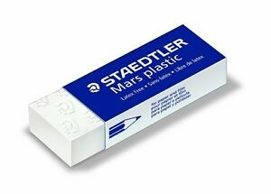It's Alex's ru_ _ _ _ .
Đáp án: bber
121. Wash/ your/ hands,/ Tom.
Đáp án: Wash your hands, Tom.
122. Does she have any _______?
A. banana B. bananas C. bananas’ D. banana’s
Đáp án: bananas
123. Raise your ..., please.
A. hand B. sit C. stand D. open
Đáp án: hand
124. rulers/ are/ How/ there?/ many/
Đáp án: How many rulers are there?
125. Linda: How are you? - Jane: I’m _ _ _ _ , thanks.
Đáp án: fine
126. Teacher: Is your school library big? - Tommy: No, it … .
A. don’t B. am not C. doesn’t D. isn’t
Đáp án: Chọn ý: D
127. Do you like _ oing Maths?
Đáp án: d
128. your/ pencils/ Put/ away,/ children./
Đáp án: Put your pencils away, children.
129. My school bag is _ _ all. Your school bag is big.
Đáp án: sm
130. Yes, _ _ is a new notebook.
Đáp án: it
131. David?/ sister,/ this/ your/ Is/
Đáp án: Is this your sister, David?
132. spell/ of this animal?/ How/ do you/ the name
Đáp án: How do you spell the name of this animal?
133. _ _ _ _ _ are you from? - I'm from Vietnam.
Đáp án: where
134. I am .... I want a cake.
A. thirsty B. tired C. happy D. hungry
Đáp án: Chọn ý: D
135. Four and five are n_ _ _ .
Đáp án: ine
136. Ảnh: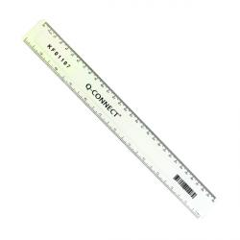R_ _ _ _
Đáp án: ULER
137. ____ do you like? - This one.
A. What B. Where C. How D. Which
Đáp án: What
138. What is your favourite ...? – I like milk very much.
A. food B. drink C. subject D. colour
Đáp án: drink
139. They aren't her books. They are _ _ s books.
Đáp án: hi
140. These are my … .
A. book B. pencil case C. poster D. bags
Đáp án: Chọn ý: D
141. This is m_ cat.
Đáp án: y
142. My mother buys many school things such as notebooks, pens, pencils and _________.
A. hamburger B. shoes C. balls D. rubbers
Đáp án: Chọn ý: D
143. They like frogs … they don’t like spiders.
A. but B. and C. so D. or
Đáp án: but
144. Ảnh: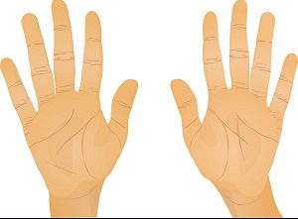Two ha_ _ _ have ten fingers.
Đáp án: nds
145. Nam: May I _ _ out? - Teacher: Yes, please.
Đáp án: go
146. break time./ hide-and-seek/ Let's/ play/ at
Đáp án: Let's play hide-and-seek at break time.
147. Odd one out:
A. fish B. dolphin C. monkey D. shark
Đáp án: monkey
148. Nghe:Nhấn giữ Ctrl và bấm chuột để nghe: Listen and tick:
A. pen B. pencil C. pen case D. ruler
Đáp án: pen
149. Nghe:Nhấn giữ Ctrl và bấm chuột để nghe: Polly is my best _ _ _ _ _ _ .
Đáp án: friend
150. Which word is odd one out?
A. pig B. men C. chicken D. fish
Đáp án: men
151. Ảnh: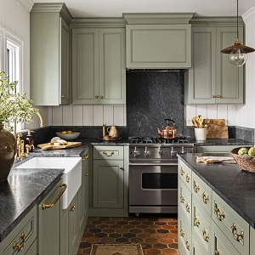His mother is in the kitch_ _ .
Đáp án: en
152. Ảnh:Let's make paper bo_ ts.
Đáp án: a
153. 'Do you play badminton at break time?' - '_________.'
A. No, you can’t. B. Yes, you do. C. Yes, I do. D. Yes, I am.
Đáp án: Yes, I do.
154. like/ English?/ Alice/ does/ Why/
Đáp án: Why does Alice like English?
155. My family have dinner in the ____.
A. living room B. bedroom C. basement D. dining room
Đáp án: Chọn ý: D
156. and sister./ brother/ my/ These/ are/
Đáp án: These are my brother and sister.
157. play/ Max and his friends/ badminton/ in the/ playground./
Đáp án: Max and his friends play badminton in the playground.
158. The _________ is Jane.
A. me B. boy C. girl D. she
Đáp án: girl
159. are/ the wall./ on/ pictures/ The/
Đáp án: The pictures are on the wall.
160. Are you a student or a teacher?
A. Yes, I am. B. No, I am not. C. I’m a student. D. Yes, I.
Đáp án: I’m a student.
161. What time …?
A. are they B. is it C. aren’t they D. isn’t it
Đáp án: is it
162. Can/ one to ten?/ you count/ from/
Đáp án: Can you count from one to ten?
163. What colour is this? - … .
A. It blue B. It’s blue C. Is blue D. It is a blue
Đáp án: It’s blue
164. Listen _____ repeat.
A. or B. and C. with D. now
Đáp án: and
165. Jane: What _ _ _ our is your desk? - Linda: It is pink.
Đáp án: col
166. How old is his grandmother? - _______
A. She's fine. B. There are some tables in the room. C. She's sixty now. D. Thank you very much.
Đáp án: She's sixty now.
167. A: Goodbye. - B: Bye. _________
A. See you tomorrow. B. Thank you. C. Sorry. D. Nice to meet you.
Đáp án: See you tomorrow.
168. How mu_ _ milk would you like?
Đáp án: ch
169. my/ is/ Living room/ favourite room.
Đáp án: Living room is my favourite room.
170. Would you _ _ _ _ some water?
Đáp án: like
171. Hamburger/ favourite/ my/ is/ food./
Đáp án: Hamburger is my favourite food.
172. Choose the incorrect word(s) in the following sentence: My uncle is thirty year old.
A. My B. is C. year D. old
Đáp án: year
173. Let’s listen _ _ some music.
Đáp án: to
174. Let’s make a cir_ le.
Đáp án: c
175. W_ _ _ _ is Mary from?
Đáp án: here
176. Peter: What are their …? - Hoa: Mai and Huong.
A. name B. names C. your name D. your names
Đáp án: names
177. Nghe:Nhấn giữ Ctrl và bấm chuột để nghe: _ _ _ _ _ _ _ _ _
Đáp án: badminton
178. _ _ you like playing football?
Đáp án: Do
179. Ảnh:She has a beautiful _ _ _ _ .
Đáp án: doll
180. At break time, we ___ different games and sports.
A. do B. get C. go D. play
Đáp án: Chọn ý: D
181. A: Do you like bananas? - B: ______
A. I like bananas. B. I don't like bananas. C. Yes, I do. D. Yes, I am.
Đáp án: Yes, I do.
182. John: Are you a student? - Jane: Yes,... .
A. Yes, I am B. I am C. I’m student D. Yes, I
Đáp án: I’m student
183. large./ The computer/ is/ room/
Đáp án: The computer room is large.
184. Nghe:Nhấn giữ Ctrl và bấm chuột để nghe: _ _ _ _ _ _
Đáp án: friend
185. Ảnh:What’s the weather like? - It’s _ _ _ _ _ .
Đáp án: rainy
186. Ảnh: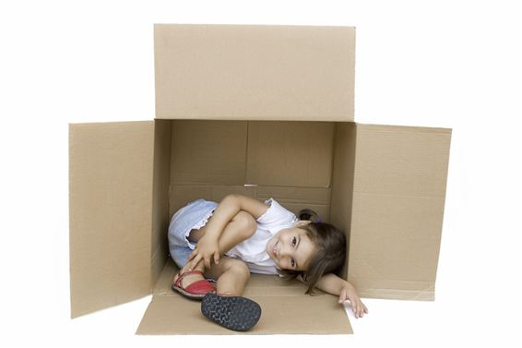The child is _ _ the box.
Đáp án: in
187. cat/ the/ sofa./ is on/ The/
Đáp án: The cat is on the sofa.
188. May I _ _ me in?
Đáp án: co
189. Ảnh: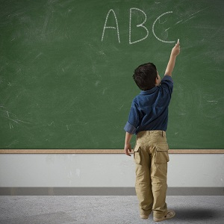He _____ some words on the blackboard.
A. listens B. writes C. goes D. plays
Đáp án: writes
190. my/ pens./ are/ new/ These/
Đáp án: These are my new pens.
191. David can play ... .
A. desk B. chair C. pencil D. football
Đáp án: Chọn ý: D
192. Choose the odd one out:
A. song B. subjects C. animal D. plant
Đáp án: subjects
193. Nghe:Nhấn giữ Ctrl và bấm chuột để nghe: _ _ _ _ _
Đáp án: brown
194. Lien: _ _ you like badminton? - Mary: Yes, I do.
Đáp án: Do
195. The board is big and n_ _ .
Đáp án: ew
196. How _ _ d is she? – She’s nine years old.
Đáp án: ol
197. are/ clouds./ big/ Those/
Đáp án: Those are big clouds.
198. Choose the INCORRECT word or phrase in the following sentence: These are Peter's picture on the shelf.
A. These B. picture C. on D. shelf
Đáp án: picture
199. my/ have/ I/ lunchbox./ don't/
Đáp án: I don't have my lunchbox.
200. Rai_ e your hand, please.
Đáp án: s

KEY IOE K3 2023 - 2024 SỐ 22
1. Please, give me some m_ _ e milk.
Đáp án: or
2. Nghe:Nhấn giữ Ctrl và bấm chuột để nghe: Listen and tick:
A. a plane B. a train C. a fan D. a chair
Đáp án: a train
3. Let's play hide-and-_ _ _ _ at break time.
Đáp án: seek
4. ... old is your sister? – She is nine years old.
A. When B. What C. Where D. How
Đáp án: Chọn ý: D
5. What do you usually do _ _ Saturday evenings, Mary?
Đáp án: on
6. is/ large./ room/ The/ very
Đáp án: The room is very large.
7. Ảnh: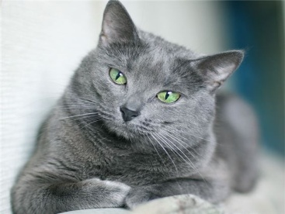My _ _ _ is grey.
Đáp án: cat
8. Jane: What _ _ _ our is your desk? - Linda: It is pink.
Đáp án: col
9. Every Tuesday, I play soccer ... school.
A. in B. for C. to D. after
Đáp án: Chọn ý: D
10. Nghe:Nhấn giữ Ctrl và bấm chuột để nghe: Listen and tick:
A. close B. old C. cold D. rose
Đáp án: close
11. Ảnh: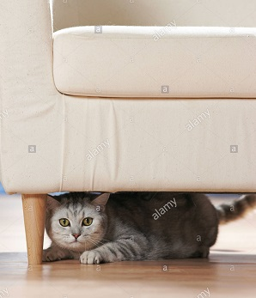It's under the ____.
A. book B. bookcase C. table D. sofa
Đáp án: Chọn ý: D
12. ______ my uncle next to my father.
A. They are B. There are C. It is D. Is there
Đáp án: It is
13. Choose the odd one out
A. Pictures B. Pencils C. Markers D. Crayons
Đáp án: Pictures
14. favourite/ subject./ my/ Music/ is/
Đáp án: Music is my favourite subject.
15. Come/ children./ in,/ please,/
Đáp án: Come in, please, children.
16. Choose the letter(s) to make a correct word: LIT_LE
A. F B. M C. N D. T
Đáp án: Chọn ý: D
17. brother's/ name?/ What/ is/ your/
Đáp án: What is your brother's name?
18. Is the_ _ a dog? – No, there is not.
Đáp án: re
19. Peter _ _ _ a brother. His name is Jack.
Đáp án: has
20. My schoo_ is small.
Đáp án: l
21. What sp_ _ _ do you play at break time? - I play badminton.
Đáp án: ort
22. Ảnh: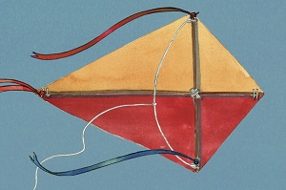Can you make a _ _ _ _ ?
Đáp án: kite
23. Nghe:Nhấn giữ Ctrl và bấm chuột để nghe: Listen and tick:
A. moon B. jump C. sun D. run
Đáp án: Chọn ý: D
24. ____ many trees are there in the garden?
A. How B. What C. Why D. Which
Đáp án: How
25. Ảnh: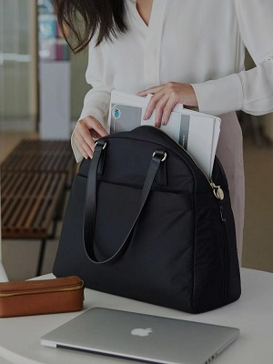The teacher comes in and puts her bag ___ the desk.
A. in B. at C. on D. to
Đáp án: on
26. June is the ... month of the year.
A. sixth B. fourth C. seventh D. eighth
Đáp án: sixth
27. _ _ _ old are you? - I’m seven years old.
Đáp án: How
28. blind man’s/ Let’s/ play/ bluff.
Đáp án: Let’s play blind man’s bluff.
29. Ảnh: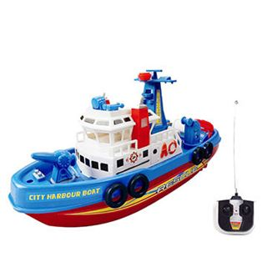The _ _ _ _ is beautiful.
Đáp án: ship
30. The fan/ on/ wall./ the/ is/
Đáp án: The fan is on the wall.
31. ... is your birthday? - It’s in July.
A. Where B. How C. When D. How old
Đáp án: When
32. Let’s speak Eng_ _ _ _ !
Đáp án: lish
33. hungry,/ Are/ you/ Henry?
Đáp án: Are you hungry, Henry?
34. They/ on the wall./ pictures/ three/ are/
Đáp án: They are three pictures on the wall.
35. How _ _ _ your dad and your mom?
Đáp án: are
36. Anne has long … hair.
A. nice B. curly C. slim D. sunny
Đáp án: curly
37. three/ have/ flowers./ I/
Đáp án: I have three flowers.
38. T_ _ _ are my uncle and aunt.
Đáp án: hey
39. a/ Is/ she/ student?
Đáp án: Is she a student?
40. Ảnh: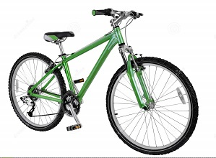I have a new ___. It's green.
A. bike B. car C. ship D. train
Đáp án: bike
41. _ _ my lunchbox, I have a banana and a sandwich.
Đáp án: In
42. Choose the letter(s) to make a correct word: __mputer
A. ca B. co C. sa D. sko
Đáp án: co
43. Nghe:Nhấn giữ Ctrl và bấm chuột để nghe: Which is NOT mentioned?
A. A bed B. A window C. A picture D. A bookshelf
Đáp án: A picture
44. Is she _______ years old?
A. for B. four C. fuor D.
Đáp án: four
45. Pictures of my family _ _ _ on the wall.
Đáp án: are
46. Nghe:Nhấn giữ Ctrl và bấm chuột để nghe: My brother is thir_ _ _ _ years old.
Đáp án: teen
47. __________ elephant has a long nose.
A. A B. An C. It D. All are incorrect.
Đáp án: An
48. What do you _ _ in your free time?
Đáp án: do
49. _________ - She's forty.
A. How many books are there? B. How old are you? C. What is her name? D. How old is she?
Đáp án: Chọn ý: D
50. Lien can sing _______ English songs.
A. an B. some C. this D. a
Đáp án: some
51. Nghe:Nhấn giữ Ctrl và bấm chuột để nghe: Which number is NOT in the recording?
A. 16 B. 17 C. 18 D. 19
Đáp án: 16
52. Ảnh: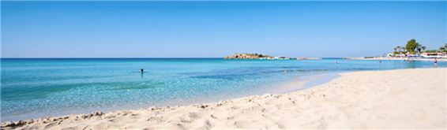We are on the _ _ _ _ _ because it’s very hot today.
Đáp án: beach
53. and/ that is/ her pencil./ This is/ my pen/
Đáp án: This is my pen and that is her pencil.
54. One and one is _ _ _ .
Đáp án: two
55. … is your school? – It’s at the corner of the street.
A. Who B. Where C. How D. What
Đáp án: Where
56. Ảnh: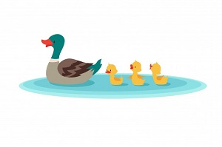The d_ _ _ swims in the pond.
Đáp án: uck
57. eight/ Peter/ old./ is/ years
Đáp án: Peter is eight years old.
58. Ảnh: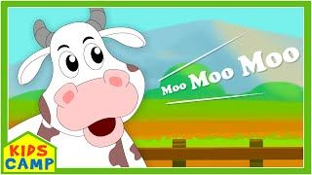The _ _ _ on the farm says 'moo moo moo'.
Đáp án: cow
59. Ảnh:That is the ph_ _ _ of my family.
Đáp án: oto
60. Choose the letter(s) to make a correct word: DE__
A. KS B. SK C. KA D. AK
Đáp án: SK
61. Nghe:Nhấn giữ Ctrl và bấm chuột để nghe: _ _ _ _ _ _
Đáp án: yellow
62. This is my/ pencil/ new/ box.
Đáp án: This is my new pencil box.
63. Jane: Are … your friends? - David: Yes, they are.
A. Peter B. Mary C. are D. Peter and Mary
Đáp án: Chọn ý: D
64. do you/ How/ spell/ your uncle's/ name?/
Đáp án: How do you spell your uncle's name?
65. Nghe:Nhấn giữ Ctrl và bấm chuột để nghe: Do you go to school in the _ _ _ _ _ _ _ _ _ ?
Đáp án: afternoon
66. My brother has t_ n pets.
Đáp án: e
67. My bedroom is not big. It’s ... .
A. a small B. small C. is small D. it’s small
Đáp án: small
68. Ảnh: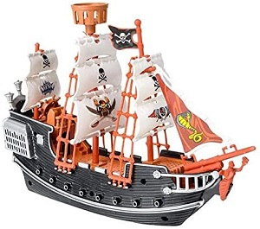I have a _ _ _ _ . It's my birthday present.
Đáp án: ship
69. I don’t/ on/ have/ Friday./ Art/
Đáp án: I don’t have Art on Friday.
70. Nice to m_ _ _ you, too.
Đáp án: eet
71. I have a cat _ _ _ a dog.
Đáp án: and
72. the/ Look/ at/ board.
Đáp án: Look at the board.
73. I like/ to/ on the radio./ listening/ fairy tales
Đáp án: I like listening to fairy tales on the radio.
74. Ảnh: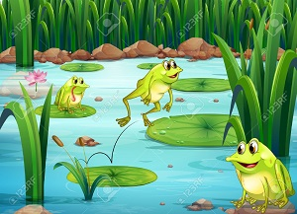The ____ are in the pond.
A. fish B. frogs C. chickens D. birds
Đáp án: frogs
75. Nghe:Nhấn giữ Ctrl và bấm chuột để nghe: This is Sue, Andy’s _ _ _ _ _ _ .
Đáp án: friend
76. Ảnh: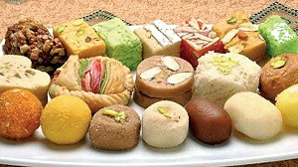SWE_ T
Đáp án: E
77. lamb./ has/ Marry/ little/ a/
Đáp án: Marry has a little lamb.
78. you/ Goodbye./ See/ later.
Đáp án: Goodbye. See you later.
79. Ảnh: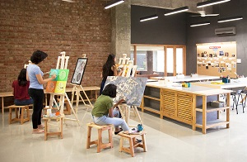That is the _ _ _ room.
Đáp án: art
80. - Alice: Who is …? - Mark: Who? - Alice: The girl over there.
A. this B. that C. there D. these
Đáp án: that
81. You are welc_ me.
Đáp án: o
82. Nghe:Nhấn giữ Ctrl và bấm chuột để nghe: Listen and tick:
A. moon B. man C. meet D. new
Đáp án: meet
83. Happy birthday ... you, Jenny.
A. at B. in C. to D. on
Đáp án: to
84. There _ _ _ many clouds in the sky.
Đáp án: are
85. Who is our new tea_ _ er?
Đáp án: ch
86. Tom _ _ _ born on October 24th.
Đáp án: was
87. Let’s … a song, children.
A. play B. take C. sing D. speak
Đáp án: sing
88. Look ____ this photo of my family. Do you guess how old I am?
A. in B. at C. on D. by
Đáp án: at
89. Ảnh: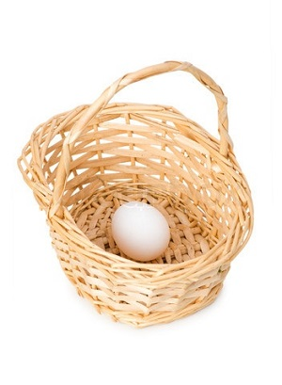There is an _ _ _ on the basket.
Đáp án: egg
90. blue/ eraser./ is/ It/ a/
Đáp án: It is a blue eraser.
91. His/ small./ old/ is/ house/
Đáp án: His old house is small.
92. kind/ doesn’t/ Tony/ of music./ like this/
Đáp án: Tony doesn’t like this kind of music.
93. this/ square/ box?/ a/ Is/
Đáp án: Is this a square box?
94. your/ Is/ in the wardrobe?/ blanket/
Đáp án: Is your blanket in the wardrobe?
95. How m_ _ y dogs do you have?
Đáp án: an
96. Choose the letter(s) to make a correct word: G__NDFATHER
A. AR B. OR C. RO D. RA
Đáp án: Chọn ý: D
97. playing chess/ like/ or football?/ you/ Do/
Đáp án: Do you like playing chess or football?
98. Nghe:Nhấn giữ Ctrl và bấm chuột để nghe: Listen and tick:
A. shy B. sit C. six D. soup
Đáp án: six
99. I like English very ... .
A. many B. much C. any D. how
Đáp án: much
100. My classroom is ... . It’s not small.
A. big B. a big C. the big D. a small
Đáp án: big
101. Lan/ Does/ like/ volleyball?/ playing
Đáp án: Does Lan like playing volleyball?
102. Plea_ _ _ to meet you!
Đáp án: sed
103. I _ _ _ _ books in the school library.
Đáp án: read
104. Are they/ the bed?/ Peter's balls/ under/
Đáp án: Are they Peter's balls under the bed?
105. … is this? – It’s my brother.
A. Who B. What C. How D. When
Đáp án: Who
106. the children?/ Where/ are/
Đáp án: Where are the children?
107. little sister/ is/ years old./ five/ My/
Đáp án: My little sister is five years old.
108. They ha_ _ two dogs.
Đáp án: ve
109. How are …? - … am fine, thanks.
A. they / He B. we / We C. you / I D. him / He
Đáp án: you / I
110. house/ is/ big./ not/ My/
Đáp án: My house is not big.
111. you/ like/ Do/ carrots?
Đáp án: Do you like carrots?
112. Ảnh:Uncle Tom is a _ _ _ _ _ driver.
Đáp án: truck
113. Do you have any pets? – Yes, I have … .
A. any B. some C. much D. no pets
Đáp án: some
114. Ảnh:My father is ______ years old.
A. thirty-eight B. forty-eight C. fourteen-eight D. fifteen-eight
Đáp án: forty-eight
115. ... your teeth, Tommy.
A. Read B. Listen C. Stand D. Brush
Đáp án: Chọn ý: D
116. Nghe:Nhấn giữ Ctrl và bấm chuột để nghe: Listen and tick the word(s) you hear:
A. a pen B. a pencil C. a bank D. a band
Đáp án: a pencil
117. Choose the letter(s) to make a correct word: ga__en
A. dd B. td C. rt D. rd
Đáp án: Chọn ý: D
118. Nghe:Nhấn giữ Ctrl và bấm chuột để nghe: _ _ _ _ your book.
Đáp án: open
119. Your mother’s sister is your … .
A. niece B. aunt C. sister D. relative
Đáp án: aunt
120. P_ t the words into the blanks.
Đáp án: u
121. Nghe:Nhấn giữ Ctrl và bấm chuột để nghe: Where is Mai?
A. She’s in her bedroom. B. She’s in the library. C. She’s in the kitchen. D. She’s in the garden.
Đáp án: She’s in the kitchen.
122. Say your n_ _ e, please.
Đáp án: am
123. my/ notebooks./ These/ not/ are/
Đáp án: These are not my notebooks.
124. Let’s dr_ _ a picture.
Đáp án: aw
125. Pick ... your books, please.
A. to B. on C. at D. up
Đáp án: Chọn ý: D
126. I want to play sports. Let’s go to the g_ _ .
Đáp án: ym
127. Peter: What _ _ _ _ _ _ is your pen? - Mary: It’s red.
Đáp án: colour
128. my/ bedroom./ is/ This/
Đáp án: This is my bedroom.
129. Nghe:Nhấn giữ Ctrl và bấm chuột để nghe: They are ____.
A. 12 B. 13 C. 14 D. 15
Đáp án: 13
130. me./ after/ read/ Please/
Đáp án: Please read after me.
131. May/ mom?/ open/ I/ the window,
Đáp án: May I open the window, mom?
132. Lan: What colour are your pencils? - Huong: They ... blue and green
A. do B. don’t C. are D. is
Đáp án: are
133. Do you have ... on Friday? – No, I have English.
A. Informatics B. cakes C. desks D. books
Đáp án: Informatics
134. Do you … skateboarding?
A. like B. liking C. likes D. to like
Đáp án: like
135. John./ my/ This/ new friend,/ is/
Đáp án: This is my new friend, John.
136. My pets _ _ _ beautiful.
Đáp án: are
137. English/ my/ teacher./ is/ Mr. John/
Đáp án: Mr. John is my English teacher.
138. What is this? - ….
A. His name is Rod B. It is a ruler C. It’s an ruler D. It’s Rod
Đáp án: It is a ruler
139. Choose the INCORRECT word or phrase in the following sentence: Three little cat are in the yard.
A. cat B. are C. in D. yard
Đáp án: cat
140. She plays hide-and-_ _ _ _ in the garden.
Đáp án: seek
141. Are you happy?
A. Yes, I am. B. Yes, am. C. Yes, I I’m. D. Yes, it’s me.
Đáp án: Yes, I am.
142. When is your ... birthday? - It’s on December 4th .
A. mothers’ B. mother’s C. is mother D. mothers
Đáp án: mother’s
143. Ảnh: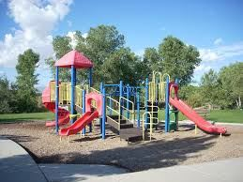This is the play_ _ _ _ _ _ .
Đáp án: ground
144. Lis_ _ _ to the teacher, please.
Đáp án: ten
145. Children shouldn’t drink coffee. It is not good _ _ _ their health.
Đáp án: for
146. Can you he_ p me, please?
Đáp án: l
147. What are these? - _______ cakes.
A. These B. There are C. It’s D. They are
Đáp án: Chọn ý: D
148. is/ My father/ forty-five/ old./ years
Đáp án: My father is forty-five years old.
149. I’m running … Andy. He runs so quickly.
A. behind B. between C. among D. next to
Đáp án: behind
150. It _ _ my birthday today.
Đáp án: is
151. Ảnh:They _ _ _ _ _ to school every morning.
Đáp án: cycle
152. What _ _ _ _ your father do?
Đáp án: does
153. Nghe:Nhấn giữ Ctrl và bấm chuột để nghe: _ _ _ are you?
Đáp án: Who
154. Betty/ a/ is/ pretty/ girl./
Đáp án: Betty is a pretty girl.
155. … is that? – That’s Jane. She is my friend.
A. How B. When C. Who D. Where
Đáp án: Who
156. small./ school/ My/ bag/ is
Đáp án: My school bag is small.
157. _ _ _ is that? – It’s Alice.
Đáp án: who
158. I/ school./ at/ chess/ play/
Đáp án: I play chess at school.
159. Billy: Are they your friends? - Minh: No, they ... .
A. don’t B. have C. do D. aren’t
Đáp án: Chọn ý: D
160. Nghe:Nhấn giữ Ctrl và bấm chuột để nghe: _ _ _ _ _ _
Đáp án: friend
161. Nghe:Nhấn giữ Ctrl và bấm chuột để nghe: He’s listening to _ _ _ _ _ .
Đáp án: music
162. It’s m_ umbrella.
Đáp án: y
163. These/ puzzles./ are/ my/
Đáp án: These are my puzzles.
164. The sky is black __ night.
A. on B. at C. in D. to
Đáp án: at
165. What time _ _ _ _ the library open?
Đáp án: does
166. Jim can speak Eng_ _ _ h but cannot speak Vietnamese.
Đáp án: lis
167. Ảnh:Tom, my little brother, likes doing _ _ _ _ _ es.
Đáp án: puzzl
168. Peter: Is your classroom big? - Mai: … .
A. Yes, it is B. Yes, please C. Yes, I do D. Yes, I don’t
Đáp án: Yes, it is
169. Are/ new/ they/ your/ classmates?/
Đáp án: Are they your new classmates?
170. Do you like music?
A. Yes, it is. B. Yes, please. C. Yes, I do. D. Yes, I don’t.
Đáp án: Yes, I do.
171. Listen _ _ me, please.
Đáp án: to
172. Ảnh: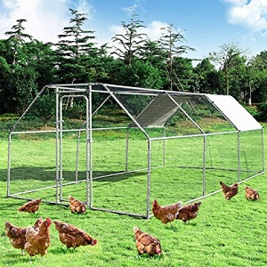The ch_ _ _ _ _ _ are walking in the garden.
Đáp án: ickens
173. My aunt’s daughters _ _ _ my cousins.
Đáp án: are
174. Pick ... your pen, children.
A. at B. on C. to D. up
Đáp án: Chọn ý: D
175. a/ is/ This/ flower./ red
Đáp án: This is a red flower.
176. Nghe:Nhấn giữ Ctrl và bấm chuột để nghe: The _ _ _ _ _ _ _ is very tidy.
Đáp án: kitchen
177. _ _ _ are you? - Fine, thanks.
Đáp án: How
178. Miss White is my new tea_ _ er.
Đáp án: ch
179. These/ circles./ some/ are/
Đáp án: These are some circles.
180. Do you like _ oing Maths?
Đáp án: d
181. Hi, _ _ _ are you? – I’m fine, thanks.
Đáp án: how
182. H_ _ _ _ , Alex. How are you?
Đáp án: ello
183. I want to be a musician in _ _ _ future.
Đáp án: the
184. Ảnh: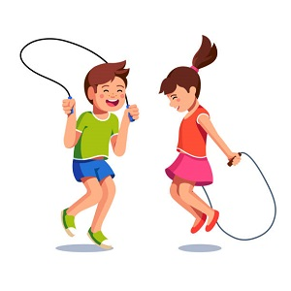It's great to play sk_ _ _ ing with you.
Đáp án: ipp
185. ... morning, John.
A. Good’s B. Bye C. Hi D. Good
Đáp án: Chọn ý: D
186. nine/ years old?/ Are/ cousins/ his/
Đáp án: Are his cousins nine years old?
187. Nam is .... He’d like to sit down.
A. tired B. hungry C. thirsty D. cold
Đáp án: tired
188. new?/ classroom/ Is/ your/
Đáp án: Is your classroom new?
189. ... are you? – I’m fine, thanks.
A. Who B. When C. How D. Where
Đáp án: How
190. Ảnh:A person has o_ _ nose.
Đáp án: ne
191. Choose the INCORRECT word or phrasein the following sentence: How many lamp are there in the room?
A. lamp B. are C. in D. room
Đáp án: lamp
192. to/ Happy/ birthday/ you!
Đáp án: Happy birthday to you!
193. My sister can play the ... .
A. book B. chess C. piano D. football
Đáp án: piano
194. Choose the odd one out:
A. is B. am C. are D. those
Đáp án: Chọn ý: D
195. Lan: What are they? Huong: They are my ... .
A. teachers B. friends C. pencil cases D. Lan and Mai
Đáp án: pencil cases
196. there/ garden?/ any ponds/ in the/ Are/
Đáp án: Are there any ponds in the garden?
197. Where ________? - Behind my house.
A. are your bikes B. is your bikes C. are your bike D. your bikes
Đáp án: are your bikes
198. Tam likes skat_ _ _ very much.
Đáp án: ing
199. Nghe:Nhấn giữ Ctrl và bấm chuột để nghe: There is a _____ next to my bed.
A. table B. desk C. shelf D. book
Đáp án: desk
200. sisters?/ Are/ they/ your/
Đáp án: Are they your sisters?

KEY IOE K3 2023 - 2024 SỐ 23
1. are/ good/ They/ my/ friends./
Đáp án: They are my good friends.
2. Linda: _ _ t's go to school together! - Nam: OK.
Đáp án: Le
3. Ảnh: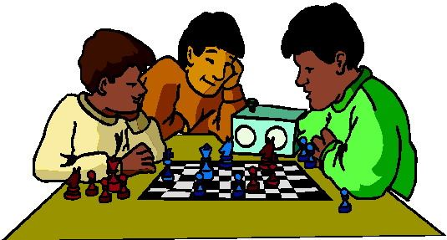We play … at break time.
A. tennis B. football C. chess D. badminton
Đáp án: chess
4. Tom/ new/ are/ my/ and Kevin/ friends./
Đáp án: Tom and Kevin are my new friends.
5. ... you like chicken?
A. Do B. Does C. Are D. Is
Đáp án: Do
6. The cat’s eyes _ _ _ green.
Đáp án: are
7. He ... my friend.
A. are B. is C. me D. I
Đáp án: is
8. Choose the odd one out:
A. am B. is C. are D. this
Đáp án: Chọn ý: D
9. I pick ___ my pen and give it to Tony.
A. out B. up C. at D. on
Đáp án: up
10. Why ... we come and visit Uncle Tom? - That’s a good idea.
A. don’t B. have C. do D. aren’t
Đáp án: don’t
11. May I ... in?
A. can B. are C. is D. come
Đáp án: Chọn ý: D
12. How old is your father?
A. He’s fine. B. He’s three ten. C. He’s forty. D. He’s four five.
Đáp án: He’s forty.
13. I _ _ a student at Oxford Primary School.
Đáp án: am
14. Choose the odd one out:
A. bag B. book C. big D. pencil
Đáp án: big
15. Ảnh:My grand_ _ _ _ er is in the garden.
Đáp án: fath
16. Ảnh: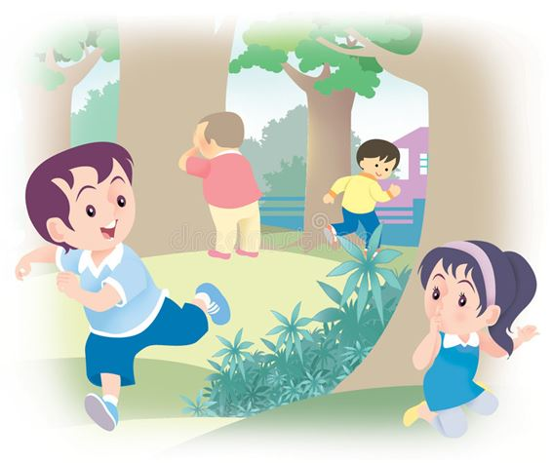We like playing hide-and-_ _ _ _ at weekends
Đáp án: seek
17. are/ three/ They/ on the wall./ pictures
Đáp án: They are three pictures on the wall.
18. Ha can dance _ _ _ she cannot play football.
Đáp án: but
19. Hi, David. _ _ _ are you? – I’m fine, thanks.
Đáp án: how
20. are/ They/ in/ the kitchen./ talking/
Đáp án: They are talking in the kitchen.
21. _ _ _ often do you do morning exercise in the summer?
Đáp án: How
22. Ảnh:My mother is a teac_ _ _ .
Đáp án: her
23. I/ like/ much./ very/ orange colour/
Đáp án: I like orange colour very much.
24. How old is his grandmother? - _______
A. She's fine. B. There are some tables in the room. C. She's sixty now. D. Thank you very much.
Đáp án: She's sixty now.
25. Ảnh: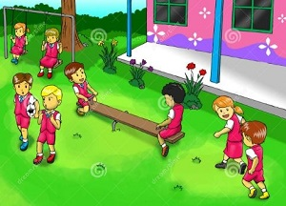What do they do __ break time?
A. in B. on C. for D. at
Đáp án: Chọn ý: D
26. I like _ _ _ _ _ puzzles after school.
Đáp án: doing
27. Nghe:Nhấn giữ Ctrl và bấm chuột để nghe: _ _ _ _ _
Đáp án: small
28. Nghe:Nhấn giữ Ctrl và bấm chuột để nghe: _ _ _ _ _ _
Đáp án: yellow
29. Tick the odd one:
A. picture B. red C. black D. green
Đáp án: picture
30. She is my sister. She is a pretty ________.
A. girl B. boy C. father D. friend
Đáp án: girl
31. Ảnh:The s_ _ is very hot.
Đáp án: un
32. Peter: What _ _ _ _ _ _ is your pen? - Mary: It’s red.
Đáp án: colour
33. teacher Hoa./ is/ This/ my/
Đáp án: This is my teacher Hoa.
34. Ảnh:It is a beautiful purp_ _ flower.
Đáp án: le
35. Ảnh: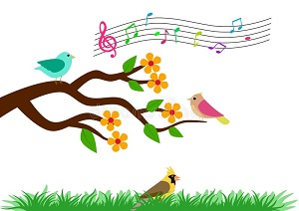On the t_ _ _ , the birds are singing.
Đáp án: ree
36. What's his name? - He _ _ Alan.
Đáp án: is
37. you/ like/ Do/ or football?/ playing chess
Đáp án: Do you like playing chess or football?
38. I have a cat _ _ d a dog.
Đáp án: an
39. I like doing karate. - ... .
A. No, thanks B. Me too C. Yes, please D. Sorry
Đáp án: Me too
40. Ảnh:This is your …, Tom.
A. bench B. desk C. chair D. board
Đáp án: desk
41. Let’s go t_ the library.
Đáp án: o
42. My/ blue and/ orange./ is/ schoolbag/
Đáp án: My schoolbag is blue and orange.
43. evening?/ every/ do/ do you/ What/
Đáp án: What do you do every evening?
44. in winter/ It/ snows/ here./ always/
Đáp án: It always snows in winter here.
45. What is your school’s n_ _ _ ? – It’s Oxford Primary School.
Đáp án: ame
46. Nghe:Nhấn giữ Ctrl và bấm chuột để nghe: What do you _ _ _ _ , Billy?
Đáp án: like
47. Choose the odd one out:
A. am B. are C. is D. thanks
Đáp án: Chọn ý: D
48. Choose the odd one out:
A. you B. I C. fine D. he
Đáp án: fine
49. Pick up/ ruler/ and/ your/ eraser./
Đáp án: Pick up your ruler and eraser.
50. Nghe:Nhấn giữ Ctrl và bấm chuột để nghe: _ _ _ _ _
Đáp án: again
51. on/ Are there/ the desk?/ Lan's notebooks/
Đáp án: Are there Lan's notebooks on the desk?
52. is/ doll/ green./ My/
Đáp án: My doll is green.
53. your/ Can/ books?/ close/ you/
Đáp án: Can you close your books?
54. Ảnh: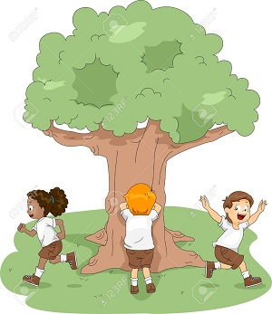Do you like playing hide-and-seek with your friends?
A. Yes, I am B. Yes, I do C. Yes, I don't D. No, I do
Đáp án: Yes, I do
55. Nghe:Nhấn giữ Ctrl và bấm chuột để nghe: Which number is NOT in the recording?
A. 16 B. 17 C. 18 D. 19
Đáp án: 16
56. I/ don’t/ sweets./ like/
Đáp án: I don’t like sweets.
57. Nghe:Nhấn giữ Ctrl và bấm chuột để nghe: The library is _ _ _ .
Đáp án: big
58. Phong ____ a new school bag.
A. have B. do C. has D. does
Đáp án: has
59. Ảnh:The player throws the ball into the basket. What sport is it?
A. Basketball B. Baseball C. Badminton D. Football
Đáp án: Basketball
60. ... is her classroom.
A. These B. They C. Those D. That
Đáp án: Chọn ý: D
61. is/ coat/ under/ the bed./ His/
Đáp án: His coat is under the bed.
62. Dogs, cats, rabbits and hamsters are … .
A. birds B. vets C. pets D. turtles
Đáp án: pets
63. This is my school lib_ _ _ _ . It’s big.
Đáp án: rary
64. Does/ his uncle/ stand/ over there?
Đáp án: Does his uncle stand over there?
65. Lien: _ _ you like badminton? - Mary: Yes, I do.
Đáp án: Do
66. Where are you from, Peter? – I’m _ _ _ _ England.
Đáp án: from
67. Lan: What colour is your desk? - Huong: It’s o_ _ _ _ _ .
Đáp án: range
68. Have ... nice day, Robin. – Thank you very much.
A. an B. the C. a D. are
Đáp án: a
69. Happy birthday to y_ _ !
Đáp án: ou
70. is/ my/ That/ school/ library./
Đáp án: That is my school library.
71. That is my mother. _ _ _ is a teacher.
Đáp án: she
72. Nghe:Nhấn giữ Ctrl và bấm chuột để nghe: He is ____.
A. 12 B. 13 C. 14 D. 15
Đáp án: 14
73. Hello. How _ _ _ you today?
Đáp án: are
74. your/ away,/ children./ Put/ pencils/
Đáp án: Put your pencils away, children.
75. Children shouldn’t drink coffee. It is not good _ _ _ their health.
Đáp án: for
76. Ảnh: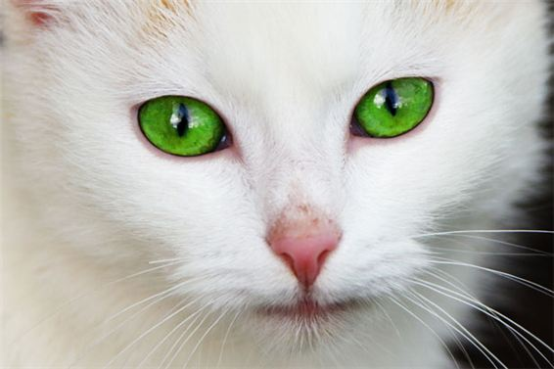What colour is the cat’s eyes? It is _ _ _ _ _ .
Đáp án: green
77. Sit do_ _ , please.
Đáp án: wn
78. please!/ Be/ quiet,/
Đáp án: Be quiet, please!
79. Ảnh:The woman is very _ _ _ . She's eighty now.
Đáp án: old
80. Is this a bag? - ... .
A. Nice to meet you B. Yes, it is C. Yes, isn’t D. No, It is
Đáp án: Yes, it is
81. Let’s play vo_ _ _ _ ball!
Đáp án: lley
82. Nghe:Nhấn giữ Ctrl và bấm chuột để nghe: Listen and tick the word(s) you hear:
A. happy B. hide-and-seek C. zero D. hero
Đáp án: Chọn ý: D
83. What … those? – They are kites.
A. are B. is C. am D. have
Đáp án: are
84. Let’s go outside and _ _ _ a kite?
Đáp án: fly
85. Ảnh: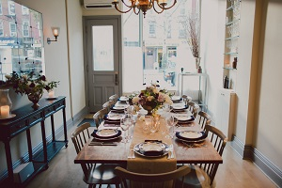We have dinner in the dining _ _ _ _ .
Đáp án: room
86. Please/ your/ close/ notebook.
Đáp án: Please close your notebook.
87. ... colour are your pencils?
A. What B. How C. Where D. When
Đáp án: What
88. class./ Be/ quiet,/
Đáp án: Be quiet, class.
89. Ảnh:The woman has got two _ _ _ _ _ _ .
Đáp án: babies
90. This pink box is _ _ _ you, Simon. – Thank you very much.
Đáp án: for
91. there./ bookshelf/ is/ The/ over
Đáp án: The bookshelf is over there.
92. This is _ new pen.
Đáp án: a
93. What is it? - …
A. It’s a rubber. B. I am fine, thanks. C. She is my friend. D. Yes, it is.
Đáp án: It’s a rubber.
94. Ảnh:fourteen, _______, sixteen.
A. fiveteen B. fifteen C. fifty D. fourty
Đáp án: fifteen
95. Ảnh:The girl is … .
A. doing puzzles B. playing basketball C. playing hide-and-seek D. skipping rope
Đáp án: Chọn ý: D
96. Between two subject lessons, we have a little time for ….
A. break B. take C. make D. check
Đáp án: break
97. come/ I/ in?/ May/
Đáp án: May I come in?
98. It’s a lo_ _ ruler.
Đáp án: ng
99. and/ your pencil/ Show me/ rulers,/ please./
Đáp án: Show me your pencil and rulers, please.
100. How many people are _ _ _ _ _ in your family?
Đáp án: there
101. There are twenty stude_ _ _ in my class.
Đáp án: nts
102. Nghe:Nhấn giữ Ctrl và bấm chuột để nghe: They _ _ _ _ and they are happy.
Đáp án: talk
103. say./ and/ ask/ Point,/
Đáp án: Point, ask and say.
104. on the wall./ hangs/ the clock/ My father/
Đáp án: My father hangs the clock on the wall.
105. Students all ________ when their English teacher comes in.
A. stand up B. sit down C. go out D. come in
Đáp án: stand up
106. Ảnh:The children are playing … now.
A. badminton B. volleyball C. hide-and-seek D. break time
Đáp án: hide-and-seek
107. How m_ _ y dogs do you have?
Đáp án: an
108. ... are you? – I’m fine, thanks.
A. Who B. What C. How D. When
Đáp án: How
109. _ _ _ is Tuan happy? - He is happy because today is his birthday.
Đáp án: Why
110. Nghe:Nhấn giữ Ctrl và bấm chuột để nghe: _ _ _ _ _
Đáp án: chair
111. Her coat/ yellow. It's/ new./ is/
Đáp án: Her coat is yellow. It's new.
112. some/ I/ would/ like/ milk./
Đáp án: I would like some milk.
113. Nghe:Nhấn giữ Ctrl và bấm chuột để nghe: This is my _ _ _ _ _ _ .
Đáp án: school
114. Is this _ _ eraser? – No, it isn’t.
Đáp án: an
115. the pen./ can/ draw/ with/ My sister/
Đáp án: My sister can draw with the pen.
116. Does/ have/ she/ new sandals?
Đáp án: Does she have new sandals?
117. Choose the odd one out:
A. you B. your C. his D. her
Đáp án: you
118. … does your father do in his free time? – He plays tennis.
A. What B. Who C. When D. Where
Đáp án: What
119. _____ is your grandmother? - She's in the dining room.
A. What B. When C. How D. Where
Đáp án: Chọn ý: D
120. A/ eight/ legs./ has got/ spider/
Đáp án: A spider has got eight legs.
121. doesn't like it./ badminton/ but/ her sister/ Jane likes/
Đáp án: Jane likes badminton but her sister doesn't like it.
122. Nghe:Nhấn giữ Ctrl và bấm chuột để nghe: I have _ _ _ books.
Đáp án: six
123. … does your father get to work? – By taxi.
A. What B. Where C. How D. Which
Đáp án: How
124. Is/ new?/ classroom/ your/
Đáp án: Is your classroom new?
125. My fish are very _ _ _ _ tiful.
Đáp án: beau
126. Ảnh: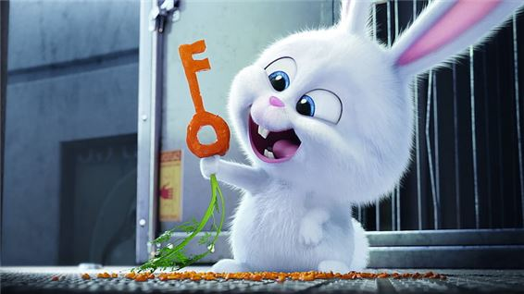This rabbit has an orange _ _ _ .
Đáp án: key
127. What’s the matter? – I’m ... .
A. doctor B. sick C. teacher D. student
Đáp án: sick
128. W_ _ is he? – He is my best friend.
Đáp án: ho
129. Peter: Are they your friends? - Tom: No, they _ _ _ _ ’t.
Đáp án: aren
130. Lemonade is my favourite … .
A. drink B. food C. apple D. milk
Đáp án: drink
131. How _ _ _ is your brother? - He's eleven.
Đáp án: old
132. Ảnh:My father is a doct_ _ .
Đáp án: or
133. This book ... interesting.
A. has B. have C. is D. don’t
Đáp án: is
134. Do you like my new ball? - _ _ _ , I do.
Đáp án: yes
135. Nghe:Nhấn giữ Ctrl và bấm chuột để nghe: Listen and tick:
A. a pet B. a bed C. a bird D. a bag
Đáp án: a bird
136. Ảnh:The board is _ _ the wall.
Đáp án: on
137. Does your father like p_ _ _ ing sports?
Đáp án: lay
138. Lan: Do you ... swimming? - Huong: Yes, we do.
A. play B. like C. likes D. read
Đáp án: like
139. ... is your birthday? - It’s in July.
A. Where B. How C. When D. How old
Đáp án: When
140. Nghe:Nhấn giữ Ctrl và bấm chuột để nghe: _ _ _ _ your book.
Đáp án: open
141. ... this? – It’s a ball.
A. Is B. What C. What’s D. How
Đáp án: What’s
142. This desk is ye_ _ ow.
Đáp án: ll
143. Ảnh:My mother is ______ years old.
A. three-five B. three-fift C. thirteen-five D. thirty-five
Đáp án: Chọn ý: D
144. the song about/ please./ our country,/ Sing/
Đáp án: Sing the song about our country, please.
145. What’s this? - ... .
A. It’s a pen B. Yes, it is C. No, it isn’t D. They are pens
Đáp án: It’s a pen
146. How are you today, Peter? – I’m ..., thanks.
A. nice B. nice’s C. fine D. fine’s
Đáp án: fine
147. That is _ bed.
Đáp án: a
148. Ảnh: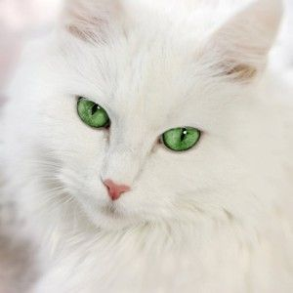His cat has gr_ _ _ eyes.
Đáp án: een
149. Is/ your/ Peter/ friend?
Đáp án: Is Peter your friend?
150. many/ How/ books/ are/ there?/
Đáp án: How many books are there?
151. My birthday gift … a doll.
A. is B. are C. am D. the
Đáp án: is
152. _ _ _ _ _ birthday to you, Jane.
Đáp án: Happy
153. Where is his book? - It’s ... the booshelf.
A. on B. in C. at D. to
Đáp án: on
154. My/ are/ the table./ pencils/ on
Đáp án: My pencils are on the table.
155. Ảnh:R_ _ _ _
Đáp án: ULER
156. Linda./ name/ is/ Her/
Đáp án: Her name is Linda.
157. in/ now./ the computer/ We are/ room
Đáp án: We are in the computer room now.
158. in/ My sister/ 3A./ class/ is/
Đáp án: My sister is in class 3A.
159. Let’s dr_ _ a picture.
Đáp án: aw
160. old./ is/ Peter/ eight/ years
Đáp án: Peter is eight years old.
161. What time _ _ you get up?
Đáp án: do
162. Reorder the words to make a complete sentence: friend / My / playing / likes / badminton.
A. Friend my likes playing badminton. B. My friend likes playing badminton. C. My friend likes badminton playing. D. Playing badminton my friend likes.
Đáp án: My friend likes playing badminton.
163. My house _ s small.
Đáp án: i
164. _ _ _ _ _ are you going to stay? - In a hotel.
Đáp án: Where
165. Hi. What's your _ _ _ _ ? - I'm Peter.
Đáp án: name
166. Ảnh: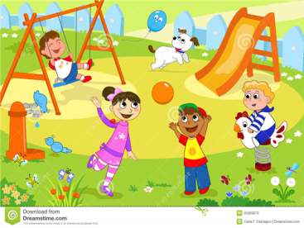Where’s Andy? – He is in the school_ _ _ _ .
Đáp án: yard
167. Choose the odd one out.
A. Teacher B. Pencil C. Rubber D. Ruler
Đáp án: Teacher
168. Which sentence is correct?
A. Santa Claus flying over the town. B. Santa Claus is riding his sleigh. C. Santa Claus is ride a reindeer. D. Santa Claus is walking in the sky.
Đáp án: Santa Claus is riding his sleigh.
169. This is my pen and these ... their pens.
A. is B. are C. am D. be
Đáp án: are
170. What time does your sister _ _ _ _ lunch?
Đáp án: have
171. Time always go_ _ fast.
Đáp án: es
172. Nghe:Nhấn giữ Ctrl và bấm chuột để nghe: What is this? - It’s a _ _ _ _ .
Đáp án: book
173. This is my …, Eddie. He is very hard-working.
A. uncle B. aunt C. sister D. mother
Đáp án: uncle
174. They are her _______.
A. pencil case B. pencils case C. pencils cases D. pencil cases
Đáp án: Chọn ý: D
175. Four and five are n_ _ _ .
Đáp án: ine
176. Nghe:Nhấn giữ Ctrl và bấm chuột để nghe: They are wearing _ _ _ _ _ es.
Đáp án: glass
177. Have ... nice day, Clare. – Thank you.
A. an B. the C. a D. are
Đáp án: a
178. Are/ garden?/ in the/ there/ any ponds/
Đáp án: Are there any ponds in the garden?
179. Let's/ go/ together./ home/
Đáp án: Let's go home together.
180. desk/ is a/ my room./ There/ in
Đáp án: There is a desk in my room.
181. How/ today?/ weather/ is/ the/
Đáp án: How is the weather today?
182. Nghe:Nhấn giữ Ctrl và bấm chuột để nghe: Listen and tick:
A. a pen B. a pencil C. a bank D. a band
Đáp án: a pencil
183. These are their _____.
A. schoolbag B. school bags C. schools bag D. schools bags
Đáp án: school bags
184. This isn’t ... bag. It’s my bag.
A. he B. his C. me D. you
Đáp án: his
185. Nghe:Nhấn giữ Ctrl và bấm chuột để nghe: Listen and tick:
A. man B. learn C. plant D. stand
Đáp án: plant
186. today./ her/ It's/ birthday/
Đáp án: It's her birthday today.
187. _________ two teams playing football together.
A. It is B. There is C. There are D. Are there
Đáp án: There are
188. Jane: ... is her name? - Nga: Her name is Joane.
A. How B. What C. When D. Who
Đáp án: What
189. She never stays _ _ late at night.
Đáp án: up
190. in/ cooks dinner/ Our grandmother/ the kitchen.
Đáp án: Our grandmother cooks dinner in the kitchen.
191. Ảnh:They _ _ _ _ _ to school every morning.
Đáp án: cycle
192. Listen _ _ me, please.
Đáp án: to
193. my mother./ with/ often/ go shopping/ I/
Đáp án: I often go shopping with my mother.
194. playground/ Is/ your/ big?
Đáp án: Is your playground big?
195. She comes home at half _ _ _ _ two and has lunch.
Đáp án: past
196. Nghe:Nhấn giữ Ctrl và bấm chuột để nghe: Listen and tick the word(s) you hear:
A. snowy B. cloudy C. sunny D. rainy
Đáp án: Chọn ý: D
197. Nghe:Nhấn giữ Ctrl và bấm chuột để nghe: Are your classmates in the _ _ _ _ _ _ _ _ _ _ ?
Đáp án: playground
198. Do you have any toy_ ?
Đáp án: s
199. _ _ o is that? – That’s Tommy. He is my friend.
Đáp án: Wh
200. There … some cheese in the fridge.
A. are B. is C. be D. have
Đáp án: is

KEY IOE K3 2023 - 2024 SỐ 24
1. A: How do you spell your … name?- B: … Carter.
A. family - It’s B. surname - I’m C. first - He’s D. full - That’s
Đáp án: family - It’s
2. Nghe:Nhấn giữ Ctrl và bấm chuột để nghe: She can _ _ _ _ .
Đáp án: swim
3. Choose the odd one out:
A. play B. skip C. skate D. boy
Đáp án: Chọn ý: D
4. What ____ is your flower pot? - It's green.
A. old B. many C. name D. colour
Đáp án: Chọn ý: D
5. What is ... name? - My name is Jenny.
A. she B. you C. he D. your
Đáp án: Chọn ý: D
6. Do you _ _ to the zoo with your family?
Đáp án: go
7. This isn’t ... bag. It’s my bag.
A. he B. his C. me D. you
Đáp án: his
8. ..., students. See you later.
A. Good morning B. Good night C. Goodbye D. Nice to meet you
Đáp án: Goodbye
9. is/ her/ name?/ What/
Đáp án: What is her name?
10. I have _ cat.
Đáp án: a
11. under/ The/ is/ that chair./ cat/
Đáp án: The cat is under that chair.
12. What’s his name? - … .
A. OK, fine B. Nice to meet you, too C. His name is Rod D. He is my friend
Đáp án: His name is Rod
13. My cat/ with a/ ball./ is playing/
Đáp án: My cat is playing with a ball.
14. Ảnh:There is a big poster in ____ of the shop.
A. at B. on C. front D. out
Đáp án: front
15. Is it … elephant? – No, it’s a hippo.
A. an B. a C. the D. one
Đáp án: an
16. Ảnh: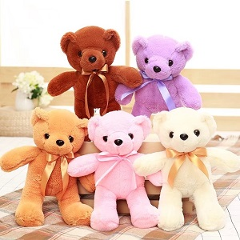My sister has _ _ _ _ teddy bears.
Đáp án: five
17. I’m fine, th_ _ _ _ .
Đáp án: anks
18. Nghe:Nhấn giữ Ctrl và bấm chuột để nghe: He is ____.
A. 12 B. 13 C. 14 D. 15
Đáp án: 14
19. Penguins live in the South Pole. They … snow.
A. likes B. like C. liking D. to like
Đáp án: like
20. Would you like to p_ _ _ games with us?
Đáp án: lay
21. ... is the kite? – It’s in the sky.
A. How B. What C. Where D. When
Đáp án: Where
22. Nghe:Nhấn giữ Ctrl và bấm chuột để nghe: The ______ is blue.
A. ski B. skiing C. sky D. fly
Đáp án: sky
23. playing/ No,/ the piano./ like/ I do not/
Đáp án: No, I do not like playing the piano.
24. How ...re you today, Lenny? – Oh, I’m fine, thanks.
A. b B. r C. w D. a
Đáp án: Chọn ý: D
25. Ảnh: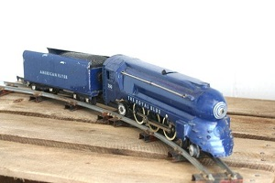It's my new toy. It's a blue ___.
A. bike B. car C. ship D. train
Đáp án: Chọn ý: D
26. My _ _ _ _ is Linda.
Đáp án: name
27. Ảnh:Do you like playing hide-and-seek with your friends?
A. Yes, I am B. Yes, I do C. Yes, I don't D. No, I do
Đáp án: Yes, I do
28. How/ do you/ “playground”?/ spell/ the word
Đáp án: How do you spell the word “playground”?
29. Wr_ _ _ the names in the blanks.
Đáp án: ite
30. These are my … .
A. book B. pencil case C. poster D. bags
Đáp án: Chọn ý: D
31. These/ dolls/ beautiful./ are/
Đáp án: These dolls are beautiful.
32. please./ circles,/ two/ Let’s/ make/
Đáp án: Let’s make two circles, please.
33. What time is it? - … .
A. Nine twenty B. Nine years old C. Nine hundred D. Ninety six
Đáp án: Nine twenty
34. your/ What/ family/ is/ name?/
Đáp án: What is your family name?
35. are there/ in a month?/ weeks/ How many/
Đáp án: How many weeks are there in a month?
36. … school is that? – It’s Khuong Mai primary school.
A. What B. Who C. How D. Where
Đáp án: What
37. Linda ____ this yellow dress.
A. like B. is C. likes D. are
Đáp án: likes
38. Tom and Minh are _ _ friends.
Đáp án: my
39. _ _ _ _ do you do at school?
Đáp án: what
40. What does your mother do? – She ….
A. She does homework B. She is a cook C. She works hard D. Well, she is nice
Đáp án: She is a cook
41. Ảnh:I like making a _______.
A. paper plane B. paper boat C. paper kite D. paper flower
Đáp án: paper boat
42. the old/ Those/ photos/ are/ of my family./
Đáp án: Those are the old photos of my family.
43. Ảnh: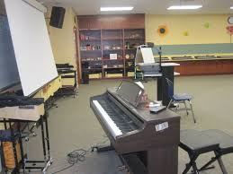Excuse me, where is the mu_ _ _ room?
Đáp án: sic
44. Nghe:Nhấn giữ Ctrl và bấm chuột để nghe: Listen and tick the word(s) you hear:
A. jumping B. climbing C. swimming D. skipping
Đáp án: Chọn ý: D
45. ... is this? – It’s an apple.
A. How B. Who C. What D. Is
Đáp án: What
46. What are _____? - They are my books.
A. this B. it C. you D. these
Đáp án: Chọn ý: D
47. There _ _ one lamp on the desk.
Đáp án: is
48. Ảnh: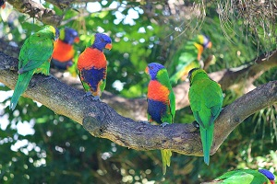How many birds _______ on the tree?
A. there are B. there is C. is there D. are there
Đáp án: Chọn ý: D
49. G_ _ dbye. See you later.
Đáp án: oo
50. Nghe:Nhấn giữ Ctrl và bấm chuột để nghe: Listen and tick:
A. onion B. oil C. orange D. open
Đáp án: orange
51. May I go out? - ... .
A. Sure B. See you later C. Goodbye D. Hello
Đáp án: Sure
52. Trang and Chau ... two bikes.
A. has B. have C. is D. don’t
Đáp án: have
53. Goodb_ e, Tommy. See you later.
Đáp án: y
54. Ảnh:It’s _ _ _ outside.
Đáp án: hot
55. Does/ reading books?/ her/ like/ brother/
Đáp án: Does her brother like reading books?
56. Nghe:Nhấn giữ Ctrl và bấm chuột để nghe: B: I’m … . Thank you. And you? - A: I’m very … . Thank you.
A. fine – fine B. fine – well C. well – well D. well – fine
Đáp án: fine – well
57. Ảnh:Is that your pen_ _ _ ?
Đáp án: cil
58. Ảnh: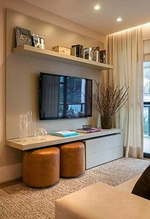The TV is not small. It's _ _ _ .
Đáp án: big
59. How _ _ d is your sister?
Đáp án: ol
60. Ảnh:I have a _ _ _ _ . It's my birthday present.
Đáp án: ship
61. Ảnh:That’s my pencil _ _ g!
Đáp án: ba
62. my room./ is a/ in/ desk/ There/
Đáp án: There is a desk in my room.
63. is/ on/ desk./ The cat/ that
Đáp án: The cat is on that desk.
64. Do/ your friends/ skipping?/ like/
Đáp án: Do your friends like skipping?
65. A: … is your school? - B: … is big and new.
A. Where – He B. How – It C. What – She D. Who - That
Đáp án: How – It
66. Pick … your pencil, John.
A. on B. in C. of D. up
Đáp án: Chọn ý: D
67. There/ in the bottle./ any water/ isn't/
Đáp án: There isn't any water in the bottle.
68. Where are you from, Peter? – I’m _ _ _ _ England.
Đáp án: from
69. This is _ photo of my family.
Đáp án: a
70. Is/ your/ he/ brother,/ Andy?/
Đáp án: Is he your brother, Andy?
71. My _ _ _ _ _ father is old but very sporty.
Đáp án: grand
72. Nghe:Nhấn giữ Ctrl và bấm chuột để nghe: Listen and tick:
A. mirror B. under C. fisher D. soldier
Đáp án: mirror
73. like for your birthday?/ you/ do/ toy/ What/
Đáp án: What toy do you like for your birthday?
74. Nghe:Nhấn giữ Ctrl và bấm chuột để nghe: _ _ _ _
Đáp án: toys
75. What _______ at break time?
A. do you do B. is he do C. are you do D. are they do
Đáp án: do you do
76. A: What is this? - B: …
A. It’s yellow. B. It’s a blue pencil. C. It’s very nice. D. It’s my friend.
Đáp án: It’s a blue pencil.
77. Nghe:Nhấn giữ Ctrl và bấm chuột để nghe: My room is _ _ _ _ _ .
Đáp án: large
78. Ảnh: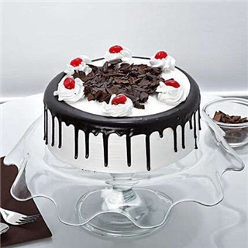_ _ _ _
Đáp án: cake
79. ... your hands, please.
A. Write B. Sing C. Wash D. Study
Đáp án: Wash
80. Nghe:Nhấn giữ Ctrl và bấm chuột để nghe: Listen and tick:
A. shy B. sit C. six D. soup
Đáp án: six
81. days./ I wash/ my hair/ two/ every/
Đáp án: I wash my hair every two days.
82. Nghe:Nhấn giữ Ctrl và bấm chuột để nghe: The girl is fif_ _ _ _ .
Đáp án: teen
83. What ... it? – It’s a black ruler.
A. is B. it C. that D. this
Đáp án: is
84. Ảnh:The trees are tall and _____ in the forest.
A. gray B. green C. black D. yellow
Đáp án: green
85. He likes ____ games.
A. plays B. to playing C. play D. playing
Đáp án: Chọn ý: D
86. Choose the letter(s) to make a correct word: par__t
A. ao B. ra C. or D. ro
Đáp án: Chọn ý: D
87. What/ is/ her/ name?
Đáp án: What is her name?
88. the/ May/ I/ window?/ open/
Đáp án: May I open the window?
89. Ảnh: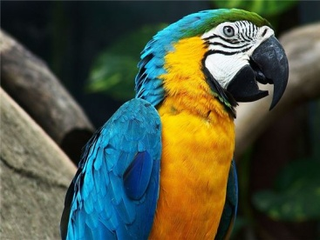_ _ _ _ _ _
Đáp án: parrot
90. your sisters/ dogs?/ Do/ like/
Đáp án: Do your sisters like dogs?
91. much./ I/ swimming/ like/ very
Đáp án: I like swimming very much.
92. Ảnh: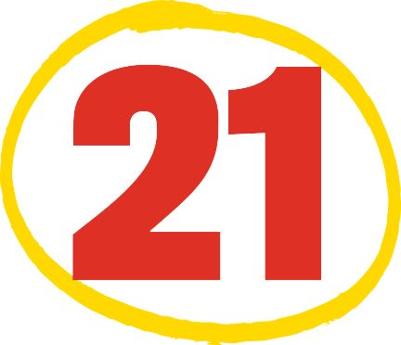How old is Nam’s brother?
A. He’s twenty with one. B. He’s twoty one. C. He’s two one. D. He’s twenty one.
Đáp án: Chọn ý: D
93. I/ would/ some/ like/ milk./
Đáp án: I would like some milk.
94. The map _ _ on the wall.
Đáp án: is
95. One plus thr_ _ makes four.
Đáp án: ee
96. Nghe:Nhấn giữ Ctrl và bấm chuột để nghe: _ _ _ _ _
Đáp án: blind
97. Choose the INCORRECT word or phrase in the following sentence: It are a pond in the garden.
A. are B. pond C. in D. garden
Đáp án: are
98. This is my new f_ _ _ _ d, Tony.
Đáp án: rien
99. She never stays _ _ late at night.
Đáp án: up
100. Ảnh:My _ _ _ likes running on grass.
Đáp án: dog
101. What is/ book?/ favourite/ of your/ the name/
Đáp án: What is the name of your favourite book?
102. I’m fine, thanks. How a_ _ _ t you?
Đáp án: bou
103. T_ _ _ _ are some birds singing on the tree.
Đáp án: here
104. One plus one makes _ _ _ .
Đáp án: two
105. How many colours does a rainbow have?
A. five B. six C. seven D. eight
Đáp án: seven
106. open/ May/ the window,/ I/ mom?/
Đáp án: May I open the window, mom?
107. I have _ _ uncle. He's thirty now.
Đáp án: an
108. Choose the odd one out:
A. library B. bathroom C. bedroom D. dining room
Đáp án: library
109. Choose the odd one out:
A. large B. small C. old D. class
Đáp án: Chọn ý: D
110. ... your teeth, Tommy.
A. Read B. Listen C. Stand D. Brush
Đáp án: Chọn ý: D
111. He is David. He is my ... .
A. school B. name C. book D. friend
Đáp án: Chọn ý: D
112. large./ The computer/ is/ room/
Đáp án: The computer room is large.
113. milk./ I/ some/ would/ like/
Đáp án: I would like some milk.
114. What do _ _ _ do after school, Mary?
Đáp án: you
115. Nghe:Nhấn giữ Ctrl và bấm chuột để nghe: _ _ _ , Nam.
Đáp án: Bye
116. Ảnh:There are five fingers on _ _ _ hand.
Đáp án: one
117. Ảnh:Shhh! The baby is _ _ _ _ _ _ _ _ .
Đáp án: sleeping
118. Do you have ... on Friday? – No, I have English.
A. Informatics B. cakes C. desks D. books
Đáp án: Informatics
119. I’m _ _ _ e, thanks. And you?
Đáp án: fin
120. Ảnh:A person has o_ _ nose.
Đáp án: ne
121. Do you like music?
A. Yes, it is. B. Yes, please. C. Yes, I do. D. Yes, I don’t.
Đáp án: Yes, I do.
122. It's/ winter./ cold/ in/
Đáp án: It's cold in winter.
123. are there/ your classroom?/ How many/ in/ desks/
Đáp án: How many desks are there in your classroom?
124. June is the ... month of the year.
A. sixth B. fourth C. seventh D. eighth
Đáp án: sixth
125. _ _ _ _ colour is it? - It’s red.
Đáp án: What
126. May I go _ _ t? - Yes, please.
Đáp án: ou
127. Nghe:Nhấn giữ Ctrl và bấm chuột để nghe: Here is his grandf_ _ _ _ _ .
Đáp án: ather
128. _____ is Jack from? - He's from England.
A. What B. When C. How D. Where
Đáp án: Chọn ý: D
129. The big tree is beh_ nd my house.
Đáp án: i
130. Nghe:Nhấn giữ Ctrl và bấm chuột để nghe: _ _ _ _ _ _
Đáp án: eleven
131. Wow! A robot. Thank _ _ _ .
Đáp án: you
132. We go to school ... .
A. alone B. together C. gether D. by me
Đáp án: together
133. Choose the odd one out:
A. computer room B. park C. zoo D. playground
Đáp án: computer room
134. I/ flowers./ three/ have/
Đáp án: I have three flowers.
135. Nghe:Nhấn giữ Ctrl và bấm chuột để nghe: Max’s favorite color is _ _ _ _ _ .
Đáp án: green
136. Let’s listen _ _ some music.
Đáp án: to
137. Nghe:Nhấn giữ Ctrl và bấm chuột để nghe: The teacher tells the students to … .
A. sit down B. stand up C. go out D. come in
Đáp án: sit down
138. What do you usually do _ _ Saturday evenings, Mary?
Đáp án: on
139. _ _ at is my green pencil.
Đáp án: Th
140. Nghe:Nhấn giữ Ctrl và bấm chuột để nghe: Her …’s name’s Frank.
A. brother B. grandpa C. uncle D. dad
Đáp án: grandpa
141. _ _ you like playing football?
Đáp án: do
142. spell/ your uncle's/ How/ name?/ do you/
Đáp án: How do you spell your uncle's name?
143. Choose the odd one out
A. Pond B. Classroom C. Garden D. Playground
Đáp án: Classroom
144. _ _ _ is Tuan happy? - He is happy because today is his birthday.
Đáp án: Why
145. Let’s go outside and _ _ _ a kite?
Đáp án: fly
146. after/ me./ read/ Please/
Đáp án: Please read after me.
147. My aunt’s daughters _ _ _ my cousins.
Đáp án: are
148. Nghe:Nhấn giữ Ctrl và bấm chuột để nghe: Choose the correct response.
A. No, I don’t. B. Yes, I am. C. No, it doesn’t. D. Yes, it is.
Đáp án: Chọn ý: D
149. are/ My/ and big./ long/ pencils/
Đáp án: My pencils are long and big.
150. like/ Do/ basketball?/ you/
Đáp án: Do you like basketball?
151. sunny/ It's/ in/ summer.
Đáp án: It's sunny in summer.
152. This/ is/ my/ cat.
Đáp án: This is my cat.
153. Choose the odd one out:
A. nice B. you C. he D. she
Đáp án: nice
154. yellow/ and/ her cats/ Are/ white?/
Đáp án: Are her cats yellow and white?
155. What’s your name? – … Tuan.
A. She’s B. He’s C. I’m D. You’re
Đáp án: I’m
156. My family have dinner in the ____.
A. living room B. bedroom C. basement D. dining room
Đáp án: Chọn ý: D
157. Ảnh:Can you make a _ _ _ _ ?
Đáp án: kite
158. _ _ _ t is that? – That is a red apple.
Đáp án: Wha
159. the rain./ take any/ photos/ We can’t/ because of
Đáp án: We can’t take any photos because of the rain.
160. Ảnh: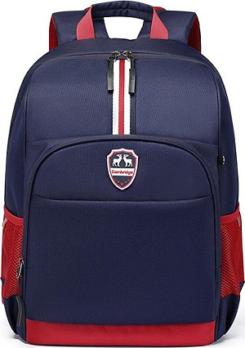SCHOOL _ _ _
Đáp án: BAG
161. N_ _ e to meet you, Lan Anh.
Đáp án: ic
162. Be qu_ _ _ . Listen to the teacher, please.
Đáp án: iet
163. ... have you got English? - Four times a week.
A. How B. When C. How often D. Where
Đáp án: How often
164. make/ can/ a paper boat./ Peter/
Đáp án: Peter can make a paper boat.
165. _ _ _ 's that? - It's my teacher.
Đáp án: who
166. Which is your house? – That … .
A. two B. three C. one D. four
Đáp án: one
167. like/ some/ pizza./ I'd/
Đáp án: I'd like some pizza.
168. W_ _ _ is this? - It’s a ruler.
Đáp án: hat
169. Be q_ _ et, please.
Đáp án: ui
170. case/ the/ My pencil/ is on/ table./
Đáp án: My pencil case is on the table.
171. please!/ Listen/ to/ your teacher,/
Đáp án: Listen to your teacher, please!
172. Have ... nice day, Robin. – Thank you very much.
A. an B. the C. a D. are
Đáp án: a
173. you/ See/ later./
Đáp án: See you later.
174. I _ _ _ _ books in the school library.
Đáp án: read
175. The dog is ... the sofa.
A. on B. to C. between D. for
Đáp án: on
176. school things./ not/ are/ her/ These/
Đáp án: These are not her school things.
177. Which animal has ONLY two legs?
A. Cat B. Tiger C. Bird D. Dog
Đáp án: Bird
178. that is/ and/ This is/ her pencil./ my pen/
Đáp án: This is my pen and that is her pencil.
179. Where are you from, Peter? – I’m _ _ _ _ England.
Đáp án: from
180. Wh_ _ is this? – This is a pen.
Đáp án: at
181. A: _______ - B: Sorry.
A. See you later. B. May I come in? C. Nice to see you. D. Don't talk in class!
Đáp án: Chọn ý: D
182. can/ English songs./ many/ I/ sing/
Đáp án: I can sing many English songs.
183. Mr. Green is talking _ _ Mrs. Green in a café.
Đáp án: to
184. Ảnh: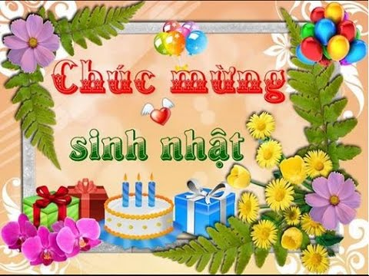Hap_ _ birthday!
Đáp án: py
185. Ảnh: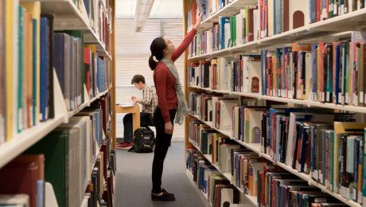_ _ _ _ _ _ _
Đáp án: library
186. I'm __ school now.
A. on B. at C. in D. to
Đáp án: at
187. Ta_ e out your pencils, children.
Đáp án: k
188. Come and play with ... .
A. to B. my C. I D. me
Đáp án: Chọn ý: D
189. The piano is nice but … .
A. old B. new C. big D. good
Đáp án: old
190. Ảnh:What are they doing? - They are sw_ _ _ _ _ _ .
Đáp án: imming
191. _ _ _ those my pens?
Đáp án: Are
192. Nghe:Nhấn giữ Ctrl và bấm chuột để nghe: Some students go by _ _ _ _ _ _ _ .
Đáp án: bicycle
193. Mr. Parker r_ _ _ _ newspapers everyday.
Đáp án: eads
194. There are/ a week./ days/ seven/ in
Đáp án: There are seven days in a week.
195. Ảnh:My pen is _ _ _ _ .
Đáp án: blue
196. Linda: _ _ t's go to school together! - Nam: OK.
Đáp án: Le
197. a shirt./ I open/ and pick up/ the wardrobe/
Đáp án: I open the wardrobe and pick up a shirt.
198. on/ pencils/ the table./ My/ are/
Đáp án: My pencils are on the table.
199. father/ a/ is/ My/ doctor./
Đáp án: My father is a doctor.
200. This is _ _ ice cream.
Đáp án: an

KEY IOE K3 2023 - 2024 SỐ 25
1. W_ _ is he? – He is my best friend.
Đáp án: ho
2. I often play sports _ _ Tuesday afternoons.
Đáp án: on
3. Ảnh: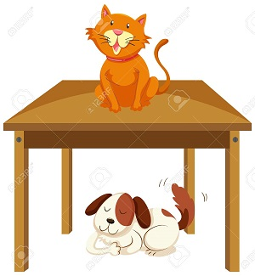The _ _ _ is on the table.
Đáp án: cat
4. ... your teeth, Tommy.
A. Read B. Listen C. Stand D. Brush
Đáp án: Chọn ý: D
5. I have an English friend. _ _ _ name is Kate.
Đáp án: her
6. How are you? – I’m … .
A. six B. happy C. yellow D. new
Đáp án: happy
7. How _ _ ny bananas are there in the box?
Đáp án: ma
8. This is _ book. It’s green.
Đáp án: a
9. Let’s go fishing. – That’s a good i_ _ _ .
Đáp án: dea
10. there?/ many/ are/ How/ books/
Đáp án: How many books are there?
11. Choose the odd one out.
A. Father B. Mother C. Brother D. Uncle
Đáp án: Chọn ý: D
12. next to/ your mother?/ Is/ your aunt/
Đáp án: Is your aunt next to your mother?
13. _____ Lisa like going out with you?
A. Do B. Are C. Is D. Does
Đáp án: Chọn ý: D
14. Can you speak English? - Yes,... can.
A. he B. she C. you D. I
Đáp án: Chọn ý: D
15. John: This is my sister. Peter: What is _ _ r name?
Đáp án: he
16. pond./ are swimming/ The fish/ in the/
Đáp án: The fish are swimming in the pond.
17. These are my s_ _ ters.
Đáp án: is
18. This is Tom and _ _ _ cute dog, Rex.
Đáp án: his
19. Those _ _ _ my pens and pencils.
Đáp án: are
20. Ảnh:What are they doing? - They are sw_ _ _ _ _ _ .
Đáp án: imming
21. with/ Can/ you/ play/ a yo yo?/
Đáp án: Can you play with a yo yo?
22. Hamburger/ my/ favourite/ is/ food./
Đáp án: Hamburger is my favourite food.
23. Orange juice is my favourite ... .
A. drink B. food C. apple D. milk
Đáp án: drink
24. playing/ at break time./ We/ like/ games
Đáp án: We like playing games at break time.
25. Choose the letter(s) to make a correct word: cent__l
A. ra B. re C. aa D. ar
Đáp án: ra
26. Ảnh:There are _ _ _ _ toes on a foot.
Đáp án: five
27. Nghe:Nhấn giữ Ctrl và bấm chuột để nghe: The girl is fif_ _ _ _ .
Đáp án: teen
28. white. It's/ small./ Lan's eraser/ is/
Đáp án: Lan's eraser is white. It's small.
29. _ _ _ are you? - I’m fine, thanks.
Đáp án: How
30. Hello. My name’s Betty. - ....
A. Bye, see you again B. See you soon C. Hi. I am Susan. Nice to meet you D. Goodbye
Đáp án: Hi. I am Susan. Nice to meet you
31. Nghe:Nhấn giữ Ctrl và bấm chuột để nghe: It’s a … book.
A. little B. small C. big D. large
Đáp án: big
32. Ảnh: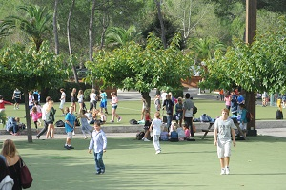The school playground is crowded at _ _ _ _ _ time.
Đáp án: break
33. Write your name _ _ the board, please.
Đáp án: on
34. next to/ the living room./ The/ is/ kitchen/
Đáp án: The kitchen is next to the living room.
35. My school bag _ _ new.
Đáp án: is
36. Do you ____ a comic book? - Yes, I do.
A. having B. like C. knows D. are
Đáp án: like
37. Jane./ new friend/ is/ This/ my/
Đáp án: This is my new friend Jane.
38. Ảnh: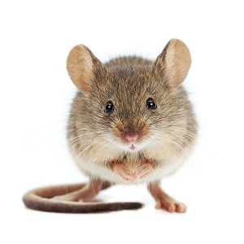MOUS_
Đáp án: E
39. Where is your school libra_ _ ?
Đáp án: ry
40. Ảnh: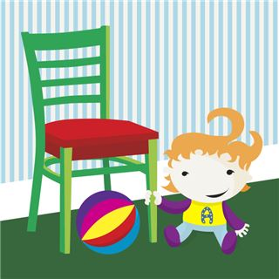There is NOT _______ in the picture.
A. a ball B. a baby C. a desk D. a chair
Đáp án: a desk
41. Spe_ _ your name, please.
Đáp án: ll
42. _ _ _ t’s your name? – My name’s Sean.
Đáp án: Wha
43. Peter: Let’s dr_ _ a picture. - Nam: Yes, let’s.
Đáp án: aw
44. do/ How/ you/ spell/ her name?/
Đáp án: How do you spell her name?
45. Ảnh:The cup is here, __ the table.
A. in B. on C. behind D. under
Đáp án: on
46. school/ I/ on Sunday./ go to/ don’t/
Đáp án: I don’t go to school on Sunday.
47. Nghe:Nhấn giữ Ctrl và bấm chuột để nghe: Listen and tick the word(s) you hear:
A. lion B. lamp C. ruler D. cloudy
Đáp án: lion
48. Linda _____ a little cat.
A. have B. do C. has D. am
Đáp án: has
49. Ảnh:His cat has gr_ _ _ eyes.
Đáp án: een
50. I like my school _ _ _ _ much.
Đáp án: very
51. There … some cheese in the fridge.
A. are B. is C. be D. have
Đáp án: is
52. Ảnh: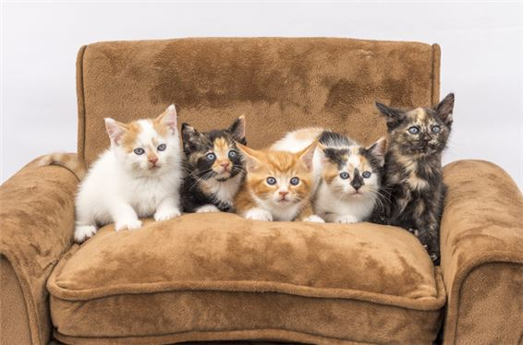There are five _ _ _ _ in the armchair.
Đáp án: cats
53. Is that a crayon? - ... .
A. No, they are B. Yes, they are C. Yes, it is D. No, they aren’t
Đáp án: Yes, it is
54. _ _ _ sun is shining.
Đáp án: The
55. How … fans are there? – Three.
A. many B. much C. old D. long
Đáp án: many
56. Which word has the underlined part pronounced LIKE the letter E in SISTER
A. nice B. brother C. new D. bedroom
Đáp án: brother
57. Which is your school? - … one.
A. The B. A C. An D. This
Đáp án: Chọn ý: D
58. What is your school’s n_ _ _ ? – It’s Oxford Primary School.
Đáp án: ame
59. song./ sing/ Let’s/ a/
Đáp án: Let’s sing a song.
60. are my/ and Tommy/ new/ friends./ Peter/
Đáp án: Peter and Tommy are my new friends.
61. Gi_ e me the book, please.
Đáp án: v
62. Do you like listening to music?
A. Yes, I am. B. No, I do. C. No, I don't. D. Yes, it is.
Đáp án: No, I don't.
63. Choose the INCORRECT word or phrase in the following sentence: Our living room are very big and beautiful.
A. are B. very C. and D. beautiful
Đáp án: are
64. Nghe:Nhấn giữ Ctrl và bấm chuột để nghe: Sue _ _ _ _ _ up at seven o’clock in the morning.
Đáp án: wakes
65. Choose the INCORRECT word or phrase in the following sentence: They are my ball, Daddy.
A. They B. my C. ball D. Daddy
Đáp án: ball
66. is/ What/ your/ sister's/ name?/
Đáp án: What is your sister's name?
67. Is that a purple flower? – ..., it is.
A. No B. Yes C. Not D. No, it isn’t
Đáp án: Yes
68. Choose the letter(s) to make a correct word: bla__
A. kk B. cc C. kc D. ck
Đáp án: Chọn ý: D
69. teacher./ Point/ to/ the/
Đáp án: Point to the teacher.
70. My parents are _ _ the living room.
Đáp án: in
71. Ảnh:What colour is the fence?
A. Blue B. Black C. White D. Yellow
Đáp án: White
72. Nghe:Nhấn giữ Ctrl và bấm chuột để nghe: How many cakes are there in total?
A. There are twenty-nine. B. There are ninety. C. There are thirty-nine. D. There are ninety-nine.
Đáp án: There are twenty-nine.
73. She never stays _ _ late at night.
Đáp án: up
74. What do you do in … free time?
A. you B. yours C. you’re D. your
Đáp án: Chọn ý: D
75. I’m ha_ _ y.
Đáp án: pp
76. What … her name? – She is Mai Anh.
A. are B. is C. am D. does
Đáp án: is
77. May/ in?/ come/ I/
Đáp án: May I come in?
78. What/ the evening?/ does/ she do/ in
Đáp án: What does she do in the evening?
79. kitchen./ a/ There/ is/
Đáp án: There is a kitchen.
80. their/ is/ name?/ school's/ What/
Đáp án: What is their school's name?
81. Let’s go t_ the library.
Đáp án: o
82. Smith?/ How/ are/ Miss/ you,/
Đáp án: How are you, Miss Smith?
83. Reorder/ sentences./ the/
Đáp án: Reorder the sentences.
84. These chairs … small.
A. are B. is C. am D. not
Đáp án: are
85. Nghe:Nhấn giữ Ctrl và bấm chuột để nghe: The library is _ _ _ .
Đáp án: big
86. Ảnh:Her sister can’t d_ _ _ e.
Đáp án: anc
87. sunny/ It's/ summer./ in/
Đáp án: It's sunny in summer.
88. There ... three cats in the box.
A. am B. is C. are D. there
Đáp án: are
89. Nghe:Nhấn giữ Ctrl và bấm chuột để nghe: That is my _____.
A. notebook B. computer C. pencil case D. rubber
Đáp án: computer
90. Ảnh: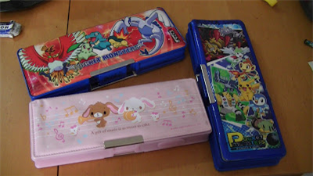These are three pencil _ _ _ _ _ in my school bag.
Đáp án: cases
91. very/ This/ flower/ beautiful./ is/
Đáp án: This flower is very beautiful.
92. Ảnh: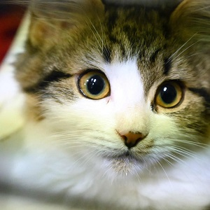_ _ _
Đáp án: CAT
93. My favorite colour is g_ _ _ n.
Đáp án: ree
94. Choose the odd one out
A. Mother B. Father C. Teacher D. Grandmother
Đáp án: Teacher
95. I ... John. Nice to meet you.
A. is B. am C. be D. are
Đáp án: am
96. Don't make a mess. - _______
A. Thanks. B. Yes, please. C. Yes, you can. D. Sorry.
Đáp án: Chọn ý: D
97. What _______ at break time?
A. do you do B. is he do C. are you do D. are they do
Đáp án: do you do
98. Ảnh:That’s my pencil _ _ g!
Đáp án: ba
99. Nghe:Nhấn giữ Ctrl và bấm chuột để nghe: _ _
Đáp án: we
100. _ _ . Nice to meet you.
Đáp án: hi
101. there?/ over/ Who/ the tall girl/ is/
Đáp án: Who is the tall girl over there?
102. Mandy/ How many/ have?/ dolls/ does/
Đáp án: How many dolls does Mandy have?
103. There _ _ one lamp on the desk.
Đáp án: is
104. Nghe:Nhấn giữ Ctrl và bấm chuột để nghe: Andy is _ _ _ _ _ .
Đáp án: seven
105. What is this? - ….
A. It a orange B. Is a orange C. It’s a orange D. It’s an orange
Đáp án: Chọn ý: D
106. windows./ to the/ is/ next/ The radio/
Đáp án: The radio is next to the windows.
107. The new music room is _______.
A. new B. ten C. old D. large
Đáp án: Chọn ý: D
108. in/ class/ 3A./ My sister/ is/
Đáp án: My sister is in class 3A.
109. The pencil is long and the rubber is sh_ _ _ .
Đáp án: ort
110. Nghe:Nhấn giữ Ctrl và bấm chuột để nghe: Listen and tick the word(s) you hear:
A. classroom B. bathroom C. living room D. bedroom
Đáp án: classroom
111. Who is your …? – The man over there.
A. father B. mother C. aunt D. sister
Đáp án: father
112. Peter has _ _ work all day in the factory.
Đáp án: to
113. Let’s make a ci_ _ le.
Đáp án: rc
114. you/ spell/ your name?/ How/ do/
Đáp án: How do you spell your name?
115. three/ have/ I/ flowers.
Đáp án: I have three flowers.
116. Your sister is pre_ _ y.
Đáp án: tt
117. Nghe:Nhấn giữ Ctrl và bấm chuột để nghe: Here is his _ _ _ _ _ _ .
Đáp án: mother
118. There … some cheese in the fridge.
A. are B. is C. be D. have
Đáp án: is
119. I like Maths but my friends ….
A. isn’t B. doesn’t C. don’t D. aren’t
Đáp án: don’t
120. Which word has the underlined part pronounced LIKE the letter I in BIG
A. his B. nine C. kite D. nice
Đáp án: his
121. not/ feel/ today./ I do/ well
Đáp án: I do not feel well today.
122. books/ my/ Those/ are/
Đáp án: Those are my books
123. What …? – They are my crayons.
A. are those B. is this C. is that D. are there
Đáp án: are those
124. Art/ on/ have/ I don’t/ Friday./
Đáp án: I don’t have Art on Friday.
125. Thank you very much – You’re ... .
A. welcome’s B. welcomes C. welcome D. welcome’re
Đáp án: welcome
126. My uncle doesn’t work … Saturday.
A. at B. in C. on D. of
Đáp án: on
127. Are there any fruits on the table? - Yes, ______.
A. there is B. are there C. is there D. there are
Đáp án: Chọn ý: D
128. There is ___ pen in the pencil case.
A. one B. two C. three D. four
Đáp án: one
129. My cla_ _ _ _ _ m is small.
Đáp án: ssroo
130. Students all ________ when their English teacher comes in.
A. stand up B. sit down C. go out D. come in
Đáp án: stand up
131. Which is your house? – That __________.
A. one B. two C. three D. four
Đáp án: one
132. One plus one makes _ _ _ .
Đáp án: two
133. How _ _ d is your sister?
Đáp án: ol
134. up,/ please./ Stand/
Đáp án: Stand up, please.
135. Who _ _ _ those people?
Đáp án: are
136. The cats are white. _ _ _ _ are very beautiful.
Đáp án: they
137. This gift is for you. - Thank you very _ _ _ _ .
Đáp án: much
138. What/ name?/ is/ her/
Đáp án: What is her name?
139. Good morning, children. - ... .
A. Good morning, teacher B. Hello C. Hi D. Bye
Đáp án: Good morning, teacher
140. Ảnh: R_ _ _ _
Đáp án: ULER
141. teacher./ my/ Miss Lien/ is/ new
Đáp án: Miss Lien is my new teacher.
142. ... are you from, Jean? – I’m from Canada.
A. What B. How C. Where D. When
Đáp án: Where
143. Peter: What _ _ _ _ _ _ is your pen? - Mary: It’s red.
Đáp án: colour
144. What/ lunch boxes?/ colour/ are/ your
Đáp án: What colour are your lunch boxes?
145. My friend is ten _ _ _ _ _ old.
Đáp án: years
146. My aunt is a _ _ _ ter of my mother.
Đáp án: sis
147. GRAN___THER
A. TFA B. DMA C. DFO D. DMO
Đáp án: Chọn ý: D
148. Can you remem_ _ r my birthday?
Đáp án: be
149. Nghe:Nhấn giữ Ctrl và bấm chuột để nghe: Listen and tick the word(s) you hear:
A. sunny B. Sunday C. summer D. seven
Đáp án: Sunday
150. my bag./ I/ have/ in/ two pens/
Đáp án: I have two pens in my bag.
151. your/ name,/ Write/ please.
Đáp án: Write your name, please.
152. _ _ ke out your book.
Đáp án: Ta
153. How o_ _ are you?
Đáp án: ld
154. Be … Don’t make noise.
A. lazy B. quiet C. funny D. angry
Đáp án: quiet
155. R_ _ se your hands, please.
Đáp án: ai
156. The children like playing in the park because … very large.
A. it is B. they are C. he is D. she is
Đáp án: it is
157. Nghe:Nhấn giữ Ctrl và bấm chuột để nghe: Who likes drawing?
A. Mr. Macaroni. B. Meg. C. Tom. D. Mrs. Green.
Đáp án: Meg.
158. A: … is your school? - B: … is big and new.
A. Where – He B. How – It C. What – She D. Who - That
Đáp án: How – It
159. Don't be late __ school.
A. at B. in C. for D. with
Đáp án: for
160. ... at the board, please.
A. Put B. Look C. Stand D. Sit
Đáp án: Look
161. Your rulers/ are/ green. They/ are in the bag.
Đáp án: Your rulers are green. They are in the bag.
162. you do/ free/ What do/ in your/ time?/
Đáp án: What do you do in your free time?
163. I ... my teeth in the morning.
A. do B. brush C. have D. does
Đáp án: brush
164. A: What is this? - B: …
A. It’s yellow. B. It’s a blue pencil. C. It’s very nice. D. It’s my friend.
Đáp án: It’s a blue pencil.
165. Nghe:Nhấn giữ Ctrl và bấm chuột để nghe: His _ _ _ is in the football net.
Đáp án: toy
166. Nghe:Nhấn giữ Ctrl và bấm chuột để nghe: There are … people in her family.
A. four B. five C. six D. three
Đáp án: five
167. What are these ? - ….
A. It’s a motorbike B. They’re motorbikes C. They’re motorbike D. It is motorbike
Đáp án: They’re motorbikes
168. that boy/ her/ brother?/ Is/
Đáp án: Is that boy her brother?
169. are/ Duong?/ you,/ old/ How/
Đáp án: How old are you, Duong?
170. three/ They/ pictures/ on the wall./ are/
Đáp án: They are three pictures on the wall.
171. Nghe:Nhấn giữ Ctrl và bấm chuột để nghe: This is my _ _ _ _ _ _ _ _ _ _ _ .
Đáp án: grandfather
172. How do you _ _ _ ll your name?
Đáp án: spe
173. _ _ _ _ _ are you going to stay? - In a hotel.
Đáp án: Where
174. my/ books./ Those/ are/
Đáp án: Those are my books.
175. your bags/ the car?/ in/ Are/
Đáp án: Are your bags in the car?
176. Nice to m_ _ _ you, too.
Đáp án: eet
177. Ảnh: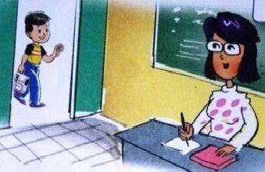May I _ _ _ _ in?
Đáp án: come
178. Which word has the underlined part pronounced LIKE the letter ’A’ in ’SMALL’?
A. tall B. classroom C. play D. father
Đáp án: tall
179. Ảnh:You use your _____ to write.
A. head B. hand C. eyes D. foot
Đáp án: hand
180. I ... fine, thanks.
A. am B. is C. are D. the
Đáp án: am
181. _ _ _ _ time do you go to bed?
Đáp án: What
182. name/ is/ Allie./ Her/
Đáp án: Her name is Allie.
183. Nga: Do you play football? - Huong: No, I … I like basketball.
A. don’t B. am not C. doesn’t D. isn’t
Đáp án: don’t
184. quiet,/ Be/ class./
Đáp án: Be quiet, class.
185. Nam: What’s his _ _ _ _ ? - Hoa: Tony.
Đáp án: name
186. Nghe:Nhấn giữ Ctrl và bấm chuột để nghe: Is she a _ _ _ _ _ _ _ ?
Đáp án: teacher
187. Is your house big … small?
A. and B. or C. but D. of
Đáp án: or
188. please./ Show/ me/ your/ cards,
Đáp án: Show me your cards, please.
189. Nghe:Nhấn giữ Ctrl và bấm chuột để nghe: My brother is thir_ _ _ _ years old.
Đáp án: teen
190. Ảnh: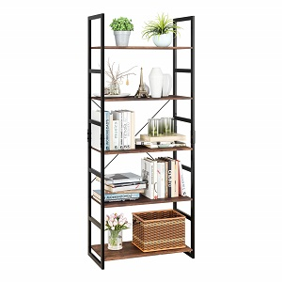BOOK_ _ _ _
Đáp án: CASE
191. Ảnh: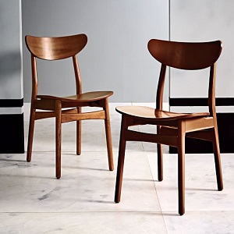Those are our ch_ _ _ _ .
Đáp án: airs
192. Ảnh:The _ _ _ _ is beautiful.
Đáp án: ship
193. Nghe:Nhấn giữ Ctrl và bấm chuột để nghe: Listen and tick:
A. boat B. cook C. book D. look
Đáp án: cook
194. Her father goes to work _ _ 6 o’clock.
Đáp án: at
195. Ảnh: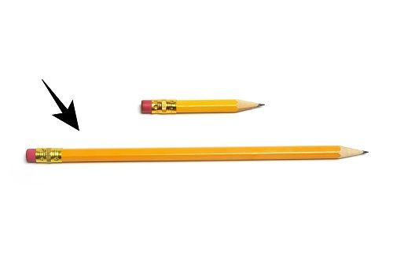My pencil is _ _ _ _ . Her pencil is short.
Đáp án: long
196. Nghe:Nhấn giữ Ctrl và bấm chuột để nghe: Pat is in the _ _ _ _ _ _ room.
Đáp án: living
197. I have _ _ ice cream.
Đáp án: an
198. children/ are/ chess./ The/ playing
Đáp án: The children are playing chess.
199. Can you give me some pens, pl_ _ se?
Đáp án: ea
200. give/ more water./ Please,/ some/ me/
Đáp án: Please, give me some more water.

KEY IOE K3 2023 - 2024 SỐ 26
1. Th_ _ _ s. And you?
Đáp án: ank
2. Does/ stand/ over there?/ his uncle/
Đáp án: Does his uncle stand over there?
3. Peter: Do you play badminton at break time? - Mai: ... .
A. Yes, it is B. Yes, please C. Yes, I do D. Yes, I don’t
Đáp án: Yes, I do
4. Let’s make a ci_ _ le.
Đáp án: rc
5. Nghe: Nhấn giữ Ctrl và bấm chuột để nghe: This is his _ _ _ _ _ _ _ .
Đáp án: brother
6. Nghe: Nhấn giữ Ctrl và bấm chuột để nghe: Which is NOT mentioned?
A. There is a bed. B. There is a desk. C. There are two windows. D. There are two chairs.
Đáp án: Chọn ý: D
7. draw/ let’s/ a/ picture./ Peter/
Đáp án: Peter let’s draw a picture.
8. Hoa: What do you do ... break time? - Peter: I play badminton.
A. at B. on C. in D. for
Đáp án: at
9. Ảnh: My father is ______ years old.
A. thirty-eight B. forty-eight C. fourteen-eight D. fifteen-eight
Đáp án: forty-eight
10. Nghe: Nhấn giữ Ctrl và bấm chuột để nghe: This is my _ _ _ _ _ _ .
Đáp án: school
11. Thank you _ _ _ _ much.
Đáp án: very
12. she/ teacher?/ Is/ a/
Đáp án: Is she a teacher?
13. free/ in your/ you do/ What do/ time?/
Đáp án: What do you do in your free time?
14. Miss Lan./ you/ meet/ Nice/ to/
Đáp án: Nice to meet you Miss Lan.
15. Nghe: Nhấn giữ Ctrl và bấm chuột để nghe: Listen and tick:
A. fingers B. goldfish C. farmer D. fireman
Đáp án: Chọn ý: D
16. ________- Yes, you can.
A. How are you? B. How old are you? C. Let's play football! D. May I borrow your book?
Đáp án: Chọn ý: D
17. Nghe: Nhấn giữ Ctrl và bấm chuột để nghe: D_ _
Đáp án: OG
18. Which is your school? - … one.
A. The B. A C. An D. This
Đáp án: Chọn ý: D
19. That is/ my/ big./ classroom./ It’s
Đáp án: That is my classroom. It’s big.
20. time/ for/ It’s/ breakfast,/ John./
Đáp án: It’s time for breakfast, John.
21. read/ Look/ and/ aloud.
Đáp án: Look and read aloud.
22. Ảnh: 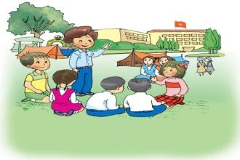 What do you do at break time? - I ch_ _ with my friends.
Đáp án: at
23. ... are you? – Fine, thanks.
A. Who B. Is C. Are D. How
Đáp án: Chọn ý: D
24. Ảnh: 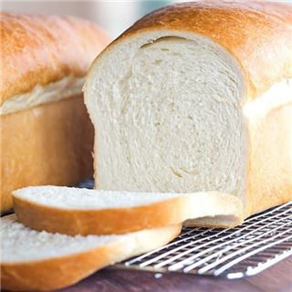 I have _ _ _ _ _ and butter for breakfast.
Đáp án: bread
25. of Anna./ have/ picture/ a/ I/
Đáp án: I have a picture of Anna.
26. Choose the letter(s) to make a correct word: CLE_N
A. I B. O C. E D. A
Đáp án: Chọn ý: D
27. ... are you? – I’m fine, thanks.
A. Who B. When C. How D. Where
Đáp án: How
28. Ảnh: My father is a doct_ _ .
Đáp án: or
29. Lo_ _ at the board, children.
Đáp án: ok
30. Ảnh: My brother is a pup_ _ .
Đáp án: il
31. His backpacks/ black. They/ are/ aren't brown.
Đáp án: His backpacks are black. They aren't brown.
32. My pictures are ... the wall.
A. on B. to C. for D. at
Đáp án: on
33. What ... their …?
A. is name B. are / names C. is / names D. are / name
Đáp án: are / names
34. Ảnh: _ _ _ _
Đáp án: BALL
35. Are they students in your class? – Yes, ...
A. they are B. they do C. are they D. are their
Đáp án: they are
36. Ảnh: There are five _ _ _ _ _ _ _ on a hand.
Đáp án: fingers
37. My little daughter is interested _ _ dancing.
Đáp án: in
38. It _ _ a pink doll.
Đáp án: is
39. The box _ _ very big.
Đáp án: is
40. What is your f_ _ _ _ _ name?
Đáp án: amily
41. My _ _ _ _ is Linda.
Đáp án: name
42. That’s my new friend. H_ _ name’s Jenny.
Đáp án: er
43. Nghe: Nhấn giữ Ctrl và bấm chuột để nghe: Listen and tick the word(s) you hear:
A. classroom B. bathroom C. living room D. bedroom
Đáp án: classroom
44. The lunch _ _ _ _ is over there.
Đáp án: room
45. Nghe: Nhấn giữ Ctrl và bấm chuột để nghe: It’s _ _ _ _ _ _ _ _ _ .
Đáp án: beautiful
46. Nghe: Nhấn giữ Ctrl và bấm chuột để nghe: That is my pen _ _ _ _ .
Đáp án: case
47. Nghe: Nhấn giữ Ctrl và bấm chuột để nghe: There are four_ _ _ _ eggs in the box.
Đáp án: teen
48. friend,/ How/ your/ is/ Tom?/
Đáp án: How is your friend, Tom?
49. Ảnh: 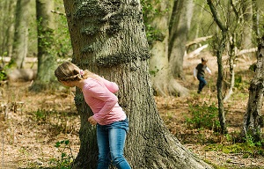 We play hide-and-seek, but I can't ____ Nam.
A. meet B. find C. play D. go
Đáp án: find
50. How are you? - ... .
A. Fine, thanks B. Nice to meet you C. My name’s Sean D. See you later
Đáp án: Fine, thanks
51. Put the flower vase _ _ the table.
Đáp án: on
52. ______ this? – It’s a ball.
A. What B. What’s C. What’s is D. What it
Đáp án: What’s
53. Ảnh: What a lovely _ _ _ _ !
Đáp án: room
54. Nghe: Nhấn giữ Ctrl và bấm chuột để nghe: Listen and tick:
A. hide-and-seek B. hometown C. house D. housewife
Đáp án: Chọn ý: D
55. May I go _ _ _ ?
Đáp án: out
56. do you/ her name,/ How/ spell/ Jane?/
Đáp án: How do you spell her name, Jane?
57. Peter: How do you _ _ _ _ _ your name? - Huyen: That’s H-U-Y-E-N.
Đáp án: spell
58. Good morning, children. - ... .
A. Good morning, teacher B. Hello C. Hi D. Bye
Đáp án: Good morning, teacher
59. Let’s make a cir_ le.
Đáp án: c
60. _ _ my lunchbox, I have a banana and a sandwich.
Đáp án: In
61. My/ are red./ aren't/ umbrellas/ yellow. They
Đáp án: My umbrellas aren't yellow. They are red.
62. How ... chairs in your classroom?
A. much B. very C. old D. many
Đáp án: Chọn ý: D
63. Is this ... book? - Yes,it’s my book.
A. her B. my C. his D. your
Đáp án: Chọn ý: D
64. Mary _ _ s born in America.
Đáp án: wa
65. Ảnh: 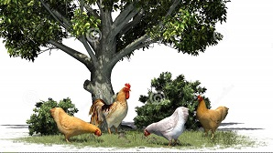 The chickens are under the big _ _ _ _ in the garden.
Đáp án: tree
66. Mary is m_ friend.
Đáp án: y
67. ______ up, please!
A. Stand B. Sit C. Open D. Close
Đáp án: Stand
68. Are those your notebooks? - No, ... .
A. it is B. it isn’t C. they are D. they aren’t
Đáp án: Chọn ý: D
69. days./ my hair/ every/ two/ I wash/
Đáp án: I wash my hair every two days.
70. Choose the correct sentence.
A. I like playing chess at break time. B. I like play chess at break time. C. I like playing chess on break time. D. I like playing a chess at break time.
Đáp án: I like playing chess at break time.
71. ... your teeth everyday, Tess.
A. Read B. Listen C. Stand D. Brush
Đáp án: Chọn ý: D
72. Ảnh: ELEPH_ _ _
Đáp án: ANT
73. How _ _ _ you today?
Đáp án: are
74. Ảnh: 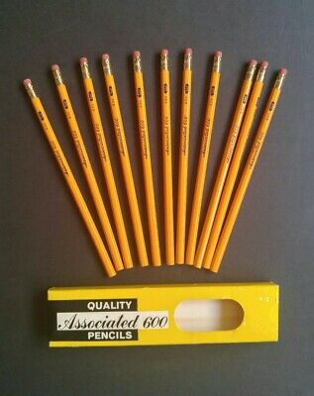 There are elev_ _ pencils on the desk.
Đáp án: en
75. Who is our new tea_ _ er?
Đáp án: ch
76. Ảnh: The children are playing … now.
A. badminton B. volleyball C. hide-and-seek D. break time
Đáp án: hide-and-seek
77. Linda: Do your friends play games at school? - Hoa: Yes,they ... .
A. do B. does C. are D. is
Đáp án: do
78. Sit d_ _ n, please!
Đáp án: ow
79. seek/ with my friends./ hide/ I play/ and/
Đáp án: I play hide and seek with my friends.
80. often/ do puzzles/ my brother./ I/ with
Đáp án: I often do puzzles with my brother.
81. Mary is a student a_ Rose Wood School.
Đáp án: t
82. What is this? – It is ... ice-cream.
A. a B. an C. this D. that
Đáp án: an
83. Choose the INCORRECT word or phrase in the following sentence: The woman behind him are my aunt.
A. woman B. behind C. him D. are
Đáp án: Chọn ý: D
84. What is this? – It is ... eraser.
A. a B. an C. this D. that
Đáp án: an
85. Ảnh: fourteen, _______, sixteen.
A. fiveteen B. fifteen C. fifty D. fourty
Đáp án: fifteen
86. _ _ _ is Tuan happy? - He is happy because today is his birthday.
Đáp án: Why
87. I have an English friend. _ _ _ name is Kate.
Đáp án: her
88. Is … a chair? - Yes, it is.
A. are B. it C. it’s D. his
Đáp án: it
89. Which word has the underlined part pronounced LIKE the letter ’A’ in ’SMALL’?
A. tall B. classroom C. play D. father
Đáp án: tall
90. Write your name _ _ the board, please.
Đáp án: on
91. to/ Happy/ Jane./ birthday/ you,
Đáp án: Happy birthday to you, Jane.
92. My pen is red and my pencils ... blue.
A. are B. is C. am D. do
Đáp án: are
93. Nghe: Nhấn giữ Ctrl và bấm chuột để nghe: It’s a blue _ _ _ _ _ .
Đáp án: ruler
94. Do_ _ he go to school today?
Đáp án: es
95. open/ mom?/ May/ the window,/ I/
Đáp án: May I open the window, mom?
96. Choose the INCORRECT word or phrase in the following sentence: They are my ball, Daddy.
A. They B. my C. ball D. Daddy
Đáp án: ball
97. _ _ ite your name here, please.
Đáp án: Wr
98. This is my aunt. … is very friendly.
A. She B. He C. Her D. His
Đáp án: She
99. Nghe: Nhấn giữ Ctrl và bấm chuột để nghe: Look at _ _ _ _ photo.
Đáp án: this
100. A: _______ - B: Sorry.
A. See you later. B. May I come in? C. Nice to see you. D. Don't talk in class!
Đáp án: Chọn ý: D
101. is/ book./ a/ This/ red
Đáp án: This is a red book.
102. Choose the odd one out:
A. Good morning. B. Goodbye. C. See you again. D. See you soon.
Đáp án: Good morning.
103. Good mor_ _ ng, children!
Đáp án: ni
104. Wr_ _ _ your name here, please.
Đáp án: ite
105. Show/ pen,/ your/ please./ me/
Đáp án: Show me your pen, please.
106. monkey looking/ see/ I/ a/ at me./
Đáp án: I see a monkey looking at me.
107. has/ Tom/ a new/ case./ pencil
Đáp án: Tom has a new pencil case.
108. It/ the pond./ in/ a fish/ is/
Đáp án: It is a fish in the pond.
109. Who’s that? - …
A. It’s purple. B. It’s my friend. C. I love food. D. Here you are.
Đáp án: It’s my friend.
110. pink./ is/ My/ doll/
Đáp án: My doll is pink.
111. … are my classmates.
A. This B. That C. These D. There
Đáp án: These
112. O_ _ n your school bags, children.
Đáp án: pe
113. Ảnh: 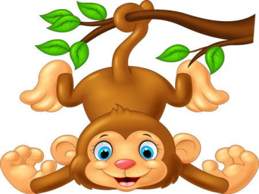 The _ _ _ _ _ _ is swinging.
Đáp án: monkey
114. name?/ his teacher's/ do you/ spell/ How/
Đáp án: How do you spell his teacher's name?
115. Ảnh: That’s a _ _ _ _ _ pencil
Đáp án: short
116. _ _ _ _ time do you go to bed?
Đáp án: What
117. Choose the odd one out:
A. is B. am C. are D. those
Đáp án: Chọn ý: D
118. Close/ please./ book,/ your/
Đáp án: Close your book, please.
119. … your teeth, Tommy.
A. Read B. Listen C. Stand D. Brush
Đáp án: Chọn ý: D
120. Nghe: Nhấn giữ Ctrl và bấm chuột để nghe: My _ _ _ _ is green.
Đáp án: ball
121. lunchbox./ my/ don't/ I/ have/
Đáp án: I don't have my lunchbox.
122. The children are happy at break _ _ _ _ .
Đáp án: time
123. How … students are there in your classroom?
A. much B. many C. more D. some
Đáp án: many
124. Ảnh: 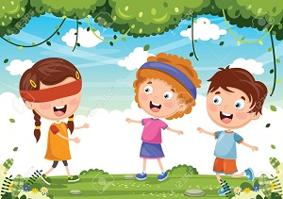 _ _ _ nd man's bluff is a game.
Đáp án: bli
125. May I come in? - …
A. No, you don’t. B. Yes, please. C. Yes, you are. D. No, you aren’t.
Đáp án: Yes, please.
126. … do you like? – I like riding a horse.
A. When B. How C. What D. Who
Đáp án: What
127. One and one is t_ _ .
Đáp án: wo
128. I’m h_ _ gry.
Đáp án: un
129. What's/ name?/ mother's/ her/
Đáp án: What's her mother's name?
130. your/ she/ new/ Is/ classmate?/
Đáp án: Is she your new classmate?
131. … is this? – It’s my rubber.
A. Who B. What C. How D. Where
Đáp án: What
132. Choose the letter(s) to make a correct word: ga__en
A. dd B. td C. rt D. rd
Đáp án: Chọn ý: D
133. Nghe: Nhấn giữ Ctrl và bấm chuột để nghe: HOU_ _
Đáp án: SE
134. Ảnh: What colour is the fence?
A. Blue B. Black C. White D. Yellow
Đáp án: White
135. Choose the odd one out:
A. repeat B. listen C. read D. am
Đáp án: Chọn ý: D
136. toys./ have/ some/ My sisters/
Đáp án: My sisters have some toys.
137. Goodbye. See you a_ _ _ n!
Đáp án: gai
138. That’s a big play_ _ _ _ _ _ .
Đáp án: ground
139. white./ in/ You/ are/ beautiful/
Đáp án: You are beautiful in white.
140. Which sentence is correct?
A. Santa Claus flying over the town. B. Santa Claus is riding his sleigh. C. Santa Claus is ride a reindeer. D. Santa Claus is walking in the sky.
Đáp án: Santa Claus is riding his sleigh.
141. There … some cheese in the fridge.
A. are B. is C. be D. have
Đáp án: is
142. Can you give me some pens, pl_ _ se?
Đáp án: ea
143. Does your father like p_ _ _ ing sports?
Đáp án: lay
144. is/ Mr. Gerhard/ now./ the computer room/ in/
Đáp án: Mr. Gerhard is in the computer room now.
145. Have … nice day, Jane. – Thank you.
A. a B. an C. the D. am
Đáp án: a
146. What is this box? - … a present for mom on Christmas Day.
A. She’s B. He’s C. It’s D. I’m
Đáp án: It’s
147. nice/ Have/ day./ a/
Đáp án: Have a nice day.
148. We play sports _ _ _ games at break time.
Đáp án: and
149. Nghe: Nhấn giữ Ctrl và bấm chuột để nghe: How do you _ _ _ _ _ your name?
Đáp án: spell
150. a park/ in your/ Is there/ town?
Đáp án: Is there a park in your town?
151. Peter: Are they your friends? - Tom: No, they _ _ _ _ ’t.
Đáp án: aren
152. Nga: ... play chess! - Peter: Yes, let’s.
A. Do you B. Don’t you C. Let’s D. Are you
Đáp án: Let’s
153. Have ... nice day, Robin. – Thank you very much.
A. an B. the C. a D. are
Đáp án: a
154. This is my school lib_ _ _ _ . It’s big.
Đáp án: rary
155. noodles?/ Can/ more/ I have/ some/
Đáp án: Can I have some more noodles?
156. Nghe: Nhấn giữ Ctrl và bấm chuột để nghe: _ _ _ _ _ _ _ _ _
Đáp án: afternoon
157. Do they/ volleyball/ school?/ after/ play/
Đáp án: Do they play volleyball after school?
158. Great to s_ _ you.
Đáp án: ee
159. two/ Let’s/ circles,/ please./ make/
Đáp án: Let’s make two circles, please.
160. toys/ many/ How/ have?/ do you
Đáp án: How many toys do you have?
161. Ảnh: That is my pencil s_ _ _ _ _ _ _ _ .
Đáp án: harpener
162. That is my father. … name is Jame.
A. Her B. She C. He D. His
Đáp án: Chọn ý: D
163. with/ my friend./ to play/ I like/ chess/
Đáp án: I like to play chess with my friend.
164. How do/ you/ name?/ spell/ your
Đáp án: How do you spell your name?
165. My fish are very _ _ _ _ tiful.
Đáp án: beau
166. I ... my teeth in the morning.
A. do B. brush C. have D. does
Đáp án: brush
167. There are th_ _ e books on the table.
Đáp án: re
168. Is the_ _ a dog? – No, there is not.
Đáp án: re
169. Which animal has four legs?
A. Chicken B. Duck C. Dog D. Hen
Đáp án: Dog
170. _ _ _ _ _ are you going to stay? - In a hotel.
Đáp án: Where
171. my bag./ two pens/ I/ have/ in
Đáp án: I have two pens in my bag.
172. Choose the letter(s) to make a correct word: ki__chen
A. d B. t C. b D. k
Đáp án: t
173. is/ school/ my/ That/ library./
Đáp án: That is my school library.
174. the sky./ There/ a kite/ in/ is/
Đáp án: There is a kite in the sky.
175. Ảnh: F_ SH
Đáp án: I
176. Nghe: Nhấn giữ Ctrl và bấm chuột để nghe: The ______ is blue.
A. ski B. skiing C. sky D. fly
Đáp án: sky
177. Nghe: Nhấn giữ Ctrl và bấm chuột để nghe: They go to school by _ _ _ .
Đáp án: bus
178. I want to see the animals. Let’s go to the _ _ _ .
Đáp án: zoo
179. Nghe: Nhấn giữ Ctrl và bấm chuột để nghe: My new _ _ _ _ _ _ is Adam.
Đáp án: friend
180. in/ the car?/ your bags/ Are/
Đáp án: Are your bags in the car?
181. Tom and Minh are _ _ friends.
Đáp án: my
182. Which word is odd one out?
A. pig B. men C. chicken D. fish
Đáp án: men
183. This gift is for you. - Thank you very _ _ _ _ .
Đáp án: much
184. Let’s _ _ _ _ badminton.
Đáp án: play
185. Tom can ... a bicycle.
A. bye B. ride C. drive D. rides
Đáp án: ride
186. Let’s speak Eng_ _ _ _ !
Đáp án: lish
187. My classroom is ... . It’s not small.
A. big B. a big C. the big D. a small
Đáp án: big
188. She plays hide-and-_ _ _ _ in the garden.
Đáp án: seek
189. Ảnh: 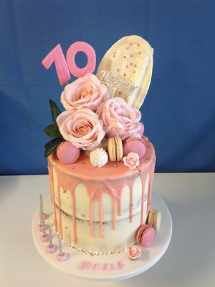 _________
A. Happy New Year! B. Happy birthday! C. Merry Christmas! D. Happy day!
Đáp án: Happy birthday!
190. your/ new/ they/ Are/ classmates?/
Đáp án: Are they your new classmates?
191. This is ... orange.
A. a B. an C. is D. are
Đáp án: an
192. C_ _ se your bag, Tom.
Đáp án: lo
193. Ảnh: That’s a pencil sharp_ _ _ _ .
Đáp án: ener
194. Hello,/ Trang./ is/ my name/
Đáp án: Hello, my name is Trang.
195. of/ is/ a photo/ my school./ This/
Đáp án: This is a photo of my school.
196. name?/ What/ family/ is/ your/
Đáp án: What is your family name?
197. Ảnh: His brother is _ _ _ teen years old.
Đáp án: fif
198. Nghe: Nhấn giữ Ctrl và bấm chuột để nghe: _ _ _ _
Đáp án: tick
199. your/ Peter/ friend?/ Is/
Đáp án: Is Peter your friend?
200. My/ name/ Long./ is/
Đáp án: My name is Long.

KEY IOE K3 2023 - 2023 SỐ 27
1. is/ It/ a box/ under the bed.
Đáp án: It is a box under the bed.
2. eraser?/ this/ Is/ an/
Đáp án: Is this an eraser?
3. Ảnh: It is snow_ in winter.
Đáp án: y
4. your/ brother's/ What/ is/ name?/
Đáp án: What is your brother's name?
5. my/ My pencil/ is in/ backpack./ case/
Đáp án: My pencil case is in my backpack.
6. your/ rulers?/ Are/ those/
Đáp án: Are those your rulers?
7. Nghe: Nhấn giữ Ctrl và bấm chuột để nghe: Are there any _ _ _ _ _ _ _ in the room?
Đáp án: posters
8. your/ colour/ What/ pencil sharpener?/ is/
Đáp án: What colour is your pencil sharpener?
9. Nghe: Nhấn giữ Ctrl và bấm chuột để nghe: The teacher tells the students to … .
A. sit down B. stand up C. go out D. come in
Đáp án: sit down
10. pink/ My mother/ a/ wants/ dress./
Đáp án: My mother wants a pink dress.
11. How many … are there? – Two.
A. dinosaur B. dinosaurs C. dinosaur’s D. dinosaurs’
Đáp án: dinosaurs
12. What is/ the name/ favourite/ of your/ book?/
Đáp án: What is the name of your favourite book?
13. My brother and I ... to school every morning.
A. go B. go’s C. goes D. goes to
Đáp án: go
14. What is your favourite ...? – I like milk very much.
A. food B. drink C. subject D. colour
Đáp án: drink
15. in/ room./ computer/ We are/ the/
Đáp án: We are in the computer room.
16. Ảnh: 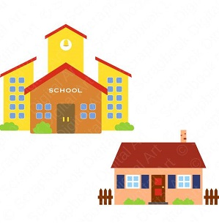 My house is _____ my school.
A. on B. at C. in D. near
Đáp án: Chọn ý: D
17. Nghe: Nhấn giữ Ctrl và bấm chuột để nghe: Let’s _ _ _ _ badminton.
Đáp án: play
18. Is that your father? – No, … .
A. it is B. it isn’t C. that is D. is that
Đáp án: it isn’t
19. Ảnh: _ _ _
Đáp án: CAR
20. and/ your/ eraser./ Pick up/ ruler/
Đáp án: Pick up your ruler and eraser.
21. Nghe: Nhấn giữ Ctrl và bấm chuột để nghe: Sue has ______ tomatoes.
A. two B. three C. some D. any
Đáp án: some
22. Thanks _ _ _ your invitation.
Đáp án: for
23. My father is _ _ engineer.
Đáp án: an
24. Good af_ _ _ _ _ _ _ , Mr. Parker!
Đáp án: ternoon
25. Nghe: Nhấn giữ Ctrl và bấm chuột để nghe: The ____ watch is mine.
A. blue B. yellow C. black D. white
Đáp án: yellow
26. Nam: W_ _ _ is this? - Mai: It’s a ruler.
Đáp án: hat
27. Does/ Lisa/ a cat?/ have/
Đáp án: Does Lisa have a cat?
28. days/ in/ There are/ seven/ a week./
Đáp án: There are seven days in a week.
29. Teacher: Do you like break time? - Anh: Yes, ... .
A. thank B. I do C. I don’t D. I am
Đáp án: I do
30. Who’s that girl? - ... .
A. She’s at school B. She’s from Australia C. She’s nine years old D. She’s Mary.
Đáp án: Chọn ý: D
31. Nghe: Nhấn giữ Ctrl và bấm chuột để nghe: Here is his …. .
A. mother B. brother C. sister D. father
Đáp án: Chọn ý: D
32. I’m _ _ _ _ _ , I’m late.
Đáp án: sorry
33. Wh_ _ _ are your pens? - They're in my pencil case.
Đáp án: ere
34. What is your fav_ _ _ _ te subject?
Đáp án: ouri
35. _ _ _ _ is your name? - My name is Jerry.
Đáp án: What
36. My brother is th_ _ _ years old.
Đáp án: ree
37. My class is …: ten girls and eleven boys.
A. nice B. tidy C. big D. new
Đáp án: big
38. Choose the odd one out:
A. you B. hi C. I D. She
Đáp án: hi
39. Nghe: Nhấn giữ Ctrl và bấm chuột để nghe: Choose the correct question.
A. Where is the garden? B. Where’s Peter? C. What is Peter doing? D. Is there a garden?
Đáp án: Where’s Peter?
40. Tony puts some toothpaste on his toothbrush. He is going to _ _ _ _ _ his teeth.
Đáp án: brush
41. My school is ... .
A. new’s B. new C. news D. names
Đáp án: new
42. Tha_ is my picture. It’s on the wall.
Đáp án: t
43. Nghe: Nhấn giữ Ctrl và bấm chuột để nghe: Can I have these burgers and that _____?
A. pencil B. chicken C. bread D. toy
Đáp án: chicken
44. Ảnh: In autumn, the sky is very _____.
A. black B. white C. green D. blue
Đáp án: Chọn ý: D
45. My new school bag is ... .
A. big B. school C. you D. skate
Đáp án: big
46. My books are ... the table.
A. at B. to C. under D. on
Đáp án: Chọn ý: D
47. kind/ Tony/ of music./ like this/ doesn’t/
Đáp án: Tony doesn’t like this kind of music.
48. your/ pen?/ new/ What/ colour is/
Đáp án: What colour is your new pen?
49. Ảnh: That’s a _ _ _ _ _ pencil
Đáp án: short
50. Ảnh: 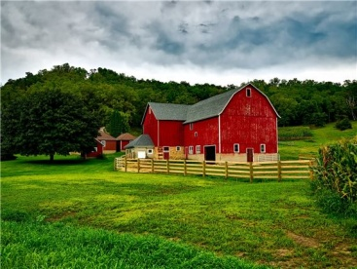 Horses and sheep live on the _ _ _ _ .
Đáp án: farm
51. Choose the odd one out:
A. you B. your C. his D. her
Đáp án: you
52. with/ my mother./ go shopping/ often/ I/
Đáp án: I often go shopping with my mother.
53. Teacher: What’s this? - Minh: It’s _ pencil sharperner
A. on B. in C. a D. an
Đáp án: a
54. you/ later./ See/
Đáp án: See you later.
55. My aunt is 51 … old. She is a nurse.
A. months B. years C. weeks D. days
Đáp án: years
56. sentences./ the/ Reorder/
Đáp án: Reorder the sentences.
57. What's his name? - He _ _ Alan.
Đáp án: is
58. Choose the odd one out
A. Cloud B. Sun C. Moon D. Pencil
Đáp án: Chọn ý: D
59. Peter: How …are you? - Hoa: I’m eight years old.
A. all B. old C. tall D. small
Đáp án: old
60. Nghe: Nhấn giữ Ctrl và bấm chuột để nghe: My _ _ _ _ is green.
Đáp án: ball
61. G_ _ dbye. See you later.
Đáp án: oo
62. Write the an_ _ _ rs, please.
Đáp án: swe
63. That is my brother. Hi_ name is Tom.
Đáp án: s
64. I often play football _ _ Tuesday afternoons.
Đáp án: on
65. Is there/ one garden/ in/ your school?
Đáp án: Is there one garden in your school?
66. Ảnh: How many cats are there in the picture? - _ _ _ _ _ .
Đáp án: three
67. playing/ with a robot?/ like/ Do/ you/
Đáp án: Do you like playing with a robot?
68. you/ from?/ are/ Where/
Đáp án: Where are you from?
69. H_ _ name is Jenny.
Đáp án: er
70. My school bag _ _ new.
Đáp án: is
71. a/ is/ square box./ That/
Đáp án: That is a square box.
72. What _______ at break time?
A. do you do B. is he do C. are you do D. are they do
Đáp án: do you do
73. Tuan is _ _ the computer room.
Đáp án: in
74. playground/ Is/ your/ big?
Đáp án: Is your playground big?
75. Choose the odd one out.
A. school items B. pencil sharpeners C. black boards D. school bags
Đáp án: school items
76. Peter is _ _ the classroom now.
Đáp án: in
77. _ _ _ _ _ are you going to stay? - In a hotel.
Đáp án: Where
78. I want to play sports. Let’s go to the g_ _ .
Đáp án: ym
79. Nghe: Nhấn giữ Ctrl và bấm chuột để nghe: _ _ _ _ _
Đáp án: small
80. She ... long hair.
A. have B. has C. is D. with
Đáp án: has
81. I don’t have ... sandwich.
A. a B. those C. an D. these
Đáp án: a
82. Listen/ please./ to/ teacher/ the/
Đáp án: Listen to the teacher please.
83. _ _ _ re is Peter from? – He’s from England.
Đáp án: Whe
84. Ảnh: Excuse me, where is the mu_ _ _ room?
Đáp án: sic
85. My name is Peter. I _ _ a student at Oxford Primary School.
Đáp án: am
86. Billy: Are they your pencils? - Minh: No, they ... .They’re my pens.
A. don’t B. have C. do D. aren’t
Đáp án: Chọn ý: D
87. Let’s introduce … .
A. your B. self C. yourself D. end
Đáp án: yourself
88. Ảnh: Let’s count to t_ _ _ ty.
Đáp án: wen
89. My bedroom is b_ _ utiful.
Đáp án: ea
90. subjects/ What/ best?/ like/ do you/
Đáp án: What subjects do you like best?
91. Do you _ _ to the zoo with your family?
Đáp án: go
92. _ _ _ old are you?
Đáp án: how
93. Ảnh: We go to school ________.
A. on my classmates B. on my parents C. on my friends D. on school day
Đáp án: Chọn ý: D
94. match./ and/ Listen/
Đáp án: Listen and match.
95. Where _ _ you study, Trang?
Đáp án: do
96. Mai: What’s that? - Linda: That’s my … .
A. Peter B. school library C. friend D. teacher
Đáp án: school library
97. Nghe: Nhấn giữ Ctrl và bấm chuột để nghe: This is my s_ _ _ _ _ .
Đáp án: ister
98. Ảnh: My pencil is _ _ _ _ . Her pencil is short.
Đáp án: long
99. there/ in the room?/ windows/ How many/ are/
Đáp án: How many windows are there in the room?
100. Stand/ up,/ please./
Đáp án: Stand up, please.
101. Choose the incorrect word or phrase in the following sentence: There is a garden on front of his house.
A. is B. garden C. on D. his
Đáp án: on
102. Tom live ... England
A. on B. in C. for D. to
Đáp án: in
103. Ảnh: The school playground is crowded at _ _ _ _ _ time.
Đáp án: break
104. Ảnh: How old is your _ _ _ _ _ father?
Đáp án: grand
105. away,/ your/ Put/ books/ please./
Đáp án: Put your books away, please.
106. My family has _ big dinner.
Đáp án: a
107. This is my/ pencil/ new/ box.
Đáp án: This is my new pencil box.
108. Jane: Are … your friends? - David: Yes, they are.
A. Peter B. Mary C. are D. Peter and Mary
Đáp án: Chọn ý: D
109. Ảnh: CA_ _
Đáp án: KE
110. a glass/ It/ of milk./ is/
Đáp án: It is a glass of milk.
111. What do you do in … free time?
A. you B. yours C. you’re D. your
Đáp án: Chọn ý: D
112. Why do you like Music? – Because I like _ _ sing.
Đáp án: to
113. Point … your names, children.
A. at B. on C. in D. to
Đáp án: Chọn ý: D
114. His/ coat/ is/ under/ the bed./
Đáp án: His coat is under the bed.
115. Ảnh: The _______ fly around the flowers.
A. frogs B. grasshoppers C. butterflies D. birds
Đáp án: butterflies
116. Ảnh: What are they doing? - They are sw_ _ _ _ _ _ .
Đáp án: imming
117. What is this? - ….
A. It a orange B. Is a orange C. It’s a orange D. It’s an orange
Đáp án: Chọn ý: D
118. your/ Where/ is/ house?
Đáp án: Where is your house?
119. colour/ your old/ ball?/ is/ What/
Đáp án: What colour is your old ball?
120. Nghe: Nhấn giữ Ctrl và bấm chuột để nghe: Listen and tick the word(s) you hear:
A. classroom B. bathroom C. living room D. bedroom
Đáp án: classroom
121. My ... is Sean.
A. name’s B. names C. name D. namese
Đáp án: name
122. Why ... we come and visit Uncle Tom? - That’s a good idea.
A. don’t B. have C. do D. aren’t
Đáp án: don’t
123. I can sing but I _ _ _ _ _ _ dance.
Đáp án: cannot
124. _ _ _ often do you do morning exercise in the summer?
Đáp án: How
125. Thank you very much – You’re ... .
A. welcome’s B. welcomes C. welcome D. welcome’re
Đáp án: welcome
126. Who is your _ _ iend?
Đáp án: fr
127. He_ _ _ , I’m Micheal. Nice to meet you..
Đáp án: llo
128. How _ _ ny bananas are there in the box?
Đáp án: ma
129. Her/ from/ are/ friends/ France./
Đáp án: Her friends are from France.
130. Ảnh: 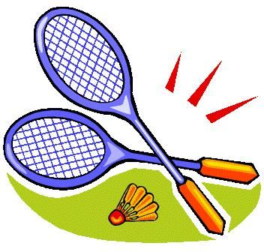 My favourite sport is badm_ _ _ _ _ .
Đáp án: inton
131. can/ many/ draw/ pictures./ My brother/
Đáp án: My brother can draw many pictures.
132. Ảnh: 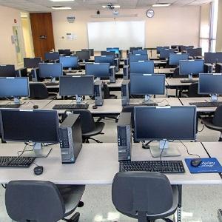 This is the _ _ _ _ _ _ _ _ room.
Đáp án: computer
133. Nghe: Nhấn giữ Ctrl và bấm chuột để nghe: Listen and tick the word(s) you hear:
A. a pen B. a pencil C. a bank D. a band
Đáp án: a pencil
134. ... you like chicken?
A. Do B. Does C. Are D. Is
Đáp án: Do
135. Ảnh: __________
A. Happy New Year! B. Merry Christmas! C. Happy birthday! D. Happy day!
Đáp án: Happy New Year!
136. Nghe: Nhấn giữ Ctrl và bấm chuột để nghe: Those are my _ _ _ _ _ .
Đáp án: books
137. … is your school? – It’s at the corner of the street.
A. Who B. Where C. How D. What
Đáp án: Where
138. Is there … sugar in the jar?
A. any B. some C. a D. an
Đáp án: any
139. These are their _____.
A. schoolbag B. school bags C. schools bag D. schools bags
Đáp án: school bags
140. Ảnh: They _ _ _ _ _ to school every morning.
Đáp án: cycle
141. white./ You/ beautiful/ in/ are/
Đáp án: You are beautiful in white.
142. I like doing karate. - ... .
A. No, thanks B. Me too C. Yes, please D. Sorry
Đáp án: Me too
143. The new playground is _ _ g.
Đáp án: bi
144. Ảnh: There are elev_ _ pencils on the desk.
Đáp án: en
145. Teacher: ... to me, please.
A. Listens B. Listen C. Listening D. Is listening
Đáp án: Listen
146. Peter is my fr_ _ _ _ .
Đáp án: iend
147. these,/ What/ Dad?/ are/
Đáp án: What are these, Dad?
148. My pictures are _ _ the wall.
Đáp án: on
149. Alex/ likes/ table tennis/ likes chess./ and Max
Đáp án: Alex likes table tennis and Max likes chess.
150. ... a round ball.
A. Is it B. It’s C. What is D. They are
Đáp án: It’s
151. my/ is/ This/ new/ classroom./
Đáp án: This is my new classroom.
152. Ảnh: 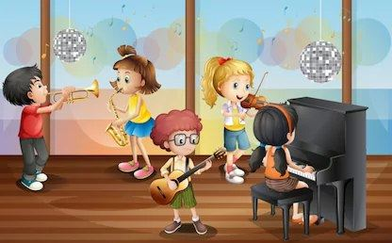 _ _ _ _ _ room
Đáp án: music
153. Nghe: Nhấn giữ Ctrl và bấm chuột để nghe: Sue is in the … room.
A. living B. dining C. sitting D. bed
Đáp án: living
154. How are you today, Peter? – I’m ..., thanks.
A. nice B. nice’s C. fine D. fine’s
Đáp án: fine
155. Nam is .... He’d like to sit down.
A. tired B. hungry C. thirsty D. cold
Đáp án: tired
156. There is on_ book in my bag.
Đáp án: e
157. Nghe: Nhấn giữ Ctrl và bấm chuột để nghe: _ _ _ _
Đáp án: tick
158. That is _ bed.
Đáp án: a
159. Goodbye. See you lat_ _ !
Đáp án: er
160. Ảnh: What colour is the cat’s eyes? It is _ _ _ _ _ .
Đáp án: green
161. Phuong: This is my friend Mai. - Linda: Nice to meet ..., Mai.
A. your B. you C. my D. me
Đáp án: you
162. Linda: Do your friends play games at school? - Hoa: Yes,they ... .
A. do B. does C. are D. is
Đáp án: do
163. Nghe: Nhấn giữ Ctrl và bấm chuột để nghe: My school has a big _ _ _ _ _ _ _ .
Đáp án: library
164. Simon is my new fr_ _ _ _ .
Đáp án: iend
165. What colour is ____ classroom? - My classroom is white.
A. her B. your C. its D. his
Đáp án: your
166. Nghe: Nhấn giữ Ctrl và bấm chuột để nghe: Listen and tick the word(s) you hear:
A. man B. learn C. plant D. stand
Đáp án: plant
167. ... your hands, please.
A. Write B. Sing C. Wash D. Study
Đáp án: Wash
168. What are ...? - They are my books
A. it B. this C. that D. these
Đáp án: Chọn ý: D
169. How _ o you spell your name?
Đáp án: d
170. Ảnh: Let's make paper bo_ ts.
Đáp án: a
171. What/ book/ it?/ is/
Đáp án: What book is it?
172. My children/ school/ everyday./ walk to/
Đáp án: My children walk to school everyday.
173. the name/ What is/ favourite/ of your/ book?/
Đáp án: What is the name of your favourite book?
174. Ảnh: The girl is … .
A. doing puzzles B. playing basketball C. playing hide-and-seek D. skipping rope
Đáp án: Chọn ý: D
175. What ... it? – It’s a black ruler.
A. is B. it C. that D. this
Đáp án: is
176. I l_ _ _ swimming very much.
Đáp án: ike
177. This is _ new pen.
Đáp án: a
178. more/ some/ please./ Give me/ milk,
Đáp án: Give me some more milk, please.
179. well./ The/ dance/ can/ little girl/
Đáp án: The little girl can dance well.
180. Lan: What colour are your pencils? - Huong: They ... blue and green
A. do B. don’t C. are D. is
Đáp án: are
181. What’s the matter? – I’m ... .
A. tired B. teacher C. student D. Peter
Đáp án: tired
182. Fine, thanks. … you?
A. But B. So C. And D. Or
Đáp án: And
183. Spe_ _ your name, please.
Đáp án: ll
184. new pen?/ your/ is/ What/ colour/
Đáp án: What colour is your new pen?
185. I’m _ _ ne, thanks.
Đáp án: fi
186. Let’s/ go/ school./ to/
Đáp án: Let’s go to school.
187. I/ May/ notebook?/ close/ the
Đáp án: May I close the notebook?
188. Pick ... your pen, children.
A. at B. on C. to D. up
Đáp án: Chọn ý: D
189. Nghe: Nhấn giữ Ctrl và bấm chuột để nghe: Phuong is reading a _ _ _ _ .
Đáp án: book
190. One and one is t_ _ .
Đáp án: wo
191. Can you _ _ _ _ _ from one to one hundred?
Đáp án: count
192. It's/ cream./ ice/ brother's/ my/
Đáp án: It's my brother's ice cream.
193. are/ circles./ These/ some/
Đáp án: These are some circles.
194. Where is your school? – It’s … Nguyen Trai Street.
A. on B. at C. to D. from
Đáp án: on
195. It's not my pen. It's y_ _ _ pen.
Đáp án: our
196. Nghe: Nhấn giữ Ctrl và bấm chuột để nghe: This is his … and this is his … .
A. hat – shirt B. ball – T-shirt C. cap – shorts D. bag - shoes
Đáp án: ball – T-shirt
197. My brother can ... football.
A. play B. plays C. play’s D. to play
Đáp án: play
198. The park is large _ _ _ new.
Đáp án: and
199. Read/ the/ chant/ aloud.
Đáp án: Read the chant aloud.
200. Hoa: … that? - Tony: That’s my school bag.
A. Who B. Who’s C. What D. What’s
Đáp án: Chọn ý: D

KEY IOE K3 2023 - 2024 SỐ 28
1. Thanks _ _ _ your invitation.
Đáp án: for
2. Lan is a stu_ _ _ _ .
Đáp án: dent
3. ________- Yes, you can.
A. How are you? B. How old are you? C. Let's play football! D. May I borrow your book?
Đáp án: Chọn ý: D
4. your/ new/ What/ colour is/ pen?/
Đáp án: What colour is your new pen?
5. much./ I/ swimming/ like/ very
Đáp án: I like swimming very much.
6. Where is your school? – It’s … Nguyen Trai Street.
A. on B. at C. to D. from
Đáp án: on
7. Students all … when their English teacher comes in.
A. stand up B. go out C. sit down D. come in
Đáp án: stand up
8. Her ruler _ _ n't new. It's old.
Đáp án: is
9. pencil?/ your/ is/ color/ What/
Đáp án: What color is your pencil?
10. Lan: Is Linda your friend? - Huong: Yes, ... is.
A. he B. she’s C. she D. she is
Đáp án: she
11. Nghe: Nhấn giữ Ctrl và bấm chuột để nghe: _ _ _ _ _
Đáp án: APPLE
12. Yes, _ _ is a new notebook.
Đáp án: it
13. Choose the odd one out:
A. Good morning. B. Goodbye. C. See you again. D. See you soon.
Đáp án: Good morning.
14. D_ _ _ she love Science?
Đáp án: oes
15. Ảnh: 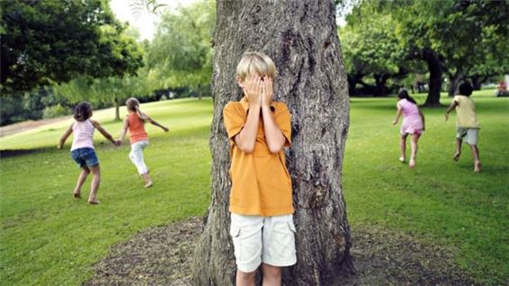 Let’s play hide-and-s_ _ k with us.
Đáp án: ee
16. Ảnh: Re_ _ and answer.
Đáp án: ad
17. _ _ you have pets? - No, I don’t.
Đáp án: Do
18. Peter: What are their …? - Hoa: Mai and Huong.
A. name B. names C. your name D. your names
Đáp án: names
19. Nghe: Nhấn giữ Ctrl và bấm chuột để nghe: My pencil is ye_ _ _ _ .
Đáp án: llow
20. ice/ my/ brother's/ cream./ It's/
Đáp án: It's my brother's ice cream.
21. Your rulers/ green. They/ are/ are in the bag.
Đáp án: Your rulers are green. They are in the bag.
22. My little brother … like eating vegetables.
A. doesn’t B. don’t C. isn’t D. aren’t
Đáp án: doesn’t
23. Mr. Parker r_ _ _ _ newspapers everyday.
Đáp án: eads
24. in/ a week./ seven/ There are/ days/
Đáp án: There are seven days in a week.
25. Ảnh: That’s my pencil _ _ g!
Đáp án: ba
26. Here are your shoes. – _ _ _ _ _ _ .
Đáp án: Thanks
27. The new playground is _ _ g.
Đáp án: bi
28. on/ Friday./ I don’t/ Art/ have/
Đáp án: I don’t have Art on Friday.
29. is/ book/ it?/ What/
Đáp án: What book is it?
30. Nghe: Nhấn giữ Ctrl và bấm chuột để nghe: He is ____.
A. 12 B. 13 C. 14 D. 15
Đáp án: 14
31. The sofa/ the window./ near/ is/
Đáp án: The sofa is near the window.
32. Ảnh: This is your …, Tom.
A. bench B. desk C. chair D. board
Đáp án: desk
33. One and one is t_ _ .
Đáp án: wo
34. Ảnh: What colour is the armchair?
A. yellow B. red C. black D. white
Đáp án: red
35. Gi_ e me the book, please.
Đáp án: v
36. Nghe: Nhấn giữ Ctrl và bấm chuột để nghe: This is my _ _ _ _ her.
Đáp án: brot
37. Ảnh: I have a new ___. It's green.
A. bike B. car C. ship D. train
Đáp án: bike
38. My friends go to school _ _ bikes. They live near the school.
Đáp án: by
39. Teacher: Have a break! - Children: Let’s play … .
A. blind man’s bluff B. books C. board D. dog
Đáp án: blind man’s bluff
40. Tam: What ... is your pencil? - Mai: It’s red.
A. colour B. this C. that D. the
Đáp án: colour
41. Choose the odd one out:
A. bag B. book C. big D. pencil
Đáp án: big
42. How old is your niece? - … is fifteen years old.
A. He B. She C. They D. It
Đáp án: She
43. name?/ mother's/ her/ What's/
Đáp án: What's her mother's name?
44. Ảnh: 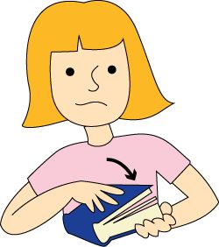 … your book, please.
A. Open B. Close C. Read D. Write
Đáp án: Close
45. Ảnh: A person has _ _ _ hands.
Đáp án: two
46. What are those? - … chalks.
A. They’re B. It’s C. You’re D. We’re
Đáp án: They’re
47. Look _ _ the blackboard, please.
Đáp án: at
48. your/ is/ When/ birthday?
Đáp án: When is your birthday?
49. What ... it? – It’s a black ruler.
A. is B. it C. that D. this
Đáp án: is
50. cat/ the table./ is a/ next to/ There/
Đáp án: There is a cat next to the table.
51. _ _ _ t’s your name? – My name’s Sean.
Đáp án: Wha
52. Wh_ is that? – That’s Collin. He is my good friend.
Đáp án: o
53. park/ my school./ There is/ a small/ near
Đáp án: There is a small park near my school.
54. Choose the odd one out
A. Behind B. Front C. Under D. Wall
Đáp án: Chọn ý: D
55. What is his _ _ _ _ ? – He is Eddie Murray.
Đáp án: name
56. Are these _ _ _ _ posters? – Yes, they are my posters.
Đáp án: your
57. Nghe: Nhấn giữ Ctrl và bấm chuột để nghe: This is my _ _ _ _ .
Đáp án: book
58. May I _ _ out?
Đáp án: go
59. … do you spell his name?
A. How B. What C. Who D. Why
Đáp án: How
60. Ảnh: It is snow_ in winter.
Đáp án: y
61. He ... my friend.
A. are B. is C. me D. I
Đáp án: is
62. Choose the odd one out
A. Picture B. Photo C. Table D. School
Đáp án: Chọn ý: D
63. Teacher: Have a ... . - Children: Let’s play games.
A. break B. take C. make D. check
Đáp án: break
64. Show/ please!/ me/ your/ tickets,
Đáp án: Show me your tickets, please!
65. Hello, My name’s Kate. I am ten _ _ _ _ _ old.
Đáp án: years
66. Nghe: Nhấn giữ Ctrl và bấm chuột để nghe: She’s got curly _ _ _ _ .
Đáp án: hair
67. Ảnh: 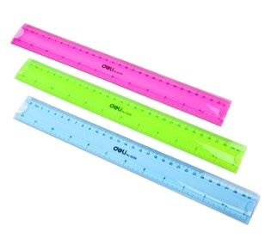 These are Mike’s _ _ _ _ _ _ .
Đáp án: rulers
68. Does Mary like playing badminton? - …
A. Yes, she does. B. No, she isn’t. C. Yes, she can. D. No, she hasn’t.
Đáp án: Yes, she does.
69. Ảnh: What colour is the sun? – It’s y_ _ _ _ _ .
Đáp án: ellow
70. like/ pizza./ I'd/ some/
Đáp án: I'd like some pizza.
71. books/ please./ away,/ your/ Put/
Đáp án: Put your books away, please.
72. Where/ are/ the children?/
Đáp án: Where are the children?
73. Let’s sing w_ _ h me, please.
Đáp án: it
74. Choose the INCORRECT word or phrase in the following sentence: They are my ball, Daddy.
A. They B. my C. ball D. Daddy
Đáp án: ball
75. a new/ ship. It/ is my/ birthday present./ It's/
Đáp án: It's a new ship. It is my birthday present.
76. You are welc_ me.
Đáp án: o
77. Choose the odd one out:
A. repeat B. listen C. read D. am
Đáp án: Chọn ý: D
78. Goodbye. _ _ _ you again.
Đáp án: see
79. not/ do/ like/ I/ dogs./
Đáp án: I do not like dogs.
80. They are my _ _ _ _ tives.
Đáp án: rela
81. Choose the letter(s) to make a correct word: POS_ER
A. R B. S C. T D. N
Đáp án: T
82. Where are your pens and pencils?
A. They're the bag. B. They on the bag. C. They're in the bag. D. They are on bag.
Đáp án: They're in the bag.
83. My bag is … the table.
A. to B. at C. on D. for
Đáp án: on
84. ten rooms/ Are there/ this building?/ in/
Đáp án: Are there ten rooms in this building?
85. Nghe: Nhấn giữ Ctrl và bấm chuột để nghe: His sister’s _ _ _ _ is in the tree.
Đáp án: kite
86. funny./ The/ is/ game/
Đáp án: The game is funny.
87. Our/ school library/ is/ not/ large./
Đáp án: Our school library is not large.
88. His classroom is b_ g. It’s not small.
Đáp án: i
89. Ảnh: 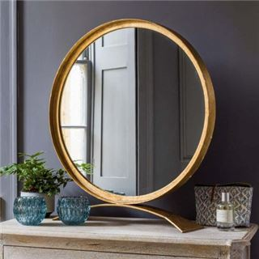 There is a magic _ _ _ _ _ _ in the story 'Snow White and Seven Dwarfs'.
Đáp án: mirror
90. How old is Rose? - She _ _ ten.
Đáp án: is
91. Where is my pencil shar_ _ _ er?
Đáp án: pen
92. Nghe: Nhấn giữ Ctrl và bấm chuột để nghe: This is my _ _ _ _ _ _ .
Đáp án: school
93. Mr. Green is talking _ _ Mrs. Green in the living room.
Đáp án: to
94. with/ my brother./ do/ I/ puzzles/
Đáp án: I do puzzles with my brother.
95. It’s a b_ ue pencil.
Đáp án: l
96. Nghe: Nhấn giữ Ctrl và bấm chuột để nghe: There is a p_ _ _ _ .
Đáp án: lane
97. Is this a ch_ ir? - Yes, it is.
Đáp án: a
98. My mother/ makes/ in the morning./ cakes/
Đáp án: My mother makes cakes in the morning.
99. Ảnh: _ _ _
Đáp án: PEN
100. work/ goes/ to/ at 6 o'clock./ She/
Đáp án: She goes to work at 6 o'clock.
101. How many ... are there ? - There is one peach.
A. crayons B. peachs C. peach D. peaches
Đáp án: Chọn ý: D
102. Choose the odd one out
A. Games B. Swimming C. Skipping D. Chess
Đáp án: Games
103. big?/ Is/ playground/ your/
Đáp án: Is your playground big?
104. Can you _ _ _ _ _ from one to one hundred?
Đáp án: count
105. We play sports _ _ _ games at break time.
Đáp án: and
106. they/ your/ classmates?/ Are/ new
Đáp án: Are they your new classmates?
107. ... up, please!
A. Sit B. Open C. Close D. Stand
Đáp án: Chọn ý: D
108. How m_ _ y crayons are there?
Đáp án: an
109. There is _ _ apple on the table.
Đáp án: an
110. She ... long hair.
A. have B. has C. is D. with
Đáp án: has
111. Nghe: Nhấn giữ Ctrl và bấm chuột để nghe: They go to school by _ _ _ .
Đáp án: bus
112. his teacher's/ How/ spell/ name?/ do you/
Đáp án: How do you spell his teacher's name?
113. like/ English?/ Alice/ does/ Why/
Đáp án: Why does Alice like English?
114. does/ up?/ When/ get/ Hoang/
Đáp án: When does Hoang get up?
115. Nghe: Nhấn giữ Ctrl và bấm chuột để nghe: They are playing ….
A. volleyball B. football C. basketball D. baseball
Đáp án: football
116. orange bag./ an/ is/ This/
Đáp án: This is an orange bag.
117. A: What is this? - B: …
A. It’s yellow. B. It’s a blue pencil. C. It’s very nice. D. It’s my friend.
Đáp án: It’s a blue pencil.
118. I … a blue pencil and a white ruler.
A. has B. have C. don’t have D. doesn’t have
Đáp án: have
119. Ảnh: Rosy’s ice cream is _ _ _ _ .
Đáp án: pink
120. Mary is reading books in the … . She comes there every weekend.
A. music room B. computer room C. library D. laboratory
Đáp án: library
121. Does your mother like do_ _ _ yoga?
Đáp án: ing
122. I am .... I want a cake.
A. thirsty B. tired C. happy D. hungry
Đáp án: Chọn ý: D
123. He_ _ o, my name’s Richard. - Nice to meet you.
Đáp án: ll
124. Ảnh: It’s _ _ _ outside.
Đáp án: hot
125. There is a kite ... the sky.
A. on B. to C. for D. in
Đáp án: Chọn ý: D
126. blue desk?/ Do/ you/ like/ that
Đáp án: Do you like that blue desk?
127. Ảnh: There are many stars in the s_ _ .
Đáp án: ky
128. sing/ Let’s/ an English/ song.
Đáp án: Let’s sing an English song.
129. Who is your _ _ iend?
Đáp án: fr
130. Andy is my friend. _________ is short.
A. I B. He C. It D. You
Đáp án: He
131. David can play ... .
A. desk B. chair C. pencil D. football
Đáp án: Chọn ý: D
132. Do you … skateboarding?
A. like B. liking C. likes D. to like
Đáp án: like
133. Can you speak English? - ... .
A. Yes, I can’t B. No, I can C. No, I can’t D. Yes, I do
Đáp án: No, I can’t
134. G_ _ _ bye, see you later.
Đáp án: ood
135. Nghe: Nhấn giữ Ctrl và bấm chuột để nghe: The _____ trainers are mine.
A. green B. black C. blue D. white
Đáp án: Chọn ý: D
136. football/ plays/ David/ weekend./ at the
Đáp án: David plays football at the weekend.
137. Ảnh: A person has _ _ _ legs.
Đáp án: two
138. I like _______ hide-and-seek with my friends.
A. playing B. plays C. play D. to playing
Đáp án: playing
139. How ... chairs in your classroom?
A. much B. very C. old D. many
Đáp án: Chọn ý: D
140. This is my grandf_ _ _ _ _ . He is 83 years old.
Đáp án: ather
141. brown./ green and/ My pencils/ are/ red, blue,/
Đáp án: My pencils are red, blue, green and brown.
142. Nghe: Nhấn giữ Ctrl và bấm chuột để nghe: My school _ _ _ is very long.
Đáp án: bus
143. The piano is nice but … .
A. old B. new C. big D. good
Đáp án: old
144. Nghe: Nhấn giữ Ctrl và bấm chuột để nghe: Sue _ _ _ _ _ up at seven o’clock in the morning.
Đáp án: wakes
145. ... you like some milk? - No, thanks.
A. Can B. Are C. Is D. Would
Đáp án: Chọn ý: D
146. Nghe: Nhấn giữ Ctrl và bấm chuột để nghe: There are two _ _ _ _ _ _ _ _ .
Đáp án: bedrooms
147. Ảnh: He is wearing an o_ _ _ _ _ T-shirt.
Đáp án: range
148. Linh: Does Nam like playing tennis? - Hoa: Yes, … does.
A. he B. he’s C. you D. they
Đáp án: he
149. I/ book?/ my/ open/ May/
Đáp án: May I open my book?
150. This pen _ _ blue.
Đáp án: is
151. _ _ _ _ _ pencils are these? – They’re mine.
Đáp án: Whose
152. isn't/ in the/ classroom. She/ is outside./ My friend/
Đáp án: My friend isn't in the classroom. She is outside.
153. Hello. My ... is Tom.
A. name B. is C. am D. are
Đáp án: name
154. Choose the odd one out.
A. numbers B. twenty C. thirteen D. seven
Đáp án: numbers
155. The map is on the wa_ _ .
Đáp án: ll
156. Nghe: Nhấn giữ Ctrl và bấm chuột để nghe: My room is _ _ _ _ _ .
Đáp án: large
157. Nghe: Nhấn giữ Ctrl và bấm chuột để nghe: _ _ _ _
Đáp án: cook
158. My/ not/ big./ room/ is/
Đáp án: My room is not big.
159. Children shouldn’t drink coffee. It is not good _ _ _ their health.
Đáp án: for
160. she/ new sandals?/ have/ Does/
Đáp án: Does she have new sandals?
161. This is ... bag. It’s yellow.
A. a B. b C. c D. d
Đáp án: a
162. What/ a/ say?/ does/ cat
Đáp án: What does a cat say?
163. Choose the correct sentence.
A. I like playing chess at break time. B. I like play chess at break time. C. I like playing chess on break time. D. I like playing a chess at break time.
Đáp án: I like playing chess at break time.
164. _ _ _ _ time do you go to bed?
Đáp án: What
165. Nghe: Nhấn giữ Ctrl và bấm chuột để nghe: Listen and tick:
A. fingers B. goldfish C. farmer D. fireman
Đáp án: Chọn ý: D
166. W_ _ _ _ are the children? - They are at school.
Đáp án: here
167. Underline/ words of place/ the/ text./ in/
Đáp án: Underline words of place in the text.
168. I have Maths _ _ Monday.
Đáp án: on
169. I _ _ _ _ books in the school library.
Đáp án: read
170. Where are you from, Peter? – I’m _ _ _ _ England.
Đáp án: from
171. What is yo_ _ name? – My name’s Jane.
Đáp án: ur
172. Ảnh: How many rooms are there in your ho_ _ _ ?
Đáp án: use
173. Ảnh: 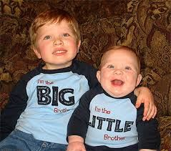 Who are in this ph_ _ _ ? - My brother and I.
Đáp án: oto
174. Nghe: Nhấn giữ Ctrl và bấm chuột để nghe: Listen and tick:
A. bike B. kite C. rice D. tie
Đáp án: bike
175. my mother./ go shopping/ I/ often/ with
Đáp án: I often go shopping with my mother.
176. My pictures are ... the wall.
A. on B. to C. for D. at
Đáp án: on
177. I like playing ... .
A. yoga B. aerobics C. puzzles D. badminton
Đáp án: Chọn ý: D
178. The/ maps/ the shelf./ are/ on
Đáp án: The maps are on the shelf.
179. My/ sister/ is/ fifteen.
Đáp án: My sister is fifteen.
180. Look … the picture, Mary.
A. to B. on C. for D. at
Đáp án: Chọn ý: D
181. Mr. Parker r_ _ _ _ newspapers everyday.
Đáp án: eads
182. One and one is _ _ _ .
Đáp án: two
183. Nghe: Nhấn giữ Ctrl và bấm chuột để nghe: Her brother, Tom, is _ _ _ years old.
Đáp án: six
184. play/ Let's/ break time./ at/ hide-and-seek/
Đáp án: Let's play hide-and-seek at break time.
185. you/ Do/ pizza?/ like/
Đáp án: Do you like pizza?
186. children./ Raise/ your/ hand,/
Đáp án: Raise your hand, children.
187. ______ Mi like chicken?
A. Are B. Do C. Does D. Is
Đáp án: Does
188. … many desks are there in your classroom?
A. How B. What C. Who D. Which
Đáp án: How
189. Nam: W_ _ _ is this? - Mai: It’s a ruler.
Đáp án: hat
190. My father is _ _ engineer.
Đáp án: an
191. Choose the odd one out:
A. eraser B. cat C. goldfish D. parrot
Đáp án: eraser
192. These books _ re pink.
Đáp án: a
193. do?/ What/ can/ Ryan/
Đáp án: What can Ryan do?
194. ______ my uncle next to my father.
A. They are B. There are C. It is D. Is there
Đáp án: It is
195. Good...ye! See you later.
A. a B. d C. y D. b
Đáp án: Chọn ý: D
196. Wow! A robot. Thank _ _ _ .
Đáp án: you
197. notebook/ I/ and a big/ book./ have a small/
Đáp án: I have a small notebook and a big book.
198. go/ school./ to/ Let’s/
Đáp án: Let’s go to school.
199. I’m fine, thank you. ... ?
A. You B. And you C. And D. Are
Đáp án: And you
200. Between two subject lessons, we have a little time for ….
A. break B. take C. make D. check
Đáp án: break

KEY IOE K3 2023 - 2024 SỐ 29
1. Would you _ _ _ _ some water?
Đáp án: like
2. now./ is/ in/ Mr. Gerhard/ the computer room
Đáp án: Mr. Gerhard is in the computer room now.
3. Nghe: Nhấn giữ Ctrl và bấm chuột để nghe: I’ve got an _ _ _ _ _ .
Đáp án: apple
4. Which word is the odd one out?
A. table B. doll C. robot D. ball
Đáp án: table
5. Ảnh: 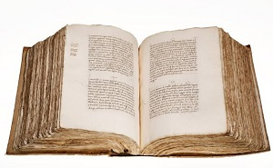 _ _ _ _
Đáp án: BOOK
6. Peter/ make/ can/ a paper boat.
Đáp án: Peter can make a paper boat.
7. Nghe: Nhấn giữ Ctrl và bấm chuột để nghe: Heidi's ____ is Kim.
A. father B. grandfather C. grandmother D. Mom
Đáp án: Chọn ý: D
8. Teacher: Have a break! - Children: Let’s play … .
A. blind man’s bluff B. books C. board D. dog
Đáp án: blind man’s bluff
9. Rooney./ Nice/ to/ you,/ meet/
Đáp án: Nice to meet you, Rooney.
10. Nam:... do you spell your name? - Linda: L_I_N_D_A.
A. How B. What C. Who D. Who’s
Đáp án: How
11. new/ she/ Is/ the/ teacher?/
Đáp án: Is she the new teacher?
12. are/ you/ from?/ Where/
Đáp án: Where are you from?
13. want/ I/ clothes./ new/ some/
Đáp án: I want some new clothes.
14. Ảnh: The boy has a red _ _ _ _ _ .
Đáp án: apple
15. is/ Her/ Allie./ name/
Đáp án: Her name is Allie.
16. It’s eleven o’clock. It’s time ….
A. to have B. for lunch C. for play D. to bed
Đáp án: for lunch
17. Read/ “Computer”./ after/ me:/
Đáp án: Read after me: “Computer”.
18. This is Mary. _ _ _ is my friend.
Đáp án: she
19. Ảnh: These are my … .
A. pens B. chalks C. posters D. notebooks
Đáp án: Chọn ý: D
20. Choose the letter(s) to make a correct word: B__THER
A. OR B. RO C. AR D.
Đáp án: RO
21. He … to school every morning.
A. go B. go to C. goes D. goes to
Đáp án: goes
22. ... John from Canada? - No, he isn’t.
A. Are B. This C. Is D. It
Đáp án: Is
23. This is my school lib_ _ _ _ . It’s big.
Đáp án: rary
24. Is that your classmate? – Yes, … .
A. she is B. we are C. they are D. I am
Đáp án: she is
25. What do you … at break time? - I play chess.
A. sing B. go C. hear D. do
Đáp án: Chọn ý: D
26. Ảnh: Her pencil _ _ _ _ is pink.
Đáp án: case
27. Happy birthday, Hai. This gift is for you. - Thank you _ _ _ _ much.
Đáp án: very
28. There are twenty stude_ _ _ in my class.
Đáp án: nts
29. Sit … and open your notebooks, please!
A. up B. on C. to D. down
Đáp án: Chọn ý: D
30. These ... my pencils.
A. and B. is C. are D. am
Đáp án: are
31. My father is _ _ engineer.
Đáp án: an
32. N_ _ e to meet you, Lan Anh.
Đáp án: ic
33. Choose the odd one out:
A. apple B. bird C. cat D. dog
Đáp án: apple
34. Nghe: Nhấn giữ Ctrl và bấm chuột để nghe: _ _ _ _ _
Đáp án: small
35. Which word has the underlined part pronounced LIKE the letter I in KITE?
A. ship B. milk C. nine D. fish
Đáp án: nine
36. Ảnh: Those are our ch_ _ _ _ .
Đáp án: airs
37. _ _ _ _ night, mommy.
Đáp án: Good
38. Ảnh: There is a lovely golden _ _ _ _ in a bowl
Đáp án: fish
39. I am …, thanks. And you?
A. five B. fight C. fine D. find
Đáp án: fine
40. It's great ___ you!
A. see B. meet C. seeing D. to see
Đáp án: Chọn ý: D
41. Choose the incorrect word or phrase in the following sentence: The gates of the house is blue.
A. The B. of C. house D. is
Đáp án: Chọn ý: D
42. open/ mom?/ May/ the window,/ I/
Đáp án: May I open the window, mom?
43. The apple is a kind of fr_ _ ts.
Đáp án: ui
44. Nghe: Nhấn giữ Ctrl và bấm chuột để nghe: They like _ _ _ _ _ _ _ .
Đáp án: skating
45. That _ _ a green school bag.
Đáp án: is
46. Ảnh: Tonny is drinking _ _ _ _ .
Đáp án: milk
47. How/ Tom?/ friend,/ is/ your/
Đáp án: How is your friend, Tom?
48. me/ tickets,/ your/ please!/ Show/
Đáp án: Show me your tickets, please!
49. Ảnh: I want to buy a _ _ _ _ _ book.
Đáp án: green
50. Choose the letter(s) to make a correct word: WARD_OBE
A. D B. R C. M D. N
Đáp án: R
51. shirts?/ are/ their/ What/ colour/
Đáp án: What colour are their shirts?
52. I like cakes and biscuits, _ _ _ .
Đáp án: too
53. at break time?/ do/ do you/ What/
Đáp án: What do you do at break time?
54. Jane./ to/ birthday/ Happy/ you,
Đáp án: Happy birthday to you, Jane.
55. What colour is that kite? - It is … .
A. big B. small C. green D. short
Đáp án: green
56. Nghe: Nhấn giữ Ctrl và bấm chuột để nghe: Look at these pictures of my ….
A. house B. family C. class D. school
Đáp án: Chọn ý: D
57. What do you do at b_ _ _ _ time? – We play football.
Đáp án: reak
58. Good_ _ _ . See you again.
Đáp án: bye
59. desks/ your classroom?/ How many/ are there/ in
Đáp án: How many desks are there in your classroom?
60. Peter: How do you _ _ _ _ _ your name? - Huyen: That’s H-U-Y-E-N.
Đáp án: spell
61. Ảnh: It's Alex's ru_ _ _ _ .
Đáp án: bber
62. My brother h_ _ a fish.
Đáp án: as
63. Her _ _ _ ily name is Brown.
Đáp án: fam
64. I/ sharpener./ need/ a new/ pencil
Đáp án: I need a new pencil sharpener.
65. John: This is my sister. Peter: What is _ _ r name?
Đáp án: he
66. Tom’s birthday is in A_ _ _ _ _ .
Đáp án: ugust
67. How do ________ spell _________ name, Peter? - R-O-S-Y.
A. she - her B. you - her C. they - she D. you - he
Đáp án: you - her
68. _ _ _ . See you later.
Đáp án: bye
69. Nghe: Nhấn giữ Ctrl và bấm chuột để nghe: That is my pen _ _ _ _ .
Đáp án: case
70. window./ near/ a TV/ There is/ the
Đáp án: There is a TV near the window.
71. Do you have any pets? – Yes, I have … .
A. any B. some C. much D. no pets
Đáp án: some
72. quiet,/ class./ Be/
Đáp án: Be quiet, class.
73. Ảnh: The girl is … .
A. doing puzzles B. playing basketball C. playing hide-and-seek D. skipping rope
Đáp án: Chọn ý: D
74. Ha can dance _ _ _ she cannot play football.
Đáp án: but
75. R_ _ se your hands, please.
Đáp án: ai
76. Ảnh: _ _ _
Đáp án: PEN
77. _________ - He is Tom.
A. Where is Tom? B. How old is he? C. What is he? D. What's his name?
Đáp án: Chọn ý: D
78. Ảnh: That is a _ _ ler.
Đáp án: ru
79. Nghe: Nhấn giữ Ctrl và bấm chuột để nghe: Listen and tick:
A. happy B. hide-and-seek C. zero D. hero
Đáp án: Chọn ý: D
80. It _ _ my birthday today.
Đáp án: is
81. your/ Is/ playground/ big?
Đáp án: Is your playground big?
82. What’s your favorite ...? - I like orange juice.
A. colour B. subject C. pet D. drink
Đáp án: Chọn ý: D
83. garden?/ there/ any ponds/ Are/ in the
Đáp án: Are there any ponds in the garden?
84. kite?/ a/ Can/ fly/ you/
Đáp án: Can you fly a kite?
85. This is my new f_ _ _ _ d, Tony.
Đáp án: rien
86. What …? – They are my crayons.
A. are those B. is this C. is that D. are there
Đáp án: are those
87. every/ two/ I wash/ my hair/ days./
Đáp án: I wash my hair every two days.
88. butterfly./ is playing/ My cat/ with a/
Đáp án: My cat is playing with a butterfly.
89. Her ruler _ _ n't new. It's old.
Đáp án: is
90. How do … spell … name, Peter?
A. you / your B. he / his C. she / her D. they / their
Đáp án: you / your
91. What do you _ _ in your free time?
Đáp án: do
92. _ _ _ your books pink? – Yes, they are.
Đáp án: Are
93. … out your book.
A. Take’s B. Take C. Takes D. To take
Đáp án: Take
94. Thank you very m_ _ h.
Đáp án: uc
95. please!/ Open/ your/ book,/
Đáp án: Open your book, please!
96. S_ _ _ _ up, please.
Đáp án: tand
97. How do … spell … name, Peter?
A. you – your B. he – your C. she – his D. they – our
Đáp án: you – your
98. Ảnh: There are elev_ _ pencils on the desk.
Đáp án: en
99. I’m fine, _ _ _ _ _ you.
Đáp án: thank
100. Is he your uncle? – No, he _ _ _ ’t.
Đáp án: isn
101. Nghe: Nhấn giữ Ctrl và bấm chuột để nghe: I have _ _ _ books.
Đáp án: six
102. Pick up/ your/ ruler/ and/ eraser./
Đáp án: Pick up your ruler and eraser.
103. Nghe: Nhấn giữ Ctrl và bấm chuột để nghe: Is she a _ _ _ _ _ _ _ ?
Đáp án: teacher
104. Ảnh: 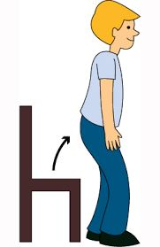 ..., please.
A. Sit down B. Stand up C. Go out D. Come in
Đáp án: Stand up
105. I play/ seek/ hide/ and/ with my friends./
Đáp án: I play hide and seek with my friends.
106. In summer, it __ hot.
A. is B. are C. am D. do
Đáp án: is
107. best?/ What/ subjects/ like/ do you/
Đáp án: What subjects do you like best?
108. Choose the letter(s) to make a correct word: th...e
A. os B. se C. ar D. he
Đáp án: os
109. Nghe: Nhấn giữ Ctrl và bấm chuột để nghe: There are many _ _ _ _ in the pencil case.
Đáp án: pens
110. have/ juice./ Let's/ some/
Đáp án: Let's have some juice.
111. Is your classroom big? – No, it isn’t. It’s s_ _ _ _ .
Đáp án: mall
112. Nghe: Nhấn giữ Ctrl và bấm chuột để nghe: Here is his _ _ _ _ _ _ .
Đáp án: mother
113. playing/ with/ My sister/ dolls./ doesn't like/
Đáp án: My sister doesn't like playing with dolls.
114. big/ are/ Those/ clouds.
Đáp án: Those are big clouds.
115. My brother can play football … can’t play chess.
A. and B. but C. so D. or
Đáp án: but
116. Ảnh: 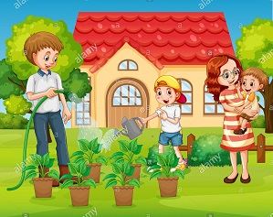 The garden is ____ his house.
A. near to B. on front of C. next to D. in front of
Đáp án: Chọn ý: D
117. sleep/ on the roof?/ Does/ your cat/
Đáp án: Does your cat sleep on the roof?
118. W_ o’s that?
Đáp án: h
119. What colour is this? - … .
A. It yellow B. It’s yellow C. Is yellow D. It is a yellow
Đáp án: It’s yellow
120. Nghe: Nhấn giữ Ctrl và bấm chuột để nghe: _ _ _ _ _ shoes are hers.
Đáp án: these
121. Would you like ... apple? – Yes, please.
A. an B. a C. the D. some
Đáp án: an
122. Nghe: Nhấn giữ Ctrl và bấm chuột để nghe: _ _ _ are you?
Đáp án: Who
123. in/ my bag./ There are/ pencils/ two/
Đáp án: There are two pencils in my bag.
124. box?/ Is/ square/ a/ this/
Đáp án: Is this a square box?
125. Ảnh: How old is your _ _ _ _ _ father?
Đáp án: grand
126. to/ I/ May/ go/ the library?/
Đáp án: May I go to the library?
127. There _ _ _ many trees in the park.
Đáp án: are
128. Ảnh: 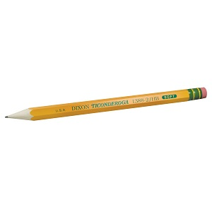 PEN_ _ _
Đáp án: CIL
129. Billy: Are they your pencils? - Minh: No, they ... .They’re my pens.
A. don’t B. have C. do D. aren’t
Đáp án: Chọn ý: D
130. ruler/ is/ pink./ That/
Đáp án: That ruler is pink.
131. Pick ... your pen, children.
A. at B. on C. to D. up
Đáp án: Chọn ý: D
132. Ảnh: It’s _ _ _ _ _ now.
Đáp án: rainy
133. Is your house big … small?
A. and B. or C. but D. of
Đáp án: or
134. like/ Do/ football?/ you/
Đáp án: Do you like football?
135. likes/ She/ Art/ the/ most./
Đáp án: She likes Art the most.
136. Class: Good morning t_ _ _ _ _ _ ! - Miss Hoa: Good morning, children. Please, sit down.
Đáp án: eacher
137. W_ _ is he? – He is my best friend.
Đáp án: ho
138. Ảnh: This is the _ _ _ _ _ _ _ _ room.
Đáp án: computer
139. Choose the letter(s) to make a correct word: swi__ing
A. mm B. m C. nn D. n
Đáp án: mm
140. Let’s chan_ .
Đáp án: t
141. Pick ... your books, please.
A. to B. on C. at D. up
Đáp án: Chọn ý: D
142. It _ _ my birthday today.
Đáp án: is
143. Come and play with ... .
A. to B. my C. I D. me
Đáp án: Chọn ý: D
144. Ảnh: __________
A. Happy New Year! B. Merry Christmas! C. Happy birthday! D. Happy day!
Đáp án: Happy New Year!
145. Which word is the odd one out?
A. evening B. morning C. noon D. breakfast
Đáp án: Chọn ý: D
146. Who _ _ _ those people?
Đáp án: are
147. These/ pencils./ are/ my/
Đáp án: These are my pencils.
148. ... at the board, please.
A. Put B. Look C. Stand D. Sit
Đáp án: Look
149. Linda: Is this a book? - Phuong: ….
A. Yes, its B. Yes, it C. Yes, it is D. Yes, it isn’t
Đáp án: Yes, it is
150. Is there … sugar in the jar?
A. any B. some C. a D. an
Đáp án: any
151. like/ don’t/ I/ sweets.
Đáp án: I don’t like sweets.
152. Have/ a/ nice/ day.
Đáp án: Have a nice day.
153. Put/ your/ down,/ hand/ Peter./
Đáp án: Put your hand down, Peter.
154. Which word has the underlined part pronounced LIKE the letter E in SISTER
A. nice B. brother C. new D. bedroom
Đáp án: brother
155. Ảnh: My grandfather is ______ years old.
A. seventeen B. seventy C. seventy-one D. seven-one
Đáp án: seventy-one
156. There are th_ _ e books on the table.
Đáp án: re
157. I like _ _ _ _ _ puzzles after school.
Đáp án: doing
158. It’s/ for/ John./ time/ breakfast,
Đáp án: It’s time for breakfast, John.
159. the wardrobe/ and pick up/ a shirt./ I open/
Đáp án: I open the wardrobe and pick up a shirt.
160. ______ my uncle next to my father.
A. They are B. There are C. It is D. Is there
Đáp án: It is
161. Lis_ _ _ to the teacher carefully, Mary.
Đáp án: ten
162. to/ your teacher,/ Listen/ please!
Đáp án: Listen to your teacher, please!
163. Nghe: Nhấn giữ Ctrl và bấm chuột để nghe: What do you _ _ _ _ , Billy?
Đáp án: like
164. Nghe: Nhấn giữ Ctrl và bấm chuột để nghe: Is this your _ _ _ _ _ _ ?
Đáp án: pencil
165. Choose the letter(s) to make a correct word: G__NDFATHER
A. AR B. OR C. RO D. RA
Đáp án: Chọn ý: D
166. May I _ _ me in?
Đáp án: co
167. This is _ _ ice-cream.
Đáp án: an
168. When is your sister’s birthday? – H_ _ birthay is in July.
Đáp án: er
169. Who is he? - … .
A. He’s fine B. She’s Mary C. He’s Peter D. I’m fine, thanks
Đáp án: He’s Peter
170. are/ flowers/ beautiful./ very/ These/
Đáp án: These flowers are very beautiful.
171. Give me some more honey, please. - H_ _ _ you are.
Đáp án: ere
172. Are you a student or a teacher?
A. Yes, I am. B. No, I am not. C. I’m a student. D. Yes, I.
Đáp án: I’m a student.
173. _ _ _ old are you?
Đáp án: how
174. Nghe: Nhấn giữ Ctrl và bấm chuột để nghe: She goes running at seven _____.
A. fifteen B. fiveteen C. fourteen D. forteen
Đáp án: fifteen
175. my/ I/ friend Lizzie./ old/ miss/
Đáp án: I miss my old friend Lizzie.
176. This is my brother and this is _______ bike.
A. he B. his C. him D. its
Đáp án: his
177. How _ _ d is your sister?
Đáp án: ol
178. Ảnh: That’s a pencil sharp_ _ _ _ .
Đáp án: ener
179. Nice to meet you. - ... .
A. Goodbye B. See you later C. Nice to meet you, too D. Good morning
Đáp án: Nice to meet you, too
180. meet/ you,/ Rooney./ to/ Nice/
Đáp án: Nice to meet you, Rooney.
181. Is that _ _ ice-cream?
Đáp án: an
182. Is it your ...?
A. big B. new C. small D. bag
Đáp án: Chọn ý: D
183. Pick … your pencil, John.
A. on B. in C. of D. up
Đáp án: Chọn ý: D
184. please./ me/ my/ Give/ rubber,
Đáp án: Give me my rubber, please.
185. Nghe: Nhấn giữ Ctrl và bấm chuột để nghe: Put the pencil … the chair.
A. on B. next to C. under D. near
Đáp án: under
186. sneakers?/ are/ those/ colour/ What/
Đáp án: What colour are those sneakers?
187. 'Do you play badminton at break time?' - '_________.'
A. No, you can’t. B. Yes, you do. C. Yes, I do. D. Yes, I am.
Đáp án: Yes, I do.
188. There _ _ _ five books on the shelf.
Đáp án: are
189. Ảnh: A bird can _ _ _ , but it can't swim.
Đáp án: fly
190. I like playing ... .
A. yoga B. aerobics C. puzzles D. badminton
Đáp án: Chọn ý: D
191. Are you happy?
A. Yes, I am. B. Yes, am. C. Yes, I I’m. D. Yes, it’s me.
Đáp án: Yes, I am.
192. Nghe: Nhấn giữ Ctrl và bấm chuột để nghe: She’s got _ _ _ _ _ eyes.
Đáp án: brown
193. cat/ that chair./ under/ is/ The/
Đáp án: The cat is under that chair.
194. These are my s_ _ ters.
Đáp án: is
195. Pick ... your notebook, Helen.
A. on B. to C. up D. and
Đáp án: up
196. O_ _ n your book, please.
Đáp án: pe
197. Nghe: Nhấn giữ Ctrl và bấm chuột để nghe: _ _ _ _ _
Đáp án: blind
198. Nghe: Nhấn giữ Ctrl và bấm chuột để nghe: Listen and tick the word(s) you hear:
A. hide-and-seek B. hometown C. house D. housewife
Đáp án: Chọn ý: D
199. Ảnh: 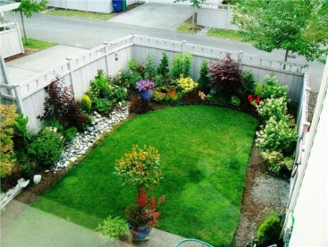 We have a small _ _ _ _ _ _ behind our house.
Đáp án: garden
200. How _ _ d is she? – She’s nine years old.
Đáp án: ol

KEY IOE K3 2023 - 2024 SỐ 30
1. Who/ over there?/ the woman/ is/
Đáp án: Who is the woman over there?
2. Ảnh: Her father is in the livi_ _ room.
Đáp án: ng
3. Nghe: Nhấn giữ Ctrl và bấm chuột để nghe: We need to ___ this room.
A. close B. open C. hide D. tidy
Đáp án: Chọn ý: D
4. Tom is my best _ _ _ _ _ _ .
Đáp án: friend
5. That is my s_ _ _ _ _ library.
Đáp án: chool
6. My brother is th_ _ e years old.
Đáp án: re
7. on the/ Are there/ water/ any/ moon?/
Đáp án: Are there any water on the moon?
8. This is ... eraser. It’s not my eraser.
A. this B. he C. me D. your
Đáp án: Chọn ý: D
9. Ảnh: 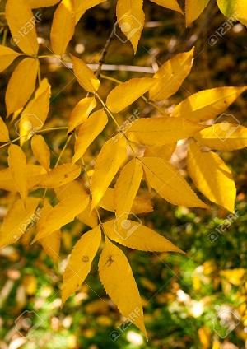 In autumn, the leaves are y_ _ _ _ _ .
Đáp án: ellow
10. Is your house big … small?
A. and B. or C. but D. of
Đáp án: or
11. That man is _______.
A. fifty one B. fifteen one C. five ten one D. five one
Đáp án: fifty one
12. Which word has the underlined part pronounced LIKE the letter U in RUBBER
A. picture B. colour C. sun D. ruler
Đáp án: sun
13. Is this your bag? - … .
A. No, thanks B. Sure C. No, it is D. Yes, it is
Đáp án: Chọn ý: D
14. Nghe: Nhấn giữ Ctrl và bấm chuột để nghe: His name is ... .
A. Abramson B. Abraham C. Apranson D. Adramsun
Đáp án: Abramson
15. are/ nice/ Those/ oranges.
Đáp án: Those are nice oranges.
16. pencil/ is/ sharpener/ old./ My/
Đáp án: My pencil sharpener is old.
17. Lan: What are they? Huong: They are my ... .
A. teachers B. friends C. pencil cases D. Lan and Mai
Đáp án: pencil cases
18. Your/ mother/ is/ nice.
Đáp án: Your mother is nice.
19. Good bye, Nam. _ _ _ you later.
Đáp án: See
20. Let’s go to the Art room. I wan to draw a pic_ _ _ _ .
Đáp án: ture
21. Peter: What _ _ _ _ _ _ is your pen? - Mary: It’s red.
Đáp án: colour
22. Why/ bears?/ does/ Nam/ like
Đáp án: Why does Nam like bears?
23. My brother ... to play the piano.
A. like B. to like C. likes D. is like
Đáp án: likes
24. _ _ _ _ bye, Mrs. Brown.
Đáp án: good
25. like in/ weather/ What's/ winter?/ the/
Đáp án: What's the weather like in winter?
26. bluff./ blind man’s/ play/ Let’s/
Đáp án: Let’s play blind man’s bluff.
27. Let’s ... English.
A. say B. speak C. listen D. show
Đáp án: speak
28. My friend _______ chess in his free time.
A. does plays B. plays C. is play D. play
Đáp án: plays
29. _ _ _ _ is the date today, Sam?
Đáp án: What
30. Does Jane like eating sweets? - Yes, she _ _ _ _ .
Đáp án: does
31. Is … an alarm clock in your room?
A. these B. this C. that D. there
Đáp án: Chọn ý: D
32. Ảnh: That is my pencil s_ _ _ _ _ _ _ _ .
Đáp án: harpener
33. Ảnh: These are my … .
A. pens B. chalks C. posters D. notebooks
Đáp án: Chọn ý: D
34. What’s this? - ... .
A. It’s a pen B. Yes, it is C. No, it isn’t D. They are pens
Đáp án: It’s a pen
35. Hello. My name is Nga. - ... .
A. See you later B. Hi. I am Alice C. Goodbye D. Good night
Đáp án: Hi. I am Alice
36. Choose the odd one out:
A. library B. bathroom C. bedroom D. dining room
Đáp án: library
37. tall./ is/ friend/ My/
Đáp án: My friend is tall.
38. Nghe: Nhấn giữ Ctrl và bấm chuột để nghe: This is his _ _ _ _ _ _ _ .
Đáp án: brother
39. Nghe: Nhấn giữ Ctrl và bấm chuột để nghe: _ _ _ _ _ _
Đáp án: thirty
40. Ảnh: What is this? - It’s a _ _ _ _ _ _ .
Đáp án: pencil
41. Ảnh: A bird can _ _ _ , but it can't swim.
Đáp án: fly
42. Nghe: Nhấn giữ Ctrl và bấm chuột để nghe: Listen and tick:
A. shy B. sit C. six D. soup
Đáp án: six
43. It is a brown in_ pot.
Đáp án: k
44. Ảnh: On the t_ _ _ , the birds are singing.
Đáp án: ree
45. He is David. He is my ... .
A. school B. name C. book D. friend
Đáp án: Chọn ý: D
46. Long is opposite to short, then large is to … .
A. narrow B. big C. new D. fine
Đáp án: narrow
47. Put your book a_ _ y.
Đáp án: wa
48. Nghe: Nhấn giữ Ctrl và bấm chuột để nghe: They are ____.
A. 12 B. 13 C. 14 D. 15
Đáp án: 13
49. What is that? - ….
A. It is my cat B. That is my friend C. They are my cats D. It is Kevin
Đáp án: It is my cat
50. My pencil/ case/ backpack./ is in/ my
Đáp án: My pencil case is in my backpack.
51. the evening?/ she do/ in/ does/ What/
Đáp án: What does she do in the evening?
52. Which word has the underlined part pronounced LIKE the letter O in ROBOT?
A. snow B. room C. for D. school
Đáp án: snow
53. Nghe: Nhấn giữ Ctrl và bấm chuột để nghe: A _______
A. APPLE B. PINEAPPLE C. CANDY D. CAKE
Đáp án: PINEAPPLE
54. but/ very nice./ big/ is not/ My school/
Đáp án: My school is not big but very nice.
55. Here are your shoes. – _ _ _ _ _ _ .
Đáp án: Thanks
56. What colour ______? - Black.
A. is your shoes B. are your shoes C. are your shoe D. your shoes
Đáp án: are your shoes
57. Would you like to come to _ _ _ bookstore with me?
Đáp án: the
58. How many/ planes/ the toybox?/ in/ are there/
Đáp án: How many planes are there in the toybox?
59. come/ teacher/ in?/ . May I/ Good morning/
Đáp án: Good morning teacher . May I come in?
60. Ảnh: What colour is the armchair?
A. yellow B. red C. black D. white
Đáp án: red
61. Ảnh: 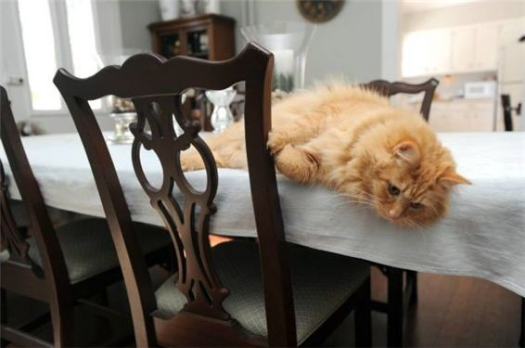 The cat is lying on the _ _ _ _ _ .
Đáp án: table
62. What is this box? - … a present for mom on Christmas Day.
A. She’s B. He’s C. It’s D. I’m
Đáp án: It’s
63. I’m fine, thank you. ... ?
A. You B. And you C. And D. Are
Đáp án: And you
64. How mu_ _ milk would you like?
Đáp án: ch
65. ruler/ eraser./ and/ your/ Pick up/
Đáp án: Pick up your ruler and eraser.
66. Which is your house? – That … .
A. two B. three C. one D. four
Đáp án: one
67. Nghe: Nhấn giữ Ctrl và bấm chuột để nghe: Listen and tick the word(s) you hear:
A. a plane B. a train C. a fan D. a chair
Đáp án: a train
68. Be q_ _ et, please.
Đáp án: ui
69. She's ten _ _ _ _ _ old.
Đáp án: years
70. my/ aren’t/ Those/ kites.
Đáp án: Those aren’t my kites.
71. Ảnh: Her brother is _ _ _ _ _ _ _ years old.
Đáp án: fifteen
72. Ảnh: In autumn, the sky is very _____.
A. black B. white C. green D. blue
Đáp án: Chọn ý: D
73. my bag./ pencils/ two/ in/ There are/
Đáp án: There are two pencils in my bag.
74. _ _ _ _ _ pencils are these? – They’re mine.
Đáp án: Whose
75. My si_ ter’s name is Mary.
Đáp án: s
76. not/ black./ Her/ hair/ is/
Đáp án: Her hair is not black.
77. These are their _____.
A. schoolbag B. school bags C. schools bag D. schools bags
Đáp án: school bags
78. Ảnh: We are on the _ _ _ _ _ because it’s very hot today.
Đáp án: beach
79. her/ that boy/ brother?/ Is/
Đáp án: Is that boy her brother?
80. Nghe: Nhấn giữ Ctrl và bấm chuột để nghe: GUITA_
Đáp án: R
81. This isn’t ... bag. It’s my bag.
A. he B. his C. me D. you
Đáp án: his
82. Choose the odd one out:
A. apple B. bird C. cat D. dog
Đáp án: apple
83. on/ the/ wall./ is/ The fan/
Đáp án: The fan is on the wall.
84. … is my friend.
A. This B. Those C. These D. There
Đáp án: This
85. Hello. I _ _ Peter. Nice to meet you.
Đáp án: am
86. She/ today./ looks/ tired/
Đáp án: She looks tired today.
87. This pen _ _ blue.
Đáp án: is
88. Nghe: Nhấn giữ Ctrl và bấm chuột để nghe: Heidi's ____ is Alex.
A. Mom B. sister C. brother D. Dad
Đáp án: Chọn ý: D
89. There … a small garden in front of the house.
A. is B. are C. am D. has
Đáp án: is
90. Nice to meet you, Paul. - Nice to meet you, t_ _ .
Đáp án: oo
91. Where is your school libra_ _ ?
Đáp án: ry
92. W_ _ is he? – He is my best friend.
Đáp án: ho
93. Peter: How are you? - Huong: I’m fine. ... you?
A. Thank B. Thanks C. And D. Welcome
Đáp án: And
94. the name/ of your/ book?/ favourite/ What is/
Đáp án: What is the name of your favourite book?
95. This is Jane. _ _ _ is my friend.
Đáp án: She
96. Ảnh: 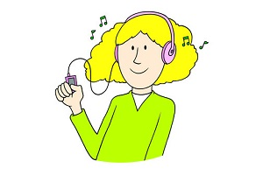 You use your ____ to listen.
A. eyes B. head C. arm D. ears
Đáp án: Chọn ý: D
97. I ... fine, thanks.
A. am B. is C. are D. the
Đáp án: am
98. I have _ cat.
Đáp án: a
99. 10th of/ is/ 2015./ Today/ January
Đáp án: Today is 10th of January 2015.
100. do you/ subject/ What/ the most?/ like
Đáp án: What subject do you like the most?
101. How many/ does/ have?/ floors/ your school
Đáp án: How many floors does your school have?
102. Nghe: Nhấn giữ Ctrl và bấm chuột để nghe: Listen and tick:
A. moon B. jump C. sun D. run
Đáp án: Chọn ý: D
103. Peter: How …are you? - Hoa: I’m eight years old.
A. all B. old C. tall D. small
Đáp án: old
104. Nam/ bears?/ like/ Does/
Đáp án: Does Nam like bears?
105. How do … spell … name, Peter?
A. you / your B. he / his C. she / her D. they / their
Đáp án: you / your
106. Odd one out:
A. fish B. dolphin C. monkey D. shark
Đáp án: monkey
107. They like frogs … they don’t like spiders.
A. but B. and C. so D. or
Đáp án: but
108. to school/ I/ usually/ go/ by bike./
Đáp án: I usually go to school by bike.
109. Look … the picture, Mary.
A. to B. on C. for D. at
Đáp án: Chọn ý: D
110. Ảnh: 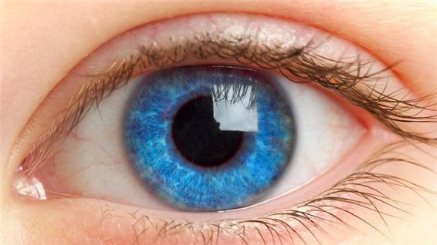 Sally has _ _ _ _ eyes and blonde hair.
Đáp án: blue
111. H_ _ full name is Peter Brown.
Đáp án: is
112. How _ _ _ _ bananas are there in the fridge?
Đáp án: many
113. … many desks are there in your classroom?
A. How B. What C. Who D. Which
Đáp án: How
114. Ảnh: There are four people in my fa_ _ _ _ : my father, my mother, my sister and I.
Đáp án: mily
115. Listen ... the teacher, please.
A. on B. at C. to D. for
Đáp án: to
116. The/ chess./ children/ playing/ are/
Đáp án: The children are playing chess.
117. Nghe: Nhấn giữ Ctrl và bấm chuột để nghe: My eyes are _ _ _ _ .
Đáp án: blue
118. Are you happy?
A. Yes, I am. B. Yes, am. C. Yes, I I’m. D. Yes, it’s me.
Đáp án: Yes, I am.
119. There is/ the/ window./ near/ a TV/
Đáp án: There is a TV near the window.
120. ... John from Canada? - No, he isn’t.
A. Are B. This C. Is D. It
Đáp án: Is
121. Jim’s children _ _ _ watching TV and playing in the living room.
Đáp án: are
122. What/ is/ your/ colour/ new pen?/
Đáp án: What colour is your new pen?
123. Ảnh: 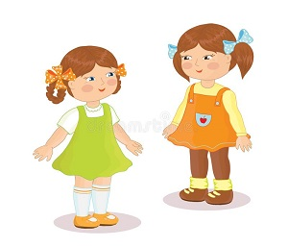 The gi_ _ _ over there are my sisters.
Đáp án: rls
124. ... photo is this? – It’s Jerry’s.
A. Whose B. What C. Which D. Who
Đáp án: Whose
125. What c_ _ _ _ are you in? - I'm in 3B.
Đáp án: lass
126. Nghe: Nhấn giữ Ctrl và bấm chuột để nghe: I like playing _ _ _ _ _ _ _ _ _ _ at break time.
Đáp án: basketball
127. run/ The dogs/ the yard./ in/
Đáp án: The dogs run in the yard.
128. They aren't in the classroom _ _ break time.
Đáp án: at
129. How many people _ _ _ there in your family?
Đáp án: are
130. Thank you. – You are w_ _ come.
Đáp án: el
131. Nghe: Nhấn giữ Ctrl và bấm chuột để nghe: A _____
A. MANGO B. BOOK C. RULER D. RUBBER
Đáp án: MANGO
132. Mary is _ _ English teacher.
Đáp án: an
133. sport?/ favourite/ your/ What's/
Đáp án: What's your favourite sport?
134. What toys do you have?
A. I have a dog, a cat and a rabbit. B. I have a doll, a teddy bear and a yo-yo. C. I have a book, a yo-yo and a toy train. D. I have a doll, a dog and a goldfish.
Đáp án: I have a doll, a teddy bear and a yo-yo.
135. Nghe: Nhấn giữ Ctrl và bấm chuột để nghe: Listen and tick:
A. sheep B. tiger C. lion D. cow
Đáp án: lion
136. These ... my pencils.
A. and B. is C. are D. am
Đáp án: are
137. Wa_ _ your hands, please.
Đáp án: sh
138. My favorite colour is g_ _ _ n.
Đáp án: ree
139. What time/ do/ sleep?/ go to/ you/
Đáp án: What time do you go to sleep?
140. Nghe: Nhấn giữ Ctrl và bấm chuột để nghe: _ _ _ are you?
Đáp án: Who
141. My friends are _ _ the school library now.
Đáp án: in
142. Tom: Wh_ ’s that? - Lan: That’s my friend Nam.
Đáp án: o
143. I have a cat _ _ d a dog.
Đáp án: an
144. play/ hide-and-seek/ schoolyard./ in the/ We/
Đáp án: We play hide-and-seek in the schoolyard.
145. Ảnh: It’s _ _ _ outside.
Đáp án: hot
146. My school is ... .
A. new’s B. new C. news D. names
Đáp án: new
147. Those _ _ _ my bags.
Đáp án: are
148. have/ Do you/ Susan?/ any/ pets,
Đáp án: Do you have any pets, Susan?
149. often/ my brother./ with/ do puzzles/ I/
Đáp án: I often do puzzles with my brother.
150. Ảnh: You need a rope to play _ _ _ _ ping.
Đáp án: skip
151. you do/ What do/ in your/ time?/ free
Đáp án: What do you do in your free time?
152. I’m fine, thanks. _ _ _ you?
Đáp án: and
153. favourite/ the name/ book?/ of your/ What is/
Đáp án: What is the name of your favourite book?
154. Can you _ _ _ _ _ from one to one hundred?
Đáp án: count
155. How … students are there in your classroom?
A. much B. many C. more D. some
Đáp án: many
156. Collin: ... is your desk? - Tommy: It’s blue.
A. What B. What’s C. What colour D. What size
Đáp án: What colour
157. Ảnh: 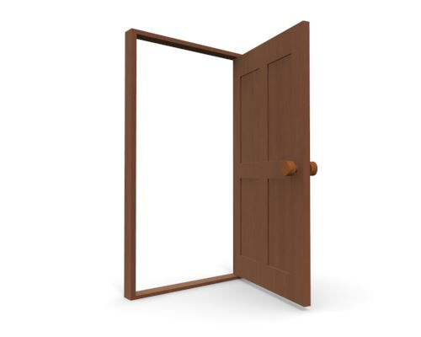 Close the _ _ _ _ , please!
Đáp án: door
158. _ _ my lunchbox, I have a banana and a sandwich.
Đáp án: In
159. I’m _ _ _ e, thanks. And you?
Đáp án: fin
160. this/ Is/ David?/ sister,/ your/
Đáp án: Is this your sister, David?
161. Ảnh: 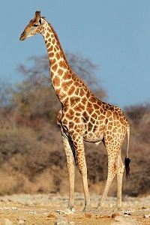 There are many animals in the zoo such as elephants, monkeys, kangaroos and _____.
A. giraffes B. boxes C. money D. castles
Đáp án: giraffes
162. Nghe: Nhấn giữ Ctrl và bấm chuột để nghe: There is a _____ next to my bed.
A. table B. desk C. shelf D. book
Đáp án: desk
163. Her shirts/ are/ aren't pink./ white. They/
Đáp án: Her shirts are white. They aren't pink.
164. His/ is/ name/ David.
Đáp án: His name is David.
165. How/ many/ cats/ you have?/ do
Đáp án: How many cats do you have?
166. My school is l_ _ _ e. Your school is small.
Đáp án: arg
167. Choose the odd one out:
A. computer room B. park C. zoo D. playground
Đáp án: computer room
168. Teacher: Please….in, Peter. - Peter:Thank you, teacher.
A. sit B. stand C. come D. go
Đáp án: come
169. Nghe: Nhấn giữ Ctrl và bấm chuột để nghe: _ _ _ _ _ _ _
Đáp án: fifteen
170. What’s the matter? – I’m … .
A. tired B. teacher C. student D. Kevin
Đáp án: tired
171. do?/ What/ can/ Ryan/
Đáp án: What can Ryan do?
172. Ảnh: Rosy’s ice cream is _ _ _ _ .
Đáp án: pink
173. Mai: How old is Linda? - Hoa: She’s … years old.
A. fine B. five C. nice D. night
Đáp án: five
174. Tony puts some toothpaste on his toothbrush. He is going to _ _ _ _ _ his teeth.
Đáp án: brush
175. Is/ your/ room/ or narrow?/ large
Đáp án: Is your room large or narrow?
176. the rain./ photos/ We can’t/ take any/ because of
Đáp án: We can’t take any photos because of the rain.
177. Ảnh: The ball is _ _ the box.
Đáp án: in
178. This is my pen and these ... their pens.
A. is B. are C. am D. be
Đáp án: are
179. Ảnh: David's grandmother isn't young. She's o_ _ .
Đáp án: ld
180. _ _ s name is John.
Đáp án: Hi
181. Ảnh: That’s a pencil sharp_ _ _ _ .
Đáp án: ener
182. The map is on the wa_ _ .
Đáp án: ll
183. Nghe: Nhấn giữ Ctrl và bấm chuột để nghe: She goes running at seven _____.
A. fifteen B. fiveteen C. fourteen D. forteen
Đáp án: fifteen
184. Why don’t you like the weather there? – … it’s too cold.
A. So B. But C. And D. Because
Đáp án: Chọn ý: D
185. How many flowers ... there in the vase?
A. it B. are C. is D. am
Đáp án: are
186. the song about/ Sing/ our country,/ please.
Đáp án: Sing the song about our country, please.
187. doll/ My/ pink./ is/
Đáp án: My doll is pink.
188. flowers/ There are/ garden./ many/ in the
Đáp án: There are many flowers in the garden.
189. Ảnh: What’s in the schoolbag? – My books and a c_ _ _ _ _ _ .
Đáp án: ompass
190. What are these? - _______ cakes.
A. These B. There are C. It’s D. They are
Đáp án: Chọn ý: D
191. would/ a/ Peter/ hamburger./ like/
Đáp án: Peter would like a hamburger.
192. Thank you for this beautiful gift. – You are wel_ _ me.
Đáp án: co
193. Nghe: Nhấn giữ Ctrl và bấm chuột để nghe: His sister’s _ _ _ _ is in the tree.
Đáp án: kite
194. How ... chairs in your classroom?
A. much B. very C. old D. many
Đáp án: Chọn ý: D
195. What are those? - …
A. It’s my notebook. B. They are crayons. C. These are my pens. D. They are blue and red.
Đáp án: They are crayons.
196. Ảnh: That is the ph_ _ _ of my family.
Đáp án: oto
197. Ảnh: My grand_ _ _ _ er is in the garden.
Đáp án: fath
198. Choose the odd one out
A. Sixty B. Book C. Seventeen D. Nineteen
Đáp án: Book
199. room/ The/ beautiful./ living/ is
Đáp án: The living room is beautiful.
200. Is this a bag? - ... .
A. Nice to meet you B. Yes, it is C. Yes, isn’t D. No, It is
Đáp án: Yes, it is

KEY IOE K3 2023 - 2024 SỐ 31
1. The new music room is _______.
A. new B. ten C. old D. large
Đáp án: Chọn ý: D
2. Don't make a mess. - _______
A. Thanks. B. Yes, please. C. Yes, you can. D. Sorry.
Đáp án: Chọn ý: D
3. How o_ _ are you?
Đáp án: ld
4. How _ _ d is your sister?
Đáp án: ol
5. teacher./ the/ Point/ to/
Đáp án: Point to the teacher.
6. Choose the letter(s) to make a correct word: bla__
A. kk B. cc C. kc D. ck
Đáp án: Chọn ý: D
7. She never stays _ _ late at night.
Đáp án: up
8. How are you? – I’m … .
A. six B. happy C. yellow D. new
Đáp án: happy
9. Which word has the underlined part pronounced LIKE the letter ’A’ in ’SMALL’?
A. tall B. classroom C. play D. father
Đáp án: tall
10. come/ May/ in?/ I/
Đáp án: May I come in?
11. Ảnh: What are they doing? - They are sw_ _ _ _ _ _ .
Đáp án: imming
12. Nghe: Nhấn giữ Ctrl và bấm chuột để nghe: How many cakes are there in total?
A. There are twenty-nine. B. There are ninety. C. There are thirty-nine. D. There are ninety-nine.
Đáp án: There are twenty-nine.
13. Let’s/ sing/ a/ song.
Đáp án: Let’s sing a song.
14. books/ are/ my/ Those/
Đáp án: Those are my books
15. Students all ________ when their English teacher comes in.
A. stand up B. sit down C. go out D. come in
Đáp án: stand up
16. We/ like/ playing/ at break time./ games
Đáp án: We like playing games at break time.
17. I’m ha_ _ y.
Đáp án: pp
18. Which is your school? - … one.
A. The B. A C. An D. This
Đáp án: Chọn ý: D
19. Ảnh: The school playground is crowded at _ _ _ _ _ time.
Đáp án: break
20. I have _ _ ice cream.
Đáp án: an
21. Ảnh: May I _ _ _ _ in?
Đáp án: come
22. Peter: Let’s dr_ _ a picture. - Nam: Yes, let’s.
Đáp án: aw
23. Ảnh: R_ _ _ _
Đáp án: ULER
24. spell/ you/ How/ do/ her name?/
Đáp án: How do you spell her name?
25. Let’s go fishing. – That’s a good i_ _ _ .
Đáp án: dea
26. Choose the odd one out.
A. Father B. Mother C. Brother D. Uncle
Đáp án: Chọn ý: D
27. Ảnh: There is NOT _______ in the picture.
A. a ball B. a baby C. a desk D. a chair
Đáp án: a desk
28. The cats are white. _ _ _ _ are very beautiful.
Đáp án: they
29. sentences./ the/ Reorder/
Đáp án: Reorder the sentences.
30. Miss/ you,/ How/ are/ Smith?/
Đáp án: How are you, Miss Smith?
31. A: … is your school? - B: … is big and new.
A. Where – He B. How – It C. What – She D. Who - That
Đáp án: How – It
32. These chairs … small.
A. are B. is C. am D. not
Đáp án: are
33. Ảnh: There are _ _ _ _ toes on a foot.
Đáp án: five
34. the living room./ kitchen/ next to/ The/ is/
Đáp án: The kitchen is next to the living room.
35. Ảnh: Her sister can’t d_ _ _ e.
Đáp án: anc
36. I have an English friend. _ _ _ name is Kate.
Đáp án: her
37. ... your teeth, Tommy.
A. Read B. Listen C. Stand D. Brush
Đáp án: Chọn ý: D
38. Ảnh: You use your _____ to write.
A. head B. hand C. eyes D. foot
Đáp án: hand
39. There is ___ pen in the pencil case.
A. one B. two C. three D. four
Đáp án: one
40. are/ playing/ chess./ children/ The/
Đáp án: The children are playing chess.
41. Nghe: Nhấn giữ Ctrl và bấm chuột để nghe: Sue _ _ _ _ _ up at seven o’clock in the morning.
Đáp án: wakes
42. _ _ . Nice to meet you.
Đáp án: hi
43. Nghe: Nhấn giữ Ctrl và bấm chuột để nghe: There are … people in her family.
A. four B. five C. six D. three
Đáp án: five
44. your bags/ Are/ in/ the car?
Đáp án: Are your bags in the car?
45. W_ _ is he? – He is my best friend.
Đáp án: ho
46. give/ more water./ Please,/ me/ some
Đáp án: Please, give me some more water.
47. My cla_ _ _ _ _ m is small.
Đáp án: ssroo
48. Show/ me/ cards,/ your/ please./
Đáp án: Show me your cards, please.
49. Nghe: Nhấn giữ Ctrl và bấm chuột để nghe: Andy is _ _ _ _ _ .
Đáp án: seven
50. Nghe: Nhấn giữ Ctrl và bấm chuột để nghe: The library is _ _ _ .
Đáp án: big
51. Ảnh: That’s my pencil _ _ g!
Đáp án: ba
52. in/ I/ two pens/ have/ my bag./
Đáp án: I have two pens in my bag.
53. Nice to m_ _ _ you, too.
Đáp án: eet
54. Peter/ and Tommy/ new/ friends./ are my/
Đáp án: Peter and Tommy are my new friends.
55. your/ colour/ are/ lunch boxes?/ What/
Đáp án: What colour are your lunch boxes?
56. Mandy/ dolls/ have?/ How many/ does/
Đáp án: How many dolls does Mandy have?
57. Those _ _ _ my pens and pencils.
Đáp án: are
58. ... are you from, Jean? – I’m from Canada.
A. What B. How C. Where D. When
Đáp án: Where
59. There … some cheese in the fridge.
A. are B. is C. be D. have
Đáp án: is
60. John: This is my sister. Peter: What is _ _ r name?
Đáp án: he
61. I ... John. Nice to meet you.
A. is B. am C. be D. are
Đáp án: am
62. _ _ _ are you? - I’m fine, thanks.
Đáp án: How
63. I ... my teeth in the morning.
A. do B. brush C. have D. does
Đáp án: brush
64. Ảnh: There are five _ _ _ _ in the armchair.
Đáp án: cats
65. class/ 3A./ in/ My sister/ is/
Đáp án: My sister is in class 3A.
66. I/ don’t/ on Sunday./ go to/ school
Đáp án: I don’t go to school on Sunday.
67. Ảnh: My pencil is _ _ _ _ . Her pencil is short.
Đáp án: long
68. well/ I do/ feel/ today./ not/
Đáp án: I do not feel well today.
69. Nghe: Nhấn giữ Ctrl và bấm chuột để nghe: It’s a … book.
A. little B. small C. big D. large
Đáp án: big
70. The children like playing in the park because … very large.
A. it is B. they are C. he is D. she is
Đáp án: it is
71. My friend is ten _ _ _ _ _ old.
Đáp án: years
72. Write your name _ _ the board, please.
Đáp án: on
73. Gi_ e me the book, please.
Đáp án: v
74. sister's/ What/ is/ name?/ your/
Đáp án: What is your sister's name?
75. Where is your school libra_ _ ?
Đáp án: ry
76. There … some cheese in the fridge.
A. are B. is C. be D. have
Đáp án: is
77. Nghe: Nhấn giữ Ctrl và bấm chuột để nghe: That is my _____.
A. notebook B. computer C. pencil case D. rubber
Đáp án: computer
78. three/ are/ on the wall./ pictures/ They/
Đáp án: They are three pictures on the wall.
79. books./ my/ are/ Those/
Đáp án: Those are my books.
80. Who is your …? – The man over there.
A. father B. mother C. aunt D. sister
Đáp án: father
81. Nga: Do you play football? - Huong: No, I … I like basketball.
A. don’t B. am not C. doesn’t D. isn’t
Đáp án: don’t
82. _ _ _ _ time do you go to bed?
Đáp án: What
83. Which word has the underlined part pronounced LIKE the letter I in BIG
A. his B. nine C. kite D. nice
Đáp án: his
84. Peter has _ _ work all day in the factory.
Đáp án: to
85. These are my s_ _ ters.
Đáp án: is
86. This/ my/ Jane./ is/ new friend
Đáp án: This is my new friend Jane.
87. What are these ? - ….
A. It’s a motorbike B. They’re motorbikes C. They’re motorbike D. It is motorbike
Đáp án: They’re motorbikes
88. flowers./ three/ have/ I/
Đáp án: I have three flowers.
89. Nghe: Nhấn giữ Ctrl và bấm chuột để nghe: _ _
Đáp án: we
90. Nghe: Nhấn giữ Ctrl và bấm chuột để nghe: Listen and tick the word(s) you hear:
A. lion B. lamp C. ruler D. cloudy
Đáp án: lion
91. Ảnh: What colour is the fence?
A. Blue B. Black C. White D. Yellow
Đáp án: White
92. Be … Don’t make noise.
A. lazy B. quiet C. funny D. angry
Đáp án: quiet
93. Choose the letter(s) to make a correct word: cent__l
A. ra B. re C. aa D. ar
Đáp án: ra
94. free/ in your/ What do/ time?/ you do/
Đáp án: What do you do in your free time?
95. _ _ _ t’s your name? – My name’s Sean.
Đáp án: Wha
96. _ _ _ _ _ are you going to stay? - In a hotel.
Đáp án: Where
97. R_ _ se your hands, please.
Đáp án: ai
98. What do you do in … free time?
A. you B. yours C. you’re D. your
Đáp án: Chọn ý: D
99. is/ the tall girl/ over/ there?/ Who/
Đáp án: Who is the tall girl over there?
100. favourite/ is/ Hamburger/ my/ food./
Đáp án: Hamburger is my favourite food.
101. Choose the INCORRECT word or phrase in the following sentence: Our living room are very big and beautiful.
A. are B. very C. and D. beautiful
Đáp án: are
102. Ảnh: The cup is here, __ the table.
A. in B. on C. behind D. under
Đáp án: on
103. I like my school _ _ _ _ much.
Đáp án: very
104. Ảnh: The _ _ _ is on the table.
Đáp án: cat
105. you,/ old/ are/ How/ Duong?/
Đáp án: How old are you, Duong?
106. Is that a purple flower? – ..., it is.
A. No B. Yes C. Not D. No, it isn’t
Đáp án: Yes
107. Ảnh: _ _ _
Đáp án: CAT
108. Let’s make a ci_ _ le.
Đáp án: rc
109. This is Tom and _ _ _ cute dog, Rex.
Đáp án: his
110. Can you give me some pens, pl_ _ se?
Đáp án: ea
111. Who _ _ _ those people?
Đáp án: are
112. What is your school’s n_ _ _ ? – It’s Oxford Primary School.
Đáp án: ame
113. Peter: What _ _ _ _ _ _ is your pen? - Mary: It’s red.
Đáp án: colour
114. My school bag _ _ new.
Đáp án: is
115. Are there any fruits on the table? - Yes, ______.
A. there is B. are there C. is there D. there are
Đáp án: Chọn ý: D
116. class./ quiet,/ Be/
Đáp án: Be quiet, class.
117. GRAN___THER
A. TFA B. DMA C. DFO D. DMO
Đáp án: Chọn ý: D
118. This gift is for you. - Thank you very _ _ _ _ .
Đáp án: much
119. Do you ____ a comic book? - Yes, I do.
A. having B. like C. knows D. are
Đáp án: like
120. There _ _ one lamp on the desk.
Đáp án: is
121. Lan's eraser/ small./ white. It's/ is/
Đáp án: Lan's eraser is white. It's small.
122. Is that a crayon? - ... .
A. No, they are B. Yes, they are C. Yes, it is D. No, they aren’t
Đáp án: Yes, it is
123. books/ there?/ are/ many/ How/
Đáp án: How many books are there?
124. Nghe: Nhấn giữ Ctrl và bấm chuột để nghe: This is my _ _ _ _ _ _ _ _ _ _ _ .
Đáp án: grandfather
125. There ... three cats in the box.
A. am B. is C. are D. there
Đáp án: are
126. your mother?/ next to/ your aunt/ Is/
Đáp án: Is your aunt next to your mother?
127. My uncle doesn’t work … Saturday.
A. at B. in C. on D. of
Đáp án: on
128. What …? – They are my crayons.
A. are those B. is this C. is that D. are there
Đáp án: are those
129. _ _ _ sun is shining.
Đáp án: The
130. Which is your house? – That __________.
A. one B. two C. three D. four
Đáp án: one
131. Nghe: Nhấn giữ Ctrl và bấm chuột để nghe: Is she a _ _ _ _ _ _ _ ?
Đáp án: teacher
132. Ảnh: Those are our ch_ _ _ _ .
Đáp án: airs
133. Stand/ up,/ please./
Đáp án: Stand up, please.
134. do/ you/ spell/ your name?/ How/
Đáp án: How do you spell your name?
135. Linda _____ a little cat.
A. have B. do C. has D. am
Đáp án: has
136. Thank you very much – You’re ... .
A. welcome’s B. welcomes C. welcome D. welcome’re
Đáp án: welcome
137. I often play sports _ _ Tuesday afternoons.
Đáp án: on
138. Ảnh: BOOK_ _ _ _
Đáp án: CASE
139. Choose the odd one out
A. Mother B. Father C. Teacher D. Grandmother
Đáp án: Teacher
140. Her father goes to work _ _ 6 o’clock.
Đáp án: at
141. My aunt is a _ _ _ ter of my mother.
Đáp án: sis
142. One plus one makes _ _ _ .
Đáp án: two
143. beautiful./ flower/ is/ This/ very
Đáp án: This flower is very beautiful.
144. Nghe: Nhấn giữ Ctrl và bấm chuột để nghe: His _ _ _ is in the football net.
Đáp án: toy
145. Can you remem_ _ r my birthday?
Đáp án: be
146. How … fans are there? – Three.
A. many B. much C. old D. long
Đáp án: many
147. Do you like listening to music?
A. Yes, I am. B. No, I do. C. No, I don't. D. Yes, it is.
Đáp án: No, I don't.
148. My parents are _ _ the living room.
Đáp án: in
149. Nghe: Nhấn giữ Ctrl và bấm chuột để nghe: Listen and tick the word(s) you hear:
A. classroom B. bathroom C. living room D. bedroom
Đáp án: classroom
150. Which word has the underlined part pronounced LIKE the letter E in SISTER
A. nice B. brother C. new D. bedroom
Đáp án: brother
151. Don't be late __ school.
A. at B. in C. for D. with
Đáp án: for
152. I ... fine, thanks.
A. am B. is C. are D. the
Đáp án: am
153. What … her name? – She is Mai Anh.
A. are B. is C. am D. does
Đáp án: is
154. Ảnh: MOUS_
Đáp án: E
155. _ _ ke out your book.
Đáp án: Ta
156. Choose the INCORRECT word or phrase in the following sentence: They are my ball, Daddy.
A. They B. my C. ball D. Daddy
Đáp án: ball
157. with/ Can/ a yo yo?/ you/ play/
Đáp án: Can you play with a yo yo?
158. Nghe: Nhấn giữ Ctrl và bấm chuột để nghe: Here is his _ _ _ _ _ _ .
Đáp án: mother
159. Spe_ _ your name, please.
Đáp án: ll
160. How do you _ _ _ ll your name?
Đáp án: spe
161. Let’s go t_ the library.
Đáp án: o
162. Nghe: Nhấn giữ Ctrl và bấm chuột để nghe: Pat is in the _ _ _ _ _ _ room.
Đáp án: living
163. is/ Miss Lien/ new/ teacher./ my/
Đáp án: Miss Lien is my new teacher.
164. green. They/ Your rulers/ are/ are in the bag.
Đáp án: Your rulers are green. They are in the bag.
165. Hello. My name’s Betty. - ....
A. Bye, see you again B. See you soon C. Hi. I am Susan. Nice to meet you D. Goodbye
Đáp án: Hi. I am Susan. Nice to meet you
166. What/ school's/ is/ their/ name?/
Đáp án: What is their school's name?
167. Ảnh: His cat has gr_ _ _ eyes.
Đáp án: een
168. that boy/ Is/ her/ brother?
Đáp án: Is that boy her brother?
169. Ảnh: The _ _ _ _ is beautiful.
Đáp án: ship
170. Nghe: Nhấn giữ Ctrl và bấm chuột để nghe: My brother is thir_ _ _ _ years old.
Đáp án: teen
171. There/ a/ kitchen./ is/
Đáp án: There is a kitchen.
172. to the/ The radio/ windows./ is/ next/
Đáp án: The radio is next to the windows.
173. Nghe: Nhấn giữ Ctrl và bấm chuột để nghe: Listen and tick:
A. boat B. cook C. book D. look
Đáp án: cook
174. is/ name?/ her/ What/
Đáp án: What is her name?
175. Nghe: Nhấn giữ Ctrl và bấm chuột để nghe: The girl is fif_ _ _ _ .
Đáp án: teen
176. Nam: What’s his _ _ _ _ ? - Hoa: Tony.
Đáp án: name
177. Ảnh: These are three pencil _ _ _ _ _ in my school bag.
Đáp án: cases
178. Can you speak English? - Yes,... can.
A. he B. she C. you D. I
Đáp án: Chọn ý: D
179. The pencil is long and the rubber is sh_ _ _ .
Đáp án: ort
180. are swimming/ in the/ The fish/ pond.
Đáp án: The fish are swimming in the pond.
181. I like Maths but my friends ….
A. isn’t B. doesn’t C. don’t D. aren’t
Đáp án: don’t
182. This is _ book. It’s green.
Đáp án: a
183. Is your house big … small?
A. and B. or C. but D. of
Đáp án: or
184. in/ It's/ summer./ sunny/
Đáp án: It's sunny in summer.
185. Art/ on/ Friday./ have/ I don’t/
Đáp án: I don’t have Art on Friday.
186. What/ does/ she do/ the evening?/ in
Đáp án: What does she do in the evening?
187. Good morning, children. - ... .
A. Good morning, teacher B. Hello C. Hi D. Bye
Đáp án: Good morning, teacher
188. Allie./ Her/ name/ is/
Đáp án: Her name is Allie.
189. My favorite colour is g_ _ _ n.
Đáp án: ree
190. A: What is this? - B: …
A. It’s yellow. B. It’s a blue pencil. C. It’s very nice. D. It’s my friend.
Đáp án: It’s a blue pencil.
191. What _______ at break time?
A. do you do B. is he do C. are you do D. are they do
Đáp án: do you do
192. Your sister is pre_ _ y.
Đáp án: tt
193. ... at the board, please.
A. Put B. Look C. Stand D. Sit
Đáp án: Look
194. name,/ please./ your/ Write/
Đáp án: Write your name, please.
195. Nghe: Nhấn giữ Ctrl và bấm chuột để nghe: Who likes drawing?
A. Mr. Macaroni. B. Meg. C. Tom. D. Mrs. Green.
Đáp án: Meg.
196. Orange juice is my favourite ... .
A. drink B. food C. apple D. milk
Đáp án: drink
197. _____ Lisa like going out with you?
A. Do B. Are C. Is D. Does
Đáp án: Chọn ý: D
198. Nghe: Nhấn giữ Ctrl và bấm chuột để nghe: Listen and tick the word(s) you hear:
A. sunny B. Sunday C. summer D. seven
Đáp án: Sunday
199. How _ _ ny bananas are there in the box?
Đáp án: ma
200. What is this? - ….
A. It a orange B. Is a orange C. It’s a orange D. It’s an orange
Đáp án: Chọn ý: D

KEY IOE K3 2023 - 2024 SỐ 32
1. _ _ ke out your book.
Đáp án: Ta
2. Ảnh: I don’t like sk_ _ _ _ _ _ .
Đáp án: ipping
3. They are ... chairs.
A. my B. a C. an D. one
Đáp án: my
4. Is the w_ _ _ _ over there your mother?
Đáp án: oman
5. Nghe: Nhấn giữ Ctrl và bấm chuột để nghe: Listen and tick the word(s) you hear:
A. lion B. lamp C. ruler D. cloudy
Đáp án: lion
6. There are many trees _ _ the forest.
Đáp án: in
7. Nghe: Nhấn giữ Ctrl và bấm chuột để nghe: This is her grand_ _ _ _ _ _ .
Đáp án: mother
8. _ _ o is that? – That’s my brother.
Đáp án: Wh
9. Nghe: Nhấn giữ Ctrl và bấm chuột để nghe: The bus is _ _ _ _ .
Đáp án: long
10. Ảnh: The _ _ _ _ _ _ is swinging.
Đáp án: monkey
11. Choose the INCORRECT word or phrasein the following sentence: How many lamp are there in the room?
A. lamp B. are C. in D. room
Đáp án: lamp
12. These are my friends. The_ _ names are Lan and Phuong.
Đáp án: ir
13. where/ Excuse me,/ the/ is/ principal’s room?/
Đáp án: Excuse me, where is the principal’s room?
14. ... old is your sister? – She is nine years old.
A. When B. What C. Where D. How
Đáp án: Chọn ý: D
15. Where are you from, Peter? – I’m _ _ _ _ England.
Đáp án: from
16. help/ Can/ you/ me?
Đáp án: Can you help me?
17. Choose the odd one out:
A. its B. his C. she D. her
Đáp án: she
18. Nghe: Nhấn giữ Ctrl và bấm chuột để nghe: That is my _____.
A. notebook B. computer C. pencil case D. rubber
Đáp án: computer
19. Wow! A robot. Thank _ _ _ .
Đáp án: you
20. What's there next _ _ the door?
Đáp án: to
21. Ảnh: I have a y_ _ _ _ _ lamp next to my bed
Đáp án: ellow
22. Are t_ _ _ students?
Đáp án: hey
23. What do you do at …? – I play football.
A. break time B. school time C. English lessons D. the home
Đáp án: break time
24. My mother gets up at 5 o’clock … the morning.
A. at B. on C. in D. from
Đáp án: in
25. school bag./ in/ my/ two rulers/ There are/
Đáp án: There are two rulers in my school bag.
26. What colour are your pencils? - They _________ blue and green.
A. are B. is C. aren’t D. does
Đáp án: are
27. The/ school gym/ new./ is/
Đáp án: The school gym is new.
28. have/ three/ flowers./ I/
Đáp án: I have three flowers.
29. Go _ _ the door, please.
Đáp án: to
30. Nghe: Nhấn giữ Ctrl và bấm chuột để nghe: Is she a _ _ _ _ _ _ _ ?
Đáp án: teacher
31. Choose the odd one out:
A. is B. am C. are D. those
Đáp án: Chọn ý: D
32. study/ at/ many subjects/ I/ school./
Đáp án: I study many subjects at school.
33. Ảnh: How many cats are there in the picture? - _ _ _ _ _ .
Đáp án: three
34. Ảnh: There is a big poster in ____ of the shop.
A. at B. on C. front D. out
Đáp án: front
35. What/ do/ have/ on Thursday?/ we/
Đáp án: What do we have on Thursday?
36. sport?/ her/ favourite/ is/ What/
Đáp án: What is her favourite sport?
37. Is this a book? - ... .
A. No, it is B. Yes, it isn’t C. Yes, it is D. No, they are
Đáp án: Yes, it is
38. Are these _ _ _ _ posters? – Yes, they are my posters.
Đáp án: your
39. _ _ _ re is Peter from? – He’s from England.
Đáp án: Whe
40. Nghe: Nhấn giữ Ctrl và bấm chuột để nghe: Listen and tick the word(s) you hear:
A. draw B. write C. see D. hear
Đáp án: draw
41. Who/ is/ the tall girl/ there?/ over
Đáp án: Who is the tall girl over there?
42. Choose the letter(s) to make a correct word: KI_CHEN
A. C B. X C. T D. O
Đáp án: T
43. _ _ _ _ color is it? - It’s red.
Đáp án: What
44. Her father goes to work _ _ 6 o’clock.
Đáp án: at
45. Nghe: Nhấn giữ Ctrl và bấm chuột để nghe: My school _ _ _ is very long.
Đáp án: bus
46. I/ not/ tigers./ like/ do/
Đáp án: I do not like tigers.
47. _ _ _ sun is shining.
Đáp án: The
48. Is/ big?/ classroom/ your/
Đáp án: Is your classroom big?
49. ..., students. See you later.
A. Good morning B. Good night C. Goodbye D. Nice to meet you
Đáp án: Goodbye
50. door,/ the/ Close/ please!
Đáp án: Close the door, please!
51. What do you do at b_ _ _ _ _ _ _ _ ?
Đáp án: reaktime
52. There are many gray _ _ _ _ _ _ in the sky. It's going to rain.
Đáp án: clouds
53. Tom can ... a bicycle.
A. bye B. ride C. drive D. rides
Đáp án: ride
54. Ảnh: _ _ _ _ _ _
Đáp án: parrot
55. I like to eat pizza v_ _ y much.
Đáp án: er
56. I don’t/ my bedroom./ have a/ in/ bookcase/
Đáp án: I don’t have a bookcase in my bedroom.
57. What colour is this? - … .
A. It yellow B. It’s yellow C. Is yellow D. It is a yellow
Đáp án: It’s yellow
58. That’s my new friend. H_ _ name’s Jenny.
Đáp án: er
59. The boys/ and girls/ and short./ tall/ are/
Đáp án: The boys and girls are tall and short.
60. a/ ball?/ big/ this/ Is/
Đáp án: Is this a big ball?
61. Nga: ... play chess! - Peter: Yes, let’s.
A. Do you B. Don’t you C. Let’s D. Are you
Đáp án: Let’s
62. My ruler is ye_ _ ow.
Đáp án: ll
63. Ảnh: 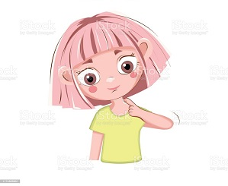 Under your head, it's your ne_ _ .
Đáp án: ck
64. The dog/ in front/ of the/ desk./ is/
Đáp án: The dog is in front of the desk.
65. Where is Sandra? – ... at school.
A. He B. She C. He’s D. She’s
Đáp án: Chọn ý: D
66. How are …? - … am fine, thanks.
A. they / He B. we / We C. you / I D. him / He
Đáp án: you / I
67. Do you like _ oing Maths?
Đáp án: d
68. Ảnh: Those are our ch_ _ _ _ .
Đáp án: airs
69. Nghe: Nhấn giữ Ctrl và bấm chuột để nghe: My eyes are _ _ _ _ .
Đáp án: blue
70. Is that y_ _ _ school? – Yes, it is.
Đáp án: our
71. The swimming pool/ is/ big./ very/
Đáp án: The swimming pool is very big.
72. Choose the letter(s) to make a correct word: POS_ER
A. R B. S C. T D. N
Đáp án: T
73. Art/ Friday./ have/ I don’t/ on
Đáp án: I don’t have Art on Friday.
74. We have English _ _ Friday.
Đáp án: on
75. in/ What/ bedroom?/ is/ her
Đáp án: What is in her bedroom?
76. He_ _ _ , I’m Micheal. Nice to meet you..
Đáp án: llo
77. Ảnh: There are many animals in the zoo such as elephants, monkeys, kangaroos and _____.
A. giraffes B. boxes C. money D. castles
Đáp án: giraffes
78. Linh: Can you ... the window? It’s hot. - Lan: OK.
A. open B. play C. read D. listen
Đáp án: open
79. Are there any fruits on the table? - Yes, ______.
A. there is B. are there C. is there D. there are
Đáp án: Chọn ý: D
80. _ _ _ _ colour is it? - It’s red.
Đáp án: What
81. the/ windows?/ I/ May/ open/
Đáp án: May I open the windows?
82. I like doing karate. - ... .
A. No, thanks B. Me too C. Yes, please D. Sorry
Đáp án: Me too
83. Ảnh: That’s not my _ _ _ _ _ .
Đáp án: ruler
84. Her birthday is ... June.
A. on B. in C. at D. to
Đáp án: in
85. What/ Ryan/ do?/ can/
Đáp án: What can Ryan do?
86. _________ - She's forty.
A. How many books are there? B. How old are you? C. What is her name? D. How old is she?
Đáp án: Chọn ý: D
87. John: Are you a student? - Jane: Yes,... .
A. Yes, I am B. I am C. I’m student D. Yes, I
Đáp án: I’m student
88. R_ _ se your hands, please.
Đáp án: ai
89. _ _ _ is that? – It’s Alice.
Đáp án: who
90. Please, sit ... .
A. at B. in C. down D. on
Đáp án: down
91. May I go out? - … .
A. Hello B. Nice to meet you C. Fine, thanks D. Sure
Đáp án: Chọn ý: D
92. Peter: Let’s dr_ _ a picture. - Nam: Yes, let’s.
Đáp án: aw
93. Nghe: Nhấn giữ Ctrl và bấm chuột để nghe: How do you _ _ _ _ _ your name?
Đáp án: spell
94. My father raises some fish in the _____.
A. garden B. forest C. pond D. yard
Đáp án: pond
95. She's ten _ _ _ _ _ old.
Đáp án: years
96. My/ is/ nurse./ mom/ a
Đáp án: My mom is a nurse.
97. Choose the odd one out:
A. America B. English C. Canada D. Vietnam
Đáp án: Chọn ý: B
98. It's not my pen. It's y_ _ _ pen.
Đáp án: our
99. Nghe: Nhấn giữ Ctrl và bấm chuột để nghe: It’s _ _ _ _ _ _ today.
Đáp án: cloudy
100. ... you tomorrow, children. – Goodbye, teacher.
A. See B. See’s C. See you D. Bye
Đáp án: See
101. cakes?/ these/ Do/ you like/
Đáp án: Do you like these cakes?
102. What’s y_ _ r name? – My name’s David.
Đáp án: ou
103. My mother li_ es jogging.
Đáp án: k
104. Ảnh: The st_ _ is bright at night.
Đáp án: ar
105. Nghe: Nhấn giữ Ctrl và bấm chuột để nghe: The _____ trainers are mine.
A. green B. black C. blue D. white
Đáp án: Chọn ý: D
106. Let's/ juice./ have/ some/
Đáp án: Let's have some juice.
107. A: Is your school …? – B: No, it is a bit small.
A. small B. big C. pretty D. new
Đáp án: big
108. Choose the odd one out.
A. Mother B. Father C. Sister D. Ruler
Đáp án: Chọn ý: D
109. Ảnh: What’s the weather like? - It’s _ _ _ _ _ .
Đáp án: rainy
110. This is the com_ _ _ _ _ room. You can surf the internet here.
Đáp án: puter
111. Linda: Do your friends play games at school? - Hoa: Yes,they ... .
A. do B. does C. are D. is
Đáp án: do
112. I’m OK, … you.
A. thanking B. thanks C. thank D. to thank
Đáp án: thank
113. How _ _ _ _ bananas are there in the fridge?
Đáp án: many
114. . Good bye,/ Well!/ Peter./ This is my/ school bus/
Đáp án: Well! This is my school bus . Good bye, Peter.
115. Nghe: Nhấn giữ Ctrl và bấm chuột để nghe: Listen and tick:
A. brown B. red C. orange D. black
Đáp án: orange
116. Let’s listen _ _ some music.
Đáp án: to
117. That is my father. … name is Jame.
A. Her B. She C. He D. His
Đáp án: Chọn ý: D
118. Ảnh: 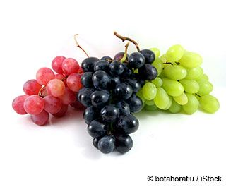 The _ _ _ _ _ _ look good. I’d like to eat them.
Đáp án: grapes
119. Nghe: Nhấn giữ Ctrl và bấm chuột để nghe: Listen and choose the word that is NOT in the recording.
A. egg B. dog C. cat D. bag
Đáp án: cat
120. Are you a student or a teacher?
A. Yes, I am. B. No, I am not. C. I’m a student. D. Yes, I.
Đáp án: I’m a student.
121. Do you want to play ...?
A. camping B. soccer C. skiing D. swimming
Đáp án: soccer
122. Does/ new sandals?/ have/ she/
Đáp án: Does she have new sandals?
123. Peter: Do you speak English? - Loan: ... .
A. Yes, I don’t B. No, I am not C. No, I do D. Yes, I do
Đáp án: Chọn ý: D
124. likes comics./ fairy tales/ likes/ and Rosy/ Shelly/
Đáp án: Shelly likes fairy tales and Rosy likes comics.
125. We go to school __ the morning.
A. on B. at C. in D. to
Đáp án: in
126. May I come in? - …
A. No, thanks. B. Yes, please. C. Yes, you are. D. No, you don’t.
Đáp án: Yes, please.
127. are/ relatives./ my/ These/
Đáp án: These are my relatives.
128. How m_ _ y dogs do you have?
Đáp án: an
129. a/ dress./ blue/ wants/ My mother/
Đáp án: My mother wants a blue dress.
130. How _ o you spell your name?
Đáp án: d
131. What _ _ your favourite game?
Đáp án: is
132. like/ much./ I/ very/ chocolate/
Đáp án: I like chocolate very much.
133. ... you like some milk? - No, thanks.
A. Can B. Are C. Is D. Would
Đáp án: Chọn ý: D
134. Choose the odd one out
A. Picture B. Photo C. Table D. School
Đáp án: Chọn ý: D
135. very/ family/ I love/ my/ much./
Đáp án: I love my family very much.
136. Here you are. - Thank _ _ _ very much.
Đáp án: you
137. Ảnh: 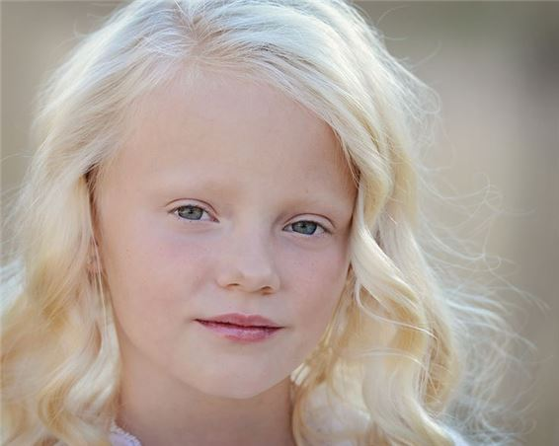 Does she have bl_ _ _ _ hair?
Đáp án: onde
138. How _ _ _ your parents?
Đáp án: are
139. this/ is/ new classmate?/ Alex,/ your
Đáp án: Alex, is this your new classmate?
140. Nghe: Nhấn giữ Ctrl và bấm chuột để nghe: Pat is in the _ _ _ _ _ _ room.
Đáp án: living
141. Ảnh: We can see a _ _ _ _ _ _ _ _ in Australia.
Đáp án: kangaroo
142. football/ and James/ likes basketball./ likes/ Jacob/
Đáp án: Jacob likes football and James likes basketball.
143. It is a brown in_ pot.
Đáp án: k
144. Ảnh: It's my aunt's birthday today. She's ____ years old.
A. thirty-two B. thirteen-two C. three-two D. threety-two
Đáp án: thirty-two
145. Nghe: Nhấn giữ Ctrl và bấm chuột để nghe: I’ve got an _ _ _ _ _ .
Đáp án: apple
146. O_ _ n your book, please.
Đáp án: pe
147. My/ tall./ friend/ is/
Đáp án: My friend is tall.
148. … to the teacher, please.
A. Listen B. Watch C. Look D. Read
Đáp án: Listen
149. The big tree is beh_ nd my house.
Đáp án: i
150. words/ Check/ you/ the/ hear./
Đáp án: Check the words you hear.
151. Their backpacks are in the _ _ _ boards.
Đáp án: cup
152. He/ a/ reads/ evening./ book/ every/
Đáp án: He reads a book every evening.
153. Alice is my friend, _ _ o.
Đáp án: to
154. please./ Give/ that/ red car,/ me/
Đáp án: Give me that red car, please.
155. Do you like my new red dress? - …
A. Where is from? B. No, it isn’t. C. Yes, it looks good on you. D. Of course, I am.
Đáp án: Yes, it looks good on you.
156. What is this? - T_ _ s is a kite.
Đáp án: hi
157. to sing/ We/ songs./ like/ English
Đáp án: We like to sing English songs.
158. Our bedroom is very … .
A. tired B. slim C. large D. well
Đáp án: large
159. ... are their desks.
A. It B. This C. Those D. That
Đáp án: Those
160. _ _ _ those my pens?
Đáp án: Are
161. My parents are _ _ the living room.
Đáp án: in
162. Ảnh: It's under the ____.
A. book B. bookcase C. table D. sofa
Đáp án: Chọn ý: D
163. Nghe: Nhấn giữ Ctrl và bấm chuột để nghe: Listen and tick:
A. moon B. man C. meet D. new
Đáp án: meet
164. Choose the odd one out:
A. sing B. he C. they D. she
Đáp án: sing
165. _ _ _ _ _ are you going to stay? - In a hotel.
Đáp án: Where
166. … is the pencil? - It’s in your schoolbag.
A. What B. Where C. How D. Whose
Đáp án: Where
167. Nghe: Nhấn giữ Ctrl và bấm chuột để nghe: Which sport does he like?
A. Volleyball B. Football C. Basketball D. Handball
Đáp án: Football
168. are yellow./ are/ new. They/ Their pegs/
Đáp án: Their pegs are new. They are yellow.
169. What colour ______? - Black.
A. is your shoes B. are your shoes C. are your shoe D. your shoes
Đáp án: are your shoes
170. these/ Peter?/ your/ Are/ pencil cases,
Đáp án: Are these your pencil cases, Peter?
171. Choose the incorrect word or phrase in the following sentence: The gates of the house is blue.
A. The B. of C. house D. is
Đáp án: Chọn ý: D
172. They/ clean/ their classroom/ after school.
Đáp án: They clean their classroom after school.
173. What ... their …?
A. is name B. are / names C. is / names D. are / name
Đáp án: are / names
174. Billy: Are they your pencils? - Minh: No, they ... .They’re my pens.
A. don’t B. have C. do D. aren’t
Đáp án: Chọn ý: D
175. What is this? – It is ... ice-cream.
A. a B. an C. this D. that
Đáp án: an
176. Nghe: Nhấn giữ Ctrl và bấm chuột để nghe: Listen and tick:
A. shy B. sit C. six D. soup
Đáp án: six
177. This is ... eraser. It’s not my eraser.
A. this B. he C. me D. your
Đáp án: Chọn ý: D
178. This is my new fr_ _ _ d.
Đáp án: ien
179. Lan's/ How/ old/ brother?/ is/
Đáp án: How old is Lan's brother?
180. red/ is/ This/ book./ a/
Đáp án: This is a red book.
181. My school bag is _ _ all. Your school bag is big.
Đáp án: sm
182. Tom is my fr_ _ _ _ . He’s from England.
Đáp án: iend
183. Nghe: Nhấn giữ Ctrl và bấm chuột để nghe: Look at _ _ _ _ photo.
Đáp án: this
184. Thank you. – You are w_ _ come.
Đáp án: el
185. My sister is happy ... today is her birthday.
A. but B. and C. because D. for
Đáp án: because
186. W_ _ is that? – That’s Jenny. She is my friend.
Đáp án: ho
187. puzzles/ evening./ does/ Thomas/ in the
Đáp án: Thomas does puzzles in the evening.
188. Ảnh: Can you play ______?
A. the piano B. baseball C. the guitar D. the trumpet
Đáp án: baseball
189. stamps?/ these/ want/ Do you/
Đáp án: Do you want these stamps?
190. This/ is/ a/ pink/ book./
Đáp án: This is a pink book.
191. This is my fa_ _ er. He is an engineer.
Đáp án: th
192. her/ kitten/ in the yard?/ Is/
Đáp án: Is her kitten in the yard?
193. My mother buys many school things such as notebooks, pens, pencils and _________.
A. hamburger B. shoes C. balls D. rubbers
Đáp án: Chọn ý: D
194. Let’s s_ ng a song, Mary.
Đáp án: i
195. _ _ _ _ is the date today, Sam?
Đáp án: What
196. What/ sneakers?/ those/ are/ colour/
Đáp án: What colour are those sneakers?
197. Do you like _______?
A. play football B. playing football C. to playing football D. to play the football
Đáp án: playing football
198. How many/ are there/ the box?/ in/ rubbers/
Đáp án: How many rubbers are there in the box?
199. is/ not/ room/ big./ My/
Đáp án: My room is not big.
200. Nghe: Nhấn giữ Ctrl và bấm chuột để nghe: Listen and tick:
A. grandmother B. teacher C. grandfather D. doctor
Đáp án: grandfather

KEY IOE K3 2023 - 2024 SỐ 33
1. Nghe: Nhấn giữ Ctrl và bấm chuột để nghe: His name is … Jackson.
A. Louise B. Louis C. Lous D. Luois
Đáp án: Louis
2. my/ is/ friend./ She/ new
Đáp án: She is my new friend.
3. Those/ big/ are/ clouds.
Đáp án: Those are big clouds.
4. Nghe: Nhấn giữ Ctrl và bấm chuột để nghe: Tony has a lot of books and he likes _ _ _ _ _ _ _ hip hop.
Đáp án: dancing
5. 'What _ _ _ _ ur is your pen?' - 'It’s red.'
Đáp án: colo
6. Nghe: Nhấn giữ Ctrl và bấm chuột để nghe: Listen and tick:
A. three B. two C. shoes D. zoo
Đáp án: two
7. Peter is _ _ the classroom now.
Đáp án: in
8. The pencil is long and the rubber is sh_ _ _ .
Đáp án: ort
9. Choose the odd one out:
A. nice B. you C. he D. she
Đáp án: nice
10. Linda: Do your friends play games at school? - Hoa: Yes,they ... .
A. do B. does C. are D. is
Đáp án: do
11. at break time?/ What/ do you/ do/
Đáp án: What do you do at break time?
12. He drinks a g_ _ _ _ of apple juice every afternoon.
Đáp án: lass
13. Are there any maps __ your classroom?
A. on B. in C. at D. of
Đáp án: in
14. Ảnh: _ _ the table, there is a plate of fruits.
Đáp án: on
15. What do you do at b_ _ _ _ _ _ _ _ ?
Đáp án: reaktime
16. Nghe: Nhấn giữ Ctrl và bấm chuột để nghe: _ _ _ _ _
Đáp án: again
17. Why ... we come and visit Uncle Tom? - That’s a good idea.
A. don’t B. have C. do D. aren’t
Đáp án: don’t
18. I have ___ black inkpot.
A. a B. an C. two D. some
Đáp án: a
19. Hello, My name’s Kate. I am ten _ _ _ _ _ old.
Đáp án: years
20. These/ puzzles./ my/ are/
Đáp án: These are my puzzles.
21. your/ Are/ rulers?/ those/
Đáp án: Are those your rulers?
22. many/ can/ draw/ My brother/ pictures./
Đáp án: My brother can draw many pictures.
23. Nghe: Nhấn giữ Ctrl và bấm chuột để nghe: _ _ _ are you?
Đáp án: Who
24. Ảnh: _ _ _ _ is good for your health.
Đáp án: fish
25. My sister can play the ... .
A. book B. chess C. piano D. football
Đáp án: piano
26. father/ a/ doctor./ My/ is/
Đáp án: My father is a doctor.
27. Nghe: Nhấn giữ Ctrl và bấm chuột để nghe: Listen and tick the word(s) you hear:
A. mirror B. under C. fisher D. soldier
Đáp án: mirror
28. Do you like music?
A. Ye, I am. B. Yes, I don’t. C. Yes, I do. D. Yes, I can.
Đáp án: Yes, I do.
29. Do you __ to school?
A. see B. listen C. go D. look
Đáp án: go
30. Choose the odd one out:
A. am B. is C. are D. this
Đáp án: Chọn ý: D
31. dog?/ is/ brown/ her/ Where/
Đáp án: Where is her brown dog?
32. _______ is the new table? - It’s in the dining room.
A. What B. Who C. When D. Where
Đáp án: Chọn ý: D
33. It _ _ my toy.
Đáp án: is
34. old./ eleven/ years/ My sister/ is/
Đáp án: My sister is eleven years old.
35. How many flowers ... there in the vase?
A. it B. are C. is D. am
Đáp án: are
36. Ảnh: There are _ _ _ _ rooms in my house.
Đáp án: five
37. Open ... books, please.
A. your B. you’re C. you D. yours
Đáp án: your
38. Ảnh: F_ SH
Đáp án: I
39. Nghe: Nhấn giữ Ctrl và bấm chuột để nghe: Listen and tick:
A. a plane B. a train C. a fan D. a chair
Đáp án: a train
40. birthday present./ is my/ ship. It/ a new/ It's/
Đáp án: It's a new ship. It is my birthday present.
41. My/ is/ cat./ favourite animal/
Đáp án: My favourite animal is cat.
42. How _ _ d is your sister?
Đáp án: ol
43. How _ _ d is she? – She’s nine years old.
Đáp án: ol
44. Nghe: Nhấn giữ Ctrl và bấm chuột để nghe: His favourite sport is _ _ _ _ _ _ _ _ _ .
Đáp án: badminton
45. What ________ _________ name?
A. are - their B. is - she C. is - his D. are - your
Đáp án: is - his
46. The/ book/ is/ in/ the bag./
Đáp án: The book is in the bag.
47. _ _ _ _ _ are you going to stay? - In a hotel.
Đáp án: Where
48. What's there next _ _ the door?
Đáp án: to
49. ..., teacher? – Sure.
A. Stand up B. Open your book C. Who is he D. May I go out
Đáp án: Chọn ý: D
50. What/ you/ subject/ do/ like?/
Đáp án: What subject do you like?
51. Choose the odd one out:
A. how B. many C. what D. where
Đáp án: many
52. Choose the letter(s) to make a correct word: BA_HROOM
A. D B. T C. H D. N
Đáp án: T
53. Ảnh: Her pencil _ _ _ _ is pink.
Đáp án: case
54. How are you, David? - …
A. I am six years old. B. I am fine, thanks. C. I like blue and green. D. I am in the classroom.
Đáp án: I am fine, thanks.
55. Linda: Do you like skating? - Phuong: Yes, ... .
A. you do B. I want C. I do D. I can
Đáp án: I do
56. Ảnh: 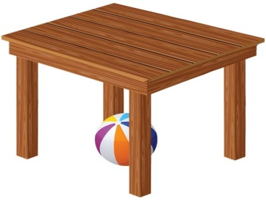 The ball is ________ the table.
A. on B. behind C. next to D. under
Đáp án: Chọn ý: D
57. What’s y_ _ _ name? – My name’s Shane.
Đáp án: our
58. This is my brother and this is _______ bike.
A. he B. his C. him D. its
Đáp án: his
59. chess/ I/ school./ at/ play/
Đáp án: I play chess at school.
60. ... are you? – Fine, thanks.
A. Who B. Is C. Are D. How
Đáp án: Chọn ý: D
61. Does she have any _______?
A. banana B. bananas C. bananas’ D. banana’s
Đáp án: bananas
62. Ảnh: The Children's Day is in _____.
A. April B. May C. June D. July
Đáp án: June
63. My ... is Tim. Nice to meet you.
A. name’s B. names C. name D. is name
Đáp án: name
64. Don’t be late … your lesson!
A. on B. for C. to D. at
Đáp án: for
65. My father/ on the wall./ the clock/ hangs/
Đáp án: My father hangs the clock on the wall.
66. Hi, my name is Phuong. - … .
A. Goodbye B. Hi, I’m Tom C. See you later D. Fine, thanks
Đáp án: Hi, I’m Tom
67. Hello, my na_ _ is Ha.
Đáp án: me
68. Linda: Is your school b_ _ ? - Nam: No, it isn’t. It’s small.
Đáp án: ig
69. How do … spell … name, Peter?
A. you – your B. he – your C. she – his D. they – our
Đáp án: you – your
70. Hi, _ _ _ are you? – I’m fine, thanks.
Đáp án: how
71. silent,/ Keep/ please!/
Đáp án: Keep silent, please!
72. is/ brother/ His/ ten/ years old./
Đáp án: His brother is ten years old.
73. room/ very/ The/ old./ is/
Đáp án: The room is very old.
74. Mary _ _ s born in America.
Đáp án: wa
75. Ảnh: It's great to play sk_ _ _ ing with you.
Đáp án: ipp
76. I’m _ _ _ _ _ , I’m late.
Đáp án: sorry
77. This is my sister and this is … bike.
A. her B. his C. their D. its
Đáp án: her
78. My school y_ _ _ is small.
Đáp án: ard
79. How do ________ spell _________ name, Peter? - R-O-S-Y.
A. she - her B. you - her C. they - she D. you - he
Đáp án: you - her
80. The trees ___ green.
A. is B. are C. am D. do
Đáp án: are
81. Choose the letter(s) to make a correct word: HOU_E
A. E B. O C. S D. U
Đáp án: S
82. The p_ _ _ are in the pencil case.
Đáp án: ens
83. Ảnh: This is the play_ _ _ _ _ _ .
Đáp án: ground
84. Your cat is _ _ _ small. It’s big.
Đáp án: not
85. These are my … .
A. book B. pencil case C. poster D. bags
Đáp án: Chọn ý: D
86. Ảnh: This rabbit has an orange _ _ _ .
Đáp án: key
87. that is/ This is/ and/ her pencil./ my pen/
Đáp án: This is my pen and that is her pencil.
88. Ảnh: CHIC_ _ _
Đáp án: KEN
89. Nghe: Nhấn giữ Ctrl và bấm chuột để nghe: Ben’s _ _ _ _ _ years old today.
Đáp án: seven
90. Ảnh: What colour is the grass?
A. Green B. Brown C. Yellow D. Red
Đáp án: Green
91. Ảnh: The children are playing … now.
A. badminton B. volleyball C. hide-and-seek D. break time
Đáp án: hide-and-seek
92. I … a blue pencil and a white ruler.
A. has B. have C. don’t have D. doesn’t have
Đáp án: have
93. H_ _ _ _ , Alex. How are you?
Đáp án: ello
94. two rulers/ my/ There are/ school bag./ in/
Đáp án: There are two rulers in my school bag.
95. There is _ _ apple on the table.
Đáp án: an
96. is/ My/ classroom/ not/ small./
Đáp án: My classroom is not small.
97. your mother,/ How/ Ben?/ is/
Đáp án: How is your mother, Ben?
98. these/ Do/ cakes?/ you like/
Đáp án: Do you like these cakes?
99. not/ do/ I/ like/ tigers./
Đáp án: I do not like tigers.
100. Ảnh: 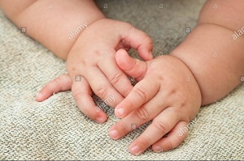 My little sister has two small _____.
A. books B. pens C. rulers D. hands
Đáp án: Chọn ý: D
101. _ _ _ many bottles of milk are there?
Đáp án: how
102. Ảnh: 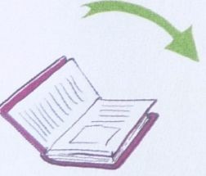 _ _ _ _ _ your book, please.
Đáp án: Close
103. Hi. What's your _ _ _ _ ? - I'm Peter.
Đáp án: name
104. dance but/ play football./ cannot/ Hung can/
Đáp án: Hung can dance but cannot play football.
105. It _ _ my birthday today.
Đáp án: is
106. Their backpacks are in the _ _ _ boards.
Đáp án: cup
107. and short./ and girls/ tall/ are/ The boys/
Đáp án: The boys and girls are tall and short.
108. The classroom is modern … large.
A. and B. but C. so D. or
Đáp án: and
109. Ảnh: Close the _ _ _ _ , please!
Đáp án: door
110. They are her _______.
A. pencil case B. pencils case C. pencils cases D. pencil cases
Đáp án: Chọn ý: D
111. Yes, _ _ is a new notebook.
Đáp án: it
112. Let’s ma_ e a circle.
Đáp án: k
113. There are ... students in my class. Twenty boys and twenty girls.
A. twenty B. thirty C. forty D. fifty
Đáp án: forty
114. He is Simon. He is my ... .
A. school B. name C. book D. friend
Đáp án: Chọn ý: D
115. I have a cat _ _ d a dog.
Đáp án: an
116. big./ classroom/ is/ very/ My/
Đáp án: My classroom is very big.
117. David can play ... .
A. desk B. chair C. pencil D. football
Đáp án: Chọn ý: D
118. Mai./ picture,/ draw/ Let’s/ a/
Đáp án: Let’s draw a picture, Mai.
119. Nghe: Nhấn giữ Ctrl và bấm chuột để nghe: It’s the _ _ _ _ _ _ _ _ room.
Đáp án: computer
120. Ảnh: Can you make a _ _ _ _ ?
Đáp án: kite
121. I like doing karate. - ... .
A. No, thanks B. Me too C. Yes, please D. Sorry
Đáp án: Me too
122. They go to school _ _ _ _ Monday to Friday.
Đáp án: from
123. C_ _ se your bag, Tom.
Đáp án: lo
124. ___ I use your computer?
A. May B. Cannot C. Am D. Canot
Đáp án: May
125. Nghe: Nhấn giữ Ctrl và bấm chuột để nghe: Which number is NOT in the recording?
A. 14 B. 13 C. 12 D. 11
Đáp án: 14
126. Wr_ _ _ your name here, please.
Đáp án: ite
127. Tho_ _ are my crayons.
Đáp án: se
128. Ảnh: It's _ pink cup.
Đáp án: a
129. What time _ _ you get up?
Đáp án: do
130. red/ This/ flower./ a/ is/
Đáp án: This is a red flower.
131. Nghe: Nhấn giữ Ctrl và bấm chuột để nghe: Sue is in the … room.
A. living B. dining C. sitting D. bed
Đáp án: living
132. Is that your father? – No, … .
A. it is B. it isn’t C. that is D. is that
Đáp án: it isn’t
133. Ảnh: On the t_ _ _ , the birds are singing.
Đáp án: ree
134. Tom: _ _ _ _ colour is your pencil case? - Jenny: It’s green.
Đáp án: What
135. How many months are there in a year?
A. 10 B. 11 C. 12 D. 13
Đáp án: 12
136. are/ new. They/ Her notebooks/ are on/ the bookcase./
Đáp án: Her notebooks are new. They are on the bookcase.
137. Is this a book? - ... .
A. No, it is B. Yes, it isn’t C. Yes, it is D. No, they are
Đáp án: Yes, it is
138. Nghe: Nhấn giữ Ctrl và bấm chuột để nghe: This is my ___.
A. ice B. light C. knife D. kite
Đáp án: Chọn ý: D
139. are/ tall trees./ These/ five/
Đáp án: These are five tall trees.
140. large./ very/ is/ The/ room/
Đáp án: The room is very large.
141. _ _ _ _ do you usually do in your free time?
Đáp án: What
142. Pictures of my family _ _ _ on the wall.
Đáp án: are
143. My pictures are ... the wall.
A. on B. in C. for D. to
Đáp án: on
144. Nghe: Nhấn giữ Ctrl và bấm chuột để nghe: Listen and tick the word(s) you hear:
A. happy B. hide-and-seek C. zero D. hero
Đáp án: Chọn ý: D
145. Ảnh: 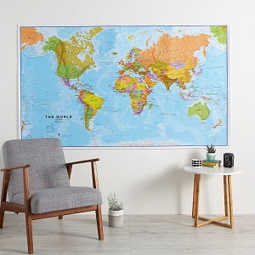 The _ ap is on the wall.
Đáp án: m
146. in your/ a park/ Is there/ town?
Đáp án: Is there a park in your town?
147. we/ go to/ This is/ the way/ school./
Đáp án: This is the way we go to school.
148. I like _______ hide-and-seek with my friends.
A. playing B. plays C. play D. to playing
Đáp án: playing
149. _ _ _ _ is it? – It is a kite.
Đáp án: What
150. your/ big?/ Is/ classroom/
Đáp án: Is your classroom big?
151. What ... it? – It’s a desk.
A. is B. hi C. bye D. hello
Đáp án: is
152. Let’s ... a picture, Daisy.
A. sit B. read C. draw D. stand
Đáp án: draw
153. Nghe: Nhấn giữ Ctrl và bấm chuột để nghe: My school _ _ _ is very long.
Đáp án: bus
154. Billy is th_ _ e years old.
Đáp án: re
155. My school library is b_ _ . Your library is small.
Đáp án: ig
156. at/ the/ Look/ board.
Đáp án: Look at the board.
157. Ảnh: Every classroom has a bl_ _ _ board
Đáp án: ack
158. Ảnh: 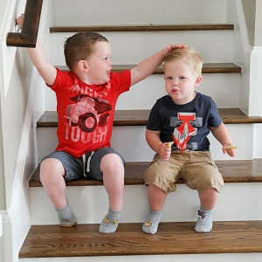 Who are the bo_ _ over there? - They're my brothers.
Đáp án: ys
159. P__STER
A. L B. A C. O D. E
Đáp án: O
160. isn’t/ classmate./ That/ girl/ my
Đáp án: That girl isn’t my classmate.
161. My brother’s name is … .
A. Daisy B. Mary C. Ben D. Nicole
Đáp án: Ben
162. there?/ dolls/ How/ many/ are
Đáp án: How many dolls are there?
163. Nghe: Nhấn giữ Ctrl và bấm chuột để nghe: They are ____.
A. 12 B. 13 C. 14 D. 15
Đáp án: 13
164. Ảnh: _ _ _ _ _ _
Đáp án: twenty
165. I like to eat pizza v_ _ y much.
Đáp án: er
166. Lis_ _ _ to the teacher, please.
Đáp án: ten
167. book/ is/ boring./ The/
Đáp án: The book is boring.
168. _ _ _ _ do you do at school?
Đáp án: What
169. your/ they/ Are/ new/ classmates?/
Đáp án: Are they your new classmates?
170. green. They/ are/ are in the bag./ Your rulers/
Đáp án: Your rulers are green. They are in the bag.
171. Nghe: Nhấn giữ Ctrl và bấm chuột để nghe: His sister’s _ _ _ _ is in the tree.
Đáp án: kite
172. Ảnh: _ _ _
Đáp án: CAT
173. she/ a/ Is/ teacher?
Đáp án: Is she a teacher?
174. These _ _ _ two dolls.
Đáp án: are
175. The kittens/ balcony./ sleep/ in the/
Đáp án: The kittens sleep in the balcony.
176. Roses are … and grapes are purple.
A. sweet B. nice C. red D. lovely
Đáp án: red
177. love/ We/ very much./ break time/
Đáp án: We love break time very much.
178. How many chairs are there in your living room? - _______
A. I'm great today. B. There are five chairs. C. There are two days. D. It's large and big.
Đáp án: There are five chairs.
179. Ảnh: She likes _ red dress.
Đáp án: a
180. __________ - Green.
A. What's your favourite colour? B. Good morning! C. Goodbye! D. Sorry!
Đáp án: What's your favourite colour?
181. Ảnh: 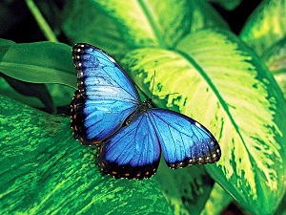 BUTTERFL_
Đáp án: Y
182. Linh: Can you ... the window? It’s hot. - Lan: OK.
A. open B. play C. read D. listen
Đáp án: open
183. Does/ bananas?/ like/ Mary/
Đáp án: Does Mary like bananas?
184. match./ Listen/ and/
Đáp án: Listen and match.
185. What does she do _ t break time?
Đáp án: a
186. I ... my teeth in the morning.
A. do B. brush C. have D. does
Đáp án: brush
187. Nghe: Nhấn giữ Ctrl và bấm chuột để nghe: He is ____.
A. 12 B. 13 C. 14 D. 15
Đáp án: 14
188. Nghe: Nhấn giữ Ctrl và bấm chuột để nghe: My _ _ _ _ is green.
Đáp án: ball
189. These ... my pencils.
A. and B. is C. are D. am
Đáp án: are
190. This is my/ new/ pencil/ box.
Đáp án: This is my new pencil box.
191. Math teacher?/ How/ is/ old/ your
Đáp án: How old is your Math teacher?
192. I’d like _ _ apple, please.
Đáp án: an
193. Nghe: Nhấn giữ Ctrl và bấm chuột để nghe: Listen and tick the word(s) you hear:
A. large B. cycle C. clean D. jeans
Đáp án: clean
194. There is a big tree next _ _ the pond.
Đáp án: to
195. Is this _ _ eraser? – No, it isn’t.
Đáp án: an
196. My brother __ to school today.
A. go B. goes C. play D. plays
Đáp án: goes
197. Hoa?/ Is/ Miss/ that/
Đáp án: Is that Miss Hoa?
198. bedroom/ Is/ her/ or small?/ big
Đáp án: Is her bedroom big or small?
199. Peter: Are those your notebooks? - Jane: No, ... .
A. it is B. it isn’t C. they are D. they aren’t
Đáp án: Chọn ý: D
200. The big tree is beh_ nd my house.
Đáp án: i

KEY IOE K3 2023 - 2024 SỐ 34
1. What time …?
A. are they B. is it C. aren’t they D. isn’t it
Đáp án: is it
2. John: Are you a student? - Jane: Yes,... .
A. Yes, I am B. I am C. I’m student D. Yes, I
Đáp án: I’m student
3. Ảnh: It's Alex's ru_ _ _ _ .
Đáp án: bber
4. your/ school/ it/ Is/ bag?/
Đáp án: Is it your school bag?
5. two rulers/ in/ my/ school bag./ There are/
Đáp án: There are two rulers in my school bag.
6. Good af_ _ _ _ _ _ _ Mr. Smith.
Đáp án: ternoon
7. The/ is on/ the/ cat/ sofa./
Đáp án: The cat is on the sofa.
8. How/ many/ there?/ rulers/ are
Đáp án: How many rulers are there?
9. Nghe: Nhấn giữ Ctrl và bấm chuột để nghe: My new _ _ _ _ _ _ is Adam.
Đáp án: friend
10. Ảnh: Two ha_ _ _ have ten fingers.
Đáp án: nds
11. book./ a/ This/ pink/ is/
Đáp án: This is a pink book.
12. are/ Those/ big/ clouds.
Đáp án: Those are big clouds.
13. These are my … .
A. book B. pencil case C. poster D. bags
Đáp án: Chọn ý: D
14. Ảnh: ELEPH_ _ _
Đáp án: ANT
15. Teacher: Is your school library big? - Tommy: No, it … .
A. don’t B. am not C. doesn’t D. isn’t
Đáp án: Chọn ý: D
16. Is this your bag? - … .
A. No, thanks B. Sure C. No, it is D. Yes, it is
Đáp án: Chọn ý: D
17. Ảnh: D_ _ _ a flower on your sheet.
Đáp án: raw
18. Goo_ _ _ e. See you tomorrow, students.
Đáp án: dby
19. schoolyard/ is/ The/ not/ large./
Đáp án: The schoolyard is not large.
20. Is your classroom big? – No, it _ _ n’t.
Đáp án: is
21. Pick … your pencil, John.
A. on B. in C. of D. up
Đáp án: Chọn ý: D
22. Listen _____ repeat.
A. or B. and C. with D. now
Đáp án: and
23. Nghe: Nhấn giữ Ctrl và bấm chuột để nghe: Ben’s _ _ _ _ _ years old today.
Đáp án: seven
24. Nice to meet you. - ... .
A. Goodbye B. See you later C. Nice to meet you, too D. Good morning
Đáp án: Nice to meet you, too
25. your aunt/ Is/ your mother?/ next to/
Đáp án: Is your aunt next to your mother?
26. We/ break time/ very much./ love/
Đáp án: We love break time very much.
27. The _________ is Jane.
A. me B. boy C. girl D. she
Đáp án: girl
28. with his friend/ basketball/ plays/ after school./ Tuan/
Đáp án: Tuan plays basketball with his friend after school.
29. Does she have any _______?
A. banana B. bananas C. bananas’ D. banana’s
Đáp án: bananas
30. Ảnh: That _ _ _ _ _ pen is not mine.
Đáp án: green
31. W_ _ _ _ is Mary from?
Đáp án: here
32. 'Do you play badminton at break time?' - '_________.'
A. No, you can’t. B. Yes, you do. C. Yes, I do. D. Yes, I am.
Đáp án: Yes, I do.
33. The computer/ room/ large./ is/
Đáp án: The computer room is large.
34. _ _ _ _ is your name? - My name is Jerry.
Đáp án: What
35. How many flowers _ _ _ there in the vase?
Đáp án: are
36. _ _ _ are you? - I'm John's brother.
Đáp án: Who
37. Nghe: Nhấn giữ Ctrl và bấm chuột để nghe: _ _ _ _ _ _ _ _ _
Đáp án: badminton
38. Jane: What _ _ _ our is your desk? - Linda: It is pink.
Đáp án: col
39. the garden./ many/ There are/ flowers/ in
Đáp án: There are many flowers in the garden.
40. Ảnh: The child is _ _ the box.
Đáp án: in
41. Which word is odd one out?
A. pig B. men C. chicken D. fish
Đáp án: men
42. Ảnh: Come and see the pho_ _ of my family.
Đáp án: to
43. Are you a student or a teacher?
A. Yes, I am. B. No, I am not. C. I’m a student. D. Yes, I.
Đáp án: I’m a student.
44. _ _ _ is she? – She’s Ms. Wilson. She’s my English teacher.
Đáp án: Who
45. these/ stamps?/ want/ Do you/
Đáp án: Do you want these stamps?
46. Ảnh: We can see a _ _ _ _ _ _ _ _ in Australia.
Đáp án: kangaroo
47. Choose the incorrect word or phrase in the following sentence: They play badminton in break time.
A. play B. badminton C. in D. time
Đáp án: in
48. Nghe: Nhấn giữ Ctrl và bấm chuột để nghe: _ _ _ _ _ _ _ _
Đáp án: bathroom
49. A: Is your school …? – B: Yes, there are four big buildings and a big schoolyard.
A. small B. little C. large D. narrow
Đáp án: large
50. At break time, we ___ different games and sports.
A. do B. get C. go D. play
Đáp án: Chọn ý: D
51. David?/ sister,/ your/ Is/ this/
Đáp án: Is this your sister, David?
52. Nghe: Nhấn giữ Ctrl và bấm chuột để nghe: They’ve got two _ _ _ sins, Amy and Leo.
Đáp án: cou
53. Nghe: Nhấn giữ Ctrl và bấm chuột để nghe: Listen and tick:
A. hat B. hot C. red D. cat
Đáp án: hat
54. The big tree is beh_ nd my house.
Đáp án: i
55. Her/ from/ friends/ are/ France./
Đáp án: Her friends are from France.
56. What/ do/ every/ do you/ evening?/
Đáp án: What do you do every evening?
57. Ảnh: What’s the weather like? - It’s _ _ _ _ _ .
Đáp án: rainy
58. Nghe: Nhấn giữ Ctrl và bấm chuột để nghe: Polly is my best _ _ _ _ _ _ .
Đáp án: friend
59. Choose the odd one out:
A. Vietnam B. England C. America D. Vietnamese
Đáp án: Chọn ý: D
60. ______ my uncle next to my father.
A. They are B. There are C. It is D. Is there
Đáp án: It is
61. one garden/ Is there/ your school?/ in/
Đáp án: Is there one garden in your school?
62. Would you _ _ _ _ some water?
Đáp án: like
63. How many months are there in a year?
A. 10 B. 11 C. 12 D. 13
Đáp án: 12
64. A: Goodbye. - B: Bye. _________
A. See you tomorrow. B. Thank you. C. Sorry. D. Nice to meet you.
Đáp án: See you tomorrow.
65. Let’s listen _ _ some music.
Đáp án: to
66. I like my school _ _ _ _ much.
Đáp án: very
67. in/ pens/ the box?/ are there/ How many/
Đáp án: How many pens are there in the box?
68. cakes and/ in a/ We eat/ coffee shop./ drink tea/
Đáp án: We eat cakes and drink tea in a coffee shop.
69. B_ _ . See you later.
Đáp án: ye
70. Mary often gets _ _ early in the morning.
Đáp án: up
71. I … a blue pencil and a white ruler.
A. has B. have C. don’t have D. doesn’t have
Đáp án: have
72. ____ do you like? - This one.
A. What B. Where C. How D. Which
Đáp án: What
73. Nghe: Nhấn giữ Ctrl và bấm chuột để nghe: The ____ watch is mine.
A. blue B. yellow C. black D. white
Đáp án: yellow
74. sentences./ Reorder/ the/
Đáp án: Reorder the sentences.
75. Your father’s brother is your _ _ _ _ _ .
Đáp án: uncle
76. Ảnh: The children like building a sand_ _ _ _ _ _ on the beach.
Đáp án: castle
77. Choose the odd one out:
A. song B. subjects C. animal D. plant
Đáp án: subjects
78. Ảnh: He is wearing an o_ _ _ _ _ T-shirt.
Đáp án: range
79. Linda: How are you? - Jane: I’m _ _ _ _ , thanks.
Đáp án: fine
80. _ _ _ _ _ are you from? - I'm from Vietnam.
Đáp án: where
81. Put/ away,/ children./ your/ pencils/
Đáp án: Put your pencils away, children.
82. new/ These/ pens./ my/ are/
Đáp án: These are my new pens.
83. Nghe: Nhấn giữ Ctrl và bấm chuột để nghe: Sue is in the _ _ _ _ _ _ car
Đáp án: yellow
84. brother/ These/ are/ and sister./ my/
Đáp án: These are my brother and sister.
85. I ... my teeth in the morning.
A. do B. brush C. have D. does
Đáp án: brush
86. Where _ _ you study, Trang?
Đáp án: do
87. Rai_ e your hand, please.
Đáp án: s
88. May I _ _ me in?
Đáp án: co
89. Which … their pencil sharpeners?
A. are B. am C. is D. have
Đáp án: are
90. Lien: _ _ you like badminton? - Mary: Yes, I do.
Đáp án: Do
91. the sky./ in/ There are/ six/ kites/
Đáp án: There are six kites in the sky.
92. Choose the incorrect word(s) in the following sentence: My uncle is thirty year old.
A. My B. is C. year D. old
Đáp án: year
93. This is ... eraser. It’s not my eraser.
A. this B. he C. me D. your
Đáp án: Chọn ý: D
94. My mother li_ es jogging.
Đáp án: k
95. Nghe: Nhấn giữ Ctrl và bấm chuột để nghe: Meg is _ _ _ _ _ years old.
Đáp án: eight
96. How mu_ _ milk would you like?
Đáp án: ch
97. My family have dinner in the ____.
A. living room B. bedroom C. basement D. dining room
Đáp án: Chọn ý: D
98. your/ pencil sharpener?/ What/ is/ colour/
Đáp án: What colour is your pencil sharpener?
99. Ảnh: My grandfather is ______ years old.
A. seventeen B. seventy C. seventy-one D. seven-one
Đáp án: seventy-one
100. is/ new/ my/ She/ friend./
Đáp án: She is my new friend.
101. Is this ... classroom?
A. are B. a C. am D. an
Đáp án: a
102. a glass/ of milk./ is/ It/
Đáp án: It is a glass of milk.
103. Nghe: Nhấn giữ Ctrl và bấm chuột để nghe: Listen and tick the word(s) you hear:
A. a pet B. a bed C. a bird D. a bage
Đáp án: a bird
104. Max and his friends/ playground./ badminton/ play/ in the
Đáp án: Max and his friends play badminton in the playground.
105. is/ Living room/ my/ favourite room.
Đáp án: Living room is my favourite room.
106. Hamburger/ is/ my/ food./ favourite
Đáp án: Hamburger is my favourite food.
107. This is ... orange.
A. a B. an C. is D. are
Đáp án: an
108. The board is big and n_ _ .
Đáp án: ew
109. have/ don't/ lunchbox./ my/ I/
Đáp án: I don't have my lunchbox.
110. red/ is/ This/ a/ flower./
Đáp án: This is a red flower.
111. My father raises some fish in the _____.
A. garden B. forest C. pond D. yard
Đáp án: pond
112. Can/ one to ten?/ you count/ from/
Đáp án: Can you count from one to ten?
113. Ảnh: My grand_ _ _ _ er is in the garden.
Đáp án: fath
114. years/ is/ eleven/ My brother/ old./
Đáp án: My brother is eleven years old.
115. Let’s make a cir_ le.
Đáp án: c
116. Four and five are n_ _ _ .
Đáp án: ine
117. Which sentence is correct?
A. Santa Claus flying over the town. B. Santa Claus is riding his sleigh. C. Santa Claus is ride a reindeer. D. Santa Claus is walking in the sky.
Đáp án: Santa Claus is riding his sleigh.
118. That is my mother. _ _ _ is a teacher.
Đáp án: she
119. How are you? - I _ _ fine.
Đáp án: am
120. Ảnh: It is a beautiful purp_ _ flower.
Đáp án: le
121. How many days are there in _ week?
Đáp án: a
122. at/ play/ break time./ hide-and-seek/ Let's/
Đáp án: Let's play hide-and-seek at break time.
123. Raise your ..., please.
A. hand B. sit C. stand D. open
Đáp án: hand
124. Ảnh: Let's make paper bo_ ts.
Đáp án: a
125. Choose the odd one out.
A. numbers B. twenty C. thirteen D. seven
Đáp án: numbers
126. is/ old/ brother?/ Lan's/ How/
Đáp án: How old is Lan's brother?
127. Yes, _ _ is a new notebook.
Đáp án: it
128. on/ The cat/ is/ bench./ that
Đáp án: The cat is on that bench.
129. Ảnh: You are in the water to play this sport. What sport is it?
A. Badminton B. Volleyball C. Table tennis D. Swimming
Đáp án: Chọn ý: D
130. They like frogs … they don’t like spiders.
A. but B. and C. so D. or
Đáp án: but
131. Choose the letter(s) to make a correct word: G__NDFATHER
A. AR B. OR C. RO D. RA
Đáp án: Chọn ý: D
132. My bedroom is not big. It’s sm_ _ _ .
Đáp án: all
133. … does your father do in his free time? – He plays tennis.
A. What B. Who C. When D. Where
Đáp án: What
134. you/ like?/ What/ colour do/
Đáp án: What colour do you like?
135. _ _ you like playing football?
Đáp án: Do
136. W_ _ _ _ is Mary from? - She’s from England.
Đáp án: here
137. Her ruler _ _ n't new. It's old.
Đáp án: is
138. Nghe: Nhấn giữ Ctrl và bấm chuột để nghe: The ___ T-shirt is William's.
A. red B. yellow C. black D. white
Đáp án: black
139. Nghe: Nhấn giữ Ctrl và bấm chuột để nghe: She’s got _ _ _ _ _ eyes.
Đáp án: brown
140. How old is his grandmother? - _______
A. She's fine. B. There are some tables in the room. C. She's sixty now. D. Thank you very much.
Đáp án: She's sixty now.
141. How/ of this animal?/ spell/ the name/ do you/
Đáp án: How do you spell the name of this animal?
142. Goodb_ e, Tommy. See you later.
Đáp án: y
143. My school bag is _ _ all. Your school bag is big.
Đáp án: sm
144. What colour is this? - … .
A. It blue B. It’s blue C. Is blue D. It is a blue
Đáp án: It’s blue
145. Nghe: Nhấn giữ Ctrl và bấm chuột để nghe: Listen and tick:
A. pen B. pencil C. pen case D. ruler
Đáp án: pen
146. Choose the odd one out:
A. play B. quiet C. talk D. stand
Đáp án: quiet
147. Ảnh: Shhh! The baby is _ _ _ _ _ _ _ _ .
Đáp án: sleeping
148. Tom./ hands,/ Wash/ your/
Đáp án: Wash your hands, Tom.
149. We go to school ... .
A. alone B. together C. gether D. by me
Đáp án: together
150. Ảnh: fourteen, _______, sixteen.
A. fiveteen B. fifteen C. fifty D. fourty
Đáp án: fifteen
151. Ảnh: She has a beautiful _ _ _ _ .
Đáp án: doll
152. This is m_ cat.
Đáp án: y
153. my/ is/ He/ friend,/ too./
Đáp án: He is my friend, too.
154. How _ _ d is she? – She’s nine years old.
Đáp án: ol
155. I am .... I want a cake.
A. thirsty B. tired C. happy D. hungry
Đáp án: Chọn ý: D
156. Nghe: Nhấn giữ Ctrl và bấm chuột để nghe: His sister’s _ _ _ _ is in the tree.
Đáp án: kite
157. Is/ she/ teacher?/ the/ new
Đáp án: Is she the new teacher?
158. a/ need/ sofa./ new/ I/
Đáp án: I need a new sofa.
159. Peter: What are their …? - Hoa: Mai and Huong.
A. name B. names C. your name D. your names
Đáp án: names
160. do/ you/ a/ Can/ puzzle?/
Đáp án: Can you do a puzzle?
161. Nghe: Nhấn giữ Ctrl và bấm chuột để nghe: _ _ _ _ _ _
Đáp án: friend
162. Choose the INCORRECT word or phrase in the following sentence: These are Peter's picture on the shelf.
A. These B. picture C. on D. shelf
Đáp án: picture
163. Ảnh: Her pencil _ _ _ _ is pink.
Đáp án: case
164. There are four people _ _ my family.
Đáp án: in
165. This/ is/ ruler/ pink.
Đáp án: This ruler is pink.
166. Nghe: Nhấn giữ Ctrl và bấm chuột để nghe: Look at _ _ _ _ photo.
Đáp án: this
167. Which is your school? – This _ _ _ .
Đáp án: one
168. David can play ... .
A. desk B. chair C. pencil D. football
Đáp án: Chọn ý: D
169. What is your favourite ...? – I like milk very much.
A. food B. drink C. subject D. colour
Đáp án: drink
170. Ảnh: He _____ some words on the blackboard.
A. listens B. writes C. goes D. plays
Đáp án: writes
171. The flowers are colourful in _ _ _ garden.
Đáp án: the
172. My elder brother h_ _ a goldfish.
Đáp án: as
173. Nghe: Nhấn giữ Ctrl và bấm chuột để nghe: This is her grand_ _ _ _ _ _ .
Đáp án: mother
174. Nghe: Nhấn giữ Ctrl và bấm chuột để nghe: _ _ _ _ _
Đáp án: brown
175. What time _ _ _ _ the library open?
Đáp án: does
176. Nam: May I _ _ out? - Teacher: Yes, please.
Đáp án: go
177. A: Do you like bananas? - B: ______
A. I like bananas. B. I don't like bananas. C. Yes, I do. D. Yes, I am.
Đáp án: Yes, I do.
178. Choose the odd one out:
A. am B. is C. are D. this
Đáp án: Chọn ý: D
179. Choose the odd one out:
A. bag B. book C. big D. pencil
Đáp án: big
180. Ảnh: R_ _ _ _
Đáp án: ULER
181. is/ a/ blue/ eraser./ It/
Đáp án: It is a blue eraser.
182. Put/ away,/ please./ books/ your/
Đáp án: Put your books away, please.
183. Nghe: Nhấn giữ Ctrl và bấm chuột để nghe: Which number is NOT in the recording?
A. 16 B. 17 C. 18 D. 19
Đáp án: 16
184. Let’s ... English.
A. say B. speak C. tell D. sing
Đáp án: speak
185. Mary ... to school every morning.
A. go B. go’s C. goes D. goes to
Đáp án: goes
186. Ảnh: F_ SH
Đáp án: I
187. Those/ big/ are/ clouds.
Đáp án: Those are big clouds.
188. the wall./ pictures/ are/ on/ The/
Đáp án: The pictures are on the wall.
189. Ảnh: His mother is in the kitch_ _ .
Đáp án: en
190. Ảnh: This is your …, Tom.
A. bench B. desk C. chair D. board
Đáp án: desk
191. This is m_ pen. It’s not your pen.
Đáp án: y
192. Do you like _ oing Maths?
Đáp án: d
193. Is that y_ _ _ nephew?
Đáp án: our
194. Odd one out:
A. fish B. dolphin C. monkey D. shark
Đáp án: monkey
195. What can you do … English? – I can count to 100, sing an English song.
A. in B. at C. on D. by
Đáp án: Chọn ý: D
196. Write the an_ _ _ rs, please.
Đáp án: swe
197. My mother buys many school things such as notebooks, pens, pencils and _________.
A. hamburger B. shoes C. balls D. rubbers
Đáp án: Chọn ý: D
198. English?/ Alice/ Why/ does/ like
Đáp án: Why does Alice like English?
199. My class is …: ten girls and eleven boys.
A. nice B. tidy C. big D. new
Đáp án: big
200. They aren't her books. They are _ _ s books.
Đáp án: hi

KEY IOE K3 2023 - 2024 SỐ 35
1. Quyen is playing _ _ _ piano.
Đáp án: the
2. Jim/ from/ London./ isn’t/
Đáp án: Jim isn’t from London.
3. the music room?/ boys/ How many/ in/ are there/
Đáp án: How many boys are there in the music room?
4. … do you do at lunch time?
A. What B. How C. Where D. When
Đáp án: What
5. likes to/ play/ sister/ dolls./ My/
Đáp án: My sister likes to play dolls.
6. Who is tall_ _ , Jack or Jim?
Đáp án: er
7. When/ Lan’s/ birthday?/ is/
Đáp án: When is Lan’s birthday?
8. Ảnh: 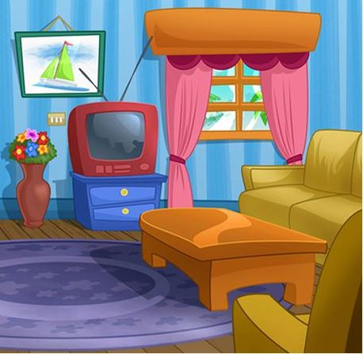 There is a p_ _ _ _ _ e above the television.
Đáp án: ictur
9. There are s_ _ en days in a week.
Đáp án: ev
10. Nghe: Nhấn giữ Ctrl và bấm chuột để nghe: Where are the _ _ _ _ _ _ ?
Đáp án: chairs
11. near/ Ninh Binh?/ Is/ Hoa Binh/
Đáp án: Is Hoa Binh near Ninh Binh?
12. This is/ bag./ a purple/
Đáp án: This is a purple bag.
13. is/ very/ bedroom/ large./ Mary’s/
Đáp án: Mary’s bedroom is very large.
14. ... is that? - It’s a blue ball.
A. How B. When C. What D. Where
Đáp án: What
15. Nghe: Nhấn giữ Ctrl và bấm chuột để nghe: _ _ _ _ _
Đáp án: where
16. Ảnh: 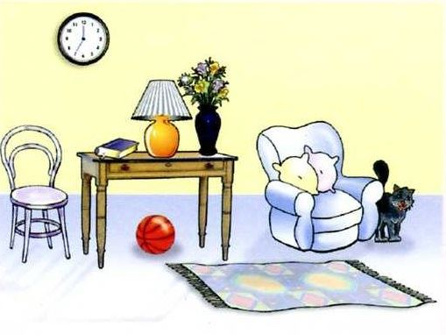 Look at the picture and choose the FALSE statement.
A. There is a book on the table. B. There is a picture on the wall. C. There is a cat next to the armchair. D. There is a ball under the table.
Đáp án: There is a picture on the wall.
17. Gi_ e me the eraser.
Đáp án: v
18. My family/ the drawer./ album/ in/ is/
Đáp án: My family album is in the drawer.
19. mother/ kitchen./ the/ My/ is in/
Đáp án: My mother is in the kitchen.
20. Ảnh: My sister is _ _ _ _ _ _ _ years old.
Đáp án: fifteen
21. Is your school ...? - No, it is big.
A. small B. on C. bye D. this
Đáp án: small
22. Some _ _ _ chers are in the hall.
Đáp án: tea
23. Nghe: Nhấn giữ Ctrl và bấm chuột để nghe: The cat walks _ _ _ _ to the ball.
Đáp án: over
24. now./ out/ go/ cannot/ You/
Đáp án: You cannot go out now.
25. Is your school small or la_ _ _ ?
Đáp án: rge
26. We learn h_ _ to read at school.
Đáp án: ow
27. A: What does your aunt …? - B: She is very sporty.
A. like B. look like C. likes D. like looking
Đáp án: look like
28. cold/ is/ The weather/ very/ today./
Đáp án: The weather is very cold today.
29. What is the name … your school?
A. about B. to C. of D. at
Đáp án: of
30. your bedroom?/ Why/ you/ like/ don’t/
Đáp án: Why don’t you like your bedroom?
31. May I come _ n? – Yes, please.
Đáp án: i
32. Ảnh: 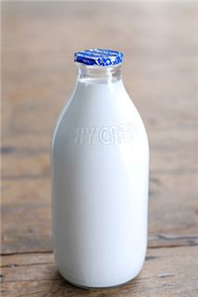 Give me a b_ _ _ _ _ of milk, please.
Đáp án: ottle
33. not/ Rosie’s/ It’s/ teddy/ bear./
Đáp án: It’s not Rosie’s teddy bear.
34. Nghe: Nhấn giữ Ctrl và bấm chuột để nghe: Sally has got a _ _ _ _ _ dog.
Đáp án: black
35. Nghe: Nhấn giữ Ctrl và bấm chuột để nghe: There is a desk _ _ _ _ to my bed.
Đáp án: next
36. It’s always … in summer.
A. cold B. red C. icy D. hot
Đáp án: Chọn ý: D
37. What are these? - T_ _ se are my crayons.
Đáp án: he
38. A: What is … name? – B: My name is Tommy.
A. we B. you C. your D. they
Đáp án: your
39. Ảnh: She _ _ _ _ _ _ around the park.
Đáp án: cycles
40. What’s/ name?/ your/ friend’s/
Đáp án: What’s your friend’s name?
41. A_ _ you a student at Oxford Primary School?
Đáp án: re
42. I’m ... a letter to my friend at the moment.
A. writing B. writes C. written D. to write
Đáp án: writing
43. is/ name?/ your/ aunt’s/ What/
Đáp án: What is your aunt’s name?
44. Which word has ‘ch’ pronounced as the letter ‘k’ in \"clock\"?
A. chair B. chess C. school D. kitchen
Đáp án: school
45. Ảnh: My mother is _ _ _ _ _ _ _ for dinner.
Đáp án: cooking
46. Choose the odd one out.
A. cat B. dog C. car D. hen
Đáp án: car
47. Nghe: Nhấn giữ Ctrl và bấm chuột để nghe: Look at the _ _ _ _ in the tree.
Đáp án: ball
48. _ _ she your new classmate?
Đáp án: is
49. We catch a bus _ _ school every schoolday.
Đáp án: to
50. Choose the letter(s) to make a correct word: ru__ing
A. n B. nn C. mm D. mn
Đáp án: nn
51. My sister can … a pony.
A. my B. ride C. ride’s D. I
Đáp án: ride
52. Long An/ Viet Nam./ is/ south/ in/
Đáp án: Long An is in south Viet Nam.
53. Nghe: Nhấn giữ Ctrl và bấm chuột để nghe: Nina is a _ _ _ .
Đáp án: cat
54. What do you have _ _ _ lunch?
Đáp án: for
55. Ảnh: 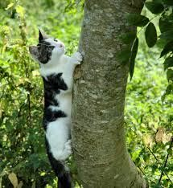 A cat can cl_ _ b a tree.
Đáp án: im
56. Nghe: Nhấn giữ Ctrl và bấm chuột để nghe: _ _ love pets.
Đáp án: We
57. What grade … your twin brothers in?
A. am B. is C. are D. do
Đáp án: are
58. What’s the matter ... your eyes?
A. with B. to C. at D. for
Đáp án: with
59. What are those? – They are rub_ _ _ _ .
Đáp án: bers
60. A … helps people with sickness.
A. doctor B. worker C. farmer D. housewife
Đáp án: doctor
61. my bedroom/ that is/ and/ This is/ my brother’s./
Đáp án: This is my bedroom and that is my brother’s.
62. Nghe: Nhấn giữ Ctrl và bấm chuột để nghe: The sky is _ _ _ _ .
Đáp án: blue
63. Choose the incorrect word(s) in the following sentence: My friend, Quynh, doesn’t has any comic books.
A. My B. has C. any D. books
Đáp án: has
64. Odd one out:
A. a B. this C. an D. the
Đáp án: this
65. … are you? – I’m fine, thanks.
A. What B. How C. Who D. Where
Đáp án: How
66. ... is it from your house to the bakery?
A. How often B. How far C. How D. How much
Đáp án: How far
67. Your school and your library is big. – Yes, t_ _ _ are very big and nice.
Đáp án: hey
68. I _ _ _ _ breakfast with my sister.
Đáp án: have
69. What/ do/ you/ have?/ pets/
Đáp án: What pets do you have?
70. doing?/ teacher/ her/ is/ What/
Đáp án: What is her teacher doing?
71. I don’t like the music room. It is so s_ _ _ l.
Đáp án: mal
72. Nghe: Nhấn giữ Ctrl và bấm chuột để nghe: Egg is playing the ….
A. guitar B. violin C. piano D. drum
Đáp án: piano
73. play/ time./ They often/ at break/ volleyball/
Đáp án: They often play volleyball at break time.
74. Can you he_ p me?
Đáp án: l
75. teacher./ English/ Miss Paula/ is/ my/
Đáp án: Miss Paula is my English teacher.
76. My friends and I … a new way to learn English.
A. go B. look C. find D. do
Đáp án: find
77. This is my aunt. …. twenty-six years old.
A. They are B. He is C. You are D. She is
Đáp án: Chọn ý: D
78. What toy do you like?
A. Tom and Jerry. B. Gold fish C. A rabbit. D. A yo-yo.
Đáp án: Chọn ý: D
79. chicken?/ like/ you/ Do/
Đáp án: Do you like chicken?
80. Ảnh: 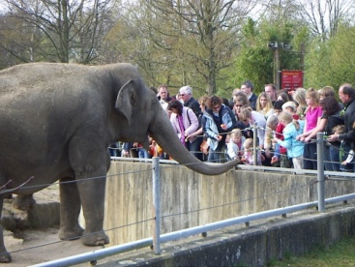 ______ do you see elephants? – In the zoo.
A. When B. How C. Where D. What
Đáp án: Where
81. on/ is taking/ a nap/ My dad/ the sofa./
Đáp án: My dad is taking a nap on the sofa.
82. chairs and a table/ are/ There/ eight/ in my dining room./
Đáp án: There are eight chairs and a table in my dining room.
83. _ s your school small? – Yes, it is small.
Đáp án: I
84. Ảnh: 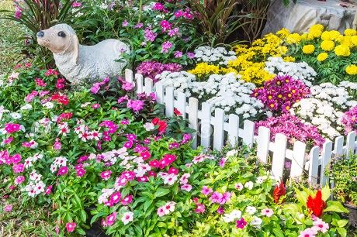 There are many beautiful _ _ _ _ _ _ _ in the garden.
Đáp án: flowers
85. Listen ... the teacher, please.
A. on B. in C. to D. for
Đáp án: to
86. _ _ _ ’t talk. It’s so noisy.
Đáp án: don
87. Nghe: Nhấn giữ Ctrl và bấm chuột để nghe: They’re ....
A. hungry B. happy C. lucky D. sad
Đáp án: happy
88. Choose the incorrect word(s) in the following sentence: What do Linda do after school? – She cooks.
A. do B. do after C. She D. cooks
Đáp án: do
89. doesn’t/ Tim/ coffee./ like/
Đáp án: Tim doesn’t like coffee.
90. Ảnh: 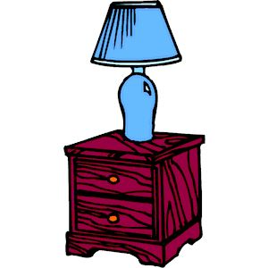 The lamp is … the cupboard.
A. next to B. on C. under D. over
Đáp án: on
91. R_ ad after me, children.
Đáp án: e
92. Ảnh: This big _ _ _ is very funny.
Đáp án: dog
93. I wash/ every/ my hair/ days./ two
Đáp án: I wash my hair every two days.
94. These … members of my family.
A. is B. are C. am D. be
Đáp án: are
95. This is a photo _ _ my class.
Đáp án: of
96. Great to see you ________, Jane.
A. too B. and C. again D. but
Đáp án: again
97. in/ my classroom./ are/ There/ twenty desks/
Đáp án: There are twenty desks in my classroom.
98. Li_ ten to the teacher, please.
Đáp án: s
99. Nghe: Nhấn giữ Ctrl và bấm chuột để nghe: Wooly runs _ _ _ _ .
Đáp án: away
100. a song/ for/ I like/ you./ to sing/
Đáp án: I like to sing a song for you.
101. Ảnh: 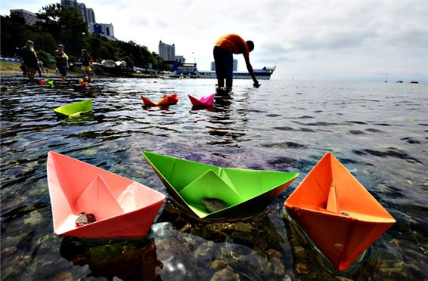 Do you like playing …?
A. football B. paper boats C. chess D. hide-and-seek
Đáp án: paper boats
102. Peter is my friend, t_ _ .
Đáp án: oo
103. Ảnh: 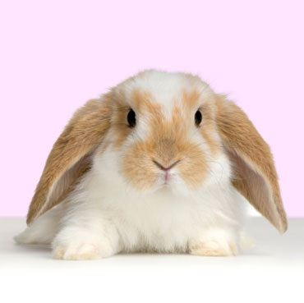 It is a cute _ _ _ _ _ _ with two long ears.
Đáp án: rabbit
104. My brother can play the piano but … play the guitar.
A. can B. can not C. cannot D. cant’
Đáp án: cannot
105. Ảnh: 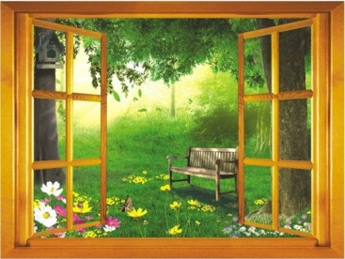 I can see two big tr_ _ _ through the window.
Đáp án: ees
106. She _______ a picture.
A. take B. drawing C. is drawing D. draw
Đáp án: is drawing
107. cannot/ football./ play/ My father/
Đáp án: My father cannot play football.
108. Nghe: Nhấn giữ Ctrl và bấm chuột để nghe: The boy’s name is _ _ _ _ .
Đáp án: Alex
109. the park./ in/ is/ cycling fast/ A girl/
Đáp án: A girl is cycling fast in the park.
110. Hi_ name is Peter.
Đáp án: s
111. and/ go to/ watch the new video./ Let's/ the library/
Đáp án: Let's go to the library and watch the new video.
112. Can the cat _ _ _ _ _ a tree? – Yes, it can.
Đáp án: climb
113. Choose the odd one out.
A. bedroom B. bathroom C. kitchen D. garden
Đáp án: Chọn ý: D
114. Nghe: Nhấn giữ Ctrl và bấm chuột để nghe: _ _ _ _ _ _ _
Đáp án: bedroom
115. toybox./ We have/ a red/ in our/ plane/
Đáp án: We have a red plane in our toybox.
116. Choose the odd one out:
A. living room B. bedroom C. garden D. kitchen
Đáp án: garden
117. the/ I/ play/ can/ piano./
Đáp án: I can play the piano.
118. What’s her ...?
A. old B. name C. there D. age
Đáp án: name
119. When is your birth day, Tommy? – Well, Taylor, it’s … December 5th.
A. in B. like C. on D. at
Đáp án: on
120. Mai/ doing?/ What’s/
Đáp án: What’s Mai doing?
121. This is my school b_ g.
Đáp án: a
122. Which pen is your pen? – This o_ _ .
Đáp án: ne
123. They are ... the beach this summer.
A. going B. going to C. visiting D. go
Đáp án: going to
124. Nghe: Nhấn giữ Ctrl và bấm chuột để nghe: My house has a ... yard.
A. small B. fat C. large D. big
Đáp án: large
125. Nghe: Nhấn giữ Ctrl và bấm chuột để nghe: What colour is her hair? - _ _ _ _ _ .
Đáp án: Brown
126. The/ picture/ is/ the clock./ above
Đáp án: The picture is above the clock.
127. _ _ _ _ is Nga doing? - She’s doing her homework.
Đáp án: What
128. Nghe: Nhấn giữ Ctrl và bấm chuột để nghe: What colour are her eyes? - _ _ _ _ .
Đáp án: Blue
129. Ảnh: 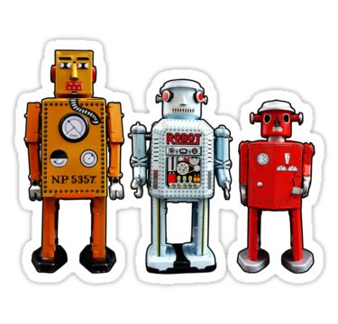 I have t_ _ _ _ robots.
Đáp án: hree
130. Listen _ _ the teacher, please.
Đáp án: to
131. _ _ _ _ _ is a doll.
Đáp án: There
132. Glad to meet you. – Glad to meet you, _ _ _ .
Đáp án: too
133. The opposite of OUT is _ _ .
Đáp án: in
134. Nghe: Nhấn giữ Ctrl và bấm chuột để nghe: Can I borrow you ruler? – Yes, but don’t forget to give it _ _ _ _ .
Đáp án: back
135. a pond/ of/ Is there/ in front/ your house?/
Đáp án: Is there a pond in front of your house?
136. _______ pet do you like? – I like cats.
A. What B. Who C. Where D. When
Đáp án: What
137. Ảnh: 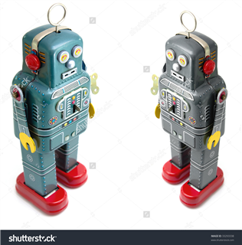 My brother has _ _ _ robots.
Đáp án: two
138. Let’s/ after/ play/ dinner./ chess/
Đáp án: Let’s play chess after dinner.
139. What/ does/ Beck/ like?/ look
Đáp án: What does Beck look like?
140. Would you like ... to the movies tonight?
A. go B. going C. to go D. goes
Đáp án: to go
141. Good m_ _ ning, everyone.
Đáp án: or
142. Choose the incorrect word(s) in the following sentence: There are one robot in my house. Its name is Toro.
A. are B. in C. Its D. is
Đáp án: are
143. Ảnh: 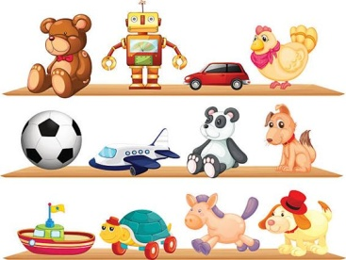 Peter has many toys. He puts them on the sh_ _ _ .
Đáp án: elf
144. My father can dr_ _ e a car.
Đáp án: iv
145. Mary … breakfast at 7 o’clock.
A. have B. does C. plays D. has
Đáp án: Chọn ý: D
146. He is David. He is my ... .
A. school B. name C. book D. friend
Đáp án: Chọn ý: D
147. sing/ an English/ song?/ you/ Can/
Đáp án: Can you sing an English song?
148. Nghe: Nhấn giữ Ctrl và bấm chuột để nghe: The car behind the _ _ _ _ _ is white.
Đáp án: chair
149. school bus./ is/ a/ It/ red
Đáp án: It is a red school bus.
150. …. I can’t do this puzzle.
A. Can you play? B. May you help me? C. Do you like these? D. How are you?
Đáp án: May you help me?
151. Ảnh: 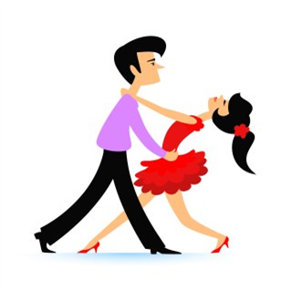 _ _ _ cing is their hobby.
Đáp án: Dan
152. is/ brother/ nine/ years old./ My/
Đáp án: My brother is nine years old.
153. new/ classroom/ Is/ big?/ your/
Đáp án: Is your new classroom big?
154. Mai is laughing. She is ______.
A. hungry B. sad C. happy D. nervous
Đáp án: happy
155. Ảnh: 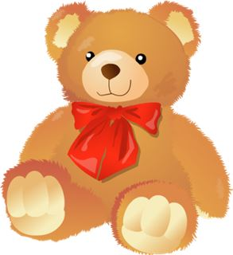 Oh, this teddy _ _ _ _ is cute. Can you buy it for me, Mum?
Đáp án: bear
156. What s_ _ _ _ _ ts do you like? – I like Maths and English.
Đáp án: ubjec
157. _ _ _ _ is your favourite drink? – I like orange juice.
Đáp án: what
158. is/ a long/ It/ pen./ red
Đáp án: It is a long red pen.
159. Which word has the underlined part pronounced like the letter ‘A’ in “RAINY”?
A. skating B. bathroom C. garden D. sofa
Đáp án: skating
160. Can you _ _ _ _ a bicycle?
Đáp án: ride
161. Is that a bag? – No, it is _ _ _ .
Đáp án: not
162. This is Mary. ... is my friend.
A. I B. You C. She D. He
Đáp án: She
163. Good_ _ _ Mary. See you later.
Đáp án: bye
164. This living room is s_ big.
Đáp án: o
165. Lan is a … at Thong Nhat primary school.
A. farmer B. worker C. student D. doctor
Đáp án: student
166. Choose the odd one out:
A. ruler B. rabbit C. cat D. dog
Đáp án: ruler
167. Choose the odd one out:
A. paint B. draw C. write D. walk
Đáp án: Chọn ý: D
168. Odd one out:
A. is B. do C. he D. go
Đáp án: he
169. Tony ... football at break time but today he … basketball.
A. plays - is playing B. plays - plays C. is playing - plays D. is playing - is playing
Đáp án: plays - is playing
170. Rosie is having a shower in the ….
A. kitchen B. bathroom C. bedroom D. playground
Đáp án: bathroom
171. What’s the weather _______ in your city?
A. be B. like C. round D. All are incorrect.
Đáp án: like
172. He/ is/ tall/ and/ young./
Đáp án: He is tall and young.
173. name/ your/ here/ , please./ Write/
Đáp án: Write your name here , please.
174. Where does Minh study? – He studies at Sunrise Pri_ _ _ _ School.
Đáp án: mary
175. This pen is _ _ _ blue. It’s green.
Đáp án: not
176. Ảnh: There are se_ _ _ people in my family.
Đáp án: ven
177. F__TY
A. O B. OUR C. OR D. UR
Đáp án: OR
178. Nam./ outside,/ go/ Let’s/
Đáp án: Let’s go outside, Nam.
179. trucks./ have/ any/ don’t/ I/
Đáp án: I don’t have any trucks.
180. Ảnh: 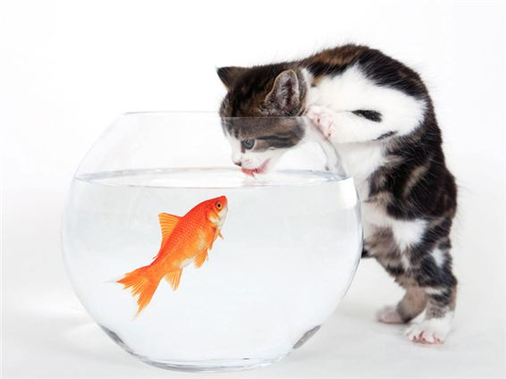 My cat likes _ _ sh very much.
Đáp án: fi
181. She is pre_ _ y.
Đáp án: tt
182. How are ..., Mary? – I’m fine, thanks.
A. he B. she C. you D. his
Đáp án: you
183. Sing wit_ me.
Đáp án: h
184. beautiful./ Those/ kites/ very/ are/
Đáp án: Those kites are very beautiful.
185. Odd one out:
A. school B. cinema C. place D. circus
Đáp án: place
186. Her/ birthday/ in/ June./ is/
Đáp án: Her birthday is in June.
187. How m_ _ _ dogs do you have?
Đáp án: any
188. Ảnh: 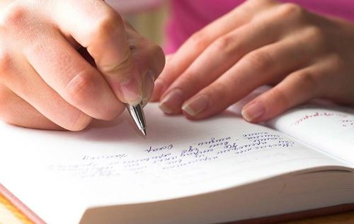 _ _ _ _ _ your answer, please.
Đáp án: write
189. Nghe: Nhấn giữ Ctrl và bấm chuột để nghe: Jenny is _ _ _ _ ing with her friends.
Đáp án: talk
190. The gym is big and n_ _ .
Đáp án: ew
191. Ảnh: The mouse is _ _ _ ind the box.
Đáp án: beh
192. it/ Is/ outside?/ raining/
Đáp án: Is it raining outside?
193. How ______ is she? – She’s nine.
A. new B. small C. big D. old
Đáp án: Chọn ý: D
194. I do _ _ t go to school on Sunday.
Đáp án: no
195. How ... dogs do you have?
A. many B. five C. bird D. much
Đáp án: many
196. I’m … I want rice and chicken.
A. hungry B. fine C. thirsty D. good
Đáp án: hungry
197. She’s learning how to _ _ _ _ spaghetti.
Đáp án: cook
198. _ _ _ _ is your name?
Đáp án: What
199. ... do you learn how to write? – At school.
A. What B. Where C. How D. When
Đáp án: Where
200. Is the w_ _ _ _ over there your mother?
Đáp án: oman

KEY IOE K3 2023 - 2024 SỐ 36
1. ... is she? – She’s Margaret.
A. Who’s B. What C. What’s D. Who
Đáp án: Chọn ý: D
2. A: What is your father’s name? – B: His … is Brown.
A. name B. names C. nice D. nine
Đáp án: name
3. ... is that? - It’s a pen.
A. How B. When C. What D. Where
Đáp án: What
4. A: What is _ _ _ hobby? - B: She likes dancing.
Đáp án: her
5. Nghe: Nhấn giữ Ctrl và bấm chuột để nghe: Baz’s boat is in his _ _ _ _ .
Đáp án: coat
6. Show me _ _ _ r pens, children.
Đáp án: you
7. Ha: _ _ _ _ colour is that pen? - Mai: It is a blue.
Đáp án: What
8. My birthday is in _ _ cember.
Đáp án: De
9. Do you _ _ _ _ playing hide-and-seek?
Đáp án: like
10. Odd one out:
A. age B. her C. his D. your
Đáp án: age
11. in/ the kitchen./ are/ They/ talking/
Đáp án: They are talking in the kitchen.
12. upstairs./ bedroom/ Our/ is/
Đáp án: Our bedroom is upstairs.
13. Is this a red pencil? - ..., it is.
A. No B. Not C. Yes D. No, it isn’t
Đáp án: Yes
14. Ảnh: This family has two _ _ _ _ . They are brown and white.
Đáp án: pets
15. I _ _ _ _ breakfast with my sister.
Đáp án: have
16. Nghe: Nhấn giữ Ctrl và bấm chuột để nghe: _ _ _ _ _
Đáp án: photo
17. My uncle is going to make a cake … me.
A. from B. at C. for D. on
Đáp án: for
18. Nice _ _ meet you, Tom.
Đáp án: to
19. What … is that? – It’s a monkey.
A. holiday B. subject C. sport D. animal
Đáp án: Chọn ý: D
20. Rosie’s mother looks so ….
A. new B. young C. large D. long
Đáp án: young
21. _______ is his coat? - It’s on his bed.
A. When B. Where C. Who D. What
Đáp án: Where
22. What do they usually do ... summer?
A. at B. on C. in D. to
Đáp án: in
23. Nghe: Nhấn giữ Ctrl và bấm chuột để nghe: She’s carrying a(n) ….
A. handbag B. basket C. raincoat D. umbrella
Đáp án: Chọn ý: D
24. drives/ My father/ to work./ his/ car
Đáp án: My father drives his car to work.
25. Ảnh: 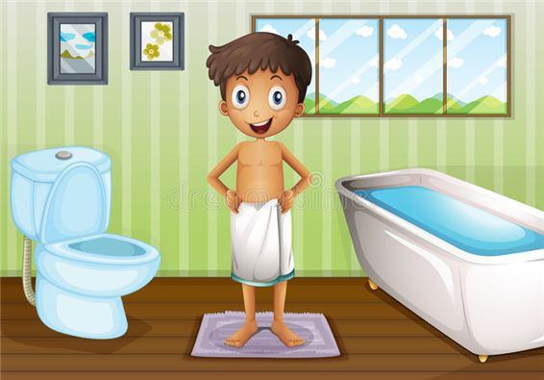 A: Where’s your brother? - B: He’s in the _ _ _ _ room.
Đáp án: bath
26. Ảnh: The apple is ________ the box.
A. under B. in front of C. beside D. behind
Đáp án: Chọn ý: D
27. My mother _ _ a teacher.
Đáp án: is
28. Mary is a ... at London Primary School.
A. boy B. toy C. student D. she
Đáp án: student
29. Nghe: Nhấn giữ Ctrl và bấm chuột để nghe: Doll is swimming in the _ _ _ .
Đáp án: sea
30. have?/ How many/ you/ do/ sisters/
Đáp án: How many sisters do you have?
31. Ảnh: 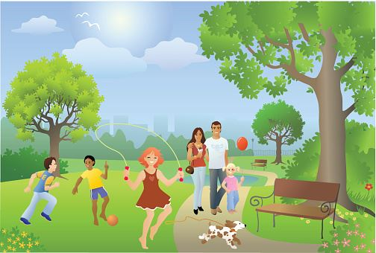 Choose the TRUE statement.
A. Two boys are playing baseball. B. The girl is dancing. C. The dog is eating. D. The couples are walking.
Đáp án: Chọn ý: D
32. … are they? – They’re my friends.
A. Who B. What C. Which D. Where
Đáp án: Who
33. book?/ it/ Is/ a/
Đáp án: Is it a book?
34. Wh_ _ _ are the maps? – They are on the wall.
Đáp án: ere
35. What is this? - ….
A. It’s a mobile phone. B. This is nice book. C. That is a big table. D. Its a ruler.
Đáp án: It’s a mobile phone.
36. These are my s_ _ ters.
Đáp án: is
37. Ảnh: She _ _ _ _ _ _ around the park.
Đáp án: cycles
38. Nghe: Nhấn giữ Ctrl và bấm chuột để nghe: The sky is _ _ _ _ .
Đáp án: blue
39. Do you like playing puz_ _ _ _ ?
Đáp án: zles
40. Nghe: Nhấn giữ Ctrl và bấm chuột để nghe: Her name ... Linda.
A. are B. is C. am D. it
Đáp án: is
41. Who is tall_ _ , Jack or Jim?
Đáp án: er
42. beautiful?/ Is/ your/ school garden/
Đáp án: Is your school garden beautiful?
43. Ảnh: 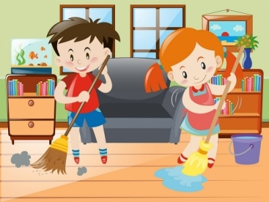 We help our mother with the _ _ _ _ _ _ _ _ _ .
Đáp án: housework
44. likes/ games./ playing/ computer/ Tim/
Đáp án: Tim likes playing computer games.
45. That is my s_ _ _ _ _ library.
Đáp án: chool
46. Ảnh: The mouse is _ _ _ ind the box.
Đáp án: beh
47. the/ mother/ is in/ My/ kitchen./
Đáp án: My mother is in the kitchen.
48. Are you free _ _ Monday evening?
Đáp án: on
49. I am sorry. I am late. - … in please!
A. Do B. Go C. Come D. Study
Đáp án: Come
50. Let’s p_ ay outside, children.
Đáp án: l
51. I don’t like the music room. It is so s_ _ _ l.
Đáp án: mal
52. a picture/ There/ the wall./ on/ is/
Đáp án: There is a picture on the wall.
53. What ... this? - This is a pen.
A. it B. iss C. is D. are
Đáp án: is
54. five/ members./ has/ family/ My/
Đáp án: My family has five members.
55. What’s y_ _ r name? – My name’s Tom.
Đáp án: ou
56. There is o_ e cat in that box.
Đáp án: n
57. is/ doll./ This/ a/
Đáp án: This is a doll.
58. many/ are/ desks/ How/ there in your classroom?/
Đáp án: How many desks are there in your classroom?
59. Nghe: Nhấn giữ Ctrl và bấm chuột để nghe: He eats his breakfast in the _ _ _ _ _ _ _ .
Đáp án: kitchen
60. for/ a song/ you./ to sing/ I like/
Đáp án: I like to sing a song for you.
61. Let’s listen _ _ some music.
Đáp án: to
62. Come/ and/ in/ please./ sit down,
Đáp án: Come in and sit down, please.
63. I have many _ _ _ _ : a cat, a dog, two birds and four goldfish.
Đáp án: pets
64. Music./ and/ I have/ Today/ Maths/
Đáp án: Today I have Maths and Music.
65. The opposite of IN FRONT OF is _ _ _ _ _ _ .
Đáp án: behind
66. cousin./ over there/ my/ is/ The girl/
Đáp án: The girl over there is my cousin.
67. is/ The/ weather/ good./ today/
Đáp án: The weather today is good.
68. Does Jim like ______ with paper planes?
A. play B. plays C. playing D. on playing
Đáp án: playing
69. Nghe: Nhấn giữ Ctrl và bấm chuột để nghe: My _ _ _ _ is large.
Đáp án: room
70. My sister is very bea_ tiful.
Đáp án: u
71. Jenny is my new f_ _ end.
Đáp án: ri
72. Nghe: Nhấn giữ Ctrl và bấm chuột để nghe: I’ve got two big _ _ _ _ .
Đáp án: cats
73. Ảnh: 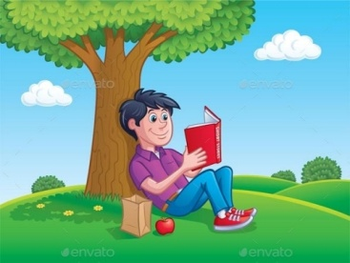 He’s sitting under a tree and _ _ _ _ ing a book.
Đáp án: read
74. This is Mary. ... is my friend.
A. I B. You C. She D. He
Đáp án: She
75. How … her grandmother?
A. are B. is C. am D. be
Đáp án: is
76. birthday/ Is/ today?/ your/
Đáp án: Is your birthday today?
77. ... your school bags, please.
A. Close B. Stand C. Sit D. See
Đáp án: Close
78. computer/ room./ our/ It’s/
Đáp án: It’s our computer room.
79. Which word has the letters ’e’ pronounced as the letter ’e’ in 'pen'?
A. kitchen B. chicken C. bookshelf D. new
Đáp án: bookshelf
80. … room is your computer room? – That big room over there.
A. Which B. What C. How D. When
Đáp án: Which
81. How are you today, John? – I’m ..., thanks.
A. nice B. nice’s C. fine D. fine’s
Đáp án: fine
82. Ảnh: Where are the maps? - They are on the _ _ _ _ .
Đáp án: wall
83. Ảnh: 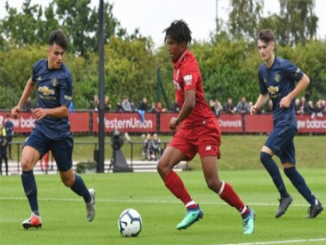 My brother can play _ _ _ _ _ _ _ _ .
Đáp án: football
84. A: Do you have a cat? - B: No, I _ _ _ ’t.
Đáp án: don
85. There ______ keys on the desk.
A. is B. isn’t C. aren’t D. be
Đáp án: aren’t
86. The picture is _ _ _ _ _ _ _ the window and the shelf.
Đáp án: between
87. It’s _______ in Hanoi today.
A. cloud B. funny C. sunny D. snow
Đáp án: sunny
88. Ảnh: My cat likes _ _ sh very much.
Đáp án: fi
89. Ảnh: 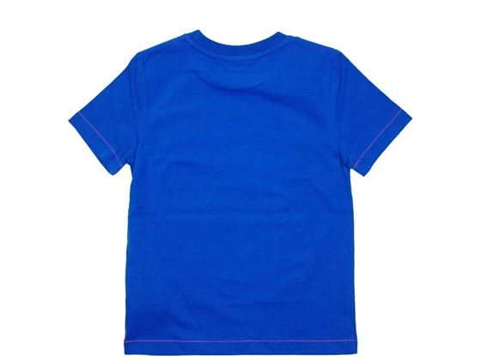 What is that? – It’s a white _ _ _ rt for Jimmy.
Đáp án: shi
90. Ha Noi is in n_ _ _ _ Viet Nam.
Đáp án: orth
91. She lives ... the sea.
A. in B. on C. near D. at
Đáp án: near
92. some/ milk?/ like/ Would/ you/
Đáp án: Would you like some milk?
93. tree/ There is/ in/ a big/ my garden./
Đáp án: There is a big tree in my garden.
94. old./ is/ school/ Their/
Đáp án: Their school is old.
95. Choose the odd one out.
A. bedroom B. bathroom C. kitchen D. garden
Đáp án: Chọn ý: D
96. These _____ old notebooks.
A. am B. is C. are D. have
Đáp án: are
97. This pen is _ _ _ blue. It’s green.
Đáp án: not
98. There are ... chairs in my living room.
A. one B. five C. a D. an
Đáp án: five
99. ... I go out?
A. May B. My C. Me D. Mai
Đáp án: May
100. A: What is … name? – B: My name is Tommy.
A. we B. you C. your D. they
Đáp án: your
101. carefully./ teacher/ to/ Listen/ the/
Đáp án: Listen to the teacher carefully.
102. Ảnh: 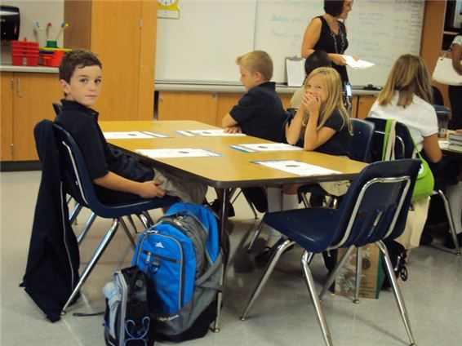 Henry, Mary and I sit … tables.
A. in B. at C. on D. by
Đáp án: at
103. _ _ o is that? – That’s Mary.
Đáp án: Wh
104. Let’s go through the … into the garden.
A. gate B. yard C. pond D. fence
Đáp án: gate
105. What is his date … birth?
A. on B. of C. at D. in
Đáp án: of
106. My home village has a lot of _ _ _ _ tains.
Đáp án: moun
107. from?/ Where/ are/ students/ the new/
Đáp án: Where are the new students from?
108. with Nhung./ I always/ go/ school/ to/
Đáp án: I always go to school with Nhung.
109. Look ... that map, David.
A. to B. in C. for D. at
Đáp án: Chọn ý: D
110. The ... is Peter.
A. boy B. girl C. toy D. he
Đáp án: boy
111. Ảnh: 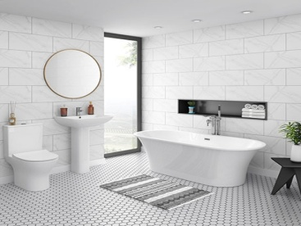 Your _ _ _ _ _ _ _ _ is so beautiful.
Đáp án: bathroom
112. a/ Let’s/ make/ paper lion.
Đáp án: Let’s make a paper lion.
113. some/ wants/ Peter/ food.
Đáp án: Peter wants some food.
114. Lang Son is far _ _ _ _ Quang Binh.
Đáp án: from
115. May I ... out?
A. ride B. go C. meet D. come
Đáp án: go
116. My sister can … a pony.
A. my B. ride C. ride’s D. I
Đáp án: ride
117. fun/ It's/ to be/ with Linda.
Đáp án: It's fun to be with Linda.
118. You don’t look well. ….
A. Are you ok? B. How old are you? C. What’s your name? D. What is that?
Đáp án: Are you ok?
119. Choose the incorrect word(s) in the following sentence: What do Linda do after school? – She cooks.
A. do B. do after C. She D. cooks
Đáp án: do
120. _ _ _ _ colour is your teddy bear?
Đáp án: What
121. What col_ _ r is this book? – It’s red.
Đáp án: ou
122. Nghe: Nhấn giữ Ctrl và bấm chuột để nghe: I can draw a ....
A. cat B. hat C. map D. bat
Đáp án: cat
123. Nghe: Nhấn giữ Ctrl và bấm chuột để nghe: Tom and Lee are playing ….
A. volleyball B. baseball C. football D. basketball
Đáp án: Chọn ý: D
124. Thes_ are my cats.
Đáp án: e
125. Thai Phien is a big _ _ _ _ ary school in Hai Phong.
Đáp án: prim
126. Nghe: Nhấn giữ Ctrl và bấm chuột để nghe: Listen and choose the correct phrases you hear:
A. It’s a B. I am C. I can D. I do
Đáp án: I can
127. What _ _ you do during English lessons?
Đáp án: do
128. on/ Her birthday/ the nineteenth/ of March./ is/
Đáp án: Her birthday is on the nineteenth of March.
129. Odd one out:
A. cloud B. rainy C. sunny D. windy
Đáp án: cloud
130. Nghe: Nhấn giữ Ctrl và bấm chuột để nghe: Julie has got a _ _ _ _ _ dog.
Đáp án: white
131. Nghe: Nhấn giữ Ctrl và bấm chuột để nghe: My _ _ _ is blue.
Đáp án: bed
132. Australia?/ from/ she/ Is/
Đáp án: Is she from Australia?
133. Ảnh: 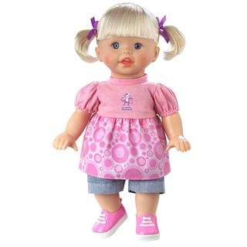 Do you have toys? – Yes, I have a _ _ _ _ .
Đáp án: doll
134. Nghe: Nhấn giữ Ctrl và bấm chuột để nghe: ... are you?
A. who B. where C. how D. what
Đáp án: how
135. Ảnh: 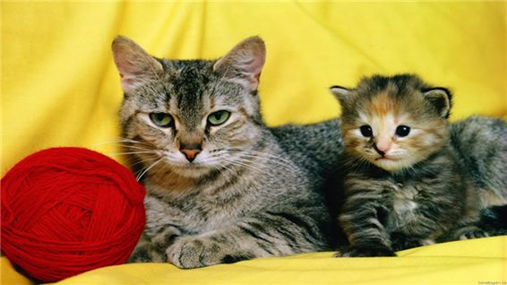 This is a mo_ _ _ _ cat. That is its baby.
Đáp án: ther
136. Ảnh: 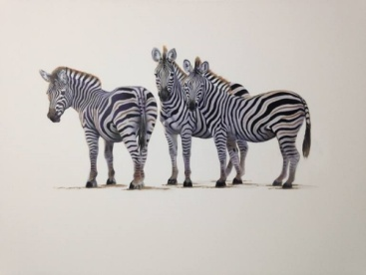 _______ zebras are there in the picture? – There are three zebras.
A. How B. What C. Where D. How many
Đáp án: Chọn ý: D
137. Boy: M_ _ I play football here? - Man: No, you can’t.
Đáp án: ay
138. It’s time … lunch, Peter.
A. to B. in C. on D. for
Đáp án: Chọn ý: D
139. This birthday cake is … you.
A. for B. on C. of D. to
Đáp án: for
140. My pen/ desk./ is/ that/ on/
Đáp án: My pen is on that desk.
141. How m_ _ y crayons are there? – There are 3 crayons.
Đáp án: an
142. A bird can f_ y.
Đáp án: l
143. Nga is singing a nice s_ _ _ .
Đáp án: ong
144. That girl is from Australia. _ _ _ is my new friend.
Đáp án: She
145. How o_ _ is she? – She’s six.
Đáp án: ld
146. What is her favourite subject? – She likes … .
A. January B. Sunday C. Korea D. PE
Đáp án: Chọn ý: D
147. My pet is a ... .
A. bird B. ship C. robot D. doll
Đáp án: bird
148. Are you ______? – No. I’m full.
A. thirsty B. hungry C. hot D. tired
Đáp án: hungry
149. school’s/ name?/ is/ What/ your/
Đáp án: What is your school’s name?
150. Nghe: Nhấn giữ Ctrl và bấm chuột để nghe: Can you see it _ _ _ _ ?
Đáp án: here
151. Ảnh: 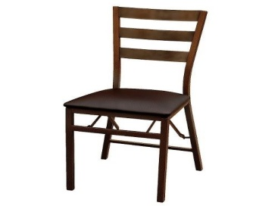 My chair is _ _ _ _ _ .
Đáp án: brown
152. in/ like/ walking/ the rain./ I don’t/
Đáp án: I don’t like walking in the rain.
153. ________ subjects do you like the most?
A. What B. When C. Why D. Who
Đáp án: What
154. My father can dr_ _ e a car.
Đáp án: iv
155. The opposite of \"tall\" is \"_ _ _ _ _ \".
Đáp án: short
156. Please c_ _ _ t from 1 to 10 in English.
Đáp án: oun
157. _ _ _ _ _ is the poster? – It’s on the wall.
Đáp án: where
158. Ảnh: 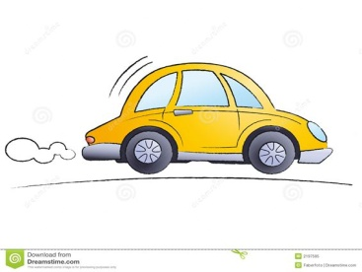 My father can drive a _ _ _ .
Đáp án: car
159. Your garden is _ _ beautiful.
Đáp án: so
160. Nghe: Nhấn giữ Ctrl và bấm chuột để nghe: Mary’s gloves are _ _ _ .
Đáp án: red
161. Nam: Your school and your library is big. - Nga: Yes, t_ _ _ are very big and nice.
Đáp án: hey
162. What … is it? – It’s eleven o’clock.
A. name B. colour C. time D. day
Đáp án: time
163. Taylor is from England. She … me every month.
A. calls B. write C. read D. speak
Đáp án: calls
164. School./ is/ school/ My/ Nguyen Gia Thieu
Đáp án: My school is Nguyen Gia Thieu School.
165. Ảnh: 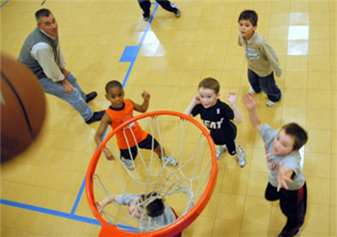 My brother likes playing _ _ _ _ _ _ ball in the yard.
Đáp án: basket
166. Tom is nine … old.
A. year B. year’s C. yeah D. years
Đáp án: Chọn ý: D
167. ... that a pink pencil? – No, it isn’t.
A. Are B. Is C. Who D. When
Đáp án: Is
168. is/ my parents./ my birthday present/ from/ The cat/
Đáp án: The cat is my birthday present from my parents.
169. like/ Does/ cat/ vegetables?/ your/
Đáp án: Does your cat like vegetables?
170. my toys/ very/ much./ I/ love/
Đáp án: I love my toys very much.
171. Ảnh: 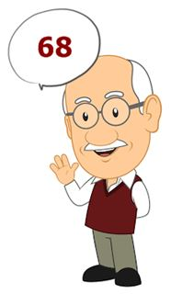 My grandpa is … years old.
A. eighty-six B. sixty-eight C. fifty-eight D. fifty-six
Đáp án: sixty-eight
172. a bowl./ is swimming/ A small/ fish/ in
Đáp án: A small fish is swimming in a bowl.
173. bedroom/ is/ large./ very/ Mary’s/
Đáp án: Mary’s bedroom is very large.
174. new/ classroom/ your/ big?/ Is/
Đáp án: Is your new classroom big?
175. Nghe: Nhấn giữ Ctrl và bấm chuột để nghe: We’re playing football in the _ _ _ _ _ _ _ _ _ _ .
Đáp án: playground
176. swim./ dance/ I can’t/ I can/ but/
Đáp án: I can’t dance but I can swim.
177. are/ the wall./ on/ There/ two clocks/
Đáp án: There are two clocks on the wall.
178. ... is that? - It’s a blue ball.
A. How B. When C. What D. Where
Đáp án: What
179. on/ your name/ the paper./ Write/
Đáp án: Write your name on the paper.
180. school/ is/ festival/ very fun./ My/
Đáp án: My school festival is very fun.
181. Ảnh: What do you do during Music lessons? – I learn to _ _ _ _ .
Đáp án: sing
182. in a/ your sister/ work/ factory?/ Does/
Đáp án: Does your sister work in a factory?
183. I like to s_ ng.
Đáp án: i
184. Ảnh: 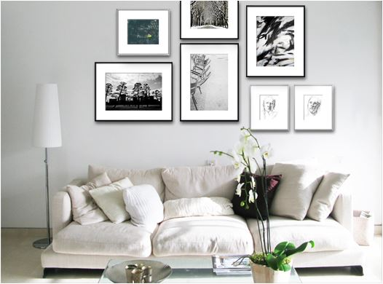 There are seven _ _ _ tures on the wall.
Đáp án: pic
185. My little brother often … his kite when he’s not busy.
A. does B. plays C. goes D. flies
Đáp án: Chọn ý: D
186. These … members of my family.
A. is B. are C. am D. be
Đáp án: are
187. Let’s play h_ _ e-and-seek.
Đáp án: id
188. the/ name of/ What is/ school?/ your
Đáp án: What is the name of your school?
189. Choose the odd one out:
A. is B. are C. am D. name
Đáp án: Chọn ý: D
190. Odd one out:
A. mine B. hers C. your D. Tom’s
Đáp án: your
191. beautiful/ “Twinkle Twinkle Little Star”/ a/ is/ song./
Đáp án: “Twinkle Twinkle Little Star” is a beautiful song.
192. Quan is _ _ _ _ _ his homework in his room.
Đáp án: doing
193. doesn't/ weather./ like/ hot/ He/
Đáp án: He doesn't like hot weather.
194. Nghe: Nhấn giữ Ctrl và bấm chuột để nghe: Our school bus is _ _ _ _ .
Đáp án: blue
195. T_ _ s is a board.
Đáp án: hi
196. Mary is … . She wants some water.
A. hungry B. thirsty C. sick D. pretty
Đáp án: thirsty
197. Van: What’s that tall building there? - Lan: It’s _ _ new school
Đáp án: my
198. Nghe: Nhấn giữ Ctrl và bấm chuột để nghe: The girl’s T-shirt is in the _ _ _ .
Đáp án: car
199. My/ red./ favourite/ colour/ is
Đáp án: My favourite colour is red.
200. Let’s/ book./ read/ the/
Đáp án: Let’s read the book.

KEY IOE K3 2023 - 2024 SỐ 37
1. It/ is/ not/ my/ bedroom./
Đáp án: It is not my bedroom.
2. See you tomo_ _ ow.
Đáp án: rr
3. I’m/ in?/ sorry/ . May I come/ I’m late/
Đáp án: I’m sorry I’m late . May I come in?
4. What ... it? – It’s my book.
A. is B. hi C. bye D. hello
Đáp án: is
5. It is _ desk.
Đáp án: a
6. How many _______ does Quang have?
A. book B. balls C. frog D. schoolbag
Đáp án: balls
7. These … members of my family.
A. is B. are C. am D. be
Đáp án: are
8. Choose the odd one out:
A. skipping B. table tennis C. badminton D. tennis
Đáp án: skipping
9. his friends/ Kevin and/ doing?/ What/ are/
Đáp án: What are Kevin and his friends doing?
10. and/ in the living room./ There are/ one table/ five chairs/
Đáp án: There are five chairs and one table in the living room.
11. What do you have _ _ _ lunch?
Đáp án: for
12. the school/ all/ yard./ in/ We’re/
Đáp án: We’re all in the school yard.
13. Nghe: Nhấn giữ Ctrl và bấm chuột để nghe: Look! This is Mum’s _ _ _ _ .
Đáp án: book
14. Nghe: Nhấn giữ Ctrl và bấm chuột để nghe: Who's _ _ _ _ _ _ _ _ , you or your brother?
Đáp án: stronger
15. Do you know _ _ _ _ my name is?
Đáp án: what
16. What ab_ _ t an apple? – Yes, please.
Đáp án: ou
17. Choose the odd one out:
A. tidy B. nice C. clean D. dirty
Đáp án: Chọn ý: D
18. Rai_ e your hand, please.
Đáp án: s
19. Don’t/ in/ room./ that/ come/
Đáp án: Don’t come in that room.
20. “Twinkle Twinkle Little Star”/ a/ beautiful/ is/ song./
Đáp án: “Twinkle Twinkle Little Star” is a beautiful song.
21. Do you have _ _ _ cats?
Đáp án: any
22. The computer room is new, but the art room is _ _ _ .
Đáp án: old
23. is/ young./ He/ tall/ and
Đáp án: He is tall and young.
24. A: How old … you? – B: I am nine years old.
A. am B. are C. is D. it
Đáp án: are
25. May I c_ _ _ in and study?
Đáp án: ome
26. Nghe: Nhấn giữ Ctrl và bấm chuột để nghe: _ _ _
Đáp án: any
27. Nghe: Nhấn giữ Ctrl và bấm chuột để nghe: What colour are her eyes? - _ _ _ _ .
Đáp án: Blue
28. Ảnh: Don’t play outside, son. It’s ….
A. raining B. snowing C. windy D. stormy
Đáp án: raining
29. Ảnh: I like _ _ _ _ _ _ _ _ in the pool in summer.
Đáp án: swimming
30. Ảnh: 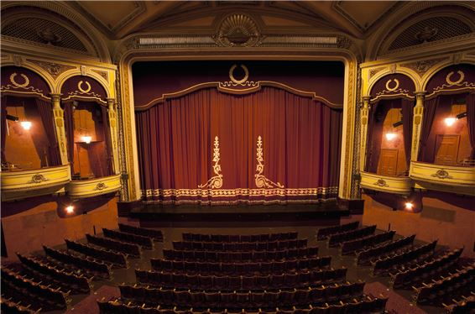 A: Where are you going now? - B: I’m going to the ….
A. cinema B. theatre C. temple D. hospital
Đáp án: theatre
31. eight/ are/ There/ in my dining room./ chairs and a table
Đáp án: There are eight chairs and a table in my dining room.
32. How many wardrobes ________? - There is one.
A. is there B. there is C. there are D. are there
Đáp án: Chọn ý: D
33. _ _ _ _ _ pencils are these? – They’re my pencils.
Đáp án: Whose
34. W_ _ t do you do during Music lessons?
Đáp án: ha
35. What colour is that pencil? – It’s ... .
A. book B. crayon C. ruler D. blue
Đáp án: Chọn ý: D
36. Do you have _ _ _ brothers?
Đáp án: any
37. a TV/ my/ living room./ There is/ in/
Đáp án: There is a TV in my living room.
38. Choose the letter(s) to make a correct word: hor__
A. si B. ce C. se D. ci
Đáp án: se
39. Our English teacher is a very frien_ _ _ person.
Đáp án: dly
40. Ảnh: I’m a student and my friends are _ _ _ _ _ _ _ _ too.
Đáp án: students
41. that/ the box?/ What/ is/ in
Đáp án: What is that in the box?
42. Miss Carol is my Engli_ _ teacher.
Đáp án: sh
43. Nghe: Nhấn giữ Ctrl và bấm chuột để nghe: I ... orange.
A. love B. like C. hate D. eat
Đáp án: like
44. do/ you/ puzzles?/ Can/
Đáp án: Can you do puzzles?
45. Choose the odd one out:
A. thirty B. seventy C. eighty D. twelve
Đáp án: Chọn ý: D
46. That is Lan. _ _ _ is my friend.
Đáp án: she
47. Hai Phong is in _ _ _ _ _ Vietnam.
Đáp án: north
48. Ảnh: 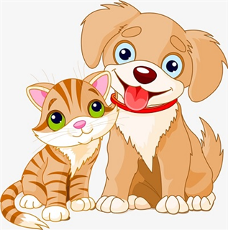 What pets do you have?
A. I have two cats. B. I have a cat and a dog. C. I have two dogs. D. I have two cats or two dogs.
Đáp án: I have a cat and a dog.
49. Are Philip and Tony watching TV?
A. Yes, he is. B. Yes, they are. C. No, he and he are not. D. No, they not.
Đáp án: Yes, they are.
50. cannot/ out/ go/ now./ You/
Đáp án: You cannot go out now.
51. Nghe: Nhấn giữ Ctrl và bấm chuột để nghe: _ _ _ _
Đáp án: like
52. Your/ is/ bedroom/ nice./ very
Đáp án: Your bedroom is very nice.
53. Nghe: Nhấn giữ Ctrl và bấm chuột để nghe: Which is NOT mentioned in the recording?
A. garden B. bathroom C. bedroom D. kitchen
Đáp án: bedroom
54. Nghe: Nhấn giữ Ctrl và bấm chuột để nghe: This is my _ _ _ _ _ .
Đáp án: house
55. Tommy is playing in the play_ _ _ _ _ _ with his friends.
Đáp án: ground
56. your name?/ spell/ do/ I/ How/
Đáp án: How do I spell your name?
57. Let’s listen _ _ some music.
Đáp án: to
58. ... is that? - It’s a blue ball.
A. How B. When C. What D. Where
Đáp án: What
59. How often ... you play badminton?
A. do B. am C. is D. are
Đáp án: do
60. This is my father. ... name is Lam.
A. Her B. His C. This D. My
Đáp án: His
61. Nghe: Nhấn giữ Ctrl và bấm chuột để nghe: The ... is yellow.
A. bag B. bat C. bus D. book
Đáp án: bus
62. This/ doll/ for/ is/ you./
Đáp án: This doll is for you.
63. Let’s play h_ _ e-and-seek.
Đáp án: id
64. Lo_ _ . There are Linh’s new school things.
Đáp án: ok
65. Ma_ I go out, please?
Đáp án: y
66. W_ _ t is that? – It’s a teddy bear.
Đáp án: ha
67. Thank you very much. – You’re w_ _ _ _ me.
Đáp án: elco
68. That is an ora_ _ e pencil.
Đáp án: ng
69. Santa Claus/ coffee?/ drinking/ like/ Does/
Đáp án: Does Santa Claus like drinking coffee?
70. Ảnh: 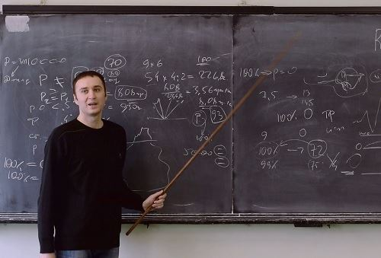 Look at the _ _ _ _ _ , please.
Đáp án: board
71. A: … do you go shopping? – B: Once a week.
A. How many B. What C. How often D. When
Đáp án: How often
72. Ảnh: 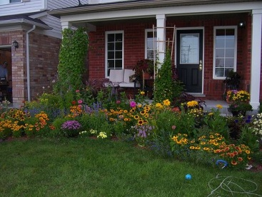 There is a flower garden … the house.
A. behind B. next to C. in front of D. under
Đáp án: in front of
73. the dining/ room?/ in/ Rosy/ Is/
Đáp án: Is Rosy in the dining room?
74. on/ the pond./ is swimming/ Look!/ The duck/
Đáp án: Look! The duck is swimming on the pond.
75. is/ Her/ years old./ sister/ twelve
Đáp án: Her sister is twelve years old.
76. _______ are they? - They are in the library.
A. Who B. What C. When D. Where
Đáp án: Chọn ý: D
77. good/ It’s/ Hoa./ to/ see you,
Đáp án: It’s good to see you, Hoa.
78. Do you like ______ a kite?
A. playing B. riding C. flying D. doing
Đáp án: flying
79. Ảnh: _ _ _ cing is their hobby.
Đáp án: Dan
80. Nghe: Nhấn giữ Ctrl và bấm chuột để nghe: Which is the most _ _ _ , video games, reading or studying?
Đáp án: fun
81. with me./ often/ My sister/ goes/ to school
Đáp án: My sister often goes to school with me.
82. How/ old/ eldest brother?/ is/ your
Đáp án: How old is your eldest brother?
83. Hi, _ _ _ are you Sean? – I’m fine, thanks.
Đáp án: how
84. That is my new friend. H_ _ name is Alice.
Đáp án: er
85. Ảnh: 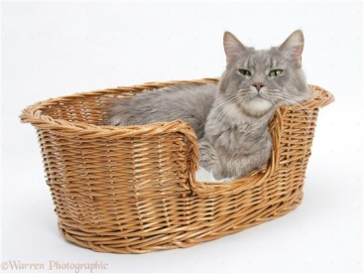 There is a cat … the basket.
A. on B. at C. in D. of
Đáp án: in
86. Ảnh: 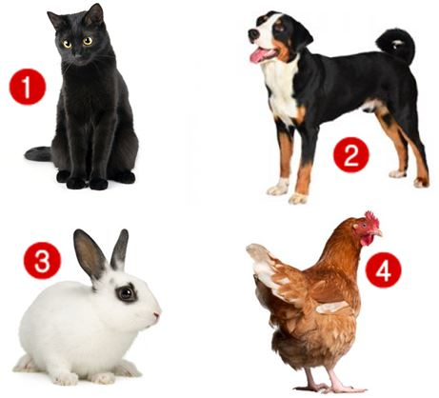 Linda has a rabbit. It’s very cute.
A. Picture 1 B. Picture 2 C. Picture 3 D. Picture 4
Đáp án: Picture 3
87. How are your friends? … are all ok.
A. We B. They C. He D. You
Đáp án: They
88. your/ Open/ book,/ please.
Đáp án: Open your book, please.
89. Nghe: Nhấn giữ Ctrl và bấm chuột để nghe: Wooly runs _ _ _ _ .
Đáp án: away
90. The opposite of OUT is _ _ .
Đáp án: in
91. Nghe: Nhấn giữ Ctrl và bấm chuột để nghe: He carries a baby in his _ _ _ _ .
Đáp án: arms
92. I … music. It is wonderful.
A. see B. like C. look D. go
Đáp án: like
93. Nghe: Nhấn giữ Ctrl và bấm chuột để nghe: Choose the correct sentence.
A. This is my father. B. This is my mother. C. This is my brother. D. This is my sister.
Đáp án: This is my father.
94. Choose the odd one out.
A. brother B. sister C. mother D. teacher
Đáp án: Chọn ý: D
95. The white cat/ that/ is/ desk./ on/
Đáp án: The white cat is on that desk.
96. This ruler is gr_ en.
Đáp án: e
97. Ảnh: My mother is _ _ _ _ _ _ _ for dinner.
Đáp án: cooking
98. Nghe: Nhấn giữ Ctrl và bấm chuột để nghe: How _ _ you go to school?
Đáp án: do
99. On _ _ _ wall, there is a clock.
Đáp án: the
100. you/ ice cream?/ Would/ an/ like/
Đáp án: Would you like an ice cream?
101. Ảnh: This big _ _ _ is very funny.
Đáp án: dog
102. girl/ in the/ that/ corner?/ Who’s/
Đáp án: Who’s that girl in the corner?
103. The books are _ _ the shelves.
Đáp án: on
104. Sunrise is a _ _ _ _ ary school in Hai Phong.
Đáp án: prim
105. This is ______ room. It’s her room.
A. my B. his C. she D. not my
Đáp án: Chọn ý: D
106. This _ _ Linda.
Đáp án: is
107. is/ The poster/ the shelf./ above/
Đáp án: The poster is above the shelf.
108. I/ much./ English/ like/ very
Đáp án: I like English very much.
109. My school/ new./ all/ are/ things/
Đáp án: My school things are all new.
110. short/ but/ is/ big./ She/
Đáp án: She is short but big.
111. and/ Let's/ go to/ watch the new video./ the library/
Đáp án: Let's go to the library and watch the new video.
112. John/ soon./ will/ better/ get/
Đáp án: John will get better soon.
113. How … her grandmother?
A. are B. is C. am D. be
Đáp án: is
114. apples/ the kitchen?/ there in/ are/ How many/
Đáp án: How many apples are there in the kitchen?
115. How m_ _ _ apples do you want?
Đáp án: any
116. Ảnh: 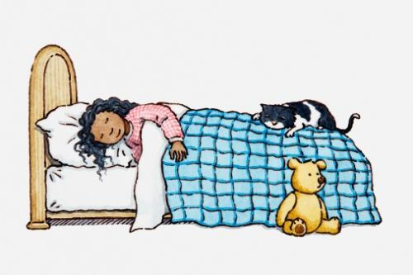 Choose the correct sentence.
A. The girl is reading on the bed. B. The cat is sleeping on the bed. C. The teddy is lying next to the cat. D. The girl is holding the cat.
Đáp án: The cat is sleeping on the bed.
117. … subjects do you have on Friday?
A. What B. How C. Who D. Where
Đáp án: What
118. Ảnh: 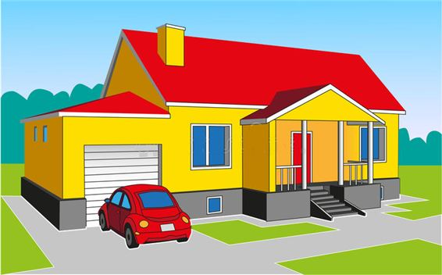 Don’t forget put the car in the ….
A. kitchen B. garden C. bedroom D. garage
Đáp án: Chọn ý: D
119. _ hat’s your name?
Đáp án: W
120. Choose the odd one out:
A. ride B. go C. bike D. run
Đáp án: bike
121. Look! My doll is in fr_ _ _ of Lily’s.
Đáp án: ont
122. Let’s ma_ e a circle.
Đáp án: k
123. Nghe: Nhấn giữ Ctrl và bấm chuột để nghe: _ _ _ _ _ _ _ _
Đáp án: goldfish
124. How do you feel? – I’m very ______?
A. hungry B. short C. pretty D. tall
Đáp án: hungry
125. Stand _ _ , please.
Đáp án: up
126. Is/ Tony?/ box/ green,/ your/
Đáp án: Is your box green, Tony?
127. These are four pencil box_ _ .
Đáp án: es
128. are/ kites/ beautiful./ Those/ very
Đáp án: Those kites are very beautiful.
129. How is the weather ... London today?
A. at B. on C. in D. to
Đáp án: in
130. The o_ _ computer is very slow.
Đáp án: ld
131. Have ... nice day, Tim. – Thank you.
A. an B. the C. a D. are
Đáp án: a
132. What ... is this pencil? – It’s green.
A. ruler B. name C. colour D. colour’s
Đáp án: colour
133. Ảnh: 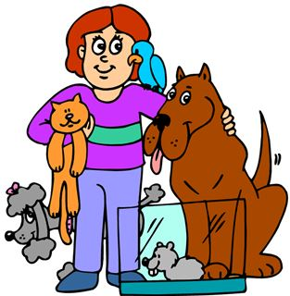 She has five ….
A. toys B. pets C. dogs D. cats
Đáp án: pets
134. This is my aunt. …. twenty-six years old.
A. They are B. He is C. You are D. She is
Đáp án: Chọn ý: D
135. The picture is _ _ the wall.
Đáp án: on
136. This is my ... . His name is Tommy.
A. sister B. brother C. mother D. ruler
Đáp án: brother
137. milk?/ like/ some/ you/ Would/
Đáp án: Would you like some milk?
138. Loan?/ How/ your name,/ do you/ spell/
Đáp án: How do you spell your name, Loan?
139. is/ my new/ friend,/ Hoang./ This/
Đáp án: This is my new friend, Hoang.
140. Ảnh: 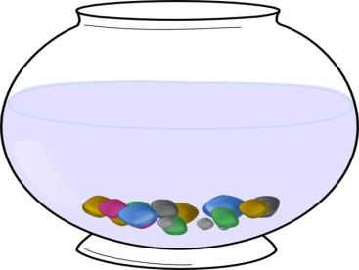 There are lots of colourful pebbles in the fish t_ _ _ .
Đáp án: ank
141. My sister is … doctor at Bach Mai hospital.
A. a B. an C. the D. in
Đáp án: a
142. here,/ Your/ are/ on the desk./ school things/
Đáp án: Your school things are here, on the desk.
143. Ảnh: _______ zebras are there in the picture? – There are three zebras.
A. How B. What C. Where D. How many
Đáp án: Chọn ý: D
144. My father/ in/ works/ a local/ hospital./
Đáp án: My father works in a local hospital.
145. December./ His/ in/ is not/ birthday/
Đáp án: His birthday is not in December.
146. Nghe: Nhấn giữ Ctrl và bấm chuột để nghe: Listen and tick the correct word you hear:
A. Goodbye B. Hello C. Hi D. Bye
Đáp án: Hello
147. A: Is he Tony? – B: No, … .
A. he is B. he isn’t C. he not is D. not he is
Đáp án: he isn’t
148. ______ backpacks does Linh have? – She has one.
A. What B. Which C. How D. How many
Đáp án: Chọn ý: D
149. I/ open/ May/ the/ windows?/
Đáp án: May I open the windows?
150. Ảnh: I have three cups. They are blue, red and ye_ _ _ _ .
Đáp án: llow
151. Odd one out:
A. your B. me C. us D. him
Đáp án: your
152. Teacher: Nam, go to the b_ _ _ _ and write your sentence. - Nam: Yes, Miss.
Đáp án: oard
153. Hi, my name’s Sean. - ... .
A. See you tomorrow B. Good night C. Hi, I’m Peter D. Goodbye
Đáp án: Hi, I’m Peter
154. Look at t_ e cat.
Đáp án: h
155. Hello. I _ _ Mai.
Đáp án: am
156. Ảnh: 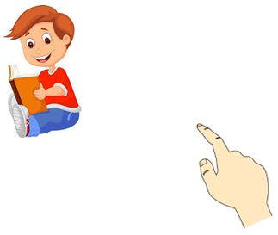 A: Who’s th_ _ ? - B: It’s my brother.
Đáp án: at
157. How ______ is she? – She’s nine.
A. new B. small C. big D. old
Đáp án: Chọn ý: D
158. Nghe: Nhấn giữ Ctrl và bấm chuột để nghe: You are reading a _ _ _ _ _ now.
Đáp án: comic
159. My aunt is a housew_ _ _ .
Đáp án: ife
160. Is this your grandfather? – Yes, he _ _ .
Đáp án: is
161. Are those his school bags? - ________
A. Yes, it is. B. Yes, they are. C. Yes, are they. D. No, they are.
Đáp án: Yes, they are.
162. Nghe: Nhấn giữ Ctrl và bấm chuột để nghe: How _ _ _ are you?
Đáp án: old
163. Ảnh: 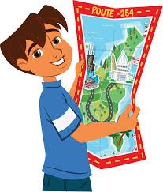 The boy is reading a _ _ _ .
Đáp án: map
164. Ảnh: 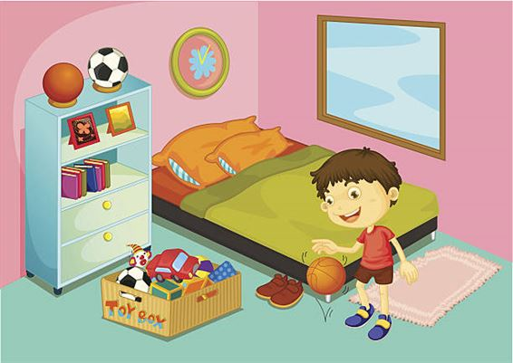 A: Where is Adam? - B: He’s in the ….
A. bathroom B. bedroom C. living room D. dining room
Đáp án: bedroom
165. erasers/ have?/ do you/ many/ How/
Đáp án: How many erasers do you have?
166. How is the weather in Hanoi today? – It’s … .
A. rainy B. rain C. sun D. wind
Đáp án: rainy
167. My school is next _ _ a park.
Đáp án: to
168. Ảnh: 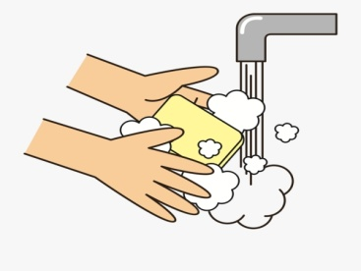 You should _______ after you play with your pets.
A. wash your leg B. wash your hair C. wash your face D. wash your hands
Đáp án: Chọn ý: D
169. her/ house./ in/ There are/ six rooms/
Đáp án: There are six rooms in her house.
170. What is that? – It is ... orange.
A. a B. an C. am D. are
Đáp án: an
171. There is a flower va_ e on the table.
Đáp án: s
172. boys/ in/ the music room?/ are there/ How many/
Đáp án: How many boys are there in the music room?
173. My bedroom is small. It’s not _ _ _ .
Đáp án: big
174. Choose the odd one out:
A. bathroom B. music room C. art room D. classroom
Đáp án: bathroom
175. The children are reading Engl_ _ _ in their room.
Đáp án: ish
176. Nghe: Nhấn giữ Ctrl và bấm chuột để nghe: It’s ... today.
A. rainy B. foggy C. sunny D. cloudy
Đáp án: Chọn ý: D
177. A: Are they your friends? – B: No, … aren’t.
A. we B. you C. your D. they
Đáp án: Chọn ý: D
178. How m_ _ _ dogs do you have?
Đáp án: any
179. Who’s she? – She’s my ______.
A. aunt B. brother C. uncle D. grandfather
Đáp án: aunt
180. My brother likes to dri_ _ milk very much.
Đáp án: nk
181. Odd one out:
A. Vietnam B. English C. America D. China
Đáp án: English
182. tidy./ but/ Her/ room is/ small/
Đáp án: Her room is small but tidy.
183. How many … are there on the table?
A. flower B. flowers C. ruler D. eraser
Đáp án: flowers
184. The/ is far/ sweet shop/ flat./ from our
Đáp án: The sweet shop is far from our flat.
185. Thank you. – You’re ... .
A. welcome’s B. welcomes C. welcome D. welcome’re
Đáp án: welcome
186. This is ... chair.
A. he B. she C. it D. my
Đáp án: Chọn ý: D
187. It is ... blue desk.
A. a B. am C. are D. is
Đáp án: a
188. Ảnh: 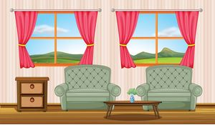 There are two armchairs and two _ _ _ _ _ _ s in the room.
Đáp án: window
189. Ảnh: 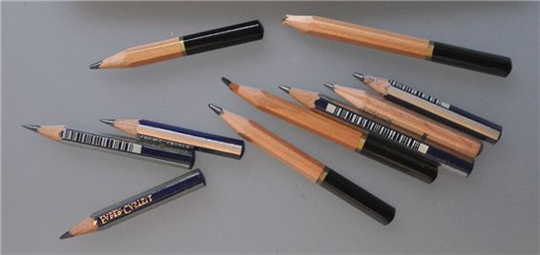 These pencils aren’t very long. Are they _ _ d?
Đáp án: ol
190. Nghe: Nhấn giữ Ctrl và bấm chuột để nghe: The house is on _ _ _ _ .
Đáp án: fire
191. I go _ _ school every morning.
Đáp án: to
192. the/ fourth/ of July./ Today/ is/
Đáp án: Today is the fourth of July.
193. Vinh: What is that? - Binh: It’s _ big red ball.
Đáp án: a
194. Is that his name? – Yes, _ _ is.
Đáp án: it
195. ... is she? – She’s Margaret.
A. Who’s B. What C. What’s D. Who
Đáp án: Chọn ý: D
196. Kevin _ _ _ _ _ football with his classmates in the yard behind his school.
Đáp án: plays
197. too./ very/ am/ I/ well
Đáp án: I am very well too.
198. This is a de_ k.
Đáp án: s
199. Close _ _ at door, please.
Đáp án: th
200. Ảnh: 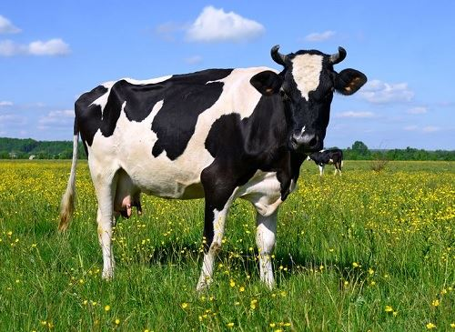 That’s a _ _ _ . It’s big.
Đáp án: cow

KEY IOE K3 2023 - 2024 SỐ 38
1. W_ _ h your hands carefully, Kate.
Đáp án: as
2. A: How many chairs are there? - B: Let me co_ _ _ them. One, two, three, …. There are five.
Đáp án: unt
3. Ảnh: 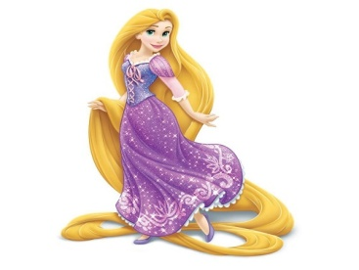 Rapunzel ______ long straight blonde hair.
A. has B. have C. haves D. is has
Đáp án: has
4. How/ do/ many/ you have?/ skirts/
Đáp án: How many skirts do you have?
5. long/ My cat/ tail./ has/ a/
Đáp án: My cat has a long tail.
6. Odd one out:
A. Vietnam B. English C. America D. China
Đáp án: English
7. What are they? – They are ….
A. red B. small C. stars D. big
Đáp án: stars
8. I _ _ Chi. I am in class 3A.
Đáp án: am
9. What grade … your twin brothers in?
A. am B. is C. are D. do
Đáp án: are
10. Mary and Peter can … Vietnamese.
A. speaks B. speak C. to speak D. a speak
Đáp án: speak
11. classroom?/ students/ How many/ are there/ in your
Đáp án: How many students are there in your classroom?
12. Rosie is having a shower in the ….
A. kitchen B. bathroom C. bedroom D. playground
Đáp án: bathroom
13. _ _ _ _ colour is your teddy bear?
Đáp án: What
14. What … is it? – It’s eleven o’clock.
A. name B. colour C. time D. day
Đáp án: time
15. playing/ and Sarah/ Linda/ board games./ are/
Đáp án: Linda and Sarah are playing board games.
16. Dr_ _ a big brown dog, please.
Đáp án: aw
17. Ảnh: 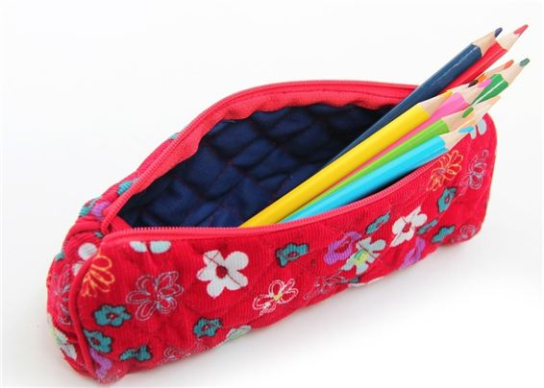 What is that? – It is a ….
A. pencil case B. ruler C. pen D. book
Đáp án: pencil case
18. They are ... the beach this summer.
A. going B. going to C. visiting D. go
Đáp án: going to
19. summer./ sunny/ in/ always/ It is/
Đáp án: It is always sunny in summer.
20. Nam: Is that girl new? - Lien: I don’t kn_ _ . Ask Hoa.
Đáp án: ow
21. Ảnh: Cinderella is ______ with the prince at the party.
A. dance B. dances C. dancing D. danceing
Đáp án: dancing
22. Sing wit_ me.
Đáp án: h
23. My sister _ _ _ a doll.
Đáp án: has
24. Goodbye, David. See y_ u later.
Đáp án: o
25. I like to s_ ng.
Đáp án: i
26. Odd one out:
A. your B. me C. us D. him
Đáp án: your
27. Come and _ _ at with your friends.
Đáp án: ch
28. My brother likes to dri_ _ milk very much.
Đáp án: nk
29. Informatics./ My/ subject/ is/ favourite/
Đáp án: My favourite subject is Informatics.
30. Nghe: Nhấn giữ Ctrl và bấm chuột để nghe: When it’s sunny, the sky is _ _ _ _ .
Đáp án: blue
31. A: What does your aunt …? - B: She is very sporty.
A. like B. look like C. likes D. like looking
Đáp án: look like
32. Who is he? - ... .
A. He my friend B. She my friend C. He is Simon. He is my good friend D. She’s Mary
Đáp án: He is Simon. He is my good friend
33. This is an ora_ ge book.
Đáp án: n
34. W_ _ is she, Peter? – She’s is Alice.
Đáp án: ho
35. _ _ _ _ _ _ close your notebook.
Đáp án: please
36. I a_ nine years old. How old are you?
Đáp án: m
37. Nghe: Nhấn giữ Ctrl và bấm chuột để nghe: _ _ _ _
Đáp án: does
38. Ảnh: 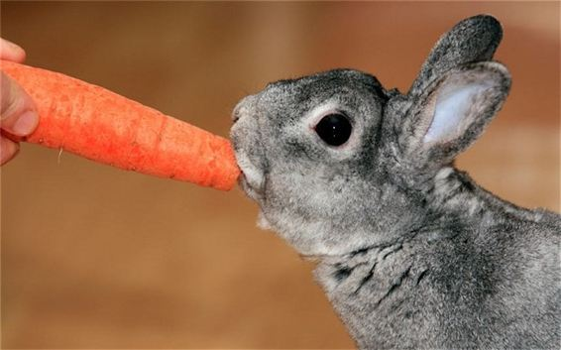 Rabbits like car_ _ _ _ very much.
Đáp án: rots
39. This/ our/ classroom./ is/
Đáp án: This is our classroom.
40. … and listen to your teacher, please.
A. Opening your book B. Sit still C. Reading aloud D. Not speaking
Đáp án: Sit still
41. is/ This/ green./ shirt/
Đáp án: This shirt is green.
42. Sally is standing n_ _ _ to David.
Đáp án: ext
43. my neighborhood./ in/ any theatres/ aren’t/ There/
Đáp án: There aren’t any theatres in my neighborhood.
44. Ảnh: 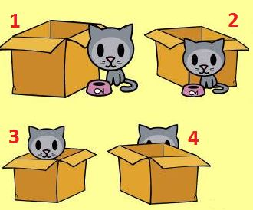 A: Where is the cat? - B: It’s behind the box.
A. Picture 1 B. Picture 2 C. Picture 3 D. Picture 4
Đáp án: Chọn ý: D
45. old./ very/ grandparents/ My/ are/
Đáp án: My grandparents are very old.
46. Those are my blue balloo_ _ .
Đáp án: ns
47. Ảnh: Do you like playing …?
A. football B. paper boats C. chess D. hide-and-seek
Đáp án: paper boats
48. Hamburger/ my/ is/ favourite/ food./
Đáp án: Hamburger is my favourite food.
49. Nghe: Nhấn giữ Ctrl và bấm chuột để nghe: Mai likes ... flowers.
A. beautiful B. wonderful C. colorful D. blue
Đáp án: beautiful
50. Listen ... the teacher.
A. to B. me C. you D. he
Đáp án: to
51. Listen/ to/ carefully./ teacher/ the/
Đáp án: Listen to the teacher carefully.
52. Is this your grandfather? – Yes, he _ _ .
Đáp án: is
53. sixty-seven/ is/ old./ years/ My grandfather/
Đáp án: My grandfather is sixty-seven years old.
54. ... are you? – Fine, thanks.
A. Who B. Is C. Are D. How
Đáp án: Chọn ý: D
55. He/ ten/ old./ years/ is/
Đáp án: He is ten years old.
56. Choose the odd one out:
A. thirty B. seventy C. eighty D. twelve
Đáp án: Chọn ý: D
57. Let’s/ a song/ with/ me./ sing/
Đáp án: Let’s sing a song with me.
58. ... your teeth, John.
A. Read B. Listen C. Stand D. Brush
Đáp án: Chọn ý: D
59. Choose the word which has the same sound with the word ’’wait’’.
A. talk B. kite C. late D. cold
Đáp án: late
60. This is a r_ ler.
Đáp án: u
61. Look!/ on/ the pond./ is swimming/ The duck/
Đáp án: Look! The duck is swimming on the pond.
62. Nghe: Nhấn giữ Ctrl và bấm chuột để nghe: It has _ _ _ _ _ _ _ _ of many animals.
Đáp án: pictures
63. My school is next _ _ a park.
Đáp án: to
64. A: How old is she? - B: She is ten … old.
A. yeasr B. yares C. yreas D. years
Đáp án: Chọn ý: D
65. ... this a desk? – Yes, it is.
A. Is B. Are C. How D. Whatname’s
Đáp án: Is
66. There is o_ e kitchen in his house.
Đáp án: n
67. It's/ with Linda./ to be/ fun/
Đáp án: It's fun to be with Linda.
68. How are you? - ... .
A. I’m Binh B. She’s my sister C. I’m fine, thank you D. Goodbye
Đáp án: I’m fine, thank you
69. Nghe: Nhấn giữ Ctrl và bấm chuột để nghe: The boy’s name is _ _ _ _ .
Đáp án: Alex
70. 1st/ Day./ Children’s/ is/ June/
Đáp án: June 1st is Children’s Day.
71. Can the cat _ _ _ _ _ a tree? – Yes, it can.
Đáp án: climb
72. Who is/ now?/ with Chi/ right/ talking/
Đáp án: Who is talking with Chi right now?
73. A: Is your house _ _ _ _ the cinema? - B: No, it’s very far.
Đáp án: near
74. Choose the odd one out:
A. book B. pen C. ruler D. Mary
Đáp án: Chọn ý: D
75. Ảnh: Let’s go to the _ _ _ _ _ _ _ with me. It has a lot of interesting books.
Đáp án: library
76. A: Are David and James singing? - B: Yes, ….
A. they aren’t B. they are C. he is D. he isn’t
Đáp án: they are
77. Take ou_ your books, children.
Đáp án: t
78. Ảnh: 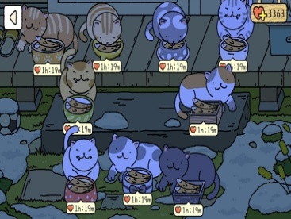 How many cats are there in the yard? - There are _ _ _ _ cats. They are eating fish.
Đáp án: nine
79. Nghe: Nhấn giữ Ctrl và bấm chuột để nghe: The girl’s T-shirt is in the _ _ _ .
Đáp án: car
80. May we _ _ to school together?
Đáp án: go
81. Choose the odd one out.
A. brother B. sister C. mother D. teacher
Đáp án: Chọn ý: D
82. Is the girl o_ _ _ there your classmate, Rosie?
Đáp án: ver
83. his friends./ in the playground/ John/ is playing/ with
Đáp án: John is playing in the playground with his friends.
84. Some _ _ _ chers are in the hall.
Đáp án: tea
85. yellow./ is/ dog/ The/
Đáp án: The dog is yellow.
86. Nghe: Nhấn giữ Ctrl và bấm chuột để nghe: This is my _ _ _ _ _ .
Đáp án: house
87. favourite/ subject?/ What/ is/ your/
Đáp án: What is your favourite subject?
88. I’m fine, than_ _ .
Đáp án: ks
89. Nine and three is _ _ _ _ _ _ .
Đáp án: twelve
90. Nghe: Nhấn giữ Ctrl và bấm chuột để nghe: _ _ _ _ _ _
Đáp án: garden
91. These _____ old notebooks.
A. am B. is C. are D. have
Đáp án: are
92. Nghe: Nhấn giữ Ctrl và bấm chuột để nghe: Which _ _ _ _ _ is Sam in?
Đáp án: class
93. This is my d_ ll.
Đáp án: o
94. has/ doll./ a/ Alice/ pink
Đáp án: Alice has a pink doll.
95. Nghe: Nhấn giữ Ctrl và bấm chuột để nghe: Put the computer in the ….
A. wardrobe B. bookcase C. table D. cupboard
Đáp án: Chọn ý: D
96. I/ would like/ a/ of milk./ glass
Đáp án: I would like a glass of milk.
97. Pl_ _ _ _ give me that old black pen.
Đáp án: ease
98. two/ robots./ I/ have/
Đáp án: I have two robots.
99. My new _ _ _ _ _ _ is Adam.
Đáp án: friend
100. ... you want to ride a bike with me?
A. Can B. Do C. Are D. Am
Đáp án: Do
101. green/ This/ is a/ book.
Đáp án: This is a green book.
102. … full name is Mary Jane.
A. Her B. She’s C. She is D. She has
Đáp án: Her
103. Ảnh: 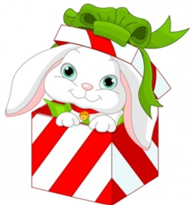 A: Where is the _ _ _ bit? - B: It’s in the box.
Đáp án: rab
104. Ảnh: We help our mother with the _ _ _ _ _ _ _ _ _ .
Đáp án: housework
105. Choose the odd one out.
A. ship B. truck C. plane D. duck
Đáp án: Chọn ý: D
106. How/ father?/ your/ is/ old/
Đáp án: How old is your father?
107. again?/ meet/ Can/ I/ you
Đáp án: Can I meet you again?
108. Odd one out:
A. he B. she C. they D. me
Đáp án: Chọn ý: D
109. A: How old … you? – B: I am nine years old.
A. am B. are C. is D. it
Đáp án: are
110. Nghe: Nhấn giữ Ctrl và bấm chuột để nghe: Choose the TRUE statement.
A. There are two armchairs, a sofa and a window in the living room. B. There are two sofas, an armchair and a window in the living room. C. There are two windows, a sofa and an armchair in the living room. D. There are two armchairs, two sofas and a window in the living room.
Đáp án: There are two armchairs, a sofa and a window in the living room.
111. Would you like some …? – No, thanks. I hate sweets.
A. coffee B. lemonade C. chocolate D. chicken
Đáp án: chocolate
112. Ảnh: 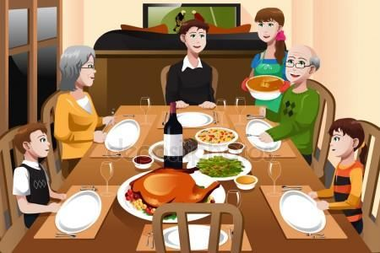 My family is having dinner in the _ _ _ _ ng room.
Đáp án: dini
113. Nghe: Nhấn giữ Ctrl và bấm chuột để nghe: Can I borrow your _ _ _ _ for a minute? – Sure.
Đáp án: book
114. The books are _ _ the shelves.
Đáp án: on
115. Ảnh: A: Who’s th_ _ ? - B: It’s my brother.
Đáp án: at
116. Come ov_ r here.
Đáp án: e
117. Tom can swim … dance.
A. but B. and C. for D. to
Đáp án: and
118. Nghe: Nhấn giữ Ctrl và bấm chuột để nghe: There are six _ _ _ _ _ _ _ on top.
Đáp án: candles
119. table tennis?/ Do/ you/ playing/ like/
Đáp án: Do you like playing table tennis?
120. you/ “Tom and Jerry”?/ Do/ like/
Đáp án: Do you like “Tom and Jerry”?
121. Wh_ _ do you have Maths? – I have it on Monday.
Đáp án: en
122. What’s the matter _ _ _ _ your eyes?
Đáp án: with
123. rulers/ on the/ table./ are/ The/
Đáp án: The rulers are on the table.
124. five chairs/ There are/ one table/ and/ in the living room./
Đáp án: There are five chairs and one table in the living room.
125. How many balls are _ _ _ _ _ in the basket?
Đáp án: there
126. like/ doesn’t/ cats./ My/ brother/
Đáp án: My brother doesn’t like cats.
127. This is a de_ k.
Đáp án: s
128. Nghe: Nhấn giữ Ctrl và bấm chuột để nghe: Which is the _ _ _ _ _ _ _ , a giraffe, an elephant or a monkey? – Of course, a giraffe.
Đáp án: tallest
129. Ảnh: This is a mo_ _ _ _ cat. That is its baby.
Đáp án: ther
130. The school is far _ _ _ _ the cinema.
Đáp án: from
131. Tho_ _ books are mine. These books are yours.
Đáp án: se
132. Do/ your/ you/ house?/ like/
Đáp án: Do you like your house?
133. That is an ora_ _ e pencil.
Đáp án: ng
134. What a_ _ _ t an apple? – Yes, please.
Đáp án: bou
135. colouring/ now./ Alex is/ his/ pictures
Đáp án: Alex is colouring his pictures now.
136. hide-and-seek?/ Do you/ play/ like/ to/
Đáp án: Do you like to play hide-and-seek?
137. Ảnh: 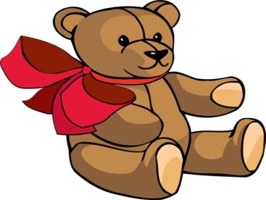 The teddy bear has a r_ _ tie.
Đáp án: ed
138. Are … four people in your family, Jack?
A. it B. they C. we D. there
Đáp án: Chọn ý: D
139. to/ Do you/ music?/ like/ listening/
Đáp án: Do you like listening to music?
140. very/ are/ These/ beautiful./ flowers/
Đáp án: These flowers are very beautiful.
141. Nghe: Nhấn giữ Ctrl và bấm chuột để nghe: _ _ _ _ _ _
Đáp án: rabbit
142. Can/ you/ do/ puzzles?
Đáp án: Can you do puzzles?
143. This is ... doll.
A. she B. me C. my D. hi
Đáp án: my
144. Ảnh: 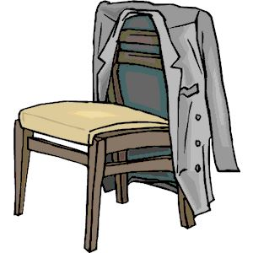 The c_ _ _ is on the chair.
Đáp án: oat
145. This is _ _ _ way we go to school.
Đáp án: the
146. I have m_ _ y toys.
Đáp án: an
147. Is … bedroom large? – Yes, it is.
A. Jimmy B. Minh’s C. my friend D. house
Đáp án: Minh’s
148. May I go o_ _ for a while?
Đáp án: ut
149. I’m fine, thanks. ... you?
A. End B. And C. On D. Ten
Đáp án: And
150. That is a gr_ _ n doll.
Đáp án: ee
151. Is your school big? - ..., it is.
A. No B. Not C. Yes D. No, it isn’t
Đáp án: Yes
152. Choose the incorrect word(s) in the following sentence: My friend, Quynh, doesn’t has any comic books.
A. My B. has C. any D. books
Đáp án: has
153. ... you like chicken?
A. Do B. Does C. Are D. Is
Đáp án: Do
154. Is this your sister? – Yes, _______.
A. it is B. it’s not C. he is D.
Đáp án: it is
155. Choose the odd one out:
A. paint B. draw C. write D. walk
Đáp án: Chọn ý: D
156. Is/ it/ today?/ stormy/
Đáp án: Is it stormy today?
157. Do you like playing puz_ _ _ _ ?
Đáp án: zles
158. Choose the odd one out:
A. on B. where C. under D. behind
Đáp án: where
159. a pen/ to/ Write/ friend./ a postcard/
Đáp án: Write a postcard to a pen friend.
160. after work?/ does/ What/ do/ Khai/
Đáp án: What does Khai do after work?
161. Choose the odd one out:
A. ruler B. crayon C. sing D. eraser
Đáp án: sing
162. Ha: _ _ _ _ colour is that pen? - Mai: It is a blue.
Đáp án: What
163. He _______ to the zoo in the morning.
A. go B. ride C. has D. walks
Đáp án: Chọn ý: D
164. ... is that? - It’s a pen.
A. How B. When C. What D. Where
Đáp án: What
165. Nghe: Nhấn giữ Ctrl và bấm chuột để nghe: The chairs are _ _ _ _ the table.
Đáp án: near
166. friends/ Her/ from/ France./ are/
Đáp án: Her friends are from France.
167. Ảnh: 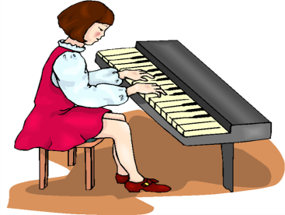 She is playing the pi_ _ _ .
Đáp án: ano
168. Taylor is from England. She … me every month.
A. calls B. write C. read D. speak
Đáp án: calls
169. Tom re_ _ _ books in the library in the afternoon.
Đáp án: ads
170. Ảnh: 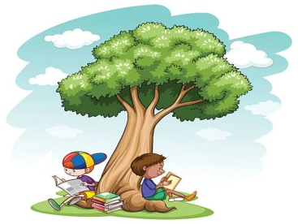 Two boys are reading their books _ _ _ _ _ the tree.
Đáp án: under
171. Nghe: Nhấn giữ Ctrl và bấm chuột để nghe: _ _ _ _
Đáp án: cage
172. There are ... chairs in my living room.
A. one B. five C. a D. an
Đáp án: five
173. Nghe: Nhấn giữ Ctrl và bấm chuột để nghe: I’ve got two big _ _ _ _ .
Đáp án: cats
174. Nghe: Nhấn giữ Ctrl và bấm chuột để nghe: Look at the _ _ _ _ in the tree.
Đáp án: ball
175. draw/ I/ can/ a/ picture./
Đáp án: I can draw a picture.
176. Hello. My ... is Tom.
A. name B. is C. am D. are
Đáp án: name
177. after/ dinner./ play/ Let’s/ volleyball/
Đáp án: Let’s play volleyball after dinner.
178. Choose the odd one out:
A. how B. hello C. hi D. good morning
Đáp án: how
179. This is my father. _ _ _ name is John.
Đáp án: his
180. has/ My/ toys./ brother/ many
Đáp án: My brother has many toys.
181. Odd one out:
A. they B. ten C. we D. you
Đáp án: ten
182. My pictures _ _ _ on the wall.
Đáp án: are
183. tidy./ but/ small/ room is/ Her/
Đáp án: Her room is small but tidy.
184. Ảnh: 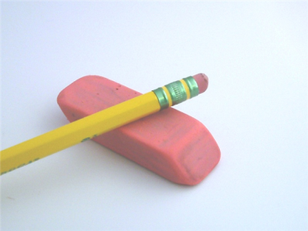 It is an old rub_ _ _ .
Đáp án: ber
185. Simon is my friend, t_ _ .
Đáp án: oo
186. I go … school early in the morning.
A. in B. at C. to D. from
Đáp án: to
187. The opposite of \"on\" is \"_ _ _ _ _ \".
Đáp án: under
188. What’s/ the/ Mary?/ time/ now,
Đáp án: What’s the time now, Mary?
189. Which word has the letter ‘e’ pronounced as the letter ‘e’ in \"yes\"?
A. new B. orange C. come D. bed
Đáp án: Chọn ý: D
190. Is it the music room? - …. It’s the computer room.
A. Yes, it is. B. No, it isn’t. C. No, it doesn’t. D. Yes, it does.
Đáp án: No, it isn’t.
191. What toys/ not/ he/ like?
A. What toys doesn’t he like? B. What toys don’t he likes? C. What toys isn’t he like? D. What toys aren’t he likes?
Đáp án: What toys doesn’t he like?
192. These are my classmates. … in class 3D.
A. He is B. She is C. We are D. You are
Đáp án: We are
193. What col_ _ r is this book? – It’s red.
Đáp án: ou
194. …. - Yes, my book is new.
A. Is your shoe new? B. Are these books new? C. Is that new? D. Are those new?
Đáp án: Is that new?
195. Choose the odd one out.
A. chicken B. beef C. pork D. food
Đáp án: Chọn ý: D
196. Dolly/ now?/ Is/ fine/
Đáp án: Is Dolly fine now?
197. The/ game/ very/ exciting./ is/
Đáp án: The game is very exciting.
198. Nghe: Nhấn giữ Ctrl và bấm chuột để nghe: Her English teacher is Mr. _ _ _ _ .
Đáp án: tony
199. Ảnh: Oh, this teddy _ _ _ _ is cute. Can you buy it for me, Mum?
Đáp án: bear
200. I k_ _ _ little English and French.
Đáp án: now

KEY IOE K3 2023 - 2024 SỐ 39
1. Ảnh: My family is having dinner in the _ _ _ _ ng room.
Đáp án: dini
2. Sit _ _ _ _ , please.
Đáp án: down
3. What co_ our is this? – It’s pink.
Đáp án: l
4. but/ It’s sunny/ in Ha Noi/ it’s rainy/ in Ho Chi Minh City./
Đáp án: It’s sunny in Ha Noi but it’s rainy in Ho Chi Minh City.
5. are/ Where/ pictures?/ the/
Đáp án: Where are the pictures?
6. Nghe: Nhấn giữ Ctrl và bấm chuột để nghe: Let’s play ....
A. basketball B. football C. volleyball D. ball
Đáp án: football
7. See you later. _ _ e.
Đáp án: By
8. ... is that? - It’s a pen.
A. How B. When C. What D. Where
Đáp án: What
9. Would you like … cup of coffee, Mary?
A. a B. an C. some D. any
Đáp án: a
10. Do you/ listening/ like/ to/ music?/
Đáp án: Do you like listening to music?
11. Nghe: Nhấn giữ Ctrl và bấm chuột để nghe: This is my _ _ _ _ _ .
Đáp án: house
12. Nghe: Nhấn giữ Ctrl và bấm chuột để nghe: The girl has got ….
A. one brother and two sisters B. two brothers and two sisters C. two brothers and one sister D. one brother and one sister
Đáp án: Chọn ý: D
13. Lang Son is far _ _ _ _ Quang Binh.
Đáp án: from
14. 1 to/ from/ 100?/ Can you/ count/
Đáp án: Can you count from 1 to 100?
15. Is your school big? - ..., it is.
A. No B. Not C. Yes D. No, it isn’t
Đáp án: Yes
16. There are ten des...s in my classroom.
A. t B. k C. q D. p
Đáp án: k
17. bathroom/ Is/ new?/ your/
Đáp án: Is your bathroom new?
18. Let’s ma_ e a circle.
Đáp án: k
19. rice?/ I have/ more/ some/ Can/
Đáp án: Can I have some more rice?
20. Nghe: Nhấn giữ Ctrl và bấm chuột để nghe: What colour is her hair? - _ _ _ _ _ .
Đáp án: Brown
21. Let’s make a li_ e, children.
Đáp án: n
22. has a/ lot/ He/ at school./ of friends
Đáp án: He has a lot of friends at school.
23. near Hue/ from Ca Mau./ but/ very far/ Da Nang is/
Đáp án: Da Nang is near Hue but very far from Ca Mau.
24. Is it a r_ _ nd box? – No, it is a square box.
Đáp án: ou
25. You are happy and I am … too.
A. tired B. big C. new D. happy
Đáp án: Chọn ý: D
26. a/ I/ glass/ of milk./ would like/
Đáp án: I would like a glass of milk.
27. H_ w are you? - Fine, thanks.
Đáp án: o
28. ______ fences in your house?
A. There is B. There are C. Is there D. Are there
Đáp án: Chọn ý: D
29. Nghe: Nhấn giữ Ctrl và bấm chuột để nghe: Which is NOT mentioned in the recording?
A. ball B. doll C. puzzle D. teddy
Đáp án: doll
30. _ _ _ _ Mr. Black have a new car?
Đáp án: Does
31. Se_ you tomorrow, children.
Đáp án: e
32. Hai Phong is in _ _ _ _ _ Vietnam.
Đáp án: north
33. desk./ is/ that/ on/ My pen/
Đáp án: My pen is on that desk.
34. Nghe: Nhấn giữ Ctrl và bấm chuột để nghe: Anna is drawing a _ _ _ _ _ .
Đáp án: plane
35. Tim: How are you? – Jane: I … fine, thank you. And you?
A. are B. am C. is D. in
Đáp án: am
36. ... is this? – It’s an apple.
A. How B. Who C. What D. Is
Đáp án: What
37. This is Mary. She ... my friend.
A. is B. are C. the D. a
Đáp án: is
38. Ảnh: 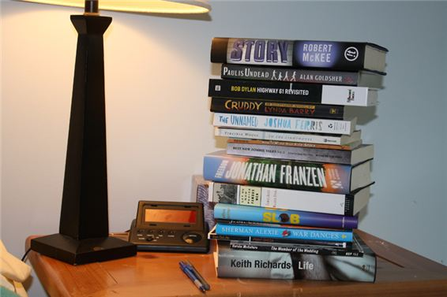 Where are my books? – They are ….
A. on the table B. on the chair C. under the table D. on the floor
Đáp án: on the table
39. Ảnh: Don’t forget put the car in the ….
A. kitchen B. garden C. bedroom D. garage
Đáp án: Chọn ý: D
40. _ _ _ many books on your bookshelf? – There are 10 books.
Đáp án: how
41. That is my s_ _ _ _ _ library.
Đáp án: chool
42. Thomas … to music now.
A. is listening B. listen C. listens D. to listen
Đáp án: is listening
43. Ảnh: 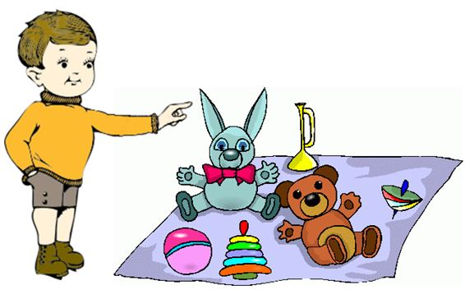 A: Are _ _ _ _ _ your toys? - B: Yes, they are.
Đáp án: these
44. A: What are you doing, Daniel? - B: …
A. He is listening to the radio. B. Daniel is listening to the radio. C. I’m listening to the radio. D. You are listening to the radio.
Đáp án: I’m listening to the radio.
45. the table?/ is/ What/ on/ that/
Đáp án: What is that on the table?
46. is/ My/ teacher./ a/ mother/
Đáp án: My mother is a teacher.
47. Nghe: Nhấn giữ Ctrl và bấm chuột để nghe: Nina is a _ _ _ .
Đáp án: cat
48. a/ your house/ have/ Does/ garage?/
Đáp án: Does your house have a garage?
49. Susan/ like/ wearing/ shirts?/ Does/
Đáp án: Does Susan like wearing shirts?
50. Nghe: Nhấn giữ Ctrl và bấm chuột để nghe: Let’s all go _ _ _ _ now.
Đáp án: home
51. Is this a bag? - ... .
A. Yes, it is B. Yes, isn’t C. No, it is D. Not, it isn’t
Đáp án: Yes, it is
52. your little sister/ Which/ is/ in?/ grade/
Đáp án: Which grade is your little sister in?
53. My family lives in _ house in Thai Binh Province.
Đáp án: a
54. Does she like f_ _ _ ts? - B: Yes, she does. She likes eating apples very much.
Đáp án: rui
55. Kien: Is this your dog? - Thanh: Yes, _ _ is.
Đáp án: it
56. M_ y I go out?
Đáp án: a
57. doing?/ is/ he/ What/
Đáp án: What is he doing?
58. This is Tom. _ _ is my new friend.
Đáp án: he
59. everyday./ watching/ TV/ likes/ She/
Đáp án: She likes watching TV everyday.
60. May I ... out?
A. ride B. go C. meet D. come
Đáp án: go
61. … full name is Catherine Jones.
A. Her B. Hers C. She D. She’s
Đáp án: Her
62. Excuse me. - …?
A. No B. Not C. Yes D. Thanks
Đáp án: Yes
63. ... is its name?
A. What B. How C. When D. Where
Đáp án: What
64. The lamp is _ _ _ ween the sofa and the armchair.
Đáp án: bet
65. Nghe: Nhấn giữ Ctrl và bấm chuột để nghe: _ _ _ _ _
Đáp án: white
66. the fish/ above/ is/ The picture/ tank./
Đáp án: The picture is above the fish tank.
67. is/ Who/ boy?/ that/ little
Đáp án: Who is that little boy?
68. Ảnh: The teddy bear has a r_ _ tie.
Đáp án: ed
69. My sch_ _ l is big.
Đáp án: oo
70. a song/ with/ sing/ Let’s/ me./
Đáp án: Let’s sing a song with me.
71. above/ is/ picture/ The/ the clock./
Đáp án: The picture is above the clock.
72. picture./ The poster/ is/ under/ the
Đáp án: The poster is under the picture.
73. This is my father. ... name is Lam.
A. Her B. His C. This D. My
Đáp án: His
74. Nghe: Nhấn giữ Ctrl và bấm chuột để nghe: How _ _ you go to school?
Đáp án: do
75. Tom re_ _ _ books in the library in the afternoon.
Đáp án: ads
76. in/ a dining/ room/ my house./ There is/
Đáp án: There is a dining room in my house.
77. our/ music/ That/ room./ is/
Đáp án: That is our music room.
78. Our children aren’t watching a cartoon. _ _ _ _ are doing their homework.
Đáp án: They
79. This/ book./ a brown/ is/
Đáp án: This is a brown book.
80. This is my friend James. … is a nice boy.
A. He B. She C. They D. It
Đáp án: He
81. school’s/ is/ What/ name?/ your/
Đáp án: What is your school’s name?
82. Is this a glass of water? - ..., it is.
A. No B. Not C. Yes D. No, it is
Đáp án: Yes
83. _ _ _ _ _ pencils are these? – They’re my pencils.
Đáp án: Whose
84. The book/ is/ between/ the pencil and/ the lamp./
Đáp án: The book is between the pencil and the lamp.
85. …. - It’s in my bag.
A. What is that? B. How are you? C. Where is my book? D. Who is he?
Đáp án: Where is my book?
86. book./ is a/ This/ green/
Đáp án: This is a green book.
87. _ _ at’s her name? – She is Mary.
Đáp án: Wh
88. What is your ...? – I’m Peter.
A. name B. name’s C. meet D. friend
Đáp án: name
89. Ảnh: 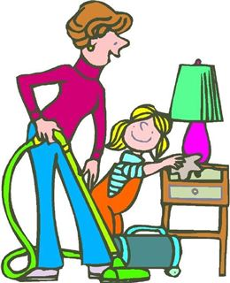 My mother and I are _ _ _ _ ning our house.
Đáp án: clea
90. Ảnh: What pets do you have?
A. I have two cats. B. I have a cat and a dog. C. I have two dogs. D. I have two cats or two dogs.
Đáp án: I have a cat and a dog.
91. He _ _ _ swim but he can’t dance.
Đáp án: can
92. May I speak to you now? - ….
A. No, you may not. B. Yes, you may. C. No, I am not. D. Sure. You can.
Đáp án: Chọn ý: D
93. the wall./ on/ Your/ pictures/ are/
Đáp án: Your pictures are on the wall.
94. B_ _ . See you later.
Đáp án: ye
95. Ảnh: 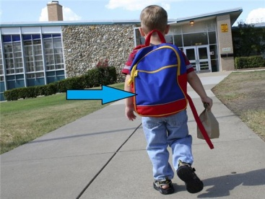 What is this? - It’s my school _ _ g.
Đáp án: ba
96. _ _ _ _ is your name?
Đáp án: What
97. … your brother swim?- Yes, he can.
A. Will B. Does C. Is D. Can
Đáp án: Chọn ý: D
98. What grade are you ________, James?
A. at B. on C. of D. in
Đáp án: Chọn ý: D
99. I can … a kite.
A. this B. fly C. the D. a
Đáp án: fly
100. has/ beautiful/ Daisy/ a/ hat./
Đáp án: Daisy has a beautiful hat.
101. … are they? – They’re my friends.
A. Who B. What C. Which D. Where
Đáp án: Who
102. That’s Peter. ... is my friend.
A. I B. You C. She D. He
Đáp án: Chọn ý: D
103. Nghe: Nhấn giữ Ctrl và bấm chuột để nghe: Jenny is _ _ _ _ ing with her friends.
Đáp án: talk
104. My school/ things/ all/ are/ new./
Đáp án: My school things are all new.
105. When is your birth day, Tommy? – Well, Taylor, it’s … December 5th.
A. in B. like C. on D. at
Đáp án: on
106. A: Do you … fun at school? – B: Yes, I do.
A. are B. play C. have D. go
Đáp án: have
107. Nghe: Nhấn giữ Ctrl và bấm chuột để nghe: There aren’t any _ _ _ _ here.
Đáp án: boys
108. _ s your school small? – Yes, it is small.
Đáp án: I
109. this/ Can/ eat/ mooncake?/ I/
Đáp án: Can I eat this mooncake?
110. in/ Is/ a bathroom/ your house?/ there/
Đáp án: Is there a bathroom in your house?
111. Bella likes playing _ _ _ guitar.
Đáp án: the
112. Choose the odd one out:
A. he B. she C. its D. they
Đáp án: its
113. Viet Nam./ Long An/ in/ is/ south
Đáp án: Long An is in south Viet Nam.
114. a/ is/ teacher./ good/ Mr. Manh/
Đáp án: Mr. Manh is a good teacher.
115. Nghe: Nhấn giữ Ctrl và bấm chuột để nghe: The phone is … in the dining room.
A. on the chair B. on the table C. under the chair D. under the table
Đáp án: on the table
116. How ... you today? – I’m fine, thanks.
A. am B. is C. are D. fine
Đáp án: are
117. weather/ nice/ It’s/ today.
Đáp án: It’s nice weather today.
118. Nghe: Nhấn giữ Ctrl và bấm chuột để nghe: Sue is painting her ….
A. doll B. bus C. truck D. ball
Đáp án: doll
119. What’s y_ ur name?
Đáp án: o
120. This is m_ cat.
Đáp án: y
121. Do you like the new girl? - ….
A. Yes, he is very friendly. B. Yes, I do. She is very funny. C. Yes, he is nice D. No, I like.
Đáp án: Yes, I do. She is very funny.
122. The computer room is new, but the art room is _ _ _ .
Đáp án: old
123. Goodbye. See you aga_ _ .
Đáp án: in
124. Choose the odd one out:
A. eraser B. notebook C. crayon D. England
Đáp án: Chọn ý: D
125. three times/ He/ English/ a week./ has/
Đáp án: He has English three times a week.
126. There are many fish _ _ the pond.
Đáp án: in
127. Her favourite _ _ _ _ _ _ _ is Art.
Đáp án: subject
128. Happy/ birthday/ you,/ to/ Jimmy./
Đáp án: Happy birthday to you, Jimmy.
129. Ảnh: 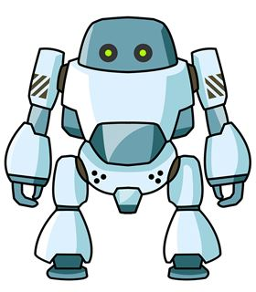 There is a _ _ _ ot.
Đáp án: rob
130. Hoa: May I come back home? - Teacher: _ _ , you can’t.
Đáp án: No
131. Good morning, Peter. - ... .
A. Good morning, Jean B. Good night, Jean C. My name’s Jean D. Jean, this is my pen
Đáp án: Good morning, Jean
132. Ảnh: 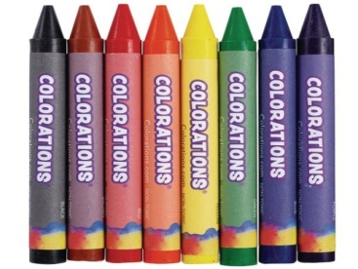 How many crayons _______ you have? – I have 8.
A. do B. does C. are D. are there
Đáp án: do
133. Ảnh: A: Where are you going now? - B: I’m going to the ….
A. cinema B. theatre C. temple D. hospital
Đáp án: theatre
134. favourite/ of your/ song?/ the name/ What is/
Đáp án: What is the name of your favourite song?
135. A: What’s the w_ _ _ _ er like today? - B: It’s sunny.
Đáp án: eath
136. Nghe: Nhấn giữ Ctrl và bấm chuột để nghe: Listen and choose the best response.
A. Yes, it does. B. Yes, they are. C. No, it isn’t. D. No, they don’t.
Đáp án: No, it isn’t.
137. Nghe: Nhấn giữ Ctrl và bấm chuột để nghe: Mrs Boot opens the _ _ _ _ .
Đáp án: door
138. John is a st_ _ _ nt at Oxford Primary School.
Đáp án: ude
139. Look that woman! _ _ _ ’s my teacher.
Đáp án: She
140. Choose the odd one out:
A. bird B. desk C. cat D. dog
Đáp án: desk
141. Ảnh: A: Where’s your brother? - B: He’s in the _ _ _ _ room.
Đáp án: bath
142. fun/ to be/ with Linda./ It's/
Đáp án: It's fun to be with Linda.
143. on/ The white cat/ is/ that/ desk./
Đáp án: The white cat is on that desk.
144. Ảnh: Give me a b_ _ _ _ _ of milk, please.
Đáp án: ottle
145. too./ meet/ you,/ to/ Nice/
Đáp án: Nice to meet you, too.
146. Hoa: What are these? - Nam: They are my sc_ _ _ _ things for this new year.
Đáp án: hool
147. … subjects do you have on Friday?
A. What B. How C. Who D. Where
Đáp án: What
148. GA__EN
A. AR B. RD C. RT D. D
Đáp án: RD
149. My be_ _ oom is small.
Đáp án: dr
150. What ... your name?
A. are B. amfriend C. is D. butmee
Đáp án: is
151. ... does your father get up? – At 5:30 every day.
A. How old B. What time C. How often D. What grade
Đáp án: What time
152. Choose the letter(s) to make a correct word: chi__en
A. sk B. ck C. cc D. kk
Đáp án: ck
153. Ảnh: We help our mother with the _ _ _ _ _ _ _ _ _ .
Đáp án: housework
154. H_ _ _ y birthday to you. – Thank you.
Đáp án: app
155. Nghe: Nhấn giữ Ctrl và bấm chuột để nghe: _ _ _ are you?
Đáp án: How
156. Peter is my friend, t_ _ .
Đáp án: oo
157. Odd one out:
A. nice B. glad C. beautiful D. pretty
Đáp án: glad
158. Nghe: Nhấn giữ Ctrl và bấm chuột để nghe: Tom and Lee are playing ….
A. volleyball B. baseball C. football D. basketball
Đáp án: Chọn ý: D
159. Does Jim like ______ with paper planes?
A. play B. plays C. playing D. on playing
Đáp án: playing
160. There ______ a book on the bookshelf.
A. is B. are C. aren’t D. am
Đáp án: is
161. _ _ _ ’t talk. It’s so noisy.
Đáp án: don
162. This gift is for you. – Thank you very m_ _ h.
Đáp án: uc
163. What … do you go to school?
A. name B. time C. subjects D. many
Đáp án: time
164. Choose the odd one out:
A. am B. is C. are D. name
Đáp án: Chọn ý: D
165. Sunrise is a _ _ _ _ ary school in Hai Phong.
Đáp án: prim
166. The picture is _ _ the wall.
Đáp án: on
167. This is our w_ _ home from school.
Đáp án: ay
168. Ảnh: Her pens are on the tab_ _ .
Đáp án: le
169. Close the d_ _ _ , please.
Đáp án: oor
170. Wh_ _ _ are the maps? – They are on the wall.
Đáp án: ere
171. Ha Noi is in n_ _ _ _ Viet Nam.
Đáp án: orth
172. The/ weather/ is/ today/ good./
Đáp án: The weather today is good.
173. are/ two chairs./ and/ There/ two tables/
Đáp án: There are two tables and two chairs.
174. are/ the bus/ We/ all at/ stop./
Đáp án: We are all at the bus stop.
175. My b_ _ thday is in May.
Đáp án: ir
176. place./ nice/ My university/ a/ is/
Đáp án: My university is a nice place.
177. Ảnh: My brother can play _ _ _ _ _ _ _ _ .
Đáp án: football
178. Ảnh: These pencils aren’t very long. Are they _ _ d?
Đáp án: ol
179. Odd one out:
A. from B. in C. at D. want
Đáp án: Chọn ý: D
180. Does/ he/ football after school?/ play/
Đáp án: Does he play football after school?
181. Ảnh: It’s _ _ _ _ _ at Christmas.
Đáp án: snowy
182. Nam is/ his friends./ the park/ in/ with
Đáp án: Nam is in the park with his friends.
183. Great … you again.
A. sees B. to see C. to seeing D. on seeing
Đáp án: to see
184. Nghe: Nhấn giữ Ctrl và bấm chuột để nghe: Linda has a _ _ _ _ _ _ .
Đáp án: puzzle
185. She can play chess but … do puzzles.
A. can B. cannot C. can-not D. cant’
Đáp án: cannot
186. This pen is _ _ _ blue. It’s green.
Đáp án: not
187. What/ you/ pets/ have?/ do/
Đáp án: What pets do you have?
188. Is this a book? - ... .
A. Yes, it is B. Yes, isn’t C. No, it is D. Bye
Đáp án: Yes, it is
189. Ảnh: 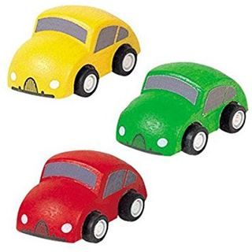 I have three toy cars. They are green, red and ye_ _ _ _ .
Đáp án: llow
190. Nghe: Nhấn giữ Ctrl và bấm chuột để nghe: This is John. He is a _ _ _ _ _ _ .
Đáp án: farmer
191. Odd one out:
A. Vietnam B. English C. America D. China
Đáp án: English
192. Sing wit_ me.
Đáp án: h
193. Che_ _ the words you hear.
Đáp án: ck
194. _______ - It’s in the city.
A. Where is your house? B. Where are you? C. Where is Hanoi? D. Where is Vietnam?
Đáp án: Where is your house?
195. Come and _ _ at with your friends.
Đáp án: ch
196. What … is it? – It’s green.
A. time B. name C. day D. colour
Đáp án: Chọn ý: D
197. Oh, I want pizza, milk … candy.
A. an B. and C. for D. to
Đáp án: and
198. Let’s ______ a song together.
A. read B. watch C. sing D. write
Đáp án: sing
199. Sing with ..., Simon .
A. he B. she C. I D. me
Đáp án: Chọn ý: D
200. a/ apple./ This/ red/ is/
Đáp án: This is a red apple.

KEY IOE K3 2023 - 2024 SỐ 40
1. A: What is … name? – B: My name is Tommy.
A. we B. you C. your D. they
Đáp án: your
2. Nghe: Nhấn giữ Ctrl và bấm chuột để nghe: Look at the _ _ _ _ _ , Rosy.
Đáp án: train
3. Nghe: Nhấn giữ Ctrl và bấm chuột để nghe: Today it’s very _ _ _ _ _ .
Đáp án: windy
4. … are they? – They’re my friends.
A. Who B. What C. Which D. Where
Đáp án: Who
5. Boy: M_ _ I play football here? - Man: No, you can’t.
Đáp án: ay
6. How ... you today? – I’m fine, thanks.
A. am B. is C. are D. fine
Đáp án: are
7. _ _ _ you twelve years old?
Đáp án: Are
8. colours./ orange/ I/ and blue/ like/
Đáp án: I like orange and blue colours.
9. Nghe: Nhấn giữ Ctrl và bấm chuột để nghe: That’s a nice fence _ _ _ _ _ _ the house.
Đáp án: around
10. You don’t look well. ….
A. Are you ok? B. How old are you? C. What’s your name? D. What is that?
Đáp án: Are you ok?
11. is taking/ a nap/ My dad/ the sofa./ on
Đáp án: My dad is taking a nap on the sofa.
12. … do you go to school? – It’s early in the morning.
A. What B. Which C. How D. When
Đáp án: Chọn ý: D
13. Let’s sing an English s_ _ g.
Đáp án: on
14. These are four pencil box_ _ .
Đáp án: es
15. What’s y_ _ r name? – My name’s Tom.
Đáp án: ou
16. to/ Nice/ you,/ meet/ Alex./
Đáp án: Nice to meet you, Alex.
17. subjects/ today?/ have/ do you/ What/
Đáp án: What subjects do you have today?
18. you,/ How/ old/ are/ Quang?/
Đáp án: How old are you, Quang?
19. Ảnh: 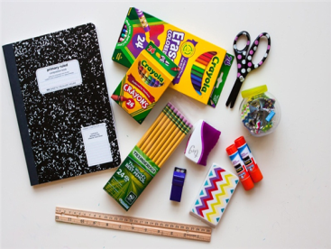 What are these? – These are ….
A. school things B. pencil cases C. flowers D. pens
Đáp án: school things
20. Ảnh: My p_ _ _ _ ts are between my sister and me.
Đáp án: aren
21. car/ drives/ to work./ My father/ his/
Đáp án: My father drives his car to work.
22. My father is a ... . He works hard in the field.
A. worker B. farmer C. doctor D. teacher
Đáp án: farmer
23. I can sing and I _ _ _ dance.
Đáp án: can
24. school/ that blue/ bag./ Give me/
Đáp án: Give me that blue school bag.
25. Our children aren’t watching a cartoon. _ _ _ _ are doing their homework.
Đáp án: They
26. you/ do at/ What/ do/ break time?/
Đáp án: What do you do at break time?
27. How/ many/ does Tim/ have?/ toys/
Đáp án: How many toys does Tim have?
28. ... is that? - It’s a blue ball.
A. How B. When C. What D. Where
Đáp án: What
29. My family/ watching/ now./ is/ TV
Đáp án: My family is watching TV now.
30. What books are they? - T_ _ _ are Maths books.
Đáp án: hey
31. like?/ What/ does/ Lan/ pets/
Đáp án: What pets does Lan like?
32. Great … you again.
A. sees B. to see C. to seeing D. on seeing
Đáp án: to see
33. the/ the books/ Put/ shelf./ on/
Đáp án: Put the books on the shelf.
34. May I c_ _ _ in and study?
Đáp án: ome
35. Ảnh: She has five ….
A. toys B. pets C. dogs D. cats
Đáp án: pets
36. What colour ... that chair? – It’s yellow.
A. it B. is C. that D. hi
Đáp án: is
37. you/ right now?/ at home/ Are/
Đáp án: Are you at home right now?
38. Nghe: Nhấn giữ Ctrl và bấm chuột để nghe: Where are the _ _ _ _ _ s?
Đáp án: chair
39. W_ _ t is that? – It’s a teddy bear.
Đáp án: ha
40. I’m fine, thank_ .
Đáp án: s
41. Are those your pencil sharpeners?
A. Yes, it is. B. No, it isn’t. C. Yes, they are. D. No, they are.
Đáp án: Yes, they are.
42. ... your school bags, please.
A. Close B. Stand C. Sit D. See
Đáp án: Close
43. My primary/ a nice/ is/ school/ place./
Đáp án: My primary school is a nice place.
44. That is m_ . My name is Peter.
Đáp án: e
45. T_ _ s is a board.
Đáp án: hi
46. Nghe: Nhấn giữ Ctrl và bấm chuột để nghe: Sam is riding a …
A. bike B. bus C. horse D. boat
Đáp án: horse
47. Ảnh: My brother has _ _ _ robots.
Đáp án: two
48. Let’s p_ ay outside, children.
Đáp án: l
49. Her name ... Sarah.
A. are B. is C. be D. am
Đáp án: is
50. Nghe: Nhấn giữ Ctrl và bấm chuột để nghe: Where is Nick?
A. He is in the garden. B. He is in the bedroom. C. He is in the bathroom. D. He is in the kitchen.
Đáp án: Chọn ý: D
51. Do you have … today?
A. Art B. write C. sing D. read
Đáp án: Art
52. This/ is/ pencil/ green.
Đáp án: This pencil is green.
53. game/ is/ The/ very/ exciting./
Đáp án: The game is very exciting.
54. He is Peter. He is my ... .
A. name B. family C. friend D. book
Đáp án: friend
55. The _ _ _ of my father is my brother.
Đáp án: son
56. Choose the odd one out:
A. skipping B. table tennis C. badminton D. tennis
Đáp án: skipping
57. Ảnh: 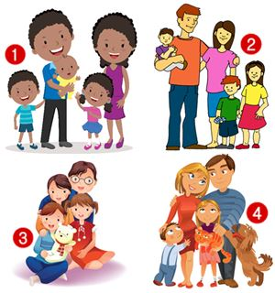 I’m Rosie. There are four people in my family. We have a dog and a cat.
A. Picture 1 B. Picture 2 C. Picture 3 D. Picture 4
Đáp án: Chọn ý: D
58. Choose the odd one out:
A. thirty B. seventy C. eighty D. twelve
Đáp án: Chọn ý: D
59. Tell me a_ _ _ _ the things in your bedroom.
Đáp án: bout
60. dog./ my/ Look/ at/
Đáp án: Look at my dog.
61. my/ my sister’s./ This is/ and that is/ bedroom/
Đáp án: This is my bedroom and that is my sister’s.
62. Nghe: Nhấn giữ Ctrl và bấm chuột để nghe: Let’s go to _ _ _ _ _ _ together.
Đáp án: school
63. Thank you. – You are w_ _ _ _ me.
Đáp án: elco
64. FRI_ ND
Đáp án: E
65. St_ _ d up, please.
Đáp án: an
66. old./ twenty-five/ years/ My teacher/ is/
Đáp án: My teacher is twenty-five years old.
67. How ... books are there in your school bag?
A. much B. is C. are D. many
Đáp án: Chọn ý: D
68. Choose the odd one out:
A. living room B. bedroom C. garden D. kitchen
Đáp án: garden
69. Nghe: Nhấn giữ Ctrl và bấm chuột để nghe: How _ _ _ are you?
Đáp án: old
70. Are you happy? – Yes, I _ _ .
Đáp án: am
71. What is her fa_ _ _ rite sport? – She likes doing yoga best.
Đáp án: vou
72. Nghe: Nhấn giữ Ctrl và bấm chuột để nghe: What letter do you hear?
A. I B. A C. E D. O
Đáp án: A
73. work/ Do/ a company?/ your parents/ in
Đáp án: Do your parents work in a company?
74. It’s a b_ ue pencil.
Đáp án: l
75. Hello, I am Mai. - …
A. Goodbye and see you later. B. I don’t know. C. Hi, I am fine. Thanks D. Nice to see you.
Đáp án: Chọn ý: D
76. My sister _ _ _ a doll.
Đáp án: has
77. My pencils are _ _ the table.
Đáp án: on
78. pets./ have/ doesn't/ She/ any
Đáp án: She doesn't have any pets.
79. _ _ _ is wearing a red T-shirt? – My dad.
Đáp án: who
80. That shirt _ _ green.
Đáp án: is
81. Nghe: Nhấn giữ Ctrl và bấm chuột để nghe: _ _ _ _ _ _ _
Đáp án: teacher
82. This/ my/ grandmother./ is/
Đáp án: This is my grandmother.
83. flowers/ very/ These/ are/ beautiful./
Đáp án: These flowers are very beautiful.
84. is/ not/ It/ bedroom./ my
Đáp án: It is not my bedroom.
85. The books are _ _ the shelves.
Đáp án: on
86. Goodbye, David. See y_ u later.
Đáp án: o
87. They are/ fishing/ at the pond/ their house./ near
Đáp án: They are fishing at the pond near their house.
88. many/ there?/ How/ apples/ are
Đáp án: How many apples are there?
89. Ảnh: I like _ _ _ _ _ _ _ _ in the pool in summer.
Đáp án: swimming
90. Can you _ _ _ _ a bicycle?
Đáp án: ride
91. my/ This is/ uncle/ his daughter./ and
Đáp án: This is my uncle and his daughter.
92. M_ _ I play football here? - No, you can’t.
Đáp án: ay
93. My brother is tall … slim.
A. then B. and C. so D. or
Đáp án: and
94. Good morning, Peter. - ... .
A. Good morning, Jean B. Good night, Jean C. My name’s Jean D. Jean, this is my pen
Đáp án: Good morning, Jean
95. Can the cat _ _ _ _ _ a tree? – Yes, it can.
Đáp án: climb
96. I have a book in my schoo_ bag.
Đáp án: l
97. It’s time … lunch, Peter.
A. to B. in C. on D. for
Đáp án: Chọn ý: D
98. Nghe: Nhấn giữ Ctrl và bấm chuột để nghe: My ... is very tall.
A. father B. brother C. sister D. mother
Đáp án: brother
99. ice-cream./ I/ chocolate/ and/ love/
Đáp án: I love chocolate and ice-cream.
100. Are there _________ pictures on the wall?
A. a B. any C. some D. an
Đáp án: any
101. What’s the weather _ _ _ _ in Ho Chi Minh City?
Đáp án: like
102. Let’s ma_ e a circle.
Đáp án: k
103. Khai/ after work?/ does/ What/ do
Đáp án: What does Khai do after work?
104. The students are sp_ _ king English.
Đáp án: ea
105. There is o_ e cat in that box.
Đáp án: n
106. Choose the odd one out:
A. he B. you C. I D. yes
Đáp án: Chọn ý: D
107. ... morning, Peter.
A. Good’s B. Bye C. Hi D. Good
Đáp án: Chọn ý: D
108. Goodbye Tommy. See you s_ _ _ .
Đáp án: oon
109. this/ I/ dress./ like/ pink
Đáp án: I like this pink dress.
110. The lamp is _ _ _ ween the sofa and the armchair.
Đáp án: bet
111. near/ Is/ Hoa Binh/ Ninh Binh?
Đáp án: Is Hoa Binh near Ninh Binh?
112. I’d l_ _ e an orange, please.
Đáp án: ik
113. …. - Yes, my book is new.
A. Is your shoe new? B. Are these books new? C. Is that new? D. Are those new?
Đáp án: Is that new?
114. What ... this? - This is a pen.
A. it B. iss C. is D. are
Đáp án: is
115. Nghe: Nhấn giữ Ctrl và bấm chuột để nghe: They go to school by _ _ _ .
Đáp án: bus
116. There is a flower va_ e on the table.
Đáp án: s
117. I see a rainbow. It … beautiful.
A. sees B. sounds C. has D. looks
Đáp án: Chọn ý: D
118. Pizza is my favourite ... .
A. drink B. food C. water D. milk
Đáp án: food
119. This is m_ cat.
Đáp án: y
120. My dog’s _ _ _ _ is Barkie.
Đáp án: name
121. friend?/ your/ new/ this/ Is/
Đáp án: Is this your new friend?
122. What’s ... name? - It’s Quang Trung Primary School.
A. it B. it’s C. its D. his
Đáp án: its
123. Nghe: Nhấn giữ Ctrl và bấm chuột để nghe: Is it day or _ _ _ _ _ ?
Đáp án: night
124. Jane is short. Alice is … .
A. slimmer B. stronger C. shorter D. bigger
Đáp án: shorter
125. old/ It’s an/ television./ black/ and white
Đáp án: It’s an old black and white television.
126. Nghe: Nhấn giữ Ctrl và bấm chuột để nghe: Can I borrow you ruler? – Yes, but don’t forget to give it _ _ _ _ .
Đáp án: back
127. How/ are/ desks/ there in your classroom?/ many/
Đáp án: How many desks are there in your classroom?
128. How do you know my n_ _ e?
Đáp án: am
129. … your brother swim?- Yes, he can.
A. Will B. Does C. Is D. Can
Đáp án: Chọn ý: D
130. A: How old are you? – B: I am … years old.
A. a B. an C. eight D. one
Đáp án: eight
131. Minh … like fish and beef very much.
A. isn’t B. doesn’t C. don’t D. never
Đáp án: doesn’t
132. Is this your grandfather? – Yes, he _ _ .
Đáp án: is
133. _______ is his coat? - It’s on his bed.
A. When B. Where C. Who D. What
Đáp án: Where
134. know/ the story/ “Harry Potter”?/ Do/ you/
Đáp án: Do you know the story “Harry Potter”?
135. Nghe: Nhấn giữ Ctrl và bấm chuột để nghe: This is my _ _ _ _ pen.
Đáp án: blue
136. Have ... nice day, Tim. – Thank you.
A. an B. the C. a D. are
Đáp án: a
137. Nghe: Nhấn giữ Ctrl và bấm chuột để nghe: _ _ _ _ _ _ _
Đáp án: grandma
138. Is your school bag big or sm_ _ _ ?
Đáp án: all
139. Nghe: Nhấn giữ Ctrl và bấm chuột để nghe: I can draw a ....
A. cat B. hat C. map D. bat
Đáp án: cat
140. bag?/ colour/ What/ school/ is your/
Đáp án: What colour is your school bag?
141. There _ _ a book on my desk.
Đáp án: is
142. What is your … drink? – I like orange juice the most.
A. name B. favourite C. much D. many
Đáp án: favourite
143. Children’s/ June/ is/ Day./ 1st/
Đáp án: June 1st is Children’s Day.
144. How’s the wea_ _ er today? – It’s sunny.
Đáp án: th
145. Choose the incorrect word(s) in the following sentence: What are you doing? – I’m skateing with my friends in the park.
A. are B. doing C. skateing D. with
Đáp án: skateing
146. , please./ Write/ name/ here/ your/
Đáp án: Write your name here , please.
147. Ảnh: _______ zebras are there in the picture? – There are three zebras.
A. How B. What C. Where D. How many
Đáp án: Chọn ý: D
148. is/ a/ doll./ This/
Đáp án: This is a doll.
149. Is this a bag? - ... .
A. Yes, it is B. Yes, isn’t C. No, it is D. Not, it isn’t
Đáp án: Yes, it is
150. A: Are they your friends? – B: No, … aren’t.
A. we B. you C. your D. they
Đáp án: Chọn ý: D
151. … to meet you, Alice.
A. Well B. Fine C. Nice D. Kind
Đáp án: Nice
152. Nancy has a pet. It can catch a mouse. It’s a _ _ _ .
Đáp án: cat
153. Where do you live? – I live … 107 Tran Dang Ninh Street with my parents.
A. on B. in C. at D. to
Đáp án: at
154. It is ... blue desk.
A. a B. am C. are D. is
Đáp án: a
155. Listen ... the teacher, please.
A. on B. in C. to D. for
Đáp án: to
156. How m_ _ y dogs are there in the garden?
Đáp án: an
157. Who can cl_ _ _ a tree?
Đáp án: imb
158. Ảnh: 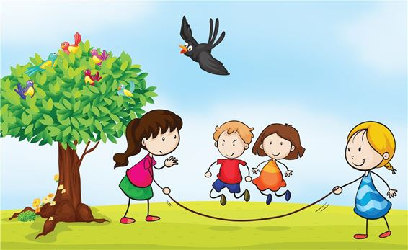 The children are ….
A. playing hide-and-seek B. playing blind man’s buff C. skipping rope D. skateboarding
Đáp án: skipping rope
159. How are Tom and Linda? - _ _ _ y are fine.
Đáp án: The
160. from our/ is far/ flat./ sweet shop/ The/
Đáp án: The sweet shop is far from our flat.
161. There _ _ _ eleven chairs in my class.
Đáp án: are
162. picture./ a/ Let’s/ draw/
Đáp án: Let’s draw a picture.
163. Ảnh: Linda has a rabbit. It’s very cute.
A. Picture 1 B. Picture 2 C. Picture 3 D. Picture 4
Đáp án: Picture 3
164. How do you feel? – I’m very ______?
A. hungry B. short C. pretty D. tall
Đáp án: hungry
165. Choose the odd one out:
A. blue B. pink C. green D. book
Đáp án: Chọn ý: D
166. Ảnh: 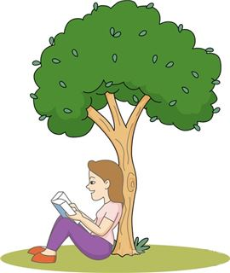 She is _ _ _ ding under the tree.
Đáp án: rea
167. goldfish/ tank./ his/ in the/ Peter keeps/
Đáp án: Peter keeps his goldfish in the tank.
168. I am … England. I am English.
A. from B. to C. in D. at
Đáp án: from
169. Nghe: Nhấn giữ Ctrl và bấm chuột để nghe: She has _ _ _ cats.
Đáp án: two
170. Hi_ name is Peter.
Đáp án: s
171. school?/ name of/ the/ What is/ your
Đáp án: What is the name of your school?
172. Ảnh: That’s a _ _ _ . It’s big.
Đáp án: cow
173. is/ in?/ class/ What/ she
Đáp án: What class is she in?
174. Thai Phien is a big _ _ _ _ ary school in Hai Phong.
Đáp án: prim
175. This/ book./ green/ is a/
Đáp án: This is a green book.
176. It’s _ _ _ today. Please turn on the fan.
Đáp án: hot
177. Ảnh: 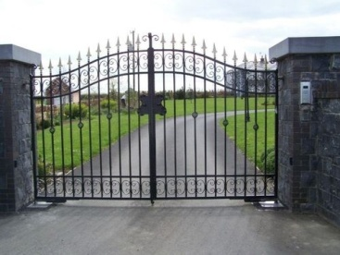 Unscramble this word: egta ---> _ _ _ _
Đáp án: gate
178. I have a dog and my friend has a dog t_ _ .
Đáp án: oo
179. very/ Those/ kites/ beautiful./ are/
Đáp án: Those kites are very beautiful.
180. This is o_ r classroom.
Đáp án: u
181. I don’t like cooking but I ... singing.
A. likes B. like C. do D. to like
Đáp án: like
182. Choose the odd one out:
A. eraser B. notebook C. crayon D. England
Đáp án: Chọn ý: D
183. This _ _ my school library.
Đáp án: is
184. borrow/ of/ your notebook/ May I/ Maths?/
Đáp án: May I borrow your notebook of Maths?
185. Can you remem_ _ r my birthday?
Đáp án: be
186. Do you like football or basketball?
A. I don’t like. B. I like it. C. No, I don’t. D. I like volleyball.
Đáp án: Chọn ý: D
187. I’m so_ _ y. I’m late.
Đáp án: rr
188. tells/ a nice/ me/ My teacher/ story./
Đáp án: My teacher tells me a nice story.
189. Nghe: Nhấn giữ Ctrl và bấm chuột để nghe: It’s a nice _ _ _ _ _ _ room.
Đáp án: living
190. This is an ora_ ge book.
Đáp án: n
191. Nghe: Nhấn giữ Ctrl và bấm chuột để nghe: I _ _ _ _ a cat.
Đáp án: have
192. Ảnh: A: Where are you going now? - B: I’m going to the ….
A. cinema B. theatre C. temple D. hospital
Đáp án: theatre
193. Let’s play _______ piano together.
A. some B. a C. the D. with
Đáp án: the
194. You’re so noisy. _______, please.
A. Stand up B. Be quiet C. Close your book D. Let’s sing
Đáp án: Be quiet
195. for/ is/ robot/ you./ This/
Đáp án: This robot is for you.
196. My brother is th_ _ e years old.
Đáp án: re
197. white./ are/ These/ eggs/
Đáp án: These eggs are white.
198. Helen often _ _ _ _ to school with her friend, Elle.
Đáp án: goes
199. Is that lit_ _ _ boy your friend? – Yes, his name is Tom.
Đáp án: tle
200. This is Mary. ... is my friend.
A. I B. You C. She D. He
Đáp án: She

KEY IOE K3 2023 - 2024 SỐ 41
1. fish/ many/ There are/ in the/ lake./
Đáp án: There are many fish in the lake.
2. in,/ I/ come/ May/ please?/
Đáp án: May I come in, please?
3. I’m fine, thanks. How a_ _ _ t you?
Đáp án: bou
4. Nghe: Nhấn giữ Ctrl và bấm chuột để nghe: _ _ _ _ _ _ _
Đáp án: bedroom
5. During M_ _ _ s lessons, I learn about numbers.
Đáp án: ath
6. How is the weather ... London today?
A. at B. on C. in D. to
Đáp án: in
7. Choose the odd one out:
A. tidy B. nice C. clean D. dirty
Đáp án: Chọn ý: D
8. Nghe: Nhấn giữ Ctrl và bấm chuột để nghe: Anna is drawing a _ _ _ _ _ .
Đáp án: plane
9. Ảnh: Henry, Mary and I sit … tables.
A. in B. at C. on D. by
Đáp án: at
10. See/ tomorrow./ you/
Đáp án: See you tomorrow.
11. Ha Noi is in n_ _ _ _ Viet Nam.
Đáp án: orth
12. Hi, my name’s Sean. - ... .
A. See you tomorrow B. Good night C. Hi, I’m Peter D. Goodbye
Đáp án: Hi, I’m Peter
13. Can you come and s_ _ _ a song with me?
Đáp án: ing
14. Gi_ _ me the book, please. – Here you are.
Đáp án: ve
15. ten o’clock./ goes to/ Mary/ bed/ at
Đáp án: Mary goes to bed at ten o’clock.
16. What ... this? - This is a pen.
A. it B. iss C. is D. are
Đáp án: is
17. in/ Yen So Park?/ cycling/ like/ Do you/
Đáp án: Do you like cycling in Yen So Park?
18. large./ of/ our house/ The pond/ is
Đáp án: The pond of our house is large.
19. Goodbye. See you to_ _ rrow.
Đáp án: mo
20. Nghe: Nhấn giữ Ctrl và bấm chuột để nghe: I can draw a ....
A. cat B. hat C. map D. bat
Đáp án: cat
21. Taylor is _ _ the school yard right now.
Đáp án: in
22. … your name on the board?
A. Is B. Are C. What D. How
Đáp án: Is
23. How many … are there on the table?
A. flower B. flowers C. ruler D. eraser
Đáp án: flowers
24. It/ red/ is a/ ruler.
Đáp án: It is a red ruler.
25. outside?/ Is/ it/ raining/
Đáp án: Is it raining outside?
26. Nghe: Nhấn giữ Ctrl và bấm chuột để nghe: He’s wearing a white _ _ _ _ .
Đáp án: coat
27. What colour ... that chair? – It’s yellow.
A. it B. is C. that D. hi
Đáp án: is
28. Do you have any rubbers? – Yes, here t_ _ _ are.
Đáp án: hey
29. WR__ING
A. ET B. ETI C. ITE D. IT
Đáp án: Chọn ý: D
30. Nghe: Nhấn giữ Ctrl và bấm chuột để nghe: David and Simon are ….
A. playing football B. having lunch C. drawing their pictures D. read the books
Đáp án: drawing their pictures
31. _ _ at’s her name? – She is Mary.
Đáp án: Wh
32. is/ there./ coat/ Your/ over
Đáp án: Your coat is over there.
33. That is Lan. _ _ _ is my friend.
Đáp án: she
34. to be/ fun/ It's/ with Linda.
Đáp án: It's fun to be with Linda.
35. is/ old/ your/ brother?/ How/
Đáp án: How old is your brother?
36. likes/ playing/ robots with/ Minh/ his friends./
Đáp án: Minh likes playing robots with his friends.
37. Ảnh: Tommy has three cats and four d_ _ _ .
Đáp án: ogs
38. These books are for you. – Thank you very m_ _ h.
Đáp án: uc
39. the table./ There/ is a/ next to/ cat/
Đáp án: There is a cat next to the table.
40. many/ do/ you have?/ How/ skirts/
Đáp án: How many skirts do you have?
41. …? - It is on the table.
A. Where are my apples B. Where is your ruler C. What are you doing D. How are you
Đáp án: Where is your ruler
42. What … do you go to school?
A. name B. time C. subjects D. many
Đáp án: time
43. a/ has/ long/ tail./ My cat/
Đáp án: My cat has a long tail.
44. December./ born/ in/ was/ I/
Đáp án: I was born in December.
45. Goodbye. See you l_ _ _ r.
Đáp án: ate
46. Nam usually … badminton in the afternoon.
A. played B. plays C. playing D. to play
Đáp án: plays
47. Nga is singing a nice s_ _ _ .
Đáp án: ong
48. Ảnh: 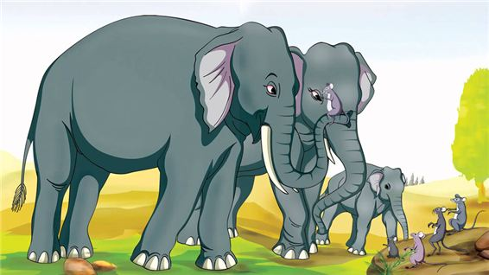 An elephant is b_ _ and a mouse is small.
Đáp án: ig
49. Let’s go to school t_ _ _ _ _ _ _ !
Đáp án: ogether
50. Your doll is gr_ _ n and my doll is yellow.
Đáp án: ee
51. cooking/ doesn’t/ He/ like/ at home./
Đáp án: He doesn’t like cooking at home.
52. Is this a book? - ... .
A. Yes, it is B. Yes, isn’t C. No, it is D. Bye
Đáp án: Yes, it is
53. Do you like Tet? - ….
A. Yes, I love Tet B. Yes, I am C. No, he doesn’t D. No, I am not sure
Đáp án: Yes, I love Tet
54. has twenty/ girls./ boys and/ My class/ twenty-two
Đáp án: My class has twenty boys and twenty-two girls.
55. Ảnh: 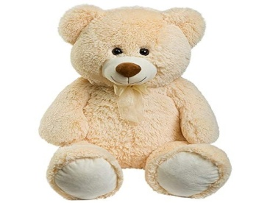 I have a lovely teddy _ _ _ _ .
Đáp án: bear
56. Minh: Where are you? - Nga: I am w_ _ _ my friends.
Đáp án: ith
57. Ảnh: 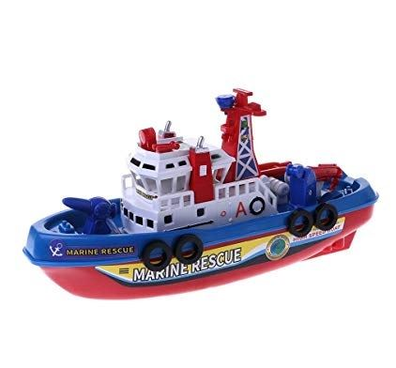 He has a toy _ _ _ _ .
Đáp án: ship
58. Nghe: Nhấn giữ Ctrl và bấm chuột để nghe: Look at the _ _ _ _ in the tree.
Đáp án: ball
59. Mary likes to read books in the school li_ _ ary.
Đáp án: br
60. Nghe: Nhấn giữ Ctrl và bấm chuột để nghe: The chairs are _ _ _ _ the table.
Đáp án: near
61. When/ birthday?/ is/ Lan’s/
Đáp án: When is Lan’s birthday?
62. does/ pet/ like?/ Khoi/ What/
Đáp án: What pet does Khoi like?
63. _ _ _ _ is your name?
Đáp án: What
64. Sing wit_ me.
Đáp án: h
65. the/ and/ Listen/ pictures./ number/
Đáp án: Listen and number the pictures.
66. Great to see you …, Jane.
A. too B. again C. but D. and
Đáp án: again
67. Let’s go out for _ _ _ ner. I’m hungry now.
Đáp án: din
68. How do you know my n_ _ e?
Đáp án: am
69. My uncle is going to make a cake … me.
A. from B. at C. for D. on
Đáp án: for
70. There are four room_ in my house.
Đáp án: s
71. _ _ _ _ _ pencils are these? – They’re my pencils.
Đáp án: Whose
72. Choose the odd one out:
A. skipping B. table tennis C. badminton D. tennis
Đáp án: skipping
73. Li_ ten to the teacher, please.
Đáp án: s
74. … is that boy? – He is my new friend from school.
A. What B. Which C. Who D. Where
Đáp án: Who
75. Ảnh: Give me a b_ _ _ _ _ of milk, please.
Đáp án: ottle
76. Bring an um_ _ _ lla in case rains.
Đáp án: bre
77. Does David ______ any ships? – Yes, he does.
A. have B. having C. has D. haves
Đáp án: have
78. Circle the ans_ er, please.
Đáp án: w
79. Can you swim _ _ _ play chess?
Đáp án: and
80. ... is it from your house to the bakery?
A. How often B. How far C. How D. How much
Đáp án: How far
81. Don’t eat too … sugar.
A. much B. many C. lots of D. a lot
Đáp án: much
82. Is ... a yellow kite? – No, it isn’t. That is a green kite.
A. that’s B. that C. this D. this is
Đáp án: that
83. in/ lots of/ my hometown./ There are/ mountains/
Đáp án: There are lots of mountains in my hometown.
84. bluff?/ like/ Do you/ man’s/ blind/
Đáp án: Do you like blind man’s bluff?
85. T_ _ s is a board.
Đáp án: hi
86. playing/ likes/ Tim/ computer/ games./
Đáp án: Tim likes playing computer games.
87. Take _ look at the picture in your book.
Đáp án: a
88. Who is tall_ _ , Jack or Jim?
Đáp án: er
89. Ảnh: 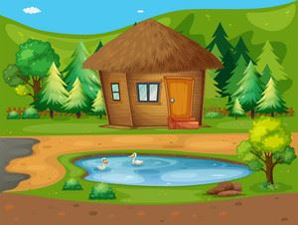 There is a p_ _ _ in front of the house.
Đáp án: ond
90. the/ living/ house./ room in/ There is a/
Đáp án: There is a living room in the house.
91. Choose the letter(s) to make a correct word: e__phant
A. lle B. li C. lli D. le
Đáp án: Chọn ý: D
92. You don’t look well. ….
A. Are you ok? B. How old are you? C. What’s your name? D. What is that?
Đáp án: Are you ok?
93. Choose the odd one out.
A. ship B. truck C. plane D. duck
Đáp án: Chọn ý: D
94. A: How _ _ _ is your grandpa? - B: He’s sixty.
Đáp án: old
95. all/ new./ are/ things/ My school/
Đáp án: My school things are all new.
96. His/ birthday/ is not/ in/ December./
Đáp án: His birthday is not in December.
97. ... is that? - It’s a blue ball.
A. How B. When C. What D. Where
Đáp án: What
98. What _______ do you like best? – It’s blue.
A. pet B. colour C. toy D. book
Đáp án: colour
99. I have Maths _ _ Monday.
Đáp án: on
100. ...? - He’s from France.
A. Where is he from B. What’s his name C. What does he do D. What’s his nationality
Đáp án: Where is he from
101. Ảnh: Cinderella is ______ with the prince at the party.
A. dance B. dances C. dancing D. danceing
Đáp án: dancing
102. Ảnh: The apple is ________ the box.
A. under B. in front of C. beside D. behind
Đáp án: Chọn ý: D
103. Choose the odd one out:
A. Peter B. Tim C. Alan D. Monday
Đáp án: Chọn ý: D
104. of March./ Her birthday/ is/ on/ the nineteenth
Đáp án: Her birthday is on the nineteenth of March.
105. Nghe: Nhấn giữ Ctrl và bấm chuột để nghe: There are six _ _ _ _ _ _ _ on top.
Đáp án: candles
106. Draw a pict_ _ e of yourself.
Đáp án: ur
107. Nghe: Nhấn giữ Ctrl và bấm chuột để nghe: Is it day or _ _ _ _ _ ?
Đáp án: night
108. May I go o_ _ for a while?
Đáp án: ut
109. Your pictures are ... the wall.
A. on B. in C. for D. to
Đáp án: on
110. You and … are friends forever.
A. me B. my C. I D. myself
Đáp án: I
111. Peter is my friend, t_ _ .
Đáp án: oo
112. _ _ _ ’s the weather? – It’s sunny.
Đáp án: how
113. He can … with a yo-yo.
A. play B. catch C. do D. say
Đáp án: play
114. What’s the weather _ _ _ _ in Ho Chi Minh City?
Đáp án: like
115. My friends and I … a new way to learn English.
A. go B. look C. find D. do
Đáp án: find
116. A: Is your house _ _ _ _ the cinema? - B: No, it’s very far.
Đáp án: near
117. This pen is _ _ _ blue. It’s green.
Đáp án: not
118. _ _ dog is two years old.
Đáp án: my
119. My brother can play the piano but … play the guitar.
A. can B. can not C. cannot D. cant’
Đáp án: cannot
120. This _ _ Linda.
Đáp án: is
121. Choose the odd one out:
A. seven B. eleven C. fourteen D. seventeen
Đáp án: seven
122. My father … to work at 6 o’clock.
A. go B. play C. goes D. plays
Đáp án: goes
123. Peter and Mary/ are/ at/ gate./ the school
Đáp án: Peter and Mary are at the school gate.
124. Put your books s a_ _ y, please.
Đáp án: wa
125. What is Mary’s … of birth?
A. day B. date C. today D. birthday
Đáp án: date
126. Do you have … today?
A. Art B. write C. sing D. read
Đáp án: Art
127. Look at the board. – Y_ _ , Miss.
Đáp án: es
128. food./ wants/ some/ Peter/
Đáp án: Peter wants some food.
129. ________ subjects do you like the most?
A. What B. When C. Why D. Who
Đáp án: What
130. Nghe: Nhấn giữ Ctrl và bấm chuột để nghe: The garden is very _ _ _ _ _ _ _ _ _ .
Đáp án: beautiful
131. Take/ , Alan./ your/ notebooks/ out/
Đáp án: Take out your notebooks , Alan.
132. This ... a house.
A. are B. is C. you D. here
Đáp án: is
133. My brother is th_ _ e years old.
Đáp án: re
134. Nghe: Nhấn giữ Ctrl và bấm chuột để nghe: _ _ _ _ _
Đáp án: photo
135. My sister is very bea_ tiful.
Đáp án: u
136. Ảnh: 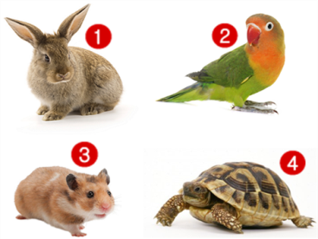 Which is Peter’s pet? Peter has a lovely pet. It can fly in the sky.
A. Picture 1 B. Picture 2 C. Picture 3 D. Picture 4
Đáp án: Picture 2
137. ... this a desk? – Yes, it is.
A. Is B. Are C. How D. Whatname’s
Đáp án: Is
138. Ảnh: The mouse is _ _ _ ind the box.
Đáp án: beh
139. Which word has the letters 'w' pronounced as the letter ’w’ in 'who'?
A. write B. where C. when D. what
Đáp án: write
140. new/ she/ your/ Is/ friend?/
Đáp án: Is she your new friend?
141. Tommy can _ _ _ _ _ Vietnamese.
Đáp án: speak
142. Nghe: Nhấn giữ Ctrl và bấm chuột để nghe: _ _ _ _ _ _
Đáp án: eighty
143. How _ _ _ _ dogs do you have? – I don’t have any dogs.
Đáp án: many
144. The map is on the w_ _ _ .
Đáp án: all
145. … your brother swim?- Yes, he can.
A. Will B. Does C. Is D. Can
Đáp án: Chọn ý: D
146. My pictures _ _ _ on the wall.
Đáp án: are
147. Sally is standing n_ _ _ to David.
Đáp án: ext
148. Ảnh: Rapunzel ______ long straight blonde hair.
A. has B. have C. haves D. is has
Đáp án: has
149. Nghe: Nhấn giữ Ctrl và bấm chuột để nghe: He carries a baby in his _ _ _ _ .
Đáp án: arms
150. cloudy/ in/ It’s/ and windy/ Ha Noi./
Đáp án: It’s cloudy and windy in Ha Noi.
151. Choose the odd one out:
A. bathroom B. music room C. art room D. classroom
Đáp án: bathroom
152. My teacher/ years/ is/ twenty-five/ old./
Đáp án: My teacher is twenty-five years old.
153. She can play chess but … do puzzles.
A. can B. cannot C. can-not D. cant’
Đáp án: cannot
154. Nghe: Nhấn giữ Ctrl và bấm chuột để nghe: _ _ _ _ _ _ _ _ _
Đáp án: seventeen
155. My family/ has a big/ every Sunday./ always/ dinner
Đáp án: My family always has a big dinner every Sunday.
156. school/ colour/ bag?/ is your/ What/
Đáp án: What colour is your school bag?
157. The main character is funny _ _ _ gentle.
Đáp án: and
158. Ảnh: 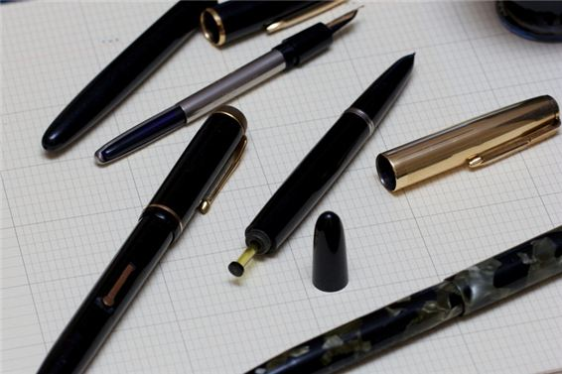 What are these? – These are my old _ _ _ _ .
Đáp án: pens
159. have/ a/ Emma/ Does/ goldfish?/
Đáp án: Does Emma have a goldfish?
160. It is ... blue desk.
A. a B. am C. are D. is
Đáp án: a
161. Tom re_ _ _ books in the library in the afternoon.
Đáp án: ads
162. ... is this? – It’s an apple.
A. How B. Who C. What D. Is
Đáp án: What
163. Nghe: Nhấn giữ Ctrl và bấm chuột để nghe: _ _ _ _ _ _
Đáp án: garden
164. Ảnh: My chair is _ _ _ _ _ .
Đáp án: brown
165. Ảnh: 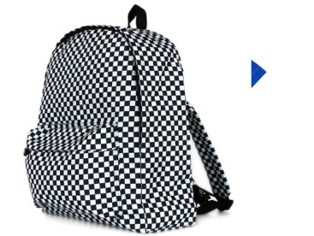 Is this black and white bac_ _ _ _ _ yours?
Đáp án: kpack
166. old./ is/ years/ He/ ten/
Đáp án: He is ten years old.
167. Nghe: Nhấn giữ Ctrl và bấm chuột để nghe: How many hot dogs does he take out of the package?
A. Three B. Two C. One D. Four
Đáp án: Two
168. are/ pencils/ on/ the table./ His/
Đáp án: His pencils are on the table.
169. pen/ Which/ is/ yours?
Đáp án: Which pen is yours?
170. Is your school big? - _ _ _ , it is.
Đáp án: Yes
171. We often play football in the schoolyard at … time.
A. free B. break C. spare D. any
Đáp án: break
172. Golf _ _ my father’s favourite sport.
Đáp án: is
173. Choose the odd one out:
A. are B. you C. am D. is
Đáp án: you
174. ... are you today? – I’m fine, thanks.
A. Who B. That C. How D. Where
Đáp án: How
175. fly?/ can/ animals/ What/
Đáp án: What animals can fly?
176. A: … rooms are there in your house? - B: Five.
A. How much B. How many C. How old D. How long
Đáp án: How many
177. What’s y_ _ r name? – My name’s Tom.
Đáp án: ou
178. black cat/ is/ under/ The/ the bed./
Đáp án: The black cat is under the bed.
179. Oh, I want pizza, milk … candy.
A. an B. and C. for D. to
Đáp án: and
180. run./ but/ it can’t/ A goldfish/ can swim,/
Đáp án: A goldfish can swim, but it can’t run.
181. Ảnh: My friend loves _ _ _ _ ing very much.
Đáp án: sing
182. Choose the letter(s) to make a correct word: classm__e
A. ra B. ad C. et D. at
Đáp án: Chọn ý: D
183. A: How old are you? – B: I am … years old.
A. a B. an C. eight D. one
Đáp án: eight
184. That ... his family.
A. am B. is C. are D. and
Đáp án: is
185. friends/ Primary School./ My old/ at Kim Dong/ study/
Đáp án: My old friends study at Kim Dong Primary School.
186. … subjects do you have on Tuesday?
A. What B. How C. Who D. When
Đáp án: What
187. Nghe: Nhấn giữ Ctrl và bấm chuột để nghe: How many pages does the book have?
A. 52 B. 32 C. 42 D. 62
Đáp án: 52
188. the wall./ There/ is/ a picture/ on
Đáp án: There is a picture on the wall.
189. Nghe: Nhấn giữ Ctrl và bấm chuột để nghe: The tree has blown _ _ _ _ .
Đáp án: down
190. see/ it./ Come/ and/
Đáp án: Come and see it.
191. Thank you very much. – You’re w_ _ _ _ me.
Đáp án: elco
192. in/ Hue/ It’s/ cloudy/ today./
Đáp án: It’s cloudy in Hue today.
193. so/ It/ today./ is/ hot
Đáp án: It is so hot today.
194. house/ My/ quite/ large./ is/
Đáp án: My house is quite large.
195. Is that your m_ _ _ _ _ ? - No, she is my aunt.
Đáp án: other
196. Nghe: Nhấn giữ Ctrl và bấm chuột để nghe: My house has a ... yard.
A. small B. fat C. large D. big
Đáp án: large
197. That is her n_ w school.
Đáp án: e
198. brothers?/ Do/ have/ you/ any
Đáp án: Do you have any brothers?
199. Nghe: Nhấn giữ Ctrl và bấm chuột để nghe: Let’s go to _ _ _ _ _ _ together.
Đáp án: school
200. The child of my uncle is my c_ _ _ _ n.
Đáp án: ousi

KEY IOE K3 2023 - 2024 SỐ 42
1. The school is far _ _ _ _ the cinema.
Đáp án: from
2. A: What … do you like? - B: I like ships.
A. sports B. games C. toys D. pets
Đáp án: toys
3. You/ to me./ say/ hello/
Đáp án: You say hello to me.
4. having/ in/ Is she/ breakfast/ the dining room?/
Đáp án: Is she having breakfast in the dining room?
5. I can … a kite.
A. this B. fly C. the D. a
Đáp án: fly
6. What is your favourite _ _ _ _ ? - It’s hide-and-seek.
Đáp án: game
7. Do you like … puzzles?
A. playing B. doing C. do D. play
Đáp án: doing
8. What/ does/ subject/ like best?/ Peter
Đáp án: What subject does Peter like best?
9. Ảnh: These are … of my family.
A. posters B. photos C. maps D. papers
Đáp án: photos
10. This is my ... . Her name is Alice.
A. mother B. father C. brother D. grandfather
Đáp án: mother
11. Are there _________ clocks on the table?
A. a B. an C. some D. any
Đáp án: Chọn ý: D
12. Ảnh: 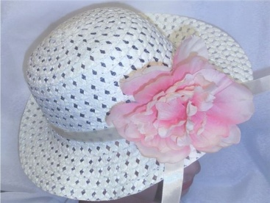 Which one is your _ _ _ ? – It’s the one with a pink flower.
Đáp án: hat
13. the music room?/ How many/ boys/ in/ are there/
Đáp án: How many boys are there in the music room?
14. our/ It’s/ room./ computer/
Đáp án: It’s our computer room.
15. Ảnh: It is a cute _ _ _ _ _ _ with two long ears.
Đáp án: rabbit
16. ______ - There are two pens over there.
A. What are over there? B. Where are two pens? C. Are there any pens over there? D. How many pens are there over there?
Đáp án: Chọn ý: D
17. May I c_ _ _ in and study?
Đáp án: ome
18. Nghe: Nhấn giữ Ctrl và bấm chuột để nghe: My _ _ _ _ _ _ is in the garden.
Đáp án: parrot
19. Ảnh: 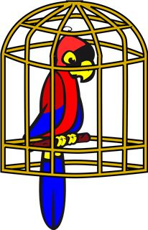 I keep my parrot in a _ _ _ _ .
Đáp án: cage
20. How many pictures are there _ _ the wall? – There are four pictures.
Đáp án: on
21. What’s the weather _ _ _ _ in Ho Chi Minh City?
Đáp án: like
22. repeat/ me./ after/ Please/
Đáp án: Please repeat after me.
23. I can r_ _ e a bicycle.
Đáp án: id
24. Nghe: Nhấn giữ Ctrl và bấm chuột để nghe: Mai likes ... flowers.
A. beautiful B. wonderful C. colorful D. blue
Đáp án: beautiful
25. Ảnh: My friend loves _ _ _ _ ing very much.
Đáp án: sing
26. That is my s_ _ _ _ _ library.
Đáp án: chool
27. What … your parents look like?
A. does B. do C. is D. are
Đáp án: do
28. in/ My/ father/ is/ the kitchen./
Đáp án: My father is in the kitchen.
29. best./ Art/ I/ lessons/ like/
Đáp án: I like Art lessons best.
30. This ... my mother.
A. are B. am C. is D. and
Đáp án: is
31. Let’s play h_ _ e-and-seek.
Đáp án: id
32. Nghe: Nhấn giữ Ctrl và bấm chuột để nghe: Which is NOT mentioned in the recording?
A. garden B. bathroom C. bedroom D. kitchen
Đáp án: bedroom
33. like/ to/ listening/ music?/ Do you/
Đáp án: Do you like listening to music?
34. It is _ desk.
Đáp án: a
35. Are you happy? – Yes, I _ _ .
Đáp án: am
36. May I borrow your books for some days? - ….
A. No, I don’t. B. Yes, I can. C. I am fine. Thank you. D. Yes, you can.
Đáp án: Chọn ý: D
37. birthday/ My mother’s/ in/ February./ is/
Đáp án: My mother’s birthday is in February.
38. Don’t/ much fast/ eat/ food./ too/
Đáp án: Don’t eat too much fast food.
39. Ảnh: They are … .
A. pencils B. sharpeners C. rulers D. erasers
Đáp án: Chọn ý: D
40. This is m_ cat.
Đáp án: y
41. Ảnh: 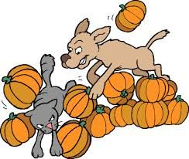 The dog is ch_ _ _ ng the cat.
Đáp án: asi
42. Where’s Bac Ninh Province? – It’s in ______ Vietnam.
A. north B. central C. south D. the
Đáp án: north
43. Are Philip and Tony watching TV?
A. Yes, he is. B. Yes, they are. C. No, he and he are not. D. No, they not.
Đáp án: Yes, they are.
44. He’s old./ My/ isn’t/ young./ grandfather/
Đáp án: My grandfather isn’t young. He’s old.
45. What is your … drink? – I like orange juice the most.
A. name B. favourite C. much D. many
Đáp án: favourite
46. A dog has _______.
A. four eyes B. four noses C. four tails D. four legs
Đáp án: Chọn ý: D
47. Che_ _ the words you hear.
Đáp án: ck
48. _ s your school small? – Yes, it is small.
Đáp án: I
49. Nghe: Nhấn giữ Ctrl và bấm chuột để nghe: There is a desk _ _ _ _ to my bed.
Đáp án: next
50. Nghe: Nhấn giữ Ctrl và bấm chuột để nghe: I have a _ _ _ fridge.
Đáp án: red
51. She’s learning how to _ _ _ _ spaghetti.
Đáp án: cook
52. The lamp is _ _ _ ween the sofa and the armchair.
Đáp án: bet
53. This is ... doll.
A. she B. me C. my D. hi
Đáp án: my
54. Ảnh: 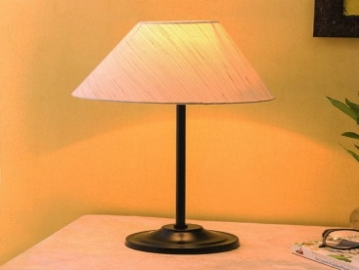 Please turn on the _ _ _ _ . The room is dark.
Đáp án: lamp
55. What toys/ not/ he/ like?
A. What toys doesn’t he like? B. What toys don’t he likes? C. What toys isn’t he like? D. What toys aren’t he likes?
Đáp án: What toys doesn’t he like?
56. This is a_ ice cream.
Đáp án: n
57. What is that? - … is a new pen.
A. He B. It C. They D. These
Đáp án: It
58. Teacher: Nam, go to the b_ _ _ _ and write your sentence. - Nam: Yes, Miss.
Đáp án: oard
59. are/ friends/ Where/ now?/ your/
Đáp án: Where are your friends now?
60. too./ you,/ Nice/ meet/ to/
Đáp án: Nice to meet you, too.
61. There are four win_ _ _ _ in my classroom.
Đáp án: dows
62. Nghe: Nhấn giữ Ctrl và bấm chuột để nghe: What’s the name of the pupil? – She’s _ _ _ _ .
Đáp án: alex
63. Rosie is having a shower in the ….
A. kitchen B. bathroom C. bedroom D. playground
Đáp án: bathroom
64. Mary is … . She wants some water.
A. hungry B. thirsty C. sick D. pretty
Đáp án: thirsty
65. … is your school? – That one.
A. What B. Where C. Which D. When
Đáp án: Which
66. The gym is big and n_ _ .
Đáp án: ew
67. Choose the letter(s) to make a correct word: clas__oom
A. ss B. rr C. rs D. sr
Đáp án: Chọn ý: D
68. Ảnh: That’s a _ _ _ . It’s big.
Đáp án: cow
69. There are four room_ in my house.
Đáp án: s
70. very/ beautiful./ are/ flowers/ These/
Đáp án: These flowers are very beautiful.
71. What … do you go to school?
A. name B. time C. subjects D. many
Đáp án: time
72. Mary is a ... at London Primary School.
A. boy B. toy C. student D. she
Đáp án: student
73. that/ the box?/ What/ in/ is/
Đáp án: What is that in the box?
74. Does Khanh/ bluff/ blind man’s/ play/ break time?/ at/
Đáp án: Does Khanh play blind man’s bluff at break time?
75. in/ Is/ room?/ Rosy/ the dining
Đáp án: Is Rosy in the dining room?
76. Let’s go out for _ _ _ ner. I’m hungry now.
Đáp án: din
77. Are there a_ _ kites on the sky?
Đáp án: ny
78. Are there _________ pictures on the wall?
A. a B. any C. some D. an
Đáp án: any
79. I like to s_ ng.
Đáp án: i
80. Nghe: Nhấn giữ Ctrl và bấm chuột để nghe: My _ _ _ is blue.
Đáp án: bed
81. Is that girl new? – I don’t _ _ ow.
Đáp án: kn
82. … subjects do you have on Tuesday?
A. What B. How C. Who D. When
Đáp án: What
83. Hi_ name is Peter.
Đáp án: s
84. Odd one out:
A. sun B. snowy C. cloud D. wind
Đáp án: snowy
85. There ... one ruler on that desk.
A. am B. an C. is D. are
Đáp án: is
86. Ảnh: 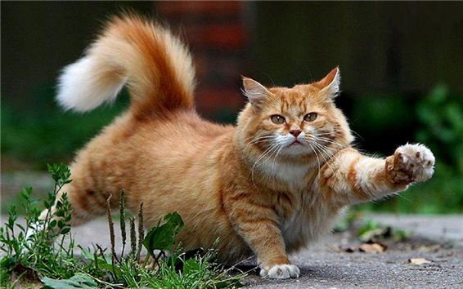 There is a big fat c_ _ .
Đáp án: at
87. friend?/ new/ your/ Is/ this/
Đáp án: Is this your new friend?
88. _______ is his coat? - It’s on his bed.
A. When B. Where C. Who D. What
Đáp án: Where
89. I don’t like the music room. It is so s_ _ _ l.
Đáp án: mal
90. This is my friend James. … is a nice boy.
A. He B. She C. They D. It
Đáp án: He
91. Is that your classroom? It is so _ _ _ ge.
Đáp án: lar
92. This gift is for you. – Thank you very m_ _ h.
Đáp án: uc
93. the radio./ to/ is/ listening/ She/
Đáp án: She is listening to the radio.
94. What’s the matter _ _ _ _ your eyes?
Đáp án: with
95. I/ am/ very/ now./ tired
Đáp án: I am very tired now.
96. Ảnh: 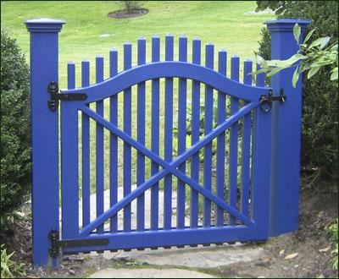 Our house has a small blue _ _ _ _ .
Đáp án: gate
97. Ảnh: Do you have toys? – Yes, I have a _ _ _ _ .
Đáp án: doll
98. Do you _ _ _ w Phong? – Yes, I do. He is my classmate.
Đáp án: kno
99. school/ with Nhung./ I always/ go/ to/
Đáp án: I always go to school with Nhung.
100. Nghe: Nhấn giữ Ctrl và bấm chuột để nghe: Who's _ _ _ _ _ _ _ _ , you or your brother?
Đáp án: stronger
101. How/ do/ spell/ your name?/ I/
Đáp án: How do I spell your name?
102. What do you have _ _ _ breakfast? – I have sandwiches.
Đáp án: for
103. your/ birthday?/ is/ When/
Đáp án: When is your birthday?
104. May you play hide-and-seek w_ _ _ us?
Đáp án: ith
105. My house _ _ _ _ _ ’t have a pond.
Đáp án: doesn
106. Where ______ you _______ on Sundays?
A. do – do B. does – do C. does - go D. do - go
Đáp án: Chọn ý: D
107. Pizza is my favourite ... .
A. drink B. food C. water D. milk
Đáp án: food
108. Nghe: Nhấn giữ Ctrl và bấm chuột để nghe: How many pages does the book have?
A. 52 B. 32 C. 42 D. 62
Đáp án: 52
109. That’s Peter. ... is my friend.
A. I B. You C. She D. He
Đáp án: Chọn ý: D
110. Nghe: Nhấn giữ Ctrl và bấm chuột để nghe: These _ _ _ _ _ _ _ _ are in the USA.
Đáp án: students
111. Good morning, Peter. - ... .
A. Good morning, Jean B. Good night, Jean C. My name’s Jean D. Jean, this is my pen
Đáp án: Good morning, Jean
112. These _ _ _ two yellow dolls.
Đáp án: are
113. a/ family./ happy/ We/ are/
Đáp án: We are a happy family.
114. Nghe: Nhấn giữ Ctrl và bấm chuột để nghe: He’s _ _ _ _ _ years old.
Đáp án: eight
115. This is my aunt. …. twenty-six years old.
A. They are B. He is C. You are D. She is
Đáp án: Chọn ý: D
116. BA__ROOM
A. TH B. T C. D D. TA
Đáp án: TH
117. school/ bags./ are/ our/ Those/
Đáp án: Those are our school bags.
118. Ảnh: How many crayons _______ you have? – I have 8.
A. do B. does C. are D. are there
Đáp án: do
119. is in/ school/ My/ the/ countryside./
Đáp án: My school is in the countryside.
120. A: … do you go shopping? – B: Once a week.
A. How many B. What C. How often D. When
Đáp án: How often
121. Her favourite _ _ _ _ _ _ _ is Art.
Đáp án: subject
122. Nghe: Nhấn giữ Ctrl và bấm chuột để nghe: His _ _ _ _ _ _ is in the kitchen with his mother.
Đáp án: sister
123. I can sing and I _ _ _ dance.
Đáp án: can
124. Ảnh: 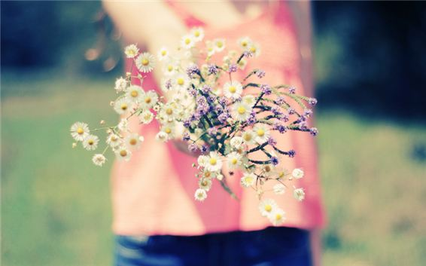 Do you like …? – Yes, I do.
A. books B. flowers C. pencil cases D. ice-cream
Đáp án: flowers
125. Is _ _ _ _ e a park near your house?
Đáp án: ther
126. like/ do/ football?/ Why/ you/
Đáp án: Why do you like football?
127. all at/ are/ the bus/ We/ stop./
Đáp án: We are all at the bus stop.
128. W_ _ _ are these? – These are my new crayons.
Đáp án: hat
129. Would you like … cup of coffee, Mary?
A. a B. an C. some D. any
Đáp án: a
130. Nghe: Nhấn giữ Ctrl và bấm chuột để nghe: She shows them the pictures in the _ _ _ _ .
Đáp án: book
131. _ _ _ _ Mr. Black have a new car?
Đáp án: Does
132. like/ much?/ rats/ cats/ Does/
Đáp án: Does cats like rats much?
133. tigers./ I/ not/ like/ do/
Đáp án: I do not like tigers.
134. is/ room./ our/ music/ That/
Đáp án: That is our music room.
135. It’s always … in summer.
A. cold B. red C. icy D. hot
Đáp án: Chọn ý: D
136. It’s _ _ _ _ dy today. You should bring your umbrella.
Đáp án: clou
137. Nghe: Nhấn giữ Ctrl và bấm chuột để nghe: They’re ....
A. hungry B. happy C. lucky D. sad
Đáp án: happy
138. ... is this? – It’s an apple.
A. How B. Who C. What D. Is
Đáp án: What
139. Nam: Your school and your library is big. - Nga: Yes, t_ _ _ are very big and nice.
Đáp án: hey
140. red/ This/ is/ apple./ a/
Đáp án: This is a red apple.
141. What’s the matter ... your eyes?
A. with B. to C. at D. for
Đáp án: with
142. Is/ raining/ it/ outside?
Đáp án: Is it raining outside?
143. Nghe: Nhấn giữ Ctrl và bấm chuột để nghe: This is John. He is a _ _ _ _ _ _ .
Đáp án: farmer
144. in/ Nam is/ his friends./ with/ the park/
Đáp án: Nam is in the park with his friends.
145. I’m f_ ne, thank you.
Đáp án: i
146. name?/ your/ What’s/ teacher’s/
Đáp án: What’s your teacher’s name?
147. Does/ banana?/ Mary/ like/
Đáp án: Does Mary like banana?
148. How/ Jimmy’s/ old/ little brother?/ is/
Đáp án: How old is Jimmy’s little brother?
149. They/ playing/ the violin/ very much./ like/
Đáp án: They like playing the violin very much.
150. Ảnh: My cat likes _ _ sh very much.
Đáp án: fi
151. How ... dogs do you have?
A. many B. five C. bird D. much
Đáp án: many
152. Vinh: What is that? - Binh: It’s _ big red ball.
Đáp án: a
153. Choose the odd one out:
A. how B. hello C. hi D. good morning
Đáp án: how
154. Mum?/ my/ parrot/ Is/ there,
Đáp án: Is my parrot there, Mum?
155. Is your school blue ... white?
A. to B. or C. and D. but
Đáp án: or
156. Ảnh: 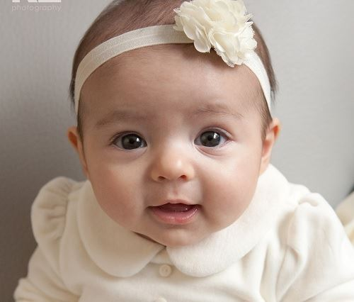 That is my _ _ _ _ sister.
Đáp án: baby
157. Thank you. – You are w_ _ come.
Đáp án: el
158. Nghe: Nhấn giữ Ctrl và bấm chuột để nghe: _ _ _ _ _
Đáp án: sheep
159. A: Is there a cupboard or a wardrobe in your bedroom? - B: …
A. Yes, there is. B. There are both of them. C. My clothes are in the wardrobe. D. My toys are in the cupboard.
Đáp án: There are both of them.
160. Thang?/ is/ old/ How/
Đáp án: How old is Thang?
161. school/ is in her/ now./ Chi/ garden
Đáp án: Chi is in her school garden now.
162. Where … the candles? – They are on the cake.
A. do B. does C. are D. is
Đáp án: are
163. A: Is that Peter? – B: Yes, … .
A. he is B. is he C. is not D. he not
Đáp án: he is
164. Is this a green pen? - ..., it is.
A. Not B. Yes C. No D. Yes, it isn’t
Đáp án: Yes
165. What is your _ _ _ _ _ _ _ _ _ drink, Sam? – I like lemonade the most.
Đáp án: favourite
166. teacher/ the/ Listen/ carefully./ to/
Đáp án: Listen to the teacher carefully.
167. Choose the odd one out:
A. America B. England C. Vietnamese D. Singapore
Đáp án: Vietnamese
168. Ảnh: 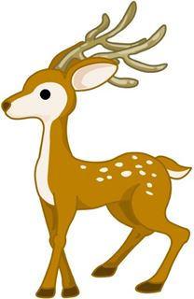 This de_ _ is looking for his mom.
Đáp án: er
169. Ảnh: A: What is Mai doing now? - B: She is ….
A. reading a book B. doing her homework C. drawing a picture D. doing puzzles
Đáp án: doing her homework
170. Who is tall_ _ , Jack or Jim?
Đáp án: er
171. Ảnh: ______ do you see elephants? – In the zoo.
A. When B. How C. Where D. What
Đáp án: Where
172. Ảnh: 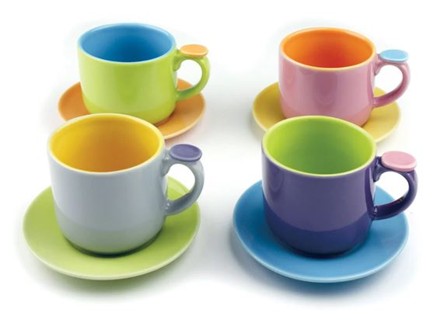 There are four pretty _ _ _ s here.
Đáp án: cup
173. Ảnh: My brother has _ _ _ robots.
Đáp án: two
174. He/ has/ three times/ English/ a week./
Đáp án: He has English three times a week.
175. It’s … in Ho Chi Minh city.
A. pets B. toys C. rainy D. chairs
Đáp án: rainy
176. Nghe: Nhấn giữ Ctrl và bấm chuột để nghe: Sally has got a _ _ _ _ _ dog.
Đáp án: black
177. Ảnh: 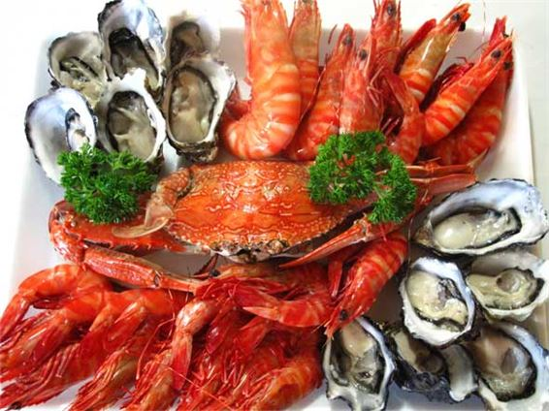 Do you like s_ _ food?
Đáp án: ea
178. What s_ _ _ _ _ ts do you like? – I like Maths and English.
Đáp án: ubjec
179. paper lion./ a/ make/ Let’s/
Đáp án: Let’s make a paper lion.
180. is/ above/ The poster/ the shelf.
Đáp án: The poster is above the shelf.
181. _______ - It’s in the city.
A. Where is your house? B. Where are you? C. Where is Hanoi? D. Where is Vietnam?
Đáp án: Where is your house?
182. Be care_ _ _ ! A car is coming fast.
Đáp án: ful
183. chess/ playing/ at break time./ likes/ Mary/
Đáp án: Mary likes playing chess at break time.
184. How’s the wea_ _ er today? – It’s sunny.
Đáp án: th
185. Her house is small but … is very nice.
A. he B. she C. they D. it
Đáp án: Chọn ý: D
186. Do you want s_ _ e milk?
Đáp án: om
187. Tom/ likes/ playing games/ very/ much./
Đáp án: Tom likes playing games very much.
188. Peter/ Linda/ hide-and-seek/ now.
A. Peter and Linda is playing hide-and-seek now. B. Peter and Linda are playing with hide-and-seek now. C. Peter and Linda playing hide-and-seek now. D. Peter and Linda are playing hide-and-seek now.
Đáp án: Chọn ý: D
189. meet/ Can/ again?/ you/ I/
Đáp án: Can I meet you again?
190. Tom re_ _ _ books in the library in the afternoon.
Đáp án: ads
191. Nghe: Nhấn giữ Ctrl và bấm chuột để nghe: Which is the slowest, a turtle, a _ _ _ _ _ _ or a cat?
Đáp án: rabbit
192. Ảnh: The boy is washing his _ _ _ .
Đáp án: dog
193. Nghe: Nhấn giữ Ctrl và bấm chuột để nghe: He is hungry. He wants something to _ _ _ .
Đáp án: eat
194. Our school is _ _ north city.
Đáp án: in
195. pencils/ His/ on/ are/ the table./
Đáp án: His pencils are on the table.
196. My be_ _ oom is small.
Đáp án: dr
197. What … your sister look like?
A. does B. do C. is D. are
Đáp án: does
198. This ... a house.
A. are B. is C. you D. here
Đáp án: is
199. Please … the window. It’s cold.
A. close B. open C. draw D. paint
Đáp án: close
200. Nghe: Nhấn giữ Ctrl và bấm chuột để nghe: Today, it is very _ _ _ _ .
Đáp án: cold

KEY IOE K3 2023 – 2024 SỐ 43
1. Let’s p_ ay outside, children.
Đáp án: l
2. Ảnh: I’m Rosie. There are four people in my family. We have a dog and a cat.
A. Picture 1 B. Picture 2 C. Picture 3 D. Picture 4
Đáp án: Chọn ý: D
3. I/ ice-cream./ and/ love/ chocolate/
Đáp án: I love chocolate and ice-cream.
4. The books are _ _ the shelves.
Đáp án: on
5. Minh … like fish and beef very much.
A. isn’t B. doesn’t C. don’t D. never
Đáp án: doesn’t
6. My dog’s _ _ _ _ is Barkie.
Đáp án: name
7. Thank you. – You are w_ _ _ _ me.
Đáp án: elco
8. Boy: M_ _ I play football here? - Man: No, you can’t.
Đáp án: ay
9. T_ _ s is a board.
Đáp án: hi
10. There is a flower va_ e on the table.
Đáp án: s
11. Put/ the/ shelf./ the books/ on/
Đáp án: Put the books on the shelf.
12. she/ in?/ class/ What/ is/
Đáp án: What class is she in?
13. There _ _ a book on my desk.
Đáp án: is
14. How m_ _ y dogs are there in the garden?
Đáp án: an
15. My father is a ... . He works hard in the field.
A. worker B. farmer C. doctor D. teacher
Đáp án: farmer
16. Nghe: Nhấn giữ Ctrl và bấm chuột để nghe: I can draw a ....
A. cat B. hat C. map D. bat
Đáp án: cat
17. ... your school bags, please.
A. Close B. Stand C. Sit D. See
Đáp án: Close
18. I/ colours./ like/ and blue/ orange/
Đáp án: I like orange and blue colours.
19. Choose the odd one out:
A. eraser B. notebook C. crayon D. England
Đáp án: Chọn ý: D
20. years/ My teacher/ twenty-five/ is/ old./
Đáp án: My teacher is twenty-five years old.
21. Is this your grandfather? – Yes, he _ _ .
Đáp án: is
22. That shirt _ _ green.
Đáp án: is
23. ... is that? - It’s a blue ball.
A. How B. When C. What D. Where
Đáp án: What
24. The students are sp_ _ king English.
Đáp án: ea
25. What colour ... that chair? – It’s yellow.
A. it B. is C. that D. hi
Đáp án: is
26. It’s an/ old/ and white/ black/ television./
Đáp án: It’s an old black and white television.
27. Look/ at/ my/ dog.
Đáp án: Look at my dog.
28. Goodbye, David. See y_ u later.
Đáp án: o
29. game/ very/ exciting./ The/ is/
Đáp án: The game is very exciting.
30. Nghe: Nhấn giữ Ctrl và bấm chuột để nghe: Sam is riding a …
A. bike B. bus C. horse D. boat
Đáp án: horse
31. Is that lit_ _ _ boy your friend? – Yes, his name is Tom.
Đáp án: tle
32. Are those your pencil sharpeners?
A. Yes, it is. B. No, it isn’t. C. Yes, they are. D. No, they are.
Đáp án: Yes, they are.
33. These are four pencil box_ _ .
Đáp án: es
34. Nghe: Nhấn giữ Ctrl và bấm chuột để nghe: _ _ _ _ _ _ _
Đáp án: grandma
35. to/ you,/ meet/ Nice/ Alex./
Đáp án: Nice to meet you, Alex.
36. Our children aren’t watching a cartoon. _ _ _ _ are doing their homework.
Đáp án: They
37. St_ _ d up, please.
Đáp án: an
38. Nghe: Nhấn giữ Ctrl và bấm chuột để nghe: My ... is very tall.
A. father B. brother C. sister D. mother
Đáp án: brother
39. Let’s play _______ piano together.
A. some B. a C. the D. with
Đáp án: the
40. How’s the wea_ _ er today? – It’s sunny.
Đáp án: th
41. Do you like football or basketball?
A. I don’t like. B. I like it. C. No, I don’t. D. I like volleyball.
Đáp án: Chọn ý: D
42. Nghe: Nhấn giữ Ctrl và bấm chuột để nghe: Look at the _ _ _ _ _ , Rosy.
Đáp án: train
43. bag./ school/ that blue/ Give me/
Đáp án: Give me that blue school bag.
44. Choose the odd one out:
A. living room B. bedroom C. garden D. kitchen
Đáp án: garden
45. Ảnh: She is _ _ _ ding under the tree.
Đáp án: rea
46. This is m_ cat.
Đáp án: y
47. June/ is/ Children’s/ Day./ 1st/
Đáp án: June 1st is Children’s Day.
48. Ảnh: She has five ….
A. toys B. pets C. dogs D. cats
Đáp án: pets
49. Nghe: Nhấn giữ Ctrl và bấm chuột để nghe: Where is Nick?
A. He is in the garden. B. He is in the bedroom. C. He is in the bathroom. D. He is in the kitchen.
Đáp án: Chọn ý: D
50. …. - Yes, my book is new.
A. Is your shoe new? B. Are these books new? C. Is that new? D. Are those new?
Đáp án: Is that new?
51. A: Are they your friends? – B: No, … aren’t.
A. we B. you C. your D. they
Đáp án: Chọn ý: D
52. Is this a bag? - ... .
A. Yes, it is B. Yes, isn’t C. No, it is D. Not, it isn’t
Đáp án: Yes, it is
53. Can you _ _ _ _ a bicycle?
Đáp án: ride
54. This is Mary. ... is my friend.
A. I B. You C. She D. He
Đáp án: She
55. “Harry Potter”?/ know/ you/ Do/ the story
Đáp án: Do you know the story “Harry Potter”?
56. desks/ are/ many/ How/ there in your classroom?/
Đáp án: How many desks are there in your classroom?
57. Are there _________ pictures on the wall?
A. a B. any C. some D. an
Đáp án: any
58. Do/ a company?/ work/ in/ your parents/
Đáp án: Do your parents work in a company?
59. Nghe: Nhấn giữ Ctrl và bấm chuột để nghe: _ _ _ _ _ _ _
Đáp án: teacher
60. What is your … drink? – I like orange juice the most.
A. name B. favourite C. much D. many
Đáp án: favourite
61. Choose the incorrect word(s) in the following sentence: What are you doing? – I’m skateing with my friends in the park.
A. are B. doing C. skateing D. with
Đáp án: skateing
62. My sister _ _ _ a doll.
Đáp án: has
63. ... morning, Peter.
A. Good’s B. Bye C. Hi D. Good
Đáp án: Chọn ý: D
64. at home/ right now?/ Are/ you/
Đáp án: Are you at home right now?
65. … your brother swim?- Yes, he can.
A. Will B. Does C. Is D. Can
Đáp án: Chọn ý: D
66. bag?/ What/ is your/ school/ colour/
Đáp án: What colour is your school bag?
67. goldfish/ his/ tank./ Peter keeps/ in the
Đáp án: Peter keeps his goldfish in the tank.
68. … do you go to school? – It’s early in the morning.
A. What B. Which C. How D. When
Đáp án: Chọn ý: D
69. Hi_ name is Peter.
Đáp án: s
70. a nice/ me/ story./ My teacher/ tells/
Đáp án: My teacher tells me a nice story.
71. _______ is his coat? - It’s on his bed.
A. When B. Where C. Who D. What
Đáp án: Where
72. How are Tom and Linda? - _ _ _ y are fine.
Đáp án: The
73. You don’t look well. ….
A. Are you ok? B. How old are you? C. What’s your name? D. What is that?
Đáp án: Are you ok?
74. Goodbye Tommy. See you s_ _ _ .
Đáp án: oon
75. Ảnh: Unscramble this word: egta ---> _ _ _ _
Đáp án: gate
76. this/ your/ Is/ friend?/ new
Đáp án: Is this your new friend?
77. This is an ora_ ge book.
Đáp án: n
78. doesn't/ She/ pets./ any/ have/
Đáp án: She doesn't have any pets.
79. I don’t like cooking but I ... singing.
A. likes B. like C. do D. to like
Đáp án: like
80. I am … England. I am English.
A. from B. to C. in D. at
Đáp án: from
81. Choose the odd one out:
A. skipping B. table tennis C. badminton D. tennis
Đáp án: skipping
82. are/ there?/ How/ many/ apples/
Đáp án: How many apples are there?
83. green./ is/ pencil/ This/
Đáp án: This pencil is green.
84. They are/ their house./ near/ at the pond/ fishing/
Đáp án: They are fishing at the pond near their house.
85. May I c_ _ _ in and study?
Đáp án: ome
86. does/ What/ do/ Khai/ after work?/
Đáp án: What does Khai do after work?
87. Nghe: Nhấn giữ Ctrl và bấm chuột để nghe: How _ _ _ are you?
Đáp án: old
88. Are you happy? – Yes, I _ _ .
Đáp án: am
89. Nghe: Nhấn giữ Ctrl và bấm chuột để nghe: Today it’s very _ _ _ _ _ .
Đáp án: windy
90. I see a rainbow. It … beautiful.
A. sees B. sounds C. has D. looks
Đáp án: Chọn ý: D
91. What ... this? - This is a pen.
A. it B. iss C. is D. are
Đáp án: is
92. My brother is tall … slim.
A. then B. and C. so D. or
Đáp án: and
93. Can you remem_ _ r my birthday?
Đáp án: be
94. on/ the sofa./ is taking/ a nap/ My dad/
Đáp án: My dad is taking a nap on the sofa.
95. Let’s sing an English s_ _ g.
Đáp án: on
96. Can the cat _ _ _ _ _ a tree? – Yes, it can.
Đáp án: climb
97. Listen ... the teacher, please.
A. on B. in C. to D. for
Đáp án: to
98. It is ... blue desk.
A. a B. am C. are D. is
Đáp án: a
99. These/ white./ are/ eggs/
Đáp án: These eggs are white.
100. have?/ many/ How/ toys/ does Tim
Đáp án: How many toys does Tim have?
101. Nghe: Nhấn giữ Ctrl và bấm chuột để nghe: I _ _ _ _ a cat.
Đáp án: have
102. Nghe: Nhấn giữ Ctrl và bấm chuột để nghe: Is it day or _ _ _ _ _ ?
Đáp án: night
103. He is Peter. He is my ... .
A. name B. family C. friend D. book
Đáp án: friend
104. Ảnh: A: Where are you going now? - B: I’m going to the ….
A. cinema B. theatre C. temple D. hospital
Đáp án: theatre
105. A: What is … name? – B: My name is Tommy.
A. we B. you C. your D. they
Đáp án: your
106. Tell me a_ _ _ _ the things in your bedroom.
Đáp án: bout
107. This is o_ r classroom.
Đáp án: u
108. Nghe: Nhấn giữ Ctrl và bấm chuột để nghe: This is my _ _ _ _ pen.
Đáp án: blue
109. A: How old are you? – B: I am … years old.
A. a B. an C. eight D. one
Đáp án: eight
110. Hoa Binh/ Is/ Ninh Binh?/ near/
Đáp án: Is Hoa Binh near Ninh Binh?
111. There is o_ e cat in that box.
Đáp án: n
112. my/ It/ bedroom./ is/ not/
Đáp án: It is not my bedroom.
113. You’re so noisy. _______, please.
A. Stand up B. Be quiet C. Close your book D. Let’s sing
Đáp án: Be quiet
114. green/ This/ book./ is a/
Đáp án: This is a green book.
115. Her name ... Sarah.
A. are B. is C. be D. am
Đáp án: is
116. This/ grandmother./ my/ is/
Đáp án: This is my grandmother.
117. FRI_ ND
Đáp án: E
118. your/ Write/ , please./ here/ name/
Đáp án: Write your name here , please.
119. It’s a b_ ue pencil.
Đáp án: l
120. I have a dog and my friend has a dog t_ _ .
Đáp án: oo
121. Ảnh: I like _ _ _ _ _ _ _ _ in the pool in summer.
Đáp án: swimming
122. Have ... nice day, Tim. – Thank you.
A. an B. the C. a D. are
Đáp án: a
123. today?/ What/ have/ subjects/ do you/
Đáp án: What subjects do you have today?
124. How do you feel? – I’m very ______?
A. hungry B. short C. pretty D. tall
Đáp án: hungry
125. Where do you live? – I live … 107 Tran Dang Ninh Street with my parents.
A. on B. in C. at D. to
Đáp án: at
126. Ảnh: The children are ….
A. playing hide-and-seek B. playing blind man’s buff C. skipping rope D. skateboarding
Đáp án: skipping rope
127. I’m fine, thank_ .
Đáp án: s
128. What’s y_ _ r name? – My name’s Tom.
Đáp án: ou
129. Hello, I am Mai. - …
A. Goodbye and see you later. B. I don’t know. C. Hi, I am fine. Thanks D. Nice to see you.
Đáp án: Chọn ý: D
130. Do you have … today?
A. Art B. write C. sing D. read
Đáp án: Art
131. Those/ are/ very/ kites/ beautiful./
Đáp án: Those kites are very beautiful.
132. The lamp is _ _ _ ween the sofa and the armchair.
Đáp án: bet
133. I can sing and I _ _ _ dance.
Đáp án: can
134. Ảnh: What are these? – These are ….
A. school things B. pencil cases C. flowers D. pens
Đáp án: school things
135. _ _ _ is wearing a red T-shirt? – My dad.
Đáp án: who
136. My pencils are _ _ the table.
Đáp án: on
137. I’m so_ _ y. I’m late.
Đáp án: rr
138. What’s ... name? - It’s Quang Trung Primary School.
A. it B. it’s C. its D. his
Đáp án: its
139. Thai Phien is a big _ _ _ _ ary school in Hai Phong.
Đáp án: prim
140. Helen often _ _ _ _ to school with her friend, Elle.
Đáp án: goes
141. the/ name of/ What is/ your/ school?/
Đáp án: What is the name of your school?
142. I’d l_ _ e an orange, please.
Đáp án: ik
143. your notebook/ borrow/ May I/ of/ Maths?/
Đáp án: May I borrow your notebook of Maths?
144. It’s time … lunch, Peter.
A. to B. in C. on D. for
Đáp án: Chọn ý: D
145. from our/ The/ is far/ flat./ sweet shop/
Đáp án: The sweet shop is far from our flat.
146. Pizza is my favourite ... .
A. drink B. food C. water D. milk
Đáp án: food
147. Nghe: Nhấn giữ Ctrl và bấm chuột để nghe: Can I borrow you ruler? – Yes, but don’t forget to give it _ _ _ _ .
Đáp án: back
148. What books are they? - T_ _ _ are Maths books.
Đáp án: hey
149. Jane is short. Alice is … .
A. slimmer B. stronger C. shorter D. bigger
Đáp án: shorter
150. Choose the odd one out:
A. blue B. pink C. green D. book
Đáp án: Chọn ý: D
151. I have a book in my schoo_ bag.
Đáp án: l
152. How ... books are there in your school bag?
A. much B. is C. are D. many
Đáp án: Chọn ý: D
153. Nghe: Nhấn giữ Ctrl và bấm chuột để nghe: It’s a nice _ _ _ _ _ _ room.
Đáp án: living
154. W_ _ t is that? – It’s a teddy bear.
Đáp án: ha
155. Ảnh: Linda has a rabbit. It’s very cute.
A. Picture 1 B. Picture 2 C. Picture 3 D. Picture 4
Đáp án: Picture 3
156. These/ flowers/ very/ are/ beautiful./
Đáp án: These flowers are very beautiful.
157. a/ Let’s/ draw/ picture.
Đáp án: Let’s draw a picture.
158. is/ a nice/ My primary/ school/ place./
Đáp án: My primary school is a nice place.
159. It’s _ _ _ today. Please turn on the fan.
Đáp án: hot
160. Nghe: Nhấn giữ Ctrl và bấm chuột để nghe: What letter do you hear?
A. I B. A C. E D. O
Đáp án: A
161. Great … you again.
A. sees B. to see C. to seeing D. on seeing
Đáp án: to see
162. How do you know my n_ _ e?
Đáp án: am
163. Choose the odd one out:
A. he B. you C. I D. yes
Đáp án: Chọn ý: D
164. Who can cl_ _ _ a tree?
Đáp án: imb
165. My father/ drives/ car/ his/ to work./
Đáp án: My father drives his car to work.
166. Nancy has a pet. It can catch a mouse. It’s a _ _ _ .
Đáp án: cat
167. … are they? – They’re my friends.
A. Who B. What C. Which D. Where
Đáp án: Who
168. That is m_ . My name is Peter.
Đáp án: e
169. I/ like/ dress./ this/ pink
Đáp án: I like this pink dress.
170. Let’s ma_ e a circle.
Đáp án: k
171. Nghe: Nhấn giữ Ctrl và bấm chuột để nghe: Let’s go to _ _ _ _ _ _ together.
Đáp án: school
172. uncle/ my/ This is/ his daughter./ and
Đáp án: This is my uncle and his daughter.
173. This _ _ my school library.
Đáp án: is
174. Ảnh: My p_ _ _ _ ts are between my sister and me.
Đáp án: aren
175. my sister’s./ and that is/ This is/ my/ bedroom/
Đáp án: This is my bedroom and that is my sister’s.
176. Nghe: Nhấn giữ Ctrl và bấm chuột để nghe: That’s a nice fence _ _ _ _ _ _ the house.
Đáp án: around
177. do/ What/ you/ break time?/ do at
Đáp án: What do you do at break time?
178. There _ _ _ eleven chairs in my class.
Đáp án: are
179. How ... you today? – I’m fine, thanks.
A. am B. is C. are D. fine
Đáp án: are
180. Ảnh: _______ zebras are there in the picture? – There are three zebras.
A. How B. What C. Where D. How many
Đáp án: Chọn ý: D
181. Is your school bag big or sm_ _ _ ?
Đáp án: all
182. What is her fa_ _ _ rite sport? – She likes doing yoga best.
Đáp án: vou
183. My brother is th_ _ e years old.
Đáp án: re
184. What’s the weather _ _ _ _ in Ho Chi Minh City?
Đáp án: like
185. Lan/ pets/ like?/ What/ does/
Đáp án: What pets does Lan like?
186. This/ is/ doll./ a/
Đáp án: This is a doll.
187. Choose the odd one out:
A. thirty B. seventy C. eighty D. twelve
Đáp án: Chọn ý: D
188. My family/ is/ TV/ now./ watching/
Đáp án: My family is watching TV now.
189. Nghe: Nhấn giữ Ctrl và bấm chuột để nghe: She has _ _ _ cats.
Đáp án: two
190. Nghe: Nhấn giữ Ctrl và bấm chuột để nghe: Where are the _ _ _ _ _ s?
Đáp án: chair
191. Ảnh: That’s a _ _ _ . It’s big.
Đáp án: cow
192. … to meet you, Alice.
A. Well B. Fine C. Nice D. Kind
Đáp án: Nice
193. is/ This/ robot/ you./ for
Đáp án: This robot is for you.
194. The _ _ _ of my father is my brother.
Đáp án: son
195. Ảnh: My brother has _ _ _ robots.
Đáp án: two
196. Good morning, Peter. - ... .
A. Good morning, Jean B. Good night, Jean C. My name’s Jean D. Jean, this is my pen
Đáp án: Good morning, Jean
197. Nghe: Nhấn giữ Ctrl và bấm chuột để nghe: They go to school by _ _ _ .
Đáp án: bus
198. How/ old/ you,/ are/ Quang?/
Đáp án: How old are you, Quang?
199. M_ _ I play football here? - No, you can’t.
Đáp án: ay
200. _ _ _ you twelve years old?
Đáp án: Are

KEY IOE K3 2023 - 2024 SỐ 44
1. What col_ _ r is this book? – It’s red.
Đáp án: ou
2. My little brother often … his kite when he’s not busy.
A. does B. plays C. goes D. flies
Đáp án: Chọn ý: D
3. a look/ at that/ have/ May I/ shirt?/
Đáp án: May I have a look at that shirt?
4. Ha: _ _ _ _ colour is that pen? - Mai: It is a blue.
Đáp án: What
5. Is this a ruler? - ..., it is.
A. That B. Yes C. This D. His
Đáp án: Yes
6. often/ My sister/ to school/ goes/ with me./
Đáp án: My sister often goes to school with me.
7. Nghe: Nhấn giữ Ctrl và bấm chuột để nghe: He has five _ _ _ _ _ _ _ .
Đáp án: parrots
8. That is Lan. _ _ _ is my friend.
Đáp án: she
9. What do you have _ _ _ breakfast? – I have sandwiches.
Đáp án: for
10. in/ my bag./ a book/ I have/
Đáp án: I have a book in my bag.
11. Circle the ans_ er, please.
Đáp án: w
12. my class./ There are/ only/ in/ three girls/
Đáp án: There are only three girls in my class.
13. is/ not near/ My/ the city./ home village/
Đáp án: My home village is not near the city.
14. What are they? – They are ….
A. red B. small C. stars D. big
Đáp án: stars
15. Nghe: Nhấn giữ Ctrl và bấm chuột để nghe: _ _ _ _ _
Đáp án: white
16. Let’s ma_ e a circle.
Đáp án: k
17. H_ _ _ y birthday to you. – Thank you.
Đáp án: app
18. What colour is that pencil? – It’s ... .
A. book B. crayon C. ruler D. blue
Đáp án: Chọn ý: D
19. Dr_ _ a big brown dog, please.
Đáp án: aw
20. _ _ _ _ _ is the poster? – It’s on the wall.
Đáp án: where
21. It is _ desk.
Đáp án: a
22. Goodbye, John. See you ... .
A. agains B. again C. again’s D. see again
Đáp án: again
23. are/ on the/ apples/ table./ The/
Đáp án: The apples are on the table.
24. _ s this a pencil? – Yes, it is.
Đáp án: I
25. Ảnh: 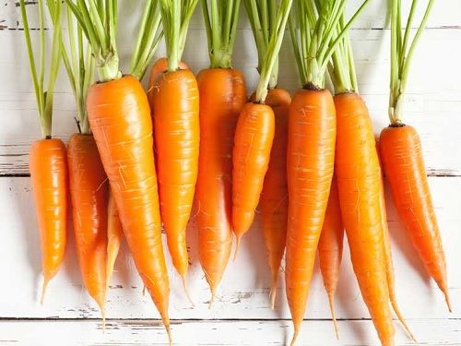 Do you like _ _ _ _ _ _ s?
Đáp án: carrot
26. likes/ chess./ books about/ reading/ They/
Đáp án: They likes reading books about chess.
27. Which word has the letter ‘g’ pronounced as the letter ‘g’ in \"gym\"?
A. orange B. go C. skating D. granddad
Đáp án: orange
28. Nghe: Nhấn giữ Ctrl và bấm chuột để nghe: Nina is a _ _ _ .
Đáp án: cat
29. Let’s go out for _ _ _ ner. I’m hungry now.
Đáp án: din
30. Nghe: Nhấn giữ Ctrl và bấm chuột để nghe: What colour are her eyes? - _ _ _ _ .
Đáp án: Blue
31. Nghe: Nhấn giữ Ctrl và bấm chuột để nghe: Her English teacher is Mr. _ _ _ _ .
Đáp án: tony
32. any/ you/ pets?/ Do/ have/
Đáp án: Do you have any pets?
33. These books are for you. – Thank you very m_ _ h.
Đáp án: uc
34. Nghe: Nhấn giữ Ctrl và bấm chuột để nghe: _ _ _ _ _ _ _ _
Đáp án: thirteen
35. Ảnh: A: Where is the cat? - B: It’s behind the box.
A. Picture 1 B. Picture 2 C. Picture 3 D. Picture 4
Đáp án: Chọn ý: D
36. ...? - He’s from France.
A. Where is he from B. What’s his name C. What does he do D. What’s his nationality
Đáp án: Where is he from
37. A: Where’s my school bag, Mum? - B: ....
A. It’s very big and pretty. B. It’s red and orange. C. I have a small school bag. D. I don’t know, son.
Đáp án: Chọn ý: D
38. Susan/ wearing/ shirts?/ Does/ like/
Đáp án: Does Susan like wearing shirts?
39. Sing wit_ me.
Đáp án: h
40. Nghe: Nhấn giữ Ctrl và bấm chuột để nghe: I _ _ _ _ a cat.
Đáp án: have
41. Is that your new pencil case? - No, it isn’t. It’s ….
A. my sister’s B. him C. her D. my brother
Đáp án: my sister’s
42. _ _ _ _ _ is a doll.
Đáp án: There
43. Ha Noi is in n_ _ _ _ Viet Nam.
Đáp án: orth
44. Would you like ... to the movies tonight?
A. go B. going C. to go D. goes
Đáp án: to go
45. The lamp is _ _ _ ween the sofa and the armchair.
Đáp án: bet
46. Which word has the underlined part pronounced differently from the letter ‘U’ in “TRUCK”?
A. cupboard B. funny C. sunny D. picture
Đáp án: Chọn ý: D
47. Nghe: Nhấn giữ Ctrl và bấm chuột để nghe: _ _ _ _ _ _ _
Đáp án: running
48. I can/ dance/ swim./ I can’t/ but/
Đáp án: I can’t dance but I can swim.
49. room./ a bookcase/ my/ There’s/ in/
Đáp án: There’s a bookcase in my room.
50. Ảnh: 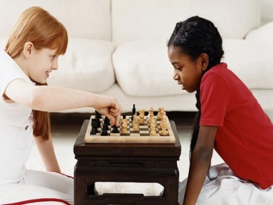 We like playing _ _ _ _ _ after school.
Đáp án: chess
51. These … members of my family.
A. is B. are C. am D. be
Đáp án: are
52. old/ are/ How/ and Peter?/ Tim
Đáp án: How old are Tim and Peter?
53. How do you spell the wo_ _ ’’MONKEY’’?
Đáp án: rd
54. Look that woman! _ _ _ ’s my teacher.
Đáp án: She
55. Thank you very much. – You’re w_ _ _ _ me.
Đáp án: elco
56. A: How old is your grandma? - B: … fifty-nine years old.
A. She is B. He is C. They are D. We are
Đáp án: She is
57. These a_ _ pink desks.
Đáp án: re
58. Nghe: Nhấn giữ Ctrl và bấm chuột để nghe: Which is the _ _ _ _ _ _ _ , a giraffe, an elephant or a monkey? – Of course, a giraffe.
Đáp án: tallest
59. Would you like some …? – No, thanks. I hate sweets.
A. coffee B. lemonade C. chocolate D. chicken
Đáp án: chocolate
60. What/ is/ teacher’s/ name?/ your/
Đáp án: What is your teacher’s name?
61. Helen often _ _ _ _ to school with her friend, Elle.
Đáp án: goes
62. Ảnh: 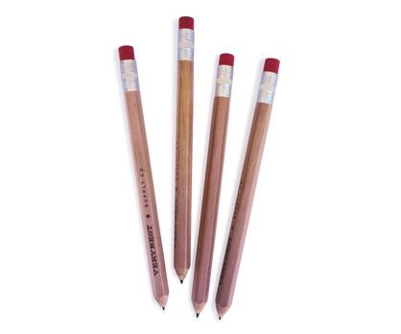 I have four p_ _ _ _ _ _ in my school bag today
Đáp án: encils
63. Ninh _ _ _ _ _ comic books in his classroom at break time.
Đáp án: reads
64. the park/ Nam is/ his friends./ in/ with
Đáp án: Nam is in the park with his friends.
65. They/ are/ in/ the kitchen./ talking/
Đáp án: They are talking in the kitchen.
66. Where is the chair? - It's _____ my bedroom.
A. on B. in C. at D. to
Đáp án: in
67. Ope_ your book.
Đáp án: n
68. Ảnh: My p_ _ _ _ ts are between my sister and me.
Đáp án: aren
69. Linda is her _ _ me.
Đáp án: na
70. Pick _ _ your ruler.
Đáp án: up
71. A: Is he Tony? – B: No, … .
A. he is B. he isn’t C. he not is D. not he is
Đáp án: he isn’t
72. there?/ many/ keys/ are/ How/
Đáp án: How many keys are there?
73. Choose the letter(s) to make a correct word: chi__en
A. sk B. ck C. cc D. kk
Đáp án: ck
74. a look/ Come in/ at/ my bedroom./ and take/
Đáp án: Come in and take a look at my bedroom.
75. Ảnh: 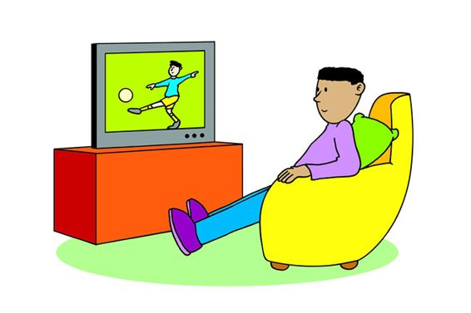 Look at the picture and choose the TRUE statement.
A. He is watching a football match on TV. B. He is sitting on the chair. C. There is a teddy bear behind him. D. There is a computer in front of him.
Đáp án: He is watching a football match on TV.
76. Nghe: Nhấn giữ Ctrl và bấm chuột để nghe: ... are you?
A. who B. where C. how D. what
Đáp án: how
77. Nghe: Nhấn giữ Ctrl và bấm chuột để nghe: There are _ _ _ teen children in the girl’s class.
Đáp án: fif
78. friends/ are/ Her/ France./ from
Đáp án: Her friends are from France.
79. Come and _ _ at with your friends.
Đáp án: ch
80. Do you like colouring? – Yes, it is so m_ _ _ fun.
Đáp án: uch
81. and blue/ like/ orange/ I/ colours./
Đáp án: I like orange and blue colours.
82. This/ is/ my/ friend./ new
Đáp án: This is my new friend.
83. books/ How/ have?/ many/ do you
Đáp án: How many books do you have?
84. ... I go out?
A. May B. My C. Me D. Mai
Đáp án: May
85. ... are you? – I’m fine, thanks.
A. When B. How C. What D. Who
Đáp án: How
86. What is her fa_ _ _ rite sport? – She likes doing yoga best.
Đáp án: vou
87. Great … you again.
A. sees B. to see C. to seeing D. on seeing
Đáp án: to see
88. We catch a bus _ _ school every schoolday.
Đáp án: to
89. family/ is/ his/ name?/ What/
Đáp án: What is his family name?
90. Which word has the letter ‘e’ pronounced as the letter ‘e’ in \"yes\"?
A. new B. orange C. come D. bed
Đáp án: Chọn ý: D
91. How are ..., Mary? – I’m fine, thanks.
A. he B. she C. you D. his
Đáp án: you
92. in the/ Do you/ late/ evening?/ come home/
Đáp án: Do you come home late in the evening?
93. My new _ _ _ _ _ _ is Adam.
Đáp án: friend
94. Who can p_ _ _ the guitar? – Dad.
Đáp án: lay
95. How’s the weather today?
A. It’s a cloud. B. It’s cloudy. C. It’s fine, thank you. D. It has a sun.
Đáp án: It’s cloudy.
96. _ _ they have a pet?
Đáp án: Do
97. Listen ... the teacher, please.
A. on B. in C. to D. for
Đáp án: to
98. All members of my family like d_ _ _ _ sports.
Đáp án: oing
99. Nice to meet you. - ….
A. Bye. See you later. B. I am fine. Thank you. C. It’s rainy. D. Glad to meet you too.
Đáp án: Chọn ý: D
100. forest./ is/ near the/ house/ The/
Đáp án: The house is near the forest.
101. volleyball/ after/ He often/ plays/ school./
Đáp án: He often plays volleyball after school.
102. … are you? – I’m fine, thanks.
A. What B. How C. Who D. Where
Đáp án: How
103. How’s the wea_ _ er today? – It’s sunny.
Đáp án: th
104. like/ best./ I/ Art/ lessons
Đáp án: I like Art lessons best.
105. Nice to meet ..., too .
A. me B. he C. your D. you
Đáp án: Chọn ý: D
106. the/ shelf./ the books/ Put/ on/
Đáp án: Put the books on the shelf.
107. These _____ old notebooks.
A. am B. is C. are D. have
Đáp án: are
108. ... that a pink pencil? – No, it isn’t.
A. Are B. Is C. Who D. When
Đáp án: Is
109. are/ cups/ These/ blue.
Đáp án: These cups are blue.
110. What is his friend’s name? - … name is Anna.
A. His B. Their C. Her D. She
Đáp án: Her
111. Is school fun? - Yes, it is so _ _ ch fun.
Đáp án: mu
112. Do/ “Tom and Jerry”?/ you/ like/
Đáp án: Do you like “Tom and Jerry”?
113. ... your teeth, John.
A. Read B. Listen C. Stand D. Brush
Đáp án: Chọn ý: D
114. The picture is _ _ the wall.
Đáp án: on
115. Nghe: Nhấn giữ Ctrl và bấm chuột để nghe: Listen and choose the correct phrases you hear:
A. yellow bananas B. yellow brothers C. yellow apples D. yellow books
Đáp án: yellow bananas
116. There ... one ruler on that desk.
A. am B. an C. is D. are
Đáp án: is
117. Is your school big? - _ _ _ , it is.
Đáp án: Yes
118. A: … do you go shopping? – B: Once a week.
A. How many B. What C. How often D. When
Đáp án: How often
119. Nghe: Nhấn giữ Ctrl và bấm chuột để nghe: Flames come out of the _ _ _ _ _ _ .
Đáp án: window
120. My bedroom is ... big. It’s small.
A. no B. not C. yes D. hi
Đáp án: not
121. planting some flowers/ the garden./ My grandmother/ in/ is/
Đáp án: My grandmother is planting some flowers in the garden.
122. Ảnh: 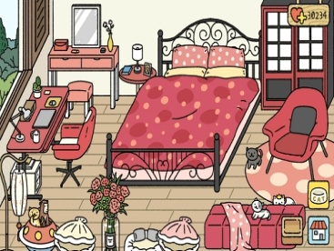 How many beds are there in the room?
A. One. B. Two. C. Three. D. Four.
Đáp án: One.
123. Dr_ _ a big brown dog, please.
Đáp án: aw
124. Nghe: Nhấn giữ Ctrl và bấm chuột để nghe: _ _ love pets.
Đáp án: We
125. is/ favourite/ your/ What/ subject?/
Đáp án: What is your favourite subject?
126. Is this a bag? - ... .
A. Yes, it is B. Yes, isn’t C. No, it is D. Not, it isn’t
Đáp án: Yes, it is
127. _ _ _ _ is your favourite drink? – I like orange juice.
Đáp án: what
128. Ảnh: _ _ _ _ _ your answer, please.
Đáp án: write
129. favourite/ Science/ your/ subject?/ Is/
Đáp án: Is Science your favourite subject?
130. GA__EN
A. AR B. RD C. RT D. D
Đáp án: RD
131. Ảnh: 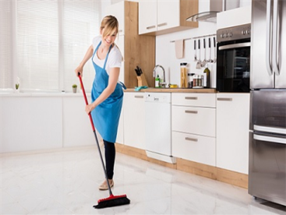 Nguyet is _ _ _ _ _ _ _ _ the floor.
Đáp án: cleaning
132. a/ Mary/ skirt./ has/ green
Đáp án: Mary has a green skirt.
133. I’m ... a letter to my friend at the moment.
A. writing B. writes C. written D. to write
Đáp án: writing
134. You and … are friends forever.
A. me B. my C. I D. myself
Đáp án: I
135. Bella likes playing _ _ _ guitar.
Đáp án: the
136. Glad to meet you. – Glad to meet you, _ _ _ .
Đáp án: too
137. Mary likes to read books in the school li_ _ ary.
Đáp án: br
138. Let’s play _______ piano together.
A. some B. a C. the D. with
Đáp án: the
139. It is/ sunny/ always/ in/ summer./
Đáp án: It is always sunny in summer.
140. We like … to music in the morning.
A. listen B. listening C. listens D. not listen
Đáp án: listening
141. Ảnh: Where is your sister? – She is sitting in the armchair ______ the living room.
A. in B. on C. at D. between
Đáp án: in
142. What day is it _ _ _ ay?
Đáp án: tod
143. Is your bedroom big? – No, it’s s_ _ ll.
Đáp án: ma
144. Nghe: Nhấn giữ Ctrl và bấm chuột để nghe: _ _ _ _ _
Đáp án: photo
145. This/ is a/ grandparents and/ my uncles./ photo of my/
Đáp án: This is a photo of my grandparents and my uncles.
146. Nghe: Nhấn giữ Ctrl và bấm chuột để nghe: The cat walks _ _ _ _ to the ball.
Đáp án: over
147. Linda/ like/ play/ guitar
A. Linda likes playing guitar. B. Linda like playing the guitar. C. Linda likes playing a guitar. D. Linda like playing guitar.
Đáp án: Linda likes playing guitar.
148. P_ _ your hand down, Simon.
Đáp án: ut
149. twelve/ in my class./ students/ are/ There/
Đáp án: There are twelve students in my class.
150. give/ Please,/ me/ some/ more pencils./
Đáp án: Please, give me some more pencils.
151. How _ _ _ _ dogs do you have? – I don’t have any dogs.
Đáp án: many
152. Please c_ _ _ t from 1 to 10 in English.
Đáp án: oun
153. … do you like to play? – I like to play hide-and-seek.
A. What B. Where C. When D. How
Đáp án: What
154. twelve/ is/ old./ She/ years
Đáp án: She is twelve years old.
155. This is Mary. ... is my friend.
A. I B. You C. She D. He
Đáp án: She
156. Ảnh: 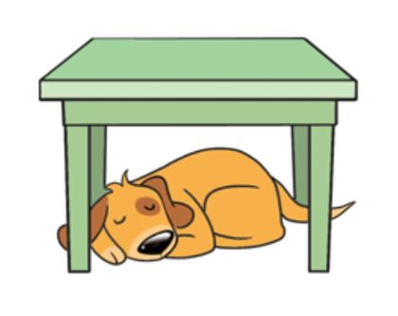 My dog is sleeping _ _ _ _ _ the table.
Đáp án: under
157. Ảnh: What is it? – It’s a … .
A. pencil B. pen C. book D. crayon
Đáp án: Chọn ý: D
158. Ảnh: 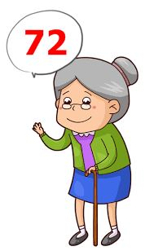 A: Is your grandma … years old? - B: Yes, she is.
A. seventy-two B. twenty-seven C. seventy-seven D. twenty-two
Đáp án: seventy-two
159. Nghe: Nhấn giữ Ctrl và bấm chuột để nghe: My _ _ _ _ _ are black.
Đáp án: shoes
160. She’s learning how to _ _ _ _ spaghetti.
Đáp án: cook
161. Ảnh: Do you have toys? – Yes, I have a _ _ _ _ .
Đáp án: doll
162. Our school is _ _ north city.
Đáp án: in
163. A … helps people with sickness.
A. doctor B. worker C. farmer D. housewife
Đáp án: doctor
164. aloud./ Read/ chant/ the/
Đáp án: Read the chant aloud.
165. _ _ _ _ _ birthday to you, Katie.
Đáp án: Happy
166. Choose the odd one out:
A. living room B. bedroom C. garden D. kitchen
Đáp án: garden
167. cousin./ my/ The girl/ is/ over there/
Đáp án: The girl over there is my cousin.
168. Lan is a … at Thong Nhat primary school.
A. farmer B. worker C. student D. doctor
Đáp án: student
169. It’s/ teddy/ Rosie’s/ not/ bear./
Đáp án: It’s not Rosie’s teddy bear.
170. are/ playing/ badminton/ My friends/ at the court./
Đáp án: My friends are playing badminton at the court.
171. He _ _ _ swim but he can’t dance.
Đáp án: can
172. It is n_ t my chair.
Đáp án: o
173. M_ _ I go out?
Đáp án: ay
174. How many wardrobes ________? - There is one.
A. is there B. there is C. there are D. are there
Đáp án: Chọn ý: D
175. Choose the odd one out:
A. skipping B. table tennis C. badminton D. tennis
Đáp án: skipping
176. Nghe: Nhấn giữ Ctrl và bấm chuột để nghe: There are schools all _ _ _ _ _ _ the world.
Đáp án: around
177. … are my new books? - They are under the table.
A. What B. How C. When D. Where
Đáp án: Chọn ý: D
178. My brother likes to dri_ _ milk very much.
Đáp án: nk
179. I don’t like rock _ _ _ ic much.
Đáp án: mus
180. How is the ______ today?
A. activity B. colour C. weather D. age
Đáp án: weather
181. school/ our/ bags./ Those/ are/
Đáp án: Those are our school bags.
182. in/ family./ There are/ five people/ Phong’s
Đáp án: There are five people in Phong’s family.
183. A: Is your house _ _ _ _ the cinema? - B: No, it’s very far.
Đáp án: near
184. The o_ _ computer is very slow.
Đáp án: ld
185. She sometimes goes to school ... foot.
A. by B. to C. on D. in
Đáp án: on
186. How/ old/ father?/ is/ your
Đáp án: How old is your father?
187. Mary is … . She wants some water.
A. hungry B. thirsty C. sick D. pretty
Đáp án: thirsty
188. Nghe: Nhấn giữ Ctrl và bấm chuột để nghe: My _ _ _ is blue.
Đáp án: bed
189. Today,/ is/ the/ nice./ weather/
Đáp án: Today, the weather is nice.
190. Nghe: Nhấn giữ Ctrl và bấm chuột để nghe: I’ve got an _ _ _ .
Đáp án: egg
191. the/ bathroom?/ Is/ he/ in/
Đáp án: Is he in the bathroom?
192. What colour ... this?
A. it B. this C. that D. is
Đáp án: Chọn ý: D
193. She _______ a picture.
A. take B. drawing C. is drawing D. draw
Đáp án: is drawing
194. you play/ badminton/ Do/ yard at break time?/ in the school
Đáp án: Do you play badminton in the school yard at break time?
195. hobby?/ What/ is/ your/
Đáp án: What is your hobby?
196. This is our w_ _ home from school.
Đáp án: ay
197. Which is your school? – This _ _ _ .
Đáp án: one
198. What’s your nam_ ?
Đáp án: e
199. My b_ _ thday is in May.
Đáp án: ir
200. today./ The weather/ is/ very/ cold
Đáp án: The weather is very cold today.

KEY IOE K3 2023 - 2024 SỐ 45
1. St_ _ d up, please.
Đáp án: an
2. What grade are you …, James?
A. on B. at C. of D. in
Đáp án: Chọn ý: D
3. Nghe: Nhấn giữ Ctrl và bấm chuột để nghe: Listen and choose the correct phrases you hear:
A. It’s a B. I am C. I can D. I do
Đáp án: I can
4. is far/ The/ from our/ sweet shop/ flat./
Đáp án: The sweet shop is far from our flat.
5. This pen is _ _ _ blue. It’s green.
Đáp án: not
6. What/ have?/ pets/ do/ you
Đáp án: What pets do you have?
7. bedroom/ is/ very/ large./ Mary’s/
Đáp án: Mary’s bedroom is very large.
8. over there?/ on the desk/ that/ Is/ your pencil sharpener/
Đáp án: Is that your pencil sharpener on the desk over there?
9. your house/ a/ have/ Does/ garage?/
Đáp án: Does your house have a garage?
10. What is your favourite …? – I like pink.
A. food B. drink C. subject D. colour
Đáp án: Chọn ý: D
11. … to meet you, Alice.
A. Well B. Fine C. Nice D. Kind
Đáp án: Nice
12. Nghe: Nhấn giữ Ctrl và bấm chuột để nghe: He’s ..... years old.
A. two B. nine C. late D. eight
Đáp án: Chọn ý: D
13. Nghe: Nhấn giữ Ctrl và bấm chuột để nghe: The ... is yellow.
A. bag B. bat C. bus D. book
Đáp án: bus
14. Mary and Peter can … Vietnamese.
A. speaks B. speak C. to speak D. a speak
Đáp án: speak
15. May I ... out?
A. ride B. go C. meet D. come
Đáp án: go
16. Nghe: Nhấn giữ Ctrl và bấm chuột để nghe: How old is her grandfather? – He’s ______.
A. 51 B. 52 C. 53 D. 54
Đáp án: 53
17. A: Do you have a cat? - B: No, I _ _ _ ’t.
Đáp án: don
18. There are s_ _ en days in a week.
Đáp án: ev
19. Are there _________ clocks on the table?
A. a B. an C. some D. any
Đáp án: Chọn ý: D
20. Let’s/ learn/ English./
Đáp án: Let’s learn English.
21. Ảnh: 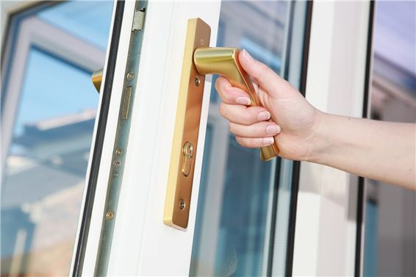 May I open the …? – Yes, you can.
A. book B. pencil case C. notebook D. door
Đáp án: Chọn ý: D
22. Is your classroom ...? - No, it is small.
A. big B. this C. bye D. nice
Đáp án: big
23. H_ _ many books are there in your bag?
Đáp án: ow
24. brother/ nine/ My/ years old./ is/
Đáp án: My brother is nine years old.
25. How/ your/ name?/ do I/ spell/
Đáp án: How do I spell your name?
26. Ảnh: They are … .
A. pencils B. sharpeners C. rulers D. erasers
Đáp án: Chọn ý: D
27. Van: What’s that tall building there? - Lan: It’s _ _ new school
Đáp án: my
28. Glad to meet you. – Glad to meet you, _ _ _ .
Đáp án: too
29. Ảnh: Look at the picture and choose the FALSE statement.
A. There is a book on the table. B. There is a picture on the wall. C. There is a cat next to the armchair. D. There is a ball under the table.
Đáp án: There is a picture on the wall.
30. Nancy has a pet. It can catch a mouse. It’s a _ _ _ .
Đáp án: cat
31. ...at colour is this? – It’s blue.
A. Wt B. Ho C. Wh D. We
Đáp án: Wh
32. Ảnh: Please turn on the _ _ _ _ . The room is dark.
Đáp án: lamp
33. FRI_ ND
Đáp án: E
34. Ảnh: 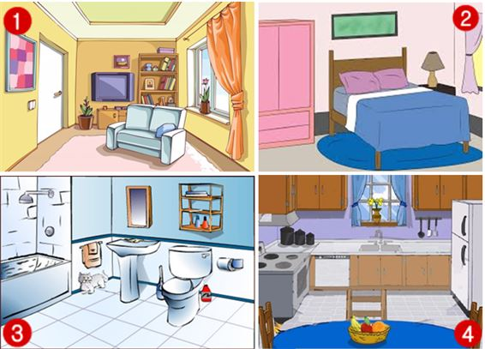 Where is the cat?
A. Picture 1 B. Picture 2 C. Picture 3 D. Picture 4
Đáp án: Picture 3
35. _ _ y you help me? I can’t do it.
Đáp án: Ma
36. Choose the odd one out.
A. pencil B. door C. book D. ruler
Đáp án: door
37. Do you play _ _ _ guitar in the afternoon? – Yes, I do.
Đáp án: the
38. My father … to work at 6 o’clock.
A. go B. play C. goes D. plays
Đáp án: goes
39. Gi_ e me the book, please.
Đáp án: v
40. What grade … your twin brothers in?
A. am B. is C. are D. do
Đáp án: are
41. It’s a b_ ue pencil.
Đáp án: l
42. bluff/ at/ break time?/ play/ blind man’s/ Does Khanh/
Đáp án: Does Khanh play blind man’s bluff at break time?
43. toybox./ a red/ We have/ in our/ plane/
Đáp án: We have a red plane in our toybox.
44. birthday?/ is/ When/ your/
Đáp án: When is your birthday?
45. you/ like/ “Tom and Jerry”?/ Do/
Đáp án: Do you like “Tom and Jerry”?
46. Hello. My name’s Tommy. - ... .
A. See you later B. Good night C. Hi. I am Tim. Nice to meet you D. Goodbye
Đáp án: Hi. I am Tim. Nice to meet you
47. Nghe: Nhấn giữ Ctrl và bấm chuột để nghe: Mike’s favourite pet is his ….
A. dog B. parrot C. cat D. rabbit
Đáp án: dog
48. Does/ your/ friend/ a robot?/ have
Đáp án: Does your friend have a robot?
49. Ảnh: 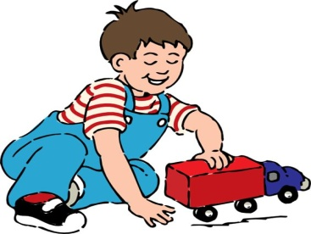 My brother is playing with a ….
A. plane B. kite C. ship D. truck
Đáp án: Chọn ý: D
50. Odd one out:
A. school B. cinema C. place D. circus
Đáp án: place
51. How are you, Tommy? - ... .
A. I’m ten years old B. She’s my sister C. I’m fine, thank you. And you? D. See you later
Đáp án: I’m fine, thank you. And you?
52. My birthday is in _ _ cember.
Đáp án: De
53. Do you/ man’s/ bluff?/ blind/ like/
Đáp án: Do you like blind man’s bluff?
54. How many ______ are there in your pencil case?
A. ruler B. pencil C. rubber D. markers
Đáp án: Chọn ý: D
55. What’s his name? – H_ s name is Peter.
Đáp án: i
56. my birthday present/ The cat/ my parents./ is/ from
Đáp án: The cat is my birthday present from my parents.
57. _________ likes doing yoga, mom or Uncle John? – My mom.
A. What B. Which C. Who D. When
Đáp án: Who
58. my/ not/ Thanh/ sister./ is/
Đáp án: Thanh is not my sister.
59. Are you ______? – No. I’m full.
A. thirsty B. hungry C. hot D. tired
Đáp án: hungry
60. Nghe: Nhấn giữ Ctrl và bấm chuột để nghe: Look! Here is a _ _ _ _ .
Đáp án: kite
61. Look! Birds … in the sky.
A. flies B. fly C. is flying D. are flying
Đáp án: Chọn ý: D
62. The pond/ is/ large./ our house/ of/
Đáp án: The pond of our house is large.
63. ... I go out?
A. May B. My C. Me D. Mai
Đáp án: May
64. Is your school bag blue? - Y_ _ , it is.
Đáp án: es
65. Goodbye. See you aga_ _ .
Đáp án: in
66. four paintings/ and a big poster/ on/ There are/ the wall./
Đáp án: There are four paintings and a big poster on the wall.
67. Is he playing t_ _ _ e tennis in the gym?
Đáp án: abl
68. classroom./ is/ This/ our/
Đáp án: This is our classroom.
69. the story/ Do/ know/ “Harry Potter”?/ you/
Đáp án: Do you know the story “Harry Potter”?
70. Ảnh: I keep my parrot in a _ _ _ _ .
Đáp án: cage
71. I’m Mai. H_ _ are you? – I’m fine, thanks.
Đáp án: ow
72. pencil case?/ in your/ Are/ there any/ crayons/
Đáp án: Are there any crayons in your pencil case?
73. Who is bigger, Jane _ _ Alice?
Đáp án: or
74. Nghe: Nhấn giữ Ctrl và bấm chuột để nghe: Which is NOT mentioned in the recording?
A. garden B. bathroom C. bedroom D. kitchen
Đáp án: bedroom
75. is/ bag/ Your/ pink./ school/
Đáp án: Your school bag is pink.
76. Ảnh: Do you like playing …?
A. football B. paper boats C. chess D. hide-and-seek
Đáp án: paper boats
77. I have m_ _ y toys.
Đáp án: an
78. A: Is the dining room large? - B: No, it isn’t. It’s sm_ _ _ .
Đáp án: all
79. He can … with a yo-yo.
A. play B. catch C. do D. say
Đáp án: play
80. his friends./ with/ Nam is/ in/ the park/
Đáp án: Nam is in the park with his friends.
81. old?/ your father/ Is/ years/ forty-one/
Đáp án: Is your father forty-one years old?
82. Ảnh: They are _ _ _ _ _ _ kites in the playground.
Đáp án: flying
83. These fl_ _ ers are for you, Mary. – Thank you.
Đáp án: ow
84. Her house is small but … is very nice.
A. he B. she C. they D. it
Đáp án: Chọn ý: D
85. Nghe: Nhấn giữ Ctrl và bấm chuột để nghe: He’s _ _ _ _ _ years old.
Đáp án: eight
86. Ảnh: What are these? - They are my sc_ _ _ _ things for this new year.
Đáp án: hool
87. My father can dr_ _ e a car.
Đáp án: iv
88. How _ _ _ _ pencils are there in the box?
Đáp án: many
89. That is my s_ _ _ _ _ library.
Đáp án: chool
90. Thank you. – You are w_ _ _ _ me.
Đáp án: elco
91. This _ _ my school library.
Đáp án: is
92. _ _ _ _ Mr. Black have a new car?
Đáp án: Does
93. Could you tell me the way … the hospital?
A. on B. at C. to D. in
Đáp án: to
94. Would you _ _ _ _ some cakes?
Đáp án: like
95. Is that a yellow kite? - _ _ , it isn’t.
Đáp án: no
96. … subjects do you have on Tuesday?
A. What B. How C. Who D. When
Đáp án: What
97. near/ their house./ They are/ at the pond/ fishing/
Đáp án: They are fishing at the pond near their house.
98. He/ young./ and/ is/ tall/
Đáp án: He is tall and young.
99. My friends and I … a new way to learn English.
A. go B. look C. find D. do
Đáp án: find
100. Nghe: Nhấn giữ Ctrl và bấm chuột để nghe: This is a bike. It’s a _ _ _ _ bike.
Đáp án: fast
101. wardrobe?/ colour/ is/ your/ What/
Đáp án: What colour is your wardrobe?
102. Hoa: Where does Minh study? - Nga: He studies at Le Ngoc Han Pri_ _ _ _ School.
Đáp án: mary
103. How’s the weather today?
A. It’s a cloud. B. It’s cloudy. C. It’s fine, thank you. D. It has a sun.
Đáp án: It’s cloudy.
104. sleeping in/ is/ Hieu/ bedroom./ his
Đáp án: Hieu is sleeping in his bedroom.
105. These a_ _ pink desks.
Đáp án: re
106. Nghe: Nhấn giữ Ctrl và bấm chuột để nghe: Little cloud changes into a _ _ _ _ _ cloud.
Đáp án: giant
107. What are you doing? – I am _ _ _ _ _ _ _ _ TV.
Đáp án: watching
108. A: How many … do you have? - B: Six.
A. fish B. dog C. cat D. hen
Đáp án: fish
109. in/ three girls/ my class./ only/ There are/
Đáp án: There are only three girls in my class.
110. bedroom/ lovely./ Your/ is/
Đáp án: Your bedroom is lovely.
111. How is the weather ... London today?
A. at B. on C. in D. to
Đáp án: in
112. a big/ tree/ There is/ my garden./ in
Đáp án: There is a big tree in my garden.
113. The picture is _ _ _ _ _ _ _ the window and the shelf.
Đáp án: between
114. you,/ to/ Jimmy./ Happy/ birthday/
Đáp án: Happy birthday to you, Jimmy.
115. What is your ...? – I’m Peter.
A. name B. name’s C. meet D. friend
Đáp án: name
116. Is this your grandfather? – Yes, he _ _ .
Đáp án: is
117. The opposite of \"on\" is \"_ _ _ _ _ \".
Đáp án: under
118. Fine, thanks. A_ d you?
Đáp án: n
119. A: Does Peter have any ...? - B: Yes. He does. He has three.
A. rabbit B. parrot C. goldfish D. tortoise
Đáp án: goldfish
120. R_ ad after me, children.
Đáp án: e
121. Nghe: Nhấn giữ Ctrl và bấm chuột để nghe: Choose the TRUE statement.
A. She has a big house and a big garden. B. She has a big house and a small garden. C. She has a small house and a big garden. D. She has a small house and a small garden.
Đáp án: She has a big house and a small garden.
122. … you swim? – No, I can’t.
A. Do B. Who C. When D. Can
Đáp án: Chọn ý: D
123. L_ _ k at the board, please.
Đáp án: oo
124. _______ you have any toys?
A. Does B. Do C. Are D. Is
Đáp án: Do
125. doll./ is/ a/ This/
Đáp án: This is a doll.
126. My wife/ cooking/ a chicken/ is/ for dinner./
Đáp án: My wife is cooking a chicken for dinner.
127. The map is on the w_ _ _ .
Đáp án: all
128. that/ Who’s/ girl/ in the/ corner?/
Đáp án: Who’s that girl in the corner?
129. Those are my blue balloo_ _ .
Đáp án: ns
130. May I _ _ _ y the piano?
Đáp án: pla
131. play/ me./ with/ Let’s/
Đáp án: Let’s play with me.
132. Nghe: Nhấn giữ Ctrl và bấm chuột để nghe: Two ... are swimming in the water.
A. donkeys B. chickens C. bears D. monkeys
Đáp án: Chọn ý: D
133. My brother is tall … slim.
A. then B. and C. so D. or
Đáp án: and
134. Mai is laughing. She is ______.
A. hungry B. sad C. happy D. nervous
Đáp án: happy
135. I can … a kite.
A. this B. fly C. the D. a
Đáp án: fly
136. Good m_ _ ning, everyone.
Đáp án: or
137. Nghe: Nhấn giữ Ctrl và bấm chuột để nghe: Listen and choose the correct phrases you hear:
A. What is B. How old C. Can you D. Would you
Đáp án: How old
138. Is this a ruler? - ..., it is.
A. That B. Yes C. This D. His
Đáp án: Yes
139. Let’s w_ _ k to school today. My bike is broken.
Đáp án: al
140. I can r_ _ e a bicycle.
Đáp án: id
141. My brother can play the piano but … play the guitar.
A. can B. can not C. cannot D. cant’
Đáp án: cannot
142. It/ a/ school bus./ green/ is/
Đáp án: It is a green school bus.
143. today/ good./ The/ weather/ is
Đáp án: The weather today is good.
144. Ảnh: I have three toy cars. They are green, red and ye_ _ _ _ .
Đáp án: llow
145. His house _ _ not big.
Đáp án: is
146. Ảnh: 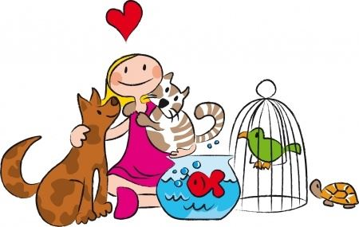 Look at the picture. Which pet DOESN’T she have?
A. A tortoise. B. A dog. C. A fish. D. A chicken.
Đáp án: Chọn ý: D
147. does/ Terry/ What/ have?/ books/
Đáp án: What books does Terry have?
148. where/ are./ I/ your bag/ don’t know/
Đáp án: I don’t know where your bag are.
149. My mother likes chatting with ….
A. I B. she C. her friends D. Minh’s
Đáp án: her friends
150. Good_ _ _ Mary. See you later.
Đáp án: bye
151. Stand _ _ , please.
Đáp án: up
152. Minh often plays football … his friends on Sunday.
A. with B. to C. of D. at
Đáp án: with
153. Nghe: Nhấn giữ Ctrl và bấm chuột để nghe: Listen and tick the word you hear:
A. Swim B. Fly C. Run D. Jump
Đáp án: Chọn ý: D
154. ... that a pink pencil? – No, it isn’t.
A. Are B. Is C. Who D. When
Đáp án: Is
155. birthday?/ my/ Can/ you/ remember/
Đáp án: Can you remember my birthday?
156. A: How old are you? – B: I am … years old.
A. a B. an C. eight D. one
Đáp án: eight
157. I am sorry. I am late. - … in please!
A. Do B. Go C. Come D. Study
Đáp án: Come
158. I go _ _ school every morning.
Đáp án: to
159. There are a lot of trees a_ _ _ nd my house.
Đáp án: rou
160. lessons/ like/ Art/ I/ best./
Đáp án: I like Art lessons best.
161. is playing/ with a/ My cat/ butterfly.
Đáp án: My cat is playing with a butterfly.
162. Nghe: Nhấn giữ Ctrl và bấm chuột để nghe: This is my school _ _ _ .
Đáp án: bag
163. notebooks/ , Alan./ your/ Take/ out/
Đáp án: Take out your notebooks , Alan.
164. Nghe: Nhấn giữ Ctrl và bấm chuột để nghe: Can I borrow you ruler? – Yes, but don’t forget to give it _ _ _ _ .
Đáp án: back
165. A: What is your sister _ _ ing? - B: She’s listening to music.
Đáp án: do
166. Ảnh: Look at the _ _ _ _ _ , please.
Đáp án: board
167. Is the girl o_ _ _ there your classmate, Rosie?
Đáp án: ver
168. I have Math on Monday and Friday. We have it ... a week.
A. once B. twice C. three times D. four times
Đáp án: twice
169. Can the cat _ _ _ _ _ a tree? – Yes, it can.
Đáp án: climb
170. This is my father. ... name is Lam.
A. Her B. His C. This D. My
Đáp án: His
171. Ảnh: There is a _ _ _ ot.
Đáp án: rob
172. A: Is there a cupboard or a wardrobe in your bedroom? - B: …
A. Yes, there is. B. There are both of them. C. My clothes are in the wardrobe. D. My toys are in the cupboard.
Đáp án: There are both of them.
173. is/ class/ What/ she/ in?/
Đáp án: What class is she in?
174. Can you come and s_ _ _ a song with me?
Đáp án: ing
175. time/ John./ homework,/ for/ It’s/
Đáp án: It’s time for homework, John.
176. Choose the odd one out:
A. How B. What C. Who D. Jane
Đáp án: Chọn ý: D
177. Who is he? - ... .
A. He my friend B. She my friend C. He is Simon. He is my good friend D. She’s Mary
Đáp án: He is Simon. He is my good friend
178. two/ I wash/ my hair/ every/ days./
Đáp án: I wash my hair every two days.
179. These … members of my family.
A. is B. are C. am D. be
Đáp án: are
180. Why does/ usually/ go to/ Jimmy/ the zoo?/
Đáp án: Why does Jimmy usually go to the zoo?
181. My uncle is going to make a cake … me.
A. from B. at C. for D. on
Đáp án: for
182. Nghe: Nhấn giữ Ctrl và bấm chuột để nghe: The dog’s name is S_ _ _ _ ge.
Đáp án: ausa
183. Ảnh: It’s a red _ _ _ _ _ . It’s ringing.
Đáp án: clock
184. Do you like … puzzles?
A. playing B. doing C. do D. play
Đáp án: doing
185. My cat/ tail./ has/ a/ long
Đáp án: My cat has a long tail.
186. Ảnh: 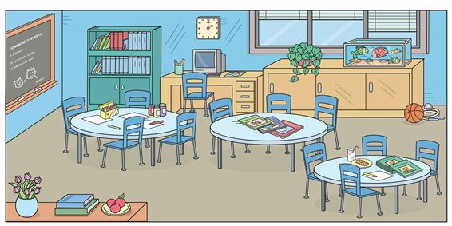 There are … round tables and … chairs.
A. one - four B. four - eleven C. five - twelve D. three - twelve
Đáp án: Chọn ý: D
187. Nghe: Nhấn giữ Ctrl và bấm chuột để nghe: A girl is eating _ _ _ ice-creams.
Đáp án: two
188. Nghe: Nhấn giữ Ctrl và bấm chuột để nghe: What is ... job?
A. her B. its C. his D. their
Đáp án: his
189. Ảnh: The _ _ _ _ is on the armchair.
Đáp án: ball
190. He...o, my name’s Lan.
A. li B. ll C. lk D. lw
Đáp án: ll
191. Ảnh: Which is not in the toy box?
A. The ball. B. The robot. C. The teddy bear. D. The truck.
Đáp án: Chọn ý: D
192. Close the d_ _ _ , please.
Đáp án: oor
193. C_ _ _ on. We don’t have much time.
Đáp án: ome
194. pen/ yours?/ is/ Which/
Đáp án: Which pen is yours?
195. What is this? - ….
A. It’s a mobile phone. B. This is nice book. C. That is a big table. D. Its a ruler.
Đáp án: It’s a mobile phone.
196. Read the world a_ _ _ _ .
Đáp án: loud
197. The opposite of IN FRONT OF is _ _ _ _ _ _ .
Đáp án: behind
198. What’s y_ ur name?
Đáp án: o
199. _ _ _ _ do you do in the afternoon? – I play badminton.
Đáp án: what
200. Nghe: Nhấn giữ Ctrl và bấm chuột để nghe: He likes _ _ _ _ _ _ .
Đáp án: trucks

KEY IOE K3 2023 - 2024 SỐ 46
1. There is a green kite ... the sky.
A. on B. at C. for D. in
Đáp án: Chọn ý: D
2. Is this your dog? – Yes, _ _ is.
Đáp án: it
3. birthday?/ is/ your/ When/
Đáp án: When is your birthday?
4. My class/ boys and/ has twenty/ girls./ twenty-two
Đáp án: My class has twenty boys and twenty-two girls.
5. These fl_ _ ers are for you, Mary. – Thank you.
Đáp án: ow
6. Lang Son is far _ _ _ _ Quang Binh.
Đáp án: from
7. Ảnh: Do you like s_ _ food?
Đáp án: ea
8. Ảnh: Look at the picture and choose the FALSE statement.
A. There is a book on the table. B. There is a picture on the wall. C. There is a cat next to the armchair. D. There is a ball under the table.
Đáp án: There is a picture on the wall.
9. What is your hobby? – I … walking the dog in the park.
A. like B. have C. can D. do
Đáp án: like
10. Play with m_ , please.
Đáp án: e
11. is reading/ book./ My friend,/ Linda,/ a
Đáp án: My friend, Linda, is reading a book.
12. … subjects do you have on Tuesday?
A. What B. How C. Who D. When
Đáp án: What
13. Can you _ _ _ _ a bicycle?
Đáp án: ride
14. _ _ _ _ _ birthday to you, Katie.
Đáp án: Happy
15. Taylor is from England. She … me every month.
A. calls B. write C. read D. speak
Đáp án: calls
16. Nghe: Nhấn giữ Ctrl và bấm chuột để nghe: The cat is _ _ _ _ _ .
Đáp án: black
17. are there/ the music room?/ boys/ in/ How many/
Đáp án: How many boys are there in the music room?
18. Ảnh: 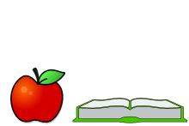 The apple is … the book.
A. next to B. on C. under D. over
Đáp án: next to
19. Ảnh: My brother likes playing _ _ _ _ _ _ ball in the school gym.
Đáp án: basket
20. Nam: Is that girl new? - Lien: I don’t kn_ _ . Ask Hoa.
Đáp án: ow
21. ... is that? - It’s a pen.
A. How B. When C. What D. Where
Đáp án: What
22. This birthday cake is … you.
A. for B. on C. of D. to
Đáp án: for
23. Play with m_ .
Đáp án: e
24. Are those his school bags? - ________
A. Yes, it is. B. Yes, they are. C. Yes, are they. D. No, they are.
Đáp án: Yes, they are.
25. Ảnh: 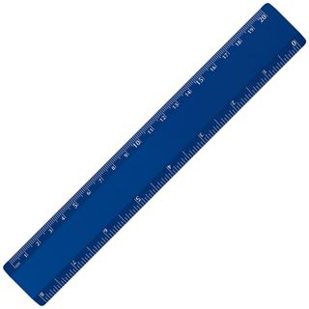 My ruler is pink. Your ruler is _ _ _ _ .
Đáp án: blue
26. Ảnh: My mother is _ _ _ _ _ _ _ for dinner.
Đáp án: cooking
27. Nghe: Nhấn giữ Ctrl và bấm chuột để nghe: He’s ..... years old.
A. two B. nine C. late D. eight
Đáp án: Chọn ý: D
28. spell/ do you/ How/ Loan?/ your name,
Đáp án: How do you spell your name, Loan?
29. During M_ _ _ s lessons, I learn about numbers.
Đáp án: ath
30. You never know how _ _ _ _ I love you, my parents.
Đáp án: much
31. Let’s ma_ e a circle.
Đáp án: k
32. Nghe: Nhấn giữ Ctrl và bấm chuột để nghe: The ... is yellow.
A. bag B. bat C. bus D. book
Đáp án: bus
33. A bird can f_ y.
Đáp án: l
34. Let’s sing an English s_ _ g.
Đáp án: on
35. boy?/ is/ Who/ little/ that/
Đáp án: Who is that little boy?
36. Nghe: Nhấn giữ Ctrl và bấm chuột để nghe: Which is NOT mentioned in the recording?
A. ball B. doll C. puzzle D. teddy
Đáp án: doll
37. shopping/ want to go/ Do you/ with me?
Đáp án: Do you want to go shopping with me?
38. Ảnh: 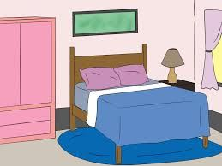 This is my parents’_ _ _ room.
Đáp án: bed
39. There are m_ _ y toys in my room.
Đáp án: an
40. Draw/ a picture/ of/ yourself.
Đáp án: Draw a picture of yourself.
41. Ha Long Bay is ______ from Hanoi.
A. near B. next to C. above D. far
Đáp án: Chọn ý: D
42. Minh often plays football … his friends on Sunday.
A. with B. to C. of D. at
Đáp án: with
43. Choose the odd one out:
A. paint B. draw C. write D. walk
Đáp án: Chọn ý: D
44. in my dining room./ chairs and a table/ There/ are/ eight/
Đáp án: There are eight chairs and a table in my dining room.
45. How are you? - ... .
A. I’m Binh B. She’s my sister C. I’m fine, thank you D. Goodbye
Đáp án: I’m fine, thank you
46. Peter/ Linda/ hide-and-seek/ now.
A. Peter and Linda is playing hide-and-seek now. B. Peter and Linda are playing with hide-and-seek now. C. Peter and Linda playing hide-and-seek now. D. Peter and Linda are playing hide-and-seek now.
Đáp án: Chọn ý: D
47. Nghe: Nhấn giữ Ctrl và bấm chuột để nghe: This is his house. It’s _ _ _ .
Đáp án: big
48. Ảnh: The children are ….
A. playing hide-and-seek B. playing blind man’s buff C. skipping rope D. skateboarding
Đáp án: skipping rope
49. Choose the odd one out.
A. play basketball B. listening to music C. drawing a picture D. reading a book
Đáp án: play basketball
50. is/ the radio./ She/ listening/ to
Đáp án: She is listening to the radio.
51. toys/ she have?/ many/ does/ How/
Đáp án: How many toys does she have?
52. Nghe: Nhấn giữ Ctrl và bấm chuột để nghe: Julie has got a _ _ _ _ _ dog.
Đáp án: white
53. Ảnh: 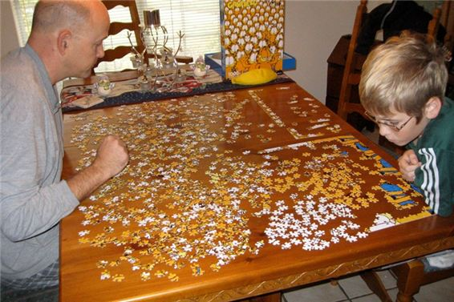 This _ _ _ _ le is not easy. I can’t do it.
Đáp án: puzz
54. Our uncles are wor_ _ _ s. They work in a factory.
Đáp án: ker
55. What is that? – It’s _ big red ball.
Đáp án: a
56. This/ green/ is a/ book.
Đáp án: This is a green book.
57. The lamp is _ _ _ ween the sofa and the armchair.
Đáp án: bet
58. … is your birthday?
A. Who B. When C. Where D. How
Đáp án: When
59. Minh: Where are you? - Nga: I am w_ _ _ my friends.
Đáp án: ith
60. some/ Can/ rice?/ more/ I have/
Đáp án: Can I have some more rice?
61. Rosie’s/ It’s/ bear./ teddy/ not/
Đáp án: It’s not Rosie’s teddy bear.
62. Ảnh: Cinderella is ______ with the prince at the party.
A. dance B. dances C. dancing D. danceing
Đáp án: dancing
63. Hi_ name is Peter.
Đáp án: s
64. Nghe: Nhấn giữ Ctrl và bấm chuột để nghe: The cat walks _ _ _ _ to the ball.
Đáp án: over
65. Nghe: Nhấn giữ Ctrl và bấm chuột để nghe: A girl is eating _ _ _ ice-creams.
Đáp án: two
66. Primary School./ friends/ study/ at Kim Dong/ My old/
Đáp án: My old friends study at Kim Dong Primary School.
67. My little brother often … his kite when he’s not busy.
A. does B. plays C. goes D. flies
Đáp án: Chọn ý: D
68. is/ on/ the wall?/ this/ What/
Đáp án: What is this on the wall?
69. Which word has the letter ‘i’ pronounced as the letter ‘i’ in ’’it’’?
A. I B. blind C. library D. big
Đáp án: Chọn ý: D
70. Nghe: Nhấn giữ Ctrl và bấm chuột để nghe: _ _ _ _ _ _
Đáp án: number
71. Choose the letter(s) to make a correct word: voll__ball
A. ii B. ie C. ey D. iy
Đáp án: ey
72. garden?/ there/ are/ in the/ What/
Đáp án: What are there in the garden?
73. The new boy sits … me.
A. down B. next to C. up D. at
Đáp án: next to
74. Linda and I are ….
A. brothers B. sister C. friends D. classmate
Đáp án: friends
75. school?/ the/ What is/ your/ name of/
Đáp án: What is the name of your school?
76. Nghe: Nhấn giữ Ctrl và bấm chuột để nghe: _ _ _ _ _ _ _ _ _
Đáp án: seventeen
77. Can you _ _ _ _ _ your name, please? – Yes. P-E-T-E-R.
Đáp án: spell
78. … is that boy? – He is my new friend from school.
A. What B. Which C. Who D. Where
Đáp án: Who
79. Choose the odd one out:
A. How B. What C. Who D. Jane
Đáp án: Chọn ý: D
80. See you tomo_ _ ow.
Đáp án: rr
81. in/ There’s/ my/ room./ a bookcase/
Đáp án: There’s a bookcase in my room.
82. birthday?/ his/ is/ When/
Đáp án: When is his birthday?
83. I _ _ Chi. I am in class 3A.
Đáp án: am
84. My bedroom is large _ _ _ beautiful.
Đáp án: and
85. of sports./ play/ can/ I/ a lot
Đáp án: I can play a lot of sports.
86. Ảnh: Do you have toys? – Yes, I have a _ _ _ _ .
Đáp án: doll
87. The opposite of \"small\" is \"_ _ _ \".
Đáp án: big
88. Peter is my friend, t_ _ .
Đáp án: oo
89. Ảnh: Don’t forget put the car in the ….
A. kitchen B. garden C. bedroom D. garage
Đáp án: Chọn ý: D
90. doing?/ What’s/ Mai/
Đáp án: What’s Mai doing?
91. What/ lessons?/ you do/ during English/ do/
Đáp án: What do you do during English lessons?
92. Nghe: Nhấn giữ Ctrl và bấm chuột để nghe: Is your school big _ _ little?
Đáp án: or
93. Re_ _ der the sentences.
Đáp án: or
94. eggs/ These/ white./ are/
Đáp án: These eggs are white.
95. Unscramble this word: restpo -> _ _ _ _ _ _
Đáp án: poster
96. in/ are/ the/ brown box./ My toys/
Đáp án: My toys are in the brown box.
97. Choose the odd one out:
A. eraser B. notebook C. crayon D. England
Đáp án: Chọn ý: D
98. Nghe: Nhấn giữ Ctrl và bấm chuột để nghe: Baz’s boat is in his _ _ _ _ .
Đáp án: coat
99. Andy./ is/ My name/
Đáp án: My name is Andy.
100. My sister can … a pony.
A. my B. ride C. ride’s D. I
Đáp án: ride
101. W_ _ t is that? – It’s a teddy bear.
Đáp án: ha
102. I go _ _ school every morning.
Đáp án: to
103. I _ _ _ not play any sports.
Đáp án: can
104. Nghe: Nhấn giữ Ctrl và bấm chuột để nghe: Choose the TRUE statement.
A. There is some cola on the table. B. There are some cakes and cola on the table. C. There aren’t any cakes and cola on the table. D. There are some cakes on the table.
Đáp án: Chọn ý: D
105. out/ your/ , Alan./ Take/ notebooks
Đáp án: Take out your notebooks , Alan.
106. What books are they? - T_ _ _ are Maths books.
Đáp án: hey
107. This ... my mother.
A. are B. am C. is D. and
Đáp án: is
108. I have Math on Monday and Friday. We have it ... a week.
A. once B. twice C. three times D. four times
Đáp án: twice
109. countryside./ school/ is in/ My/ the
Đáp án: My school is in the countryside.
110. coffee./ Tim/ doesn’t/ like/
Đáp án: Tim doesn’t like coffee.
111. blue/ It/ is/ phone./ a/
Đáp án: It is a blue phone.
112. A: …? - B: No, he isn’t.
A. Does your father work on the farm? B. Is that your father? C. Is your father watching TV? D. Does your father have any pets?
Đáp án: Is your father watching TV?
113. Ảnh: I can hear with my _ _ _ s.
Đáp án: ear
114. Let’s go to school t_ _ _ _ _ _ _ !
Đáp án: ogether
115. What is your … drink? – I like orange juice the most.
A. name B. favourite C. much D. many
Đáp án: favourite
116. Nghe: Nhấn giữ Ctrl và bấm chuột để nghe: ... is my house.
A. This B. That C. It D. These
Đáp án: This
117. doll/ for/ you./ This/ is/
Đáp án: This doll is for you.
118. father?/ your/ old/ is/ How/
Đáp án: How old is your father?
119. _ hat’s your name?
Đáp án: W
120. _______ is Nam from? – He’s from Da Nang.
A. What B. When C. Where D. Who
Đáp án: Where
121. Tom re_ _ _ books in the library in the afternoon.
Đáp án: ads
122. What colour ... that chair? – It’s yellow.
A. it B. is C. that D. hi
Đáp án: is
123. My new _ _ _ _ _ _ is Adam.
Đáp án: friend
124. Our/ is/ so much/ fun./ class/
Đáp án: Our class is so much fun.
125. Ảnh: 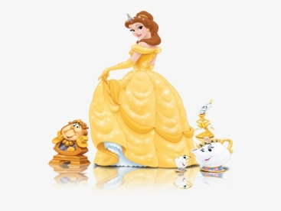 Belle is wearing a beautiful y_ _ _ _ _ dress.
Đáp án: ellow
126. The cat is sitting ... the tree.
A. near to B. next C. in D. under
Đáp án: Chọn ý: D
127. I’m fine, thank you. ... ?
A. You B. Bye C. And you D. Are
Đáp án: And you
128. Ảnh: This big _ _ _ is very funny.
Đáp án: dog
129. Ảnh: 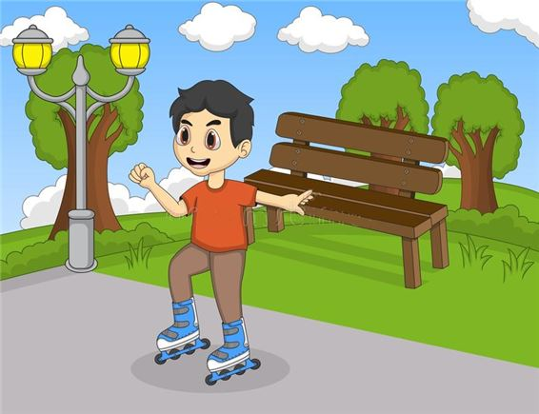 He is _ _ _ _ ing in the park now.
Đáp án: skat
130. Are you ______? – No. I’m full.
A. thirsty B. hungry C. hot D. tired
Đáp án: hungry
131. Ảnh: The c_ _ _ is on the chair.
Đáp án: oat
132. Do you like _ _ _ _ _ _ _ hide-and-seek? – Yes, I do
Đáp án: playing
133. Nghe: Nhấn giữ Ctrl và bấm chuột để nghe: There is a blue _ _ _ _ _ _ _ _ on the desk.
Đáp án: computer
134. This/ is/ doll./ a/
Đáp án: This is a doll.
135. read/ Let’s/ book./ the/
Đáp án: Let’s read the book.
136. She lives ... the sea.
A. in B. on C. near D. at
Đáp án: near
137. I am … England. I am English.
A. from B. to C. in D. at
Đáp án: from
138. Jenny is my new f_ _ end.
Đáp án: ri
139. It’s _______ in Hanoi today.
A. cloud B. funny C. sunny D. snow
Đáp án: sunny
140. your/ friend?/ new/ this/ Is/
Đáp án: Is this your new friend?
141. Ảnh: They are … .
A. pencils B. sharpeners C. rulers D. erasers
Đáp án: Chọn ý: D
142. Ảnh: She is _ _ _ ding under the tree.
Đáp án: rea
143. Nghe: Nhấn giữ Ctrl và bấm chuột để nghe: My house has a ... yard.
A. small B. fat C. large D. big
Đáp án: large
144. May we _ _ to school together?
Đáp án: go
145. much/ coat?/ the/ How/ is/
Đáp án: How much is the coat?
146. These pictures a_ _ beautiful.
Đáp án: re
147. There is/ my garden./ dog/ in/ a big/
Đáp án: There is a big dog in my garden.
148. Ảnh: 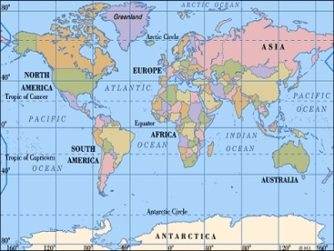 Look at the _ _ _ , please.
Đáp án: map
149. Ảnh: My brother is playing with a ….
A. plane B. kite C. ship D. truck
Đáp án: Chọn ý: D
150. Wh_ _ _ are the maps? – They are on the wall.
Đáp án: ere
151. The books are _ _ the shelves.
Đáp án: on
152. Nghe: Nhấn giữ Ctrl và bấm chuột để nghe: I ... orange.
A. love B. like C. hate D. eat
Đáp án: like
153. What … your parents look like?
A. does B. do C. is D. are
Đáp án: do
154. How are you Hoa, Vinh and Nam? … fine. Thanks.
A. She is B. He is C. They are D. We are
Đáp án: Chọn ý: D
155. What are they? – They are ….
A. red B. small C. stars D. big
Đáp án: stars
156. I love strawberries juice. – Me t_ _ .
Đáp án: oo
157. Nghe: Nhấn giữ Ctrl và bấm chuột để nghe: Which is the _ _ _ _ _ _ _ , a giraffe, an elephant or a monkey? – Of course, a giraffe.
Đáp án: tallest
158. Nghe: Nhấn giữ Ctrl và bấm chuột để nghe: There are three ... on the table.
A. rulers B. pencils C. erasers D. pens
Đáp án: pencils
159. old/ is/ eldest brother?/ How/ your
Đáp án: How old is your eldest brother?
160. grandfather./ writing/ to my/ I am/ a letter/
Đáp án: I am writing a letter to my grandfather.
161. Ảnh: Kim: What books are they? - Khoa: They are my English _ _ _ _ _ .
Đáp án: books
162. Ha Noi is in n_ _ _ _ Viet Nam.
Đáp án: orth
163. How ma_ _ trees are there?
Đáp án: ny
164. is/ shelf./ The radio/ the/ on/
Đáp án: The radio is on the shelf.
165. My brother is short … sporty.
A. but B. while C. so D. or
Đáp án: but
166. This pen is _ _ _ blue. It’s green.
Đáp án: not
167. A dog has _______.
A. four eyes B. four noses C. four tails D. four legs
Đáp án: Chọn ý: D
168. This ... a house.
A. are B. is C. you D. here
Đáp án: is
169. Pick _ _ your ruler.
Đáp án: up
170. My pet is a ... .
A. bird B. ship C. robot D. doll
Đáp án: bird
171. I/ two/ have/ robots.
Đáp án: I have two robots.
172. Peter _ _ s many rulers.
Đáp án: ha
173. Do you like football or basketball?
A. I don’t like. B. I like it. C. No, I don’t. D. I like volleyball.
Đáp án: Chọn ý: D
174. Read the world a_ _ _ _ .
Đáp án: loud
175. Nghe: Nhấn giữ Ctrl và bấm chuột để nghe: Come on! We must _ _ _ _ him.
Đáp án: help
176. A: … is your birthday? – B: It’s in July.
A. What B. How C. When D. Where
Đáp án: When
177. like/ the/ weather./ I/ windy
Đáp án: I like the windy weather.
178. Happy/ to/ you,/ Jimmy./ birthday/
Đáp án: Happy birthday to you, Jimmy.
179. Would you like some …? – No, thanks. I hate sweets.
A. coffee B. lemonade C. chocolate D. chicken
Đáp án: chocolate
180. I … count to 100.
A. cannot B. cant C. can’s D.
Đáp án: cannot
181. What’s the matter _ _ _ _ your eyes?
Đáp án: with
182. Wh_ _ do you have Maths? – I have it on Monday.
Đáp án: en
183. the library?/ often/ Do/ go to/ you/
Đáp án: Do you often go to the library?
184. Ảnh: She has five ….
A. toys B. pets C. dogs D. cats
Đáp án: pets
185. I a_ nine years old. How old are you?
Đáp án: m
186. There are four win_ _ _ _ in my classroom.
Đáp án: dows
187. Odd one out:
A. large B. kitchen C. small D. big
Đáp án: kitchen
188. ... are you? – I’m fine, thanks.
A. When B. How C. What D. Who
Đáp án: How
189. Odd one out:
A. October B. May C. Tom D. July
Đáp án: Tom
190. Is your school big? - ..., it is.
A. No B. Not C. Yes D. No, it isn’t
Đáp án: Yes
191. A: How _ _ _ is your grandpa? - B: He’s sixty.
Đáp án: old
192. Co_ plete the sentences.
Đáp án: m
193. Ảnh: They are … at the moment.
A. reading B. singing C. dancing D. drawing
Đáp án: singing
194. his friends./ Minh/ robots with/ likes/ playing/
Đáp án: Minh likes playing robots with his friends.
195. ... that a pink pencil? – No, it isn’t.
A. Are B. Is C. Who D. When
Đáp án: Is
196. birthday?/ you/ remember/ my/ Can/
Đáp án: Can you remember my birthday?
197. What/ is/ hobby?/ your/
Đáp án: What is your hobby?
198. The children are reading Engl_ _ _ in their room.
Đáp án: ish
199. like/ “Tom and Jerry”?/ Do/ you/
Đáp án: Do you like “Tom and Jerry”?
200. This/ is a/ red apple./
Đáp án: This is a red apple.

KEY IOE K3 SỐ 47
1. Ảnh: 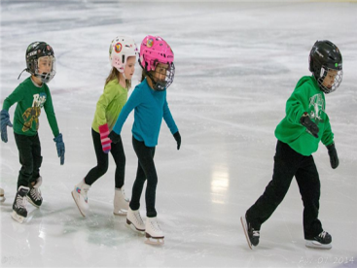 They are … right now.
A. skating B. skipping C. singing D. dancing
Đáp án: skating
2. My house _ s small.
Đáp án: i
3. Who ... that? – That’s Mary. She is my sister.
A. are B. is C. this D. and
Đáp án: is
4. Nghe: Nhấn giữ Ctrl và bấm chuột để nghe: You are reading a _ _ _ _ _ now.
Đáp án: comic
5. There are two cat_ in that box.
Đáp án: s
6. the books/ on/ Put/ shelf./ the
Đáp án: Put the books on the shelf.
7. Ảnh: There are four pretty _ _ _ s here.
Đáp án: cup
8. In Vietnam, we don’t go to school on ... .
A. Monday B. Sunday C. Thursday D. Friday
Đáp án: Sunday
9. He/ lot/ at school./ has a/ of friends
Đáp án: He has a lot of friends at school.
10. Mary’s/ very/ large./ is/ bedroom/
Đáp án: Mary’s bedroom is very large.
11. cake./ pink/ a/ It is/
Đáp án: It is a pink cake.
12. of/ Is there/ your house?/ a pond/ in front/
Đáp án: Is there a pond in front of your house?
13. you/ have?/ What/ do/ pets/
Đáp án: What pets do you have?
14. water/ Are there/ Moon?/ on the/ any/
Đáp án: Are there any water on the Moon?
15. Nghe: Nhấn giữ Ctrl và bấm chuột để nghe: Listen and choose the best response.
A. I keep it in the cage. B. It’s very lovely. C. It has brown hair. D. It’s two months ago.
Đáp án: I keep it in the cage.
16. How m_ _ _ books are there? – There are three books.
Đáp án: any
17. Nghe: Nhấn giữ Ctrl và bấm chuột để nghe: She shows them the pictures in the _ _ _ _ .
Đáp án: book
18. a mat./ on/ is/ Lucy/ sitting/
Đáp án: Lucy is sitting on a mat.
19. what/ to/ says./ Listen/ the teacher
Đáp án: Listen to what the teacher says.
20. Nghe: Nhấn giữ Ctrl và bấm chuột để nghe: They are in the ....
A. kitchen B. garden C. kitten D. house
Đáp án: garden
21. This is a picture ______ my family.
A. in B. of C. on D. over
Đáp án: of
22. … subjects do you have on Tuesday?
A. What B. How C. Who D. When
Đáp án: What
23. go to/ We/ school/ a week./ five days
Đáp án: We go to school five days a week.
24. My friends and I … a new way to learn English.
A. go B. look C. find D. do
Đáp án: find
25. May we _ _ to school together?
Đáp án: go
26. Hi, ... name is John.
A. your B. my C. its D. me
Đáp án: my
27. Look! Birds … in the sky.
A. flies B. fly C. is flying D. are flying
Đáp án: Chọn ý: D
28. mother./ this song/ with my/ I/ sing/
Đáp án: I sing this song with my mother.
29. Ảnh: Where are the maps? - They are on the _ _ _ _ .
Đáp án: wall
30. Is this a book? - ... .
A. Yes, it is B. Yes, isn’t C. No, it is D. Bye
Đáp án: Yes, it is
31. your parents/ right now?/ at home/ Are/
Đáp án: Are your parents at home right now?
32. Ha Noi./ and windy/ in/ cloudy/ It’s/
Đáp án: It’s cloudy and windy in Ha Noi.
33. Ảnh: Rabbits like car_ _ _ _ very much.
Đáp án: rots
34. brother/ and sister?/ are/ Where/ your/
Đáp án: Where are your brother and sister?
35. Ảnh: That’s a _ _ _ . It’s big.
Đáp án: cow
36. Jane never goes to bed l_ _ _ . Because he wants to get up early.
Đáp án: ate
37. It is ... chair.
A. an B. a C. this D. it
Đáp án: a
38. Ảnh: It is an old rub_ _ _ .
Đáp án: ber
39. Ảnh: She has five ….
A. toys B. pets C. dogs D. cats
Đáp án: pets
40. Choose the odd one out:
A. how B. hello C. hi D. good morning
Đáp án: how
41. Hello, I am Mai. - …
A. Goodbye and see you later. B. I don’t know. C. Hi, I am fine. Thanks D. Nice to see you.
Đáp án: Chọn ý: D
42. Ảnh: There is a cat … the basket.
A. on B. at C. in D. of
Đáp án: in
43. What’s your nam_ ?
Đáp án: e
44. a/ is/ yellow/ yo-yo./ This/
Đáp án: This is a yellow yo-yo.
45. Ảnh: 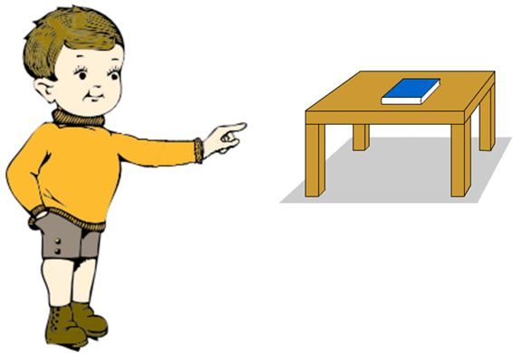 The book is t_ _ _ _ , on the table.
Đáp án: here
46. What col_ _ r is this book? – It’s red.
Đáp án: ou
47. Choose the odd one out:
A. balloon B. yo-yo C. doll D. school
Đáp án: Chọn ý: D
48. Odd one out:
A. they B. ten C. we D. you
Đáp án: ten
49. _ _ at’s her name? – She is Mary.
Đáp án: Wh
50. I have Maths _ _ Monday.
Đáp án: on
51. Ảnh: I’m a student and my friends are _ _ _ _ _ _ _ _ too.
Đáp án: students
52. Ảnh: 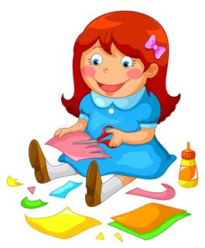 Akiko is ….
A. putting her toys away B. making paper toys C. reading her books D. cooking a meal.
Đáp án: making paper toys
53. Is the w_ _ _ _ over there your mother?
Đáp án: oman
54. Is that girl new? – I don’t _ _ ow.
Đáp án: kn
55. and Sarah/ board games./ are/ playing/ Linda/
Đáp án: Linda and Sarah are playing board games.
56. Look that woman! _ _ _ ’s my teacher.
Đáp án: She
57. Ảnh: Who’s he? - He’s my grand_ _ _ _ _ _ .
Đáp án: father
58. We have a _ _ _ of toys.
Đáp án: lot
59. _ _ _ ’s that man? – He’s my brother.
Đáp án: Who
60. Are you happy? - Yes, I _ _ .
Đáp án: am
61. Is the_ _ a dog? – No, there is not.
Đáp án: re
62. my sister/ my bedroom/ I share/ , Lucy./ with/
Đáp án: I share my bedroom with my sister , Lucy.
63. Let’s make a li_ e, children.
Đáp án: n
64. Nghe: Nhấn giữ Ctrl và bấm chuột để nghe: Which is NOT mentioned in the recording?
A. ball B. doll C. puzzle D. teddy
Đáp án: doll
65. Ảnh: Cinderella is ______ with the prince at the party.
A. dance B. dances C. dancing D. danceing
Đáp án: dancing
66. My sister can … a pony.
A. my B. ride C. ride’s D. I
Đáp án: ride
67. me/ Kids/ very much./ like/
Đáp án: Kids like me very much.
68. Are there _________ clocks on the table?
A. a B. an C. some D. any
Đáp án: Chọn ý: D
69. sitting on the bench?/ tall/ is that/ Who/ girl
Đáp án: Who is that tall girl sitting on the bench?
70. Let’s/ a/ paper lion./ make/
Đáp án: Let’s make a paper lion.
71. desk/ your/ Touch/ , please.
Đáp án: Touch your desk , please.
72. My sister h_ s a new doll.
Đáp án: a
73. _ _ _ _ _ and eleven is sixty-one.
Đáp án: fifty
74. Ảnh: My p_ _ _ _ ts are between my sister and me.
Đáp án: aren
75. May we _ _ out together?
Đáp án: go
76. Ảnh: Look at the _ _ _ _ _ , please.
Đáp án: board
77. This is a r_ ler.
Đáp án: u
78. Quan is _ _ _ _ _ his homework in his room.
Đáp án: doing
79. cooking/ He/ like/ doesn’t/ at home./
Đáp án: He doesn’t like cooking at home.
80. Are these your ______? – No, they ______.
A. rubber – are B. rubber – is C. rubbers – don’t D. rubbers – aren’t
Đáp án: Chọn ý: D
81. Rai_ _ your hands, please.
Đáp án: se
82. Ảnh: Two boys are reading their books _ _ _ _ _ the tree.
Đáp án: under
83. Nghe: Nhấn giữ Ctrl và bấm chuột để nghe: ... are the chairs?
A. Where B. There C. Here D. These
Đáp án: Where
84. This is my aunt. …. twenty-six years old.
A. They are B. He is C. You are D. She is
Đáp án: Chọn ý: D
85. is/ What/ your/ hobby?
Đáp án: What is your hobby?
86. _ _ o is that? – That’s Mary.
Đáp án: Wh
87. What is his date … birth?
A. on B. of C. at D. in
Đáp án: of
88. Nghe: Nhấn giữ Ctrl và bấm chuột để nghe: Do you have an _ _ _ _ _ _ ?
Đáp án: eraser
89. You and … are friends forever.
A. me B. my C. I D. myself
Đáp án: I
90. It’s always … in summer.
A. cold B. red C. icy D. hot
Đáp án: Chọn ý: D
91. Ảnh: A: Are _ _ _ _ _ your toys? - B: Yes, they are.
Đáp án: these
92. There are ... chairs in my living room.
A. one B. five C. a D. an
Đáp án: five
93. Re_ _ der the sentences.
Đáp án: or
94. is/ name?/ your/ teacher’s/ What/
Đáp án: What is your teacher’s name?
95. Nghe: Nhấn giữ Ctrl và bấm chuột để nghe: Mai is ....
A. running B. writing C. cycling D. reading
Đáp án: cycling
96. the/ puzzle./ Complete/ crossword/
Đáp án: Complete the crossword puzzle.
97. Which word has the letter \"a\" pronounced as the letter \"a\" in \"that\"?
A. name B. ball C. orange D. apple
Đáp án: Chọn ý: D
98. What is that? – It is ... orange.
A. a B. an C. am D. are
Đáp án: an
99. What ... your name?
A. are B. amfriend C. is D. butmee
Đáp án: is
100. Nghe: Nhấn giữ Ctrl và bấm chuột để nghe: Baz’s boat is in his _ _ _ _ .
Đáp án: coat
101. ... is that? - It’s a pen.
A. How B. When C. What D. Where
Đáp án: What
102. Jenny is my new f_ _ end.
Đáp án: ri
103. Nghe: Nhấn giữ Ctrl và bấm chuột để nghe: Her name ... Linda.
A. are B. is C. am D. it
Đáp án: is
104. Who is he? - ... .
A. He my friend B. She my friend C. He is Simon. He is my good friend D. She’s Mary
Đáp án: He is Simon. He is my good friend
105. There is a green kite ... the sky.
A. on B. at C. for D. in
Đáp án: Chọn ý: D
106. I’m fine, thank ... . And you?
A. your B. you are C. you’re D. you
Đáp án: Chọn ý: D
107. My sister can f_ _ a kite.
Đáp án: ly
108. bag/ is/ pink./ Your/ school/
Đáp án: Your school bag is pink.
109. What do they usually do ... summer?
A. at B. on C. in D. to
Đáp án: in
110. A: _ _ _ ’s that? - B: It’s my uncle.
Đáp án: Who
111. Is this a bag? - ... .
A. Yes, it is B. Yes, isn’t C. No, it is D. Not, it isn’t
Đáp án: Yes, it is
112. big/ I/ want/ a/ carrot./
Đáp án: I want a big carrot.
113. very/ is/ The/ exciting./ game/
Đáp án: The game is very exciting.
114. ... you like chicken?
A. Do B. Does C. Are D. Is
Đáp án: Do
115. Nghe: Nhấn giữ Ctrl và bấm chuột để nghe: He’s _ _ _ _ _ years old.
Đáp án: eight
116. Odd one out:
A. sun B. snowy C. cloud D. wind
Đáp án: snowy
117. likes/ My/ and candies./ friend/ fast food
Đáp án: My friend likes fast food and candies.
118. _ _ _ _ do you do in the afternoon? – I play badminton.
Đáp án: what
119. Nghe: Nhấn giữ Ctrl và bấm chuột để nghe: It has _ _ _ _ _ _ _ _ of many animals.
Đáp án: pictures
120. Are those your pencil sharpeners?
A. Yes, it is. B. No, it isn’t. C. Yes, they are. D. No, they are.
Đáp án: Yes, they are.
121. My pictures _ _ _ on the wall.
Đáp án: are
122. her favourite/ I want/ film./ to/ know/
Đáp án: I want to know her favourite film.
123. Nghe: Nhấn giữ Ctrl và bấm chuột để nghe: There is a concert in the _ _ _ _ .
Đáp án: park
124. and/ complete/ sentences./ Listen/ the
Đáp án: Listen and complete the sentences.
125. To_ _ _ is February 14th. Do you have any plan?
Đáp án: day
126. Linda is her _ _ me.
Đáp án: na
127. Who is she, Peter? - ... .
A. She Mary B. He’s Tom C. She’s Mary D. My name is Mary
Đáp án: She’s Mary
128. chicken./ is/ His/ food/ favourite/
Đáp án: His favourite food is chicken.
129. A: … do you go shopping? – B: Once a week.
A. How many B. What C. How often D. When
Đáp án: How often
130. This is ... doll.
A. she B. me C. my D. hi
Đáp án: my
131. Ảnh: How many cats are there in the yard? - There are _ _ _ _ cats. They are eating fish.
Đáp án: nine
132. It is my chai_ .
Đáp án: r
133. Ha can dance _ _ _ cannot play football.
Đáp án: but
134. Ảnh: 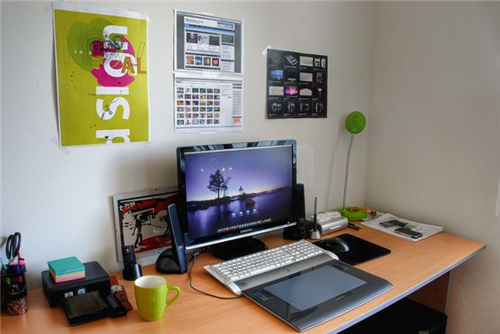 This is my new co_ _ _ ter room.
Đáp án: mpu
135. Ảnh: 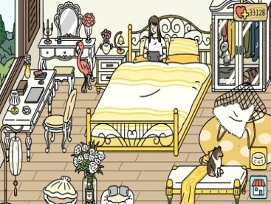 There is a cat _ _ the wardrobe.
Đáp án: in
136. My mother _ _ a teacher.
Đáp án: is
137. Nghe: Nhấn giữ Ctrl và bấm chuột để nghe: ... is my house.
A. This B. That C. It D. These
Đáp án: This
138. house/ is/ near the/ The/ forest./
Đáp án: The house is near the forest.
139. countryside./ in the/ We/ have/ wonderful time/
Đáp án: We have wonderful time in the countryside.
140. I/ read/ to/ books./ like/
Đáp án: I like to read books.
141. What grade are you ________, James?
A. at B. on C. of D. in
Đáp án: Chọn ý: D
142. Music/ his/ favourite/ Is/ subject?/
Đáp án: Is Music his favourite subject?
143. Ảnh: 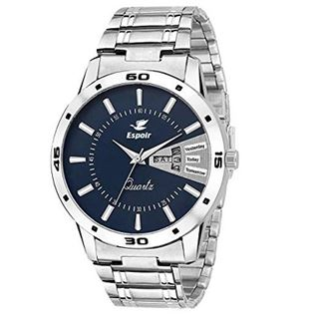 Where is your _ _ _ _ _ ?
Đáp án: watch
144. Can the cat _ _ _ _ _ a tree? – Yes, it can.
Đáp án: climb
145. Ảnh: Nguyet is _ _ _ _ _ _ _ _ the floor.
Đáp án: cleaning
146. Would you like an apple? - _ _ , thanks.
Đáp án: no
147. _ _ _ many dolls are there in that box? – There are three dolls.
Đáp án: How
148. Nghe: Nhấn giữ Ctrl và bấm chuột để nghe: Sue’s toy is a ... .
A. star B. far C. car D. bear
Đáp án: car
149. Is your school small or la_ _ _ ?
Đáp án: rge
150. See/ tomorrow./ you/
Đáp án: See you tomorrow.
151. Nghe: Nhấn giữ Ctrl và bấm chuột để nghe: This is an _ _ _ _ _ _ .
Đáp án: eraser
152. Nghe: Nhấn giữ Ctrl và bấm chuột để nghe: It has a big school _ _ _ _ _ _ _ _ _ _ .
Đáp án: playground
153. photos./ taking/ He/ really/ likes/
Đáp án: He really likes taking photos.
154. birthday?/ Can/ you/ my/ remember/
Đáp án: Can you remember my birthday?
155. What colour is that flower? – It’s yel_ _ w.
Đáp án: lo
156. a garage/ have/ our car./ to keep/ We/
Đáp án: We have a garage to keep our car.
157. is/ the bed./ black cat/ under/ The/
Đáp án: The black cat is under the bed.
158. after/ dinner./ Let’s/ play/ chess/
Đáp án: Let’s play chess after dinner.
159. my/ toy./ This doll/ favourite/ is/
Đáp án: This doll is my favourite toy.
160. Ảnh: 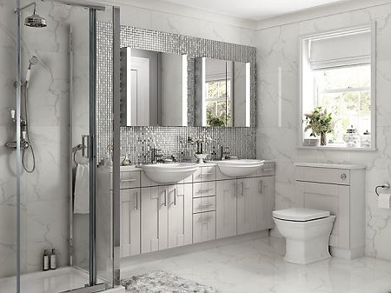 What room is this?
A. It’s a living room. B. It’s a bathroom. C. It’s a kitchen. D. It’s a bedroom.
Đáp án: It’s a bathroom.
161. Look at tho_ _ black clouds in the sky.
Đáp án: se
162. 100?/ count/ Can you/ from/ 1 to
Đáp án: Can you count from 1 to 100?
163. What’s the weather _ _ _ _ in Ho Chi Minh City?
Đáp án: like
164. Who is he? - ... .
A. She is Mary B. He my friend C. She my friend D. He’s Tom
Đáp án: Chọn ý: D
165. What ... it? – It’s my book.
A. is B. hi C. bye D. hello
Đáp án: is
166. My teachers go to school ea_ _ _ in the morning.
Đáp án: rly
167. She p_ _ _ _ badminton with her classmate in the gym.
Đáp án: lays
168. That shirt _ _ green.
Đáp án: is
169. A: How _ _ _ are you? - B: I’m forty-five.
Đáp án: old
170. _ _ _ _ _ _ close your notebook.
Đáp án: please
171. a/ is reading/ Linda,/ book./ My friend,/
Đáp án: My friend, Linda, is reading a book.
172. Who is tall_ _ , Jack or Jim?
Đáp án: er
173. It’s _______ in Hanoi today.
A. cloud B. funny C. sunny D. snow
Đáp án: sunny
174. … - J-E-N-N-I-F-E-R.
A. Spell your name, please. B. What is your name? C. What girl is it? D. Is that you Jennifer?
Đáp án: Spell your name, please.
175. How/ your/ brother?/ old/ is/
Đáp án: How old is your brother?
176. do/ like/ Music lessons?/ Why/ you/
Đáp án: Why do you like Music lessons?
177. That is my new friend. H_ _ name is Alice.
Đáp án: er
178. Is that your desk? - ….
A. No, not my desk. B. No, it isn’t. C. No, I am not. D. Yes, it does.
Đáp án: No, it isn’t.
179. of July./ the/ is/ fourth/ Today/
Đáp án: Today is the fourth of July.
180. His name ... Tommy.
A. are B. is C. be D. and
Đáp án: is
181. Nghe: Nhấn giữ Ctrl và bấm chuột để nghe: She can _ _ _ _ .
Đáp án: swim
182. My little brother often … his kite when he’s not busy.
A. does B. plays C. goes D. flies
Đáp án: Chọn ý: D
183. Excuse me. - …?
A. No B. Not C. Yes D. Thanks
Đáp án: Yes
184. My b_ _ thday is in May.
Đáp án: ir
185. The flowers are ... that vase.
A. on B. to C. for D. in
Đáp án: Chọn ý: D
186. Odd one out:
A. October B. May C. Tom D. July
Đáp án: Tom
187. Sit _ _ _ _ , please.
Đáp án: down
188. Linda and I are ….
A. brothers B. sister C. friends D. classmate
Đáp án: friends
189. Odd one out:
A. mother B. father C. sister D. family
Đáp án: Chọn ý: D
190. hand/ down,/ your/ Simon./ Put/
Đáp án: Put your hand down, Simon.
191. Odd one out:
A. desk B. chair C. bedroom D. ruler
Đáp án: bedroom
192. Nghe: Nhấn giữ Ctrl và bấm chuột để nghe: Listen and choose the best response.
A. Yes, it does. B. Yes, they are. C. No, it isn’t. D. No, they don’t.
Đáp án: No, it isn’t.
193. How is the weather in Hanoi today? – It’s … .
A. rainy B. rain C. sun D. wind
Đáp án: rainy
194. Choose the odd one out:
A. on B. where C. under D. behind
Đáp án: where
195. the desk?/ under/ those/ are/ What/
Đáp án: What are those under the desk?
196. What colour is that pencil? – It’s ... .
A. book B. crayon C. ruler D. blue
Đáp án: Chọn ý: D
197. Mary likes doing … in her free time.
A. football B. volleyball C. music D. puzzles
Đáp án: Chọn ý: D
198. Nghe: Nhấn giữ Ctrl và bấm chuột để nghe: At low tide, the ocean moves _ _ _ _ the beach.
Đáp án: down
199. Ảnh: Look at the _ _ _ , please.
Đáp án: map
200. Kevin _ _ _ _ _ football with his classmates in the yard behind his school.
Đáp án: plays

KEY IOE K3 SỐ 48
1. teacher./ morning,/ Good/
Đáp án: Good morning, teacher.
2. My dog’s _ _ _ _ is Barkie.
Đáp án: name
3. tank./ Peter keeps/ goldfish/ in the/ his/
Đáp án: Peter keeps his goldfish in the tank.
4. happy/ family./ We/ are/ a/
Đáp án: We are a happy family.
5. She … two dogs and a cat.
A. have B. has C. is D. are
Đáp án: has
6. Choose the odd one out:
A. ride B. go C. bike D. run
Đáp án: bike
7. Do/ chicken/ you/ like/ and milk?/
Đáp án: Do you like chicken and milk?
8. Where … the candles? – They are on the cake.
A. do B. does C. are D. is
Đáp án: are
9. Choose the odd one out:
A. eraser B. notebook C. crayon D. England
Đáp án: Chọn ý: D
10. find/ in/ me/ Can you/ this photo?/
Đáp án: Can you find me in this photo?
11. How are you, Lan? - I’m fine, t_ _ nks.
Đáp án: ha
12. Please c_ _ _ t from 1 to 10 in English.
Đáp án: oun
13. Nghe: Nhấn giữ Ctrl và bấm chuột để nghe: Look at those _ _ _ _ _ .
Đáp án: sheep
14. Which pen is your pen? – This o_ _ .
Đáp án: ne
15. Is this a notebook? - ..., it is.
A. No B. Not C. Yes D. No, it is
Đáp án: Yes
16. I see a rainbow. It … beautiful.
A. sees B. sounds C. has D. looks
Đáp án: Chọn ý: D
17. Ảnh: What is it? – It’s a … .
A. pencil B. pen C. book D. crayon
Đáp án: Chọn ý: D
18. Ảnh: My brother likes playing _ _ _ _ _ _ ball in the yard.
Đáp án: basket
19. Ảnh: The lamp is … the cupboard.
A. next to B. on C. under D. over
Đáp án: on
20. Quan is _ _ _ _ _ his homework in his room.
Đáp án: doing
21. His house _ _ not big.
Đáp án: is
22. there/ are/ garden?/ in the/ What/
Đáp án: What are there in the garden?
23. Are there _________ clocks on the table?
A. a B. an C. some D. any
Đáp án: Chọn ý: D
24. A: … do you go shopping? – B: Once a week.
A. How many B. What C. How often D. When
Đáp án: How often
25. Ảnh: The boy is washing his _ _ _ .
Đáp án: dog
26. ... that a pink pencil? – No, it isn’t.
A. Are B. Is C. Who D. When
Đáp án: Is
27. What a_ _ _ t an apple? – Yes, please.
Đáp án: bou
28. is/ our/ That/ room./ music
Đáp án: That is our music room.
29. desk./ The lamp/ is/ the/ behind/
Đáp án: The lamp is behind the desk.
30. Goodbye. See you l_ _ _ r.
Đáp án: ate
31. I’m fine, thank you. ... ?
A. You B. Bye C. And you D. Are
Đáp án: And you
32. Choose the odd one out:
A. school B. library C. classroom D. mother
Đáp án: Chọn ý: D
33. Nghe: Nhấn giữ Ctrl và bấm chuột để nghe: What letter do you hear?
A. I B. A C. E D. O
Đáp án: A
34. Linda is her _ _ me.
Đáp án: na
35. FI__TEEN
A. T B. VE C. F D. S
Đáp án: F
36. Ảnh: 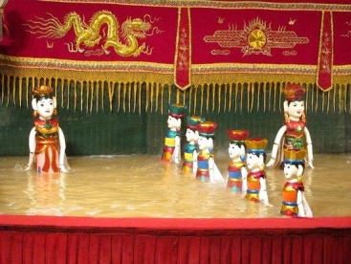 A: Do you know what they are? - B: Yes. They’re water ….
A. dolls B. puppets C. teddies D. clowns
Đáp án: puppets
37. pen./ red/ is/ It/ a long/
Đáp án: It is a long red pen.
38. the lamp./ The book/ between/ the pencil and/ is/
Đáp án: The book is between the pencil and the lamp.
39. is/ Vietnamese/ Teacher’s Day./ 20th/ November/
Đáp án: November 20th is Vietnamese Teacher’s Day.
40. Who ... that? – That’s Mary. She is my sister.
A. are B. is C. this D. and
Đáp án: is
41. love/ very/ much./ I/ my toys/
Đáp án: I love my toys very much.
42. What is your favourite _ _ _ _ ? - It’s hide-and-seek.
Đáp án: game
43. My mother _ _ a teacher.
Đáp án: is
44. Ảnh: This de_ _ is looking for his mom.
Đáp án: er
45. My family often … TV in the evening.
A. looks B. sees C. watches D. hears
Đáp án: watches
46. He...o, my name’s Lan.
A. li B. ll C. lk D. lw
Đáp án: ll
47. How many pictures are there _ _ the wall? – There are four pictures.
Đáp án: on
48. I go … school early in the morning.
A. in B. at C. to D. from
Đáp án: to
49. Thai Phien is a big _ _ _ _ ary school in Hai Phong.
Đáp án: prim
50. Nghe: Nhấn giữ Ctrl và bấm chuột để nghe: Look at the _ _ _ _ _ .
Đáp án: train
51. I _ _ _ not play any sports.
Đáp án: can
52. How are you today, John? – I’m ..., thanks.
A. nice B. nice’s C. fine D. fine’s
Đáp án: fine
53. Nghe: Nhấn giữ Ctrl và bấm chuột để nghe: _ _ _ _ _
Đáp án: sheep
54. Ảnh: It’s _ _ _ _ _ at Christmas.
Đáp án: snowy
55. Let’s w_ _ k to school today. My bike is broken.
Đáp án: al
56. Which word has the underlined part pronounced like the letter ‘O’ in “PIANO”?
A. mother B. poster C. flower D. young
Đáp án: poster
57. and/ young/ beautiful?/ Linda/ looks/
Đáp án: Linda looks young and beautiful?
58. and/ yellow/ I love/ rubbers/ red pencils./
Đáp án: I love yellow rubbers and red pencils.
59. Nghe: Nhấn giữ Ctrl và bấm chuột để nghe: Can I borrow a _ _ _ _ _ _ ?
Đáp án: pencil
60. I have Maths _ _ Monday.
Đáp án: on
61. Is that a bag? – No, it is _ _ _ .
Đáp án: not
62. What ... it? – It’s my book.
A. is B. hi C. bye D. hello
Đáp án: is
63. … is Minh’s school? – It’s over there.
A. Where B. Which C. What D. How
Đáp án: Where
64. school/ on Sunday./ don’t/ go to/ I/
Đáp án: I don’t go to school on Sunday.
65. There is a pen _ _ the desk.
Đáp án: on
66. Science lessons _ _ _ very interesting.
Đáp án: are
67. students/ the new/ are/ from?/ Where/
Đáp án: Where are the new students from?
68. Let’s ______ a song together.
A. read B. watch C. sing D. write
Đáp án: sing
69. Minh often plays football … his friends on Sunday.
A. with B. to C. of D. at
Đáp án: with
70. a/ Let’s/ draw/ picture.
Đáp án: Let’s draw a picture.
71. Nghe: Nhấn giữ Ctrl và bấm chuột để nghe: He puts the hot dogs on a _ _ _ _ _ .
Đáp án: plate
72. Nghe: Nhấn giữ Ctrl và bấm chuột để nghe: Put the _ _ _ _ in the bag.
Đáp án: pens
73. Who is he? - ... .
A. He my friend B. She my friend C. He is Simon. He is my good friend D. She’s Mary
Đáp án: He is Simon. He is my good friend
74. school/ pink./ bag/ is/ Your/
Đáp án: Your school bag is pink.
75. Let’s listen _ _ some music.
Đáp án: to
76. The cat/ under/ the/ is/ chair./
Đáp án: The cat is under the chair.
77. your/ Is/ new?/ bathroom/
Đáp án: Is your bathroom new?
78. Golf _ _ my father’s favourite sport.
Đáp án: is
79. Choose the odd one out:
A. skipping B. running C. cutting D. looking
Đáp án: Chọn ý: D
80. Thank you very much. – You’re w_ _ _ _ me.
Đáp án: elco
81. Ảnh: Where is your sister? – She is sitting in the armchair ______ the living room.
A. in B. on C. at D. between
Đáp án: in
82. large./ house/ My/ quite/ is/
Đáp án: My house is quite large.
83. Jane: Who is this? – Tom: … is Marry.
A. That B. This C. These D. Those
Đáp án: This
84. Open your school bag, ple_ _ e.
Đáp án: as
85. Nghe: Nhấn giữ Ctrl và bấm chuột để nghe: Tom is the boy with a _ _ _ .
Đáp án: hat
86. That shirt _ _ green.
Đáp án: is
87. They/ at/ play/ break time./ tennis/
Đáp án: They play tennis at break time.
88. Nghe: Nhấn giữ Ctrl và bấm chuột để nghe: What’s the weather like? - It’s _ _ _ _ _
Đáp án: rainy
89. the city./ home village/ is/ My/ not near
Đáp án: My home village is not near the city.
90. Choose the odd one out:
A. balloon B. yo-yo C. doll D. school
Đáp án: Chọn ý: D
91. A: Where’s my school bag, Mum? - B: ....
A. It’s very big and pretty. B. It’s red and orange. C. I have a small school bag. D. I don’t know, son.
Đáp án: Chọn ý: D
92. Do you li_ _ playing hide-and-seek?
Đáp án: ke
93. Choose the odd one out:
A. America B. England C. Vietnamese D. Singapore
Đáp án: Vietnamese
94. Ảnh: I want to buy some _ _ _ sents for my baby sister.
Đáp án: pre
95. ______ fences in your house?
A. There is B. There are C. Is there D. Are there
Đáp án: Chọn ý: D
96. Who is tall_ _ , Jack or Jim?
Đáp án: er
97. Odd one out:
A. he B. she C. they D. me
Đáp án: Chọn ý: D
98. Odd one out:
A. rice B. bread C. cake D. milk
Đáp án: Chọn ý: D
99. Choose the odd one out:
A. bird B. desk C. cat D. dog
Đáp án: desk
100. do you/ How/ erasers/ many/ have?/
Đáp án: How many erasers do you have?
101. Odd one out:
A. nice B. glad C. beautiful D. pretty
Đáp án: glad
102. lessons/ like/ best./ Art/ I/
Đáp án: I like Art lessons best.
103. are/ pictures?/ Where/ the/
Đáp án: Where are the pictures?
104. My family lives in _ house in Thai Binh Province.
Đáp án: a
105. Draw a pict_ _ e of yourself.
Đáp án: ur
106. _ _ _ _ _ _ close your notebook.
Đáp án: please
107. A: How old … you? – B: I am nine years old.
A. am B. are C. is D. it
Đáp án: are
108. Nghe: Nhấn giữ Ctrl và bấm chuột để nghe: Julie is in the _ _ _ _ today.
Đáp án: park
109. Nghe: Nhấn giữ Ctrl và bấm chuột để nghe: There is a blue _ _ _ _ _ _ _ _ on the desk.
Đáp án: computer
110. Ảnh: Do you like playing _ _ _ _ _ _ ton with me?
Đáp án: badmin
111. Do you have any rubbers? – Yes, here t_ _ _ are.
Đáp án: hey
112. What is ... name?
A. she B. you C. he D. your
Đáp án: Chọn ý: D
113. _ ash your hands, please.
Đáp án: W
114. I keep my goldfish in the fish ….
A. house B. tank C. cage D. room
Đáp án: tank
115. Her birthday is in Ap_ _ _ .
Đáp án: ril
116. Ảnh: There is a flower garden … the house.
A. behind B. next to C. in front of D. under
Đáp án: in front of
117. Good morning, c_ _ _ _ . Sit down, please.
Đáp án: lass
118. … are you? – I’m fine, thanks.
A. What B. How C. Who D. Where
Đáp án: How
119. Greet/ your/ friend./
Đáp án: Greet your friend.
120. please?/ I/ sit/ Can/ here
Đáp án: Can I sit here please?
121. Nghe: Nhấn giữ Ctrl và bấm chuột để nghe: _ _ _ _ _ _ _ _
Đáp án: goldfish
122. Ảnh: The book is t_ _ _ _ , on the table.
Đáp án: here
123. Nghe: Nhấn giữ Ctrl và bấm chuột để nghe: _ _ _ _ _
Đáp án: where
124. The/ the clock./ is/ picture/ above
Đáp án: The picture is above the clock.
125. Tim/ doesn’t/ tea./ like/
Đáp án: Tim doesn’t like tea.
126. Wr_ _ _ your name here, please.
Đáp án: ite
127. Nghe: Nhấn giữ Ctrl và bấm chuột để nghe: What do you like? - I like _ _ _ _ _ _ _ _ .
Đáp án: balloons
128. very/ nice./ Your/ bedroom/ is/
Đáp án: Your bedroom is very nice.
129. ... are you? – I’m fine, thanks.
A. When B. How C. What D. Who
Đáp án: How
130. Ảnh: There are two armchairs and two _ _ _ _ _ _ s in the room.
Đáp án: window
131. new/ friend./ is/ This/ my/
Đáp án: This is my new friend.
132. That _ _ a long ruler.
Đáp án: is
133. What is/ matter/ the/ with/ your cat?/
Đáp án: What is the matter with your cat?
134. A: Wh_ _ _ is my umbrella, Mum? - B: It’s over there, son.
Đáp án: ere
135. How is the weather ... London today?
A. at B. on C. in D. to
Đáp án: in
136. Ảnh: Our house has a small blue _ _ _ _ .
Đáp án: gate
137. is/ name?/ What/ your/ aunt’s
Đáp án: What is your aunt’s name?
138. This ... a house.
A. are B. is C. you D. here
Đáp án: is
139. is/ dog/ yellow./ The/
Đáp án: The dog is yellow.
140. Ảnh: Do you like _ _ _ _ _ _ s?
Đáp án: carrot
141. piano./ I/ can/ the/ play/
Đáp án: I can play the piano.
142. This is ... chair.
A. he B. she C. it D. my
Đáp án: Chọn ý: D
143. Nghe: Nhấn giữ Ctrl và bấm chuột để nghe: She can _ _ _ _ .
Đáp án: swim
144. Nghe: Nhấn giữ Ctrl và bấm chuột để nghe: Doll is swimming in the _ _ _ .
Đáp án: sea
145. Would you like … cup of coffee, Mary?
A. a B. an C. some D. any
Đáp án: a
146. My school is next _ _ a park.
Đáp án: to
147. There’s a _ ed in my bedroom.
Đáp án: b
148. There … a big picture on the wall.
A. is B. are C. am D. be
Đáp án: is
149. toybox./ a red/ in our/ plane/ We have/
Đáp án: We have a red plane in our toybox.
150. What is her name? - ... .
A. He name is Peter B. His name Peter C. Her name Sammy D. Her name is Sammy
Đáp án: Chọn ý: D
151. your/ Is/ house?/ new/ that/
Đáp án: Is that your new house?
152. my/ There’s/ a bookcase/ in/ room./
Đáp án: There’s a bookcase in my room.
153. _ _ _ many books on your bookshelf? – There are 10 books.
Đáp án: how
154. and/ my mom./ my/ I love/ dad/
Đáp án: I love my dad and my mom.
155. I like _ _ ese books.
Đáp án: th
156. What is your … drink? – I like orange juice the most.
A. name B. favourite C. much D. many
Đáp án: favourite
157. Minh: Where are you? - Nga: I am w_ _ _ my friends.
Đáp án: ith
158. his friends./ robots with/ playing/ likes/ Minh/
Đáp án: Minh likes playing robots with his friends.
159. He _ _ _ swim but he can’t dance.
Đáp án: can
160. It is _ desk.
Đáp án: a
161. I am … England. I am English.
A. from B. to C. in D. at
Đáp án: from
162. don’t/ have/ pencils./ any/ I/
Đáp án: I don’t have any pencils.
163. Ảnh: My friend loves _ _ _ _ ing very much.
Đáp án: sing
164. Nghe: Nhấn giữ Ctrl và bấm chuột để nghe: It’s ... the table.
A. beside B. under C. next to D. behind
Đáp án: Chọn ý: D
165. Wh_ _ do you have Maths? – I have it on Monday.
Đáp án: en
166. Close the d_ _ _ , please.
Đáp án: oor
167. It/ is/ snowy/ today.
Đáp án: It is snowy today.
168. Look at the board. – Y_ _ , Miss.
Đáp án: es
169. dinner/ My family/ has a big/ every Sunday./ always/
Đáp án: My family always has a big dinner every Sunday.
170. What is this? – _ t is an eraser.
Đáp án: i
171. John … painting pictures.
A. like B. likes C. to like D. liking
Đáp án: likes
172. Ảnh: They are … right now.
A. skating B. skipping C. singing D. dancing
Đáp án: skating
173. is/ friend./ new/ Jenny/ my/
Đáp án: Jenny is my new friend.
174. My mother a_ _ I go shopping every Sunday.
Đáp án: nd
175. Nghe: Nhấn giữ Ctrl và bấm chuột để nghe: This is his house. It’s _ _ _ .
Đáp án: big
176. desk./ My pen/ on/ is/ that
Đáp án: My pen is on that desk.
177. A: What is Susan’s ho_ _ y? - B: She likes singing and playing the piano.
Đáp án: bb
178. Sit d_ _ _ , Tommy.
Đáp án: own
179. Choose the odd one out:
A. grandfather B. teacher C. uncle D. cousin
Đáp án: teacher
180. The flowers are ... that vase.
A. on B. to C. for D. in
Đáp án: Chọn ý: D
181. Does/ like/ drinking/ coffee?/ Santa Claus/
Đáp án: Does Santa Claus like drinking coffee?
182. What is this? - ... .
A. It ruler B. It’s ruler C. It is a ruler D. It is rulers
Đáp án: It is a ruler
183. scarf./ orange/ an/ Mary/ has/
Đáp án: Mary has an orange scarf.
184. Is/ a bathroom/ there/ your house?/ in
Đáp án: Is there a bathroom in your house?
185. Do you like to play badminton? - ….
A. Let’s see. B. Sure. Let’s play. C. I can’t do that. D. I am fine. Thanks.
Đáp án: Sure. Let’s play.
186. What are you doing? – I am _ _ _ _ _ _ _ _ TV.
Đáp án: watching
187. I have … cat and … dog.
A. aa B. a / two C. a / an D. one / some
Đáp án: aa
188. Ma_ I go out, please?
Đáp án: y
189. Ảnh: 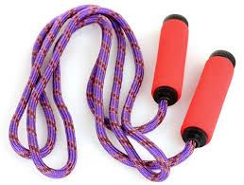 I have got a skipping r_ _ e.
Đáp án: op
190. yard./ in/ We’re/ all/ the school
Đáp án: We’re all in the school yard.
191. Ảnh: There are seven _ _ _ tures on the wall.
Đáp án: pic
192. Choose the odd one out:
A. lunch B. breakfast C. doll D. dinner
Đáp án: doll
193. What does his un_ _ _ look like?
Đáp án: cle
194. They have _ _ _ _ _ at 12:00 everyday.
Đáp án: lunch
195. What’s your favourite …? – It’s milk.
A. food B. subject C. drink D. sport
Đáp án: drink
196. Nghe: Nhấn giữ Ctrl và bấm chuột để nghe: The boy’s coloring the car on the table ….
A. green B. pink C. blue D. grey
Đáp án: green
197. Sing wit_ me.
Đáp án: h
198. Mum: Is school fun? - Boy: Yes, it is so _ _ ch fun.
Đáp án: mu
199. Look at t_ e cat.
Đáp án: h
200. Nghe: Nhấn giữ Ctrl và bấm chuột để nghe: Linda has a _ _ _ _ _ _ .
Đáp án: puzzle

KEY IOE K3 SỐ 49
1. Nghe: Nhấn giữ Ctrl và bấm chuột để nghe: What do her parents do?
A. Sing a song B. Clap their hands C. Dance D. Sit down
Đáp án: Clap their hands
2. my/ is/ It/ not/ bedroom./
Đáp án: It is not my bedroom.
3. Nghe: Nhấn giữ Ctrl và bấm chuột để nghe: Listen and choose the correct phrases you hear:
A. green bananas B. green monster C. green mother D. green monsters
Đáp án: green monster
4. Ảnh: 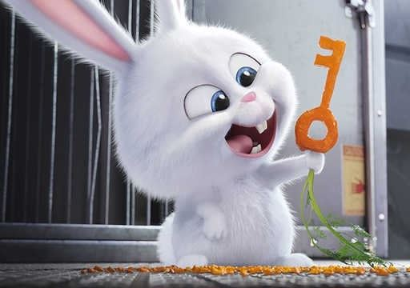 Do you like _ _ _ _ _ _ _ ?
Đáp án: rabbits
5. I’m fine, thanks. ... you?
A. End B. And C. On D. Ten
Đáp án: And
6. Nghe: Nhấn giữ Ctrl và bấm chuột để nghe: The sky is _ _ _ _ _ you.
Đáp án: above
7. They/ books about/ chess./ reading/ likes/
Đáp án: They likes reading books about chess.
8. There are ... chairs in my living room.
A. one B. five C. a D. an
Đáp án: five
9. Nghe: Nhấn giữ Ctrl và bấm chuột để nghe: _ _ _ _ _ _ _
Đáp án: teacher
10. Peter/ Linda/ hide-and-seek/ now.
A. Peter and Linda is playing hide-and-seek now. B. Peter and Linda are playing with hide-and-seek now. C. Peter and Linda playing hide-and-seek now. D. Peter and Linda are playing hide-and-seek now.
Đáp án: Chọn ý: D
11. Ảnh: That is my _ _ _ _ sister.
Đáp án: baby
12. _ _ _ _ _ and eleven is sixty-one.
Đáp án: fifty
13. I have many _ _ _ _ : a cat, a dog, two birds and four goldfish.
Đáp án: pets
14. Ảnh: 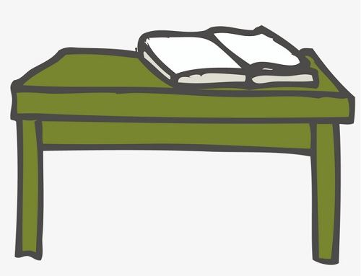 My book is on the _ _ _ _ _ .
Đáp án: table
15. May we _ _ out together?
Đáp án: go
16. Are those your pencil sharpeners?
A. Yes, it is. B. No, it isn’t. C. Yes, they are. D. No, they are.
Đáp án: Yes, they are.
17. Ảnh: There is a white … around my house.
A. tree B. gate C. pond D. fence
Đáp án: Chọn ý: D
18. Are Philip and Tony watching TV?
A. Yes, he is. B. Yes, they are. C. No, he and he are not. D. No, they not.
Đáp án: Yes, they are.
19. a/ phone./ is/ It/ blue
Đáp án: It is a blue phone.
20. Vinh and I … at home right now.
A. am B. is C. are D. do
Đáp án: are
21. Tony ... football at break time but today he … basketball.
A. plays - is playing B. plays - plays C. is playing - plays D. is playing - is playing
Đáp án: plays - is playing
22. Where are you? - I am w_ _ _ my friends.
Đáp án: ith
23. I love dancing very _ _ _ _ .
Đáp án: much
24. Sing with ..., Simon .
A. he B. she C. I D. me
Đáp án: Chọn ý: D
25. Nghe: Nhấn giữ Ctrl và bấm chuột để nghe: He puts the hot dogs on a _ _ _ _ _ .
Đáp án: plate
26. C_ _ you ride a bike?
Đáp án: an
27. How many balls are _ _ _ _ _ in the basket?
Đáp án: there
28. Choose the odd one out:
A. tidy B. nice C. clean D. dirty
Đáp án: Chọn ý: D
29. Ảnh: This _ _ _ _ _ is cute. It says 'baa-baa'.
Đáp án: sheep
30. Put your books s a_ _ y, please.
Đáp án: wa
31. Van: What’s that tall building there? - Lan: It’s _ _ new school
Đáp án: my
32. Nghe: Nhấn giữ Ctrl và bấm chuột để nghe: What colour do you hear?
A. Oil B. Yellow C. Black D. Orange
Đáp án: Chọn ý: D
33. Ảnh: May you come and s_ _ _ with me?
Đáp án: ing
34. _ _ _ _ is your name?
Đáp án: What
35. weather/ sunny/ today./ is/ The/
Đáp án: The weather is sunny today.
36. not near/ the city./ My/ home village/ is/
Đáp án: My home village is not near the city.
37. My be_ _ oom is small.
Đáp án: dr
38. C_ _ _ on. We don’t have much time.
Đáp án: ome
39. I have m_ _ y toys.
Đáp án: an
40. … fishing together now!
A. Let go B. Lets go C. Let’s go D. Let goes
Đáp án: Let’s go
41. …. - Yes, my book is new.
A. Is your shoe new? B. Are these books new? C. Is that new? D. Are those new?
Đáp án: Is that new?
42. is/ The gate of/ the house/ green./ dark
Đáp án: The gate of the house is dark green.
43. Ảnh: A: Who’s th_ _ ? - B: It’s my brother.
Đáp án: at
44. May you give me that pencil case? – Here y_ _ are.
Đáp án: ou
45. Friday/ is/ day./ favourite/ my/
Đáp án: Friday is my favourite day.
46. There are two cat_ in that box.
Đáp án: s
47. is/ How/ Thang?/ old/
Đáp án: How old is Thang?
48. Wh_ _ _ are the maps? – They are on the wall.
Đáp án: ere
49. Look that woman! _ _ _ ’s my teacher.
Đáp án: She
50. Nghe: Nhấn giữ Ctrl và bấm chuột để nghe: Her sister is _ _ _ years old.
Đáp án: ten
51. Odd one out:
A. they B. ten C. we D. you
Đáp án: ten
52. Ảnh: Don’t play outside, son. It’s ….
A. raining B. snowing C. windy D. stormy
Đáp án: raining
53. in front/ of/ a pond/ your house?/ Is there/
Đáp án: Is there a pond in front of your house?
54. Thinh and ______ are twenty.
A. me B. I C. my D. your
Đáp án: I
55. Ảnh: Is it your new …?
A. mobile phone B. book C. table D. bed
Đáp án: book
56. This gift is for you. – Thank you very m_ _ h.
Đáp án: uc
57. in the/ early/ Can you/ morning?/ get up/
Đáp án: Can you get up early in the morning?
58. bedroom./ his/ sleeping in/ is/ Hieu/
Đáp án: Hieu is sleeping in his bedroom.
59. is/ This/ my/ new/ friend./
Đáp án: This is my new friend.
60. Lo_ k at the board, please.
Đáp án: o
61. Nghe: Nhấn giữ Ctrl và bấm chuột để nghe: May I _ _ _ _ a song?
Đáp án: sing
62. … is Minh’s school? – It’s over there.
A. Where B. Which C. What D. How
Đáp án: Where
63. Ảnh: Is this black and white bac_ _ _ _ _ yours?
Đáp án: kpack
64. yellow/ rubbers/ and/ red pencils./ I love/
Đáp án: I love yellow rubbers and red pencils.
65. ... you want to ride a bike with me?
A. Can B. Do C. Are D. Am
Đáp án: Do
66. John ________ painting pictures.
A. like B. likes C. is liking D. to like
Đáp án: likes
67. from/ not/ America./ She/ is/
Đáp án: She is not from America.
68. The opposite of THESE is _ _ _ _ _ .
Đáp án: those
69. Ha Long Bay is ______ from Hanoi.
A. near B. next to C. above D. far
Đáp án: Chọn ý: D
70. days/ a week./ in/ seven/ There are/
Đáp án: There are seven days in a week.
71. How’s the weather today?
A. It’s a cloud. B. It’s cloudy. C. It’s fine, thank you. D. It has a sun.
Đáp án: It’s cloudy.
72. has/ hat./ beautiful/ Daisy/ a/
Đáp án: Daisy has a beautiful hat.
73. at the court./ are/ playing/ badminton/ My friends/
Đáp án: My friends are playing badminton at the court.
74. Ảnh: How’s the weather? – It’s _ _ _ _ _ .
Đáp án: rainy
75. This ... my mother.
A. are B. am C. is D. and
Đáp án: is
76. _ _ _ many posters are there in the room?
Đáp án: how
77. The o_ _ computer is very slow.
Đáp án: ld
78. eight/ pictures/ There are/ the classroom./ in
Đáp án: There are eight pictures in the classroom.
79. Ảnh: Do you like _ _ _ _ _ _ s?
Đáp án: carrot
80. Show me _ _ _ r pens, children.
Đáp án: you
81. Nghe: Nhấn giữ Ctrl và bấm chuột để nghe: Sue’s toy is a ... .
A. star B. far C. car D. bear
Đáp án: car
82. A: Is there a cupboard or a wardrobe in your bedroom? - B: …
A. Yes, there is. B. There are both of them. C. My clothes are in the wardrobe. D. My toys are in the cupboard.
Đáp án: There are both of them.
83. Choose the letter(s) to make a correct word: ta__ng
A. ki B. kei C. ke D. ci
Đáp án: ki
84. birthday?/ you/ remember/ my/ Can/
Đáp án: Can you remember my birthday?
85. Which word has ‘ch’ pronounced as the letter ‘k’ in \"clock\"?
A. chair B. chess C. school D. kitchen
Đáp án: school
86. I’m/ I’m late/ . May I come/ sorry/ in?/
Đáp án: I’m sorry I’m late . May I come in?
87. Nghe: Nhấn giữ Ctrl và bấm chuột để nghe: How do you ... your name?
A. tell B. talk C. write D. spell
Đáp án: Chọn ý: D
88. Look! My doll is in fr_ _ _ of Lily’s.
Đáp án: ont
89. _ hat’s your name?
Đáp án: W
90. What is this? - ... .
A. It ruler B. It’s ruler C. It is a ruler D. It is rulers
Đáp án: It is a ruler
91. flowers/ There are/ in our/ school./ many/
Đáp án: There are many flowers in our school.
92. Our school is _ _ north city.
Đáp án: in
93. There is a flower va_ e on the table.
Đáp án: s
94. A: Is that Peter? – B: Yes, … .
A. he is B. is he C. is not D. he not
Đáp án: he is
95. Ảnh: Give me a packet of _ _ _ _ , please.
Đáp án: milk
96. _ _ _ _ _ pencils are these? – They’re my pencils.
Đáp án: Whose
97. What/ are/ on/ the shelf?/ those/
Đáp án: What are those on the shelf?
98. Nghe: Nhấn giữ Ctrl và bấm chuột để nghe: My house has a ... yard.
A. small B. fat C. large D. big
Đáp án: large
99. Nghe: Nhấn giữ Ctrl và bấm chuột để nghe: He’s wearing a white _ _ _ _ .
Đáp án: coat
100. My pictures _ _ _ on the wall.
Đáp án: are
101. Odd one out:
A. sun B. snowy C. cloud D. wind
Đáp án: snowy
102. Are you going to visit Huong Pagoda ...?
A. today B. tomorrow C. now D. yesterday
Đáp án: tomorrow
103. is/ my/ toy./ This/
Đáp án: This is my toy.
104. Ảnh: This is a mo_ _ _ _ cat. That is its baby.
Đáp án: ther
105. The cat is sitting ... the tree.
A. near to B. next C. in D. under
Đáp án: Chọn ý: D
106. … your hands before eating.
A. Brush B. Wash C. Catch D. Look at
Đáp án: Wash
107. a/ This/ is/ doll.
Đáp án: This is a doll.
108. Choose the odd one out:
A. ruler B. rabbit C. cat D. dog
Đáp án: ruler
109. Is/ today?/ birthday/ your/
Đáp án: Is your birthday today?
110. We may come back tog_ _ _ _ _ . It is very late now.
Đáp án: ether
111. please?/ sit/ here/ I/ Can/
Đáp án: Can I sit here please?
112. notebooks,/ Alan./ out/ your/ Take/
Đáp án: Take out your notebooks, Alan.
113. How _ _ _ _ children are there in the playground?
Đáp án: many
114. Ảnh: He has a toy _ _ _ _ .
Đáp án: ship
115. Nghe: Nhấn giữ Ctrl và bấm chuột để nghe: Tom is the boy with a _ _ _ .
Đáp án: hat
116. me/ some/ Please,/ give/ more pencils./
Đáp án: Please, give me some more pencils.
117. Nghe: Nhấn giữ Ctrl và bấm chuột để nghe: It’s a nice _ _ _ _ _ _ room.
Đáp án: living
118. Good_ _ _ Mary. See you later.
Đáp án: bye
119. Ảnh: This de_ _ is looking for his mom.
Đáp án: er
120. How’s the wea_ _ er today? – It’s sunny.
Đáp án: th
121. These fl_ _ ers are for you, Mary. – Thank you.
Đáp án: ow
122. … do you like to play? – I like to play hide-and-seek.
A. What B. Where C. When D. How
Đáp án: What
123. See you later. _ _ e.
Đáp án: By
124. in the playground/ is playing/ his friends./ with/ John/
Đáp án: John is playing in the playground with his friends.
125. green/ pen./ It is/ a/
Đáp án: It is a green pen.
126. cook/ meal./ big/ Let's/ a/
Đáp án: Let's cook a big meal.
127. Who’s she? – She’s my ______.
A. aunt B. brother C. uncle D. grandfather
Đáp án: aunt
128. I keep my goldfish in the fish ….
A. house B. tank C. cage D. room
Đáp án: tank
129. _______ is his coat? - It’s on his bed.
A. When B. Where C. Who D. What
Đáp án: Where
130. Wh_ is that? – That’s David.
Đáp án: o
131. There are/ lake./ in the/ many/ fish/
Đáp án: There are many fish in the lake.
132. chairs and a table/ There/ in my dining room./ eight/ are/
Đáp án: There are eight chairs and a table in my dining room.
133. Choose the odd one out:
A. old B. nine C. ten D. six
Đáp án: old
134. R_ ad after me, children.
Đáp án: e
135. this song/ I/ with my/ mother./ sing/
Đáp án: I sing this song with my mother.
136. My si_ _ er’s name is Mary.
Đáp án: st
137. is large/ new./ Our/ and/ school playground/
Đáp án: Our school playground is large and new.
138. What col_ _ r is this book? – It’s red.
Đáp án: ou
139. Ảnh: A: Is there a(n) … in your bedroom? - B: No, there isn’t.
A. window B. fan C. clock D. armchair
Đáp án: Chọn ý: D
140. What … your sister look like?
A. does B. do C. is D. are
Đáp án: does
141. What … your parents look like?
A. does B. do C. is D. are
Đáp án: do
142. This is a photo _ _ my class.
Đáp án: of
143. the kitchen./ My/ in/ father/ is/
Đáp án: My father is in the kitchen.
144. Choose the odd one out:
A. write B. sit C. read D. ruler
Đáp án: Chọn ý: D
145. Quan is _ _ _ _ _ his homework in his room.
Đáp án: doing
146. Linda is her _ _ me.
Đáp án: na
147. What is your … drink? – I like orange juice the most.
A. name B. favourite C. much D. many
Đáp án: favourite
148. Which word has the letter ‘e’ pronounced as the letter ‘e’ in \"yes\"?
A. new B. orange C. come D. bed
Đáp án: Chọn ý: D
149. like?/ is/ Betty/ What/
Đáp án: What is Betty like?
150. Nghe: Nhấn giữ Ctrl và bấm chuột để nghe: The car behind the _ _ _ _ _ is white.
Đáp án: chair
151. in/ June./ birthday/ is/ Her/
Đáp án: Her birthday is in June.
152. … room is your computer room? – That big room over there.
A. Which B. What C. How D. When
Đáp án: Which
153. _ _ _ _ is it? – It is a chair.
Đáp án: What
154. Is that your classroom? It is so _ _ _ ge.
Đáp án: lar
155. in/ Don’t/ come/ room./ that
Đáp án: Don’t come in that room.
156. He is se_ _ n years old.
Đáp án: ve
157. It’s/ to school/ fun/ everyday./ to go/
Đáp án: It’s fun to go to school everyday.
158. Peter/ subject/ What/ like best?/ does/
Đáp án: What subject does Peter like best?
159. Nghe: Nhấn giữ Ctrl và bấm chuột để nghe: There aren’t any _ _ _ _ here.
Đáp án: boys
160. Mary is a ... at London Primary School.
A. boy B. toy C. student D. she
Đáp án: student
161. FI__TEEN
A. T B. VE C. F D. S
Đáp án: F
162. Ảnh: Hoa: What is this? - Lan: It’s my school _ _ _ . There are a lot of my school things.
Đáp án: bag
163. Thanks _ _ _ _ much.
Đáp án: very
164. Ảnh: The apple is … the book.
A. next to B. on C. under D. over
Đáp án: next to
165. Nghe: Nhấn giữ Ctrl và bấm chuột để nghe: When it’s sunny, the sky is _ _ _ _ .
Đáp án: blue
166. Minh ______ drawing pictures of cats.
A. like B. likes C. is like D. is likes
Đáp án: likes
167. your name,/ Loan?/ do you/ spell/ How/
Đáp án: How do you spell your name, Loan?
168. These a_ _ pink desks.
Đáp án: re
169. Pick _ p your pencil, please.
Đáp án: u
170. Choose the odd one out:
A. thirty B. seventy C. eighty D. twelve
Đáp án: Chọn ý: D
171. Ảnh: This is my new co_ _ _ ter room.
Đáp án: mpu
172. are./ your bag/ where/ don’t know/ I/
Đáp án: I don’t know where your bag are.
173. Have a n_ ce day.
Đáp án: i
174. Hi, ... name is John.
A. your B. my C. its D. me
Đáp án: my
175. What is your favourite _ _ _ _ ? - It’s hide-and-seek.
Đáp án: game
176. Nghe: Nhấn giữ Ctrl và bấm chuột để nghe: Which is NOT mentioned in the recording?
A. ball B. doll C. puzzle D. teddy
Đáp án: doll
177. Nghe: Nhấn giữ Ctrl và bấm chuột để nghe: The girl is _ _ _ _ _ years old.
Đáp án: eight
178. shelf./ Put/ the books/ on/ the
Đáp án: Put the books on the shelf.
179. This is my friend James. … is a nice boy.
A. He B. She C. They D. It
Đáp án: He
180. May I speak to you now? - ….
A. No, you may not. B. Yes, you may. C. No, I am not. D. Sure. You can.
Đáp án: Chọn ý: D
181. Nghe: Nhấn giữ Ctrl và bấm chuột để nghe: _ _ _ _
Đáp án: like
182. is/ name?/ your/ What/ teacher’s
Đáp án: What is your teacher’s name?
183. Choose the odd one out:
A. book B. pen C. ruler D. Mary
Đáp án: Chọn ý: D
184. very/ I/ much./ like/ English/
Đáp án: I like English very much.
185. those/ are/ table?/ What/ the/ on
Đáp án: What are those on the table?
186. She lives ... the sea.
A. in B. on C. near D. at
Đáp án: near
187. Do you h_ _ e Maths today?
Đáp án: av
188. Tom can swim … dance.
A. but B. and C. for D. to
Đáp án: and
189. Ảnh: There are … round tables and … chairs.
A. one - four B. four - eleven C. five - twelve D. three - twelve
Đáp án: Chọn ý: D
190. A: Is he Tony? – B: No, … .
A. he is B. he isn’t C. he not is D. not he is
Đáp án: he isn’t
191. _______ are they? - They are in the library.
A. Who B. What C. When D. Where
Đáp án: Chọn ý: D
192. These are my classmates. … in class 3D.
A. He is B. She is C. We are D. You are
Đáp án: We are
193. Choose the word which has the same sound with the word ’’wait’’.
A. talk B. kite C. late D. cold
Đáp án: late
194. Those _ _ _ my bags.
Đáp án: are
195. Are you five _ _ _ _ _ old?
Đáp án: years
196. _ _ she your new classmate?
Đáp án: is
197. Gi_ e me the book, please.
Đáp án: v
198. your father/ forty-one/ old?/ years/ Is/
Đáp án: Is your father forty-one years old?
199. come/ in,/ May/ please?/ I/
Đáp án: May I come in, please?
200. don’t/ your bedroom?/ Why/ you/ like
Đáp án: Why don’t you like your bedroom?

KEY IOE K3 SỐ 50
1. pictures/ his/ now./ Alex is/ colouring/
Đáp án: Alex is colouring his pictures now.
2. Ảnh: A: Who’s th_ _ ? - B: It’s my brother.
Đáp án: at
3. Come and _ _ at with your friends.
Đáp án: ch
4. Taylor is from England. She … me every month.
A. calls B. write C. read D. speak
Đáp án: calls
5. A: How many chairs are there? - B: Let me co_ _ _ them. One, two, three, …. There are five.
Đáp án: unt
6. ... are you? – Fine, thanks.
A. Who B. Is C. Are D. How
Đáp án: Chọn ý: D
7. Nghe: Nhấn giữ Ctrl và bấm chuột để nghe: I’ve got two big _ _ _ _ .
Đáp án: cats
8. ... your teeth, John.
A. Read B. Listen C. Stand D. Brush
Đáp án: Chọn ý: D
9. These/ flowers/ beautiful./ are/ very
Đáp án: These flowers are very beautiful.
10. This is ... doll.
A. she B. me C. my D. hi
Đáp án: my
11. Nghe: Nhấn giữ Ctrl và bấm chuột để nghe: _ _ _ _ _ _
Đáp án: rabbit
12. … and listen to your teacher, please.
A. Opening your book B. Sit still C. Reading aloud D. Not speaking
Đáp án: Sit still
13. My new _ _ _ _ _ _ is Adam.
Đáp án: friend
14. Do you/ like/ listening/ to/ music?/
Đáp án: Do you like listening to music?
15. Who is he? - ... .
A. He my friend B. She my friend C. He is Simon. He is my good friend D. She’s Mary
Đáp án: He is Simon. He is my good friend
16. Would you like some …? – No, thanks. I hate sweets.
A. coffee B. lemonade C. chocolate D. chicken
Đáp án: chocolate
17. What … is it? – It’s eleven o’clock.
A. name B. colour C. time D. day
Đáp án: time
18. This is an ora_ ge book.
Đáp án: n
19. Ảnh: A: Where is the _ _ _ bit? - B: It’s in the box.
Đáp án: rab
20. Goodbye, David. See y_ u later.
Đáp án: o
21. My brother likes to dri_ _ milk very much.
Đáp án: nk
22. have/ two/ I/ robots.
Đáp án: I have two robots.
23. Choose the incorrect word(s) in the following sentence: My friend, Quynh, doesn’t has any comic books.
A. My B. has C. any D. books
Đáp án: has
24. does/ What/ Khai/ after work?/ do
Đáp án: What does Khai do after work?
25. _ _ _ _ colour is your teddy bear?
Đáp án: What
26. Ảnh: Do you like playing …?
A. football B. paper boats C. chess D. hide-and-seek
Đáp án: paper boats
27. My pictures _ _ _ on the wall.
Đáp án: are
28. Nghe: Nhấn giữ Ctrl và bấm chuột để nghe: Her English teacher is Mr. _ _ _ _ .
Đáp án: tony
29. Nghe: Nhấn giữ Ctrl và bấm chuột để nghe: The chairs are _ _ _ _ the table.
Đáp án: near
30. Choose the odd one out.
A. brother B. sister C. mother D. teacher
Đáp án: Chọn ý: D
31. Odd one out:
A. Vietnam B. English C. America D. China
Đáp án: English
32. How/ is/ old/ your/ father?/
Đáp án: How old is your father?
33. Tom re_ _ _ books in the library in the afternoon.
Đáp án: ads
34. grandparents/ are/ My/ old./ very
Đáp án: My grandparents are very old.
35. aren’t/ There/ any theatres/ my neighborhood./ in
Đáp án: There aren’t any theatres in my neighborhood.
36. He _______ to the zoo in the morning.
A. go B. ride C. has D. walks
Đáp án: Chọn ý: D
37. Informatics./ subject/ is/ favourite/ My/
Đáp án: My favourite subject is Informatics.
38. glass/ of milk./ I/ would like/ a/
Đáp án: I would like a glass of milk.
39. Nghe: Nhấn giữ Ctrl và bấm chuột để nghe: Can I borrow your _ _ _ _ for a minute? – Sure.
Đáp án: book
40. Those are my blue balloo_ _ .
Đáp án: ns
41. I like to s_ ng.
Đáp án: i
42. Nghe: Nhấn giữ Ctrl và bấm chuột để nghe: Put the computer in the ….
A. wardrobe B. bookcase C. table D. cupboard
Đáp án: Chọn ý: D
43. A: How old is she? - B: She is ten … old.
A. yeasr B. yares C. yreas D. years
Đáp án: Chọn ý: D
44. Nghe: Nhấn giữ Ctrl và bấm chuột để nghe: _ _ _ _
Đáp án: cage
45. There are/ and/ five chairs/ one table/ in the living room./
Đáp án: There are five chairs and one table in the living room.
46. What’s the matter _ _ _ _ your eyes?
Đáp án: with
47. W_ _ is she, Peter? – She’s is Alice.
Đáp án: ho
48. ... you want to ride a bike with me?
A. Can B. Do C. Are D. Am
Đáp án: Do
49. rulers/ The/ on the/ are/ table./
Đáp án: The rulers are on the table.
50. Come ov_ r here.
Đáp án: e
51. Pl_ _ _ _ give me that old black pen.
Đáp án: ease
52. Is it the music room? - …. It’s the computer room.
A. Yes, it is. B. No, it isn’t. C. No, it doesn’t. D. Yes, it does.
Đáp án: No, it isn’t.
53. That is a gr_ _ n doll.
Đáp án: ee
54. years/ is/ old./ My grandfather/ sixty-seven/
Đáp án: My grandfather is sixty-seven years old.
55. Nghe: Nhấn giữ Ctrl và bấm chuột để nghe: Look at the _ _ _ _ in the tree.
Đáp án: ball
56. Nghe: Nhấn giữ Ctrl và bấm chuột để nghe: The boy’s name is _ _ _ _ .
Đáp án: Alex
57. A: Is your house _ _ _ _ the cinema? - B: No, it’s very far.
Đáp án: near
58. the/ teacher/ Listen/ carefully./ to/
Đáp án: Listen to the teacher carefully.
59. Is this your grandfather? – Yes, he _ _ .
Đáp án: is
60. Nine and three is _ _ _ _ _ _ .
Đáp án: twelve
61. Is your school big? - ..., it is.
A. No B. Not C. Yes D. No, it isn’t
Đáp án: Yes
62. Ảnh: Rapunzel ______ long straight blonde hair.
A. has B. have C. haves D. is has
Đáp án: has
63. ... this a desk? – Yes, it is.
A. Is B. Are C. How D. Whatname’s
Đáp án: Is
64. like/ play/ Do you/ hide-and-seek?/ to/
Đáp án: Do you like to play hide-and-seek?
65. Ảnh: Two boys are reading their books _ _ _ _ _ the tree.
Đáp án: under
66. My sister _ _ _ a doll.
Đáp án: has
67. Do you like playing puz_ _ _ _ ?
Đáp án: zles
68. Nghe: Nhấn giữ Ctrl và bấm chuột để nghe: Mai likes ... flowers.
A. beautiful B. wonderful C. colorful D. blue
Đáp án: beautiful
69. It's/ with Linda./ fun/ to be/
Đáp án: It's fun to be with Linda.
70. Simon is my friend, t_ _ .
Đáp án: oo
71. I a_ nine years old. How old are you?
Đáp án: m
72. Which word has the letter ‘e’ pronounced as the letter ‘e’ in \"yes\"?
A. new B. orange C. come D. bed
Đáp án: Chọn ý: D
73. Choose the odd one out:
A. ruler B. crayon C. sing D. eraser
Đáp án: sing
74. Choose the word which has the same sound with the word ’’wait’’.
A. talk B. kite C. late D. cold
Đáp án: late
75. Ảnh: The teddy bear has a r_ _ tie.
Đáp án: ed
76. Choose the odd one out.
A. ship B. truck C. plane D. duck
Đáp án: Chọn ý: D
77. volleyball/ dinner./ play/ after/ Let’s/
Đáp án: Let’s play volleyball after dinner.
78. Choose the odd one out:
A. thirty B. seventy C. eighty D. twelve
Đáp án: Chọn ý: D
79. Let’s/ with/ sing/ a song/ me./
Đáp án: Let’s sing a song with me.
80. talking/ right/ now?/ with Chi/ Who is/
Đáp án: Who is talking with Chi right now?
81. Nam: Is that girl new? - Lien: I don’t kn_ _ . Ask Hoa.
Đáp án: ow
82. Tho_ _ books are mine. These books are yours.
Đáp án: se
83. What are they? – They are ….
A. red B. small C. stars D. big
Đáp án: stars
84. Nghe: Nhấn giữ Ctrl và bấm chuột để nghe: Choose the TRUE statement.
A. There are two armchairs, a sofa and a window in the living room. B. There are two sofas, an armchair and a window in the living room. C. There are two windows, a sofa and an armchair in the living room. D. There are two armchairs, two sofas and a window in the living room.
Đáp án: There are two armchairs, a sofa and a window in the living room.
85. Nghe: Nhấn giữ Ctrl và bấm chuột để nghe: When it’s sunny, the sky is _ _ _ _ .
Đáp án: blue
86. Ảnh: Oh, this teddy _ _ _ _ is cute. Can you buy it for me, Mum?
Đáp án: bear
87. Nghe: Nhấn giữ Ctrl và bấm chuột để nghe: This is my _ _ _ _ _ .
Đáp án: house
88. are/ Her/ from/ France./ friends/
Đáp án: Her friends are from France.
89. A: What does your aunt …? - B: She is very sporty.
A. like B. look like C. likes D. like looking
Đáp án: look like
90. The school is far _ _ _ _ the cinema.
Đáp án: from
91. 1st/ June/ Children’s/ Day./ is/
Đáp án: June 1st is Children’s Day.
92. Choose the odd one out:
A. how B. hello C. hi D. good morning
Đáp án: how
93. Mary and Peter can … Vietnamese.
A. speaks B. speak C. to speak D. a speak
Đáp án: speak
94. Choose the odd one out.
A. chicken B. beef C. pork D. food
Đáp án: Chọn ý: D
95. Ảnh: What is that? – It is a ….
A. pencil case B. ruler C. pen D. book
Đáp án: pencil case
96. This is a de_ k.
Đáp án: s
97. Is this your sister? – Yes, _______.
A. it is B. it’s not C. he is D.
Đáp án: it is
98. This is my father. _ _ _ name is John.
Đáp án: his
99. …. - Yes, my book is new.
A. Is your shoe new? B. Are these books new? C. Is that new? D. Are those new?
Đáp án: Is that new?
100. and Sarah/ playing/ are/ board games./ Linda/
Đáp án: Linda and Sarah are playing board games.
101. That is an ora_ _ e pencil.
Đáp án: ng
102. This is my d_ ll.
Đáp án: o
103. These are my classmates. … in class 3D.
A. He is B. She is C. We are D. You are
Đáp án: We are
104. Can the cat _ _ _ _ _ a tree? – Yes, it can.
Đáp án: climb
105. Nghe: Nhấn giữ Ctrl và bấm chuột để nghe: The girl’s T-shirt is in the _ _ _ .
Đáp án: car
106. Tom can swim … dance.
A. but B. and C. for D. to
Đáp án: and
107. Is … bedroom large? – Yes, it is.
A. Jimmy B. Minh’s C. my friend D. house
Đáp án: Minh’s
108. ... is that? - It’s a pen.
A. How B. When C. What D. Where
Đáp án: What
109. Ảnh: The c_ _ _ is on the chair.
Đáp án: oat
110. W_ _ h your hands carefully, Kate.
Đáp án: as
111. table tennis?/ you/ like/ playing/ Do/
Đáp án: Do you like playing table tennis?
112. I’m fine, thanks. ... you?
A. End B. And C. On D. Ten
Đáp án: And
113. Nghe: Nhấn giữ Ctrl và bấm chuột để nghe: Which is the _ _ _ _ _ _ _ , a giraffe, an elephant or a monkey? – Of course, a giraffe.
Đáp án: tallest
114. They are ... the beach this summer.
A. going B. going to C. visiting D. go
Đáp án: going to
115. Choose the odd one out:
A. book B. pen C. ruler D. Mary
Đáp án: Chọn ý: D
116. is a/ This/ book./ green/
Đáp án: This is a green book.
117. John/ in the playground/ his friends./ is playing/ with
Đáp án: John is playing in the playground with his friends.
118. a postcard/ Write/ friend./ to/ a pen
Đáp án: Write a postcard to a pen friend.
119. What a_ _ _ t an apple? – Yes, please.
Đáp án: bou
120. Nghe: Nhấn giữ Ctrl và bấm chuột để nghe: It has _ _ _ _ _ _ _ _ of many animals.
Đáp án: pictures
121. game/ is/ The/ very/ exciting./
Đáp án: The game is very exciting.
122. A: Are David and James singing? - B: Yes, ….
A. they aren’t B. they are C. he is D. he isn’t
Đáp án: they are
123. green./ This/ is/ shirt/
Đáp án: This shirt is green.
124. Ha: _ _ _ _ colour is that pen? - Mai: It is a blue.
Đáp án: What
125. Ảnh: How many cats are there in the yard? - There are _ _ _ _ cats. They are eating fish.
Đáp án: nine
126. Choose the odd one out:
A. on B. where C. under D. behind
Đáp án: where
127. I’m fine, than_ _ .
Đáp án: ks
128. you/ your/ like/ Do/ house?/
Đáp án: Do you like your house?
129. What col_ _ r is this book? – It’s red.
Đáp án: ou
130. How are you? - ... .
A. I’m Binh B. She’s my sister C. I’m fine, thank you D. Goodbye
Đáp án: I’m fine, thank you
131. Wh_ _ do you have Maths? – I have it on Monday.
Đáp án: en
132. Ảnh: This is a mo_ _ _ _ cat. That is its baby.
Đáp án: ther
133. Ảnh: We help our mother with the _ _ _ _ _ _ _ _ _ .
Đáp án: housework
134. There is o_ e kitchen in his house.
Đáp án: n
135. Odd one out:
A. your B. me C. us D. him
Đáp án: your
136. Odd one out:
A. he B. she C. they D. me
Đáp án: Chọn ý: D
137. Choose the odd one out:
A. paint B. draw C. write D. walk
Đáp án: Chọn ý: D
138. Ảnh: Rabbits like car_ _ _ _ very much.
Đáp án: rots
139. do/ you have?/ How/ skirts/ many/
Đáp án: How many skirts do you have?
140. Nghe: Nhấn giữ Ctrl và bấm chuột để nghe: Which _ _ _ _ _ is Sam in?
Đáp án: class
141. Listen ... the teacher.
A. to B. me C. you D. he
Đáp án: to
142. Ảnh: My family is having dinner in the _ _ _ _ ng room.
Đáp án: dini
143. Hello. My ... is Tom.
A. name B. is C. am D. are
Đáp án: name
144. Are … four people in your family, Jack?
A. it B. they C. we D. there
Đáp án: Chọn ý: D
145. These _____ old notebooks.
A. am B. is C. are D. have
Đáp án: are
146. Some _ _ _ chers are in the hall.
Đáp án: tea
147. on/ The duck/ Look!/ is swimming/ the pond./
Đáp án: Look! The duck is swimming on the pond.
148. are there/ in your/ students/ classroom?/ How many/
Đáp án: How many students are there in your classroom?
149. “Tom and Jerry”?/ you/ like/ Do/
Đáp án: Do you like “Tom and Jerry”?
150. _ _ _ _ _ _ close your notebook.
Đáp án: please
151. Ảnh: It is an old rub_ _ _ .
Đáp án: ber
152. is/ He/ ten/ old./ years
Đáp án: He is ten years old.
153. I have m_ _ y toys.
Đáp án: an
154. May I go o_ _ for a while?
Đáp án: ut
155. is/ The/ yellow./ dog/
Đáp án: The dog is yellow.
156. cats./ like/ doesn’t/ My/ brother/
Đáp án: My brother doesn’t like cats.
157. again?/ I/ Can/ meet/ you
Đáp án: Can I meet you again?
158. ... you like chicken?
A. Do B. Does C. Are D. Is
Đáp án: Do
159. always/ sunny/ in/ summer./ It is/
Đáp án: It is always sunny in summer.
160. Dolly/ fine/ Is/ now?
Đáp án: Is Dolly fine now?
161. many/ My/ brother/ toys./ has/
Đáp án: My brother has many toys.
162. favourite/ your/ subject?/ is/ What/
Đáp án: What is your favourite subject?
163. Sing wit_ me.
Đáp án: h
164. Ảnh: She is playing the pi_ _ _ .
Đáp án: ano
165. The opposite of \"on\" is \"_ _ _ _ _ \".
Đáp án: under
166. Nghe: Nhấn giữ Ctrl và bấm chuột để nghe: _ _ _ _ _ _
Đáp án: garden
167. stormy/ Is/ today?/ it/
Đáp án: Is it stormy today?
168. This/ is/ our/ classroom.
Đáp án: This is our classroom.
169. This is a r_ ler.
Đáp án: u
170. There are ... chairs in my living room.
A. one B. five C. a D. an
Đáp án: five
171. Nghe: Nhấn giữ Ctrl và bấm chuột để nghe: _ _ _ _
Đáp án: does
172. Rosie is having a shower in the ….
A. kitchen B. bathroom C. bedroom D. playground
Đáp án: bathroom
173. Ảnh: A: Where is the cat? - B: It’s behind the box.
A. Picture 1 B. Picture 2 C. Picture 3 D. Picture 4
Đáp án: Chọn ý: D
174. May we _ _ to school together?
Đáp án: go
175. I/ picture./ can/ draw/ a
Đáp án: I can draw a picture.
176. What toys/ not/ he/ like?
A. What toys doesn’t he like? B. What toys don’t he likes? C. What toys isn’t he like? D. What toys aren’t he likes?
Đáp án: What toys doesn’t he like?
177. I _ _ Chi. I am in class 3A.
Đáp án: am
178. Nghe: Nhấn giữ Ctrl và bấm chuột để nghe: There are six _ _ _ _ _ _ _ on top.
Đáp án: candles
179. My cat/ a/ tail./ long/ has/
Đáp án: My cat has a long tail.
180. This is _ _ _ way we go to school.
Đáp án: the
181. do/ you/ Can/ puzzles?
Đáp án: Can you do puzzles?
182. Dr_ _ a big brown dog, please.
Đáp án: aw
183. Ảnh: Let’s go to the _ _ _ _ _ _ _ with me. It has a lot of interesting books.
Đáp án: library
184. Her/ small/ tidy./ but/ room is/
Đáp án: Her room is small but tidy.
185. Take ou_ your books, children.
Đáp án: t
186. Odd one out:
A. they B. ten C. we D. you
Đáp án: ten
187. Sally is standing n_ _ _ to David.
Đáp án: ext
188. pink/ doll./ has/ a/ Alice/
Đáp án: Alice has a pink doll.
189. Is the girl o_ _ _ there your classmate, Rosie?
Đáp án: ver
190. I go … school early in the morning.
A. in B. at C. to D. from
Đáp án: to
191. I k_ _ _ little English and French.
Đáp án: now
192. A: How old … you? – B: I am nine years old.
A. am B. are C. is D. it
Đáp án: are
193. The books are _ _ the shelves.
Đáp án: on
194. My school is next _ _ a park.
Đáp án: to
195. the/ time/ Mary?/ now,/ What’s/
Đáp án: What’s the time now, Mary?
196. Hamburger/ my/ is/ favourite/ food./
Đáp án: Hamburger is my favourite food.
197. What grade … your twin brothers in?
A. am B. is C. are D. do
Đáp án: are
198. How many balls are _ _ _ _ _ in the basket?
Đáp án: there
199. Ảnh: Cinderella is ______ with the prince at the party.
A. dance B. dances C. dancing D. danceing
Đáp án: dancing
200. … full name is Mary Jane.
A. Her B. She’s C. She is D. She has
Đáp án: Her

