Kỷ niệm 91 năm Ngày thành lập Đoàn TNCS Hồ Chí Minh (26/3/1931 - 26/3/2022)

Tác giả: Nguồn: Trang Thông tin điện tử Trung ương Đoàn TNCS Hồ Chí Minh

[](http://hvcsnd.edu.vn/Uploads/2020/3/17/20/1.jpg)

[](http://hvcsnd.edu.vn/Uploads/2020/3/17/20/2.jpg)

[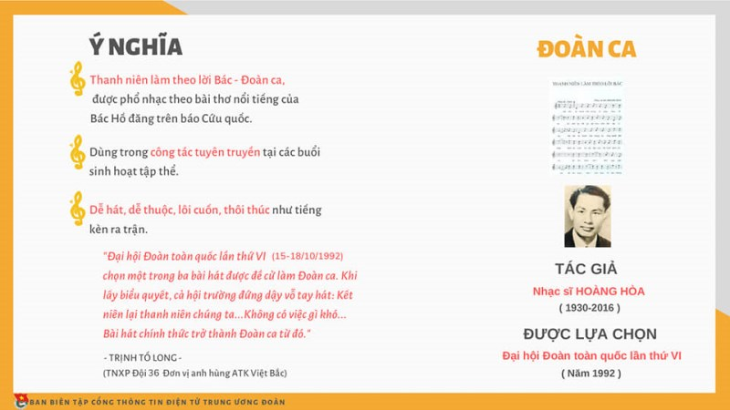](http://hvcsnd.edu.vn/Uploads/2020/3/17/20/3.jpg)

[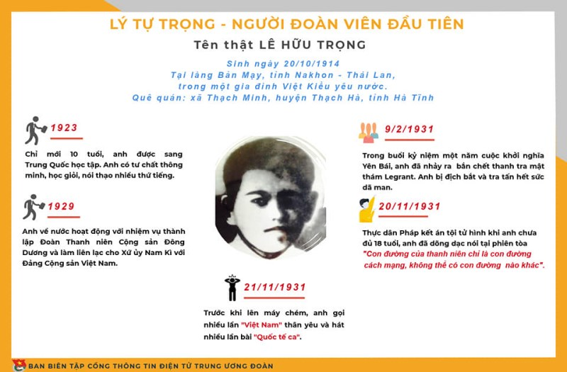](http://hvcsnd.edu.vn/Uploads/2020/3/17/20/4.jpg)

[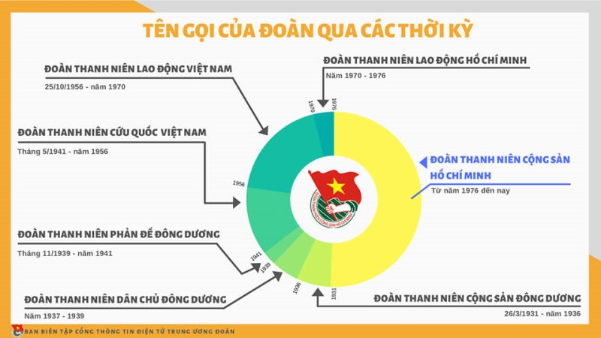](http://hvcsnd.edu.vn/Uploads/2020/3/17/20/5.jpg)

[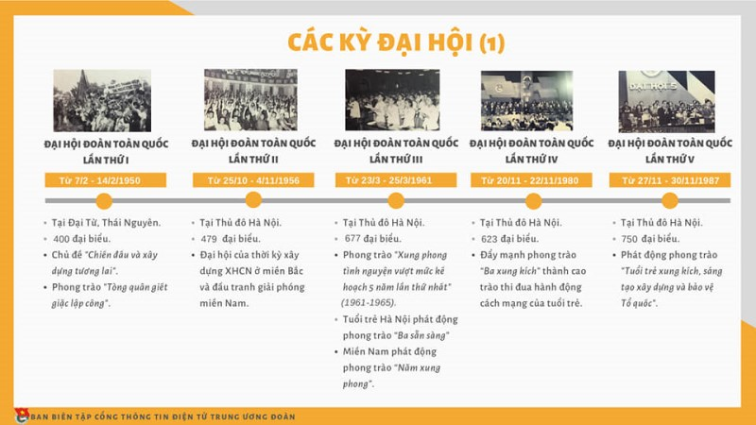](http://hvcsnd.edu.vn/Uploads/2020/3/17/20/6.jpg)

[](http://hvcsnd.edu.vn/Uploads/2020/3/17/20/7.jpg)

[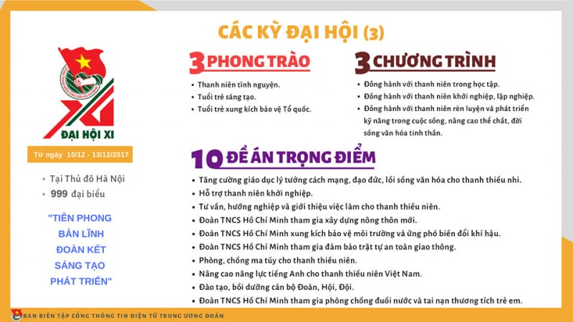](http://hvcsnd.edu.vn/Uploads/2020/3/17/20/8.jpg)

[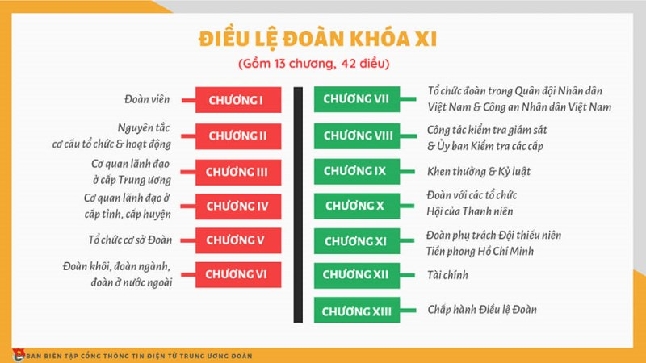](http://hvcsnd.edu.vn/Uploads/2020/3/17/20/9.jpg)

[](http://hvcsnd.edu.vn/Uploads/2020/3/17/20/10.jpg)

[](http://hvcsnd.edu.vn/Uploads/2020/3/17/20/11.jpg)

[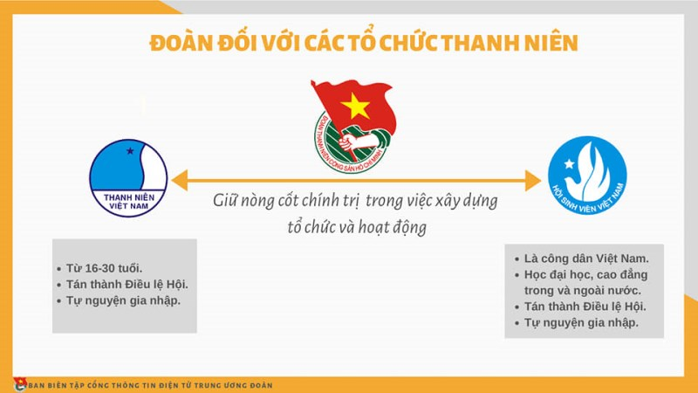](http://hvcsnd.edu.vn/Uploads/2020/3/17/20/12.jpg)

[](http://hvcsnd.edu.vn/Uploads/2020/3/17/20/13.jpg)

[](http://hvcsnd.edu.vn/Uploads/2020/3/17/20/14.jpg)

[](http://hvcsnd.edu.vn/Uploads/2020/3/17/20/15.jpg)

[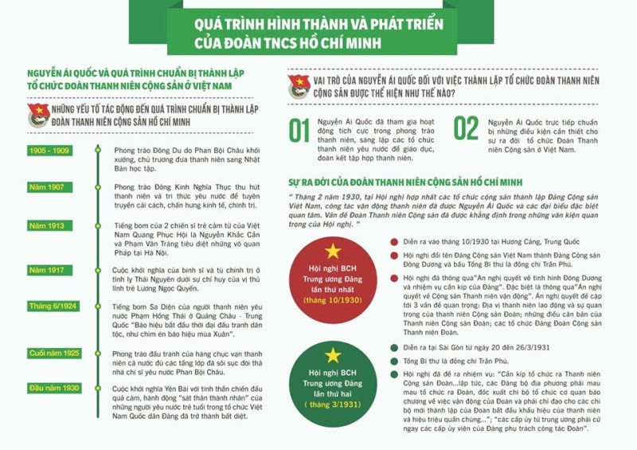](http://hvcsnd.edu.vn/Uploads/2020/3/17/20/16.jpg)

[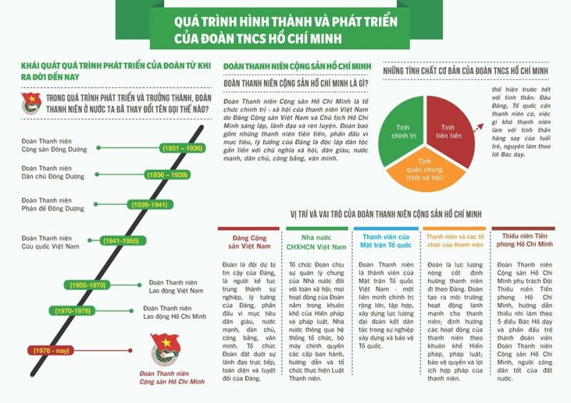](http://hvcsnd.edu.vn/Uploads/2020/3/17/20/17.jpg)

[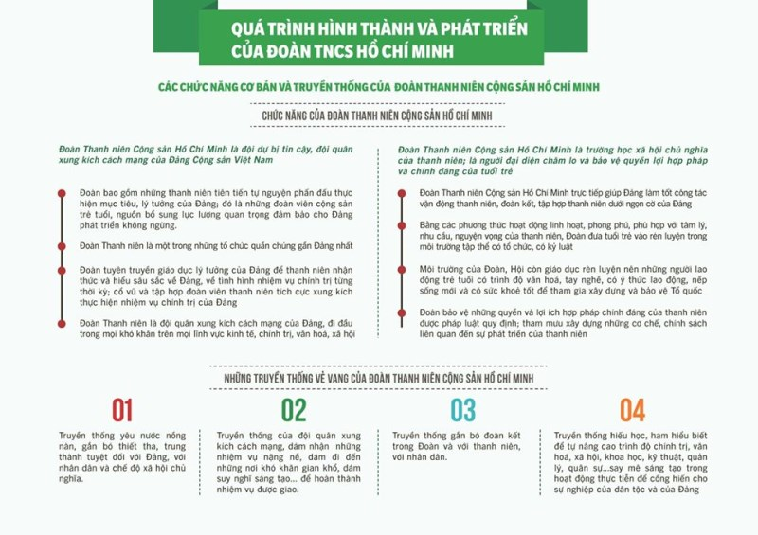](http://hvcsnd.edu.vn/Uploads/2020/3/17/20/18.jpg)