- BÀI TẬP THỰC HÀNH UNIT 8- LỚP 6C
Hoàn thành ngày 27/2/2020
PART 1 PHONETICS

I. Find the word which has a different sound in the part underlined. Read the words aloud.
1. A. top B. stay C. ten D. tomato
2. A. tune B. stop C. stick D. sticker
3. A. pretty B. potato C. test D. steer
4. A. state B. tip C. statement D. station
5. A. lost B. tennis C. photo D. telephone
6. A. stand B. stamps C. steal D. tape
7. A. toy B. just C. tea D. tight
8. A. stole B. stolen C. stuff D. script
9. A. beast B. button C. time D. ticket
10. A. staff B. style C. total D. stone
II. Fill in the blank with a suitable word.
1. Mary is my friend. is very kind.
A. She B. It C. They D. He
2. has four legs and one truck.
A. Elephant B. An elephant C. The elephant D. Elephants
3. A rat is a small animal. lives in a hole.
A. He B. She C. They D. It
4. We should love, respect and obey teachers.
A. your B. my C. our D. their
5. John and Mary are students. are going to school.
A. They B. We C. He D. She
6. are flying high in the sky.
A. Bird B. A bird C. The birds D. The bird
7. are playing in the garden.
A. Child B. A child C. The children D. Childrens
8. I have a little sister. is very cute.
A. She B. He C. It D. Me
9. is very faithful to its master.
A. Dog B. Dogs C. A dog D. The dogs
10. John always the latrine after use.
A. flush B. flushes C. flushing D. flushed
11. We do not away anything useful.
A. threw B. throwing C. throw D. thrown
12. A giraffe is a wild animal. has a long neck.
A. It B. That C. This D. They
13. They are on the floor.
A. sitting B. sat C. sit D. None of these
14. am eating fruits.
A. I B. You C. They D. He
15. That is a kite. is flying high in the sky.
A. It B. He C. She D. This
16. The baby is crying must be hungry.
A. It B. That C. She D. He
17. Mother is in the kitchen. is in the kitchen.
A. She B. He C. They D. It
18. is a white horse.
A. It B. They C. She D. He
19. The parrot is in cage.
A. her B. his C. its D. their
20. is a library in our school.
A. It B. There C. That D. This
PART 2. VOCABULARY & GRAMMAR
I. Circle A, B, C or D for each picture.
1. 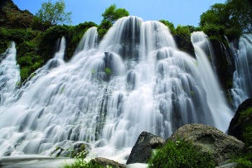  A. river  B. waterfall  C. desert  D. forest | 4. 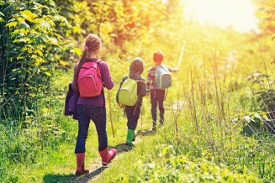  A. riding a bike  B. going hiking  C. going fishing  D. dancing
2. 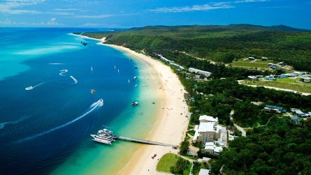  A. cave  B. mountain  C. island  D. bamboo forest | 5. 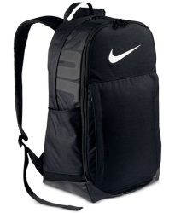  A. sun cream  B. plaster  C. backpack  D. painkillers
3. 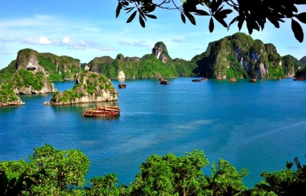  A. The Sahara  B. Ha Long Bay  C. Everest  D. Loch Lomond | 6. 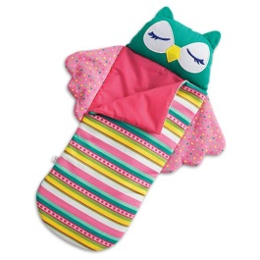  A. scissors  B. walking boots  C. compass  D. sleeping bag
II. Put the verbs in brackets into Present simple or Present continuous.
1. Sit down! A strange dog (run) to you.
2. My mom often (buy) meat from the butcher's.
3. My brothers (not/ drink) coffee at the moment.
4. Look! Those people (climb) the mountain so fast.
5. That girl (cry) loudly in the party now.
6. These students always (wear) warm clothes in summer.
7. What (you/ do) in the kitchen?
8. I never (eat) potatoes.
9. The 203 bus (set off) every fifteen minutes.
10. Tonight we (not/ go) to our teacher's wedding party.
III. Write the comparatives or superlatives of the adjectives in the parenthesis.
Dear Linda,
I'm writing to tell you about our new house. It's lovely!
It's ⁽¹⁾ (nice) house I have ever seen. It's much ⁽²⁾ (big) than the last one but also ⁽³⁾ (expensive) . The house looks very modern. There are many rooms with large windows and wooden floors. I finally have a room that I don't have to share with my ⁽⁴⁾ (young) brother.
My bedroom is on the second floor and it has a great view.⁽⁵⁾ (good) thing about this house is that it has a lovely garden. There are lots of flowers and trees around, which makes the place much ⁽⁶⁾ (colorful) .
The new house is in a peaceful area. It’s actually ⁽⁷⁾ (quiet) area I've ever lived in. The neighbors are also very kind. Can you believe they organized a party for us? They are definitely ⁽⁸⁾ (friendly) people I have ever met.
Well, that's all my news. I hope you'll visit me soon. I can't wait to show you the new place.
Yours,
Betty
IV. Choose the correct answers to complete the following sentences.
1. He is ..................... football player in this city.
A. the best B. the worse C. the goodest
2. Bill works ..................... his brother.
A. as successfully as B. so successfully as
C. successfully than
3. Mount Everest is ..................... highest mountain in the world.
A. as B. more C. the
4. ..................... all the countries in the world, Vatican is the smallest.
A. in B. Of C. the
5. Jenny behaves ..................... than Helen.
A. kinder B. more kindly C. as kindly as
6. It is ..................... in the countryside than in a city.
A. freshest B. as fresh as C. fresher
7. Da Lat is the coolest place ..................... Vietnam.
A. in B. at C. on
8. If you work ....................., you can do it .....................
A. more hardly - better B. harder - better
C. the hardest - gooder
9. She is ..................... more hard-working than her sister.
A. more B. much C. some
10. Who has ..................... apples in all of us?
A. the maniest B. more C. the most
PART 3. READING
I. Read the passage and choose the correct answer.
The Great Pyramid at Giza is one of the world's most amazing landmarks. Rising high above the Sahara Desert in the Giza region of northern Egypt, the Great Pyramid stands some 450 feet into the burning desert sky and occupies an area of 13 acres. The rough climate of the Sahara has actually caused the pyramid to shrink 30 feet from its original height. The pyramid was such an amazing feat of engineering that it remained the tallest structure in the world for over 3800 years! The entire pyramid was originally faced with polished limestone to make it shine brilliantly in the sun.

Most Egyptologists, scientists who study ancient Egypt, agree that the Great Pyramid was built around 2560 BC, a little more than 4,500 years ago. It took tens of thousands of workers twenty years to build. The pyramid contains over two million stone blocks. Although most of the blocks weigh two or three tons, some weigh up to 80 tons!
The Great Pyramid of Giza was ordered built by the Pharaoh Khufu as a magnificent tomb. His vizier (advisor), Hemon, is credited with being the pyramid’s architect. Khufu's pyramid is actually part of a complex of pyramids that includes the Pyramid of Khafre, the smaller Pyramid of Menkaure, a variety of smaller pyramids and structures, and the Great Sphinx. The Great Pyramid of Giza is the last remaining of the Seven Wonders of the World.

1. Where is the Great Pyramid NOT located?
A. Northern Egypt B. Sahara Desert
C. Giza D. Southern Egypt
2. How many stone blocks make up the pyramid?
A. 3800 B. 2560
C. More than two million D. 4500
3. Most of the blocks in the pyramid weigh about tons.
A. five B. two or three
C. 80 D. 4500
4. The Pharaoh ordered the pyramid to built as his .
A. Khufu -wonder of the world B. Khufu – tomb
C. Hemon - tomb D. vizier - tomb
5. Which is NOT part of complex of pyramids?
A. The Great Pyramid of Giza B. The sphinx
C. The pyramid of Khafre D. The Tomb of King Tut

II. Read the passages and choose the correct options A, B, c or D.
- Passage 1:
One of my favorite vacation places is Mexico. I really like the weather there because it never gets cold. The people are very nice too. They never laugh at my bad Spanish. The food is really good. Mexico City is a very interesting place to visit. It has some great museums and lots of fascinating old buildings. The hotels are too expensive to stay but there are more affordable options. For example, you can stay at one of the beach resorts like Acapulco. If you are planning to visit Mexico, you should definitely see the Mayan temples near Merida.

1. A. Sam likes warm weather. B. Sam doesn’t like warm weather at all
C. Sam hates warm water. D. Sam likes cold weather
2. A. His Spanish is very good. B. He speaks Spanish very well.
C. He is Spanish D. He doesn't speak Spanish very well.
3. A. There's a lot to see and do in Mexico.
B. There aren't a lof of beautiful places in Mexico.
C. Mexico is a dirty place.
D. Tourists never come to Mexico.
4. A. Hotels are very cheap in Mexico.
B. The hotels aren't comfortable there.
C. Hotels are all poor in Mexico.
D. The hotels in Mexico are pretty expensive.
- Passage 2:
Last summer, we decided to spend our vacation at the beach because the weather was very hot in the mountains. The travel agent said that traveling by bus was the cheapest way, but we went by plane because it was faster. We wanted to have more time to spend at the beach. The weather was beautiful and we had a great time.
5. We decided to go to the beach because .
a. it was cheaper than going to the mountains
B. the travel agent said that it was the cheapest
C. of the hot weather in the mountains
D. we wanted to spend time at the beach
6. The bus was the way to travel.
A. best B. easiest C. cheapest D. slowest
7. Traveling by plane was than by bus.
A. more fun B. cheaper C. expensive D. faster
8. We our vacation.
A. hated B. didn't like C. enjoyed D. regretted
9. We had very weather during our vacation.
A. good B. hot C. warm D. cold
PART 4. WRITING
I. Write the full sentences using given words.
1. He/ often/ have/ breakfast/ late.

2. You/ do/ the housework/ at the moment?

3. I/ not/ go/ to/ school/on weekends.

4. John's girlfriend/ wear/ a red T-shirt/ now.

5. They/ like/ beer or wine?

6. What/ he/ usually/ do/ at night?

7. The teacher/ never/ lose/ his temper.

8. Why/ you/ listen/ to music/ loudly now?

II. Rewrite the sentences in past simple tense.
1. I am very busy with work.

2. She has a big breakfast with her children.

3. He goes to school by bike.

4. Is she at home?

5. Luke and Susan do not work outside.

6. They aren’t very well when they are back from work.

III. Put the words/ phrases below in the correct order.
1. is/ comfortable/ the most/ of/ Sunday/ the week./ day

2. best/ is/ the/ album/ This/ Westlife./ of

3. Helen/ beautiful/ is/ the/ most/ know./ I/ girl

4. lives/ He/ farthest./ the

5. Tom Cruise/ most/ the/ of/ actors./ all/ the/ acts/ successfully

