E9 - Zoom 11: Revision unit 10

A. VOCABULARY
New words | Meaning | Picture | Example
altitude  /ˈæltɪtjuːd/  (n) | độ cao so với mực nước biển | 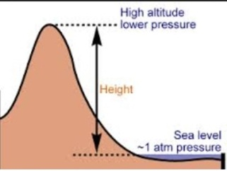 | Only few animals can live in high altitude.  Chỉ có một vài động vật có thể sống ở rất cao so với mặt biển.
astronaut  /ˈæstrənɔːt/  (n) | nhà du hành vũ trụ | 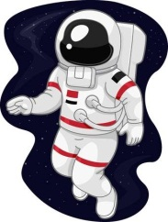 | Neil Armstrong was the first astronaut to walk on the moon.  Neil Armstrong là nhà du hành vũ trụ đầu tiên đi trên mặt trăng.
astronomy  /əˈstrɒnəmi/  (n) | thiên văn học | 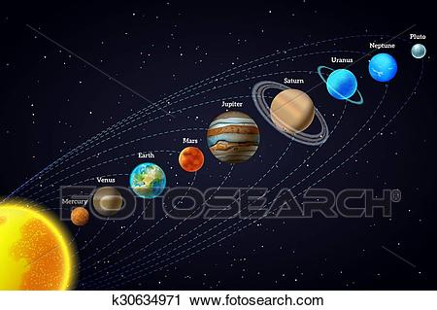 | My brother wants to study astronomy in the future.  Anh tôi muốn học thiên văn học trong tương lai.
attach  (v) | gắn vào |  | They attached the coupon to the last page of the magazine.  Họ đính phiếu giảm giá ở trang cuối cuốn tạp chí.
crew  /kruː/  (n) | đoàn, đội | 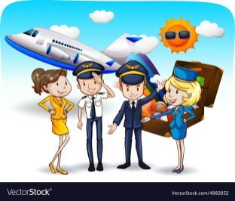 | My father is a member of the flight crew.  Bố tôi là một thành viên của phi hành đoàn.
habitable  /ˈhæbɪtəbl/  (adj) | có thể sinh sống | 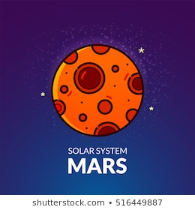 | Do you think that Mars is habitable?  Bạn có nghĩ rằng sao Hỏa là nơi có thể sinh sống được không?
launch  /lɔːntʃ/  (v) | phóng, mở, khởi đầu | 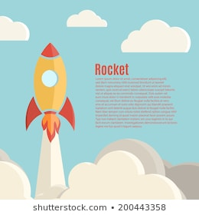 | The first rocket was launched in July 1950.  Tên lửa đầu tiên được phóng vào tháng bảy năm 1950.
maintenance  /ˈmeɪntənəns/  (n) | sự bảo trì |  | They closed the store for maintenance.  Họ đóng cửa hàng để bảo trì.
meteorite  /ˈmiːtiəraɪt/  (n) | thiên thạch | 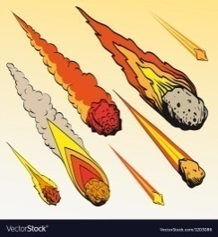 | Have you ever seen a meteorite?  Bạn đã nhìn thấy thiên thạch bao giờ chưa?
once in a blue moon  /wʌns ɪn ə muːn/  (idiom) | rất hiếm khi |  | Jim reads book about astronomy once in a blue moon.  Jim rất hiếm khi đọc sách về thiên văn học.
orbit  /ˈɔːbɪt/  (v) | xoay quanh | 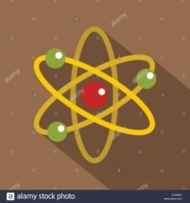 | There are many space stations orbiting around the moon.  Có rất nhiều trạm không gian xoay xung quanh mặt trăng.
over the moon  /ˈəʊvə(r) ðə muːn/  (idiom) | rất vui vẻ |  | Yesterday my friends and I were over the moon.  Đêm qua bạn tôi và tôi đã rất vui vẻ.
rocket  /ˈrɒkɪt/  (n) | tên lửa | 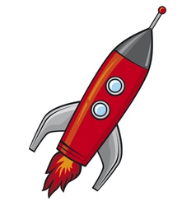 | I wish to be a rocket scientist one day.  Tôi ước trở thành một nhà khoa học về tên lửa một ngày nào đó.
satellite  /ˈsætəlaɪt/  (n) | vệ tinh | 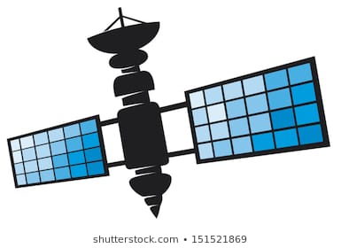 | The national channel broadcast the soccer match via satellite.  Kênh truyền hình quốc gia phát sóng trận bóng đá thông qua vệ tinh.
weightless  /ˈweɪtləs/  (n) | không trọng lượng | 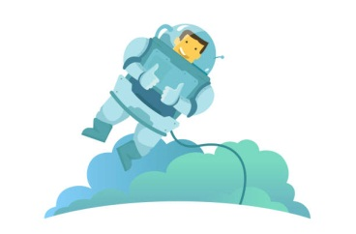 | I have experienced the weightless condition.  Tôi đã từng trải nghiệm trạng thái không trọng lượng.

B. Practice:
I. Find the word which has a different sound in the part underlined.
1. A. habitat | B. parabolic | C. spacewalk | D. galaxy
2. A. telescope | B. microgravity  vi trọng lực | C. cooperate | D. rocket
3. A. universe  (vũ trụ, vạn vật) | B. museum | C. rinseless | D. space
4. A. necessarily | B. mechanic | C. exception | D. apprentice (học nghề)
5. A. double | B. enough | C. resource | D. rough (a) (ráp, nám, xù xì

II. Find the word which has a different stress in the part underlined.
1. A. astronomy  /'''ə´strɔnəmi'''/ | B. astronomer | C. astronomic  /,æstrə'nɔmik/ | D. emergency
2. A. satellite | B. meteorite | C. maintenance | D. adventure
3. A. gravity | B. telescope | C. Mercury | D. survival
4. A. universe | B. parabolic | C. temperature | D. Jupiter
5. A. alien | B. atmosphere | C. resourceful | D. galaxy
III. CHOOSE THE BEST ANSWER
1. This aircraft is capable of 30 passengers.
A. holding B. placing
C. accommodating D. flying
2. food is specially created and processed for consumption astronaut in outer space.
A. Universe B. Land C. Planet D. Space
3. Do you believe that space have landed on our planet?
A. robots B. terrorists C. aliens D. advertisement
4. How many orbit sun?
A. spaces B. Mars C.UFOs D. planets
5. The first was done by Alexei Leonov, a Russian cosmonaut on March 18th, 1965. It was 10 minutes long.
A. spacesuit B. spacewalk C. spaceship D. spaceward
6. The Milky Way is just a in the universe and it contains our Solar System.
A. planet B. comet C. meteorite D. galaxy
7. Christer Fuglesang said he enjoyed floating around in the environment.
A. homesick B. heavy C. weightless D. quiet
8. NASA is now working hard to whether there is life on Mars.
A. discover B. collect C. experience D. accept
9. The closest potentially planet ever found has been spotted by Australian scientists, ant it’s just 14 light-years away.
A. foreseeable B. habitable C. transferable D. workable
10. As soon as the spacecraft into space, the crew started to observe the sun.
A. travelled B. was travelling C. has travelled D. had travelled

IV. Fill in each blank with an appropriate preposition.
1. Yuri Gagarin lifted into space aboard theVostok1 9.07 a.m. Moscow time 12th April,1961.
2. He was orbit around the Earth a speed of more than 17,000 miles per hour.
3. How would the mind deal the psychological tension?
4. How would the body react the extreme changes in temperature?
5. We congratulate you your successful flight.
6. The American people shared the Soviet people their satisfaction for the safe flight.
7. After his death, his home town was named him.
8. Chinabecamethethirdcountryintheworldtobeabletoindependentlycarry manned spaceflights.
9. China launched its first manned spacecraft space October, 2003.
10. No one knew precisely what would happen being a human being______space.

V. Choose the word A, B, C or D - that best fits the blank space in the following passage.
Since the beginning of time, people have looked (1) at the stars and dreamed of going to space to (2) other planets. For many years, this was just a dream, but in the past 40 years, it has become a (3)________ . In the 1960s, the Soviet Union and the United States were in a frantic (4)_______to get to space first. The Soviets took an (5)_________lead by sending the first person into space, but then Americans(6) by sending the first man to the moon. (7) the early days of space exploration, many people have gone into space,(8)_____ men and women, African Americans, Asians, and now(9)______civilians have gone to space too.(10)__________, space exploration continues.
1. A. out | B. on | C. up | D. round
2. A. invent | B. develop | C. control | D. explore
3. A. reality | B. practice | C. truth | D. realistic
4. A. pace | B. race | C. fight | D. rush
5. A. overall | B. usual | C. extended | D. early
6. A. broke out | B. caught up | C. brought up | D. went through
7. A. On | B. In | C. Since | D. From
8. A. both | B. either | C. all | D. every
9. A. little | B. a little | C. few | D. a few
10. A. Consequently | B. However | C. Moreover | D. Therefore

VI. Read the passage carefully, then choose the correct answer.
There is one planet that still fascinates and teases scientists mainly because it doesn’t have an atmosphere to obscure observation, yet it is not big enough for sufficiently accurate telescopic observation. The fact that it is also very close to the sun also makes it difficult for astronomers.
However, space telescopes have told US a lot more about Mercury. It is rather similar to Earth’s moon and to Mars. There are mountainous areas dotted with craters and large valleys which are uncratered. The moon’s valleys have fewer cracks and ridges are smoother. Mercury’s valleys are filled with volcanic rocks, similar to on the moon, yet there is no evidence of volcanoes, even extinct ones, on Mercury, as there is on the both Mars and the moon, and of course here on Earth.
So, scientists presume the valleys on Mercury were caused by different things, that is to say not by volcanoes, but by very large meteorites, which also caused the cracks in the terrain and left the ridges rough and uneven. More and better photos of Mercury are needed to prove what are at present at best only hypotheses.
1. What is the main topic of this passage?
A. The planet, Mercury. B. Observation of planets.
C. The Earth moon. D. Astronomers’ difficulties.
2. Why does Mercury still tease scientists?
A. Because it has an atmosphere which obscures observation.
B. Because it is too close to the sun.
C. Because it is too small.
D. Because it is difficult for space probes to get close to.
3. What is true about Mercury but not true about the moon or Mars?
A. The valleys are filled with volcanic rocks. B. There are no volcanoes.
C. The valleys are uncratered. D. There are hilly regions.
4. What does the author imply space telescopes can do better than land-based telescopes?
A. Show the volcanoes on Mercury.
B. Show the meteorites which hit Mercury.
C. Show what caused Mercury valleys.
D. Show more of the planet, Mercury.
5. What can we infer from the passage that astronomers still need to get more detailed observation of Mercury?
A. Better and more space telescopes.
B. More hypotheses.
C. Larger space telescopes.
D. More ways to prove hypotheses.
HOMEWORK
VII. Choose the best answer
11. The launch of the space Shuttle Endeavour broadcast live this morning.
A. was B. had been C. has been D. was being
12. In 1961 Yuri Gagarin lifted into space aboard the Vostok1.
A. off B. up C. on D.∅
13. After landing, the team members were greeted like heroes.
A. conquer B. conquering C. conqueror D. conquest
14. No one knew precisely what would happen to a human being in space.
A. exactly B. clearly C. carefully D. vividly
15. Neil Armstrong, an American , was the first man to step on the moon’s surface
A. scientist B. astrologer C. astronaut D. astronomer
16. The 27-year-ols Soviet cosmonaut became the first person to eat and drink in
A. weight B. weighting C. weightless D. weightlessness
17. About 100 Russian satellites are the earth.
A. flying B. orbiting C. traveling D. circuiting
18. By the time the police , the fire had been spreading throughout the area.
A. arrive B. have arrived C. arrived D. will arrive
19. China its first manned spacecraft into space on October 15th, in2003.
A. launched B. lifted C. pushed D. gave
20. My daughter came home crying because she bad mark in her maths test.
A. had had B. has area. C. was having D. is having

