Full name: ………………………………………..  Class: ……………………………………………… | ENGLISH LANGUAGE TEST  Time: 15 minutes
I. READING AND WRITING
Task 1. Look and write. There is one example.

Example: 
tfryo → f o r t y
1. sestir → s _ _ _ _ _ | 2. bretohr → b _ _ _ _ _ _ | 3. morteh → m _ _ _ _ _
 |  | 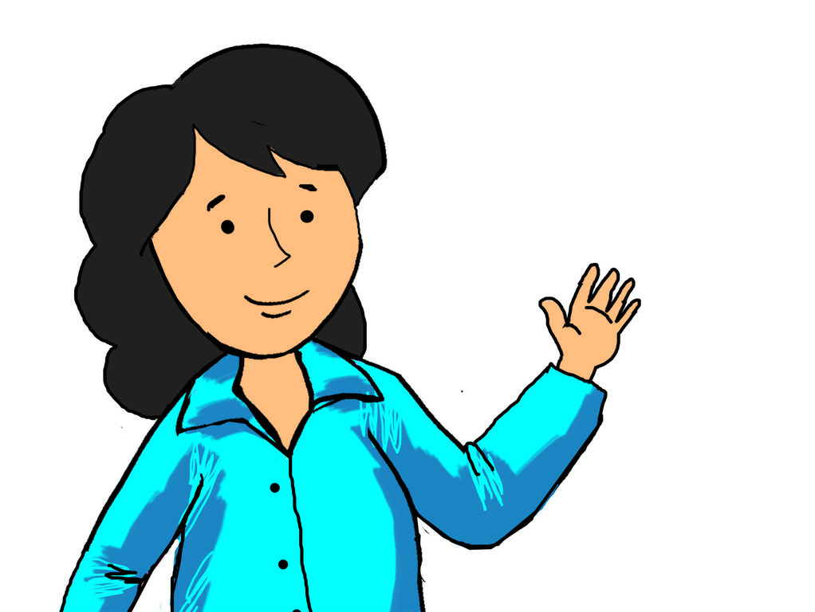
4. engitehe → e _ _ _ _ _ _ _ | 5. welvet → t _ _ _ _ _
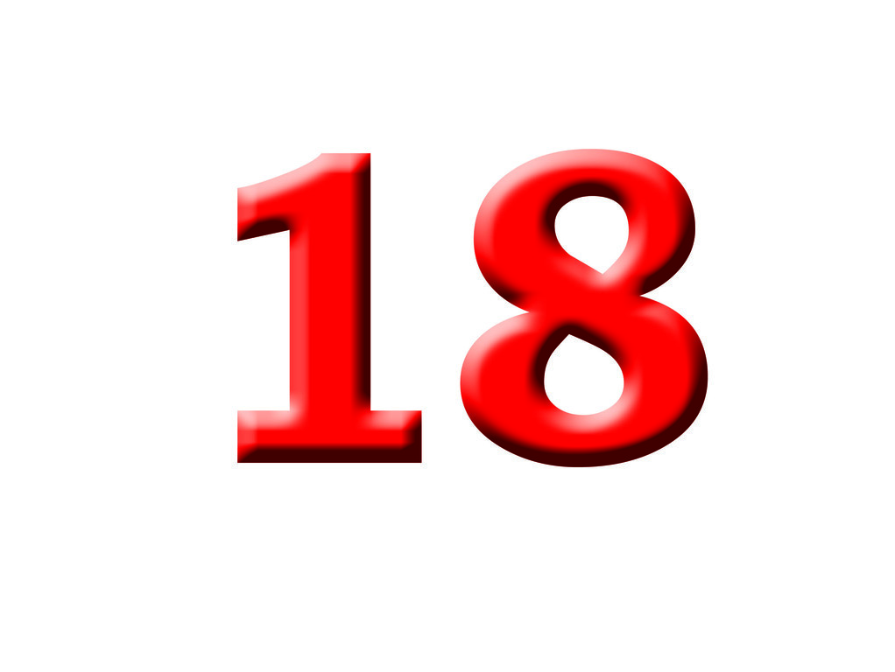 | 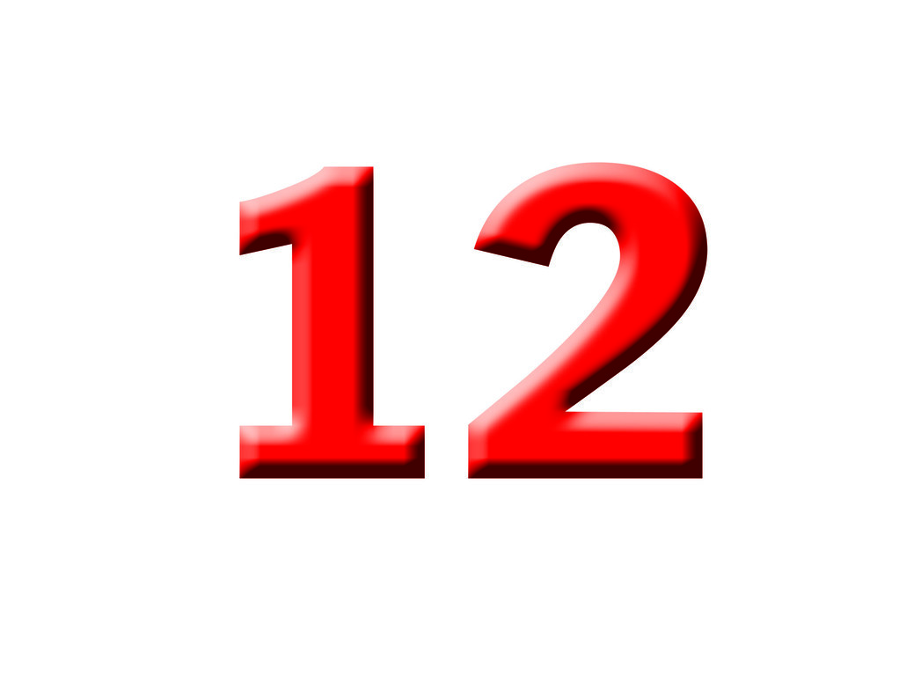

Task 2. Look and read. Tick  or cross  the box. There are two examples.

Examples:
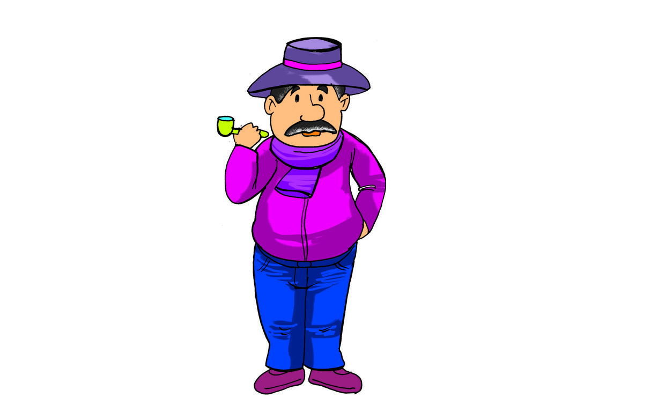  A. My grandfather is old. |  | 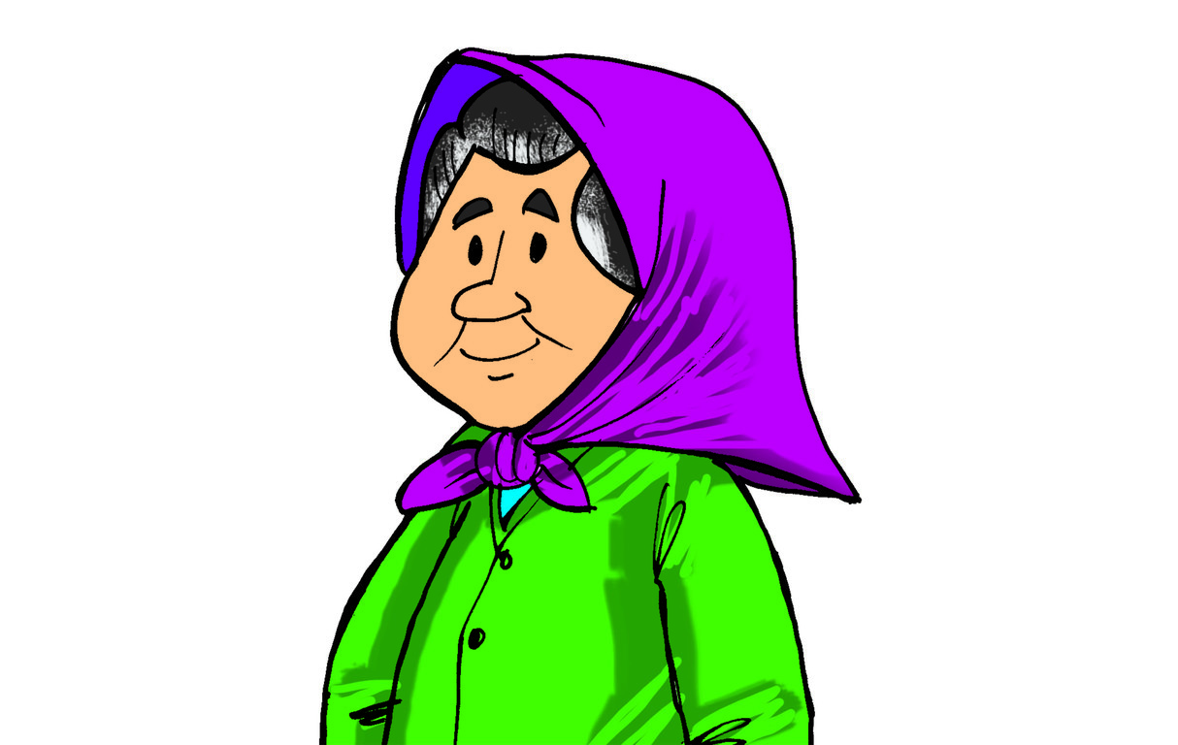  B. She is my sister.
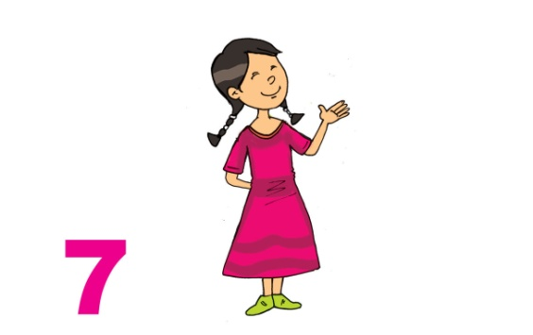  1.  My grandmother is seventy-seven years old. | 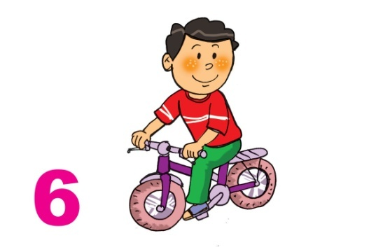  2. My grandfather is sixty-nine years old. |  | 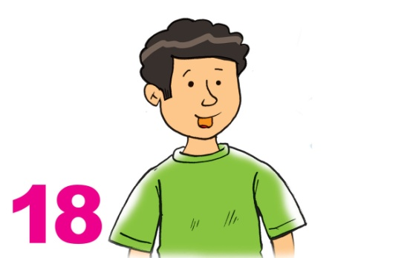  3. My brother is eighteen years old.
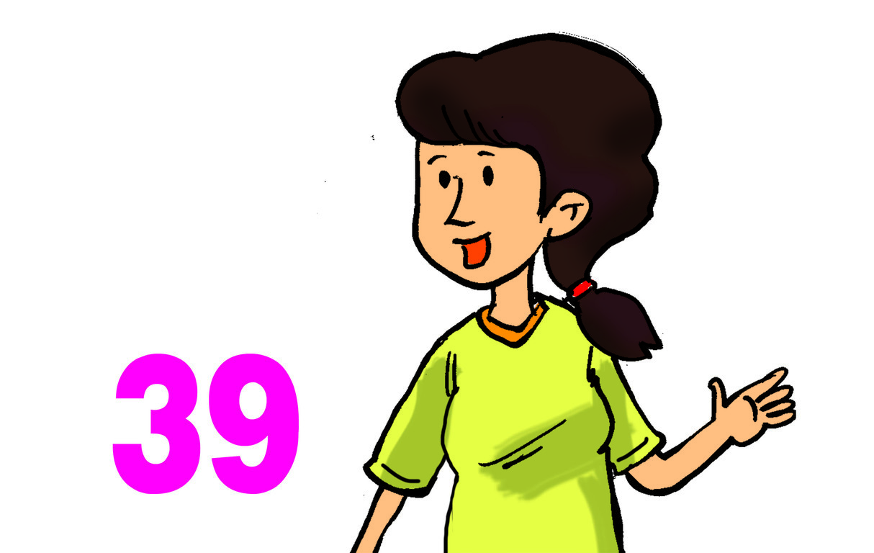  4. My mother is thirty-nine years old. |   5. My father is fifty years old.

Task 3. Read and complete. There is one example (0).

mother | who | sister | old | how | thirteen

A: Is this your (0) mother?
B: Yes, it is.
A: Who’s that?
B: She’s my (1) __________.
A: Oh, really? (2) __________ old is she?
B: She’s (3) __________.
A: And (4) __________ is next to her?
B: She’s my little sister. She’s two years (5) __________.
– The end –
manual page break

Đáp án
I. READING AND WRITING
Task 1. Look and write. There is one example.
Key: 1. sister 2. brother 3. mother 4. eighteen 5. twelve
Task 2. Look and read. Tick or cross the box. There are two examples.
Key: 1. 2. 3. 4. 5.
Task 3. Read and complete. There is one example (0).
Key: 1. sister 2. How 3. thirteen 4. who 5. old

